Radiocommunication Study Groups | 
Source: Document 3J/TEMP/48 | Document 3J/FAS/1-E
Source: Document 3J/TEMP/48 | 17 February 2010
Source: Document 3J/TEMP/48 | English only
Working Party 3J
FASCICLE
CONCERNING THE STATISTICAL DISTRIBUTIONS OF INTEGRATED
WATER VAPOUR AND LIQUID WATER CONTENTS GIVEN IN
RECOMMENDATIONS ITU-R P.836-4 AND ITU-R P.840-4

1 Introduction
The accuracy of modelling of propagation effects due to atmospheric components depends on the accuracy, the resolution (both statistical and spatial) and the statistical range of applicability of the radio-climatological input parameters, in particular with regard to water vapour, clouds and rain.
Study Group 3 activities put in evidence that the maps derived from long-term global re-analysis products of Numerical Weather Prediction (NWP) systems, provide an improvement of prediction models accuracy, with particular regard to the atmospheric attenuation for radio systems operating at millimetric wavelengths. Hence ITU-R Recommendations initiated to provide NWP derived maps since 1998 [1].
At the same the NWP systems experienced a fast evolution in terms of period of observation, spatial resolution and quality products, as an effect of an increasing number of Earth Observation systems, better atmospheric models and the adoption improved assimilation and forecast numerical techniques. As a result, new re-analysis products characterized by a longer observation period, higher spatial resolution and increased accuracy of meteorological quantities, have been made available to the scientific community (e.g. ECMWF ERA-15 [2] and ERA-40 [3]).
WP 3J activities also benefited from this trend and in 2007 the Recommendation ITU-R P.837-5 was updated to include maps of rain parameters derived from the ECMWF ERA-40 product [4]. SG 3 also recommended to participants to pursue the analysis of NWP products also for water vapour and cloud attenuation.
This document describes the new statistical maps total water vapour, water vapour scale height and reduced cloud liquid water content derived from the ECMWF ReAnalysis project ERA40, in response to the SG 3 work plan. The validation of the new maps has been performed using radiosonde observations from a selected number of stations distributed worldwide.
Measurements of the total cloud liquid, water vapour content and vapour, cloud and total attenuation performed using ground based radiometer and beacon measurements in the K, Q and V frequency bands in the framework of the ITALSAT experiment, confirmed the improvement of accuracy provided by the ERA-40 derived maps.
Water vapour is characterized by a relevant vertical variation along the atmosphere, therefore the difference between the height of the radio link and the system of reference of the input map of total water vapour should be accounted for and properly scaled, in order to improve the modelling accuracy. This issue can be addressed by introducing an additional climatological parameter, the water vapour scale height whose spatial and statistical distribution can also be derived from NWP products.
The results and the discussion contained in this document provide the background and the rationale for the modification of the Recommendations ITU-R P.836-3 and ITU-R P.840-3.
This document is divided into the following chapters:
• Review of NWP products and ITU-R recommendations
• New maps derived from the ERA40 product
• Technique for scaling of the total water vapour content to the height of the receiver
• Validation of ERA40 derived maps using RAOBS data
• Accuracy assessment of the ERA 40 data using ITALSAT campaign ground measurements
• Probabilistic modelling for ERA40 Vapour and Cloud Maps
• Conclusions.

2 Review of NWP products and ITU-R recommendations
In this chapter a brief introduction on the use of NWP products in ITU-R SG 3 activities is given. An introduction on general use of meteorological, NWP and experimental data for propagation modelling can be found in [4].
NWP systems generate weather spatial fields at regular interval of times by means of two separate analysis and forecast processes (see Fig. 1 from [1]).
Figure 1
Example of NWP data assimilation using a 6 hour cycles
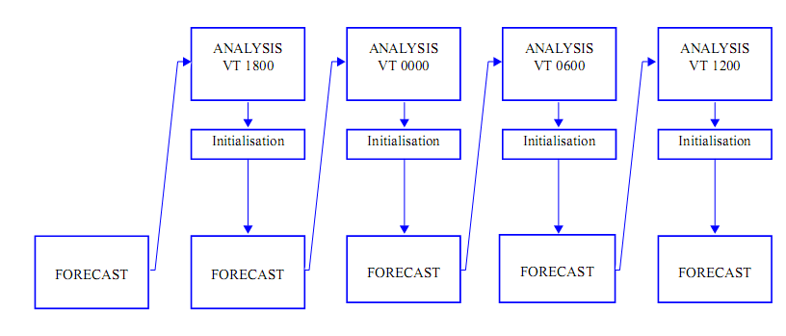
The analysis process assimilates observations (e.g. from radiosonde or satellite observations of the earth) and previous forecast data into a numerical atmospheric model using 3D/4D-Var techniques [6] to produce an estimate of the state of the atmosphere on a regular 3 dimensional grid and fixed intervals of time. The output parameters of this process are also characterized by the reduction of the original instrumental biases at the cost of a reduced spatial and temporal resolution.
Therefore analysis products are intended to provide the best estimate of the atmospheric model even if they can be characterized by issues like the degradation of accuracy results along the land and sea separation.
NWP systems can be distinguished between operational and re-analysis activities. In NWP operational systems improved processes for assimilation, modelling and spatial resolution are regularly introduced to increase of accuracy fields but at the cost of having temporal discontinuities into spatial fields. Therefore re-analysis products, in which all the observations over collected over a long-period (i.e. more than 10 years) are reprocessed using consistent analysis, are usually preferred over operational data for climatological analyses.
Atmospheric profiles of air total pressure, specific humidity and air temperature (P, q and T) are generated by the assimilation process, while parameters related to precipitation are generated by the forecast process. The cloud vertical profile of cloud water can be estimated from the atmospheric profiles of P, q and T using a cloud detection algorithm [7], commonly used also with radiosonde observations. Thanks to the assimilation process the NWP atmospheric vertical profiles of P, q and T are applicable also in presence of atmospheric precipitation but the validity of the used cloud detection algorithm in rainy conditions remains to be verified.
The maps currently provided by Recommendation ITU-R P.836-3 (Annex 2) and Recommendation ITU-R P.840-3, have been derived from two years (the NA4 ECMWF dataset covering 1992-1993) of initialization data of the numerical weather forecast of the European Centre for Medium-range Weather Forecast (ECMWF). After the NA4 dataset, ECMWF produced two additional complete re-analyses products, the ERA15 [1] and the ERA40 [2]. ECMWF used for every new product new assimilation and forecast procedures and increased the number of input observations, the observation period and the horizontal and vertical resolution of global weather fields. The precipitation data of the ERA40 project have been already used to generate the rainfall map currently described in Recommendation ITU-R P.837-5.
Each product is characterized by its specific accuracy and characteristics, e.g. the land/sea mask, the topography of ground reference levels etc. It is therefore advisable to use for propagation prediction models like the ones described in Recommendation ITU-R P.618-9, coherent set of input climatological maps, in particular for atmospheric precipitation, water vapour content and cloud liquid content.
The characteristics of the ERA40 dataset used for the maps presented in this document are described in Table 1.
Table 1
Main characteristics of NA4, ERA15 and ERA40 ECMWF
products used for ITU-R SG 3 activities
 | NA4 | ERA15 | ERA40
Period of Observations | 1992-1994 | 1978-1992 | 1959-2001  (Precip Forec)
Period of Observations | 1992-1994 | 1978-1992 | 1985-2000  (P,q,T) Analysis
Horizontal Resolution  (lat long) (deg) | 1.5x1.5 | 1.5x1.5 | 1.125x1.125
Number of  model vertical levels | 23 | 31 | 47
Rec. ITU-R P. | 836-3  840-3  1510-0 | 835-4 (Annex 3)  834-6 (chap. 6) | 837-5

3 New maps derived from the ERA40 product

3.1 Total columnar water vapour content
The maps of the total columnar water vapour content, V_{gd} [kg/m²] or [mm], exceeded for the following percentages of the year: 0.1, 0.2, 0.3, 0.5, 1, 2, 3, 5, 10, 20, 30, 50, 60, 70, 80, 90, 95 and 99%, derived from ERA40, are available on the FTP server: ftp://ftp.estec.esa.nl/pub/xe/ITU/SG3/ERA40/vtot or on the share-folder.
V_{gd} is relative to the height above mean sea level of the ERA40 grid point, derived according to the Recommendation ITU-R P.1511-0 (Annex 1).
The spatial distribution of the difference and the relative difference of ERA40 total columnar vapour content values with respect to Recommendation ITU-R P.836-3 for 1% of the annual time are given in Figure 2 and Figure 3.
Figure 2
Difference between ERA40 and Recommendation ITU-R P.837-3
total columnar vapour content at 1% of the year
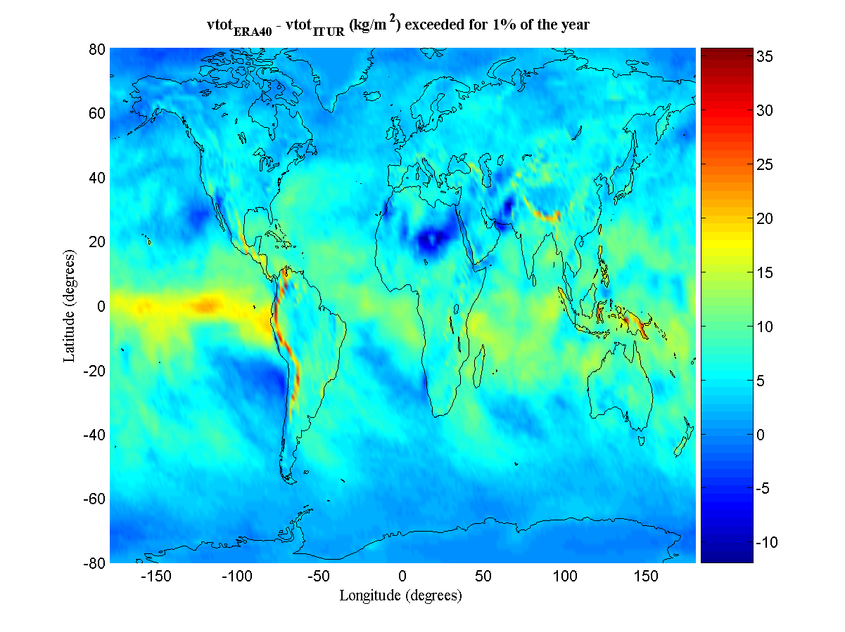
Figure 3
Relative difference [%] between ERA40 and Recommendation ITU-R P. 837-3 total columnar vapour
content at 1% of the average year (white pixel indicate values higher than the 50%)
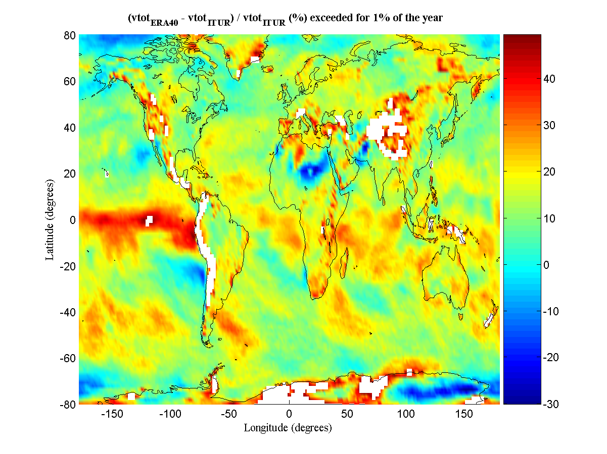

3.2 Ground water vapour density
The maps of the water vapour density at ground, vap_{d} [g/m³], exceeded for the following percentages of the year: 0.1, 0.2, 0.3, 0.5, 1, 2, 3, 5, 10, 20, 30, 50, 60, 70, 80, 90, 95 and 99%, derived from ERA40, are available on the FTP server: ftp://ftp.estec.esa.nl/pub/xe/ITU/SG3/ERA40/vapd.
vap_{d} is relative to the height above sea mean level the ERA40 grid point, derived according to the Recommendation ITU-R P.1511-0 (Annex 1).
The spatial distribution of difference and relative difference of ERA40 water vapour density at ground with respect to Recommendation ITU-R P.836-3 for 1% of the annual time are given in Figure 4 and Figure 5, respectively.
Figure 4
Difference between ERA40 and Recommendation ITU-R P.837-3 water vapour
ground density at ground at 1% of the year
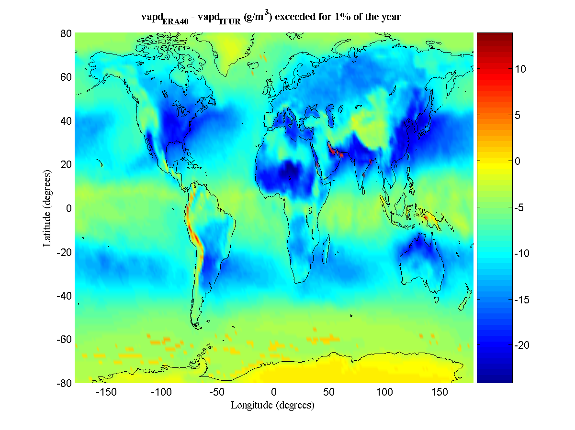
Figure 5
Relative difference [%] between ERA40 and Recommendation ITU-R P.837-3 water vapour
ground density at 1% of the average year (white pixel indicate values out
of the colour-bar range
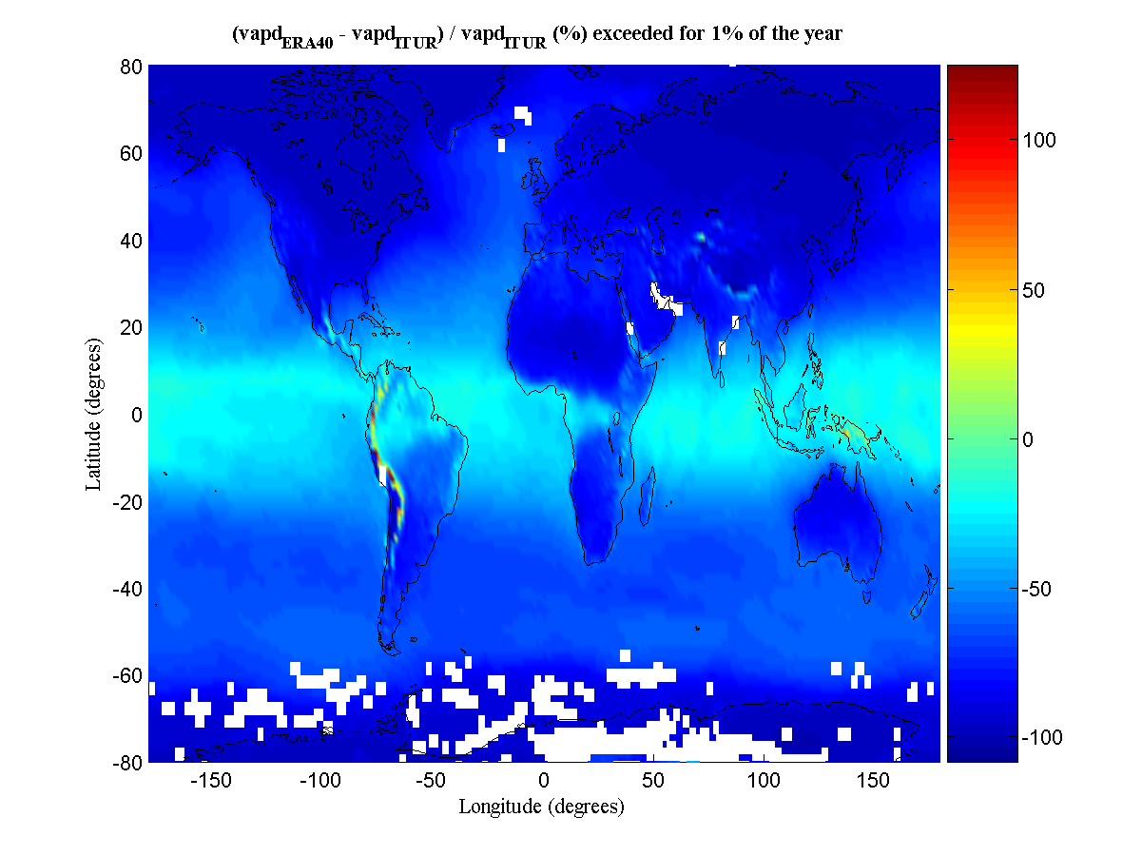

3.3 Water vapour scale height
The maps of the values of water vapour scale height, V_{sch [}, [km] exceeded for the following percentages of the year: 0.1, 0.2, 0.3, 0.5, 1, 2, 3, 5, 10, 20, 30, 50, 60, 70, 80, 90, 95 and 99%, derived from ERA40, are available on the ESA FTP server: ftp://ftp.estec.esa.nl/pub/xe/ITU/SG3/ERA40/vsch.
Samples of water vapour scale height has been derived from simultaneous values of ERA40 total columnar water content and water vapour density using Equation 2 (see chapter 4).
The map of values of water vapour scale height exceeded for 1% of the year is given in Figure 6.
Figure 6
Spatial distribution of ERA40 water vapour scale height [km]
exceeded for 1% of the year

3.4 Reduced cloud liquid columnar content
The maps of the values of the normalized total columnar content of cloud liquid water, L_{red} [kg/m²], or [mm], exceeded for the following percentages of the year: : 0.1, 0.2, 0.3, 0.5, 1, 2, 3, 5, 10, 20, 30, 50, 60, 70, 80, 90, 95 and 99%, derived from ERA40, are available on the ESA FTP server: ftp://ftp.estec.esa.nl/pub/xe/ITU/SG3/ERA40/rliq
Cloud vertical profiles have estimated using the same Salonnen-Uppal cloud detection algorithm originally employed for the current Recommendation ITU-R P.840-3. The algorithm is described in Annex 2.
The spatial distribution of difference and relative difference of ERA40 reduced cloud liquid columnar content with respect to Recommendation ITU-R P.836-3 for 1% of the annual time are given in Figure 7 and Figure 8, respectively.
Figure 7
Difference between ERA40 and Recommendation ITU-R P.837-3 reduced
cloud liquid columnar content at 1% of the year
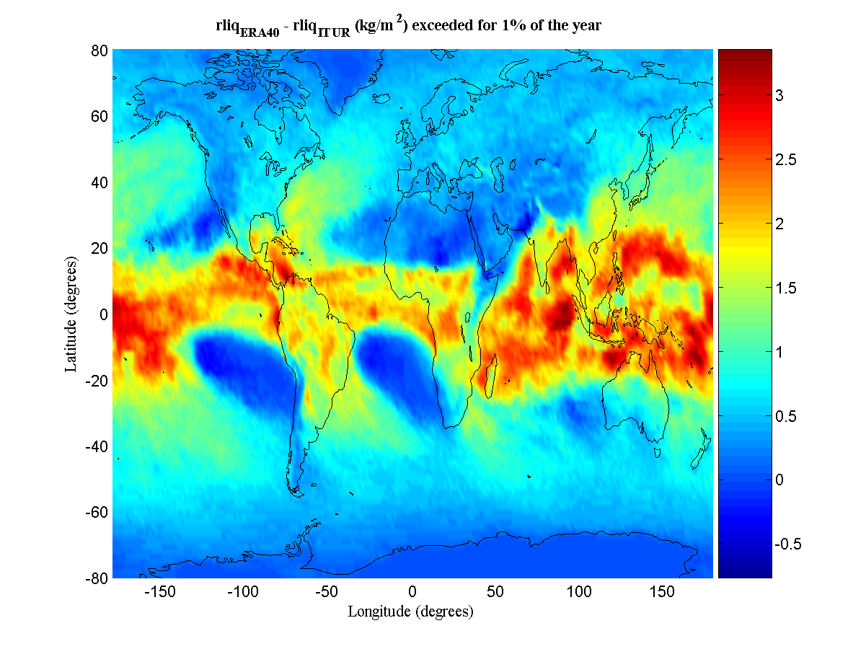
Figure 8
Relative difference between ERA40 and Recommendation ITU-R P.837-3
reduced cloud liquid columnar content at 1% of the year
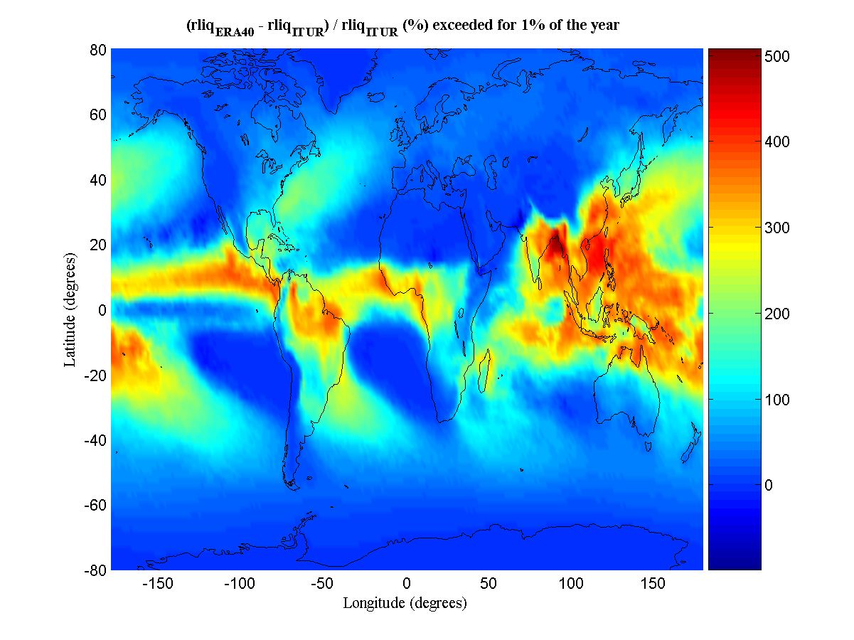

4 Technique for scaling of the total water vapour content to the height of the receiver
The distribution of water vapour density the atmosphere, [g/m³], can be modelled as a negative exponential of the altitude, h [km], in:
(1)
where h_{gd} [km] is the altitude above mean sea level of the ground, [g/m³] is the water vapour density at the ground and h_{V} [km] is the scale height of water vapour.
The integrated total columnar water vapour content above ground, V_{gd} [kg/m2] or [mm], is given by:
(2)
By using Equations 1 and 2 the following relationship can be derived for the integrated total columnar water vapour content, V_{h} [kg/m2], above a generic height above mean sea level, h [km]:
(3)
The statistical analysis revealed that in average and V_{gd} and have a positive correlation so Equation 3 can be used also to derive V_{h}(P) from V_{gd}(P), and h_{V}(P) exceeded for the percentage, P [%], of the year :
(4)
Therefore, considering on one hand the exponential variation of the total columnar water vapour content along the height and on the other hand the need to preserve the original information provided by the ERA40 maps, the spatial interpolation procedure used to derive the of total columnar water vapour at the position of the station from ERA40 grid points, has to be performed after scaling in height the ERA40 values of V_{E40} from h_{E40} to h_{st} using Equation 4, V_{st} [kg/m2], located at the position identified by latitude, longitude and height Lat_{st}, Long_{st} [deg] and from the values of the total water vapour of the nearest ERA40 grid points, V_{E40} [kg/m2], located at an altitude above mean sea level h_{E40} [km].
The detailed procedure to derive the values of total columnar water vapour content above the station, V_{st}(P), from V_{E40}(P) values exceeded for the percentage of the year P [%], is:
1) For each percentage of the year, P [%], and for each ERA40 grid point around the station calculate the height of the total columnar water vapour content above the mean sea level , using the following equation:
where:
V_{E40}(P) is the total columnar water vapour content above the height above mean sea level of the ERA40 grid point, h_{E40} [km], h_{V-E40} [km]
h_{v}(P) is the water vapour scale height of the ERA 40 grid point exceeded for the P percentage of the year.
h_{st} [km] is the height of station above mean sea level.
2) Derive the total columnar water vapour content above the station, V_{st}(P) performing a bilinear interpolation with the values of the nearest ERA40 grid points.

5 Validation of ERA40 derived maps using RAOBS data
The validation of the new maps derived from ERA40 has been performed by using a dataset of radiosonde observations (RAOBS) performed in 24 stations. Those stations are a subset of the ESA RAOBS FERAS database covering the world for an observation period of 10 years starting from 1980. The FERAS database includes both ground and upper air meteorological measurements and it has been used to generate the reference standard atmospheres described in Rec. ITU-R P.835-4 (Annex 2). The validation stations, listed in Annex 1, have been selected according to data availability and quality selection criteria. The station number reported in Annex 1 is used as station reference in the abscissa of the following diagrams. Cloud liquid profiles from RAOBS observations have been estimated using the Salonen-Uppala cloud detection algorithm (see Annex 2). ERA15 and ERA40 have been interpolated in height according to the procedure described in chapter 4.
The mean and rms of the difference between Recommendation ITU-R P.836-3 (Annex 2), ERA15 data (previously distributed in SG 3), ERA40 and FERAS data are given in Figure 9 and Figure 10.
Figure 9
Mean value of the difference between FERAS RAOBS data and ERA40,
ERA15 and Recommendation ITU-R P.836-3 values of total water vapour content
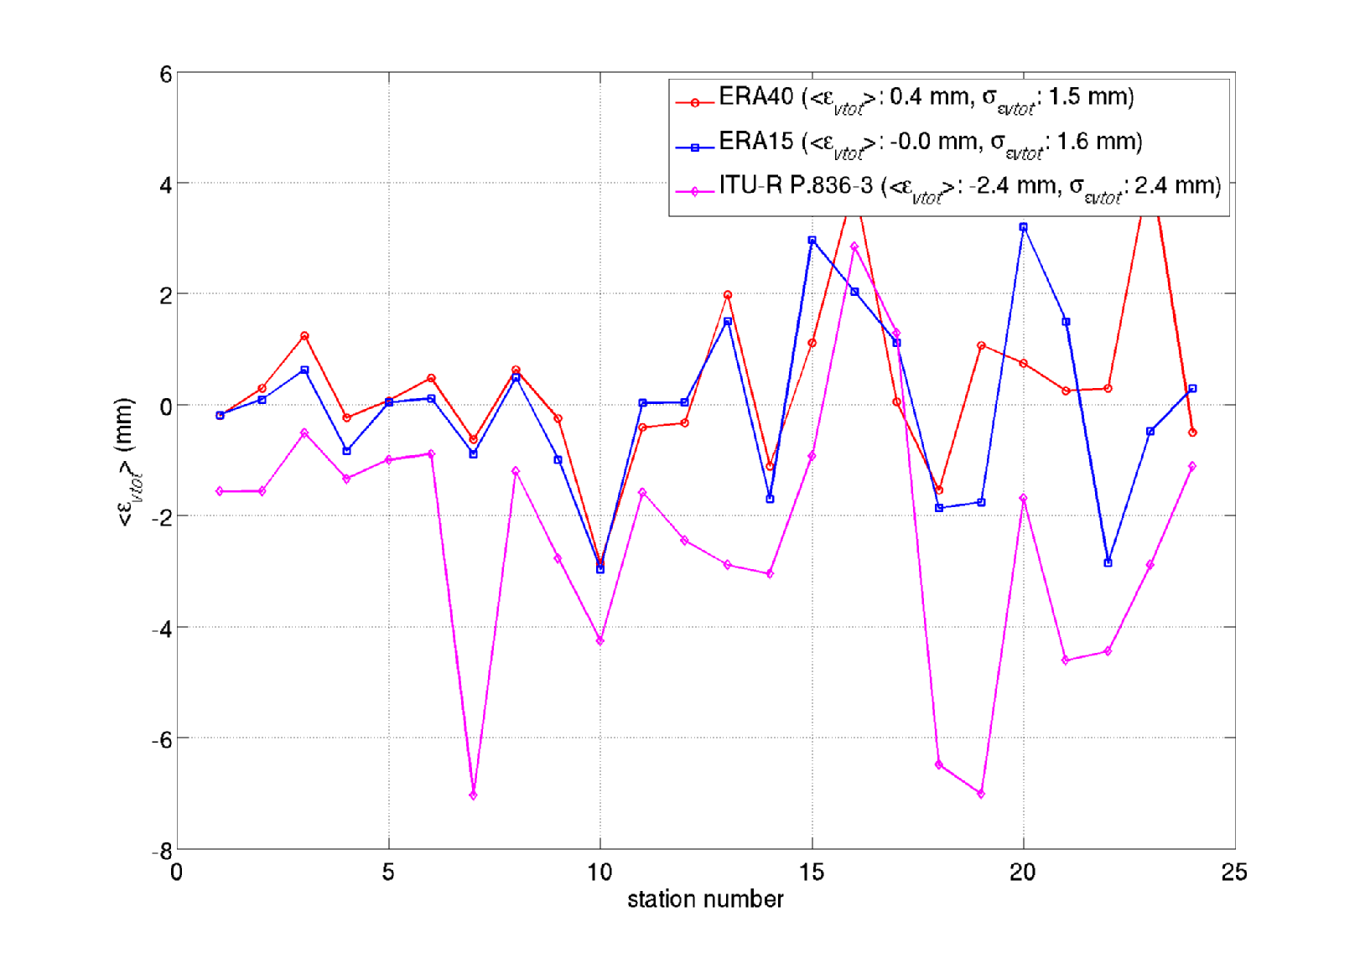
Figure 10
rms value of the difference between FERAS RAOBS data and ERA40, ERA15
and Recommendation ITU-R P.836-3 values of total water vapour content
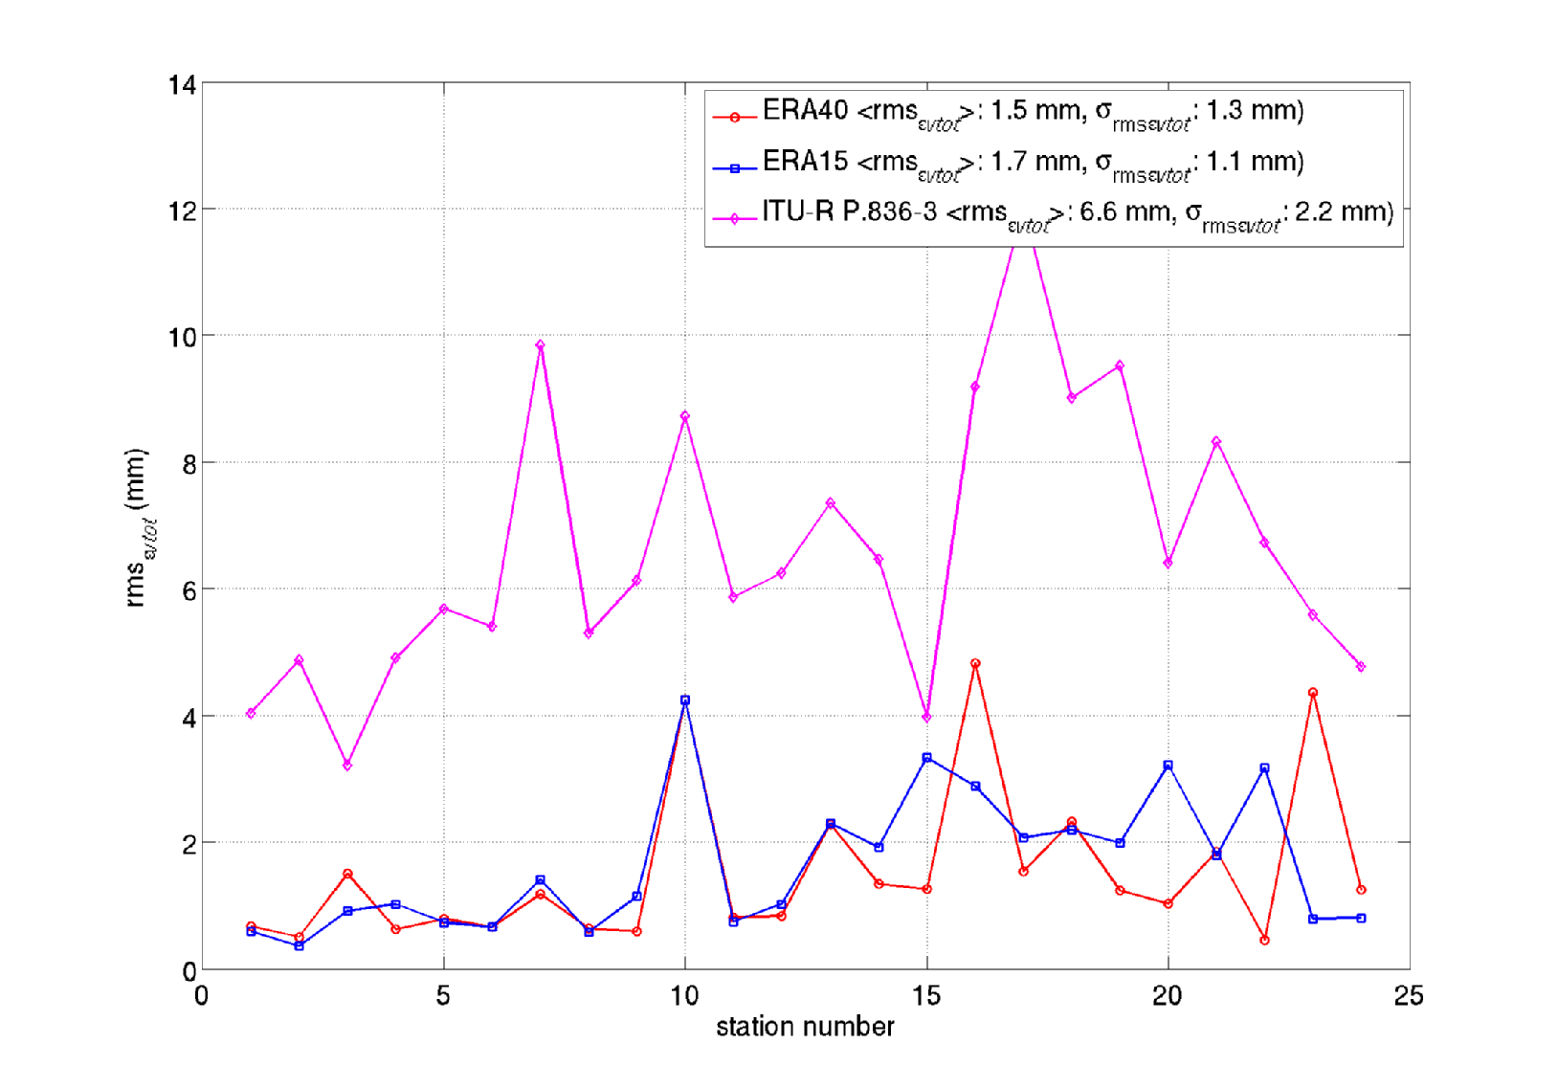
The rms residual error of the ERA40 data is lower than the rms of the residual error of the Rec. ITU-R P.836-3 of a factor 2 (at least) and is characterized by a minimum residual bias (almost 0 vs more than 2 mm).
The mean and rms of the difference between Recommendation ITU-R P.840-3, ERA15 data (previously distributed in SG 3), ERA40 and FERAS data are given in Figures 3 and 4.
It is to be noted that Recommendation ITU-R P.840-3 contains values to normalized 0 C and are plotted only for validation purposes. Nevertheless differences between normalized and not-normalized values are usually small.
Figure 11
Mean value of the difference between FERAS RAOBS data and ERA40, ERA15
and Recommendation ITU-R P.840-3 values of total of total cloud water content
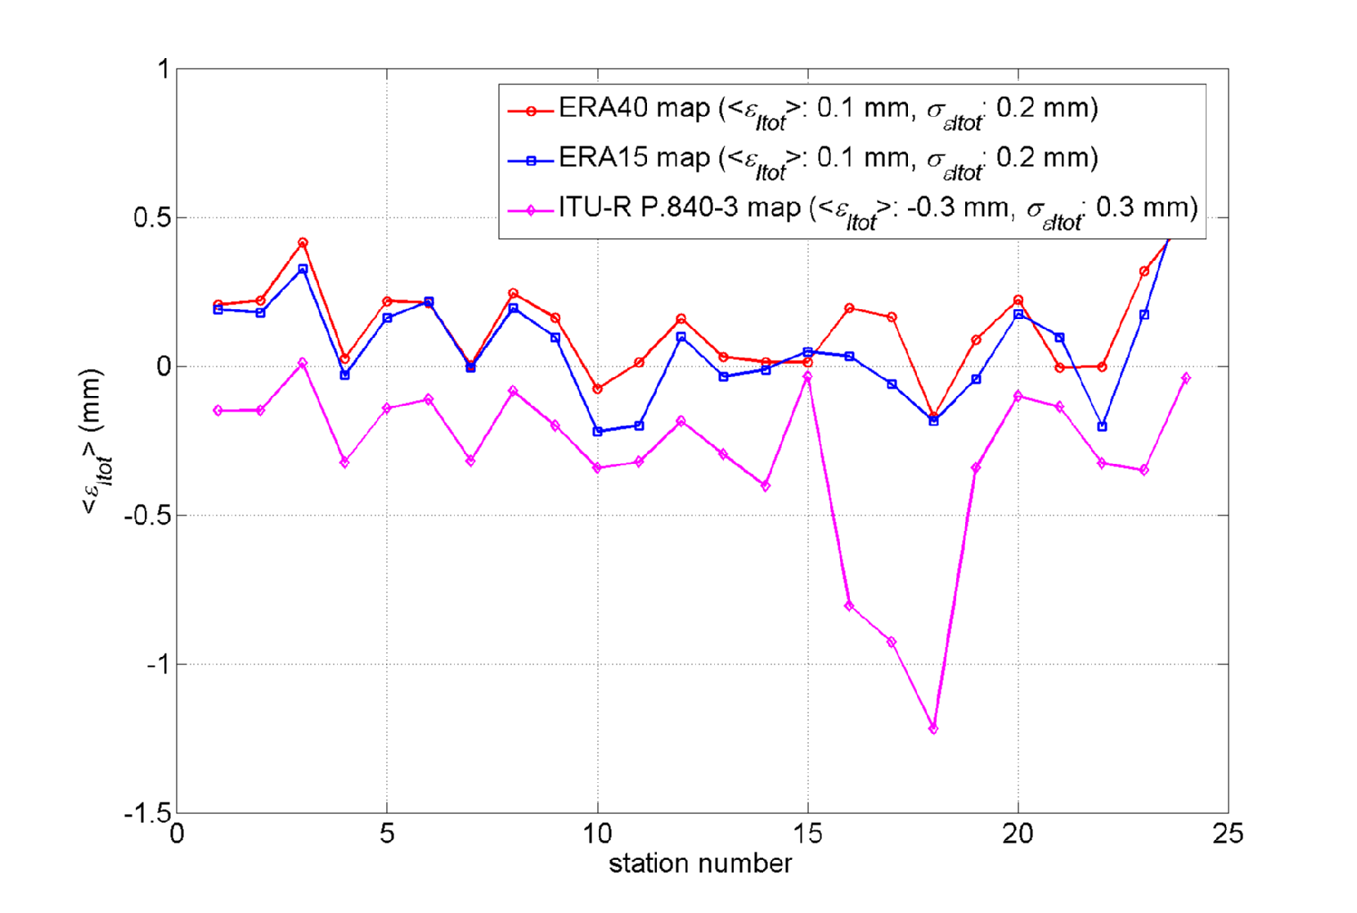
Figure 12
rms value of the difference between FERAS RAOBS data and ERA40, ERA15 and
Recommendation ITU-R P.840-3 values of total cloud water content
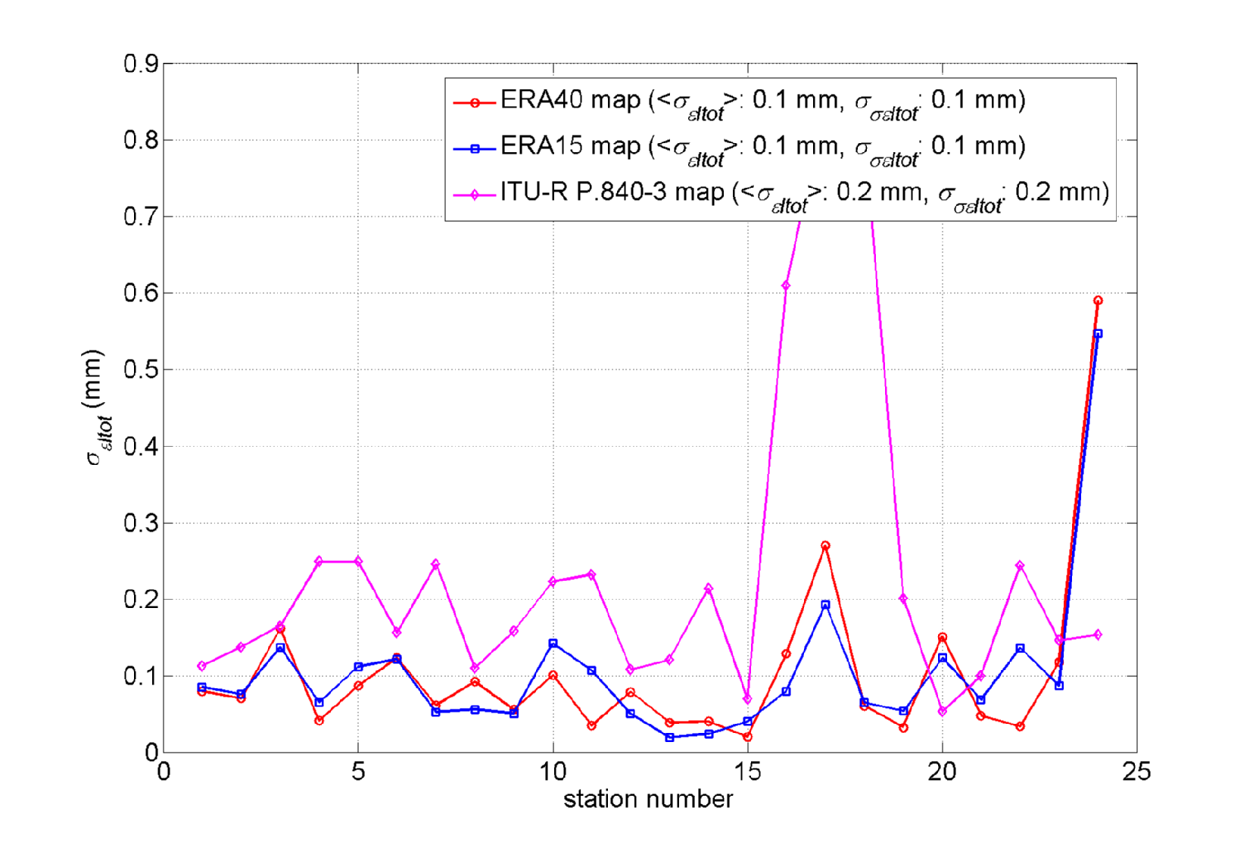

6 Accuracy assessment of the ERA 40 data using ITALSAT campaign ground measurements
The testing of ERA40-derived maps of V_{tot} and L_{red} has been conducted with data collected at Spino d’Adda (latitude 45.4°N, longitude 9.5°E, altitude a.m.s.l. 84m). The ground station located at Spino d'Adda received since 1993 the signals of the three ITALSAT beacons (at 18.7, 39.6 and 49.5 GHz) with an offset of 3.5 m diameter antenna equipped with de-icing and tracking systems. These signals were coherently detected, sampled at the rate of 1 Hz, stored, edited and analysed off-line by the Centro di Studio sulle Telecomunicazioni Spaziali (CSTS-CNR) at Politecnico di Milano. The station was equipped since 1994 with a set of noise injection radiometers at 13.0 GHz, 23.8 GHz and 31.65 GHz to evaluate liquid water and water vapour atmospheric content. A set of traditional meteorological instruments (thermometer, hygrometer, barometer and tipping bucket rain gauge) was also available.
Data from different sources have been exploited. Specifically:
• FERAS (FUB-ESA Radiosonde, being FUB the acronym for Fondazione Ugo Bordoni) radiosoundings provided by the European Space Agency (ESA), which have been derived from a NCAR (National Center for Atmospheric Research) database: vertical profiles of pressure, temperature and relative humidity, collected routinely twice a day (0 and 12 Coordinated Universal Time UTC) for ten years (1980-1989) in non rainy condition at Milano/Linate airport (45.26° N; 9.17° E, 122 m amsl), which is 20 kilometres West of Milano/Linate. The complete FERAS database can be found in Rec. ITU-R P.835-4.
• radiometric measurements: 1-s sampled brightness temperatures collected at Spino d’Adda in the period 1992-2001 by a dual-channel radiometer (23.8 GHz and 31.6 GHz, 37.7° elevation angle) manufactured by Elecktronic Centralen. The instrument was calibrated weekly with the tip curve procedure [2] and once a year with a cold reference load [3]. The radiometric resolution is about 0.1 K and the radiometric precision is estimated to be lower than 2 K. This corresponds to a precision of radiometric retrieval of about 0.1 mm and 3 mm for cloud liquid and total vapour content, respectively.
• beacon measurements: 7 years (1994-2000) of 1-s sampled attenuation data collected at Spino d’Adda in the framework of the ITALSAT propagation experiment at 18.7 GHz, 39.6 GHz and 49.5 GHz, along a 37.7° slant path [4], by a ground terminal located at the experimental station of Spino d’Adda.

6.1 Comparison between ERA40 and radiometric retrievals
FERAS RAOBS were assumed as the reference data set for characterizing the non precipitating atmosphere in the Milan area. Vertical profiles of pressure, temperature and relative humidity were used as input to the Liebe MPM93 [5] mass absorption models in order to calculate the specific attenuation at each altitude layer consequently, the total path attenuation due to gases and clouds through simple linear integration along the vertical profile. The Salonen-Uppala cloud detection algorithm has been used to estimate cloud vertical profiles from RAOBS observations. The profiles of atmospheric specific attenuation were used together with the radiative transfer model (in non-scattering conditions) to simulate sky brightness temperatures at radiometric frequencies and then to derive radiometric retrieval coefficients for total attenuation, V_{tot} and columnar cloud liquid content, L_{tot}. As well, the oxygen attenuation and vapour and cloud mass absorption coefficients for the radiometric channels have been calculated and are provided for reference in Table 2.
Table 2
Oxygen attenuation and mass absorption
coefficients zenithal path
 | Radiom. Channel
 | 23.8 GHz | 31.6 GHz
A_{O} (dB) | 0.072 | 0.12
a_{V} (dB/mm) | 0.0243 | 0.009
a_{L} (dB/mm) | 0.536 | 0.898

In Figure 13 a comparison between the statistical distribution of V_{tot} is shown: the black curve is obtained from the radiometric measurements according, the back curve with circles is obtained from FERAS RAOBS, while the blue and red curves are obtained from ERA40 map and from Recommendation ITU-R P.838-6, respectively. The ERA15 data (green curve) is also shown. ERA40 and ERA15 values of water vapour content were scaled in height according to the procedure described in Chapter 4.
Since the radiometric curves can be considered as an independent experimental reference for this climatological parameter, it is clear from Figure 1 that the best accuracy is obtained in Spino d’Adda using ERA40 data. The difference between ERA40 values and radiometric estimate is always lower than the estimated precision of retrieval.
Figure 13
Statistical Distribution of V_{tot} (in abscissa) derived from radiometric measurements (black curve),
FERAS RAOBS (black curve with circles), ERA40 (blue curve), ERA15 map (green curve) and Recommendation ITU-R P.836-3. Probability 1 corresponds to 100% of annual time
In Figure 14a a comparison between the statistical distribution of L_{tot} is shown: the black curve is, the back curve with circles is obtained from FERAS RAOBS, while the blue and red curves are obtained from ERA40 map and from Recommendation ITU-R P.838-6, respectively. It is to be noted that L_{tot} is the total content of water in the clouds and is different from the cloud liquid water content reduced to the temperature of 0C provided by Rec. ITU-R P.840-3. For comparison in Figure 14, the distribution of L_{red} for ERA40, ERA15 are also plotted. It is to be recalled that the only experimental measurement of cloud liquid content is done by the ground microwave radiometer, whereas both radiosonde (FERAS) or NWP (ERA15 or ER40) estimates are performed using a cloud detection algorithm. It is clear from the comparison that the most accurate prediction is provided by ERA40 data, which is in agreement with radiometric data within the estimated retrieval precision.
Figure 14
Statistical Distribution of L_{tot} (continuous line) and L_{red} (dashed line) derived from radiometric
measurements (black curve), FERAS RAOBS (black solid curve with circles, L_{tot}), ERA40 (blue curve), Recommendation ITU-R P.840-3 (red dashed curve, only L_{red}) and ERA15 (green dashed curve, only L_{red})

6.2 Comparison between ERA40 and beacon measurements
The effect of the new maps on the accuracy of the model contained in Rec. ITU-R P. 618-9 has been evaluated by comparing the statistics of total attenuation (gas, cloud, rain and scintillation attenuation) obtained by combining radiometric and ITALSAT beacon measurements at 18.7, 39.6 and 49.5 GHz (with an elevation angle of 37.7 deg.) have been compared with the predictions obtained with Recommendation ITU-R 618-9 (gas, Recommendation ITU-R P.676-7, cloud, Recommendation ITU-R P.840-4, and scintillation, Recommendation ITU-R P.618-9, attenuation). The attenuation due to rain has been not considered in the ITU-R prediction since the time percentage of interest has been limited from 10 to 100% where beacon attenuation measurements do not contain any contribution due to rain (since P0 for Spino d’Adda is in between 3 and 5%). In Figure 4, Figure 5 and Figure 6 the results at 18.7, 39.6 and 49.5 GHz are shown. The black curve represents measured total attenuation, the blue curve represents the ITU-R prediction with ERA40 as for surface temperature (used to calculate oxygen attenuation), V_{tot} and L_{red}, while the red curve represents the ITU-R prediction with ITU-R parameters as for surface temperature, V_{tot} and L_{red}. The wet term of refractivity (used to calculate scintillation) has been calculated from Rec. ITU-R P.453-9.
Total Attenuation calculated with ERA40 data agrees with beacon measurements within the estimated measurement accuracy.
Figure 15
Statistical distribution of total attenuation at 18.7 GHz (37.7 deg. of elevation angle) derived from
ITALSAT beacon measurements (black curve) and calculated with Recommendation ITU-R P.618-9
using with ERA40 for surface temperature, V_{tot} and L_{red} (blue curve), and using current
ITU-R Rec. for surface temperature, V_{tot} and L_{red} (red curve)
Figure 16
Statistical distribution of total attenuation at 39.6 GHz (37.7 deg. of elevation angle) derived from
ITALSAT beacon measurements (black curve) and calculated with Recommendation ITU-R P.618-9
using with ERA40 for surface temperature, V_{tot} and L_{red} (blue curve), and using current ITU-R
Recommendation for surface temperature, V_{tot} and L_{red} (red curve)
Figure 17
Statistical distribution of total attenuation at 49.5 GHz (37.7 deg of elevation angle) derived from
ITALSAT beacon measurements (black curve) and calculated with Recommendation ITU-R P.618-9
using with ERA40 for surface temperature, V_{tot} and L_{red} (blue curve), and using current ITU-R
Recommendation for surface temperature, V_{tot} and L_{red} (red curve)

6.3 Recommendation ITU-R P.311 Testing of ERA40 and ITU-R Recommendations in Spino
The performances of the testing variable recommended by Recommendation ITU-R P.311 for total attenuation, estimated using both ITU-R Recommendations and the new ERA40 maps as input to Recommendation ITU-R P.618-9, have been evaluated using the Spino d’Adda measurements contained in the SG 3 experimental tables (II-1).
The results are summarized in the following table for three different intervals of percentages of annual time. The use of the ERA40 maps improves the performances of the ITU-R for the percentages of time above 10% and between 0.01% and 10%. In the range of percentages from 0.1 to 10% ERA40 appears to be characterized by a higher bias. The detailed analysis of the test variable for each probability value, provided in annex 3, reveals that the bias and rms of the ERA40 error are higher than the ones of ITU-R maps only in for the probability ranges (from 3 to 10%) where the Recommendation ITU-R P.618-9 rain attenuation model predicts non-zero rain attenuation values even if the rain in Spino is observed only below about 3% of the annual time.
Table 3
Averaged errors summary for the probability range 0.01 – 1%
====================================================================
| Method | RMS ERRORS | WEIGHT |
--------------------------------------------------------------------
| | MEAN RMS STD | Distance | YEARS |
--------------------------------------------------------------------
| ITUR618-9 ERA40 | 0.00 0.17 0.17 | 0.00 | 16.5 |
| ITUR618-9 ITU-R | -0.05 0.18 0.17 | 0.01 | 16.5 |
====================================================================
Table 4
Averaged errors summary for the probability range 0.1 – 10%
====================================================================
| Method | RMS ERRORS | WEIGHT |
--------------------------------------------------------------------
| | MEAN RMS STD | Distance | YEARS |
--------------------------------------------------------------------
| ITUR618-9 ITU-R | 0.00 0.21 0.21 | 0.00 | 20.8 |
| ITUR618-9 ERA40 | 0.10 0.24 0.21 | 0.03 | 20.8 |
--------------------------------------------------------------------
Table 5
Averaged errors summary for the probability range 10 – 50%
====================================================================
| Method | RMS ERRORS | WEIGHT |
--------------------------------------------------------------------
| | MEAN RMS STD | Distance | YEARS |
--------------------------------------------------------------------
| ITUR618-9 ERA40 | 0.02 0.07 0.07 | 0.00 | 12.0 |
| ITUR618-9 ITU-R | -0.10 0.13 0.08 | 0.05 | 12.0 |
--------------------------------------------------------------------

7 Probabilistic modelling for ERA40 Vapour and Cloud Maps
The development of channel models for total atmospheric attenuation (e.g. synthetic time series generators) requires a probabilistic model for the statistical model distribution of the climatological parameter. Such a model can be derived by regression analysis of NWP tables like the ERA40 maps discussed in this document. It has to be stressed that the probabilistic modeling constitutes actually an additional processing step, in addition to the one originally performed by the NWP system on the actual (scattered) observations and to the spatial interpolation process described in Chapter 4. As such it can increase the final error of the prediction with respect to the local distribution.
In [8] it has been shown that a Weibull distribution model can be used to describe the statistic of integrated columnar water vapour content provided by ECMWF ERA15:
(5)
Therefore, the integrated columnar water vapour content is:
(6)
The coefficients of the Weibull distribution model, k [mm] and λ, derived by least square analysis of ERA40 data are provided in Figure 18 and Figure 19.
Figure 18
Spatial distribution of the k parameter of the Weibull distribution
derived from ERA40 maps
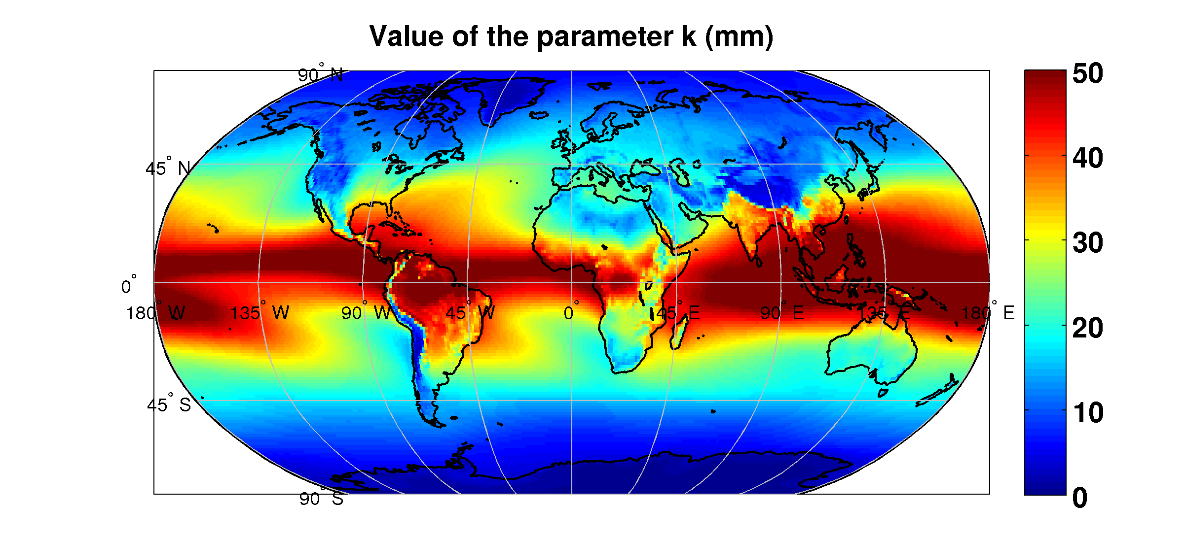
Figure 19
Spatial distribution of the λ parameter of the Weibull distribution
derived from ERA40 maps
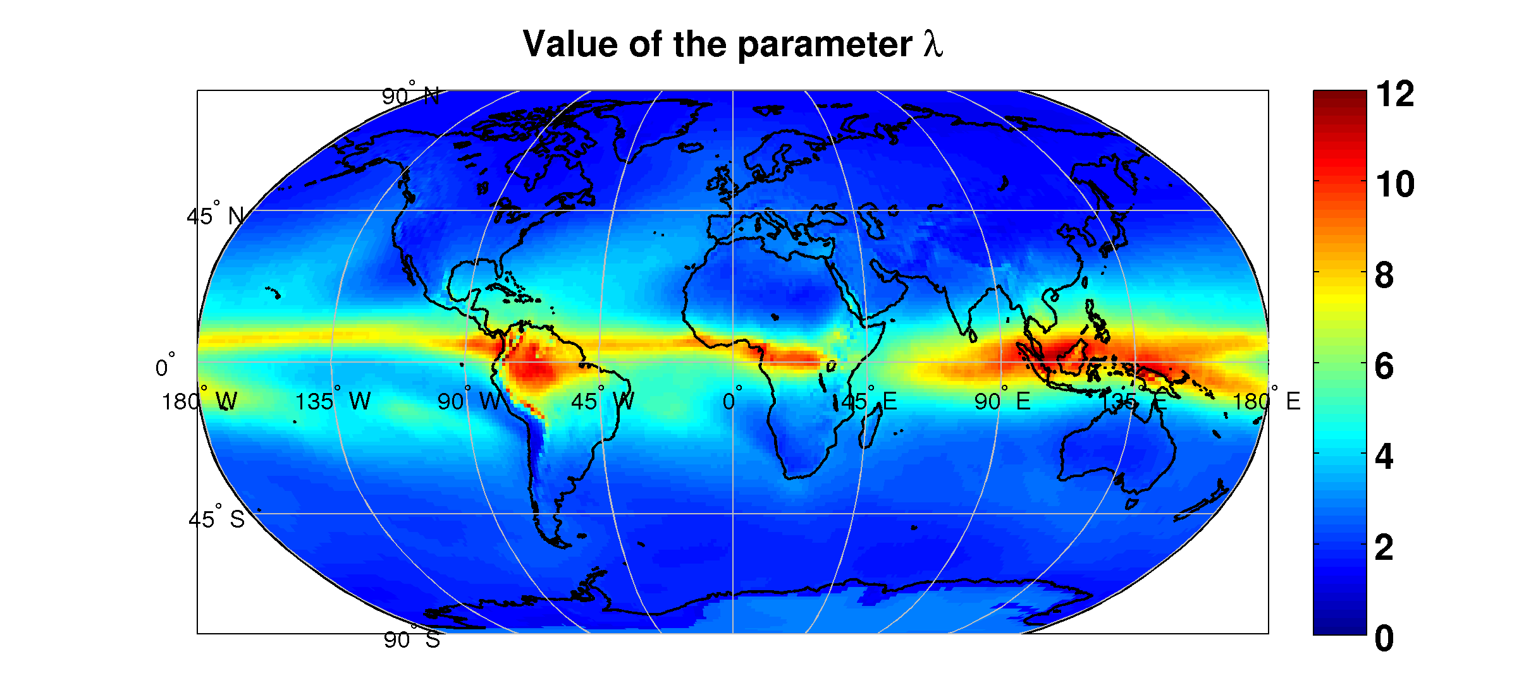
The spatial distribution of the rms error of the Weibull model with respect to the original ERA40 data is provided in Figure 20. The error is higher than the assumed precision of radiometric retrieval (3 mm) is some areas around the tropical and equatorial regions.
Figure 20
Spatial distribution of the rms error of the Weibull distribution derived from ERA40
maps with respect to the original ERA40 data
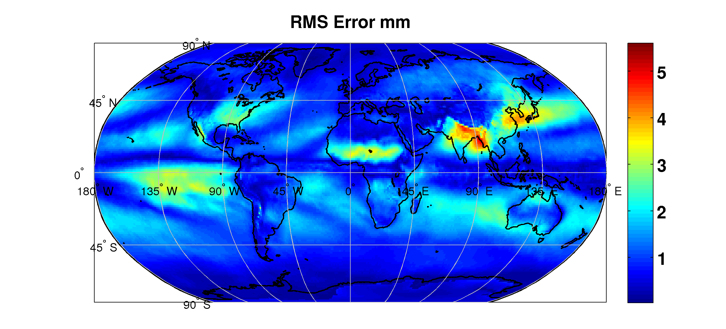
The statistical distribution of the reduced cloud water columnar content can be described by a combination of a Dirac with a log-normal distribution [8].
(7)
Therefore, the reduced cloud water columnar content is:
(8)
Where
The coefficients of the distribution model of Equation 7, P(L > 0), μ and σ derived by least square analysis of ERA40 data are provided in Figure 21, Figure 22 and Figure 23.
Figure 21
Spatial distribution of the probability of liquid water cloud
derived from ERA40 maps
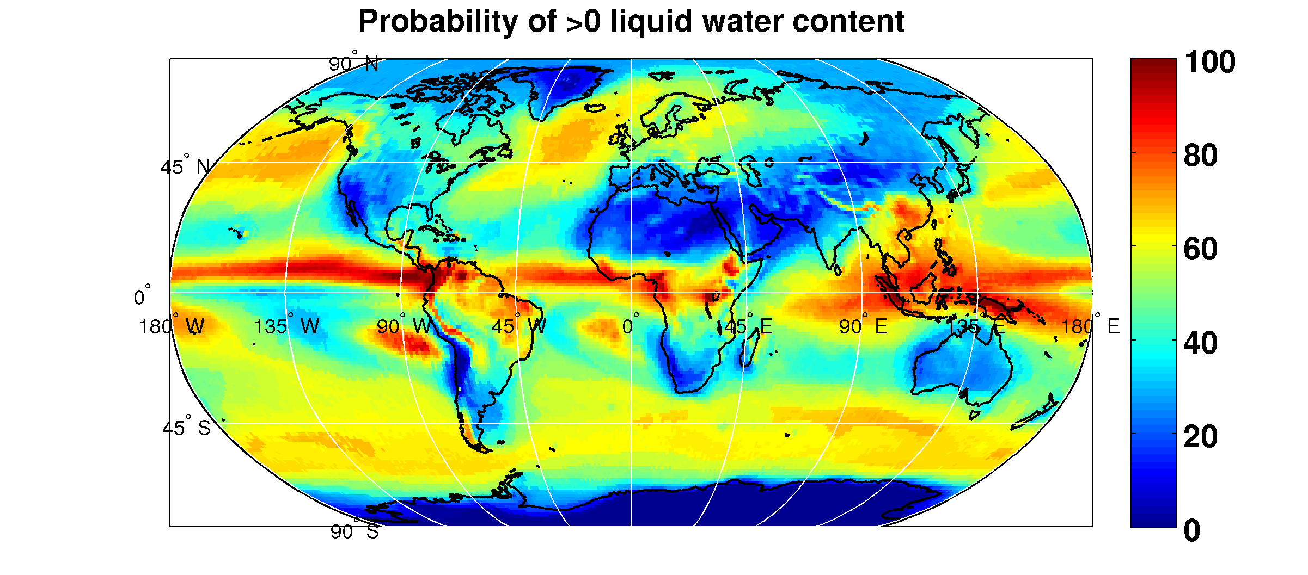
Figure 22
Spatial distribution of the μ parameter of the model for reduced cloud
liquid distribution derived from ERA40 maps
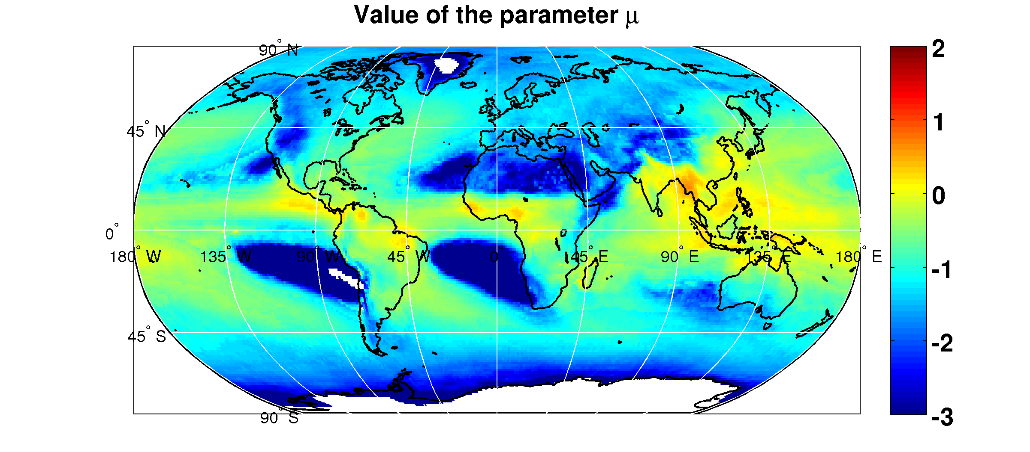
Figure 23
Spatial distribution of the σ parameter of the model for reduced
cloud liquid distribution derived from ERA40 maps
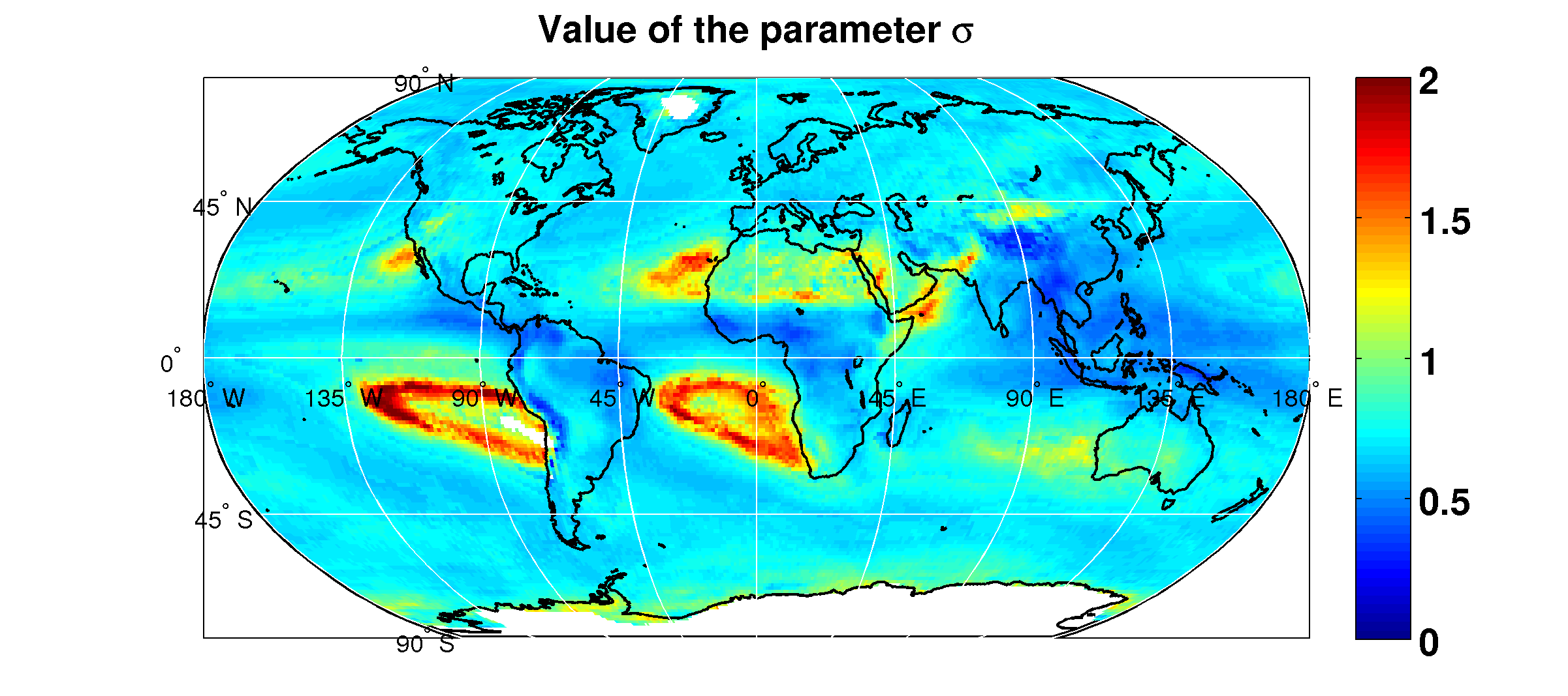
The spatial distribution of the rms error of the model for reduced cloud liquid water with respect to the original ERA40 data is provided in Figure 20. The error is higher than the assumed precision of radiometric retrieval (0.1 mm) is along the tropical and equatorial belts.
Figure 24
Spatial distribution of the rms error of the Weibull distribution derived
from ERA40 maps with respect to the original ERA40 data
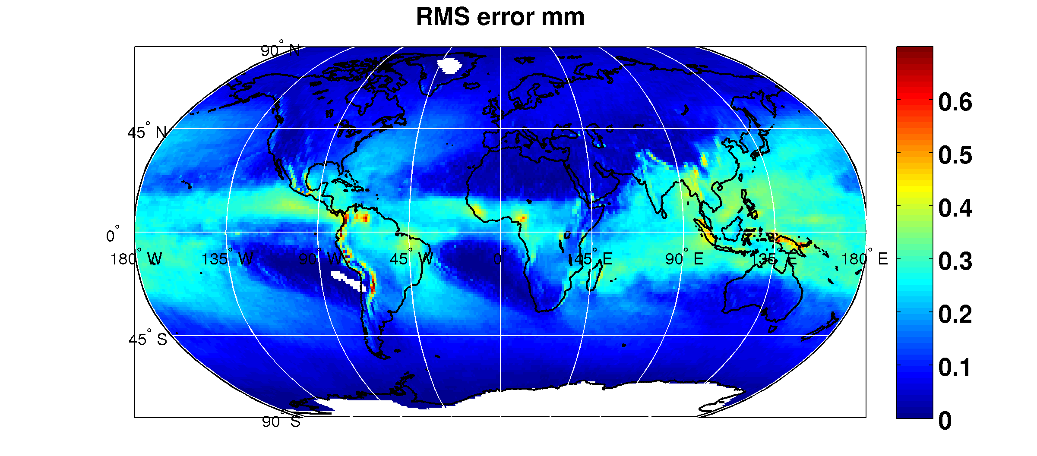

8 Conclusions
From the comparison between site specific radiometric/beacon joint measurement and the ITU-R Recommendations, using ERA40 as input data, it can be concluded that maps derived from ERA40 assimilation can significantly improve prediction accuracy.
On this basis the adoption by SG 3 of the new tables is recommended. As well the described procedure for or the scaling in height of the total water vapour content to the receiver altitude is suggested to improve the accuracy of the recommendation.
Considering the required accuracy for gaseous and liquid attenuation this test should be repeated using only other experimental data where accurate concurrent radiometric and beacon measurements at Ka, Q and V band have been performed.
For the purpose of using probabilistic models for modelling of the channel dynamic (synthetic time series generators) analytical functions and input statistical parameters can be used to reproduce the original statistical distribution of total water vapour and cloud liquid content at the expense of a residual error which is comparable to the current instrumental accuracy.
Acknowledgments
The results presented in this document have obtained in the framework of the ESA contracts 17760/03/NL/JA “Characterisation and Modelling of Propagation Effects in 20-50 GHz band”, 18278/04/NL/US “Assessment of radiowave propagation for satellite communication and navigation systems in tropical areas”, 20046/06/NL/CO “ERA40 Statistical analysis” and 21317/07/NL/HE “Assessment of Propagation Effects in the W Frequency Band for Space Exploration” and with the support of the EU FP6 SatNex project.

9 References
[1] Poiares-Baptista P., Salonen E., 1998: “Review of rainfall rate modeling and mapping”, Proc. of URSI Commission F Open Symposium on Climatic Parameters in Radiowave Propagation Prediction (CLIMPARA’98), Ottawa, Ontario, Canada.
[2] ERA: ECMWF Re-analysis project report series, “1. ERA-15 Description”, Version 2, January 1999, European Centre for Medium-Range Weather Forecasts.
[3] ERA: ECMWF Re-analysis project report series, “ERA-40 Archive”, December 2002, European Centre for Medium-Range Weather Forecasts
[4] L. Castanet, C. Capsoni, G. Blarzino, D. Ferraro and A. Martellucci, “Development of a new global rainfall rate model based on ERA40, TRMM and GPCC products”, Proceedings of ISAP07, August 20-24 2007, Niigata, Japan
[5] A. Martellucci, “Use and development of climatological and experimental databases for radiowave propagation modelling in SatCom and SatNav systems”, invited paper, Proceedings of 3rd European conference on antennas and propagation, EuCAP 2009, 23-27 March 2009, Berlin, Germany, pp. 2002-2006
[6] Ref. for 3D/4D variational techniques
[7] Martellucci A., Poiares Baptista, J.P.V., Blarzino, G. : “Effects of ice on slant path Earth-space radio communication links”, Proceedings of the XXVIIth URSI General Assembly, Maastricht, the Netherlands, 17-24 August 2002
[8] Jeannin N, L. Féral, H. Sauvageot, L. Castanet (2008) : “Statistical distribution of integrated liquid water and water vapor content from meteorological reanalysis”, IEEE Transactions on Antennas and Propagation, 56(10), pp 3350-3355.
Annex 1
List of FERAS station used for ERA40 maps validation

01) Sodankyla
02) Jokioinen
03) Stornoway
04) Hemsby-In-Norfolk
05) De-Bilt
06) Uccle
07) Lyon/Satolas
08) Berlin/Templehof(Us)
09) Wien/Hohe-Warte
10) Milano/Linate
11) Brindisi
12) Trapani/Birgi
13) Cagliari/Elmas
14) Moscow
15) Tabuk
16) Delhi/Safdarjung
17) Hong-Kong/Kings-Pk.
18) Singapore/Changi
19) Dar-El-Beida
20) Capetown/D-Malan
21) San-Diego/Lindberg
22) Denver/Stapleton
23) Mexico-City/Juarez
24) Lihue-On-Kauai
Details on site characteristics are given in Recommendation ITU-R P.835-4 (Annex 2).

Annex 2
The Salonen-Uppala cloud detection algorithm

This algorithm uses a critical humidity function U_{C} (ranging from 0 to 1) to detect clouds:
(1)
where , and σ is ratio between the pressure at the considered level and at the surface level. If the measured humidity is higher than the critical one at the same pressure level, the layer is assumed to be within a cloud. The estimation of the liquid water density w in g/m³ at each level is derived from the air temperature in the layer and its height with respect to the cloud base, according to the following relations [5]:
(g/m³) (2)
where:
w₀ = 0.17 (g/m³)
c = 0.04 (° C⁻¹)
t = temperature (° C)
h_{r} = 1 500 (m)
h_{c} = height from the cloud base (m).
The cloud liquid and ice density water fraction p_{w}(t) is approximated by the function:
(3)
Finally, L is obtained by linear integration of w along the profile.
Annex 3
Tables of Recommendation ITU-R P.311 test variable for Total attenuation
in Spino d’Adda for each percentage of time (0.01 to 50%)

=====================================================================
| Method |0.0100% PROBABILITY RELATIVE ERROR | WEIGHT |
---------------------------------------------------------------------
| | MEAN RMS STD.DEV. | YEARS |
---------------------------------------------------------------------
| ITUR618-9 ITU-R | -0.06 0.13 0.11 | 7.0 |
| ITUR618-9 ERA40 | -0.06 0.13 0.11 | 7.0 |
---------------------------------------------------------------------

=====================================================================
| Method |0.0200% PROBABILITY RELATIVE ERROR | WEIGHT |
---------------------------------------------------------------------
| | MEAN RMS STD.DEV. | YEARS |
---------------------------------------------------------------------
| ITUR618-9 ITU-R | -0.04 0.13 0.12 | 10.0 |
| ITUR618-9 ERA40 | -0.04 0.12 0.12 | 10.0 |
---------------------------------------------------------------------

=====================================================================
| Method |0.0300% PROBABILITY RELATIVE ERROR | WEIGHT |
---------------------------------------------------------------------
| | MEAN RMS STD.DEV. | YEARS |
---------------------------------------------------------------------
| ITUR618-9 ITU-R | -0.01 0.13 0.13 | 13.0 |
| ITUR618-9 ERA40 | -0.00 0.13 0.13 | 13.0 |
---------------------------------------------------------------------

=====================================================================
| Method |0.0500% PROBABILITY RELATIVE ERROR | WEIGHT |
---------------------------------------------------------------------
| | MEAN RMS STD.DEV. | YEARS |
---------------------------------------------------------------------
| ITUR618-9 ITU-R | -0.02 0.13 0.13 | 15.0 |
| ITUR618-9 ERA40 | -0.00 0.13 0.13 | 15.0 |
---------------------------------------------------------------------

=====================================================================
| Method |0.1000% PROBABILITY RELATIVE ERROR | WEIGHT |
---------------------------------------------------------------------
| | MEAN RMS STD.DEV. | YEARS |
---------------------------------------------------------------------
| ITUR618-9 ITU-R | -0.08 0.19 0.18 | 20.0 |
| ITUR618-9 ERA40 | -0.04 0.18 0.18 | 20.0 |
---------------------------------------------------------------------

=====================================================================
| Method |0.2000% PROBABILITY RELATIVE ERROR | WEIGHT |
---------------------------------------------------------------------
| | MEAN RMS STD.DEV. | YEARS |
---------------------------------------------------------------------
| ITUR618-9 ITU-R | -0.08 0.20 0.18 | 20.0 |
| ITUR618-9 ERA40 | -0.03 0.18 0.18 | 20.0 |
---------------------------------------------------------------------

=====================================================================
| Method |0.3000% PROBABILITY RELATIVE ERROR | WEIGHT |
---------------------------------------------------------------------
| | MEAN RMS STD.DEV. | YEARS |
---------------------------------------------------------------------
| ITUR618-9 ITU-R | -0.08 0.20 0.18 | 21.0 |
| ITUR618-9 ERA40 | -0.02 0.18 0.17 | 21.0 |
---------------------------------------------------------------------
=====================================================================
| Method |0.5000% PROBABILITY RELATIVE ERROR | WEIGHT |
---------------------------------------------------------------------
| | MEAN RMS STD.DEV. | YEARS |
---------------------------------------------------------------------
| ITUR618-9 ITU-R | -0.06 0.20 0.19 | 21.0 |
| ITUR618-9 ERA40 | 0.02 0.19 0.18 | 21.0 |
---------------------------------------------------------------------

=====================================================================
| Method |1.0000% PROBABILITY RELATIVE ERROR | WEIGHT |
---------------------------------------------------------------------
| | MEAN RMS STD.DEV. | YEARS |
---------------------------------------------------------------------
| ITUR618-9 ITU-R | 0.00 0.21 0.21 | 21.0 |
| ITUR618-9 ERA40 | 0.11 0.23 0.20 | 21.0 |
---------------------------------------------------------------------

=====================================================================
| Method |2.0000% PROBABILITY RELATIVE ERROR | WEIGHT |
---------------------------------------------------------------------
| | MEAN RMS STD.DEV. | YEARS |
---------------------------------------------------------------------
| ITUR618-9 ITU-R | 0.08 0.23 0.22 | 21.0 |
| ITUR618-9 ERA40 | 0.22 0.30 0.21 | 21.0 |
---------------------------------------------------------------------

=====================================================================
| Method |3.0000% PROBABILITY RELATIVE ERROR | WEIGHT |
---------------------------------------------------------------------
| | MEAN RMS STD.DEV. | YEARS |
---------------------------------------------------------------------
| ITUR618-9 ITU-R | 0.14 0.24 0.19 | 21.0 |
| ITUR618-9 ERA40 | 0.27 0.32 0.18 | 21.0 |
---------------------------------------------------------------------

=====================================================================
| Method |5.0000% PROBABILITY RELATIVE ERROR | WEIGHT |
---------------------------------------------------------------------
| | MEAN RMS STD.DEV. | YEARS |
---------------------------------------------------------------------
| ITUR618-9 ITU-R | 0.19 0.23 0.13 | 21.0 |
| ITUR618-9 ERA40 | 0.31 0.34 0.13 | 21.0 |
---------------------------------------------------------------------

=====================================================================
| Method |10.0000% PROBABILITY RELATIVE ERROR | WEIGHT |
---------------------------------------------------------------------
| | MEAN RMS STD.DEV. | YEARS |
---------------------------------------------------------------------
| ITUR618-9 ITU-R | -0.12 0.14 0.08 | 21.0 |
| ITUR618-9 ERA40 | 0.06 0.09 0.07 | 21.0 |
---------------------------------------------------------------------

=====================================================================
| Method |20.0000% PROBABILITY RELATIVE ERROR | WEIGHT |
---------------------------------------------------------------------
| | MEAN RMS STD.DEV. | YEARS |
---------------------------------------------------------------------
| ITUR618-9 ITU-R | -0.10 0.13 0.08 | 9.0 |
| ITUR618-9 ERA40 | 0.01 0.07 0.07 | 9.0 |
---------------------------------------------------------------------

=====================================================================
| Method |30.0000% PROBABILITY RELATIVE ERROR | WEIGHT |
---------------------------------------------------------------------
| | MEAN RMS STD.DEV. | YEARS |
---------------------------------------------------------------------
| ITUR618-9 ITU-R | -0.10 0.12 0.06 | 9.0 |
| ITUR618-9 ERA40 | -0.02 0.05 0.04 | 9.0 |
---------------------------------------------------------------------

=====================================================================
| Method |50.0000% PROBABILITY RELATIVE ERROR | WEIGHT |
---------------------------------------------------------------------
| | MEAN RMS STD.DEV. | YEARS |
---------------------------------------------------------------------
| ITUR618-9 ITU-R | -0.06 0.08 0.06 | 9.0 |
| ITUR618-9 ERA40 | 0.01 0.03 0.03 | 9.0 |
---------------------------------------------------------------------

______________

