Regional Radiocommunication Conference (RRC-06)  (Second Session)  Geneva, 15 May – 16 June 2006 |  |  | 
Appendix 1 to
Document 32-E
 |  |  | 8 May 2006
 |  |  | Original: English
Director, Radiocommunication Bureau
Appendix 1
Testing and verification of the RRC planning software

1. Introduction
This document presents the manual calculations performed as part of the process to verify and test the planning software as presented in Annex A. Additionally, the reports from individual administrations provided their reports on the testing of the planning software as presented in Annex B.

Annexes: 2
Annex A
Reports on testing of the planning software by the Radiocommunication Bureau
and PXT

A.1 Description of tests
The IPG-2 meeting indicated that the planning software should be verified according to all combinations of digital broadcasting requirements and existing assignments for all possible combinations of propagation conditions. It was noted that in practice not all combinations can occur.
During its meetings the PXT concluded that, because the planning software is modular, it is possible to test and verify the different modules for different combinations, thus reducing the overall number of combinations that need to be considered. Once a particular module is deemed to perform correctly, its output may be used in subsequent tests as a reliable calculated result and only the additional results should be verified.

A.1.1 Verifying the propagation model
The propagation module is central to almost all the analysis modules of the planning software. It was deemed necessary to test the propagation model for several combinations of propagation zones and transmitter characteristics, which would ensure the verification of several .
The propagation curves included in Chapter 2 of the RRC-04 report were used with the following link to the data given in Annex 2.2:
http://www.itu.int/ITU-R/conferences/rrc/rrc-04/index.asp which points to
http://www.itu.int/ITU-R/conferences/rrc/rrc-04/docs/FS_curves_RRC_04.zip

The following configuration was used for testing:
- A standard power of 1kW at 75 meters was used for the transmitters.
- For basics tests at standard heights and standard distances, the values in the txt file were used.
- For test involving intERPolation, the values were read off the paper curves in Chapter2.
- Since the propagation module used in the compatibility analysis is the same as the module provided in the EBU propagation test program v 1.4, the latter was used.

A.1.1.1 Simple paths at nominal frequency and at tabulated heights

A.1.1.1.1 Zone 1, Geneva-Besançon, 1 kW, 600 MHz
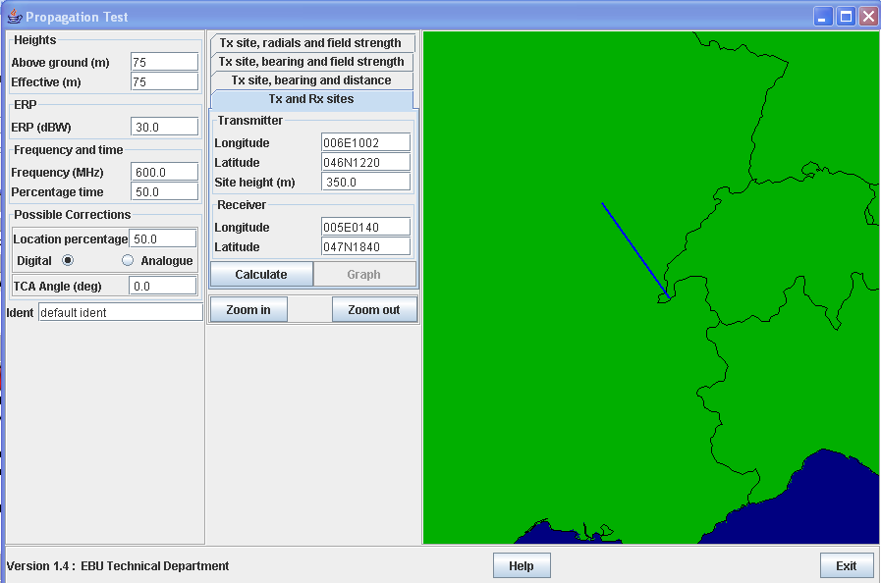
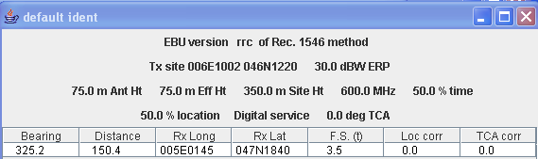
Field strength value read off text file: 3.528 dBμV/m at 150 km and 1.873 dBμV/m at 160 km
Linear intERPolation at 150.4 km gives 3.46 dBμV/m

A.1.1.1.2 Zone 2, Oulad Mahmoud – Timinoun Algeria, 1 kW, 600 MHz
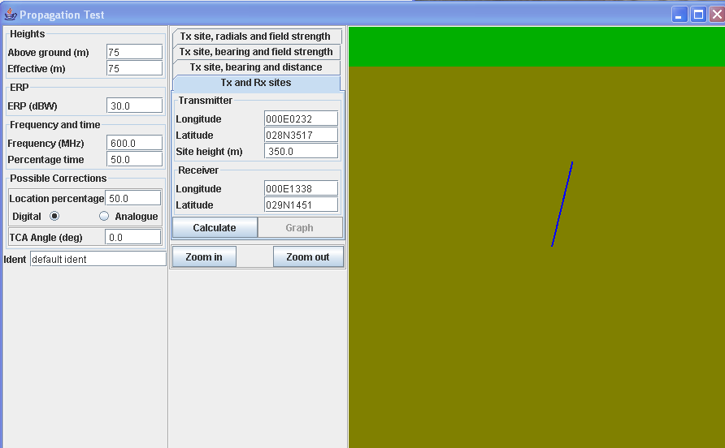
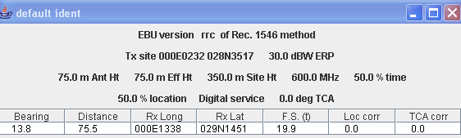
Field strength value read off text file: 20.038 dBμV/m at 75 km and 18.346 dBμV/m at 80 km
Linear intERPolation at 75.5 km = 19.87 dBμV/m

A.1.1.1.3 Zone D, Al Mubarraz – Ayn Dar, ARS, 1 kW, 600 MHz
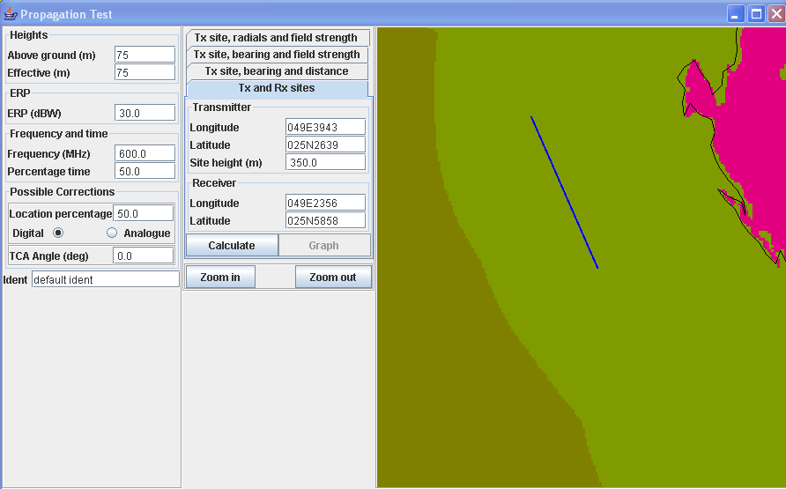
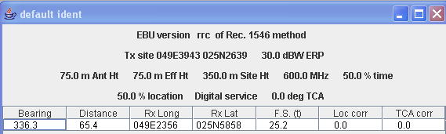
Field strength value read off text file: 25.364 dBμV/m at 65 km, 23.458 dBμV/m at 70 km
Linear intERPolation at 65.4 km gives 25.17 dBμV/m.

A.1.1.2 Simple path with frequency intERPolation

A.1.1.2.1 Zone 1, Geneva-Besançon, 1 kW, 229 MHz
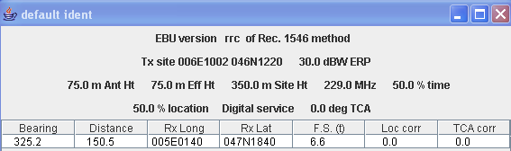

For verification, take the calculated value at 100MHz
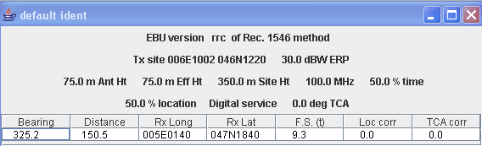
Field strength value read off text file: 9.346 dBμV/m at 150 km and 7.907 dBμV/m at 160 km
Linear intERPolation at 150.4 km gives 9.288 dBμV/m

According to equation (12), with
F_{sup} = 600 MHz, E_{sup} = 3.46 dBμV/m
F_{inf} = 100 MHz, E_{inf} = 9.29 dBμV/m
and F = 229 MHz
we get E = 6.59 dBμV/m.

A.1.1.2.2 Mixed land Path according to A.2.1.8 a) :
Tiznit – Takat MRC
Approximately 30 km in Zone 1 and 34 km in Zone 2
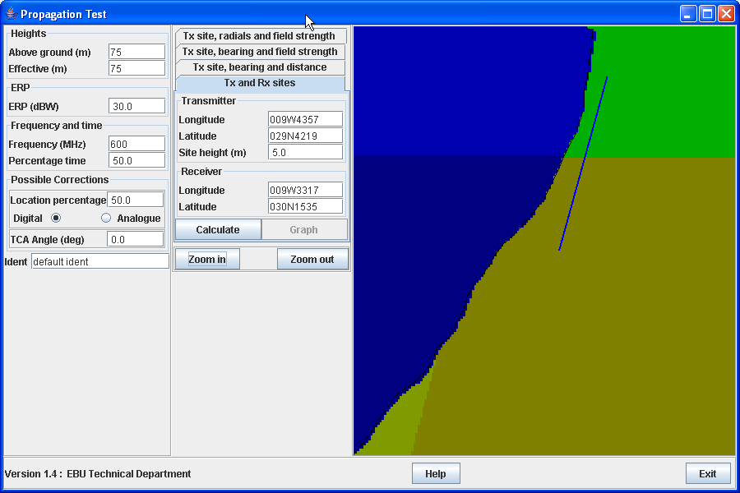
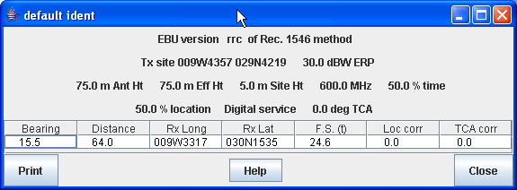
Calculation the whole path as if in Zone 1, field value read off txt file: 26.616 dBμV/m at 60 km, 24.486 dBμV/m at 65 km
Linear intERPolation at 64 km gives 24.91 dBμV/m

Calculation the whole path as if in Zone 2, field value read off text file: 26.029 dBμV/m at 60 km and 23.862 dBμV/m at 65 km
Linear intERPolation at 64 km gives 24.29 dBμV/m

Using Equation (14), E= 24.91(30/64) + 24.29(34/64) = 24.58 dBμV/m

A.1.1.2.3 Mixed Path according to A.2.1.8 b) :
Al Muharraq – BHR to Al Mubarraz – ARS
Approximately 46.7 km in Zone C, and 84.5 km in Zone D gives a total path of 131.2 km.
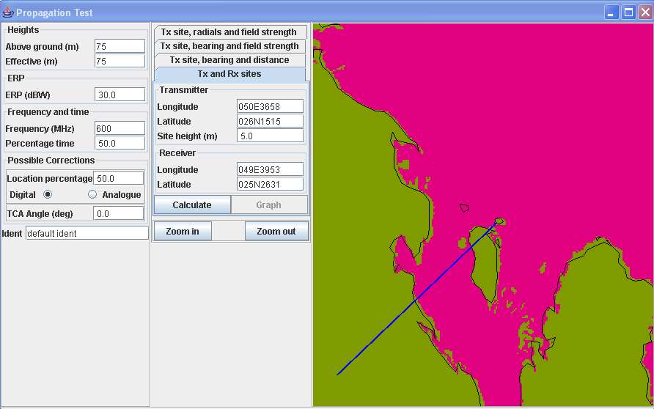
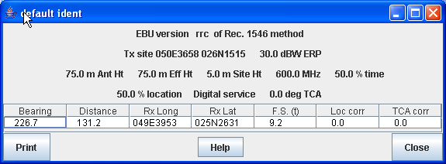
Calculation the whole path as if in Zone D, field value read off txt file: 8.358 dBμV/m at 130 km and 6.552 dBμV/m at 140 km
Linear intERPolation at 131.2 km gives 8.14 dBμV/m

Calculation the whole path as if in Zone C, field value read off txt file:13.77 dBμV/m at 130 km and 11.342 dBμV/m at 140 km
Linear intERPolation at 131.2 km gives 13.48 dBμV/m

Factor A₀ =0.25 (read off figure A.2.1-2 for.2 Fs = 46.7/131 or 0.36)
$Δ$ = 13.48-8.14 = 5.34 and V = 1 + (5.34/40) = 1+0.1335 = 1.1335
giving A = (.25)^{1.1335} = 0.208 and
E=(1-0.208)8.14 + 0.208 (13.48) = 6.45 + 2.8 = 9.25 dBμV/m

A.1.2 Interaction between digital television broadcasting requirements

A.1.2.1 TVAllotment (DT2) interfered with by a TV Allotment (DT2)
1.2.1.1 The “General Analysis Results” menu option of RRC06 Planning Interface 1.5.2 was used to view a list of calculation results for Allotments

A.1.2.1.2 Wanted Allotment F__00002, ALPES-THE-PROVENCE was selected (ch 21). 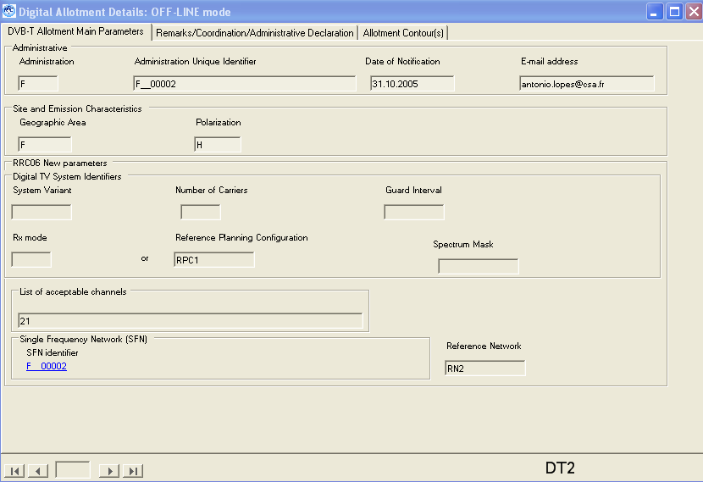

From the data table, interfering allotment F__00893 was selected.
A.1.2.1.3 Version 2.0.2 of EBU program was used to perform calculations in named mode. This created a large output file of which the following was extracted for review:
F ALPES-HTE-PROVENCE F__00002 pol H allotment RPC 1 FO RN 2 chan 21 min med 53.2

F F__00893 AIN-REGIONAL chan 21 prt 33.8 dB
adm identifier pol netnum bear dist cnfs margin wtplng wtplat itplng itplat C
F F__00893 U 2 142.1 161.1 61.6 8.99 6.90 44.47 5.65 45.62

From the EBU program detailed calculations,the:
CNFS=FS+PRT or FS=CNFS-PRt = 61.6-33.8 =27.8 dBuV/m.

The details for allotment F__00893 are as follows:
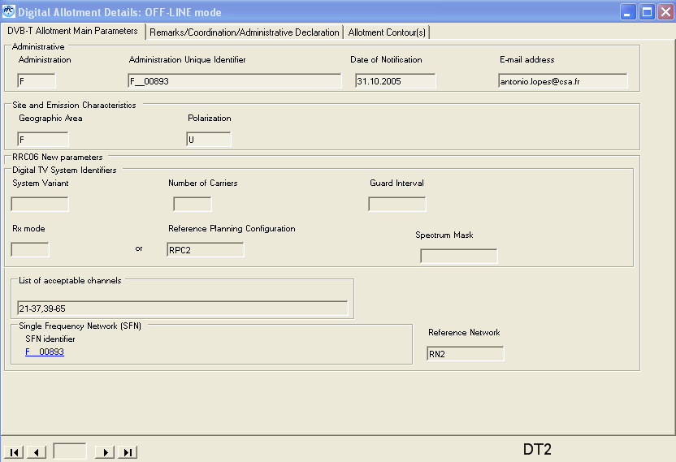

The calculated ERP for interfering allotment F__00893 at 474 MHz is:
(36 dBW + 3dB + 30 log (474/650) +3dB) = 39 –4.11 = 34.9 dBW.

The distance of 161.1 km is the shortest distance between allotments F__00893 and F__00002. The minimum median FS for F ALPES-HTE-PROVENCE is 53.2 dBuV/m, which is the corrected value from 56 dBuV/m for RPC1 at 650 MHz, correct to 474 MHz with 56 + 20log(474/650).

The closest point of F__00893 AIN-REGIONAL is point 0 at Long and lat of (005E3857, 45N3725) and the shortest distance to F__00002 is to pt 1(6E5344,44N2822).
Here are the EBU Proptest program results for the interfering allotment :
It is a necessary to calculate the field from the 3 transmitters of the RN2 at the calculation point of F__0002 and then use the power sum of the 3 fields. From the geometryof the RN2 (figure A.3.7-3), we can calculate the distances of 162,178 and 187km respectively for the 3 transmitters. For one direct calculation (tx 1 of the RN2) the result is:

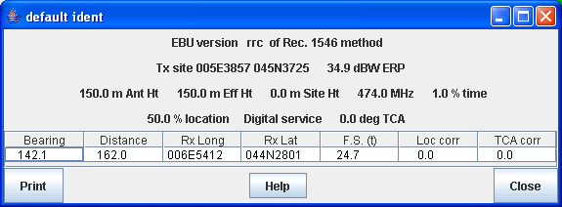

Here is the calculation for the 2nd tx:
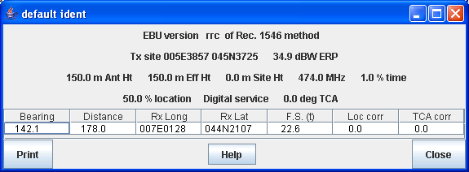

and finally for the 3rd tx in the RN2:
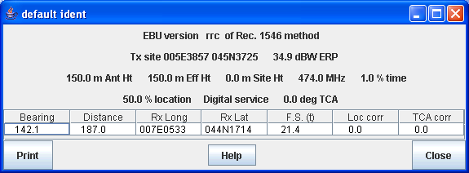

Summing these 3 fields one gets a field strength of:
10 log 10(10 ^{24.7/10} + 10 ^{22.6/10} + 10 ^{21.4/10}) = 27.9 dBuV/m
The EBU program gave FS = 27.8 dBuV/m.
Manual calculation appears to overestimate the received FS by 0.1 dBuV/m.

A.1.2.2 TV Allotment (DT2) interfered with by a TV Assignment(DT1)
A.1.2.2.1 Allotment F__0002 already considered above was selected as the wanted allotment. The interfering assignment selected was
F__1001-21 GEX MONTROND.
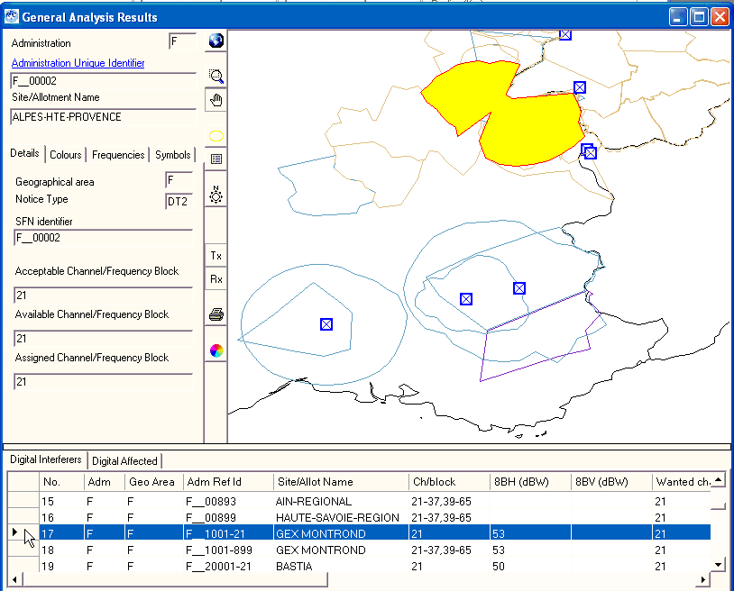
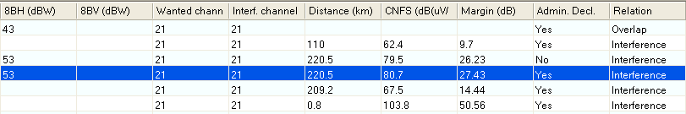

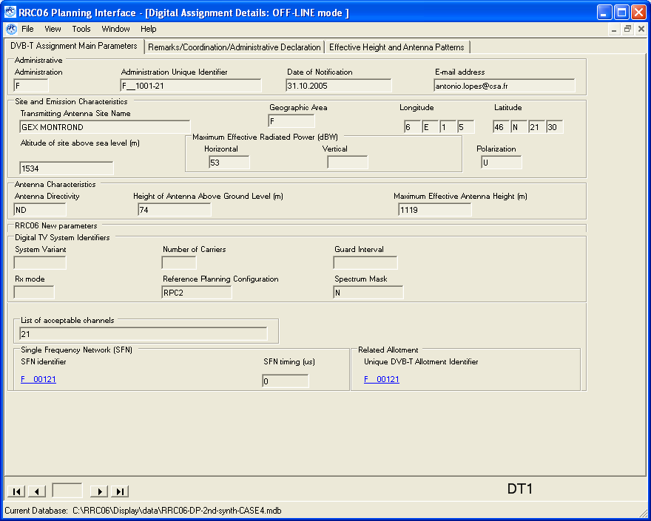

A.1.2.2.2 Version 2.0.2 of EBU programme was used in named mode to obtain a large output file of which the following was extracted for review:
F ALPES-HTE-PROVENCE F__00002 pol H allotment RPC 1 FO RN 2 chan 21 min med 53.2

F F__1001-21 GEX MONTROND chan 21 prt 33.8 dB
adm identifier pol ERPh ERPv ERP effht bear dist cnfs margin ang wtplng wtplat C
F F__1001-21 U 53.0 -99.9 N 53.0 1063.3 161.6 220.5 80.7 27.43 6.90 44.47

From the above FS = CNFS-PRT = 80.7-33.8 = 46.9 dB uV/m

A.1.2.2.3 For interfering allotment F__1001-21 parameters are:
Lon, lat are 06E0105, 46N2130
ERP is 53 dBW.
Effhgt at bearing 161.6 degrees is 1070+(1.6/10)*(1028-1070) = 1063.3

The worst test point of F__0002 receives a cnfs of 80.7 and is located at 220.5 km . It is pt1 located at(6E5344,44N2822).
A.1.2.2.4 EBU Proptest program gives the following results:
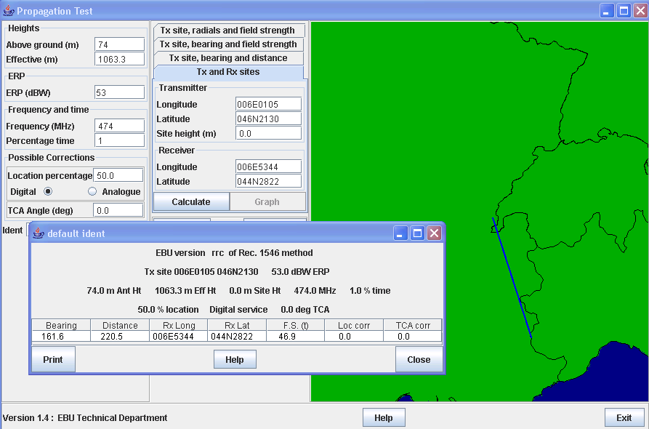

In this case manual calculations give exactly the same interfering FS of 46.9 dBuV/m.

A.1.3.4 TV Assignment(DT1) interfered with by a TV Assignment (DT1)
The wanted assignment selected was AFS “ 1” ALIWAL NORTH. The interfering unwanted assignment selected was AFS , AFS1304048, BUTTERWORTH.
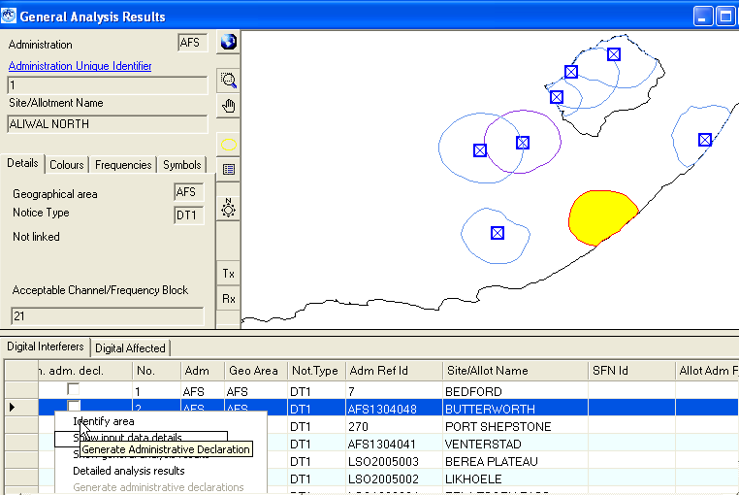

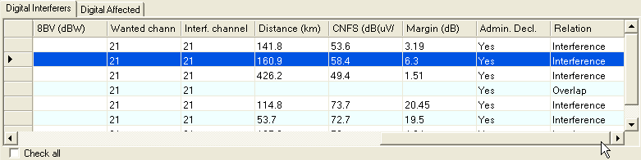

A.1.3.4.1 Technical details of wanted assignment AFS “ 1” ALIWAL NORTH are:

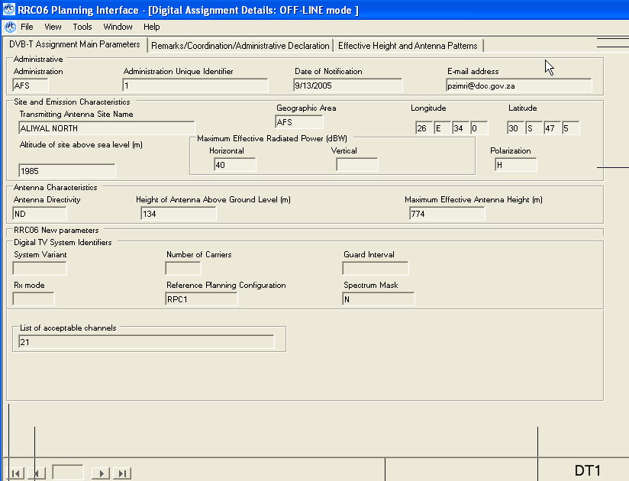

A.1.3.4.2 Technical details of interfering assignment AFS , AFS1304048, BUTTERWORTH.

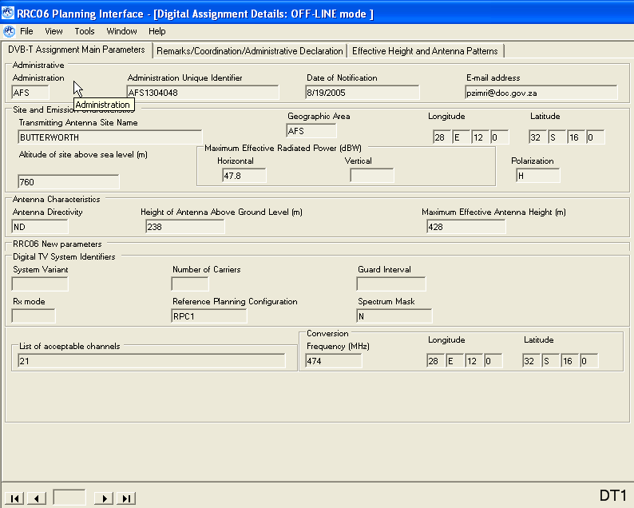

A.1.3.4.3 With the latest version of the planning software, a detailed analysis results was performed by simply right-clicking on the line in the table where the interfering assignment appears. The extracted results are as follows:

AFS ALIWAL NORTH 1 pol H asignment RPC 1 FO chan 21 min med 53.2

AFS AFS1304048 BUTTERWORTH chan 21 prt 33.8 dB
adm identifier pol erph erpv erp effht bear dist cnfs margin ang wtplng wtplat
AFS AFS1304048 H 47.8 -99.9 N 47.8 267.4 319.3 160.9 58.4 6.30 130.0 27.10 -31.16

From the above calculations, CNFS= FS +PRT – Rantdisc or FS = CNFS – PRT + Rantdisc
FS = 58.4 -33.8 +16 = 40.6 dBuV/m

A.1.3.4.4 Verification of the results
Erp of interfering assignment: 47.8 dBW
Effhgt calculated at 319.3 degrees is 267.4 meters

EBU Proptest program gives the following results at the test point:
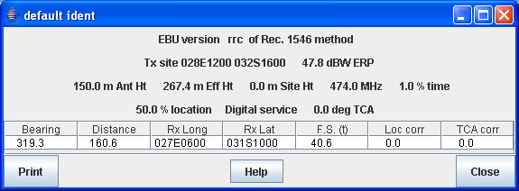

Received interfering FS at the test point is 40.6 dBuV/m which is the same as in the analysis program.

A.1.2.3 TV Assignment(DT1) interfered with by a TV Allotment(DT2)
The wanted assignment selected was SUI-01-05-02, CARONA MT S SALVATORE. Allotment AUT23100, AUT_2V was selected as the interfering unwanted allotment.
A.1.2.3.1 Here is the General Analysis Results screen for this study:
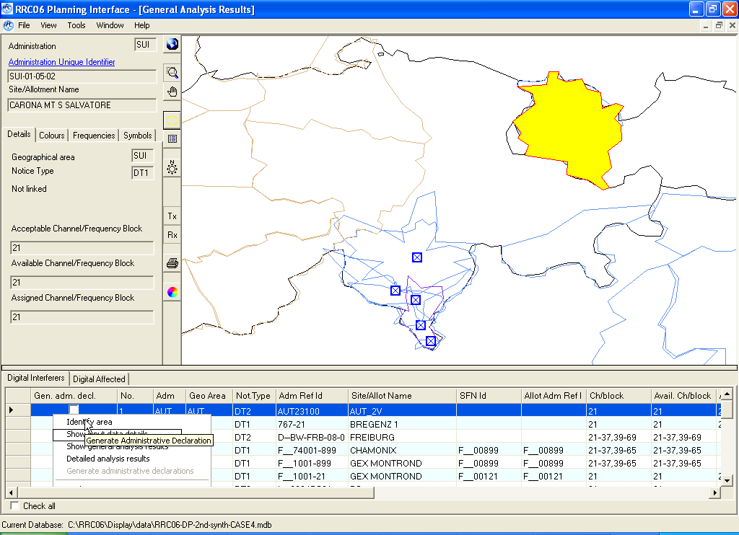
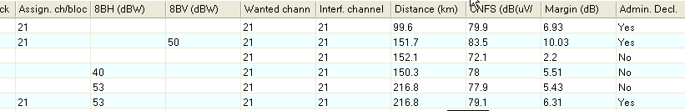

A.1.2.3.2 details of the wanted assignment and interfering allotment follow:
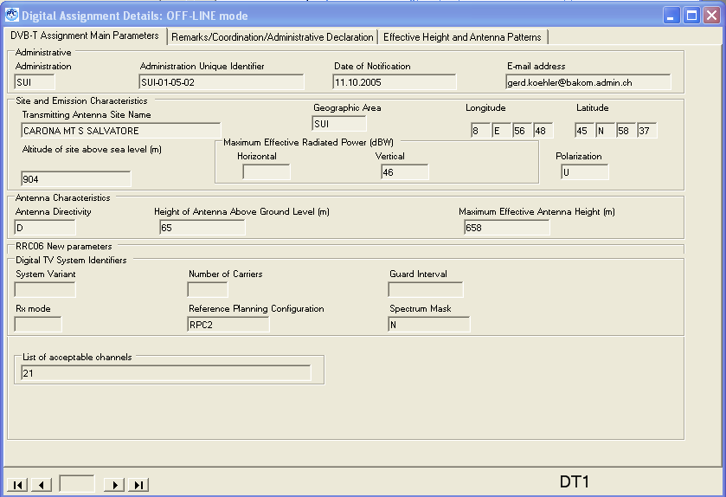

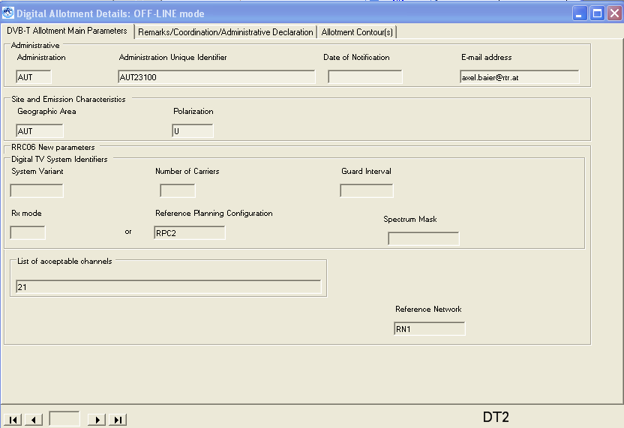
A.1.2.3.3 Detailed analysis results (obtained by right-clicking on the line of the interferer in the table) follow:

SUI CARONA MT S SALVATOR SUI-01-05-02 pol U asignment RPC 2 PO chan 21 min med 73.9

Any potentially interfering requirements are listed

AUT AUT23100 AUT_2V chan 21 prt 31.8 dB
adm identifier pol netnum bear dist cnfs margin wtplng wtplat itplng itplat
AUT AUT23100 U 1 217.9 99.6 79.9 6.93 9.08 46.23 9.87 46.94

As CNFS = FS + PRT or FS = CNFS –PRT = 79.9 -31.8 = 47.1 dBuV/m.

B1.3.3.4 Here are the technical parameters for a RN1 and RPC2:
-ERP = 46.7 +3dB = 49.7 dB adjusted for 474 MHz gives 49.7+30log (4.74/650) = 49.7-4.11= 45.6 dBw
- ant height = 150m
- service area diameter = 115km
-dist between transmitters = 50km
From the geometry of the hexagon we can assume that:
-the two closest tx to the allotment area are located at 109 km
-the 2 tx located above and below the center tx are located at 157.5 km
- the central tx is at distance of 149.4 km
-finally the the last two are at distance of 194.3km.

B1.3.3.4 Here are the Proptest calculations for these 7 transmitters:

First one calculation at the Interfering test point for a first guess at the received FS:

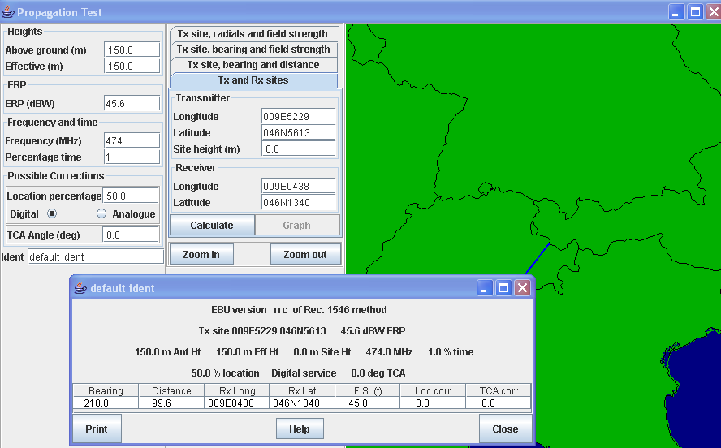

Calculation for the closest two transmitters:
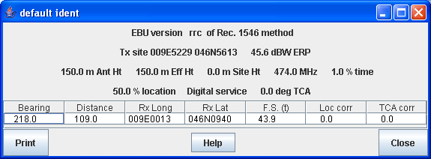

For the two tx above and below the center tx:
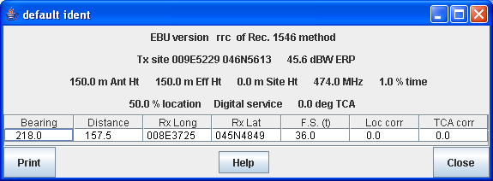

For the center tx:
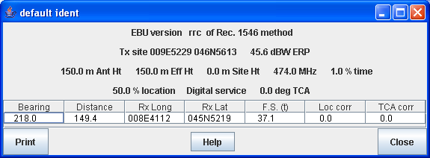

For the last two tx

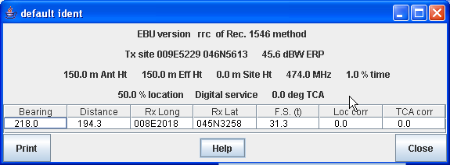

Summing the 7 received interfering fields we get :
10 log 10(2x10 ^{43.9/10} + 2x10 ^{36.0/10} + 10 ^{37.1/10 +} 2x10 ^{31.3/10}) = 48.1 dBuV/m

The detailed analysis results gives an interfering FS of 47.1 .
Manual calculations seems to overestimate by 1.0 dB.

A.1.3 Interference from digital television broadcasting requirements to digital sound broadcasting requirements

A.1.3.1 Assignment Afmadu (SOM) interfering with assignment DS00349 (KEN)

A.1.3.1.1 Input data
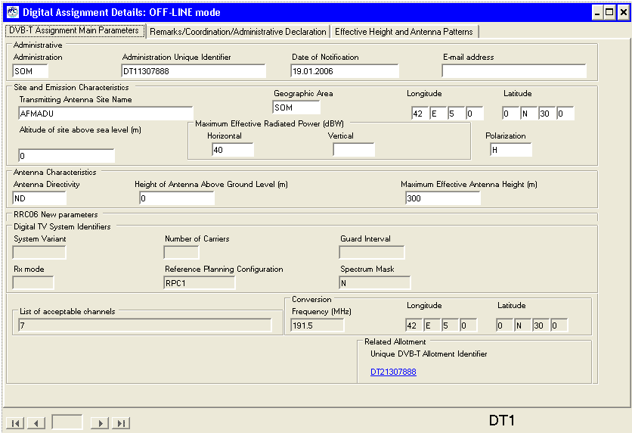

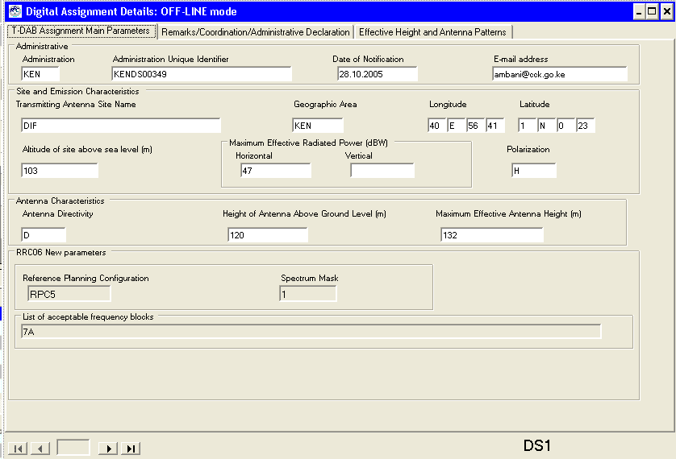

A.1.3.1.2 Calculated results
The interfering assignment is characterised by:

SOM DT11307888 AFMADU chan 7 prt 23.6 dB

Detail results from the planning software give:

adm identifier pol erph erpv dir erp effht bear dist cnfs margin ang wtplng wtplat C
SOM DT11307888 H 40.0 -99.9 N 40.0 300.0 290.3 133.0 64.9 2.85 170.0 40.96 0.92
SOM DT11307888 H 40.0 -99.9 N 40.0 300.0 281.6 129.2 65.5 3.16 180.0 40.94 0.73
SOM DT11307888 H 40.0 -99.9 N 40.0 300.0 281.7 134.5 64.7 2.75 190.0 40.90 0.74

Where the wanted sound broadcasting assignment is characterised by:

KEN DIF KENDS00349 pol H asignment RPC 5 PI chan 7A min med 65.3

A.1.3.1.3 Verified results
The interfering assignment has a omni-directional antenna and equal effective antenna heights of 300 metres in all directions. The point to be protected on the service area of the wanted is the closest to the interfering assignment. The protection ratio represents the case of a 9 dB (7 MHz DVB-T signal interfering with a T-DAB requirement) and a location correction factor of:
clc = sqrt(2(5.5² + 3²))Q(95%) = 14.57 dB
From the propagation model:
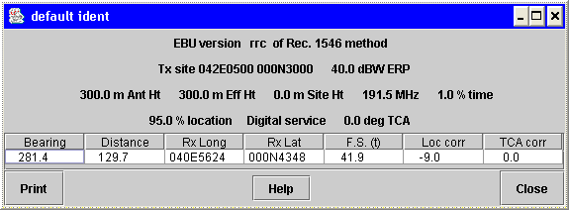
CNFS = FSi + PR + clc
41.9 dBµV/m + 9 + 14.57 dB =65.47 dBµV/m
The FS min med (RPC5 at 188.928 MHz) = 66 dBµV/m + 30log(188.928/200) = 65.26 dBµV/m
The margin = 10log(10^{CNFSi/10} + 10^{FSminmed} ) – Fsmin med = 3.12 dB

A.1.3.2 Assignment KENDT00476 (KEN) interfering with allotment TZ10020SAM2 (TZA)

A.1.3.2.1 Input data
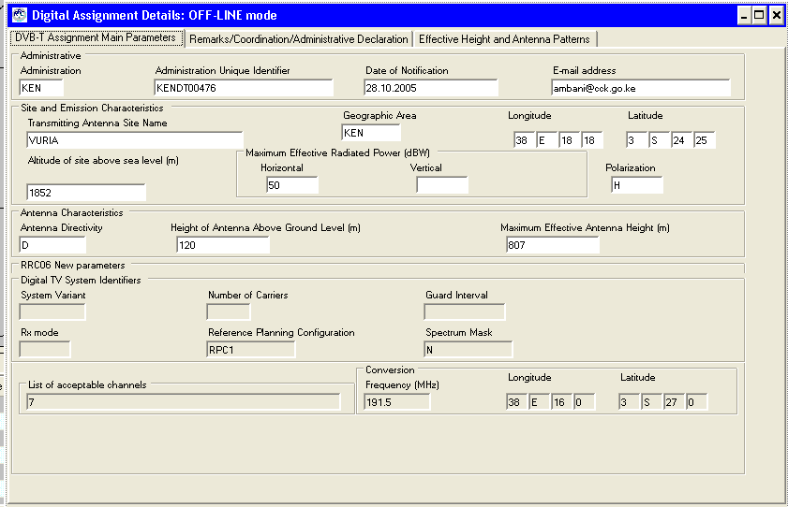

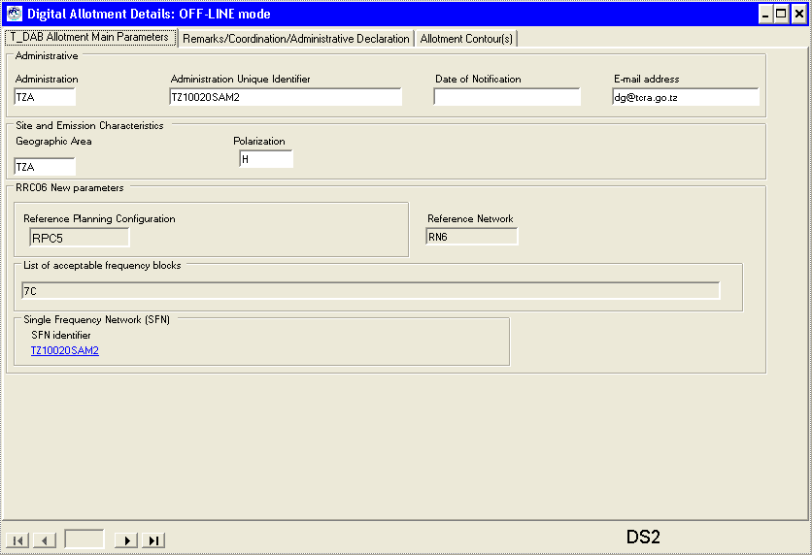

A.1.3.2.2 Calculated results
The interfering assignment is characterised by:

KEN KENDT00476 VURIA chan 7 prt 23.6 dB

Detail results from the planning software give:

adm identifier pol erph erpv dir erp effht bear dist cnfs margin ang wtplng wtplat C
KEN KENDT00476 H 50.0 -99.9 D 35.0 590.5 251.0 100.3 71.4 6.87 37.45 -3.70
KEN KENDT00476 H 50.0 -99.9 D 35.0 565.9 255.6 78.9 76.7 11.52 37.62 -3.58
KEN KENDT00476 H 50.0 -99.9 D 35.0 759.9 186.9 66.4 84.6 19.14 38.23 -4.00
KEN KENDT00476 H 50.0 -99.9 D 35.0 802.0 171.5 83.5 79.8 14.50 38.42 -4.15

Where the wanted sound broadcasting allotment is characterised by:

TZA SAME TZ10020SAM2 pol H allotment RPC 5 PI RN 6 chan 7C min med 65.5

A.1.3.1.3 Verified results
The interfering assignment has a directional antenna with an ERP of 50 dBW- 15 dB = 35 dBW and an effective antenna height of 760 metres in 187 degrees East of North. The identified point on the service area of the wanted allotment is the closest point to the interfering assignment. The protection ratio represents the case of a 9 dB (7 MHz DVB-T signal interfering with a T-DAB requirement) and a location correction factor of:
clc = sqrt(2(5.5² + 3²))Q(95%) = 14.57 dB
From the propagation model:
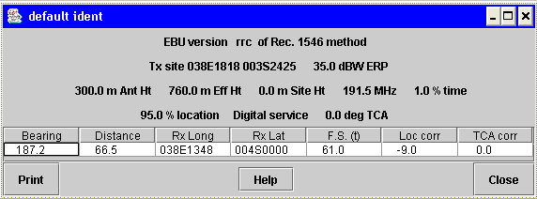
CNFS = FSi + PR + clc
61 dBµV/m + 9 + 14.57 dB =84.57 dBµV/m
The FS min med (RPC5 at 192.352 MHz) = 66 dBµV/m + 30log(192.352/200) = 65.49 dBµV/m
The margin = 10log(10^{CNFS/10} + 10^{FSminmed} ) – Fsmin med = 19.13 dB

A.1.3.3 Allotment TURNET1-REG78 (TUR) interfering with assignment SYRALEPDAB2 (SYR)

A.1.3.3.1 Input data
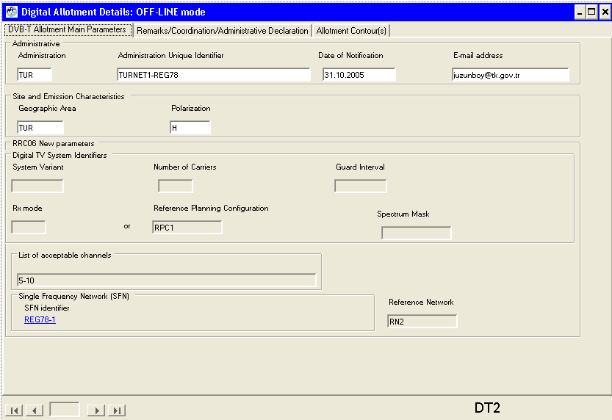

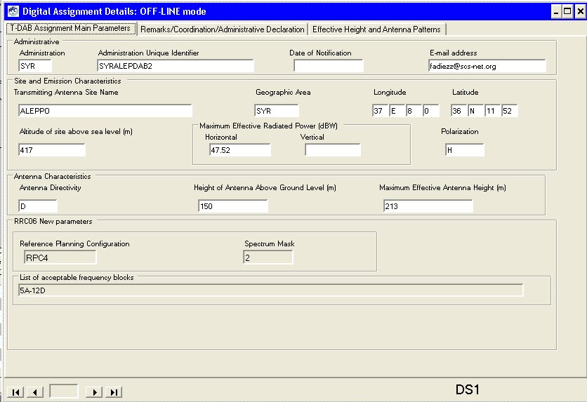

A.1.3.3.2 Calculated results
The interfering allotment is characterised by:

TUR TURNET1-REG78 REGION 78 chan 10 prt 27.1 dB

Detail results from the planning software give:

adm identifier pol netnum bear dist cnfs margin wtplng wtplat itplng itplat C
TUR TURNET1-REG78 H 2 211.6 46.4 67.7 9.88 37.20 36.29 37.47 36.64
TUR TURNET1-REG78 H 2 186.0 15.8 82.6 24.41 37.45 36.50 37.47 36.64
TUR TURNET1-REG78 H 2 181.2 24.7 77.2 19.02 37.46 36.42 37.47 36.64
TUR TURNET1-REG78 H 2 175.7 30.8 74.0 15.89 37.49 36.37 37.47 36.64

Where the wanted sound broadcasting assignment is characterised by:

SYR ALEPPO SYRALEPDAB2 pol H asignment RPC 4 MO chan 5A min med 58.3

A.1.3.3.3 Verified results
The interfering allotment uses RN2 for RPC1 with an ERP of 24.63 dBW per transmitter. The identified point on the service area of the wanted assignment is the closest point to the interfering allotment. The protection ratio represents the case of a 9 dB (7 MHz DVB-T signal interfering with a T-DAB requirement) and a location correction factor of:
clc = sqrt(2)(5.5)Q(99%) = 18.1 dB
From the propagation model:
For transmitter 1 at a distance of 22 km the interfering field strength is: 56 dBµV/m
For transmitter 2 at a distance of 45.11 km the interfering field strength is: 42.4 dBµV/m
For transmitter 3 at a distance of 59.87 km the interfering field strength is: 36.9 dBµV/m
The power sum of the field strengths give: 56.236 dBµV/m

CNFS = FSi + PR + clc
56.236 dBµV/m + 9 dB + 18.1 dB = 83.336 dBµV/m
The FS min med (RPC4 at 174.928 MHz) = 60 dBµV/m + 30log(174.928/200) = 58.25 dBµV/m
The margin = 10log(10^{CNFS/10} + 10^{FSminmed} ) – Fsmin med = 25.12 dB

A.1.3.4 Allotment IRL DTT EAST 8 interfering with allotment IRL DAB RN-LD-SLM

A.1.3.4.1 Input data
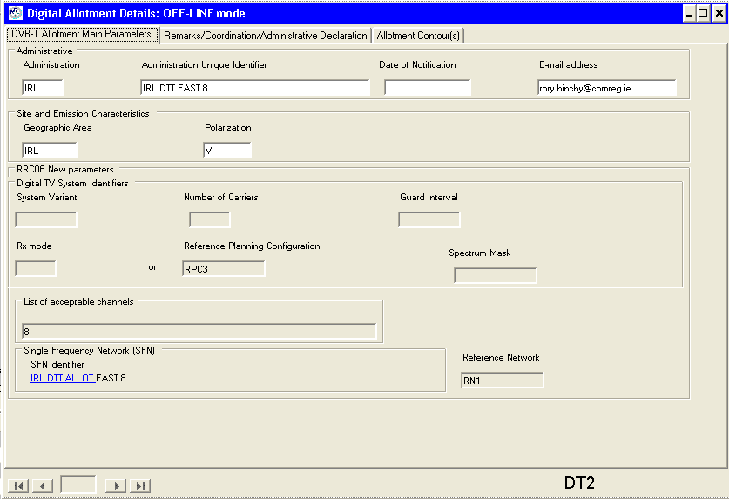

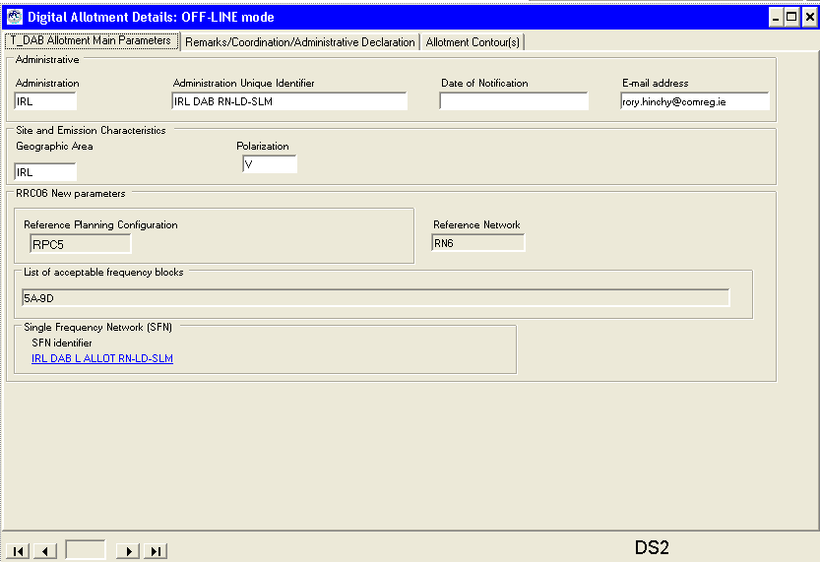

A.1.3.4.2 Calculated results
The interfering allotment is characterised by:

IRL IRL DTT EAST 8 IRL DTT EAST chan 8 prt 23.6 dB

Detail results from the planning software give:

adm identifier pol netnum bear dist cnfs margin wtplng wtplat itplng itplat C
IRL IRL DTT EAST 8 V 1 313.1 44.6 81.8 15.98 -7.58 53.66 -7.09 53.38
IRL IRL DTT EAST 8 V 1 311.6 44.1 81.9 16.13 -7.59 53.65 -7.09 53.38
IRL IRL DTT EAST 8 V 1 309.1 40.9 83.0 17.16 -7.57 53.61 -7.09 53.38
IRL IRL DTT EAST 8 V 1 306.6 42.0 82.6 16.79 -7.60 53.61 -7.09 53.38
IRL IRL DTT EAST 8 V 1 293.4 42.5 82.4 16.62 -7.68 53.53 -7.09 53.38

Where the wanted sound broadcasting allotment is characterised by:

IRL IRL DAB L RN-LD-SLM IRL DAB RN-L pol V allotment RPC 5 PI RN 6 chan 5A min med 64.3

A.1.3.3.3 Verified results
The interfering allotment uses RN1 for RPC3 with an ERP of 39.90 dBW per transmitter. The identified point on the service area of the wanted allotment is the closest point to the interfering allotment. The protection ratio represents the case of a 9 dB (7 MHz DVB-T signal interfering with a T-DAB requirement) and a location correction factor of:
clc = sqrt(2(5.5² + 3²))Q(95%) = 14.57 dB
From the propagation model:
For transmitter 1 and 2 at a distance of 50.25 km the interfering field strength is: 55.6 dBµV/m
For transmitter 3 and 4 at a distance of 90.11 km the interfering field strength is: 44.7 dBµV/m
For transmitter 5 and 6 at a distance of 117.1 km the interfering field strength is: 40.0 dBµV/m
For transmitter 7 at a distance of 80.74 km the interfering field strength is: 46.7 dBµV/m
The power sum of the field strengths give: 59.3 dBµV/m

CNFS = FSi + PR + clc
59.3 dBµV/m + 9 dB + 14.57 dB = 82.9 dBµV/m
The FS min med (RPC4 at 201.072 MHz) = 66 dBµV/m + 30log(201.072/200) = 66.07 dBµV/m
The margin = 10log(10^{CNFS/10} + 10^{FSminmed} ) – Fsmin med = 16.92 dB

A.1.4 Interference from digital sound broadcasting requirements to digital television broadcasting requirements

A.1.4.1 Assignment KENDS00123 (KEN) interfering with KENDT00362 (KEN) assignment

A.1.4.1.1 Input data
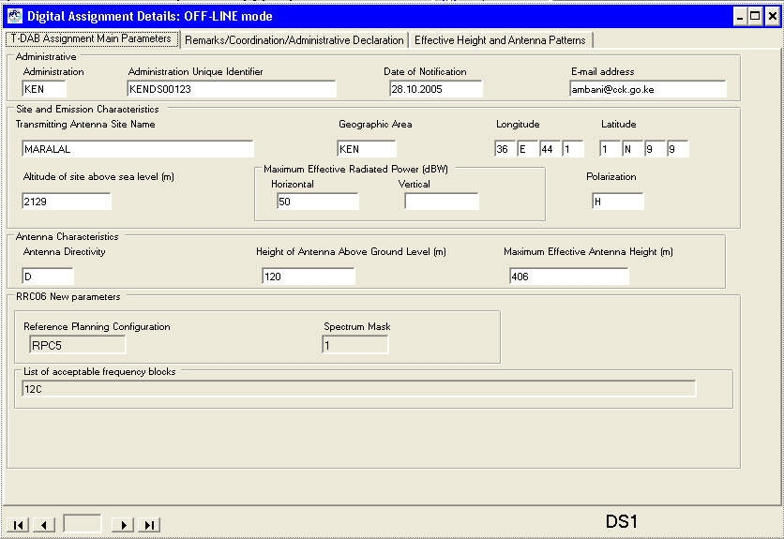

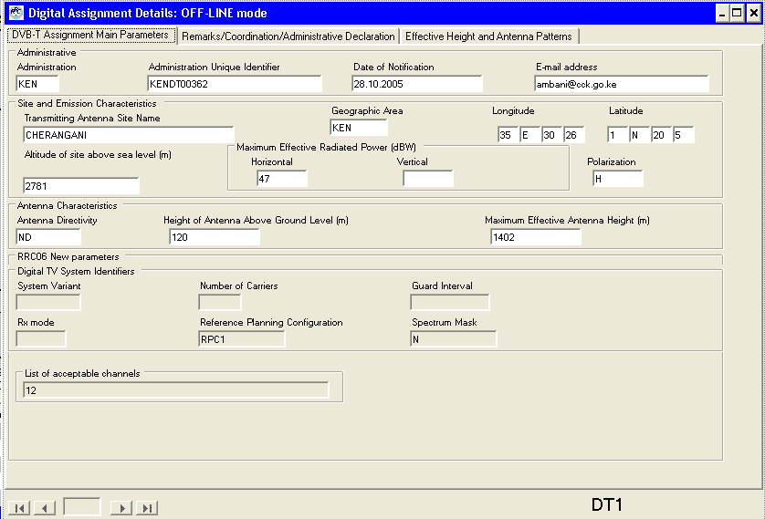

A.1.4.1.2 Calculated results
The interfering assignment is characterised by:

KEN KENDS00123 MARALAL chan 12C prt 40.0 dB

Detail results from the planning software give:

adm identifier pol erph erpv dir erp effht bear dist cnfs margin ang wtplng wtplat C
KEN KENDS00123 H 50.0 -99.9 D 40.0 -42.5 312.2 30.2 64.2 13.36 90.0 36.53 1.33
KEN KENDS00123 H 50.0 -99.9 D 40.0 104.3 272.1 27.3 92.4 41.29 100.0 36.49 1.16
KEN KENDS00123 H 50.0 -99.9 D 40.0 166.0 246.7 40.2 88.9 37.82 110.0 36.40 1.01

Where the wanted sound broadcasting allotment is characterised by:

KEN CHERANGANI KENDT00362 pol H asignment RPC 1 FO chan 12 min med 51.1

A.1.4.1.3 Verified results
The interfering assignment has a directional antenna with an ERP of 50 dBW- 10 dB = 40 dBW and an effective antenna height of 105 metres in 272.1 degrees East of North. The identified point on the service area of the wanted allotment is the closest point to the interfering assignment. The protection ratio represents the case of an T-DAB requirement interfering with an RPC1 DVB-T requirement, with a protection ratio of 27.2 dB and a location correction factor of:
clc = sqrt(2(5.5²))Q(95%) = 12.79 dB
From the propagation model:
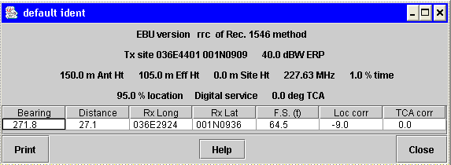
NFS = FSi + PR + clc – Rx antenna discrimination
64.5 dBµV/m + 27.2 + 12.79 dB – 12 dB = 92.5 dBµV/m
The FS min med (RPC1 at 226.5 MHz) = 50 dBµV/m + 20log(226.5/200) = 51.08 dBµV/m
The margin = 10log(10^{FSi/10} + 10^{FSminmed} ) – Fsmin med = 41.42 dB

A.1.5 Interaction between digital sound broadcasting requirements
(to be completed)

A.1.6 Interaction between digital television broadcasting requirements and analogue television assignments

A.1.6.1 UCKA→ I__2161AR68

A.1.6.1.1. Input data:
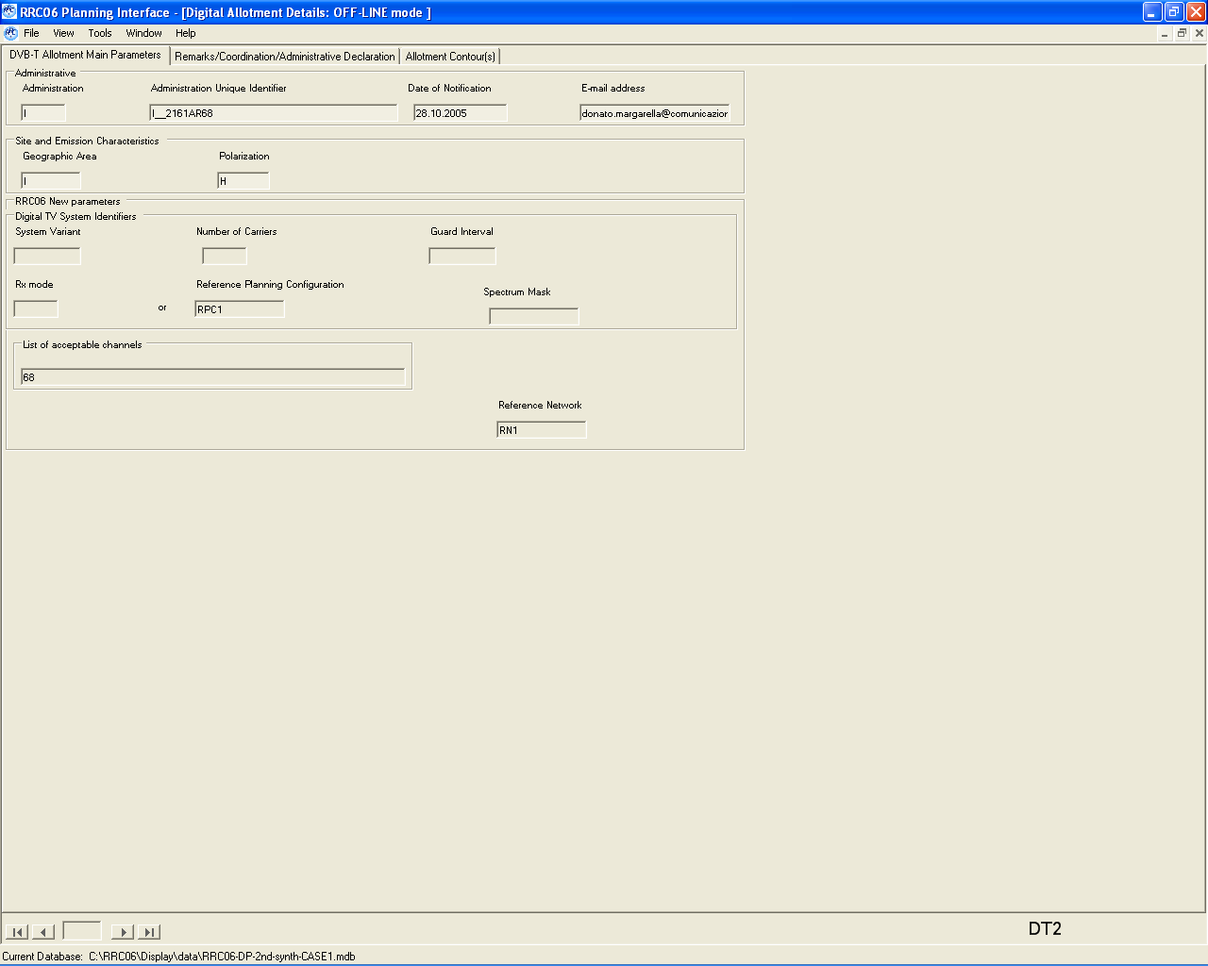
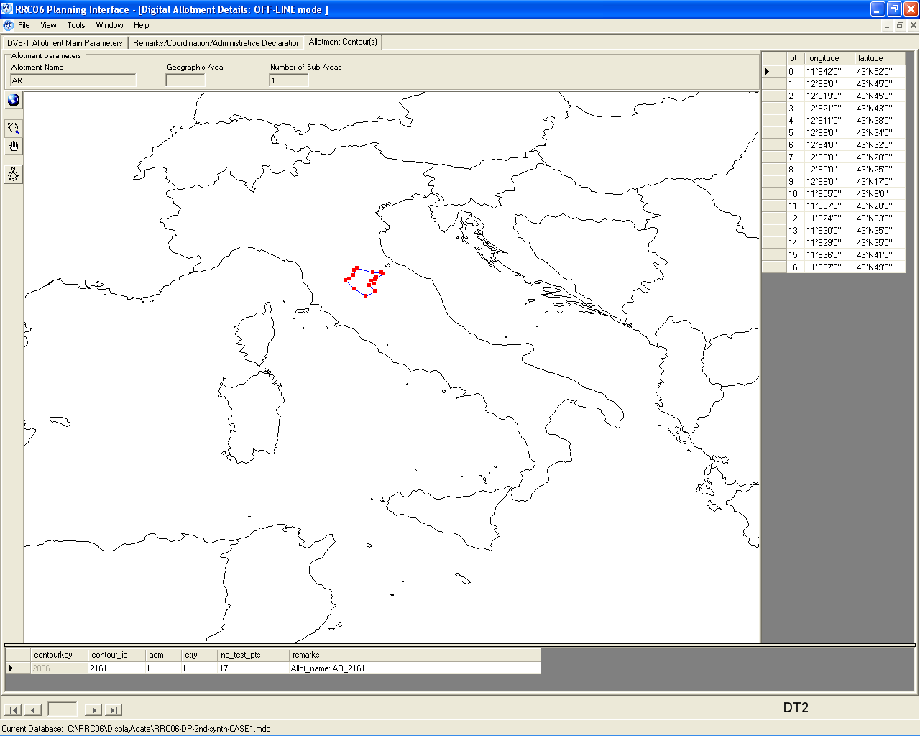
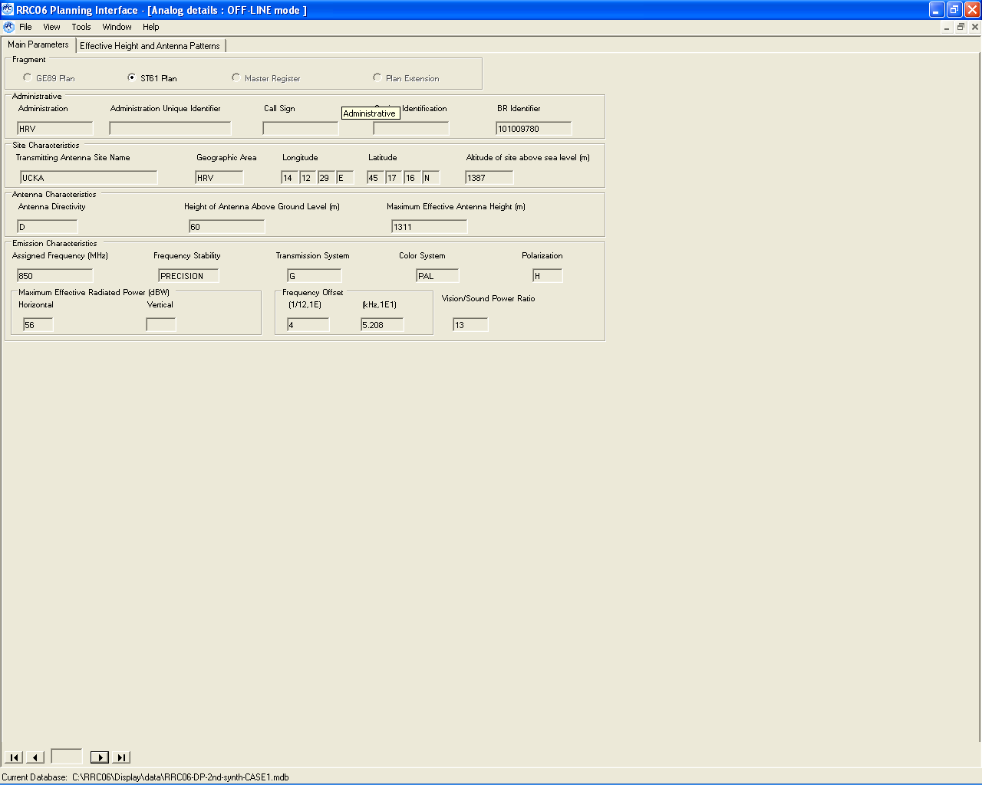

A.1.6.1.2. Results of planning software:
Version 2.0.0 of EBU programme (14/02/06) to analyze the cases of UHF analogue television assignments interfering with digital television requirements

The input data are on two binary files and the output data are written to two text files used as part of the input to read44UHF

The location variation of test points on the sea is calculated as if they were on land.

The items in the listing below have the following meanings (ERPh) and (ERPv) relate to the maximum ERPs (ERP) and (effht) relate to the values on the quoted bearing (bear) from the interfering assignment to the test point the test point (wtplng, wtplat) is at distance (dist) from the interfering assignment any (ang) quoted is the angle from a digital assignment to the test point

I AR I__2161AR68 pol H allotment RPC 1 FO RN 1 chan 68 min med 58.3

Any potentially interfering requirements are listed A "G" in column "C" indicates coordination

HRV 101009780 UCKA chan 68 pr 24.8 dB
adm identifier pol ERPh ERPv dir ERP effht bear dist cnfs margin ang wtplng wtplat C
HRV 101009780 H 56.0 -99.9 D 56.0 1214.4 225.1 239.1 78.3 20.04 12.10 43.75
HRV 101009780 H 56.0 -99.9 D 56.0 1217.9 221.9 227.4 80.8 22.53 12.32 43.75
HRV 101009780 H 56.0 -99.9 D 56.0 1219.1 220.8 228.5 80.4 22.07 12.35 43.72
HRV 101009780 H 56.0 -99.9 D 56.0 1218.0 221.9 244.2 77.2 18.91 12.18 43.63
HRV 101009780 H 56.0 -99.9 D 56.0 1218.7 221.2 251.6 75.6 17.35 12.15 43.57

A.1.6.1.3 Verification of results:

A.1.6.1.3.1 Calculation of FSi: by the propagation tool
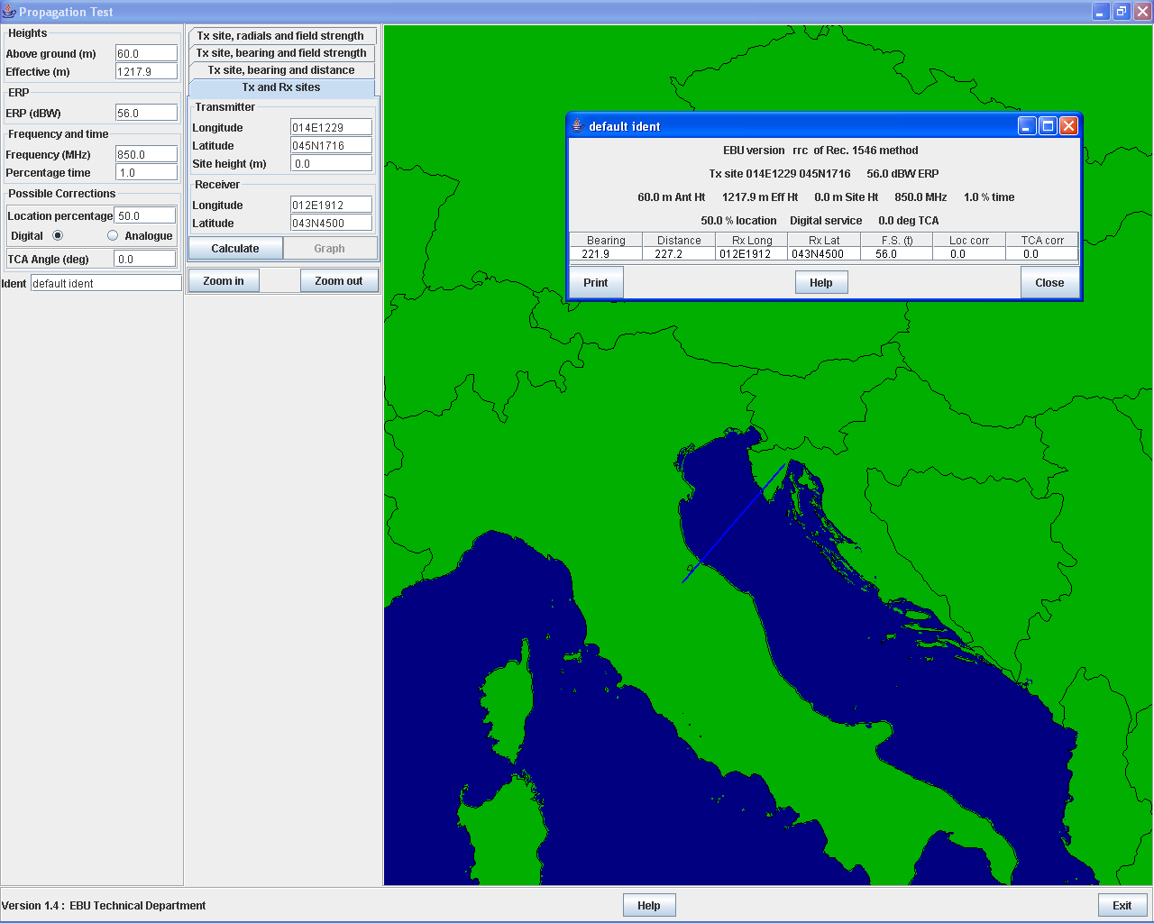

A.1.6.1.3.2 Calculation of the minimum median field strength:

FSminmed = FSminmed ref + Corr

FSmin med = 56 +20log (850/650)
= 58.3

A.1.6.1.3.3 Calculation of the CNFS :
CNFS = FSi + PR - Ant descr + clc

Ant desc = 0 (the wanted is a digital assignment)

FSi= 56
Clc = 1.645 √(2* 5.5²) = 12.8
PR = 12, (RPC1 corresponds to 64QAM3/4)

Then
CNFS = 56 + 12 + 12.8
= 80.8

A.1.6.1.3.4 Calculation of Margin:
Margin = 10log (10^(CNFS/10)+10^(Fsminmed/10)) - FSminmed
= 22.524

A.1.6.2 ROMMANI → Rabat Zaer

A.1.6.2.1 Input data:
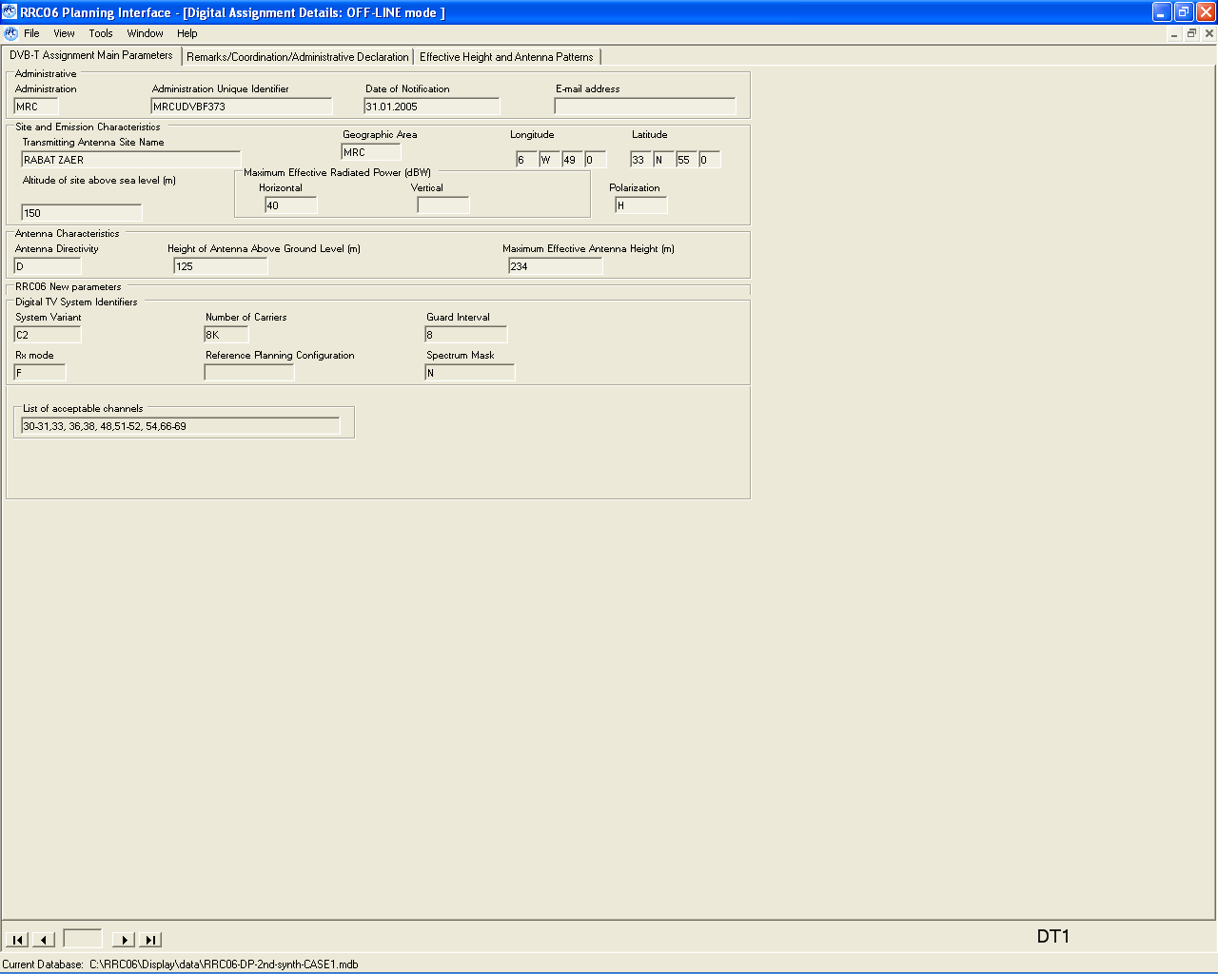

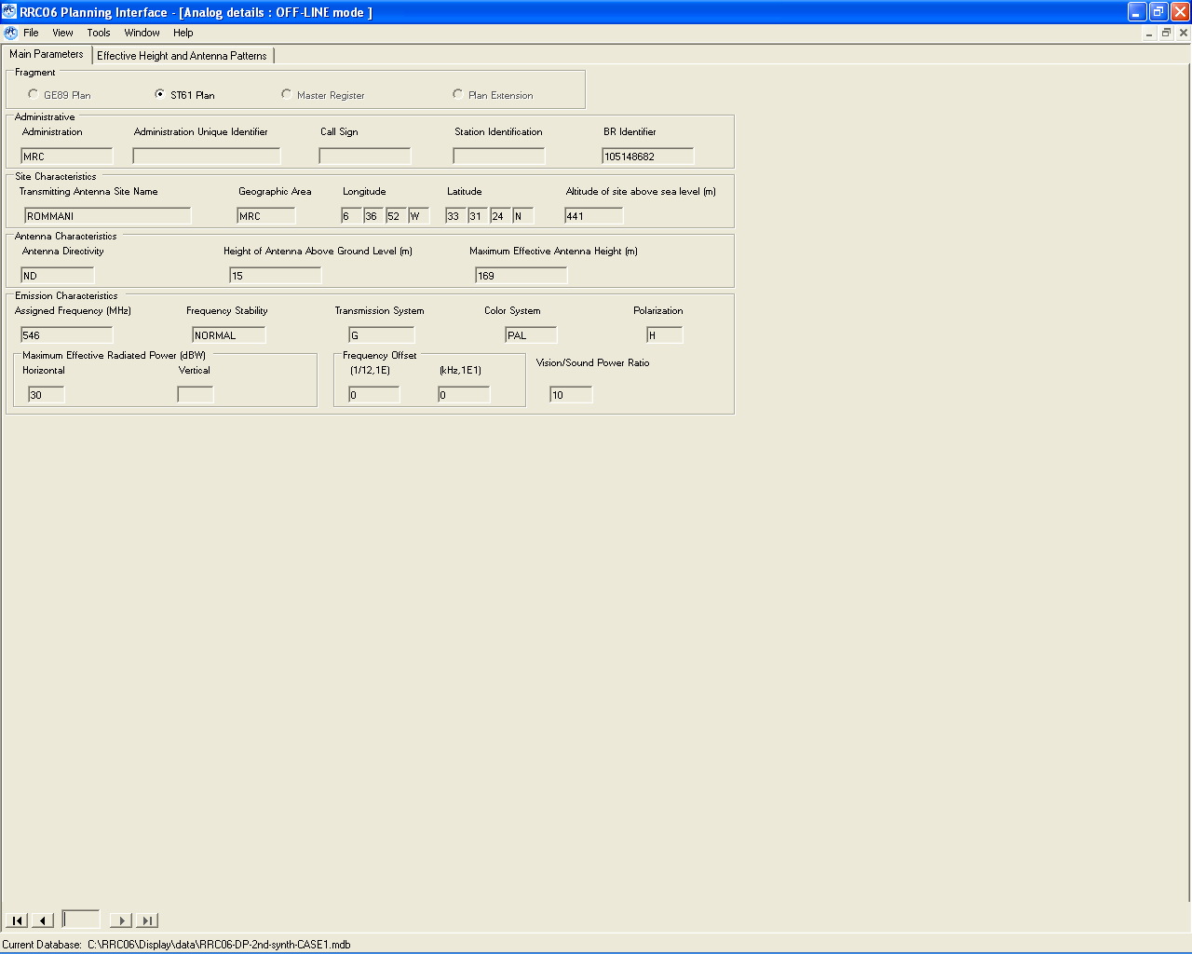

A.1.6.2.2 Results of planning software:
Version 2.0.0 of EBU programme (14/02/06) to analyze the cases of UHF analogue television assignments interfering with digital television requirements
The input data are on two binary files and the output data are written to two text files used as part of the input to read44UHF
The location variation of test points on the sea is calculated as if they were on land.
The items in the listing below have the following meanings (ERPh) and (ERPv) relate to the maximum ERPs (ERP) and (effht) relate to the values on the quoted bearing (bear) from the interfering assignment to the test point the test point (wtplng, wtplat) is at distance (dist) from the interfering assignment any (ang) quoted is the angle from a digital assignment to the test point
MRC RABAT ZAER MRCUDVBF373 pol H assignment 64QAM 2/3 FO chan 30 min med 53.3
Any potentially interfering requirements are listed A "G" in column "C" indicates coordination

MRC 105148682 ROMMANI chan 30 pr 17.3 dB
adm identifier pol ERPh ERPv dir ERP effht bear dist cnfs margin ang wtplng wtplat C
MRC 105148682 H 30.0 -99.9 N 30.0 169.0 355.8 79.0 51.4 2.18 20.0 -6.68 34.23 G
MRC 105148682 H 30.0 -99.9 N 30.0 169.0 358.8 73.3 50.3 1.78 30.0 -6.63 34.18 G
MRC 105148682 H 30.0 -99.9 N 30.0 169.0 4.5 72.9 48.7 1.31 40.0 -6.55 34.18 G
MRC 105148682 H 30.0 -99.9 N 30.0 169.0 9.3 44.3 49.5 1.52 90.0 -6.54 33.92 G
MRC 105148682 H 30.0 -99.9 N 30.0 169.0 9.2 39.8 51.6 2.28 100.0 -6.55 33.88 G
MRC 105148682 H 30.0 -99.9 N 30.0 169.0 20.4 34.7 54.4 3.59 110.0 -6.48 33.82 G
MRC 105148682 H 30.0 -99.9 N 30.0 169.0 10.4 30.3 57.0 5.27 120.0 -6.56 33.79 G
MRC 105148682 H 30.0 -99.9 N 30.0 169.0 359.8 28.1 58.4 6.31 130.0 -6.62 33.78 G
MRC 105148682 H 30.0 -99.9 N 30.0 169.0 359.0 21.9 63.1 10.23 140.0 -6.62 33.72 G
MRC 105148682 H 30.0 -99.9 N 30.0 169.0 343.3 24.6 60.9 8.35 150.0 -6.69 33.74 G
MRC 105148682 H 30.0 -99.9 N 30.0 169.0 334.6 27.8 58.6 6.49 160.0 -6.74 33.75 G
MRC 105148682 H 30.0 -99.9 N 30.0 169.0 327.5 28.3 58.3 6.23 170.0 -6.78 33.74 G
MRC 105148682 H 30.0 -99.9 N 30.0 169.0 317.6 27.7 58.7 6.51 180.0 -6.82 33.71 G

A.1.6.2.3 Verification of results:

A.1.6.2.3.1 Calculation of FSi: by the propagation tool
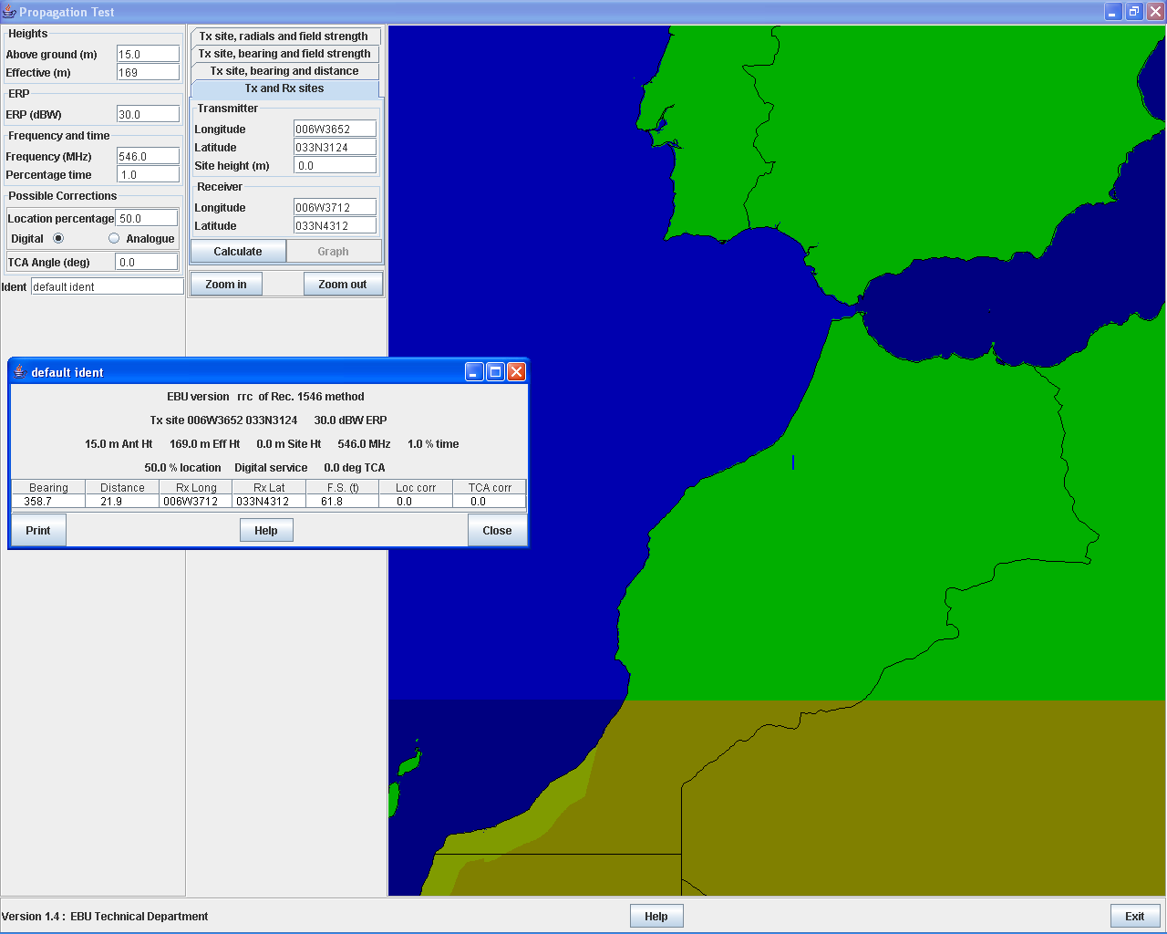

A.1.6.2.3.2 Calculation of the minimum median field strength:
Calculation of the minimum median field strength, according to Annex 3.5 and table A.3.5-2 of RRC-04 report, because the assignment is not an RPC.
P_{n} = F + 10 log₁₀ (k T₀ B)
= 7 + 10log₁₀ (1.38*10⁻²³*290*7.61*10⁶)
= - 128.16 dBW
P_{s min} = C/N + P_{n}
= 17.1 – 128.16
= -111.06 dBW
φ _{min} = P_{s min} – A_{a} + L_{f} for fixed reception
= -111.06 + 3.3 + 3
= -104.7 dB(W/m²)
E_{min} = φ_{min} + 120 + 10 log₁₀ (120π) = φ _{min} + 145.8
= -104.7 + 148.5
= 41.03 dB(μV/m)
φ _{med} = φ_{min} + P_{mmn} + C_{l} for fixed reception
= -104.7 + 0 + 9
= -95.7 dB(W/m²)
E_{med} = φ_{med} + 120 + 10 log₁₀ (120π) = φ_{med} + 145.8
= -95.7 + 145.8
= 50.1 dB(μV/m)
FSmin med = 50.1 + 3 = 53.1 dB(μV/m) ; The 3dB added according to A.5.2.2.1.2
The calculated by the software is:
FSmin med = 53.3

A.1.6.2.3.3 Calculation of the CNFS :
CNFS = FSi + PR – RX ant desc + clc
Ant desc = 0 (the wanted is a digital assignment)
FSi= 61.86
Clc = 1.645 √(2* 5.5²) = 12.8
PR = 4.5 (protection ratio for DVB-T signals interfered with by analogue tv)
Then:
CNFS = 61.8 + 12.8 – 16 + 4.5
= 63.1

A.1.6.2.3.4 Calculation of Margin :
Margin = 10log (10^(CNFS/10)+10^(Fsminmed/10)) - FSminmed
= 10.23

A.1.6.2 093 (allotment)→ El Minya

A.1.6.2.1 Input data:

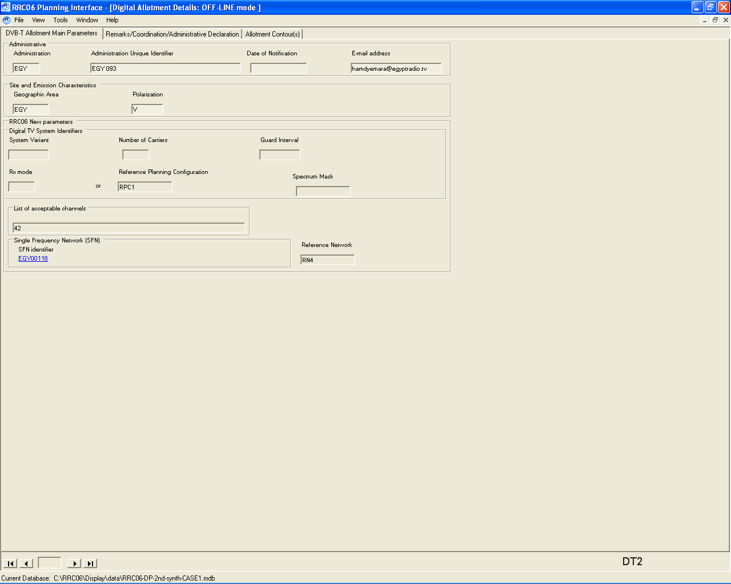
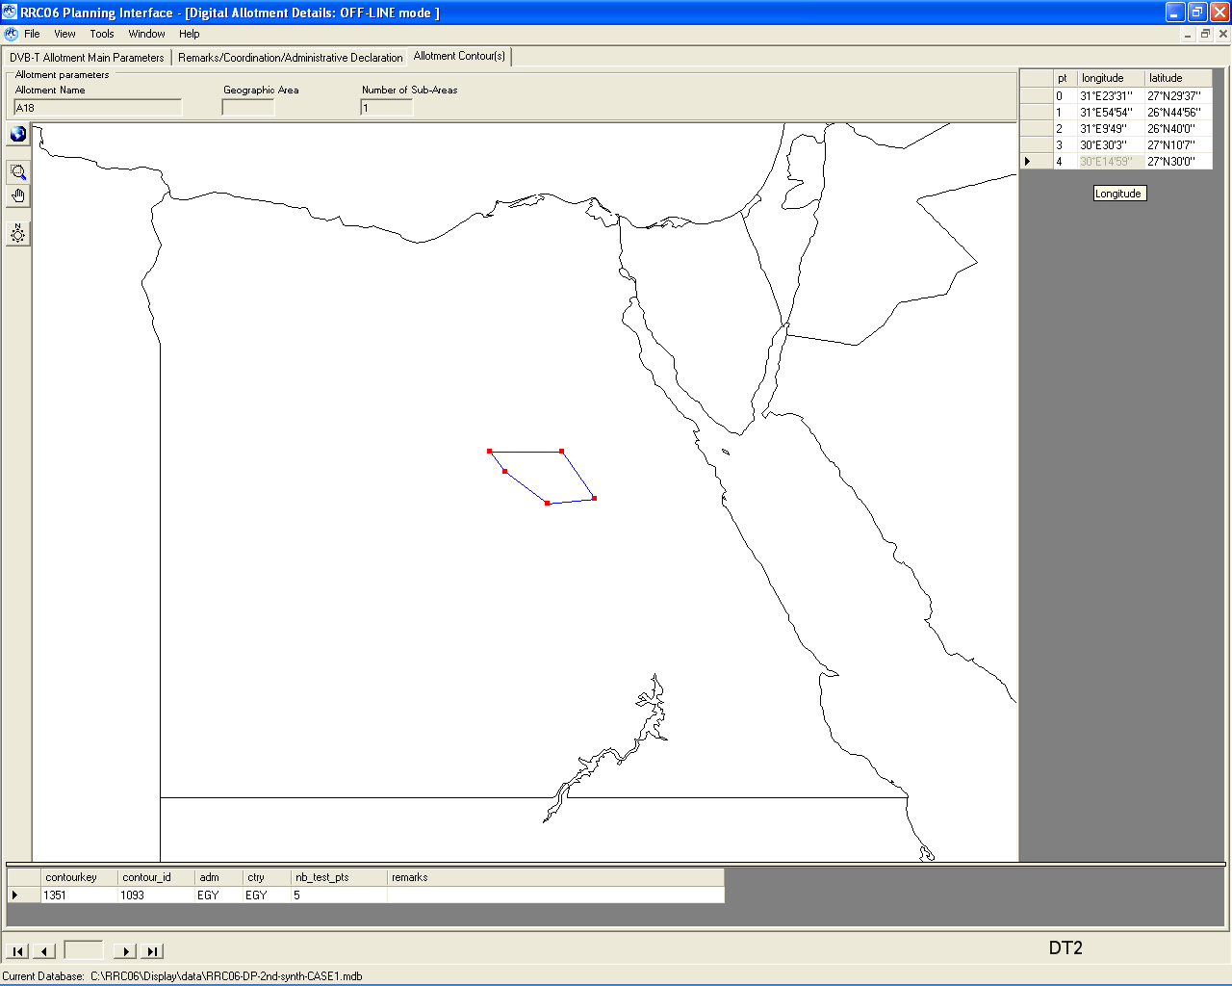
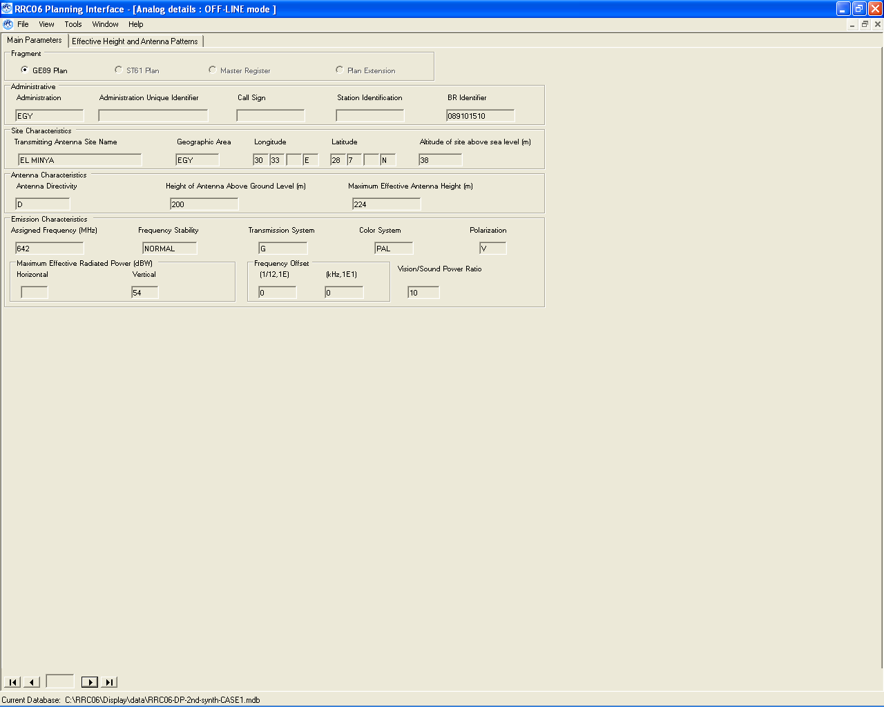

A.1.6.2.2 Detail results from the planning software
Version 2.0.0 of EBU programme (14/02/06) to analyze the cases of potential interference from UHF digital requirements to analogue television assignments
The input data are on two binary files and the output data are written to two text files used as part of the input to read44UHF
The items in the listing below have the following meanings in the case of an interfering assignment, (ERPh) and (ERPv) relate to the maximum ERPs
(ERP) and (effht) relate to the values on the quoted bearing (bear) from the assignment to the test point the test point (wtplng, wtplat) is at distance (dist) from the interfering assignment any (ang) quoted is the angle from the analogue assignment to the test point in the case of an interfering allotment, (itplng) and (itplat) is the location of the current RN and (bear) and (dist) are relative to this point
EGY A18 EGY 093 pol V allotment RPC 1 FO RN 4 chan 42
Any potentially affected requirements are listed A "G" in column "C" indicates coordination
EGY 089101510 EL MINYA chan 42 prt 34.0 dB pr50 40.0 dB
adm identifier pol bear dist nfs margin ang wtplng wtplat itplng itplat C
EGY 089101510 V 24.1 85.7 57.2 0.53 30.0 30.61 28.20 30.25 27.50 G
EGY 089101510 V 62.9 42.9 58.5 0.87 170.0 30.64 27.68 30.25 27.50 G
EGY 089101510 V 57.6 35.0 63.5 2.34 180.0 30.55 27.67 30.25 27.50 G
EGY 089101510 V 44.8 30.2 66.9 4.07 190.0 30.47 27.69 30.25 27.50 G
EGY 089101510 V 28.8 28.4 68.2 4.88 200.0 30.39 27.72 30.25 27.50 G
EGY 089101510 V 15.0 33.6 64.6 2.76 210.0 30.34 27.79 30.25 27.50 G
EGY 089101510 V 8.8 41.4 59.4 1.02 220.0 30.31 27.87 30.25 27.50 G

A.1.6.2.3 Calculation of the NFS
The given point from which the interference is calculated to the point on the service area of the wanted assignment represents the worst case as verified by inspection.
The example represents a case of continuous interference. Using RN4 for RPC1:
Transmitter 1 at a distance of 30.6 km and an ERP of 23.3 dBW provides an interfering field strength of 44.0 dBµV/m.
Transmitter 2 at a distance of 53.5 km and an ERP of 23.3 dBW provides an interfering field strength of 28.5 dBµV/m.
Transmitter 3 at a distance of 69.2 km and an ERP of 29.3 dBW provides an interfering field strength of 26.4 dBµV/m.
The sum of the field strengths of these three transmitters come to 44.19 dBµV/m
Since for all three transmitters the maximum receiving antenna discrimination results, the NFS is given by:
NFS = FSi + PRcontinuous – Rx ant. discrimination
44.19 dBµV/m + 40 dB – 16 dB = 68.19 dBµV/m

A.1.7 Interaction between digital sound broadcasting requirements and analogue television assignments

A.1.7.1 T-DAB assignment to analogue television assignment KAN KAN→ GBARNGA

A.1.7.1.1 Input data:
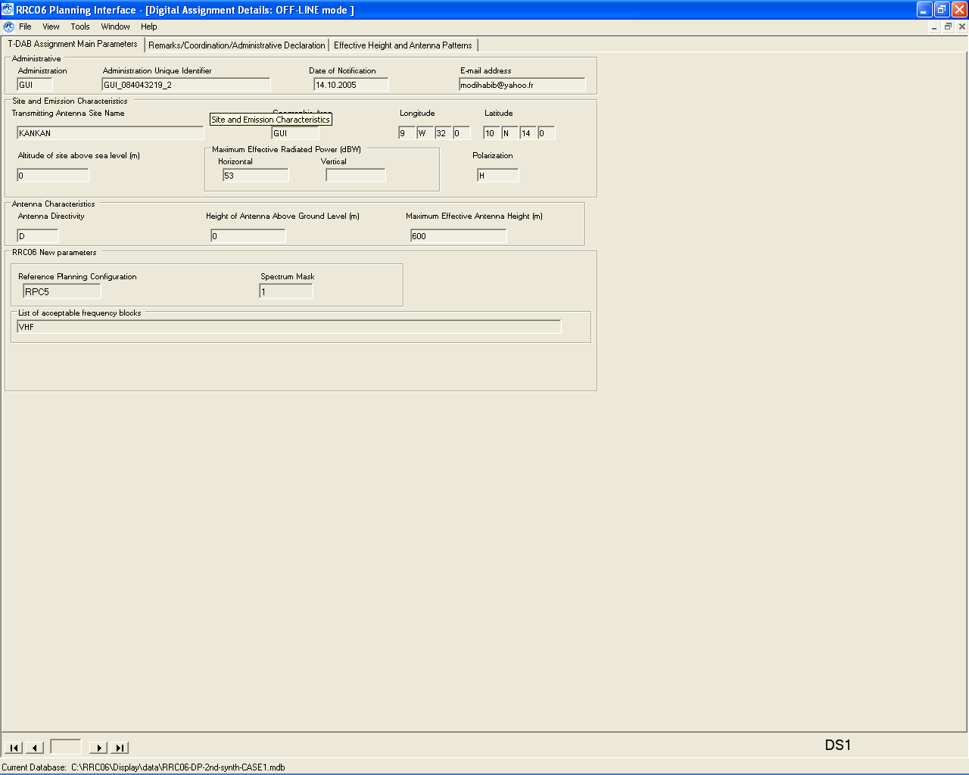
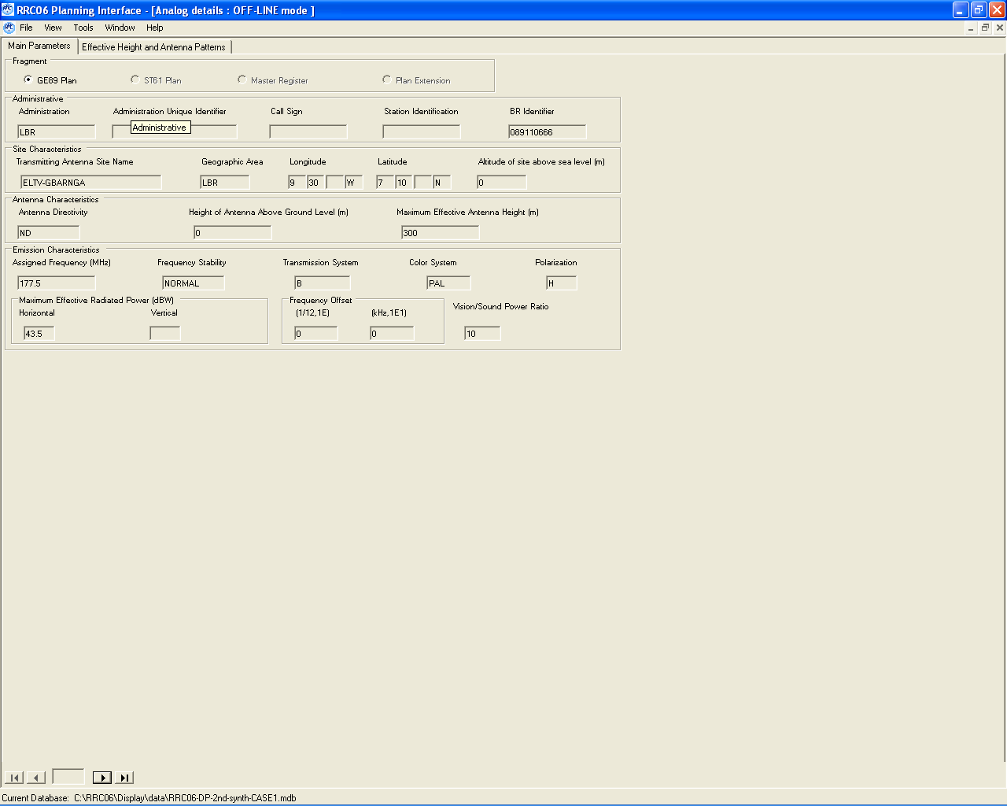

A.1.7.1.2 Results of planning software:
Version 2.0.1 of EBU programme (25/02/06) to analyze the cases of potential interference from VHF digital requirements to analogue television assignments
The input data are on two binary files and the output data are written to two text files used as part of the input to read44VHF
The items in the listing below have the following meanings in the case of an interfering assignment, (ERPh) and (ERPv) relate to the maximum ERPs
(ERP) and (effht) relate to the values on the quoted bearing (bear) from the assignment to the test point the test point (wtplng, wtplat) is at distance (dist) from the interfering assignment
any (ang) quoted is the angle from the analogue assignment to the test point
in the case of an interfering allotment, (itplng) and (itplat) is the location of the current RN
and (bear) and (dist) are relative to this point
GUI KANKAN GUI_08404321 pol H assignment RPC 5 PI chan 5A
Any potentially affected requirements are listed A "G" in column "C" indicates coordination
LBR 089110666 ELTV-GBARNGA chan 5 prt 34.0 dB pr50 40.0 dB
adm identifier pol ERPh ERPv ERP effht bear dist nfs margin ang wtplng wtplat C
LBR 089110666 H 53.0 -99.9 D 53.0 600.0 179.3 295.7 59.0 0.99 0.0 -9.50 7.57
LBR 089110666 H 53.0 -99.9 D 53.0 600.0 177.8 297.0 58.9 0.93 10.0 -9.43 7.56
LBR 089110666 H 53.0 -99.9 D 53.0 600.0 174.2 371.1 56.6 0.51 130.0 -9.19 6.91
LBR 089110666 H 53.0 -99.9 D 53.0 600.0 175.1 376.0 59.5 0.98 140.0 -9.24 6.86
LBR 089110666 H 53.0 -99.9 D 53.0 600.0 176.0 381.0 61.9 1.75 150.0 -9.30 6.81
LBR 089110666 H 53.0 -99.9 D 53.0 600.0 177.1 383.9 61.6 1.69 160.0 -9.36 6.78
LBR 089110666 H 53.0 -99.9 D 53.0 600.0 178.3 384.5 61.5 1.50 170.0 -9.43 6.78
LBR 089110666 H 53.0 -99.9 D 53.0 600.0 179.4 383.0 61.7 1.23 180.0 -9.50 6.79
LBR 089110666 H 53.0 -99.9 D 53.0 600.0 180.5 380.0 62.0 0.92 190.0 -9.56 6.82
LBR 089110666 H 53.0 -99.9 D 53.0 600.0 181.5 378.7 62.1 1.00 200.0 -9.62 6.83

A.1.7.1.3 Verification of results:

A.1.7.1.3.1 Calculation of FSi: by the propagation tool
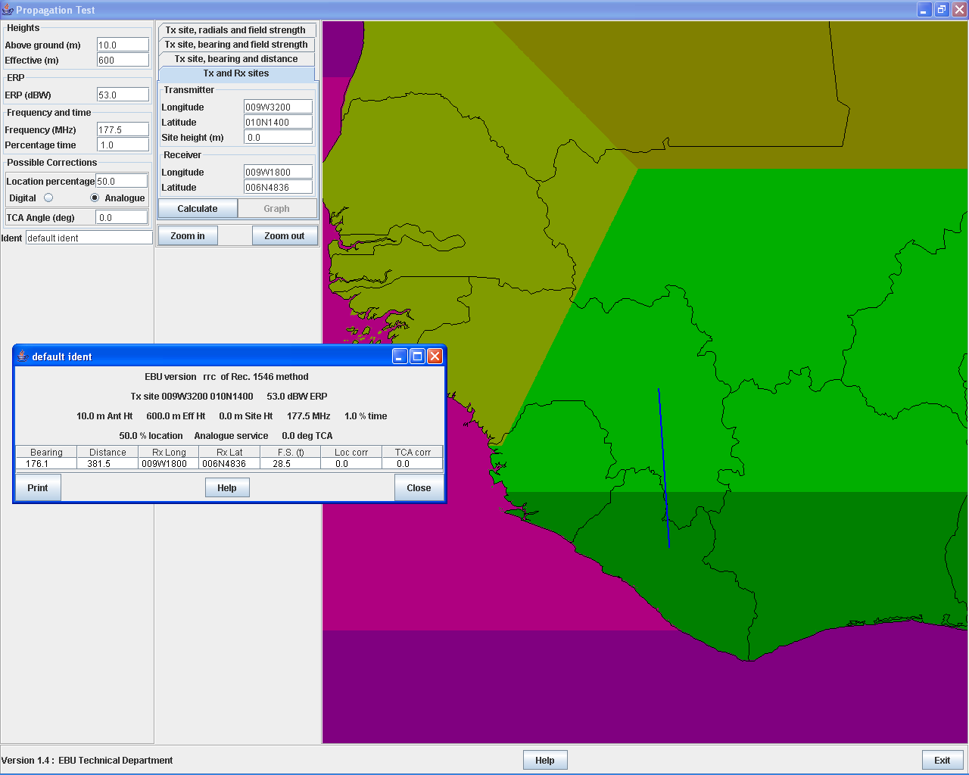

A.1.7.1.3.2 Calculation of the minimum median field strength:
For RPC5, min med = 66 for 200 MHz
For 5A (174,928 MHz): min med= 66+log (174.928/200)= 65.94

A.1.7.1.3.3 Calculation of the NFS :
The protection ratio:
The central frequency for the T-DAB signal is 174.928
The central frequency for the analogue TV signal is 177.5, the image carrier: 175.25
Δf= 175.25 – 174.928 = 0.322
According to Recommandation ITU-R BT 655-7:
For continuous interference, PR = 40dB
For Tropospheric interference, PR = 34 dB
Nfs= Fsi + PR - Rx ant.descrimination

Rx ant descr = 0

Fsi = 28.5

Then nfs = 28.5 + 34 = 62.5 (The calculated 61.9)

A.1.7.1.3.4 Calculation of the Margin :
Margin = 10log (10^(NFS/10)+10^(Fsminmed/10)) – Fsminmed
= 1.6

A.1.8 Interaction between digital television broadcasting requirements and assignments to other primary services
(to be completed)

A.1.9 Interaction between digital sound broadcasting requirements and assignments to other primary services
(to be completed)

A.1.10 Interaction between analogue television assignments
Please see document IPG-1-EP3E. http://www.itu.int/ITU-R/conferences/rrc/rrc-04/intersession/ipg/elec_pub_IPG-1/docs/ipg-1-ep3e.doc

A.1.11 Verifying the estimated service areas of digital broadcasting assignments
For the assignment requirement:

The FS min med (RPC1 at 226.5 MHz) = 50 dBµV/m + 20log(226.5/200) = 51.08 dBµV/m This field strength should be adjusted by 3 dB to make provision for the interference limitation of the service area.
The antenna is omni-directional and has an effective antenna height of 280 metres on the azimuth 220 degrees East of North. Using this information on obtains the wanted field strength at 70 kilometres from the transmitter in the direction 220 degrees East of North. The planning software provides the service area for the requirement as azimuth and longitude and latitude as decimal degrees. The point for the azimuth of 220 degrees is 35.103 degrees East and 0.853 degrees North, which corresponds to a distance of 70 kilometres from the transmitting antenna.

Service area definition as produced by the planning software:

KENKEN 85900986 12 CHERANGANI 37 54.1
0 35.507 2.390
1 35.700 2.427
2 35.898 2.409
3 36.079 2.324
4 36.260 2.231
5 36.381 2.067
6 36.448 1.877
7 36.500 1.696
8 36.546 1.518
9 36.533 1.335
10 36.488 1.162
11 36.402 1.009
12 36.296 0.879
13 36.142 0.802
14 35.949 0.808
15 35.566 1.233
16 35.539 1.246
17 35.523 1.242
18 35.507 1.219
19 35.493 1.255
20 35.414 1.079
21 35.346 1.056
22 35.103 0.853
23 35.048 0.949
24 34.903 0.986
25 34.839 1.091
26 34.704 1.193
27 34.811 1.335
28 34.860 1.449
29 34.910 1.552
30 34.985 1.636
31 35.002 1.758
32 35.020 1.914
33 34.950 2.299
34 35.136 2.353
35 35.338 2.291
36 35.507 2.390

A.2 List of detected errors
No incompatibilities were found in the case of service area overlap between digital television allotments and service areas of the land mobile service in the band 690 – 862 MHz even when such areas did overlap.
Propagation zones in Iraq were not reflecting the correct definition of the zones as they were used during the first planning exercise.

A.3 Verification of the correction of all known errors
The definition of the propagation zones in Iraq are now correct:
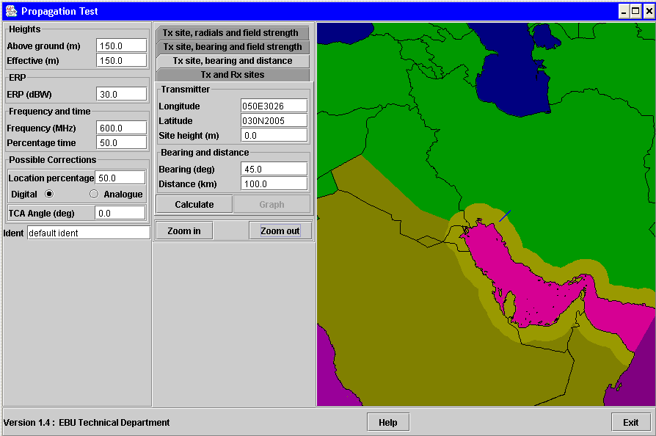
(Section to be completed for the verification of the corrections to the programs concerning primary terrestrial services other than broadcasting received after the date of the publication of this document.)

A.4 Conclusions on validation of the planning software
It was possible to verify the fundamental calculations of the planning software by performing manual calculations. These calculations proved that the planning software is performing in the expected manner, except for those cases where problems were identified that were subsequently corrected. In the process of verifying the planning software the results from previously confirmed parts were used for further testing.

Annex B
Reports on testing of the planning software received from the administrations

B.1 Report from the Administration of France

“Dear Mr Hai,
Answering to your request, I am pleased to tell you that there has been no difficulty reported to me after the various tests performed in France within both ANFR and TDF on the last version of the planning software, and I take this opportunity to thank and congratulate you and your team for reaching so difficult a goal.
Sincerely

A. Miquel”

B.2 Report from the Administration of the United Kingdom
“Hai
We have been successfully trying out the ITU Planning software without any problems or unexpected results.
It has been run on Dell 270SF desktops, Fujitsu Siemens 6120 S series Lifebook notepads, and IBM T43 Thinkpad Notepads.
See you in two weeks time.
Regards
Steve Ripley
Manager, Television Engineering
Television Broadcasting,
Planning and Licensing Team,
Competitions and Markets,
Direct Dial: +44 20 7783 4382
Fax: +44 20 7783 4589
steve.ripley@ofcom.org.uk

Ofcom
Riverside House
2a Southwark Bridge Road
London SE1 9HA”

B.3 Report from the Administration of Israel
As a mean to check the software, some calculation have been performed manually and compared to several outputs. The results match reasonably. The calculations have been performed on different software and database versions. We find the software technically useful for Administrations and accurate for the planning. The most important achievement is that instead of engineers coming up with their different tools, all participants may share the same software, to cooperate and get better results. The results are summarized below; more details are brought in the attached appendixes. Further remarks are brought consequently to issues raised during IPG-2.

The approach to the testing is as following:
The NFS (or interference level FS) value calculated by the program is compared to the NFS (or FS) value obtained manually.
Using; NFS = median interfering field strength (FS) + protection ratio – receiving antenna discrimination (Taken here as Zero).
The manual NFS/FS calculation is performed as following:
a) The appropriate Zone, 1% 600 MHz propagation curve is used to calculate the interfering field strength. The proper transmitter effective height and the proper distances are used in the curve.
b) As the calculation is for a 1kW transmitter, the field is adjusted for the actual transmitter e.r.p.
c) This field has to be adjusted by extrapolation to the actual frequency.
d) This field is obtained for a 20 meters receiving antenna. Correction is equal approximately to 5…7 dB.
e. We got the calculated FS appearing in the tables, NFS less protection value (-5 dB) and compared to the design software results.

1) Using the RRC06 Display version 1.4.7 and the first database version Case 1:

TV Transmitter | Cellular Site  (BR No) | Distance, km | Interfering FS, dB(μV/m)
TV Transmitter | Cellular Site  (BR No) | Distance, km | Planning software | Manual calculations
El Owga  Id: Egy El Owga 63 | Kziot  ISR 105124185 | 14.3 | 36.1 | ~ 36 - 37
El Arish  Id: Egy El Arish 67 | Har Mirbats  105124162 | 115 | 18.1 | ~ 17
See Attachment 1 for the Calculation example of El Owga–Kziot.

2) Using the version 2.0.0 of planning software and the database version from 07.03.2006 Case 1

TV Transmitter | Cellular Site  (BR. No) | Distance, km | Interfering FS, dB(μV/m)
TV Transmitter | Cellular Site  (BR. No) | Distance, km | Planning software | Manual calculations
Tapket Fahel  Id: JORT0309 | Elyakim  ISR 105124365 | 55 | 36.2 | 38
Ras Munif B  Id: JORT0094 | Beit Jan  ISR 105124357 | 76 | 49.5 | 50
Details of calculation – see Attachment 2.

3) In the RRC06 Planning Interface version 1.5.1, we have found TV antennas with Front-to-Back Ratio up to 40 dB (see example in Attachment 3). Such F/B value are rare in the RF band 174-862 MHz, and can only be achieved in an antenna test range. In any practical installation, where an antenna is installed on a tower, one can hardly expect the real front to back ratio to be more than 25-30 dB. Therefore, we propose that the software should probably keep this value as a maximal and avoid use of higher values.

B.3 Report from the EBU group, B/EPS on planning software testing

Introduction
The EBU has set up the project group B/EPS in order to assess the efficacy of the software. The group reported already in June 2005 on the software version available then produced by the Technical Department to assist with the RRC-06 planning process. As the second session of the RRC approaches, the software is being finalised and feedback is required from users regarding the accuracy of the EBU software provided to the ITU.
To do this, it would be useful to be able to separate the EBU software from the ITU software, but in recent months, the two have been integrated to a point where it is now almost impossible to do this. B/EPS has assessed the EBU developed software on the basis of the results contained in the Plans databases released by the BR.
Propagation Model
RRC-04 adopted a propagation model close to that in Rec. P.1546. The TD quickly provided an implementation of that model and the corresponding source code. A few months after the original software release, the TD issued a revised version which corrected some small errors noticed since the first release. Using that source code, the BBC was able to compile a Windows DLL containing all the provided functions. This DLL and software using it has been widely used during bi- and multi-lateral meetings involving the UK in the past two years.
On occasion, differences have been noticed between the results from this software and that provided by commercial vendors. Most often this was explained by differences in land/sea databases between different provisions. The BBC software, based on EBU source code and land/sea data, has always been accepted as it is believed to be closer to that which will be used by the ITU in the production of the Plan at RRC-06.
Although the BBC’s P.1546 software has been extensively used, it has only been checked against any other implementations, including the test software produced by the EBU, on one or two test cases (mainly to check that the BBC implementation of the DLL was working correctly).
In addition, TDF has implemented independently the propagation module and got the same results as with the EBU module.
A problem remains however with negative effective antenna heights; P.1546 has to be modified for this point.
Compatibility Analysis
Intermediate results from the compatibility analysis are not directly available from the Plans database, so inferences must be taken from the information that is available.
Thus, calculations must be based on NFS rather than any absolute indication of interfering field strength. Further calculations must be done to relate this to field strength, and these are dependent on the RPC of the affected system. There is no certainty, therefore, that these calculations correctly reflect the interpretation that should be placed on the results shown.
Some parts of the compatibility calculation (e.g. the interference caused by a reference network) are very hard to check in detail, partly because the RRC-04 report contains ambiguities regarding the correct usage. The EBU Technical Department has drawn attention to such ambiguities when noticed during the implementation and has on occasion requested clarification from the inter-sessional bodies. Notwithstanding this, it has been difficult to ensure a fully compliant but independent implementation of such features.
In the case of interference from one DVB-T assignment to another, it is possible to (manually) calculate a 1% time interfering field strength and then to add appropriate terms to represent system C/N, combined location correction and (if applicable) receiving antenna discrimination. On all occasions when this has been done, values for NFS shown in the Results database agree within less than 1 dB with that calculated independently.
Calculations have also been done from a DVB-T assignment to a DVB-T allotment, in which case no receiving antenna discrimination is appropriate. Again, results agreed within less than 1 dB.
Some attempt has been made at calculating the interference from a DVB-T reference network to a DVB-T assignment. Again, the results agree within 1 dB with those derived from the Results database. These calculations make so many assumptions about placement of reference networks as well as the calculation of an assignment’s “service area” that such close agreement between results is very encouraging.
Finally some DAB test cases were checked and they also where in close agreement to the ones in the ITU Results database.
Recently some problems were encountered: it was found that in these cases an older software version was used with intermediate data. It is important to note that always the latest software version and input data must be used.
Synthesis
The results of the synthesis process have perhaps received more scrutiny than any other part of the software. Such scrutiny normally consists of questions such as “why wasn’t requirement X allocated a channel?”
In all such cases, where a channel was not allocated as expected, incompatibilities that are not covered by Administrative Declarations exist. No cases were found where a channel had not been allocated despite there being no apparent incompatibilities.
The possible case where a channel was allocated when incompatibilities do exist has not been checked.
As it has not been possible to check, over a limited area, whether the synthesis process has yielded results that are the “best” achievable, or at least close to optimal, no comment can be offered on this. However it should be noted that there is no unique definition of what is the “best”. In general the synthesis module tries to maximise the number of assignments that get in the plan.

Conclusion
EBU project group B/EPS did not find major anomalies in the software for the RRC-06. However as there are still requests for modification or additional features, the software is still upgraded. Testing by the EBU Members should continue and any anomaly should be reported to EBU and/or ITU.

23/03/2006

Attachment 1

Calculation example for El Owga - Kziot
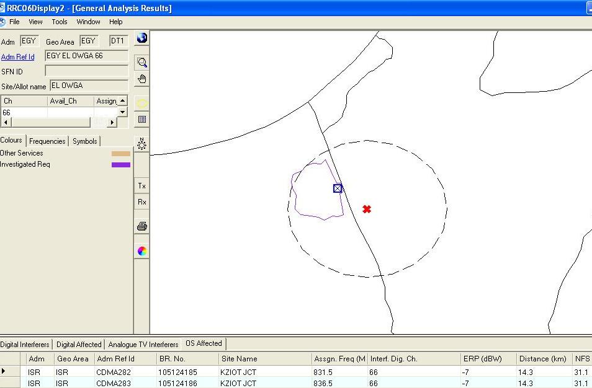
TV transmitter El Owga
CDMA site Kziot
Distance ~14.3km
Geographical map
P_{tr} = 32dBW
NFS =31.1dB(μV/m)

Initial data:
El Owga – Kziot direction ~ 130º, (according to Version 2.0.0 Of EBU program – 129.2º),
El Owga – Kziot distance ~14 km (program gives 14.3 km);
TV transmitter El Owga parameters:
- ERP (full) = 32 dBW,
- Attenuation to Kziot direction = 30dB, so ERP to Kziot = 2 dBW,
- Effective antenna height to Kziot = 55 m (program gives the same result).
Results:
Program calculations: NFS = 31.1 dB(μV/m), so Interfering Field Strength = 36.1 dB(μV/m).
600 MHz 1% time Zone 1
Interfering Field Strength graph for 600 MHz 1% time Zone 1 gives ~ 59 dB(μV/m).
Interpolations for 831 MHz reduce the result ~ for 1 dB, so interfering FS is about 58 dB(μV/m).
Correction for receiving antenna height 20m gives the following result:
Correction = $K_{h_{2}}$ log (h2 / R') [dB], where
$K_{h_{2}}$ = 3.2 + 6.2 log ( f[MHz] ),
h₂ - receiving antenna height,
R' = R = 10 m
(See Chapter 2,. A2.1.9 Correction for receiving/mobile antenna height))
Calculation gives the correction value ~ 6.41 dB.

So, the manual calculations for El Owga – Kziot interference give the EMF strength approximately equal to
58 – (30 – 2) + 6.4 ≈ 36 - 37 dB(μV/m).
Planning software calculations for the same place give interfering FS = 36.1 dB(μV/m).

Attachment 2

- Example 1 For the following trace:
Jordan Tapket Fahel (TV transmitter) to Israel Elyakim.

 | According to planning software | Checked values
Source – destination sites | Jordan: Tapket Fahel Israel: Elyakim.  35ºE37'20" 32ºN29'10" 35ºE3'40" 32ºN37'50"
TV transmitter ERP | 24.0 dBW
Azimuth to dest. Point (deg) | 287.1 | 290
ERP to dest. Point (dBW) | 20.7 | 21
Eff. Height to dest. Point (m) | 230.1 | 230
Distance (km) | 55.0 | 55
NFS [dB(μV/m)] | 31.2
NFS according to Zone 1, 1% time for 30 dBW ERP, 830 MHz |  | 40
Checked IFS [dB(μV/m)] (for 21 dBW, including antenna height correction) |  | 38
Final results (Interfering FS) | 36.2 | 38

- Example 2 For the following trace:
Jordan Ras-Munif B (TV transmitter) to Israel Beit Jan.

 | According to planning software | Checked values
Source – destination sites | Jordan: Ras-Munif B Israel: Beit Jan  35ºE47'51" 32ºN21'16" 35ºE22'15" 32ºN57'00"
TV transmitter ERP | 35.0 dBW
Azimuth to dest. Point (deg) | 327.4 | 330
ERP to dest. Point (dBW) | 34.7 | 34
Eff. Height to dest. Point (m) | 508.2 | 490
Distance (km) | 76.0 | 75
NFS [dB(μV/m)] | 44.5
NFS according to Zone 1, 1% time for 30 dBW ERP, 830 MHz |  | 41
Checked IFS [dB(μV/m)] (for 34 dBW, including antenna height correction) |  | 50
Final results (Interfering FS) | 49.5 | 50

Attachment 3
TV antenna with FB ratio 39 dB – EGY Mazar 46
Id: 078 (EGY Mazar 49)



