The 25th Anniversary of the Introduction of HDTV in Europe
ITU, 16 October 2007

‘ITU-R studies of the HDTV standards resulted in the HDTV growth worldwide’

Remarks by Prof. Mark Krivocheev, Honorary Chairman of ITU-R Study Group 6 and Former Chairman of ITU-R (CCIR) SG 11

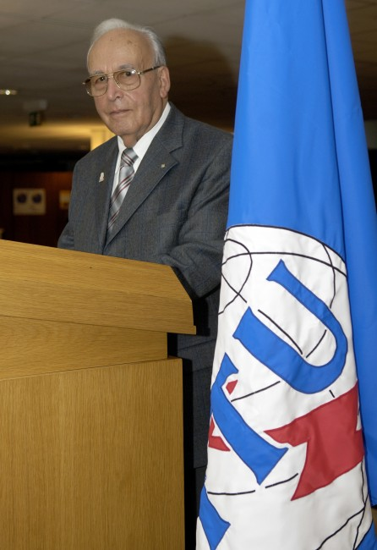
Photo source: ITU / J.M. Ferré (Compulsory)

Dear collegues, dear friends!

The process of international digital HDTV standardisation was long and really difficult*. I am happy to highlight the importance of the work done by EBU and a lot of European specialists.

At the SG 11 Meeting in July 1972 the historic Contribution of Japan suggested to initiate the studies on HDTV, the UK and France suggested to launch studies on digital TV. So, the studies in these two important directions of TV broadcasting started simultaneously 35 years ago. Based on the analysis of the chaos existing in the multistandard analog color television, a new methodology was defined to develop the international TV and HDTV standards.
The first study program on the digital compression of TV signals was adopted. That was an important milestone in the history of HDTV. It marked the start of international coordination of work on the TV signal coding for the use of conventional bandwidths. It also played a decisive role in the development of digital broadcasting systems, cable TV, as well as IPTV, and continues to be fundamental to build the digital TV.
The major achievement of ITU-R in this respect was the development of the international strategy of the digital HDTV, while retaining the existing terrestrial and satellite channels (the "6-7-8" concept).

The XVII Plenary Assembly of the CCIR held in Dusseldorf in 1990 approved five HDTV recommendations.

But some important parameters relating to the picture characteristics remained to be agreed.

The digital HDTV systems demonstrated in 1991-1992 in Alexandria (USA), by the HD-DIVINE consortium and other organizations in Europe showed that narrow-band transmission of digital HDTV and digital multiprogram TV in 6, 7 and 8 MHz channels (conception 6-7-8) is not a fantasy but a reality (Recommendation 798). In accordance with Recommendations ВТ.798 and ВТ.1206 the existing systems SDTV and HDTV of digital broadcasting could be developed.

At the meeting held in April 1997 the Working Group 11A (Chairman D.Wood (EBU) made the significant progress. There was agreed the Common Image Format- 1080 by 1920 picture samples which can be used at 50 Hz or 60 Hz filed rate.

In June 1999, WG 11 A (Chairman D.Wood) in collaboration with J.Flaherty (NABA), Junji Kumada (NHK), Yukihiro Nishida, B.Hopkins (Sony), R.Bunch, R.Barton (FACTS, Australia), N.Kisrawi (Syria), G.Rossi (ITU-R), SMPTE prepared a significant new draft version of unique REC. 709. It opens many doors. Further achievements in video compression guarantee 1080px50 broadcasting. Such a quality of image levels were never produced before.

After a great work done in specifying and adjusting systems’ parameters for digital terrestrial TV and achieving a consensus with an active participation of WG 11A Chairman D. Wood (EBU) and former ABU Technical director O. Khushu, the draft ITU-R Recommendation BT.1306 signed by over 50 states and international organizations was prepared in February 2000.

The Chairman of the WG-6E L.Olson (USA) was involved in the development of the planning methods for terrestrial digital broadcasting and the TG 6/8 (Chairman S.Perpar, Slovenia) prepared the report to the RRC-04 on this matter.

The RRC-06 (digital terrestrial broadcasting) was chaired and brought to a successful conclusion by K.Arasteh from the Islamic Republic of Iran. The use of the conception of HDTV-6-7-8 in Digital Plan provided capabilities to the parallel introduction of the multiprogram SDTV and HDTV which is extremely important today in the new environment.

Presently the HDTV satellite broadcasting in Europe is supported by about 20 spacecrafts and transmit about 100 HDTV programs. Such a wide implementation became possible by timely developed Recommendations.

For the first time the Plan for BSS was developed in 1977. Dr. V.V. Timofeev brought a considerable contribution in its development. The Plan envisaged also the possibility for the use of digital methods.

Christoph Dosch's great efforts (IRT, Germany) promoted the allocation of frequencies for HDTV in the 21 GHz band at the WARC-92.

Extremely High Resolution Imagery (EHRI) systems were based on Recommendation 709. Such system format about 8000 Horizontal pixels were implemented in Japan.

Large Screen Digital Television Imagery Task Group 6/9 chaired by J.Flaherty developed a set of 17 Recommendations.

I wish to express our profound appreciation to the former chairman of the World Broadcasting Union Technical Committee Dr. J.A.Flaherty (CBS) for his contribution in many recommendations. I would like to stress that Dr. J. A. Flaherty was the initiator of ENG and SNG systems studies and Rec. ITU-R BT.601. His most important contribution was made in worldwide HDTV standards; in fact, he is an eminent international leader and a catalyst for progress in his area.

Special thanks are addressed to the CCIR and ITU-R Secretariat, and in particular to J.W.Herbstreit, R.C. Kirby, R.V.Jones, V.Timoffev, Director, R.Froom, G.Grotelueschen, G.Mesias Counsellors, R.L. Nickelson and for the last years to G.Rossi, Head of Study Group Department for their valuable and efficient support.

The ITU-R work in the field of HDTV represents a truly “global approach” with the necessary harmonization, which provided the creation of the worldwide foundation for HDTV introduction and development.

We foreseen a great deal of work in view of the progress of digital and new nanotechnologies, free-viewpoint and 3D television in light of the information society goals.

In spite of the extremely short time given for the presentation I have the honour to thank in addition to the mentioned above persons the European collegues, namely: George Watters (EBU), Wolfgang Haberman (Germany), Paolo Zaccarian (Italy), O.Makitalo (Sweden), Jacque Sabatier (France), Domenique Nasse (France), Ulrich Reimers (Germany), Ch.Sandbank (UK), Henrikas Yushkiavitshus (USSR), Philip Laven (EBU), Petko Kantchev (Bulgaria), Valery Khleborodov (Russia), O.V. Gofeizen (Ukraine), Ron Bedford (UK), Alfreido Magenta (Italy), Franco Barbiery (Italy) and many others.

Good luck the HDTV in Europe. Good luck the HDTV all over the world.

_________________________________________________________
*The first stage and progress of the international HDTV standardization is described in: Krivocheev M.I., The first twenty years of HDTV: 1972-1992. – SMPTE. – 1993; S.N.Baron, M.I. Krivocheev Digital image and audio communication. Toward a Global Information Infrastructure.-Van Nostrand Reinhold, 1996, USA; M.I. Krivocheev The international standardization of the digital TV broadcasting.- NIIR, Moscow, 2006. (E-mail: http://tvmuseum-1.hosting.parking.ru/catalog.asp?ob_no=7013 ).

