The 25th Anniversary of the Introduction of HDTV in Europe
ITU, 16 October 2007

Remarks by Mr. Valery Timofeev, Director, Radiocommunication Bureau, ITU
at the opening of the 25th anniversary celebrations of the introduction of HDTV in Europe
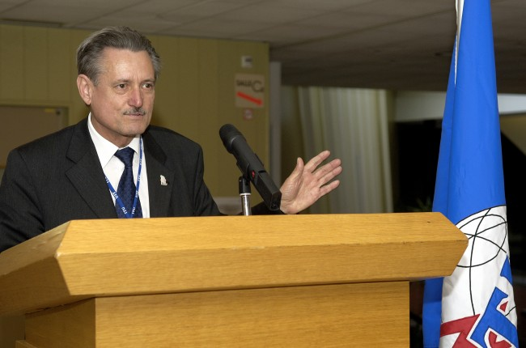
Photo source: ITU / J.M. Ferré (Compulsory)

Excellencies,
Mr Secretary-General,
Mr Deputy Secretary-General,
Fellow Directors,
Ladies and gentlemen,
Dear colleagues,

It is both a pleasure and an honour for me to welcome you to this evening’s function, where we are celebrating the 25th anniversary of the introduction of HDTV in Europe as well as the development of an unique worldwide high-definition television standard – Recommendation ITU-R BT.709. I note that we have many speakers today who will touch on various aspects of the progression towards the HDTV standard.
Television is a very powerful and influential communication medium. Due to its commercial potential, it is of great importance to markets worldwide. When colour television was developed, we had different standards in different parts of the world, with no one accepting the other’s format. Even the early versions of the Recommendation for HDTV had multiple standards and many footnotes (of exclusion). This goes to highlight the great achievement that the ITU-R has been able to accomplish: to have a worldwide standard for HDTV production and international programme exchange, based on the Common Image Format (CIF) and the Common Data Rate.
Although BT.709 is the key Recommendation, we should note that many supporting Recommendations and Reports were developed, that enabled the achievement of this Recommendation. The migration of television service from analogue to digital technologies provided the basis for the development of the common HDTV standard. Today, digital technologies are used in all aspects of broadcasting, from image capture to recording, editing, production and distribution. You are all aware that we are also celebrating the 25th Anniversary of Recommendation ITU-R BT.601, that became the building block of digital television systems. BT.601 is 25 years old and still relevant today. Digital television has been available for some time already through satellite and cable delivery. Digital terrestrial television broadcasting (DTTB) is becoming a reality in many parts of the world. Along with the increased use of digital technologies in broadcasting, consumer electronics have also been implementing digital technologies in the consumer receiver market. Flat panel displays, which are “Full HD” are pretty much the norm and high-definition DVDs are getting popular.
I should mention here about the Regional Radiocommunication Conference held in 2006 (RRC-06). This landmark Conference for 118 ITU Member States from Region 1, one Member State from Region 3 and one Observer with special status within ITU established a regional agreement and associated Plans for digital sound and television broadcasting in the frequency bands 174-230 MHz and470-862 MHz. The Plan provides possibilities for structured development of digital terrestrial broadcasting, as well as having sufficient flexibility for adaptation to the changing telecommunication environment. The majority of Member States intend to carry out full transition to all-digital broadcasting by 17 June 2015. As the Secretary-General has highlighted, this move to all-digital broadcasting meets targets set by the Millenium Development Goals and is an important factor in achieving the WSIS outcomes relating to ICT.
I would like to conclude by welcoming all of you to this celebration of a very significant ITU-R achievement and we can only hope that the ITU-R will continue on this successful track for future technologies in this media.
---

Rec. ITU-R BT.709: Parameter values for the HDTV standards for production and international programme exchange
Rec. ITU-R BT.601: Studio encoding parameters for digital television for standard 4:3 and wide screen 16:9 aspect ratios

