Rohde & Schwarz and the ITU Radio Regulations

Ing. Gerhard Geier,
Executive Vice-President,
Head of Radiomonitoring and Radiolocation Division,
Rohde & Schwarz

A Hundred Years of ITU Radio Regulations – Why Regulating the Use of the Frequency Spectrum Will Continue to Play a Central Role

For a global, mobile information-based society, which we are evolving into, the wireless exchange of information is an absolute must. Billions of people and millions of companies and organizations increasingly use radiocommunications on a daily basis, and unlimited availability is being taken for granted more and more. Information exchange about radiocommunications is thus an indispensable driver of worldwide social and economic development.

Among the four groups – users, network operators, industry and regulatory authorities – the ITU as the representative of national regulatory authorities plays a unifying role.

The unhindered technological development makes it already possible today, through the use of multiband and multimode terminals, to implement global radiocommunications networks, even without uniform frequency bands or a uniform standard. In a free market, competition is what selects the most efficient standard. Does this mean that the job of a regulatory authority will become superfluous? By no means!

Its job will be to examine the rules and structures that have accompanied and grown with technological advancement over the years and to eliminate or adapt them as necessary – in other words, as much regulation as necessary and as much deregulation as possible. This is why we need the ITU more than ever.

Rules are also required therefore for releasing frequency bands for communications that are not defined by transmission standards. Without establishing a minimum number of rules, such as maximum transmission power, adjacent channel suppression and other parameters, a "live and let live" system will soon result in anarchy, where "let live" will no longer be possible.

Since frequency planning has developed historically in large areas, the assignment of services to the individual frequency bands is not always optimally balanced between the physical conditions and the requirements of the individual services.

Software defined radio (SDR) technology allows gradual restructuring with higher efficiency.

Regardless of further increases in the efficiency of communications systems, the need for suitable frequency bands will continue to rise. Just appropriation of naturally limited resources must not exclusively be based on economic or political strength. Only an organization such as the ITU, which represents all nations, can provide a just balance that allows all nations to benefit from further economic and technological development.

What began in Berlin 100 years ago with the first International Radiotelegraph Conference in a comparably manageable world of radiocommunications must still continue in a much more complex world and a global, mobile information-based society.

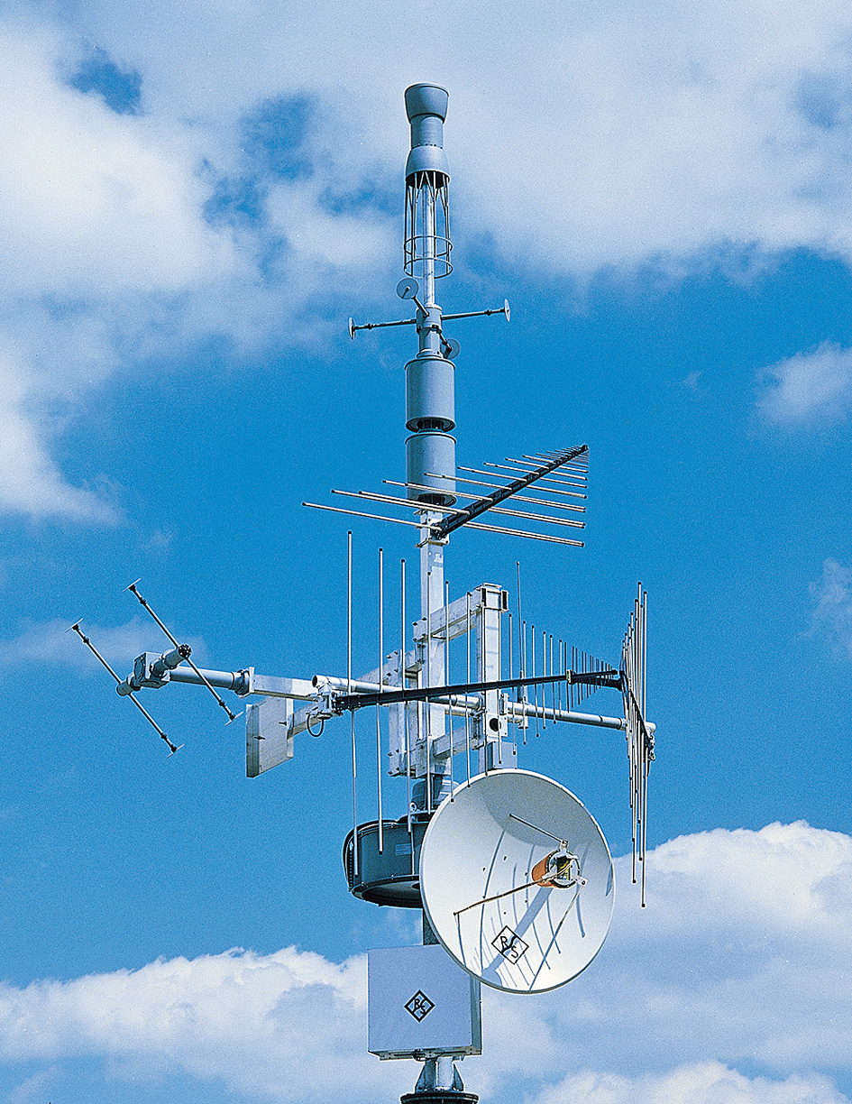 | Rohde and Schwarz has codetermined and advanced the rapid development of radiocommunications for more than 70 years. As a global company that has specialized in professional radiocommunications – from test and measurement to broadcasting and communications to spectrum monitoring – we look forward to fruitful cooperation with the ITU in the future to jointly help shape the requirements for efficient, interference-free and high-performance radiocommunications.  Rohde & Schwarz GmbH & Co. KG  Radio Monitoring and Radiolocation Division  gerhard.geier@rsd.rohde-schwarz.com  www.rohde-schwarz.com

