ITU Seminar for Americas Region  
Science services: regulatory, technical and practical implications  
Manta, Ecuador, 20-21 September 2012

Accommodation and hotel reservations

The Ecuadorian Administration has secured special rates with a number of city centre hotels, details of which are given in the table on the next page, where there is also a map showing the location of each hotel in relation to the meeting venue. In order to get special rates please refer to the event organized by MINTEL.

Once the delegates have arranged their accommodation with the hotels, they are kindly requested to inform us of the reservations made, by e-mail to: [meetingecuador.uit@mintel.gob.ec](mailto:meetingecuador.uit@mintel.gob.ec); [gabriela.gallegos@hotmail.es](mailto:gabriela.gallegos@hotmail.es) using the forms provided for the purpose.

It is important that reservations be made as early as possible. All reservations must include a credit card number. You will receive a confirmation message once your reservation has been accepted by the hotel. Should you subsequently find that you will be unable to attend the meeting, the reservation must be cancelled sufficiently in advance (at least 7 days); and it should be done with our intermediary in order to avoid any inconvenience.

There will be buses that will arrive to the suggested hotels in a planned schedule arrangement, to take the delegates to the meeting place. As it takes about 20 minutes to get there by car/bus, it is not convenient to go by walking.

It is important for delegates to fill out the form in Annex 3 in order to coordinate the transfer from the airport to the hotel.

CIUDAD ALFARO CIVIC CENTER

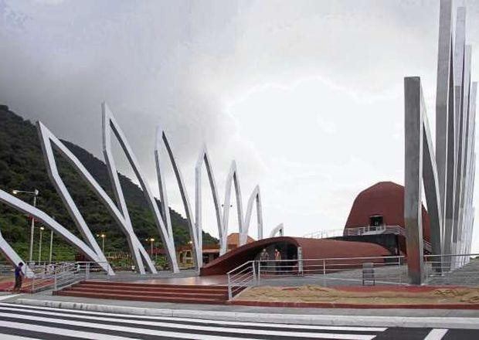



**A.** Eloy Alfaro Airport

**B.** Ciudad Alfaro Civic Center



**A.** Oro Verde Hotel **C.** Los Almendros Hotel

**B.** Howard Johnson Hotel **D.** Balandra Hotel

|  |  |  |  |  |
| --- | --- | --- | --- | --- |
| **HOTEL** | **CATEG** | **TYPE OF ROOM** | **RATE** | **REMARKS** |
| **(1) Hotel Howard Johnson**  Km. 1.5 Vía Barbasquillo [www.ghlhoteles.com](http://www.ghlhoteles.com/)  Tel/Fax: +593-5-2629999  Cel: 593-9-4501909  [reservas@hojamanta.com](mailto:reservas@hojamanta.com) [mercadeo@hojamanta.com](mailto:mercadeo@hojamanta.com) | ***** | Single  Double | USD 79.30  USD 91.50 | Includes buffet breakfast |
| **(2) Hotel Oro Verde**  Malecón y Calle 23 [www.oroverdehotels.com/manta](http://www.oroverdehotels.com/manta)  Tel: +593-5-2629200  Fax: +593-5-2629210 [reservas_mta@oroverdehotels.com](mailto:reservas_mta@oroverdehotels.com) [ov_mta@oroverdehotels.com](mailto:ov_mta@oroverdehotels.com) [corpuio@oroverdehotels.com](mailto:corpuio@oroverdehotels.com) | ***** | Single  Double  Grand Suites  Junior Suites | USD 91.50  USD 103.70  USD 103.70  USD 152.50  USD 176.90 | Includes buffet breakfast |
| **(3) Hotel – Cabañas Balandra**  Barrio Córdova Av. 7 y Calle 20 [www.hotelbalandra.com](http://www.hotelbalandra.com/)  Tel: +593-5-2620316  Fax: +593-5-2620545 [eventos@hotelbalandra.com](mailto:eventos@hotelbalandra.com) [cecilia1411@hotmail.com](mailto:cecilia1411@hotmail.com) | * * * | Single  Triplex | USD 93.94  USD 48.80 per person. | Includes breakfast |
| **(4) Hotel Los Almendros**  [www.almendrosaparthotel.com](http://www.almendrosaparthotel.com/)  Tel: +593-5-2620932  Fax: +593-5-2610636 [reservas@almendrosaparthotel.com](mailto:reservas@almendrosaparthotel.com) [marcelgaravi@gmail.com](mailto:marcelgaravi@gmail.com) | * * * | Single  Double | USD 85.40  USD 103.70 | Includes breakfast |