Information for Workshop on IMT-Advanced
in Kyoto, Japan, 22 May 2007

Introduction
Workshop on IMT-Advanced will take place at the Kyoto International Conference Center (ICC Kyoto), Kyoto, Japan, on 22 May 2007 at the invitation of Japan Administration.
The workshop will be held in conjunction with the 22nd meeting of ITU-R Working Party 8F.
It is necessary for the participants in WP8F meeting to pre-register for the Workshop.

Place of the workshop
The workshop will take place at the:
Kyoto International Conference Center (ICC Kyoto)
Takaragaike, Sakyo-ku, Kyoto 606-0001, Japan
Tel: +81-75-705-1234
Fax: +81-75-705-1100
E-mail: ask@icckyoto.or.jp
Website: http://www.icckyoto.or.jp/en/index.html
For further information see Annex 2.

Registration
There are not particular qualifications for the participants and anybody can take part in the workshop. In order to make the necessary arrangements, we should be grateful if you would pre-register by completing the registration form in Annex 3 (one per a participant) and sending it by e-mail to workshop@ituaj.jp as soon as possible, but not later than Monday 7 May 2007.

Program of the workshop
The draft program for the workshop is contained in Annex 1. The workshop will conduct its work in English.
The workshop will open at 09:00 hours on 22 May 2007 in Room A of ICC Kyoto. On-site registration will start on Tuesday 22 May 2007 at 07:30 hours at the workshop venue, where a valid badge will be issued to provide access to the workshop.

Documentation
The documents for the workshop are stored on the ITU-R Working Party 8F web page (http://www.itu.int/ITU-R/index.asp?category=study-groups&link=rwp8f&lang=en) under “Related Activities”.
Participants are encouraged to download the documents at above URL. Please note that most of paper copies of the documents will not be available on site.
Wireless and wired LAN facilities will be provided in the room for the workshop.

Social events
A welcome reception will be held in the evening of Tuesday, 22 May 2007.

Visa Application
Participants who need an invitation letter and/or visa supporting documents for entering Japan shall fill out completely the “VISA APPLICATION FORM” and “CURRICULUM VITAE” in Attachment 4 to Annex 2, and fax or e-mail them and a “Copy of passport (page of photograph)” to the contact point in Section 6 in Annex 2 immediately. We will do our best if you will send them by 16 April (see section 5 in Annex 2).

Hotel accommodation
Available rooms are valid from 21 to 22 May (i.e. 23 May, the checkout date). (see attachment 3 in Annex 2)

Annexes: 3
Annex 1

Revised: 19 May 2007

Draft program for Workshop on IMT-Advanced
in Kyoto, Japan Tuesday, 22 May 2007

09:00 – 09:10 Welcome from the host committee
Speaker : Mr. T.Mori (Ministry of Internal Affairs and Communications)

09:10 – 09:20 Introductory remarks
Speaker : Dr. E.J.Kim (ITU Regional Office)
Title : Opening Speech, Workshop on IMT-Advanced

09:20 – 09:40 Summary of ITU-R WP 8F activities in preparation for WRC-07
Speaker : Mr. S.Blust (WP8F Chairman)
Title : Summary of ITU-R WP 8F activities in preparation for WRC-07

09:40 – 10:00 Overview of the anticipated IMT-Advanced process
Speaker : Dr. K.J.Wee (WP8F Vice-chairman)
Title : Overview of the anticipated IMT-Advanced process

10:00 – 10:20 Coffee break

10:20 – 12:00 Progress in 3G and efforts towards IMT-Advanced (Part 1: Operators)
Speaker : Mr. B.Yves (Orange)
Title : Mobile services in Europe,
How to accommodate current and future growth
Speaker : Mr. S.Onoe (NTT DoCoMo)
Title : DoCoMo's progress in 3G and efforts toward IMT-Advanced
Speaker : Dr. J.T.Ihm (SKT)
Title : SK Telecom's Progress in 3G and IMT-Advanced
Speaker : Mr. M.Zhou (China Mobile)
Title : TBD

12:00 – 13:30 Lunch break

13:30 – 15:30 Progress in 3G and efforts towards IMT-Advanced (Part 2: Vendors)
Speaker : Dr. B.Gudmundson (Ericsson),
Title : Evolution of 3G into IMT-Advanced
Speaker : Mr. J.Kahtava (Nokia)
Title : Nokia vision on IMT
Speaker : Dr. J.Costa (Nortel)
Title : Multi-hop wireless access: a key enabler for IMT-Advanced
Speaker : Dr. J.H.Park (Samsung)
Title : Progress on 3G & IMT-Advanced
Speaker : Mr. L.X.Sun (Huawei)
Title : TBD
Speaker : Mr. E.Fukuda (Fujitsu)
Title : Fujitsu's R & D Activities towards IMT-Advanced

15:30 – 15:50 Coffee break

15:50 – 17:30 Industry Forums and research activities towards IMT-Advanced
Speaker : Dr. J.S.Choi(CJK-B3G WG)
Title : CJK B3G Standards Collaboration
Speaker : Mr. F.Courau(3GPP)
Title : 3GPP LTE overview
Speaker : Mr. R.Marks (IEEE)
Title : IEEE Standards for Advanced Wireless Networks
Speaker : Dr. W.Mohr(WINNER)
Title : The European WINNER Project Towards IMT-Advanced

17:30 – 18:15 Views of Emerging Market on IMT-Advanced
Speaker : Mr. D.Ngae (Cameroon)
Title : Views from developing countries on IMT-Advanced

18:30 – 20:30 Reception
Annex 2
Additional information about Workshop on IMT-Advanced

1 Introduction
The Ministry of Internal Affairs and Communications of Japan is pleased to welcome participants to Workshop on IMT-Advanced which will take place in Kyoto, Japan, 22 May 2007.
This annex provides some information that you need to know about the workshop.

2 The Workshop venue
Kyoto International Conference Center (ICC Kyoto)
Takaragaike, Sakyo-ku, Kyoto 606-0001, Japan
Tel: +81-75-705-1234
Fax: +81-75-705-1100
E-mail: ask@icckyoto.or.jp
Website: http://www.icckyoto.or.jp/en/index.html
Location: See attached map in Attachments 1 and 2 to this Annex.

3 Transportation to the workshop venue
It is recommended that you arrive at Kansai International Airport (Kanku). From Kansai International Airport, the most convenient transportation is by limousine bus at #8 bus stop for Kyoto Station. The bus fare is 2,300 Yen and it takes about 105 minutes to Kyoto Station. (See http://www.kate.co.jp/pc/english/english.html). Alternatively, the JR Express Train “HARUKA” is available from Kansai International Airport to Kyoto Station. The train fare is 2,980 Yen and travel time is about 75 minutes.
From Narita/Tokyo Airport you need one or more connections of domestic transportation to Kyoto. For details, see Attachment 1.
Maps of “ICC Kyoto” and hotels are provided in Attachment 2.
From the hotels to the workshop venue
The workshop venue is easily accessible from Kyoto Station within 25 minutes as shown on the map in Attachment 2 using the ‘Karasuma subway line’. The table in Attachment 2 shows the walking time to the nearest subway station from each recommended hotel and the time required by subway to “Kokusaikaikan Station” which is close to the workshop venue “ICC Kyoto”.

4 Hotel accommodation
JTB Western Japan has booked hotels in Kyoto for the workshop. Reservations will be made on a first-come, first-served basis. Please indicate your order of preference on the reservation form in Attachment 3 to this Annex.
Participants wishing to reserve hotel accommodation should complete the reservation form and return it by fax to JTB Western Japan no later than 2 May 2007. Credit card data should be included on the form to guarantee the hotel reservation.

5 Passports and Visas
A valid passport is required to enter Japan. Expired date of the passport shall be three months later than the arrival date in Japan. Participants who require a visa should apply for a visa at a Japanese consulate or diplomatic mission in their respective country well in advance of departure. Participants are also advised to contact their local travel agents or carriers. For more information please visit the web site of the Ministry of Foreign Affairs of Japan at:
http://www.mofa.go.jp/j_info/visit/visa/index.html.
Participants who need an invitation letter and/or visa supporting documents for entering Japan shall fill out completely the “VISA APPLICATION FORM” and “CURRICULUM VITAE” in Attachment 4 to this Annex, and fax or e-mail them and a “Copy of passport (page of photograph)” to the contact point in Section 6 as soon as possible.

6 Contact point
For any further information you may require or if you need a personal invitation letter or official document for your visa application, please contact:
Ms. Erika Maki / Mr. Katsuro Ohmi
Technical Department, The ITU Association of Japan, Inc.
3rd floor Kanda KS Building, 1-8-6 Kaji-cho, Chiyoda-ku, Tokyo 101-0044, Japan
Tel: +81 3 5207 5722
Fax: +81 3 5207 5731
E-mail: tec@ituaj.jp

7 Computer facilities
Wireless network using IEEE 802.11b/g and wired network will be available in the room for the workshop.

8 Language
Japanese is the dominant language in Japan. English is spoken in major hotels, large restaurants, department stores and other major organizations and tourist locations.

9 Currency and Banking
Only Japanese Yen (JPY) is accepted at stores and restaurants. Major foreign currencies may be exchanged to JPY at hotels and foreign exchange banks in Kyoto and at International Airports. Regular banking hours are 9 am – 3 pm, Monday through Friday.

Exchange rate as of 29 January 2007
 | JPY(¥)
1 USD $ | 121.92
1 EUR € | 157.45

Several foreign currencies (cash and/or traveller’s checks) can also be changed at the Kyoto International Conference Center: “ICC Kyoto” opens from 9 am – 5 pm every day.

10 Credit cards
Most hotels, restaurants, car rental agencies, department stores and shops accept major credit cards (American Express, Diners Club, JCB, MasterCard, VISA). Usually there is a sticker at the entrance indicating which cards are accepted.

11 Climate
Average temperature and rainfall by month in Kyoto are as follows:
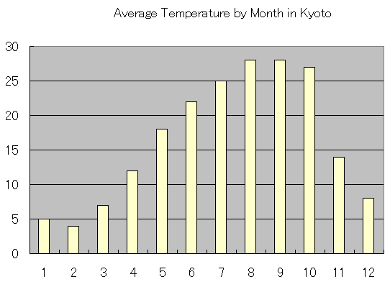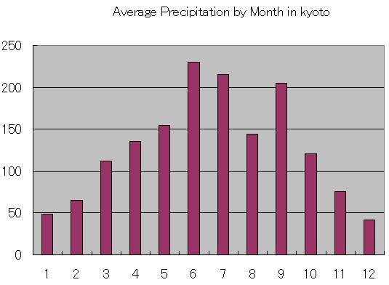
Month
C
mm
Month
Average rainfall in Kyoto
Average temperature in Kyoto

12 Local time
Local time is UTC +9h (no daylight saving in Japan.)

13 Tipping

Tipping is not customary in Japan.

14 Taxes
Sales tax in Japan is 5%.

15 Electrical appliances
The standard power supply in Japan is 100 volts. The frequency is 60 Hz in western Japan including Kyoto (50 Hz in eastern Japan including Tokyo). The type of power outlet/connector used in Japan is A type which is a two parallel pronged type.
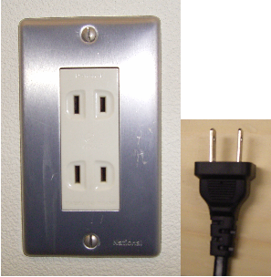
Attachment 1
Access to Kyoto International Conference Center (ICC Kyoto)
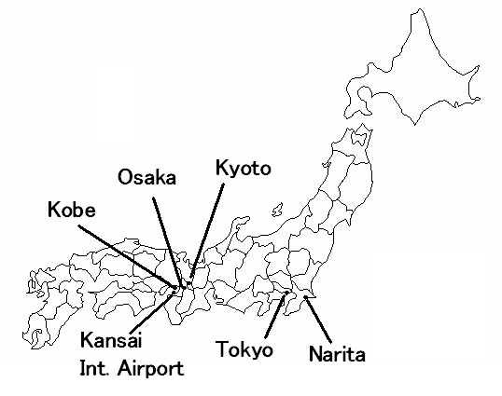
By limousine bus
Fare: ¥3,000
Travel time: 80-110 min.
Departure time: 06:55 – 23:00
(Approx. 30 min intervals)
By JR bullet train,
“NOZOMI”
Fare: ¥13,520
Travel time: 135 min.
Departure time
06:00 – 21:18
(Approx. 20 min. intervals)
Tokyo Station
By limousine bus
Fare: ¥1,280
Travel time: 55 min.
Departure time:
08:05 – 21:20
(Approx. 20 min. intervals)
2 New Miyako Hotel

3 Aranvert Hotel Kyoto

4 Hearton Hotel Kyoto

5 Hotel Hokke Club Kyoto

*1 Limousine Bus from Kansai International Airport http://www.kate.co.jp/pc/english/english.html
*2 Advance reservation is requested. For further information visit the website:
http://www.wp8fkyoto.jp/yasaka_taxi.pdf

Kansai International Airport (Kanku)
By JR limited express train;
“NARITA EXPRESS”
Fare: ¥2,940
Travel time: 55 min.
Departure time: 07:42 – 21:43
(Approx. 30 min intervals)
By domestic flight
Fare: ¥19,100
Travel time: 70 min.
Departure:
3 flights a day
Kyoto Station (JR Line)
about ¥800
about 5 min.
about ¥1,200
about 15 min.
By Taxi
Fare: about ¥32,000
Travel time:
about 120 min.
“Kansai Airport Shuttle”^{*2}
operated by Yasaka Taxi
Fare: ¥3,000/person
Travel time:
about 120 min.
By limousine bus *¹
Fare: ¥2,300
Travel time: 95 min.
Departure time:
07:00 – 23:30
(Approx. 60 min. intervals)
By JR Express Train,
“HARUKA”
Fare: ¥2,980
Travel time: 75 min.
Departure time:
05:30 – 20:30
(Approx.:30 min intervals)
By Taxi
5-min. walk.
5-min. walk.
about ¥3,000
about 40 min.
By Taxi
By Taxi
Osaka International
Airport (Itami)
On foot
On foot
Narita International Airport
1 Grand Prince Hotel Kyoto

Attachment 2
The Workshop venue and Hotel location
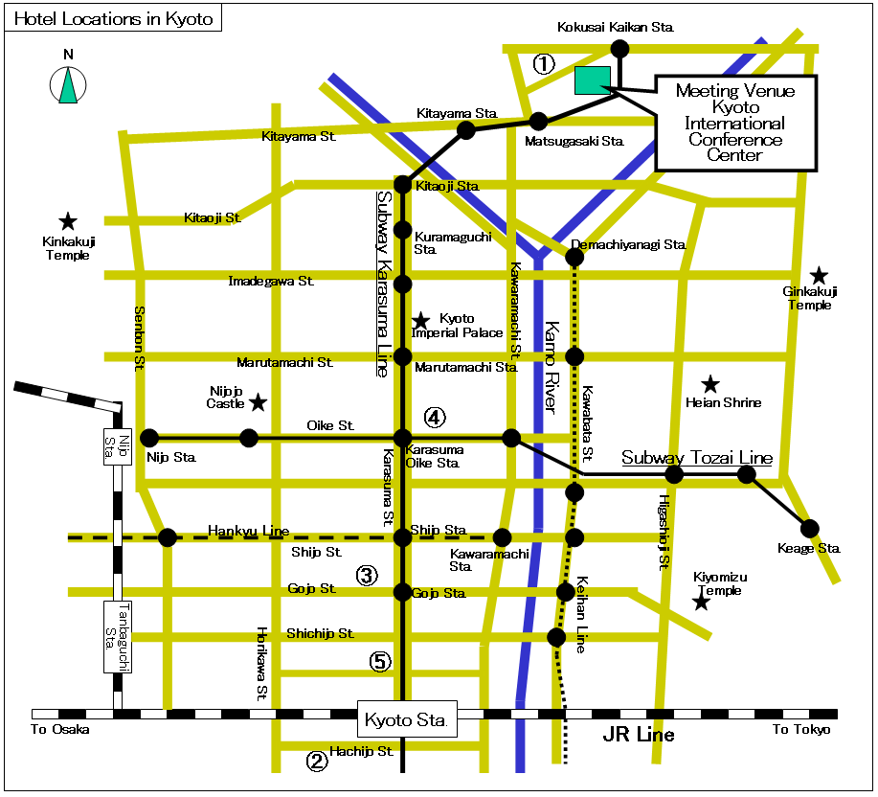
(Note) “Sta.” stands for Station
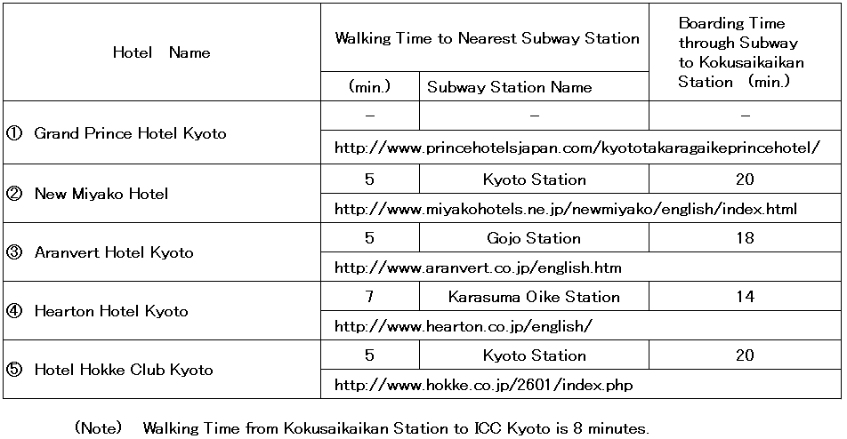
The Workshop Venue vicinity

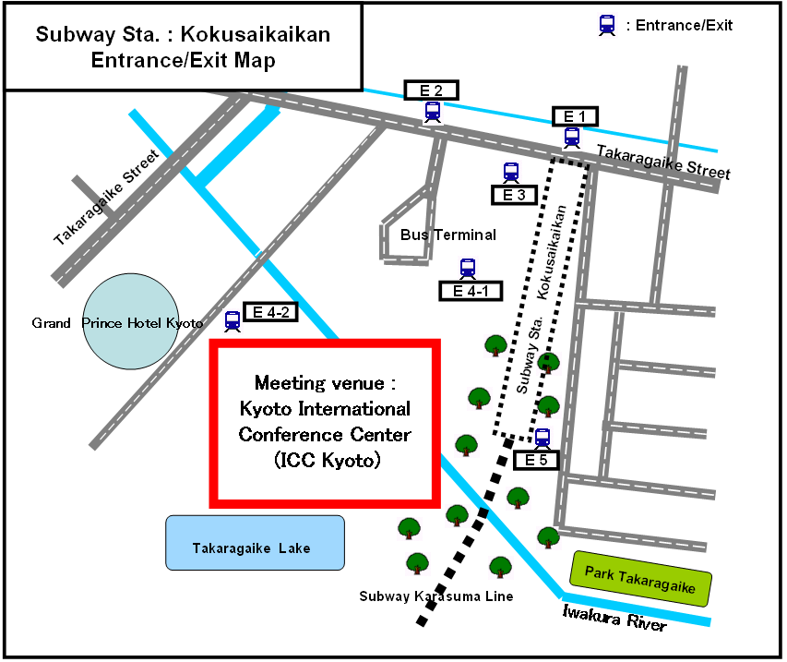
NOTE - E4-2 is nearest to ICC Kyoto, opening at 7 am and closing at 10:30 pm.

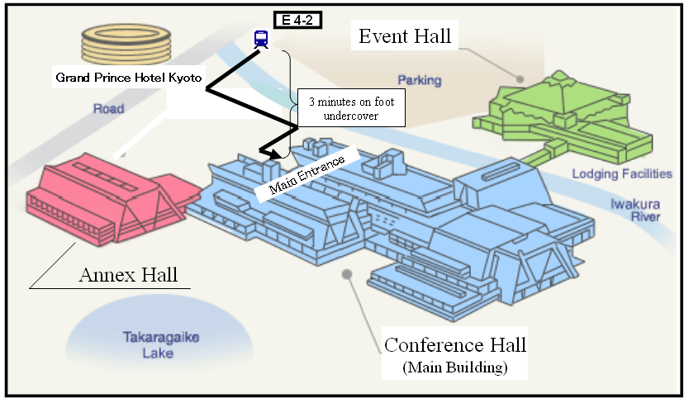
Attachment 3
Hotel accommodation for Workshop on IMT-Advanced
22 May 2007, Kyoto International Conference Center, Kyoto, Japan

Travel agent
JTB Western Japan handles all hotel accommodation for participants to the workshop.
JTB Event & Convention Sale Dept.
Western Japan Regional Headquarters
Kyutaro-machi, Chuo-ku, Osaka, 541-0056 Japan
Tel: +81-6-6260-5076; Fax: +81-6-6263-0717
Hotel accommodation
JTB Western Japan has booked hotels in Kyoto at very special rates for participants to the workshop. Reservations will be made on a first-come, first-served basis. Please indicate your order of preference on the reservation form. Hotel locations in Kyoto are indicated in Attachment 2 (see previous page).
Hotel number | Name of Hotel | Room rate |  | Breakfast | Number of Available Rooms
Hotel number | Name of Hotel | Twin | Single | Breakfast | Number of Available Rooms
1 | Grand Prince Hotel Kyoto | 23,000 yen | 16,000 yen | 2,310 yen | 100
2 | New Miyako Hotel | 19,000 yen | 15,000 yen | 2,079 yen | 150
3 | Aranvert Hotel Kyoto | 16,000 yen | 9,000 yen | 1,732 yen | 20
4 | Hearton Hotel Kyoto | 15,000 yen | 8,500 yen | 1,000 yen | 25
5 | Hotel Hokke Club Kyoto | - | 7,500 yen | 1,050 yen | 45
NOTES:
1. Room rates include tax and service charge.
2. Room rates do not include breakfast.
Application and payment
Participants wishing to reserve hotel accommodation should complete the reservation form on the next page and return it by fax to JTB Western Japan no later than 2 May 2007. Credit card data should be included on the form to guarantee the hotel reservation and to pay cancellation fees.
No reservation will be confirmed in the absence of this reservation form. All payment must be in Japanese yen.
The following credit cards are accepted:
1. American Express 2. Diners Club 3. JCB
4. MasterCard 5. VISA
Cancellation
In the event of cancellation, written notification should be sent to JTB Western Japan. The following cancellation fees will be charged against your credit card, indicated on the next page.
Up to 21 days before the first night of stay No cancellation fee
20 to 9 days before the first night of stay 2,000 yen
8 to 2 days before the first night of stay 20% of total room charge
1 day before the first night of stay 80% of total room charge
On the day of the first night of stay or no notice given 100% of total room charge
Hotel accommodation reservation form for
Workshop on IMT-Advanced in Japan, 22 May 2007
Please complete and return this form by fax to: JTB Event & Convention Sale Dept. Western Japan Regional Headquarters
Deadline: 2 May 2007
(Please type or print in block letters and check appropriate boxes.)
FULL NAME: □ Prof. □ Dr. □ Mr. □ Ms.
Family name First name
ORGANIZATION:
FULL ADDRESS: □ Office □ Home

Postcode: Country:
Phone: + Fax: + E-mail:
Name of Accompanying Person(s), if any: □Mr. □Ms.
Family name First name
HOTEL ACCOMMODATION
Please select the hotel number you wish to book from the hotel numbers 1 to 5 (see table on the previous page).
Hotel Number | Number of room(s) | Date of check in and check out
1st choice . | Twin(s): .  Single(s): . | Check in May  Check out May/June
2nd choice . | Twin(s): .  Single(s): . | Check in May  Check out May/June
CREDIT CARD
□ American Express □ Diners Club □ JCB □ MasterCard □ VISA
Card number: Expiration date:
Name of card holder:
Authorized signature:
Date: Signature:
NOTES:
1. All payment must be in Japanese Yen.
2. Regarding payment of hotel charge with traveler’s check, following three hotels are available; Grand Prince Hotel Kyoto, New Miyako Hotel, Aranvert hotel Kyoto..
3. This application will be valid upon receipt for confirmation from JTB Western Japan.
The ITU Association of Japan, Inc.
Tel: +81-3-5207-5722 Fax: +81-3-5207-5731 E-mail: tec@ituaj.jp
Attention to: Erica MAKI (Ms) and Katsuro OHMI (Mr), Technical Department
Attachment 4
Visa Application Form
Participants who need an invitation letter and/or visa supporting documents for entering Japan shall fill out COMPLETELY the “VISA APPLICATION FORM” and “CURRICULUM VITAE (on the next page)” in block letters (English). Please send them along with a “Copy of passport (page containing photograph)” to the above address by fax and/or e-mail immediately. We will do our best if you will send them by 16 April (see section 5 in Annex 2).
1. FULL NAME
□ Mr. / □ Ms __________________ __________________ _________________ (English)
(Given Name) (Middle Name) (Family Name)
__________________ __________________ _________________ (Chinese)
* For those having Chinese nationality, please write clearly your full name in both Chinese and English.
2. PASSPORT INFORMATION
Nationality: _______________________ Age: as of 1 March 2007
Passport number: _______________________ Date of expiry: ______/_____/_____
(Day / Month / Year)
Date of birth: _______/______ /________ Place of birth: _________________
(Day / Month / Year)
3. COMPANY NAME, JOB TITLE and COMPANY ADDRESS
Company name: ______________________________________________________
Job Title/Department: ______________________________________________________
Company address: ______________________________________________________
* For those having Chinese nationality, please fill out the blank above clearly in both Chinese and English.
4. TELEPHONE NUMBER, FAX NUMBER and E-MAIL ADDRESS
Telephone number: _____________________ Fax number: __________________
E-mail address: _______________________________________________________
5. STAYING PLACE in Japan (HOTEL) ___________________________________________
6. FLIGHT INFORMATION (TO/FROM JAPAN)
Arrival
Flight No. ________________________________
Time/Date/Month _________/__________/____________
Name of airport (arrival) ________________________________
Departure
Flight No. ________________________________
Time/Date/Month _________/__________/____________
Name of airport (departure) ________________________________
* For visa application, planned flight schedule is also acceptable, in case your flight is not fixed.
Please inform us by fax and/or e-mail immediately after fixing.

CURRICULUM VITAE

1. FULL NAME
2. HOME ADDRESS
3. HOME TELEPHONE
NUMBER
4. NATIONALITY

5. WORK EXPERIENCE

6. EDUCATION

annex 3
Please complete the registration form (one per a participant) and sending it by e-mail to workshop@ituaj.jp as soon as possible, but not later than Monday 7 May 2007.

Registration Form
Workshop on IMT-Advanced
Japan, 22 May 2007
I wish to participate in

Workshop on IMT-Advanced
✓

Mr. Mrs. Ms. Miss: | …………………………………………………………. |  |  |  | …………………………………………………………………...
 |  |  | (family name) |  | (first name)
OFFICIAL ADDRESS
Name of the Company: |  | …………………………………………………………………………………………………………………………
Street Address: |  | …………………………………………………………………………………………………………………………
City/State/Code/Country: |  | …………………………………………………………………………………………………………………………
Business tel.: |  | …………………………………………… |  | Fax: |  | ……………………………………………
E-mail: |  | …………………………………………… |  | In case of emergency: |  | ……………………………………………

