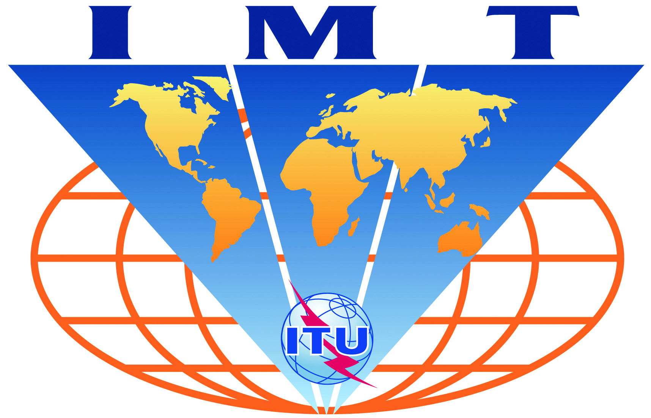

IMT-Advanced-Satellite
Evaluation Group Registration Form

Name of the Evaluation Group:

ETSI TC SES Mobile Satellite System Working Group

Organizations participating in the Group's evaluation activities:

Thales, ETRI, Hughes Network Systems, EADS Astrium, DLR, ESA, Inmarsat, SES Astra, etc...

Contact person(s):
- name: Nicolas CHUBERRE, Chairman of the MSS WG of TC SES at ETSI
- telephone: +33 6 80 94 84 32
- email: nicolas.chuberre@thalesaleniaspace.com
- related web site (if available): http://portal.etsi.org/Portal_Common/home.asp

