|  |  |
| --- | --- |
| **Radiocommunication Study Groups** |  |
|  |  |
|  |  |
| Source: Document 3J/TEMP/6 | **Document 3J/FAS/3-E** |
| **22 June 2012** |
| **English only** |
| Working Party 3J | |
| FASCICLE | |
| concerning the rainfall rate model given in Annex 1[1] to Recommendation ITU-R P.837-6 | |

# 1 Introduction

Current rain attenuation prediction methods need as input, among the other parameters, the rainfall rate (mm/h) exceeded for given percentages of the year. This parameter can be directly measured or approximated for each location worldwide by using the rainfall rate prediction method given by Recommendation ITU-R P.837-4. Obviously, any inaccuracy in rainfall rate provided by Recommendation ITU-R P.837-4 directly affects the accuracy of rain attenuation models.

In 1999, Study Group 3 adopted a new version of Recommendation ITU-R P.837 (version 2) in which the old rain zone maps (given in version 1) had been replaced by the Salonen-Baptista double exponential model, [Poiares-Baptista and Salonen, 1998]. Recommendation ITU-R P.837 relies on this model and requires as input the following meteorological parameters:

– MS = mean annual stratiform rainfall amount (mm);

– MC = mean annual convective rainfall amount (mm);

– Pr6 = probability of rainy 6-hours periods (%).

These parameters have been mapped all over the world using 15 years of re-analysis products of the European Centre for Medium-range Weather Forecasts (ECMWF, ERA15 dataset).

More recently, a new product has been available from ECMWF (ERA40 dataset), which is a new reanalysis product generated by ECMWF over a longer period by using updated assimilation and forecast procedures and with a better spatial resolution than ERA15. The objective of this fascicle is to describe the methodology used to improve the prediction method given in Recommendation ITU‑R P.837-4 and adopted in June 2007 to constitute the in-force Recommendation ITU‑R P.837‑5, by reconsidering both the model input parameters and the model coefficients [Castanet et al., June 2007] [Castanet et al., August 2007].

# 2 Description of ECMWF re-analysis products

Two databases available at ESA [Martellucci, 2004]: NA-4 and ERA 15 have been used to generate maps of input parameters for ITU-R Recommendations.

The NA-4 database contains 2 years (from 10/1992 to 9/1994) of ECMWF analysis products and has been used to generate climatological maps for Recommendations ITU-R P.836-3 (IWVC: Integrated Water Vapour Content), ITU-R P.840-3 (ILWC: Integrated Liquid Water Content) and ITU-R P.1511 (mean annual temperature at ground level) and has been used also for creating statistics of cloud ice total content [Martellucci et al., 2002].

The ECMWF Re-analysis (ERA) 15 database has been used to generate maps of input parameters for Recommendations ITU-R P.452 (Nwet: wet term of the refractive index), P.835 (profiles of pressure, temperature and humidity), ITU-R P.837 and ITU-R P.839 (h0: mean annual altitude of the 0°C isotherm above mean sea level).

## 2.1 ERA 15 database (including Climpara’98)

The ERA-15 database contains data derived from ECMWF re-analysis activities of the period (January 1979 - December 1993) [ERA 15, 1999]. Each point of a regular grid (1.5×1.5 degrees) that covers the whole globe, contains values of total air pressure at surface, total fractional cloud cover, total column water, total column vapour and vertical profiles of air temperature, specific humidity and wind velocity along N-S and E-W directions at 31 model levels. The vertical profiles are referred to time 00.00, 06:00, 12:00, 18:00 UTC. Maps of surface geopotential and land-sea mask are also available. The following precipitation parameters are available for the same period and sampling time: stratiform accumulated precipitation; convective accumulated precipitation and total accumulated snowfall.

ERA 15 database has been used to generate maps of input parameters for Recommendations ITU‑R P.452 (Nwet: wet term of the refractive index), ITU-R P.835 (profiles of pressure, temperature and humidity), and ITU-R P.839 (h0: mean annual altitude of the 0°C isotherm above mean sea level), ITU-R P.834 (Effects of tropospheric refraction on radiowave propagation, paragraph 6) and ITU-R P.835 (Reference standard atmospheres, Annex 3).

Concerning rainfall rate statistical parameters, ERA 15 has been used to generate maps of Ms (mean annual stratiform rain amount), Mc (mean annual convective rain amount) and Pr6: (probability of rain in 6 hours) currently used in Recommendation ITU-R P.837, also called Climpara’98 rain maps [Poiares-Baptista and Salonen, 1998]. From these parameters, the mean total rainfall amount (Mt) and the mean annual convectivity ratio that is the convective-rainfall-amount to total-rainfall-amount ratio () can be calculated (see Figure 1).

Figure 1

Climpara’98 maps of Mt (upper figure),  (middle figure) and Pr6: (lower figure)  
generated from ERA 15 [Poiares-Baptista and Salonen, 1998]

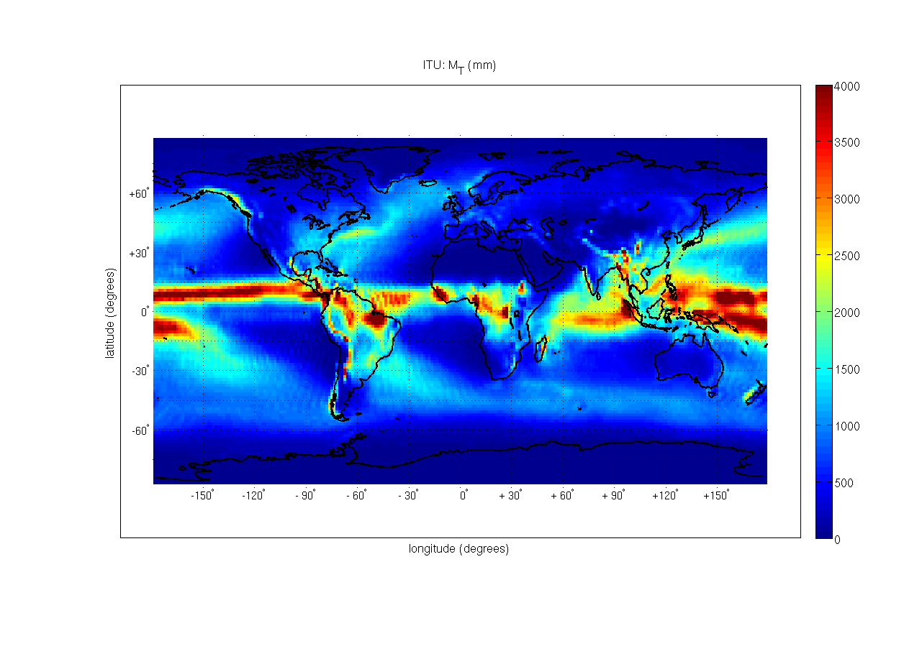

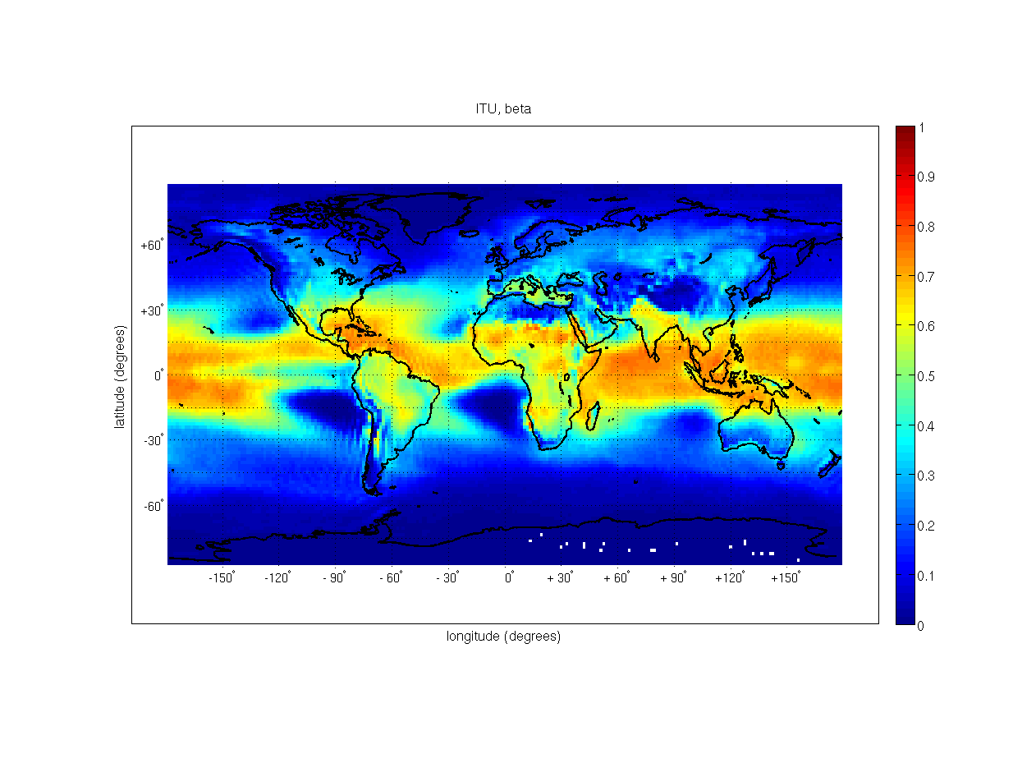

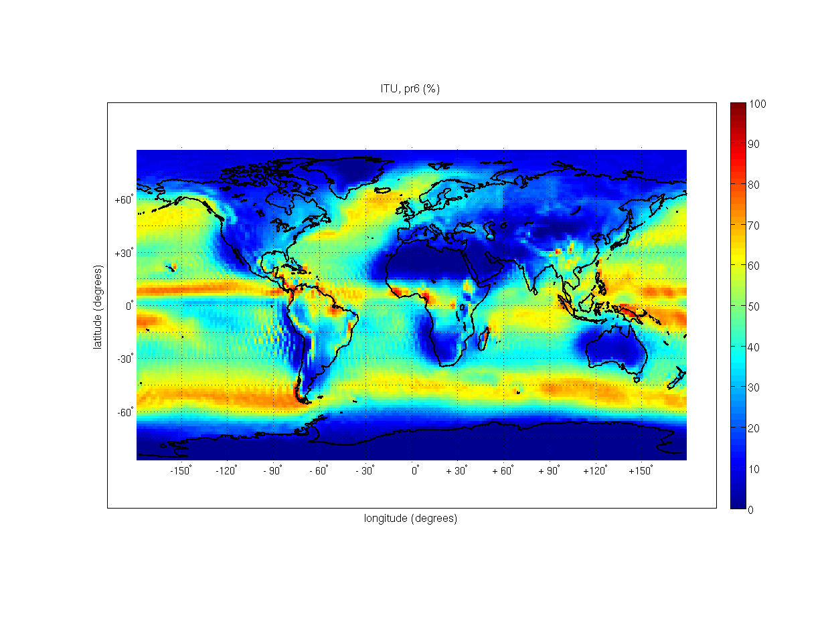

## 2.2 ERA 40 database

ERA 40 is a new reanalysis product generated by ECMWF using improved assimilation and forecast procedures and covering a longer period with a better spatial resolution than ERA 15. The ERA-40 database contains data derived from ECMWF re-analysis activities over the period (mid 1957 - 2001) [ERA 40, 2002]. Each point of a regular grid (1.125×1.125 degrees) that covers the whole globe contains values of surface total air pressure, sea or soil temperature, fractional cloud cover, total column water, two-metre dewpoint and air temperature, large scale accumulated precipitation, convective scale accumulated precipitation, large scale accumulated snowfall, convective scale accumulated snowfall and profiles of air temperature, specific humidity, cloud water and solid density, fractional cloud cover and wind velocity along N-S and E-W direction at 47 model levels. Vertical profiles are referred to time 00.00, 06:00, 12:00, 18:00 UTC. A major difference between the ERA15 and 40 dataset is the possibility of deriving for the latter the convective and large-scale rain accumulated over 6 hrs directly from the corresponding precipitation and snowfalls quantities. In the following large-scale is renamed as stratiform.

Based on the observational data that were used, the whole ERA40 time period 1958-2001 can be divided into three parts: the satellite period 1989-2001 when a large amount of satellite data were assimilated into the ERA40 system, the pre-satellite period 1958-1972 when no satellite data were available, and the transition period 1973-1988 when the amount of satellite data that were assimilated increases with time. These periods correspond also to the three streams which were produced separately during the ERA40 production timeframe. Regarding precipitation, the quality of the hydrological cycle (i.e. the system of equations used to obtain precipitation forecasts) differs between the periods as the biases in the hydrological cycle are strongly influenced by the different observing systems available in the three periods [ECMWF, 1].

Concerning rainfall statistical parameters, as for ERA 15, ERA 40 can be used to generate climatological maps of Ms (mean annual stratiform rain amount), Mc (mean annual convective rain amount) and Pr6: (probability of rain in 6 hours), input parameters of Recommendation ITU‑R P.837. From these parameters, the mean total rainfall amount (Mt) and the mean annual convectivity ratio that is the convective-rainfall-amount to total-rainfall-amount ratio () can be calculated (see Figure 2).

Then, the differences for these parameters between ERA 40 and Climpara’98 are presented in Figure 3.

As far as Mt is concerned, strong percentage differences between ERA40 and ITU are present, as one could expect, over very dry regions (Antarctica, West coasts of Africa and South America, North Africa/Middle East, Greenland, Himalayan range, etc). Generally ERA40 and ITU differ by less than ±20%, but higher discrepancies can be noted over some European regions, South America, Tropical Africa and India: this is likely due to the different reanalysis procedures used by ECMWF.

Regarding , the main differences occur in the tropical belt where ERA40 values of  over land are lower than those from Climpara’98 (especially over Africa, India and Indonesia), whereas over oceans the opposite is observed (ERA 40 gives higher values than Climpara’98).

Concerning Pr6, differences are also concentrated in the tropical belt (mainly over South America) and essentially over equatorial and tropical oceans (in particular over Indian Ocean and West coasts of South America, Africa and Australia).

From this analysis, it appears therefore the interest of comparing climatological maps extracted from ECMWF reanalysis products with respect to other sources of data, such as meteorological or Earth observation products.

Figure 2

Maps of Mt (upper figure),  (middle figure) and Pr6: (lower figure) generated from ERA 40

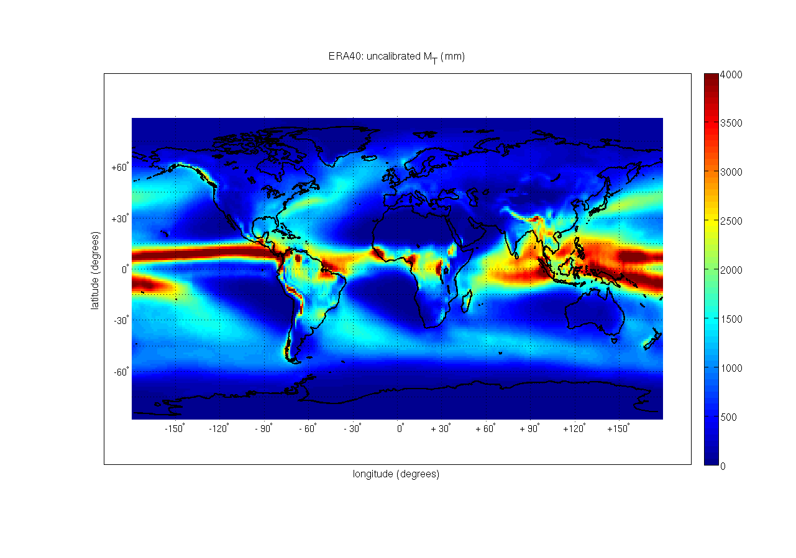

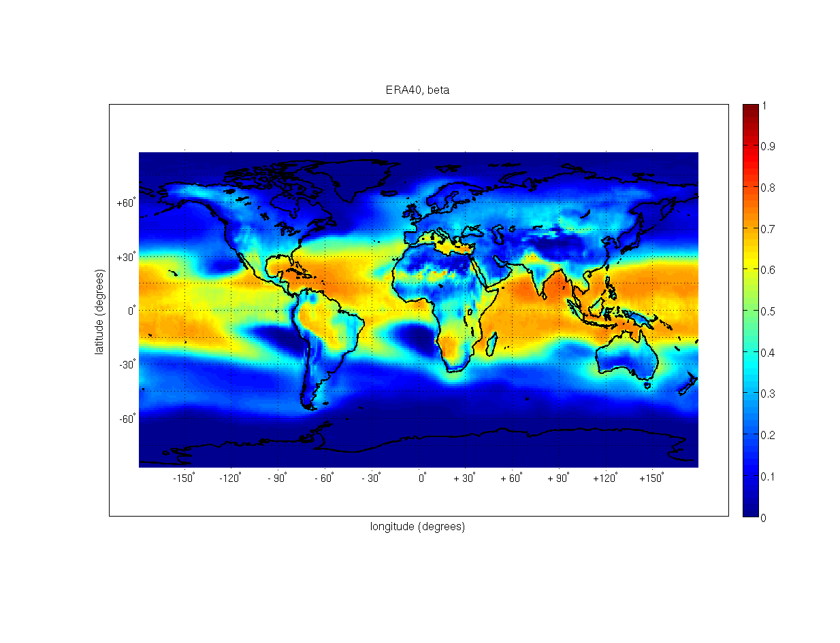

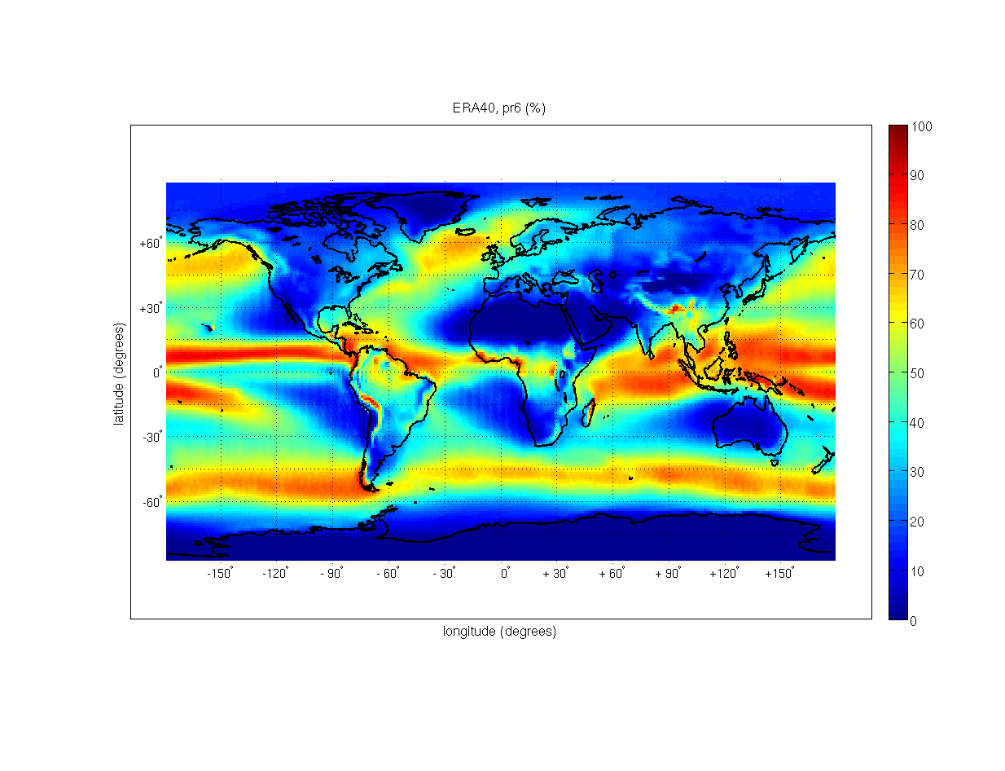

Figure 3

Maps of the differences between Mt (upper figure),  (middle figure) and Pr6: (lower figure) generated from ERA 40 and from Climpara’98 (ERA40 being calculated at the corresponding ITU grid point  
by bi-linear interpolation)

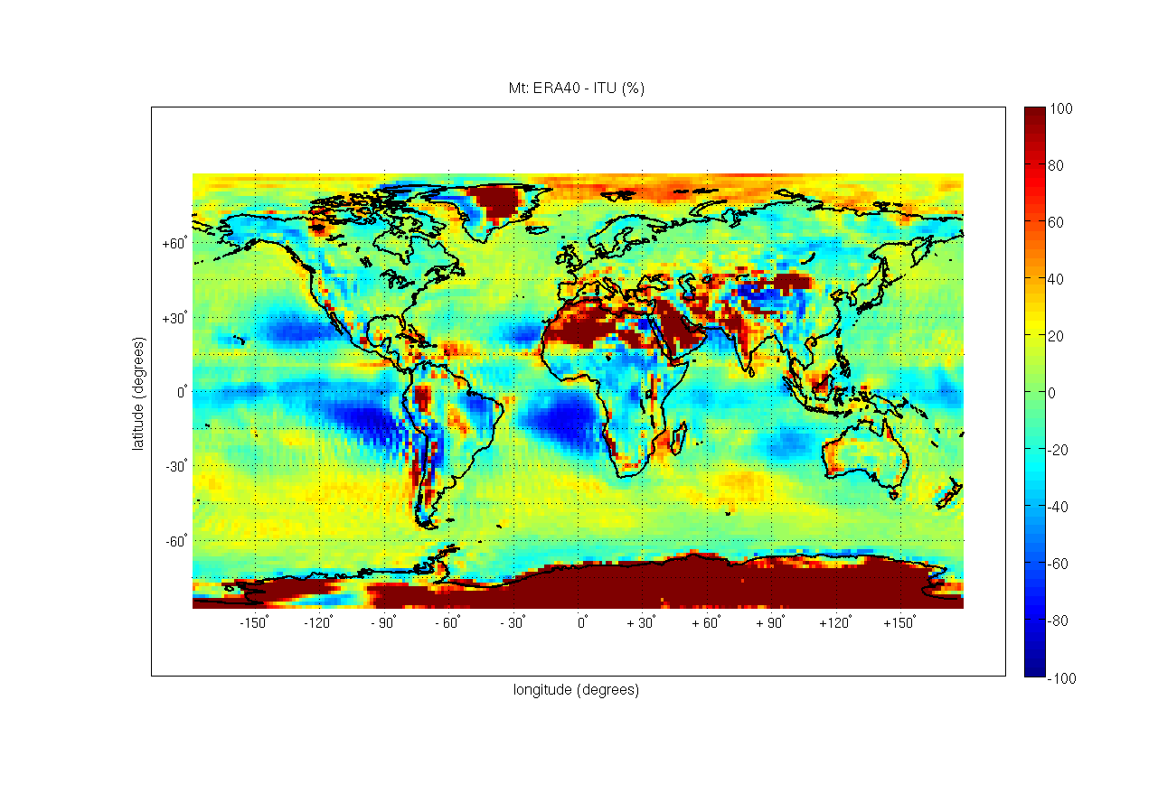

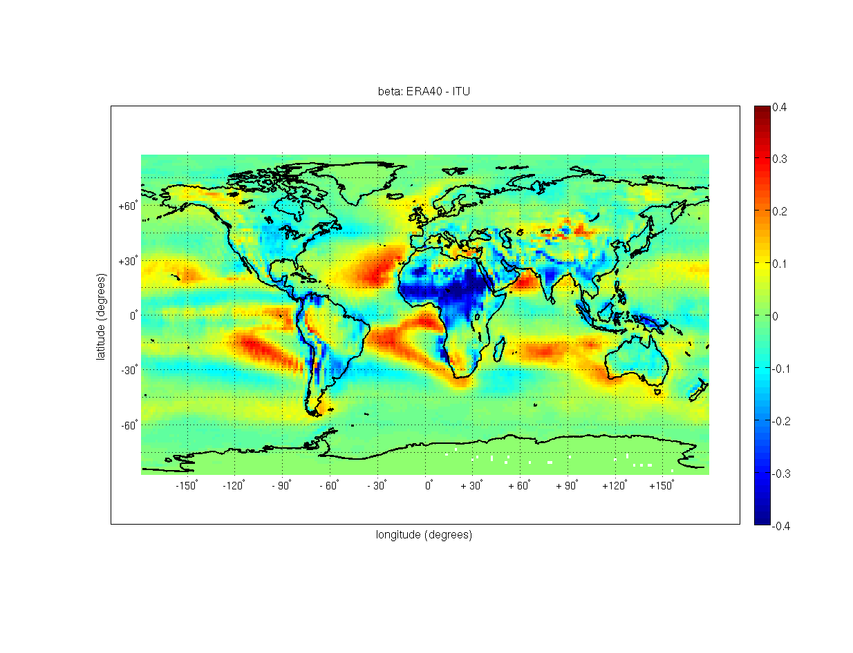

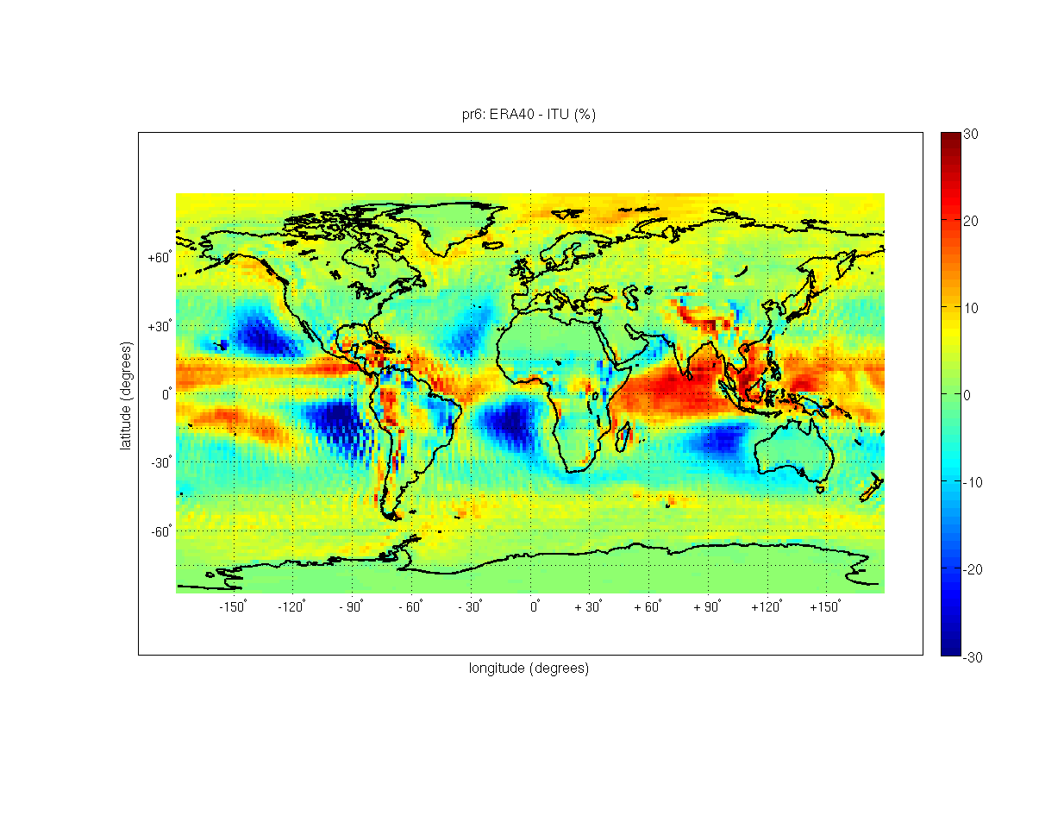

# 3 Comparison of precipitation parameters derived from ECMWF products, meteorological data and Earth Observation products

In this section, a comparative analysis of precipitation parameters derived from ECMWF re‑analysis data is performed with respect to gridded meteorological data and Earth observation products.

## 3.1 Global meteorological data

Global meteorological data consist of databases gathering measurements carried out worldwide, that could be either direct measurements at specific locations (distributed all over the world) or products generated from direct measurements and re-interpolated over a regular grid covering the world. Three datasets have been analyzed in this study: GHCN, GPCC, and GPCP.

### 3.1.1 GHCN data

The Global Historical Climatology Network (GHCN) version 2 (used here) database contains time series of temperature, precipitation, and pressure data for thousands of land surface rain gauge stations worldwide. The global surface climate dataset of GHCN is used operationally by NCDC (*National Climatic Data Center, USA*) to monitor the climatic variability, and it is widely applied in studies of climate change and in international assessment activities. This last version of the database was released in May 1997.

In this study, only the last 105 years of the available measurements have been selected, more precisely, from 1900 to 2005. The Monthly values of total precipitation of this period have been processed to derive the yearly mean value of the accumulated rain for each station. Stations with less than 10 years of available measurements were excluded from analysis. A total of 584 stations reported wrong values of latitude, longitude and country code and therefore were discarded. 18 521 valid GHCN stations have been selected for the subsequent analyses.

Figure 4 shows the value of mean yearly cumulated rain for each station expressed in millimeters.

Figure 4

Worldwide values of mean yearly cumulated rain (Mt) extracted from the GHCN dataset

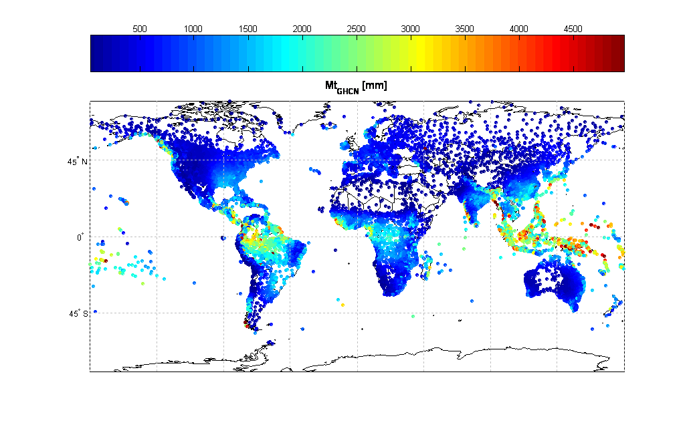

### 3.1.2 GPCC data

The Global Precipitation Climatology Centre of the Germany’s National Weather Service (Offenbach, Germany) provides with monthly gridded precipitation analyses based on in-situ observed data from rain gauge networks. Among the others, the “Full Data Product” is recommended for hydrometeorological and verification studies, due to its high accuracy. Each GPCC grid point represents the mean precipitation over the corresponding grid box.

GPCC dataset has been generated from a vast collection of rain gauge measurements (including GHCN dataset), worldwide distributed. In-situ values are interpolated on regular grid points using a sophisticated interpolation technique. Monthly area-average precipitation on regular grid boxes is given at different spatial resolutions: 0.5×0.5 degrees, 1.0×1.0 degrees and 2.5×2.5 degrees. A relevant aspect is that both the ERA40 and the GPCC datasets cover the same time period (i.e. 1951 to 2004). The main drawback of this dataset is that GPCC gridded data are not available over sea.

Values of mean annual rainfall amount (Mt) as obtained from GPCC “Full Data Product” at (2.5×2.5 degrees) are shown in Figure 5. It can be noted that GPCC values are available over continents as well as over islands.

Figure 5

Mean annual rainfall amount (Mt) as obtained from GPCC “Full Data Product”  
at (2.5×2.5 degrees)

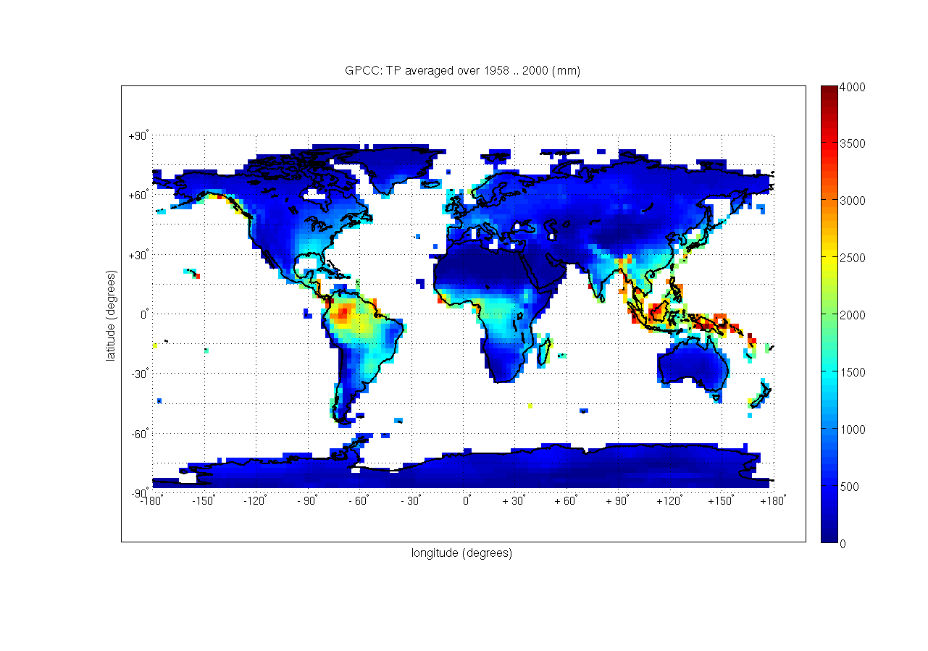

### 3.1.3 GPCP data

The Global Precipitation Climatology Project of the NASA Goddard Space Flight Center (USA) provides monthly mean precipitation data on a (2.5 × 2.5 degrees) latitude/longitude grid. Among the others, the GPCP “satellite-gauge precipitation product” (version 2) provides globally complete, monthly estimates of surface precipitation. It is a merged analysis that incorporates precipitation estimates from low-orbit satellite microwave data, geosynchronous-orbit satellite infrared data, and surface rain gauge observations from GPCC.

The major advantage of GPCP over GPCC is that it covers both lands and sea, but the drawback is that represented by its shorter time period (i.e. 1979 .. 2001 vs. the GPCC 40 years dataset).

Values of mean annual rainfall amount (Mt) as obtained from GPCP “satellite gauge precipitation product” are shown in Figure 6. The combination of satellite and ground measurements allows to characterize the precipitation field both over land and sea. However, due to the characteristics of Earth observation orbits the Arctic region is not covered.

Figure 6

Mean annual rainfall amount (Mt) as obtained from GPCP “Satellite Gauge precipitation product”  
at (2.5×2.5 degrees)

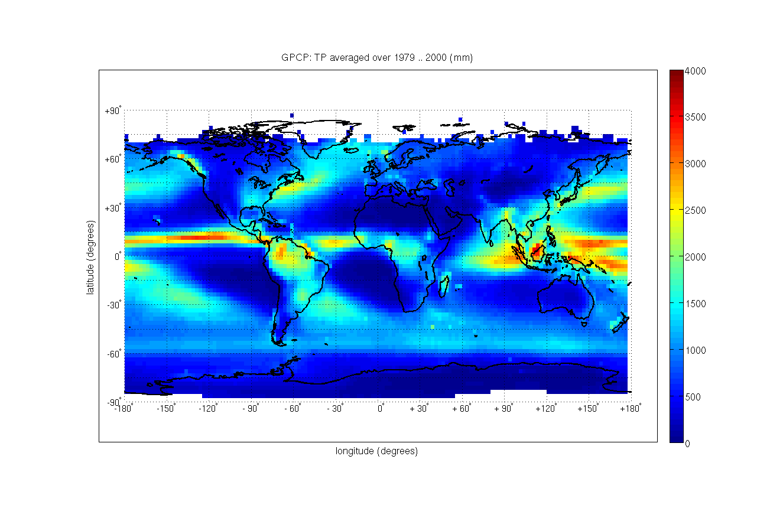

## 3.2 Earth observation satellites: TRMM products

Recent progress in satellite remote sensing of the atmosphere has been done in the last years thanks to the success of different Earth observation missions. Among them, the NASA-JAXA TRMM mission is of particular interest as its main goal has been to characterize precipitation in the tropical belt.

In the framework of the TRMM project, the following products have been generated: orbital data products (Level-1,2 TRMM data), ground-based data products, gridded data products (Level-3 TRMM data), other data products (GPI, SSM/I, etc.). In particular Level-3 TRMM products provide meteorological parameters on regular grids covering the tropical and sub-tropical areas at various spatial (from 5×5 degrees up to 0.25×0.25 degrees) and time (from monthly up to 3-hours) resolutions.

Among these Level-3 TRMM products, the 3B43 product that provides mean monthly rainfall rate (see Figure 7) in the latitude belt contained between 50 N and 50 S with a spatial resolution of 0.25×0.25 degrees (lat/long), has been used in this study. Using this product the annual mean rainfall amount can be calculated.

Figure 7

TRMM 3B43: mean annual rainfall amount (mm)

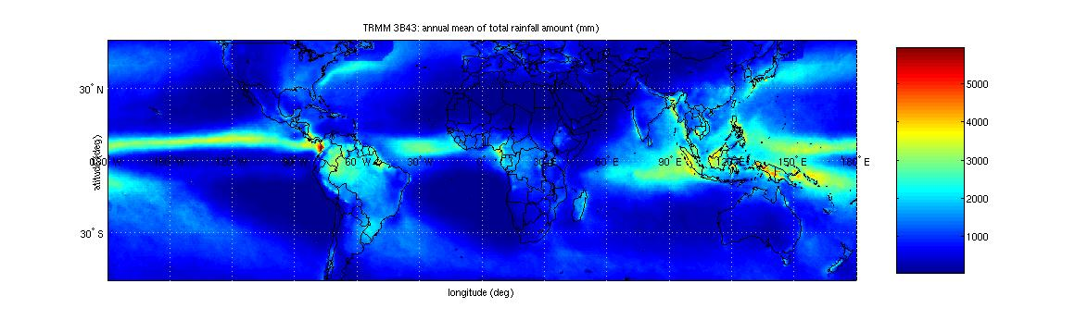

### 3.2.1 Comparison of annual mean rainfall amounts from TRMM, ERA15 and ERA40

By considering that:

– TRMM 3B43 is suggested as the best TRMM product for monthly rainfall;

– 3B43 dataset includes all the period from 1998 to 2004;

– TRMM data have not been used for ERA (15 and 40) processing;

– ERA Precipitation parameters are generated by forecast processes.

The annual mean rainfall amount obtained from 3B43 is assumed as an independent reference value for the assessment of ERA precipitation products.

Thus, it has been compared with annual rainfall amount as given by Recommendation ITU-R P.837-4 (Figure 8), that was originally derived from the ECMWF ERA15 product.

Figure 8

ITU : mean annual rainfall amount (mm) from Recommendation ITU-R P.837-4

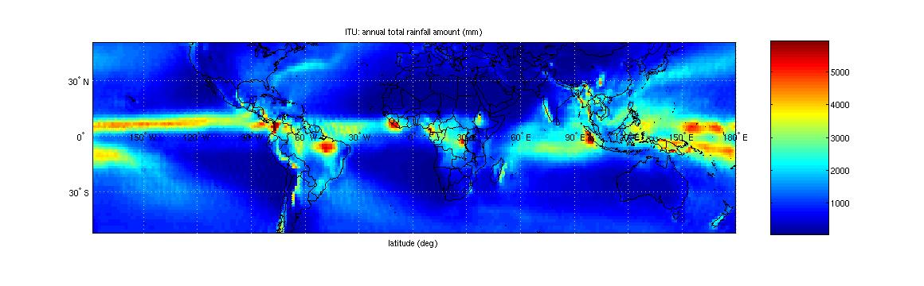

Figure 9

Mean annual rainfall amount: ITU minus 3B43 (mm) (ITU being calculated at the  
corresponding 3B43 grid points by bi-linear interpolation)

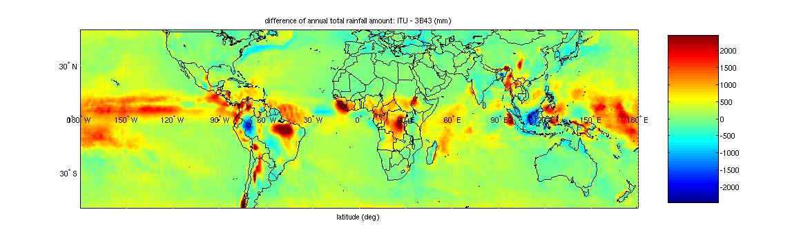

The two datasets are in good agreement over land at mid-latitudes, but there are major differences in tropical areas (see central Africa, South-America, Indonesia), (see Figure 9). These differences could be ascribed to the overestimation of precipitation in ERA15, as already noted in [ECMWF, 1 and 3].

Similar differences have observed also for the ERA40 dataset [ECMWF, 1 and 2]. The annual rainfall amount was obtained from ERA40 (see Figure 10) and TRMM 3B43 for the same temporal period (01/01/1998 . 31/12/2001).

Those differences between ERA and TRMM products can be ascribed to the issues of clouds and precipitation physical modelling in particular over the tropical regions.

Figure 10

ECMWF ERA40: mean annual rainfall amount (mm).   
The spatial resolution is 2.5x2.5 degrees, time period is from 01/01/1998 to 31/12/2001

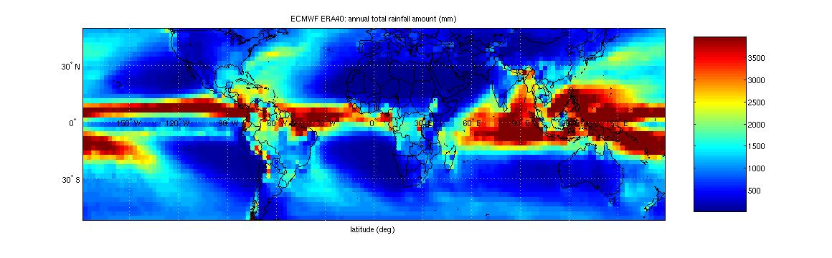

Figure 11

mean annual rainfall amount: ERA40 minus 3B43 (mm)  
(ERA40 being calculated at the corresponding 3B43 grid points by bi-linear interpolation)

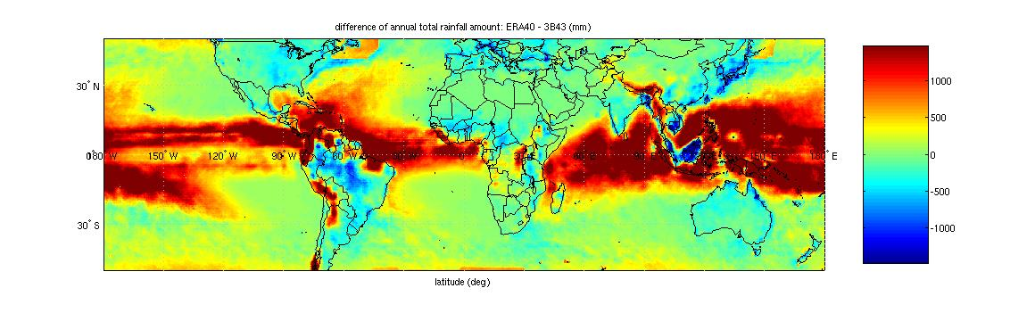

The comparison (see Figure 11) shows that ERA40 provides a slightly improved representation of precipitation over land with respect to the ERA15 (in particular over tropical Africa and South-America). In spite of these improvements, a significant overestimation of tropical precipitation over oceans still affects ERA40 data.

These results are in agreement with those of [ECMWF, 1 and 2]: the differences between TRMM 3B43 and ERA40 are similar to those observed between ERA40 and GPCP data. This was expected, considering that GPCP data are also used for generating the 3B43 TRMM product.

Due to the severe overestimation of precipitation over oceans in the tropics (and in some areas over land), care should be taken when using ERA15 and ERA40 data and a correction procedure has to be defined for ERA40 precipitation data.

### 3.2.2 Conclusion of the analysis of TRMM data

To the aim of testing or improving the accuracy of Recommendation ITU-R P.837, the use of TRMM products has been considered to derive the input climatic parameters: Ms, Mc and Pr6. From the analysis and the processing of TRMM Level-3 products, the following conclusions can be drawn.

Strong discrepancies have been found about the mean annual rainfall amount (MT) obtained from TRMM 3B43 and ECMWF ERA15/40 data, especially over the tropics. It seems that ERA15/40 data overestimate precipitation due to a problem in the humidity scheme of the ECMWF assimilation system, as already found for the ERA15 dataset [ECMWF, 1 and 3] and ERA40 dataset [ECMWF, 1 and 2]. This overestimation is particularly strong in ERA40 data over tropical oceans, so further analysis on ERA 40 needs to be performed in order to solve this problem.

Similar analysis has been done on the probability of rain. Indeed, the probability of rainy 3-hours periods (Pr3) can be calculated directly from TRMM 3B42 dataset. This can be converted into Pr6 in order to be used as input for the rainfall rate prediction model given in Recommendation ITU‑R P.837-4. Strong discrepancies between TRMM 3B42 and ECMWF ERA15 have been found about Pr6 over oceans and in few areas over land. This could be ascribed to an overestimated precipitation in ERA15 data, due to a problem in the humidity scheme of the ECMWF assimilation system, as already found for the ERA15 dataset [ECMWF, 1 and 3], and ERA40 dataset [ECMWF, 1 and 2].

Concerning the ratio of convective to total rain, it is not possible to directly compare TRMM and ERA 15 / ERA 40 results since the definitions of stratiform and convective rain adopted by TRMM and ECMWF do not correspond.

From the analyses presented in this section it can be concluded that the ERA 40 product can be used to derive the precipitation parameters relevant for rainfall rate modelling (as in Recommendation ITU-R P.837-4) using an approach similar to that originally used for the ‘Climpara 98’ model. However, the comparison with TRMM data revealed that the ERA products, and in particular ERA40, can overestimate the mean annual rainfall amount, especially over tropical and equatorial areas. Therefore this parameter has to be corrected using other data sources, as discussed in the following.

# 4 Correction of ERA 40 derived mean annual rainfall amount

The benefits of using ERA40 product for rain modelling are:

– ERA40 is generated from assimilation and forecast procedures updated   
with respect to the ones used for ERA15.

– The horizontal spatial resolution is higher than in ERA15.

– The longer ERA40 time period ensures higher statistical stability and could also allow analysis of seasonal effects.

However, the overestimation of ERA40 annual rainfall amount discussed in the previous chapter and in [ECMWF, 1 and 2] calls for a correction procedure.

## 4.1 Correction criteria and reference data for ERA 40 calibration

The correction of the ERA 40 mean annual rainfall amount (MT parameter) is to be performed primarily over land but also values over sea are of interest. The goal is to obtain a final, calibrated map of MT with improved accuracy, spatial resolution and statistical stability w.r.t. the current one used in Recommendation ITU-R P. 837-4.

To fulfill this goal, two main aspects need to be considered:

– to identify independent precipitation data sources for ERA 40 correction;

– to design a correction procedure.

### 4.1.1 Datasets of precipitation measurements for ERA 40 calibration

Different precipitation data sources can be considered for the calibration of ERA 40 mean annual rainfall amount. The selection of data sources is done by taking into account the following issues:

– accuracy of precipitation measurements;

– the data should be available over a regular grid covering the world or from point measurements distributed all over the world with a sufficiently high density network;

– the period of observation should be concurrent with the ERA 40 period (1958 .. 2001).

The analysis of the available precipitation datasets yields to the following conclusions:

– TRMM dataset, despite its high accuracy, cannot be used for calibration due to its limited temporal coverage (1998 .. present). Nevertheless, it can be used on a later stage for validation of the corrected ERA 40 precipitation parameters.

– GHCN dataset cannot be used for calibration due to its highly sparse spatial coverage and its irregular time availability over time (especially in the period 1973 .. 2000).

– GPCC dataset “Full Data Product” represents a valid solution due to its highly accurate precipitation estimates, spatial homogeneity and long-term duration concurrent with ERA 40 data. These data provide with precipitation values over land only, and have been chosen to calibrate ERA 40 data.

– GPCP dataset “satellite-gauge precipitation product” (version 2) represents a valuable, independent source of precipitation estimates, available on a global scale. However, these data are available over a shorter period (1979 .. 2000) than ERA 40. GPCP data have been chosen to calibrate ERA40 precipitation over sea only.

### 4.1.2 Description of ERA40 precipitation correction procedure

The first part deals with the correction of ERA 40 precipitation over land by using GPCC precipitation. The second part describes with the calibration of ERA 40 precipitation over oceans by using GPCP precipitation estimates. The final map of calibrated ERA 40 mean annual rainfall amount (MT) is obtained by superimposition of land and sea maps.

Standard rain gauges and satellite estimates of precipitation, on which GPCC and GPCP data rely, are affected by the presence of ice/snow [DAAC, 1], [GPCP, 1] , therefore the calibration of ERA 40 data (over land and sea) is carried out by considering the total precipitation amount (i.e. rain + snow). This parameter is calculated after applying a threshold of 0.1 mm/6h to ERA 40 original precipitation time series, to remove numerical noise. This procedure was also applied originally on ERA15 processing for the ‘Climpara’ model.

ERA 40 Calibration over land

The calibration process is performed for each one of the three ERA 40 data stream and is calculated for each grid point and for each year within the same data stream after conversion of all data to a common high resolution grid (0.125×0.125 degrees).

For each grid point and for each year yi within the data stream DSj, the calibration factor is given by the ratio of the Total Precipitation (TP):

 (1)

where: m = index of the m-th GPCC (2.5×2.5 degrees) grid point. If both nominator and denominator of Equation (1) are equal to zero, .

The calibrated ERA 40 total precipitation is then calculated over the high-resolution grid as:

 (2)

 (3)

Where

 is the average value of the correction in grid point factor during one of the three ERA40 data streams (*DSj*).

Equation (3) is used only for a small subset of grid points where total precipitation is almost zero.

Finally, the data are converted to the original ERA 40 resolution of (1.125×1.125 degrees) by standard bilinear interpolation.

ERA 40 Calibration over sea

The same principle is applied for the calibration of ERA 40 over sea. However, as GPCP and ERA 40 data are not concurrent, two periods are considered :

– the period between 1958 and 1978 where no GPCP data are available;

– the period between 1979 and 2000 where GPCP and ERA 40 are concurrent.

The new calibration factors are therefore :

 for the period between 1979 and 2000 (4)

 for the period between 1958 and 1978 (5)

where:

 = GPCP precipitation averaged over the period (1979 .. 2000) and m = index of the m-th GPCP (2.5×2.5 degrees) grid point. Here again, if both nominator and denominator are equal to zero, .

The calibrated ERA 40 total precipitation is then calculated over the high-resolution grid as:

 (6)

 (7)

Equation (7) is used only for a small subset of grid points where total precipitation is almost zero.

Finally, the data are converted to the original ERA 40 resolution of (1.125×1.125 degrees).

Merging of calibrated ERA40 over land and sea and calculation of MT

The final calibrated ERA40 total precipitation map is obtained by merging maps of ERA40 calibrated over land and sea separately. Calibrated ERA40 mean annual rainfall amount (MT) is finally obtained by multiplying the calibrated ERA40 total precipitation by the ratio of rain over total precipitation, as obtained from the original ERA40 data.

### 4.1.3 Comparison with other datasets

A comparison between mean annual rainfall amount obtained from new calibrated ERA 40, from in-force Recommendation ITU-R P.837-4, from TRMM and from GHCN datasets is carried out, in order to quantify features and potential improvements guaranteed by the new map.

Qualitative analysis

Figure 12 shows the Final ERA 40 MT map calibrated by GPCC and GPCP data.

Figure 12

Calibrated ERA 40 mean annual rainfall amount (MT)

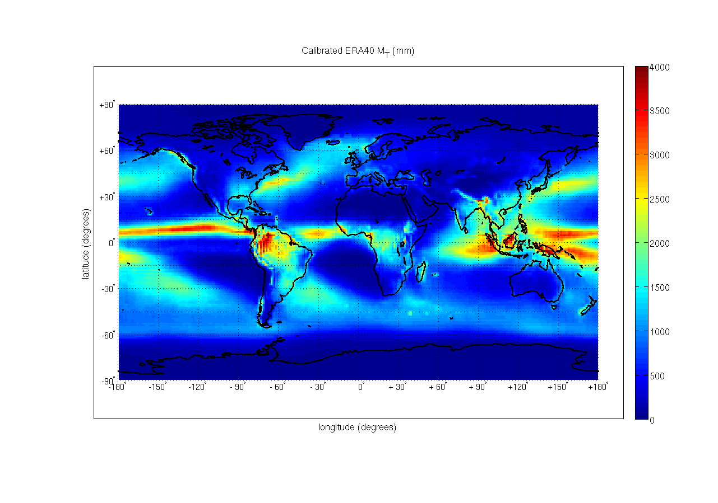

As expected, MT values are higher over tropical land and oceans. It can be noted in Figure 13 that the year-to-year variability is generally lower than 20%. Higher variabilities are present, as one could expect, over very dry regions (Antarctica, North Africa/Middle East, Australian desert, Andes). On the other hand, high variability over limited areas of equatorial and tropical oceans could be due to the climatology of those specific regions.

Figure 13

Calibrated ERA 40: MT interannual variability

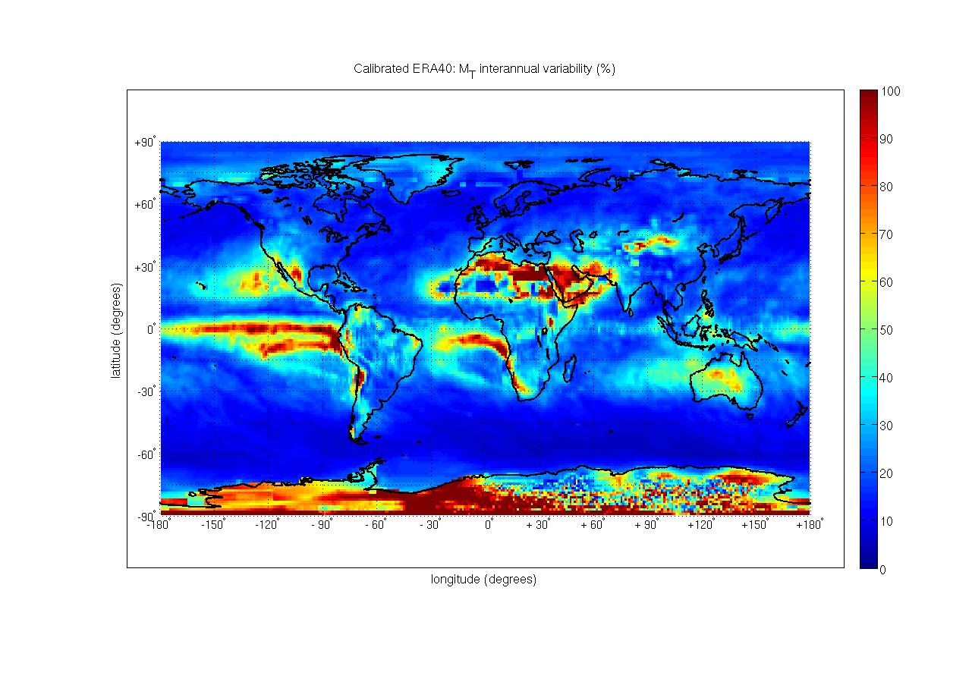

On a global scale, the relative difference in mean annual rainfall amounts between ERA 15, original ERA 40 and calibrated ERA 40 w.r.t. those obtained from TRMM is given in Figure 14.

Figure 14

MT: percentage difference between TRMM 3B43 and original ERA 40 (top),  
Recommendation ITU-R P. 837-4 (centre) and calibrated ERA 40 (bottom)

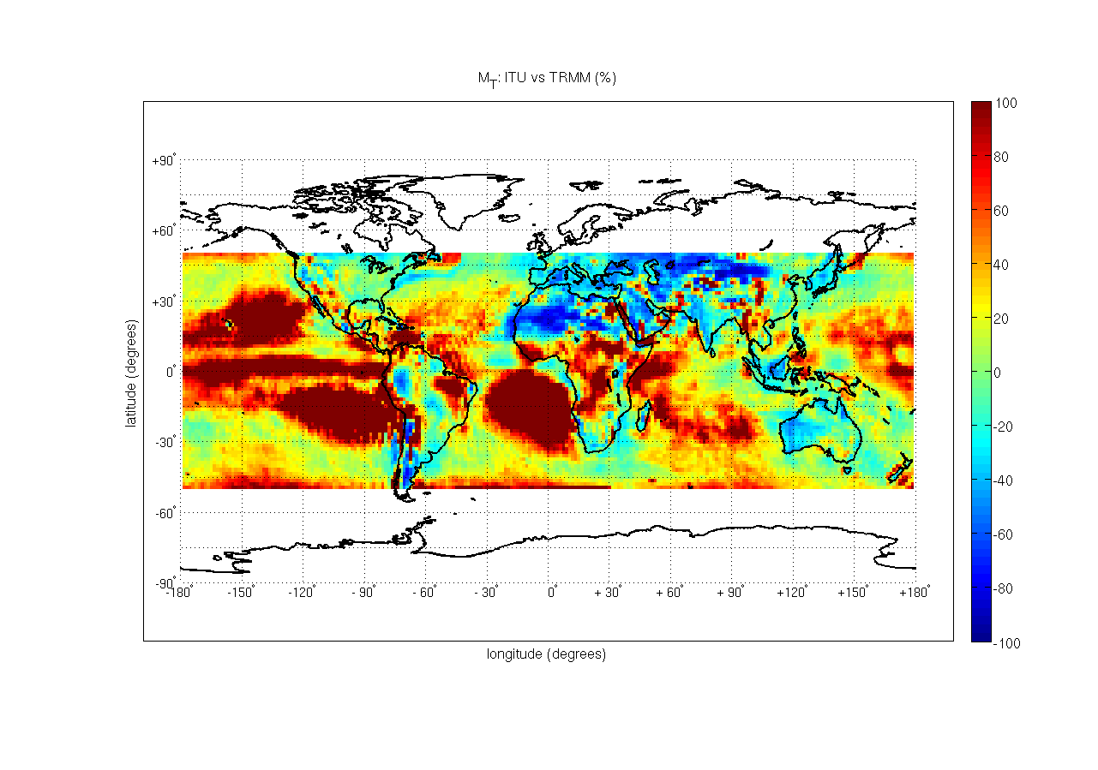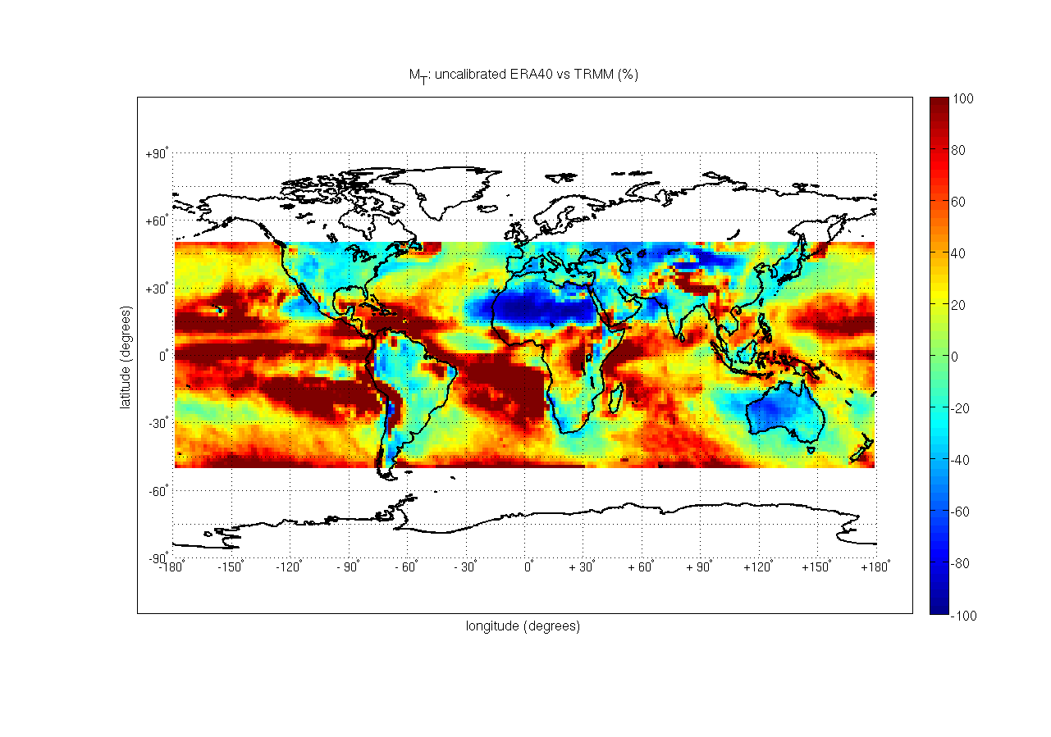

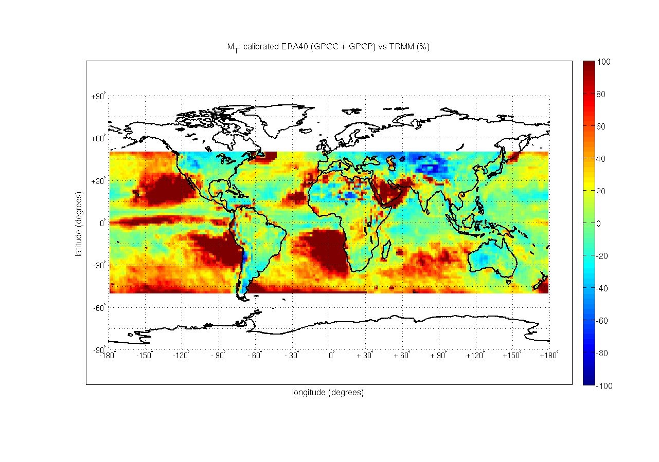

It can be noted that both ERA 15 and uncorrected ERA 40 highly overestimate precipitation over oceans in the tropical belt, while over land differences are concentrated over Africa, South America and Asia (with particular emphasis over mountains). On the other hand, it can be seen that the calibration of ERA 40 over land results in a much better agreement with TRMM. Over sea, it can be seen the effective improvement obtained by calibrating ERA40 by GPCP data: high percentage differences over oceans shown in Figure 14 are mainly concentrated over very dry regions (West coasts of North/South America and Africa). Calibrated ERA40 is nearly equal to TRMM on Eastern Pacific and Indian Ocean, but wetter over Western Pacific and in general over middle and high latitudes (Figure 14): this could be related to limitations of GPCP estimates over these areas [GPCP, 1]. Generally speaking, discrepancies with values from TRMM over oceans could indicate that TRMM is better in estimating precipitation on these areas [TRMM, 1], [GPCP, 1].

Quantitative analysis

A quantitative analysis is now carried out by averaging MT from ERA 15, calibrated ERA 40 and TRMM over latitudes (for land and sea separately), and then comparing them (see Figure 15 and Figure 16). The mean, STD and RMS values are summarized in Table 1.

Figure 15

Mean annual rainfall amount (left-hand figure) and relative difference (right-hand figure), average latitude values over land: comparison between TRMM (black line), ERA 40 calibrated by GPCC (2.5 x 2.5 deg,   
blue dashed line) and Rec. ITU-R P.837-4 (red dashdot line). Missing values between 65S .. 50S in the  
left figure are due to the lack of land, TRMM values are available only between 50S .. 50N

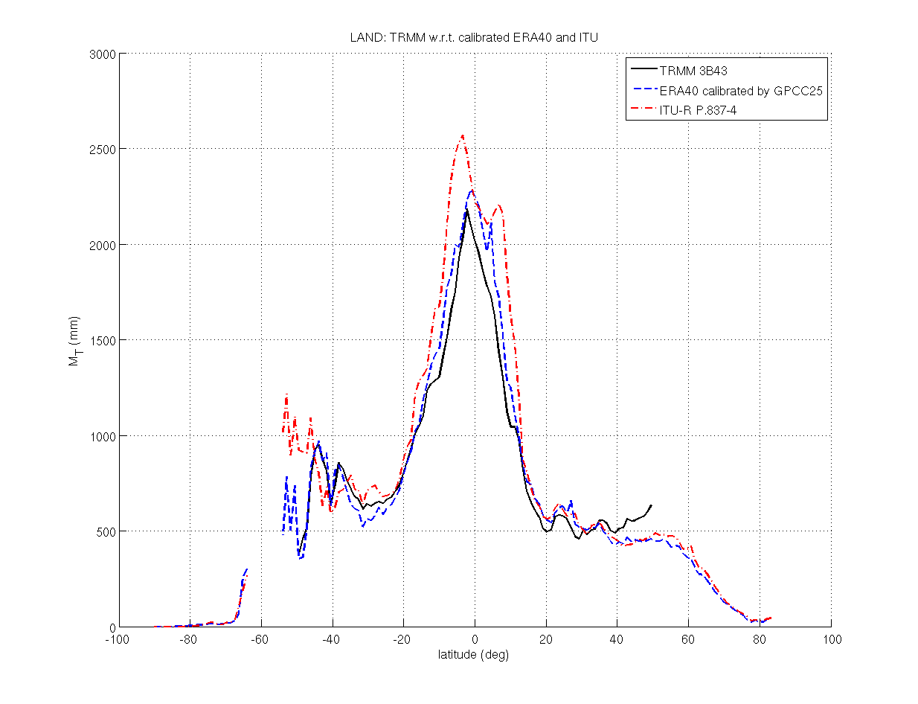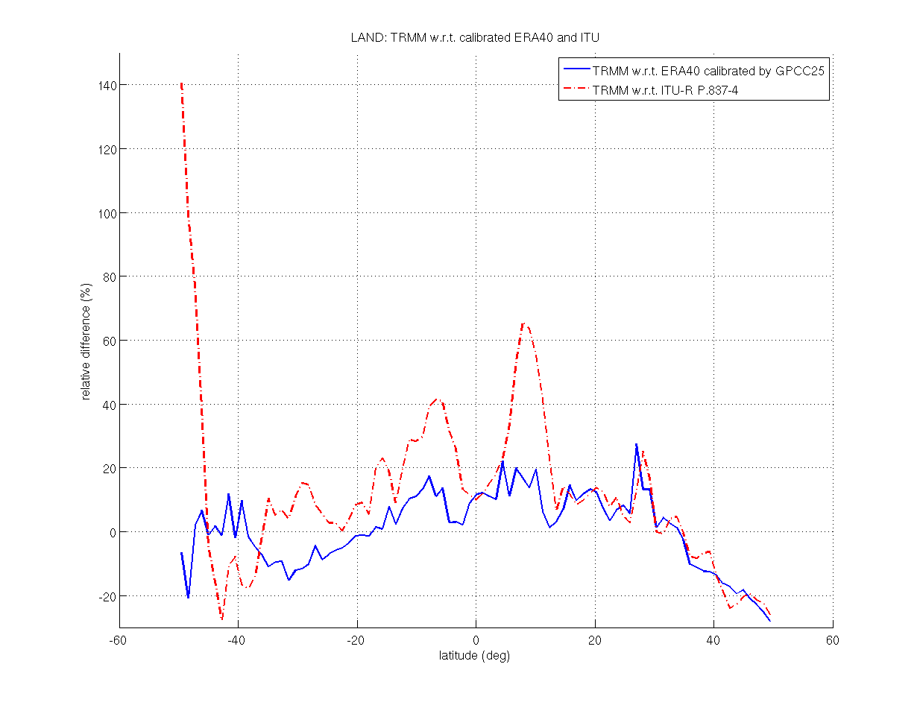

Figure 16

Mean annual rainfall amount (left) and relative difference (right), average latitude values over sea: comparison between TRMM (black line), uncalibrated ERA40 (magenta dashdot line), ERA 40 calibrated by ECMWF coefficients (green line), ERA40 calibrated by GPCP (2.5×2.5 deg, blue dashed line) and Rec. ITU-R P.837-4  
(red dashdot line). TRMM values are available only between 50S .. 50N.

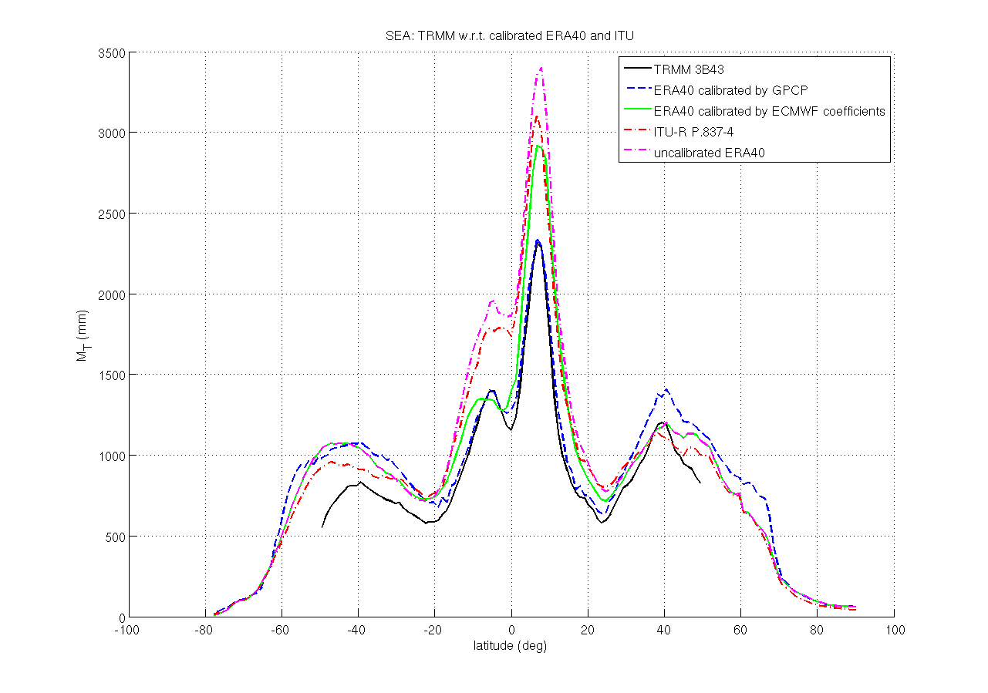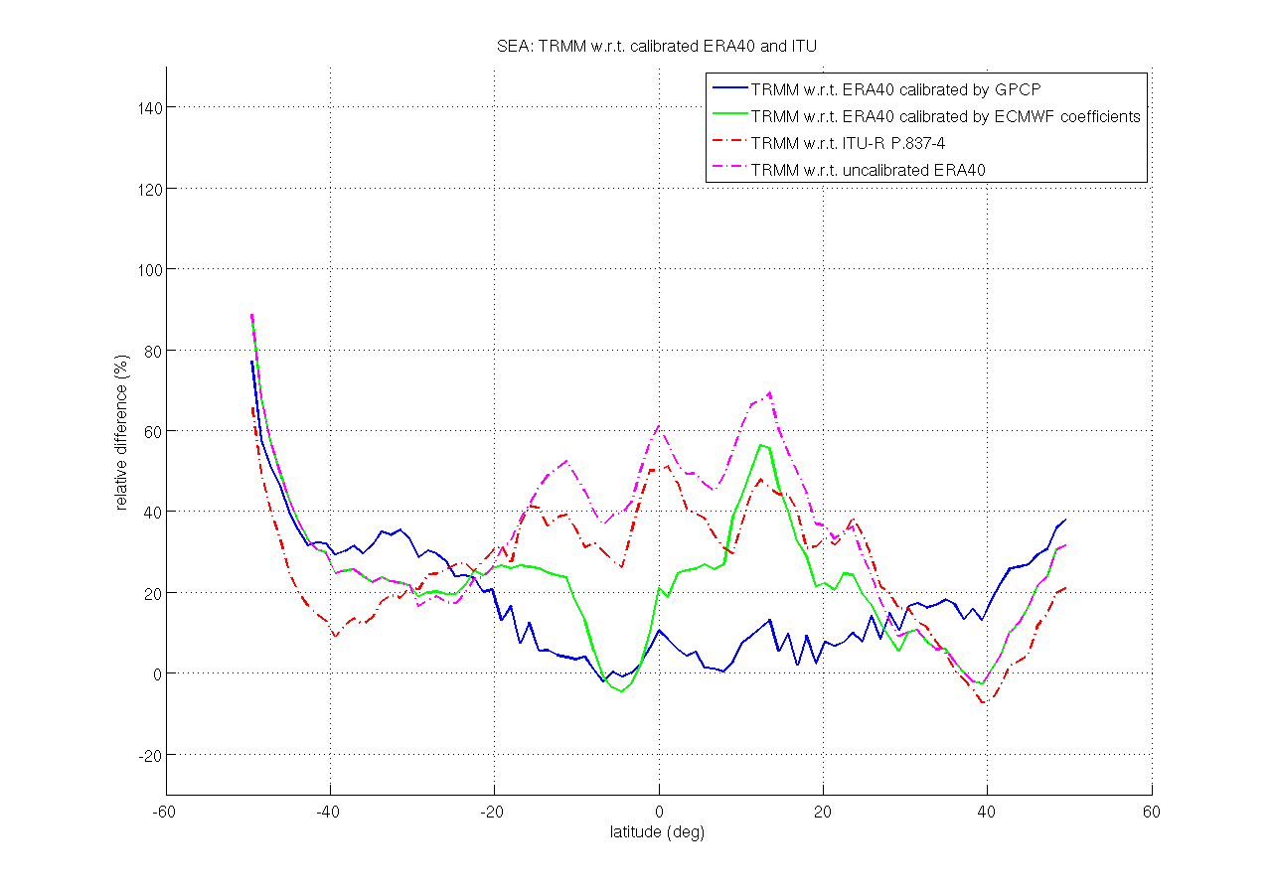

In the above figures, ERA40, TRMM and ITU values are averaged respectively over the periods (1958 .. 2000), (1998 .. 2004) and (1979 .. 1993).

This analysis confirms the effective improvement guaranteed by using calibrated ERA 40 rather than ERA 15 or uncalibrated ERA40 values, especially in the latitude range 50S .. 15N. Results summarised in

Table 1 highlight a reduction of ~18% (land) and ~12% (sea) of RMS values and the cancellation of the positive bias (from 12.6% to 0.9% over land, from 26.5% to 15.5% over sea) when using calibrated ERA 40 instead of ERA 15. When compared to the original ERA40, calibrated ERA40 allows a reduction of ~19% (land) and ~16.5% (sea) of RMS values as well as of the positive bias (from 7.9% to 0.9% over land, from 33.6% to 15.5% over sea).

Table 1

Summary of bias, std and RMS of the relative difference of TRMM 3B43 w.r.t calibrated ERA 40 and Rec. ITU‑R P.837-4 (red = comparison over land, green = comparison over sea)

|  |  |  |  |
| --- | --- | --- | --- |
|  | Mean | STD | RMS |
| ERA 15 vs. TRMM (%) | 12.6 | 26.8 | 29.5 |
| Uncalibrated ERA 40 vs. TRMM (%) | 7.9 | 29.5 | 30.4 |
| Calibrated ERA 40 vs. TRMM (%) | 0.9 | 11.7 | 11.7 |
| ERA 15 vs. TRMM (%) | 26.5 | 15.0 | 30.4 |
| Uncalibrated ERA 40 (GPCP) vs. TRMM (%) | 33.6 | 19.0 | 38.5 |
| Calibrated ERA 40 (GPCP) vs. TRMM (%) | 15.5 | 15.7 | 22.0 |

Further comparisons are carried out using GHCN precipitation data, following the methodology defined in the previous section. Figure 17 shows the relative difference w.r.t. original and calibrated ERA 40 at each GHCN station, with results summarized in Table 2.

Figure 17

Percentage error between GHCN and ERA 40 calibrated with GPCC at resolution of  
2.5 degrees (left-hand figure) and between *GHCN and original ERA 40  
(right-hand figure),* y axis is limited to [–200 400]%



A further refinement has been made by evaluating the relative differences according to three latitude belts:

– Equatorial belt:  deg 🡪 266 GHCN stations

– Tropical belt:  &  deg 🡪 1677 GHCN stations

– Temperate belt:  &  deg 🡪 4362 GHCN stations

Results are summarized in Table 2. It can be noted that in all latitude belts the calibrated ERA 40 guarantees significantly reduced bias and RMS values ~10-20% lower than the original ERA 40. It can also be noted that equatorial and especially tropical belt present higher differences with respect to GHCN than the temperate belt.

Table 2

Summary of bias, std and RMS of the relative difference between GHCN and calibrated/original  
ERA 40, globally and for 3 different latitude belts

|  |  |  |  |
| --- | --- | --- | --- |
| Parameters | | Corrected ERA 40 vs. GHCN | Original ERA 40 vs. GHCN |
| GHCN | Mean (%) | 0.9 | 15.3 |
| STD (%) | 33.4 | 48.3 |
| RMS (%) | 33.4 | 50.7 |
| EQ. Belt | Mean (%) | 2.3 | -7.0 |
| STD (%) | 31.7 | 47.7 |
| RMS (%) | 31.7 | 48.3 |
| TROP. Belt | Mean (%) | 1.5 | 11.2 |
| STD (%) | 49.6 | 59.3 |
| RMS (%) | 49.6 | 60.3 |
| TEMP. Belt | Mean (%) | 0.6 | 18.3 |
| STD (%) | 24.7 | 42.9 |
| RMS (%) | 24.7 | 46.6 |

# 5 Rainfall rate modelling

In this chapter, the optimization of Recommendation ITU-R P. 837-4 model coefficients is described. Firstly, the analytical expression of the proposed model is given, secondly the databases used to perform modelling and testing activities are defined, thirdly the results of the modelling activity are summarized before giving in the last section the results of the testing activity.

## 5.1 Basic principles of the proposed model of the CDF of rainfall rate

The analytical model of the rainfall rate CDF given in current Recommendation ITU-R P.837-4 has the following expression:

 (1)

where [*a, b, c, P0*] are calculated from the meteorological quantities [*MT, Pr6h, Mc, Ms*], derived from the ERA 15 database:

 (2)

In the modelling activity, the analytical shape of the model, i.e. equation 1 and the proposed relationships (equations 2), is still assumed to be valid, so that the parameters to be optimized (hereinafter referred to as “unknowns”) become the numerical coefficients in equations 2, that have been indicated with *x, y, z, a*0 in equations 3:

 (3)

The input meteorological database in this activity is the “corrected ERA 40” (described in the previous chapter).

## 5.2 Databases of experimental rain rate statistics

The reference database of measured CDFs of rainfall rate for modelling and testing purposes is Table IV-1 of DBSG3 containing 743 experimental statistics distributed over the 139 locations shown in Figure 18.

Figure 18

Position of the 139 stations (CDFs of rainfall rate) extracted from the DBSG3



Position of the 139 locations where rainfall rate statistics are available  
Colorbar indicates the number of available years of each location

**5.2.1 Generation of the databases for modelling and testing purposes**

Measured CDFs of rainfall rate are carefully checked and, when necessary, pre-processed before their use in the modelling and testing activities. A three step pre-processing procedure is applied:

1) Selection of the CDF of rainfall rate.

2) Conversion of integration time from *n*-minute to 1-minute (when needed).

3) Generation of multiple-year statistics.

As far as the first point is concerned, only yearly experimental CDFs of rainfall rate are taken into account, i.e. corresponding to duration longer than 340 days.

Regarding the second point, the DBSG3 C4-1 database contains some yearly CDFs of rainfall rate with integration time longer than 60 s, specifically, 300 s and 1200 s. Such curves are converted to 60 s integration time according to [ITU-R Document 3J/TEMP/55, 26 October, 2004]:

 (mm/h) (4)

where:

– from *n* = 5 min to 1 min, the coefficients in equation (20) are *a* = 0.97 and *b* = 1.04: applied to 4 CDFs of rainfall rate in Korea;

– from *n* = 20 min to 1 min, the coefficients in equation (20) are *a* = 0.85 and *b* = 1.13: applied to 26 CDFs of rainfall rate in Spain and to 28 CDFs of rainfall rate in China.

Concerning the third point, when multiple year statistics are not directly provided by experimenters, multiple year statistics are generated by computing for any probability level, the arithmetic mean of the associated rain rate values extracted from the single year CDFs of rainfall rate.

*Remark: From the theoretical point of view, this procedure is not correct: the correct one, in fact, would require averaging the probability levels at each given rain rate value. Because of the high correlation between the probability of occurrence and the rain rate, the difference in the output result of the two procedures is almost negligible (the RMS of the difference between the two curves is around 4 % for the long-term rain rate CDF in Spino d’Adda shown in Figure 19).*

Figure 19

Available CDFs of rainfall rate in Spino d’Adda (Milano - Italy) useful for multiple years statistics generation. The correspondent long-term rainfall rate statistics is indicated by the bold dashed black curve



On the other hand, the proposed method has two advantages: 1) it maintains as much as possible the full probability interval of the original CDFs of rainfall rate, 2) it uses directly the values provided in the database, without interpolation, thus avoiding to introduce further approximation of the measured values.

### 5.2.2 Database for modelling purposes

A limited number (31) of sites is selected to constitute the database devoted to the modelling activity. The selection of the sites is carried out by taking into account to the following conditions, applied in sequence:

1) well behaved shape of the curve with respect to the analytical model (in order to obtain reasonable parameters from the fitting procedure);

2) proper geographical distribution of the sites (in order to consider all possible kinds of climates). In particular, care has been paid in choosing an adequate number of sites – the wider the belt, the higher the number of sites – in each geographical belt (see below);

3) availability of multiple year measurements (in order to reduce as much as possible the year to year variability effects in the modelling activity);

4) geographical sites with specific microclimates are not used (e.g. very small islands).

The three belts are defined as (see Appendix G):

– Equatorial:  degrees

– Tropical:  degrees

– Temperate:  degrees

List of the selected sites:

Table 3, Table 4 and Table 5 list the sites selected for the modelling activity, where D indicates the number of years relative to each experiment. All the selected sites are plotted in Figure 20.

Table 3

List of sites extracted from DBSG3 and selected for the modelling activity in the equatorial belt

|  |  |  |  |  |  |  |
| --- | --- | --- | --- | --- | --- | --- |
| # site | Station | Code | Lat. (deg) | Lon. (deg) | D | R0.01% |
| 1 | TABATINGA | 82210 | –4.23 | –69.94 | 1 | 110.5 |
| 2 | BELEM | 82010 | –1.45 | –48.48 | 7 | 126.9 |
| 3 | FORTALEZA | 82060 | –3.77 | –38.55 | 3 | 62 |
| 4 | MANAUS | 82090 | –3.15 | 60.02 | 7 | 110 |
| 5 | Bukit Tima | 48710 | 1.3 | 103.9 | 3 | 128.2 |

Table 4

List of sites extracted from DBSG3 and selected for the modelling activity in the tropical belt

|  |  |  |  |  |  |  |
| --- | --- | --- | --- | --- | --- | --- |
| # site | Station | Code | Lat. (deg) | Lon. (deg) | D | R0.01% |
| 6 | CRUZEIRO DO SUL | 82040 | –7.6 | –72.67 | 1 | 120.1 |
| 7 | BATCHELOR | 94120 | –13.056 | 131.023 | 3 | 95.12 |
| 8 | SAN ANTONIO DE PRADO | 80090 | 6.19 | –75.66 | 4 | 71.6 |
| 9 | BRASILIA | 82030 | –15.48 | –47.83 | 4 | 71 |
| 10 | GOV.VALADARES | 82070 | –18.85 | –41.95 | 2 | 61 |
| 11 | RIO DE JANEIRO | 82150 | –22.92 | –43.95 | 11 | 71.78 |
| 12 | Bangkok | 48320 | 13.7 | 100.5 | 3 | 110.2 |
| 13 | Bandung | 96010 | –6.9 | 107.6 | 3 | 115.4 |
| 14 | HAIKOU | 50100 | 20.03 | 110.47 | 10 | 116.9 |

Table 5

List of sites extracted from DBSG3 and selected for the modelling activity in the temperate belt

|  |  |  |  |  |  |  |
| --- | --- | --- | --- | --- | --- | --- |
| # site | Station | Code | Lat. (deg) | Lon. (deg) | D | R0.01% |
| 15 | VANCOUVER | 71110 | 49.25 | –123.22 | 2 | 11.86 |
| 16 | WALLOPS IS | 72011 | 37.8 | –75.5 | 4 | 59.69 |
| 17 | NORMAN | 72120 | 35.21 | –97.44 | 4 | 68.64 |
| 18 | CHEB | 11410 | 50.0739 | 12.3889 | 6 | 24.8 |
| 19 | CURITIBA | 82050 | –25.42 | –49.28 | 2 | 59.48 |
| 20 | Spino d'Adda | 16010 | 45.4 | 9.5 | 8 | 48.35 |
| 21 | Chicago | 72040 | 41.9 | 87.65 | 10 | 63.26 |
| 22 | Miami | 72070 | 25.65 | –80.43 | 10 | 115.9 |
| 23 | BADAJOZ | 8030 | 38.88 | –6.97 | 20 | 26.77 |
| 24 | CASTELLON | 8050 | 39.95 | –0.07 | 15 | 39.05 |
| 25 | MADRID | 8120 | 40.42 | –3.68 | 20 | 20.49 |
| 26 | SEVILLA | 8180 | 37.41 | –5.9 | 9 | 30.21 |
| 27 | SEOUL | 47108 | 37.57 | 126.97 | 10 | 74.68 |
| 28 | PUSAN | 47159 | 35.1 | 129.03 | 10 | 74.83 |
| 29 | ANQING | 50010 | 30.52 | 117.03 | 10 | 74.03 |
| 30 | BEIJING | 50020 | 39.8; | 116.47 | 10 | 58.01 |
| 31 | ZHENGZHOU | 50280 | 34.72 | 113.65 | 10 | 60.73 |

Figure 20

Position of the 31 stations extracted from DBSG3 and selected for modelling purpose



### 5.2.3 Database for testing purposes

All the sites that have not been considered for the modelling activity are used for the testing activity (68 sites); they are listed in Table 6 and graphically reported on a world map in Figure 21. As for the modelling database, *D* indicates the number of years relative to each experiment.

Table 6

List of sites extracted from the DBSG3 Table C4-1 and selected for the testing activity

| # site | Station | Code | Lat. (deg) | Lon. (deg) | D | R0.01% |
| --- | --- | --- | --- | --- | --- | --- |
| 1 | Macapá | 82080 | 0.3 | –51.1 | 1 | 119 |
| 2 | Boa Vista | 82020 | 2.78 | –60.68 | 1 | 112 |
| 3 | Ponta Das Lages | 82120 | –3.2 | –59.9 | 2 | 98 |
| 4 | Santarém | 82170 | –2.5 | –54.72 | 1 | 112.4 |
| 5 | São Paulo | 82190 | –23.53 | –46.62 | 3 | 66.89 |
| 6 | Mosqueiro | 82100 | –1.4 | –50.69 | 2 | 129.7 |
| 7 | Natal | 82110 | –5.77 | –35.2 | 2 | 91 |
| 8 | Kuala Lumpur | 48610 | 3.16 | 101.71 | 3 | 138 |
| 9 | Annaburroo | 94110 | –12.914 | 131.673 | 3 | 107.95 |
| 10 | Bathurst | 94130 | –11.772 | 130.62 | 2 | 94.11 |
| 11 | Lba | 82200 | –10.35 | –62.58 | 1 | 107.82 |
| 12 | Ayura | 80010 | 6.17 | –75.52 | 4 | 61.84 |
| 13 | Convento | 80030 | 6.34 | –75.52 | 4 | 60.9 |
| 14 | Cucaracho | 80040 | 6.29 | –75.61 | 4 | 68 |
| 15 | Gerona | 80050 | 6.23 | –75.56 | 4 | 65.1 |
| 16 | Girardota | 80060 | 6.39 | –75.46 | 4 | 50.68 |
| 17 | Manantiales | 80070 | 6.32 | –75.54 | 4 | 55.42 |
| 18 | Pedregal | 80080 | 6.31 | –75.58 | 4 | 56.76 |
| 19 | San Cristobal | 80100 | 6.28 | –75.64 | 4 | 60.69 |
| 20 | Recife | 82140 | –8.05 | –34.9 | 3 | 71.02 |
| 21 | Kwajalein | 91250 | 8.79 | 167.62 | 7 | 77.93 |
| 22 | Siracha | 48310 | 13.1 | 100.8 | 3 | 111.36 |
| 23 | Wallops Is | 72015 | 37.8 | –75.33 | 4 | 55.43 |
| 24 | Reston | 72140 | 38.95 | –77.33 | 4 | 56.75 |
| 25 | Tampa | 72160 | 28.06 | –82.42 | 4 | 95.46 |
| 26 | Porto Alegre | 82130 | –51.22 | –51.22 | 1 | 51.13 |
| 27 | Frantiskovy Lazne | 11420 | 50.11 | 12.35 | 6 | 20.6 |
| 28 | Praha - Klementinum | 11430 | 50.09 | 14.41 | 5 | 28.4 |
| 29 | Praha – Testcom | 11440 | 50.03 | 14.48 | 7 | 30 |
| 30 | Houston | 72050 | 29.77 | –95.73 | 8 | 93.75 |
| 31 | Jacksonville | 72060 | 28.34 | –80.93 | 8 | 91.4 |
| 32 | Montreal | 71030 | 45.52 | –73.57 | 10 | 45.66 |
| 33 | Alicante | 8010 | 38.28 | 0.55 | 20 | 29.97 |
| 34 | Caceres | 8040 | 39.47 | –6.33 | 20 | 24.65 |
| 35 | Ciudad Real | 8060 | 38.98 | –3.92 | 20 | 19.83 |
| 36 | Cordoba | 8070 | 37.85 | –4.83 | 7 | 31.24 |
| 37 | Cuenca | 8080 | 40.07 | –2.13 | 9 | 22.31 |
| 38 | Guadalajara | 8100 | 40.63 | –3.17 | 7 | 20.57 |
| 39 | Melilla | 8140 | 35.28 | 2.91 | 19 | 24.51 |
| 40 | Molina De Aragon | 8150 | 40.85 | –1.22 | 15 | 24.64 |
| 41 | Moron De La Frontera | 8160 | 37.15 | –5.62 | 7 | 34.54 |
| 42 | Murcia | 8170 | 38.1 | 1.1666 | 19 | 21.69 |
| 43 | Toledo | 8200 | 39.88 | –4.88 | 20 | 19.73 |
| 44 | Valencia | 8210 | 39.48 | –0.38 | 15 | 32.56 |
| 45 | Granada | 8090 | 37.18 | –3.78 | 15 | 16.77 |
| 46 | Huelva | 8110 | 37.28 | –6.91 | 10 | 38.67 |
| 47 | Malaga | 8130 | 36.66 | –4.48 | 10 | 34.61 |
| 48 | Taejon | 47133 | 36.37 | 127.37 | 10 | 70.67 |
| 49 | Taegu | 47143 | 35.88 | 128.62 | 10 | 46.16 |
| 50 | Changchun | 50030 | 43.9 | 125.22 | 10 | 48.6 |
| 51 | Chongqing | 50040 | 29.58 | 106.47 | 10 | 72.12 |
| 52 | Dalian | 50050 | 38.9 | 121.63 | 10 | 51.88 |
| 53 | Dongxing | 50060 | 21.53 | 107.97 | 10 | 155.3 |
| 54 | Fuzhou | 50070 | 26.08 | 119.28 | 10 | 78.08 |
| 55 | Guanzhou | 50080 | 23.05 | 113.32 | 10 | 101.86 |
| 56 | Guilin | 50090 | 25.33 | 110.3 | 10 | 90.42 |
| 57 | Hangzhou | 50110 | 30.32 | 120.2 | 10 | 63.8 |
| 58 | Harbin | 50120 | 45.68 | 126.62 | 10 | 52.35 |
| 59 | Jinan | 50130 | 36.68 | 116.98 | 10 | 67.72 |
| 60 | Nanchang | 50170 | 28.67 | 115.97 | 10 | 72 |
| 61 | Nangjing | 50180 | 32.32 | 118.8 | 10 | 61.55 |
| 62 | Shenyang | 50190 | 41.77 | 123.43 | 10 | 48.95 |
| 63 | Taiyuan | 50200 | 37.78 | 112.55 | 10 | 31.72 |
| 64 | Urumqi | 50210 | 43.9 | 87.47 | 10 | 15.2 |
| 65 | Wuhan | 50220 | 30.63 | 114.07 | 10 | 78.68 |
| 66 | Xining | 50240 | 36.58 | 101.92 | 10 | 21.3 |
| 67 | Yichun | 50250 | 27.8 | 114.38 | 10 | 64 |
| 68 | Yinchuan | 50260 | 38.4 | 106.22 | 10 | 22 |

Figure 21

Position of the 68 stations extracted from DBSG3 and selected for testing purpose



### 5.3 Rainfall rate modelling activity[2]

A three step procedure is applied to optimise the coefficients of the model:

1) Analytical fit of each experimental CDF of rainfall rate of the database for modeling.

2) Inversion of the model (equations 3) to retrieve the four coefficients for each measured CDF.

3) Weighted average of the whole set of the four coefficients.

In the first step, the rainfall rate CDF estimated by Recommendation ITU-R P.837-4 is fitted to each measured CDF of rainfall rate pertaining to the modelling database in order to derive the best set of the four parameters [*afit, bfit, cfit, P*0*,fit*]. The fitting procedure is based on the minimization of the difference (considering rain rate values) between the measured and the analytical curves, through the Gauss-Newton method.

In the second step, the inversion of the first three relationships in equation 3, allows the unknowns to be retrieved as a function of the meteorological input (calibrated ERA 40) parameters and of the fitting parameters [*afit, bfit, cfit, P0,fit*]:

    (4)

The above procedure generates a set of 31 unknowns, from which the “best set” of coefficients applicable to any location has to be derived.

In the third step, of the procedure, the term “weighted” means that the average values of the four coefficients are obtained by taking into account the statistical stability of the measured CDFs of rainfall rate as explained in detail below. Moreover, the term “average” means: an arithmetic average for the coefficient *a* and a geometric average for coefficients *xi, yi, zi*.

Both in the process to generate the “best set“ of coefficients and in the testing activity it is necessary to properly take into account the quality (in terms of statistical stability) of the measured CDFs of rainfall rate. It is obvious, in fact, that the coefficients derived by a long term CDF of rainfall rate should weight more in the computation of the “best set“ than the ones coming from a one-year experiment. In other words, the rain rate prediction model should predict more accurately a long term rainfall rate CDF rather than a one-year CDF that is obviously subject to the year-to-year variability.

An analysis has been carried out with GHCN data in order to find the most appropriate weighting factor, because many sites of this dataset contain very long observation time (more than 80 years of observation have been considered). The proposed weighting function is:



where  is the standard deviation estimator of the time-variable  for each of the considered latitude belts. In fact, this expression of the weighting factor accounts for both the number of available years and for the variability characterizing a certain latitude belt.

Table 7 shows the results of the optimization process, performed from the database of experimental statistics for modelling purpose.

Table 7

Table of the parameters retrieved from the optimisation process

|  |  |  |
| --- | --- | --- |
| Model parameters | Recommendation ITU-R P.837-4 | Model optimized on the calibrated ERA 40 database |
| a | 1.11 | 1.09 |
| x | 0.0117 | 0.0079 |
| y | 22932 | 21797 |
| z | 31.5 | 26.02 |

## 5.4 Testing analysis

### 5.4.1 Testing methodology

Three sets of tests are performed using Recommendation ITU-R P.837-4 and the model optimized on the calibrated ERA40 database:

– Test 1 is carried out on the Nst (31) stations used for the modelling activity;

– Test 2 is carried out on the NT - Nst (68) stations, i.e. not used in the modelling activity;

– Test 3 is carried out on all the NT (99) stations.

In each case, the error figure is defined as:

 (%)

where *REst*(*pj*) is the estimated rain rate exceeded for more than *pj* percent of the time and *RMeas*(*pj*) is the measured rain rate exceeded for more than *pj* percent of the time.

The estimated rain rate value is in turn:

1) the one provided by Recommendation ITU-R P.837-4 (input meteorological database: ERA 15; original model parameters: *x* = 0.0117, *y* = 22932, *z* = 31.5, *a* = 1.1) 🡪 *RCLIM98*(*pj*);

2) the one provided by the model optimized on the calibrated ERA40 database 🡪 *Rnew*(*pj*).

For each test, the weighted average (E), the standard deviation *σ* and the RMS values of the overall error are calculated taking into account the weighting function coefficients  and the number of probability levels *ni*, both relative to site *i*:







### 5.4.2 Results of the testing activity

Results of the tests conducted on the 31 sites selected for the modelling activity are shown in Table 8. The RMS values for each of the 31 sites are displayed in Figure 22.

Table 8

Results obtained on the database for modelling purpose (test 1)

|  |  |  |  |
| --- | --- | --- | --- |
|  | Mean (%) | RMS (%) | STD (%) |
| Recommendation ITU-R P. 837-4 | –7.8 | 34.9 | 34.0 |
| Model optimized on the calibrated ERA40 database | –10.8 | 29.8 | 27.8 |

Figure 22

RMS values of the error for the 31 locations of the database for modelling purpose



Results of the tests conducted on the 68 sites selected for the independent testing activity are shown in Table 9. The RMS values for each of the 68 sites are displayed in Figure 23.

Table 9

Results obtained on the database for testing purpose (test 2)

|  |  |  |  |
| --- | --- | --- | --- |
|  | Mean (%) | RMS (%) | STD (%) |
| Recommendation ITU-R P. 837-4 | 0.4 | 41.6 | 41.6 |
| Model optimized on the calibrated ERA40 database | –2.5 | 28.8 | 28.7 |

Figure 23

RMS values of the error for the 68 locations of the database for testing purpose



Results of the tests conducted on the 99 sites selected for the independent testing activity are shown in Table 10.

Table 10

Results obtained on the database for testing purpose (test 3)

|  |  |  |  |
| --- | --- | --- | --- |
|  | Mean (%) | RMS (%) | STD (%) |
| Recommendation ITU-R P. 837-4 | –2.2 | 39.7 | 39.6 |
| Model optimized on the calibrated ERA40 database | –5.1 | 29.2 | 28.7 |

As a general conclusion, it is important to point out that the model optimized on the calibrated ERA 40 database guarantees an improvement of about 10 % on the RMS of the estimation error (whole database) with respect to Recommendation ITU-R P.837-4.

An optimization procedure using ERA 15 as input has been carried out. This analysis has led to results which are very similar to the ones obtained using the original Recommendation ITU‑R P.837-4. This allows to draw the two following main conclusions:

– the optimization procedure that has been implemented in this work seems to be appropriate as it provides similar results with respect to the one that has been used in the definition of Recommendation ITU-R P.837-4;

– the performance improvement shown by the model optimized on the calibrated ERA 40database (see table VIII and table XII) is mainly due to the input database, whose calibration allows a more accurate description of the precipitation field (average value and year-to-year variability). In fact, the calibration of the ERA 40 database has led to a better estimate of the long-term yearly accumulated rain *Mt*, which is a key parameter of the rainfall rate estimation model.

# 6 Conclusions

The objective of this fascicle is to provide information on how the availability of new products generated from Earth observation systems or from Numerical Weather Forecasts have been used in order to improve the rainfall rate model given in Recommendation ITU-R P.837-4 to the one given in in-force Recommendation ITU-R P.837-5.

First of all, a description of the ECMWF re-analysis databases currently available has been given. With regard in particular to the ERA 40 re-analysis product, this dataset guarantees improvements with respect to ERA 15 (from which climatological maps of current Recommendation ITU‑R P.837-4 have been derived) in terms of resolution and statistical stability. Then, ECMWF re‑analysis products have been evaluated with respect to gridded products generated from meteorological observations (such as GHCN, GPCC or GPCP) and from Earth observation data like TRMM. This comparative analysis has shown that ECMWF products, and in particular ERA 40, tend to over-estimate precipitation especially in tropical and equatorial areas.

To overcome this limitation, it has been proposed to calibrate the ERA 40 precipitation field by the above mentioned meteorological gridded products, in order to obtain a more accurate map of mean annual rainfall amount (i.e. the parameter to which the ITU-R P.837-4 model has shown the highest sensitivity). This calibration has been performed with respect to GPCC over land and with respect to GPCP over sea. Comparisons with GHCN and TRMM demonstrate the better accuracy obtained with the new calibrated ERA 40 map of mean annual rainfall amount.

Additional work has been carried out on the model given in Recommendation ITU-R P.837-4. As the internal coefficients of this model have been optimised by using input parameters retrieved from ERA 15 [Poiares-Baptista and Salonen, 1998], a new set of coefficients should be calculated when using new parameters retrieved from ERA40. Taking into account that the fundamentals of the model are still relevant, the model itself has not been questioned and a new optimisation has been carried out, in order to retrieve new coefficients optimised for the new parameters from ERA 40 (MT, β and Pr6). The combination of optimised coefficients together with new input parameters, allows the accuracy of the model to be improved from a RMS value of 40 % for in‑force Recommendation ITU-R P.837-4 to a RMS value of 29 % for the new model.

Finally, the impact of the possible use of the change in Recommendation ITU-R P.837 on prediction of rain attenuation and total attenuation was investigated in Document 3J/193 Annex 6. A testing analysis of the performance that would have Recommendations ITU-R P.530-11 and ITU‑R P.618-8 using as input Recommendation ITU-R P.837-5 instead of Recommendation ITU‑R P.837-4 have been carried out. These analyses did not show any global significant degradation of the performance of these prediction methods, with respect to the experimental statistics contained in Tables I-1 and II-1 of the SG 3 databank.

Moreover, the use of ERA 40 precipitation data will allow future activities to be carried out. As ERA 40 has been generated from 40 years of re-analysed meteorological observations, the year-to-year variability of rain can be inferred in order to reliably estimate the uncertainty of predicted rainfall rate and its effect on predicted rain attenuation. Furthermore, monthly CDF of rainfall rate (and then monthly CDF of rain attenuation) can be calculated, which is of particular interest in particular for tropical and equatorial areas. Another potential application of this database is related to diurnal variations that can be assessed more reliably.

*Acknowledgments: This study has been carried out in the frameworks of the ESA study 18278/04/NL/US: “Assessment of radiowave propagation for satellite communication and navigation system in tropical and sub-tropical areas” and of the Propagation Joint Activity (JA‑2310) of the European network of Excellence SatNEx.*

# 7 References

[Castanet et al., June 2007] Castanet L., Blarzino G., Jeannin N., Testoni A., Capsoni C., Ferraro D., Luini L., Rogers D., Amaya C., Bouchard P., Pontes M., Silva Mello L. : “Assessment of radiowave propagation for satellite communication and navigation systems in tropical and sub-tropical areas”, ESA study n°18278/04/NL/US, ONERA Final report RF 4/09521 DEMR, June 2007.

[Castanet et al., August 2007] Castanet L., Capsoni C., Blarzino G., Ferraro D., Martellucci A. : “Development of a new global rainfall rate model based on ERA40, TRMM and GPCC products”, International Symposium on Antennas and Propagation, ISAP 2007, Niigata, Japan, 20-24 August 2007.

[DAAC, 1] Global Rain Gauge Analysis from GPCC, NASA (http://daac.gsfc.nasa.gov/interdisc/readmes/gpcc.shtml)

[ECMWF, 1] Hagemann S., Arpe K., Bengtsson L., "ERA-40, Project Report Series: 24. Validation of the Hydrological Cycle of ERA-40".

[ECMWF, 2] Troccoli A., Kallberg P. "ERA-40 Project Report Series: 13. Precipitation correction in the ERA-40 Reanalysis".

[ECMWF, 3] Stendel M., Arpe K.: **"**ECMWF Re-Analysis Project Report Series : 6. Evaluation of the Hydrological Cycle in Reanalyses and Observations",

[ERA 15, 1999] ERA: ECMWF Re-analysis project report series, “1. ERA-15 Description”, Version 2, January 1999, European Centre for Medium-Range Weather Forecasts.

[ERA 40, 2002] ERA: ECMWF Re-analysis project report series, “ERA-40 Archive”, December 2002, European Centre for Medium-Range Weather Forecasts.

[GPCP, 1] Adler et al., The version-2 global precipitation climatology project (GPCP) monthly precipitation analysis (1979-present), Journal of Hydrometeorology, Vol. 4 (2003)

[Martellucci A. et al., 2002] Martellucci A., Poiares Baptista, J.P.V., Blarzino, G. : “Effects of ice on slant path Earth-space radio communication links”, *Proceedings of the XXVIIth URSI General Assembly*, Maastricht, the Netherlands, 17-24 August 2002.

[Martellucci, 2004] Martellucci A. : “Catalogue of available meteorological and propagation measurements database”, technical note ESA n°TOS-EEP/2004.178/AM, 7 April 2004.

[Poiares-Baptista and Salonen, 1998] Poiares-Baptista P., Salonen E., 1998: “Review of rainfall rate modelling and mapping”, Proc. of URSI Commission F Open Symposium on Climatic Parameters in Radiowave Propagation Prediction (CLIMPARA’98), Ottawa, Ontario, Canada.

[TRMM, 1] Adler et al., “Tropical rainfall distributions determined using TRMM combined with other satellite and rain gauge information”, Journal of applied meteorology, Vol. 39 (2000).

<http://www.ecmwf.int/research/era/ERA-15/Report_Series/index.html>

_______________

1. The model in Annex 1 of Recommendation ITU-R P.837-6 is the same as that in Annex 1 of Recommendation ITU-R P.837-5.
2. The criteria used in the optimization of the coefficients of the model focussed exclusively on reproducing the rain rate distribution for rain attenuation modelling. The optimization process was not aimed at reproducing other climatological parameters of atmospheric precipitation (e.g. Mt or Beta).