Report ITU-R SM.2453-0
(06/2019)
Cooperation in the field of space radio monitoring

SM Series
Spectrum management

Foreword
The role of the Radiocommunication Sector is to ensure the rational, equitable, efficient and economical use of the radio-frequency spectrum by all radiocommunication services, including satellite services, and carry out studies without limit of frequency range on the basis of which Recommendations are adopted.
The regulatory and policy functions of the Radiocommunication Sector are performed by World and Regional Radiocommunication Conferences and Radiocommunication Assemblies supported by Study Groups.

Policy on Intellectual Property Right (IPR)
ITU-R policy on IPR is described in the Common Patent Policy for ITU-T/ITU-R/ISO/IEC referenced in Resolution
ITU-R 1. Forms to be used for the submission of patent statements and licensing declarations by patent holders are available from http://www.itu.int/ITU-R/go/patents/en where the Guidelines for Implementation of the Common Patent Policy for ITU-T/ITU-R/ISO/IEC and the ITU-R patent information database can also be found.

Series of ITU-R Reports
(Also available online at http://www.itu.int/publ/R-REP/en)
Series | Title
BO | Satellite delivery
BR | Recording for production, archival and play-out; film for television
BS | Broadcasting service (sound)
BT | Broadcasting service (television)
F | Fixed service
M | Mobile, radiodetermination, amateur and related satellite services
P | Radiowave propagation
RA | Radio astronomy
RS | Remote sensing systems
S | Fixed-satellite service
SA | Space applications and meteorology
SF | Frequency sharing and coordination between fixed-satellite and fixed service systems
SM | Spectrum management

Note: This ITU-R Report was approved in English by the Study Group under the procedure detailed in Resolution ITU-R 1.

Electronic Publication
Geneva, 2019
© ITU 2019
All rights reserved. No part of this publication may be reproduced, by any means whatsoever, without written permission of ITU.

REPORT ITU-R SM.2453-0
Cooperation in the field of space radio monitoring
(2019)

TABLE OF CONTENTS
Page
Annex – Example of a Memorandum of Understanding on Satellite Monitoring (SAT MoU) used within the European Conference of Postal and Telecommunications Administrations (CEPT) 2
1 Introduction 2
2 Satellite monitoring – a need for CEPT administrations 3
3 SAT MoU measurement history 4
Attachment to Annex 6

Introduction
Due to the highly specialised and costly nature of satellite monitoring facilities, it is suitable to establish a common approach to conduct space radio monitoring. One way to do so is through establishing a Memorandum of Understanding that provides the possibility for the signing Administrations to access and undertake satellite monitoring activities.
The purpose of this Report is to describe an example of a fruitful cooperation that is the first 12 years of activities of the Memorandum of Understanding on Satellite Monitoring (SAT MoU) within some European Administrations (see Annex 1). This example may be considered as a basis for similar cooperation agreements and is contained for information purposes only.

Annex
Example of a Memorandum of Understanding on Satellite Monitoring
(SAT MoU) used within the European Conference of Postal and Telecommunications Administrations (CEPT)

1 Introduction
The increasing usage of geostationary as well as non-geostationary satellites will result in a more crowded frequency spectrum. This has a significant economic impact. In order to guarantee reliable satellite services and interference free operation, Administrations will take the responsibility for efficient frequency management.
Satellite spectrum monitoring is required to ensure efficient frequency management. For this purpose, a fully equipped space radio monitoring station is available in Leeheim (Germany). It comprises four major antennas covering the frequency range 130 MHz-26.5 GHz (see Fig. 1). The station is capable of monitoring geostationary satellites at orbital longitudes between 67°W and 83°E as well as non-geostationary satellites and also of localising satellite interferers on Earth.
Figure 1
Leeheim monitoring station, Germany
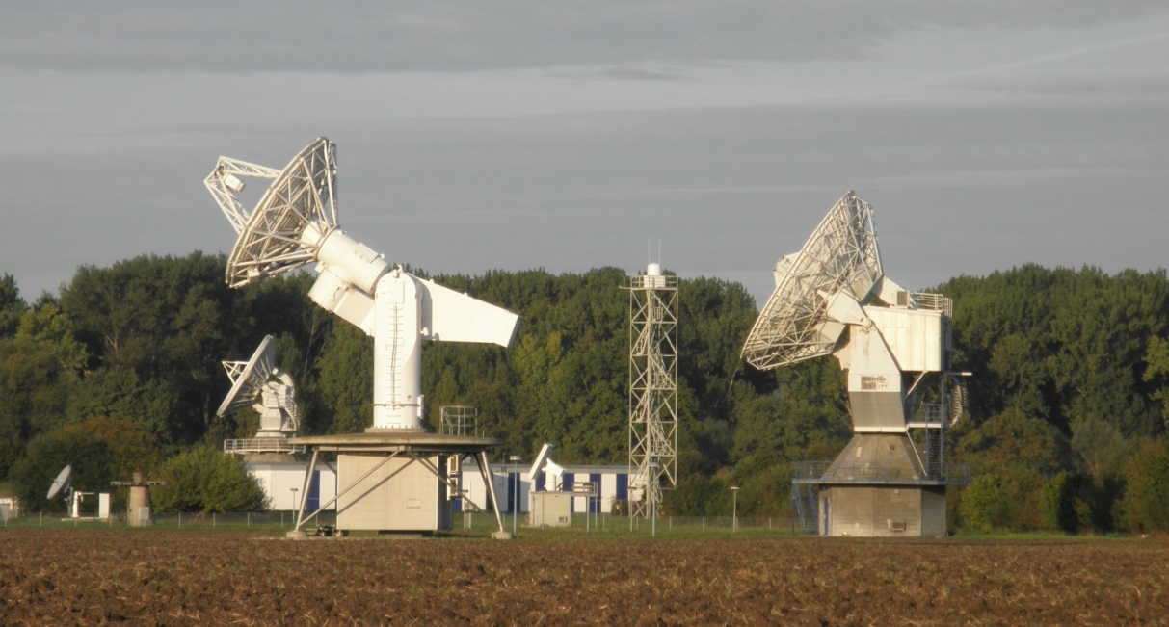
NOTE – Detailed technical description of the facilities can be found in the Space radio monitoring station Handbook.
Due to the highly specialised and costly nature of space radio monitoring facilities, an agreement on the access to these facilities and on the sharing of costs for national authorities using these facilities has been established within the CEPT. The agreement facilitates the following monitoring activities:
– Investigation of interference to and from satellites.
– Detection of the illicit use of satellites.
– Monitoring the usage of spectrum and orbital resources.
The signatories of the agreement are France, Germany, Luxembourg, the Netherlands, Switzerland and the United Kingdom.
Figure 2
Member countries in 2017
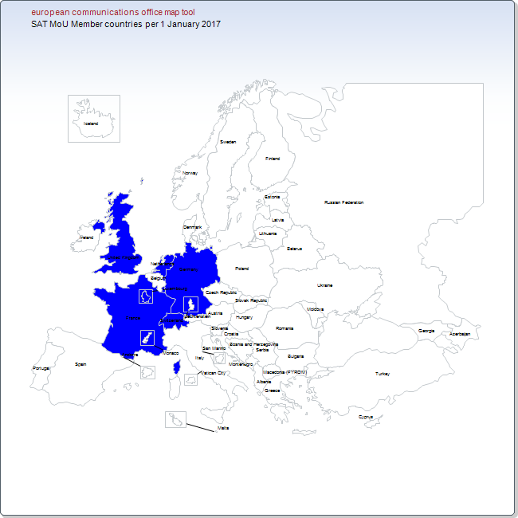

2 Satellite monitoring – a need for CEPT administrations
There are only a few CEPT administrations who have notified satellites. Nevertheless, all administrations have rights and obligations relating to emissions to and from satellites. Terrestrial services may be affected by emissions from satellites, and satellites may be interfered by transmissions or any other radiation emanating from an administration territory.
In both cases satellite monitoring facilities, including relevant skills and know-how, are required to cope with the problem. The increasing number of satellites used for communication, navigation, earth observation, research and the distribution of broadcasting signals makes interference more likely to happen, sooner or later.
Joining the Sat MoU is one option to be prepared for such instances. Furthermore, particularly for small administrations, it is less expensive than purchasing an own space radio monitoring station.

3 SAT MoU measurement history
Since it entered into force, the SAT MoU has been essentially used for the Radio Navigation Satellite Service (i.e. RNSS: GALILEO, GPS and GLONASS) studies, and for the protection of the radio astronomy service (RAS).
Based on request of some SAT MoU members, investigation of harmful interference, training of staff and monitoring of the compliance of space station technical characteristics have been performed. Such campaigns are beneficial for SAT MoU members as a step towards eliminating harmful interference into their satellite systems.
RNSS measurements were conducted in early 2000 in order to support CEPT in the course of preparations for various ITU-R meetings. The measurement campaign had various goals. Some measurements were conducted on navigation and location satellites to know the actual transmitted GNSS bandwidths to determine the maximum usable bandwidth for very accurate applications like geodesy or science. Unwanted emission levels of operational RNSS systems have been measured in order to achieve better protection of passive services in the course of the preparation of the World Radiocommunication Conference in 2007 (WRC-07, agenda item 1.21). The operational RNSS system spectrum measurement at 1.2 GHz, as well as the first Galileo satellite spectrum measurement in the bands 1.2 GHz and 1.5 GHz have been performed to support the Working Group Spectrum Engineering (WGSE) sharing studies. The measurement of emissions from the operational RNSS system geostationary satellite in the S-band (2 483.5-2 500 MHz) has been carried out since this band was being considered under WRC-12 agenda item 1.18 for a worldwide primary allocation to the Radio Determination Satellite Service (RDSS).
Figure 3
GNSS constellation
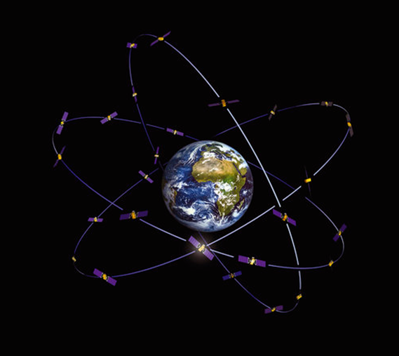

Regarding the protection of the RAS, it appears necessary that compliance with the conditions for use of radio frequencies by current and future Mobile Satellite Service (MSS) systems in their respective allocated bands (space-to-Earth) is monitored regularly (e.g. once a year) as well as the degree of interference in the frequency band 1 610.6-1 613.8 MHz caused by this usage. The results should be reported to the Electronic Communications Committee (ECC). For this reason, measurements of unwanted emissions from IRIDIUM satellites in the radio astronomy band 1 610.6-1 613.8 MHz have been carried out since 2004 in order to assess the impact of the mitigation techniques implemented by IRIDIUM in order to protect the RAS. In 2017, the most recent generation of IRIDIUM satellites (IRIDIUM NEXT) was planned to be measured. To conduct these highly sensitive measurements at the Leeheim station, specific measurement techniques have been developed and the equipment has been improved.
Satellite geolocation is an important part of investigating cases of harmful interference. The Leeheim space radio monitoring station is capable of receiving signals emanating from sources of interference on Earth via an interfered satellite and via an adjacent satellite simultaneously. Today the geolocation principle is based on the Time Difference of Arrival (TDOA) and the Frequency Difference of Arrival (FDOA) of the signals. The received signals differ slightly in their time and frequency of arrival due to their different path lengths and the movement of both satellites (Doppler Effect). The correlation of both signals facilitates the determination of the TDOA and FDOA lines. Further processing leads to an estimation of where the source of interference is located. The Leeheim station has developed and improved its capability to obtain a precise estimation of the location of the source of interference.
The necessary investment of the Federal Network Agency (BNetzA), the German Regulatory Office, was supported by payments of the SAT MoU. Firstly, in 2011 a Reference Transmitter Campaign was performed to estimate the geolocation capabilities of the Leeheim station in European countries (France, Spain and Switzerland). Later, in 2014, the SAT MoU has funded a study to improve the satellite geolocation process. In terms of the results, the Leeheim station has successfully located interference sources in Europe but also further away in the Middle East.
The Attachment to this Annex presents a list and short description of measurements carried out by the Leeheim station under supervision of the SAT MoU. These measurements can be divided into two categories: they are either requested by an Administration participating in the SAT MoU or by an ECC Working Group. For instance, Working Group Spectrum Engineering (WGSE) and Working Group Frequency Management (WGFM) requested measurements to provide the technical background for the development of ECC Reports and ECC Decisions and also in preparations for World Radio Conferences.
As space services are so strategically important and some are the most promising markets in terms of European growth such as the Global Navigation Satellite Systems (GNSS), CEPT needs to continue undertaking satellite monitoring activities.
Since 2003, the SAT MoU members funded a number of measurements in support of CEPT Working Groups activities in order to achieve an efficient use of spectrum and prompt elimination of harmful interference.
In order to continue to share all these results and success, SAT MoU members would like to invite all the CEPT members to join the SAT MoU.
Please contact the European Communications Office (ECO).

Attachment
to Annex
The Satellite Memorandum of Understanding has authorised/approved the following measurements or studies:
Year | Title | Description | Benefit of the study (satellite service, type of measurement)
2003 | Mobile satellite communications | Measurement of mobile satellite communications in the MSS, GALILEO and GPS frequency bands. | RNSS & MSS – Monitoring of the compliance of space station technical characteristics.
2003 | Satellite communications & satellite navigation system | Measurement of the FSS Ku band downlink emission parameters from Satellite communications.  Measurement of the spurious emissions in the FSS Ku band and BSS X band downlink. | FSS – Monitoring of the compliance of space station technical characteristics.
2003 | Observation of satellite navigation system in L band | Observation of the satellite navigation system at 80° East in L band. | RNSS – Measurements and recording for technical and scientific projects.
2004 | Satellite communications | Measurement of satellites at 7 orbital positions from 30°West to 54.5°West. | FSS – Monitoring of the compliance of space station technical characteristics.
2004 | Iridium | Measurements of Iridium system:  – use of frequency bands below 1 621.35 MHz by the Iridium System;  – pfd levels in the radio-astronomy band;  – detection of unwanted emissions in radio-astronomy band. | Protection of radio-astronomy service (afforded under the RR).
2004 | EESS | Measurement of the power emissions of satellites in the 8 025-8 450 MHz frequency bands. | EESS – Monitoring of the compliance of space station technical characteristics.
2005 | Satellite navigation system & RA-band | Measurement of Glonass emissions  in the radio astronomy band  1 610.6-1 613.8 MHz – Measurements were used as a technical background for  Res. 739 (Rev.WRC-07). | Protection of radio astronomy.
2005 | Satellite navigation system at 1,6 GHz | Measurement of Glonass Emissions in the radionavigation band at 1.6 GHz. | RNSS – Measurements and recording for technical and scientific projects.
2005 | Satellite navigation system at 1,5 GHz | Monitoring of GPS emissions in the allocated band at 1.5 GHz. | RNSS – Measurements and recording for technical and scientific projects.
2005 | Satellite navigation system Glonass sat 1.2 GHz | Measurement of the old and new generation of Glonass satellites. | RNSS – Measurements and recording for technical and scientific projects.
2005 | Satellite navigation system | Measurement of the new GPS IIR-M satellite at L2 frequency band. | RNSS – Measurements and recording for technical and scientific projects.
2006 | Observation of GIOVE A satellite | Measurement of the GIOVE A satellite at E1, L1, E2, E6, E5a-E5b frequency bands. | RNSS – Measurements and recording for technical and scientific projects.
2006 | Satellite communications interference | Interference investigation for NSS 7 at Ku frequency band. | FSS – Investigation of harmful interference.
2006 | Training of staff | A member of the Sat MoU requires carrying out the training of technicians on monitoring satellite-services procedures. | Training of staff – satellite-monitoring activities.
2006 | Satellite communications | Occupation of 8 orbital positions (from 61º West to 30º West).  Determination of transponder occupancy and consequentially detection of a percentage of paper satellites. | FSS – Monitoring of the compliance of space station technical characteristics.
2006 | Satellite navigation system | Galileo Sharing at 1.2 GHz, 1.3 GHz and 1.5 GHz – GPS unwanted Emission at 1.6 GHz | RNSS – Measurements and recording for technical and scientific projects.
2006 | EESS improved | Measurement of Spectra in the 8 025-8 400 MHz EESS band, PFD measurement in the 8 025-8 400 MHz EESS band, e.i.r.p. measurement in the 8 025-8 400 MHz EESS band  Examination for unwanted emissions in the band 8 450 to 8 500 MHz (deep space band)  Measurement of the last generation of EESS satellites. | EESS – Measurements and recording for technical and scientific projects.
2006 | CRAF-Iridium | Participation to the SE 40 meeting. | RAS – Protection to radio astronomy – Monitoring of the compliance of space station technical characteristics.
2006 | CRAF-Iridium measurement | Registration of spectra of the whole frequency range 1 610.6-1 613.8 MHz. | RAS – Protection to radio astronomy – Monitoring of the compliance of space station technical characteristics.
2007 | Satellite navigation system | Observation of satellite navigation system recently launched in MEO orbit and in IGSO orbit. The spectrum in S band and in E1 band has to be recorded. | RNSS – Measurements and recording for technical and scientific projects.
2007 | Satellite communications | Two Interference notifications from Satellite communications. | FSS – Investigation of harmful interference.
2008 | Iridium | Registration of spectra of the whole frequency range 1 610.6-1 613.8 MHz. | RAS – Protection to radio astronomy – Monitoring of the compliance of space station technical characteristics.
2009 | Monitoring of geostationary Positions | Monitor the frequency band 10 700 MHz – 12 750 MHz at 2 geostationary orbit positions. | FSS – Monitoring of the compliance of space station technical characteristics.
2009 | Satellite navigation system | Measurement of the pfd radiated by Satellite navigation system in the band 2 483.5-2 500 MHz and measurement of any RNSS signal by the experimental Satellite navigation system.  Measurement of the spectra and pfd levels of the Satellite navigation system in the frequency bands 1 164-1 215, 1 215-1 300 MHz and 1 555-1 613.8 MHz. | RNSS – Measurements and recording for technical and scientific projects.
2010 | Interference detection for radio astronomy at 150.9 MHz | Interference to the radio astronomy at frequency 150.9 MHz. | RAS – Investigation of harmful interference.
2011 | Training of Staff | The training includes the presentation of the Space Radio Monitoring Station, description and presentation of the monitoring techniques including geolocation measurement facility and using of Reference Transmitter Equipment with hands-on experience. | Training of staff – Satellite-monitoring activities including geolocation measurement.
2011 | Satellite navigation system | Monitoring of GALILEO, new GPS satellites and Glonass K satellites. | RNSS – Measurements and recording for technical and scientific projects.
2011 | Training of Staff | The training includes the presentation of the Space Radio Monitoring Station, description and presentation of the monitoring techniques including geolocation measurement facility and using of Reference Transmitter Equipment with hands-on experience. | Training of staff – Satellite-monitoring activities including geolocation measurement.
2011 | Reference Transmitter Campaign | Reference Transmitter Campaign in France, Spain and Switzerland. | Satellite Geolocation improvement technics.
2012 | GEO Satellites | Monitoring emissions from GSO satellites located at 16°E and 21.6°E. | FSS – Monitoring of the compliance of space station technical characteristics.
2014 | Satellite Geolocation | Report on the Study on Satellite Geolocation. | Satellite Geolocation improvement technics.
2015 | Training of staff | Training of the Leeheim staff. | Training of staff – Advanced geolocation technics
2015 | ISRMM 2015 | Presentation of the Study on Satellite Geolocation. | Satellite Geolocation improvement technics.
2017 | Iridium | Next generation measurement. | RAS – Protection to radio astronomy – Monitoring of the compliance of space station technical characteristics.
2017 | Software Geolocation | Development of Geolocation planning tool software. | Satellite Geolocation improvement technics.

______________

https://www.cept.org/files/8438/StationHandbook-Issue%20Nov%202018.pdf
http://www.cept.org/eco/groups/eco/sat-mou/client/introduction/.

