|  |
| --- |
| **Report ITU-R SM.2258**  **(06/2012)** |
| **Overview of interference source detection and geolocation affecting the 406.0-406.1 MHz band used  by emergency beacons** |
| **SM Series**  **Spectrum management** |

Foreword

The role of the Radiocommunication Sector is to ensure the rational, equitable, efficient and economical use of the radio-frequency spectrum by all radiocommunication services, including satellite services, and carry out studies without limit of frequency range on the basis of which Recommendations are adopted.

The regulatory and policy functions of the Radiocommunication Sector are performed by World and Regional Radiocommunication Conferences and Radiocommunication Assemblies supported by Study Groups.

# Policy on Intellectual Property Right (IPR)

ITU-R policy on IPR is described in the Common Patent Policy for ITU-T/ITU-R/ISO/IEC referenced in Annex 1 of Resolution ITU-R 1. Forms to be used for the submission of patent statements and licensing declarations by patent holders are available from <http://www.itu.int/ITU-R/go/patents/en> where the Guidelines for Implementation of the Common Patent Policy for ITU‑T/ITU‑R/ISO/IEC and the ITU-R patent information database can also be found.

|  |  |
| --- | --- |
| Series of ITU-R Reports  (Also available online at <http://www.itu.int/publ/R-REP/en>) | |
| **Series** | Title |
| **BO** | Satellite delivery |
| **BR** | Recording for production, archival and play-out; film for television |
| **BS** | Broadcasting service (sound) |
| **BT** | Broadcasting service (television) |
| **F** | Fixed service |
| **M** | Mobile, radiodetermination, amateur and related satellite services |
| **P** | Radiowave propagation |
| **RA** | Radio astronomy |
| **RS** | Remote sensing systems |
| **S** | Fixed-satellite service |
| **SA** | Space applications and meteorology |
| **SF** | Frequency sharing and coordination between fixed-satellite and fixed service systems |
| **SM** | **Spectrum management** |

|  |
| --- |
|  |

|  |
| --- |
| ***Note****: This ITU-R Report was approved in English by the Study Group under the procedure detailed in Resolution ITU-R 1.* |

*Electronic Publication*

Geneva, 2012

© ITU 2012

All rights reserved. No part of this publication may be reproduced, by any means whatsoever, without written permission of ITU.

REPORT ITU-R SM.2258

Overview of interference source detection and geolocation affecting the  
406.0-406.1 MHz band used by emergency beacons

# 1 Background

Cospas-Sarsat is an international satellite-based search and rescue (SAR) distress alert system which detects and locates emergency beacons activated by aircraft, ships and backcountry hikers in distress worldwide. As of February, 2012, forty-three countries are participants in the program[1]. Reliable satellite detection of emergency beacons in the 406.0-406.1 MHz spectrum band depends on clear spectrum in that range. For various reasons, interference is often experienced, impairing or preventing emergency beacon detection in some areas.

A significant step in recent years is the Automated Interference Monitoring System (AIMS), which the USA developed to automatically detect, geolocate and refer interference sources to the US Federal Communications Commission (FCC), for their mitigation of the interfering source. This document describes the Cospas-Sarsat program, the impact of interference to emergency beacon detection, the AIMS system processes for locating interference, and how the source locations are reported to the FCC for mitigation. Additionally, the document describes the Monthly 406 MHz Interference Report that the USA, and eight other states, prepare and send to ITU.

This document is designed to explain the processes used to detect and geolocate interference sources, in order to help regulatory authorities engaged in spectrum monitoring and interference resolution to effectively locate and mitigate interference sources. It is hoped that the description of the Automated Interference Monitoring System (AIMS) in use in the USA will encourage regulatory authorities to investigate the use of similar processes to quickly detect and refer interfering sources for mitigation.

## 1.1 Overview of the system

The overall system is depicted in Fig. 1, showing the steps involved in a typical distress event, and illustrating the main components of the system – beacons, satellites and local user terminals:

Figure 1

COSPAS – SARSAT system overview

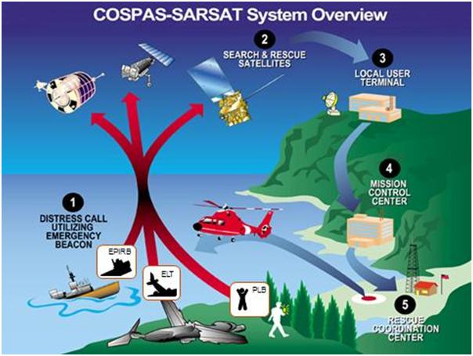

Search and rescue system (numbers correlate with those in Fig. 1)

1) Beacon is activated (either manually or automatically).

2) Distress signals received by COSPAS-SARSAT satellites. All satellites receive 406 MHz beacon signals. Both low-earth-orbiting (LEO) and geostationary earth orbit (GEO) satellites are used in the system, but geolocation processes use the LEO satellites.

3) Beacon signal re-transmitted to automated ground station local user terminals (LUT), where beacon alert and location messages are determined and sent to the Mission Control Center (MCC).

4) MCC forwards location to Rescue Control Center (RCC).

5) RCC sends location to nearest Search and Rescue (SAR) unit.

6) SAR units go to the scene.

Steps 2 through 5 are automatic. Successful and accurate detection and location depends in part on interference-free spectrum. A detailed description of the history of Cospas-Sarsat and the detailed system architecture is found in Annex 1.

# 2 Doppler localization

The location of a signal source is determined by Doppler processing of the signal through the orbiting LEO satellites. As the LEO satellite orbits, its on-board Search and Rescue Processor (SARP) provides an opportunity to continuously demodulate the digitally encoded beacon signals in the 406 MHz band. The SARP recovers the beacon unique identification number (ID), measures the received carrier frequency and records the time that the signal was received. These three items (Beacon ID, satellite received frequency and signal reception time) are recorded in an on-board memory and also downlinked to the nearest LUTs.

The LUT receives the downlink and processes the SARP data from which it determines the beacon Doppler curve. The LUT may also independently process the Search and Rescue Repeater downlink spectrum, from which Doppler curves from beacons as well as interference sources are determined.

Due to motion between the source and the satellite, when the satellite first comes into view of a source, the received frequency is at its greatest and continually decreases until the source passes out of view. The resulting frequency vs. time plot constitutes a Doppler curve. The LUT analyses the Doppler curve to determine the inflection point in the curve (the point at which the curve changes curvature). If the Doppler curve does not contain the inflection point, the LUT extrapolates the curve, either forward or backward in time, to estimate the inflection point. At the inflection point, the Doppler shift is zero, since there is no relative motion between the source and the satellite. This is the time of closest approach (TCA) between the source and the satellite. The LUT also determines the slope of the Doppler curve at TCA. These two items, slope and time, at TCA are crucial to determining the source’s geographic location.

Figure 2 shows the frequency vs. time curve which includes the inflection point as the satellite moves towards the signal source, with the frequency changing from maximum at time T1 through 0 at T2 and becomes a minimum at T3. This is the Doppler shift effect and is illustrated for a 406 MHz beacon which transmits a ½ second burst every 50 s. The same process takes place for 121.5/243.0 MHz beacons, except that the resulting Doppler curve is a continuous line (or several lines, depending on the level of sideband energy). It is important to note that in-band interference also produces similar Doppler curves.

Figure 2

Doppler shift (change in measured frequency due to relative motion  
between transmitter and receiver)

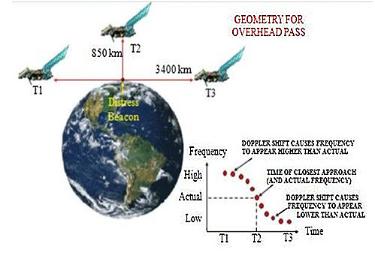

One other important point to note is that the Doppler-localization process actually yields two possible locations, one on each side of the ground track, referred to as the “A” side and “B” side geolocations. This creates an ambiguity which requires additional information to resolve, such as a second satellite pass which provides a second Doppler solution and resolves the ambiguity, as illustrated in Fig. 3.

Figure 3

Two pass resolution of Doppler localization ambiguity

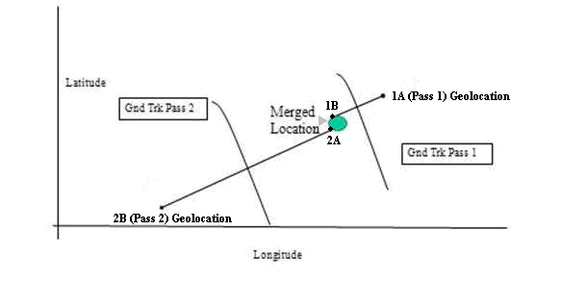

# 3 Effects of interference

Background

The band 406.0 to 406.1 MHz is reserved, by international agreement, for the transmission of distress signals from ground based beacons to orbiting satellites. However, in some instances others are using some of this spectrum range for non-distress communications (often mobile communications, wireless modems, and / or radar). Other times radio transmitters in adjacent bands emit spurious signals which lie within the distress band. Finally, some beacons which malfunction can also cause interference. All such signals are considered to be interferers, since they can, and often do, interfere with the satellite reception of distress beacon transmissions, thereby delaying the initiation of legitimate searches, with the possible consequence of loss of life.

The interference examples presented below are illustrated using both the 121.5 MHz beacon spectrum and the 406 MHz beacon spectrum. Although the 121.5/243 MHz beacon signals are no longer Doppler-processed, the effects are comparable to the impairments seen at 406.0‑406.1 MHz.

## 3.1 121.5 MHz channel, clean spectrum

Figure 4 is somewhat untypical in that there is almost no interference present in the 121.5 MHz band. The central portion of the figure shows a baseband plot of the power across the spectrum (in 1 s time bins) vs. time throughout the satellite pass from acquisition of signal to loss of signal. The abscissa is graduated in 100 s intervals, beginning at acquisition of signal acquisition of signal; the ordinate is scaled from band centre to ±12 kHz.

At the top of the figure (in red) the display shows the satellite ID, time of acquisition of signal and loss of signal, and date (Satellite S2, orbit 58748, 17:00:54 to 17:12:14, 4 May 1996). The banner at the bottom of the figure shows the LUT ID (California #2) and hours, minutes, and seconds until the next pass.

Prominent in the left half of the figure is a complete Doppler curve of a 121.5 MHz beacon. The carrier and sidebands are clearly identifiable. At the extreme right of the figure is the final spectrogram (taken just prior to loss of signal). The spectrogram clearly shows the beacon carrier at about –3.5 kHz (corresponding to 3.5 kHz below the centre of the band). The LUTs use proprietary methods to identify Doppler curves, compute the corresponding TCA and Doppler curve slope, and, ultimately, the beacon’s true and image location estimates.

A partial Doppler curve of another 121.5 MHz beacon is first seen at about acquisition of signal +300 s, when the carrier can be identified. At about 500 s, the modulation sidebands are clearly evident and remain identifiable for about 100 s. The second Doppler curve would also have produced a location solution, albeit of lesser quality than the first Doppler curve. In this instance, the LUT passed out of view of the satellite before the full Doppler curve could be relayed, thus, the LUT had only a partial Doppler curve available for processing. In general, a minimum of 4 minutes of Doppler curve is required to produce a usable solution (a usable solution is considered to be when the source has a high probability of being within 20 km of the identified coordinates). The quality of the solution increases considerably when the Doppler curve includes the TCA, which it seems to do, in this case.

Examination of Fig. 4 also shows a series of horizontal lines. These lines are due to satellite on‑board interference which is verified by the absence of uplink Doppler shift. Because the data shown in Fig. 4 is all digitized, it is a relatively simple matter to remove the on-board interference from the data so as to not contaminate the Doppler processing.

Figure 4

121.5 MHz spectrum with minimal interference

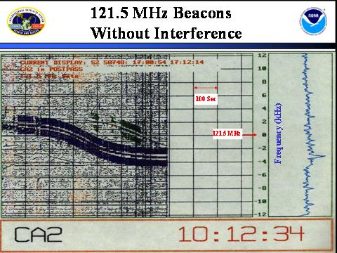

Figure 5

121.5 MHz spectrum with significant interference

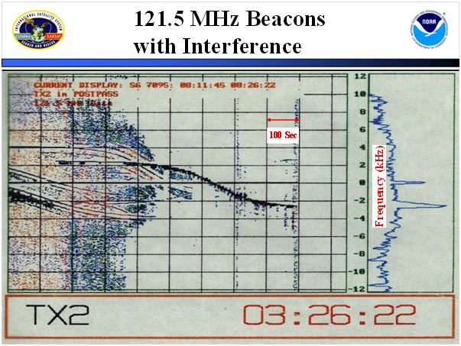

## 3.2 121.5 MHz channel spectrum with significant interference

The display shown in Fig. 5 was produced with the same process as shown in Fig. 4. The only difference was uplink interference which was so strong that it actually desensitized the satellite receiver, causing it to be unable to retransmit the much weaker beacon signals. The frequency scan immediately prior to loss of signal (at about 900 s from acquisition of signal) graphically shows the magnitude of the interfering signal, which can be located using the same methods.

## 3.3 406.0 to 406.1 MHz channel spectrum

The 406 MHz channel spectrum is shown in Fig. 6. The method used to process and display the 406.0‑406.1 MHz channel is similar to that used to display the 121.5 MHz channel. As with the 121.5 channel display shown in Figs 4 and 5, the horizontal scale is time and begins at the LUT acquisition of signal (each division is 100 s). The vertical scale grid is the channel 100 kHz baseband bandwidth (divisions are each 10 kHz). A major difference from the 121.5 MHz channel display is that the processor detects and decodes the beacon burst. The processor then highlights the burst with a colored dot, and prints the beacon Hex ID at the top right of the figure (using the same color as the burst dots). Examination of the red dots indicates a missed burst at about 360 s after acquisition of signal. The missed burst is likely the result of broad-band interference that can be seen across the band from about 320 s to 525 s after acquisition of signal.

Figure 6

406.0-406.1 MHz repeater spectrum

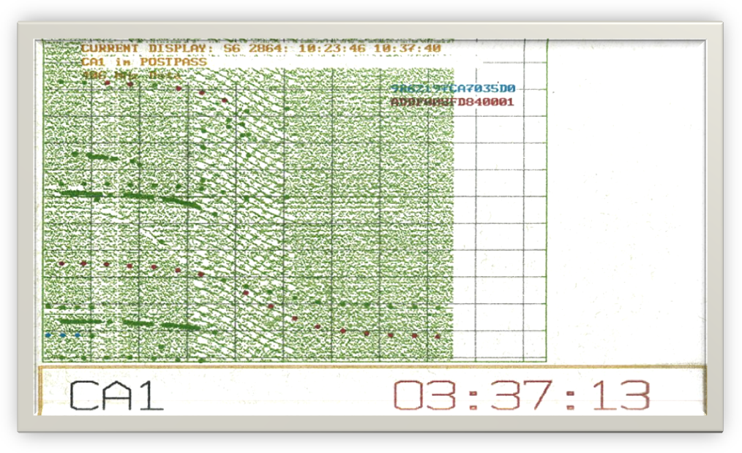

Shortly after acquisition of signal, four beacon bursts occur in sequence, at about 9 kHz, and separated in time by 30 s. The bursts are colour coded blue and are the trailing end of a Doppler curve from a C-S System reference beacon (Orbitography beacon), one of about 6 worldwide which are used to calibrate the orbits of the LEO satellites. In this case, a Doppler localization can generally be made, however, the quality of the data would be poor, because the points are all at an extreme end of one side of the Doppler curve. Several similar dots are coloured green. These dots represent beacon signals which have been detected, but have had their ID code corrupted to the extent that the beacon cannot be identified.

In addition to the broadband noise already discussed, two other interfering signals can be seen beginning about 80 s after acquisition of signal at about 14 kHz and 60 kHz. It is also quite likely that Doppler localizations could be determined for each of the interfering signals which make upthe broadband spectrum shown (approximately 40 signals spread across the band (resulting in 40 pairs of estimated locations).

About eight countries have LUTs monitoring the LEO satellites which have proprietary software that allow the LUT to maintain a database of interfering signals which is sent to its associated Mission Control Center. Each participating country uses the interference data bases from its LUTs to prepare a Monthly 406 MHz Interference Report for ITU. An example of the report format is found in Annex 2.

# 4 USA interferer location and reporting

## 4.1 Background

In the United States, interfering signals in the 406.0-406.1 MHz band are detected and processed by the USA LUTs. The resulting location approximations are sent to NOAA’s Automated Interference Monitoring System (AIMS) which analyses the data to determine if a persistent interferer is present. When enough data of sufficient quality is collected so that the interference source is statistically within 12 km of the estimated position, the latitude and longitude of the estimated position are provided, automatically via AIMS, to the FCC’s Centralizing Office (the FCC Operations Center). Although radio interference in all three frequency bands has been a continuing problem for the Cospas-Sarsat System, only interference in the 406.0-406.1 MHz band is analysed by the AIMS. At present, all AIMS location communication is via Fax.

## 4.2 AIMS interference location methodology

The Interference Database contains virtually all of the parameters associated with the determination of the A-side and B-side locations of the interferer, including the A and B side latitude and longitude, the time and frequency at closest approach, and the cross track angle (the data fields utilized by the AIMS are listed in Annex 3). Each administration has developed its own methodology for analysing the Interference Database. The methodology used by the USA is described in this section, and an example is presented.

Figure 7 shows a recent interferer plot of North America using the newly developed Interference Analysis Tool which illustrates the multiple interference sources typically observed. Often, an interfering signal would consist of many subcarriers, each of which would produce a slightly different Doppler localization so that, when an area of interest was zoomed in and plotted, the locations had the appearance of a more or less random scatterplot.

Figure 7

406 MHz interferer location display (blue dots) with 2 levels of zoom (Fig. 7A, showing all of  
North America with a small area highlighted, and Fig. 7B, showing expanded inset from 7A)

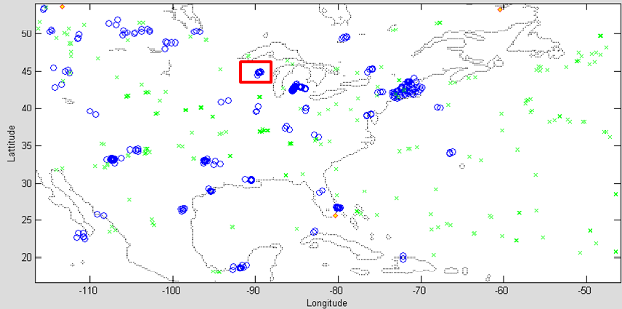

Figure 7a

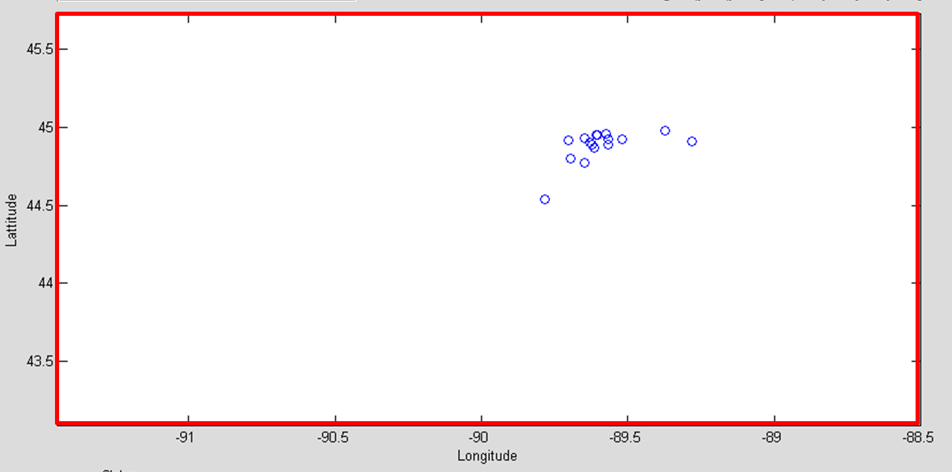

Figure 7b

Prior to development of the Tool, it was necessary to manually expand each area of interest in order to determine which sites contained a sufficient number of interference events, and were contained within a reasonable search area.

An estimated location was determined by calculating the mean latitude and mean longitude of the population of data points, as shown in the example in Fig. 7B. An estimated search radius was determined by combining the standard deviation of the latitude and longitude (corrected by the cosine of the latitude). This is the basic process that was automated and became known as the Automated Interference Monitoring System (AIMS).

## 4.3 AIMS improvement

Shortly after beginning the monthly Interference report to the ITU (described in Annex 2), NOAA developed an iterative method of data processing which improved the accuracy of the estimated interferer location and probable search area. The iterative method expands on the basic AIMS process by making successive calculations of mean location and standard deviation and subsequently excluding data elements that fall outside of a specific standard deviation.

When manually applied to an interference data set, the additional iterative steps can produce superior results. A comparison of the AIMS process versus the AIMS plus iterative process, for a specific interference event, is shown in Table 1. If additional similar comparison results consistently show improvement, the method may be incorporated into the AIMS process.

TABLE 1

Salt Lake City interferer result summary with and without iteration

|  |  |  |  |  |
| --- | --- | --- | --- | --- |
|  | Latitude | Longitude | Search radius (km) | Location error (km) |
| Actual coords | 40.7719 | –111.9542 | – | – |
| AIMS method | 40.803 | –111.829 | 11 | 12.6 |
| Iteration method | 40.7890 | –111.9441 | 9.2 | 2.2 |

Annex 4 provides a detailed location error comparison between the basic AIMS analysis and the improvements (in this case) using iterative methods. Further work is continuing to improve results and processing of interference locations.

## 4.4 AIMS – FCC reporting procedure

Operation of the AIMS – FCC Report currently follows the following protocol:

1) The AIMS monitors the interference site database solution files for interferers which are estimated to lie within the FCC area of responsibility.

2) The AIMS computes an estimated search area radius, which is updated in near real time as new solutions are added to the database.

3) When at least eight satellite overflights have detected interference, and the estimated search area radius is less than 12 km, the AIMS sends its automated message to the FCC.

NOTE – Both of these parameters (number of satellite overflights, and search area radius) are readily changed.

The AIMS report provides the FCC the following data along with a request for feedback regarding the precise location, type of equipment, action taken to mitigate the interference, etc. (example from USMCC notification 24 October 2000):

Location: 27 25.7 N 099 20.4 W (27.428 –99.340)

Frequency: Range = 406.015 to 406.081 – Average = 406.055

First detection: 2000/10/14 23:03:47

Last detection: 2000/10/24 02:32:34

Duration: 219 h 28 min. 47 s

Search radius: 11.0 km

USMCC Site ID: 6598.

# 5 Final search and mitigation

After the FCC receives an interference report, the information is routed to the nearest FCC Enforcement Bureau Field Office for further investigation. Typically, these are responded to within one day if the signal remains active. The FCC field office deploys an investigative team with a mobile radio-direction-finding vehicle and portable handheld direction-finding equipment to the coordinates reported by the AIMS system. The identified area is generally searched starting at or near the centre coordinates, outward to (and sometimes beyond) the identified radius of the target area (this depends on the road network and other factors). If the vehicle direction-finding indications are toward buildings, docks, marinas, etc. the investigators may proceed on foot with handheld equipment to finally locate the source.

Once the source is located, the owner is contacted and/or the device is disabled by shutting it off, removing power or batteries, etc. Operators of devices causing interference are subject to various sanctions under FCC rules, ranging from warnings to forfeitures (depending on the circumstances). Finally, feedback is provided to the U.S. Mission Control Center at NOAA, to advise them of the actual location, interfering device type, and details on power and frequency of operation when available.

# 6 References

COSPAS _ SARSAT System

<http://www.sarsat.noaa.gov/background.html>

<http://www.cospas-sarsat.org/>

Monthly 406 MHz Interference Reports provided to the ITU by participating countries.

**Monitoring Programme band 406-406.1 MHz (Resolution 205, COSPAS-SARSAT)**

<http://www.itu.int/ITU-R/index.asp?category=terrestrial&rlink=resolution-205&lang=en>

Annexes

Annex 1 – History and detailed description of Cospas-Sarsat System

Annex 2 – Format of the ITU monthly Report

Annex 3 – Partial list of parameters in the 406 MHz interference database

Annex 4 – AIMS/Iterative processing example

Annex 5 – Related ITU documents.

Annex 1  
  
Cospas-Sarsat system description

## A1.1 History

In 1978, the United States, Canada, and France joined together to form the Search and Rescue Satellite Aided Tracking (SARSAT) experiment to determine if a Low Earth-Orbiting (LEO) satellite-based system could be used to detect and locate distress beacons used by ships and aircraft by the use of Doppler localization techniques. Carriage of the distress beacons had been mandated (in the USA) in 1965, however, there was no reliable system to detect the signals. The beacons transmitted an effective radiated power of 50 mW on each of two analog modulated carriers at 121.5 and 243.0 MHz, and were known in aircraft as Emergency Locator Transmitters (ELT), and on vessels as Emergency Position Indicating Radio Beacons (EPIRB). Commercial airliners were requested to monitor the distress frequencies, however, most airlines only monitored the distress frequency when requested by the air traffic controllers. Additionally, a new beacon type was developed specifically for detection by SARSAT satellites. The new beacons were digitally encoded with a unique Identification Code, transmitted at a nominal power output or 5 W, and operated in the designated SAR band (406.0 to 406.1 MHz).

Shortly after its formation, SARSAT joined with a similar program being developed by the Soviet Union called COSPAS, which is a Russian acronym for “Space System for the Search of Vessels in Distress”. The first C-S Understanding was signed in November, 1979, and in May of 1980 all parties agreed to an implementation plan which spelled out all of the performance characteristics of the C-S system, including beacon, ground station, and satellite operational requirements.

Milestones in the history of the Cospas-Sarsat program include:

– 406 MHz set aside by ITU for low-powered distress beacons

– 1982: First 121.5 MHz save

– 1984: 1st 406 MHz save (Dec. 1984)

– 1985: LEOSAR declared operational

– 1988-1993: 406 MHz beacons mandated by IMO

– 1995: 1st GEO satellites operating

– 1998: GEOSAR declared operational

– 1999: ICAO required 406 MHz ELTs

– 2006: International Beacon Registration Database (IBRD) established

– 2009: Satellite processing of 121.5/243 terminated

– 2010-11: *Requirements* definition for 2nd Generation beacons designed to operate through MEOSAR

– 2011-12: Cospas-Sarsat 2nd Generation Beacon / MEOLUT Specifications.

As of February 2012, the Cospas-Sarsat System included 12 satellites (6 in low earth orbit and 6 in geostationary orbit) and more than 1 million 406 MHz beacons worldwide. Future improvements include plans for the development of Medium Earth Orbit Search And Rescue (MEOSAR) Satellites.

In general, only aspects of the C-S System relevant to interferer localization are discussed in this document (detailed descriptions of the C-S System including beacons, satellites and ground stations is available at the C-S website listed in the References).

## A1.2 Satellites and satellite instrumentation

Both geostationary earth orbit (GEO) and low earth orbit (LEO) satellites are used in the system, however only LEO satellites, because of their orbit motion are suitable for Doppler localization. Each LEO satellite contains a 406 MHz receiver/data processor, on-board memory storage, a 406 MHz repeater and a 121.5 MHz repeater. Additionally, the SARSAT satellites contained a 243 MHz repeater.

The data processor decodes the beacon signal and records the entire digital message, including the beacon ID. It measures and records the received frequency, and the time that the beacon signal was received. These three items are stored in the satellite memory, and are also retransmitted in real time. The memory is in a continuous playback loop and is large enough to store at least two days of beacon data before the eldest files are overwritten by new data.

Figure 8

SARSAT downlink spectrum (1 544.5 MHz carrier frequency)

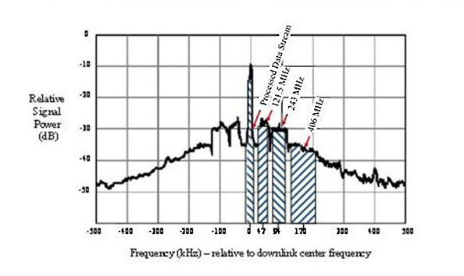

The downlink spectrum (for SARSAT) is shown in Fig. 8. The figure shows the 1 544.5 MHz carrier (modulated by a 2.4 kbit/s data stream), and the frequency translated spectrums from the 121.5, 243.0 and 406 MHz beacon transmissions.

## A1.3 Ground stations

The C-S system ground stations, called Local User Terminals (LUTs), receive 144.5 MHz downlink signal, process the data, and send the processed data to a Mission Control Center (MCC). The LUTs are typically remotely controlled from their associated Mission MCC.

The LUT tracks its scheduled satellite passes via a parabolic Left-Hand Circular Polarized (LCP) antenna (about 6 ft. in diameter), and processes the received beacon signals to recover the satellite 2.4 kbit data, and the frequency translated 121.5, 243.0 and 406 MHz spectrum. The data and spectrum from the 406 MHz transmission is processed as follows:

– *2.4 kbit data:*

The 2.4 kbit data channel (modulated on the 1 544.5 MHz satellite downlink carrier) contains digital data from the satellite Search and Rescue Processer (SARP) and contains the entire beacon digital message, including the beacon ID; the measured frequency, and the time that the beacon signal was received by the satellite. The LUT uses both the real time and the satellite memory play back to accumulate all of the SARP data available from the beacon during the period of time that the satellite was in view of the beacon (typically 15 minutes for an overhead satellite pass, resulting in a possibility of the satellite receiving up to 18 transmissions from the beacon).

The beacon messages are accumulated and a Doppler curve is developed. The parameters of the Doppler curve and knowledge of the satellite ephemeris allow the LUT to compute the location of the beacon based on Doppler processing.

– *406 MHz band:*

The 406 MHz channel has a spectrum bandwidth of 100 kHz (406.0-406.1 MHz) which is received and frequency translated in the satellite Search And Rescue Repeater (SARR) and combined with the repeater outputs for the 121.5/243 MHz bands. All three bands are combined for transmission to the LEOLUTs on a 1 544.5 MHz downlink carrier. Some LUTs (those with the ability to process the 406 MHz band in order to Doppler-locate interferers) digitize the 406.0-406.1 MHz spectrum at a rate of one sample per second throughout the satellite over-flight. Any active beacons that are also in view of the satellite will have their signal included in the satellite 1 544.5 MHz downlink.

The process of Doppler localization of the ground signals is further described in § 2. Similar processing on the 121.5 MHz and 243 MHz signals was discontinued on 1 February 2009. However the 121.5 MHz “homing” signal is still used for the “last mile” search by ground teams, as it is a continuous signal.

## A1.4 Satellite antenna footprint

Figure 9 shows an example ground track of 2 ½ successive orbits of a SARSAT satellite (COSPAS satellite ground tracks are similar). The first orbit is shown with a S to N equator crossing at time T1 (over Indonesia at about 130° Longitude). The track continues through the northern hemisphere and crosses the equator in a north to south direction above northwestern Brazil at about –62.5° longitude. After passing over the southern hemisphere, the ground track crosses the equator in a south to north direction at time T2 at about 105° longitude. The antenna footprint is represented by the blue oval centred on the ground track at about 12° latitude and covering Florida, Cuba, and a northern portion of South America. The footprint is actually a circle, about 6 000 km in diameter, centred at the sub-satellite point, and is thus moving as the satellite orbits the earth. It is this movement of the satellite relative to a beacon at a fixed point on the earth that creates the Doppler shift in frequency that is necessary to compute the beacon location.

Figure 9

LEO satellite ground track and field of view

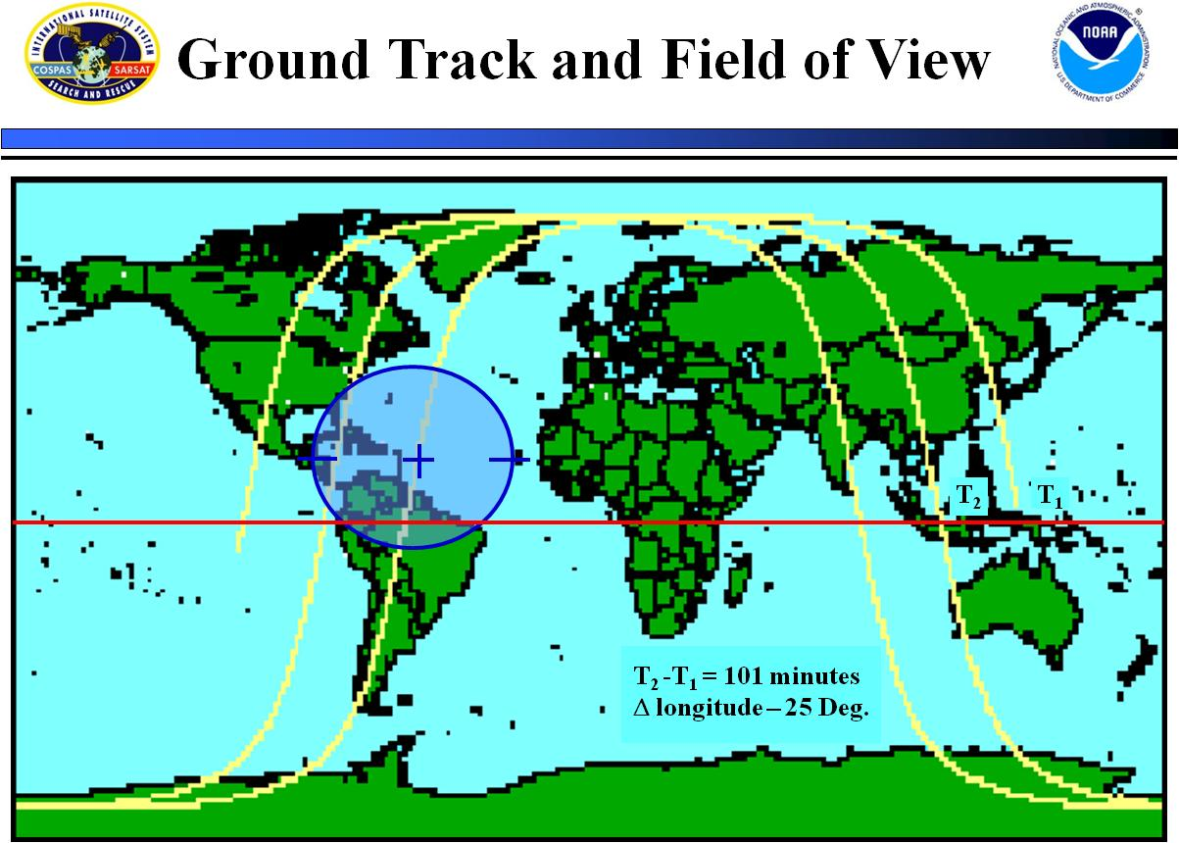

As Fig. 9 shows, if a beacon is at mid latitude, the opportunity to determine a location will occur with three successive satellite passes, with about a 100 minute wait between passes. There will then be a wait of about 6 hours before another series of 3 overflights occurs. The wait time is considerably reduced when additional satellites are added to the system. The C-S System baseline configuration is to have four LEO satellites in orbit (there are typically six).

Figure 10

LUT coverage (blue shows areas not covered)

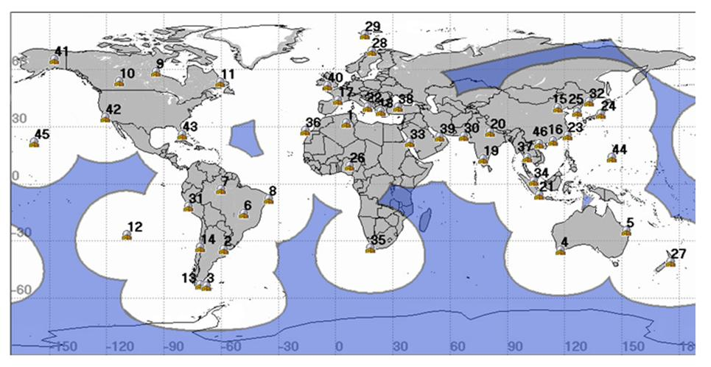

Figure 10 (white and grey) shows the areas of the world that are covered by LUTs (46 sites as of January 2012). An interferer situated anywhere in the blue area cannot be Doppler-located in real‑time since there is no LUT in view of the satellite. However, the stored data can be used to Doppler-locate when the satellite passes in view of a LUT. The numbers indicate the location of the site of a LUT, and are listed in the table below (collocated LUTs share the same site number).

| # | City, Country | # | City, Country |
| --- | --- | --- | --- |
| 1- | OUARGLA, ALGERIA | 24- | GUNMA, JAPAN |
| 2- | EL PALOMAR, ARGENTINA | 25- | INCHEON, KOREA |
| 3- | RIO GRANDE, ARGENTINA | 26- | ABUJA, NIGERIA |
| 4- | ALBANY, AUSTRALIA | 27- | WELLINGTON, NEW ZEALAND |
| 5- | BUNDABERG, AUSTRALIA | 28- | TROMSOE, NORWAY |
| 6- | BRASILIA, BRAZIL | 29- | SPITSBERGEN, NORWAY |
| 7- | MANAUS, BRAZIL | 30- | KARACHI, PAKISTAN |
| 8- | RECIFE, BRAZIL | 31- | CALLAO, PERU |
| 9- | CHURCHILL, CANADA | 32- | NAKHODKA, RUSSIA |
| 10- | EDMONTON, CANADA | 33- | JEDDAH, SAUDI ARABIA * |
| 11- | GOOSE BAY, CANADA | 34- | SINGAPORE |
| 12- | EASTER ISLAND, CHILE | 35- | CAPE TOWN, SOUTH AFRICA |
| 13- | PUNTA ARENAS, CHILE | 36- | MASPALOMAS, SPAIN |
| 14- | SANTIAGO, CHILE | 37- | BANGKOK, THAILAND * |
| 15- | BEIJING, CHINA * | 38- | ANKARA, TURKEY * |
| 16- | HONG KONG, CHINA * | 39- | ABU DHABI, UAE |
| 17- | TOULOUSE, FRANCE ** | 40- | COMBE MARTIN, UK |
| 18- | PENTELI, GREECE | 41- | ALASKA, USA * |
| 19- | BANGALORE, INDIA | 42- | CALIFORNIA, USA * |
| 20- | LUCKNOW, INDIA | 43- | FLORIDA, USA * |
| 21- | CENGKARENG, INDONESIA | 44- | GUAM * |
| 22- | BARI, ITALY | 45- | HAWAII, USA * |
| 23- | KEELUNG, ITDC * | 46- | HAIPHONG, VIETNAM |
| NOTES: (Table updated January, 2012)  # Numbered location of LEOLUT displayed in Fig. 10.  * Indicates dual system  ** Indicates dual system operating as one LEOLUT. | | | |

Annex 2  
  
406 MHz ITU monthly report format

TABLE 2

406 MHz interference report format1 (Part 1)

Reporting period (DD Month - DD Month YY)

|  |  |  |  |  |  |  |  |  |  |  |  |  |  |  |  |  |  |  |  |  |
| --- | --- | --- | --- | --- | --- | --- | --- | --- | --- | --- | --- | --- | --- | --- | --- | --- | --- | --- | --- | --- |
| Site ID number2 | Location | | | | Search area8 (probable search radius from mean location) | Mean latitude  (degr. & decimal parts of degree) | Mean longitude  (degr. & decimal parts of degree) | Median detected  Freq. (MHz) | Modula-tion charact.3 | Impact on system4 | Monthly detection ratio5, 6  (number/ total number of passes in visibility) | Monitoring period | | Times and days of week of occurrences | | | | Number of observations (number since last report and total) | | Other details |
|  | Country | Near-est city | Direct-ion | Distance  (km) | (km) |  |  |  |  |  |  | First date of occur-rence | Last date of occur-rence | Date | Day of week | Start time | End time | Current period | Total |  |
| 1 | 2 | 3 | 4 | 5 | 6 | 7 | 8 | 9 | 10 | 11 | 12 | 13 | 14 | 15 | 16 | 17 | 18 | 19 | 20 | 21 |
| MID123456 | Text | Text | NE,W,  SW, etc. | nn | nn | ±nn.nn | ±nn.nn | 406.nnn | N/ME/PE | H/M/L | 0.nn | DDMonthYY | DDMonthYY | DDMonthYY | Sn,M, Tu,etc | HH:MM | HH:MM | nn | nnnn | Text |
| MID123457 |  |  |  |  |  |  |  |  |  |  |  |  |  |  |  |  |  |  |  |  |
| etc. |  |  |  |  |  |  |  |  |  |  |  |  |  |  |  |  |  |  |  |  |

TABLE 2

406 MHz interference report format1 (Part 2 – see Note 7)

|  |  |  |  |  |  |  |  |  |  |  |  |  |
| --- | --- | --- | --- | --- | --- | --- | --- | --- | --- | --- | --- | --- |
| Status  (open/closed) | Location  (Confirmed) | | | | Narrative including the identification of the source, as available | | | | | | | |
| 1-opn, 0-clsd | Country | Nearest city | Latitude  (degree) | Longitude  (degree) | Type of equipment | Assigned frequency | Assigned frequency band | Class of emission | Power characteristics | Cause of interference | Action taken | Other data |
| 22 | 23 | 24 | 25 | 26 | 27 | 28 | 29 | 30 | 31 | 32 | 33 | 34 |
| 1 | Text | Text | ±nn.nn | ±nn.nn |  |  |  |  |  |  |  |  |
| 0 |  |  |  |  |  |  |  |  |  |  |  |  |
|  |  |  |  |  |  |  |  |  |  |  |  |  |
| NOTE 1 – Reporting should be provided in Excel format on a monthly basis. Minimum data is required for the following columns: 1, 2, 3, 6, 7, 8, 9, 13, 14, 19 and 20. Fields for which data is not available can be left blank.  NOTE 2 – Site ID number consists of two parts: 3-digit country code according to ITU MID code of the country of reporting authority plus 6 digits, assigned by the authority to the site. The label in  (  ) is the Site ID reported in the first of consecutive reports.  NOTE 3 – Type of modulation of main carrier: N – emission of unmodulated carrier, ME – emission of modulated carrier, PE – emission of pulses (data optional for Part 1, supplied in case of availability).  NOTE 4 – High: Reducing throughput of reference beacon in case of mutual visibility by 50% and more, Medium – by 25-50%, Low – less than 25%.  NOTE 5 – Monthly detection ratio DR = N1/(N1+N2), where: N1 – number of passes over emitter at/above 5 degrees, with at least 1 location; N2 – number of passes over emitter at/over 5 degrees, with no location.  NOTE 6 – Interferers with DR > 0.1 and with no less than 10 separate observations (10 distinct satellite passes) per month by the reporting MCC over the current reporting period are the ones that should normally be reported. However, given the different levels of interference in various parts of the world, MCCs may adjust their reporting criteria in order to keep the number of interferers reported at a reasonable level. The criteria used shall be indicated in the report (header of columns 12 and 19). An interferer that remains below the chosen reporting criteria over a given reporting period may still be reported in order to ensure continuity with previous reports. MCCs are encouraged to use their judgment to ensure the continuity of the content of their reports over time and to give a meaningful account of the interferers located in their region.  NOTE 7 – These items depend on feedback report concerning interference source. This is normally provided after the site has been closed and emissions have been stopped.  NOTE 8 – The radius of the Search area (column 6) may be computed using the standard deviations of latitude and longitude. | | | | | | | | | | | | |

TABLE 3

Countries providing 406 MHz monthly interferer reports to the ITU

*(as of February 2012)*

|  |  |
| --- | --- |
| ITU Code | Country |
| AUS | Australia |
| CAN | Canada |
| CHN | China (PRC) |
| E | Spain |
| F | France |
| GRC | Greece |
| TUR | Turkey |
| USA | United States |
| VTN | Vietnam |

Reference

Monitoring Programme band 406-406.1 MHz (Resolution 205, COSPAS-SARSAT)

<http://www.itu.int/ITU-R/index.asp?category=terrestrial&rlink=resolution-205&lang=en>

Annex 3  
  
Partial list of parameters in the 406 MHz interference database

|  |  |  |
| --- | --- | --- |
| Item | Column heading | Description |
| 1 | Solution_Id | LEOLUT assigned solution serial number |
| 2 | Alert_Site_Number | LEOLUT grouping of solutions which is assigned a Site number. Grouping is a function of distance and frequency between solutions (user-selectable, typically 50 km and 100 kHz for USA). In general, a site will contain nearly equal numbers of A and B solutions |
| 3 | Sat_ID | Satellite identification number |
| 4 | Orbit_Number | Satellite orbit number |
| 5 | LUT_ID | LEOLUT identification number |
| 6 | A_Prob | A side probability |
| 7 | A_Lat | A side latitude |
| 8 | A_Lon | A side longitude |
| 9 | A_TCA | A side Time Of Closest Approach (TCA) |
| 10 | A_CTA | A side Cross Track Angle (CTA); angle with vertex at the Earth’s centre and arms passing through the solution location and the satellite at TCA |
| 11 | A_Freq_Bias | Frequency at Doppler curve inflection point, offset from 406.025 MHz |
| 12 | B_Lat | See counterpart for A side |
| 13 | B_Lon | See counterpart for A side |
| 14 | B_Tca | See counterpart for A side |
| 15 | B_CTA | See counterpart for A side |
| 16 | B+FreqBias | See counterpart for A side |

Annex 4  
  
AIMS/Iterative processing example

Location error analysis of Salt Lake City 406 MHz interferer

Purpose

The purpose of this Report is to present the results of an analysis of the location and search radius determined by the present version of the Automated Interference Monitoring System (AIMS) with those determined with the iterative processing techniques currently used to produce the monthly 406 MHz interference report.

Background

On 11 August 2006, the USMCC AIMS sent a message to the FCC notifying them of an interferer detected in the Salt Lake City, Utah Area. The estimated Latitude, Longitude, and probable search area radius were provided, along with the dates of the first and latest detection. The FCC determined that the interference was coming from a NOAA ASOS 2 transmitter driving a Yagi antenna and provided the GPS-measured location to the USMCC.

The nominal operating frequency of the interfering transmitter was 410.075 MHz, however spurious outputs were being produced in the SAR band. The NOAA engineer in charge installed a band pass filter on the transmitter on 15 August, after which the interference was no longer detectable by the C-S system.

Result summary

Table 4 is a summary to the analysis results. The table provides the GPS-measured location of the interferer, as well as the estimated locations and search area radius determined by the AIMS and by a manual Iterative process. The final column shows the location error in the two processes (both processes used data obtained from 3 to 11 August).

Notable is that the AIMS location error is greater than the related search radius (the actual location in not within the estimated search area).

TABLE 4

Result summary

|  |  |  |  |  |
| --- | --- | --- | --- | --- |
|  | Latitude | Longitude | Search radius (km) | Location error (km) |
| **Actual coords** | 40.7719 | –111.9542 | – | – |
| **AIMS method** | 40.803 | –111.829 | 11 | 12.6 |
| **Iteration method** | 40.7890 | –111.9441 | 9.2 | 2.2 |

Conclusion

For this incident, the iterative process was clearly superior to the present AIMS process. While not conclusive, it indicates that the iterative process has the potential of providing better location estimates, thus providing a strong incentive to analyse more cases. Additionally, it highlights the importance of obtaining truth information regarding located interferers.

Data analysis

Figure 11 shows a scatter plot of all AIMS elementary solutions in the vicinity of Salt Lake City for the period 3-11 August 2006. The real side solutions are shown as small red dots; the image solutions are shown as small black dots (only the real side solutions are used in the iteration processing). Also shown in Fig. 11 are the plotted positions of the Actual interferer location (green triangle), the AIMS solution (Blue X), and the Iterative solution (large black dot). A cursory examination of Fig. 11 reveals that merely averaging the elemental solutions will probably create an easterly bias in the result, since there are more large errors to the east of the major concentration of data points. As will be discussed, the iterative process avoids this bias by eliminating large errors from the data set.

Figure 12 is an enlarged view of Fig. 11, with the added feature of the estimated Search Area (AIMS, Blue circle; Iterative Process, Black circle). As previously mentioned, the actual location of the interferer (green triangle) lies outside the AIMS-estimated search area (blue circle).

Table 5 shows the results of the iterative processing. Iteration “0” is merely the average of the 29 elementary real-side solution files (obtained from the AIMS data base for the period 3‑13 August 2006). The first iteration consists of ordering the elemental solutions in ascending order according to their distance from the mean of the data set and then deleting the 10% of the data that is farthest from the mean. A new mean (and other statistics) are then determined, and a new estimated location and search area determined. The process continues until a figure of merit[2] approaches an empirically determined value of 0.18 (as shown highlighted in Table 5).

Notable in Table 5 is that the actual error using the Iteration process was 2.21 km, while the estimated search radius was 9.2 km, thus indication that the estimated search radius is pessimistic, and could possibly be reduced.

Figure 11

AIMS elementary locations (Hits), estimated location, and actual location of Salt Lake City interferer

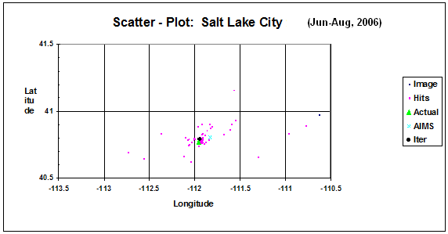

Figure 12

Enlarged view of Fig. 11 with estimated search areas



TABLE 5

Iteration processing results

|  |  |  |  |  |  |  |  |
| --- | --- | --- | --- | --- | --- | --- | --- |
| Iteration number | Count | Latitude | Longitude | SD Ratio | Search radius (km) | Search area (km2) | Location error (km) |
| 0 | 29 | 40.7968 | –111.8468 |  | 24.1 | 1 821 | 10.75 |
| 1 | 26 | 40.7978 | –111.8947 | –0.35 | 15.7 | 775 | 7.21 |
| 2 | 23 | 40.7968 | –111.9142 | –0.28 | 11.3 | 399 | 5.23 |
| 3 | 21 | 40.7890 | –111.9441 | –0.19 | 9.2 | 265 | 2.21 |
| 4 | 19 | 40.7936 | –111.9487 | –0.16 | 7.7 | 185 | 2.49 |
| AIMS |  | 40.803 | –111.829 |  | 11 | 380 | 12.60 |
| Actual |  | 40.7719 | –111.9542 |  |  |  |  |

Annex 5  
  
Related ITU documents

Recommendation ITU-R SM.1051

<http://www.itu.int/rec/R-REC-SM.1051-2-199707-I/en>

Interference with COSPAS – SARSAT defined as possible when interference signals increase the background interference signals in the 406-406.1 MHz band exceed –190 dBW/m2/Hz   
(–154 dBW/m2/4 kHz) at the satellite antenna (at 850 km), which increases the background noise level by 0.3 dB. This corresponds to an emitter on Earth having an e.i.r.p. of –60 dBW/Hz   
(–24 dBW/4 kHz) for broadband noise or –40 dBW for a cw signal.

Recommendation ITU-R M.1478-2 (2000-2004-2012)

<http://www.itu.int/rec/R-REC-M.1478-2-201201-I/en>

This Recommendation provides protection criteria for Cospas-Sarsat search and rescue instruments placed on-board satellites in geostationary, medium-Earth and low-Earth orbits (LEO) and receiving signals from emergency position indicating radio beacons (EPIRBs) and other distress beacons operating in the 406‑406.1 MHz band.

1. See: <http://www.cospas-sarsat.org/en/about-us/participating-countries-organisations>.
2. The Figure of Merit used in the iteration algorithm uses the average of the Latitude and Longitude Standard Deviations (SD) of the data set from each successive iteration. When the ratio of the average SD from successive iterations drops below 0.18, then the iteration step which has a SD ratio closest to 0.18 is used as the best estimator of the search area and its corresponding beacon location.