|  |
| --- |
| **Report ITU-R SM.2257**  **(06/2012)** |
| **Spectrum management and monitoring during major events** |
| **SM Series**  **Spectrum management** |

Foreword

The role of the Radiocommunication Sector is to ensure the rational, equitable, efficient and economical use of the radio-frequency spectrum by all radiocommunication services, including satellite services, and carry out studies without limit of frequency range on the basis of which Recommendations are adopted.

The regulatory and policy functions of the Radiocommunication Sector are performed by World and Regional Radiocommunication Conferences and Radiocommunication Assemblies supported by Study Groups.

# Policy on Intellectual Property Right (IPR)

ITU-R policy on IPR is described in the Common Patent Policy for ITU-T/ITU-R/ISO/IEC referenced in Annex 1 of Resolution ITU-R 1. Forms to be used for the submission of patent statements and licensing declarations by patent holders are available from <http://www.itu.int/ITU-R/go/patents/en> where the Guidelines for Implementation of the Common Patent Policy for ITU‑T/ITU‑R/ISO/IEC and the ITU-R patent information database can also be found.

|  |  |
| --- | --- |
| Series of ITU-R Reports  (Also available online at <http://www.itu.int/publ/R-REP/en>) | |
| **Series** | Title |
| **BO** | Satellite delivery |
| **BR** | Recording for production, archival and play-out; film for television |
| **BS** | Broadcasting service (sound) |
| **BT** | Broadcasting service (television) |
| **F** | Fixed service |
| **M** | Mobile, radiodetermination, amateur and related satellite services |
| **P** | Radiowave propagation |
| **RA** | Radio astronomy |
| **RS** | Remote sensing systems |
| **S** | Fixed-satellite service |
| **SA** | Space applications and meteorology |
| **SF** | Frequency sharing and coordination between fixed-satellite and fixed service systems |
| **SM** | **Spectrum management** |

|  |
| --- |
|  |

|  |
| --- |
| ***Note****: This ITU-R Report was approved in English by the Study Group under the procedure detailed in Resolution ITU-R 1.* |

*Electronic Publication*

Geneva, 2012

© ITU 2012

All rights reserved. No part of this publication may be reproduced, by any means whatsoever, without written permission of ITU.

REPORT ITU-R SM.2257

Spectrum management and monitoring during major events

# 1 Introduction

Major events like Olympics, Formula 1 races, music festivals and state visits are in the focus of the public interest. Although there is no unified definition for major events yet, they are characterized by a certain importance for one or more regions or even countries. Moreover, major events regularly require participation and coordination of various parties including governmental departments. In contrast to disasters in most cases the spectrum demands and spectrum usage of major events could be known in advance. Major events are mainly characterized by of a variety of radio applications and a substantial number of radio equipment aggregated within a limited area. The applications range from broadcasting, police, ambulance, wireless microphones and cameras to RLANs. Therefore adequate spectrum planning, licensing, spectrum monitoring, inspection of radio stations and processing of radio interferences are essential for the performance of a major event. Moreover, technical equipment limitations and last minute license applications require a rapid and in particular flexible on-site frequency management during the event.

The purpose of this Report is to provide guidance to administrations that are responsible for frequency management and enforcement activities such as spectrum management, spectrum monitoring and inspection of radio stations. Although this Report refers to major events, the basic considerations are applicable to minor regional or local special events too.

The Annexes to this Report provide practical examples of administrations’ activities in spectrum management and monitoring activities during major events.

# 2 Information search

As there are plenty of events during a year, information from newspapers, television, Internet, calendars of events should be examined to identify events that may need special attention due to the economical or political importance of the event, the number of expected short term licenses or because of problems experienced in past events. These events should be recorded in an annual plan.

The annual plan must be handled in a flexible way and may need to be revised when new information is available. The plan should be visible to the staff, e.g. on the Intranet, so that the persons involved can duly dispose themselves.

# 3 General considerations

## 3.1 Organization team

Particularly smaller events without any on-site presence may be organized completely by a single frequency manager. The organization of major events, however, when several entities have to be coordinated, requires the nomination of a project manager who is experienced and widely recognized in the administration. He will be supported by an organization team comprising at least staff from the frequency management section and from the radio monitoring and inspection section. Lawyers, accountants and others may join the team permanently or temporarily as appropriate.

## 3.2 Coordination with other organizations

The following entities may be involved in the planning and performance of major events:

− organizer of the event;

− administration responsible for frequency management, monitoring and inspection;

− local authorities;

− police, ambulance, fire brigade;

− armed forces;

− other government organizations;

− security services of the organizer;

− telecommunication operators;

− broadcaster;

− press;

− participants, e.g. teams, bands;

− public authorities of neighbouring countries (e.g. for frequency coordination).

## 3.3 Frequency planning

The objectives of frequency planning are the settlement of spectrum demands as far as possible and the protection of other spectrum users, in particular protection of the safety services. The spectrum demand during major events like the Olympics may be much more than the frequency plan could provide on the regular channels. This problem must be solved by departing from the frequency plan.

In addition, the given frequency raster of the equipment in use may restrict the possibilities of frequency assignments.

Some channels for short term licenses may be obtained by negotiations with regular users. License holders may, for example, not require some channels during weekends. These could be used for the event.

The spectrum demand of the press is often the crucial test for the frequency management. The nomination of a host broadcaster proved to be advantageous in order to facilitate cooperation and to provide the technical and organizational basis for the press. The host broadcaster could be entrusted with the frequency coordination amongst all broadcasting companies or even with licensing for some frequency bands.

Frequency coordination with neighbouring countries may become a relevant issue if the event is located close to a border. Negotiations with the neighbouring administration may result in temporary reduced frequency reuse distances thus extending the own possibilities.

Frequency planning may become even more complex in cases of multinational events, e.g. cycle races through 3 countries. Broadcasters and supporters escorting the teams cannot simply change the frequencies of their equipment when crossing the border.

Anyway, the intense knowledge of the actual spectrum use is essential for successful frequency management. Hence “zero state” spectrum monitoring a few month before the event may be considered an appropriate tool in this regard.

## 3.4 Licensing

The procedure for applying for a short term or temporary license for a special event should be as simple as possible. In particular foreign applicants will not be familiar with the administrative procedures. It would be helpful if the application forms and the respective instructions on how to complete them were available in foreign languages too. The instructions should clearly indicate where the applicant has to send his application to and which information, e.g. frequency and power, he has to provide. Also the licensing fee should be known in advance.

The licensing staff should have a list of available frequencies including additional channels that are made available especially for the event.

If an application has to be refused the administration should explain its reasons and offer alternative frequencies or come forward with other proposals as appropriate.

## 3.5 Fees collection

In the various countries, fees for short term licenses may be based on different criteria, e.g. the particular radio service, duration of the license, number of equipment. Hence license fees can differ substantially from country to country.

The problems of fee collection should not be underestimated. If the applications are received sufficiently in advance of the event, the standard procedures are applicable. Procedures have to be implemented for last minute applications. Would it be acceptable not to issue a license because there is no documented evidence about the payment of fees available? The staff needs very clear regulations and management support in this regard.

The collection of fees is even more difficult if licenses have to be issued or modified on site which is sometimes unavoidable. Issuing a license and mailing the bill at a later point in time includes a high risk of losing money. If last minute licenses have to be paid in cash, two other problems emerge. First it is not sure that all applicants have enough cash with them and secondly the cash taken has to be safely stored. For this reason, some administrations will not accept cash payment. Payment by credit card is possibly the most user-friendly solution. However, this requires additional infrastructure like card readers. Where administration supports the functionality of online payment, this shall be considered as another alternative option for payment.

## 3.6 Labelling

Several administrations found it expedient to label previously inspected radio equipment. The event organizer could ensure that only equipment bearing a special event sticker is used at the venue. Stickers must be clearly visible and should be difficult to copy or modify. Different colours and different designs may be used to distinguish different events or locations.

## 3.7 Interference investigation

Cases of radio interference during major events are often of great significance and require immediate response, e.g. if the radio link between a helicopter and the TV compound on ground is interfered with. It would take too long to get a vehicle from a monitoring station. Furthermore, crowd, traffic and restricted movement would not allow proper action. Hence measurement vehicles and handheld equipment should already be at the venue. This could be complemented by fixed monitoring stations in the vicinity.

## 3.8 Logistics

The preparation and execution of events require qualified staff, measurement equipment and vehicles. These resources should be clearly identified. They are not available for other tasks at the same time. The necessary IT infrastructure like computers, data-base access, networking and interconnection with the office must also not be disregarded.

Accommodation of staff and vehicles is another important issue. Oftentimes staff and vehicles have to be accredited early enough in advance of the event. The secured position of monitoring vehicles and their mobility have to be discussed with the organizer. Administrative work could be done in a van, in a rented cabin or much better in an office at the venue. The availability of electricity supply and telecommunication lines is essential in all cases.

It should be taken into account that the staff may not be able to leave a certain area of the venue for a longer time, e.g. during Formula 1 races. Hence a substitute team may be needed depending on the national protection of labour regulations.

Usually it would be not efficient and sometimes even impossible to bring and depart monitoring vehicles daily during an event lasting several days. Hence staff transportation from and to a hotel must be arranged. It is important to book hotel rooms betimes because shortly before the event it may be impossible to find any free rooms.

## 3.9 Radiocommunication equipment for spectrum management and monitoring staff

Some aspects of communication have already been addressed in § 3.8 on logistics. Likewise the need for communication between the frequency management team and the monitoring teams, working at their home office, walking on foot with handheld equipment or working in vehicles inside and outside the venue, has to be considered. The use of public telephone networks may be sufficient under normal conditions. However, such networks may collapse at large scale events and especially in case of disasters. Setting up an own PMR network should be considered to prevent such incidences. Important advantages of PMR networks using simple FM technology like walkie-talkies is that there is no delay due to settling times and that several users can be addressed simultaneously on the same channel.

## 3.10 Appearance in public

The on-site licensing and spectrum monitoring/inspection teams represent their organization anytime – at work as well as during breaks. A competent and friendly appearance is essential. This includes close cooperation and mutual information of the teams involved. Any discussions about procedures and lack of information in front of the customers and other persons are likely to cause the administration to appear in a bad light and hence have to be avoided.

For the same reason it is important to select proper clothing. The introduction of official dress may be considered so the staff can be identified immediately. A cheap solution would be a vest labelled with the administration’s name or simply “frequency management”.

# 4 Preparatory actions

## 4.1 Contacting the organizer of the event

It is useful to contact the organizer at a very early stage even in cases when no on-site presence of spectrum licensing or inspection teams during the event is intended. Experience shows that many organizers and participants are neither aware of the need of a radio license nor have sufficient understanding of interference problems. The unauthorized use of radio equipment, in particular equipment of foreign participants, may result in severe interference to broadcasting, safety and other radio services.

The first contact should be in written form. The organizer should be informed of the principles of frequency assignment and usable frequencies. Flyers and other available information material should be attached. Depending on the significance of the event, the organizer may be invited for a meeting.

The purpose of this meeting is to mutually understand the demands and problems and to have a firm basis for a decision on the further course of action. The organizer should understand the different types of licenses, e.g. permanent licenses, temporary licenses and general licenses (in many administrations called “license exempt”). The administration should obtain a general view of the number of frequency users and the spectrum required.

## 4.2 Plan of action

The coordination team should develop a plan of action. The plan must clearly identify dates and responsibilities. The following list illustrates possible activities that may be applicable, dependent on the relevance and size of an event. Due to the diversity of events, there is no “correct” order for the activities. Also no general rules can be provided regarding the timing. Advance planning and first actions may start 8 weeks or 2 years before the event.

| Activities before the event |
| --- |
| – Consulting the organizer in written form; |
| – Counselling interview with the organizer; |
| – Information about the radio monitoring/inspection service; |
| – Further meetings with the organizer; |
| – Providing information on the organizer’s home page; a link to the spectrum agency would be advisable; |
| – Providing event related information on the spectrum agency’s home page; |
| – Visit of the event location; |
| – Drawing up a time-table; |
| – Labelling required: yes or no? |
| – Assigning tasks to the spectrum monitoring/inspection service; |
| – Fixing the manpower requirements; |
| – Review of the situation regarding accreditation; |
| – Fixing the location of measuring vehicles and vehicles for passenger transportation |
| – Organization of the power supply; |
| – Contacting the host broadcaster regarding spectrum coordination; |
| – Contacting security organizations (police, ambulance, etc.); |
| – Monitoring the spectrum (zero state); |
| – Allowing spectrum applications; |
| – Handling of applications: |
| − Considering applications (availability of spectrum, compatibility) ; |
| − Spectrum coordination with neighbouring administrations; |
| − Approving applications; |
| – Hotel booking; |
| – Organizing an on-site office and office equipment; |
| – Planning of communication (radio, telephone, Internet); |
| – Preparation of on-site collection of fees; |
| – Arrangement of staff schedule;  – Carry out any required coordination with a neighbouring country. |

# 5 Activities during the event

Customers and the public are usually not familiar with the structure of an administration. Thus all colleagues should be approachable regarding all questions related to licensing, monitoring and inspection. The enquiring partner should either receive an immediate answer or be referred to a competent staff member.

| Activities during the event |
| --- |
| – Coordination of the staff involved in the event; |
| – Processing short term applications; |
| – Documentation of all activities including date and time; |
| – Client counselling; |
| – Contacting the relevant persons (event manager, companies, public authorities); |
| – Inspection and labelling of radio equipment; at least the frequency should be checked; |
| – Monitoring the spectrum; |
| – Interference investigation; |
| – Identification and elimination of unlicensed frequency use. |

# 6 Activities after the event

A first recapitulation of the event may be given still on-site. However, the teams probably want to leave the event as soon as possible. The activities after the meeting are compiled in the list below.

| Activities after the event |
| --- |
| – Equipment removal; |
| – Return transport of staff; |
| – Return of borrowed equipment; |
| – Settlement of accounts; |
| – Finalization of interference handling if necessary; |
| – Initiation of legal measures (in cases of identified infringements); |
| – Reporting, including relevant findings, should be retained for use at later events;  – Create statistics for evaluation and later use; |
| – Final review. |

The project manager should chair a debriefing meeting shortly after the event. He should use the opportunity to address the highlights and to thank his team. A review of the perceived difficulties and an analysis of unsolved problems should result in a final report that may be used for the preparation of the next major event.

# 7 Conclusion

Additional spectrum demand, a variety of radio applications and equipment, movement restrictions and the need for short term decisions in a flexible way are a challenge for the spectrum management at major events. Thorough planning and close cooperation with all relevant parties is essential for the success of the event. The deliberations in this Report are adaptable to smaller events.

The examples in the Annexes to this Report are intended to provide suggestions for those who are going to participate in the preparation and execution of major events.

Visiting other administrations or the exchange of information in writing well in advance of a major event could be useful.

Annex 1  
  
Spectrum management and spectrum monitoring during the Beijing 2008  
Olympic Games and the Paralympics Games

# 1 The importance of spectrum management and spectrum monitoring during a major event

As information technology prevails, radiocommunication applications play a more and more critical role in almost all important events, especially for an event as important as the Olympic Games. These major events strongly rely on the use of a great number of radio applications in virtually all aspects. These applications are, in many cases “mission-critical” for the major event, and sometimes not a minor mistake is allowed. Furthermore, the Olympic Games competition generally undergo during a limited time period and within a densely electronic-device-populated area or venue, which led to an extremely complex radio “environment” for these radio applications. All this brings about a number of major difficulties and high demands for the spectrum regulators and spectrum monitoring engineers to control the risks of failure of radiocommunication. This Annex introduces how the spectrum regulation and spectrum monitoring were undertaken during the Beijing 2008 Olympic Games and the Paralympics Games. It can serve as a reference for future Olympic Games and other major sport event alike.

# 2 Overview of the Olympic Games (some statistics)

## 2.1 Statistics

The following statistics gives some general information concerning the Games:

− over 11 000 athletes and from 204 countries and regions;

− over 26 000 accredited journalists and 5 900-plus un-accredited journalists from 100‑plus media;

− over 70 000 employees and volunteers served the Games;

− more than 110 dignitaries (Heads of State, Member of royal families, etc.) from 50-plus countries;

− 36 sport venues and 15 Areas under Special Control (such as the headquarters of the Games’ organizers).

## 2.2 Major radio equipment types and their frequencies during the Games

Major radiocommunication equipment used during the Games (as recommended by IOC and the past host of the Games) are listed as following text.

NOTE – The abbreviations shown in the subsections refer to Fig. 1.3.

### 2.2.1 Fixed microwave links (FL)

This type of equipment is used between two fixed points for the transmission of video, audio or other data.

### 2.2.2 Mobile micro-wave links (ML)

The terminals are located on board of vehicles, vessels or helicopters. Generally, ML is used for video transmissions, and will occupy a bandwidth of 8 MHz up to 30 MHz.

### 2.2.3 Satellite news gathering (SNG)

An SNG terminal must be able to be rapidly deployed, to transmit vision and associated sound or sound programme signals, to provide limited receiving capability to assist in the pointing of the antenna and to monitor (where possible) the transmitted signals, and to provide two-way communications for operation and supervision. SNG equipment is able to coexist well with other users in the Ku-band. However, interference may happen between SNG in C band and other microwave links, therefore analysis is required in this case.

### 2.2.4 Land mobile radio systems (LMRS)

Handheld or portable equipment for communication purposes is used with a large number of users.

### 2.2.5 Talk back systems (TBS)

They are used primarily for communication between the director of activities and their employees such as presenters, interviewers, cameramen, sound operators, lighting operators and engineers. TBS equipment works in the band of 403-470 MHz and 137-167 MHz in general. Since there is a great number of existing users of TBS, the frequencies for the Olympic users must be planned carefully with the assistance of radio station database.

### 2.2.6 Hand-held two-way radios (HR)

This is often known as walkie-talkies, being widely used by a large number of users. They share the same bands as the TBS equipment.

### 2.2.7 Cordless cameras (CC)

This is a type of video camera which is capable of capturing and transmitting high-quality video and audio signals within a short range (no more than 500 metres). It is either hand-held or carried by other means and is composed of transmitting circuits, battery and antenna. Typical CC equipment works between 2.0-2.7 GHz, with a bandwidth of 8 MHz up to 20 MHz.

### 2.2.8 Wireless microphones (WM)

Handheld or body worn professional microphones with integrated or body worn transmitter. Convenient for the interpreters and reporters, WMs were largely used during press conferences. Typical WMs occupies 120 kHz bandwidth, with a certain number exception of 180 kHz. The power of this type of equipment is very low (30-50 mW), which made it easy for the reuse of frequencies.

### 2.2.9 Remote control equipment

Working within the 403-470 MHz band, the telemetry and telecommand equipment was used to control the cordless cameras, vehicles, or the time and score recording equipment. Being a critical type of equipment, it worked in the most heavily used band and attentions should be paid to its coexistence with other equipment.

### 2.2.10 Wireless LAN (WLAN)

In total, 16 channels were made available in venues, Olympic related hotels and operational centres. Eight of these channels within the 5 150-5 350 MHz band were of a temporary nature, and they are put into use to satisfy the demand from the users.

### 2.2.11 In-ear monitoring system (IEMS)

An IEMS is mini receiving equipment used for the monitoring the audio communication of actors, etc. Typical WMs occupies 125 kHz bandwidth, with a certain number exception of 200 kHz. Their transmitting frequencies are within the 520-860 MHz band approximately.

## 2.3 Three phases for spectrum management and spectrum monitoring before and during the Games

During the Beijing 2008 Olympic Games and its preparations, the spectrum management and spectrum monitoring can be roughly divided into three phases, namely the long term preparation, just before the Games, and during the Games, each with different priorities.

**2.3.1** The long-term preparation (before the end of Dec. 2006). During this period a number of preparatory tasks were undertaken, including:

− an investigation of the potential demand for frequency resources;

− some preliminary studies of EMC analysis;

− improving and integrating spectrum monitoring facilities;

− designing of the website for frequency application;

− beginning formulating all types of work plans and procedures.

**2.3.2** Just before the Games (between Jan. 2007 and July 2008). During this period features the heaviest work load and proved to be the most critical for the success of the next phase.

− Launching of the website for frequency applications;

− Frequency planning and assignment;

− Improving the procedures for spectrum monitoring and equipment testing;

− On-site spectrum monitoring of the “background spectrum” at venues;

− Technical training;

− Practice and rehearsals (especially during the Gook Luck Beijing test events).

### 2.3.3 During the Games (between July 2008 and Sept. 2008)

− Spectrum monitoring;

− Equipment testing;

− Emergencies regarding unexpected radio interference.

# 3 Spectrum management

## 3.1 Survey and analysis of the frequency demand

By correspondence or at meetings, the frequency demands of domestic and foreign users were collected, this was completed 18 months before the Games. The spectrum management team also visited their counterparts of the 2000 and the 2004 Games, in Sidney and Athens respectively. Becoming aware of the previous situations, the team estimated that the frequency demand could rise by 30% than the Athens Games.

## 3.2 Collecting of the frequency resource

− The un-planned bands were put into temporary use. (For example, the 5.15-5.35 GHz band was temporarily authorized to be used for WLAN during the Games.)

− Radio stations profiles were thoroughly reviewed and the unused or illegally used frequencies were taken back.

− Frequency coordination meetings were held with the broadcasting administration and some operators. (For example, a great number of frequencies were “borrowed” from the Beijing local broadcasting administration for wireless microphone equipment.)

## 3.3 Application of frequencies

A website dedicated to the application of frequencies for the Games was launched. It proved to be a good tool for spectrum management and the users alike. Their workload reduced thanks to the high automated processing of the applications.

Figure 1.1

Welcoming page of the frequency application website

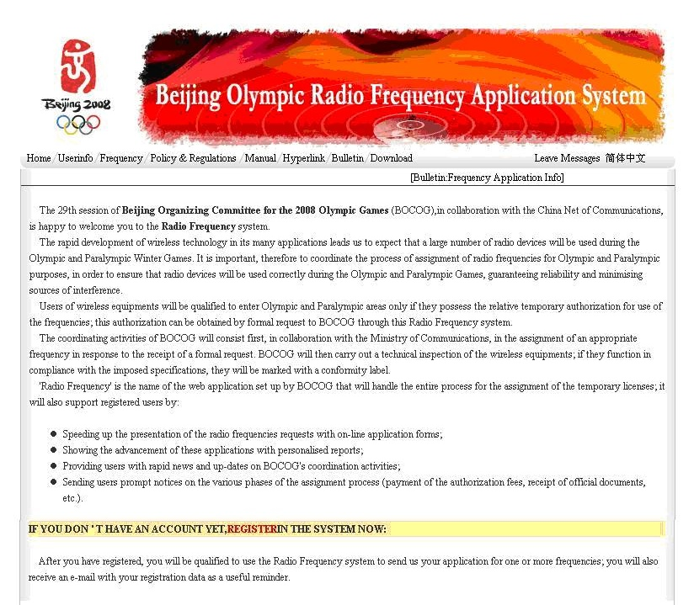

For important frequency users such as Beijing Olympic Broadcasting (BOB), who applied large number of frequencies, it possible for batch process of their applications.

Repeated corrections to applications will exert heavy pressure on spectrum management. In order to reduce the number of unqualified applications and ease the pressure, it is important for the spectrum managers to have a good communication with the users of radio equipment. On the one hand, the needs of the users can be well understood, on the other, the users can be made aware of the scarcity of the frequencies and allow them to be informed of the frequencies available for application. Additionally, the spectrum managers could also advise on the type of equipment for the user, making it less likely for repeated corrections to applications.

From Fig. 1.2, it is apparent that for frequency application, the bulk of their workload appears in December 2007, 8 months prior to the Games.

Figure 1.2

Work load for radio frequency application



Figure 1.3

Radio applications used in the Games



## 3.4 Frequency planning and assignment

### 3.4.1 Considerations in frequency reuse

Thirty-one venues and 15 venues for non-competition purposes were divided into six zones as shown in Fig. 1.4; spatial reuse can be applied in different zones. For short-range devices, spatial reuse can even be applied in different venues.

Time reuse can be applied for equipment scheduled to be used at different periods within the same zone.

NOTE – The venues and key areas are grouped into different zones according to their location (See Fig. 1.4), and these zones include the West Zone, the Central Zone, the North Zone, the Universities Zone and the East Zone. The events which cover a large area should also be taken into considerations (for example the marathon or the road bicycle races).

Figure 1.4

Distributions of the venues in Beijing

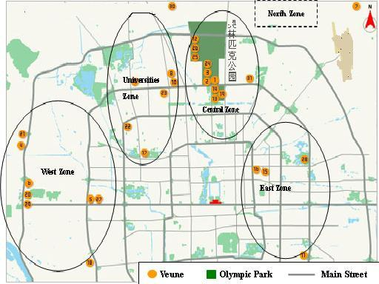

The structure of the venue must be taken into consideration while planning for frequency reuse. A venue of a concrete structure can attenuate 30 dB of a signal at 400 MHz, while the National Aquatics Centre, with its ETFE membrane structure, presents little attenuation to radio waves at 400 MHz.

### 3.4.2 Frequency grouping

For frequency assignments, available frequencies were divided into different groups. Within the same group, there were no adjacent frequencies or a frequency which falls into the third-order inter‑modulation frequency points of any other two frequencies within the group. The groups can be used when making assignments to different equipment used in the same zone of at the same period. Additionally, some “versatile” frequencies and backup frequencies were reserved for unexpected situations.

### 3.4.3 Frequency bands for typical radio communication equipment used in the Games

TABLE 1.1

Typical radio communication equipment used in the Games and their frequency bands

|  |  |  |
| --- | --- | --- |
| Application | Frequency range | Bandwidth per channel |
| Two-way radios including LMRS/TBS/HRS | 137-174 MHz/403-470 MHz/800 MHz | 12.5 kHz/25 kHz |
| Public mobile communication GSM/CDMA/TD-SCDMA | 900 MHz/1 800 MHz/ 800 MHz/2 000 MHz | 200 kHz/1.25 MHz/ 1.6 MHz |
| WLAN | 2.4 GHz/5.1 GHz/5.8 GHz | 22 MHz |
| Wireless microphones | 500-806 MHz | 125 kHz |
| Wireless cameras and mobile microwave equipment | 1 920-2 700 MHz/3 200-3 700 MHz | 10 MHz/20 MHz |
| Time and score | 3 MHz band/2 400-2 475 MHz |  |
| Satellite and fixed microwave equipment | C-band or Ku-band |  |

# 4 Spectrum monitoring

## 4.1 Objectives and tasks at different phases

− Preparation period

Frequency occupancy measurements were undertaken to have a basis for drawing up the frequency plan.

− Just before the Games

Monitoring of the assigned frequencies were undertaken to ensure an interference-free spectrum. In case of interference to the assigned frequency, the investigation and location will be conducted to locate the source and eliminate the interference.

− During the Games

Assigned frequencies were under close monitoring with an aim to protect the radiocommunication.

## 4.2 Configurations of monitoring stations

The terrestrial fixed monitoring network is composed of one control center and nine fixed monitoring stations. This monitoring network is used in preliminary analysis as to which part in the city the signal under test originates.

Monitoring facilities within zones: all the Olympic venues were divided into eleven monitoring zones, each zone was equipped with one or two monitoring vehicle and spectrum monitoring can be undertaken.

Portable monitoring equipment can be very useful because most radio equipment was used inside venues. Due to its low transmitting power, there is a significant difference of the spectrum status between the interior and the exterior. Therefore, it is important to have portable monitoring equipment deployed inside venues.

In addition to terrestrial spectrum monitoring, it is also the responsibility of the spectrum monitoring organization to conduct monitoring of satellites’ emissions, which is critical for broadcasting or transmitting the event to other parts of the world. During the Beijing Olympic Games, the satellites carrying emissions related to the Games were closely monitored. In case of interference or failure of satellite transmission, the automatic monitoring system will send warning messages to monitoring engineers, who will immediately react. In addition, two monitoring vehicles dedicated for the SHF band were used for monitoring of the satellite uplinks or other emissions falling into this band.

## 4.3 Monitoring network

All the fixed monitoring stations and mobile stations are networked, which made it possible for the monitoring officers to have an overall view of the spectrum at different locations. At the same time, the direction-finding results can be processed to yield locations of stations under test.

## 4.4 Case studies of interference resolution

Case One: A case study of new technologies in spectrum monitoring-real-time wideband spectrum analysis

Limited by its tuning or sweeping time, the super-heterodyne receiver or spectrum analyseris sometimes unable to analyse frequency agile signals or burst signals within a wide frequency range. These signals could pose significant interference to radio applications. However, thanks to the FFT technology in wideband, real-time analysis, it is possible to conduct real-time monitoring of the up to hundreds of Megahertz of spectrum, burst or agile interference can be easily detected.

Figure 1.5

The use of real-time spectrum analysis to detect frequency agile signals

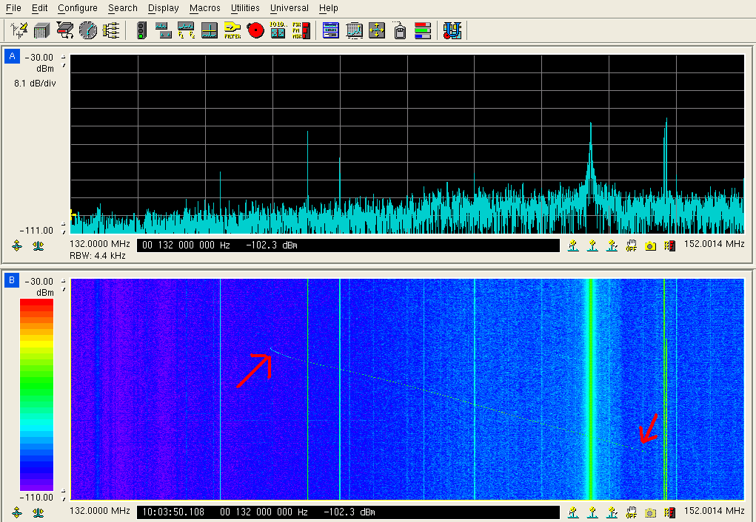

As is shown in Fig. 1.5, traditional spectrum analyser was unable to detect a sweeping, frequency modulation signal (upper part of the figure). While at the same time, the real-time analyser recorded its trace in its waterfall mode (lower part of the figure).

Case Two: Radio interference caused by ISM equipment

During the Good-Luck Beijing testing event (an overall rehearsal prior to the Games) in February, 2008, radio interference with the WLAN system in the Nation Aquatics Center (NAC) was found. The interference caused high failures rates and unusually low speed access for the WLAN users. By direction finding, the interferer was identified to be the “Dual-channel microwave oven” which leaked at 2 458 MHz with a power of −50 dBm to −70 dBm in the NAC. This kind of giant microwave ovens was used to prepare food for the staff working for the Games. In addition the interference is partly because of the special membrane structure of the NAC outside layer. This membrane structure attenuates very little of the radio waves.

Figure 1.6

Interior of the “Dual-channel microwave oven”

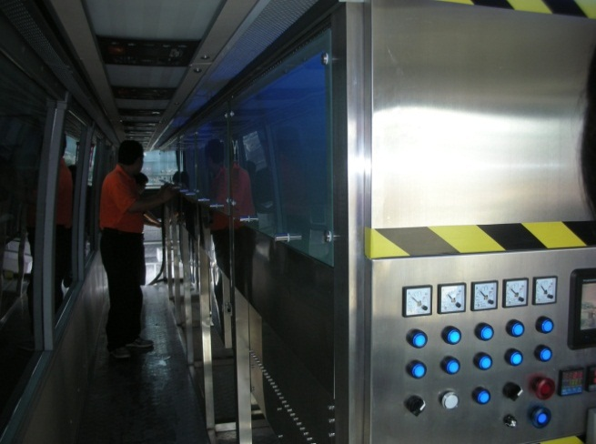

In China, the 2 400-2 500 MHz band is “designated for industrial, scientific and medical (ISM) applications. Radiocommunication services operating within these bands must accept harmful interference which may be caused by these applications.” However, considering its importance to the Games, WLAN should be protected. Therefore, a compromise solution was reached to install shielding facilities around the oven and the WLAN quality of service was much improved.

# 5 Equipment testing

## 5.1 Purpose

The purpose of equipment testing is to verify whether the users’ equipment complies with the technical parameters in the frequency license granted by the spectrum managers.

## 5.2 Testing teams and testing sites

Four fixed testing sites and three mobile testing sites were available for the media and the players. The three fixed sites were located at the IBC, the MPC and the OLV (the International Broadcast Center, the Main Press Center and the Olympic village). Such equipment as spectrum analysers, communication testing sets, GTEM chambers and label printers were available at these sites.

## 5.3 Workload

For equipment testing, the peak of its workload appears between four to two weeks prior to the competition.

## 5.4 Parameters to be tested

The parameters for mandatory tests include frequency, power, bandwidth and spurious transmissions.

## 5.5 Sample ratio to the equipment under test

TABLE 1.2

Sample ratio and technical standards of the equipment under test

|  |  |
| --- | --- |
| Equipment | Sample ratio |
| Fixed or mobile link | 5-10％ |
| Satellite news gathering or fixed satellite | 5-10％ |
| LMRS/TBS/HR | 10-20％ |
| Cordless camera | 10-20％ |
| Wireless microphone | 5-10％ |
| WLAN | 10-20％ |

## 5.6 Others

Potential interference may be produced by devices for non-communication purposes. For instance, UPS power may interfere with the timing and scoring systems working under 30 MHz, and microwave ovens may interfere with WLAN equipment. It is of essential importance for the spectrum regulators and monitoring organizations to have a good communication with the other event organizers, for example, the security staff should be notified to try not to use radio jammers. It is equally important to address problems in advance as much as possible. This is because that during the event, there will not be much time left for trouble-shooting and the access of the spectrum regulating and monitoring staff are quite limited.

# 6 Conclusions

## 6.1 Spectrum management

− The demand for spectrum resources during a major event is expected to be greater and greater. It is very likely that this demand during the next Olympic Games would exceed that of the Beijing Games.

− Except for a small number of important application (the time and score recording applications and those applications for the opening and closing ceremonies for example), sharing use of the spectrum among multiple applications is becoming an obvious solution. Therefore, sharing criteria and standards should be a very important subject to study.

## 6.2 Spectrum monitoring

− The configuration, distribution and coverage of monitoring facilities are critical for the investigation and location of interference. For example, a monitoring system in the VHF/UHF band should be installed as high as possible to improve its coverage.

− The advancement of digital technology renders it possible to perform real-time wideband monitoring and in-depth off-line analysis.

## 6.3 Equipment testing

− Frequency and bandwidth are important parameters for equipment tests and verifications. Power is another important one, but because it is difficult for some types of equipment with integrated antenna, it is a good practice to roughly estimate the e.i.r.p. by calculation the free space loss.

## 6.4 Spectrum management and monitoring within venues

− For the spectrum managers and monitoring engineers within venues, it is critical to get the most accurate and up-to-date information of the use of radio equipment in terms of its place, time and user.

## 6.5 Information systems

− To have an accurate radio station database and equipment database will lay a solid foundation for radio management and monitoring.

− It is essential to network fixed monitoring stations, equipment testing sites, monitoring vehicles, etc., which significantly improves the efficiency and response time.

Annex 2  
  
Spectrum management and spectrum monitoring during 2007 the   
Pan-American Games and Parapan American  
Games held in Brazil

# 1 Introduction

As important as such services as security, health, transport, energy, etc., are telecommunications play a special role in all stages of such events as Pan-American Games, World Cup and Olympic Games. The integration of these infrastructural aspects is essential for the success of the event. The high density of different electronic devices can build a complex telecommunication scenario like was faced in 2007 Pan-American Games held in Brazil. The objective of this Report is to present how spectrum management and spectrum monitoring were undertaken during the Pan-American Games and Parapan American Games, in order to provide another reference for major events in the future.

The activities planning performed by Anatel to attend the Games Organizing Committee (CO-Rio) request was partially based on the ACA report on 2000 Sydney Olympic and Paralympics Games.

# 2 Overview of 2007 Pan-American games

## 2.1 General information

The Rio 2007 Pan American and Parapan American Games brought together many countries from the Americas Region. The following numbers give general information about this event:

– 5 633 athletes from 42 countries;

– 1 395 accredited journalists;

– 21 054 workforce members accredited at Pan American Games;

– 6 514 workforce members accredited at Parapan American Games;

– 5 633 athlete entries in 47 sport disciplines and 332 Pan American Games events, and 1 115 entries for 10 Parapan AmericanGames sport disciplines and 287 events;

– 759 hours of live images;

– 675 hours produced in HDTV;

– 84 hours produced in SDTV;

– 15 venues with live broadcast;

– 12 venues with pre-recorded coverage;

– more than 100 cameras and 30 recorders;

– more than 2 000 accredited broadcasters;

– 10 Mobile Units (MU) and more than 20 broadcast trailers.

## 2.2 Technological operations center (TOC)

The technological operation during the 2007 Pan American Games was coordinated by TOC, which was responsible for all of the critical technology and crisis decision-making processes. Besides, this operational center was in charge of providing information about the frequency plan and spectrum necessities. The following information describes the general TOC infrastructure:

– 16 000 m of electric cables;

– 5 000 m of data and voice cables;

– 500 kVA of electric power;

– 166 TR (130 TR comfort and 36 TR precision) of cooling capacity (1TR=12 000 BTU/h);

– 475 m air-conditioning ducts;

– 600 sq. metres of brick walls and 1 350 sq. metres of dry walls;

– 180 telephone lines;

– 250 desktops;

– 180 work positions;

– 500 kVA emergency electric system;

– fully redundant voice, data, energy and air conditioning structure.

# 3 Spectrum management

The Games Organizing Committee (CO-Rio) that was in charge of the organization of the 2007 Pan-American Games contacted the National Telecommunication Agency (Anatel) five months prior to the games. Anatel is the Regulatory Authority in charge of telecommunication issues in Brazil.

## 3.1 Spectrum requested

There are activities in major events that demand special infrastructure, such as communication, transport, energy, etc. Communication support is essential for the whole chain of activities that are inherent in the event. Such activities as security, broadcast, and process management demand significant use of communication. To attend this demand, CO-Rio requested several bands that were considered critical for the success of the Games. With this request it was possible to develop the frequency planning, and the resources for spectrum monitoring were rationally applied.

Another relevant point is the huge demand for spectrum resources for security sector. In this case, because of reasons related to spectrum efficiency use, strategies such as frequency reuse must be considered.

As spectrum use was critical for the realization of the event, an area encompassing the four major event regions, as presented in Fig. 2.1, was delimited as a special control zone, where all license requests were processed by a centralized office and non-essential requests were delayed to after the event period, exempt for CO-Rio request.

## 3.2 Preparation period

After the first contact, a task force formed within Anatel established priorities concerning spectrum resources and telecommunication infrastructure. The main concern of the spectrum planning were the available resources and the requests of CO-Rio.

Before the games, the spectrum monitoring was constantly made in the areas that would be used for competitions to evaluate the bands that would be suitable for games proposals.

In addition, Anatel created a coordination group to work exclusively with 2007 Pan-American Games. This coordination was held in Anatel’s office in Rio, which became the operational center. The coordination considered enforcement, equipment testing and spectrum monitoring major activities.

The enforcement activities planning took into consideration the presence of at least two Anatel agents in each competition, the logistics and simultaneous occurrence of competitions on different sites, which created a total demand of 100 agents.

For equipment testing a special sticker was used to identify the equipment that had been tested. This procedure avoided overlap in equipment testing.

One of the main difficulties during the preparation was the identification of parking sites for mobile units that would allow continuous operation during the games, including infrastructure support to such areas as power and security.

## 3.3 Just before

Two weeks before the games, the coordination group concluded the planning work for major activities enforcement, equipment testing and spectrum monitoring.

The coordination group presented the planning for the games to all personnel involved. This presentation included a short course about main procedures that would be applied such as approach and spectrum monitoring around the venues. In addition, transport and logistics organization were tested.

## 3.4 During the games

Specially authorized personnel from Anatel went to competition areas for activities such as spectrum monitoring, equipment testing and inspections. Another part stayed out of the competition areas in order to remotely monitor the activities.

Every day, all members that had worked during that day reported to the coordination group on relevant events that had taken place that day.

## 3.5 Spectrum monitoring

Three fixed and one mobile monitoring stations were used to identify the spectrum profile for each band requested by CO-Rio. The set-up of these stations was configured according to the performed frequency planning. Frequency bands requested by CO-Rio, and such other aspects as spectrum availability, frequency reuse, essential games services and location of venues were taken into account in order to plan an efficient use of spectrum.

The topography of Rio de Janeiro city is characterized by spreading hills, which has a significant influence on radio propagation above VHF band. Thus, the mobile monitoring station was intensively used in order to cover areas where fixed monitoring station could not be used.

Data gathered on spectrum use before the event in the competition areas was essential for spectrum planning.

Figure 2.1 presents the competition areas where the mobile monitoring station collected data about spectrum use.

Figure 2.1

2007 Pan-American Games competition areas



During the games, in order to guarantee protection against intentional or non-intentional emissions that could interfere with the telecommunications systems, three more mobile monitoring station were put into the competition areas.

## 3.6 Spectrum available for VHF, UHF and SHF bands

Despite the fact that almost all frequency bands had already been assigned for different kinds of telecommunication services, special licenses were assigned during the games. These licenses took into account the aspects of primary services, defense, security and other radiocommunication stations with licenses issued before the event.

The following table presents a fragment of the studies based on licensed station and spectrum monitoring. The results of these actions provided the strategic information about the available spectrum before the 2007 Pan-American Games. The level of availability had taken into account not only the licenses issued before the games, but also the spectrum availability, coordination with other users during the event and potential harmful interference with users that had already been operating before.

For evaluating the level of availability, such aspects as coordination procedures take into consideration point-to-point and point-to-multipoint applications as well as the importance of the service, for instance public phone service and public mobile communication.

|  |  |  |
| --- | --- | --- |
| Frequency band (MHz) | Application | Availability |
| **138-267** | Fixed services, mobile maritime service, radio amateur, broadcast auxiliary service | Low |
| **335.4-399.9** | Fixed and mobile service | Middle |
| **406.1-411.675** | Fixed and mobile service | Low |
| **420-432** | Trunking, multimedia service, radio amateur | Middle |
| **440-450** | Fixed and mobile service | Middle |
| **450-470** | Fixed and mobile service | Very Low |
| **2 300-2 690** | Broadcast auxiliary service, ISM, MMDS | Low |
| **3 300-3 400** | Broadcast auxiliary service | Middle |
| **3 400-3 600** | Broadcast auxiliary service, telephone fixed service, multimedia communication | Low |
| **6 650-6 770** | Satellite service | Low |
| **6 990-7 410** | Broadcast auxiliary service | Middle |
| **10 150-10 300** | Broadcast auxiliary service | Middle |
| **12 200-13 250** | Fixed service | Middle |
| **17 700-17 800** | Fixed and mobile service, mobile phone links | Low |
| **19 260-19 360** | Fixed and mobile service, mobile phone links | Low |
| **21 200-21 800** | Fixed and mobile service | High |
| **22 400-23 000** | Fixed and mobile service | High |

## 3.7 Radio equipment used during the games

The following graphic presents the major usage of radio equipment during the games. Even though this is a partial list of the equipment that had been used, it can be seen that wireless microphone is extensively used by the organization of the games.



Additionally, the organization of event informed that there was a huge use of hand-held radios, Satellite News Gathering and Wireless LAN.

# 4 Temporary spectrum use licensing

Just before the games, a new version of the licensing system for temporary spectrum use licensing was deployed, allowing digital submission of requests and suppressing the paper forms, which allowed achieving greater efficiency on this procedure. The graphic below represents the number of licenses issued in 2007, displaying a ten-fold activities increase during the Pan-American Games.



It can be seen that the number of temporary licenses issued for fixed and mobile stations peaks in July of 2007, when the 2007 Pan-American Games took place. The use of telecommunication services during the games was massive. In this period, almost all licenses issued were associated with the games.

# 5 Conclusions

## 5.1 Spectrum management

The spectrum planning contributed significantly to the success of the games. Although the period of time to elaborate the planning had been very short, the planning helped to avoid many drawbacks related to interference and waste of resources.

The procedure of prompt reporting allowed optimizing the resources available for spectrum monitoring. In fact it reduced significantly the problems caused by harmful interference.

In large areas with irregular topography such as Rio, mobile monitoring stations are essential for spectrum monitoring of events like 2007 Pan-American Games. This kind of infrastructure allows to identify weak signals, which could not be detected by fixed monitoring station, for instance. Besides, mobile monitoring stations were able to help to localize interference sources with a good precision in few seconds.

## 5.2 Equipment testing

It was clear how important it is to advertise the role of administration to every sport delegation. This procedure avoids incident troubles at the beginning and during the event.

## 5.3 Temporary use of spectrum

As presented above, the temporary use of spectrum increased dramatically, which demanded the evaluation of a large number of requests in a short period of time. This kind of situation can expose the event realization to unnecessary risks, and should thus be avoided.

Finally, it is essential to build a cooperative environment between the Regulatory Authority and the Organizing Committee. This optimizes such actions as equipment acquisitions, frequency planning, infrastructure sizing, etc. Besides, it allows pretests to minimize the uncertainties about the whole telecommunication system that will be deployed.

Annex 3  
  
Spectrum management and spectrum monitoring during the 2005APEC  
Summit meeting I 2010 G20 Seoul Summit in the Republic of Korea

# 1 Introduction

Major events such as Olympics, summit meeting and world cup games are in the focus of the public interest and also take too much time to prepare. During the event a lot of radio applications and equipment are used within the arena and therefore there is great potential of radio interference or noise. The applications range from broadcasting and communication, police, wireless microphone, and so on. Therefore systematic spectrum planning, licensing, spectrum monitoring, inspecting and eliminating interference are very important to host the event successfully.

The purpose of this report is to provide information to administrations by sharing the general experience of the KCC (Korean Communication Commission) in some cases of activities especially in the field of licensing, spectrum monitoring and interference eliminating.

# 2 Overview of activities during the major event

## 2.1 General tasks of preparatory group to host the major event

The preparatory group usually carries out the following tasks to make the major event successfully. First, the group establishes an annual plan with investigating domestic and international events, and has a close relation with relevant organizations by contacting regularly. Just before the event, it is very important to measure radio environment around the arena and eliminate interference resource. During the event, the group monitors authorized frequency band for the purpose of security, police, broadcasting and so on. After the event, the group discusses the result and finds a solution of the problem.

## 2.2 Before the event

The preparatory group performs radio environment measurement and spectrum monitoring around the arena to prevent radio interference before the event is started.

When radio interference or unwanted signal is detected, the group eliminates it promptly on-site. Especially in case that the signal is not reached to spectrum monitoring vehicle, the group moves to the location and investigates the cause.

Also, spectrum monitoring is more strengthened at the fixed site for searching violations of radio regulation and illegal radio stations. It focuses on certain frequency band which is used in the arena. If an illegal radio signal is captured then the group notifies to CS team.

CS (Customer Satisfaction) team

CS team, which belongs to KCC, consists of some staffs and monitoring vehicle.

When users cannot operate their radio stations normally because of interference or electromagnetic wave, CS team deals with these inconveniences in ten days and protects radio environment.

CS team can usually carry out two main tasks. One is “notifying arrival time of customer” and the other is “One-stop radio service”. “Notifying arrival time” is a service to inform the customer when CS team actually goes on-site to solve the problem. “One-stop radio service” is a complaint handling. Once the staffs receive a complaint from a customer by the phone or the internet, CS team removes the interference resource and then notifies the result to the customer.

## 2.3 During the event

Once the event is started, CS team (They are members of preparatory group.) performs spectrum monitoring and direction finding with monitoring vehicle.

The team is made up of four staff who operate a monitoring vehicle. The team also has portable equipment to investigate radio interference and eliminate it.

Also, the team carries out spectrum monitoring. It is to find out violations and radio interferences in monitoring vehicle with radio quality measurement system and monitoring equipment. This measurement system automatically scans and searches authorized frequency band.

## 2.4 After the event

After the event, the preparatory group reports the results of their activities to KCC. Considering this report, relevant officials establish a solution and take improvement of measures if it is necessary.

# 3 Cases of spectrum management and radio monitoring during the major event

## 3.1 2005APEC summit meeting

### 3.1.1 Overview

KCC temporarily configured the preparatory group to support for the operation of wire and wireless networks and good communication services during the APEC summit. The group performed activities of radio monitoring and interference eliminating by ten operators who were deployed daily around the meeting area during the event.

### 3.1.2 Spectrum management

The group received spectrum application from APEC preparatory Office in advance and licensed radio stations for broadcasting company and VIP guard considering the frequency, power and the using places.

Only radio stations for emergency communications and small equipment (wireless microphones, intercoms and walkie-talkies) were licensed on site during the event. All other applications were licensed prior to the event.

### 3.1.3 Spectrum monitoring

The CS team performed spectrum monitoring to find out violation against the radio regulation and legal frequency use. Fixed monitoring stations were used for monitoring the authorized radio frequency around meeting areas. In case of spectrum monitoring in a blind spot or the interference eliminating immediately, the monitoring vehicle was deployed around the meeting area for 24-hour.

### 3.1.4 Cases of violations and actions

In case of violations, there are two possible ways of actions:

– Certain delegation’s frequency was overlapped with police communication and they asked the delegation to stop using the frequency band.

– Some wireless equipment malfunctioned because of radio interference by telecom company’s wireless network device. So the network device was replaced with wire network device.

## 3.2 Satellite radio monitoring during the 2010 G20 Seoul Summit

### 3.2.1 Overview

During international events such as G20 Seoul Summit, international communication demands, especially satellite communications, may increase significantly. Therefore it is necessary to support stable satellite communication during the event. In this context, Korean Satellite Radio Monitoring Center (SRMC) performs several activities for protecting satellite network. The SRMC, which has responsibilities on protecting Korean satellites networks from interferences of earth and space stations, monitors satellite signals into the Korean peninsula by using fixed and mobile equipment during the G20 Summit.

### 3.2.2 Satellite radio monitoring

Especially intensive monitoring on the four Korean geostationary satellites (KOREASAT-3, KOREASAT-5, HANBYUL, CHEOLIAN) were held before and after the event, from 8 to 12 November. Two operators were deployed at the operating room of the SRMC and other two men operate the monitoring vehicle.

Considerations for monitoring

– The intensive monitoring should be performed in consecutive order on each satellite, bands for broadcasting and communication have priority.

– The interference handling has a higher priority than others during the G20 Summit.

– Mobile satellite radio monitoring vehicles should be deployed around at the venue.

– The monitoring report should be separately recorded and managed.

Measurement parameters

– Orbital position, polarization and mean frequency.

– The maximum equivalent isotropically radiated power (e.i.r.p.) of a station in the fixed or mobile shall not exceed +55 dBW. (See No. 21.3 of the Radio Regulations.)

– +47 dBW in any direction within 0.5 of the geostationary satellite orbit shall not exceed. (See No. 21.4 of the Radio Regulations.)

– Occupied bandwidth, power flux-density (PFD) and e.i.r.p.

Unusual result was not found during the event.

# 4 Conclusion

During major events, broadcasting and communication demands may increase significantly. Therefore, it is essential to support seamless communication for hosting the event successfully. To make this possible frequency planning, authorizing, monitoring, dealing with the interference and establishing a cooperative relation with all relevant parties are very important.

This Report regarding some cases may be helpful to administrations.

Annex 4  
  
Spectrum management and spectrum monitoring during the FIFA  
Soccer World Cup 2006 in Germany

# 1 Introduction

In accordance with the provisions of the German government, the president of the German Bundesnetzagentur (BnetzA, Federal Network Agency), the responsible authority for frequency management and monitoring issues, set highest priority for the support of the FIFA world soccer championship 2006 that took place from 9 June to 9 July 2006 in Germany.

Although the spectrum was already heavily occupied around the 12 venues, frequencies had to be assigned for broadcasters, security staff, the organizer and others at public-viewing locations, training locations, hotels of the teams, etc., in several towns.

The main tasks of the Federal Network Agency were:

– to provide sufficient frequencies for the additional frequency users during the event;

– to ensure for an interference-free usability of the security relevant frequencies (police, fire brigade, ambulance, aeronautical service and military); and

– to solve interference problems with other radio services rapidly.

# 2 Organisation and cooperation

On July 6, 2000: FIFA decided that the event will take place in Germany. A first contact between the Federal Network Agency and the organisation committee was established. The contacts reoccurred from 2002 until the games on a regular basis. Regarding frequency management there was a close contact to the host broadcaster which was a foreign company. At an early stage the Federal Network Agency set up a task group comprising of staff from all departments of the Agency involved.

# 3 Distribution of information

Early information of the radio users is essential for an interference-free operation. The Federal Network Agency’s homepage was supplemented accordingly in order to answer the following questions:

– What are the conditions for the use of frequencies?

– Who can be asked?

– Who provides licenses?

– What has to be noted?

The information on the homepage contained

– the general description of the relevant procedures including terms (time limits) and contact points;

– the red list of frequencies which cannot be used;

– the green list of generally licensed frequencies; and

– special application forms ensuring the provision of all relevant information.

Figure 4.1

Special application form on the occasion of the FIFA Soccer World Cup 2006



Figure 4.2

Green list and red list of frequencies

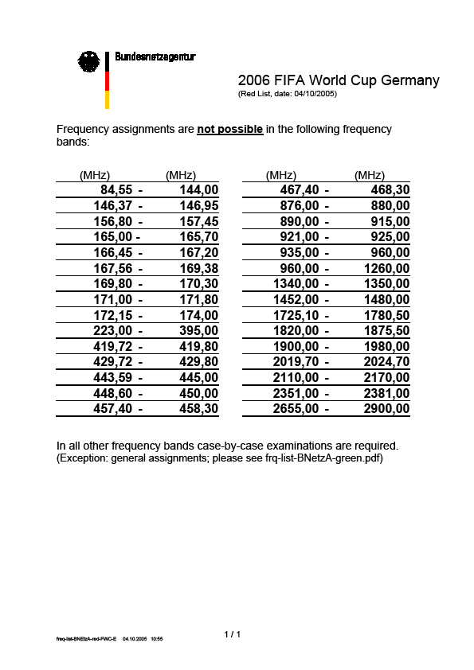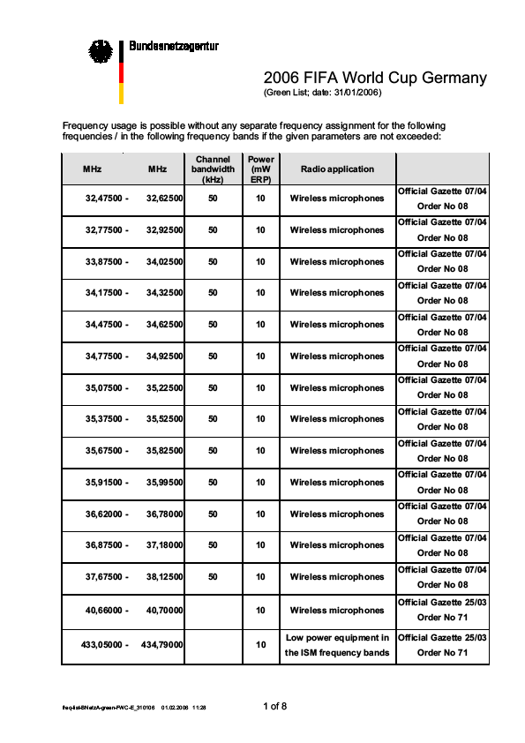

The host broadcaster organized World Broadcaster Meetings in December 2005 and April 2006. The network agency used these meetings to explain the 600 delegates the procedures. Many questions could be answered and problems were picked up at an early stage.

# 4 Confederations Cup 2005

The Confederations Cup 2005 provided an important test scenario for the FIFA Soccer World Cup 2006. In June 2005 the following issues could be tested in 5 stadiums:

– English knowledge of the staff;

– Data exchange between the BnetzA’s central project team in Mainz and the stadiums via remote access service (RAS);

– Cooperation between the central project team and the local teams;

– Technical equipment;

– Accreditation;

– Service schedule;

– Cooperation with the police;

– Clothing (spectrum management & monitoring).

# 5 Project team and local teams

For the overall coordination a central project team of up to 8 staff members was installed in the head office of the BnetzA in Mainz.

Local teams consisting of frequency managers and radio monitoring staff equipped with vehicles and handheld devices were set up in all 12 venues. They were in charge of the stadium, public viewing sites, team hotels, training areas, etc.

An additional team was responsible for the International Media Centre (IMC or IBC) in Munich, hosting offices and studios of more than 70 broadcasters.

Training courses were organized for the teams to refresh their English knowledge. As described in § 2, the project team and the local teams could test their operational readiness at the FIFA Confederations Cup 2005. This resulted in a repeated modification of the procedures and in the solution of remaining problems.

# 6 Licensing

There are differences between the frequency utilisation at the 12 stadiums and at other places like hotels and public viewing locations. The latter show lower frequency occupation but for longer periods of time compared to the other locations.

The frequency usage at the stadiums is concentrated from a few hours before the game and 2 hours after the game. Only the host broadcaster and a few other broadcasters are allowed to produce TV pictures from the stadiums. There was an increased frequency usage at the end of the contest.

All requests for frequencies had to be sent to the project office which had a special fax number and email address. The requests were checked for completeness and plausibility. Ambiguities were discussed with the applicant. The requests were recorded in a central data base and made available for the 12 local teams.

The requests were further processed by the local teams. They checked the availability of the frequencies, looked for alternatives if there were problems, assigned the frequency, produced the relevant documents including the assessment of fee and sent them to the applicants.

The teams made the following experience:

– The majority of requests for frequency assignments could be handled in due time before the event.

– In case of substitute radio equipment there was sometimes the need to assign new frequencies. This resulted in substantially increasing workload immediately before the event at the time of testing and initial operation of the radio equipment.

– A few frequency users only had not at all applied for a license.

– This was due to the good preparation and information by the Federal Network Agency, the OK 2006 and the 2 World Broadcaster Meetings.

Also the use of generally licensed (or license free) equipment needed sometimes careful attention. Several remote controlled cameras using ISM frequencies or other frequencies designated for SRDs were operated by different photo reporters. This resulted in complaints about the unintentional release of cameras. Troubleshooting was done by the host broadcaster who assigned the radio channels to the photo reporters during their morning briefing.

For the World-Cup in 2006 the German administration received over 10 000 requests of frequency assignment. Figure 4.3 shows the chronological distribution of incoming requests for frequency assignment for a single event, e.g. one of the games of the World Cup 2006.

Figure 4.3

Number of requests for over time



The figure shows a time line in weeks at the horizontal axis. At the vertical axis the frequency requests in % can be seen. The intersection point at the bottom right corner marks the date of the event.

One of the most important facts that can be analysed is that about 21% of all requests occur only one week prior an event (e.g. a single game of the World Cup 2006). Even 4% of the requests occur on the day of the event itself (this actually cannot be seen, due to the grouping of this statistical elaboration). For example staff of broadcasting companies bring equipment like cordless microphones with them on the day of the event, contact the administration staff from face to face, that in this case has to give on-the-spot support.

The figure shows other peaks at the weeks 17 and 19 prior to an event. Such peaks can be explained by two different facts. On the one hand the process of “How to request a frequency” is declared to the broadcasting companies at large conferences. Driven by this knowledge the requests are nearly given at the same time. On the other hand major events are often hosted by one “Host Broadcaster”. Frequency requests of this broadcaster are naturally of high numbers.

# 7 Staff and accreditation

The office at the International Media Centre in Munich was opened 4 weeks before the games. It was available 7 days a week until 8 p.m.

An information booth of the BnetzA with a total of 6 staff was available 2 days before the first game in all stadiums.

Figure 4.4

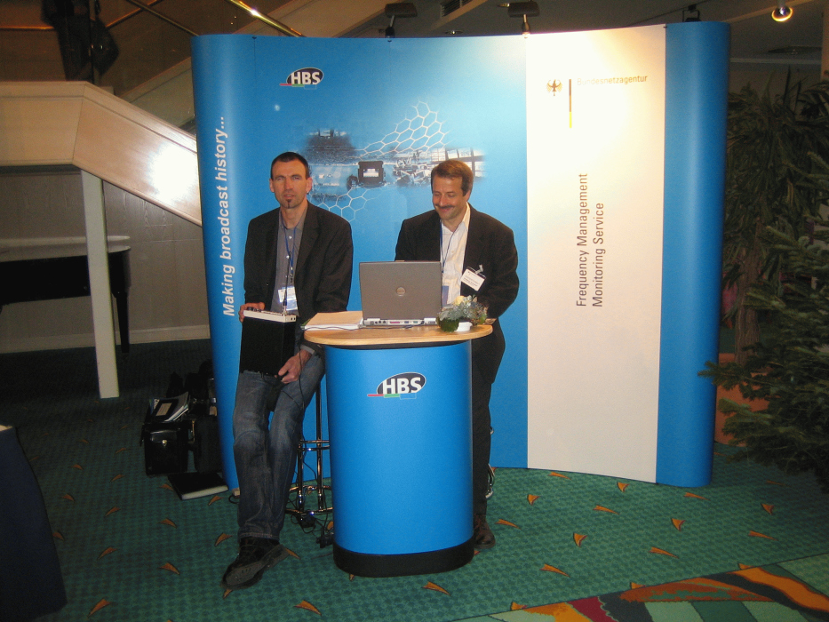**Information booth of the BnetzA**



The stadiums and the International Broadcasting Centre (IBC) were divided in several zones. As radio waves do not respect them it is essential that the agency’s staff can access as many as possible locations.

The OK 2006 issued 2-part identification badges. The first part identified the colleagues individually. The second part referred to a location. Up to 7 zone badges were issued for each of the 12 stadiums and the IBC.

The zone badges were turned over from one colleague to the next according to the work schedule. Two colleagues of the project office in Mainz received an accreditation for all sites.

# 8 The International Media Centre (IMC or IBC)

The following pictures may give an impression of the size of the international media centre.

Figure 4.5

The International Media Centre

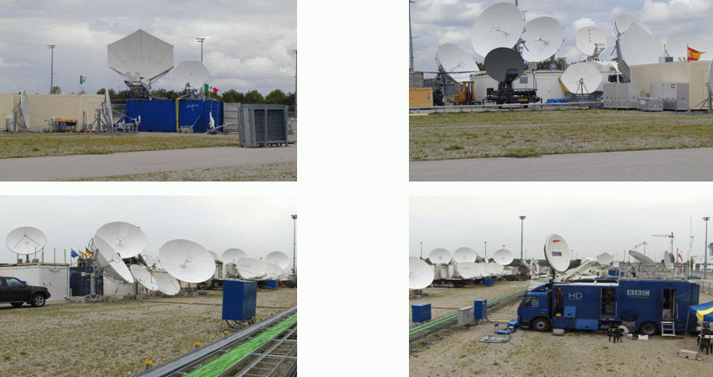

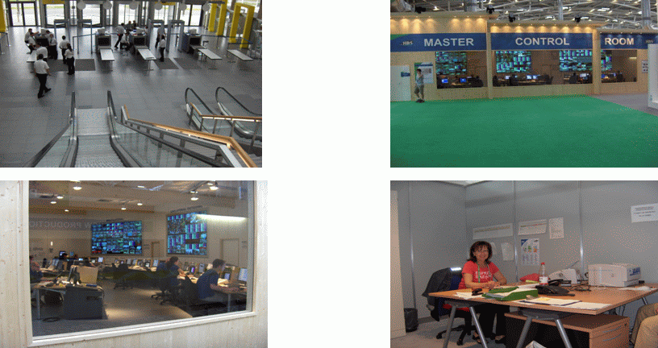

# 9 Spectrum monitoring tasks

The following tasks had to be carried out:

– Initial frequency survey;

– Inspection of the frequency users and their equipment in the TV-compound;

– Inspection of other frequency users in the stadiums (security staff, catering, etc.);

– Interference investigation;

– Monitoring of the spectrum, identification of unlicensed emissions.

## 9.1 Spectrum monitoring before the event

An initial spectrum survey (band scan and channel occupancy measurements) between 148 MHz and 3.5 GHz revealed unused frequencies which could be assigned for the event and assisted in the search of unlicensed users.

The measurements were limited to the 12 stadiums and the IBC. No measurements were carried out at training areas, hotels, etc.

– Experience shows that measurements should have been done at the fan festival in Berlin, too.

## 9.2 Spectrum monitoring during the event

The spectrum was permanently monitored by remote controlled stations during the championship in order to identify unauthorized emissions.

Mobile measurement equipment was available at the days of the event in the vicinity of the stadiums.

One mobile unit was permanently present at the IBC.

Handheld equipment was available in the stadium.

Occasionally monitoring vehicles were also deployed at public viewing locations, etc.

# 10 The fan park

The figure below shows the fan park outside the Munich stadium. Here are also a lot of possible sources of interference like large scale video displays and radio equipment.

Figure 4.6

The fan park

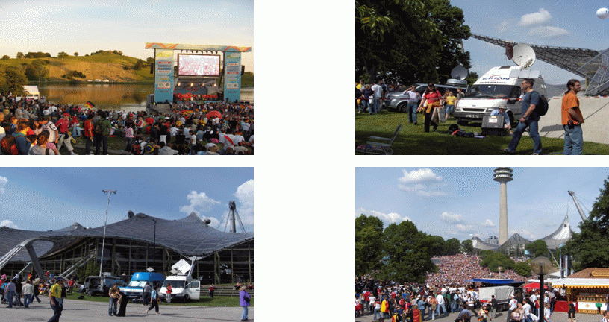

# 11 Interference investigation and problems

The following conclusions can be drawn from the event:

– When using so much equipment in a small area, interferences cannot be avoided completely.

– User equipment is installed and decomposed several times per year. This may result in faulty RF shielding and spurious emissions.

– The main problems were:

• EMC problems from video screens;

• intermodulation because of insufficient spatial decoupling;

• faulty programming of radio equipment.

# 12 Labelling

All users were informed about equipment inspection well in advance. All tested equipment was labelled. The labels were valid for up to 4 matches and could be devaluated for single matches. The figure below shows some examples.

Figure 4.7

Examples for labelling of radio equipment

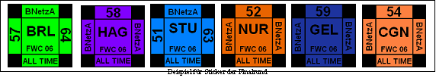

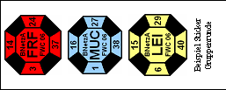

# 13 Some interesting figures

For the preparation of similar events it may be useful to see the following figures.

– 200 colleagues were accredited;

– Some 10000 frequencies requested;

– 6 500 thereof designated for the use at the 12 stadiums;

– 85% of the requests were accepted;

– 1 000 short term licenses for 150 applicants were issued;

– 84 interference reports before and after the games;

– 12 interference reports during the games;

– 60 cases of interference were solved;

– More than 6 000 stickers were issued.

# 14 Conclusion

The amount of electronic equipment in general and radio equipment in particular in a limited area provided a challenging situation for the frequency management and the radio monitoring service. Thorough planning of the event at a very early stage and participation and information of all stakeholders resulted in a successful event with a limited number of interference problems.

Annex 5  
  
Spectrum management and spectrum monitoring during  
the Formula One (F1) racing at UAE

# 1 Introduction

The Formula-1 is one of the major international events held at UAE and organized by Abu Dhabi Motorsports Management (ADMM) at Yas Abu Dhabi. The event has been held successfully since 2009 once each year.

The event requires efficient spectrum management for allocation of more than 600 frequencies to be used at the same venue for various wireless services and applications that are required by the ADMM and Formula 1 teams. Spectrum authorizations applications were including walkie-talkie, telemetry, security, radio microphones, data units, wireless cameras, broadcasting, etc. More than 12 500 wireless apparatus was imported to the UAE exclusively for the F1 event.

# 2 The Telecommunications Regulatory Authority (TRA) involvement

The TRA being the sole regulatory authority to manage the radio spectrum and monitoring was on board from the planning of the event. The TRA signed a MoU with the event management committee also responsible for security aspects. As per the MoU the TRA will provide support for:

− frequency management, assignments and coordination;

− minimize interference and illegal usage;

− security and safety for communication during the event.

To meet its obligations, the TRA constituted a team from following sections/department:

− spectrum monitoring section;

− spectrum allocation section;

− broadcasting spectrum section;

− finance.

The major responsibilities included frequency assignments and monitoring for interference free spectrum. The challenge was to:

− conduct RF surveys before and during the event to find the noise floor and clean spectrum;

− assign more than 600 frequencies in VHF, UHF and SHF, for the event to be used within a small area simultaneously;

− monitor spectrum usage and detect and resolve any harmful interference within a very short response time;

− issue on site authorizations, invoices settlement and equipment authorizations;

− handling custom clearance approvals for the imported equipment.

# 3 Preparation activities before the event

The major activities before the event are summarized as follows:

− Internal coordination within TRA departments to form a team for the event;

− establishment of team and project plan;

− identification of monitoring assets required during the event;

− analysing the frequency requirements based on discussions with the event organizers on the type of wireless equipment that will be used;

− detailed meeting with the event organizers for preparing the guidance documents to the users of the wireless equipment informing them about the procedures and requirements;

− pre-assignment site survey (spectrum occupancy measurements);

− meetings with public safety organizations to coordinate their frequency requirements;

− coordination for type approval and custom clearance of wireless equipment;

− details on establishment of site office for spectrum authorization, monitoring, spectrum fees invoicing and payments with facilities and access requirements;

− detailed spectrum planning on available frequency channels in the area after validation of monitoring results;

− site visits to identify the locations for positioning monitoring equipment.

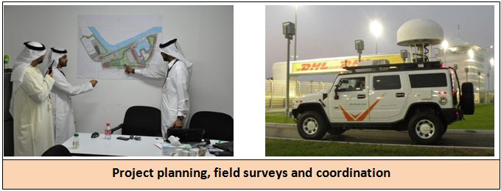

# 4 Spectrum authorizations and usage

Table 5.1 provides details on the number of assignments made for the different types of wireless equipment used at the 2011 event.

TABLE 5.1

|  |  |
| --- | --- |
| Application | No. of frequency assignments |
| Wireless camera | 57 |
| Data link | 72 |
| Digital satellite news gathering | 9 |
| Private mobile radio | 329 |
| Wireless MIC | 134 |
| FM broadcasting station | 1 |
| **TOTAL** | **602** |

The following figure shows the variations in the number of assignments for different types of wireless equipment from 2009 to 2011.

# 5 Challenges of spectrum management

Table 5.1 shows that the major challenges in assignment were related to private mobile radio, wireless microphones and wireless cameras.

## 5.1 Challenges on PMR assignments

The private mobile radio assignments are manageable within a given area. It is possible to accommodate a large number of assignments by authorizing the required power levels and balancing the assignments in both VHF and UHF bands. The actual challenge is that majority of the teams participating in the Formula One circuit have pre-programmed equipment which they are using at different venues around the world. The programmed frequencies are sometimes not readily available with the team coordinators responsible for logistics arrangements and the actual requests with specific frequencies are received at a short notice. This challenge is generally greater for the first year of the event and is then decreasing subsequently as the database of previous events is available.

## 5.2 Challenges on wireless microphone assignments

The majority of wireless microphones and other PMSE equipment work in the UHF band where either the band is allocated to broadcasting (analog or digital) and mobile. The challenge is when majority of the applications for wireless microphones are received in the 470-790 MHz range. This band is still used for analog television. The following steps are then taken to undertake spectrum planning:

### 5.2.1 Spectrum planning

Computer aided techniques of spectrum planning are used to identify the available spectrum. The software provides a list of TV channels with Usable Filed Strength value for each channel arranged in ascending order (Fig. 5.1). The channels having lower usable field strength value can be used for wireless microphones.

Figure 5.1

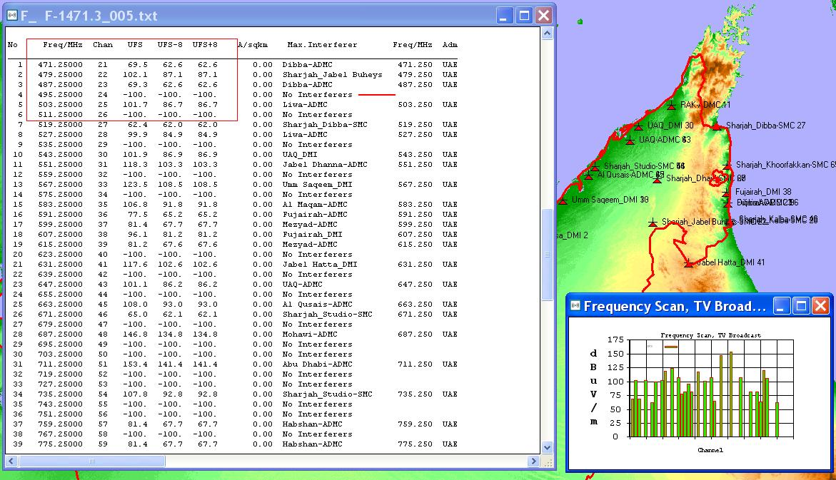

### 5.2.2 Spectrum monitoring

On site spectrum monitoring surveys are then conducted for different times of the day to ascertain exact measurements on the ground (Fig. 5.2) and to compare the prediction result with the actual situation. This helps in validating the availability of spectrum. This is required as in the Gulf region the ducting affect sometimes results in field strength values different from the predicted values.

FigURE 5.2

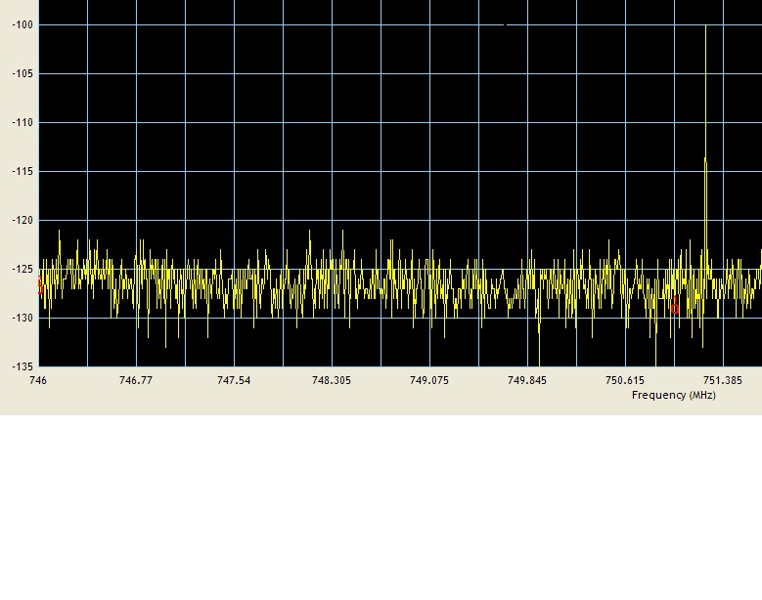

### 5.2.3 Frequency assignment

For making assignments, the applicant provides the details of the equipment along with preferred frequencies. Most of the wireless microphones manufacturers provide frequency sheets (Fig. 5.3) containing preferred frequencies to avoid inter-modulation.

FigURE 5.3

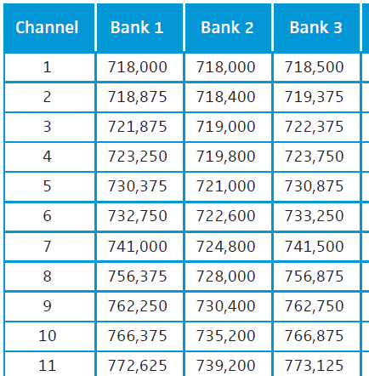

If this sheet is not available then the inter-modulation can be calculated using software (Fig. 5.4) before assigning frequencies to an applicant:

FIGURE 5.4

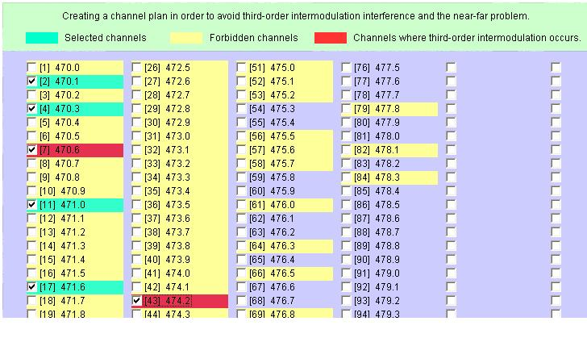

# 6 Challenges of spectrum monitoring

The spectrum monitoring challenges during the event are:

− short reaction time;

− availability and positioning of on-site monitoring equipment;

− detection of the source of harmful interference, especially when majority of the wireless equipment is positioned in close proximity;

− temporary installations create radiation leakage issues from connectors causing harmful interference;

− coordination with different entities and designated focal points;

− spectrum enforcement.

# 7 Overall lessons from spectrum management and monitoring at events

The following are the summarized lessons learnt:

− prior planning for spectrum availability, requirements and project;

− communicate and coordinate with all stakeholders;

− publish the procedures and guidelines for wireless equipment import;

− publish the spectrum authorization procedures and regulations;

− on-site support for the complete spectrum management and monitoring;

− flexibility and contingency planning for changing requirements of spectrum use;

− details on project team communication, procedures and methods.