|  |
| --- |
| **Report ITU-R SM.2156-0**  **(09/2009)** |
| **The role of spectrum monitoring  in support of inspections** |
| **SM Series**  **Spectrum management** |

Foreword

The role of the Radiocommunication Sector is to ensure the rational, equitable, efficient and economical use of the radio-frequency spectrum by all radiocommunication services, including satellite services, and carry out studies without limit of frequency range on the basis of which Recommendations are adopted.

The regulatory and policy functions of the Radiocommunication Sector are performed by World and Regional Radiocommunication Conferences and Radiocommunication Assemblies supported by Study Groups.

# Policy on Intellectual Property Right (IPR)

ITU-R policy on IPR is described in the Common Patent Policy for ITU-T/ITU-R/ISO/IEC referenced in Annex 1 of Resolution ITU-R 1. Forms to be used for the submission of patent statements and licensing declarations by patent holders are available from <http://www.itu.int/ITU-R/go/patents/en> where the Guidelines for Implementation of the Common Patent Policy for ITU‑T/ITU‑R/ISO/IEC and the ITU-R patent information database can also be found.

|  |  |
| --- | --- |
| Series of ITU-R Reports  (Also available online at <http://www.itu.int/publ/R-REP/en>) | |
| **Series** | Title |
| **BO** | Satellite delivery |
| **BR** | Recording for production, archival and play-out; film for television |
| **BS** | Broadcasting service (sound) |
| **BT** | Broadcasting service (television) |
| **F** | Fixed service |
| **M** | Mobile, radiodetermination, amateur and related satellite services |
| **P** | Radiowave propagation |
| **RA** | Radio astronomy |
| **RS** | Remote sensing systems |
| **S** | Fixed-satellite service |
| **SA** | Space applications and meteorology |
| **SF** | Frequency sharing and coordination between fixed-satellite and fixed service systems |
| **SM** | **Spectrum management** |

|  |
| --- |
|  |

|  |
| --- |
| ***Note****: This ITU-R Report was approved in English by the Study Group under the procedure detailed   in Resolution ITU-R 1.* |

*Electronic Publication*

Geneva, 2018

© ITU 2018

All rights reserved. No part of this publication may be reproduced, by any means whatsoever, without written permission of ITU.

REPORT ITU-R SM.2156-0[1]*

The role of spectrum monitoring in support of inspections

(2009)

TABLE OF CONTENTS

Page

1 Scope 2

2 Introduction 2

2.1 Effective radiated power and field strength 2

2.2 Measurement of spurious emissions 3

2.3 Mask measurements 4

2.4 Frequency measurements 4

Annex 1 – Example of monitoring used in inspections planning in the Netherlands 5

1 Comparison of field-strength measurements with calculated values 5

2 Trends 7

3 Bandwidth 8

4 Measurement schedule 9

5 Summary 10

Annex 2 – Example of mobile monitoring to select candidates for PLT network inspections in Brazil 10

1 Introduction 10

2 Mobile monitoring station used 10

3 Device under test configuration 11

4 Reference documents 11

5 Measurements 11

6 Comparing loop antenna plus spectrum analyser vs. mobile monitoring station 12

7 Conclusion 20

# 1 Scope

This Report discusses the role of spectrum monitoring in support of inspections, supported with examples. Where the link of spectrum monitoring with inspections is very strong or direct we can speak of monitoring in support of inspections. To avoid misunderstanding it needs to be clarified that this support and “on site inspections” are not interchangeable but could be complementary in the total inspection process.

The Report also contains national examples of prototypes and operational monitoring mechanisms in the form of annexes. The task of conducting spectrum monitoring in support of inspections is not new but superior results are obtained due to improvements in automatic control of monitoring equipment.

A technique discussed is the use of common monitoring/measurement equipment for triggering an inspection by recording the same parameters that would be recorded during an inspection. Monitoring results obtained with this equipment can be used to select candidates for an “on site” inspection. These monitoring processes do not form a replacement for on site inspections but can be used to save money in situations where otherwise a large number of expensive and sometimes unique measurement setups would be required.

# 2 Introduction

Remote inspections are not new but due to the availability of automation the form of such an inspection nowadays may outperform the results gathered with traditional spectrum monitoring techniques.

To place the remote inspections in their right perspective something needs to be said about accuracy and measurement uncertainty. Measurement uncertainty is influenced by both the used methodology and equipment limitations. A few of the basic parameters to be measured are discussed here along with an indication of their limitations. A thorough understanding of the limitations of using monitoring tasks to assist inspections is essential for efficient coordination between the monitoring services and inspection services, and for the effectiveness of such programs.

## 2.1 Effective radiated power and field strength

When observing several different methods to obtain e.r.p. we can identify some associated accuracies as the result of the methodology that is used. Table 1 shows the most common ones for e.r.p. measurement/estimation. Each method has its own advantage and obtainable accuracy.

TABLE 1

|  |  |  |  |
| --- | --- | --- | --- |
| Type | e.r.p. result | Accuracy (2 σ) (dB) | Independence |
| Monitoring along a route | e.r.p. and antenna diagram | 8 dB | Yes |
| Long term monitoring | 1 or 2 directions | 5 dB | Yes |
| On site inspection | Max. e.r.p. only | 2 dB | No (extra uncertainty is ±7 dB) |
| Helicopter measurement | e.r.p. and diagram | 1.4 dB | Yes |

We can see that for an on site inspection an additional uncertainty is added. The reason for this is that most large transmitting stations have combiners, filters and large synthesized antenna structures with no physical access to their individual components. Attenuation values can only be measured during installation of the station and are therefore only known with a reasonable accuracy to the operator of the station. For small stations with access to all components this additional uncertainty does not apply.

Instead of visiting transmitter sites and carrying out physical inspections or measuring with mobile monitoring units, transmitters can also be measured from fixed (remote) stations. In many countries monitoring services have remote monitoring stations available that can be used to measure basic transmitter parameters from different angles and compare the results with theoretical values obtained with planning tools. By automating these measurements, the data processing and the presentation of results this is not time consuming anymore. If automation is applied well it can be brought back to a fully administrative process, a technical capable monitoring engineer however should always take the final responsibility in quality assurance and interpreting the results. The end results of a measurement could be plots from every channel and a list presenting a green/red situation for all transmitters. The management of the monitoring station or enforcement department can decide what the follow up of these results should be. It should be noted that for obtaining the typical accuracy noted in the Table the monitoring units need to be placed at distances where field strength variations due to propagation effects are within reasonable limits.

The measurement uncertainty of the monitoring setup and the number of monitoring stations used to obtain a value are factors to take into account. Usually a monitoring receiver has a field strength indicator but lack both sufficient accuracy and linearity. Another factor is the antenna, the common monitoring antennas are broadband but do not have a well defined antenna pattern and gain over the whole frequency range. The described method therefore is not a replacement for a helicopter measurement or a physical inspection with true measurement equipment but can make the selection of candidates for further inspection easier.

## 2.2 Measurement of spurious emissions

In addition to remote e.r.p. and field strength measurements it is also possible to perform remote spurious measurement but the limitations are different.

Spurious is usually presented as an x dB down value and consists of out of band emissions, noise, harmonics etc. A factor influencing the measurement is the antenna of the transmitting station under test. Specially the antenna pattern is of concern. Spurious signals relatively far from the wanted signal are transmitted with a completely different antenna pattern than the wanted signal. This depends of course on the bandwidth and other properties of the transmitting antenna but the uncertainty is undeterminable in most cases. Figure 1 gives a graphical presentation of the problem.

The blue antenna pattern is for the wanted signal and the red for one of the spurious components. In the main lobe the spurious seems to be 20 dB down and at an azimuth of 285° there is 10 dB more spurious than the wanted signal. We can conclude that multiple measurement points are needed to conclude something about the absolute value of a spurious emission using remote measurement sites.

Figure 1

Transmitter antenna pattern for wanted and spurious signal



It is very unlikely that a single remote monitoring station can be used perform an adequate spurious measurement. An indication of the presence of measurable spurious is possible specially when measured from different locations (under different angles).

## 2.3 Mask measurements

Mask measurements are used to measure bandwidth or conformity of the emitted spectrum to a standard or reference. Usually a spectrum analyser or measurement receiver with scanning capabilities is used for this type of measurement. For certain measurements a defined scanning or processing speed is needed due to the dynamic behaviour of the signal. Monitoring receivers however can mimic some functions of a spectrum analyser with the right software. The measurement accuracy and scanning capabilities of such a system should be observed in relation to the observed deviations from the mask and the results only be used to trigger follow up inspections.

## 2.4 Frequency measurements

A standard monitoring receiver usually does not have the capability to perform very accurate frequency measurements. Most of this inaccuracy comes from temperature changes at the receivers location and the lack of a frequency standard such as an oven controlled reference oscillator. A true frequency counters is also not present in most cases, instead of this a frequency discriminator or similar solution is used. All this together leads to a relative unstable frequency measurement setup.

A possibility to perform indicative measurements is however to use an external stable frequency source in the same frequency range as the signal to be tested. This can be a stable broadcasting transmitter or a local reference source such as a from GPS-derived frequency standard. Calibration needs to be performed before each critical measurement. The results will have a large measurement uncertainty and can therefore again only be used to trigger follow up inspections.

Annex 1  
  
Example of monitoring used in inspections planning in the Netherlands

Often national administrations are responsible for planning and enforcement of the FM broadcasting (BC) band. National frequency management uses planning tools to calculate coverage and field strength based on technical parameters, such as power, antenna height, antenna patterns from stations. These technical parameters are included in the licence conditions. There is a good correlation between theoretical and practical values so the same planning tools using measured values from monitoring stations as input could be used to determine the technical parameters of the transmitting stations to some extent. This example sets this principle and treats the investigation of the FM broadcasting band (in Region 1: 87.5-108 MHz). The principle is of course also applicable for other services.

# 1 Comparison of field-strength measurements with calculated values

Monitoring stations are as already said relatively inaccurate when it comes to measuring field strength and frequency. Trends and relative measurement values can however be determined quite well.

In this practical example, data from a measured frequency band 87.500-107.500 MHz (107.480) is converted in two plots. One is a common spectrogram and the other shows processed data with min/max/median values. For both plots the same data is used. Long-term (24 h) plots reveal the on and off switching of stations but also the main field strength with reasonable accuracy.

Figure 2

Spectrogram and min/med/max plot including calculated values

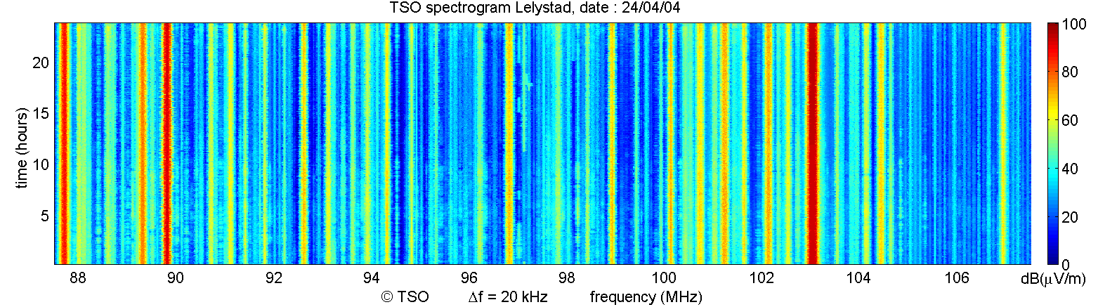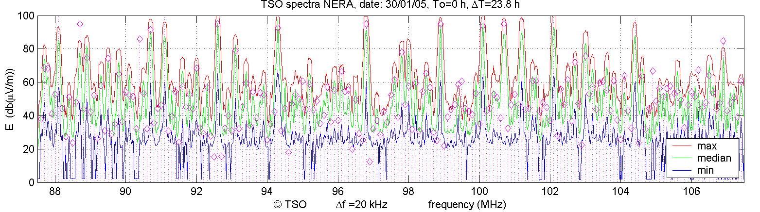

On every 100 kHz channel a min/max/median plot and also a pink line with a rhombic on top is plotted, representing the theoretical calculated value obtained from a planning tool. The calculated value can be derived from the distance of the transmitter to the monitoring station and the allowed e.r.p. value in the licence using the proper planning model. This enables the user to compare between measured and predicted (licence) field strengths.

To estimate the effects of time variance of the signal a time plot over 24 h is produced showing the theoretical calculated value by a dotted line and a distribution plot over the same period. The coloured plot represents a moving average plot ion the channel under test and the adjacent channels.

This information is used for two reasons: The first one is the stability of the monitoring system. Variations in measured values of a reference signal can be used to have an idea about the maximum achievable accuracy. The second is the actual variation of the measured signal due to propagation which also influences the accuracy.

Figure 3

Field strength over time, distribution and spectrum

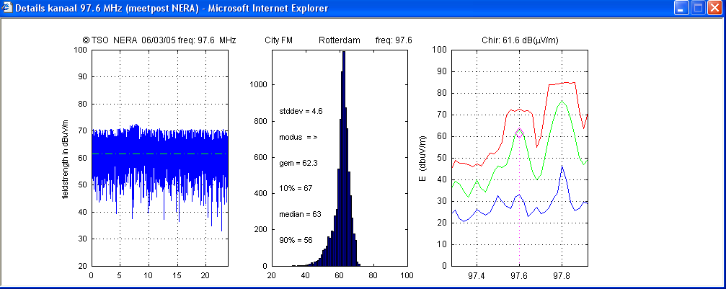

Plots as above are available for all channels on each remote station but accessing this information needs a management tool which is designed around a web interface. Figure 4 shows the interface which has the form of a spectrogram.

Figure 4

Web interface to access all individual plots

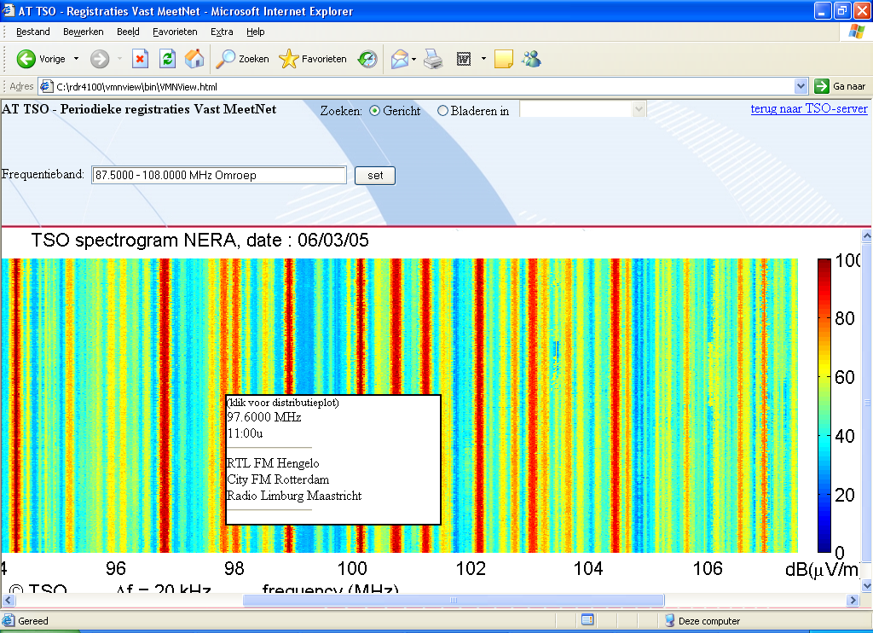

To have access to all channel plots one can select the appropriate measurement day, remote station, the wanted channel by moving the cursor over the spectrogram and then click. The three plots with detailed information divided over 3 plots will than be available on the screen. There is also a possibility to make your choice via a table with frequencies.

# 2 Trends

As shown in Table 1 in the main report, the absolute accuracy of an e.r.p. measurement using field strength measurement from remote stations is about 5 dB. For inspection purposes this is useful as an indicative measurement. For pre-inspection work a measurement like this makes more sense if measurements are performed at regular intervals and compared with historical data. This type of measurement we call a trend measurement.

From all measurements the median field strength value is calculated and stored in a file, which is used to produce plots presenting historical trends.

Every bar in Fig. 5 is the result of a 24 h measurement. The blue line shows the theoretical value.

Figure 5

Trend measurement from remote monitoring station “Axel”

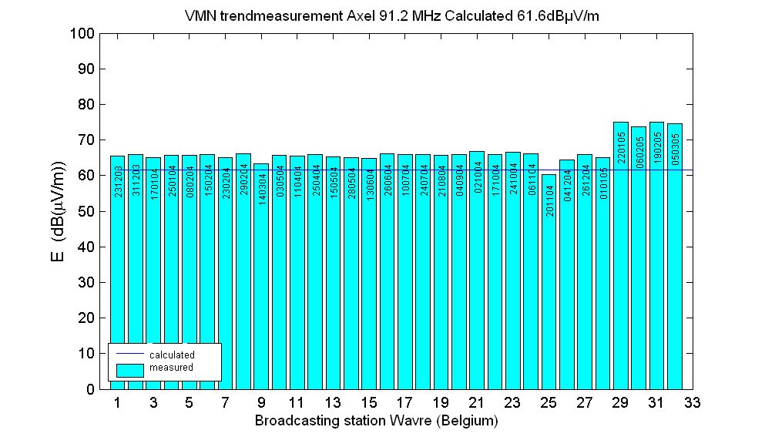

From all remote stations these plots are available and accessible per frequency channel. So every channel can be judged form different angles.

# 3 Bandwidth

Besides field strength and the e.r.p. values calculated from this, also the occupied bandwidth can be determined. For FM broadcasting Recommendation ITU-R SM.1268-4 is used to check the total deviation, modulation power and the shape and size of the spectrum with the so called spectrum mask method. These spectrum mask measurements can be simulated using the described frequency band registrations. Being not accurate enough for enforcement purposes they give however a reasonably good indication of the spectrum behaviour.

The normally performed measurements in the frequency band from 87.5-107.5 MHz or 87.5‑112.5 MHz can not be used for these spectrum mask simulations because of the low resolution of 20 kHz per step. Using a frequency span of 5 MHz with steps of 5 kHz gives an adequate resolution (if the frequency band is measured in 1 000 steps). In 10 h the total FM band can be measured for this purpose in four segments of 5 MHz.

Figure 6

Simulated spectrum mask measurements

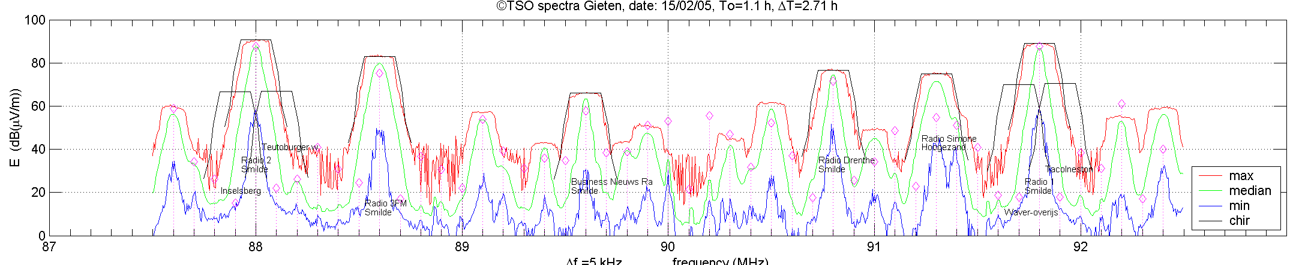

All spectra of the stronger transmitters (pre defined level) automatically receive a spectrum mask, also the theoretical predicted field-strength value (pink rhombic) and the identification of the station is plotted. For every channel it is possible to go more in detail as shown in plot below.

Figure 7

Field strength and bandwidth of a single channel

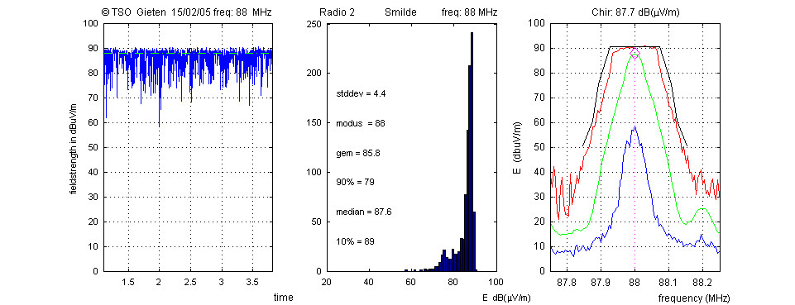

The plots of Fig. 7 show information on the received field strength and make it possible to compare the measured (87.6 dBμV/m) and the theoretical field-strength values (87.7 dBμV/m). It also gives information about the transmitter field strength over time (24 h). The used bandwidth is shown by means of a simulated spectrum mask measurement.

# 4 Measurement schedule

To measure all the field-strength values in the FM BC band frequency band registrations are used. This harmonized method, widely applied in Europe, is described in Recommendation ECC(05)01.

Every registration lasts 24 h, starting at 0000 and stops at 2 359 h and is carried out simultaneously from all available remote stations. Many FM transmitters can be received by more than one remote receiver and so transmitters can be observed from different azimuth angles.

To keep an eye on the trend in received field strength this type of automatic measurements of the FM BC band should be repeated frequently. How often depends on priorities indicated by spectrum management.

Often the remote stations are measuring frequency bands in accordance with a measurement schedule which includes the FM BC band. How frequently this band is measured depends on the importance of this band but could be once a month.

Measurement to retrieve bandwidth information by means of simulated spectrum mask measurements could be performed once per three months at random intervals.

# 5 Summary

Frequency band registrations, performed by fixed monitoring stations can be used to check a number of licence conditions assigned to radio stations from a distance with some restrictions. The licence conditions on with information can be gathered are: radiated power, antenna diagram and bandwidth.

The more remote receiving stations are used and the more evenly they are geographically distributed, the higher the quality. In areas without sufficient covering by remote controlled stations semi fixed monitoring stations can be used. The information gathered in this way can be considered as an inspection of radio stations and can also be used as an instrument to determine which radio stations should be visited for physical inspection.

Annex 2  
  
Example of mobile monitoring to select candidates for   
PLT network inspections in Brazil

# 1 Introduction

Power line telecommunications (PLT) systems are unintentional emitters of RF radiation and may cause interference to radio receivers. The Brazilian Administration has prepared regulation on broadband PLT in order to mitigate the possible interference that such equipment may cause.

The Brazilian Administration is researching an alternative method of measuring interferences from power line high data rate telecommunications systems using mobile monitoring stations. In order to ensure that the alternative method is valid, the results must be compared with the traditional loop antenna plus spectrum analyser measurements.

The tests of this study took place in Porto Alegre – RS, South of Brazil, in a trial that the Porto Alegre Data Processing Enterprise (PROCEMPA) is conducting.

# 2 Mobile monitoring station used

The mobile monitoring station includes a radio monitoring system formed by a set of equipment used for radioelectric measurements. This system allows the observation, record and analysis of radioelectric emissions, including the direction finder instruments. An active monopole antenna was used and the resolution bandwidth was set to 9 kHz.

# 3 Device under test configuration

The PLT equipment was set up to use the 7.925-11.725 MHz downstream band and the 2.460‑4.960 MHz upstream bands.

# 4 Reference documents

– FCC – 04-245: Amendment of Part 15 regarding new requirements and measurement guidelines for access broadband over power line systems/carrier current systems, including broadband over power line systems.

– ITU-T Recommendation K.60-2015 – Emmission levels and test methods for wireline telecommunication networks to minimize electromagnetic disturbance of radio services.

– Recommendation ITU-R P.372-13 (2016) – Radio Noise.

– IEC CISPR 16-2-1:2014, *Specification for radio disturbance and immunity measuring apparatus and methods – Part 2: Methods of measurement of disturbances and immunity.*

# 5 Measurements

The PLT network topology is shown in Fig. 8a. All the measurements were realized in Clara Nunes Street, a street orthogonal to the medium voltage transmission line, near node C. Only nodes B (slave) and C (master) were turned on during the tests, as shown in Fig. 8b.

Figure 8a

PLT network topology

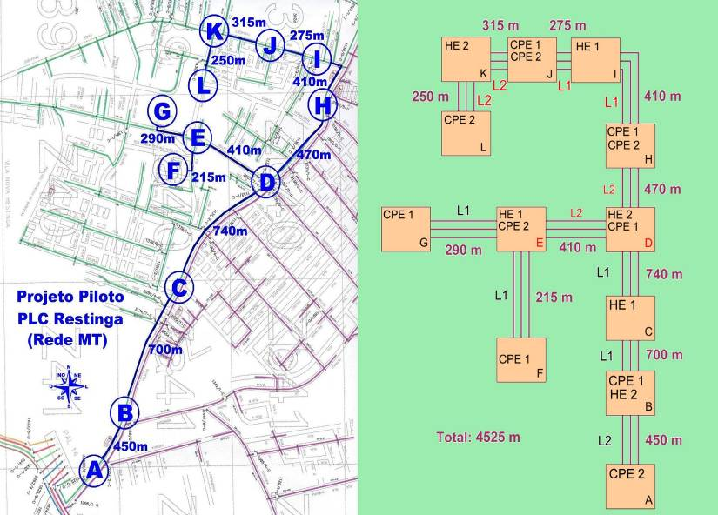

Modem under test

Figure 8b

Places of measurements

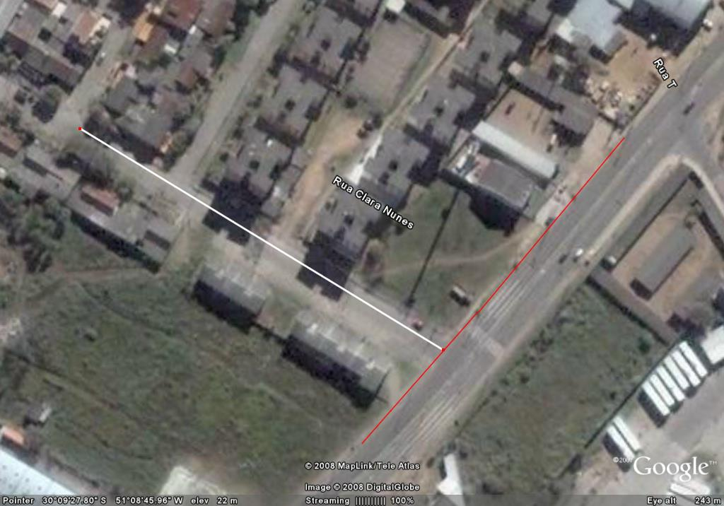

**PLT link and node C**

**10 m, 30 m, 5 0m and 150 m points of measurement**

**150-metre point of measurement**

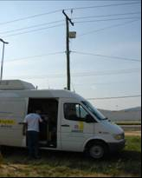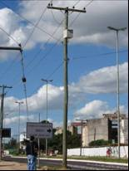

**Node “C”**

**Medium voltage line**

# 6 Comparing loop antenna plus spectrum analyser vs. mobile monitoring station

Figure 9a describes the mobile monitoring station position, where Xm is the distance between the transmission line projection to the floor and active monopole antenna projection to the ground.

Figure 9b describes the traditional setup to measure field strength[2], where Xm′ is the distance between the transmissions line projection to the floor and the loop antenna projection to the ground.

Figure 9a

Measurement setup for mobile monitoring station

Reception antenna projection to the ground

Antenna height is 2.3 meters

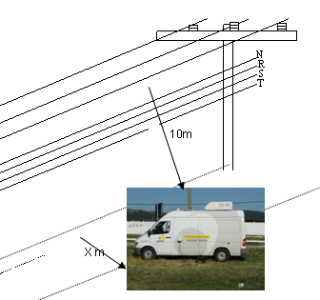

Figure 9b

Measurement setup for loop antenna

Reception antenna projection to the ground

10 m

Xm’

Antenna height is 1 meter

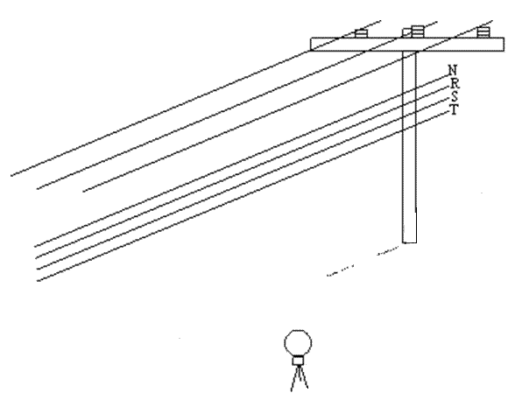

A load was inserted in the mobile monitoring station input to measure the equipment noise floor. Figure 10 compares the equipment noise floor and the environment noise floor.

Figure 10

It can be seen that the environmental noise floor is about 36 dB   
higher than the equipment noise floor

Antenna

Load

Polynomial (antenna)

Polynomial (load)



Figure 11 shows the spectrum occupation in medium frequency (MF) and in high frequency (HF) with the PLT turned on and turned off. Marks 1 and 2 are HF broadcast stations.

Figure 11

PLT ON (blue line) and PLT OFF (green line)

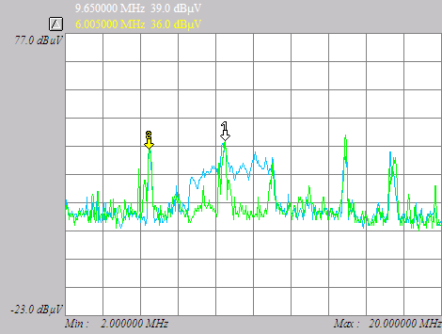

Figure 12 compares measurements of the mobile monitoring station with the loop antenna. The initial and final part of the graph must be dropped (like the green line indicates), because the measures were not synchronized. The average level of the signal was around 70 dB(μV/m) for the traditional method and 82 dB(μV/m) for the alternative method, i.e. 12 dB difference. It can be seen that both signals have the same behaviour.

Figure 12

Comparison for the mobile monitoring station (UMR) vs. loop antenna,   
both using peak detector



Figure 13 presents the comparison of different detectors (peak, quasi-peak and rms).

Figure 13

Different detectors

Peak (dBV)

RMS (dBV)

Quasi-Peak (dBV)



The 30 dB(μV/m) @ 30 m limit is equivalent to 48.6 dB(μV/m) @ 10 m, considering 40 dB/decade attenuation. In Fig. 14, the PLT output power was set to its minimum value; even then, the measured output level was higher than 48.6 dB(μV/m).

Figure 14

The measured output level was higher than 48.6 dB(μV/m)

0

6

12

18

24

30

36

42

48

54

60

66

72

78

84

90

7,9

8,296

8,692

9,097

9,493

9,898

10,29

10,7

10,78

**Frequency (MHz)**

Antena Loop

UMR

**Level (dB(μV/m))**

Figure 15 presents the results considering the PLT with maximum output power (blue line), minimum output power (pink line) and with the PLT turned off (green line), where other telecommunications services can be identified.

Figure 15

The connection master-slave was not established with the PLT set to its minimum power

PLTmin

PLTmax

PLToff

0

6

12

18

24

30

36

42

48

54

60

66

72

78

84

90

7,9

8,17

8,44

8,71

8,98

9,25

9,52

9,79

10,1

10,3

10,6

10,9

**Frequency (MHz)**

**Level (dB(μV/m))**

The following graphs represent the measurement values at distances of 30 m, 50 m, 100 m and 150 m, but now, the distances are the parameters Xm and Xm′ of Fig. 9a and 9b.

Figure 16

Measurement at 30 m. The attenuation was equivalent for both methods.   
Due to lack of synchronization, the initial and final part of the graph must be dropped

0

6

12

18

24

30

36

42

48

54

60

66

72

78

84

90

7,5

8,04

8,58

9,165

9,705

10,29

10,83

11,42

11,96

**Frequency (MHz)**

30m UMR

30m LOOP

**Level (dB(μV/m))**

Figure 17

Measurement at 50 m. The difference between both methods is still about 12 dB. However,   
the signals present a smaller co‑variation compared to the previous graphs. Again,   
the initial and final part of the graph must be dropped



Figure 18

Measurement at 100 m. At this distance the measurement with loop antenna was higher   
than with the mobile monitoring station in some frequencies. Some broadcast signals   
begin to contribute considerably to the composite signal. Again, the initial   
and final part of the graph must be dropped



Figure 19

Measurement at 150 m. At this position, a low voltage transformer began to contribute   
to the overall noise level and the carrier-to-noise relation of other telecommunication   
systems were higher. At this point, the PLT no longer interfere adversely with other   
services, including the army communication, who attended the tests



## 7 Conclusion

The results show that a systemic error occurs, however, using a correction factor this error may be minimized. The correcting factor calibration must be performed using the loop antenna.

The procedures for synchronization the measurements of the traditional and the alternate methods should be improved in order to optimize the correcting error calibration and evaluate the error statistics accurately.

Currently, the alternate method can be used for qualitative evaluation or a first order approximation for a quantitative evaluation. The analysis of uncertainties and error statistics will be subject of further studies, so that a complete comparison may be performed.

Results show that the use of mobile monitoring station with an active monopole antenna is appropriate for the measurements of radiation from telecommunication systems utilizing wired electrical power supply, but this alternate method may be improved.

1. * Radiocommunication Study Group 1 made editorial amendments to this Report in the year 2018 in accordance with Resolution ITU‑R 1.
2. The loop antenna measures the magnetic field strength, *H*, however, for non reactive near field, the electric field strength, *E*, can be evaluated multiplying *H* by 377 Ohms.