|  |
| --- |
| **Report ITU-R SM.2028-2**  **(06/2017)** |
| Monte Carlo simulation methodology for the use in sharing and compatibility studies between different radio services or systems |
| **SM Series**  **Spectrum management** |

Foreword

The role of the Radiocommunication Sector is to ensure the rational, equitable, efficient and economical use of the radio-frequency spectrum by all radiocommunication services, including satellite services, and carry out studies without limit of frequency range on the basis of which Recommendations are adopted.

The regulatory and policy functions of the Radiocommunication Sector are performed by World and Regional Radiocommunication Conferences and Radiocommunication Assemblies supported by Study Groups.

# Policy on Intellectual Property Right (IPR)

ITU-R policy on IPR is described in the Common Patent Policy for ITU-T/ITU-R/ISO/IEC referenced in Annex 1 of Resolution ITU-R 1. Forms to be used for the submission of patent statements and licensing declarations by patent holders are available from <http://www.itu.int/ITU-R/go/patents/en> where the Guidelines for Implementation of the Common Patent Policy for ITU‑T/ITU‑R/ISO/IEC and the ITU-R patent information database can also be found.

|  |  |
| --- | --- |
| Series of ITU-R Reports  (Also available online at <http://www.itu.int/publ/R-REP/en>) | |
| **Series** | Title |
| **BO** | Satellite delivery |
| **BR** | Recording for production, archival and play-out; film for television |
| **BS** | Broadcasting service (sound) |
| **BT** | Broadcasting service (television) |
| **F** | Fixed service |
| **M** | Mobile, radiodetermination, amateur and related satellite services |
| **P** | Radiowave propagation |
| **RA** | Radio astronomy |
| **RS** | Remote sensing systems |
| **S** | Fixed-satellite service |
| **SA** | Space applications and meteorology |
| **SF** | Frequency sharing and coordination between fixed-satellite and fixed service systems |
| **SM** | **Spectrum management** |

|  |
| --- |
|  |

|  |
| --- |
| ***Note****: This ITU-R Report was approved in English by the Study Group under the procedure detailed in Resolution ITU-R 1.* |

*Electronic Publication*

Geneva, 2018

© ITU 2018

All rights reserved. No part of this publication may be reproduced, by any means whatsoever, without written permission of ITU.

REPORT ITU-R SM.2028-2[1]*

Monte Carlo simulation methodology for the use in sharing and compatibility studies between different radio services or systems

(2001-2002-2017)

CONTENTS

**Page**

1 Background 3

2 Monte Carlo simulation methodology: an overview 3

2.1 Illustrative example (only unwanted emissions, most influential interferer) 4

3 Architecture requirements 6

3.1 Event generation engine 7

3.2 Interference calculations 8

Annex 1 List of input parameters 9

Annex 2 Event generation engine 11

Attachment 1 to Annex 2 Propagation model 21

1 Recommendation ITU-R P.452 propagation model 23

2 Free line of sight loss 24

3 Recommendation ITU-R P.528 propagation model for aeronautical and satellite services 25

4 Recommendation ITU-R P.1411 propagation model 25

5 VHF/UHF propagation model (Recommendation ITU-R P.1546) 25

6 Extended Hata model 26

6.1 Calculation of the median path loss *L* 27

6.2 Assessment of the standard deviation for the lognormal distribution 28

7 Spherical diffraction model 29

8 Combined indoor-outdoor propagation models 31

9 JTG 5-6 propagation model 33

10 Longley Rice (ITM) propagation model 34

11 IEEE 802.11 Model C propagation model 35

Attachment 2 to Annex 2 Power control function 36

Attachment 3 to Annex 2 Distribution definitions 36

Attachment 4 to Annex 2 Pseudo-random number generation 37

Attachment 5 to Annex 2 *dRSS* calculation flow chart 40

Attachment 6 to Annex 2 *iRSS* due to unwanted and blocking calculation 41

Attachment 7 to Annex 2 Receiver blocking 42

1 Basic concept 42

2 Blocking level measurements 42

3 Attenuation of the receiver 43

Attachment 8 to Annex 2 *iRSS* due to intermodulation 44

Attachment 9 to Annex 2 Intermodulation in the receiver 45

Attachment 10 to Annex 2 Influence of different bandwidths 46

Attachment 11 to Annex 2 Radio cell size in a noise limited network 49

Attachment 12 to Annex 2 Antenna pattern 50

References 51

Bibliography 51

Annex 3 Distribution evaluation engine 52

Attachment 1 to Annex 3 Chi-squared goodness-of-fit test 54

Attachment 2 to Annex 3 Kolmogorov-Smirnov test of stability 56

Annex 4 Interference calculation engine 56

Summary

In this Report background information on a Monte Carlo radio simulation methodology is given. Apart from giving general information this text also constitutes a specification for the Spectrum Engineering Advanced Monte Carlo Analysis Tool (SEAMCAT) software which implements the Monte Carlo methodology applied to radiocommunication scenarios.

General

The problem of unwanted emissions, as a serious factor affecting the efficiency of radio spectrum use, is being treated in depth in various fora, internal and external to the European Conference of Postal and Telecommunications Administrations (CEPT). As the need to reassess the limits for unwanted emissions within Appendix **3** of the Radio Regulations (RR) is observed, it is widely recognized that a generic method is preferable for this purpose.

One of numerous reasons why generic methods are favoured is their *a priori* potential to treat new communication systems and technologies as they emerge. Another reason is that only a generic method can aspire to become a basis for a widely recognized analysis tool.

The Monte Carlo radio simulation tool described in this Report is being developed, based on the above considerations, within the Electronic Communications Committee (ECC) of the CEPT.

SEAMCAT

SEAMCAT is the implementation of a Monte Carlo radio simulation model developed by the group of CEPT administrations, European Telecommunications Standards Institute (ETSI) members and international scientific bodies. SEAMCAT is an open source software tool distributed by the CEPT European Communications Office (ECO)[2], based in Copenhagen.

# 1 Background

In order to reassess the limits for unwanted emissions within RR Appendix **3**, it was necessary to develop an analytical tool to enable the evaluation the level of interference which would be experienced by representative receivers. It has been agreed in the ITU‑R that level of interference should be expressed in terms of the probability that reception capability of the receiver under consideration is impaired by the presence of an interferer. To assess this probability of interference, statistical modelling of interference scenarios is required and this Report describes the methodology and offers a proposal for the tool architecture.

The statistical methodology described here and used for the tool development is best known as Monte Carlo method. The term “Monte Carlo” was adopted by von Neumann and Ulam[3] during World War II, as a code-name for the secret work on solving statistical problems related to atomic bomb design. Since that time, the Monte Carlo method has been used for the simulation of random processes and is based upon the principle of taking samples of random variables from their defined probability density functions. The method may be considered as the most powerful and commonly used technique for analysing complex statistical problems.

The approach is:

– generic: a diversity of possible interference scenarios can be handled by a single model;

– flexible: the approach is very flexible, and may be easily devised in a such way as to handle the composite interference scenarios.

# 2 Monte Carlo simulation methodology: an overview

This methodology is appropriate for addressing the following items in spectrum engineering:

– sharing and compatibility studies between different radio systems operating in the same or adjacent frequency bands, respectively;

– evaluation of transmitter and receiver masks;

– evaluation of limits for parameters such as unwanted (spurious and out-of-band) blocking or intermodulation levels.

The Monte Carlo method can address virtually all radio-interference scenarios. This flexibility is achieved by the way the parameters of the system are defined. Several variable parameters (e.g. radiated power, height, location, azimuth and elevation of the transmitter and receiver antenna) can be entered considering their statistical distribution function. It is therefore possible to model even very complex situations by relatively simple elementary functions. A number of diverse systems can be treated, such as:

– broadcasting (terrestrial and satellite);

– mobile (terrestrial and satellite);

– point-to-point;

– point-to-multipoint, etc.

The principle is best explained with the following example, which considers only unwanted emissions as the interfering mechanism. In general the Monte Carlo method allows to address also other effects present in the radio environment such as out-of-band emissions, receiver blocking and intermodulation.

Some examples of applications of this methodology are:

– compatibility study between digital personal mobile radio (PMR) (TETRA) and GSM at 915 MHz;

– sharing studies between FS and FSS;

– sharing studies between short range devices (Bluetooth) and radio local area networks (RLANs) in the industrial, scientific and medical (ISM) band at 2.4 GHz;

– compatibility study for International Mobile Telecommunications-2000 (IMT‑2000) and PCS1900 around 1.9 GHz;

– compatibility study for ultra wideband systems and other radio systems operating in these frequency bands.

## 2.1 Illustrative example (only unwanted emissions, most influential interferer)

For interference to occur, it has been assumed that the minimum carrier-to-interference ratio, *C*/*I*, is not satisfied at the receiver input. In order to calculate the *C*/*I* experienced by the receiver, it is necessary to establish statistics of both the wanted signal and unwanted signal levels. Unwanted emissions considered in this simulation are assumed to result from active transmitters. Moreover, only spurii falling into the receiving bandwidth have been considered to contribute towards interference. For the mobile to fixed interference scenario, an example is shown in Fig. 1.

Figure 1

An example of interference scenario involving TV receiver and portable radios



Many potential mobile transmitters are illustrated. Only some of the transmitters are actively transmitting simultaneously and still fewer emit unwanted energy in the victim link receiver bandwidth. It is assumed that interference occurs as a result of unwanted emissions from the most influent transmitter with the lowest path loss (median propagation loss + additional attenuation variation + variation in transmit power) to the receiver.

An example of Monte Carlo simulation process as applied to calculating the probability of interference due to unwanted emissions is given in Fig. 2. For each trial, a random draw of the wanted signal level is made from an appropriate distribution. For a given wanted signal level, the maximum tolerable unwanted level at the receiver input is derived from the receiver’s *C*/*I* figure.

FIGURE 2

An example formulation of the Monte Carlo evaluation process



For the many interferers surrounding the victim, the isolation due to position, propagation loss (including any variations and additional losses) and antenna discrimination is computed. The lowest isolation determines the maximum unwanted level which may be radiated by any of the transmitters during this trial.

From many trials, it is then possible to derive a histogram of the unwanted levels and for a given probability of interference, then to determine the corresponding unwanted level.

By varying the values of the different input parameters to the model and given an appropriate density of interferers, it is possible to analyse a large variety of interference scenarios.

# 3 Architecture requirements

One of the main requirements is to select such an architectural structure for the simulation tool which would be flexible enough to accommodate analysis of composite interference scenarios in which a mixture of radio equipment sharing the same habitat and/or multiple sources of interference (e.g. out-of-band emission, spurious emission, intermodulation, ...) are involved and can be treated concurrently.

Other requirements would be that the proposed architecture consists of modular elements and is versatile enough to allow treatment of the composite interference scenarios.

In considering this, the below abstraction of functionalities has been implemented in SEAMCAT where the plugins can be optionally realised externally.

FIGURE 3

Abstraction of the implementation

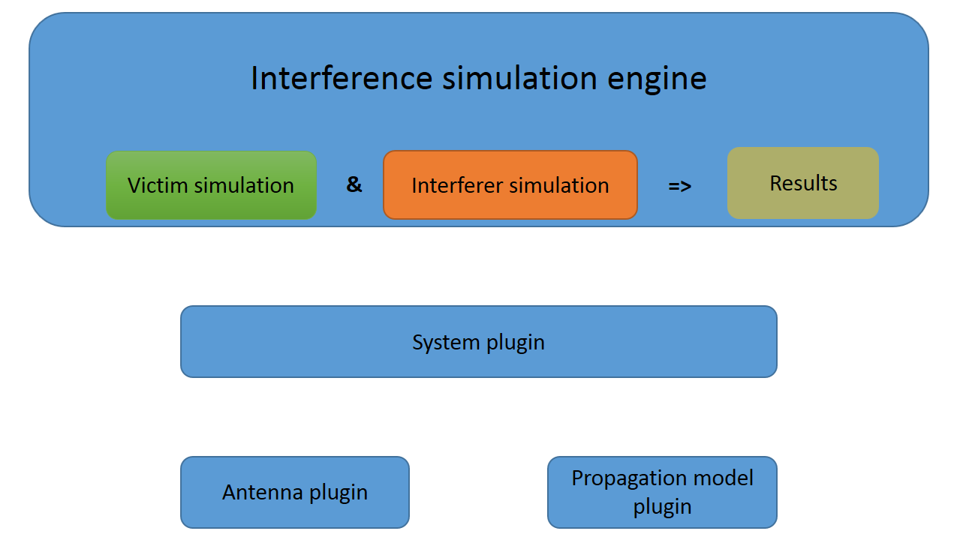

The list of interference parameters and their relevance to one or more of the processing engines is shown in Annex 1.

## 3.1 Event generation engine

The victim and the interferer(s) take the corresponding systems from the workspace settings.

The interference simulation engine performs:

– the victim simulation which generates the desired signals;

– the interferer simulation which generates the interfering signals;

– storing the collected values to the corresponding results vector.

This process is repeated *N* times, where *N* is a number of trials which should be large enough to produce statistically significant results.

The trials on parameters being common for desired and interfering radio paths are done concurrently in order to capture possible correlation between desired and interfering signals. Such an implementation will not cover those seldom cases of interference in which one interference mechanism is excited by another interference (e.g. a strong emission of the first transmitter mixes with a spurious emission of the second transmitter and produces an intermodulation type of interference).

The flow chart description and detailed algorithm description for the EGE are presented in Annex 2.

List of potential sources of interference to be found in a radio environment includes:

Transmitter interference phenomena:

– unwanted (spurious and out-of-band) emissions;

– wideband noise;

– intermodulation;

– adjacent channel;

– co-channel.

Receiver interference phenomena:

– spurious emission.

Background noise:

– antenna noise;

– man-made noise.

Other receiver interference susceptibility parameters:

– blocking;

– overloading;

– intermodulation rejection;

– adjacent and co-channel rejections;

– spurious response rejection.

All of the above sources can be classified into three generic interference mechanism categories: undesired emission, intermodulation and receiver susceptibility. Each of the above three categories requires a different model for physical processes being characteristic for that interfering mechanism. The man-made noise and the antenna temperature noise can be considered as an increase of the thermal noise level, decreasing thus the sensitivity of a receiver, and can be entered in the simulation when the criteria of interference is *I*/*N* (interference-to-noise ratio) or *C*/(*I*  *N*) (wanted signal-to-interference  noise)*.*[4]

## 3.2 Interference calculations

The interference calculations are performed in SEAMCAT by a plugin which applies the results (gathered by the interference simulation engine) for the calculation of the probability of exceeding the limit given for the selected criterion *C/I*, *C*/(*N*+*I*), (*N+I*)/*N* or *I/N*. This plugin provides two modes for the calculation of probabilities:

– Compatibility  
generates a single result showing the probability of exceeding the limit of the selected criterion.

– Translation  
generates a distribution of probabilities belonging to the variation of a reference parameter, e.g. the transmit power of an interferer or the blocking attenuation of the victim, relative to the limit of the selected criterion.

Both modes can combine each of the generated results of unwanted, blocking, intermodulation and overloading.

Further details on how the interference calculations are performed are in Annex 4.

Annex 1  
  
List of input parameters

In the schematic scenario depicted in the figure below the receiver of the victim system (victim link receiver, VLR) gets its wanted signal from its corresponding transmitter (victim link transmitter, VLT). The victim link receiver operates amongst a population of one or more interfering transmitters (interfering link transmitters, ILT). Therefore, the victim link receiver also gets interfering signal(s) originated at the interfering transmitter(s), as indicated in Fig. 4 below.

Figure 4

Schematic compatibility scenario



The following rules are applied:

− a capital letter is used for a distribution function, e.g. *P*;

− a small letter is a variable (result of a calculation or a trial), e.g. *p*;

− the index refers to a player:

• For the **wanted system**: victim link transmitter (VLT) and victim link receiver (VLR)

• For the **interfering system**: interfering link transmitter (ILT) and interfering link receiver (ILR)

Parameters for the victim link transmitter (VLT or wanted transmitter)

 power level distribution for various transmitters (dBm);

 sample power level taken from the above distribution (dBm);

 maximum antenna gain (dBi);

*patternVLT* : antenna directivity within operating bandwidth (dB) (supplied as a function or a look-up table);

Φ*VLT* : antenna azimuth distribution (1/°);

θ*VLT* : antenna elevation distribution (1/°);

*HVLT* : antenna height distribution (1/m);

 radius of the victim link transmitter coverage (km) (not required for point-to-point).

Parameters for the victim link receiver (VLR)

*C*/*I, C*/(*N+I*), (*N+I*)/*N* or *I/N*: protection ratio (dB);

: maximum antenna gain (dBi);

*patternVLR* : antenna directivity within operating bandwidth (dB) (supplied as a function or a look-up table);

*HVLR* : antenna height distribution (1/m);

*block* : receiver frequency response (dB);

*aVLR* : receiver susceptibility characteristic is expressed as a ratio between desired interfering signal levels producing unacceptable receiver performance and is *n* as a function of frequency separation between the two signals;

*intermod* : receiver intermodulation response (dB)

The intermodulation response is a measure of the capability of the receiver to receive a wanted modulated signal without exceeding a given degradation due to the presence of two unwanted signals with a specific frequency relationship to the wanted signal frequency;

*fVLR* : frequency (MHz);

*sensVLR* : sensitivity of victim link receiver (dBm);

*bVLR* : bandwidth of victim link receiver (kHz).

Parameters for the interfering link transmitter (ILT)

 power level distribution of various transmitters (dBm);

 power control threshold (dBm);

 power control dynamic range (dB);

 power control step range (dB);

 maximum antenna gain (dBi);

 radius of the interfering link transmitter coverage (km);

 radius of the area where interferers are spread (km);

*d*0 : minimum protection in distance (km) between the victim link receiver and interfering link transmitter;

*patternILT*: antenna directivity (dB) (supplied as a function or a look-up table);

*emission_relILT* : relative emission mask (dBc/(reference bandwidth)) only used for interferer and consists of the wanted signal level and all unwanted emissions including part of emission floor depending on the power control;

*emission_floorILT* : absolute emission floor (dBm/(reference bandwidth)) only used for interferer (unwanted emissions which would be emitted with the lowest possible power of the transmitter)

Note that up to Version 1.1.5 of SEAMCAT the reference bandwidth of the floor is fixed to 1 MHz.

*fILT* : frequency (MHz);

*densILT* : density (1/km2);

 probability of transmission (%), which is a statistical description of the smitter activities averaged over a large number of users and long period of time;

*tempILT* : normalized temporal activity variation function of time of the day (1/h) (activity factor).

Parameters for the interfering link receiver (ILR or wanted receiver) belonging to the interfering link transmitter

 maximum antenna gain (dBi);

*patternILR* : antenna directivity (dB) (supplied as a function or a look-up table);

*HILR* : antenna height distribution (1/m);

*sensILR*: dynamic sensitivity of the interfering link receiver, taking into account margin for the fast-fading and intra-system interference (dBm).

Environmental and propagation parameters

*fpropag* : propagation law (median loss  variation) (given in Attachment 1 to Annex 2);

*fmedian* : propagation law (median loss only) (given in Attachment 1 to Annex 2);

*env* : environment type (indoor/outdoor, urban/suburban/open area).

Annex 2  
  
Event generation engine

Introduction

This Annex describes how to construct signals that are used in the interfering scenarios: the desired signal and the interfering signals due to unwanted emission, blocking and intermodulation. The calculated signals are stored in an array which serves as input to the DEE as shown in Fig. 5.

Figure 5

General flow chart of the EGE



Inputs

The input parameters are defined in Annex 1. The different players are shown in Fig. 6.

Outputs

*dRSS* : desired received signal strength (dBm)

*iRSSspur* : interfering received signal strength including unwanted emissions (dBm)

*iRSSblocking* : interfering received signal strength due to blocking (dBm)

*iRSSintermod* : interfering received signal strength due to intermodulation (dBm)

FIGURE 6

Different players participating in the EGE



Calculation

In this section:

– *T*  represents a trial from a given distribution (algorithm described in Attachment 4).

– Distributions *U*(0,1), *G*() and *R*() are defined in Attachment 3.

– Flow chart of *dRSS* calculation is given in Attachment 5 and flow charts of *iRSS* calculations are given in Appendices 6 and 8.

NOTE 1 – Distances  between transmitters and receivers are applied with the unit in km.

a) *dRSS* calculation

There are three different choices to determine *dRSS*: depending on a variable distance, for a fixed distance or using a given signal distribution (see Attachment 5).

*Case of variable distance*:



If the received signal cannot exceed a given value (i.e. if it depends on the power control implemented in the victim system) then:

*dRSS*  min(*dRSS*, *DRSSmax*)         using *dRSS* as calculated before

where:

*fVLR* : frequency received in the victim link receiver



This frequency can be set constant or determined by a certain distribution, e.g. the discrete frequency distribution (see Attachment 3). In general, the victim frequency should not be fixed but should computed and randomly chosen as the interferer frequency using a discrete distribution (see also b)).

 maximum power level distribution supplied to the victim link transmitter antenna



: path loss between the victim link transmitter and the victim link receiver (propagation loss, slow fading and clutter losses taken into account). Depending on whether the criteria of interference will apply to the instantaneous *dRSS* (Rayleigh fading excluded) or to the mean *dRSS*



or



where:

*hVLR* : victim link receiver antenna height



e.g.:    

*hVLT* : victim link transmitter antenna height



e.g.:    :distance between the victim link receiver and the victim link transmitter



e.g.:    

Three different choices for  are considered:

*Choice 1*: Given distance 

*Choice 2*: Noise limited network

is determined by the following equation:



where:

*fmedian* : propagation loss not including slow fading

*fslowfading*(*X*%) : fading margin to be used for 1-*X*% coverage loss.

In the case of lognormal fading and a 95% coverage loss at the edge of the coverage, for large distances, the value *fslowfading* is well known 1.64 times the standard deviation of the propagation loss. Further details of the determination of the radio cell size in a noise limited network are given in Attachment 11.

*Choice 3*: Traffic limited network



*gVLT**VLR* : victim link transmitter antenna gain in the victim link receiver direction



where:

(*VLT**VLR*,*VLT**VLR*) :azimuth and elevation angles between the top of the victim link transmitter antenna and the top of the victim link receiver antenna:

e.g.: 



For the computation of the gain symmetric antenna patterns see Attachment 12.

*gVLR**VLT* : victim link receiver antenna gain in the victim link transmitter direction



Case of fixed distances:

 nominal power distribution

 fading distribution



*Case of given* *dRSS*: distribution to be given by the user.

b) *iRSSblock* calculation

$${iRSS}_{block}= \sum_{j=1}^{n_{interferers}}{f}{\left(p_{ILT}^{supplied}, g_{ILT}^{pc}, g_{ILT→VLR}, {pl}_{ILT↔VLR}, a_{VLR},g_{VLR→ILT}\right)}_{j}=10log\sum_{j=1}^{n_{interferers}}{{10}^{i_{block}/10}}$$

where the *j*-th interferer signal is given by:



where for each interferer:

*fILT* : interferer transmitting frequency



For the discrete frequency distribution see Attachment 3.

Note that it is clear that the trial of the *dRSS* frequency, *fVLR*, occurs once and only once on each simulation round, i.e. *fVLR* is tried once as the wanted victim positions, the wanted transmit power, and other distributions pertaining to the victim link. These values then tried from the *dRSS*-distributions apply to >*N* trials of *iRSS* (where *N* is the number of interferers).

If randomness of some parameters could be limited, then the model could not be used also for simulation only, but also for more exact calculations. This feature would allow an easier check of the validity of the simulation results.

 maximum power supplied to the interfering link transmitter antenna (before power control)



 power control gain for the interfering link transmitter



where:

*fpc* : power control function (given in Attachment 2)

*plILT**ILR* : path loss between the interfering link transmitter and the interfering link receiver (propagation loss, slow fading and clutter losses taken into account). Depending on the power control implementation, this can be either mean path loss or instantaneous path loss (Rayleigh fading excluded):



or



where:

*hILR* : antenna height of interfering link receiver



e.g.:    

*hILT* : interfering link transmitter antenna height



e.g.:   

: distance between the interfering link transmitter and the interfering link receiver



e.g.:    

Three different choices for  are made:

*Choice 1*: Given distance 

*Choice 2*: Noise limited network

*Choice* *3*: Traffic limited network

For further details of the cell size determination see a).

*gILT**ILR* : interfering link transmitter antenna gain in the direction of the closest base station



where:

 azimuth and elevation angles between the top of the interfering link transmitter antenna and the top of the interfering link receiver antenna

e.g.: 



For the computation of the gain for symmetric antenna patterns see Attachment 12.

*gILR**ILT*: base station antenna gain in the interfering link transmitter direction



** path loss between the interfering link transmitter *i* and the victim link receiver (propagation loss, slow fading and clutter losses taken into account).



or



The choice between *fmedian* and *fpropag* would depend on the criteria of interference, and is closely related to the choice made for assessment of *dRSS*, e.g. whether ICE will evaluate:



where:

*hVLR* : victim link receiver antenna height (defined in the *dRSS* calculation)

*hILT* : interfering link transmitter antenna height (defined previously)

: distance between the victim link receiver and the interfering link transmitter.

Three different ways to choose 

1. The most common case is when there is no spatial correlation between the elements of the victim system and the elements of the interfering system.

Then,  is a result of a trial:



where:

*Rsimu*: radius of the area where interferers are spread



where:

*n active* : number of active interferers considered in the simulation

:density of ILTs (i.e. *n active*  /km2). It should be sufficiently large so that the *n* 1 interferer would bring a negligible additional interfering power:



If a minimum protection, *dILT**VLR*  *d*0 between the victim link receiver and interfering link transmitter is introduced then *Rsimu* results in:



Note that each trial of *dILT**VLR*  *d*0 has to be rejected and repeated for another trial *dILT**VLR*  *d*0.

Note that if the protection distance *d*0  0 then a uniform distribution of the interfering link transmitter has to be chosen.

2. This case deals with the situation where the victim system and the interfering system are geographically correlated (e.g. co-located base stations).

This correlation is assumed to be only between one element (VLT or VLR) of the victim system and one element (ILT or ILR) of the interfering system.

A trial (if the distance is not fixed) of the distances and angles between the two correlated elements is made (e.g. ). The knowledge of  enables to derive the missing coordinates (e.g. ).

FIGURE 7

Interfering scenario with a geographical correlation between the victim and the interfering systems

ILR

VLR

VLT

ILT

*d*VLT, VLR θVLT, VLR

*d*ILT, ILR θILT, ILR

dILT, VLR θILT, VLR

3. Closest interferer

The influence of the closest interferer can be estimated by having a distance *dILT**VLR* following a Rayleigh distribution *R*() defined in Attachment 3 to Annex 2 and where the parameter  is related to the density of transmitters. This is an alternative method for calculating the relative location of the interfering link transmitter (ILT) respect to the victim link receiver (VLR) in non correlated mode which should avoid to perform multiple trials on the number of interferers.

In this case the distribution for the distance between *ILT* and *VLR* in the simulation area is always a Rayleigh distribution:



where standard deviation σ is related to the density of active transmitters:



Note that the simulation radius is useless but associated parameters (density, activity and probability) are still required for calculation of the density of active transmitters.



** interfering link transmitter antenna gain in the victim link receiver direction



where:

 azimuth and elevation angles between the top of the closest interfering link transmitter antenna and the top of the victim link receiver antenna

e.g.: 



*aVLR*( *fILT*,  *fVLR*) : attenuation of the victim link receiver.

Three possible ways are considered for calculating this attenuation:

1. *aVLR* is given by the user.

2. Blocking is given in terms of blocking attenuation or protection ratio. For a wanted signal 3 dB above the sensitivity, the attenuation *aVLR* can be derived from the following equation (see Attachment 7):



3. Blocking is given in terms of absolute level of blocking:



Two cases are envisaged:

*Case 1*: *block* is a mask which is a function of  It is introduced to enable calculations of interference between systems in adjacent bands;

*Case 2*: *block* is a fixed value (e.g. 80 dBm). It is used to derive generic limits.

**: victim link receiver antenna gain in the interfering link transmitter direction



c) *iRSSspur* calculation



where the *j*-th interferer signal is defined as:



Most of the parameter are already defined either in a) or b).

*emissionILT*( *fILT*, *fVLR*) : emission mask by the interfering link transmitter which generally depends on the relative emission mask, the interfering power, the gain power control and the bandwidth of emission majored by the absolute emission floor. For further details and the influence of different bandwidths of the wanted and interfering radio systems see Attachment 10 to Annex 2.



*emission*_*relILT* : a relative emission mask which is a function of  *f*  ( *fILT*, *fVLR*). It is introduced to enable calculations of interference between systems in the same or adjacent bands. The real emission is always greater or equal than the absolute emission floor *emission*_ *floorILT*( *fILT*, *fVLR*)

 power control gain for the interfering link transmitter (defined in b))

**: path loss between the interfering link transmitter and the victim link receiver (propagation loss, slow fading and clutter losses taken into account)



where:

**: victim link receiver antenna height (defined in calculation)

**: interfering link transmitter antenna height (defined in b))

**: distance between the victim link receiver and the interfering link transmitter (defined in b))

**: interfering link transmitter antenna gain in the victim link receiver direction:



where:

: azimuth and elevation angles between the top of the closest interfering link transmitter antenna and the top of the victim link receiver antenna (defined in b))

**: victim link receiver antenna gain in the interfering link transmitter direction



d) *iRSSintermod* calculation





where:

 intermodulation product of third order at the frequency *f*0:



The interferer *i* transmits at the frequency  and the interferer *j* at the frequency  b), which defines  and yields . Assuming an ideal filter (roll off factor 0) the intermodulation product has to be considered only for the bandwidth *b*:



For all other cases the intermodulation product can be neglected.

** received power in the victim link receiver due to interferer *k*  *i* at *fILT* or interferer *k*  *j* at *fILT, j*



The various parameters are defined in the previous a) to c). For the computation of the same algorithms as given in Attachment 6 can be used because  corresponds to .

*intermod* : receiver intermodulation response for a wanted signal 3 dB above the sensitivity.

Two cases are envisaged:

*Case 1*: *intermod* is given by the user, e.g. typical values are 70 dB for base station equipment and 65 dB for mobile and handportable equipment. It is used to derive generic limits.

*Case 2*: *intermod*( *f* ) is measured as a function of  *f* referred to *fVLR* (see Attachment 9 to Annex 2)

*sensVLR* : sensitivity of victim link receiver.

Attachment 1  
to Annex 2  
  
Propagation model

A number of propagation models are provided in the tool. They are depending on the environment chosen for the scenarios:

– general environment: open area, suburban or urban area;

– environment for the interferers: indoor or outdoor;

– environment for the victim link receiver: indoor or outdoor.

The tool provides built-in propagation models but also offers the means of programming user-defined (plug-in) propagation models.

The domain of validity for the models is described in Table 1.

TABLE 1

| Model | Frequency range | Distance range | Typical application |
| --- | --- | --- | --- |
| Rec. ITU-R P.452 | 100 MHz – 50 GHz | Up to 10 000 km | Point-to-point interference prediction between the stations on the surface of the Earth not exceeded for time percentages from 0.001% to 50%, accounting for clear-air interference mechanisms (diffraction, ducting/layer-reflection and troposcatter). |
| Rec. ITU-R P.525  Free-space attenuation |  | LOS Limited | Fixed links and other systems/paths where direct-LOS could be assumed. |
| Rec. ITU-R P.528 | 125 MHz – 15.5 GHz | up to 1 800 km | Aeronautical and satellite services: ground-air, ground-satellite, air-air, air‑satellite, and satellite-satellite links. Ground antenna heights between 1.5 m and 1 000 m, aero antenna heights between 1 000 m and 20 000 m, time percentage between 1% and 95%. |
| Rec. ITU-R P.1411 (§ 4.3) | 300 MHz – 3 GHz | up to 3 km | Propagation between terminals located from below roof-top height to near street level (antenna heights from 1.9 m to 3 m) and for location probability between 1% and 99%. |
| Rec. ITU-R P.1546 | 30 MHz – 3 GHz | up to 1 000 km | Broadcasting and other terrestrial services, typically considered in cases with highly mounted transmitter antenna. Effective transmitter antenna heights up to 3 000 m, receiving antenna heights above 1 m, percentage of time 1% – 50%, percentage of location 1% – 99%. |
| Extended Hata | 30 MHz – 3 GHz | up to 40 km | Mobile services and other services working in non-LOS/cluttered environment. Note that in theory, the model can be used up to 100 km since the curvature of the Earth is included, but in practice it is recommended to use it up to 40 km. Maximum antenna height from 30 m to 200 m, minimum antenna height from 1.5 m to 10 m. |
| Extended Hata Short range devices | 30 MHz – 3 GHz | up to 300 m | Short range links under direct-LOS assumption and antenna heights from 1.5 m to 3 m. |
| Spherical diffraction | above 3 GHz | up to and beyond the radio horizon | Interference prediction on terrestrial paths in predominantly open (e.g., rural) areas, accounting for spherical diffraction. |

TABLE 1 (*end*)

| Model | Frequency range | Distance range | Typical application |
| --- | --- | --- | --- |
| JTG5-6 | 600 MHz – 2 GHz | up to 1 000 km | Combination of Free-space, Extended Hata and ITU-R P.1546 propagation models depending on the distance between the transmitter and the receiver. Maximum antenna height from 30 m to 200 m, minimum antenna height from 1.5 m to 10 m. |
| Longley Rice (ITM) | 20 MHz – 40 GHz | 1 km – 2 000 km | Radio transmission loss over irregular terrain for VHF, UHF and SHF frequency bands and antenna heights from 0.5 m to 3 000 m. |
| IEEE 802.11 Model C |  |  | Propagation in dense hotspots in presence of other users across the propagation link causing additional loss due to body or multi-path interference due to scattering from the body. |
| Propagation plug-in | model specific  (user defined) | model specific (user defined) | model specific (user defined) |

# 1 Recommendation ITU-R P.452 propagation model

Recommendation ITU-R P.452 defines an interference prediction procedure for the evaluation of the available propagation loss over unwanted signal paths between stations on the surface of the Earth for frequencies above about 0.1 GHz, with losses not exceeded for time percentages over the range 0.001 ≤ *p* ≤ 50% and up to a distance limit of 10 000 km.

The models contained within Recommendation ITU-R P.452 work from the assumption that the interfering link transmitter and the interfered-with receiver both operate within the surface layer of atmosphere. The procedure includes a complementary set of propagation models which ensure that the predictions embrace all the significant interference propagation mechanisms that can arise. Methods for analysing the radiometeorological and topographical features of the path are provided so that predictions can be prepared for any practical interference path.

The clutter losses for the interferer and interfered-with stations are height dependent, and are therefore modelled by a height gain function normalized to the nominal height of the clutter. Appropriate nominal heights are available for a range of clutter types. The correction applies to all clear-air predictions in this Recommendation, i.e., for all propagation modes and time percentages.

A basic problem in interference prediction (which is indeed common to all tropospheric prediction procedures) is the difficulty of providing a unified consistent set of practical methods covering a wide range of distances and time percentages; i.e., for the real atmosphere in which the statistics of dominance by one mechanism merge gradually into another as meteorological and/or path conditions change. Especially in these transitional regions, a given level of signal may occur for a total time percentage which is the sum of those in different mechanisms. The approach in this procedure has been to define completely separate methods for clear-air and hydrometeor-scatter interference prediction. The clear-air method consists of separate models for diffraction, ducting/layer-reflection, and troposcatter. All three are applied for every case, irrespective of whether a path is LoS or transhorizon. The results are then combined into an overall prediction using a blending technique that ensures for any given path distance and time percentage that the signal enhancement in the equivalent notional line-of-sight model is the highest attainable.

Parameters of this propagation model are listed below:

a) Path dependant parameters (constant during a simulation for a given path) are:

– Water concentration (g/m3)

– Surface pressure (hPa): default 1013.25 hPa

– Refraction index gradient (N-units/km)

– Surface temperature (degrees Celsius): default 15 degrees

– Latitude of transmitter and receiver (degrees)

– Additional clutter loss at the transmitter and receiver (dB)

– Antenna gains at the transmitter and the receiver (dBi)

– Sea level surface refractivity (N-units)

– Time percentage (%): 0.001 ≤ *p* ≤ 50%

b) Variable parameters (which vary for each event of a simulation):

– Transmitter antenna height (above ground), (m)

– Receiver antenna height (above ground), (m)

– Frequency (GHz): 0.1 GHz ≤ f ≤ 50 GHz

– Distance (km): d ≤ 10 000 km

# 2 Free line of sight loss

This model describes the theoretical minimum propagation path loss achievable in free line of sight conditions. The model is appropriate for paths where unobstructed direct line-of-sight propagation could be expected (e.g. point-to-point fixed service links, links over short distances in open areas, etc.).

The free line of sight loss *L* (dB) is defined by:



where:

*f* : frequency (MHz)

*ht*: transmitter antenna height above ground (m)

*hr*: receiver antenna height above ground (m)

*d* : distance between transmitter and receiver (km).

In addition, the log-normal distributed shadowing with a given standard deviation can be applied to the calculated median path loss as:



where:

*L* : median propagation loss (dB)

σ : standard deviation of the slow fading distribution (dB).

In the specific case where *ht = hr,* we obtain the free space transmission loss between two points, as specified in Recommendation ITU-R P.525*:*



# 3 Recommendation ITU-R P.528 propagation model for aeronautical and satellite services

Recommendation ITU-R P.528 contains a method for predicting basic transmission loss in the frequency range 125-15 500 MHz for aeronautical and satellite services. The method uses an interpolation method on basic transmission loss data from sets of curves. These sets of curves are valid for ground-air, ground-satellite, air-air, air-satellite, and satellite-satellite links. The only data needed for this method are the distance between antennas, the heights of the antennas above mean sea level, the frequency, and the time percentage:

– Minimum (ground) antenna height above mean sea level (m): 1.5 m ≤ h1 ≤ 1 000 m

– Maximum (aero) antenna height above mean sea level (m): 1 000 m ≤ *h*2 ≤ 20 000 m

– Frequency (MHz): 125 MHz ≤ *f* ≤ 15 500 MHz

– Percentage time for which prediction is required (%): 1% ≤ *pt* ≤ 95%

– Distance (km): 0 km ≤ *d* ≤ 1 800 km.

In addition, the log-normal distributed shadowing with a given standard deviation σ can be applied to the calculated path loss.

# 4 Recommendation ITU-R P.1411 propagation model

Recommendation ITU-R P.1411, § 4.3 proposes a propagation model in the UHF band (from 300 MHz to 3 GHz), for Tx and Rx antenna heights between 1.9 m and 3 m, and distances up to 3 000 m. This model allows SEAMCAT to investigate scenarios in urban environments when both transmitter and receiver antennas are low height antennas i.e. located near to the ground (below roof-top height to near street level). It includes both LoS and NLoS regions, and models the rapid decrease in signal level noted at the corner between the LoS and NLoS regions. The model includes the statistics of location variability in the LoS and NLoS regions, and provides a statistical model for the corner distance between the LoS and NLoS regions.

Parameters of this propagation model are listed below:

– General environment: suburban, urban, dense urban/high rise

– Percentage of locations (%): 1% ≤ ps ≤ 99%

– Width for transition region (m): an average street width of 15 m as typical value

– Frequency (MHz): 300 MHz ≤ f ≤ 3 000 MHz

– Transmitter antenna height (m): 1.9 m ≤ ht ≤ 3 m

– Receiver antenna height (m): 1.9 m ≤ hr ≤ 3 m

– Distance (km): d ≤ 3 km.

In addition, the log-normal distributed shadowing with a given standard deviation σ can be applied to the calculated path loss.

# 5 VHF/UHF propagation model (Recommendation ITU-R P.1546)

Recommendation ITU-R P.1546 proposes a propagation model for point-to-area prediction of field strength mainly for the broadcasting, but also for land mobile, maritime mobile and certain fixed services (e.g. those employing point-to-multipoint systems) in the frequency range 30 MHz to 3 000 MHz and for the distances of up to 1 000 km. For the use of analysing compatibility scenarios, the following simplifications are assumed:

– Flat terrain.

– Restriction to propagation over land only, i.e. exclusion of mixed and sea paths.

– Positive antenna heights only.

Parameters of this propagation model are listed below:

a) Path dependant parameters (constant during a simulation for a given path) are:

– Time percentage (%): 1% ≤ pt ≤ 50%, for *p*t  50% *pt* is set to  50%

– Transmitter system: analogue/digital

– Transmitter bandwidth: Bt

– Global environment: rural, suburban, urban.

b) Variable parameters (which vary for each event of a simulation):

– Effective height of transmitter antenna (m): 0 m ≤ ht ≤ 3 000 m

– Receiver antenna height (above ground), (m): 1 m ≤ hr ≤ 3 000 m

– Frequency (MHz): 30 MHz ≤ *f* ≤ 3 000 MHz

– Distance (km): 0.001 km ≤ *d* ≤ 1 000 km.

The propagation curves derived for broadcasting are given in Recommendation ITU-R P.1546, which is based on the former Recommendation ITU-R P.370: A set of received field strength *E* (dB(V/m)) normalized to a transmitting power of 1 kW e.r.p. Using the conversion given in Recommendation ITU-R P.525, this field strength level can be converted into the median basic radio path loss  (dB) between two isotropic antennas by the following equation:



where:

*pl* : 50% of the locations

*env* : different types of environments: land (used in SEAMCAT), cold or warm sea.

Note that the path loss should be not less than the free space path loss.

The path loss, *pL*, including the variation of the locations can be denoted as the sum of the median path loss and a Gaussian distribution:



# 6 Extended Hata model

The Extended Hata model calculates the propagation loss between transmitter and receiver as:



where:

*L* : median propagation loss (dB)

σ : standard deviation of the slow fading distribution (dB)

*f* : frequency (MHz)

*h*1: transmitter antenna height above ground (m)

*h*2*:* receiver antenna height above ground (m)

*d* : distance between transmitter and receiver (km), preferably less than 100 km

*env* : (outdoor/outdoor), (rural, urban or suburban), (propagation above or below roof).

The following definition:

*Hm* : min{*h*1, *h*2}

*Hb* : max{*h*1, *h*2}

allows this model to be used reciprocally. If *Hm* and/or *Hb* are below 1 m, a value of 1 m should be used instead. Antenna heights above 200 m might also lead to significant errors. Propagation below roof means that both *Hm* and *Hb* are below the height of roofs. Propagation is above roof in other cases (*Hb* above the height of roofs).

## 6.1 Calculation of the median path loss *L*

*Case 1*:*d* ≤ 0.04 km

*Case 2*:*d* ≥ 0.1 km

Note that for short range devices in the case of low base station antenna height, *Hb*,  is replaced by:



The above expression assumes that antenna heights should not be outside the interval 1.5‑3 m.

         

*Sub-case 1*: Urban

30 MHz  *f* ≤ 150 MHz



150 MHz  *f* ≤ 1 500 MHz



1 500 MHz  *f* ≤ 2 000 MHz



2 000 MHz  *f* ≤ 3 000 MHz



*Sub-case 2*: Suburban



*Sub-case 3*: Open area



*Case 3*: 0.04 km  *d*  0.1 km



When *L* is below the free space attenuation for the same distance, the free space attenuation is used instead.

## 6.2 Assessment of the standard deviation for the lognormal distribution

*Case 1*: *d* ≤ 0.04 km  
  3.5 dB

*Case 2*: 0.04 km  *d* ≤ 0.1 km

 dB for propagation above the roofs

 dB for propagation below the roofs

*Case 3*: 0.1 km  *d* ≤ 0.2 km

  12 dB for propagation above the roofs  
  17 dB for propagation below the roofs

*Case 4*: 0.2 km  *d* ≤ 0.6 km

 dB for propagation above the roofs

 dB for propagation below the roofs

*Case 5*: 0.6 km *d*

  9 dB

# 7 Spherical diffraction model

The spherical propagation model is based on Recommendations ITU-R P.452, ITU-R P.676 and ITU‑R P.526[5].

According to Recommendation ITU-R P.452 the median loss between transmitter and receiver is given by the following equation:



where:

: basic loss (dB) as function of the time percentage, (%)

*f* : frequency (GHz)

*d* : distance (km)

: diffraction loss (dB) as function of the time percentage, (%)

*Ag* : attenuation due to atmospheric gas and water (dB).

The attenuation due to atmosphere is given by:



where:

: linear attenuation due to dry air (oxygen) (dB/km)

: linear attenuation (dB/km) due to water as function of the water concentration  (g/m3), default value: 3 g/m3.

Both terms can be approximated by the following equations according to Recommendation ITU‑R P.676:

– Attenuation due to water:

    for   *f*  < 350 GHz

– Attenuation due to oxygen:

 for *f*   57 GHz  
 for    57  *f*   60 GHz  
 for    60  *f*   63 GHz  
 for *f*  > 63 GHz

Note that for simplification a linear interpolation between 57 and 63 GHz is used. The maximum is 15 dB/km for 60 GHz.

According to Recommendation ITU-R P.526, the diffraction loss *Ld* ( *p*) can be derived by the received field strength *E* referred to the free space *E*0:



where:

*X* : normalized radio path between transmitter and receiver

*Y*1 : normalized antenna height of the transmitter

*Y*2 : normalized antenna height of the receiver:





where:

 : parameter derived from the Earth admittance factor *K* :   1 for *f*  20 MHz

*f* : frequency (MHz)

*ae* : equivalent Earth radius (km) (definition see below)

*d* : distance (km)

*hi* : antenna height above ground (m) with *i*  1 or 2 for the transmitter or receiver, respectively.

The distance-dependent term *F*(*X* ) is given by the semi-empirical formula:



The antenna height gain *G*(*Y*) is given by the formula set:

 for *Y* ≥ 2

 for 10 *K*  ≤  *Y*  2

 for *K*/10  ≤  *Y*  10 *K*

 for *Y* < *K*/10

where:

*K* : normalized Earth surface admittance factor (see Recommendation ITU-R P.526), default value: 10–5.

Note that different units for the frequency are used.

The variation in path loss is provided through the variability of the equivalent Earth radius *ae* (km) which is considered to be dependent on the time percentage, *p*:



with the Earth radius factor  expressed as:

 for   *p*  50%

 for   *p* > 50%

and



where:

*N* : mean gradient of the radio refraction profile over a 1 km layer of the atmosphere from the surface. The default valueis 40 N-units/kmfor Europe (standard atmosphere). This value yields to *k*50  4/3 and *ae*  8 500 km.

NOTE 1 – The mean gradient is positive.

0 :existence probability (%) of the super-refractive layer (*N*  100 N-units/km) in the low atmosphere. Default value: 1% for Europe.

Note that the probabilities *p* and 0 are denoted in %, i.e. a range of variety: 0 ... 100%.

Note that the default value *p*  50% is normally chosen constant. Small time percentages allow the simulation of anomalous propagation conditions.

The following restrictions of application of this model are to be considered:

– The frequency range should be larger than 3 GHz, with caution lower frequencies may be used but not below 300 MHz due to the surface admittance and polarization effects.

– The model was developed for open (rural) area. Therefore, the additional attenuation due to obstacles like buildings found in suburban or urban environment is not included.

– The loss due to rain is not covered.

– This model is applicable only for terrestrial radio paths.

# 8 Combined indoor-outdoor propagation models

Most of the published propagation models are derived either for outdoor or indoor application. But in the “real world” a combination of both types is required.

For combined scenarios, the classical outdoor models, Hata (extended version, see § 2) and spherical diffraction model (Recommendations ITU-R P.452, ITU-R P.526 and ITU-R P.676), are combined with an indoor model. An illustrative description is given in the following.

The path loss *pL* consists of median path loss *L* and the Gaussian variation *T*(*G*()) where  is the standard deviation:



where:

*f* : frequency (MHz)

*h*1 : antenna height of the transmitter antenna (m)

*h*2 : antenna height of the receiver antenna (m)

*d* : distance (km)

*env* : parameter for the environments of the transmitter and receiver.

For outdoor-outdoor propagation, the following holds:

– Scenario: transmitter and receiver are both outdoor

– Extended Hata model:

Median:   *L*(*outdoor – outdoor*)  *LHata*(*outdoor – outdoor*)

Variation:   intrinsic variation,   *outdoor – outdoor*)  *Hata*

– Spherical diffraction model:

Median:   *L*(*outdoor – outdoor*)  *Lspherical*

Variation:   no variation possible,  *outdoor – outdoor*)  0

*Case 1*: Indoor-outdoor or outdoor-indoor

– Scenario: transmitter is indoor and receiver is outdoor, or vice versa

– Extended Hata model:

Median:    *L*(*indoor – outdoor*)  *LHata*(*outdoor – outdoor*)  *Lwe*

where *Lwe* is the attenuation due to external walls (default value  10 dB).

Variation:   (*indoor – outdoor*)  

where *add* is the additional standard deviation of the signal, typically the wall loss standard deviation at the transmitter  or the receiver  side (default value: 5 dB).

The standard deviation of the lognormal distribution is increased, compared to the outdoor-outdoor scenario due to additional uncertainty on materials and relative location in the building.

– Spherical diffraction model

Median:   *L*(*indoor – outdoor*)  *Lspherical*  *Lwe*

Variation:   (*indoor – outdoor*) = *add*

The lognormal distribution is determined by the additional variation due to the variation in building materials, for the spherical diffraction model no variation is considered.

*Case 2*: Indoor-indoor

There are two different scenarios possible: The transmitter and receiver are in the same or in different buildings. The scenario used is randomly selected.

a) Selection of the scenario

The first step is to determine whether the indoor-indoor scenario corresponds to the transmitter and receiver in the same building or not. This is done by the calculation of the random variable in the same building (SB).

Trial of SB condition:

– *d* ≤ 0.020 km (20 m): SB  Yes  *P*(Yes)  1

– 0.020 km  *d* ≤ 0.050 km (50 m):

SB  Yes *P*(Yes)  (0.050 – *d*)/0.030

SB = No *P*(No) = 1 – *P*(Yes)  (*d* – 0.020)/0.030

*– d*  0.050 km (50 m): SB  No  *P*(Yes)  0

b) Indoor-indoor, different buildings

– Scenario: transmitter and receiver in different buildings: *P*(Yes)  0 or *P*(No)  1

– Extended Hata model:

Median:   *L*(*indoor – indoor*)  *LHata*(*outdoor – outdoor*)  2*Lwe*

It is to be noted that the loss due to two external walls should be added.

Variation:   (*indoor – indoor*)  

where *add* is the additional standard deviation of the signal as given by:



with  and  being the wall loss standard deviation at the transmitter and the receiver side, respectively.

– Spherical diffraction model

Median:   *L*(*indoor – indoor*)  *Lspherical*  2*Lwe*

Variation:   (*indoor – indoor*) = 

The lognormal distribution is determined by the additional variation due to the variation in building materials, for the spherical diffraction model no variation is considered. The variation is increased for the second external wall.

c) Indoor-indoor, same building

– Scenario: transmitter and receiver in the same building: *P*(Yes)  1 or *P*(No)  0

– Indoor propagation model:

Median:

*L*(*indoor – indoor*) =

with: 

*Lwi* : loss of internal wall (dB) (default value  5 dB)

*Lf* : loss between adjacent floors (dB) (default value  18.3 dB)

*b* : empirical parameter (default value  0.46)

*droom* : size of the room (m) (default value  4 m)

*hfloor* : height of each floor (m) (default value  3 m)

 : for positive real values *x*, the largest integer less than or equal to *x*.

Note that the path length  uses the unit km and the frequency the unit MHz

Variation:   (*indoor – indoor*) = *in*

The lognormal distribution trial is made using a standard deviation entered by the user and covering the variation, internal in the building, due to building design, in furniture of the rooms, etc. The default value is*in* = 10 dB.

# 9 JTG 5-6 propagation model

This propagation model has been developed by JTG 5-6 (<http://www.itu.int/md/R07-JTG5.6-C/en>) and it combines the Free-space, Extended Hata and Recommendation ITU-R P.1546 propagation models depending on the distance between the transmitter and the receiver.

Parameters of this propagation model are listed below:

a) Path dependant parameters (constant during a simulation for a given path) are:

– Time probability (%): *pt* = 1% or *pt* = 50%

– Cut-off distance (m): *dcut* < 100 m

– Local clutter height (m): *Rclut*

– Global environment: rural, suburban, urban.

b) Variable parameters (which vary for each event of a simulation):

– Transmitter antenna height (m): 30 m ≤ ht ≤ 200 m

– Receiver antenna height (m): 1.5 m ≤ hr  ≤ 10 m

– Frequency (MHz): 600 MHz ≤ *f* ≤ 2 000 MHz

– Distance (km): *d* ≤ 1 000 km.

Note that the path loss should be not less than the free space path loss. Only outdoor – outdoor scenarios are considered.

The path loss, *pL*, including the shadowing effect, can be denoted as the sum of the median path loss *L* and a Gaussian distribution:



where the standard deviation  models shadowing effect variation:

–  for all distances if hr > *Rclut*

–  for all distances if hr < *Rclut* and ht < *Rclut*.

# 10 Longley Rice (ITM) propagation model

The Longley-Rice propagation model, also known as the irregular terrain model (ITM), was developed to estimate radio transmission loss over irregular terrain for VHF, UHF, and SHF frequency bands. The signal loss computation is based on electromagnetic theory and on statistical analyses. It has been complemented by empirical dependences, during tests and measurements. The implementation assumes an area propagation mode (i.e. no need for terrain profile details to perform a path loss calculation). The model returns predicted median attenuation of a radio signal depending on statistical terrain, system, and radio-climate parameters, and takes into account variability of the signal in time and in space for a given level of confidence.

Parameters of this propagation model are listed below:

a) Path dependant parameters (constant during a simulation for a given path) are:

– Radio climate code: equatorial, continental subtropical, maritime subtropical, desert, continental temperate, maritime temperate over land, maritime temperate over sea.

– Mean surface refractivity or Ground refractivity (N-units): equatorial (360), continental subtropical (320), maritime subtropical (370), desert (280), continental temperate (301), maritime temperate over land (320), maritime temperate over sea (350).

– Terrain irregularity parameter (m): flat (0 m), plains (30 m), hills (90 m), mountains (200 m), rugged mountains (500 m).

– Electrical ground conductivity (S/m): average ground (0.005 S/m), poor ground (0.001 S/m), good ground (0.02 S/m), fresh water (0.01 S/m), sea water (5 S/m).

– Relative permittivity: average ground (15), poor ground (4), good ground (25), fresh water (81), sea water (81).

– Polarization: horizontal or vertical.

– Site criteria: random, careful, or very careful.

– Time availability (%): 1% – 99%.

– Location availability (%): 1% – 99%.

– Confidence level (%): 1% – 99%.

b) Variable parameters (which vary for each event of a simulation):

– Frequency (MHz): 20 MHz ≤ *f* ≤ 40 000 MHz.

– Transmitter antenna height (m): 0.5 m ≤ ht ≤ 3 000 m.

– Receiver antenna height (m): 0.5 m ≤ hr  ≤ 3 000 m.

– Distance (km): 1 km ≤ *d* ≤ 2 000 km.

# 11 IEEE 802.11 Model C propagation model

The presence of users across the propagation link between a transmitter and a receiver could cause additional loss, as a result of body loss or multi-path interference due to body scattering. In circumstances where the spatial density of mobile users (or terminals) is high, the probability of the path blocking is also high, and hence the terminal-to-terminal path can no longer be treated as line‑of-sight. Consequently, a path loss model with a greater exponent than the exponent of the free space path loss model is more suitable for the characterisation of terminal-to-terminal links in dense hotspots. In this propagation model, the mean path loss is characterised by a dual-slope model with a break point at a distance of *dbp*. Free-space propagation model (with an exponent of 2.0) is used for distances smaller than *dbp*, whereas for larger distances, an exponent of 3.5 is applied:



with the free space path loss *Lfs* defined as



where:

*f* : frequency (MHz)

*ht*: transmitter antenna height above ground (m)

*hr:* receiver antenna height above ground (m)

*d* : distance between transmitter and receiver (km)

*dbp* : the break-point distance from the transmitter (km).

In addition, the log-normal distributed shadowing with a given standard deviation can be applied to the calculated path loss. Where the calculated path loss is less than free space attenuation for the same distance, the free space attenuation is used instead. This propagation model is used to calculate terminal-to-terminal interference and accounts for the shadowing losses due to objects between the two terminals, but does not explicitly account for any loss from near-field objects, such as the person carrying the equipment.

Attachment 2  
to Annex 2  
  
Power control function





*P* : power received by the interfering link receiver, e.g. closest base station of the interfering system

where  and  are defined in the *iRSS* calculation sections.  is the lowest threshold (minimum) of the receiver.

*Case 1*: 





*Case* (*i*  1): 





where *i* is an integer ranging from 1 to *n_steps*   

*Case* (*n*_ *steps*  2): 





Attachment 3  
to Annex 2  
  
Distribution definitions

– Uniform distribution: 

– Gaussian distribution: 

– Rayleigh distribution: 

– User defined distribution: The option to include an user-defined distribution in the tool should be considered.

– Discrete distribution:

This is a special distribution bounded by a lower boundary, *Xmin*, an upper boundary, *Xmax*, and the step, *S*, between the samples, *xi*. A common example of such a distribution is the discrete frequency distribution having a constant channel spacing.

The corresponding distribution for *xi* is then defined by the following equation:



where:





In the case of a uniform distribution, each value is assigned to the same probability *P*(*xi*)  1/*N*. In the case of non-uniform distribution, each value is assigned to a specific weight *Pi* with the constraint that the sum of these weights is equal one.

Attachment 4  
to Annex 2  
  
Pseudo-random number generation

[Knuth, 1969; Rubinstein, 1981]

– From a uniform distribution 



where:



*a* : multiplier, e.g. *a*  16 807 or 396 204 094 or 950 706 376

*m* : modulus, e.g. *m*  231 – 1  2 147 483 647

*x*0 : seed, integer variable taking a value between 1 and (*m* – 1).

– From a Gaussian distribution 



where:

while *s* ≥ 1, *d*0 

*v*1 and *v*2 are two independent random variables (using two different seeds) uniformly distributed between –1 and 1.

– From a Rayleigh distribution 



where:

while *s* ≥ 1, *d*0 

*v*1 and *v*2 are two independent random variables (using two different seeds) uniformly distributed between –1 and 1.

From any type of distribution with a given cumulative distribution function, *cdf*.

Some trials may be performed according to a user-defined distribution *F*.

Trial is based on the use of the reciprocal cumulative distribution function, *cdf* –1,relative to the user-defined distribution, *F*, applied to the result of a uniform sample between 0 and 1.

        where          (uniform trial between 0 and 1)

Figure 8

Direct cdf



Figure 9

Inverse cdf



Attachment 5  
to Annex 2  
  
*dRSS* calculation flow chart

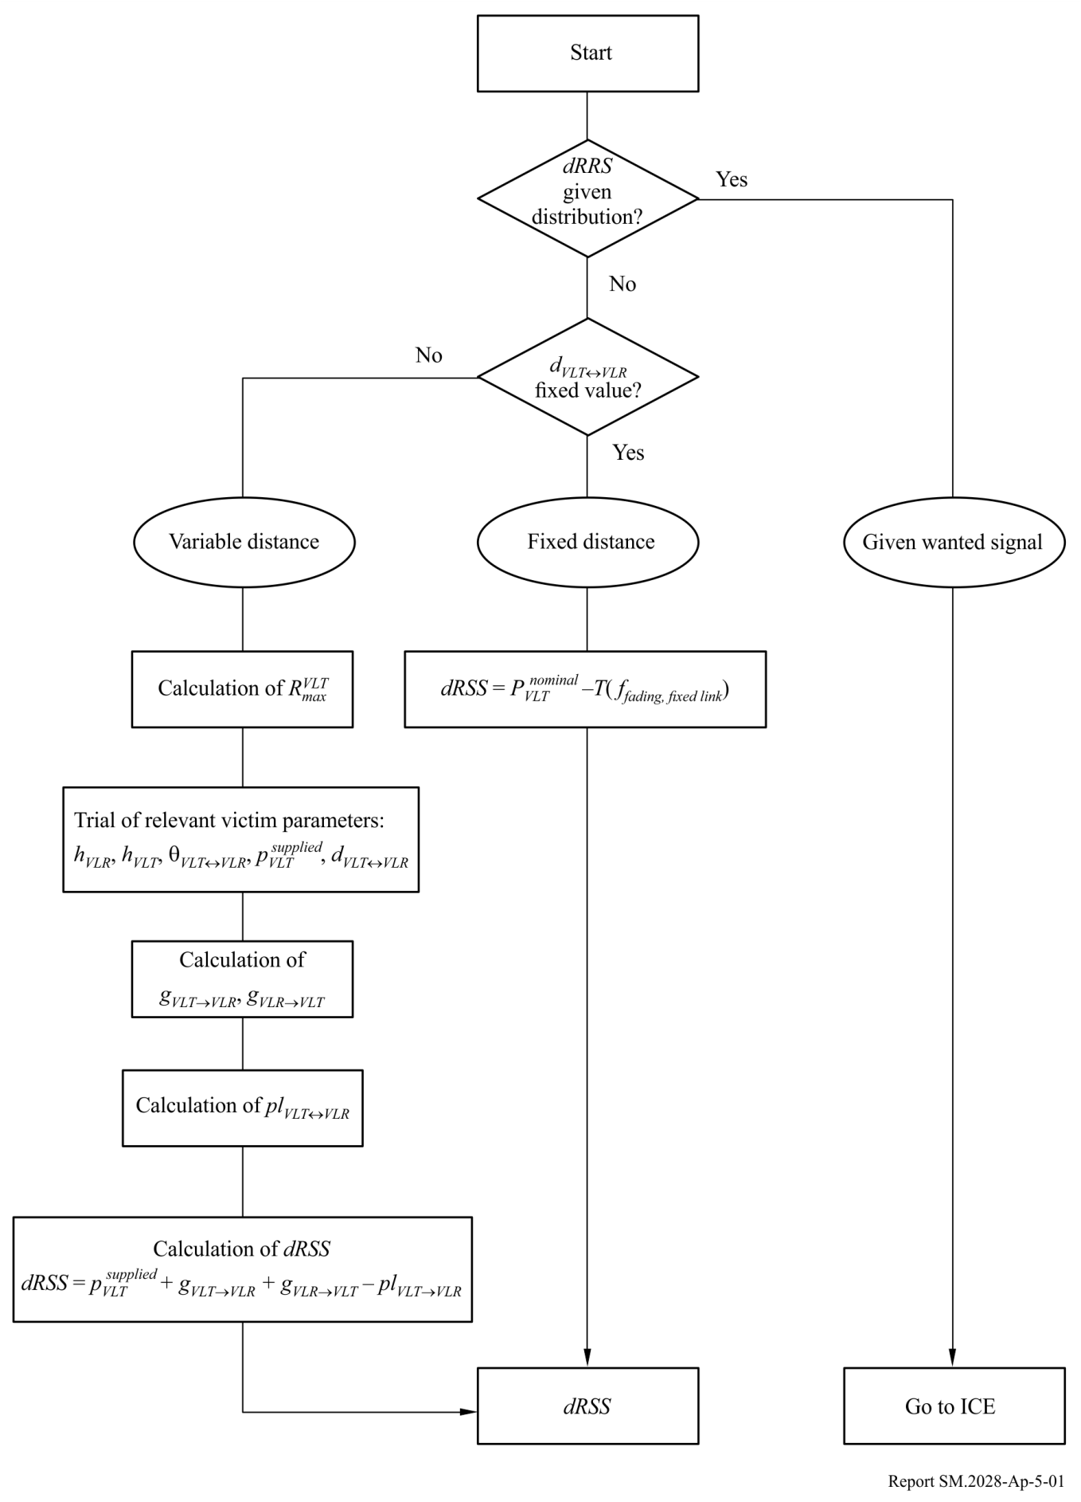

Attachment 6  
to Annex 2  
  
*iRSS* due to unwanted and blocking calculation

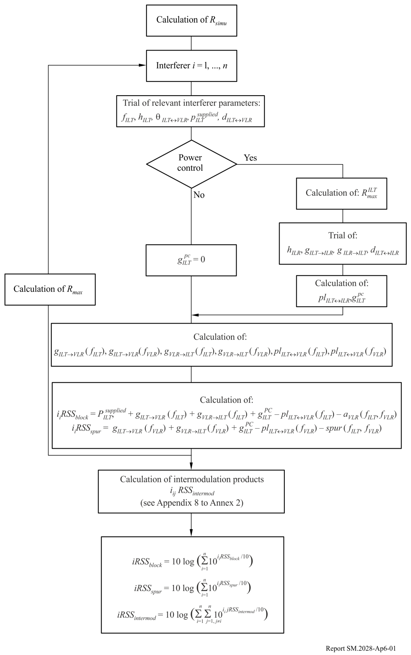

Attachment 7  
to Annex 2  
  
Receiver blocking

# 1 Basic concept

The receiver is capturing some unwanted signal because its filter is not ideal.

Figure 10

Basic concept



*Definition:* Blocking is a measure of the capability of the receiver to receive a modulated wanted input signal in the presence of an unwanted input signal on frequencies other than those of the spurious responses or the adjacent channels, without these unwanted input signals causing a degra­dation of the performance of the receiver beyond a specified limit (Document I‑ETS 300 113:1992).

# 2 Blocking level measurements

– Adjust the desired signal at the bit error ratio (BER) limit level.

– Increase this desired signal by 3 dB and add the interfering signal which is increased until the same BER is obtained.

– The ratio (interfering signal/desired signal) is the value of the receiver blocking.

Figure 11

Measurement procedure



# 3 Attenuation of the receiver

During the measurement procedure, the three following equations are valid:

– Noise floor  Protection ratio  3 dB  Desired signal level,

– Desired signal level  Blocking  Interfering signal level,

– Interfering signal level – Attenuation  Noise floor.

Hence:

|  |
| --- |
| Attenuation  3 dB  Protection ratio  Blocking |

Figure 12



Figure 13

Receiver mask



Attachment 8  
to Annex 2  
  
*iRSS* due to intermodulation

This flow chart is part of the flow chart given in Attachment 6.

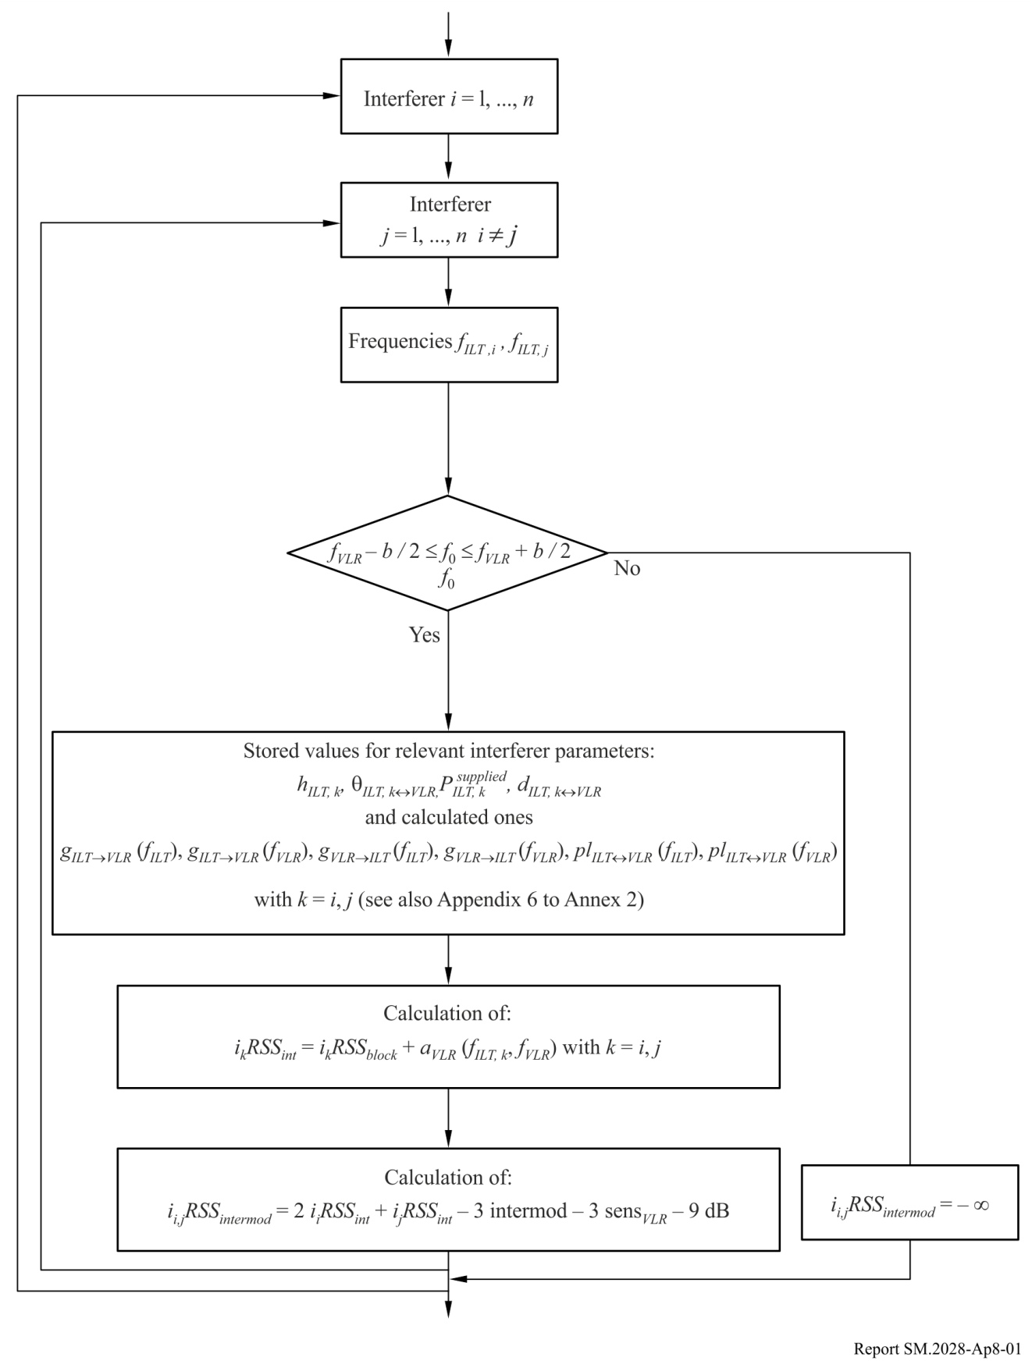

Attachment 9  
to Annex 2  
  
Intermodulation in the receiver

The main contribution to intermodulation interference originates from interfering signals in neighbouring channels due to the frequency selectivity of the antennas and the receiver equipment. We consider a service with a desired signal at frequency *f*0, a channel separation Δ*f* and interfering signals *Ei*1 and *Ei*2 at frequencies  and  respectively. The receiver non-linearities produce an intermodulation product *Eif* of third order at the frequency (see Fig. 14).

 (1)

Figure 14



The signal strength  of the intermodulation product is given by:

 (2)

with some constant *k* to be determined. For signal levels (measured in dB) equation (2) reads

 (3)

The constant 20 log *k* in equation (3) can be found from the measurement procedure which is described in the European Telecommunications Standards Institute (ETSI) Standard ETS 300‑113, § 8.8. The method is similar to the contribution in Attachment 7 for blocking interference.

ETS 300-113 defines via the intermodulation response *Limr*, the interfering signal levels *Li*1  *Li*2 at which bit errors due to intermodulation just start to be recorded (see Fig. 15).

This means, for *Li*1 and *Li*2 as in Fig. 15, we have an intermodulation product *Lif* just at the noise floor (0 dB). Introducing *Li*1 and *Li*2 from Fig. 15 into equation (3) we obtain:

 (4)

With the value of *k* from equation (4), equation (3) becomes:

 (5)

figure 15



Attachment 10  
to Annex 2  
  
Influence of different bandwidths

a) Wanted path

The victim link transmitter transmits its power *pVLT* (dBm) at the frequency *fVLR* within a given bandwidth *bVLR*. This bandwidth is also used for the determination of the intermodulation products (see Attachment 8 to this Annex 2).

b) Interfering link transmitter

For the interfering link transmitter, an emission mask *emissionILT* as function of  *f*  *f* – *fILT* should be defined as maximum power levels *emissionILT* ( *f* ) in reference bandwidth *bs* ( *f* ) as specified by the user. This mask can also be expressed as the maximum of:

– the sum of the supplied interfering power  a relative emission mask (containing the wanted transmission and all unwanted emissions including the emission floor depending on the power control) and the gain power control;

– or the absolute emission floor.

The relative emission mask is described by a triplet (frequency offset (MHz), relative emission level (dBc) and reference bandwidth (MHz)). The emission floor is defined in e) of this Attachment.

The interfering link transmitter power *pILT* (dBm) at *fILT* is used for evaluating the link budget with the interfering link receiver (i.e. power control).

c) Principle of determination of interfering power

Figure 16

Principle of determination of interfering power

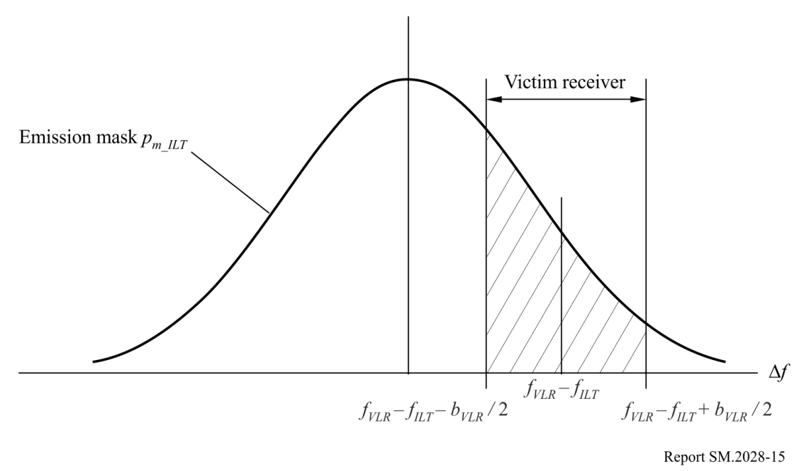

Figure 16 shows the principle of determination of the interfering power. If *fILT*  *fVLR*, then the interfering frequencies falls exactly in the receiving band of the victim link receiver (co-channel interference).

For simplification within the algorithms, the mask function *pmi* is normalized to a 1 Hz reference bandwidth:



The bandwidth *b* is the bandwidth used for the emission mask.

The total received interfering power *emissionILT* can easily be calculated by integration over the receiver bandwidth from *a*  *fVLR* – *fILT* – *bVLR* / 2 to *b* = *fVLR* – *fILT*  *bVLR* / 2



with *pni* denoting the normalized mask (dBm/Hz). Using a 1 Hz reference bandwidth the integral can be replaced by a summation, where *powerILT* is given in dBm:



NOTE 1 – The interfering power of a radio system having a different bandwidth can be estimated by the aforementioned algorithms. This calculation is only required for the interference due to unwanted emissions or co-channel but not for blocking and intermodulation.

Note that it is recommended to always apply a user-defined mask be applied even if the mask is flat.

d) Implementation in SEAMCAT

In c) the principle is explained. However, this algorithm is very slow in terms of computation time. Therefore the following approach is used:

The total interfering power relative to carrier, *emission*_*relILT*, can be calculated by integration over the receiver bandwidth from *a*  *fVLR* – *fILT* – *bVLR* / 2 to *b* = *fVLR* – *fILT*  *bVLR* / 2



with denoting the normalized user-defined mask (dBc/Hz).

This mask is expressed as an array of *N*  1 points and assumed linear between these points.



This leads to:



where:





Intermediate calculation:



Eventually:



e) Unwanted emission floor

The aforementioned equations are also applicable to absolute emission floor *emission_ floorILT* (dBm). This emission floor mask can be described by a triplet (frequency offset (MHz), reference bandwidth (MHz), emission floor (dBm)).

The real emission is bounded by the emission floor by the following equation:



which is also illustrated in Fig. 17.

Figure 17



Note that the comparison involves the power control gain if power control is selected.

Note that the unwanted emission floor is referred to 1 MHz in SEAMCAT.

Attachment 11  
to Annex 2  
  
Radio cell size in a noise limited network

Assuming that the received power is equal to the sensitivity of the victim link receiver, then the radius *Rmax* can be determined for the wanted radio path by the following equation:



where the path loss is defined by a median loss plus an additional term representing the distribution:



The distribution of the path loss, *ploss*, can be expressed in a general way by the following equation:



where *Q* is the cumulative distribution for *Rmax* and the resulting mean path loss  and an additional path loss *a* due to availability or coverage *y*. The coverage loss, *x*, corresponds to *y* by 1 – *y*. Assuming that slow fading can be approximated by log-normal distribution, i.e. median  mean, the relation *a*  *b* can be introduced where *b* stands for a multiple of the well-known standard deviation . A few examples for illustration: At a 95% coverage, *b* results in 1.96, for 99% in 2.58, for 99.9% in 3.29, or *b*  1, 68% coverage, for *b*  2 for 95.5%. The exact values can be easily determined by using the inverse Gaussian function.

Then the transcental equation:



can be solved by using a linear iteration like regular falsi:



Note that faster convergence can be obtained by applying the distance in logarithmic scale, i.e. the variable *R* has to be replaced by log(*R*).

Note that in this case, formulas given for  have to be inverted.

Attachment 12  
to Annex 2  
  
Antenna pattern

There are three different ways to describe the antenna pattern (as implemented in SEAMCAT):

1 omnidirectional antenna;

2 Horizontal and vertical directional antenna pattern (dBi); the gain is referred to the main lobe and is defined separately in the horizontal direction as a function of the azimuth angle (φ), and in the vertical direction as a function of elevation (θ);

3 Spherical directional antenna pattern (dBi); the gain is referred to the main lobe and is a function of the spherical angle ψ, defined in terms of azimuth and elevation as:



$$g_{θ,φ}= g_{max}×g_{S}\left(\cos^{-1}\left(\cos{θ}\cos{φ}\right)\right)$$

In either of the latter cases the gain can be defined in two different ways in SEAMCAT:

1 As a table of values as a function of angle, with interpolation used to define gain for unspecified angles. For horizontal and vertical patterns, the two sets of values are combined to produce a single gain value (in linear domain) as follows:

$$g_{θ,φ}=\left\{ \begin{aligned}g_{max}×\sqrt{\frac{{g_{H,θ}}_{}^{2}+{g_{V,φ}}_{}^{2}}{2}}, \left|g_{H,θ}-g_{V,φ}\right|<2 \\ &g_{max}×\min\left(g_{H,θ},g_{V,φ}\right), \left|g_{H,θ}-g_{V,φ}\right|≥2\end{aligned}\right.$$

where:

*g*θ,φ gain at the relevant angle

*gmax* peak antenna gain

*gH,* φ horizontal gain at azimuth angle φ

*gV,* θvertical gain at elevation angle θ.

For spherical antennas the gain is calculated (in linear domain, in terms of azimuth and elevation) as:

$$g_{θ,φ}= g_{max}×g_{S}\left(\cos^{-1}\left(\cos{θ}\cos{φ}\right)\right)$$

where:

*g*θ,φ gain at the relevant angle

*gmax* peak antenna gain

*gS* antenna gain as a function of spherical angle

φrelevant azimuth angle

θrelevant elevation angle.

2 Based on an equation or set of equations (e.g. Recommendations ITU-R F.699 or ITU‑R F.1336).

The pointing direction of an antenna can be defined in two different ways:

1 with a fixed pointing direction in azimuth and elevation with respect to the reference plane (e.g. cellular base stations);

2 the pointing is determined by the parameters of a link – i.e. the locations and heights (x,y,z co-ordinates) of a transmitter and receiver are specified, and the pointing is calculated relative to the other link element

It is possible to define tilt, either as a user defined input (mainly applicable to cellular base stations), or calculated as a function of the link pointing (mainly applicable to fixed service links). For tilted antennas it is necessary to apply a correction factor to the azimuth and elevation angles, as specified in Annex 5 of Recommendation ITU-R F.1336.

References

KNUTH, D. E. [1969] *The Art of Computer Programming*, Vol. 2, *Seminumerical Algorithms*. Addison-Wesley. Reading, Massachusetts, United States of America.

RUBINSTEIN, R. Y. [1981] Simulation and the Monte Carlo Method. Haifa, Israel.

ECC Report 252 [2016] SEAMCAT Handbook

Bibliography

Doc. 1‑3/31(Rev.1)-E. Proposal for a Propagation Model to be used in Models for Calculating Spurious Emission Interference (May 1995). France. Radiocommunication Study Group 1.

Annex 3  
  
Distribution evaluation engine

The flow chart for the DEE is shown in Fig. 18. A fit-of-goodness test can be performed either by the chi-squared test or by the Kolmogorov-Smirnov algorithm.

This algorithm basically tests if a random sample of observations conform to a pre-specified cumulative distribution. The pre-defined distribution can be continuous, discrete or hybrid. Thus, the chi-squared method is very versatile and a single algorithm is proposed for use within DEE for testing all possible types of probability distribution functions.

An array of samples on RSS random variable is passed to the DEE. Firstly the DEE tests if the array length, *N* (number of samples), is long enough to produce a stable distribution. This is accomplished by using *N – dN* samples to establish an initial discrete distribution function and calculate the corresponding cdf. This cdf is then used as a reference in the chi‑squared test performed now on the complete population of *N* samples. Should the test show that two discrete distributions differ more than an acceptable and pre-specified value, a message is sent back to the EGE to generate some extra samples. On the contrary, if the chi-squared criteria is satisfied the DEE proceeds with testing whether or not a continuous probability density function can be used.

The flow-chart in Fig. 18 is an example of a Gaussian distribution test. The chi-squared algorithm is equally applicable to any other continuous distribution that might be representative of RSS random variable. A continuous distribution function enables a closed form expression for probability calculation in ICE, this in turn warrants a numerically efficient calculation. If no continuous pdf fits the sample population with the adequate accuracy, discrete pdf representation and a numerical probability calculation is the only way forward.

Notation used:

 *RSS*  : random variable population

*N* : sample population size

*I*: internal counter to give stability testing

*dN* : portion of population size (e.g. dB  0.1*N*)

*Y* : chi-squared test criteria (see Attachment 1 to Annex 3)

 quantile – reference level for chi-squared test

*n* : total counter sample

 *C*  : discrete cdf coefficient array

The flow chart in Fig. 19 presents one of many different possibilities to form the discrete pdf for a random variable.

Figure 18

DEE flow chart



Figure 19



Attachment 1  
to Annex 3  
  
Chi-squared goodness-of-fit test

The chi-squared goodness-of-fit test is one of the oldest and best known statistical tests.

Let's assume *X*1*, X*2*, . . . XN* be a sample set drawn from a population with unknown cdf, *Fx*(*x*). The chi-squared test is based on testing the null hypothesis:

*H*0:  *Fx*(*x*)  *F*0(*x*) for all *x*     against the alternative  *H*1:  *Fx*(*x*) ≠ *F*0(*x*) for some *x*

Assume that *N* observations are grouped into *K* mutually exclusive categories. Let's denote by *Nj* the observed number of trials in *j-*th category ( *j*  1, 2, ..., *K* ). In addition, denote  the number of trials expected to fall into *j-*th category according to the known cdf, *F*0(*x*).

The actual test employs the following criteria:



which tends to be small when *H*0 is true and large when *H*0 is false. The *Y* is also the random variable which obeys chi-square distribution for large *N*.

In practice, for the hypothesis *H*0 to prevail we expect:



where α is the significant level, say 0.05 or 0.1; the quantile  corresponds to probability of 1-α is given in the Tables for chi-squared distribution (see Table 2).

The chi-squared goodness-of-fit test is equally applicable to discrete and continuous probability density functions.

TABLE 2

Quantile  for chi-squared distribution

|  |  |  |  |  |
| --- | --- | --- | --- | --- |
| 1 – α  *K* | 0.975 | 0.95 | 0.90 | 0.75 |
| 10 | 3.25 | 3.94 | 4.86 | 6.74 |
| 20 | 9.59 | 10.85 | 12.44 | 15.45 |
| 30 | 16.79 | 18.49 | 20.60 | 24.48 |
| 40 | 24.43 | 68.51 | 29.05 | 33.66 |
| 50 | 32.36 | 34.76 | 37.69 | 42.94 |
| 60 | 40.48 | 43.19 | 46.46 | 52.29 |
| 70 | 48.76 | 51.74 | 55.33 | 61.70 |
| 80 | 57.15 | 60.39 | 64.28 | 71.14 |
| 90 | 65.65 | 69.13 | 73.29 | 80.62 |
| 100 | 74.22 | 77.93 | 82.36 | 90.13 |

Attachment 2  
to Annex 3  
  
Kolmogorov-Smirnov test of stability

The purpose of this evaluation stage is to estimate whether the number of generated events is enough to consider the results as stable from a statistical point of view. The stability evaluation is performed by a goodness-of-fit test with the Kolmogorov-Smirnov test in order to check if the distribution obtained with *N* – *dN* samples and the one obtained with *N* samples do not differ by more than a specified value:

First, two cumulative distribution functions have to be derived from the input array vector:

– distribution derived from the first *N* – *dN* samples of the array vector,

– distribution derived from the complete array vector (*N* samples).

This is done by means of a simple array sort. The test then simply consists in performing the chi-squared test with following input:

– specified stability threshold (between 0 and 1),

– reference distribution: distribution derived from the *N*-array,

– tested distribution: distribution derived from the *N* – *dN* array.

According to the result of the Kolmogorov-Smirnov test, if the result is greater than the stability threshold, stability evaluation is considered successful.

Annex 4  
  
Interference calculation engine

*Calculation algorithm*

In the ICE calculation algorithm the following assumptions are made:

– The *iiRSS* are independent variables, where the index *i* corresponds to the *i*-th type of interfering scenario.

– One of the *iiRSS* is dominant with respect to all the other interfering signals.

The overall probability *PD* for not being interfered by the composite interfering signal reads:

 (6)

Using the second assumption, we can approximate equation (6) by the following equation:

 (7)

and since the *iiRSS* are independent variables, we can write equation (7) as:

 (8)

It can be easily shown that 1  *PD* gives the probability of being interfered.

All signals are uncorrelated and their distributions are given in closed form. First, the cumulative distribution function of the composite interfering signal is calculated by integrating the *iiRSS* distribution functions. The *iRSScomposite* distribution function is determined by the Monte Carlo technique. Finally, equation (6) is calculated by using the conditional probability formula which integrates the distributions *dRSS* and *iRSScomposite*.

1. * Radiocommunication Study Group 1 made editorial amendments to this Report in the year 2018 in accordance with Resolution ITU-R 1.
2. ECO: [www.cept.org/eco](http://www.cept.org/eco), eco@eco.cept.org .
3. <http://library.lanl.gov/cgi-bin/getfile?00326866.pdf> .
4. Not all of the aforementioned sources are separately considered by the simulation tool SEAMCAT. Some of these are combined as a common parameter, for instance the emission mask of a transmitter takes account of unwanted (spurious and out-of-band) emissions and adjacent channel.
5. The used documentation is based on documents published in 1990-1994. In the meantime newer Recommendations are available. Unfortunately some of the useful information were shifted to Reports or other Recommendations.