Report ITU-R SM.2015-2
(07/2022)
Methods for determining national long-term strategies for spectrum utilization

SM Series
Spectrum management

Foreword
The role of the Radiocommunication Sector is to ensure the rational, equitable, efficient and economical use of the radio-frequency spectrum by all radiocommunication services, including satellite services, and carry out studies without limit of frequency range on the basis of which Recommendations are adopted.
The regulatory and policy functions of the Radiocommunication Sector are performed by World and Regional Radiocommunication Conferences and Radiocommunication Assemblies supported by Study Groups.

Policy on Intellectual Property Right (IPR)
ITU-R policy on IPR is described in the Common Patent Policy for ITU-T/ITU-R/ISO/IEC referenced in Resolution ITU-R 1. Forms to be used for the submission of patent statements and licensing declarations by patent holders are available from http://www.itu.int/ITU-R/go/patents/en where the Guidelines for Implementation of the Common Patent Policy for ITU-T/ITU-R/ISO/IEC and the ITU-R patent information database can also be found.

Series of ITU-R Reports
(Also available online at http://www.itu.int/publ/R-REP/en)
Series | Title
BO | Satellite delivery
BR | Recording for production, archival and play-out; film for television
BS | Broadcasting service (sound)
BT | Broadcasting service (television)
F | Fixed service
M | Mobile, radiodetermination, amateur and related satellite services
P | Radiowave propagation
RA | Radio astronomy
RS | Remote sensing systems
S | Fixed-satellite service
SA | Space applications and meteorology
SF | Frequency sharing and coordination between fixed-satellite and fixed service systems
SM | Spectrum management

Note: This ITU-R Report was approved in English by the Study Group under the procedure detailed in Resolution ITU-R 1.

Electronic Publication
Geneva, 2022
© ITU 2022
All rights reserved. No part of this publication may be reproduced, by any means whatsoever, without written permission of ITU.

REPORT ITU-R SM.2015-2
Methods for determining national long-term strategies for spectrum utilization
(1998-2019-2022)
TABLE OF CONTENTS
Page

Chapter 1 2
1 Introduction 2
2 National long-term planning process 3
2.1 Spectrum requirements definition 3
2.2 Spectrum availability 4
2.3 Spectrum planning options 4
2.4 Spectrum planning implementation 4
2.5 The iterative process 4
3 The management or administrative body 4
Annex 1 to Chapter 1 – Influencing Factors 5
Annex 2 to Chapter 1 – Methodology of the long-term spectrum management plan development 7
Chapter 2 14
1 Introduction 14
2 The consultative approach 14
2.1 Inquiry into future spectrum/service requirements 14
2.2 Interaction among/with representative groups 15
2.3 Analysis of usage trends 15
2.4 Example 16
3 The analytical approach 16
3.1 Introduction 16
3.2 Steps for the analytical approach development 17
3.3 The use of the analytical technique in the long-term spectrum requirements planning process 18
Chapter 3 19
1 Identification of long-term spectrum management objectives 19
2 Evaluation of current spectrum management process 19
3 Transition procedures 20
3.1 Encourage effective spectrum utilization 20
3.2 Enhance spectrum use flexibility 22
3.3 Maximize the social and economic benefits that can be achieved by appropriate spectrum management 22
3.4 Ensure that the spectrum is used in all regions of the country where it is needed 23
3.5 Build a skilled work force and develop proper spectrum engineering tools 23
List of abbreviations 28

Chapter 1
Long-term planning process

1 Introduction
Recommendation ITU-R SM.1047 – National spectrum management, adopted in 2012, recommends that the development of national spectrum management programs should address the spectrum planning among other subject areas. Moreover, administrations are guided by the appropriate sections of the ITU-R Recommendations, Reports and ITU Handbooks. The Handbook on National Spectrum Management adopted in 2015 defines terminologies related to spectrum planning on Chapter 2 “Spectrum Planning”.
According to the Handbook, spectrum planning can be classified by time (short term, long term and strategic) and the areas covered (spectrum use and spectrum management systems). And ‘long term planning’ means planning that considers issues needing resolution or systems to be implemented within five to ten years, whereas ‘short term planning’ is to be implemented within three to five years. In comparison, strategic planning is involving the identification of a limited number of key issues, which require concentrated spectrum management attention for solutions that need more than ten years to be implemented.
Therefore, long-term strategy is about a defining vision and mission to solve key issues which will be implemented over ten years related to spectrum management for spectrum utilization.
At present, most spectrum planning is relatively short-term. However, if spectrum resources are to adequately support national goals and objectives, long-term planning is essential. It can provide a basis for effective spectrum management to ensure that spectrum is efficiently allocated and assigned, to accommodate constantly evolving spectrum requirements by new systems and their applications. It also facilitates decision-making by providing a basis for the practical consideration and evaluation of alternative courses of action.
Long-term planning should endeavour to:
– make today’s decisions on spectrum planning strategies in view of their consequences for the future;
– identify the impact of past decisions on the future;
– periodically adjust decisions to changing circumstances.
It should be sufficiently comprehensive to accommodate the national spectrum requirements of both known and anticipated radiocommunication systems within its stated timeframe.
It also leads to:
– revision of the national table of frequency allocations;
– the development of national positions on international radio conference agendas; and
– revision to spectrum regulations, policies and standards.

2 National long-term planning process
The development of national long-term strategies for spectrum use will require the implementation of a national long-term spectrum planning process.
One part of such process can be the development and implementation of a Plan of the spectrum prospective usage. Such plan should be revised and adjusted according to new information every 1 to 3-5 years. It should be based on civil and government users’ spectrum requirements investigations as well as trends of new technologies development. An example of such plan is provided in Table 1.
TABLE 1
An example of a Plan of the spectrum prospective usage
Frequency band  (kHz, MHz, GHz) | Existing and planned services /applications | Specifics | Planned changes | Notes
915-921 MHz | ARNS  Space operation service for telemetry, tracking, and control purposes  Mobile, except aeronautical mobile on secondary basis.  RFID | ARNS operate on primary basis | Decommissioning of ARNS after the end of depreciation period and deployment same service in other bands

The stages of the development of the Plan as well as factors that need to be taken into account are given below. A methodology that can be used to develop long-term spectrum utilization plan is given in Annex 2 to this Chapter.

2.1 Spectrum requirements definition
Spectrum requirements definition determines future broad-based national spectrum requirements for all radio services and technological, policy and economic factors (see Annex 1 to this Chapter) which may influence spectrum use.
Spectrum requirements can be defined based on the evaluation of potential scenarios (see Chapter 2). Traditionally, spectrum use scenarios have been evaluated based on consultative inputs from concerned parties including national spectrum planning organizations within governmental departments or agencies, individual user requests, and the public.
Recently, steps have been taken to perform scenario evaluation based on analytical modelling techniques (see Chapter 2, also applicable to the spectrum availability and spectrum option phases).

2.2 Spectrum availability
The objective of this phase is to assess the availability of spectrum across all national radio services and to accommodate the spectrum requirements identified in the requirements definition phase. Inputs are primarily derived from within the administration itself but also can come from the ITU International Frequency List, ITU allotment Plans and any existing regional spectrum planning studies.

2.3 Spectrum planning options
The aim of this phase is to develop suitable spectrum planning options to satisfy spectrum requirements on the basis of the data from the two preceding phases. Any analysis for the development of spectrum options would need to take account of technical, policy and economic factors. The analysis would also assess the various opportunities for services given existing and projected radiocommunication environments and/or allocations. Recommendations regarding those service requirements unable to be accommodated within current national allocations will be based on these analyses and any available spectrum monitoring results. Allocation options are developed and the relative costs of any reallocation to and/or movement of existing spectrum users assessed.

2.4 Spectrum planning implementation
This phase would provide for the implementation of various spectrum planning strategies (see Chapter 3) and could be expected to be an on-going process. The introduction of new services may require changes to national spectrum allocation tables and revisions to national and ITU regulations. Revisions to international regulations would be undertaken at the ITU World Radiocommunication Conferences (WRCs).

2.5 The iterative process
Previous decisions can be re-evaluated periodically or triggered by specific events and, if necessary, modified based on the updated information. The planning process is therefore a continuous process of exploration and data processing rather than a linear process.
A record of all changes can be maintained to provide a history of developments in the long-term plan.

3 The management or administrative body
The establishment of a management or administrative body providing leadership and supervision for the implementation of the spectrum planning programme is necessary to ensure that issues relating to long-term spectrum utilization strategies can be addressed. This will include the introduction of an early recognition system within the framework of its planning procedures. However, the body may be supported by special planning bodies such as project groups and task forces.
Long-term planning is usually a primary task at management level and one that cannot be delegated, due to the consequences and significance of the decisions to be taken. Such planning bodies are responsible for:
– developing detailed strategic policies and solving problems concerning the conversion of strategic policies into operational plans;
– allocating financial and human resources;
– strategic review of procedures, results and requirements in conjunction with the implementation of strategies;
– any necessary recommendations concerning adjustments to organization and management systems, and
– updating the planning data used as a basis for frequency management.

Annex 1
to Chapter 1
Influencing factors
The following is the list of influencing factors to be considered in the long-term planning process:
1 Policy and legal factors
1.1 Regulatory factors
1.1.1 International frequency allocation (ITU-R)
1.1.2 Regional frequency management bodies
1.1.3 National frequency allocation procedure
1.1.4 Frequency management procedures of neighbouring administrations
1.1.5 Standardizations policy
1.1.6 Telecommunications infrastructure factors
1.2 Industrial factors
2 Economic factors
2.1 User mobility
2.2 Globalization
2.3 Overall economic development
2.4 Market factors
2.4.1 Structure of prices and tariffs for equipment and services
2.4.2 Market needs and marketing factors
2.4.3 Procedures and practices used by service providers
2.4.4 Spectrum auctioning
2.5 The impact of new services and technologies
3 Social factors
3.1 Changes in demand as a result of changes in the social structure
3.2 Changes in demand as a result of changes in the daily and life-time working hours
3.3 Security and public safety
3.4 Public acceptance of radio applications
4 Ecological factors
4.1 Electromagnetic pollution and radio-frequency interference
4.2 Public dislike of large antenna structures and proliferation of sites
4.3 Debris in space
5 Technical factors
5.1 Basic technologies
5.1.1 Microelectronics
5.1.2 Signal processing
5.1.3 Equipment components
5.1.3.1 Power supplies
5.1.3.2 Batteries
5.1.4 Communication media
5.2 Coding and modulation techniques
5.2.1 Source coding
5.2.2 Channel coding
5.2.3 Modulation techniques
5.3 Channel access techniques
5.3.1 Time division multiple access (TDMA)
5.3.2 Frequency division multiple access (FDMA)
5.3.3 Code division multiple access (CDMA)
5.3.4 Orthogonal frequency division multiple access (OFDMA)
5.4 Transmission modes
5.4.1 Diversity techniques
5.4.1.1 Time diversity
5.4.1.2 Frequency diversity
5.4.1.3 Antenna diversity
5.4.1.4 Space diversity
5.4.1.5 Direction diversity
5.4.2 Spatial multiplexing techniques
5.4.2.1 Direct multiplexing
5.4.2.2 Transmit beamforming techniques
5.4.3 Spread spectrum techniques
5.5 Antennas
5.5.1 Antenna optimization
5.5.1.1 Use of new technologies and manufacturing methods to reduce side lobe level and reduce correlation among antennas
5.5.1.2 New methods in antenna development
5.5.1.3 Massive multiple-input multiple-output (MIMO) antennas
5.6 Data processing in telecommunications

Annex 2
to Chapter 1
Methodology of the long-term spectrum management plan development
The main aim of the development of a long-term spectrum management plan is efficiency of frequencies usage. Depending on its goals an Administration can choose technical, economic, policy criteria of efficiency.
The process of the development of a long-term spectrum management plan includes the following steps (see Fig. 1):
1 The evaluation of the current spectrum utilization by different technologies and applications.
2 The development of the list of perspective technologies.
3 The assessment of frequency resource that is required and sufficient for the following systems and applications: mobile, fixed, broadcasting, satellite, short-range devices (SRD).
4 The development of measures to provide perspective technologies with sufficient amount of spectrum.
Figure 1
The evaluation of the current spectrum utilization by different technologies and applications
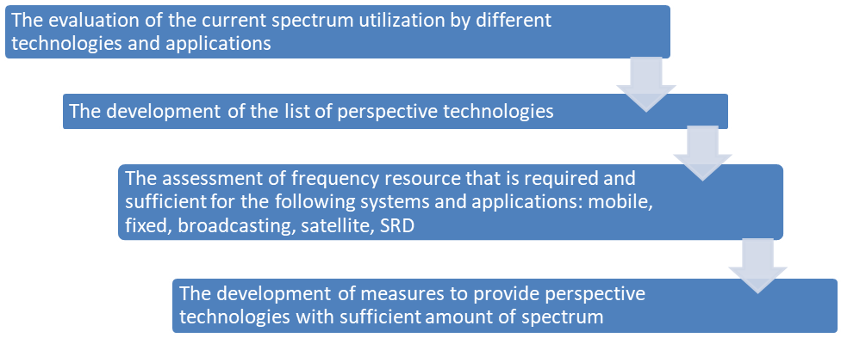
The main tasks on the stage of the evaluation of the current spectrum utilization by different technologies and applications are:
– The assessment of spectrum actually used by mobile, fixed, broadcasting, satellite, SRD applications and systems;
– Definition of frequency bands where new technologies and applications could be implemented;
– Definition of frequency bands utilized inefficiently.
The development of the list of perspective technologies
Expert methods can be used to develop the list of perspective technologies. This category has been chosen because there is few statistic data on usage of new technologies if any.
The required information can be gathered through discussions or questionnaires.
Expert judgments are opinions of highly qualified professionals expressed as qualitative or quantitative assessments of the object, and are to be used in the decision-making process.
To assess qualitative indicators, verbal-numeric scale, which comprises the description of its levels and appropriate numeric values or ranges, could be used.
An expertise can be individual or collective, having one round or multiple rounds, allowing experts to exchange information between each other or prohibiting it. They can also be open or anonymous. The variety of fields in which they can be used makes expert methods multifarious and flexible. However, implementing one of the famous and widespread schemes is not always possible. Therefore, when implementing complex and uncommon expertise, it is recommended for Administrations to be creative in using well known expert techniques and to combine the possibilities of each of them. Sometimes it could be appropriate to develop a new expert approach. The simplest and most well-known expert techniques are methods of commissions, jury of executive opinion and brainstorming. The first one is a set of open discussions on a topic to develop an integrated opinion. The second method (jury of executive opinion) assumes that expertise is performed by analogy with trial.
When brainstorming, each idea should be discussed and cannot be rejected. The administrator of expertise knows the final goal of a discussion and directs it.
Each technology chosen by experts is given an assessment of its prospectivity. To assess the technology prospectivity one can use the Delphi technique, which is often used to perform expertise. This method allows to consider independent opinions of every expert involved by consecutive consolidation of ideas, conclusions and proposals and to achieve an agreement. This method is based on multiple round anonymous group interviews.
The Delphi technique is a group of methods combined by general procedure’s organization requirements, and forms of receiving assessment from the experts. The effectiveness of expert’s work is provided by anonymity of the procedure and possibility to get more information about the subject of expertise. As a rule, the expertise is carried out in multiple rounds in order to provide feedback. This allows experts to adjust their opinion taking into account interim average assessments and experts’ clarifications. Today there is no agreement on number of rounds of Delphi procedure. It depends on the specifics of the expertise and its goals. As a rule, assessments do not change after second round.
Each step involves typical procedures. Experts are asked to assess the subject qualitatively by answering questions such as: expected time of some event, the importance of characteristics in scores etc. After receiving answers from experts data is ranked, median and quartiles of ordered data are calculated. The results are given to experts and they are asked to clarify their opinion. This especially applies to experts whose assessments fall out of limit of quartiles. Before the start of the procedure experts are given all available information on the subject.
Each expert gets a questionnaire. If the questions are difficult, they should be followed by an explanatory note. Figure 2 gives a scheme for assessing technology prospectivity.
Figure 2
Assessment of the technology prospectivity
Figure 3 shows algorithm developed to get input data for assessment of the technology prospectivity using the Delphi technique.
Figure 3
Algorithm for carrying out an expert poll using the Delphi method
According to the developed procedure, the group of experts is formed on the first stage. To define the number of experts needed to get representative results, the following formula is used.
(1)
Here Z_{P} is determined in accordance with the table by the confidence probability value of 1 − α. For 1 – α = 0.95, Z_{P} = 1.96; – experts’ assessments variance; – accuracy of assessment.
On this stage experts also define criteria for assessment of the technology prospectivity. There are three groups of criteria:
– Technical;
– Market;
– Economic.
An example of each group of criteria is given below.
Technical criteria:
К_{V} | – | expected term for spectrum release. It is important not only for operator but for government as well. Spectrum release term determines the term of new technology implementation and receiving benefits. The sooner spectrum is released, the more perspectives there are for development of the considered technology (higher score).
К_{D} | – | The number of types of devises that are removed from the band. This indicator shows complexity and duration of measures for spectrum refarming. The more types of devices are removed, the less perspectives there are for development of the considered technology (lower score)
К_{H} | – | Interference immunity of new technology’s devices shows the possibilities for compatibility of perspective technology in available band. The higher interference immunity is the more perspective technology is (higher score).
К_{S} | – | Spectral efficiency of perspective technology. This criterion shows the effectiveness of spectrum usage by perspective technology. The higher spectrum efficiency is the more perspective technology is (higher score).
Market criteria:
К_{R} | – | Availability of approved standards and regulations. This indicator reflects the availability of technology standards approved by international and regional standardization organizations. This promotes the development of technology.
К_{K} | – | Market competition between manufactures. This characterizes the prospectivity of the technology’s development through the influence of market competition between vendors. Due to specifics of market pricing and law of supply and demand the more vendors are there in the market the lower prices for devices are. The more competitive the market is, the more perspectives are there for the development of the considered technology. (higher score).
К_{E} | – | Experience in using new technology. Availability of experience makes the deployment of new technology faster and allows to consider all peculiarities of pilot and commercial networks.
Economic criteria:
К_{дох} | – | Economic efficiency (profitability) of using new technology. This indicator shows economic efficiency of using spectrum by different technologies. The more effectiveness is the more perspectives there are for the development of the technology (higher score).
When the criteria are defined, they are arranged in a questionnaire where experts are asked to score the technologies by these criteria (from 0 to 10). Especially, they are asked to give their assessment on the impact of:
– defined groups of criteria on perspectives of the development of technologies in general;
– each factor on perspectives of the development of technology within the selected group;
– each factor on the development perspectives of each radio technology under consideration.
The second stage consists in questioning procedure itself, which is organized in two rounds.
On the third stage statistical analysis of the received results is performed. For this stage the following condition is adopted: if for any technology the importance of one of the criteria is estimated as “0” by all experts then this radio technology is excluded from further calculations.
For data processing the following algorithm can be used:
1 The average value of expert assessments of the impact of the identified groups of criteria in their combined effect on the development prospects of radio technologies ():
(2)
where is a score for group of criteria l given by expert j (j=1÷n, n – number of experts).
In order to move from scores to relative units, the relative weight of the significance of each group of criteria in their combined effect is calculated:
(3)
where is weight of the significance of group l in relative unites; - the average value of expert assessments for group l in scores (l=1÷k1, k1-number of groups of criteria, k1=3). is calculated by equation (2).
2 The average value of expertsʼ assessment of each criterion of the development prospects of radio technologies is calculated.
, (4)
where is a score given to criterion m in group l by expert j.
To move from the scores to relative units a weight for each criteria in a group is calculated.
, (5)
where is weight of criterion m in relative units (m=1÷k2, k2 – a number of criteria in considered group – technical or economic); – average score of criterion m. is defined by equation (4).
3 An average score of each criterion for each technology is calculated. For convenience, the scores given by experts are divided by 10.
, (6)
where is an average score given to technology i by criterion considered (i=1÷k3, k3 – number of technologies considered); – score given to technology i by expert j divided by 10.
4 A prospectivity coefficient is calculated for each technology considered.
, (7)
where is the prospectivity coefficient for technology i (i=1÷k3, k3 – number of technologies), relative unites; – weight of group of criteria l (l=1÷k1, k1– number of groups of criteria), relative units; – weight of criterion m (m=1÷k2, k2– number of criteria in group l), relative units; – average score of technology I by criterion m in criteria’s group l, relative units.
The assessment of frequency resource that is required and sufficient for the following systems and applications: mobile, fixed, broadcasting, satellite, SRD
When determining the minimum necessary frequency resource, all selected technologies are grouped by categories: mobile communication systems, fixed communication systems, radio broadcasting systems, satellite systems, and short-range devices.
The methodology for determining spectrum demand can be described as follows:
– Selection of the parameters of the provided communication services.
– The number of subscribers per square metre is calculated by dividing the total number of subscribers by the service area (cell).
– Selection of penetration factors (%). For each zone there can be a different penetration factor.
– The number of subscribers per cell is calculated (for cellular systems).
– Traffic parameters’ values definition:
• the load in peak hours (calls / hour);
• the duration of the communication session (in seconds);
• the coefficient of subscribers’ activity (in units).
– Calculation of traffic per subscriber.
– Total traffic calculation (Mbit/s).
– Calculation of system performance taking into account the quality of communication lines and the acceptable number of call blocking.
– Assessment of spectrum required to implement new technology.
If more details are needed in assessing the required spectrum, Recommendations ITU-R M.1390 and ITU-R M.1768-1 can be the references which introduce methodologies to calculate spectrum requirements for IMT-2000 and IMT-Advanced. In addition, Recommendation ITU-R M.1651 also introduces how to assess the required spectrum for broadband nomadic wireless access systems using 5 GHz band.
The development of measures to provide perspective technologies with sufficient amount of spectrum
Conversion, reframing or use of new spectrum management methods (for example LSA) can be used as measures to provide promising technologies with radio frequency resources.

Chapter 2
Evaluation of scenarios

1 Introduction
Depending on the national outlook, the available resources, and the spectrum regulatory framework, a national spectrum manager may select from a number of methods to evaluate scenarios with respect to their potential impact on spectrum use. The evaluation of the scenarios that impact spectrum use can rely on consultative or analytical approaches or on a combination of approaches. It can be very detailed, considering all potential factors, or more cursory in its overview. Furthermore, the responsibility for consideration of factors can be primarily that of the national spectrum manager (see also Chapter 1) or be distributed to the interested constituents. This evaluation of scenarios ultimately helps to form the basis for national spectrum manager decisions regarding spectrum allocation or regulations. A scenario is a hypothetical sequence of events based on events and developments related to a specific field (e.g. a country’s population trends) or to a specific period of time, that in some manner relate to each other. A scenario is not a forecast in itself but it complements traditional forecasting by providing a record of a possible sequence of individual events related to one particularly interesting system aspect.
Within the framework of long-term planning, scenarios are used to predict possible developments. They serve to:
– increase the reliability of forecasts and interpret risks (reliability), and
– identify potential strategic options.
The scenarios are based on the main factors of influence, i.e. the policy, economic, social and technical factors. They can be developed systematically with different configurations of factors and their estimated degrees of probability.

2 The consultative approach
The consultative approach is based on the premise that spectrum planners can, through collaborative proceedings involving spectrum users, service providers, equipment manufacturers, and research institutes, arrive at a reasonably accurate and cost-effective determination of long-term spectrum requirements and use. Thus, it takes into consideration analytical and intuitive inputs from the spectrum community, placing the weight of responsibility for much of the analysis and forecasting on those who have the most at stake. The detail given to the analysis of factors is up to the user community. Given the rapid changes in the radiocommunications industry and the limited resources available to national spectrum managers, such an approach often represents the best, cost-effective option for spectrum planners.

2.1 Inquiry into future spectrum/service requirements
The consultative approach starts with an initial public notice or announcement, informing all interested parties that a long-term spectrum plan, or, in some cases, specific strategic component of a plan, is to be developed, and requesting technical, social and economic information relative to such a plan. The notice should be widely distributed, preferably in an official publication known to have a large audience. The public nature of the notice is essential to gaining maximum interest and feedback from potential system operators. Limitations on its availability will limit the response. However, in countries where such official publication methods do not exist or in cases where time is limited, the use of ongoing advisory bodies may represent an effective approach to gathering information.
The scope of the inquiry must be defined, as well as the timetable for responses. Responses can be expected from spectrum users’ groups, radio service providers, equipment manufacturers, government organizations, including the military, and the general public. Spectrum planners can require that responses be in writing or through direct dialogue. In any case, the responses received from these groups form the basis for determining spectrum requirements and lead to spectrum management decisions.
As noted above, a number of groups provide information to this consultative process. User groups are end users of telecommunications services that have a common interest in receiving the best service at the lowest cost. These user groups may be able to voice requirements for new or expanded radio services. Radiocommunication service providers are those commercial entities that supply services to the end users. Service providers have expectations of service growth based on their own surveys and business acumen. This service growth could be reflected in a demand for additional spectrum. Radio equipment manufacturers have a vested interest in the growth of radio-based systems, and can provide technical comments on the suitability of various frequency bands for a proposed radio service, along with forecasts of technical advances that may improve spectrum efficiency.
The national and local governments, as well as the military, will have spectrum requirements for the satisfaction of future radiocommunications systems. Although commercial services can satisfy a portion of these requirements, many may be unique and will require spectrum and unique radio systems devoted to these purposes. It is probable that some of the systems may involve national security to the extent that knowledge of these systems will not be in the public domain, and must be protected by the regulatory body.
The underlying principle of the consultative process is that users, service providers and manufacturers are the ones able to best evaluate their spectrum needs. Because they operate businesses or fulfil a government function, they must be able to evaluate their needs, costs, and user demands. Therefore, the societal and economic factors must be considered and identified by the participants in stating their requirements.
As those who want spectrum respond to the inquiry, there may be an understandable tendency to exaggerate their spectrum and service requirements. Therefore, the national spectrum managers may use interactive dialogue and analysis of usage trends to help ensure sufficient accuracy.

2.2 Interaction among/with representative groups
Formal consultative processes can be carried out through a several-step iterative approach. While interaction of interested parties can occur through formal responses and counter responses to the inquiry, it increases the amount of time required to complete the inquiry process. In many cases, this time may be invaluable in giving the national spectrum manager adequate opportunity to consider the issues. Furthermore, it ensures that all ideas are recorded and considered.
However, in the interest of maximizing interaction and, in some cases, speeding the process, it is appropriate to meet with representatives of the major responding groups during the period of inquiry. This interaction affords the opportunity of establishing a dialogue among users, service providers, and regulators to make clear the intent of the proceeding and to reduce or eliminate possible exaggeration of spectrum requirements. It places each requirement in the context of other requirements (both new and old) thereby bringing a note of reality to negotiations for spectrum and ultimately to the planning outcome. In many cases such a dialogue helps proponents revise their requests as they work together with others.

2.3 Analysis of usage trends
The results of any inquiry should be compared with requirements based on an analysis of the usage trends for current radio services. Increased spectrum requirements for a user population that is stable or declining would be highly suspect, unless a current lack of available service keeps the number of users from growing. Extrapolation of usage data and computation of the required spectrum assuming spectrum-efficient technologies, will provide the regulator with an approximation of future usage to compare with the results of the inquiry. Forecasting based on usage trends can be somewhat misleading in the case of non-linear trends (breakthroughs). These are cases where usage may rise exponentially in the near future due to a breakthrough in technology or significant price reductions for the service. However, in a consultative approach, the emphasis is on cost-effective processes. Therefore, the extent of the analysis of usage trends must be evaluated in terms of the improved accuracy which is judged to result from them.

2.4 Example
In 1993, an agency of the United States of America administration initiated a programme to determine the national spectrum requirements for a period of ten years into the future. A notice of inquiry was published in the Federal Register, a daily government publication in which proposed federal regulations, inquiries and general notices relating to government activities are disseminated to the public. This inquiry described the need for spectrum requirement forecasting, and posed a series of questions regarding future spectrum needs. The inquiry requested responses from organizations, firms and individuals.
In response to the inquiry, over 70 comments were received from industry, user groups, individuals, and government agencies. The extent of comments ranged from two to several hundred pages. The comments were reviewed and the future spectrum requirements for the various allocated radio services were compiled.
Statistics regarding government and private sector radio licenses were examined to determine the degree of correlation with the comments received regarding future spectrum requirements. Following the analysis, meetings were held with land mobile user groups, personal communications service providers, and manufacturers, to share additional information relating to future spectrum needs.
Preliminary results of future spectrum needs were provided to government advisory committees consisting of experts in the telecommunication field. These committees reviewed the results and provided additional comments on spectrum requirements.
Finally, having considered all the comments received, a report was prepared forecasting the future spectrum requirements for the radio services allocated in the United States of America. Based on this report and the spectrum requirements documented in other committees, plans could be made to revise national and international allocation tables to satisfy the future telecommunication service demands.

3 The analytical approach

3.1 Introduction
The analytical approach comprises a detailed analysis of the factors affecting the trend to be forecast. The analysis’ findings and assumptions are converted into comprehensible figures. These figures are calculated mathematically with the aid of software if available.
This method combining analysis and mathematics has the following advantages:
– a comprehensive bottom-up method based on detailed data is used to produce and record the results;
– the data for the influencing factors are derived from statistics for previous years. The figures for future years are extrapolated from these statistics;
– the weighting for each influencing factor can be determined using surveys and/or other research material (e.g. evaluation of external studies, technical reports and also advertising material);
– any effects that changes an individual influencing factors with respect to the forecast results can be determined immediately;
– the analytical method does not necessarily require extensive input from outside the spectrum management organizations and can be applied using existing statistics;
– the detailed and comprehensive analytical method using reliable statistics produces a relatively objective result.

3.2 Steps for the analytical approach development
The analytical approach has the following steps:
Step 1: thorough analysis of the current situation;
Step 2: reasonable assumptions made with respect to factors (see Annex 1 to Chapter 1);
Step 3: development of possible scenarios
– one reliable scenario indicating any elements of uncertainty and their underlying reasons;
– further scenarios which focus on the most significant factors of uncertainty;
Step 4: assessment of scenarios
– the scenarios are assessed for completeness, validity of the factors and their individual risks, benefits and priorities;
Step 5: presentation of a set of conclusive outputs.
Figure 4 further elaborates the development of scenarios as shown in step 3. The cone represents the range of possible evaluation over time and illustrates the scenario characteristics.
Figure 4
Development of scenarios
Near-future developments are largely determined by the present (excluding unforeseeable events). The further the future, the wider the range of possible developments. The cone illustrates how the range of possible developments widens. The diameter of the cone’s base is determined by the number of variable factors taken into account. All possible paths of developments in the period 0 to T end on the base. Some of these paths are described through scenarios: it is neither possible nor economically sensible to study all imaginable paths within the three scenarios. Scenarios A and B represent two average paths taking account of all factors. If an event occurs at 1 and interferes with the path, the path will change course and end at C. If decision is taken at 2, the path will change course again and end at D.

3.3 The use of the analytical technique in the long-term spectrum requirements planning process
The analytical technique can be viewed as a model which can be turned into a computer programme or analysed manually.
As an example, the German Regulatory Authority for Telecommunications and Posts produced, inter alia, a scenario for UMTS user number trends up to 2010. The scenario differentiated between private and business users.
Three major factors affecting private user numbers were identified:
– income trends;
– age distribution; and
– household size.
These factors were determined using Federal Statistical Office documents combined with data on mobile radio price and tariff trends, the population’s age and purchasing-power distribution, leisure activities, and the increase in the number of small (double-income, no children) households. These data were derived from previous analyses and research, technical literature and demographic statistics.
The maximum potential number of business users was determined taking account of the number and trends in the number of gainfully employed and company vehicles. The expected potential number of users by year 2010 was determined by subtracting a certain percentage to allow for dual users, i.e. persons using the UMTS for both private and business purposes.
These user data were used to produce a traffic model which ultimately led to a forecast of the UMTS spectrum requirements in 2010, taking account of technical influencing factors such as system bandwidth, channel spacing, cell radius and cell configuration.
Where a scenario has been developed in the past, it can be compared with current developments to confirm its accuracy and be revised if necessary.

Chapter 3
Appropriate procedures for transition from present spectrum utilization
to long-term objectives

1 Identification of long-term spectrum management objectives
The identification of long-term spectrum management objectives should consider the maximization of the use of the radio spectrum by various technical and operational methodologies that are currently known or under development. These objectives should consider the potential growth of existing radio services as well as the introduction and growth of new services and applications. Moreover, considerations should be given to changes in use of the spectrum by the local industry and general public, changes in technology as well as to the technical and non-technical factors described in Annex 1 to Chapter 1.
The objectives for long-term spectrum management can be broadly identified as: to foster the development and use of the radio spectrum to support the changing technological, social, political and economic environments, for the maximum net benefit of all.
The long-term objectives should include inputs from government(s), local industry and, within industry, from large and small organizations and from a number of geographic locations.

2 Evaluation of current spectrum management process
This evaluation should include a study of the current national spectrum management process to determine its weaknesses and strengths as perceived by the industry and by the government. The outcome of this evaluation will form the basis for the development of updated long-term spectrum management strategies (an example is provided in Annex 1 to this Chapter).

3 Transition procedures
The foundation of the long-term spectrum management process depends on the careful selection of strategies to meet the long-term spectrum management objectives. The selected strategies should be integrated into a national long-term spectrum plan. A list of key spectrum utilization transition procedures and long-term spectrum management strategies are provided below:

3.1 Encourage effective spectrum utilization
Transition from present spectrum utilization to long-term objectives can be achieved by the use of advanced spectrum engineering techniques and procedures. Service providers should be encouraged to use such techniques and procedures by, for example, reduced or fixed licence fees. The transition procedures addressed here are:

3.1.1 Effective use of new technologies to improve the reuse of frequencies
Frequency re-use can be defined as the number of times the same frequency can be used in a given geographic area without negatively affecting any user of the frequency. Frequency coordination is usually one of the determinant issues in the reuse technique. Effective spectrum utilization can be achieved by the use of advanced engineering techniques to increase frequency re-use; reduce channel bandwidth; improve coding techniques, improve modulation techniques; improve access strategies; improve band sharing without interference; introduce new spectrum sharing criteria; develop frequency assignment strategies and spectrum usage models; and by other engineering and operational techniques.
The technical approaches to frequency re-use, system overlays between services are well-known. The ITU Handbook on National Spectrum Management 2015, in its chapters on Spectrum Engineering Practices and Spectrum Use, covers matters which include measurements of spectrum utilization and spectrum utilization efficiency when these approaches are implemented. In addition, the Handbook addresses such techniques as interference cancellers, interference screens, millimetre wave reflecting antennas and land mobile adaptive antennas. These matters will not be duplicated here.

3.1.2 Channel splitting
This involves increasing the utilization of the spectrum through re-planning of existing spectrum bands by the use of narrower bandwidth channels. Channel splitting entails the use of more spectrally efficient technologies and the introduction of new technical and operational standards. Channel splitting procedures have to take into account the fact that the spectrum under consideration for re-planning is usually intensively utilized. Several other issues have to be analysed to consider in the development of a channel splitting plan including:
– Continuity of service: redistribution is to be performed without service interruption.
– Costs: an evolutionary approach to implementation to reduce costs on spectrum user.
– Compatibility: some measure of backward compatibility and interoperability is essential, while looking forward to the improved functionality and capacity that new technology will bring.
– Risk: a balance should be made between policies to provide additional capacity and user’s needs of low-risk solutions.
– Harmonization: it is necessary to harmonize, where possible, with neighbouring countries and internationally.

3.1.3 Spectrum redeployment
A spectrum plan may, in accordance with certain circumstances and under appropriate long-range decisions, result in redeployment of services. This could mean transitioning existing users of a spectrum band to either new technologies or to new frequency bands. The requirement for redeployment can arise for several reasons:
– a spectrum allocation may have been in operation for a considerable period of time and currently no longer meets the requirements of users, or the capabilities of modern systems;
– an allocation within a specific range of frequencies is required for a new radio service and these frequencies are occupied by services with which the new service cannot share; or
– a decision by a World Radiocommunication Conference to allocate a currently occupied frequency band to a different service on a global or regional basis.

3.1.4 Service overlay and frequency band sharing
Effective sharing of the frequency bands for a number of services can play a significant role in reducing the demand for new spectrum. The identification of current and future shared bands is essential.
The concept of broadband services sharing the spectrum with narrow band services is a promising approach for reducing demand for more spectrum. This concept addresses situations where, because of the characteristics of a specific modulation scheme or specific system parameters, it is possible for radio services to co-use a spectrum band without causing harmful interference to each other. This approach is termed service overlay.
A typical example of service overlay is the ability of spread spectrum systems to operate efficiently with conventional systems. Techniques such as Orthogonal Frequency Division Multiple (OFDM), code division multiple access (CDMA) and time division multiple access (TDMA) are commonly used to provide co-sharing systems. System overlay should be considered on a case-by-case basis with the particular protocols and architectures of the potentially interfering services being specifically analysed. It may require to spectrum sharing, frequency allocation strategies and models of spectrum use.

3.1.5 Shared radio systems
A number of organizations can share one radio system rather than operating their own individual systems. Technology is needed to create the necessary firewalls between the functions of different users and to provide transparent prioritisation. This requires a mechanism to determine, and take into account, the different loading patterns of each service on the shared system to maximize sharing capability. Sharing a radio system by a number of organizations (police, fire, ambulance) have the capability to significantly improve the utilization of the radio spectrum, especially in spectrally congested areas. This sharing will also reduce the cost of the radio system.

3.1.6 Use of the unused spectrum
Lack of finances or equipment, or the economic benefits of blocking the use of spectrum by others, currently results in some licensees not using their licensed spectrum. Policies, regulations and programmes should aim to minimize the low usage of authorized licensed spectrum by licensees. This can be achieved, for example, by penalization for non-use of the licensed spectrum perhaps by withdrawal of the licence.
Policies, regulations and programmes should also encourage service expansion into the high gigahertz bands (> 40 GHz), especially for services requiring exclusive spectrum and/or broadband applications. The radio spectrum above 40 GHz is currently under-utilized. This segment of spectrum has the potential for supporting very wide broadband services, and high frequency re-use due to the small cell-size at such high frequencies. This segment of spectrum also brings several implementation advantages including smaller antennas, narrower beamwidths, reduced hardware size and weight, and ease of installation and re-configuration.

3.1.7 Use of wireline distribution networks as a supplement
Wireline networks could be used as an alternative to wireless to reduce demand on spectrum especially in congested areas and for broadband applications. Policies and regulations should be drawn to encourage the use of advanced intelligent network technologies to: permit the seamless interfaces between wireline distribution and short-distance wireless links.

3.2 Enhance spectrum use flexibility
A long-term spectrum management programme should be designed from the beginning to permit flexibility of strategies and their prioritisation. This programme should:
– allow service flexibility i.e. the use of the radio spectrum to provide any service (voice, data, image, etc.) subject to the technical limitations of the frequency band concerned;
– allow technical flexibility i.e. the use of any technology to provide a service subject to interference limitations;
– introduce flexible, non-prescriptive policies and regulations to accommodate for innovation and market forces. Policies and regulations must have the flexibility to meet the changing social, economic and technical needs.
As an example, a programme that promotes spectrum use flexibility is the concept of block or spectrum licensing. This is where a block of spectrum, usually several megahertz, is licensed to a user on a geographic basis. The licensee becomes responsible for system engineering and for frequency co-ordination, both at the limits of the licensed area and, where the spectrum is shared with other block licensees, within the licensed area. Licensing a large block of frequencies rather than a channel-by-channel basis enables better use of the radio spectrum.

3.3 Maximize the social and economic benefits that can be achieved by appropriate spectrum management
Spectrum management plays a major role in increasing the country’s social and economic well-being by maximizing the use of the spectrum for wireless applications. It is strongly emphasized that economic benefit in this sense must be used in a broad context rather than that of merely increasing license revenue. Implementation of this concept can be achieved during the licensing process that:
– ensures use of the best available frequency range appropriate to the application with the highest efficiency permitted by technology;
– promotes sustainable competition among service providers;
– leads to higher density usage within service allocations by using spectrum efficient technologies, frequency re-use, improved frequency planning models, improved sharing criteria and traffic density projections;
– promotes new radio service entrants;
– identifies, quantifies (to the extent possible) and maximizes the social benefits accruing to the licensing strategy under consideration.
The long-term spectrum management policies, regulations, standards and programmes should be: flexible, efficient, strategic, non-prescriptive, and technology and service neutral. Considerations should be given to the implications of perceived or actual negative health impacts of spectrum use. Plans should be drawn up to accurately and effectively educate the public on these matters.

3.4 Ensure that the spectrum is used in all regions of the country where it is needed
Major cities tend to be given higher priority by service providers, leaving the smaller cities and less populated areas poorly served. The use of the spectrum in all regions of the country, including smaller cities and towns may be achieved by considering this issue in the licensing process.

3.5 Build a skilled work force and develop proper spectrum engineering tools
Develop appropriate policies and programmes to train and maintain the quality and competence of the national spectrum management work force. This work force should be provided with the latest tools particularly in terms of automated systems and computer aids to enable it to deal effectively with licensing demands and interference analysis for existing and new technologies.
Investments should also be made on research and development related to spectrum management to meet the objective of long-term spectrum utilization.

Annex 1
to Chapter 3
Example on evaluation procedures of spectrum utilization
efficiency in Korea (Rep. of)

1 Background
As the spectrum demand increases, securing spectrum resources in a timely manner becomes necessary. Although many countries have researched and analysed the current status of spectrum utilization periodically, it was difficult to produce an appropriate policy that takes into account future demand and supply comprehensively because of the limitations from fragmentary and qualitative analyses. As a result, some countries have recently applied a method of discovering candidate bands and evaluating their priority in order to secure spectrum systematically in the long-term planning process.
Since 2019, Korea (Republic of) has implemented an evaluation system to improve spectrum utilization efficiency in the process of determining national long-term strategies under the goal of responding to the rapidly increasing spectrum demand and discovering spectrum scientifically.
The results that evaluate the spectrum usage status with various factors for each frequency band to discover maintenance targets are disclosed to the public through the "Spectrum Redeployment Forecast system" to announce the timetable and measures of maintenance in advance.

2 The process of the evaluation
All frequency bands are divided into low (lower than 3 GHz), mid (3 to 10 GHz) and high (higher than 10 GHz) bands, and one of three bands is evaluated step by step every year. The evaluation process has been performed in order of self-evaluation → advisory evaluation → evaluation committee → stakeholder opinion → forecast and notification of guidance.
The criteria for evaluation of spectrum utilization efficiency are based on articles of the Radio Waves Act, and a four-level matrix for priority evaluation has been proposed, considering both demand urgency and supply ease.
Prioritizing among the various alternatives is not an easy matter because each criterion is not proportional to each other, and criteria’s trade-offs should be quantified when those are in the conflicting relationship. Therefore, for this kind of evaluation to choose alternative solutions, the Analytic Hierarchy Process (AHP) which is one of multi criteria decision making methods can be applied. The AHP provides a comprehensive and rational framework for structuring decision problems, for representing and quantifying its elements, for relating those elements to overall goals and for evaluating alternative solutions.
Figure 5
The process of selecting evaluation criteria for spectrum utilization efficiency (AHP)
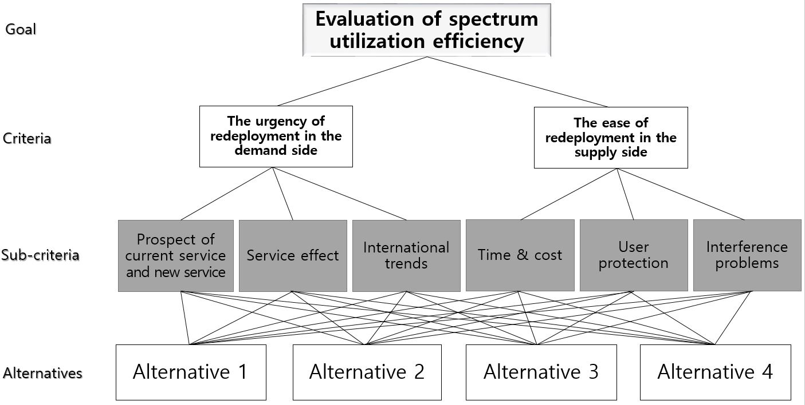
The evaluation of spectrum utilization efficiency uses several criteria that are consist of demand and supply aspects. The demand side attempts to evaluate the prospects for new services and quantity demanded based on the current service and demand status, the levels that require action to improve spectrum efficiency, and whether it is consistent with international standards and trends in major countries, in order to identify the urgency of redeployment. In comparison, on the supply side, with the aim of assessing the ease of redeployment, it is being used as an evaluation criterion of the time and cost needed, the possibility of the user protection measures, and the possibility of resolving interference problems.
TABLE 2
Evaluation criteria
Aspect | Factor | Evaluation criteria | Method
Demand analysis | The utilization rate of existing services | The trend of radio stations figures | Quantitative
 |  | The degree of technological evolution | Qualitative
 |  | Economic effect | Qualitative
 |  | Social and public interest | Qualitative
 | Potential demand for new services | Technical indicator | Qualitative
 |  | Ecosystem indicator | Qualitative
 | Actual demand for new services | Spectrum usage plan | Quantitative
 |  | Status of domestic demand raised | Quantitative
 |  | Economic effect | Qualitative
 |  | Social and public interest | Qualitative
Subtotal of the score for the degree of service demand (Y)
The possibility of spectrum supply | Unused rate of spectrum | Unused rate in the territory | Quantitative
 |  | Unused rate in big cities | Quantitative
 | The possibility of securing spectrum | The availability of alternative frequency bands | Quantitative
 |  | The possibility of spectrum maintenance | Qualitative
 |  | The cost of migration to alternatives | Qualitative
 | Other considerations | The acceptability of incumbent users | Qualitative
 |  | The relevance of the public interest for new uses | Qualitative
Subtotal of the score for the possibility of spectrum supply (X)
Total (X,Y)

The results of evaluation for each band are displayed in the matrix chart to rank the redeployment priority to four grades. The vertical scale shows that the degree of service demand (0 to 5) and the horizontal scale represents the possibility of spectrum supply (0 to 5). If the evaluated band is located in the first quadrant (Grade I), spectrum redeployment will be carried out to improve spectrum utilization efficiency, and if it falls under the second quadrant (Grade II), additional new licenses will be prohibited and long-term efficiency measures will be reviewed through pre-announcement. If it is located in the third quadrant (Grade III), it means that it will be used continuously, and the fourth quadrant (Grade IV) means promoting the use of the services currently in use or discovering new demands.
Figure 6
Example of the evaluation results of spectrum utilization efficiency
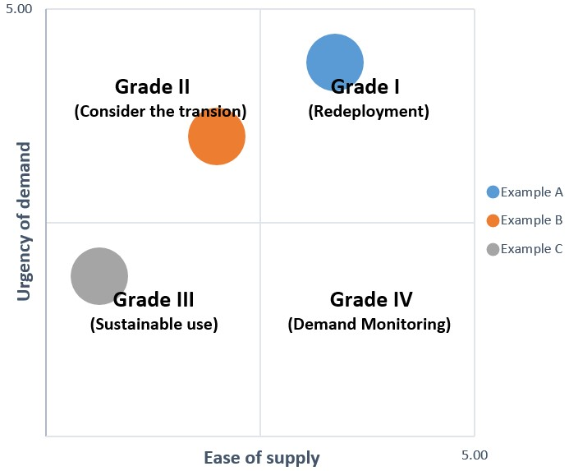

3 Actual evaluation cases
In 2020, the evaluation was conducted on the mid bands (3 to 10 GHz) where demand for frequencies has been increasing rapidly internationally, such as 5G and Wi-Fi. It was evaluated that the 3.7~4.0 GHz/3.42 GHz/6 GHz bands need spectrum reallocation and there are actual domestic demands for frequencies such as 5G, Wi-Fi, etc. and it can be supplied through spectrum redeployment. Additionally, the 5.85~5.925 GHz band for Intelligent Transportation System (ITS) requires activation of use because the new demand is low, and the existing service is underused. The 8 GHz band, which has low demand for new services and low possibility of supply of substitute bands due to saturation of existing services, was evaluated as a band that continues to be used.
To follow up the evaluation results, the Spectrum Redeployment Forecast system was implemented for 3.7 to 4.0 GHz (including 3.4 to 3.42 GHz)/6 GHz bands that was evaluated as requiring spectrum redeployment. Through the forecast system, incumbent users, device manufacturers, and sellers were informed of administrative plans such as spectrum allocation tables and related notices, as well as user measures to apply compensation for loss due to spectrum redeployment.
Figure 7
Evaluation results for spectrum utilization efficiency (2020)
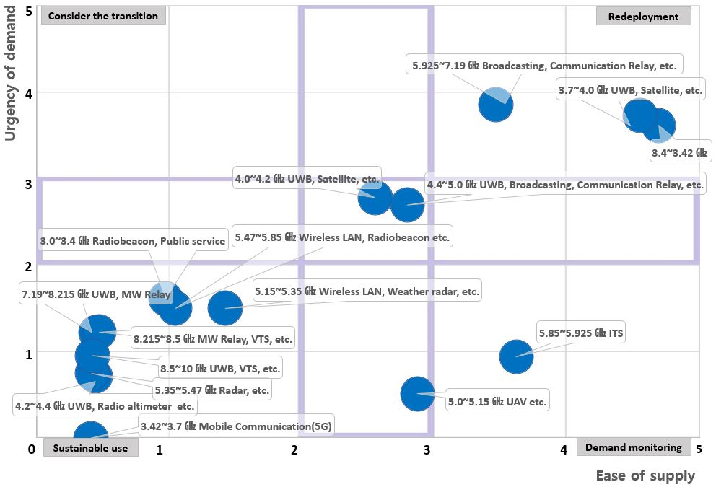

4 Countermeasures and expected effects according to evaluation results
Depending on the evaluation results, the regulatory authority can modify its national long-term strategies for spectrum utilization, and stakeholders can devise countermeasures against the bands they are using or intend to use in advance. It is expected that this evaluation system can help secure the spectrum in a timely manner, protect incumbent users properly and promote new spectrum-based businesses.
TABLE 3
The example of government policy and stakeholder’s countermeasures
according to evaluation
 | Government policy | Stakeholder’s countermeasures
Grade I | Efficiency improvement through withdrawal and reallocation of spectrum frequencies, conversion of technical standards, etc. | Preparation of new service, development of equipment, etc.
Grade II | Suspension of the new authorization, implementation (possibility) notice of efficiency improvement, execution plan of efficiency improvement, stakeholder consultation, etc. | Suspension of the new investment in existing facilities, relocation of subscribers, preparation of equipment development etc.
Grade III | Monitoring the new demand and usage of radio frequencies, excavation of spectrum | Sustainable use
Grade IV | Monitoring new demand and discovery of spectrum frequencies, promoting efficiency improvement in case of demand occurrence | Demand expression of new radio frequencies, promotion of new technology and service introduction, etc.

List of abbreviations
AHP Analytic hierarchy process
ARNS Aeronautical radio navigation service
CDMA Code division multiple access
FDMA Frequency division multiple access
ITS Intelligent transportation system
LSA Licensed shared access
MIMO Multiple-input multiple-output
OFDMA Orthogonal frequency division multiple access
RFID Radio frequency identification
SRD Short-range device
TDMA Time division multiple access
UMTS Universal Mobile Telecommunications System

For more information, see Report ITU-R SM.2404 – Regulatory tools to support enhanced shared use of the spectrum.
U.S. National Spectrum Requirements: Projections and Trends, U.S. Department of Commerce, March 1995.

