Report ITU-R SA.2162
(09/2009)
Sharing conditions between space research service extra vehicular activities (EVA)
links and fixed and mobile service links
in the 410-420 MHz band

SA Series
Space applications and meteorology

Foreword
The role of the Radiocommunication Sector is to ensure the rational, equitable, efficient and economical use of the radio-frequency spectrum by all radiocommunication services, including satellite services, and carry out studies without limit of frequency range on the basis of which Recommendations are adopted.
The regulatory and policy functions of the Radiocommunication Sector are performed by World and Regional Radiocommunication Conferences and Radiocommunication Assemblies supported by Study Groups.

Policy on Intellectual Property Right (IPR)
ITU-R policy on IPR is described in the Common Patent Policy for ITU-T/ITU-R/ISO/IEC referenced in Annex 1 of Resolution ITU-R 1. Forms to be used for the submission of patent statements and licensing declarations by patent holders are available from http://www.itu.int/ITU-R/go/patents/en where the Guidelines for Implementation of the Common Patent Policy for ITU-T/ITU-R/ISO/IEC and the ITU-R patent information database can also be found.

Series of ITU-R Reports
(Also available online at http://www.itu.int/publ/R-REP/en)
Series | Title
BO | Satellite delivery
BR | Recording for production, archival and play-out; film for television
BS | Broadcasting service (sound)
BT | Broadcasting service (television)
F | Fixed service
M | Mobile, radiodetermination, amateur and related satellite services
P | Radiowave propagation
RA | Radio astronomy
RS | Remote sensing systems
S | Fixed-satellite service
SA | Space applications and meteorology
SF | Frequency sharing and coordination between fixed-satellite and fixed service systems
SM | Spectrum management

Note: This ITU-R Report was approved in English by the Study Group under the procedure detailed
in Resolution ITU-R 1.

Electronic Publication
Geneva, 2010
© ITU 2010
All rights reserved. No part of this publication may be reproduced, by any means whatsoever, without written permission of ITU.
REPORT ITU-R SA.2162
Sharing conditions between space research service extra vehicular
activities (EVA) links and fixed and mobile service links
in the 410-420 MHz band

(2010)

TABLE OF CONTENTS

Page
1 Introduction 2
2 Space research service objectives and requirements 2
3 System description and characteristics 2
4 Interference to fixed and mobile service links from space research service EVA links 4
5 Interference to space research service EVA links from fixed and mobile service stations 7
5.1 Achievable operational distance 11
6 Conclusion 12

1 Introduction
At the World Administrative Radio Conference for dealing with frequency allocations in Certain Parts of the Spectrum (WARC-92) (Malaga-Torremolinos, 1992), a secondary allocation was made to the space research service in the 410-420 MHz band for space-to-space operations. These operations, limited to 5 km from an orbiting manned space vehicle, are to permit EVA communications between astronauts and between astronauts and primary or base space vehicles. As permanent space facilities are developed in the future, the needs and requirements for EVA will also increase in order to support many of the planned and envisioned space activities. This is particularly true when considering the construction, maintenance, and operation of space facilities.
This Report contains update to the work done at (CCIR, 1991). It shows the EVA communication requirements in the 410-420 MHz band and identifies typical communication characteristics for the fixed and mobile services in the band. The Report contains the interference investigation/analysis from the space research EVA systems to the fixed and mobile service systems in terms of power flux-densities incident at the surface of the Earth. A representative fixed service system and a representative mobile service system are used in evaluating interference to the space research EVA links. The power flux-density (pfd) levels in this Report under § 4 (called new proposed PFD limits) are those in No. 5.268 in the Radio Regulations (RR).

2 Space research service objectives and requirements
The primary purpose for the space research space-to-space links in the 410-420 MHz band is to provide high quality communication links for astronauts who have exited a space vehicle and are engaged in extra-vehicular activity. These links serve to provide the following three necessary communication requirements:
– a direct means of voice communication between astronauts engaged in EVA operations;
– a direct means of voice communication between an astronaut and the primary space vehicle;
– a direct means of data communication from an astronaut to the primary space vehicle.
Astronauts communicate via an EVA mobility unit (EMU) attached to the astronaut’s life support suit. Although communications may be required infrequently, the need for establishing the link must be available at any time. A maximum of four astronauts will be able to communicate simultaneously with the primary space vehicle.
Typical orbital altitudes for EVA activities range from 333 km to 460 km with inclination angles of up to 60°. Maximum operational distance for communications between astronauts is 500 m. For communications between an astronaut and primary space vehicle, the maximum operational distance is 1 000 m.

3 System description and characteristics
The required communications in this system results in the following three links:
– links between two (or more) astronauts (EMU-to-EMU);
– links from an astronaut to the base vehicle (EMU-to-base);
– links from the base vehicle to one (or more) astronauts (base-to-EMU).
Table 1 lists the communication characteristics and Table 2 shows the link equations for this system. Antenna radiation pattern diagrams for the EMU antenna and the base vehicle antenna are given in Figs. 1 and 2.
TABLE 1
EVA system characteristics
Frequency (MHz) | 415
Modulation | TDMA/CPFSK
Burst data rate (kbit/s) | 695
Bandwidth (kHz) | 800
Required bit error rate | 1 × 10−5
Required Eb /N0 (dB) | 12.6
 | EMU | Base vehicle
Transmitter parameters:
Transmitter power (dBW) | – 6.0 | – 6.0
Transmitter line losses (dB) | – 0.2 | – 7.0
Maximum antenna gain (dBi) | 1.5 | 3.0
Minimum antenna gain (dBi) | – 10.0 | – 6.0
Antenna polarization | Linear | Circular
Maximum e.i.r.p. (dBW) | – 4.7 | – 10.0
Receiver parameters:
Maximum antenna gain (dBi) | 1.5 | 3.0
Minimum antenna gain (dBi) | – 10.0 | – 6.0
Antenna cable loss (dB) | – 0.2 | – 7.0
System noise temperature (K) | 1 820 | 2 754

TABLE 2
EVA system link budgets
 | EMU-to-EMU | EMU-to-base | Base-to-EMU
Transmitting system:
Transmitter power (dBW) | –6.0 | –6.0 | –6.0
Transmitter line losses (dB) | –0.2 | –0.2 | –7.0
Minimum antenna gain (dBi) | –10.0 | –10.0 | –6.0
E.i.r.p. (dBW) | –16.2 | –16.2 | –19.0
Maximum distance (m) | 500 | 1 000 | 1 000
Space loss (dB) | –78.8 | –84.8 | –84.8
Receiving system:
Minimum antenna gain (dBi) | –10.0 | –6.0 | –10.0
Antenna cable losses (dB) | –0.2 | –7.0 | –0.2
Polarization loss (dB) | –3.0 | –3.0 | –3.0
Received power (dBW) | –108.2 | –117.0 | –117.0
System noise temperature (K) | 1 820 | 2 754 | 1 820
Noise spectral density (dB(W/Hz)) | –196.0 | –194.2 | –196.0
Bit rate bandwidth (dB(Hz)) | 58.4 | 58.4 | 58.4
Implementation loss (dB) | –3.0 | –3.0 | –3.0
Received Eb/N0 (dB) | 26.4 | 15.8 | 17.6
Required Eb/N0 (dB) | 12.6 | 12.6 | 12.6
Link margin (dB) | 13.8 | 3.2 | 5.0

FIGURE 1
EMU antenna pattern
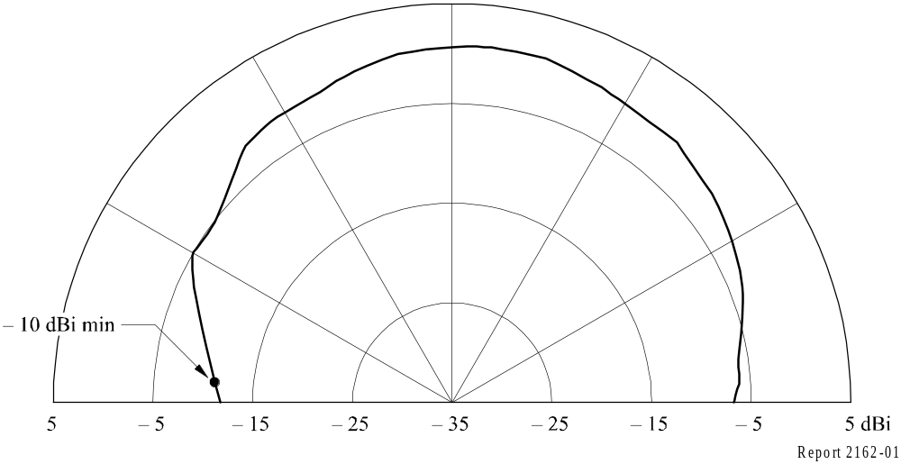

FIGURE 2
Base vehicle antenna pattern
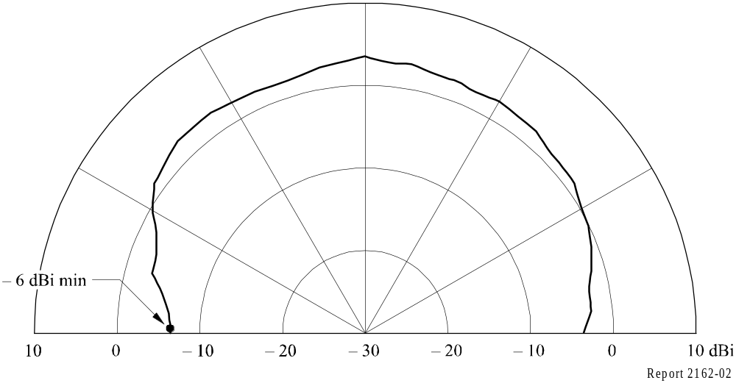

4 Interference to fixed and mobile service links from space research service EVA links
Report ITU-R M.358 – Protection ratios and minimum field strengths required in the mobile services, specifies that a degradation of the initial S/N of 20 dB to a S/(N + I) of 14 dB is an acceptable protection ratio. This 6 dB of degradation equates to a S/I of 15.26 dB. This criterion was used to determine the allowed unwanted field strength and corresponding pfd values from EVA links to protect terrestrial mobile receiving stations. At a 0° elevation angle, an unwanted field strength of −1.4 dB(μV/m) in a 16 kHz band, corresponding to a pfd of –153.2 dB(W/(m2 · 4 kHz)) was determined for a base station. For a mobile station, an unwanted field strength of +1.6 dB(μV/m) in a 16 kHz band, corresponding to a pfd of −150.2 dB(W/(m2 · 4 kHz)) was determined.
Curves B, C, D, and E of Fig. 3 show values of worst-case unwanted field strength (expressed in terms of pfds incident at the mobile receiving station) as a function of the angle of elevation of the satellite, taking into account the change in receiving antenna gain with increasing elevation angles. An interfering field strength less than (to the left of) the values given by the curves would meet the criteria.
Curve A of Fig. 3 shows the pfd limits developed by the (CCIR, 1991). As can be seen from the figure, the interfering field strength meets the criteria at most points, and is marginal for the worst-case elevation angles.

FIGURE 3
Power flux density (PFD) incident at mobile receiving station
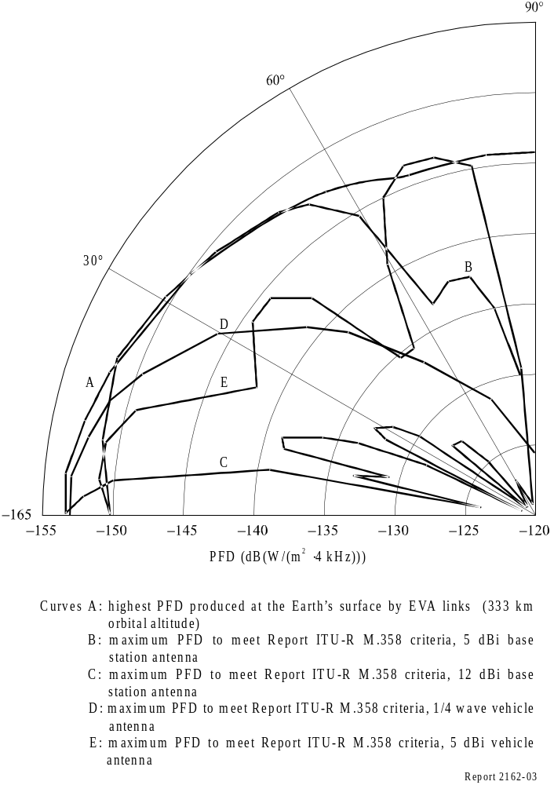
The sharing situation between EVA transmitters and terrestrial fixed systems is similar to that involving mobile base stations using 12 dBi antennas. Typical fixed systems have 25 W transmitters and use 10 dBi gain antennas with maximum gains pointed towards the horizon.
The current technology allows for more restriction on the EVA system thus allowing for more protection for the fixed and mobile services in the band. Figure 4 shows the recommended limits agreed to by the (CCIR, 1991), the proposed new recommended limits and the maximum pfd incident at the surface of the Earth produced by the EVA system.

FIGURE 4
Recommended power flux density (PFD) limits
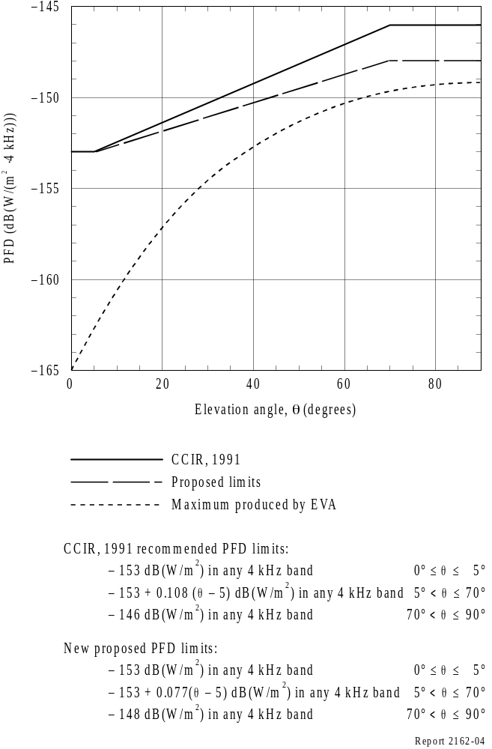

5 Interference to space research service EVA links from fixed and mobile service stations
In considering interference to EVA links, two assumptions are required regarding the development of a set of representative transmission characteristics and a worldwide distribution of mobile service stations. An explanation of these assumptions is given below:
– Characteristics of representative mobile emitters
Characteristics of mobile systems in the 410-420 MHz band were based on data from the International Frequency List (IFL) and usage in the United States of America. Characteristics of typical base and mobile stations are as follows:

 | Base | Mobile
Power (W) | 100.0 | 100.0
Power (dBW) | 20.0 | 20.0
Maximum gain (dB) | 12.0 or 5.0 | 5.0
Bandwidth (kHz) | 16.0 | 16.0

In some parts of the world, lower powers may be typically used. Figure 5 shows four antenna patterns typically used in the mobile service: a 12 dBi base station antenna, a 5 dBi base station antenna, a quarter-wave dipole vehicle antenna, and a 5 dBi vehicle antenna. For this analysis, the population of mobile transmissions is assumed to be made up of the following mix of antennas, using the transmitter power levels given above.
– 25% are base stations, using the 12 dBi base station antenna pattern (see Fig. 5a));
– 25% are base stations, using the 5 dBi base station antenna pattern (see Fig. 5b));
– 25% are mobile stations, using the quarter-wave dipole antenna pattern (see Fig. 5c));
– 25% are mobile stations, using the 5 dBi mobile station antenna pattern (see Fig. 5d)).
Line losses, although assumed to be zero in this analysis, would typically reduce the e.i.r.p. by 3 dB.
The number and distribution of simultaneous emitters
The extent to which the 410-420 MHz band is used throughout the world by the mobile services can only be roughly estimated since there is no international requirement to register all the systems in the band. For the purpose of this analysis, it was therefore necessary to assume some sort of a worldwide distribution of these systems. This distribution was based on the following considerations:
– the identification of the 479 largest cities in the world. These are shown in Fig. 6;
– mobile systems will be used mainly in and around these large cities;
– based on United States statistics, one terrestrial station per 6 224 people is assumed for the most populated cities in the world;
– for areas outside large cities: for every country where the number of telephones per capita exceeded 1% of the United States rate (from a 1990 World Almanac), the country was divided into approximately 100 km². Each of these squares represents the location of 33 terrestrial stations. The locations of these rural areas are shown in Fig. 7;
– it is assumed that each mobile station operates with a 20% duty cycle.
FIGURE 5
Mobile system antenna pattern
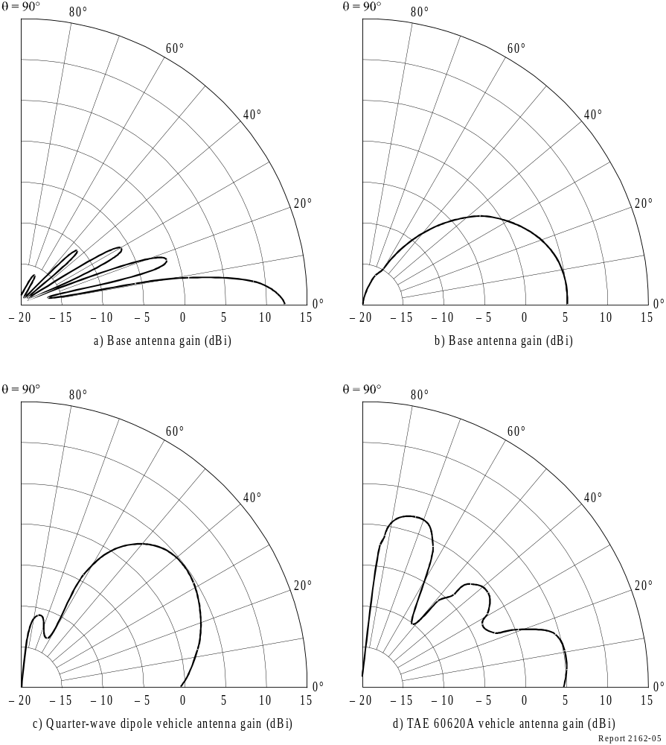
FIGURE6
Most populated cities in the world
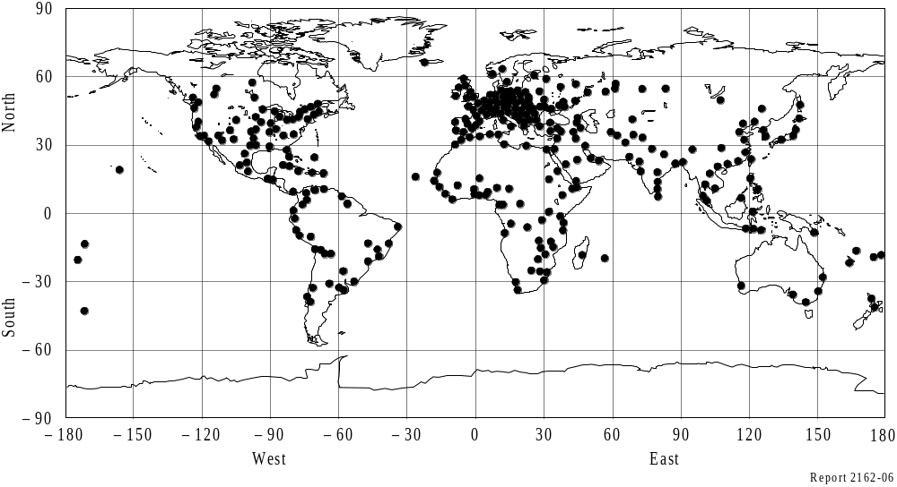

FIGURE 7
Rural areas used in the interference model
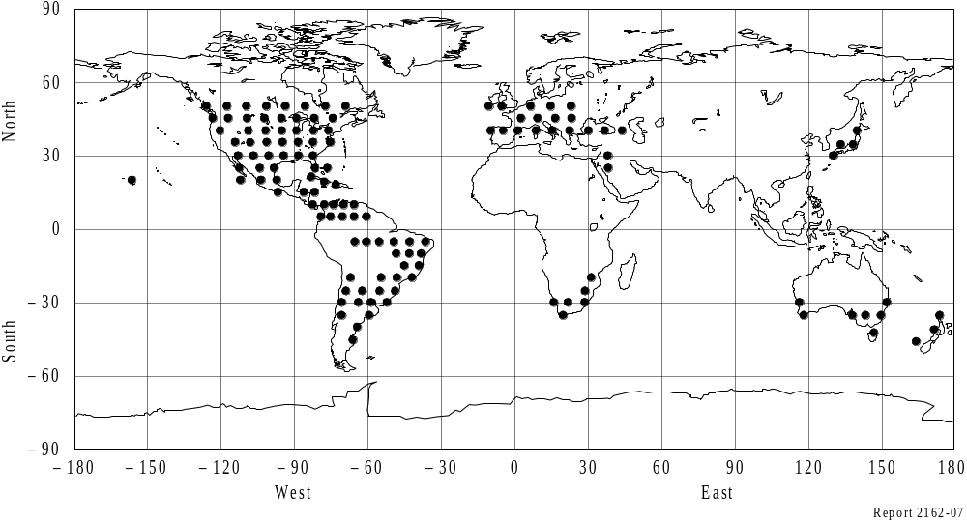
Using the distribution model described above, the interfering power level produced at orbital altitudes of 333 km and 460 km and an inclination of 60° was calculated for every point on the orbit. Interference was calculated as the power level in dB(W/MHz) that would be received by an isotropic antenna. The highest interference level obtained was −91.7 dB(W/MHz) incident at the satellite at an altitude of 333 km. Figure 8 shows the interference level versus percentage of time for the simulations. The received interference levels were the greatest over the United States of America and Europe. A map depicting the locations on the EVA orbit where the interference level was the greatest is shown in Fig. 9.

FIGURE 8
Interference level incident at the EVA system orbit versus time
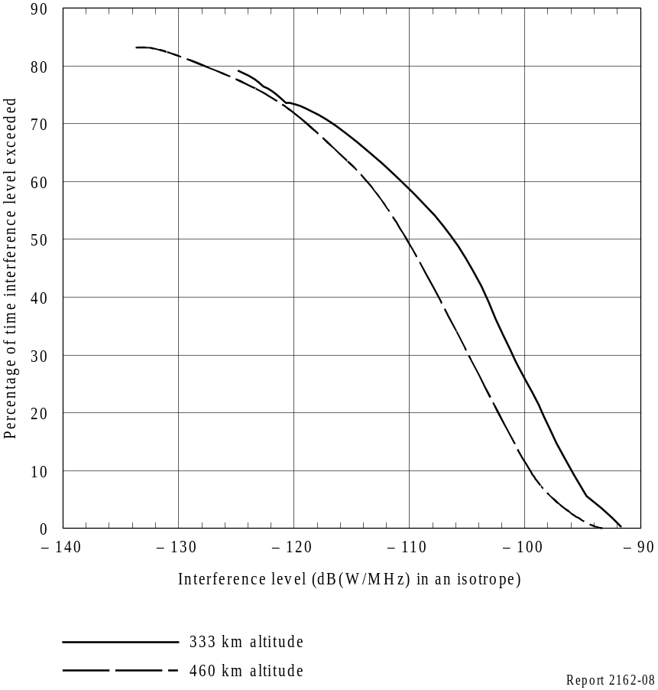
FIGURE 9
Areas on the EVA system orbit where the most interference was received
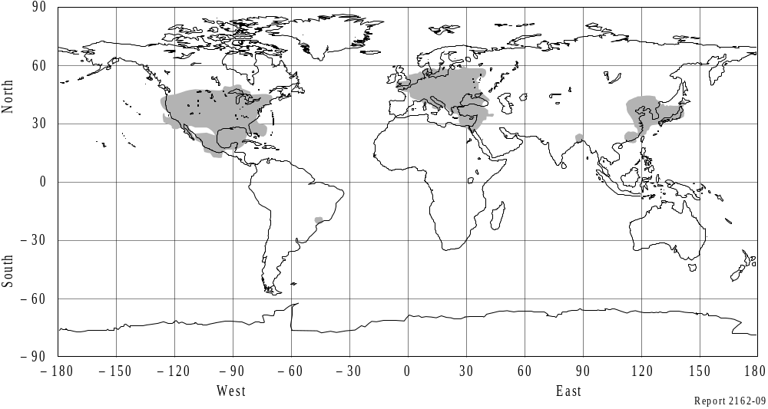

5.1 Achievable operational distance
A number of assumptions were made in analysing the effect of interference on the EVA receivers:
– the EVA link with the smallest link margin (from Table 2) was used in analysing the interference to the EVA system. This link is the EMU transmitting to the base vehicle;
– the –91.7 dB(W/MHz) interference level was assumed to have the same effect on the base vehicle receivers as random noise;
– interference was assumed to enter the maximum gain region of the base vehicle receiving antenna;
– the desired signal was assumed to enter the minimum gain region of the base vehicle antenna;
– no loss due to polarization mismatch between the mobile station and the receiving EVA base station was assumed.
The distance at which the link can be achieved can be obtained by adding the –91.7 dB(W/MHz) to the noise level in the link equation for the EMU-to-base link given in Table 2 and solving for the operational distance. This distance will vary around the base spacecraft as the gain of the base spacecraft antenna varies as shown in Fig. 2. This variation in distance as a function of direction effectively defines the service area around the base vehicle within which EVA communications can be accomplished. As seen in Fig. 10, distances from 55 m to 125 m can be achieved, depending upon direction from the base vehicle.
These distances would be greater in non-worst case scenarios, such as better than minimum antenna gain or non-zero line losses in the inclusion of polarization losses against interference. The distances will be greater than these minima for more than 99% of the time. If 3 dB line losses are included in the mobile emitters, the range of distances that can be achieved is improved by 41%. To further mitigate the effects of interference, multichannel systems with the ability to receive on the least interfered with channel are planned.

FIGURE 10
Achievable operational distance under worst conditions
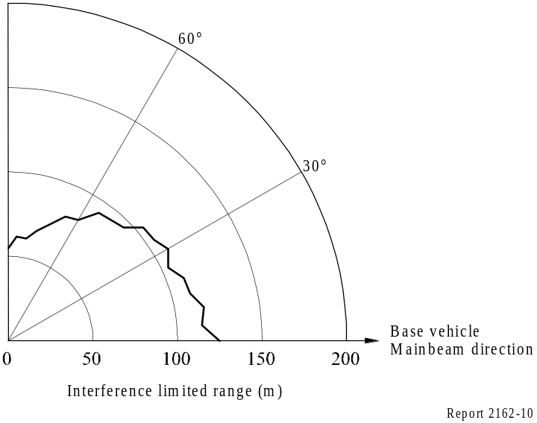

6 Conclusion
This Report preserves the technical basis, sharing conditions, sharing criteria, technical parameters and basis of pdf levels which led to the adoption of RR No. 5.268.

