|  |
| --- |
| **Report ITU-R S.2196**  **(07/2010)** |
| **Methodology on the modelling of earth station antenna gain in the region of  the antenna main-lobe and the  transition region between the minimum angle of the reference antenna pattern  and the main-lobe** |
| **S Series**  **Fixed satellite service** |

Foreword

The role of the Radiocommunication Sector is to ensure the rational, equitable, efficient and economical use of the radio-frequency spectrum by all radiocommunication services, including satellite services, and carry out studies without limit of frequency range on the basis of which Recommendations are adopted.

The regulatory and policy functions of the Radiocommunication Sector are performed by World and Regional Radiocommunication Conferences and Radiocommunication Assemblies supported by Study Groups.

# Policy on Intellectual Property Right (IPR)

ITU-R policy on IPR is described in the Common Patent Policy for ITU-T/ITU-R/ISO/IEC referenced in Annex 1 of Resolution ITU-R 1. Forms to be used for the submission of patent statements and licensing declarations by patent holders are available from <http://www.itu.int/ITU-R/go/patents/en> where the Guidelines for Implementation of the Common Patent Policy for ITU‑T/ITU‑R/ISO/IEC and the ITU-R patent information database can also be found.

|  |  |
| --- | --- |
| Series of ITU-R Reports  (Also available online at <http://www.itu.int/publ/R-REP/en>) | |
| **Series** | Title |
| **BO** | Satellite delivery |
| **BR** | Recording for production, archival and play-out; film for television |
| **BS** | Broadcasting service (sound) |
| **BT** | Broadcasting service (television) |
| **F** | Fixed service |
| **M** | Mobile, radiodetermination, amateur and related satellite services |
| **P** | Radiowave propagation |
| **RA** | Radio astronomy |
| **RS** | Remote sensing systems |
| **S** | **Fixed-satellite service** |
| **SA** | Space applications and meteorology |
| **SF** | Frequency sharing and coordination between fixed-satellite and fixed service systems |
| **SM** | Spectrum management |

|  |
| --- |
|  |

|  |
| --- |
| ***Note****: This ITU-R Report was approved in English by the Study Group under the procedure detailed   in Resolution ITU-R 1.* |

*Electronic Publication*

Geneva, 2010

© ITU 2010

All rights reserved. No part of this publication may be reproduced, by any means whatsoever, without written permission of ITU.

REPORT ITU-R S.2196

M**ethodology on the modelling of earth station antenna gain in the region of the antenna main-lobe and the transition region between the minimum angle  
of the reference antenna pattern and the main-lobe**

# 1 Modelling of the antenna main-lobe

The gain of an elliptical aperture antenna in the main-lobe for a specific angle of rotation with respect to the major axis depends on both the off-axis angle and the *D*/λ ratio for the *plane of interest*[1]. The derivation which follows is the simplified case that assumes the antenna major axis dimension of the antenna aperture is parallel to the *GSO plane*[2]. Models for calculating the *D*/λ ratio for the plane of interest for other antenna shapes and for elliptical antennas which do not conform to this simplified case can also be developed. The model for the simplified case of an elliptical antenna is developed below:

The dimensions of the antenna aperture in the GSO plane and the plane perpendicular to the GSO plane can be related to one another and to the equivalent diameter using the defined ratio *K* where:

 (1)

 (2)

where:

 is the antenna dimension in the geostationary orbit plane;

 is the antenna dimension in the plane perpendicular to;

 is the equivalent circular diameter of the physical antenna;

 is the ratio of the perpendicular dimensionsto  and the antenna boresight is normal to the plane containing the dimensions  and .

For elliptical antenna pattern, the values of *DGSO* and *D┴GSO* can be applied to an ellipse equation to calculate the antenna dimension *D* in the plane of interest. Figure 1 shows the relationship between *D* (represented by dotted line) and the ellipse in the plane of interest given by the angle θ.

FIGURE 1



***b***

*DGSO*

*D*┴*GSO*

*R*

θ

***a***

*D*

 and  are the dimensions of major axis and minor axes respectively of the elliptical antenna. Replace the semi-major axis ***a*** and semi-minor axis ***b*** of the ellipse equation with and respectively, so that in rectangular coordinates:

 (3)

Assuming the major axis of the antenna is aligned with the geostationary orbit plane and θ represents the angle of rotation in a counter-clockwise direction about the main beam direction, the antenna “dimension” (of the antenna aperture in the plane parallel to the boresight axis, passing through the direction of interest and the boresight axis) can be expressed as a function of the rotation angle θ. Therefore, *x* and *y* in (3) can be expressed as:

 (4)

 (5)

where:

*D* the dimension, in metres, of the antenna aperture in the *plane of interest* as shown in Figure 1;

 the “radius” of the antenna aperture in the *plane of interest* (=*D*/2);

** the angle, in degrees, between the plane containing the boresight and the dimension *DGSO* and the *plane of interest*, where the *plane of interest* passes through the boresight and the direction of interest (see Figure 1).

Replacing *x* and *y* in (3) by (4) and (5), and *R* with *D*/2, the antenna dimension *D* in the plane of interest can be expressed as follows:

 (6)

Substitute equation (2) into equation (6), it gives:

 (7)

To simplify the notation, the denominator of equation (7) is defined as rotation factor *F*, which is a function of the rotation angle θand the *DGSO* to *D*⊥*GSO* ratio *K*. Therefore,

 (8)

where:

 (9)

For a given antenna, having a major-to-minor axis ratio *K*, the value of *F* can be expressed as a function of the rotation angle θ. Therefore, in a plane of interest of a given antenna, having a major‑to-minor axis ratio *K*, *D* is simply a function of θ.

# 2 Modelling the antenna main-lobe given a side-lobe reference pattern

Modelling the transition region between the main-lobe of an antenna and the side-lobe envelope requires knowledge of the reference pattern depicting the antenna’s side-lobe envelope. The main-lobe of an antenna and the transition region between the main-lobe and the side-lobe envelope can be modelled for two types of side-lobe reference patterns. The methodologies in this Report may be used with either Recommendation ITU-R S.465-6 or Recommendation ITU-R S.1855. Although the intersection point in this model where the envelope of the side-lobe reference pattern intersects the antenna main lobe is equal to the main-lobe gain in equation (10), the actual gain in this vicinity may be considerably less. In fact, the first null of a parabolic reflector type antenna occurs very near this intersection point. The actual location of the null will be determined by a number of factors including type of illumination. The antenna main lobe model in equation (10) assumes a uniform illumination resulting in a wider main lobe and thus results in a conservative estimate of gain at the intersection point. The very small transition region between this intersection point and the minimum angle applicable to the side-lobe reference pattern follows the applicable side-lobe reference pattern.

2.1 Modelling the antenna main-lobe assuming a side-lobe reference envelope of Recommendation ITU-R S.465-6

### 2.1.1 Main-lobe definition

Using the main-lobe definition that can be found in Annex 3 of RR Appendix 8:

 for  (10)

 for  (11)

where:

 dBi (12)

 degrees (13)

 degrees (14)

ϕ*p* = Max (ϕr ; 100 λ/D) degrees (15)

For further calculation, we may approximate Gmax by the formula:

 (16)

where:

η = antenna aperture efficiency (fraction <1).

### 2.1.2 Intersection ϕint between the main-lobe or the first side-lobe G1 and the side-lobe envelope

For larger values of *D/λ* (where φ*r* > φ*m*), the intersection that occurs is between the first side-lobe G1 and the side‑lobe envelope (32 – 25 log(ϕ)) and is defined by:

 (17)

 (18)

However, this value is correct provided that ϕ*r* is greater than ϕ*m*. In the case that ϕ*r* is less than ϕ*m*, the intersection (φint) between the main-lobe and the side-lobe envelope (32 – 25 log(ϕ)) is then determined by solving the following expression:

 (19)

Figures 2 and 3 below show that ϕint is greater than ϕ*m* for *D/λ* varying between 45.00 and 54.45, according to the value of the aperture efficiency.

Figure 2

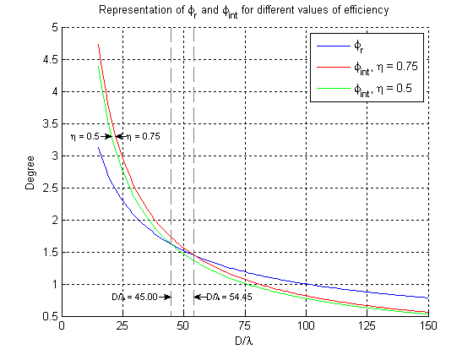

Figure 3

Minimum value of

*D/*

for  calculation

int

45.00

47.22

49.25

51.11

52.84

54.45

55.96

40

45

50

55

60

50

55

60

65

70

75

80

Efficiency (%)



*D* 

Figure 3 shows the minimum value of *D*/λ for which the intersection point (φint) of the main-lobe with the side-lobe envelope can be calculated using the expression in (18) where φint takes the value of φr. Below these values, φint must be solved for using the expression in (19). The minimum value of *D*/λ is shown as a function of aperture efficiency.

In case *D*/λ is smaller than the value shown in Figure 3 for a given efficiency, as it is stated before, the intersection ϕ*int* between the main-lobe and the side-lobe envelope (32 – 25 log(ϕ)) is then determined by solving the expression in (19).

The angle of intersection φ*int* of the main beam of the antenna with the side-lobe envelope of the antenna can be approximated by a function that takes the form: 

A “least squares” solution to this approximation function, using only values of *D*/λ  from 15 to the applicable maximum value of *D*/λ (for a given efficiency), gives different values of the coefficients for **A** and **Z**, depending on the efficiency:

|  |  |  |
| --- | --- | --- |
| Efficiency (%) | A | Z |
| 50 | 112.6522 | –1.1142 |
| 55 | 112.6702 | –1.1079 |
| 60 | 112.8286 | –1.1028 |
| 65 | 113.0639 | –1.0987 |
| 70 | 113.3417 | –1.0951 |
| 75 | 113.5527 | –1.0919 |
| 80 | 113.8002 | –1.0891 |

Figure 4 shows a graphical representation of ϕ*int*. Note that the higher value of aperture efficiency results in a greater value of ϕ*int*. In Figure 4 below, it is assumed that Note 5 of Recommendation ITU‑R S.465-6 does not apply.

Figure 4

(Angle of main-lobe intersection shown for 15 ≤ (D/λ) ≤ 150)

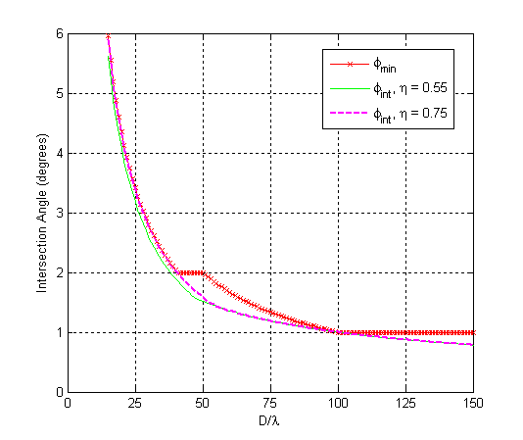

It is proposed to base the definition of ϕint on an efficiency of 0.75 as higher efficiencies result in a greater angle of intersection with the main-lobe. Furthermore, the values of the coefficients ***A*** and ***Z*** in the general expression for int in equation (20) are rounded to three significant digits such that the approximation expression of int will result in a conservative estimate such that it is not less than the value of int derived by numerical solution. Rounding the values of the coefficients of both ***A*** and ***Z*** “up” to the closest three significant digits, such that ***A*** = 114 and ***Z*** = –1.09, will achieve this goal. The minimum angle, φmin defining the intersection between the main-lobe and the first side-lobe or the side-lobe envelope as defined in Recommendation ITU-R S.465-6 can thus be defined by:

 (20)

### 2.1.3 Antenna pattern for side-lobes

The side-lobes definition can be found in Recommendation ITU-R S.465-6.

The value to be used for ϕmin is the one defined in the section 2.1.2.

*G*  32 – 25 log  dBi for min    48° (21)

  –10 dBi for 48°    180° (22)

where:

min  1° or 100 /*D* degrees, whichever is the greater, for *D/λ* ≥ 50.

min = 2° or () degrees, whichever is the greater, for *D/λ* < 50.

In the case of the coordination of new earth station antennas and where Note 5 of Recommendation ITU-R 465-6 applies, the off‑axis antenna gain is given by equations (21) and (22) above for φ ≥ 2.5°. This condition will occur when the diameter-to-wavelength ratio is less than 33.3.

### 2.1.4 Proposal for the overall antenna gain

The reference radiation pattern defined in Recommendation ITU-R S.465-6 is assumed to be rotationally symmetrical (see Note 1 of that Recommendation). The transition defined below could thus be assumed also to be rotationally symmetrical.

The antenna pattern is then for *D*/λ > 54.5:

 for  (23)

 for  (24)

 for  (25)

 for  (26)

 for  (27)

where:

$G_{1} =2+15\log\left(\frac{D}{λ}\right)$ dBi (28)

 degrees (29)

 degrees (30)

where:

ϕmin  1° or 100 /*D* degrees, whichever is the greater.

For *D*/λ ≤ 54.5, the antenna pattern is:

 for  (31)

G(φ) = Max(Gmax – 0.0025, 32 – 25log(φ)) for 0.9 ≤ φ <  (32)

 for  (33)

 for  (34)

where:

ϕmin  1° or 100 /*D* degrees, whichever is the greater, for *D/*λ≥ 50.

ϕmin = 2° or degrees, whichever is the greater, for *D/*λ< 50 (35)

 is the estimate for the intersection of the main-lobe with the side-lobe gain envelope given by 32 – 25 log(φ). Given that the antenna aperture efficiency may vary,  is only an estimate such that the angle of intersection is less than or equal to for typical values of efficiency. In order to avoid a discontinuity between the main-lobe and φmin, taking the maximum of the main-lobe gain and that of the side-lobe gain given by 32 – 25 log (φ) when 0.9 *≤* φ *<* φminin equation (32)will ensure a smooth transition between the main and side-lobes of the radiation pattern envelope (RPE).

## 2.2 Modelling the antenna main-lobe assuming a side-lobe reference in Recommendation ITU-R S.1855

### 2.2.1 Calculation of φmin

The determination of the expression for φminin *recommends* 2.1 of Recommendation ITU-R S.1855 is based, in part, on the RPE for *D*/λ ≥ 100 found in RR Appendix 7. For larger values of *D*/λ, the specific off-axis angle defining the intersection point of the main-lobe with the first side-lobe gain, *G*1 occurs at an angle of φ*m* and the first side-lobe gain G1, intersects the side-lobe envelope at an angle of φ*r* as defined below. Expressions for the antenna gain for 0° ≤ φ ≤ 7°, the main-lobe, first side-lobe gain *G*1 (provided that φ*r* > φ*m*) and the angles φ*m* and φ*r* are given in expressions (38) through (44) below:

**Main-lobe:** *G*(φ) = *G*max – 0.0025for φ ≤ φ*m* (36)

**First side-lobe:** *G*(φ) = *G*1for φ*m* < φ ≤ φ*r* (37)

**Side-lobe envelope:** *G*(φ) = 29 – 25log(φ) + 3sin²(θ)for φ*r*  < φ ≤ 7° (38)

Maximum effective isotropic gain = *Gmax =*  dBi (39)

where:

η = antenna aperture efficiency (fraction < 1)

first side-lobe gain = *G*1 =  dBi   
 (provided that φ*r* > φ*m*) (40)

where:

 degrees (41)

 degrees (42)

### 2.2.2 Note on first side-lobe gain and the transition region for larger antennas

The expression for the first-side-lobe gain (*G*1) provided in equation (40) is the same as that found in RR Appendix 7 (assuming θ = 0°) for the case of *D*/λ ≥ 100. For large values of *D*/λ, there is no intersection of the main beam with the side-lobe envelope described by the expression 29‑25 log(φ). In this case it is appropriate to use the expression for φ*r* in equation (42) for calculating the intersection of the side-lobe envelope with a first side-lobe gain *G*1 given by equation (40). For *D*/λ < 100, the equation for first side-lobe gain in RR Appendix 7 results in a lower gain. Given that the purpose of the reference earth-station radiation pattern is for coordination and/or interference assessment, it is more appropriate (provided that φ*r* > φ*m*) to use the expression for φ*r* that is derived from the intersection with the more relaxed (higher) formulation of first side-lobe gain given by the expression in (40) (assuming θ = 0°) above.

In the case of smaller values of *D*/λ, the intersection of the main beam with the side-lobe envelope can be calculated by equating the right-hand sides of equations (36) and (38) and (assuming θ = 0°) solving for ϕintin equation (43) below:

 (43)

Figure 5 below shows that ϕint is greater than ϕ*r* for *D/λ* varying between 61.12 and 72.19, according to the value of the aperture efficiency.

FIGURE 5



The maximum value of D/ can be solved similarly for other values of efficiency. The solved values of D/ for efficiencies ranging from 50% to 80% are shown in Figure 6.

FIGURE 6



In order to calculate the boundary condition, where the main-lobe region ends and the reference pattern begins, once again assuming θ = 0°, it is necessary to consider both cases: 1) the case of larger values of *D*/λ, where there is no intersection of the main beam with the side-lobe described by the expression 29-25 log(φ), and 2) the case of smaller values of *D*/λ, where the intersection of the main beam expression is approximated by the maximum value given by the expression 15.85(*D/λ*)–0.6 and that given by the expression in the form . Consideration of these two cases will allow the determination of φint over a wide range of *D*/λ.

A “least squares” solution to this approximation function, using only values of *D*/λ  from 15 to the applicable maximum value of *D*/λ (for a given efficiency), gives different values of the coefficients for ***A*** and ***Z*,** depending on the efficiency:

|  |  |  |
| --- | --- | --- |
| Efficiency (%) | A | Z |
| 50 | 114.9835 | –1.0812 |
| 55 | 115.5134 | –1.0782 |
| 60 | 116.0325 | –1.0756 |
| 65 | 116.5338 | –1.0735 |
| 70 | 117.0145 | –1.0716 |
| 75 | 117.4740 | –1.0699 |
| 80 | 117.8726 | –1.0684 |

It is proposed to base the definition of ϕint at which the side-lobe envelope begins on an efficiency of 0.75 as higher efficiencies result in a greater angle of intersection with the main-lobe. Furthermore, the values of the coefficients ***A*** and ***Z*** in the general expression () are rounded to three significant digits such that the approximation expression of int will result in a conservative estimate such that it is not less than the value of int derived by a numerical solution. Rounding the values of the coefficients of both **A** and ***Z*** “up” to the closest three significant digits, such that ***A*** = 118 and ***Z*** = –1.06, will achieve this goal. Thus, the expression for calculating the minimum angle for which the use of the side-lobe gain envelope given by 29‑25 log(φ) is appropriate is:

, D/λ ≥ 15 (44)

where:

 (45)

Figure 5 shows a graphic representation of ϕint for two different values for the aperture efficiency. Note that the higher value of aperture efficiency results in a greater value of ϕint.

Thus, under the condition that an antenna whose off-axis pattern is described by *recommends* 2.1 of Recommendation ITU-R S.1855 for “larger” antennas, there are two separate cases for the antenna main-lobe:

1) The case where φr > φm, the transition region between the main-lobe and the side-lobe envelope described by the expression 29 + 3sin²(θ) – 25log(φ) has a gain equal to the first side-lobe gain G1 given by equation (40) and applies in the vicinity of φm < φ ≤ φr. In the case of larger antennas, when φr < φ ≤ φmin, if, at a rotation angle of θ, between the GSO plane and the plane of interest, the gain exceeds the first side-lobe gain G1, the gain is capped at a value of G1. Thus:

G(ϕ) = Min(G1, 29 + 3sin²(θ) – 25 log(φ)), for φr < φ ≤ φmin (46)

2) The case where φ*r* ≤ φ*m,* the transition region between the main-lobe and the side-lobe envelope is purely the intersection of the main-lobe and the side-lobe envelope described by the expression 29 + 3sin2(θ)-25log(φ). For directions of interest having an angle of rotation, θ, between the GSO plane and the plane of interest, the estimate of φ*min* becomes smaller and approaches  given by equation (47) below, as θapproaches 90°.

, D/λ ≥ 15 (47)

 is the estimate for the intersection of the main-lobe with the side-lobe gain envelope given by 32 – 25log(φ). In order to avoid a discontinuity between the main-lobe and φmin, taking the maximum of the main-lobe gain given by equation (36) and that of the side-lobe gain given by 29 + 3sin2(θ) – 25 log(φ) when 0.9 *≤* φ *<* φminwill ensure a smooth transition between the main and side-lobes of the radiation pattern envelope. Thus:

G(φ) = Max(Gmax – 0.0025, 29 + 3sin²(θ) – 25log(φ)), for 0.9≤ φ < φmin (48)

### 2.2.3 Note on first side-lobe gain and the transition region for smaller antennas

For the case of an antenna whose off-axis pattern is described by *recommends* 2.2 of Recommendation ITU-R S.1855 for “smaller” antennas, there is only one case to consider in calculating the antenna gain in the transition region between the main-lobe and the side‑lobe envelope. Since for smaller antennas the angle φ*r* is always smaller than φ*m*, the situation is identical to that of case (2) for “larger” antennas and the gain is given by the expression in Equation (46).

In the case of the coordination of a new earth station receiving antennas and where Note 7 of Recommendation ITU-R S.1855 applies, where the formula for *min* in *recommends* 2 results in a value greater than 2.5° in the *direction of interest*, the off-axis antenna gain is given by the equation (38) above for 2.5° ≤ φ ≤ 7°. This condition will occur when the diameter-to-wavelength ratio is between 33.3 and 38 depending upon the angle of rotation θ.

# 3 Illustrative examples

3.1 Transition between the antenna main-lobe and the side-lobe specified by Recommendation ITU-R S.465-6

In order to illustrate the transition between the main-lobe and the antenna side-lobes which are specified by Recommendation ITU-R S.465-6, it is necessary to show both the main and side‑lobes on the same graph. Figures 7 and 8 apply *recommends* 2 of Recommendation ITU‑R S.465‑6 together with the equations of this Report for the main-lobe to a small antenna with a maximum boresight gain of 35.0 dBi (*D*/λ = 21.4) implemented in a computer model to demonstrate the modelling of an antenna that includes both the side-lobe envelope and the main-lobe in the GSO plane and outside of the GSO plane. Figure 7 shows a gain contour plot as cross‑section through the main beam within 8° of the antenna boresight assuming the antenna’s major axis is aligned with the GSO plane. Figure 8 shows a three dimensional (3D) surface plot of the radiation pattern within 10° of the antenna boresight. Note that only half of the 3D surface plots are shown as the remaining portion is simply a mirror image (in the plane formed by the “Perp. to GSO Plane” and “Gain (dBi)” axes) of the portion shown. The angle φmin is shown as a “heavy” line on the 3D surface plot. It is assumed that Note 5 of Recommendation ITU-R S.465-6 does not apply in the case of either Figure 7 or 8.

3.2 Transition between the antenna main-lobe and the side-lobe specified by Recommendation ITU-R S.1855

In order to illustrate the transition between the main-lobe and the antenna side-lobes which are specified by Recommendation ITU-R S.1855, it is necessary to show both the main and side-lobes on the same graph. Figures 9 through 20 apply *recommends* 2 of Recommendation ITU‑R S.1855 together with the equations of this Report for the main-lobe to a small antenna with a maximum boresight gain of 35.0 dBi (*D*/λ = 21.4) implemented in a computer model to demonstrate the modelling of an antenna that includes both the side-lobe envelope and the main-lobe in the GSO plane and outside of the GSO plane. Figures 9, 11, 13, 15, 17 and 19 show gain contour plots as cross‑sections through the main beam within 8° of the respective antenna boresights assuming each antenna’s major axis is aligned with the GSO plane. Figures 10, 12, 14, 16, 18 and 20 show three dimensional (3D) surface plots of the radiation patterns within 10° of the respective antenna boresights. Note that only half of the 3D surface plots are shown as the remaining portions are simply mirror images (in the plane formed by the “Perp. to GSO Plane” and “Gain (dBi)” axes) of the portion shown.

The angle φmin is shown as a “heavy” line on the 3D surface plot. It is assumed that Note 7 of Recommendation ITU-R S.1855 does not apply in the case of any of the Figures 9 through 20.

# 4 Antenna main-lobe pattern synthesis

The figures (Figures 7 through 20), which follow, were produced using the main-lobe models in this Report and side-lobe envelopes of Recommendations ITU-R S.465 and ITU-R S.1855. These figures do not show the peaks and nulls in the side-lobes that would result in the case of actual antenna patterns that would be obtained from direct measurements. MATLAB® code for rendering the three dimensional (3D) surface plots is contained in this Report. This computer code for the case of an antenna having a side-lobe reference pattern specified by Recommendation ITU‑R S.465-6 or Recommendation ITU‑R S.1855 is attached below and is provided for information only.

The software application Matlab® is required to use the source code. To launch the application, copy the extracted files to the default “work” directory for Matlab®, click on the filename “*ESPattern3DGUIv4a.fig*” in the “current directory” browser in Matlab® and enter required parameters in the graphical user interface.



The attached MS Excel® spreadsheet can be used to estimate the gain of the antenna main-lobe for off-axis angles, φ less than the minimum off-axis angle, φmin for a variety of different antenna shapes as a function of rotation angle, θ.



FIGURE 7

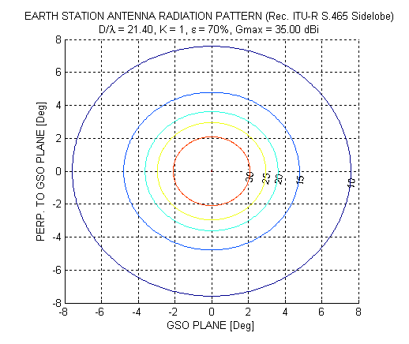

FIGURE 8

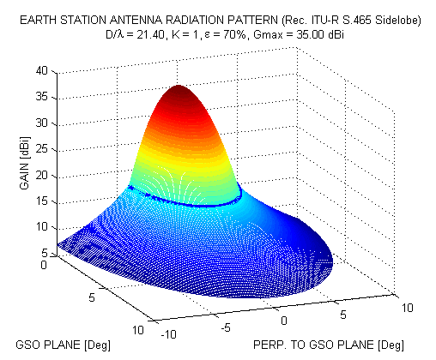

FIGURE 9

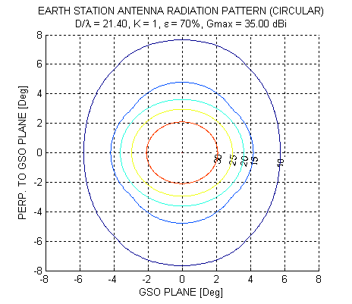

FIGURE 10

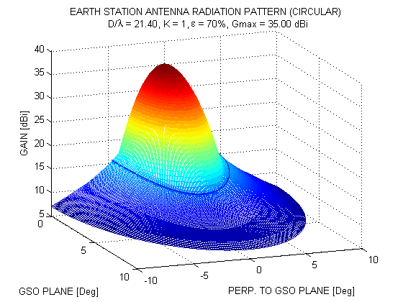

FIGURE 11

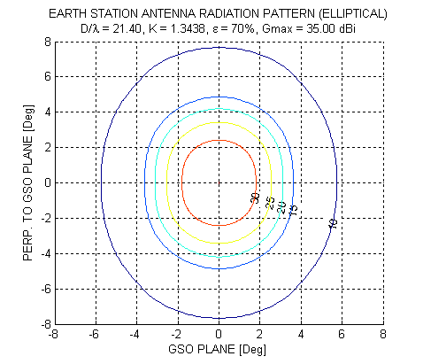

FIGURE 12

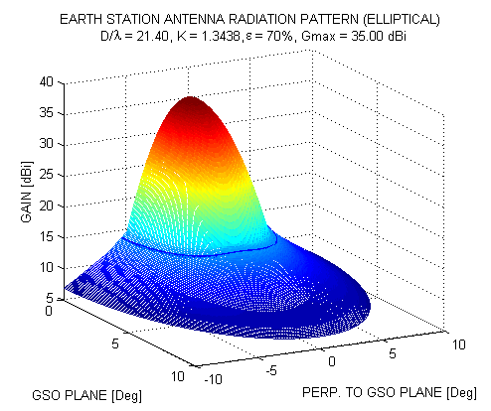

FIGURE 13

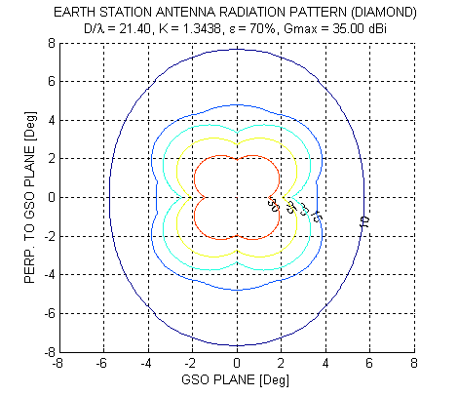

FIGURE 14

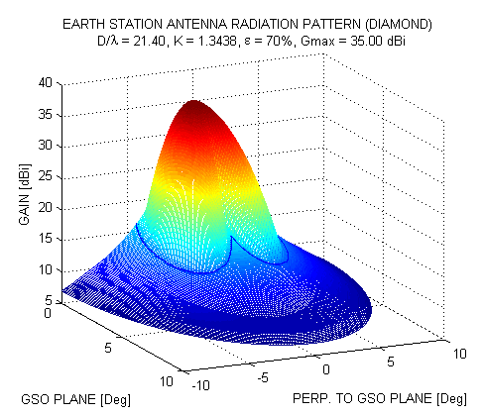

FIGURE 15

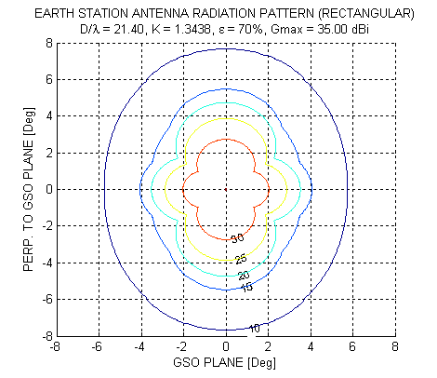

FIGURE 16

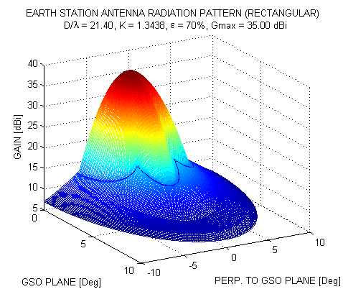

FIGURE 17

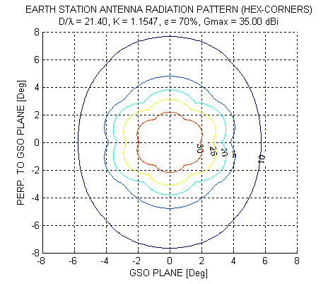

FIGURE 18

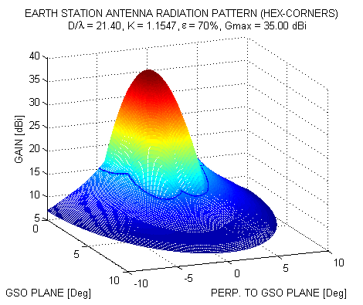

FIGURE 19

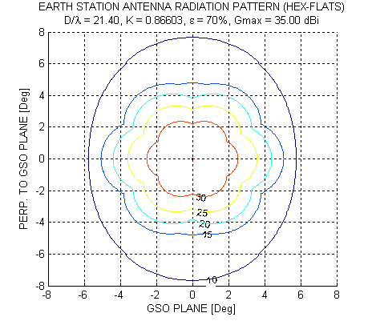

FIGURE 20

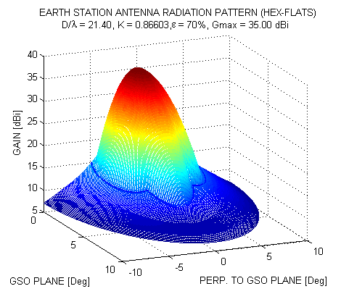

1. The plane of interest is the plane passing through the antenna boresight and the direction of interest.
2. The term “GSO plane”, which is used throughout shall be interpreted as the plane containing the tangent to the part of the GSO arc aligned with D*GSO* (see Figure 1) and the earth station.