|  |
| --- |
| **Report ITU-R M.2236**  **(11/2011)** |
| **Compatibility study to support the line of sight control and non-payload communication links for unmanned  aircraft systems proposed in the frequency bands 5 000-5 010 and  5 010-5 030 MHz** |
| **M Series**  **Mobile, radiodetermination, amateur**  **and related satellite services** |

Foreword

The role of the Radiocommunication Sector is to ensure the rational, equitable, efficient and economical use of the radio-frequency spectrum by all radiocommunication services, including satellite services, and carry out studies without limit of frequency range on the basis of which Recommendations are adopted.

The regulatory and policy functions of the Radiocommunication Sector are performed by World and Regional Radiocommunication Conferences and Radiocommunication Assemblies supported by Study Groups.

# Policy on Intellectual Property Right (IPR)

ITU-R policy on IPR is described in the Common Patent Policy for ITU-T/ITU-R/ISO/IEC referenced in Annex 1 of Resolution ITU-R 1. Forms to be used for the submission of patent statements and licensing declarations by patent holders are available from <http://www.itu.int/ITU-R/go/patents/en> where the Guidelines for Implementation of the Common Patent Policy for ITU‑T/ITU‑R/ISO/IEC and the ITU-R patent information database can also be found.

|  |  |
| --- | --- |
| Series of ITU-R Reports  (Also available online at <http://www.itu.int/publ/R-REP/en>) | |
| **Series** | Title |
| **BO** | Satellite delivery |
| **BR** | Recording for production, archival and play-out; film for television |
| **BS** | Broadcasting service (sound) |
| **BT** | Broadcasting service (television) |
| **F** | Fixed service |
| **M** | Mobile, radiodetermination, amateur and related satellite services |
| **P** | Radiowave propagation |
| **RA** | Radio astronomy |
| **RS** | Remote sensing systems |
| **S** | Fixed-satellite service |
| **SA** | Space applications and meteorology |
| **SF** | Frequency sharing and coordination between fixed-satellite and fixed service systems |
| **SM** | Spectrum management |

|  |
| --- |
|  |

|  |
| --- |
| ***Note****: This ITU-R Report was approved in English by the Study Group under the procedure detailed in Resolution ITU-R 1.* |

*Electronic Publication*

Geneva, 2012

© ITU 2012

All rights reserved. No part of this publication may be reproduced, by any means whatsoever, without written permission of ITU.

REPORT ITU-R M.2236

Compatibility study to support the line of sight control and non-payload communication links for unmanned aircraft systems proposed in  
the frequency bands 5 000-5 010 and 5 010-5 030 MHz

(2011)

Summary

This report provides information on the compatibility of line of sight control and non-payload communication links for unmanned aircraft systems with other services that operate either in or adjacent to the frequency bands 5 000-5 010 and 5 010-5 030 MHz.

# 1 Introduction

Significant growth is forecast in the unmanned aircraft (UA) systems (UAS) sector of aviation. The current state-of-the-art in UAS design and operation is leading to the rapid development of UAS applications to fill many diverse requirements. The ability of UA to effectively support long duration and hazardous missions, are key drivers in the development and deployment of increasing numbers of UAS applications.

Though UA have traditionally been used in segregated airspace where separation from other air traffic can be assured, some administrations anticipate broad deployment of UA in non-segregated airspace shared with manned aircraft. If UA operate in non-segregated civil airspace, they must be integrated safely and adhere to operational practices that provide an acceptable level of safety comparable to that of a conventional manned aircraft. In some cases, those practices will be identical to those of manned aircraft.

It should be noted that in certain countries a wide range of frequency bands have been used for control of the UA in segregated airspace for both line of sight (LoS) and beyond line of sight (BLoS). Many of these frequency bands do not have currently the safety aspect required to enable UA flight in non-segregated airspace.

Thus it is envisioned that UA will operate alongside manned aircraft in non-segregated airspace using methods of control that could make the location of the pilot transparent to air traffic control (ATC) authorities and airspace regulators.

Because the pilot is located remotely from the UA, radio frequency (RF) communications links will be required to support, among other things, UA telemetry data, telecommand messages, and the relay of ATC communications. Since this connection will be used to ensure the safe flight of UAS, reliable communications links and associated spectrum are required. It is also expected that the characteristics of the information will necessitate user authentication, and interference resilience. As UA technology advances, it can be expected that more autonomous flight capability will be incorporated into UA. Even for autonomous UAS operations, RF communications links with the same performance characteristics will be required for emergencies as well as for selected operating conditions. If the spectrum requirements of UAS operations cannot be accommodated within existing aviation spectrum allocations, additional appropriately allocated spectrum may be necessary to support UAS operations.

The goal of airspace access for appropriately equipped UAS requires a level of safety similar to that of an aircraft with a pilot on-board. The safe operation of UAS outside segregated airspace requires addressing the same issues as manned aircraft, namely integration into the ATC system.

Because some UAS may not have the same capabilities as manned aircraft to safely and efficiently integrate into non-segregated airspace, they may require communications link performance that exceeds that which is required for manned aircraft. In the near term, one critical component of UAS safety is the communication link between the UA control station (UACS) and the UA.

Radiocommunication is the primary method for remote control of the unmanned aircraft. Seamless operation of unmanned and manned aircraft in non-segregated airspace requires high-availability communication links between the UA and the UACS. In addition, radio spectrum is required for various sensor applications that are integral to UAS operations including on-board radar systems used to track nearby aircraft, terrain, and obstacles to navigation.

The objective of this study is to identify potential new allocations in which the control and non‑payload communications (CNPC) links of future UAS can operate reliably without causing harmful interference to incumbent services and systems.

The technical information given in this paper is not relevant for operational purposes.

# 2 Terminology

**Unmanned aircraft:** Designates all types of remotely controlled aircraft.

**UA control station:** Facility from which a UA is controlled remotely.

**Sense and avoid:** Corresponds to the piloting principle “see and avoid” used in all airspace volumes where thepilot is responsible for ensuring separation from nearby aircraft, terrain and obstacles.

**Unmanned aircraft system:** Consists of the following subsystems:

− UA subsystem (i.e. the aircraft itself);

− UACS subsystem;

− ATC communication subsystem (not necessarily relayed through the UA);

− sense and avoid (S&A) subsystem; and

− payload subsystem (e.g. video camera …)[1].

**Control and non-payload communications:** The radio links, used to exchange information between the UA and UACS, that ensure safe, reliable, and effective UA flight operation. The functions of CNPC can be related to different types of information such as telecommand messages, non-payload telemetry data, support for navigation aids, ATC voice relay, air traffic services data relay, S&A target track data, airborne weather radar downlink data, and non-payload video downlink data.

**Forward link:** Communication from the UACS to the UA through a satellite (see Fig. 1).

**Return link:** Communication from the UA to the UACS through a satellite (see Fig. 1).

Figure 1

Definition − forward link and return link

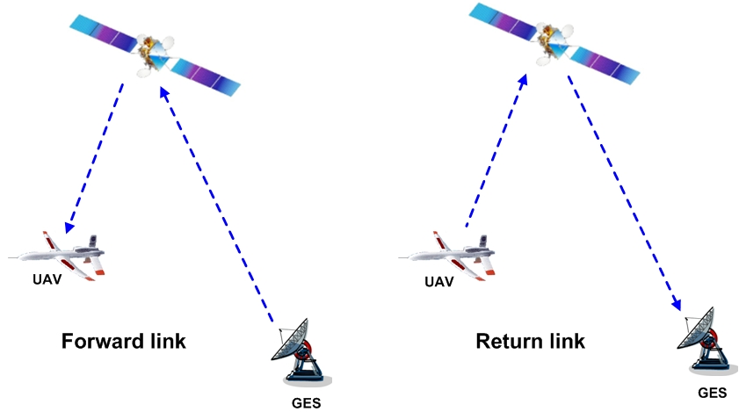

# 3 Review of radiocommunication spectrum requirements

In order to ascertain the amount of spectrum needed for UAS control links, it is necessary to estimate the non-payload UAS control link spectrum requirements for safe, reliable, and routine operation of UAS. The estimated throughput requirements of generic UA and long-term spectrum requirements for UAS non-payload control link operations through 2030 have previously been studied and can be found in Report ITU‑R M.2171[2].

The Report provides the analyses for determining the amount of spectrum required for the operation of a projected number of UAS sharing non-segregated airspace with manned air vehicles as required by World Radiocommunication Conference (WRC) Resolution 421 (WRC‑07).

The Report estimates the total spectrum requirements covering both terrestrial and satellite requirements in a separate manner. Deployment of UAS will require access to both terrestrial and satellite spectrum.

The Report estimates the maximum amounts of spectrum required for UAS are:

− 34 MHz for terrestrial systems;

− 56 MHz for satellite systems.

Figure 2 illustrates the kinds of terrestrial LoS links in the system.

Figure 2

Links involved in LoS communications

**ATC**

**Control station**

**1**

**2**

1. Remote pilot to UA 2. UA to remote pilot

For LoS links:

− the remote pilot stations satisfy the definition No. 1.81 (aeronautical station) of the Radio Regulations (RR);

− the UA corresponds to definition RR No. 1.83 (aircraft station).

Therefore the aeronautical-mobile (route) service (AM(R)S), the aeronautical-mobile service (AMS) and the mobile service (MS) could be considered for links 1 and 2.

Figure 3 depicts the various kinds of satellite links in the system.

Figure 3

Links involved in beyond LoS communications via satellite

**ATC**

**UA**

**Control station (mobile or fixed) or gateway station (to which remote pilots are connected)**

**1**

**4**

**3**

**2**

**Satellite**

Forward link:

1: Remote pilot to satellite 2: Satellite to UA

Return link:

3: UA to satellite 4: Satellite to remote control station

Case 1: Mobile unmanned aircraft control station

− the UA corresponds to definition No. 1.84 (aircraft earth station) of the RR;

− the satellite corresponds to definition No. 1.64 (space station) of the RR;

− the mobile UACS corresponds to definition No. 1.68 (mobile earth station) of the RR.

Therefore, from the RR point of view, the aeronautical mobile satellite (route) service (AMS(R)S), the aeronautical-mobile satellite service (AMSS), and the mobile-satellite service (MSS) for links 2 and 3 could be considered if the allocation is on a primary basis. MSS for links 1 and 4 could also be considered if allocated on a primary basis. In the case of mobile UACS located on the Earth’s surface, MSS except aeronautical for links 1 and 4 could be considered if the allocation is on a Primary basis. Additionally for links 1, 2, 3 and 4, FSS allocations can also be considered if sharing studies with other services allocated in the frequency bands, have been successfully completed which also require appropriate modifications of the Radio Regulations taking into account ICAO requirements.

Case 2: Fixed unmanned aircraft control station

− the UA corresponds to definition No. 1.84 (aircraft earth station) of the RR;

− the satellite corresponds to definition No. 1.64 (space station) of the RR;

− the fixed UACS corresponds to definition No. 1.63 (earth station) of the RR.

Therefore, from the RR point of view, the services AMS(R)S, AMSS and MSS for links 2 and 3 could be considered. For links 1 and 4, the fixed-satellite service (FSS) could be considered taking also into account the International Civil Aviation Authority’s (ICAO) requirements. Additionally for links 2 and 3, FSS allocations can also be considered if sharing studies with other services allocated in the frequency bands, have been successfully completed which also require appropriate modifications of the RR taking also into account ICAO requirements.

Case 3: Control station providing feeder-link station functions

− the UA corresponds to definition No. 1.84 (aircraft earth station) of the RR;

− the satellite corresponds to definition No. 1.64 (space station) of the RR;

− the UACS corresponds to definition No. 1.82 (aeronautical earth station) of the RR.

Therefore, from the RR point of view, the services AMS(R)S, AMSS and MSS for links 2 and 3 could be considered. The services FSS, AMSS, AMS(R)S for links 1 and 4 could be considered taking also into account ICAO requirements. Additionally for links 2 and 3, FSS allocations can also be considered if sharing studies with other services allocated in the frequency bands, have been successfully completed which also require appropriate modifications of the RR taking into account ICAO requirements.

# 4 Criteria for consideration of the possible frequency bands

The following criteria have been used for the consideration of the possible frequency bands for UAS operation:

**Controlled-access spectrum:** Each of the potential solutions should be evaluated on whether they will operate in spectrum that has some type of controlled access to enable the limitation and prediction of levels of interference.

**International Civil Aviation Organization position on AM(R)S and AMS(R)S spectrum:** The ICAO position is to ensure that allocations used, in particular for UAS command and control, ATC relay and S&A in non-segregated airspace are in the AM(R)S, AMS(R)S and/or aeronautical radionavigation service (ARNS) and do not adversely affect existing aeronautical systems.

**Worldwide spectrum allocation:** It will be advantageous if global harmonization is achieved and the equipment needed by a UA could thus be the same for operation anywhere in the world.

**Potentially available bandwidth:** Under this criterion a favourable rating is more likely to be awarded to a candidate frequency band whose incumbent RF systems currently leave a substantial amount of spectrum unoccupied, and have technical and/or operational characteristics that would facilitate coexistence with future in-frequency band UAS control systems. Many BLoS systems share the control link and the payload return link on one common carrier, so the wide bandwidth needs of the payload return link may drive this choice more than the lower data rate needs of the control link.

**Link range:** This criterion evaluates the distance that the unmanned aircraft can fly away from its control station without the support of additional control stations.

**Link availability:** Weather-dependent availability of the link is also a very important evaluation criterion. Therefore, each candidate frequency band should be evaluated according to the approximate availability associated with the frequency of operation. Higher frequency ranges are more susceptible to signal degradation due to rainfall and therefore receive less favourable ratings.

**Satellite transmission characteristics:** In order to determine whether satellite systems can provide the integrity and reliability needed to satisfy the link availability required for communications through satellite platforms to and from the UAS certain transmission characteristics need to be defined in sufficient detail. The following is a list of such information that is needed to make this determination.

1) The frequency band to be used.

2) Minimum and maximum antenna sizes, and the corresponding transmitting and receiving antenna gains of the earth station and of the airborne station.

3) Minimum and maximum e.i.r.p.s and e.i.r.p. densities of the earth station and of the airborne station.

4) Minimum ratio of receiving-antenna gain to receiver thermal noise temperature in Kelvins (*G*/*T*) of the receiving earth station and of the airborne station.

5) The rain conditions (i.e. rain rates) in which the link must operate, and any other propagation conditions that need to be considered.

6) Minimum required availability for the total (up and down) link (both outbound and inbound); or, alternatively, the minimum required availability in the uplink and the minimum required availability in the downlink. Note should be also taken of certain double-hop links (e.g. ATC-to-UA communications relayed through a UA-to-UACS link).

7) Off-axis gain patterns of the transmitting and receiving antennas of the earth station and the airborne station.

8) Pointing accuracies of the antennas of the control station and the airborne station.

9) Geographical coverage area where the UAS requirements will have to be met.

10) Carrier characteristics:

a) Information rates.

b) Occupied bandwidth.

c) Allocated bandwidth.

d) Modulation type.

e) Forward error correction rate.

f) Minimum required carrier-to-(interference + noise) ratio (*C*/(*I*+*N*))for the satellite/UA link and the satellite/control-station link.

g) The minimum and maximum acceptable latency in the transmission to and from the UA and UACS.

**Co-site compatibility:** This metric evaluates the relative feasibility of operating future UAS control-link radios in the frequency band under consideration, without causing harmful interference to the collocated receivers of incumbent systems in the same UA or UACS.

**Airborne equipment size, weight, and power:** The driving factor for applying this criterion is the size of the antennas on board the unmanned aircraft. Credit should be given to frequency bands in which control links could operate using omnidirectional antennas.

# 5 Frequency bands under consideration

In this Report, the frequency bands 5 000-5 010 and 5 010-5 030 MHz are studied for the terrestrial component.

# 6 Conclusions

## 6.1 Compatibility analysis in the frequency band 5 000-5 010 MHz

It should be noted that this study assumed 2% ∆*T*/*T*. This value was determined from apportioning 6% ∆*T*/*T* evenly among UAS AM(R)S and two existing services in this frequency band, ARNS and AMS(R)S. In case of others AM(R)S applications using this frequency band further study may be needed, to ensure that total aggregate interference from all sources from primary allocated services in the frequency band other than in the RNSS does not exceed 6% ∆*T*/*T*.

Transmission from medium and large UA and UACS is not feasible because compatibility with RNSS in the frequency band 5 000-5 010 MHz cannot be ensured.

In the case of small UA, sharing may be feasible under following conditions:

− limiting the transmission of AM(R)S from the UA to the UACS

− limiting the UA e.i.r.p. to −4.5 dBW

− limiting the UA out-of-band e.i.r.p. in 4 990-5 000 MHz to −106 dBW/MHz

− limiting the UA out-of-band e.i.r.p. in 5 010-5 030 MHz to −75 dBW/MHz

− implementing a guardband below 5 010 MHz to protect the RNSS in the adjacent frequency band 5 010-5 030 MHz (see Section 2.3 in Appendix 1 to Annex 1).

Further studies may be required on the details of the deployment of small UA.

## 6.2 Compatibility analysis in the frequency band 5 010-5 030 MHz

The compatibility between AM(R)S and RNSS in the frequency band 5 010-5 030 MHz is not feasible.

Annex 1  
  
Sharing study for terrestrial line-of-sight unmanned aircraft   
system communications in the frequency bands 5 000-5 010  
and 5 010-5 030 MHz

# 1 Introduction

The Table of Frequency Allocations of the RR lists the ARNS and the AMS(R)S as primary services in the frequency band 5 000-5 150 MHz. The frequency band comprises three principal sub‑bands but this report only addresses the 5 000-5 030 MHz sub-band which is also allocated to the radionavigation satellite service (RNSS).

# 2 Systems characteristics

## 2.1 Unmanned aircraft systems

The following tables give example for the UAS characteristics that are used in the sharing studies. E.i.r.p. for UAS can be lower depending on the scenarios envisaged.

TABLE 1-1

Unmanned aircraft system characteristics for the medium and large unmanned aircraft

|  |  |  |
| --- | --- | --- |
| Parameter | UACS | UA |
| Transmitter cable loss (dB) | 1 | 2 |
| e.i.r.p. (dBm) | 52 | 40 |
| Receiving antenna gain (dBi) | 10/24 | 3 |
| Receiver cable loss (dB) | 1 | 2 |
| Bandwidth (kHz) | 37.5 | 37.5/300 |

TABLE 1-2

Unmanned aircraft system characteristics for small unmanned aircraft

|  |  |  |
| --- | --- | --- |
| Parameter | UACS | UA |
| Transmitter cable loss (dB) | 1 | 2 |
| e.i.r.p. (dBm) | 35.5 | 25.5 |
| Receiving antenna gain (dBi) | 10 | 3 |
| Receiver cable loss (dB) | 1 | 2 |
| Bandwidth (kHz) | 37.5 | 37.5/300 |

NOTE − The second table gives parameters that are expected for small UA operations in LoS.

The following Figure depicts the UA transmitting mask for bandwidths of 37.5 kHz.

The generic form is as follows:

Attenuation equals 0 dB 0 ≤ offset < bw/2

Attenuation from 20 to 80 dB bw/2 ≤ offset < 9/2 bw

Attenuation equals 80 dB 9/2 bw ≤ offset

With bw: UAS bandwidth

Figure 1-1

Unmanned aircraft transmit mask for 37.5 kHz bandwidth



In this study it is considered to take an UA’s antenna similar to the DME’s antenna referred in Recommendation ITU‑R M.1642-2 but with maximum antenna gain of 3 dBi. The Figure below gives the relevant UA’s antenna gain for elevation angles between 0° and 90°.

TABLE 1-3

Medium and large unmanned aircraft antenna gain definition

|  | Extract from ITU‑R M.1642-2 | Elevation angle definition |
| --- | --- | --- |
| Elevation angle (degrees) | Relative antenna gain  *Gr*/*Gr*, *max* (dB) | 0°  -90° |
| −90 | −17.22 |
| −80 | −14.04 |
| −70 | −10.51 |
| −60 | −8.84 |
| −50 | −5.4 |
| −40 | −3.13 |
| −30 | −0.57 |
| −20 | −1.08 |
| −10 | 0 |
| −5 | −1.21 |
| −3 | −1.71 |
| −2 | −1.95 |
| −1 | −2.19 |
| 0 | −2.43 |
| 5 | −4.69 |
| 10 | −7.22 |
| 20 | −10.52 |
| 30 | −11.36 |
| 40 | −11.79 |
| 50 | −13.21 |
| 60 | −15.82 |
| 70 | −20.08 |
| 80 | −23.44 |
| 90 | −22.57 |

In the case of small aircrafts, the fuselage attenuation is expected to be lower and therefore, the UA antenna pattern considered in one study is taken from Table 1-4.

TABLE 1-4

Small unmanned aircraft antenna gain definition

|  |  |  |  |
| --- | --- | --- | --- |
| Elevation angle (degrees) | Antenna gain *Gr*/*Gr*,*max* (dB) | Elevation angle (degrees) | Antenna gain *Gr*/*Gr*,*max* (dB) |
| −90 | −9.2 | −1 | −2.19 |
| −80 | −7.5 | 0 | −2.43 |
| −70 | −5.6 | 5 | −2.5 |
| −60 | −4.7 | 10 | −3.8 |
| −50 | −2.9 | 20 | −5.6 |
| −40 | −1.7 | 30 | −6.0 |
| −30 | −0.57 | 40 | −6.3 |
| −20 | −1.08 | 50 | −7.0 |
| −10 | 0 | 60 | −8.1 |
| −5 | −1.21 | 70 | −10.7 |
| −3 | −1.71 | 80 | −12.5 |
| −2 | −1.95 | 90 | −12 |

The pattern of the ground antenna used for the study is defined by Recommendation ITU‑R F.1336‑2, Sections 2.1 and 2.1.1 and is recall below:

  for  (1-1)

 for   (1-2)

where:

*Gr*(θ): AM(R)S ground antenna gain relative to Gr, max (maximum gain);

: absolute value of the elevation angle relative to the angle of maximum gain (degrees).

## 2.2 RNSS characteristics in the frequency band 5 000-5 010 MHz

The aggregate interference levels to RNSS systems operating in the frequency band 5 000‑5 010 MHz from all radio sources of primary services in the frequency band other than in the RNSS should not exceed 6% (i.e. *I*/*N* of −12.2 dB) of the worst-case RNSS receiver system noise. Considering that ARNS and AMS(R)S already exist in this frequency band, 2% of the RNSS receiver system noise due to the aggregate AM(R)S interference should be applied with the assumption that 6% is equally divided between these three co-primary services

## 2.3 RNSS receivers characteristics in the frequency band 5 010-5 030 MHz

Table 1-5 to 1-8 give the RNSS receivers characteristics for respectively GALILEO, GPS and QZSS systems.

TABLE 1-5

Protection criteria for Galileo receiving earth stations operating  
in the frequency band 5 010-5 030 MHz

| Parameter | RNSS parameter description |
| --- | --- |
| Signal frequency range (MHz) | 5 010-5 030 |
| Maximum receiver antenna gain (dBi) | 4 |
| RF filter 3 dB bandwidth (MHz) | 20 |
| Pre-correlation filter 3 dB bandwidth (MHz) | 20 |
| Receiver system noise temperature (K) | 530 |
| Tracking mode threshold power level of aggregate narrow-band interference at the passive antenna output (dBW) | −157.1 |
| Acquisition mode threshold power level of aggregate narrow-band interference at the passive antenna output (dBW) | −160.1 |
| Tracking mode threshold power density level of aggregate wideband interference at the passive antenna output (dBW/MHz) | −147.1 |
| Acquisition mode threshold power density level of aggregate wideband interference at the passive antenna output (dBW/MHz) | −150.1 |

TABLE 1-6

Service link characteristics and protection criteria of GPS receiving user   
ground stations for operation in the frequency band 5 010-5 030 MHz

|  |  |
| --- | --- |
| Parameter | Parameter value |
| Signal frequency range (MHz) | 5 019.861 ± 9.86 |
| Maximum receiver antenna gain in upper hemisphere (dBi) | 3 |
| Maximum receiver antenna gain in lower hemisphere (dBi) | 3 (see Note 2) |
| Receiver RF filter 3 dB bandwidth (MHz) | 20 |
| Receiver pre-correlation 3 dB bandwidth (MHz) | 20 |
| Receiver system noise temperature (K) | 500 |
| Tracking mode threshold power level of aggregate narrow-band interference at the passive antenna output (dBW) | −154.6 (see Note 1) |
| Acquisition mode threshold power level of aggregate narrow‑band interference at the passive antenna output (dBW) | −157.6 (see Note 1) |
| Tracking mode threshold power density level of aggregate wideband interference at the passive antenna output (dBW/MHz) | −144.6 (see Note 1) |
| Acquisition mode threshold power density level of aggregate wideband interference at the passive antenna output (dBW/MHz) | −147.6 (see Note 1) |

NOTE 1 − Narrow-band continuous interference is considered to have a bandwidth of less than 700 Hz in the frequency band 5 010-5 030 MHz. Wideband continuous interference is considered to have greater than 1 MHz bandwidth in the frequency band 5 010-5 030 MHz . Threshold power levels for interference bandwidths between 700 Hz to 1 MHz are derived by log-linear interpolation between the narrow-band power limit in a 700 Hz bandwidth and the wideband power density limit in a 1 MHz bandwidth.

NOTE 2 − Because the antenna in some RNSS receiver applications could potentially be pointed in almost any direction, the maximum antenna gain in the lower hemisphere could (under worst-case conditions) be equal to that for the upper hemisphere.

TABLE 1-7

Characteristics and protection criteria of QZSS feeder-link receiving earth stations   
operating in the frequency band 5 010-5 030 MHz

|  |  |
| --- | --- |
| Parameter | Parameter value |
| Antenna pattern | Rec. ITU‑R S.465-5 |
| Maximum antenna gain (dBi) | 49.0 |
| Necessary bandwidth (kHz) | 400 |
| Noise temperature (K) | 150 |

TABLE 1-8

Characteristics of QZSS feeder-link transmitting space stations   
operating in the frequency band 5 010-5 030 MHz

|  |  |
| --- | --- |
| Parameter | Parameter value |
| Antenna pattern | Global beam |
| Polarization | RHCP |
| Transmit e.i.r.p. (dBW) | 23.3/9.8 |
| Modulation | PCM-PSK/PM |

In absence of filter roll-off, the study assumes different filters (roll-off of 5 and 10 dB per MHz, bandwidth of 18 and 20 MHz).

It is assumed that the RNSS transmit signals’ power spectral densities (PSD) are consistent with those using rectangular pulse modulations. The expression of the unfiltered PSD normalized to 1 W over infinite bandwidth is given by:



where *fc* is the pulse modulation rate. It is equal to the PRN chip-rate of the RNSS service downlink (*fc*= 10.23 MHz). The unfiltered baseband normalized PSD, given by the equation above for the service downlink signal is plotted below.

Figure 1-2

RNSS PSD



# 3 Compatibility analysis

## 3.1 5 000-5 010 MHz

See Appendix 1.

## 3.2 5 010-5 030 MHz

See Appendix 2.

Appendix 1 to Annex 1  
  
Compatibility studies between unmanned aircraft system terrestrial   
control and non‑payload communication links and other services  
within the frequency band 5 000-5 010 MHz

# 1 Analysis methodology

## 1.1 Analysis parameters

For the analysis, the AM(R)S characteristics can be found in Tables 1-1 and 1-2, and the RNSS was assumed to have the characteristics described in Sections 2.2 and 2.3 above. For Earth-to-space paths standard free-space propagation was assumed. Total path loss is then computed as the propagation path loss plus any polarization and cable losses.

## 1.2 Interference to AM(R)S

While sharing studies must take into account both directions, the assessment of RNSS-to-AM(R)S compatibility was relatively simple due to the limited number of RNSS ground antennas. This assumes that certain exclusion zones are required around each RNSS earth stations. Further study is required to determine the size of this exclusion zone.

## 1.3 Interference to RNSS receivers in the frequency band 5 000-5 010 MHz

The aggregate interference levels to RNSS systems operating in the frequency band 5 000-5 010 MHz from all radio sources of primary services in the frequency band other than in the RNSS should not exceed 6% (i.e. *I*/*N* of −12.2 dB) of the worst-case RNSS receiver system noise. Considering that ARNS and AMS(R)S already exist in this frequency band, 2% of the RNSS receiver system noise due to the aggregate AM(R)S interference should be applied with the assumption that 6% is equally divided between these three co-primary services.

It should be noted that under Resolution 420 Agenda item 1.4, this frequency band is also being considered for AM(R)S airport surface communication systems. Therefore, the 2% assumption used in this analysis should take into account the outcome of the Resolution 420 (WRC‑07).

### 1.3.1 Study 1 (small unmanned aircraft transmission)

Compatibility of AM(R)S with RNSS feeder links in the frequency band 5 000-5 010 MHz was addressed using the same methodology as was used for compatibility studies of AM(R)S with FSS feeder links in the frequency band 5 091-5 150 MHz (see Report ITU‑R M.2118).

The total number of UA seen in the whole Earth’s surface visible from the satellite is taken from Report ITU‑R M.2171, and then the aggregate interference into the satellite is computed and compared to the RNSS protection criteria. This study only focus on the UA to the UACS link, in the case of small UA (e.i.r.p. is limited to −4.5 dBW). All the other type of UAS links are dealt within Study 2.

Tables A1-1 and A1-2 below are extracted from Report ITU‑R M.2171 – Characteristics of unmanned aircraft systems and spectrum requirements to support their safe operation in non‑segregated airspace:

TABLE A1-1

Unmanned aircraft system deployment scenario (Methodology 1 from Report ITU‑R M.2171)

|  |  |  |  |  |  |
| --- | --- | --- | --- | --- | --- |
|  |  |  | UA | | |
|  |  |  | Small | Medium | Large |
| UA in operation by 2030 | |  | 8 336 | 2 028 | 837 |
|  | | % | 60% | | |
| Density of UA/km² | Low altitude | < 1 500 m | 0.000641 | − | − |
| Medium altitude | > 1 500 m − < 6 000 m | − | 0.000156 | − |
| High altitude | > 6 000 m | − | − | 0.000064 |

TABLE A1-2

Unmanned aircraft system deployment scenario (Methodology 2 from Report ITU‑R M.2171)

|  |  |  |  |  |  |
| --- | --- | --- | --- | --- | --- |
|  |  |  | UA | | |
|  |  |  | Small | Medium | Large |
| UA in operation by 2030 | |  | 8 343 | 2 021 | 455 |
|  | | % | 75% | | |
| Density of UA/km² | Low altitude | < 300 m | 0.000803 | − | − |
| Medium altitude | 300-5 500 m | − | 0.000195 | − |
| High altitude | > 5 500 m | − | − | 0.000044 |

In order to take into account of the worst case, this study assumes that all the flying UAS are seen from the RNSS satellite. The total number of UAS is therefore 6 258 (= 75% × 8 343, see Table A1‑2). Moreover, it is also assumed that all the small UAS will be operated within 5 000‑5 010 MHz. To be more realistic, it is envisaged that two guardbands would be necessary to protect the radiolocation service in 4 990-5 000 MHz and the RNSS (space-to-earth) in 5 010‑5 030 MHz.

When assuming the total number of UAs in operation, the following two approaches are taken:

(1) Assumption 1: Combination of worst case UA channel plan and averaged UA geographical distribution

In this assumption, all UAs are operated within the RNSS satellite receiver bandwidth as the worst case for the UA channel plan (see remark below). It is noted that this assumption is only relevant for RNSS systems receiving bandwidth of 10 MHz.

On the other hand, the worst-case assumption was avoided in the UA geographical distribution. UAs are assumed to be distributed uniformly over the whole Earth’s surface. It should be noted that, because fewer UAs can be expected over some areas of the Earth’s surface such as polar‑regions, the UA density over other areas of the Earth’s surface may be higher than this assumption (in particular, for GPS and Galileo).

Remark

This assumption is technically possible, taking into account the cell network distribution of UA to UACS links (see Table A1-3). Because the development of the operational characteristics of UA is not yet finalized, this assumption should be kept not to overlook the worst case.

TABLE A1-3

Consideration of cell distribution for unmanned aircraft to  
unmanned aircraft control station links

|  |  |  |  |
| --- | --- | --- | --- |
| Parameters | Values | | Note |
| Cell radius (km) (NOTE 1) | 200 | | Typical Cell Size in Report ITU‑R M.2233 |
| Cell area (km2) | 519.6 | | Hexagon shape cell is assumed |
| Area of whole Earth’s surface (km2) | 511 209 000 | |  |
| Number of cells | 983 820 | |  |
| Frequency reuse factor | 1/3 | 1/7 | NOTE 1 |
| Number of cells using the same frequency | 327 940 | 140 545 | Greater enough than 8 343 |
| NOTE 1 − Using the factor of 1/3, the same frequency usage in the adjacent cells can be avoided. | | | |

The factor of 1/7 is also used in some cellular systems to avoid LoS interference into other cells using the same frequency.

Taking into account that the maximum operational altitude of small UA is 1 500 m, the LoS distance of small UA is 138 km. Thus, the frequency reuse factor of 1/3 is likely to work because other cells using the same frequency can be geographically separated enough.

(2) Assumption 2: Combination of averaged UA’s channel plan distribution and the worst case UAs geographical distribution

In this assumption, UAs are assumed to be operated within 7 MHz bandwidth (out of 10 MHz bandwidth due to the guardband). UA channels are assumed to be distributed uniformly over such 7 MHz bandwidth. Thus, only the number of UA within the RNSS satellite receiver bandwidth is taken into account.

On the other hand, the worst-case assumption is made for the geographical distribution over the Earth’s surface.

Therefore, let us assume that all the small UAS are operating within only 7 MHz, which leads to a final number of 894 small UAS per MHz operating in the footprint of the RNSS satellite at the same time.

Due to the curvature of the aircraft fuselage and the effects of slant range versus elevation angle and gain versus elevation angle, it is assumed in this study, as a worst case scenario that the UA antenna patterns given below can be used.

TABLE A1-4

Small unmanned aircraft normalized antenna gain definition

|  |  |  |  |
| --- | --- | --- | --- |
| Elevation angle (degrees) | Antenna gain *Gr*/*Gr*,*max* (dB) | Elevation angle (degrees) | Antenna gain *Gr*/*Gr*,*max* (dB) |
| −90 (nadir of the UA) | −9.2 | −1 | −2.19 |
| −80 | −7.5 | 0 (horizon) | −2.43 |
| −70 | −5.6 | 5 | −2.5 |
| −60 | −4.7 | 10 | −3.8 |
| −50 | −2.9 | 20 | −5.6 |
| −40 | −1.7 | 30 | −6.0 |
| −30 | −0.57 | 40 | −6.3 |
| −20 | −1.08 | 50 | −7.0 |
| −10 | 0 | 60 | −8.1 |
| −5 | −1.21 | 70 | −10.7 |
| −3 | −1.71 | 80 | −12.5 |
| −2 | −1.95 | 90 | −12 |

### 1.3.2 Study 2 (medium and large unmanned aircraft transmission and unmanned aircraft control station transmission)

The study in § 2.1.2 derives the number of UA or UACS that can operate into the RNSS frequency band, while respecting the RNSS protection criteria.

## 1.4 Interference to radio astronomy in the adjacent frequency band 4 990-5 000 MHz

The study uses the epfd methodology detailed in Recommendation ITU‑R M.1583-1. The RAS antenna is randomly pointed in the sky, the location of UAS is randomly chosen. Then the epfd at the RAS level is calculated and integrated over a time period of 2 000 seconds, taking into account the UAS movements. The epfd is then compared to the epfd threshold derived from Recommendation ITU‑R RA.769-2. When the epfd is exceeding the threshold, there is data loss in the RAS receiver. This is done for several trials (at least 20 for each of the 2 334 cells of the sky, which is more than 45 000 trials in total). The overall data loss is then calculated over the whole sky and compare to the 2% criterion for RAS.

## 1.5 Interference to RNSS receivers in the adjacent frequency band 5 010-5 030 MHz

The following assumptions have been used in the study:

− A single AM(R)S UA station within radio horizon in the vicinity of RNSS receiver.

− Single AM(R)S transmitter unwanted emission portion is 1% of the allowable total RFI to RNSS.

− A minimum separation distance of 300 m between the AM(R)S UA station and the RNSS receiver.

− RNSS parameters given in Table 1-5 (Galileo system).

In addition, noting that there is no filter defined yet for the RNSS receiver, it is proposed to use different filter patterns in the study, as well as UA transmission masks.

# 2 Compatibility study results and discussion

## 2.1 RNSS receiver in the frequency band 5 000-5 010 MHz results

### 2.1.1 Study 1 (small unmanned aircraft transmission)

Table A1-5 below gives the results of the compatibility study between on-board AM(R)S and RNSS.

TABLE A1-5

Interference from the proposed small unmanned aircraft transmitters into RNSS receivers

|  |  |  |  |  |
| --- | --- | --- | --- | --- |
| RNSS system parameters | GPS | Galileo | QZSS | |
| Max. Rx satellite antenna gain (dBi) | 13.60 | 12.8 | 16.8 | |
| RNSS satellite receiver bandwidth (MHz) | 1.1 | 10 | 0.4 | |
| Noise level in the RNSS satellite receiver bandwidth (dBW) | −140.89 | −131 | −146.5 | −146.5 |
| Satellite altitude (km) | 20 200 | 23 222 | 39 970  (apogee) | 31 600  (perigee) |
| **Small UA parameters** | | | | |
| UA e.i.r.p. (dBw)* | −4.5 | −4.5 | −4.5 | −4.5 |
| Total UA within Earth’s surface area visible from the satellite (Geocentric angle for the Earth’s surface area visible from the satellite) (degrees) | 2 377/996 (76.1) (NOTE 1) | 2 456/6340 (77.5) (NOTE 1) | 2 699/358 (82.0) (NOTE 1) | 2 601/358 (80.3) (NOTE 1) |
| **Analyses** | | | | |
| Earth radius (km) | 6 378.14 | 6 378.14 | 6 378.14 | 6 378.14 |
| Free space loss (Max./Min.) (dB) | −192.54/ −194.66 | −193.75/ −195.65 | −198.47/ −199.67 | −196.42/ −197.89 |
| UA’s interference level in RNSS receiver bandwidth** (dBW) | −156.9/ −160.7  (NOTE 1) | −158.5/−154.3  (NOTE 1) | −157.9/−166.6  (NOTE 1) | −156.3/−164.9  (NOTE 1) |
| Δ*T*/*T* | 2.27%/0,95%  (NOTE 1) | 0.18%/0,46%  (NOTE 1) | 7.24%/0.96%  (NOTE 1) | 10.35%/1.42%  (NOTE 1) |
| * In case that one UA uses more than one channel, e.i.r.p. per one UA to be used in the analysis should be increased.  ** The total UAs interference is calculated by taking into account the relevant UA’s antenna gain for elevation angles between 0° and 90°. Geographically uniform distribution of UA over the Earth’s surface visible from RNSS satellites is assumed, based on the numbers of UA in operation by 2030 (see Table A1-2 as well as Report ITU‑R M.2171).  NOTE 1  Assumption 1: The larger number is based on the assumption that UA density of 0.1224 UA/10 000 km2 (8 343 × 75%/Earth’s surface area visible from the satellite) is multiplied by the Earth’s surface area visible from the satellite. This number is based on all small UAs and it is then assumed that they are all operated within the RNSS satellite receiver bandwidth. It is noted that this assumption is only relevant for RNSS systems receiving bandwidth of 10 MHz. | | | | |

|  |
| --- |
| Assumption 2: The smaller number is based on the total amount of small UAs flying at the same time (8 343 × 75%) and it is then assumed that they are all operated in a part of the frequency band 5 000-5 010 having guardbands with the adjacent bands. For example, it is assumed that they are all operating within 7 MHz bandwidth, which explains the number of UA used in the study for GPS is derived from 8 343 × 75% *1.1MHz/7 MHz. Because this interference analysis takes into account only the interference into the RNSS satellite receiver bandwidth, further studies may be required to assess the interference including the interference from beyond the RNSS satellite receiver bandwidth using the technical characteristics of the RNSS satellite receiver’s filter, in particular for GPS and QZSS. |

Results calculated in Table A1-5 above show that the Δ*T*/*T* is less than this 2% in all cases related to assumption 2. It can be concluded that the frequency sharing between AM(R)S (only the downlink from the UA to the UACS) and RNSS in the frequency band 5 000-5 010 MHz is feasible with appropriate e.i.r.p. limitations (−4.5 dBW/MHz).

### 2.1.2 Study 2 (medium and large unmanned aircraft transmission and unmanned aircraft control station transmission)

Using the RNSS the methodology in Report ITU‑R M.2168-1 (which was developed partly concerning compatibility between AM(R)S in 5 000-5 010 MHz and co-band RNSS), aggregate interference power limits at the output of satellite receiver antenna for the UAS terrestrial CNPC links are listed in Table A1-6. Those limits are drawn on the basis of the increase of the noise temperature of the RNSS satellite system receivers is less than 2%.

TABLE A1-6

Aggregate interference limits at the output of RNSS satellite receiver’s antenna

|  |  |  |
| --- | --- | --- |
| Galileo | GPS | QZSS |
| −148.00 dBW/10 MHz | −157.50 dBW/1.1 MHz | −163.60 dBW/400 kHz |

In order to perform the worst-case analysis, the minimum altitudes are assumed for the distance from UA or UACS to satellite. Thus the maximum tolerable number of UA or UACS to meet the limits in Table A1-7 can be estimated. The estimated results are listed in Table A1-7 and Table A1‑8.

TABLE A1-7

Estimated maximum tolerable number of medium and large unmanned aircraft (transmission)

|  |  |  |  |
| --- | --- | --- | --- |
|  | Galileo | GPS | QZSS |
| Aggregate interference power limits at the output of RNSS satellite receiver’s antenna | −148.00  (dBW/10 MHz) | −157.50  (dBW/1.1 MHz) | −163.60  (dBW/400 kHz) |
| Aggregate interference power limits at the output of RNSS satellite receiver’s antenna (dBW/MHz) | −158.00 | −157.90 | −159.60 |
| Maximum satellite Rx antenna gain (dBi) | 12.8 | 13.6 | 16.8 |
| Polarization loss (dB) | 1 | 1 | 1 |
| Feeder loss (dB) | 1 | 1 | NOTE 1 |
| Minimum slant range (km) | 23 222 | 20 200 | 31 600 |
| Free space propagation loss (dB) | 193.8 | 192.6 | 196.5 |
| Tolerable aggregate e.i.r.p. at UAs transmitter antenna (dBW/MHz) | 25.03 | 23.12 | 421.10 |
| Transmitter power per UA (NOTE 2) (dBW) | 10 | 10 | 10 |
| Antenna gain per UA (NOTE 3) (dBi) | -10 | -10 | -10 |
| e.i.r.p. per UA (dBW) | 0 | 0 | 0 |
| Maximum tolerable number of UA per MHz | 318 | 205 | 129 |
| NOTE 1 − Feeder loss is already included in the antenna gain of QZSS.  NOTE 2 − In case that UAs use more than one channel within 1 MHz bandwidth, the e.i.r.p. to be taken into account in the analysis should be increased.  NOTE 3 − The maximum UA antenna gain is supposed to be around 3 dBi, however, by taking into account the fact that the UA transmits towards the ground (additional aircraft attenuation and antenna pattern attenuation), −10 dBi may be considered as a mean value for all UA in the footprint of the satellite. It should be also noted that this assumption is correct only when there is a geographically uniform distribution of UA over the Earth’s surface. In case that UAs locate in the area where the elevation angle of less than 20 degrees are greater than those in the areas with the elevation angle of more than 20 degrees, the maximum tolerable number of UA per MHz should be less than the above analysis results. | | | |

As shown in the result in the table above, the maximum tolerable number of UA/MHz within the whole Earth’s surface visible from the RNSS satellites is much smaller than the estimated number of medium and large UA in operation by 2030 as shown in Report ITU‑R M.2171. Thus, if UA operation is allowed in the frequency band 5 000-5 010 MHz, the interference from medium and large UA into RNSS satellites will exceed the *T*/*T* of 2%.

Therefore, it can be concluded that RNSS cannot accept the interference from the proposed medium and large UA in the frequency band 5 000-5 010 MHz.

Table A1-8 below gives the results of the interference study from the proposed AM(R)S UACS into RNSS.

TABLE A1-8

Estimated maximum tolerable number of unmanned aircraft control station (transmission)

|  |  |  |  |
| --- | --- | --- | --- |
|  | Galileo | GPS | QZSS |
| Aggregate interference power limits at the output of RNSS satellite receiver’s antenna | −148.00  (dBW/10 MHz) | −157.50  (dBW/1.1 MHz) | −163.60  (dBW/400 kHz) |
| Aggregate interference power limits at the output of RNSS satellite receiver’s antenna (dBW/MHz) | −158.00 | −157.90 | −159.60 |
| Maximum Satellite Rx antenna gain (dBi) | 12.8 | 13.6 | 16.8 |
| Polarization loss (dB) | 1 | 1 | 1 |
| Feeder loss (dB) | 1 | 1 | NOTE 1 |
| Minimum slant range (km) | 23 222 | 20 200 | 31 600 |
| Free space propagation loss (dB) | 194.70 | 193.61 | 197.14 |
| Tolerable aggregate EIRP at UACS transmitter antenna (dBW/MHz) | 27.2 | 25.33 | 23.31 |
| Transmitter power per UACS (dBW) | 10 | 10 | 10 |
| Antenna gain per UACS (NOTE 2) (dBi) | 0/28 | 0/28 | 0/28 |
| EIRP per UACS (NOTE 3) (dBW) | 10/22/38 | 10/22/38 | 10/22/38 |
| Maximum tolerable number of UACS per MHz | 42/2/0 | 27/1/0 | 21/1/0 |
| NOTE 1 – Feeder loss is already included in the antenna gain of QZSS.  NOTE 2 – Taking into account the UACS antenna is directional and its direction is random, we assume the averaged UACS’ antenna gain towards RNSS satellite is 0 dBi.Another assumption was to use the maximum UACS’ antenna gain of 28 dBi (see methodology 1 of Report ITU‑R M.2237).  NOTE 3 – It is also proposed to use the maximum UACS antenna gain as it is likely the UACS transmits directly into the RNSS receiver, in particular with the assumptions that the UACS might be equipped with sectorial antenna (10 dBi) and still an e.i.r.p. of 52 dBm for large UAs. Therefore, values with the maximum e.i.r.p. (22 dBW for sectorial antennas and 38 dBW for directional antennas) have been also considered. | | | |

As shown in the result in the table above, the maximum tolerable number of UACS/MHz within the whole Earth’s surface visible from the RNSS satellites is much smaller than the estimated number of UACS in operation by 2030 as shown in Report ITU‑R M.2171.

Therefore, in order to protect RNSS satellite receivers in 5 000‑5 010 MHz , UACS operation is not feasible in the frequency band 5 000-5 010 MHz.

## 2.2 Radio astronomy sharing study

Figure A1-1 gives an example of a trial where the number of UAS is following the distribution of UAS given in Report ITU‑R M.2171. The total number of UAS is 223 in a square of 300 km × 300 km. The initial location and moving direction are randomly chosen, with a uniform law. The UAS speed is the same for all UAS, 300 km/h. The location of each UAS is then computed over 2 000 seconds which is the integration time for the radio astronomy station when considering the threshold levels contained in Recommendation ITU‑R RA.769-2. The RAS station is in the middle, at altitude 0 m (coordinates 0, 0, 0).

Figure A1-1

Example of unmanned aircraft distribution used for sharing studies with the radio astronomy

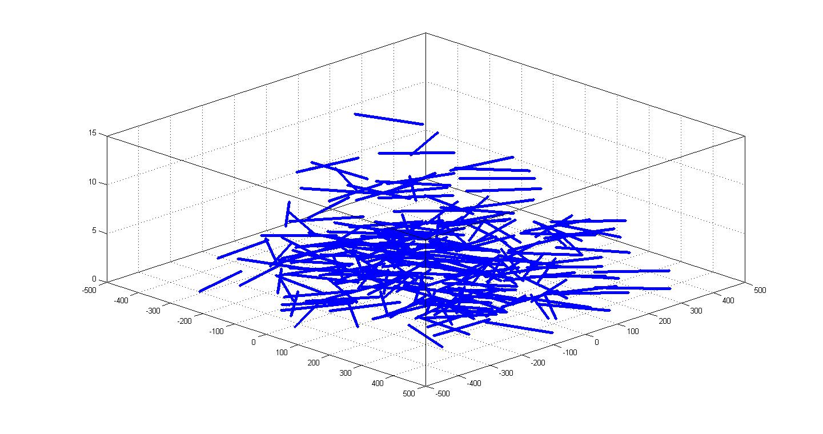

Figure A1-2 is an example of epfd calculation over the sky for one trial. The epfd is integrated over the 2 000 seconds, taking into account the UAS movement as shown above. An e.i.r.p. of 0 dBW was assumed for each UAS.

Figure A1-2

Example of epfd calculation for sharing studies with the radio astronomy

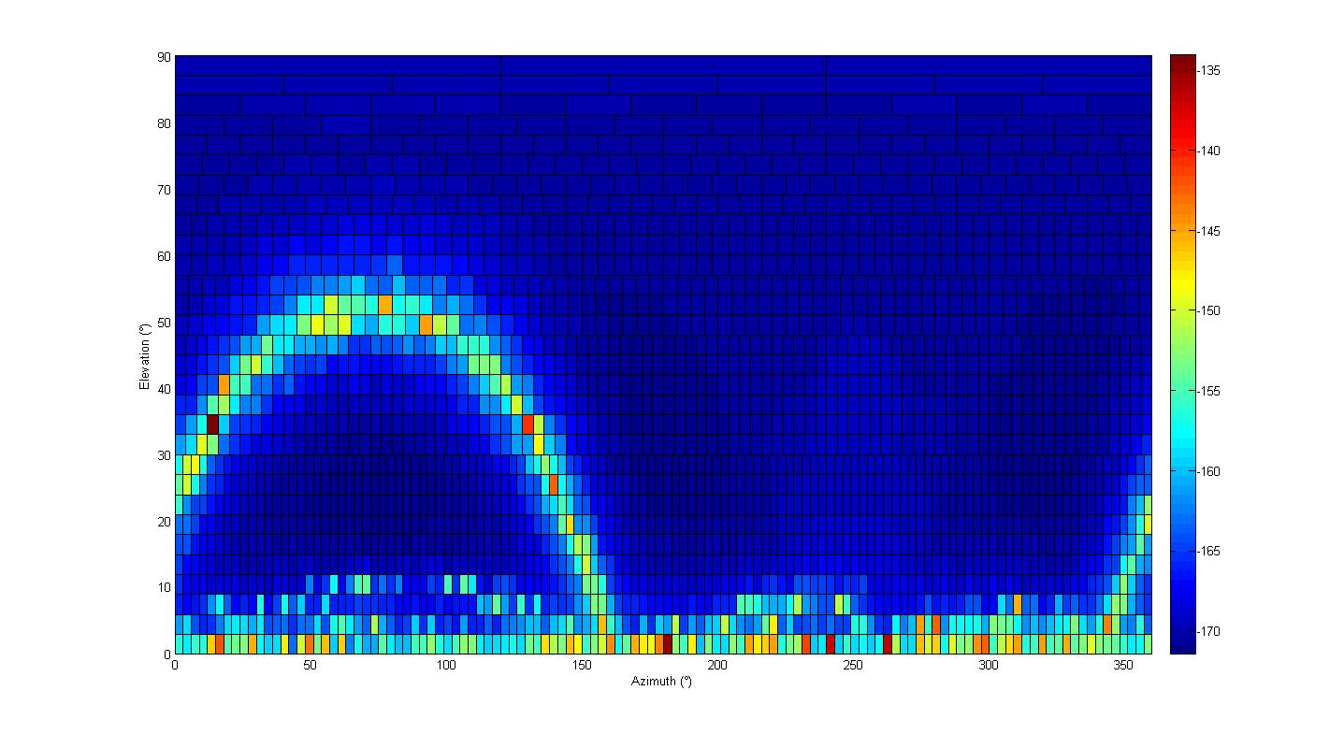

The impact of UAS is predominant at low elevation angles, below 3°. This is consistent with previous epfd simulations considering aircraft flying on air routes (see the studies performed under WRC‑12 Agenda item 1.12 with space research or studies performed prior to WRC‑03 with AMS(R)S at 14 GHz).

Figure A1-3 gives the level of data loss over the sky for 20 trials and an unwanted emission e.i.r.p. of −96 dBW in 10 MHz, noting that the epfd threshold is −245 dBW/m² in 10 MHz (continuum observations) for a 100 m diameter antenna. The overall data loss, averaged over the whole sky is 2.1%, close to the 2% criterion. This confirms that the interference occurs mainly at low elevation angles. The unwanted emission e.i.r.p. may be relaxed by 4 dB when considering elevation angles higher than 3°.

Figure A1-3

Example of calculation results for the level of data loss over the sky

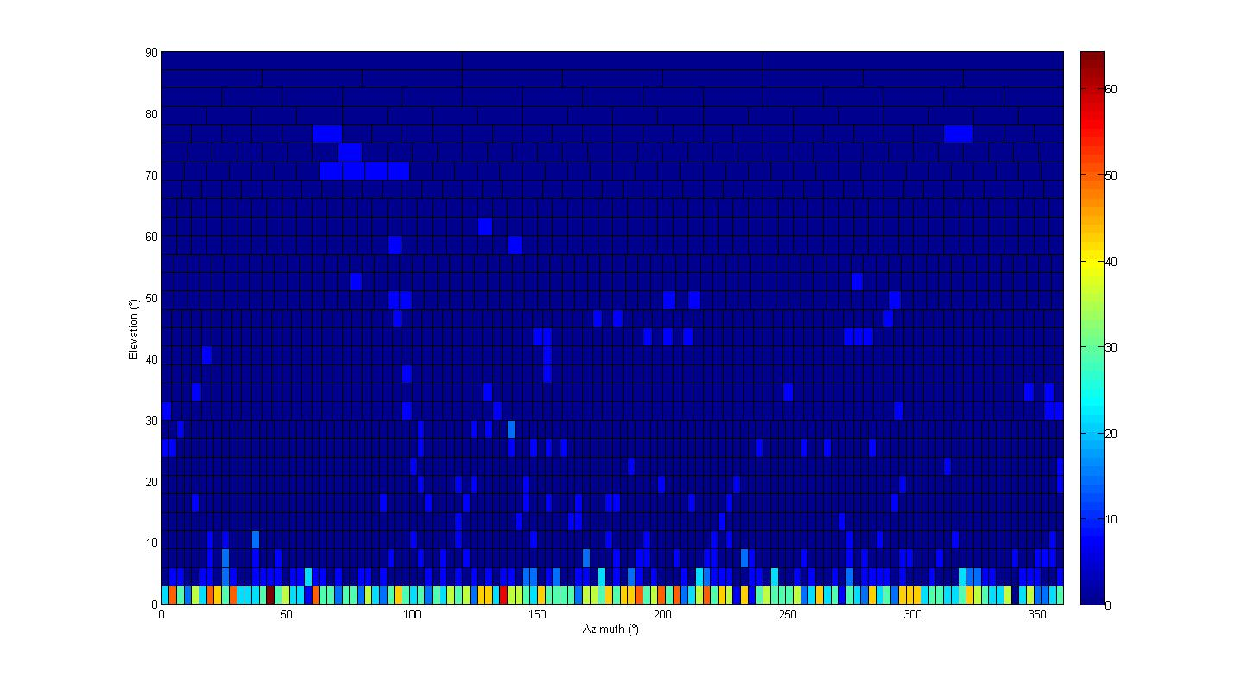

Therefore, based on the epfd methodology detailed in Recommendation ITU‑R M.1583, it can be derived that the e.i.r.p per UA or UACS should be limited to −96 dBW in the frequency band 4 990-5 000 MHz. Therefore, the out-of-band emissions of AM(R)S systems should be limited to −106 dBW/MHz which is 92 dB below the maximum e.i.r.p of this AM(R)S system.

Such attenuation could be reached only with a frequency separation to the 5 GHz frequency in the case of UA transmitters (i.e. 2 MHz of guardband) and with a distance or frequency separation in the case of UACS transmitters.

## 2.3 RNSS receivers in the frequency band 5 010-5 030 MHz results

With the methodology based on RNSS protection criteria, the table below shows the maximum AM(R)S UA station e.i.r.p. density to protect non-aeronautical RNSS receiver located at 300 m.

TABLE A1-9

Example of protection of a RNSS receiver in the adjacent frequency band from   
an unmanned aircraft AM(R)S transmitter (Galileo case)

|  |  |  |  |
| --- | --- | --- | --- |
|  |  | | High precision |
| a | Maximum aggregate Non-RNSS RFI threshold (dBW/MHz) | | −150.1 (Wideband acquisition) |
|  | Frequency band (MHz) | | 5 010-5 030 |
| b | In band single/multiple entry factor (dB) | | 20 |
| c | RNSS antenna gain (dBi) | | 4 |
| d | Attenuation at 300 m (dB) | | 96 |
| e | Polarization discrimination (dB) | | 3 |
| f | Number of AMRS transmitters | | 1 |
| g | | Max AM(R)S UA station e.i.r.p. density  (*g* = *a* − *b* − *c* + *d* + *e*−10 log10(*f*) (dBW/MHz) | −75 |

The out-of-band emissions of ARNS systems in the frequency band 5 010-5 030 MHz should be limited to −75 dBW/MHz.

In addition, to further study the sharing with RNSS, it is proposed to consider the possible RNSS filters. The calculation of the interference into the RNSS receiver is done as follows:



where:

*EIRPUA* : UA EIRP (−4.5 dBW in case of small UAs)

*GRNSS*: RNSS antenna gain (4 dBi for Galileo)

*LFSL*: free space loss

*Lpolar* : polarization loss (3 dB)

: out-of-band single/multiple entry factor (10 dB)

*FDR*: frequency dependent rejection.

For the FDR calculation, the UA signal was assumed to be a BPSK signal (as the RNSS one), but then filtered to fit into to assumed mask for UA transmission. The RNSS filter is also taken into consideration before calculation.



where:

*PSDUA* : power spectral density of the UA, normalized to 1W

*PSDRNSS* : power spectral density of the RNSS downlink, normalized to 1W

*HUA*: UA transmit filter to fit in the assumed UA mask transmission mask

*HRNSS* : RNSS assumed filter (different cases are studied).

The separation distance between the UA and the RNSS receiver is then derived by comparing the interference to the Galileo interference threshold (−150.1 dBW/MHz).

Results are given in Fig. A1-4.

Figure A1-4

Separation distance between the unmanned aircraft and an RNSS receiver   
(single/multiple entry factor of 10 dB)



It can be seen on the figures that the design of the real filter (bandwidth, roll-off) will have a direct impact on the sharing feasibility.

The results presented above can be considered as worst cases. Indeed, results would in reality be better as:

− the filter attenuation will be better than the proposed mask (the filter bandwidth is usually given as the 3 dB bandwidth);

− the interference is computed through a main lobe to main lobe scenario: the UA (antenna gain is 3 dBi) is transmitting directly into the RNSS receiver (antenna gain is 4 dBi) and such situation is unlikely;

− only free space loss has been taken into account, and most likely, atmospheric or terrain model attenuation will occur.

A guardband will certainly be necessary to protect the RNSS adjacent frequency band but this guardband can vary from 1 to 5 MHz depending on the assumed filter and the UAs transmit power. Therefore, small UAs operation may be feasible in this frequency band.

Appendix 2 to Annex 1  
  
Compatibility analysis in the frequency band 5 010-5 030 MHz

The frequency band 5 010-5 030 MHz covers two kinds of RNSS applications: the feeder downlink and the service downlink.

The protection criteria for the service downlink is around −150 dBW/MHz.

TABLE A2-1

Example of protection of an RNSS receiver from an unmanned aircraft AM(R)S in-band transmitter   
(Galileo case)

|  |  |  |  |
| --- | --- | --- | --- |
|  |  | | High precision |
| a | Maximum aggregate Non-RNSS RFI threshold (dBW/MHz) | | −150.1 (Wideband acquisition) |
|  | Frequency band (MHz) | | 5 010-5 030 |
| b | RNSS antenna gain (dBi) | | 4 |
| c | UA e.i.r.p. (See Tables 1-1 and 1-2) in 37.5 kHz (dBW) | | −4.5 to 10 |
| d | Polarization discrimination (dB) | | 3 |
| e | Number of AMRS transmitters (dB) | | 0 |
| f | | Bandwidth ratio (dB) | 14.3 |
| g | | Required attenuation (dB) | −135.3 to −149.8 |
| h | | Separation distance (Km) | 28 to 148 |

Considering the high separation distances required, frequency sharing between AM(R)S and RNSS in the frequency band 5 010-5 030 MHz is not feasible.

Annex 2  
  
Glossary

AM(R)S Aeronautical-mobile (route) service

AMS Aeronautical-mobile service

AMS(R)S Aeronautical-mobile satellite (route) service

AMSS Aeronautical-mobile satellite service

ARNS Aeronautical radionavigation service

ATC Air traffic control

BLoS Beyond line-of-sight

CNPC Control and non-payload communications

dBc dB relative to the carrier

dBi dB referred to the gain of an isotropic antenna

dBr dB relative to a maximum value

DL Downlink

DME Distance measuring equipment

e.i.r.p. Equivalent isotropically radiated power

FDD Frequency-division duplex

FDR Frequency-dependent rejection

FL Forward link

FSS Fixed-satellite service

GPS Global Positioning System

GS Ground station (for terrestrial CNPC system)

*G*/*T* Ratio of receiving-antenna gain to receiver thermal noise temperature in kelvins

HIBLEO-4 A non-geostationary-orbit satellite network

ICAO International Civil Aviation Organization

LEO Low Earth orbit (or a satellite in that orbit)

LoS Line-of-sight

MS Mobile service

MSS Mobile-satellite service

PFD Power flux density

PSD Power spectral density

RF Radio frequency

RL Return link

RNSS Radionavigation-satellite service

RR Radio Regulations

Rx Receiver

S&A Sense and avoid

SNR Signal-to-noise ratio

TDD Time-division duplex

Tx Transmitter

UA Unmanned aircraft

UACS UA control station

UAS UA system(s)

UL Uplink

WP Working Party

WRC World Radiocommunication Conference

WRC‑07 WRC 2007

WRC‑12 WRC 2012

______________

1. UAS payload communications are not covered in this Report.
2. Report ITU‑R M.2171 – Characteristics of unmanned aircraft systems and spectrum requirements to support their safe operation in non-segregated airspace, December 2009.