|  |
| --- |
| **Report ITU-R M.2202**  **(11/2010)** |
| **Maritime broadband wireless mesh networks** |
| **M Series**  **Mobile, radiodetermination, amateur**  **and related satellites services** |

Foreword

The role of the Radiocommunication Sector is to ensure the rational, equitable, efficient and economical use of the radio-frequency spectrum by all radiocommunication services, including satellite services, and carry out studies without limit of frequency range on the basis of which Recommendations are adopted.

The regulatory and policy functions of the Radiocommunication Sector are performed by World and Regional Radiocommunication Conferences and Radiocommunication Assemblies supported by Study Groups.

# Policy on Intellectual Property Right (IPR)

ITU-R policy on IPR is described in the Common Patent Policy for ITU-T/ITU-R/ISO/IEC referenced in Annex 1 of Resolution ITU-R 1. Forms to be used for the submission of patent statements and licensing declarations by patent holders are available from <http://www.itu.int/ITU-R/go/patents/en> where the Guidelines for Implementation of the Common Patent Policy for ITU‑T/ITU‑R/ISO/IEC and the ITU-R patent information database can also be found.

|  |  |
| --- | --- |
| Series of ITU-R Reports  (Also available online at <http://www.itu.int/publ/R-REP/en>) | |
| **Series** | Title |
| **BO** | Satellite delivery |
| **BR** | Recording for production, archival and play-out; film for television |
| **BS** | Broadcasting service (sound) |
| **BT** | Broadcasting service (television) |
| **F** | Fixed service |
| **M** | Mobile, radiodetermination, amateur and related satellite services |
| **P** | Radiowave propagation |
| **RA** | Radio astronomy |
| **RS** | Remote sensing systems |
| **S** | Fixed-satellite service |
| **SA** | Space applications and meteorology |
| **SF** | Frequency sharing and coordination between fixed-satellite and fixed service systems |
| **SM** | Spectrum management |

|  |
| --- |
|  |

|  |
| --- |
| ***Note****: This ITU-R Report was approved in English by the Study Group under the procedure detailed   in Resolution ITU-R 1.* |

*Electronic Publication*

Geneva, 2011

© ITU 2011

All rights reserved. No part of this publication may be reproduced, by any means whatsoever, without written permission of ITU.

REPORT ITU-R M.2202

Maritime broadband wireless mesh networks

(2010)

TABLE OF CONTENTS

Page

1 Introduction 2

2 Concept of maritime mesh network and existing standards 2

3 Feasibility of over-the-horizon wireless communication in the maritime environment 3

3.1 Propagation model 3

3.2 Reflection from nearby ships and Doppler shifts 5

3.3 Signal variation due to boat rocking 9

3.4 Data transmission with broadband wireless communication device 10

4 Potential frequency bands for consideration 21

5 Conclusion 21

Annex A – Broadband wireless mesh networking protocols 22

Annex B – Radiocommunication range required for the forming of a maritime mesh network 25

Annex C – Abbreviations 29

# 1 Introduction

Radiocommunication plays an important role in providing maritime safety and security for ships, waterways and ports. Currently, there are several maritime safety and security systems that depend heavily on radiocommunication. These systems include the Global Maritime Distress and Safety System (GMDSS) and automatic identification system (AIS). A common characteristic of these International Maritime Organization (IMO) mandated systems mentioned above is the low bandwidth of the wireless communication links which limit information exchange rates for purposes such as the transfer of essential navigation data required to improve safety and security at sea.

To improve safety at sea, IMO has proposed a concept known as e-navigation*.* This concept harmonizes the collection, integration, exchange, presentation and analysis of maritime information onboard and ashore by electronic means to enhance berth-to-berth navigation and related services, for safety and security at sea and protection of the marine environment. A high-speed and cost- effective maritime wireless communication link is essential for the success of the e-navigation concept.

In addition to the as yet undefined bandwidth requirements for e-navigation, higher demand for bandwidth is also coming from ship’s crews. More crew are demanding Internet access to stay connected to family and friends. Although satellite communication can provide broadband wireless access to ships, the speed is limited and costs are quite high.

This Report proposes the development of a high-speed maritime communication system using radios placed on board ships as relays to form a mesh network. The mesh network will address new bandwidth demands for ships travelling in dense traffic lanes and traffic lanes close to the shoreline.

# 2 Concept of maritime mesh network and existing standards

Wireless technologies are widely used for terrestrial land systems providing speeds close to 1 Gbit/s in 4G cellular networks with users enabled with access in the order of tens or even several hundred Mbit/s. However, in the maritime environment, transmission speed is still in the order of several tens or several hundreds kbit/s.

Due to the location of the ships at sea, using current cellular systems or wireless point-to-point systems, ships will only benefit in certain areas, such as busy ports, because base stations normally provide sufficient coverage with single hop transmission. At the present time, it is difficult to provide communication for ships beyond the cellular coverage. Mesh network technology can be used to address these nodes that are beyond the cellular coverage.

Figure 1 shows the desired maritime mesh network architecture. In Fig. 1, coverage extension is achieved by forming a wireless mesh network amongst neighbouring ships, marine beacons and buoys. The mesh wireless network will be connected to the terrestrial networks via land stations, which are placed at regular intervals along the shoreline. Each ship will carry a mesh radio that has the capability of frequency agility where frequencies can be switched to suit country-specific frequency regulations or sea conditions.

Figure 1

Maritime mesh network

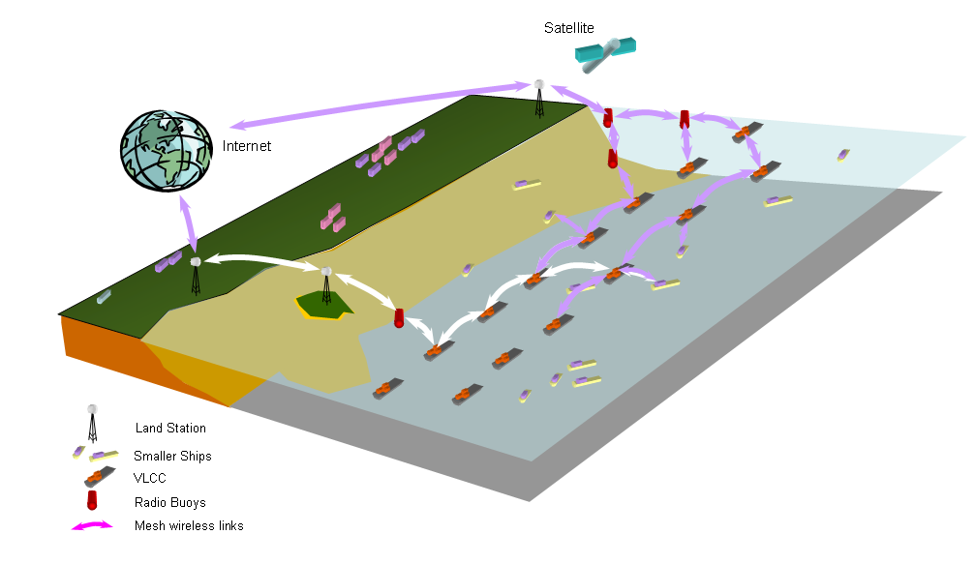

Frequencies of interest for traffic lanes closer to shore could be in the GHz range whereas locations far away from land could be based on UHF or VHF bands.

Multi-hop wireless network technologies have been a field of research for several decades and have been deployed for some practical applications. Currently in IEEE, there are several standards that address mesh networking technology. However, application of these standards for direct use in maritime environments is not straightforward.

One such mesh standard, IEEE 802.11s [1], which is a mesh network amendment to the IEEE 802.11 standard, uses the basic carrier sense multiple access with collision avoidance (CSMA/CA) technology for channel access. It is suitable for networks with short communication ranges of up to several hundred metres, but it is not suitable for maritime mesh communication networks, which require distances of several tens of kilometres.

According to analysis based on real ship traffic movement data obtained from the Maritime Port Authority of Singapore (MPA), in order to form a well-connected mesh network in a maritime environment as shown in Fig. 1, the transmission range among ships should be at least 18 km. Annex B shows the details of the analysis. Therefore, the mesh networking technologies based on 802.11s are not suitable for the maritime communication environment unless some amendments are made.

Another standard, IEEE 802.16, defines a mesh network standard for a wireless metropolitan access network (MAN). Typical communication ranges of wireless MAN may vary from a few kilometres to about 50 km. From a range standpoint, the IEEE 802.16 standard is suitable for maritime mesh networks. Existing results have shown that broadband transmission in a maritime ship-to-ship environment using IEEE 802.16e can reach 44 km with an antenna height of 16 m [2].

Unlike IEEE 802.11s, the mesh technology proposed in the IEEE 802.16-2004 Standard [3] uses time-division multiple access (TDMA) as a basic channel access method at the media access control (MAC) layer. Channel time used for data transmission is reserved before use. Both the IEEE 802.11s and 802.16 standards employ orthogonal frequency division multiple access (OFDMA) technology in the physical layer.

Based on field tests and simulation studies, IEEE 802.16 was found to be a suitable technology for maritime broadband communication. In Annex A, a brief introduction to the 802.16-2004 mesh technology is provided. Evaluation of mesh network technology proposed in the IEEE 802.16-2004 standards indicate that some amendments to the standard are necessary before it can be put into practical use in a maritime environment.

# 3 Feasibility of over-the-horizon wireless communication in the maritime environment

Deploying wireless communication systems in the maritime environment has its own challenges – see [4, 5, 6]. The wireless channel responses are different from that over land because of ship’s movements, ship’s properties, reflective properties of the sea surface, and the way ships are situated in a maritime environment. In the following section, some basic characteristics of broadband wireless communication systems in a maritime environment are discussed. Performance results were collected using RF test equipment as well as prototype broadband mesh wireless devices designed to handle the observed impairments.

Presented first are propagation loss measurements in the maritime environment, and illustration of the Doppler Shift caused by movement of the ship and reflections from metal bodies. Next, signal variations due to ship rocking are discussed. In these sub-sections, recommendations for improving the reception of signal are provided. Finally, some performance results on data transmission using prototype mesh broadband wireless devices are discussed and are used to validate the findings.

## 3.1 Propagation model

In 2006 and 2007, several propagation measurements in the Singapore Straits were carried out. In the set‑up, a 10 dBm continuous wave (CW) signal was transmitted at 2.43 GHz using a signal generator. The output signal from the signal generator was increased to 27 dBm using an amplifier.

This signal was transmitted using a vertically linearly polarized antenna, which has an omnidirectional radiation pattern. The gain of the antenna is approximately 2 dBi. The same antenna was used at the receiver. The receiver was placed on a diver’s boat and was mounted 7.2 m above the sea surface. The antenna was connected to a low noise amplifier (LNA) with 20 dB gain, and then to a spectrum analyzer.

A laptop computer was connected to the spectrum analyzer to acquire peak power readings from the spectrum analyzer every second. The collected peak power data was time-stamped. A Global Positioning System (GPS) receiver placed on the boat provided the distance from the transmitter. Distance and received signal strength were recorded and a path loss analysis was carried out by using linear regression. In one of the set‑ups, the transmitter was placed on top of Bedok Light House (BLH), which is 76 m tall. The light house is about a half kilometre away from the shore.

The received power as a function of Tx-Rx separation distance *d* is written as follow:

*PR*(*d*) = 〈*PR*(*d*0)〉 – 10*n* log(*d/d*0) – *X*σ (1)

where:

〈*PR*(*d*0)〉: the average path loss at reference distance *d*0;

*n*: the path loss exponent

*X*σ: a zero mean log-normally distributed random variable with standard deviation σ.

The parameters *n* and σ can be determined using linear regression of the path loss values against the log of normalized distance (*d/d*0) in a minimum mean square error (MMSE) manner. In the measurements, *d*0 is 10 m and the 〈*PR*(*d*0)〉 is –10.5 dBm. In this measurement involving BLH, the LoS condition was dominant.

In Fig. 2, the dots represent measured mean received power while the boat was making way. The normalized distance log (*d*/*d*0) includes the light house height. The curve that has peaks and nulls is the calculated received power using two-ray model at a normalized distance of the collected data. The first ray/path is line-of-sight (LoS) signal from the transmitter to the receiver. The second ray/path is a reflected signal from the sea surface received at the receiver on the boat.

Figure 2

Received power vs. log of normalized distance



The sea surface at 2.43 GHz still satisfies a good conductor condition. Good conductor condition is satisfied when *f* < σ/ε0ε*R* (or σ/ωε >> 1), σ is conductivity, ε0 and ε*R* are permittivity and relative permittivity, respectively. For sea water, σ = 5 S/m, ε*R* = 81. As long as the frequency of the signal is < 7 GHz, sea water can be assumed as a conductor. The model fits quite closely with the measured data. This shows the model is well suited to represent the propagation model for a sea port environment. Asymptotic behaviour of two-ray model occurs at distance *d* > *dA* = 20*hThR*/λ. The corresponding normalized distance is 3.94 and this is beyond the distance coverage during this measurement. Single linear regression is sufficient to curve fit the data to find the exponent path loss *n* and the standard deviation. The exponent path loss is found to be 2.09 and the standard deviation is 6.43.

From Fig. 2, it is clear that the reflected wave causes destructive interference at a certain distance causing up to –20 dB drop in signal. An ideal over-the-horizon mesh radio should include methods to overcome the destructive interference at the receiver.

## 3.2 Reflection from nearby ships and Doppler shifts

Figure 3

Measurement location in Singapore Port

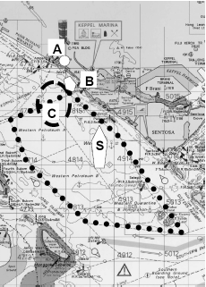

To observe Doppler Shift spectrum, a transmitter was placed at “A” (land) and a spectrum analyzer was placed on the boat at “B” as in Fig. 3. Point “S” in Fig. 3 is a ship in the vicinity of the test. The transmitter consists of a signal generator generating a CW signal frequency of 5.8 GHz and power level of 0 dBm. It was connected to a power amplifier with 30 dB gain. The output of the amplifier was connected to a sector antenna pointing towards the boat. Spectrum analyzer on the boat was connected to a receive antenna (both omnidirectional and sectorized were used) to observe the received spectrum. The CW spectrum received was saved in the spectrum analyzer. When the sector antenna was used, the antenna was always pointed toward the transmitter at A.

Figure 4 shows a snapshot of the received spectrum when the boat is moving away from A toward S. The omnidirectional antenna was used. The boat was moving at the speed of 5 m/s. There are two dominant peak signals received with amplitudes close to each other. The lower frequency was the received Doppler-shifted signal from A due to the boat’s motion away from transmitter at A. The higher frequency was the received Doppler-shifted signal from S. S can be seen as a virtual transmitter to the boat because it reflected the signal from transmitter A. Since the boat is moving toward S, the received signal is Doppler shifted to a frequency higher than that of the transmitter.

According to the Doppler shift calculation, the difference in these two frequencies is:

(2*vfc)/c* (2)

where:

*v*: the boat’s speed

*c*: the speed of light

*fc*: the transmitter frequency.

It works out to be 193 Hz, which is indicated in Fig. 4.

Figure 4

Received CW spectrum using an omnidirectional antenna,  
centre frequency = 5.8 GHz, horizontal scale = 200 Hz/div,  
vertical scale = 10 dB/div

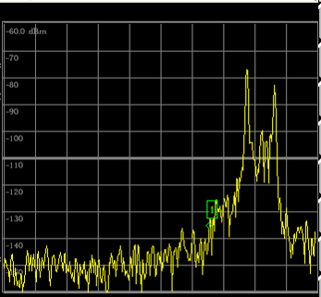



**200 Hz**

**Shift due to motion away from A**

**Shift due to motion toward S**

**10 dB**

Moving along a similar path using a sector antenna, the received spectrum no longer consists of two peaks. Since the sector antenna was always pointed toward the transmitter, the amplitude of higher frequency peak is significantly reduced as shown in Fig. 5. The sector antenna has reduced higher frequency peak by more than 30 dB compared to the lower frequency peak, and hence minimized the inter-channel interference (ICI).

It is well known that the radio channel can be modelled using a two-ray model when LoS is dominant. In a sea port, when a sector antenna was used, the received signal strength at any location can be calculated using the two-ray model to represent the dominant peak. However, when an omnidirectional antenna was used, there were two dominant peaks. The received signal strength for each peak was represented by a two-ray. Hence, for two dominant peaks, a four-ray is required to model the received signal strength. This is illustrated in Fig. 6.

Assuming perfect reflection by the sea surface, the total electric field received by the receiver was calculated and plotted using theoretical models. This plot is then compared with the received signal strength indication (RSSI) reading obtained from a fixed WiMAX system (802.16d).

Figure 5

Received CW spectrum using sector antenna, centre frequency = 5.8 GHz,   
horizontal scale = 200 Hz/div, vertical scale = 10 dB/div

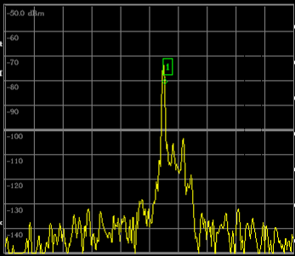

Figure 6

Illustration of four-ray model

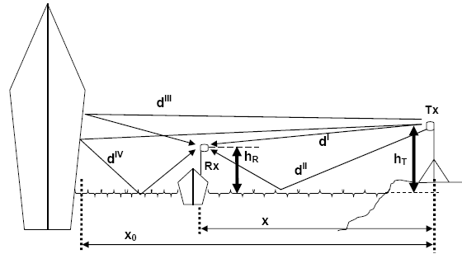

Figure 7

Calculated received power based on two-ray and four-ray models

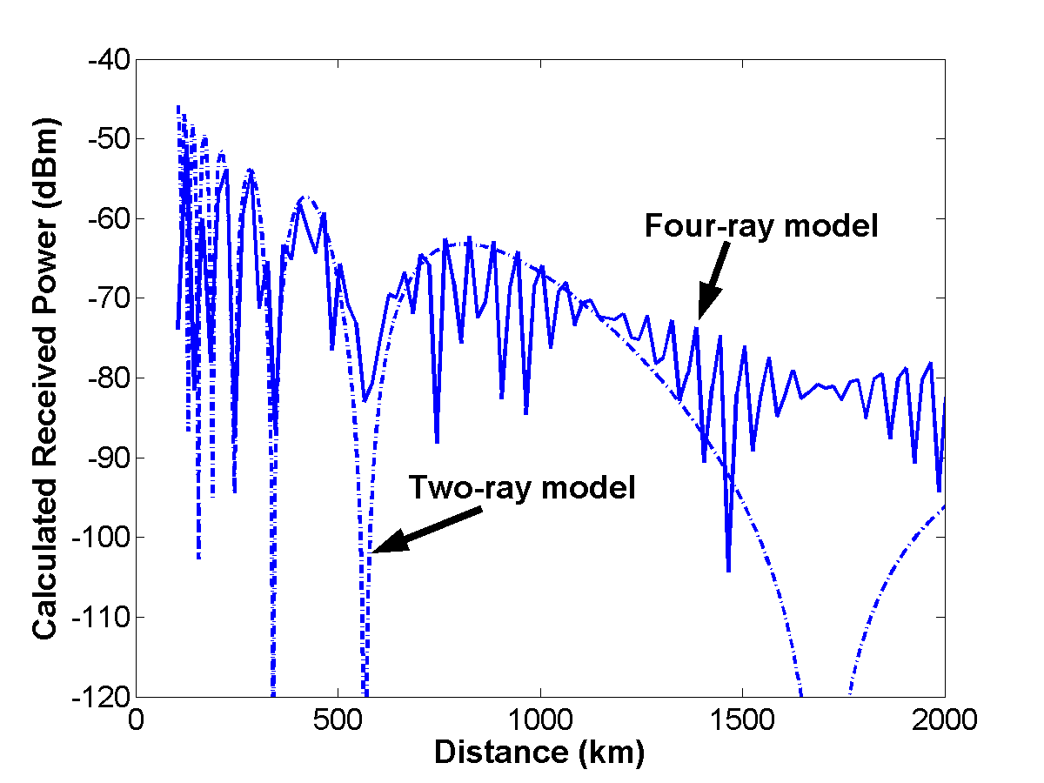

Figure 7 shows calculated received power based on the theoretical 4-ray model and the 2-ray model. These two plots should represent the power received by fixed WiMAX when an omnidirectional antenna and sector antennas are used respectively. The number of points plotted is the same as the number of points acquired by fixed WiMAX on the boat over the range of 200 m to 2 200 m from the transmitter A. The curve of two-ray model varies between peak and null much slower compared to that of four-ray model.

Figure 8

Fixed WiMAX RSSI at client site using sector (dash) and omnidirectional (solid)



To verify that the power received by fixed WiMAX was similar to that shown in Fig. 7, the transmitter and receiver were replaced by fixed WiMAX to collect RSSI reading on a similar path along B to S. Figure 8 shows the RSSI readings using a sector antenna and an omnidirectional antenna at the client site. There were 100 RSSI readings (acquisition number) for each antenna as the boat moved from B to S. When a sector antenna was used, there was only one dominant peak (Fig. 5). The RSSI (dash) behaves similar to calculated received power using the two-ray model (Fig. 7). When an omnidirectional antenna was used, there were two dominant peaks (Fig. 4). The RSSI (solid) behaves similar to calculated received power using the four-ray model (Fig. 7).

Thetwo dominant Doppler shifted signals are beating with each other to produce high frequency RSSI variation. When the RSSI fell below the receiver sensitivity of the fixed WiMAX, the fixed WiMAX temporarily lost connection, which contributed to higher bit error ratio (BER). This high frequency RSSI variation occurred even when the boat was closed to point “A” (solid, acquisition number 0 to 20). This is why irreducible BER and FER floor were present during the measurements.

FIGURE 9

BER (a) and FER (b) using sector antenna

 

To confirm no irreducible BER floor when only one Doppler-shifted signal is dominant, a sector antenna was used instead of an omnidirectional antenna at the client site. BER and FER measurements using the fixed WiMAX were carried out following the same boat path. The RSSI did not vary as fast as that corresponding to the omnidirectional antenna. Figure 9 shows BER and FER measurements. The BER is less than 10–8 when RSSI > –71 dBm. The FER dropped below when RSSI exceeded –71 dBm. As expected, the irreducible BER floor is no longer present.

This result shows that the use of sector antenna shows tremendous benefit in the deployment of the mesh network. In the experiment, a 60° horizontal plane directive antenna was used. The more directive the antenna toward the transmitter, the better the performance, but the more difficult it is to align toward the transmitter due to boat’s movements. From the measurements, it was concluded that a sectorized approach to packet reception is necessary to mitigate the Doppler and unwanted reflections from nearby metal bodies.

## 3.3 Signal variation due to boat rocking

The boat’s or ship’s movements affect received signal variation. The standard deviation of signal received using a directive antenna due to this movement can be as high as 5 dB which is quite significant. This can be simply explained by Fig. 10. Assume the transmitter is on the shore and the receiver on a ship. If the ship is perfectly stationary, the receiver will have a constant signal strength received because its antenna’s alignment with the transmitter’s antenna remains the same. Both antennas are pointing into A. However, when the ship starts rocking, the antenna alignment between Tx and Rx is disrupted and this causes changes in the received signal strength, since Tx antenna is pointing to A while Rx antenna is pointing to B.

Figure 10 shows an example of how ship’s movement due to wave affects the received signal. In this measurement, the boat carrying the received antenna is positioned 500 m away from the transmitter. The transmitter is on the shore. The received signal varies significantly as the boat is rocked by the waves. Depending on the antenna used, the variation can be as high as 10 dB. An ideal mesh maritime system should include methods to reduce the losses due to the rocking and misalignment of the antenna beams.

FIGURE 10

Illustration of ship’s movement affecting received signal



**Tx**

**Rx**

A

**B**

FIGURE 11

Received signal variation due to boat’s rocking



## 3.4 Data transmission with broadband wireless communication device

To further study the wireless broadband access in maritime environment, a mesh radio with certain enhancements to handle the propagation challenges that were observed was developed. Because of reflections from sea surface and nearby ships, sectorized antennas with azimuth beamwidth of 90° and elevation beamwidth of 8° were used. To counter the rocking problem, a specially designed antenna that has three antenna elements pointing to the same 90° azimuth direction but tilted at different elevation angles was used. One antenna is mounted with 0° elevation tilt; one antenna is mounted with a +5° tilt; and another antenna is mounted with a –5° tilt. Only one of these three antennas is active at any one time. In total, 12 elements are used to form the entire antenna structure. A gyro is used to detect the tilt degree and an antenna switching module determines which antenna should be used for transmission and reception. With such a design, the antenna gain can be maintained at a high value and the antenna beamwidth can be kept narrow to reduce the reception of reflected signals.

Several field tests in maritime environment were carried out with these mesh devices. The first set of tests was carried out at Singapore Strait and the second set of tests was carried out at Trondheim, Norway.

### 3.4.1 Maritime broadband communication testing at Singapore Strait

A series of experiments in the Strait of Singapore to validate some of the findings were conducted. Figure 12 shows the location where the experiments were carried out.

Two mesh radios were used for testing. One was placed on St. Johns Island and the other was on a boat. The frequencies used in the test were 5.8 GHz and 2.3 GHz. The land device was raised up to 8 m high using a scaffold. The antenna on the ship was about 4.5 m above sea level. With this setting, the average antenna height for the link is estimated to be about 6 m. Figure 13 shows the antenna on shore and on the boat.

FIGURE 12

Location for experiment

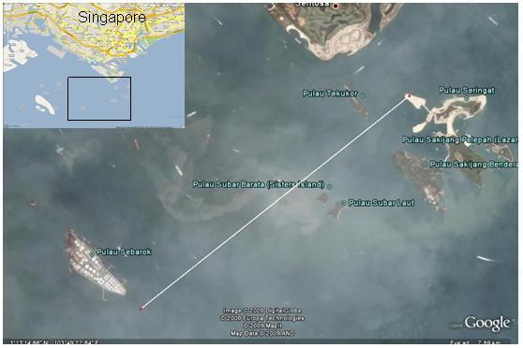

FIGURE 13

Transmitter and receiver

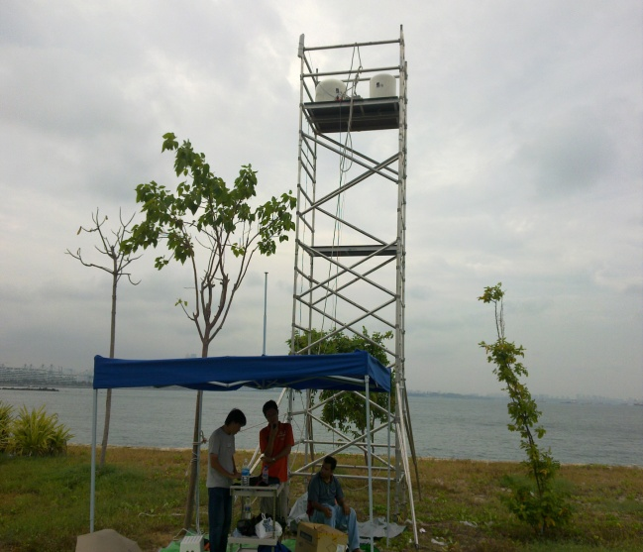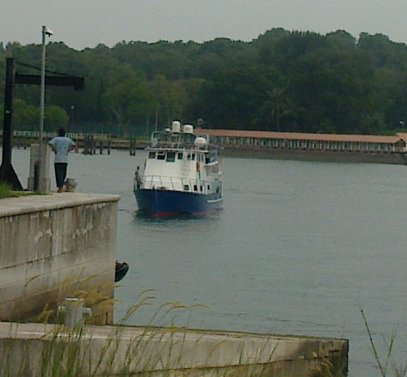

FIGURE 14

Minimum antenna height required to meet the clearance of first Fresnel Zone



The mesh node uses a simplified version of the 802.16 mesh MAC and the physical layer transmission is supported by IEEE 802.11a OFDM. The transmission power is limited to 4 W e.i.r.p. and 2 W e.i.r.p. for 5.8 GHz and 2.3 GHz, respectively due to regulatory constraints in Singapore. The data transmission rate is set to 6 Mbit/s. A readily available UDP based traffic generator to study performances such as delay, packet reception rate, etc. was used. From Fig. 14 and literature, it is clear that transmissions at GHz frequencies are strongly affected by NLoS conditions.

Fresnel Zone constraint is strong at the frequencies used in the tests. Fresnel Zone is one of a number of concentric ellipsoids of revolution, which define volumes in the radiation pattern of a (usually) circular aperture. To maximize receiver strength, one needs to minimize the effect of the out of phase signals by removing obstacles from the radio frequency RF LoS. The strongest signals are on the direct line between transmitter and receiver and always lie in the 1st Fresnel Zone. Figure 14 shows the required antenna heights for 2.3 GHz and 5.8 GHz in order to get a clearing of the first Fresnel Zone.

Fig. 14 shows that at 5.8 GHz, the required antenna height for first Fresnel Zone clearance is about 5.6 m. The average antenna height used in the test set-up, which is 6 m, sufficiently meets the Fresnel Zone requirement.

The link budget for the 5.8 GHz set-up is calculated as follows:

– e.i.r.p. = 4 W = 36 dBm.

– Receiver sensitivity = –83 dBm.

– Receiver antenna gain ~ 16 dBi (at boresight, 13 dBi at beamwidth).

– Receiver cable and efficiency losses = 3 dB.

– Link margin = 10 dB.

Using a frequency of 5.8 GHz, to satisfy the link margin requirement of 10 dB, the path loss should be less than 122 dB (i.e. 83 –– 10 – 3 + 36 + 16). Based on the two-ray ground model, the operational distance is up to 8 km [7].

Figure 15 shows the packet loss ratio measured in the experiment for 5.8 GHz. It can be observed that the packet loss ratio is below 5% even if the distance between the transmitter and receiver reaches up to 6 kilometres. This link performance level is good enough given that no link layer retransmission was used. The link distance achieved at 5.8 GHz, with the power settings and antenna heights used, matches the theoretical calculations for path loss and Fresnel Zone.

According to Fig. 14, the required antenna height for 2.3 GHz is stricter compared to 5.8 GHz. The antenna height clearance required for distances of 2, 4 and 6 km are 5, 7 and 8.5 m, respectively. With the average antenna heights of 6 metres in the test, it clearly shows that there is sufficient antenna height to achieve a transmission distance of about 3 km. The link budget for this test set-up is calculated as follows:

– e.i.r.p. = 2W = 33 dBm.

– Receiver sensitivity = –83 dBm.

– Receiver antenna gain ~ 13 dBi (at boresight, 10 dBi at beamwidth).

– Receiver cable and efficiency losses = 3 dB (estimated).

– Link margin = 10 dB.

Using a frequency of 2.3 GHz, to satisfy the requirement on the link margin of 10 dB, the path loss should be less than 116 dB (i.e. 83 – 10 – 3 + 33 + 13). Based on the two-ray ground model, the operational distance is up to 6.5 km [7].

Figure 16 shows the packet loss ratio for 2.3 GHz. Observation can be made that the packet reception progressively starts to degrade from link distance of 2 km onwards. This shows that although the link budget is sufficient, when the Fresnel Zone clearance is violated, the performance will degrade.

From the test results, it is clear that higher radio frequency transmissions (e.g. 5.8 GHz range) have less stringent antenna height requirements. However, higher power levels would be required to meet the path loss requirements. Balancing these two values are important because antenna heights are normally bounded by ship heights and power limits are subjected to regulatory constraints. A transmission at lower GHz ranges such as 2.3 GHz is subjected to more stringent Fresnel Zone requirements. Transmissions at sub-GHz frequencies have less stringent Fresnel Zone clearance requirements, but would require larger antenna structures.

FIGURE 15

Packet loss vs. distance (5.8 GHz)



FIGURE 16

Packet loss vs. distance (2.3 GHz)



### 3.4.2 Maritime wireless broadband testing at Trondheim, Norway

A second set of tests was carried out at Trondheim, Norway in May 2010. Both the ship-to-shore and ship-to-ship communications links were tested separately.

Figure 17 shows the map of Trondheim Fjord and the location of base station on shore (indicated as BS).

FIGURE 17

Location of test in Trondheim, Norway

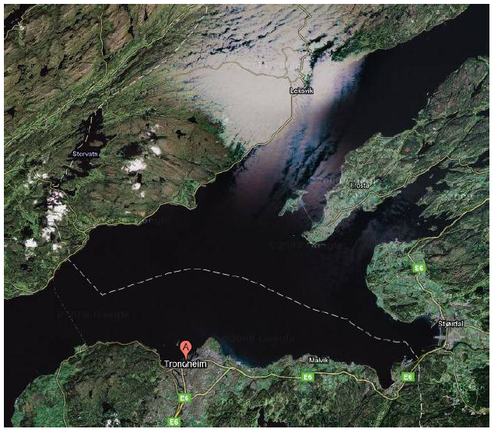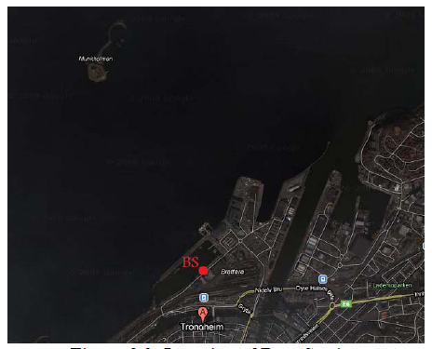

The base station (BS) was located on a building on shore with a height of 25 m above sea level. Two boats were used in the test. The antenna on the first boat had a height of 6 m. Figure 18 shows the antennas of base station and the node on the first boat. Figure 19 shows boat 2 with another node lifted by a crane on the boat to a height of 9 m from sea level.

FIGURE 18

The antenna of base station and mesh nodes on boat 1

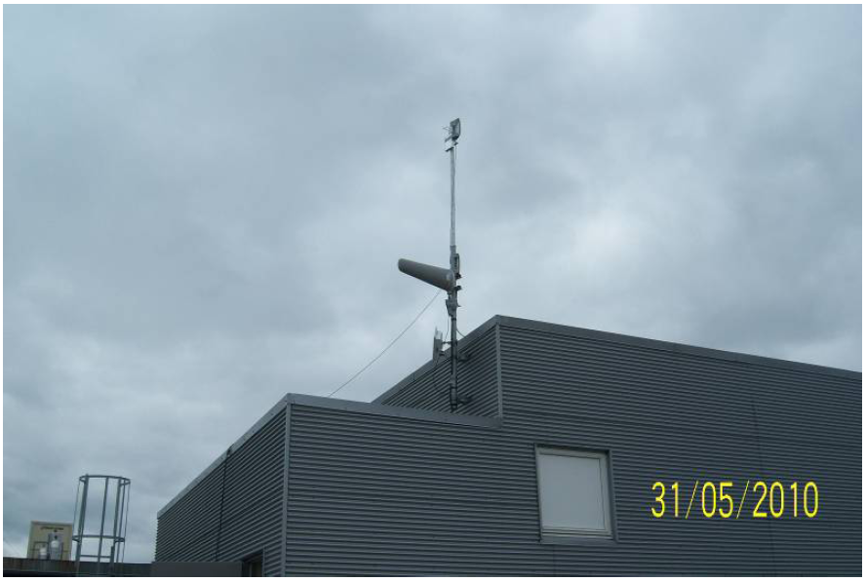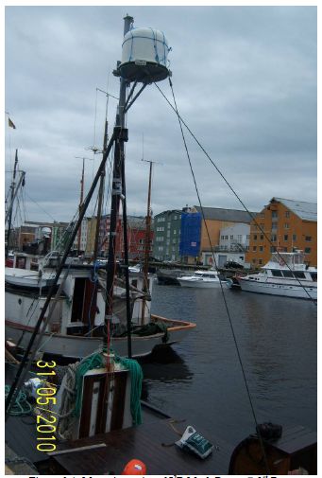

FIGURE 19

Mesh node on boat 2; lifted with a crane



The first picture in Fig. 20 shows the test path for the link test between base station and the first boat. For this test, the first boat moved to 2, 4, 6, 8, 10, 12 and 14 km points. At each point, performance data for link between base station and boat 1 was collected. The second picture in Fig. 20 shows the link between first boat and second boat. For this test, boat 1 was positioned at the point indicated in the second picture in Fig. 20 and boat 2 moved away from boat 1 towards the East direction. The measurement results were taken on boat 2 at the distance of 1, 2, 4, 6, 8 km and beyond. The purpose of going beyond 8 km was to observe the link performance when Fresnel Zone clearance was breached.

FIGURE 20

The location of ships during testing; base station to boat 1 test and boat 1 to boat 2 tests

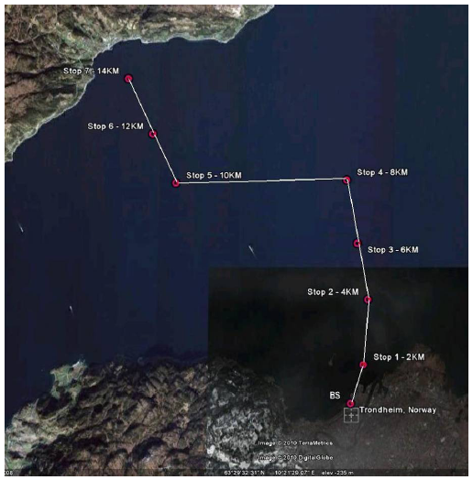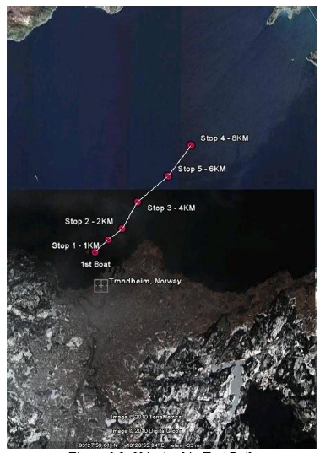

TABLE 1

Link budget calculation for base station to first boat



Table 1 above shows the link budget calculation for base station to boat 1 for a distance of 14 km. The calculation shows that a very stable link is available for single hop with about 35 dB fade margin based on the power setting that was used. Table 2 illustrates the Fresnel Zone calculations for 14 km with the base station installed at 25 m and the node on boat 1 installed at 6 m height from sea level. From the calculations, Fresnel Zone clearance is breached at 14 km with the heights of base station and node on boat 1.

The node used in the test has primarily 4 antenna sectors and the antenna set-up is described in § 3.4. Based on the performance measurement, as shown in Fig. 21, signal levels of around to –40 dBm were obtained for the antenna sector that was facing the base station. The antennas that were perpendicular to the direction of base station to boat also picked up relatively high signal levels. The antenna that was facing away from the base station had very low power level, which was in the order of –80 dBm. At the base station (green line), signal levels of around to –71 dBm were received because the antennas used by the node on the boat have lower gain and hence lower e.i.r.p.

TABLE 2

Fresnel Zone calculation for base station to boat 1



Figure 21 also shows the packets received in the ping test for the ship-to-shore link. Three different packet sizes of 1 316 bytes, 560 bytes and 40 bytes, were used in the test. As shown in Fig. 21, a loss rate lower than about 5% was observed for all ping tests performed, except when the boat was at 2 km distance away from base station. More packets were lost when the node was close to the base station due to the height difference between the narrow-beam panel antenna at the base station and the antennas on the boat. This misalignment of antenna beam pattern can be solved if another antenna is placed at a lower part of the base station.

FIGURE 21

Testing result for static links between base station and ship 1

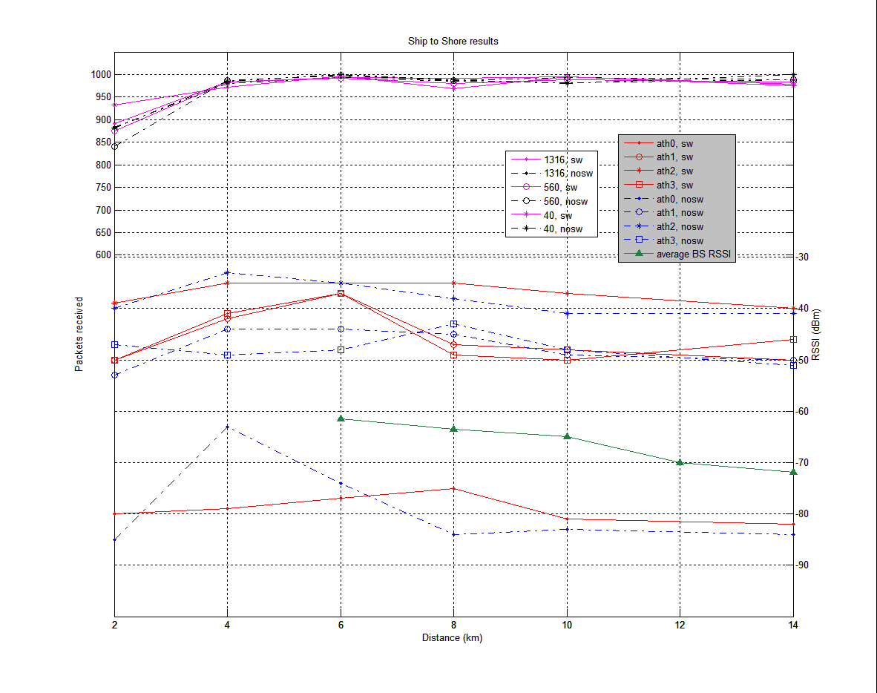

Table 3 shows the link budget calculation for boat 1 to boat 2 for a distance of 6 km. Based on the calculation, the received signal is around –47 dBm, which matches the actual RSSI received as per Fig. 22. Table 4 illustrates the Fresnel Zone clearance for boat to boat at the distance of 6 km. Based on the calculation, beyond 6 km is the point where Fresnel Zone clearance will be breached.

TABLE 3

Link budget calculation for boat 1 to boat 2



TABLE 4

Fresnel Zone calculation for boat 1 to boat 2 at distance of 6 km



FIGURE 22

Testing result for static links between ship 1 and ship 2

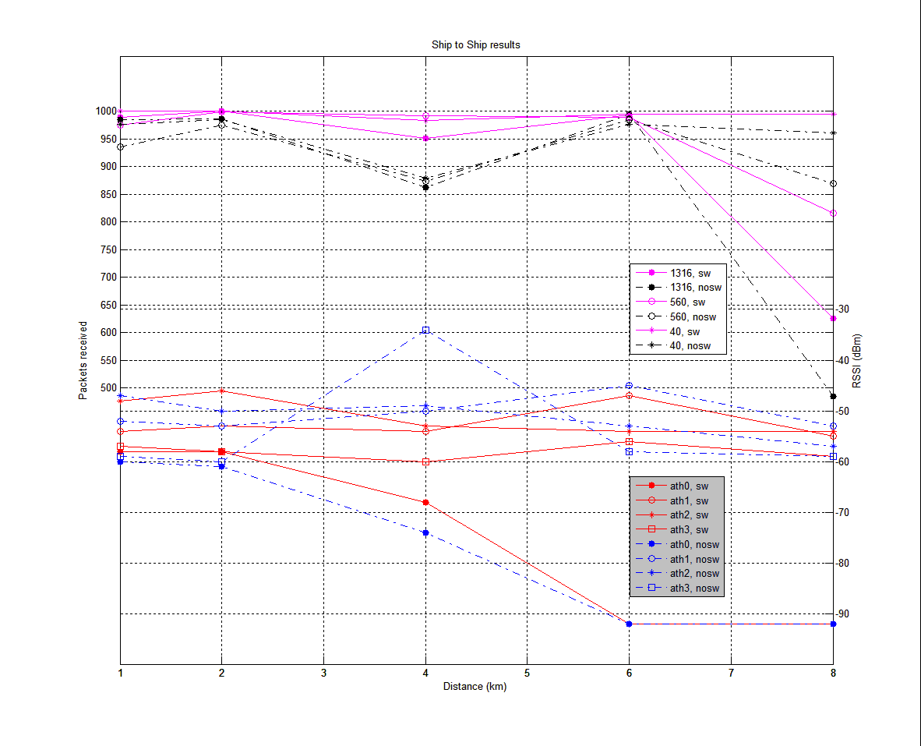

As shown in Fig. 22, signal levels of around –45 dBm to –55 dBm were received for the antenna sector on boat 2 that was facing boat 1. The figure shows the ping result for the 1 000 packets received for packet sizes of 1 316 bytes, 560 bytes and 40 bytes. Figure 22 also shows the results of the ping test when the antenna switching is turned on and off. The link had less than 5% loss rate from 1 km to 6 km distances between the two boats when the antenna switching function was used. In general, the tests with no antenna switching had worse performances compared to the switching case. At the 4 km point, the no-switching test performed significantly worse than the switching case. The link began to deteriorate significantly when boat 2 moved beyond the 6 km point from boat 1. The ping results for packet sizes of 40 and 560 bytes also showed consistent results. With switching circuit activated, the system performed better than the system with deactivated switching circuit.

The deviation of the boat position from the horizontal orientation caused by waves is compensated by the placement of sector antennas in the system and the angle in which they are tilted. The antenna switching algorithm is able to pick the right pointing antenna to maintain the horizontal antenna beam radiation. Given the RSSI value observed at the 14 km distance mark in the base station to boat 1 test, the system should be able to reach longer distances if there is sufficient Fresnel Zone clearance.

For the boat-to-boat link test, the results show a relative good link can be obtained up to 6 km range and this range is highly dependent on the Fresnel Zone clearance. The RSSI observed at 6 km was around –50 dBm. This power level is sufficient even if the ship-to-ship link distance is quadrupled to 24 km and the link has sufficient Fresnel Zone clearance.

The results from the field trials in Norway show that the maritime mesh system is particularly effective for the boat-to-boat communication.

# 4 Potential frequency bands for consideration

The radio frequency allocated for current maritime communications are in medium frequency (MF, 300 kHz‑3 MHz), high frequency (HF, 3‑30 MHz) and very high frequency (VHF, 30‑300 MHz). These low frequencies are suitable for long-range communication. However, in these bands, the amount of spectrum allocated for maritime communication is small and scattered across different bands.

Spectrum with frequencies lower than 1 GHz have been allocated for many different applications and services. Therefore, it is difficult to find available spectrum with frequencies lower than 1 GHz. An ideal broadband access for maritime communications based on mesh networks may need spectrum bandwidth in the order of tens of MHz. It is also important to harmonize the frequency band around the world for such maritime applications because ships are likely to travel between continents.

# 5 Conclusion

In this Report, a concept of maritime mesh network, which has the potential to improve communication by providing higher bandwidth for newer application demands has been described.

A series of tests to study the challenges in over-the-horizon communications for GHz frequencies have been discussed. Based on the channel characteristics and studies of link properties in the maritime environment, a prototype mesh radio was designed. A series of tests were carried out to validate the feasibility of ship-to-ship/shore communications.

This Report on mesh networks is considered an ongoing effort, and serves to provide valuable information regarding the challenges and performance evaluations of maritime mesh networks.

Prototype mesh hardware has confirmed that ship-to-ship/shore communications are feasible. Studies and trials in Singapore and other parts of the world, such as Norway and USA, have also confirmed link operation using per-hop link distances of up to 44 km.

This Report initiates the development of a standardized mesh protocol and system for maritime usage.

Studies and trials in other parts of the world have also confirmed links distances of up to 44 km [2] using the frequency of 5.8 GHz and antenna heights of 16 m above the sea surface.

Based on the tests results, mesh networking for ships appears feasible. However, some efforts will be required to standardize a mesh protocol suited for maritime usage. An existing standard such as 802.16-2004 is a possible candidate, but some improvements will be required.

An ideal broadband access for maritime communication based on mesh networks might need spectrum bandwidth in the order of tens of MHz. Operational frequency bands for broadband maritime mesh networks may be designed to operate in frequency bands such as VHF, UHF or SHF. However, it may be difficult to find sufficiently wide and dedicated spectrum at frequencies lower than 1 GHz, which is more ideal for maritime application.

However, a maritime mesh system might not require a single dedicated harmonized band to ensure operation, if the mesh system is frequency agile. This could be achieved through multi-band operation, software defined radio or cognitive radio technologies. Geo-location information provided by GPS could also be used with the mesh radio for selection of suitable radio frequencies within a region or an area. Although this document describes the tests carried out at 2.3 GHz and 5.8 GHz, identification of suitable bands for the maritime mesh system requires further study.

At the time of drafting of this report, there have been reports which identified potential interference to maritime radars operating around 3 GHz from systems known as long term evolution (LTE) and WiMAX, which operate in the 2-3 GHz range. In respect of the 2.3 and 5.8 GHz bands, this effect may be limited, considering maritime radars operate in the upper range of S-band. However, this potential effect on maritime radars operating around 3 GHz, needs to be considered.

References

[1] IEEE 802.11s Standard Status, <http://grouper.ieee.org/groups/802/11/Reports/tgs_update.htm>.

[2] <http://www.batswireless.com/ForteCaseStudy.html>.

[3] IEEE Standards for Local and Metropolitan Area Network, “Part 16: Air Interface for Fixed Broadband Wireless Access Systems”.

[4] J. Shankar, P.-Y. Kong, M.-T. Zhou, Y. Ge, H. Wang, C.-W. Ang, W. Su, H. Harada, “TRITON: High Speed Maritime Mesh Networks”, Proceedings of IEEE 19th International Symposium on Personal, Indoor and Mobile Radio Communications, 2008 (PIMRC 2008)**,** 15-18 September 2008, Palais de Festivals, France.

[5] Chee-Wei Ang and Su Wen, “Signal Strength Sensitivity and Its Effects on Routing in Maritime Wireless Networks”, 33rd IEEE Conference on Local Computer Networks (LCN), p. 192-199, 14‑17 October 2008.

[6] Y. Ge, P.Y. Kong, Chen-Khong Tham, J. Shankar, “Connectivity and Route Analysis for a Maritime Communication Network”, In Proceedings of IEEE International Conference on Information, Communication and Signal Processing (ICICS 2007), December 10-13, 2007, Singapore.

[7] <http://db.osoal.org.nz/index.pl?function=html&item_id=175>.

Annex A  
  
Broadband wireless mesh networking protocols

The IEEE 802.16-2004 standard is designed for long-range wireless broadband access. It uses a TDMA-based scheme in MAC level and OFDM at the physical layer. At the MAC layer, the IEEE 802.16d supports two modes, point-to-multi-point (PMP) mode and mesh mode. In PMP mode, the subscriber station (SS) is connected to the BS directly and SSs cannot communicate directly. In mesh mode, nearby SS can communicate to each other directly with or without the coordination of BS. SSs are not required to be within the coverage range of BS. SSs in mesh networks are designed to help each other in data forwarding and therefore they can form a multi-hop wireless network automatically.

The PMP mode is suitable for infrastructure-based cellular communication while mesh mode is suitable for infrastructure-less communication. Figure A.1 shows an example of a mesh network. Unlike cellular system on land, the density of SSs (ships) can be sparse in a maritime environment. Installing base stations at sea is also impractical. Therefore using mesh mode is more suitable for the maritime broadband communication.

FIGURE A.1

An overview of mesh network

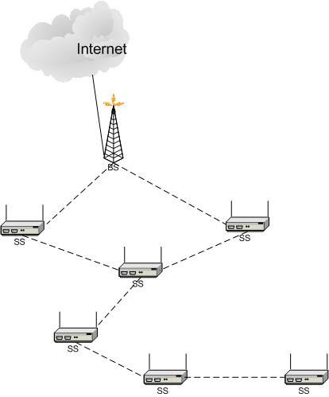

In IEEE 802.16d based mesh networks, the TDMA channel time is divided into frames with equivalent length. The frame length can be 10 ms or 20 ms. Each frame is further divided into a control subframe and a data subframe. Figure A.2 shows the frame structure of the mesh mode.

A control subframe is used for transmitting control messages and they are scheduled in a collision- free manner. The contention is resolved via scheduling information exchanged using a predefined algorithm known as mesh election. The data subframe is divided into 256 mini slots. The transmission time for each data packet has to be reserved before it can be sent out. The reservation of data transmission time is done through a centralized or a distributed algorithm.

FIGURE A.2

The mesh frame

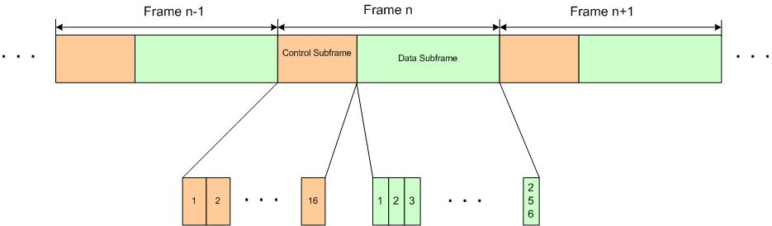

In a centralized manner, the SS sends bandwidth request to the BS it belongs to. The BS will then send down the allocated time slot resources to the corresponding nodes. With the centralized scheduling scheme, the resource reservation can be done over multiple hops. The SSs forward bandwidth request and grant information for other SSs. The bandwidth allocation could suffer from delays if the SSs issuing the bandwidth requests are many hops away from BS.

In the distributed scheduling scheme, nodes exchange their resource allocation bitmap via control message. Based on the resource allocation information, three-way-handshake mechanism is then used to avoid contention and interference in data transmission. This approach solves the hidden terminal problem encountered in the distributed wireless communication environment. Figure A.3 shows the three-way handshake resource allocation mechanisms. The sender sends a bandwidth request to the receiver first; the receiver then allocates the resources according to resource bitmap and sends back the granted allocation; the transmitter further rebroadcasts the allocated resources to their neighbours for collision and interference avoidance. All the neighbours that receive the grant or grant confirmation will update their resource allocation bitmap.

FIGURE A.3

Three-way hand-shake for bandwidth allocation

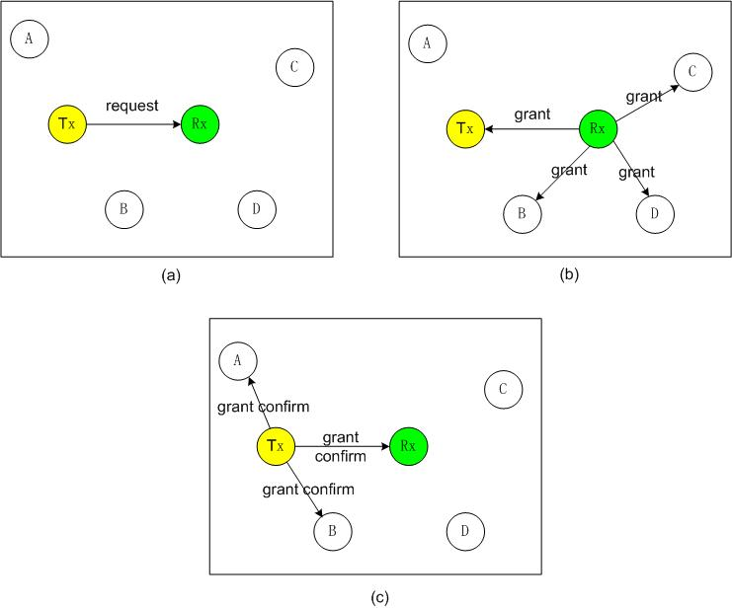

The choice of using centralized or distributed scheduling schemes depends on the depth of the routing tree. If the tree is shallow, then centralized scheme could be better. On the other hand, if the tree is large, then a distributed scheme is a better choice as delay due to centralized scheduling messages can be large.

For the physical layer, OFDM is used in the communication. IEEE 802.16-2004 has defined both OFDM and OFDMA-based physical layer profiles. The OFDM modulation scheme defined in 802.16-2004 use a fixed FFT size of 256 while the OFDMA scheme supports FFT size of 2 048. The physical layer defined in 802.16d is suitable for fixed wireless networks. The newer version physical layer that supports node mobility is defined in 802.16e uses OFDMA and support different radio bandwidths. Table A.1 shows some basic features of the OFDMA-based profiles defined in IEEE 802.16e.

TABLE A.1

Basic features of the OFDMA modulation scheme in 802.16e

|  |  |  |  |  |
| --- | --- | --- | --- | --- |
| FFT length | 128 | 512 | 1 024 | 2 048 |
| System bandwidth (MHz) | 1.25 | 5 | 10 | 20 |
| Symbol duration (μs) | 102.86 | 102.86 | 102.86 | 102.86 |
| Number of OFDM symbols (5 ms) | 48 | 48 | 48 | 48 |

Since maritime mesh networks will be formed by mobile nodes, the physical layer defined in 802.16e is more suitable. Adopting the physical layer used in 802.16e would be highly recommended.

Annex B  
  
Radiocommunication range required for the forming  
of a maritime mesh network

It is known that the density and location of ships in certain regions may vary over time. To form a mesh network with ships and land stations, it is necessary to know what the minimum required communication ranges among the land stations and ships are, so that the connectivity of the mesh network is kept above a certain desired level. Two terms, node connectivity and system connectivity have been defined in the study. Node connectivity refers to percentage of time that a node is connected to the land station. The system connectivity is defined as the average value of all node’s connectivity in the network.

To find appropriate values for communication range, the ship arrival model and movement model were derived based on data from Maritime Port Authority (MPA) of Singapore. The data records the movement of ships in the region located at the south of the east coast of Singapore as Fig. B.1 shows. The latitude and longitude of the north east corner of the studied region is (1.3167, 104.15) and the south west corner is (1.20, 103.867).

FIGURE B.1

Region for connectivity study

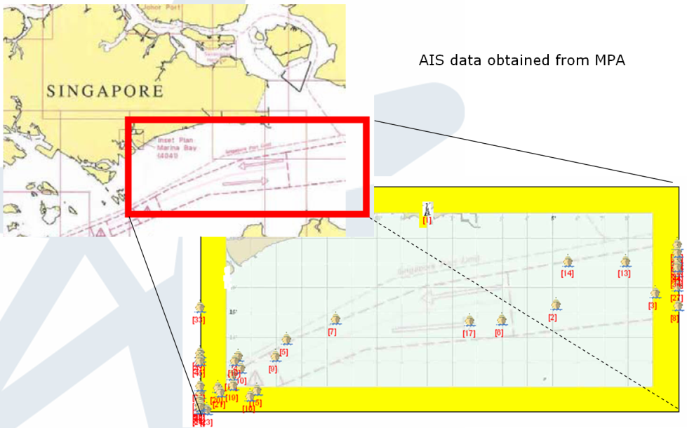

Based on the data, a model for the ship movement was derived with curve fitting as follows:

 (B.1)

 (B.2)

where *x* is speed, *c* is the multiplicative factor, μ is the mean value, and σ is the standard deviation. *F*(*x*) is the cumulative probability function for speed. For lane nearby Singapore port, the values for above model are *c* = 4.763146, μ = 10.383780, σ = 5.488477.

A model for the arrivals of ships was derived as follows:

 (B.3)

 (B.4)

where *x* is the inter-arrival time, and both *a* and *b* are arbitrary factors. *F*(*x*) is the cumulative probability function for inter-arrival time. For west bound, *a =* 0.292064 and *b* = 0.998286.

The generic maritime traffic lanes were modelled as Fig. B.2. The traffic lane is 10 km away from the coast with a width of 20 km. The lane is further divided into two lanes with equivalent width. Ships with opposite movement direction cruise in different traffic lanes. The ship arrival and movement models were inputs for this generic traffic lane model. Base stations are assumed to be stationed along the shore. The system connectivity was then studied by varying the communication range among ships, ship-to-shore, and the distance between land stations.

FIGURE B.2

Model of shipping lane

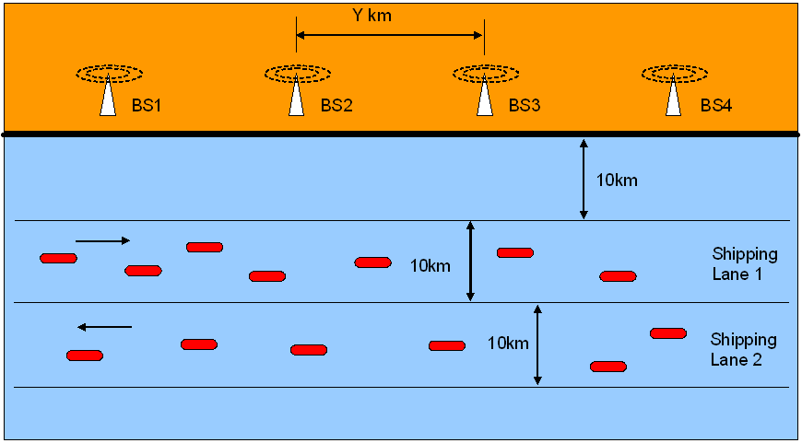

Dijkstra’s algorithm was used in forming the shortest path route for the mesh networks. Figure B.3 shows an example:

With the above traffic and shipping lane model, some simulation work for the connectivity study was carried out.

FIGURE B.3

Mesh network formed with ships

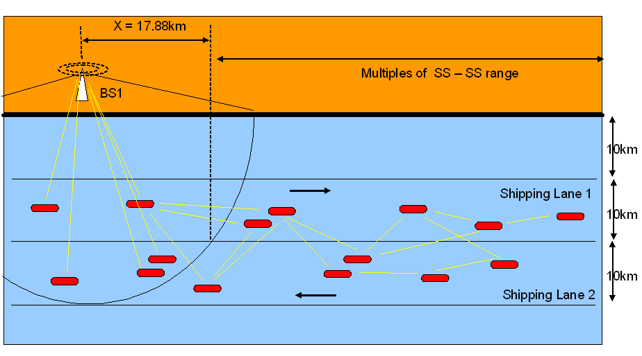

Figure B.4 shows the evaluation of the connectivity study based on different configuration of transmission range and distance between base stations. In Fig. B.4, bs_loc represents the distance between the base stations. “x” represents the transmission range between ships. bs-ss represents the transmission range of base station and ships. ss-ss represents the transmission range between ships.

According to the simulation results shown in Fig. B.4, when the communication range between BSs are 30 km, a communication range of 10 km between ships is not good enough as the total system connectivity is below 95%. To achieve full system connectivity of 100%, the communication range of ships should be at least 18 km. As a recommendation, a mesh network should be developed based on a radio range of at least 18 km between ships.

FIGURE B.4

Connectivity vs. transmission range

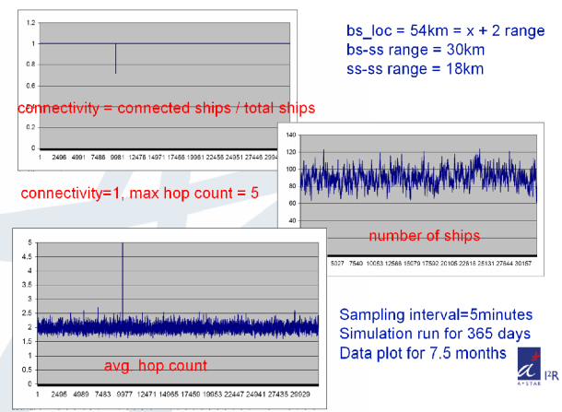

a)

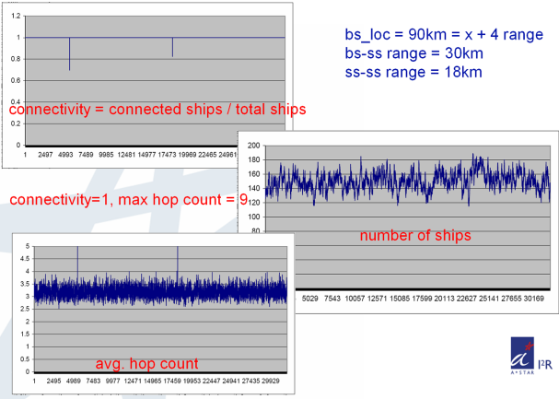

b)

\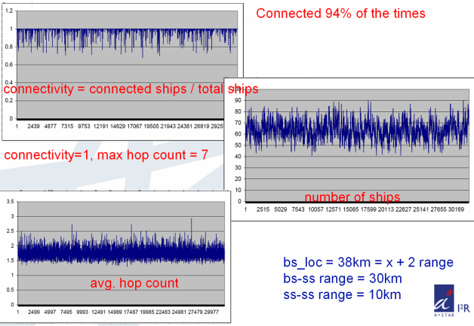

c)

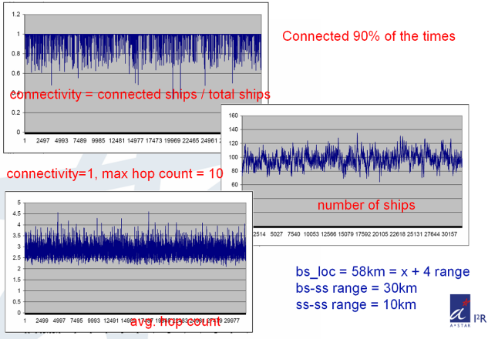

d)

Annex C  
  
Abbreviations

AIS Automatic identification system

BER Bit error ratio

BLH Bedok Light House (Singapore)

BS Base station

CSMA/CA Carrier sense multiple access/collision avoidance

CW Continuous wave

e.i.r.p. Equivalent isotropically radiated power

FER Frame error rate

FFT Fast Fourier transform

GMDSS Global Maritime Distress and Safety System

GPS Global Positioning System

ICI Inter-channel interference

IEEE Institute of Electrical and Electronics Engineers

IEEE 802.16e IEEE standard for mobile broadband wireless access systems

IEEE 802.11s IEEE draft IEEE 802.11 amendment for mesh networking

IMO International Maritime Organization

LoS Line-of-sight

LNA Low noise amplifier

LTE Long term evolution

MAC Media access control

MAN Metropolitan access network

MMSE Minimum mean square error

MPA Maritime Port Authority (Singapore)

NLoS Near line of sight

OFDM Orthogonal frequency-division multiplexing

OFDMA Orthogonal frequency-division multiple access

QAM Quadrature amplitude modulation

QPSK Quadrature phase-shift keying

PMP Point-to-multi-point

RF Radio frequency

RSSI Received signal strength indication

SHF Super high frequency

SS Subscriber station

SNR Signal-to-noise ratio

TDMA Time division multiple access

UDP User datagram protocol

WiMAX Worldwide Interoperability for Microwave Access