|  |
| --- |
| **Report ITU-R BT.2408-0**  **(10/2017)** |
| **Operational practices in HDR  television production** |
| **BT Series**  **Broadcasting service**  **(television)** |

Foreword

The role of the Radiocommunication Sector is to ensure the rational, equitable, efficient and economical use of the radio-frequency spectrum by all radiocommunication services, including satellite services, and carry out studies without limit of frequency range on the basis of which Recommendations are adopted.

The regulatory and policy functions of the Radiocommunication Sector are performed by World and Regional Radiocommunication Conferences and Radiocommunication Assemblies supported by Study Groups.

# Policy on Intellectual Property Right (IPR)

ITU-R policy on IPR is described in the Common Patent Policy for ITU-T/ITU-R/ISO/IEC referenced in Annex 1 of Resolution ITU-R 1. Forms to be used for the submission of patent statements and licensing declarations by patent holders are available from <http://www.itu.int/ITU-R/go/patents/en> where the Guidelines for Implementation of the Common Patent Policy for ITU‑T/ITU‑R/ISO/IEC and the ITU-R patent information database can also be found.

|  |  |
| --- | --- |
| Series of ITU-R Reports  (Also available online at <http://www.itu.int/publ/R-REP/en>) | |
| **Series** | Title |
| **BO** | Satellite delivery |
| **BR** | Recording for production, archival and play-out; film for television |
| **BS** | Broadcasting service (sound) |
| **BT** | Broadcasting service (television) |
| **F** | Fixed service |
| **M** | Mobile, radiodetermination, amateur and related satellite services |
| **P** | Radiowave propagation |
| **RA** | Radio astronomy |
| **RS** | Remote sensing systems |
| **S** | Fixed-satellite service |
| **SA** | Space applications and meteorology |
| **SF** | Frequency sharing and coordination between fixed-satellite and fixed service systems |
| **SM** | Spectrum management |

|  |
| --- |
|  |

|  |
| --- |
| ***Note****: This ITU-R Report was approved in English by the Study Group under the procedure detailed in Resolution ITU-R 1.* |

*Electronic Publication*

Geneva, 2017

© ITU 2017

All rights reserved. No part of this publication may be reproduced, by any means whatsoever, without written permission of ITU.

REPORT ITU-R BT.2408-0

Operational practices in HDR television production

(2017)

Summary

These operational practices are intended to provide initial guidance to help ensure optimum and consistent use of high dynamic range in television production using the PQ and HLG methods specified in Recommendation ITU-R BT.2100. They should be read in conjunction with Report ITU-R BT.2390 which provides additional background information.

# 1 Introduction

Recommendation ITU-R BT.2100 (BT.2100) specifies HDR-TV image parameters for use in production and international programme exchange using the Perceptual Quantization (PQ) and Hybrid Log-Gamma (HLG) methods.

Production in PQ is similar to standard dynamic range production. During capture, the scene may be exposed to produce the desired appearance on a reference monitor, ideally operating in the reference environment. Exposure setting may be assisted for example by setting a grey or diffuse white card to the desired signal level. It is possible for the PQ system to capture and encode information that is beyond the capabilities of a specific monitor, if that monitor cannot reach both the ideal peak luminance of 10 000 cd/m2 and the full extent of the BT.2100 wide colour gamut. If the PQ signal is not actively constrained to the capability of the reference monitor in use, more information may be revealed on a subsequent display with higher peak luminance or colour gamut.

HLG has been designed to enable a straightforward migration towards HDR television production, with few changes to SDR production working practices. The compatible nature of the HLG signal allows standard dynamic range monitors to be used in non-critical monitoring areas. HDR monitors are necessary only for critical monitoring, such as when colour grading, camera shading (or racking) and monitoring programme and preview outputs in a production gallery.

Just as line-up levels are useful for audio production, nominal signal levels for standard test charts are also useful for HDR television production. Nominal signal levels are given in order to facilitate camera line-up to help ensure consistency both within and between programmes.

Initial findings are given on viewer tolerances to variations in image brightness, aimed in particular at avoiding viewer discomfort at junctions between programmes and other items of content, as well as when switching between programme channels.

A practical guide is included for those transitioning from standard dynamic range (SDR) to high dynamic range (HDR) production. Key factors are also described for broadcasters to consider in facilitating the successful introduction of HDR-TV.

Experience of television programme production in HDR continues to grow, but is still in its relative infancy. These operational practices provide guidance based on knowledge gained so far.

# 2 Reference levels and signal format

During set-up, camera controls such as gain and shutter and others may be pre-adjusted to make best use of camera sensor capabilities, i.e. a balance between signal to noise ratio (SNR) and achieved sensor peak capability, and to establish a creative intent. During capture, the exposure may then be adjusted taking consideration of the reference levels listed below as well as the creative intent.

## 2.1 HDR Reference White

The reference level, HDR Reference White, is defined in this Report as the nominal signal level of a 100% reflectance white card. That is the signal level that would result from a 100% Lambertian reflector placed at the centre of interest within a scene under controlled lighting, commonly referred to as diffuse white[1]. There may be brighter whites captured by the camera that are not at the centre of interest, and may therefore be brighter than the HDR Reference White.

Graphics White is defined within the scope of this Report as the equivalent in the graphics domain of a 100% reflectance white card: the signal level of a flat, white element without any specular highlights within a graphic element. It therefore has the same signal level as HDR Reference White, and graphics should be inserted based on this level.

The nominal signal level corresponding to HDR Reference White, diffuse white and Graphics White is shown in Table 1.

Signal levels for common test charts and reflectance cards with different reflectances are calculated using scene light, from HDR Reference White. Details are given in § 2.2.

## 2.2 Signal levels for line-up in production

Signal levels in these operational practices are specified in terms of %PQ and %HLG. These percentages represent signal values that lie between the minimum and maximum non-linear values normalized to the range 0 to 1.

The values in Table 1 are presented as nominal recommendations for test charts and graphics for PQ production and for HLG production on a 1 000 cd/m2 (nominal peak luminance) display, under controlled studio lighting[2]. There is a practical benefit to the use of common levels for both PQ and HLG and Table 1 reflects guidance to use common levels. However, as PQ and HLG have different capabilities, and as HLG levels are influenced by a desire to maintain a degree of compatibility with SDR displays and PQ levels are not, as experience is developed in the use of both PQ and HLG this guidance to use common levels may need to be adjusted. Annex 1 describes a study of early HDR movies graded on a 4 000 cd/m2 PQ monitor. According to that study, luminance levels for indoor scenes were found to be typically about two thirds of the values indicated in Table 1, however those for outdoor scenes were found to be brighter. As producers of PQ content gain more experience, it is possible that levels in PQ indoor content may increase.

It is important to know the reflectance of greyscale charts and white cards, to ensure that cameras are aligned to deliver the appropriate signal level and consistency in production.

An 18% grey card is commonly used for camera set-up in non-live workflows as it is the closest standard reflectance card to skin tones. It may also be useful when trying to match SDR and HDR cameras as the 18% grey should not be affected by any SDR camera “knee”.

A 75% HLG or 58% PQ marker on a waveform monitor, representing the reference level, will help the camera shader ensure that objects placed at the centre of interest within a scene are placed within the appropriate signal range, and that sufficient headroom is reserved for specular highlights.

TABLE 1

Nominal signal levels for PQ and HLG production

|  |  |  |  |
| --- | --- | --- | --- |
| Reflectance Object or Reference (Luminance Factor, %)[3] | Nominal Luminance, cd/m2 (PQ & 1000 cd/m2 HLG) | Nominal Signal Level | |
| %PQ | %HLG |
| Grey Card (18%) | 26 | 38 | 38 |
| Greyscale Chart Max (83%) | 162 | 56 | 71 |
| Greyscale Chart Max (90%) | 179 | 57 | 73 |
| Reference Level: HDR Reference White (100%) also diffuse white and Graphics White | 203 | 58 | 75 |

NOTE 1 – The signal level of “HDR Reference White” is not related to the signal level of SDR “peak white”.

Typical signal levels for objects commonly used to set the exposure, where test charts are either not available or impractical, are given in Table 2. All these signals levels are preliminary, and are expected to be refined as experience is gained in HDR production.

Variations in these signal levels can be expected. The value for grass, for example, will depend on the type of grass planted for a given sport. Creatives making programme content may choose to encode content at differing levels, i.e. a dark indoor drama may put a grey card (and thus skin tones) at a lower level than shown in Table 1. Also, some productions may employ higher/brighter levels for outdoor scenes or for dramatic effect.

TABLE 2

Preliminary signal levels for common objects in PQ and HLG production

|  |  |  |  |
| --- | --- | --- | --- |
| Reflectance Object | Nominal Luminance cd/m2 (PQ & 1 000 cd/m2 HLG) | Signal Level | |
| %PQ | % HLG |
| Skin Tones | Vary by region | | |
| Grass | 30-65 | 39-47 | 40-55 |
| Ice Rink | 155 | 55 | 71 |
| White Objects | 140-425[4] | 54-66 | 69-87 |

## 2.3 Bit depth

High quality HDR programmes can be produced using conventional 10-bit infrastructure and 10-bit production codecs, with similar bitrates used for standard dynamic range production.

The use of 12-bit production systems will, however, give greater headroom for downstream signal processing for both PQ and HLG.

## 2.4 Signal range

Recommendation ITU-R BT.2100 specifies two different signal representations, “narrow” and “full”. The narrow range representation is in widespread use and is considered the default. The full range representation was newly introduced into Recommendation ITU-R BT.2100 with the intention of being used only when all parties agree.

The use of narrow range signals is strongly preferred for HLG, to preserve the signal fidelity and to reduce the risk of mistaking full range for narrow range signals (and vice versa) in production. Common video processing techniques such as image re-sizing, filtering and compression create overshoots that extend above the nominal peak luminance into the “super-white” region (where the signal *E′* > 1.0), and create under-shoots that extend below black into the “sub-black” region (where the signal *E′* < 0.0). In order to maintain image fidelity, it is important that the over-shoots and under-shoots are not clipped, which would happen if full-range signals were used. Furthermore, the black level of an HLG display used in production should be adjusted using PLUGE, which is made easier if sub-blacks are present in the signal.

The full range representation is useful for PQ signals and provides an incremental advantage against visibility of banding/contouring and for processing. Because the range of PQ is so large, it is rare for content to contain pixel values near the extremes of the range. Therefore, over-shoots and under-shoots are unlikely to be clipped.

## 2.5 Colour representation

Recommendation ITU-R BT.2100 describes two luminance and colour difference signal representations, suitable for colour sub-sampling and/or source coding: the non-constant luminance *Y′C′BC′R* signal format and the constant intensity ICTCP format.

As the ICTCP signal format is not compatible with conventional SDR monitors, and any benefits of the ICTCP colour representation are anticipated to be less for HLG than for PQ, so the non-constant luminance *Y′C′BC′R* signal format is preferred for HLG.

For PQ, the ICTCP format has been shown to be advantageous in a number of respects (see Report ITU-R BT.2390), but compatibility with signal handling equipment must be considered before choosing to employ this format.

# 3 Monitoring

Ideally, critical monitoring, such as the production switcher’s “programme” and “preview” outputs, should take place using a display that supports the full colour gamut and dynamic range of the signals. Monitors that support the BT.2100 colour space should include means to manage colours outside of their native display gamut.

## 3.1 Display of PQ signals

The content represented by PQ signals may be limited to the expected capabilities of the displays on which they are intended to be viewed, or they may be unlimited and represent the full level of highlights captured by the camera. In practice, monitors may not reach the full extent of the BT.2100 gamut or the 10 000 cd/m2 limit of the PQ signal, resulting in the possibility that some encoded colours may not be displayable on some monitors.

Monitors that support PQ may or may not include tone-mapping to bring very high brightness signals down to the capability of that monitor. Some monitors may clip at their peak output capability (e.g. 2 000 cd/m2). Some monitors may contain tone mapping that provides a soft‑clip.

For production use, monitors should generally perform a hard clip to the display capabilities, and should provide a means to identify pixels that are outside the display’s capability (either in brightness or colour). If a soft-clip is desired, a Look-up-table (LUT) can be applied to the signal to provide any desired tone mapping. Care should be taken for any content that is allowed to go outside the reference monitor colour gamut or dynamic range as that would not have been accurately presented to the operator and cannot be trusted as part of the approved or intended appearance. Reference monitors could provide a selectable overall brightness-attenuation in order to temporarily bring high brightness signals down to be within the display capability in order to provide a check on any content encoded brighter than the capability of the reference display.

If the BT.2100 PQ signal is presented to a monitor that expects a Recommendation ITU-R BT.709 (BT.709) input, the image will appear dim and washed out; colours will be desaturated and there will be some hue shifts. An external 3D LUT can provide the down-mapping function necessary to bring both colour and brightness into the BT.709 colour volume, thus allowing satisfactory display on the legacy BT.709 monitor. Some monitors may provide this function by means of an internally provided 3D LUT. While this allows viewing on the BT.709 monitor, the resulting images should not be used to make critical judgements of the HDR production.

If PQ signals must be monitored in an environment brighter than the reference environment (specified in BT.2100 as having a 5 cd/m2 surround), manufacturers may provide modified brightness and display characteristics intended to compensate for the different viewing environment.

## 3.2 Display of HLG signals

Table 5 of Recommendation ITU-R BT.2100 specifies the HLG EOTF for reference displays. Note 5e specifies how the display’s gamma is adjusted to compensate for changes in the response of the human visual system as the eye adapts, when using HLG displays of different peak luminance. The gamma adjustment allows consistent signals to be produced from a range of displays with different peak luminance. Details can be found in § 6.2 of Report ITU-R BT.2390.

Note 5f of Recommendation ITU-R BT.2100 recognises that the display’s gamma should further be adjusted to compensate for the adaption state of the eye in non-reference production environments. A formula specifying the gamma adjustment is also given in § 6.2 of Report ITU-R BT.2390.

Contrast, brightness and display system gamma (α, β and γ in Table 5 of Recommendation ITU-R BT.2100) are adjusted according to the viewing environment, as appropriate.

Firstly, the monitor gamma is adjusted, according to the formula in Note 5e of Recommendation ITU‑R BT.2100, to the appropriate value for the target nominal peak luminance of the display. The target nominal peak luminance may depend on the viewing environment.

Table 3 shows the gamma values for a range of typical production monitors in the reference viewing environment (5 cd/m2 surround).

TABLE 3

HLG Display Gamma

|  |  |
| --- | --- |
| Nominal Peak Luminance (cd/m2) | Display Gamma |
| 400 | 1.03 |
| 600 | 1.11 |
| 800 | 1.16 |
| 1 000 | 1.20 |
| 1 500 | 1.27 |
| 2 000 | 1.33 |

The display’s nominal peak luminance is then adjusted using the user gain control (legacy “contrast” control) and a photometer, with an HDR reference white (75% HLG) window test patch (typically 1% screen area). Table 4 shows the luminance levels for a range of typical production monitors.

TABLE 4

Test Patch Luminance Levels for Different Nominal Peak Displays

|  |  |
| --- | --- |
| Nominal Peak Luminance (cd/m2) | HDR Reference White (cd/m2) |
| 400 | 101 |
| 600 | 138 |
| 800 | 172 |
| 1 000 | 203 |
| 1 500 | 276 |
| 2 000 | 343 |

In non-reference viewing environments, a further adjustment should be made to the display’s system gamma to compensate for the adaptation state of the eye. Table 5 illustrates the recommended gamma adjustments for a range of common production environments, assuming a surround reflectance of approximately 60%, typical of light coloured walls. However, for the greatest signal consistency, the reference conditions specified in ITU-R BT.2100 should be used.

TABLE 5

Typical production environments with different surround conditions

|  |  |  |  |
| --- | --- | --- | --- |
| Typical environment | Typical Illumination[5] (Lux) | Typical luminance[6] (cd/m2) | Typical gamma adjustment |
| Office based production sunny day | 130 | 25 | −0.05 |
| Office based production cloudy day | 75 | 15 | −0.04 |
| Edit Suite | 50 | 10 | −0.02 |
| Grading Suite | 25 | 5 | 0.00 |
| Production gallery/ Dark grading suite | 3 | 0.5 | +0.08 |

As a guide, a gamma adjustment of 0.03 is just visible to the expert viewer when viewed side-by-side. Thus, no additional gamma adjustment is necessary across the majority of critical television production environments.

However, a gamma adjustment is suggested for bright environments such as those sometimes used for news production, or where a colourist prefers to work in a very dark environment.

Lastly, the display black level is adjusted using the black level lift control (legacy “brightness” control) and a PLUGE signal such that the negative stripes on the test pattern disappear, whilst the positive stripes remain visible.

### 3.2.1 Display of HLG signals on SDR screens

For best results when displaying HLG signals on SDR screens, the SDR monitor should support the Recommendation ITU-R BT.2020 (BT.2020) colour gamut. However, for simple confirmation of the presence or absence of a signal, BT.709 colour monitoring may be sufficient. However, BT.709 colour monitors will show a de‑saturated image with visible hue shifts.

Non-critical production monitors, such as multi-view production monitors, may be SDR BT.709 displays. A three-dimensional look-up table (3D-LUT) may be included in the monitoring chain to down-convert from BT.2100 HDR signals to BT.709 SDR, minimising colour distortions on such displays. Suitable look-up tables are often included within the display monitors themselves.

# 4 Image brightness

Work has commenced on developing automatic objective measures for brightness, akin to those in common use for audio loudness today. Experimental results (1) show that a simple mean of displayed pixel luminances provides a good correlation with subjective brightness at 3.2 picture heights from the screen. The effectiveness of this simple objective metric suggests that real-time brightness monitoring in production is a realistic goal. This would give guidance to content producers, enabling comfortable viewing in the home, whilst allowing a range for artistic freedom. The metric could be used further to characterise long-term and short-term average brightness.

## 4.1 Comfortable brightness of static images

A study was performed by NHK to learn what range of luminances are judged comfortable by viewers. A number of SDR images that, on a 100 cd/m2 reference monitor, varied in average luminance over a range of 10-50 cd/m2, were used. The study was conducted using a relative display system that employed a 3 500 cd/m2 display that was adjusted to simulate a range of display luminance levels, thus the results are relevant to the HLG system that also employs displays with relative luminance. Peak luminances of 500, 1 000, 2 000, and 2 500 cd/m2 were simulated. Viewers were asked to judge whether images were “appropriate”, “too bright”, or “too dark”.

Figure 1 shows the results in the reference viewing environment (dim surround). For each simulated display peak luminance, images with average luminance less than 25% of the peak luminance being simulated were not judged as “too bright”. Images with average luminance greater than 25% of peak luminance began to be judged as “too bright” by many viewers. The judgements were essentially independent of the peak luminance being simulated on the display; this indicates that viewers’ eyes were adapting to the different display luminances. The implication of these results is that HLG images with average luminance on a 1 000 cd/m2 HLG monitor of less than 250 cd/m2, would not be judged as too bright on an HLG monitor of any luminance up to at least 2 500 cd/m2.

FIGURE 1

Percentage of votes for “too bright” in the reference environment (dim surround)

|  |  |
| --- | --- |
| Peak luminance 500 cd/m2 | Peak luminance 1 000 cd/m2 |
|  |  |
| Peak luminance 2 000 cd/m2 | Peak luminance 2 500 cd/m2 |
|  |  |

In this experiment, viewers were asked to judge the brightness of static images. However, sudden changes in brightness can be uncomfortable even when the static levels would be acceptable, so different requirements are needed to ensure viewer comfort when brightness jumps can occur.

## 4.2 Tolerance to Brightness Shifts

Unexpected changes in image brightness might occur at programme junctions, with interstitials or channel changes. It is important to ensure that the brightness variations within HDR programmes are constrained to avoid viewer discomfort.

Subjective tests reported by the BBC investigated viewer tolerance to sudden changes in overall brightness for HDR television, using the mean pixel display luminance as a measure of brightness as described in (1). For the tests, the luminance behind the screen was 5 cd/m2, and the peak screen luminance was 1 000 cd/m2 (2). Subjects were asked to rate the change in overall brightness between two still HDR images.

Figure 2 shows the overall results, with transitions from the first brightness A to the second brightness B categorised according to whether they are “not annoying”, “slightly annoying”, or “annoying”. Two regions are marked in the figure with thick blue lines. The inner region, with mean display luminance levels of 10 to 80 cd/m2, contains no annoying jumps, and so could be considered a suitable range for normal operation. The outer region, with mean display luminance levels of 5 to 160 cd/m2, includes some slightly annoying jumps, and so could be considered an extended range for creative effect. It is expected that night scenes will usually have an overall brightness at the lower end of the normal operating range, and sunny outdoor scenes will have an overall brightness at the upper end of the range.

The suggested ranges can be freely exceeded over a short timescale for special creative effect, but it is proposed that the average brightness over the length of a programme be within the normal operating range of 10 to 80 cd/m2. It should be noted that this range still allows for significant differences in the average brightness of whole programmes, so, for example, a “moody” or “bright” look can be achieved overall.

The results presented previously in Figure 1 provide evidence that the eye adapts to a particular luminance level. Hence the scene light levels corresponding to specified brightness shift tolerances are likely to be broadly applicable for HLG displays over a range of different peak luminances.

A comfortable overall brightness does not ensure that the content makes good use of the available dynamic range. Further guidance may be useful to characterise best use of the dynamic range for common scene types.

FIGURE 2

Transitions from brightness A (cd/m2) to brightness B (cd/m2) categorised by level of annoyance

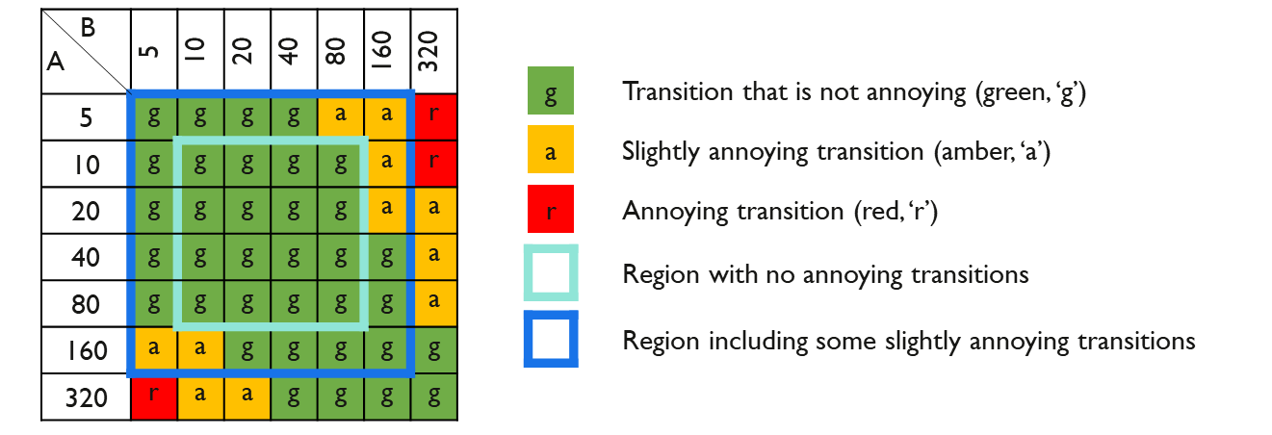

# 5 Inclusion of standard dynamic range content

**Definitions**

**Mapping** – Placing SDR content in an HDR signal to preserve the “look” of the SDR content (note that the word “mapping” (when used alone) is not a shortened form of the term “tone mapping”, which is a different process, as defined below).

**Inverse tone mapping** – Placing SDR content in an HDR signal with expanded luminance range to emulate an HDR look (i.e. up-conversion).

**Tone mapping** – Converting HDR content to an SDR signal range (i.e. down-conversion).

Standard dynamic range (SDR) content may either be “mapped” or “up-converted” into an HDR format for inclusion in HDR programmes.

Methods for mapping, place SDR content into an HDR container, analogously to how content specified using BT.709 colorimetry may be placed in a BT.2020 container. This approach is intended to preserve the “look” of the SDR content when shown on an HDR display.

In contrast, up-conversion (sometimes known as inverse tone mapping) is intended to expand luminance values to use more of the available HDR luminance range, and thereby leverage the display capabilities. In this Report, the focus is on mapping of SDR content into an HDR container.

There are two possible approaches to SDR mapping, depending on the application:

– Display-referred mapping is used when the goal is to preserve the colours and relative tones seen on an SDR BT.709 or BT.2020 display, when the content is shown on a BT.2100 HDR display; possibly at a slightly higher peak luminance to provide a value for diffuse white and skin tones that is more consistent with the brightness of native HDR content. An example of which is the inclusion of SDR graded content within an HDR programme.

– Scene-referred mapping is used where the source is a direct SDR camera output and the goal is to match the colours and lowlights and mid-tones of a BT.2100 HDR camera. An example of which is the inter-mixing of SDR and HDR cameras within a live television production.

More detailed technical descriptions of the above mapping process, including how to ensure comparable brightness of skin tones between HDR and mapped SDR content, are given in Report ITU‑R BT.2390‑3.

The nominal signal levels described in § 2.2 may be considered for format conversions, including when mapping SDR content into HDR. HDR-produced content is expected to vary around the nominal signal levels to allow artistic freedom, and to adapt to different scenes and objects.

## 5.1 Matching BT.709 SDR and BT.2100 cameras

It may be beneficial to include signals below black (sub-blacks) and above the SDR nominal peak white (super-whites) in the conversion process. Such signals, which are often present in live SDR television production, effectively increase the colour gamut captured by the camera beyond the BT.709 colour primaries. The technique can be used to ensure a closer match between BT.709 and BT.2100 cameras for colours that are close to the BT.709 colour volume boundary.

## 5.2 Use of 8-bit content

Although a minimum of 10-bits should be used for HDR production, there may be occasions when it might not be possible to avoid including 8-bit SDR content within an HDR programme. In such cases, care should be taken if up-conversion rather than mapping is used to place the content into an HDR signal container. The up-conversion process typically expands the SDR highlights. The 8‑bit resolution, compounded by any 8‑bit video compression, will limit the amount of highlight expansion that can be applied before banding and other artefacts become visible.

# 6 Conversion between PQ and HLG

Methods of converting between the PQ and HLG formats are described in § 7 of Report ITU‑R BT.2390-2 (or later).

Notably, because of the difference in the way that PQ and HLG signals are rendered on displays of different peak luminance, a conversion rather than a simple transcode is required. By choosing a reference peak displayed luminance (*Lw*) of 1 000 cd/m2 for the HLG signal, and requiring that the PQ signal be limited to the same peak luminance, consistent brightness is achieved in the converted signals.

# 7 Transitioning from SDR BT.709 to HDR BT.2100 production

## 7.1 Live production

During the transition from SDR to HDR production, the majority of viewers will be watching in SDR. So it is essential that the SDR production is not compromised in any way by the introduction of HDR. It is, however, unlikely to be economic or practical to cover live programmes and events with totally independent HDR and SDR production facilities. As well as the cost of the two productions, there may simply be insufficient camera positions available for both HDR and SDR cameras.

A native HDR production architecture is illustrated in Fig. 3. This can be used to either maintain or enhance the quality of the SDR output, as described in §§ 7.1.1 and 7.1.2 respectively.

FIGURE 3

HDR production with SDR derived by down-conversion

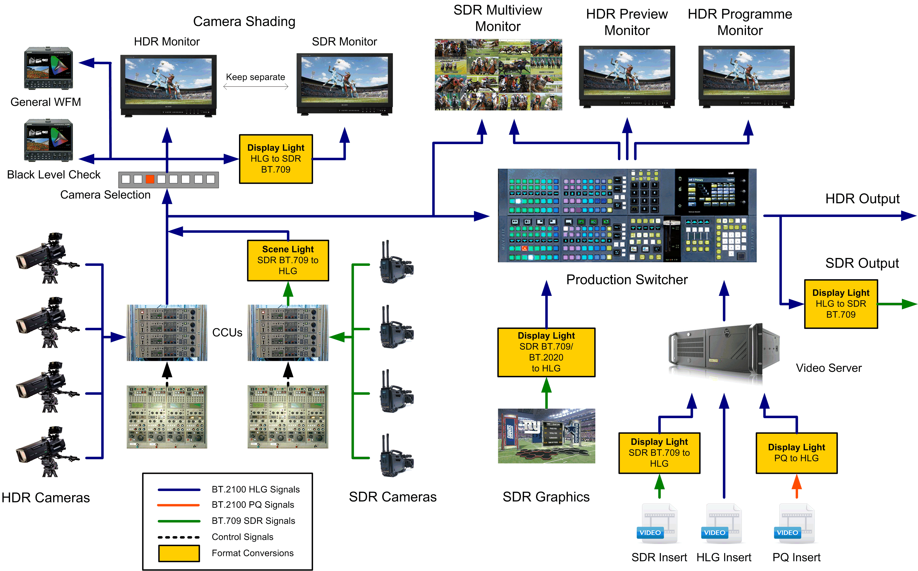

In this example, input to the production switcher is HDR. This removes the need to process separate HDR and SDR feeds throughout the production chain. The primary output from the production switcher is HDR, and the SDR BT.709 output is derived by a down-conversion of the HDR BT.2100 signal. The Figure illustrates HLG production, but PQ based production is similar.

SDR BT.709 cameras can be included in the production by using the “scene-referred” SDR mapping technique, with OOTF adjustment, as described in § 5 (additional technical details are given in Report BT.2390).

Graded SDR content and SDR graphics may be included in the HDR programme. To ensure that the SDR “look” is maintained, the “display-referred” SDR mapping described in § 5 should be used.

Work is currently underway to determine the best practice for HDR key signals. In the interim, using an SDR key signal directly has been found to deliver satisfactory results.

Where SDR content is mapped into an HDR container and the HDR signal then down-converted to feed an SDR service (known as SDR-HDR-SDR “round-tripping”), the mapped SDR content may appear darker on the SDR service than if it had been broadcast directly. Section 7.2 discusses issues that can arise from “round-tripping”.

Differences in black level may be more visible in the down-converted SDR signal than in the HDR signal, as bright highlights in the HDR image can mask detail in the shadows. To help ensure a consistent black level in the HDR and down-converted SDR signals, a dedicated waveform monitor displaying the lower portion of the signal range is recommended.

This architecture can be used to either maintain or enhance the quality of the SDR output, as described below.

### 7.1.1 HDR focussed production

For optimum quality of HDR pictures, both HDR and SDR cameras should be shaded using an HDR monitor. Nominal signal levels for shading are given in § 2.2.

### 7.1.2 SDR focussed production

If the SDR production must not be compromised, both HDR and SDR cameras should be shaded using an SDR monitor fed via a down-converter.

Note, however, that the eye may adapt to the brighter HDR screen, affecting the appearance of signals on the dimmer SDR screen. So the HDR and SDR screens should be separated for critical assessment of the down-converted SDR signal.

## 7.2 SDR-HDR-SDR “Round-Tripping”

As described in § 7.1, SDR signals will be converted to HDR during production and back again to SDR for distribution. This is the process known as “round-tripping”.

Ideally, the process of round-tripping would be transparent. However, in practice, this is difficult to achieve and is the subject of on-going investigation. To understand the difficulties that can arise it is helpful to consider the individual processes of up-conversion to HDR and down-conversion from HDR to SDR.

There are two main approaches to including SDR content in HDR programmes. The first is mapping the signal to HDR so that an SDR signal is “contained” within the HDR signal. The alternative approach, up-conversion, or inverse tone mapping, aims to increase the dynamic range.

Down-conversion of HDR to SDR is considered in Report BT.2390; for example, in the section on display mapping where the conversion can be regarded as a mapping of HDR onto an SDR display. Typically, HDR to SDR conversion might use a non-linearity, similar (and analogous) to the “knee” function found in cameras. This non-linear mapping reduces the dynamic range of highlights but does not completely remove them.

In both up-conversion and down-conversion, careful attention should be paid to those “diffuse” parts of the scene that can be supported in both SDR and HDR formats. However, this is made difficult by variation of the scene luminance factor corresponding to reference white (100% SDR signal) in SDR productions. SDR signals provide little “headroom” for highlights. Some SDR signals are simply clipped of most of the highlights (e.g. live sport), but in other cases include more highlights through the use of a camera “knee” (e.g. drama or sport “beauty” shots).

The optimum techniques for up-conversion followed by down-conversion are still under investigation.

## 7.3 Hardware colour matrices

Many of the existing hardware devices assume BT.709 colour when converting between *R′G′B′* and *Y′C′BC′R* signal formats.

Where it is not possible to configure a device for BT.2100 colour, a correction needs to be applied elsewhere. This might be in the conversion matrix on the complementary interface at the other end of the link (e.g. within a display) or, as illustrated in Fig. 4, within a look-up table performing a format conversion.

FIGURE 4

Example of colour matrix compensation within a LUT

PQ to HLG transform

LUT processing

R'G'B' to Y'C'BC'R to using BT.709 matrix (via LUT)

Y'C'BC'R to R'G'B' using BT.709 matrix

Y'C'BC'R to R'G'B' using BT.709 matrix

Y'C'BC'R to R'G'B' using BT.2100 matrix (via LUT)

Y'C'BC'R BT.2100 signal

Y'C'BC'R to R'G'B' using BT.709 matrix (via LUT)

R'G'B' to Y'C'BC'R using BT.2100 matrix (via LUT)

Y'C'BC'R BT.2100 signal

Annex 1  
  
Study to evaluate levels for PQ content

A study was performed to gain information that could be used to inform initial guidance on video levels for HDR production. The study used existing SDR materials from both broadcast content and home video content. The study also used PQ HDR materials, mostly from home video grades of movies that were done on a 4 000 cd/m2 PQ monitor. From this study, some data on levels is shown. While much of the study employed (for convenience) Caucasian skin levels, existing data on the reflectance of the Caucasian skin was employed to change the reference from skin levels (which of course are not consistent) to use of the conventional 18% grey card.

Details

Skin tones from both broadcast content and home cinema release content were analysed. The indoor SDR broadcast content was manually segmented for well-exposed (Caucasian) skin tones and was analysed assuming a BT.1886 reference monitor with 100 cd/m2 reference white and BT.709 colour primaries. A sampling of the images analysed (courtesy of SVT and FOX) is shown below:

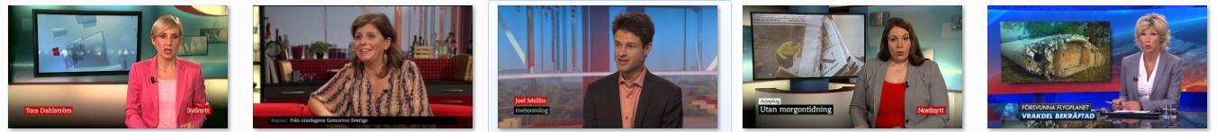

Due to the scarcity of HDR broadcast content currently available, in order to compare HDR and SDR content, the same analysis was completed utilizing HDR and SDR graded indoor scenes from cinematic content for home distribution. The cumulative histogram is given below.



HDR: 17 cd/m2

SDR: 15 cd/m2

SDR: 23 cd/m2

For cinematic content for the home, HDR Caucasian skin tones are very similar to SDR skin tones (17 cd/m2 compared to 15 cd/m2), but the standard deviation is larger. Extrapolating from this, it is hypothesized that indoor Caucasian skin tones in HDR broadcast may average 26 cd/m2 with a larger deviation than SDR broadcast. The 26 cd/m2 value maps to 38% of full scale in PQ space (or 38% PQ).

Utilizing skin tones as a reference level is, of course, not satisfactory because they vary widely across ethnicities and environments. To achieve consistency, an 18% grey card may be used instead to calibrate camera exposure. To convert from Caucasian skin tone brightness and its 38 %PQ level to find the %PQ level of an 18% grey card, a database of 340 measured samples of skin tones (Sun, Fairchild) was used to determine skin tone reflectance levels. This database shows that Caucasian skin tones have a reflectivity of 25% of that of a diffuse white object (white card: 100% Lambertian reflector).

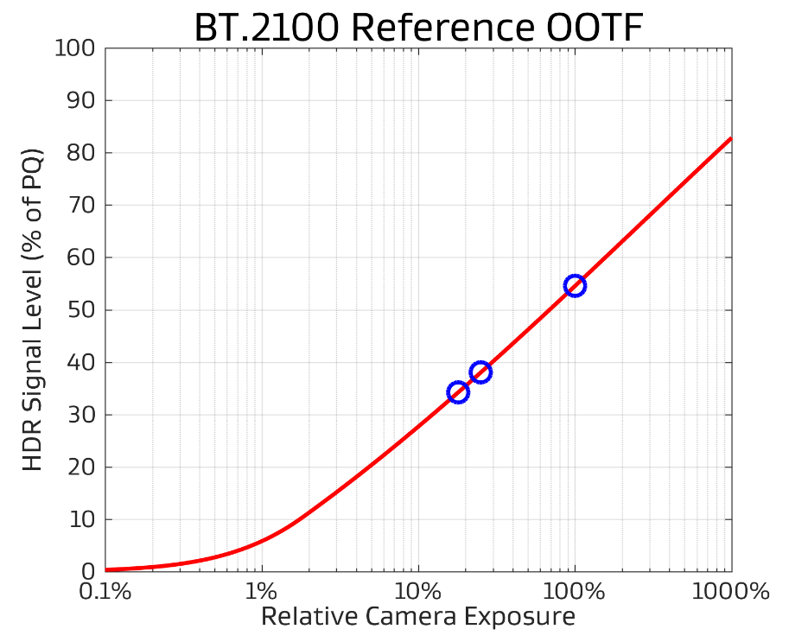

Diffuse White: 54%

Skin Tones: 38%

18% Grey Card: 34%

Using the BT.2100 reference PQ OOTF, 26 cd/m2 may be related to relative scene exposure. Then the 25% and 18% reflectivity relationship may be used to solve for the appropriate 18% grey card level: 17 cd/m2 on a PQ reference display or 34% on the PQ scale. This is the expected luminance for a grey card anchor in HDR broadcast content for indoor scenes, for content consistent with existing practice. A diffuse white would be expected to yield 54% PQ.

By segmenting HDR indoor and outdoor scenes, it was found that outdoor skin tones were an average of 1.7 stops brighter than indoor skin tones. Assuming a 1.7 stop increase in brightness from an indoor to outdoor scene, the exposure for an 18% grey card outdoors would be set to 45% PQ.

The Table below summarizes Dolby’s findings for current content; these values could be considered tentative recommendations on settings of an 18% grey card and diffuse white objects in terms of both %PQ value and reference display brightness.

|  |  |  |  |  |
| --- | --- | --- | --- | --- |
|  | Indoor | | Outdoor | |
|  | **cd/m2** | **% PQ** | **cd/m2** | **% PQ** |
| 18% Grey Card | 17 | 34 | 57 | 45 |
| Diffuse White | 140 | 54 | 425 | 66 |

The levels shown in this study are representative of some early HDR PQ content. More experience with HDR in broadcast is needed to settle on final values to be recommended. A major finding is that early HDR production has employed skin levels similar to those used in SDR content. The SDR skin levels are of necessity limited in order to leave room for full diffuse whites, and some trace of highlights. HDR signals have enough range that skin levels do not need such limitations. Given that in HDR production there is no need to limit the skin levels to those used in SDR production, it is possible that these may increase in brightness in subsequent productions. Thus, the values in the Table above might be considered the lower end of future operating levels.

Annex 2  
  
Factors facilitating successful HDR-TV

Broadcasters will benefit from a graceful, non-disruptive introduction of HDR-TV into television broadcasting and this will require the study of an end-to-end migration path from current standard dynamic range (SDR) broadcasting to HDR-TV broadcasting. With that in mind, following are some key factors to be considered when selecting which of the two BT.2100 HDR systems are selected for a given application.

The majority of television audiences will, for a period of several years, continue to watch programmes on consumer displays that were not designed to render HDR images. It will be important that the HDR-TV image systems will allow easy automatic conversion of an HDR-TV programme master to a standard dynamic range version. Also, mapping of SDR programmes into HDR will be key to inter-mixing old and new content in HDR programming.

The HDR-TV image system should provide, where appropriate, a degree of compatibility with existing workflows and broadcasters’ legacy infrastructure[7], including the possibility to use HDR‑TV in live and non-live workflows and to easily intermix HDR-TV and SDR-TV programme material both in the temporal and in the spatial domain, including graphics and video overlays. The HDR-TV image system should allow easy image and waveform monitoring throughout the broadcast chain allowing for different viewing environments while providing consistent image reproduction at each point.

The HDR-TV image system and the creative practices in production should be arranged so they lead to no adverse effects such as visual fatigue or discomfort when viewed for a significant period of time. Additionally, care should be taken in HDR production and in SDR up-conversion with regard to the effect a greater image dynamic range may have on those viewers affected by visual disturbances such as photosensitive epilepsy. This will require some study with respect to the types of scene content that may trigger such adverse effects in such viewers.

References

[1] K.C. Noland, M. Pindoria and A. Cotton, "Modelling brightness perception for high dynamic range television," *Ninth International Conference on Quality of Multimedia Experience (QoMEX)*, Erfurt, 2017.

[2] K.C. Noland and M. Pindoria, “A Brightness Measure for High Dynamic Range Television,” IBC Conference, September 2017.

1. Diffuse white is the white provided by a card that approximates to a perfect reflecting diffuser by being spectrally grey, not just colorimetrically grey, by minimizing specular highlights and minimizing spectral power absorptance. A “perfect reflecting diffuser” is defined as an “ideal isotropic, nonfluorescent diffuser with a spectral radiance factor equal to unity at each wavelength of interest”.
2. The test chart should be illuminated by forward lights and the camera should shoot the chart from a non-specular direction.
3. “Luminance factor” is the ratio of the luminance of the surface element in the given direction to the luminance of a perfect reflecting or transmitting diffuser identically illuminated.
4. From examination of movies graded on a 4 000 cd/m2 PQ monitor, see Annex 1.
5. Measured perpendicular to the screen.
6. Assuming ~ 60% reflectance surround.
7. In this context, the term “infrastructure” includes all processing and connectivity (SDI, Bit Rate Reduction, Switchers, Routers, etc.).