report ITU-R BT.2003
THE HARMONIZATION OF HDTV STANDARDS BETWEEN BROADCAST
AND NON-BROADCAST APPLICATIONS
(1994)

SECTION 1

1. Introduction
This Report concerns the studies of the ITU-R, pursuant to Decision ITU-R 91, with regard to the harmonization of standards for HDTV in broadcasting and production and the standards for non-broadcast uses of HDTV*. In particular, these studies focus on:
- application in non-broadcast uses and the possible impacts that broadcast forms of HDTV might have on the standards and practices to be developed for non-broadcast uses in the ISO, the IEC, and the ITU-T;
- the constraints that might exist for the development of standards for broadcast HDTV due to non-broadcast uses. This activity will be useful input to Task Group 11/1, Working Parties 11D, 10-11R, 10-11S, and possibly to other groups of the ITU-R;
- the areas where commonality between the standards for broadcast and non-broadcast uses of HDTV might be beneficial and the possible impacts of this commonality;
- possible areas where important differences between the standards for broadcast and non- broadcast uses may exist and possible ways to minimize their impacts.
In the studies of harmonization, a number of important concerns have been identified;
- Selection of the parameter values for television systems may fall into two classes:
a) image-related parameters of the optical/electronic interface in the camera or the electronic/optical interface in the display. Recommendation ITU-R BT.709 is an example of this class of specification;
(b) transmission-related parameters of the encoded, filtered, redundancy-reduced description of the image, from which it may be reconstructed, albeit, less than perfectly. Harmonization activities may be different in the two areas as the first relies more on fundamental, immutable concepts, while the second is constrained by service objectives and contemporary technology;
- harmonization activities should recognize that many aspects of the work relate to basic facts, which cannot be harmonized. What is then required is an architectural structure for television images that is harmonious in respect of spatial, colorimetric and temporal characteristics, into which specific systems can be nested;
- other aspects of a television system may be optimized for specific applications, industries or contemporary technologies and their harmonization may not be helpful. Conversely, harmonization of the characteristics of the delivery mechanisms (e.g., terrestrial, satellite, cable, fibre, disc, tape) to the consumer's television receiver would be beneficial;
- some aspects of a television system may not be interesting from a harmonization viewpoint, not having consequences beyond specific applications or industries;
- a major concern of harmonization must be the transfer of images between systems and applications. In the interchange, lack of harmonization or lack of definitions can result in unsatisfactory results;
- harmonization of standards for television and imagery may lead to economic advantages derived from commonality of equipment or components, economies of scale or other factors. The equitable distribution of these advantages may be an important factor in the acceptance of the standards;
- the development of standards for television and imagery may be rendered more efficient and rapid with appropriate degrees of harmonization, through the coordination of activities and the reduction of redundant effort.
It is to be noted that, although the main focus of the harmonization activity concerns television and image systems at high resolutions (HDTV/HRI), increasingly, the harmonization activity impacts television and image systems at lower levels of resolution and quality. This is particularly the case for those systems based on digital technology.

SECTION 2

2. The range of HDTV and high-resolution imagery uses, the organizations responsible for standards and their development
HDTV and high-resolution imagery (HRI) techniques have been developed to improve the quality of today's television broadcasting (production and emission), but applications of HDTV now exist in many other non-broadcast areas. The following have been indicated in contributions (see Bibliography).

TABLE 1

SECTOR | APPLICATION
Education | Teaching and training
Advertising & promotion | Electronic billboards, catalogues
Pre-recorded media | Discs and tapes
Motion pictures | Film production, film post-production, theater presentation
Industrial uses | Surveillance of production, transport, product inspection
Electronic file systems | Museums, libraries
Video conferencing | High-resolution multiple windows
Medicine | Moving and still pictures for surgery, diagnosis
Aeronautical uses | Radars, simulators
Military | Aeronautical uses and surveillance
Computer uses | Computer graphics, home interactive video terminals, image simulation, desktop multi-media
Printing | Graphics, still pictures
Photography | Still images
Scientific | Microscopy, astronomy, simulation

In some applications, different requirements might preclude common standards. In others, the use of common standards appears very likely. In between, there may be applications at levels of commonality determined by considerations of cost and convenience (e.g., standards based on common display devices).
Table 2 gives an overview of the responsibilities of the ITU-R, the ISO, the IEC and the ITU-T and provides an indication of where liaison may be necessary to harmonize standards for HDTV between broadcast and non-broadcast applications.
At the meeting of IWP 11/9 (Tokyo, 1990), it was indicated that SC 12A of the IEC was considering work on the HDTV receiver. To perform this work, however, the IEC would first require that the ITU-R provides information on the emission system.
At this same meeting, the ISO submitted information concerning the standardization in the field of image technology. This activity is carried out jointly with the IEC by the ISO/IEC JTC 1. Task Group 11/4 is invited to take part in the studies of a new Joint ISO/IEC TAG in which high priority will be placed on colour, coding and HDTV.
Also relevant is a meeting held by IWP 11/9 ad hoc Group on Liaison with representatives from the IEC, the ISO, the CCITT and the CCIR (Geneva, February 1991) [11/9-125]. The purpose of the meeting was to:
- review the work of these groups in the area of HDTV;
- identify common goals, areas for coordination and possible gaps/overlaps in work programmes or schedule conflicts/misalignment; and
- consider proposals for joint work, coordination, liaison, etc.
A significant output of this meeting was the conclusion that a strong liaison is needed between the ISO/IEC JTC1/SC2/WG11, ITU-T WP XV-1, and ITU-R Working Party 11B with regard to the matter of video coding, especially as it concerns equipment for home use.
In addition, an ITU Coordination meeting on Integrated Video Services in Broadband ISDN was held in Tokyo in September 1991 [11/9-124]. The meeting was attended by representatives of the IEC/ISO JTC-1, the ITU-T and the ITU-R (SG 11, CMTT), and was a follow-up to an earlier informal gathering of similar representatives. The primary purpose of the meeting was to closely coordinate two areas:
- standardization of network issues, to ensure similar availability timeframes and technical attributes; and
- standardization across different video services and coding groups, to ensure consistency in technical base and service area to maximize commonality of systems and increase interworking capability. Toward these ends, the groups represented at the meeting offered reports of current and future activities in these areas, as well as indications regarding the timeframe of standards related to video network, service and coding. Several matters requiring attention, including matters for ITU-R Study Group 11, were identified at the meeting, and a plan of action to address them was agreed upon.
The range of applications for high-resolution image technology is very wide, and HDTV, as defined in Report ITU-R BT.801 in both psychophysical and objective terms, might be considered to be a set of specific applications of this technology.

TABLE 2
Activity relationship between IEC/ISO organizations and the ITU-R
SUBJECT | ITU-R | IEC | ISO | ITU-T
Recording | SG 10, 11 | TC 60
Radio communications |  | TC 12
Broadcast receiving equipment | SG 10, 11 | SC 12A
Broadcast transmitters | SG 10, 11 | SC 12C
Microwave, satellite | SG 9 | SC 12E
Cable distribution | 11, CMTT | SC 12G
Equipment and systems in the field of audio, video and audiovisual engineering | SG 10, 11 | TC 84
Photography |  |  | TC 42
Cinematography film/electronic interface | SG 10, 11
Colorimetry*
Graphic arts |  |  | TC 130
Micrographics |  |  | TC 171
Optics and optical instruments | SG 11 |  | TC 172
Information technology | SG 11 | ISO/IEC JTC 1
Character sets and information coding | SG 11 | ISO/IEC JTC 1, SC 2
Bit-rate reduction; data compression | SG 10,11, CMTT | ISO/IEC JTC 1, SC 2 |  | SG XV
Still picture coding | SG 11 | ISO/IEC JTC 1, SC 2 |  | SG XV
Moving picture coding | 11, CMTT | ISO/IEC JTC 1, SC 2 222`SG XV
Telecommunications and information exchange between systems | SG 11,  CMTT | ISO/IEC JTC 1, SC 6 |  | SG XVIII
Flexible magnetic media for digital data | SG 11 | TC 60
Text and office systems | SG 11 | ISO/IEC JTC 1, SC 18
Optical digital data disc | SG 11 | ISO/IEC JTC 1, SC 23
Computer graphics | SG 11 | ISO/IEC JTC 1, SC 24
The harmonization of work in the different international standards organizations which are considering HDTV requires coordination. Each organization should work within its own area of interest. Thus, it will be necessary to establish joint mechanisms or a work assignment process in areas where overlapping or uncertainty of responsibility exists. It is essential to this coordination task that multilateral liaison and effective sharing of appropriate common information be established.
It is noted that practical limits may exist outside which harmonization may be ineffective.
In [IWP 11/9-037 and 040] aspects of harmonization are discussed. It is stated that the work of IWP 11/9 should be governed by Decision 91, and the definition of HDTV described in Report ITU-R BT.801-4, because all mutual understanding is based on this definition. This means that ITU-R Task Group 11/4 is not a joint body which can establish common standards among relevant organizations, but a group which gathers information from various application fields of HDTV for the establishment of standards.
References
CCIR Documents: IWP 11/9-006 (Australia), 11/9-020 (Japan), 11/9-033 (IEC), 11/9-034 (Canada), 11/9-037 (Japan), 11/9-040 (Italy), 11/9-066 (USA), 11/9-067 (USA), 11/9-071 (ISO), 11/9-124 (CCITT), 11/9-125 (CCIR).

Bibliography
CCIR Documents: IWP 11/9-001 (Canada), 11/9-002 (Holland), 11/9-008 (Japan), 11/9-009 (Japan), 11/9-010 (Japan), 11/9-011 (Japan), 11/9-012 (Japan), 11/9-013 (Japan), 11/9-014 (Japan), 11/9-023 (Japan), 11/9-026 (Japan), 11/9-027 (Japan), 11/9-030 (Canada), 11/9-078 (Italy), 11/9-051 (Thomson-CSF), 11/9-052 (Thomson-CSF), 11/9-055 (EBU), 11/9-067 (USA), 11/9-071 (ISO).
SECTION 3

3. Harmonization impacts on non-broadcast applications of HDTV

3.1 Requirements and constraints

3.1.1 Introduction
Harmonization of High Resolution Imaging (HRI), including HDTV, for broadcast and non-broadcast applications is possible. Furthermore, standards can facilitate this possibility of harmonization. Harmonization is possible due to recent progress in technology.
Techniques that may be useful are:
- digital technology;
- broadest feasible gamuts and ranges for parameters;
- extensibility and scalability; and
- image descriptor.
Harmonization is important since the growth rate of non-broadcasting high-definition imaging technology applications is considerably faster than the evolution in broadcast applications. Harmonization efforts must consider the broader range of imaging parameter requirements for non-broadcast applications. Further, they must recognize that images are captured, created, stored, and transmitted in many ways. The amount of film and hardcopy (paintings, printing, etc.) images in the world is very large and will continue to grow.
It would be best to concentrate harmonization efforts on those areas and parameters that are not too application-oriented. For example, such parameters may include colorimetry, pixel aspect ratio, compression, resolution, flexible image encoding, and a header identifier. Architectures and standards developed in this way can be of benefit for many years and for many steps in technological progress.

3.1.2 Aspect ratios
[IWP 11/9-038 and 052] indicate that desire for a variety of formats is cited in many applications for high-resolution imagery. Common aspect ratios which have been used for high-resolution images include 4:3, 16:9, square, split screen, and multi-screen. Other detailed variations in aspect ratio exist in paintings and printing of images. Some applications have found a square aspect ratio useful. Motion pictures also have a variety of aspect ratio formats.

3.1.3 Scanning parameters (scanning parameters for computer workstations and personal computers)
[IWP 11/9-038, 041, 051 and 052] indicate that computer displays are widely adopting a multiple-window concept.
Common computer display resolutions include 1024 x 768, 1152 x 900, 1280 x 1024, and 640 x 480. Recent workstations are also supporting 1600 x 1280, and 2048 x 2048.
Some of these horizontal and vertical display resolutions are divisible by 128.
[IWP 11/9-041, and 051] indicate that an evolutionary standards architecture would be useful that could support future advances beyond 2048 x 2048 to possibly 4096 and even 8192 in some applications. Such applications may be non-real time for the near future, but may someday be able to display full motion.
Compatibility of all of these formats to both display and generate HDTV and other high resolution formats would be beneficial for many industries. Currently, these systems are relatively incompatible.
All such computer displays are progressively scanned (non-interlaced). Interlaced HDTV implementations may have compatibility difficulties with any computer workstation type of display.
Frame display rates on these workstations are commonly 60 Hz, 66 Hz, 70 Hz, 72 Hz, and 76 Hz. Here again, compatibility with HDTV frame or field rates has to be solved.
8 bits per colour, for a total of 24 bits per pixel (16 Million total simultaneous colors) is the typical state-of-the-art for full colour computer displays. However, the workstation itself can compute pixel values more precisely with 10 or 12 bits per colour. [IWP 11/9-052] indicates that for some applications, 12 bits may be needed.

3.1.4 Colorimetry
[IWP 11/9-062 and 063] indicate that the specification of the colorimetry used for a digital representation of high definition imagery is central to cross industry harmonization. The more colour spaces which are included in a standardized representation, the more systems will be able to avail themselves of accurate colour exchange and reproduction.
It may, therefore, be best to consider a wide range for the colour space, rather than optimizing for current equipment, when approaching the issue of harmonizing HDTV across many applications.
Further, the standardization of an appropriate white point for all or some industries is a significant issue for investigation. If a single white reference colour temperature definition for digital imagery data were possible for nearly all applications, this would greatly improve harmonization of colour exchange and reproduction.
Also, a transfer function which encompasses the broadest number of uses of high resolution imagery, or is extensible to these uses, affords the best rendition of the dynamic range of the illuminance of each colour. Extensibility may be useful to consider in this regard, in that both camera sensors and displays are likely to improve their dynamic range as technology continues to develop. Some form of logarithmic representation may merit examination.
The use of all positive values in both R,G,B and Y,U,V, seems to be the most broadly compatible digital value bit representation.
The use of linear representations for appropriate points (such as filtering) in the signal processing should be considered to offer such valuable characteristics as constant luminance.
[IWP11/9-[IWP 11/9-062 and 063] indicate that compatibility between capture, storage, and printing colorimetry is a challenge when attempting to utilize various imagery sources. Full colour compatibility may require a colour gamut which reaches all of the colors represented on each system component.

3.1.5 Square pixels
[IWP 11/9-001 and 051] indicate that in the computer world, the greater majority of displays utilize a square pixel aspect ratio. This affords economy in display processing. It further affords a standard which enhances exchange of imagery due to commonality of sampling aspect ratio.
Examination of pixel aspect ratios such as 1/2, 2/3, 3/2, and 2/1, may also find these to be useful in some circumstances.
[IWP 11/9-051] also indicates that for some applications, a square sampling distribution is seen as not absolutely necessary.

3.1.6 Header descriptor
[IWP 11/9-041 and 066] indicate that a broad range of visual information exists, and it will have to be exchanged between various media and uses. Cross industry harmonization may be served by searching for a universal descriptor convention that accommodates current and future uses. An example of this is shown in [IWP 11/9-010].

3.1.7 Scalability and compatibility
[IWP 11/9-066] indicates that different industries have different resolution and frame rate requirements, and it is desirable to exchange data and programme material among them. In this regard, it may be worthwhile to investigate whether a scalable architecture offers benefit.
[IWP 11/9-041] indicates that the number of applications requiring scalability and compatibility is likely to increase. Scalability may further be required in existing applications in the parameters of size, resolution, and colour fidelity.
The possibility of open architecture workstations and displays when applied to a variety of imagery types and sources makes it useful to investigate resolution and aspect-ratio-independent picture representation.
[IWP 11/9-038] indicates that telecommunications networks provide new opportunities for distribution and exchange of high resolution still and motion imagery. Services likely to be desired on such networks may someday include still pictures, teleconferencing, conventional television distribution and contribution, and HDTV distribution and contribution.

3.1.8 Compression
[IWP 11/9-066] indicates that the potential impact of signal, compression, and transcoding questions should be considered in HDTV and other high resolution systems. As no one encoding mechanism may be able to suffice across industries and applications over time, considerations of coding mechanisms which account for cross industry application uses and which permit compatible extension over time are perhaps warranted.
[IWP 11/9-009, 038, 051 and 052] indicate that various standards bodies are exploring digital still and moving image compression techniques. Compression techniques are used in bit-rate reduction and data size reduction for various applications including CD-ROM. [IWP 11/9-038] indicates that possibly, future applications may exist for satellite and terrestrial broadcast.
The impact of compression on cross industry harmonization should be examined, if possible.

3.1.9 Electronic cinematography
[IWP 11/9-038 and 041] indicate that the factors of importance for electronic cinematography include high resolution, where a greater number lines and progressive scanning corresponding to one or possibly more integral scans per each frame. A further issue is the relationship between frame rates for film and high definition equipment. Electronic systems for cinematography and post production are potentially quite useful.
Special effects can make significant use of digital and other electronic processing of imagery.
The appropriate resolution of such equipment is possibly twice or more that of current HDTV parameters under consideration.
Often the desired output of such processing is film, in addition to display or transmission.
Investigation of the extension of the transfer function and colorimetry for electronic cinematography is possibly warranted as part of the effort to harmonize this application with other high-resolution imaging systems, such as HDTV.

3.1.10 Printing
[IWP 11/9-041] indicates that high contrast formation of half tone dots may require 40 dots per millimeter resolution or even greater. Continuous tone colour printers find 4, 6, 8, 12, and 16 pixels per millimeter resolution useful (this is roughly 100 to 400 pixels per inch).
Frame store sizes of graphic systems may be up to 8 kbytes x 8 kbytes, where the images are accessed by means of a window.

3.1.11 Medical
[IWP 11/9-041] indicates that direct view displays with 8 pixels per millimeter and 12 bits of grey level rendition on black and white displays are currently used for X-ray diagnosis and endoscopy. A suitably capable HDTV system could be utilized in situations requiring motion evaluation as part of diagnosis, training, or other uses.

3.1.12 Military and other special applications
[IWP 11/9-041] indicates that high resolution displays are used in aircraft cockpit instrumentation, air traffic control, flight simulators, and other special applications. Display cost in many of these systems is often a small part of the total system cost. Therefore, high quality displays, even though expensive, may find application in these areas.

3.1.13 Surveillance
[IWP 11/9-041] indicates that surveillance may find ever increasing resolution capabilities useful.

3.1.14 Imaging applications and their characteristics across industries
[IWP 11/9-067] indicates that in the past, imaging has often taken distinct forms in different industries. The television broadcast industry has used magnetic tape, motion picture film, and video; the movie industry used film; the medical industry used X-Ray film; and computer graphics used synthetic image generation. That characterization is changing. Indeed, different industries now use a variety of imaging technologies. These industries could benefit from cross-industry harmonization of standards. Benefits would include reduced cost and increased ease of conversion among formats with less loss of image quality. Furthermore, appropriate standards would enable the growth of high resolution applications across industries and at the same time permit the participation of many product and service providers. To develop these standards, it is necessary to specify, as clearly as possible, the characteristics of various uses and applications for different industries. Only in this way can new standards be developed that will effectively facilitate widespread but coordinated component and system development for a long period of time.
[IWP 11/9-055] indicates that consultation has occurred to try and find out whether it would be feasible and desirable to establish a commonality of signal standards with those of broadcasting. In some areas, differing requirements might preclude common standards. In others, the anticipated use of TV signals could make common standards almost mandatory. In between, there may be areas where a choice between common signals with identical equipment or different signals with switchable equipment should be made on the basis of cost and convenience.
From [IWP 11/9-055] the first Table characterizes industries and applications, and their interrelationships. Further, the subsequent Table from [IWP 11/9-067] characterizes the present situation and future trends, with some preliminary mention of parameters.
Simple conclusions are difficult to draw from the Tables, but it seems that the most critical interactions may lie in the motion picture production and computer display areas. CRT or flat panel displays are, in turn, common to most of the application areas listed.
Tables 3 and 4 characterize four classes of processing and gives their relationships with some applications.

TABLE 3
Application of HDTV in non-broadcasting areas
 | Areas where  high-definition techniques might be applied | Features different from broadcasting | Quality criteria | Factors constraining parameters | Existence  of expected  standard | Importance  of commonality  with broadcasting
Printing, graphics, stills | Where immediacy is required, and HDTV resolution is sufficient | Static images, CMYB required from RGB. Contrast range required may be higher than HDTV | Higher than video in respect of noise, and data compression for redundancy reduction only | Possible use of point-to-point links. Square 'samples' on ad-vantage. Diverse image aspect ratios to be met | Various exist
Computer visual displays & CAD | Where high resolution is required, e.g. detailed drawings and where HDTV resolution is sufficient | Currently mainly static. Computer generated images. High display update rate essential. Real time interactive video in future | Legibility important | --- | Various exist | Greater inter-change of signals foreseen, and displays accepting broadcast signals would be useful and are currently being developed
Medical | Visual diagnosis (e.g. endoscopy)  Training  Computer  assisted diagnosis | Real-time inter-active computer-generated images used in addition to camera-generated images | --- | Point-to-point links for remote diagnosis and training | None presently recognized.  HDTV desirable  Standard broadcast TV or HDTV  Linked to computer practice | Important in training
Military, radar, flight simulators | Various (surveillance data) and training | High display rates to avoid operator fatigue. Real-time interactive | Application specific resolutions | Tendency toward square pels and sequential scanning | Wide variety, deter-mined by applica-tion. Broad-cast standards may be adopted where they hap-pen to be suitable | ---
Industrial surveillance | Magnification and inspection of small part of image | Picture sometimes subjected to com-puter analysis, images often com-puter generated | --- | Point-to-point links sometimes required | Likely to adopt broadcast standards when they appear | ---
Video conferencing | To give increased awareness in face-to-face contact. Increase range of picture material. User definable windows | Real-time interactive | --- | Point-to-point links essential. Multi-channel sound and various data included | Low definition "Common inter-mediate format" derived from telecom specs but related to existing broadcast standards | Displays accepting broadcast signals and video-conference images would be useful
Home interactive video terminals | Windowing of different informa-tion. High resolution storage and printout | Real-time interactive | --- | Computer interfaces important.  Bit rate important | Dependent on type of service | Displays accepting broadcast signals would be useful
Motion pictures | Film production  Post production of films  Theatrical presentation | Greater contrast ratio | Better than HDTV quality may be preferred  Broadcast HDTV studio quality adequate | May also use computer generation  --  Will use point-to-point links and VTRs | Likely to adopt broadcast standards or be closely related to them for  theatrical presentation | Desirable  ---  Highly desirable
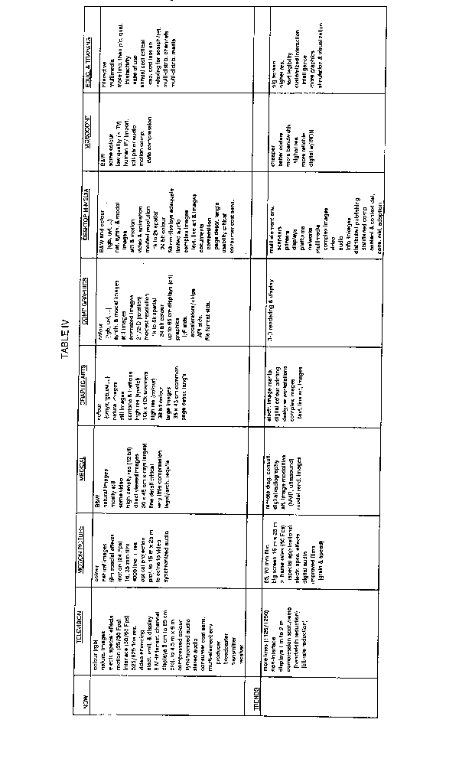
TABLE 5
Video utilization classification in the workstation world
Main process input | Main process output | Workstation process
1 Video data | Video remote command | Information retrieval  - animated sequence database
2 Video | Data | Symbolic information definition  - interactive or automatic way area, edge, object, text  - indexing
3 Data | Video | Image modification  - image processing  - image maker (editing)
4 Data | Video | Image synthesis

TABLE 6
Classification of application
Application | Class 1 | Class 2 | Class 3 | Class 4
Museum | Information point kiosk | Museum laboratories | Museum laboratories (restoration)
Printing | Picture library | Indexing | Page maker | Graphics
Cinema and TV programme production | Archive display | Indexing palette | Special effects editing | Cartoon, advertisement, setting, roll caption
Education | CAL | Production | Production | Production
Medical | Diagnostic help | Diagnostic tool | Image restoration | Scanner display
Communication | Visiophone for group ware |  | Image maker
Public place | Kiosk | Games production | Games production | Arcade games
Satellite imagery | Distribution | Photo interpretation | Restoration
3.2 Studies of HDTV technology in non-broadcast applications

3.2.1 Printing
The high-resolution and high-quality electronic picture characteristic of HDTV is bringing about entirely new production methods and presentation techniques in the printing and publishing field. The use of HDTV pictures in printed matter and the use of printing material as an HDTV picture illustrate the mutually complementary relationship that is developing between the two media, as well as the growing potential of such systems as a new communication tool [IWP 11/9-010].
Scanners and film recorders are usually used as input and output devices; suitable interfaces may provide connection to HDTV equipment as well [IWP 11/9-041].
A set of HD still picture test charts has been produced, with which the reproducibility and expressiveness (and limitations) of HD still pictures can be evaluated [New Video System Research Association, 1988].
Direct hardcopy output is sometimes required, from and HDTV program or HD electronic publishing screen. The types of electronic printing method utilized are subliminal-dye thermal development transfer and ink-jet. With these printer systems, an A4-sized page can be printed between 12 seconds to three minutes [IWP 11/9-010].
Some practical applications made by NAB broadcasters in Japan are described in [IWP 11/9-023].
The printing of an HDTV signal was applied to the Daily Sports News paper [IWP 11/9-110]. The photos were taken from a professional baseball night game, which was broadcast on HDTV and recorded with an HD-VTR. Decisive shots were chosen from the recorded tape, frozen, and put through a TV-print transformation process. A variety of clear photos was printed in each edition of the daily's next day issue together with relevant minute-by-minute reports on the game. The photos excited considerable reader admiration.
The editing time for HDTV photos was found to be some 20 minutes shorter than that for conventional optical photos, because TV photos need no film developing process.
However, fast-moving pictures may cause blur when passed in a still mode an lose quality in print. This shortcoming must be overcome by some improvement, for example, incorporating an electronic shutter system in the HDTV camera.
This HDTV-print picture conversion method will be very useful for newspapers in reporting the Olympics or other big games and important international news.

3.2.2 Cinema
[IWP 11/9-041] describes that special effects make a large use of electronic facilities; film scanners are used to transfer pictures from film to an electronic recording medium; in this form, images are then processed by graphic equipment and afterwards recorded again on film. Resolution of at least twice that of current HDTV may be required. It is known that HDTV equipment has been used for movie production, even if at an experimental stage, giving satisfactory results when movies have been shown in theaters. This is mainly due to the lower quality of released films and film projectors, and for this reason HD broadcast equipment might also play an important role in programme distribution for electronic theaters.
[IWP 11/9-011] states that HDTV application to cinema can be classified into two groups in accordance with how HDTV has been used: in one group, HDTV was used to heighten the creative effects of the product through special effects; in the other, it was used to cut down on production costs. The examples show how HDTV picture composition is used to create special effects.
Some practical results have been obtained by NAB broadcasters in Japan for non-broadcast applications as described in [IWP 11/9-023].
[IWP 11/9-038] states that the factors of importance for electronic movie production include vertical resolution and movement portrayal, where progressive scanning has merit.
For cinema, multi-purpose halls and/or theaters are essentially needed. [IWP 11/9-021] reports on the present status of these and describes real examples built in Japan based on the SMPTE 240/BTA-S00l standard.

3.2.3 Computer applications
Attractive new applications are expected from the amalgamation of TV/HDTV and computer workstations leading to new promising market enhancements of existing products and new concepts in the video domain.
Workstations are versatile and therefore will accept new HDTV formats as well as future computer formats. The first step to amalgamate the computer workstation with the TV/HDTV world is to design definitively new "workstation system" architectures to handle user interaction in real time and also video real time.
HDTV will offer new possibilities for consumer workstations: home computers will take advantage of the availability of HDTV CRT and the computer will be adapted to whichever HDTV format is needed. The reduction in cost should make possible the development of consumer workstations [IWP 11/9-051].
However, [IWP 11/9-121] expresses some doubts about whether HDTV broadcast receiver displays or monitors could also be used as workstations. It points out that requirements of such matters as viewing distance, aspect ratio and display rate will probably be different.
Considerations on the relationship between HDTV and computers are also described in [IWP 11/9-001, IWP 11/9-038 and IWP 11/9-066]. Recently, HDTV in computer graphics has been integrated in actual applications. Knowledge for efficient use of the wide screen with a 16:9 aspect ratio is being developed as illustrated in [IWP 11/9-014].
Practical applications for computer graphics have been demonstrated by NAB-broadcaster in Japan as described in [IWP 11/9-023].
[IWP 11/9-041] describes the CAD environment. The capability of exchanging data files between CAD workstations and HD graphic systems makes it easier to produce high resolution and high quality still pictures and animations, for commercials, industrial applications and training.
Due to the great architecture flexibility, PCs may host different graphic devices with a wide range of performances in terms of resolution and number of displayable colours.
[IWP 11/9-111] describes the application of the HDTV system in showrooms. One of the most popular applications of high-definition pictures in showrooms is an on-the spot presentation service which simulates and displays requirements in the form of realistic images of the HDTV screen.
The finished designs are displayed on the screen, confirmed by the customer, and printed out in hard copy so that he/she may take it home as his/her personal catalogue for placing a purchase order.
[IWP 11/9-112] describes the application of the HDTV system to landscape simulation. The Image Simulation Study Group of Hi-Vision Promotion Center (HVC) has taken individual subjects of landscape simulation from actual cases to simulate and assess them by recording the results in high-definition television (HDTV), pamphlets, posters and slides as experimental images. These subjects are natural landscape, city, street zone, historic houses, river, resort and private house.
In the HDTV image processing, data processing was performed on several specific factors which comprise the landscape, such as data correction of dust and scratches on manuscript, colour conversion (printing - - Y, M, C, K, picture - - R, G, B), colour tone correction, gradation conversion and synthesis of picture and characters, after digitizing the input data to the number of picture element on HDTV (1.920 x 1.035), to create new landscapes.
In case of the computer graphics, (CG) image, CG image data is input directly into the image processing device. Image data is used by either not modifying the picture element number of the standard display size used in graphics workstations (1.280 x 1.024), or converting the data to HDTV through the image processing device.
[IWP 11/9-041] describes that advanced audio-visual communications and processing require on-line interaction of database information with sound and video information.
[Doc. 11-4/58 (Annex 1)] describes how important a role computer imaging techniques are playing in TV programme production.
A new programme production environment called "Virtual studio system" (VSS) has been studied. The VSS technique enhances the freedom of image creation with the techniques of composing computer-generated images and real images taken by video cameras.
Two types of VSS have been developed. One is called "VSS driven by actual camera motion" (VSS-AC); the other "VSS driven by virtual camera" (VSS-VC).
The concept of VSS-AC is as follows: an actual scene of an actor is shot by a camera, the information of which, such as camera tilt, camera pan, camera-crane tilt and pan, is taken out and a motion fed to the CG generator which generates CG background pictures so that the composed images give a perspective of depth (or impression of reality). This technique is utilized for TV programme production in Japan.
VSS-VC is a system which is more advanced and which has replaced cameras with virtual cameras. Experiments are carried out for VSS-VC.
[Doc. 11-4/58 (Annex 2)] describes the real-time CG system in TV programme production. In Japan, a 30-minute daily programme, entitled "Ugougo Lhuga", has been in service since October 1992. The major part of this programme is produced by a real-time CG system using personal computers, "AMIGA" (Fig. 1).
In this programme, a boy named "Ugougo" and a girl named "Lhuga" perform with various CG casts, and they are composed of four different image planes using chroma keyer. In order to convert the body and mouth moving information of the CG casts into MIDI (Musical Instrument Digital Interface) signals respectively, the MSX type computer is used. Moving CG casts appear on two different planes, then one is mixed with the Video Disc, another with the Video Mixer.
Even though more than 95% of the programme contents are produced by CG, this programme is televised occasionally as a live programme successfully.
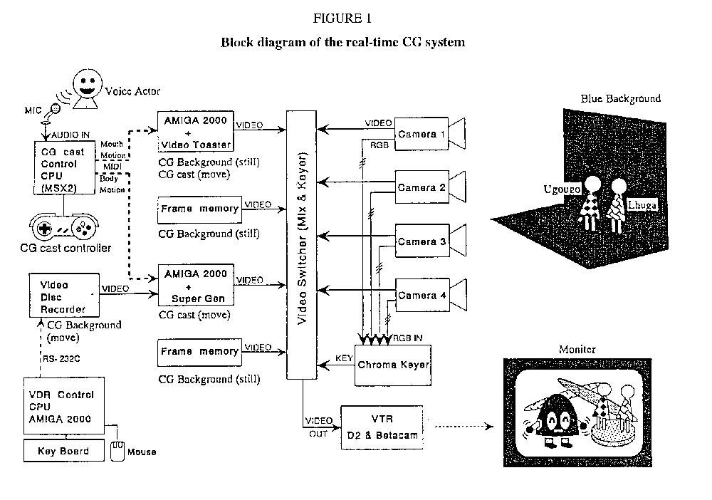
[Doc. 11-4/58 (Annex 3)] describes full colour HD still picture graphics system using personal computers (PC). This system generates both HD interlaced and other non-interlaced images. The standard pixel format (1 920 x 1 035) and square pixel format (1 840 x 1 035) are available in HD mode processing. Several options such as JPEG compression card and NTSC card are available. This is quite helpful in generating multimedia images based on HD images and creating new applications.
[Doc. 11-4/58 (Annex 6)] describes the flight information system in New Tokyo International Airport. This system provides passengers and visitors with various information by using multimedia technologies.
The system consists of the information centre and various displays and terminal facilities, most of which are connected through an integrated services network controlled by computers.
These facilities include display boards, announcement terminals, automatic announcement equipment, touch-panel information retrieval terminals and computers.
In order to reduce data amount, full colour picture data are compressed and decompressed with the DCT-SQ technique by using digital signal processor. The amount of compressed data is approximately 1/20 of the original data.

3.2.4. Medical
[IWP 11/9-041] describes that X-ray diagnosis and endoscopy require improved spatial and contrast resolution with respect to conventional TV: displays with 8 line/mm and 12 bit/pixel gray scale are currently used. HDTV equipment could be adopted in cases where diagnosis implies motion evaluation and for training purposes.
[IWP 11/9-013] reports on applications in both cases using moving pictures and still pictures, and also points out that, in many cases, image signals from existing medical equipment cannot be reproduced on an HDTV monitor without necessary changes as they differ from each other. To correct this inconvenience, a scan converter can be used to convert such signals.
Some medical applications demonstrated by NAB broadcasters in Japan are described in [IWP 11/9-023].
The High Definition Laser Video Projector shows promise in being a major component in the development of a real electronic cinema system, capable of operation in traditional and non-traditional applications. The work done so far has shown that it will operate at the current major HDTV standards, and therefore can contribute to the harmonization of HDTV standards in large screen applications [IWP 11/9-036].
[IWP 11/9-044] describes the use of common home display for HDTV entertainment and teletext information.

3.2.5. Museums
The works and displays exhibited by a museum at any particular time usually represents only a fraction of its total collection and it is sometimes quite a task for the visitors to locate the piece they wish to view. To solve such problems by supplementing museums' functions with HDTV technology, a system called high-definition (HD) gallery system has been developed.
The still picture play-back devices used in the HD gallery system employ optical discs and digital recording techniques. The types of discs are CD-ROM and write-once discs. The picture signals are component signals (RGB or YPBPR) based on the SMPTE-240M/BTA S001 standards. These signals are recorded on the discs directly or after bit-reduction processing.
The application of HDTV in museums is steadily gaining greater acceptance. At present, such systems are being used by individual museums, but in the future we should begin to see exchanges of CD-ROMs between museums. This would be especially effective for regionally distant facilities. Such potential suggests the necessity for international standards for art systems in such areas as recording medium, format, encoding method, etc. [IWP 11/9-009]
The Commission of the European Communities has, in the past, encouraged the organization of meetings to gather the members of the different museum projects to start harmonization of standards.
Among these projects, NARCISSE groups the laboratories of some of the greatest museum organizations in Europe to create a data base of pictures scanned in 8000 x 6000/10 bits resolution. 50 000 documents have to be stored and indexed in the coming months.
Another project "VASARI" is an early study for the digitization of pictures on the artwork itself. The development of dedicated workstations including data base, colorimetric and damage studies. Another one, MUSENET, deals with ISDN networking for exchange of museum pictures.
Luxembourg participants discussed the following specifications:
- scan resolution:16 pix/mm, 12 pix/mm, 8 pix/mm [IWP 11/9-052];
- colour depth:RGB 12 bits linear for scanning, 10 bits for storage [IWP 11/9-052].

3.2.6 Expositions
In the International Garden and Greenery Exposition(April to September 1990) in Osaka City, high resolution and picture quality of HDTV were used not only to introduce a wide variety of materials, but also played an important role in heightening and expanding the feeling of participation in the exposition through transmission of various events to "Satellite Halls" in principal cities in Japan.
Many displays of 50 - 60-inch, 90-inch, 250-inch rear projectors and 200-inch front projectors were used in the event halls and theaters. In addition, the multi-display system allowing the generation of bright and larger images was placed at the side of the main street.
The equipment was based on the SMPTE-240M/BTA-S001 standards.[IWP 11/9-008, 018, 019]. In general, in public spaces where many people gather, large screen displays are needed, so multi-purpose halls and/or theaters are used [IWP 11/9-021].
Recently, a stereoscopic HDTV system employing binocular parallax and polarized glasses has been utilized in several applications such as demonstrations and the medical field.
The first purpose was to verify the effect of the stereoscopic image as a candidate for the future broadcasting service, and the second purpose was to promote the development of HDTV applications.
Figure 2 illustrates an example of a projector set up for the system.

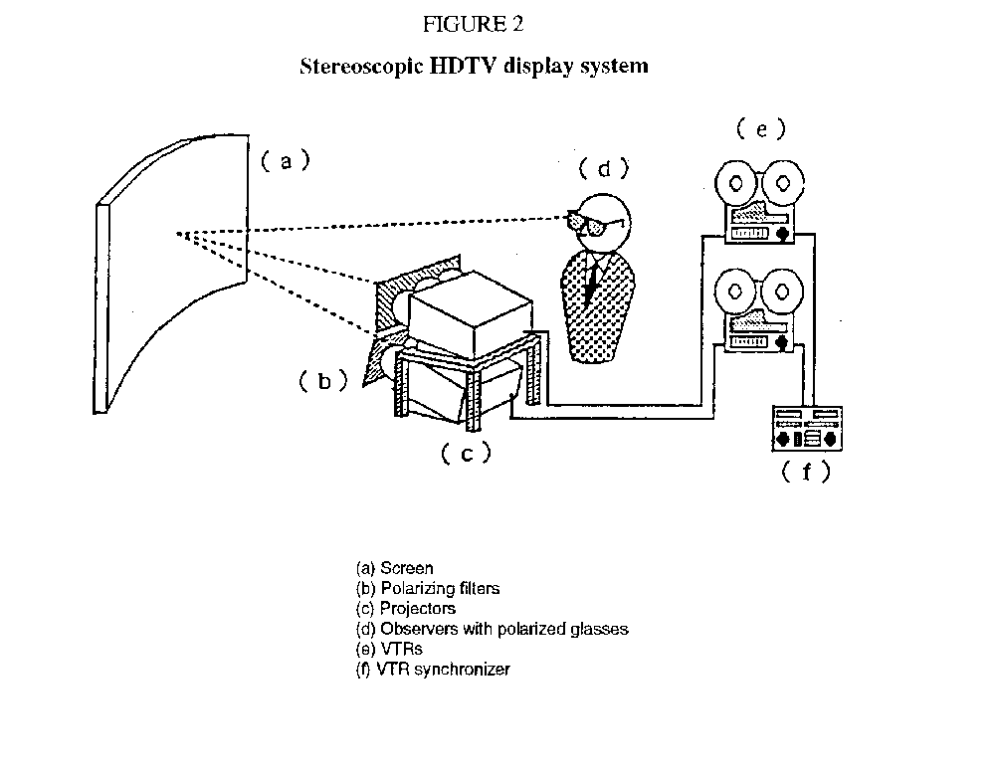
The stereoscopic screen effects are highly likely to spawn services not available in conventional television. Hereafter, consideration of a future broadcasting system will be carried out in concert with basic research on the mechanism of human vision [IWP 11/9-025].
As a new type of HDTV display, the Laser Video Projector (LVP) has been developed in the United Kingdom. The initial prototype has been used to demonstrate the European 1250/50 HDTV format on a 16 meter x 9 meter screen, and may also be used to project computer graphics as well as other HDTV standards.
The High Definition Laser Video Projector shows promise in being a major component in the development of a real Electronic Cinema system, capable of operation in traditional and non-traditional applications. The work done so far has shown that this device will operate at the current major HDTV standards, and therefore can contribute to the harmonization of HDTV standards in large screen applications [IWP 11/9-036].
[IWP 11/9-044] describes the use of common home display for HDTV entertainment and teletext information.

3.2.7. Education
[IWP 11/9-012] describes features of HDTV as an educational tool, and points out that it is necessary to accumulate knowledge in order to utilize the HDTV screen frame with its longer horizontal length for educational purposes. Using an aspect ratio of 16:9, it becomes easy to include subtitles, data and other information such as explanatory material on either the right or left side of the screen, or to divide the picture into two halves and display them side by side at the same time.
For expansion of applications, enriching the availability of peripheral equipment is important, and for industrial education computer graphics can be employed to visualize an imaginary phenomenon. Some practical educational applications have been demonstrated by NAB broadcasters in Japan as described in [IWP 11/9-023].

3.2.8 Examples of displays for non-broadcast applications
As far as display systems are concerned, there has been some progress in Japan recently [IWP 11/9 018].
At present, direct viewing 32-inch and 36-inch CRT displays and rear projection type 50-inch displays have been released for industrial and consumer use. They have achieved increased brightness.
LCD front and rear projector displays using three TFT LCD elements of 5.5 inches and up to 1.5 Mpixels have been released, and typical characteristics are shown in Table 7 [IWP 11/9-114].
TABLE 7
Characteristics of LCD projection displays
Structure | Front projection | Rear projection
Diagonal size of screen (inches) | 50-200 | 60
Horizontal resolution (TV-L) | 750 | 710
Peak brightness (CD/m2) | 295* | 240
Luminous flux (lm) | 180 | 180
Diagonal size of LCD panel (inch) | 5.5 | 5.5
Number of picture elements (million) | 1.5 | 1.2
Number of LCD panels | 3 | 3
Weight (kg) | 60 | 135
* Screen gain = 13 - diagonal size of screen = 100 inches

3.2.9 Examples of disks for non-broadcast applications
Recently, there is great progress in Japan concerning video-disc systems. A video-disc system is of great interest in non-broadcast applications. Some video-disc systems have been developed in Japan for still and moving pictures [IWP 11/9-015].
An HDTV disc system handling the MUSE signal has been put into practical use. This system can reproduce 30 minutes of moving picture on one side of the disc.
Home use HDTV receivers with built-in MUSE decoders are being developed and can be used for non-broadcast applications. As far as moving picture disks are concerned, laser diodes with a wavelength from 532 nm to 780 nm are used. The recording time of disks with wavelength 532 nm is 90 min using CLV mode.
There are a few methods of recording a baseband signal without bandwidth compression to keep the picture quality of HDTV.
Regarding disks for recording still pictures, a playback-only type, a write-once type and an erasable type have been developed, and are being put into practical use in non-broadcast applications in Japan.
The recorded signals are baseband digital data using Y, PB, PR or R.G.B video signals based on SMPTE 240M/BTA S001 standards. Table 8 shows characteristics of the HDTV disc systems for still pictures developed in Japan.
Urgent standardization of video disc systems for non-broadcast applications will be needed for programme exchange.
TABLE 8
Characteristics of still picture disks
System | (1) | (2) | (3) | (4) | (5) | (6)
Type | Optical | --- | Electro-static capacitance | Optical | --- | Magneto optical
Function | Play back only | --- | --- | Write-once | --- | Erasable
Disc size | 120 mm | 300 mm | 260 mm | 130 mm | 300 mm | 130 mm
Digital video signal/  Number of frames | 230 | 1680  (each side) | 240  (each side) | 130 | 600 (maximum) | 100
Digital video signal/  Number of picture elements per frame/Mpixels | 1.31 | 1.99 | 1.31 | 1.49 | 1.99 | 1.99
Transfer rate | 174 kBytes/s | 1.96 MBytes/s | 352 kBytes/s | 456 kbit/s | 18 Mbits/s | 12 MBytes/s
Modulation | EFM | (1.7) RLL | S-NRZ-FM | (1.7) RLL | (1.7) RLL | (1.7) RLL

[IWP 11/9-115] reports that the Hi-Vision Promotion Center (HVC) has made technical guidelines of HDTV still disc systems. [HVC ; Technological guidelines for display-type still-picture disc system, July 1991] The guidelines specify the recording format of 1125/60 HDTV still-picture disc system. The digital still picture is compressed and coded by ISO/IEC JPEG method, and recorded on optical disc media.
The still-picture disc system (Figure 2) uses three kinds of disc media which record still picture, sound, and control signals. The still-picture is recorded in either format A or B of the MO disc (130 mm) stipulated in ISO/IEC DIS 10089, or the CD-ROM (120 mm) specified in ISO/IEC 10149. The sound signal is recorded on the CD (120 mm) defined in IEC 908. The control signal is recorded on the FD specified in ISO 8860 (2DD 90 mm).
The guidelines show the logic file format for picture, sound, and control signals. These files consist of the following four sections:
(1) Volume section (see Table 9)
(2) Compression parameter section
(3) Directory section
(4) Data section
The HDTV still picture disc system is equipped with memories storing up to three frames and produces screen display effects by devising a way of reading pictures from each of these memories. Screen effects include dissolve, vertical or horizontal wipe, divided wipe, parting wipe, square wipe, scroll, slide-in, slide-out, and window to synthesize two images into one. The guidelines specify commands which control these screen effects, synchronization control to the sound, and random access playback from key input and branched control commands.
This was an outline of the technological guidelines for display-type still-picture disc systems. Disc playback systems conforming to these guidelines will find sufficient applications for art galleries and similar facilities.
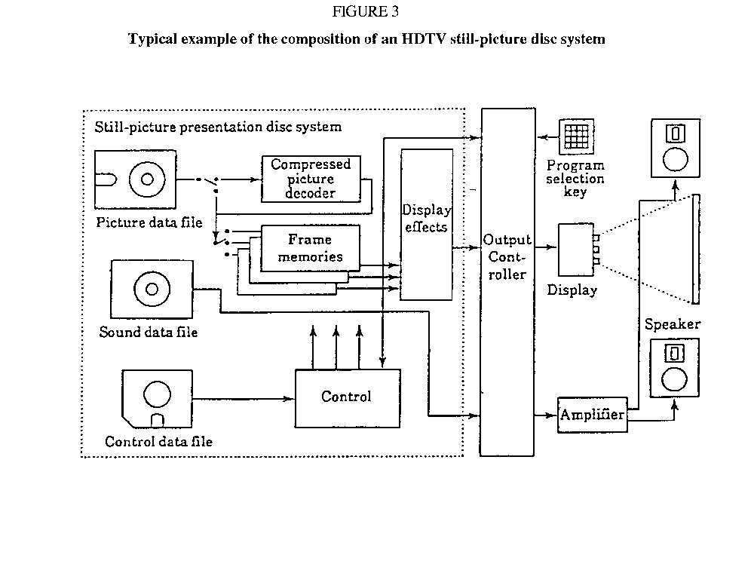
TABLE 9
Structure of the volume section
Relative address | Item | Area size (bytes) | Code format | Remarks
000-015 | Guideline ID | 16 | TEXT | Indicates the belongness of guidelines.
016-019 | Volume number | 4 | TEXT | The volume serial number of the disks.
020-023 | Number of volumes | 4 | TEXT | The total number of disks among the constituent disks.
024-055 | Volume identifier | 32 | TEXT | The identifier for managing the volumes. (Used for managing along with the volume number.)
056-135 | Disc name | 80 | TEXT
136-143 | Date of preparation | 8 | TEXT
144-147 | Management flag | 4
148-159 | Reserved | 12 |  | Not used for the time being.
160-183 | Video data section | 24 | BINARY
184-207 | Condensed video data section | 24 | BINARY
208-231 | Control data section | 24 | BINARY
232-255 | Audio data section (reserved) | 24 | BINARY | Not used for the time being
256-279 | Program wipe data section | 24 | BINARY
280-303 | Additional information data section | 24 | BINARY
304-815 | Reserved area | 512
816-1023 | Comments | 218

3.2.10 Examples of other hardware for non-broadcast applications
The development of CCD cameras for HDTV use is progressing. Four types of CCD cameras have been developed. They offer excellent picture quality as well as an increased stability in camera operation, and are expected to be virtually maintenance-free cameras [IWP 11/9-016].
The use of a single 1152 x 2048 matrix for CCDs for a dual HDTV standard has been studied [IWP-11/9-059].
There are differences in the scanning parameters between the sensors according to their applicability. Careful studies are needed for the standardization in non-broadcast applications.
Digital HDTV studio equipment has also been developed in Japan. This equipment complies with SMPTE 240M/BTA S-001 standards. If the digital switcher and digital video effect equipment are combined with analogue sources, digital VTRs and computer graphic equipment, it is possible to constitute a digital production system. Detailed information is provided in [IWP 11/9-017].
The equipment mentioned above may motivate other non-broadcast applications in the future.

3.2.11 Benefits of harmonization
The utilization of HDTV in Japan is now leaving the experimental stage, and is rapidly expanding to various forefronts. Such cases have been reported in the papers submitted to IWP 11/9 at the last Tokyo meeting and at this meeting in Brighton.
It is significant that the BTA in Japan built into the SOO1 standard for 1125/60 takes into account the Recommendation ITU-R BT.709, technical capability beyond that required for HDTV broadcasting. [IWP 011/9-113]
It is concluded that in Japan the harmonization between broadcasting and non-broadcasting HDTV in the 1125/60 standard is proceeding smoothly with no major obstacles. Furthermore, Japan continues to work within the ITU-R to seek international consensus on a worldwide HDTV production standard.

3.3 Consumer equipment for HDTV

3.3.1. Introduction
This Part of the Report deals with domestic equipment for HDTV.
[CCIR, 1986-90a] stresses, in § 6.1, the need for considering the characteristics of all the potential delivery media for HDTV to the viewer's home in parallel in order to minimize receiver complexity through maximum circuit commonalty such as picture processor, sound processor and control circuits leading to a minimum cost of the equipment.

3.3.2. Consumer-use display
A large screen high-resolution display is necessary for an HDTV reception system. This is also a key factor for determining the speed at which HDTV becomes popular. Direct-view displays using large-size cathode-ray tubes (CRTs) have been developed with an aspect ratio of about 16:9. For example, recently developed 51 to 104 cm CRT displays have sufficient brightness (90 to 230 cd/m2) and resolution for home use.
Projection displays using CRTs have also been developed with diagonals of over 100 cm. For rear projection displays, almost sufficient brightness and resolution have been obtained with 127-178 cm diagonals at a brightness of about 400 cd/m2.
To solve the problem of large-area flicker for 50 Hz field systems, especially for large screens, field rate up-conversion was investigated and several up-converters and displays were demonstrated in September 1988 (IBC 88, Brighton, United Kingdom).
Both direct view and projection displays for the converted signal on the display standard of 1250/100/2:1 with 62.5 kHz line frequency and a video bandwidth of about 60 MHz were built and demonstrated.
Another front projector designed to give a large screen made use of an automatic deflection circuit, ranging from 16 kHz to 62 kHz line rate and from 50 Hz to 100 Hz field rate, and enabled the display of both 1250/50/2:1 and 1250/100/2:1 scanning.
The simplest method of achieving field rate up-conversion is to repeat the fields producing two consecutive odd fields followed by two consecutive even fields. However, to remove problems such as interline twitter, reduction of resolution and judder, sophisticated techniques such as interpolation, picture reception and usage of DATV control signals may have to be applied.

3.3.3. Consumer-use receivers

3.3.3.1 General
Receiving equipment is an important sub-system in the HDTV broadcasting system, since it comprises the major part of the system's expense, and it determines system acceptability.
Receiving equipment of the HDTV broadcasting system, as well as the conventional system, basically consists of front-end units including an antenna, down converter, IF and demodulation stage, and a display. The front-end units are generally similar to those of conventional television receivers and are dependent on each broadcasting media. In the case of the narrow RF-band satellite broadcasting using the MUSE system, existing front-end units can be used commonly, or with some modification. This is verified through a number of receivers and field tests.
In Japan, HDTV experimental satellite broadcasting with the MUSE system has been in operation every day at a scheduled time for one hour by BS-2b since 3 June 1989. For the reception of this experimental HDTV satellite broadcasting, the same receiving antenna and the outdoor unit as those used-for existing satellite broadcasting with digital subcarrier/NTSC system are being used.
The indoor unit is configured so as to be able to receive both digital subcarrier/NTSC and MUSE systems.
When receiving the MUSE signal, the FM detected MUSE signal is supplied to the MUSE decoder, where the dispersal signal is removed and de-emphasis is performed. The keyed AFC clamp pulse is supplied from the MUSE decoder to the indoor unit. For this purpose connecting terminals for detected signal output and for clamp pulse input are provided with the indoor unit.
The efficiency of the receiving antenna and the noise figure of outdoor unit which are available in current consumer market, are 68% on average and 1.8 dB on average, respectively [CCIR, 1986-90b].
Three manufacturers announced on 20 September 1989 developments of prototypes of MUSE receiver for consumer-use. They utilize a series of custom VLSIs.
The announced receivers are of 32-inch CRT type and 50-inch rear-projection type. They are so designed as to receive those signals of the conventional VHF/UHF television, of Clear Vision (an enhanced quality television in Japan), and of Hi-Vision (HDTV in Japan) with a single equipment.
Most of them are capable of reproducing the 3-1 Surround sound (described in Report ITU-R BS.1072) accompanied by the HDTV picture. Connections with VCRs and VDPs have also been taken into their design in some cases.
Such achievement can be taken as an initial phase of the development, and further efforts will be made toward the second phase in which such consumer-use receivers will be made available in a large quantity [CCIR, 1986-90c].
Special consideration is given to other receiving equipment, and is described in the following sections.

3.3.3.2 HDTV decoders

3.3.3.2.1 General considerations
Most HDTV systems use digital processing, employing frame stores in order to achieve large-scale bandwidth compression. The required number of logic gates would be several tens of thousands and the necessary capacity of the store would be of the order of 10 Kbit.
Since the reduction of receiver cost depends on how efficiently large-scale integrated circuitry (LSI) can be introduced to signal processing, development of LSI for the MUSE decoder and related technologies is rapidly progressing. Recent trends towards larger capacity of the stores, from 1 Mbit to more than 4 Mbit, and towards digitization of conventional television receivers are expected to expedite the development of LSI circuitry for HDTV receivers.

3.3.3.2.2 MUSE decoder
As for the MUSE decoder, internal clock frequencies range from 16.2 MHz to 48.6 MHz, and the amount of memory capacity is about 20 Mbit for use in such functions as interpolation and motion detection. Experimental decoders using discrete parts, including medium-scale ICs, are produced by many different manufacturers. They have been constructed in a reasonably small size and are light-weight (e.g. volume 0.084m3, weight 50 kg) to serve as portable models.
Recently, a total of 26 kinds of custom VLSIs have been developed for the MUSE decoder. Employing these VLSIs, the decoder can be built with 46 pieces of custom VLSIs. The size and the power consumption of the decoder became approximately 1/30th that of the prototype made with conventional ICs. Such a development of the VLSIs made a significant step forward to realize low cost MUSE receivers for home-use [CCIR, 1986-90d].
HDTV receiving equipment also plays an important role in the development of other consumer equipment. For example, the MUSE receiver has a built-in memory with a capacity of about 20 Mbit. Attempts are being made to connect it to personal computers and other image processing equipment.
Successful interfacing with other devices will make the MUSE receiver multi-functional, enabling it to serve as a total information terminal in the home.

3.3.3.2.3 HDMAC decoder
The HDMAC decoder digitizes the input signal with a clock-frequency of 20.25 MHz, since the Nyquist frequency point is situated at 10.125 MHz. The output sampling frequency is 54 MHz for luminance in the 1250/50/2 display
The HDMAC receiver includes an HDMAC bandwidth reduction decoder (BRD) with an optional upconverter to a field rate of 100 Hz. The BRD gives as output an Y, U, V signal on the 1250/50/2 standard with an aspect ratio of 16:9. The upconverter will output an 1250/100/2 signal.
The BRD contains five field memories for luminance and chrominance, each with 288 lines and each active line with 698 luminance and 349 chrominance samples of 8 bit, totalling some 12 Mbit. Furthermore line memories and non-linear interpolators are integrated.
Several events are planned to be broadcast 'live" throughout Europe, using the HD-MAC/packet system. Therefore the European manufacturers for consumer electronics in the Federal Republic of Germany, Finland, France, Netherlands, Sweden and the United Kingdom have started to develop HD-MAC receivers with a high degree of circuit integration.
The development of the HD-MAC receivers is based on the experimental decoders that were made for and demonstrated at the Internationale Funk-Ausstellung 1989 (IFA) in Berlin (West) [CCIR. 1986-90e].
Most of the receivers will have a projection type of display, which is regarded as the best method today for displays with a diagonal size of over 1 meter.
All receivers will be able to display conventional PAL/SECAM signals as well as MAC signals in both 4:3 and 16:9 aspect ratio.
The DATV concept allows all the intelligent decision circuitry to be placed in the encoder. Consequently, the decoder complexity is much less and benefits from future improvement in the coding process [CCIR, 1986-90f and g].

3.3.4 Consumer-use converters
MUSE to 525-line standards converter
Considering compatibility with the existing receiver and displays, a MUSE to 525-line standards converter, intended for use with consumer receivers was developed and demonstrated. This is of small size (made up of four 20 cm by 30 cm circuit boards).
The resultant 525-line picture from this converter has, on average, higher quality than the normal picture originated with NTSC standard, although it has some flicker at the edge, with less interference than that caused by the NTSC cross-colour. It has a simple circuit construction and it will be made available at a lower price by using LST technology. The development of this MUSE to 525-line standards converter gave some prospect to HDTV broadcasting in the 1125-line system which can be received utilizing conventional 525-line receivers.
After these studies [CCIR, 1986-90h], several VLSIs have been successfully developed. A simple version of such a converter has been realized on a single VLSI-chip for low-cost applications. Another version employs five separate VLSIS. This version enables the choice of the aspect-ratio conversion by discarding side panels or by the letter box format with blanks at the top and bottom of NTSC picture [CCIR, 1986-90i].

3.3.5. Consumer-use recorders

3.3.5.1 Video cassette recorders
[CCIR, 1986-90j and k] report the development in the Netherlands of a video cassette recorder using an improved VHS transport for recording and replaying an HD-MAC signal (Weissensteiner, 1988]. This recording was demonstrated at the International Broadcasting Convention in September 1988. It achieves a signal bandwidth of 10.125 mHz (-6 dB) and an unweighted video signal-to-noise ratio of 42 dB by using four heads, two frequency-modulated recording channels and digital video and audio processing, with a residual timing error of < 15 ns. It was able to record 80 min of HD-MAC (or MAC) signal on one 1/2-inch metal particle tape and included drop-out compensation.
The HD-MAC recorder is also capable of recording and replaying the 625 lines, 50 Hz television signals (D2MAC, PAL, SECAM). With some adaptations other types of television signals can also be recorded, like 1050 lines, 59.94 Hz. More information about this recorder is given in Report ITU-R BR.1233.
A MUSE VCR for consumer use has already been developed [Ninomiya et al., 1987].

3.3.5.2 Disc systems
Disc systems that record and play back a MUSE signal have also been developed and can accommodate 60 min of HDTV programming on both sides of a 30 cm CLV (constant linear velocity) disc. The disc player can be used in combination with MUSE decoders in receivers and is expected to find a variety of applications in many fields as a long time playing medium of HDTV. Discs with customer's video materials can also be made.
[CCIR, 1986-1990j and 1] report the development of an HD-MAC video disk player which was demonstrated at the International Broadcasting Convention in September 1988. This HD-MAC video disk player was developed in the Netherlands, based on existing optical laser and disk techniques (Horstman, 1988]. Its bandwidth is about 12 MHz with an unweighted signal-to-noise ratio of 32 dB and a residual timing error of -6 ns. The playing time is 20 min per side for a 30 cm (12 inch) diameter disk.
This HD-MAC video disk player is capable of reproducing next to the complete D2-HD-MAC signal, with the full data/sound possibilities of the D2-MAC a Compact Disk (CD) signal. This CD signal is recorded in the lower band of the FM spectrum. More information about this video disk player is given in Report ITU-R BR.1233.

3.3.5.3 Still-picture disc Player
A digital MUSE video disc for still pictures, called CD-HV, has been developed. A 12 cm disc in conformity with the CD-ROM standard is used. Thus, about 640 still pictures with digital stereo sounds can be accommodated in a single disc. It can be played back either in sequential playback mode with 60 min of playing time for one disc, or random access mode with an average access time of 4.5 s [CCIR, 1986-90m].
References to section 3.3
HORSTMAN, R.A. [1988] Videodisc and player for HD-MAC. IEE Conf. Publ. No. 293, 224-227. International Broadcasting Convention (IBC 88), Brighton, England.
NINOMIYA, Y. et al. [July, 1987] Concept of the MUSE system and its protocol. NHK Lab. Note No. 348.
WEISSENSTEINER, W. [1988] Concept of a consumer-type HD-MAC VCR. IEE Conf. Publ. No. 293, 228-230. International Broadcasting Convention (IBC 88), Brighton, England.

CCIR Documents:
[1986-90]: a. 11/304 (JIWP 10-11/3); b. IWP 11/6-3024 (Japan); c. 11/577 (Japan); d. 11/581 (Japan); e. 11/540 (Germany (Fed. Re. of), Finland, France, Netherlands, Sweden, UK); f. IWP 11/6-2013 (Belgium et al.); g. IWP 11/6-2062 (France); h. IWP 11/6-2034 (Japan); i. 11/587 (Japan); j. 11/2S3 (Belgium et al.); k. 11/459 (Netherlands); 1. 11/458 (Netherlands); m. 11/285 (Japan).

SECTION 4

4. Harmonization impact on studio standards

4.1 The architectural approach
This section describes an extensible universal architecture covering different applications to provide for the interoperation of digital video systems.

4.1.1. Introduction
[IWP 11/9-105] describes areas of study for developing an extensible, scalable and inter-operable architecture for HDTV/HRS.
These areas include:
- how can a hierarchy include or coexist with existing and emerging image systems?
- are there advantages to defining a hierarchy with respect to simple proportional relationships between spatial and temporal elements?
- general image structures: how can picture elements and structures, such as picture component blocks and other such structures be accommodated?
- are there optimal structures (including aspect ratios) that result in economies in image manipulation and interchange and facilitate future extension? Among the items being investigated are: progressive versus interlace scanning structure, pixel aspect ratios and transcoding ratios.
As an example of a digital image architecture [IWP 11/9-108] proposes two concepts, the use of conditional replenishment, and the use of a hierarchical signal format. These concepts, based on decoupling the display refresh rate from the image update rate, are illustrated in Fig. 4.
The proposal envisages creating a compressed signal comprising control and picture information as the primary source in the studio. The overall cost-benefits of such an approach remain to be studied.
Conditional replenishment is a technique whereby various portions of the image are updated at differing rates. A header with the information would make sure that the image portions are displayed in the correct way and position.
It is also noted that active matrix liquid crystal displays do not produce flicker, and that such displays can be potentially used for both projection and direct viewing.
Such displays could have the capability to update individual pixels and pixel regions independently from each other, removing the necessity for fixed rate scanning of the entire image.
Further, rapidly moving areas of the image can be updated using lower resolution more often than other areas.
A hierarchical signal format is one in which various levels of quality are layered in the coding format of the signal. Such a signal format might span a range of quality which could support a wide range of receivers from the low cost portable lower definition receiver to the sophisticated high-definition receivers. Various levels of studio quality could also be layered onto the signal to provide a studio standard production format.
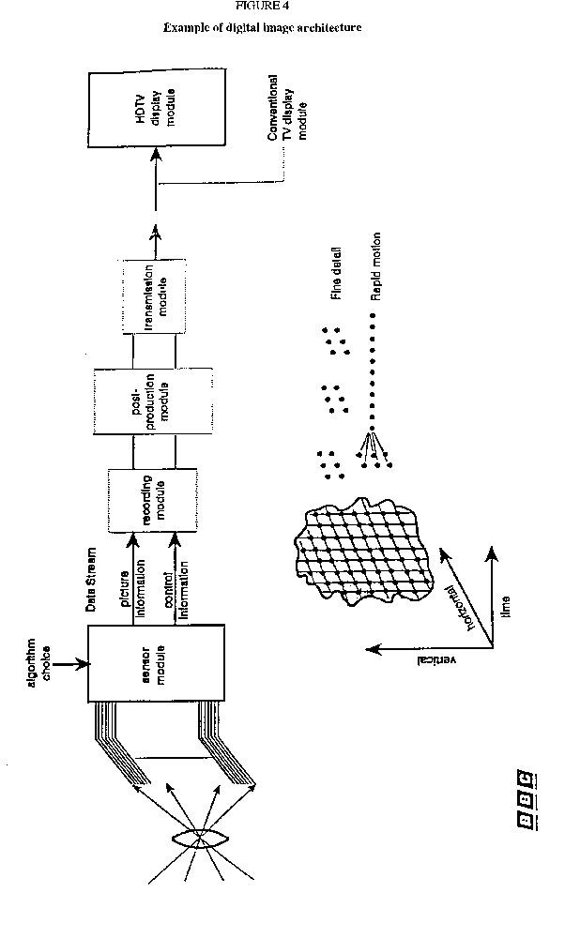
For non real-time uses of the same signal, such as colour still image, colour photography, or colour fax transmission, additional resolution could be further layered onto the signal format.
Both conditional replenishment and hierarchical signal properties are useful in HDTV/HRS systems which use digital compression. Such techniques should then be designed to work harmo-niously with digital compression. Thus, neither the studio production signal format nor a given digi-tal compression technique should be evaluated in isolation. Rather, the formats for the digital studio signal and the digital compression should be developed to be complementary. In this way, optimal quality might be achieved for each level of display quality within a hierarchical signal format. Also, future improvements in technology could fit as extensions to the format through pre-planned future layers in the hierarchical digital signal format.
If a hierarchical system is to be suitable for a large variety of applications, it is essential that a spatial and temporal sampling at the source has substantial ''headroom". In a serial data stream this would require a very high bit rate before bandwidth reduction. By integrating the sensor mo-dule with the first stage of processing (i.e. bandwidth reduction) on a single chip, parallel signal processing such as used in the eye/brain system might enable the ''headroom'' to be provided in a way not making unreasonable demands on technology. This would make sure that the essential information can be extracted in a bandwidth efficient way. For sport broadcasting, for example, high temporal resolution with spatial resolution commensurate with the bandwidth strategy of the TV system would be used.
In [IWP 11/9-121] the EBU suggests that the following questions be considered:
- what are the specific application areas of high-resolution imaging in which different solutions are presently applied and for which future harmonization would clearly benefit?
- are these benefits technical, ergonomic, of market size or providing a diversity of service?
- of these benefits, which accrue to the broadcaster and which to the viewer/consumer?
- what are the various time scales for these applications and their harmonization?

4.1.2 Model framework for the architecture of distribution and contribution systems
A model framework for the architecture of distribution and contribution systems would be valuable and will be prepared by Task Group 11/4 as part of its future work.

4.1.3 A 'layered' HDTV studio standard architecture
Similarly, the architecture of the HDTV studio standard will ensure the greatest possible facility for interoperation with other digital video systems if it is based on a layered structure, such that each layer is in principle separable and by the choice of values that are, where possible, simple integral multiples of the values adopted for those systems.
In particular, the following aspects have been identified as relevant in this context:
a) Image structure
Contribution [IWP 11/9-047 (EBU)] has drawn attention to the advantages of the CIP approach for the image structure. These studies propose a square sample distribution and a 1920 x 1080 matrix embedded within a 2048 x 1152 matrix. This approach is extendable to higher and lower resolutions and to aspect ratios other than 16:9.
[IWP 11/9-123] points out that the use of devices with digital structure generating/storing/displaying pictures, such as CCD sensors, flat display panels and frame memories, requires a definition of the image structure not only in geometrical terms but also with sampling parameters. To this aim, three indexes (isotropy, addressability and modularity) are defined as sampling parameters so to allow separate consideration of geometrical and digital requirements. These indexes may prove useful for the evaluation, the comparison and the development for comparable devices, with accompanying hardware and software benefits, particularly in HDTV application.
b) Image sampling
It is important to ensure that the rates adopted are harmonically related. For example, following pioneering work by Prof. Glenn in North America, scientists at the University of Dortmund are studying a special technique for cameras taking into account the data reduction process common in a hierarchical system. These system signals are generated by a progressive HDTV pick-up device at 25 frames per second, which is technically feasible today. The same optical image is also scanned progressively by a second device, but with four times the field rate and with a quarter of the lines per field and reduced horizontal resolution compared to the HDTV device, generating a second signal used as a source for motion vector information. By means of special processing, the two signals are combined to fit into the corresponding level of a hierarchical system.
c) Image storage
The preferred arrangement is storage of the full CIP data at the basic frame rate, accompanied by the corresponding large-area motion vectors and a comprehensive set of source descriptors. This will facilitate the subsequent studio processes, such as:
- editing/slow motion/standards conversion/re-recording for distribution.
Additionally, the recorded service information will be further processed to optimize the bandwidth- compression algorithm needed for distribution in narrow-band channels including:
- secondary distribution
- transmission
- broadcasting
- recording of compressed signals.
d) Source descriptors
These are envisaged as sets of data which provide a comprehensive description of what is available from the source recording, including:
- the image scanning process
- the source aspect ratio
- the source image structure
- the basic frame rate
- sub-sampled higher-scanning rate
- the motion vector field (blocks and resolution)
- frame and block 'activity' factors
- system process label (see Figures 5, 6 and 7 and the accompanying text).
Figures 5, 6 and 7 give conceptual examples of how the image scanning process, with its associated analysis and recording techniques, might be implemented by means of the use of source descriptors.
System A utilizes an open loop method of selecting sample blocks for recording, based upon their information content so as to practically record all the essential information derived in a high-capacity source/sensor system. A comprehensive set of source descriptors is also recorded to allow an (almost) total reconstruction of picture information if required.
Derived in this way, the source recording can be used for reconstructing the optimum source signal for various applications:
- post production
- distribution in narrow-band channels
- highly compressed recordings
System B achieves the same result as that of System A by utilizing a more complex but lower data rate output sensor in which the ''information-active'' sensor elements are selected for read-out and recording.
System C achieves similar results to those of systems A and B by use of a standar-dized series source bit-rate reduction algorithm.

4.2 The nature and use of descriptors
[IWP 11/9-035] outlines a system of video indexing for use at interfaces in the studio production environment where an interpretation of the image data is required. Aspects of the image data to be covered would include:
a) Image structure:
- sequence number
- aspect ratio
- pagination
b) Page structure:
- samples per line
- lines per page
- page identification
c) Image coding:
- RGB, Y, C1, C2
- sample quantization
- transfer characteristic
d) Multiplexing:
- interlace, sequential
- sample transmission order
e) Source and processing:
- picture rate
- film conversion
- BRR

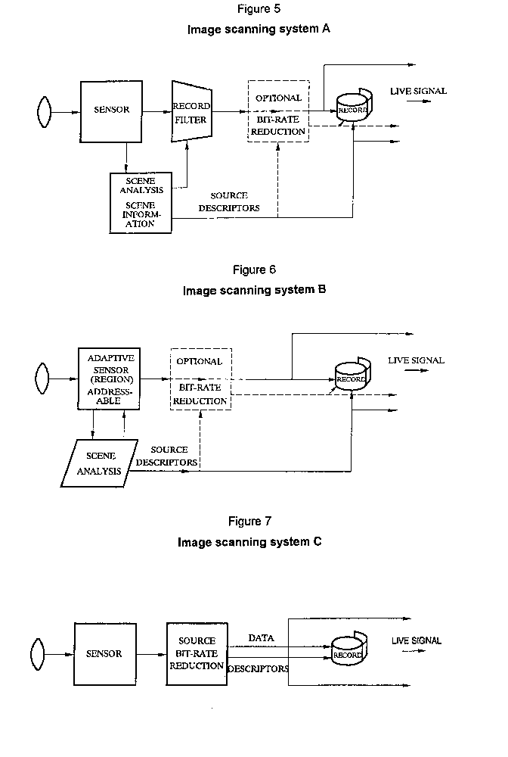
The SMPTE has two active Groups in the field of Index Data:
(a) Working Group on HDEP, and
(b) ad-hoc Group on Time Code Applications of TRRT
The latter has drafted documents defining an application oriented matrix for the use of user bits in the time code. This matrix leaves room for the index data requested in IWP 11/9-035. Consideration of this work seems advisable as well as that of group (a).
[IWP 11/9-066] proposes a header/sub-header mechanism which is a superset of the functions of a video index or descriptor as outlined in [IWP 11/9-035].
[IWP 11/9-010] reports a header composition for digital magnetic tape format.
In view of the trend towards a wide variety of high-resolution digital image systems, it is proposed that a universal header/descriptor should be devised [IWP 11/9-107].
Amongst primary design objectives is universality, that is, all video (and associated) data streams should incorporate the header so that signals can be shared across applications and uses.
Though the definition of the header is not complete, the current design requires the header to include as a minimum:
- the length of the data packet;
- unique identification of the data packet;
- recognition of the error characteristics of the media;
- recognition of the packet synchronization needs of the data stream.
Work is beginning on descriptor formats to provide additional information.

4.3 Colorimetry and transfer characteristics
Based on work previously presented to the ex-CCIR, [IWP 11/9-062] stresses the importance of a wide colour triangle for most non-broadcast applications, which in general do not use Y, C1, C2 interfaces, but RGB (or yellow, cyan, magenta). In this case, the ITU-R interim values have a drawback in the dynamic range to be processed with regard to harmonization with non-broadcast applications.
[IWP 11/9-070] points out that the transmissible colour gamut has been calculated for both television systems, one of which employs three primary colours specified in the body of Recommendation ITU-R.BS.705 and the other employs primaries given in Table I of Annex to Recommendation ITU-R.BT.709. The results show that the former system can treat all the existing surface colours if Y PR PB representation is used with a reasonable signal amplitude range, and that the latter system could exhibit a poorer signal-to-noise ratio in analogue transmission or require a finer quantization in digital transmission, compared with the former one.
[IWP 11/9-70 and IWP11/9-117] state that the choice of primary colours specified in the body of Recommendation ITU-R BT.709 is the most appropriate for both HDTV broadcasting and non-broadcasting applications.
Colour reproduction errors resulting from the bandwidth limitation of colour-difference signals are studied in detail [11/9-119]. These errors are observed with the conventional Gamma Pre-Correction system, with the Constant Luminance Coding and even with the Linear Transmission System. The errors occur not only in the high-frequency component of reproduced luminance, but also in the large area colours, such as hue and saturation averaging in a large area. The errors of this kind, for example in hue, reach more than 20 degrees in the worst case. It may be rare for natural pictures to give such large errors, but it can happen often with computer generated pictures.
A new method to reduce the colour reproduction error is also studied, which is named Pre-Equalization system (PEQ). It can reduce the errors to almost negligible order by employing some extra circuits in the conventional camera without requiring any changes in the display. In the sense, PEQ provides compatibility with the present television systems and therefore it offers one of the best ways in improving the colour-rendition of the future HDTV.
According to [IWP 11/9-052] the digital representation could be harmonized; 12 bit/sample linear coding of the transfer characteristic, depending on the choice of parameters, can be derived from [11/6-4027]. In this concept, the dynamic range includes a margin of 100%.

4.4 Temporal requirements
Requirements reported from non-broadcast applications are only dealing with display refresh-rates and therefore not directly with studio standards. In this case , care should be taken to ease the conversion between production and display standards.
The frame rate in an architectural environment should be considered in two aspects:
- movement portrayal
- flicker

4.4.1 Movement portrayal
The picture rate for continuous movement is based on the requirement of the human eye for smooth motion. It should not be lower than 24 pictures/s, but probably higher. Rates of 24, 25, 29.97, 30, 50, 59.94 and 60 Hz are in use in broadcasting.

4.4.2 Flicker
Displays using picture tubes of present technology (CRT) require a refresh-rate of not less than about 70 Hz to be considered as flicker-free for acceptable working conditions in a work station environment.

4.4.3 Architectural approach
An architectural approach would indicate the convenience of having a refresh-rate which is commonly related to the picture rates mentioned in 4.4.1. This could lead to potential refresh-rates of 72 Hz or 75 Hz, respectively in a work station environment. It seems possible that a display may be able to adjust its rate to accept both refresh-rates of 72 Hz and 75 Hz.
New display technologies may lead to lower refresh-rate requirements.

4.5 Bandwidth compression considerations
With regard to a possible use of bit-rate reduction techniques in HDTV DTTR, findings in October 1989 by JIWP l0-11/4 [IWP 11/9-031] were as follows:
- no bit-rate reduction was used at that time in HDTV DTTR for professional use, and should ideally be so in order to be as transparent as possible;
- studies on application of the technique were directed toward equipment of consumer use;
- further careful studies are necessary taking into account such requirement that any cumulative picture impairment should not be introduced in a complex programme production environment.
[IWP 11/9-066] points out the rapid development of compression technologies, in algorithms, in hardware, and in international standards. Compression is viewed in the document as an area requiring a flexible standards' architecture if the rapid changes it is undergoing are to be incorporated in high-definition equipment and software.
[IWP 11/9-106] refers to the constitution of an SMPTE study group aimed to find and characterize digital image compression techniques and artifacts which are acceptable for use in production and post production, and some forms of production-related distribution.
A number of artifact types, compression techniques, as well as image properties that may affect digital image compression for HDTV have been identified. A set of still and moving images for testing purposes is being developed. Such images may help in the evaluation of studio standards with respect to their suitability for compression under a given compression technique. In particular, effects of studio transcoding on motion vectors might be indicated in such test imagery. Also, colour detail preservation, and noise effects on compressibility might be revealed. Document 11/9-106 should be submitted to ITU-R Working Party 11E.
[IWP 11/9-118] deals with the basic requirements related to bit-rate reduction test imagery coding for HDTV.
For HDTV intra-studio transmission bit-rate reduction systems are not necessary because of the wide-band capability of optical fibre systems currently in use. For inter-studio transmission and also for cassette digital VTR recording, some bit-rate reduction may be necessary. The appropriate system should be chosen compromising transmission and hardware costs, bit rate and picture quality and consistency with the future B-ISDN. User requirements and picture quality assessment procedures should also be taken into account. For channel coding, some commonality with conventional television may be necessary in the transmission signal format and the digital modulation.
[IWP 11/9-122] considers, on the basis of computer-simulation, the adding up of image artifacts originated by the repeated use of BRR algorithms in a digital television chain.
The coding scheme was a 2D-DCT with motion compensation and pyramid vector quantization, both with inter- and intra-frame modes and adaptive assignment of the coding bit rate for each block according to its energy.
The simulations have been carried out on a set of images currently in use for the quality assessment of HDTV pictures. Graphs giving MSE versus co-decode steps and for different channel capacity generally show that intra-frame coding mode is more robust than the inter-frame mode.

Bibliography

S. MANABE, et al, [1988] "A 2-Million pixel CCD imager overlaid with an amorphous silicon photoconductive layer" ISSCC 88, WAM3.6.
K. NAGANO, et al, [1987] "A 2-Million pixel high-definition CCD image sensor" IEICE Technical Report, ED87-174.
T. NOBUSADA, et al [1989] "Frame interline transfer CCD sensor for HDTV camera" ISSCC 89, WPM8.1.
POYTON, Charles A [January 1990] "HDTV for computers Workstations." Television Mergers multiple Technologies - SMPTE 1990.
K. YNEMOTO, et al [1990] "A 2-Million pixel FIT-CCD sensor for HDTV camera system"; ISSCC 90, FAM13.2.

CCIR Documents:
[1990-94]: IWP 11/9-001 (CAN), IWP 11/9-003 (CBS), IWP 11/9-004 (CBS), IWP 11/9-007 (HOL), IWP 11/9-016 (J), IWP 11/9-031 (10-11R), IWP 11/9-035 (CAN), IWP 11/9-037 (J), IWP 11/9-038 (BEL, HOL, F, UK), IWP 11/9-039 (UK), IWP 11/9-045 (EBU), IWP 11/9-046 (EBU), IWP 11/9-047 (EBU), IWP 11/9-048 (Thomson), IWP 11/9-049 (Thomson), IWP 11/9-053 (Thomson), IWP 11/9-059 (Thomson), IWP 11/9-062 (F), IWP 11/9-063 (F), IWP 11/9-064 (F), IWP 11/9-006 (AUS), IWP 11/9-017 (J), IWP 11/9-042 (Italy), IWP 11/9-055 (EBU), IWP 11/9-069 (J), IWP 11/9-070 (J), IWP 11/9-117(J) AND IWP 11/9-119 (J).

SECTION 5

5. Harmonization impacts on transmission standards for telecommunications

5.1 Introduction
Video applications can generally be divided into three segments: production, which entails the creation of the information, delivery which is the vehicle by which the information is supplied to the customer, and display, where the customer views or otherwise interacts with the information. Figure 8 illustrates this concept for the particular case of the broadcast television chain, but the principle can be generally applied to any information industry. Boundaries, called interfaces, logically separate the three segments. Today, the same signal format is used for video information crossing these boundaries , typically NTSC, PAL, SECAM or Recommendation ITU-R BT.601, and the problems associated with this transfer are minimal and well understood. In the future, it is entirely possible that program material in the different segments will have different formats, greatly complicating the interface problems and requiring harmonization to help assure that the equipment can interoperate efficiently .
The matter is made even more complicated when the various options for delivery are considered, as in Figure 9. It is possible, even likely, that the RF signal format for the HDTV program will be different for each medium, optimized to take best advantage of the particular strengths of each signal path. In other words, there will be many delivery formats, not just one.
Figure 10 [IWP 11/9-101] expands the detail for the case of a B-ISDN transmission on optical fibre, the standard to which the world's telecommunication networks are converging. The boundaries are expanded to show the network interface (NTI) and the video coders/decoders (codecs) which would be required to carry video on such a network. A great deal of work is being done in the ITU-T, the CMTT, the IEC and the ISO to define and standardize many aspects of the telecommunications network, including interfaces, coding, and transport platform characteristics. Figure 9 also lists some of these groups and their present responsibilities. ITU-R Study Group 11, as may be seen from the Figure, is responsible for defining the end-to-end service performance characteristics of the television system, and thus plays a vital role in defining the requirements for the telecommunications transmission path.
Figure 11 [IWP 11/9-101and IWP 11/9-126], shows in one composite picture the relationship between the video work, both ongoing and proposed, in the CMTT, the ISO/IEC, and ITU-R Study Group 11. The drawing illustrates the various sub-tasks involved in standardizing the video service chain, and presents in some detail an overview of the work programmes within ITU-R Study Group 11. This information is useful, not only for structuring the ITU-R Study Group 11 work, but also for helping the ITU-T, the CMTT, the IEC and the ISO to understand its scope of activities.
The focus of this section is those issues surrounding the production/transmission interface and the transmission/display interface which are pertinent to telecommunications networks. These issues warrant further or new study by, and continuing dialogue between, the relevant groups of the ITU-R, the ITU-T, the CMTT, the ISO, and the IEC to ensure harmonization of standards.
Two areas identified as key to the production/transmission and the transmission/display interfaces are: coding/compression and transport. Various coding/compression techniques with distinct attributes have been developed and several demonstrated. In a telecommunications environment, coded signals can be carried digitally within existing and future broadband digital networks, digitally within satellite channels, or in an analogue format on dedicated channels. The contributions considered indicate a tie between the coding techniques employed and the transport platform used to carry a HDTV signal in a telecommunications network. Various transport methods are more amenable to signals coded with a particular algorithm.

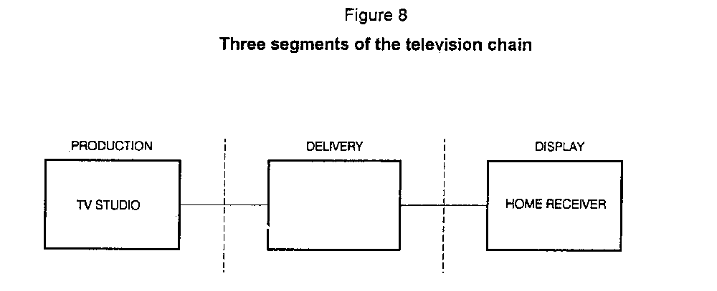
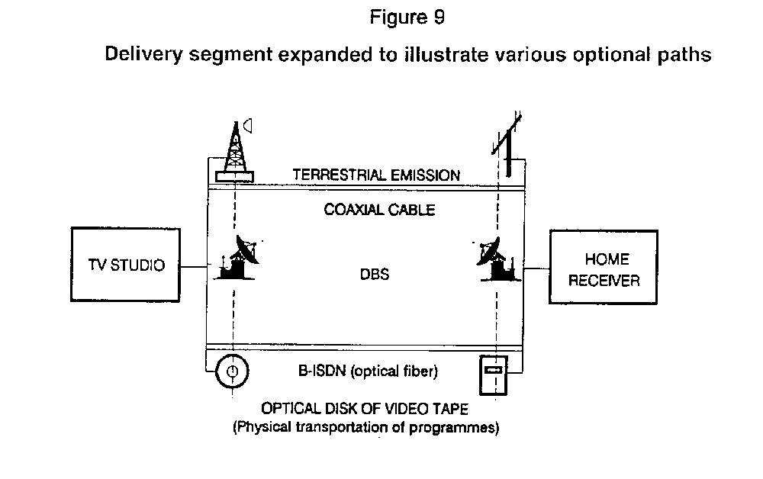

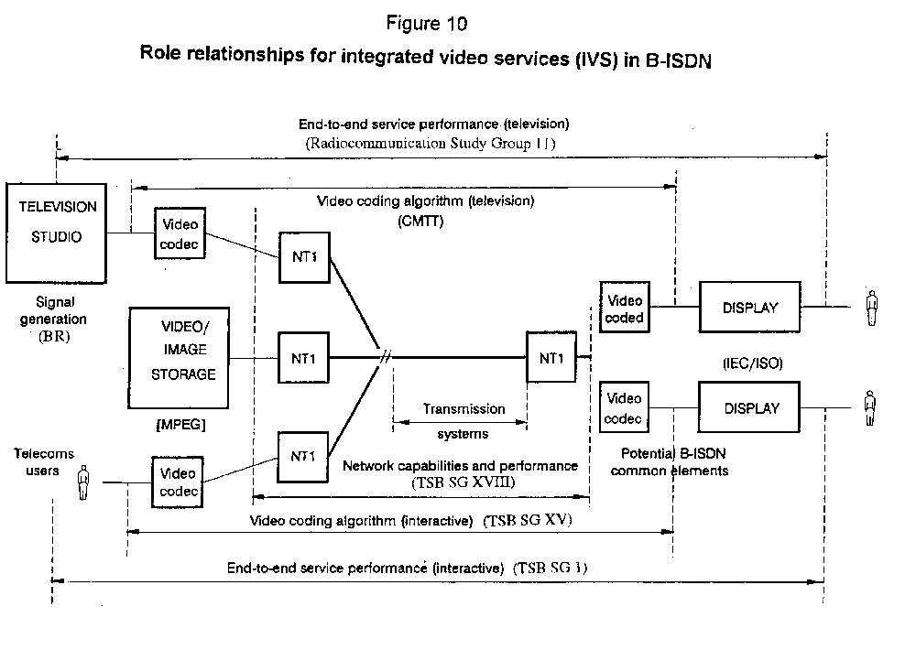
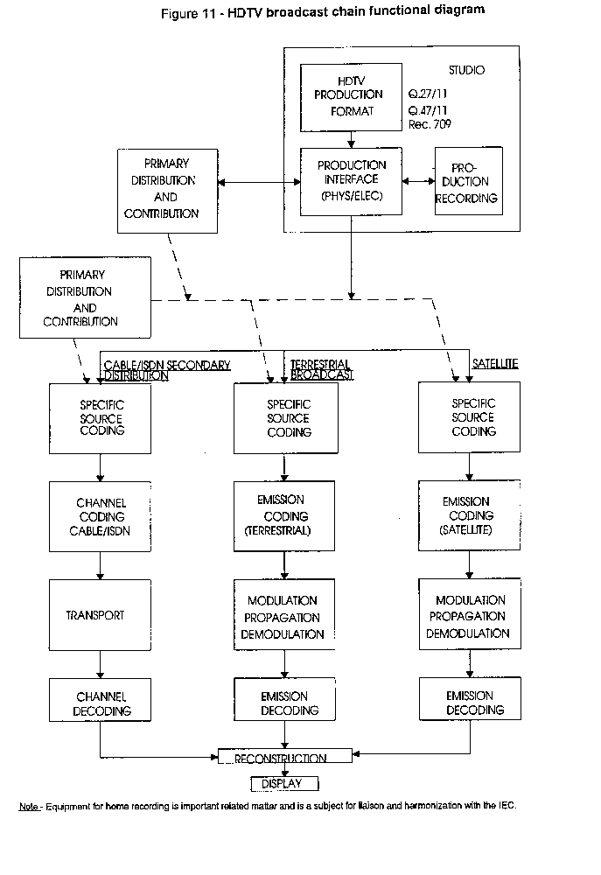
Many of the issues are being studied in the ITU-R, the ITU-T, the CMTT, and other standardization organizations (e.g., in CMTT/2, ITU-T SG I, XV, and XVIII, ITU-R SG 11, and MPEG in ISO/IEC). During September 1991, an ITU Coordination meeting on Integrated Video Services (IVS) was held. The report of the meeting [IWP 11/9-124] describes the activities underway and a schedule for work completion by the various groups involved. In some cases, the work of the group depends on work conducted in other group(s). In this regard, ITU-R Study Group 11 has been requested to provide input concerning the picture quality required for secondary distribution, the suitability of ATM as a transport platform for HDTV (as well as video signals at lower rates), and the need for harmonization between coding for different delivery systems (e.g., B-ISDN, ISDN, terrestrial emission, and satellite emission).
The two following subsections present the coding and transport issues derived from the submitted contributions. This section concludes with a summary of the issues and the areas of recommended study.

5.2 Coding

5.2.1 Existing Codecs for HDTV
Several bit-rate reduction codecs for HDTV have been studied. The following contains a brief description of the proposed codecs.
(a) Intrafield differential pulse code modulation (DPCM) coding [IWP 11/9-024]
Two intrafield DPCM systems have been developed which use simple coding algorithms for hardware compactness. The principal bit-rate reduction techniques employed in both codecs are 1/2 line offset subsampling and intrafield DPCM with previous pixel prediction. The first codec employs an adaptive noise shaping filter, prediction-value-adapted quantizers, and 4-bit fixed length codes. The coding bit rate can be 120 or 140 Mbit/s. This codec was used for an actual digital satellite experiment. The second codec employs variable length coding. The coding bit-rate is around 100-150 Mbit/s.
(b) Intrafield/interframe DPCM coding [IWP 11/9-024]
Two intrafield/interframe DPCM codecs have been developed. The first codec employs an intrafield/interframe- extrapolative/interpolative prediction and variable length coding algorithm. It also employs a spatio-temporal adaptive prefilter, which reduces random noise. The coding bit rate is about 100 Mbit/s. This codec was used in actual transmission experiments through optical fibre lines. The coding structure of the second codec is similar to the first. The characteristic feature of this codec is hybrid quantization which combines vector quantization and scalar quantization.
(c) Discrete Cosine Transform (DCT) coding
Two HDTV DCT codecs have been developed in Japan [IWP 11/9- 024]. Both codecs aim at 1125/60 HDTV transmission at the STM-1 (synchronous transfer module-1) rate of 155.52 Mbit/s in the synchronous digital hierarchy. In the first DCT codec, two dimensional 8 x 8 intrafield DCT is performed. Then, adaptive intrafield/interframe prediction and quantization are carried out for DCT coefficients. After that, variable length coding is employed. The coding rate is about 133 Mbit/s. The second DCT codec employs two dimensional 8 x 8 intrafield DCT and fixed length coding. The coding rate is about 130 Mbit/s.
A DCT codec has also been developed in the framework of the European project EUREKA 256 and has been widely used for actual satellite digital transmission [IWP 11/9-043 and 058]. The codec operates with both production standards currently being examined by the ITU-R: 1250/50/2:1 and 1125/60/2:1, and employs interfield/intrafield/interframe hybrid DCT with 8 x 8 blocks and variable length coding. The implementation of motion compensation and RS(255, 239) coding, indicated in Recommendation ITU-R.CMTT.723 is in progress. The bit rate may vary from about 60 Mbit/s to 140 Mbit/s.
The development of another DCT codec, capable of transmitting a 1250/50/2:1 or 1050/59.94/2:1 (1920 pel/line) signal on a 140 Mbit/s channel, is progressing within the European Race 1018 (HIVITS) Project [IWP 11/9- 054]. The coding algorithms of this codec is based on Recommendation ITU-R CMTT.723, which includes intrafield/interfield/motion compensated interframe DCT with 8 x 8 blocks and variable length coding. Although Recommendation ITU-R CMTT.723 is for component TV, it has been extended for HDTV in this codec.
[IWP 11/9-122] considers, on the basis of computer simulations, the addition of image artifacts created by the repeated use of bit-rate reduction (BRR )algorithms in a digital TV chain. The coding scheme was a 2D-DCT with motion compensation, pyramidal vector quantization, with both inter- and intra-frame modes and adaptive assignment of the coding bit rate for each block according to its energy. The intra-frame coding mode appeared to be more robust than the inter-frame mode.
(d) Other coding methods
A bit rate reduction system for MUSE HDTV signals is being studied, which aims at trans-mitting MUSE signals at about 60 Mbit/s via digital satellite [IWP 11/9-024]. It employs adaptive switched quantizer based on intrafield/interfield prediction values and 3/6 bit dual length coding.

5.2.2 Coding for B-ISDN
(a) Fixed rate and variable rate coding
Variable rate and layered coding have been identified as the target approach to focus further study on fully integrated video service provisioning as stated in ITU-T draft Recommendation I.211 "B-ISDN Service Aspects." [IWP 11/9-005] Variable rate coding permits encoder sensitivity to be fixed, and the video quality maintained constant with a consequential improvement in overall perceived quality at a lower average bit rate.
According to [IWP 11/9-024], however, there are some problems for variable rate coding of HDTV signals. The instantaneous coding rate would fluctuate between several tens of Mbit/s and several hundreds of Mbit/s in the variable rate coding of HDTV. Therefore a channel rate (maximum available rate for coding) of about 130 Mbit/s would be insufficient, which corresponds to 156 Mbit/s user-network interface rate. Furthermore, it is not clear what kind of other signals can be multiplexed with HDTV efficiently, considering the anticipated HDTV coding rate fluctuations. For this problem, fixed bit-rate coding over constant bit-rate (CBR) transport may be more effective than a variable bit-rate (VBR) transport.
(b) Coding for HDTV distribution
Another point to be considered is compatible coding for HDTV distribution in B-ISDN [IWP 11/9-054]. Three attributes can be given to compatible coding: uniqueness, compatibility, transcodability. Uniqueness means that the distribution video algorithm must cover the whole range of resolutions. Compatibility means decoding hardware proportional to display resolution. Transcodability relates to the capability of the distribution standard to cope with recording. The definition of a hierarchy between HDTV, TV and video-conference TV could address these issues, subject to minimum transcoding hardware.

5.3 Transport

5.3.1 Digital
B-ISDN supports different classes of service by means of two signal transfer modes: synchronous transfer mode (STM), and asynchronous transfer mode (ATM). In STM, the transmission bit rate is constant and continuous. STM provides bandwidth with predetermined transmission delay. In ATM, transmitted signals are first packed into "cells" and then transmitted to the network asynchronously [IWP 11/9-024].
ATM provides two modes, constant bit rate (CBR) mode, and variable bit rate (VBR) mode. In the case of cell loss, serious picture degradation may be produced. This loss of information can be kept to a minimum using sophisticated error protection and/or layered coding with cell loss priority indicator [IWP 11/9-005]. ATM cell structures permit the use of a wide range of transmission rates which provides flexibility and the choice of quality and cost of a particular application.
The ITU-T has recently recommended a new synchronous digital hierarchy (SDH) in Recommendations ITU-T.G.707, G.708 and G.709. HDTV transmission using SDH at different rates has been considered in Japan [IWP 11/9-024].
HDTV digital transmission experiments were carried out from Osaka to Tokyo via Nagoya using SDH optical fibre transmission systems in Japan. For the short distance transmission section, STM-4 rate (622 Mbit/s) of SDH and PCM were employed. For the long distance section, STM-1 rate (155.52 Mbit/s) and intrafield/interframe DCT codecs were employed. The PCM codecs and DCT were connected through a digital interface. Through the transmission experiments, the technical and operational feasibility of HDTV transmission via SDH transmission systems was demonstrated [IWP 11/9-116]. HDTV digital transmission experiments using intrafield/interframe DPCM codecs were also carried out in Japan through optical fibre transmission systems with 4-th level bit-rate (97.728 Mbit/s) of existing digital hierarchy [IWP 11/9-024].
Japan has carried out HDTV digital satellite transmission between Japan and the U.S. using Intelsat V and an intrafield DPCM codec at a bit rate of 140 Mbit/s [IWP 11/9-024].
Italy has carried out HDTV digital transmission over the Olympus satellite at a bit-rate of 68 Mbit/s using the DCT codec developed within the framework of the EUREKA EU256 project [IWP 11/9-043]. Signals were received at different sites in Italy and Barcelona, from where they were carried over separate digital fibre links to Madrid [IWP 11/9-057 and 058].

5.3.2 Analogue transmission
Transmission systems employing analogue modulation techniques can be implemented with relatively small size hardware. Some analogue systems of this kind have been realized and are described below. [IWP 11/9-020 and 065].
(a) FM-multiplexing using orthogonally polarized waves
A small size OB link in the 42 GHz band is being developed for use with wireless camera. This system employs three RF carriers, each of which is frequency-modulated by luminance or chrominance signal.
(b) FM-FDM optical transmission system
Two types of FM-FDM system were developed, one of which can convey a single HDTV program and the other can convey two programs. The system employs multi-FM carriers, each of which is frequency- modulated by the luminance, chrominance or audio signal.
(c) Pulse frequency/width modulation (PFWM) system
An optical fibre transmission system of small size and light weight was developed using PFWM. The system employs pulse frequency modulation (PFM) for the luminance signal and pulse width modulation (PWM) for the chrominance signals.
(d) Optical cable transmission system
An optical cable transmission system was developed, which convey 40 HDTV programs of MUSE signal. At the headend, 40 carriers are frequency-modulated by each MUSE signal, respectively, and then transmitted through the trunk line, where the modulation parameters and the channel spacings are identical with those applied in DBS.
(e) Cable transmission system with coaxial cable
Several experimental transmissions have been conducted using VSB-AM scheme, in which MUSE and HD-MAC signals were used in the existing CATV system of coaxial cables.
(f) Square Wave FM (SW-FM) for optical fibre system
An SW-FM MUSE signal was distributed through the optical fibre networks for public services from a broadcasting station to the demonstration places located in downtown Tokyo.
5.4 Conclusions
Several bit-rate reduction techniques and their implementations have been described. This illustrates the relation between the network structure utilized for transport and the choice of coding algorithm.

5.4.1 Action Items for the ITU-R
At the second meeting of CCIR IWP 11/9, the meeting report of the ITU Integrated Video Services (IVS) in Broadband ISDN Coordination Meeting [IWP 11/9-124] was considered in some detail. Contained in the meeting report are several action items and issues raised which require a response by ITU-R Study Group 11.
(a) In order to permit the planned activities of CMTT/2 related to coding systems to proceed on schedule, especially TV/HDTV digital codec architectures (planned for 1992) and HDTV digital codec specifications (planned for 1996), ITU-R Study Group 11 is requested to provide input concerning the picture quality required for secondary distribution systems.(Ref. Action Item 2, page 7, [IWP 11/9-124].
(b) ITU-R Study Group 11 and the CMTT, (as appropriate), should give consideration to the suitability of ATM as a transport platform for HDTV (as well as video signals at lower rates), the need for harmonization, and the identification of the factors appropriate for harmonization between the coding for different delivery systems (e.g., B-ISDN, ISDN, terrestrial emission, and satellite emission). (Ref. Action Item 6, page 8, [IWP 11/9-124]).
(c) In addition to the two specific action items noted above, consideration should be given to the Standardization Timetable (Annex 4 of [IWP 11/9-24]). Coordinating the work programmes described, and aligning the time frames for the work, are important elements necessary to harmonize video work in the ITU and other organizations.

5.4.2 Additional issues and areas for further study
(a) Efforts to match codec design to network transport is of prime importance.
(b) With regard to B-ISDN, various combinations are possible using fixed or variable bit-rate coding and ATM or STM transport. For each alternative, consideration should be given to coding complexity, quality of transported signal and transmission system performance.
(c) Further studies are needed for error correction techniques and cell loss compensation when transmitting HDTV signals over ATM structures of B-ISDN.
(d) Consideration should be given to satellite transmission of HDTV signals. In particular, special attention should be paid to interworking between satellite transmission and other transmission alternatives.
(e) Consideration should be given to analogue transport of HDTV signals in telecommunications networks, since analogue transport over various media affords the economical implementation of modulating/demodulating hardware in the near term.
(f) Further studies are needed to determine the signalling requirements for various types of HDTV/HRI services.
(g) Traffic characteristics of voice telephony are well known and documented. Similar studies should be undertaken to determine the traffic patterns of video users.
Consideration of the aforementioned ideas may facilitate a flexible interfacing of proposed HDTV formats with transmission over telecommunications networks. Liaison between the standards groups addressing coding techniques and transport methods may foster efficient transport of HDTV signals in a telecommunications environment. Intelligent and well-informed decisions regarding compromise and trade-offs in technologies will also be made possible.

Bibliography

CCIR Documents:
[1990-94]: Doc. IWP 11/9-005 (CCITT), IWP 11/9-020 (Japan), IWP 11/9-023 (Japan), IWP 11/9-024 (Japan), IWP 11/9-030 (Canada), IWP 11/9-043 (Italy), IWP 11/9-054 (Thomson CSF), IWP 11/9-055 (EBU), IWP 11/9-057 (Spain), IWP 11/9-058 (Spain), IWP 11/9- 065 (France), IWP 11/9-101 (CCITT), IWP 11/9-116 (Japan), IWP 11/9-122 (Italy), IWP 11/9-124 (ITU), IWP 11/9-126 (Chairman TG 11/1).

SECTION 6

6. Effects of harmonization on emission (satellite, cable and terrestrial)

6.1. Introduction
Since the basic MUSE and the HD-MAC systems have been proposed as HDTV broadcasting systems, various kinds of transmission experiments and tests have been carried out using different media to study HDTV emission characteristics, to confirm the feasibility of these systems and to define transmission parameters.
MUSE and HD-MAC have been demonstrated to the public with live transmissions from several events. The use of the MUSE systems is reported in [IWP 11/9-020 and 022] and the use of the HD-MAC system in [IWP 11/9-061].
This document outlines the main parameters of these two HDTV systems and considers issues affecting harmonization.

6.2. Emission by satellite
Up to now there have been only a few direct broadcasting satellites which have had to be taken into account when standardizing HDTV services.
Two factors are of fundamental interest for HDTV emission by satellite:
- the use of existing or available broadcasting satellites;
- sufficiently small receiver dish size for acceptable picture quality.
With regard to the channel characteristics, no significant harmonization problems have to be solved when using MUSE and HD-MAC, because both were specified as WARC-77-compatible signals. Different requirements in C/N and expected signal quality can be addressed by using adequate receiver dish sizes for a given power flux density. However, small problems may occur from slightly different pre- and deemphasis of the channel. Resolving these difficulties is an issue of the receiver design.

6.3 Emission by cable
Three important factors should be pointed out as being of fundamental interest for HDTV emission by cable:
- a unique baseband format to avoid signal regeneration in headends and different types of receivers;
- efficient parameters for cable distribution;
- sufficient signal quality for HDTV taking into account requirements of existing networks.
The main parameters for cable distribution are given in [IWP 11/9-022 (for MUSE) and IWP 11/9-065 (for HD-MAC)].
No problems in terms of harmonization are expected for some parameters, but further studies are needed for:
- Nyquist-filtering;
- frequency ranges;and
- minimum C/N.
Currently, a signal bandwidth of up to 11 MHz and a channel spacing of 12 MHz have been reported.
Integration of video services, including secondary distribution of broadcast services, is under study in ITU-T SG 15 as a key objective for ATM video coding [IWP 11/9-102]. The simulcast approach and the layered signal approach are being considered in the light of a desire to facilitate the use of common display components in terminal equipment.

6.4 Terrestrial emission
The emission of HDTV in terrestrial broadcasting channels has been studied in ITU-R Study Group 11 and is of particular concern of Task Group 11/1. The results of this work may be found in Report ITU-R BT.801-4, Part 6, Section 2 and in [TG 11-1/55]. At present, there is consideration of both analogue and digital modulation methods for terrestrial emissions of HDTV. An increasing level of interest is visible in the use of digital modulation for terrestrial television services. Draft new Questions referring to the matter have been proposed to ITU-R Study Group 11 for adoption. The timeframe for the introduction of digital, terrestrial delivery of television as reported from North America is similar to that for the introduction of video services in the B-ISDN and there is a pressing need for harmonization between these two activities.

6.5 A proposed HDTV application
A system for high-definition audio graphics was reported in [IWP 11/9-027], combining high-definition still pictures with high quality PCM sound. The system utilizes the coding scheme based on the work carried out in JPEG (the Joint Photographic Expert Group of the ISO and the ex-CCITT).
Further studies are needed to develop and resolve issues related to the emission of this proposed service, and harmonization of this proposed service with other services.

6.6 General considerations
- Existing emission systems will be used for introduction of HDTV for a mass audience in the near future. Because of frequency constraints, terrestrial emission may not be a real candidate for HDTV in some countries.
- The main HDTV emission parameters have been specified in a way that they fit into the channels of existing or available broadcasting satellites and cable networks.
- Requirements for emission by satellite and cable are different. The MUSE and HD-MAC systems have each taken this into account and selected parameters to balance the differing needs. For each system this leads to a single baseband signal format for both satellite and cable reception. This avoids additional cost for signal processing and duplication of parts in cable headends, as well as in the receivers and VCRs.
- Further harmonization between fundamental emission parameters of the two systems will also result in simplifying the design of multi-standard receivers and VCRs.
- The reported channel width of 12 MHz for MUSE and HD-MAC on cable might lead to further harmonization of other fundamental parameters or characteristics of these systems.
- Based on [IWP 11/9-022 and 11/9-065], the width of the baseband used for emission for both cable and satellite might not be more than 11 MHz. Further studies should be done to examine the possibility of harmonizing the interface between the receiver front-end and display.
- [IWP 11/9-044] points out that the skeleton of the parameters for an HDTV home display should note that, in some parts of the world, a new teletext display format, designed with HDTV capabilities and modern techniques in mind, may well be developed.

6.7 Conclusions
Cable distribution will be widely used in several countries to supply HDTV to the public. As opposed to terrestrial emission, the basic requirements have not been generally standardized. Further work in this field will be necessary to harmonize cable distribution of HDTV with distribution by other media.
Further studies are needed to obtain detailed information on the emission of HDTV, particularly digital emission, to determine where harmonization may be necessary.
Other issues ripe for study are the determination of how an HDTV receiver might display signals derived from several different emission media, such as terrestrial broadcast, cable and satellite, and perhaps different services.
Bibliography
CCIR Documents:
[1990-94]: IWP 11/9-020 (Japan), IWP 11/9-022 (Japan), IWP 11/9-027 (Japan), IWP 11/9-044 (EBU), IWP 11/9-061 (France), IWP 11/9-065 (France), IWP 11/9-101 (CCITT).

SECTION 7

7. Analysis and conclusions
Television systems of higher resolution than conventional TV systems (see Report ITU-R BT.624) have been in use for some time for specialized, non-broadcast uses; HDTV for broadcasting is a new development, arising at a time when new digitally-based technologies add wide dimensions of application. At present, the standards of HDTV are based on the requirements of broadcasting. While many non-broadcast services and applications may have requirements similar to those of broadcasters, other applications of high-resolution imagery (HRI) may have requirements significantly different. A flexible standards architecture which addresses the range of broadcast and non-broadcast requirements appears to be technically feasible and may be a useful concept to achieve harmonization. This would also further encourage the convergence of the standards for image communications, including HDTV and HRI and may lead to their future integration. It is thus essential that the developers of such standards harmonize their activities, each developing standards in their respective areas of responsibility for HDTV and HDI, that offer the highest level of synergism, within the constraints apparent in the various sectors.
The ITU-R has segmented its initial studies concerning the harmonization of standards for HDTV/HRI as outlined in the Introduction to this report and detailed in Sections 3 through 6. In these studies, it is apparent that HDTV is already firmly established in programme production and in broadcasting and that emission of HDTV services is progressing rapidly from development to implementation. It is equally evident that some applications of HDTV and of HRI to non-broadcast uses are similarly advanced and are growing rapidly. Therefore, the need to develop at least the basis of a set of harmonized standards is urgent. Otherwise economic concern may render it impossible, thus loosing a unique opportunity for the global convergence of television, imagery and telecommunications.
A number of conclusions can be drawn from this initial phase of the studies concerning certain technical details and some areas of the standards that appear to be of particular potential for commonality.
In the course of these studies it is apparent that the terminology of both HDTV/HRI and broadcast, non-broadcast uses is not consistent. A common glossary of terms would assist in the work of harmonization.

7.1 Image structure
- Spatial aspects
Aspect ratio and resolution requirements vary widely between, and sometimes within, the uses of HDTV/HRI. A flexible and communicable definition of all aspects of image geometry may thus be the goal for harmonization. The development of digital forms of HDTV/HRI offers an opportunity to define a flexible architecture for systems covering a wide range of broadcast and non-broadcast applications. Studies in this regard are now in progress.
- Colorimetry
Current uses, based on positive tri-stimulus colour expressions, are limited in the definable range of colours, often related to the output transducer (display, print, dye, etc.). Future uses of HDTV/HRI may require colour definitions (reference colorimetry) that are flexible and which result in colour reproduction uniformity on diverse output media. Colorimetry thus presents a possible opportunity for commonality and harmonization of standards.
- Transfer characteristics
Both linear and several non-linear forms of coding are employed to express image values, and in some processes it is noted that precise conversions are required. It is reported that the quantization scale of 8-bit non-linear and 10 or 12-bit non-linear coding in digital expressions is used in HDTV and HRI systems. Considerable commonality may be achieved between standards in this area.

7.2 Scanning
Both interlaced and progressive scanning of the image are employed, with HDTV broadcast based on the former, while image processing and computer display activities favour the latter. Interlaced scanning may be considered, in part, to be a non-adaptive and irreversible form of image data compression that may only be necessary in image transducers at present levels of technology. It is believed that most HDTV/HRI standards will, in the future, adopt progressive scanning.

7.3 Frame rate
Conventional broadcast television employs the same frame rate from source, through processing and transmission/distribution to display and in large measure HDTV is similarly structured. While conceptually simple, this approach may not produce an optimal balance of source performance, motion rendition, transmission efficiency and display performance, particularly when new transducer technologies (e.g. CCD sensor arrays, or LCD displays) or inter-system image exchanges are considered. In non-broadcast uses, in particular computers and graphics, the display operates at a high-frame rate (up to 76 Hz) compared to the information update rate to reduce flicker in CRT displays. Studies of the required frame rate at the source, in transmission and at the display may lead to subsequent opportunities for standards' harmonization and possible commonality.

7.4 Image compression
Image information compression is widely used in non-broadcast applications, and is under consideration for use in broadcast applications. ITU-R studies are proposed of appropriate transparent and reversible image compression algorithms for broadcast use in HDTV and they offer an opportunity for harmonization and commonality in this area.

7.5 Transmission
The transmission of HDTV/HRI may take place on the high-capacity, multi-user digital network currently under study by the ITU-T. Transmission methods foreseen include STM and ATM supporting both fixed and variable bit rate. Each has impacts on the source and channel coding of HDTV/HRI. Current studies by the ITU-R have concerned principally broadcast uses at fixed bit rates, concentrated in the range 50 - 150 Mbit/sec. Alternative transmission schemes await further information from the ITU-T. A flexible set of common standards for bit-rate reduction, usable across a number of HDTV/HRI applications appears feasible and desirable.

7.6 Distribution
Distribution of the HDTV or HRI signals to the home receiver may take place along a number of delivery media, including terrestrial or satellite emission, cable, secondary distribution on fibre, or by pre- recorded media such as cassette or disc. Some of these media, notable fibre, cassette and disc, are significantly impacted by non-broadcast usage. In addition, the receiver may have to deal with conventional television and other services such as teletext, audio graphics on inter-active data networks. Receiver complexity may be minimized by the selection of common source coding with appropriate labelling for those media, though recognizing the need for appropriate channel coding for each. Further, the tandem connection of delivery media (e.g. satellite emission to cable) reinforces the need for commonality of source coding among media and services. In view of the large public investment to be made in HDTV receivers, this aspect of HDTV standards harmonization is of great importance.
Studies proposed at the coordination meeting between the IEC/ISO, the CCITT, the CMTT and the CCIR (Tokyo, 1991) may lead to a future digital television concept illustrated in Fig. 12. While this illustration prominently displays broadcast-related delivery systems, it also includes a multi-user digital network.
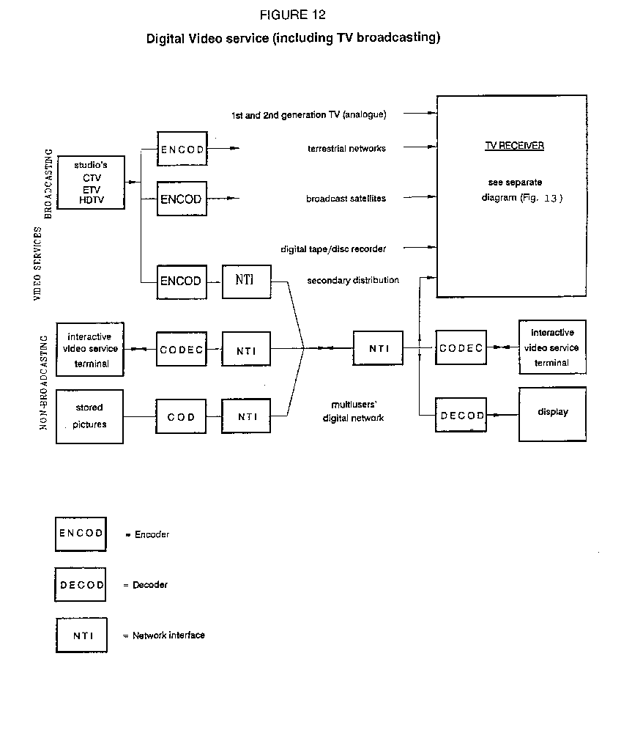
Figure 13 presents a digital receiver concept and illustrates two areas where harmonization could produce benefits by simplifying receiver design. The first area is coding schemes. The digital receiver concept describes unique decoders for each of the various media by which digital television images will be delivered (as well as existing and planned analogue delivery systems such as PAL, SECAM, NTSC, MUSE and HD-MAC). To the extent that the signalling formats employed in these media are coordinated appropriately, the number of independent decoders required for universal reception could be reduced substantially.
The second area in which harmonization could produce benefits is image formats. Among other things, the complexity of image conversion circuitry in television receivers depends on the number of independent image formats capable of being displayed. Thus, the development of an inter-related set of image formats could simplify greatly the complexity of the image conversion circuitry employed in consumer television receivers.

7.7 Required actions
The studies of HDTV harmonization in ITU-R Study Group 11, in cooperation with the IEC, the ISO and the ITU-T indicate that HDTV and HRI application are expanding rapidly in both broadcast and non-broadcast applications. A number of opportunities can be identified that are of significant value and appear to be feasible, both technically and from the viewpoint of practicability in economic terms. The necessary cooperation with the relevant expert groups in the ISO, the IEC and the ITU-T is now required to define responsibilities, to establish complementary work plans, to establish liaison and to share, on an ongoing basis, the growing pool of information and conclusions.
Consideration of harmonization can be distilled into requirements which impact the work of several of the activities of ITU-R Study Group 11. It is important that liaison mechanisms are used to ensure the effective communication of these requirements to those preparing the relevant ITU-R Recommendations. Further specific action items may be found in Sections 4 and 5.
As noted above, there is some urgency associated with the harmonization of the standards, as their development must progress adequately, the implementation of equipment, systems and services, if they are to be effective. It is believed that the basis of a set of harmonized standards must be established within the current study period (1990-1994) and that further Recommendations necessary to establish the principle system parameters be developed in the same timeframe.

7.8 Conclusions
- Widely diverse applications are embraced by high-resolution systems;
- this diversity results in numerous different requirements with respect to resolution, sampling distribution, dynamic range, colorimetry, image format, temporal rate and aspect ratio, among other attributes;
- harmonization across this diverse range would be beneficial, and technically feasibly, in principle;
- harmonization requirements should take account of the consumer-cost implication of proposed solutions;
- adopting an architectural approach with a descriptor system appears one promising route to harmonization.

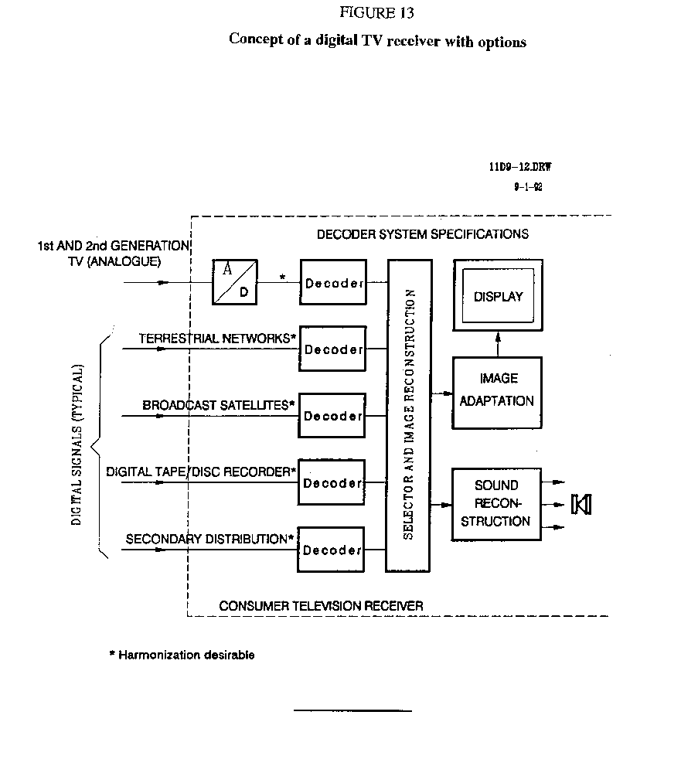

* Further details of the development of standards for broadcast HDTV may be found in Recommendations ITU-R BT.709, ITU-R BT.710, ITU-R BR.713, ITU-R BR.714 and ITU-R BR.716, and Reports ITU-R BT.801, ITU-R BO.1075, ITU-R BT.1217, ITU-R CMTT.1239 and in the activities of ITU-R Task Group 11/1 and Working Parties 11/A and 11/B.
* Colorimetry is also addressed in the CIE

