Report ITU-R BS.2144
(05/2009)
Planning parameters and coverage
for Digital Radio Mondiale (DRM) broadcasting at frequencies
below 30 MHz
BS Series
Broadcasting service (sound)

Foreword
The role of the Radiocommunication Sector is to ensure the rational, equitable, efficient and economical use of the radio-frequency spectrum by all radiocommunication services, including satellite services, and carry out studies without limit of frequency range on the basis of which Recommendations are adopted.
The regulatory and policy functions of the Radiocommunication Sector are performed by World and Regional Radiocommunication Conferences and Radiocommunication Assemblies supported by Study Groups.

Policy on Intellectual Property Right (IPR)
ITU-R policy on IPR is described in the Common Patent Policy for ITU-T/ITU-R/ISO/IEC referenced in Annex 1 of Resolution ITU-R 1. Forms to be used for the submission of patent statements and licensing declarations by patent holders are available from http://www.itu.int/ITU-R/go/patents/en where the Guidelines for Implementation of the Common Patent Policy for ITU-T/ITU-R/ISO/IEC and the ITU-R patent information database can also be found.

Series of ITU-R Reports
(Also available online at http://www.itu.int/publ/R-REP/en)
Series | Title
BO | Satellite delivery
BR | Recording for production, archival and play-out; film for television
BS | Broadcasting service (sound)
BT | Broadcasting service (television)
F | Fixed service
M | Mobile, radiodetermination, amateur and related satellite services
P | Radiowave propagation
RA | Radio astronomy
RS | Remote sensing systems
SA | Space applications and meteorology
SF | Frequency sharing and coordination between fixed-satellite and fixed service systems
SM | Spectrum management

Note: This ITU-R Report was approved in English by the Study Group under the procedure detailed
in Resolution ITU-R 1.

Electronic Publication
Geneva, 2009

© ITU 2009
All rights reserved. No part of this publication may be reproduced, by any means whatsoever, without written permission of ITU.

REPORT ITU-R BS.2144
Planning parameters and coverage for Digital Radio Mondiale (DRM)
broadcasting at frequencies below 30 MHz

(2009)

Introduction
Countries around the world are in the process of migrating from analogue to digital broadcasting techniques for both television and radio. This Report looks at sound broadcasting in the bands below 30 MHz. It briefly examines the underlying reasons for the migration and looks at the technologies involved. Its focus is the DRM system as developed for use in the LF, MF and HF bands.
The Report is intended to:
– Explain why and how a broadcaster might go digital.
– Be a reference technical document for DRM planning.
– Provide new information based on the practical experience in DRM.

TABLE OF CONTENTS
Page
Introduction 1
1 Objectives 4
1.1 Why digital? − Technical considerations 4
1.2 Why digital? − Commercial and operational considerations 4
1.3 How digital? − Technical and operational considerations 4
1.4 How digital? − Commercial considerations 5
2 DRM system aspects 6
2.1 Key features of the system design 6
2.2 Audio coding guidelines 7
2.3 Transmission modes and data rates 9
2.3.1 DRM robustness modes 9
2.3.2 Spectrum occupancy types 10
2.3.3 DRM theoretical data rates 10
3 Modification of transmitters and antennas 12
3.1 Principles of modifying existing transmitters − conversion to digital 13
3.2 Converting different types of transmitter to DRM 14
Page
3.3 Coverage efficiency 15
3.4 The experience of Vatican Radio 15
3.4.1 Modern solid-state MW transmitter 15
3.4.2 PDM SW transmitter 15
3.4.3 First-generation (GTO) PSM MW transmitter 16
3.4.4 Modern PSM (IGBT) SW transmitter 16
3.5 Spectrum mask 16
3.6 Antenna constraints 17
4 Coverage and frequency planning 18
4.1 Introduction 18
4.1.1 Minimum usable field strength 18
4.1.2 Protection criteria 19
4.2 LF/MF bands 20
4.2.1 Frequency bands allocated to LF and MF sound broadcasting 20
4.2.2 Coverage 21
4.2.3 Propagation 25
4.2.4 Frequency choice and coordination 29
4.2.5 Reception 29
4.2.6 Planning software 31
4.3 HF band 31
4.3.1 Coverage 31
4.3.2 Protection ratios 32
4.3.3 Propagation 32
4.3.4 Frequency choice and coordination 33
4.3.5 Reception 35
4.3.6 Planning software 35
4.4 Required S/N ratios for DRM reception 36
4.5 Minimum usable field-strength values for planning 36
4.5.1 Procedure for estimation of the minimum usable field strength 36
4.5.2 Computation of minimum usable field strength 36
4.5.3 Feedback from field tests 39
4.6 RF protection ratios 40
4.6.1 Relative protection ratios 40
4.6.2 Values of relative protection ratios 42
4.6.3 RF protection ratios used for HF coordination 47
4.6.4 RF power reduction for DRM 49
Page
4.7 The specific case of the 26 MHz band 50
4.8 Simulcast 51
4.9 NVIS 52
4.10 Example of SFN use in Broadcasting below 30 MHz 53
4.10.1 System setup 53
4.10.2 Stand-alone versus SFN transmitter operation 55
4.10.3 Long-term test 56
4.10.4 Conclusion 56
5 International regulations 56
5.1 The planning process: assignment planning for LF/MF 56
5.1.1 Special study regarding the use of digital modulation in the LF and MF bands governed by the Regional Agreements GE75, RJ81 and RJ88 56
5.1.2 Regulatory considerations 57
5.1.3 Regional Agreement GE75 57
5.1.4 Regional Agreement RJ81 62
5.1.5 Regional Agreement RJ88 62
5.2 Coordination for HF 63
5.2.1 The HFBC framework 63
5.2.2 The RR Article 12 procedure 63
6 Conclusions 63
6.1 DRM is already operational 63
6.2 Technical and regulatory information related to DRM services coverage planning that are compiled in this text 64
6.3 Feedback from operational and experimental transmissions is available 64
6.4 And next … 65
7 List of terms (abbreviations) 65
References 67
Annex 1 – Required S/N values for DRM reception 67
Annex 2 – Information related to RF protection ratios 72
Annex 3 – Results of some DRM trials 80
Annex 4 – RMS modulation depth 94
Annex 5 – DRM facilities and transmissions operated by European Broadcasters 96

1 Objectives

1.1 Why digital? − Technical considerations
A primary benefit of digitalization is greater control over channel performance. The overall performance of an analogue communications channel is dictated largely by the characteristics of the channel itself. The scope for exploiting the “trade-offs” implicit in Shannon’s Theorem [Shannon, 1949] is limited. By contrast, the overall performance of digital systems is largely governed by the quality of the conversion processes (analogue to digital and vice versa) provided that the capabilities of the channel are not exceeded. There is much greater scope for exploiting the “Shannon trade-offs”, particularly if error correction techniques are used. In effect, the performance of analogue systems tends to deteriorate as the channel performance deteriorates while digital systems remain as defined by the conversion processes until they fail completely. Unfortunately, this means that the subjective effects of channel performance on digital systems can be much more obtrusive when working close to the ultimate channel capacity.
Of seminal importance is the ability of digital systems to compress data into a smaller space. In the broadcasting context this means the use of compression coding techniques which allow much higher sound quality to be accommodated in the same channel bandwidth. A related benefit is the ability to trade between quality (which is dictated primarily by the degree of compression) and ruggedness more or less at will.
Further to this digital systems offer additional benefits. Firstly, the relatively easy addition of ancillary data services allows such features as automatic or semi automatic tuning, conditional access and the inclusion of supplementary (or even completely unrelated) data streams. Secondly, digital broadcasting techniques can offer credible “single frequency networks”. This in its turn makes for even more efficient use of available spectrum, potentially opening the door to more audience choice.

1.2 Why digital? − Commercial and operational considerations
As already stated, the major commercial advantage of digital broadcasting is the ability to offer higher quality and diversity of services. Since this can be done without the need for additional spectrum and with lower transmitter power this is attractive from the broadcaster’s perspective. New commercial opportunities will exist. The more consistent subjective quality can be a benefit to both providers and users, as can the ancillary services − like automatic re-tuning of a receiver.
There are, however, commercial drawbacks. For any individual broadcaster there is the cost of reequipping and it is unlikely that this will be offset by increased revenue (advertising or subsidy). Persuading the audience to invest in new receivers is of fundamental importance to the venture. This cannot be stressed too highly and to do it, it is necessary either to offer a wider range of high quality programming or threaten to discontinue the analogue service.

1.3 How digital? − Technical and operational considerations
There is little compatibility between digital and analogue broadcast transmission systems. While this can cause some transition problems it is generally advantageous because the digital systems have been optimized against their own technical and financial drivers and are not compromised by having to be compatible with less advanced existing technologies. A limiting consideration with the familiar Zenith GE system for stereo radio was that it had to be backward compatible with existing mono FM receivers.
Any technical switchover strategy must work within certain commercial and regulatory imperatives. In essence any transition strategy will probably demand the continued availability of analogue versions of existing programme streams until a high proportion of the audience is able to receive the digital services by one delivery means or another (satellite, cable or terrestrial broadcast). Typically, this will mean that digital and analogue versions of the same programmes are broadcast simultaneously during the transition period. Various technical strategies can be and have been deployed to achieve this (e.g. simulcast).
With DRM, where the digital transmission can be made to occupy the same amount of spectrum and have the same interference impact as an analogue signal, it is possible simply to replace an existing analogue service with a digital one or to use an existing, unused allocation. In most bands there are few unused allocations and so this strategy relies on the existence of broadcasters who simultaneously transmit the same material on different channels (or even platforms) and are prepared to risk one (the smaller) audience re-tuning to the other frequency. This strategy is currently being used in the AM bands. In the HF bands there is less of a problem because there is free allocation of channels through the various coordinating bodies. There are however, still problems with congestion in the lower frequency HF bands.

1.4 How digital? − Commercial considerations
It seems unlikely that there has been or will be any pressure from the audience to introduce digital services for their own sake. Audience take up is driven much more by the potential benefits:
– the availability of a wider range of services;
– improved formats such as stereo in the “AM bands”;
– improved and more consistent sound quality;
– programme associated data, metadata or even independent services like web pages;
– easier selection of programming − e.g. automatic switching between different LF, MF and HF;
transmitters or electronic programme guides.
These must be traded against the perceived cost of new equipment. It is essential therefore that the audience is presented with an attractive package of services and receivers at prices it is prepared to pay. The drivers for the industry are therefore the production of more and increasingly attractive programme content and the deployment of receivers at appropriate prices. The importance of programme content, while outside the scope of this report, cannot be stressed too highly.
Receiver price is driven by a number of factors, not least the willingness of the broadcaster or regulator to subsidies the cost in order to promote sales and uptake of the service. Any switch over strategy must recognize that, the user community can generally be divided in three in its willingness to invest in new technology.
The “early adopters” tend to be enthusiastic about technological development and will invest in new machinery simply in order to have it at an early stage. Such people will typically be prepared to pay a high price for new equipment. In the early stages of product life, the manufacturers rely on this community to offset some of the high development costs of new consumer equipment.
The early adopters are followed by the “mainstream”. These users will be much more circumspect about price and will compare the value they put on the new service with the cost of making the change before actually buying a new receiver, These people know that they intend to make the change but do so when the cost of the receiver has dropped (as it inevitably will) to the level they are prepared to pay. This is the most important group in driving the changeover.
The third group, the “unwilling” have typically decided that they will never change or they have sufficiently little interest in the subject that they are unaware of the development. These people will only change when they absolutely have to (perhaps because the analogue service is withdrawn) or when the price becomes so low that it is not important and digital has anyway become the standard.
This simplistic model of the market is clearly going to be distorted by factors such as subsidies and the threat of discontinuing the analogue services. The threat of discontinuation is a (market) driver that must be used with extreme caution. Public service broadcasters as well as the advertisers who fund a large part of the broadcasting industry will not be pleased to find themselves “cut off” from an established audience if “switch off” is contemplated before a substantial proportion of it is able to receive the new service. The community of broadcasters will be unwilling to turn any of their services off before the audience drops to the point where the transmission cost is not viable.
One thing can be stated with certainty. Continued technical development and an ever-expanding consumer base will mean that the cost of producing receivers will fall. This in turn will push down the purchase price. Continuous development in the integrated technology IT sector means that systems of ever-greater complexity can be accommodated on small silicon chipsets. Receivers with diverse capabilities and single function machines can all use elements of the same chipset, the manufacturing cost of which depends far more on production volumes than on functionality. Stifled development of purely analogue receivers will mean that the time will come when they are more expensive than their much more capable digital brothers. At this point the pressure for switch over will be unstoppable.
While the broadcasters are potentially easier to persuade than the audience when it comes to deploying new equipment, the process it not cost free. If transition is to be achieved within realistic timescales and budgets, every effort must be made to re-use existing analogue plant if at all possible. Thankfully, as the digital services are to be mounted in existing frequency bands, the transmitters and antennas, which at the lower frequencies are usually expensive and difficult to replace, can often be adapted to work with the digital transmissions. Most of the DRM transmissions now currently being broadcast around Europe are carried on analogue transmitters that have been adapted. While these transmitters are not usually optimized for carrying digital transmissions, the design considerations are quiet different, this strategy can allow the plant to continue to be used for analogue services as well as digital during the transition period. In addition the cost of mounting analogue and digital versions of the same programme material at the same time must not be ignored.

2 DRM system aspects

2.1 Key features of the system design
The DRM system is a flexible digital sound broadcasting system currently available for use in the terrestrial broadcasting bands below 30 MHz. It offers the ability to trade between perceived audio quality and robustness of reception; an important consideration, especially for HF transmissions*, **.
The DRM system provides three different audio codecs that vary in quality, application and bit rate requirements. AAC provides the highest quality, whilst CELP and HVXC require progressively lower bit rates but are designed for speech-only services. The performance of all three codecs can be enhanced by the optional use of SBR coding. SBR improves perceived audio quality by a technique of higher baseband frequency enhancement using information from the lower frequencies as cues. Section 2.2 provides guidelines for choosing between the three codecs.
COFDM/QAM is used for the channel coding and modulation, along with time interleaving and forward error correction (FEC) using multi-level coding (MLC) based on a convolutional code. Pilot reference symbols are used to derive channel equalization information at the receiver. The combination of these techniques results in higher quality sound with more robust reception within the intended coverage area when compared with that of AM.
The DRM system is designed for use in different channel bandwidths: 4.5, 5, 9, 10, 18 and 20 kHz. Differences in detail on how much of the available bit stream for these channels is used for audio, for error protection and correction, and for data depend on the allocated band (LF, MF, or HF) and on the intended use (for example, ground wave, short distance skywave or long distance skywave). In other words, there are modal trade offs available so that the system can match the diverse needs of broadcasters worldwide. DRM provides four different propagation Modes and within these Modes a choice of modulation and coding rates. Section 2.3 provides detailed information about the robustness modes, the modulation types and the spectrum occupancy types. Theoretical data rates corresponding to the possible combinations of the latter are also provided.
The system design, based on the COFDM modulation with the use of guard interval added to each transmitted symbol, permits the use of the DRM system within a single frequency network (SFN). The system also provides the capability for automatic frequency switching, which is of particular value for broadcasters who send the same signals at different transmission frequencies. For example, large HF broadcasting organizations routinely use AM to increase the probability of at least one good signal in the intended reception area. The DRM system can enable a suitable receiver to automatically select the best frequency for a programme without any effort on the part of the listener.
A receiver should be able to detect which particular DRM system mode is being transmitted, and handle it appropriately. This is done by way of the use of many of the field entries provided in the transmitted information (within the FAC and SDC). Similarly, the receiver is also informed what services are present, and, for example, how source decoding of an audio service should be performed.

2.2 Audio coding guidelines
Figure 1 shows bit rate requirements for the different audio coders used in the DRM system and the data rates available for typical HF and MF broadcast channels.
FIGure 1
Bit rate requirements for the different audio coders used in the DRM system
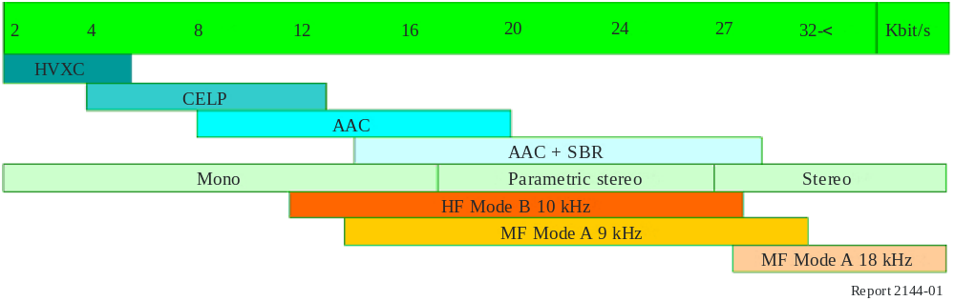
The following are the main features of these audio coders:
HVXC:
– Harmonic Vector Excitation Coding-developed by SONY – no licence is required.
– Designed for single voice only with some background noise − destroys any music and jingles.
– Bit rate is 2 000-6 560 bit/s.
– SBR can be used to increase audio bandwidth from 4 kHz to 8 kHz.
– Could be used for multi-language news reports or with data traffic in a multiple service.
CELP:
– Coded Excited Linear Prediction developed by NEC- licence needed.
– Designed for studio derived voice commentary where there is no background noise, though can cope with a greater amount of noise than HVXC. Okay with music at higher bit rates.
– Useful bit rate is 3 860-14 000 bit/s.
– SBR can be used to increase audio bandwidth up to 14 kHz.
– Both CRC and unequal error protection are available for additional error protection.
AAC:
– The successor to MP3 commonly known as MPEG-4 AAC. It is not defined as a single specification but a complex “toolbox” to perform a wide range of operations. A subset of the AAC “toolbox” was chosen to best suit the DRM system. No licence is required.
– Sampling rate is 12 kHz or 24 kHz.
– Bits rates between 8 and 20 kbit/s increase audio bandwidth in steps from 4 to 6 kHz.
– Versatile audio codec twice as efficient as MP3; would be used on HF channels which necessitate high levels of protection and in consequence lower data rates.
AAC + SBR:
– Spectral Band Replication developed by Coding Technologies. A licence is required.
– Can be used on all types of audio codec to extend frequency range, SBR is mainly a post process, adding only 2 kbit/s per channel to the original data rate.
– 3 audio bandwidth limits:
– (10 875 Hz) − 14 000-18 460 bit/s;
– (13 125 Hz) − 18 480-22 460 bit/s;
– (15 375 Hz) − 22 480-28 460 bit/s.
– Most commonly used configuration for a standard HF channel (17-21 kbit/s).
Parametric Stereo:
– Developed by Coding Technologies. A licence is required.
– Minimum bit rate is 16 480 bit/s.
– 3 audio bandwidth limits as per SBR mono.
– Only an additional 2 kbit/s required to convey a stereophonic image.
– Suitable for 9 kHz MF channels or benign single-hop HF channels.
AAC + SBR Stereo:
– Sampling rate is 24 kHz.
– Minimum bit rate is 26480 bit/s.
– 2 audio bandwidth limits:
– (13 125 Hz) − 26 480-28 480 bit/s;
– (15 375 Hz) − 28 480 bit/s.
– Suitable for double 9 kHz MF channels.

2.3 Transmission modes and data rates

2.3.1 DRM robustness modes
The digital phase/amplitude information on the RF signal is corrupted to different degrees as the RF signal propagates. Some HF channels provide challenging situations:
– fairly rapid flat fading;
– multipath interference that produces frequency selective fading;
– large path delay spreads in time; and
– ionospherically induced high levels of Doppler shift and Doppler spread.
The error protection and error correction incorporated in the DRM system design mitigates these effects to a great degree. This permits the receiver to decode the transmitted digital information accurately.
The DRM signal can be adjusted to cope with different channel conditions. For a high quality, “clean”, channel, the DRM signal needs to be less “robust” than for a difficult, noisy and or distorted channel. Table 1 shows the possible robustness modes and the corresponding typical propagation conditions and the preferred frequency bands. The differences in robustness are obtained by a suitable selection of the OFDM parameters. For information, Table 2 shows the OFDM parameters for each robustness mode.
TABLE 1
DRM robustness modes
Robustness  mode | Typical propagation conditions |  | Preferred frequency bands
A | Ground-wave channels, with minor fading | (Ground wave) | LF, MF
B | Time- and frequency-selective channels, with longer delay spread | (Skywave) | MF, HF
C | As robustness mode B, but with higher Doppler spread | (Skywave) | Only HF
D | As robustness mode B, but with severe delay and Doppler spread | (Skywave) | Only HF

Audio services are transmitted in the main service channel (MSC) of the DRM multiplex. For all robustness modes two different modulation schemes (16-QAM or 64-QAM) are defined for the MSC, which can be used in combination with one of two (16-QAM) or four (64-QAM) protection levels, respectively.
Each protection level is characterized by a specific parameter set for the two (16-QAM) or three (64-QAM) convolutional encoders, resulting in a certain average code rate for the overall multilevel encoding process in the modulator. For 16-QAM protection level, No. 0 corresponds to an average code rate of 0.5; No. 1 to 0.62. For 64-QAM the protection levels, Nos. 0 to 3 correspond to average code rates of 0.5, 0.6, 0.71 and 0.78.
The time-related OFDM symbol parameters are expressed in multiples of the elementary time period T, which is equal to 83^{1/3} μs. These parameters are:
Tg: duration of the guard interval
Ts: duration of an OFDM symbol
Tu: duration of the useful (orthogonal) part of an OFDM symbol (i.e., excluding the guard interval). The OFDM symbols are grouped to form transmission frames of duration Tf.
A certain number of cells in each OFDM symbol are transmitted with a predetermined amplitude and phase, in order to be used as references in the demodulation process. They are called “reference pilots” and represent a certain proportion of the total number of cells.

TABLE 2
OFDM symbol parameters
Parameters list | Robustness mode
Parameters list | A | B | C | D
T (ms) | 831/3 | 831/3 | 831/3 | 831/3
Tu (ms) | 24(288 × T) | 211/3(256 × T) | 142/3(176 × T) | 91/3(112 × T)
Tg (ms) | 22/3 (32 × T) | 51/3 (64 × T) | 51/3 (64 × T) | 71/3 (88 × T)
Tg/Tu | 1/9 | 1/4 | 4/11 | 11/14
Ts = Tu + Tg (ms) | 262/3 | 262/3 | 20 | 162/3
Tf (ms) | 400 | 400 | 400 | 400

2.3.2 Spectrum occupancy types
For each robustness mode the occupied signal bandwidth can be varied dependent on the frequency band and on the desired application. The specified spectrum occupancy types are shown in Table 3.
The bandwidths in the last row of Table 3 are the nominal bandwidths for the respective spectrum occupancy types of the DRM signal and the values given in lines A to D are the exact signal bandwidths for the different robustness mode combinations.

2.3.3 DRM theoretical data rates
Tables 4 to 7 give the theoretical data rates for the different robustness modes. The highlighted columns refer to the typical use.
It should be noted that DRM can cope with bandwidths of up to 20 kHz, but that its use is practically limited to 9 and 10 kHz.
TABLE 3
Bandwidths for DRM robustness mode combinations (kHz)
Robustness mode ⇓ | Spectrum occupancy type (nominal bandwidth)
Robustness mode ⇓ | 0 (4.5 kHz) | 1 (5 kHz) | 2 (9 kHz) | 3 (10 kHz)
A | 4.208 | 4.708 | 8.542 | 9.542
B | 4.266 | 4.828 | 8.578 | 9.703
C | − | − | − | 9.477
D | − | − | − | 9.536

TABLE 4
Data rate (bit/s) in standard mode, Mode A (ground wave)
Parameters  ⇓ | Bandwidth  (kHz)
Parameters  ⇓ | 4.5 | 5 | 9 | 10 | 18 | 20
64-QAM, rall = 0.5 | 9 392.5 | 10 620 | 19 695 | 22 142.5 | 40 935 | 45 840
64-QAM, rall = 0.6 | 11 272.5 | 12 740 | 23 625 | 26 570 | 49 115 | 54 995
64-QAM, rall = 0.71 | 13 305 | 15 045 | 27 892.5 | 31 367.5 | 57 982.5 | 64 940
64-QAM, rall = 0.78 | 14 745 | 16 660 | 30 910 | 34 770 | 64 260 | 71 970
16-QAM, rall = 0.5 | 6 262.5 | 7 080 | 13 125 | 14 760 | 27 285 | 30 555
16 QAM, rall = 0.62 | 7 827.5 | 8 850 | 16 412.5 | 18 452.5 | 34 112.5 | 38 200

TABLE 5
Data rate in standard mode, Mode B (skywave)
Parameters  ⇓ | Bandwidth  (kHz)
Parameters  ⇓ | 4.5 | 5 | 9 | 10 | 18 | 20
64-QAM, rall = 0.5 | 7 200 | 8 280 | 15 332.5 | 17 477.5 | 31 817.5 | 35 760
64-QAM, rall = 0.6 | 8 640 | 9 930 | 18 402.5 | 20 975 | 38 180 | 42 905
64-QAM, rall = 0.71 | 10 200 | 11 730 | 21 720 | 24 750 | 45 065 | 50 660
64-QAM, rall = 0.78 | 11 300 | 12 990 | 24 075 | 27 450 | 49 950 | 56 140
16-QAM, rall = 0.5 | 4 800 | 5 520 | 10 222.5 | 11 655 | 21 210 | 23 835
16-QAM, rall = 0.62 | 6 000 | 6 900 | 12 777.5 | 14 565 | 26 515 | 29 800

TABLE 6
Data rate in standard mode, Mode C (skywave)
Parameters  ⇓ | Bandwidth  (kHz)
Parameters  ⇓ | 4.5 | 5 | 9 | 10 | 18 | 20
16-QAM, rall = 0.5 |  |  |  | 13 785 |  | 28 952.5
16-QAM, rall = 0.6 |  |  |  | 16 537.5 |  | 34 745
16-QAM, rall = 0.71 | Not used |  |  | 19 520 | Not used | 41 015
16-QAM, rall = 0.78 |  |  |  | 21 635 |  | 45 470
16-QAM, rall = 0.5 |  |  |  | 9 187.5 |  | 19 305
16-QAM, rall = 0.62 |  |  |  | 11 487.5 |  | 24 127.5

TABLE 7
Data rate in standard mode, Mode D (skywave)
Parameters  ⇓ | Bandwidth  (kHz)
Parameters  ⇓ | 4.5 | 5 | 9 | 10 | 18 | 20
64-QAM, rall = 0.5 |  |  |  | 9 150 |  | 19 500
64-QAM, rall = 0.6 |  |  |  | 10 977.5 |  | 23 397.5
64-QAM, rall = 0.71 | Not used |  |  | 12 962.5 | Not used | 27 625
64-QAM, rall = 0.78 |  |  |  | 14 365 |  | 30 605
16-QAM, rall = 0.5 |  |  |  | 60 97.5 |  | 12 997.5
16-QAM, rall = 0.62 |  |  |  | 7 625 |  | 16 250

3 Modification of transmitters and antennas
This section:
– Deals with the principles of converting existing transmitters to digital operation:
– Bandwidth for amplitude and phase components.
– Analyses the various types of transmitters that need to be converted to DRM:
– Old Class B transmitters.
– PDM (Pulse duration modulation) transmitters.
– PSM (Phase shift modulation) transmitters.
– Discusses the Vatican experience.
– Deals with spectrum masks.
– Deals with antenna constraints.

3.1 Principles of modifying existing transmitters − conversion to digital
In order to understand the various methods that can be used to modify an existing transmitter for use with DRM it is useful to recap a few modulation principles.
A DRM signal is an amplitude- and phase-modulated RF signal. It can be represented by the expression for a generic electrical signal, x(t), as follows:
(1)
where:
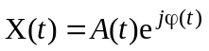 (2)
represents the baseband modulating signal.
From the last expression it may be found that:
(3)
where:
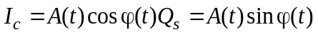 (4)
are known as “baseband analogue components” of the full modulated signal, I_{c} represents the phase component and Q_{s} the quadrature component. Under certain conditions both components are bandwidth limited.
The fully modulated signal given in § 3.1 can easily be generated from the two modulation components I/Q using a circuit that implements the operations shown in Fig. 2.
FIGure 2
Signal generation using phase and quadrature components
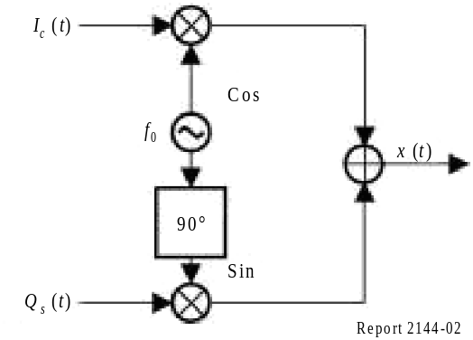
The previous relations explain that a generic transmitter can be used for DRM if it can provide an RF signal that is simultaneously amplitude and phase modulated at its output. The methods needed to achieve this are very dependent on the transmitter’s circuitry and its original set of implemented functionalities.
One possible way of using an existing transmitter for DRM is to generate the fully modulated DRM signal (as in equation (1)) outside the transmitter, which is then used as a linear amplifier.
In practice this method is only possible for lower power transmitters, where efficiency is not a significant cost factor. The high cost and poor efficiency of linear amplifiers makes them unaffordable as transmitter power is increased above 1 kW.
The optimum solution is to use “non-linear” high efficiency RF amplifiers. To use these it is necessary to generate both the amplitude component A(t) (envelope) and the phase component cos[ω0t + ϕ (t)] (RF phase-modulated) outside the amplifier and use the existing modulation chain to generate the full signal. This approach is illustrated in Fig. 3. It should be noted that the bandwidths of the individual envelope and RF phase-modulated components shown in Fig. 3 are larger than the resulting transmission bandwidth, as indicated in Table 8.
FIGure 3
Signal generation using amplitude and phase components
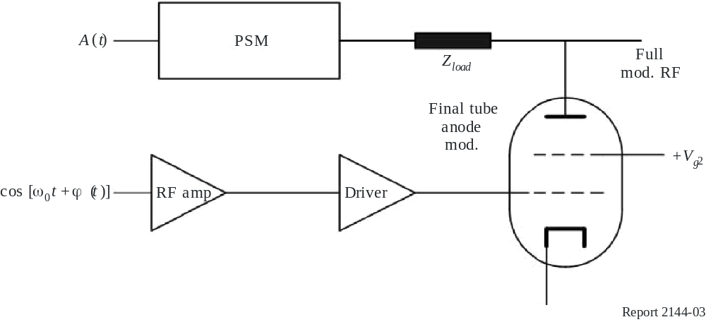
TABLE 8
Necessary transmitter bandwidths
Nominal bandwidth | Bandwidth of the RF phase  modulated component | Bandwidth of the envelope component
4.5 kHz, 5 kHz | 20 kHz | 15 to 20 kHz
9 kHz, 10 kHz | 40 kHz | 30 to 40 kHz
18 kHz, 20 kHz | 80 kHz | 60 to 80 kHz

DRM power is expressed as the average power output of the digital modulation. Since modulation peaks are high for COFDM transmission, the average power is significantly lower than for the same transmitter operating in the analogue AM mode. Under ideal conditions a DRM COFDM waveform has a peak to average ratio on the order of 10 to 12 dB.
A transmitter with an analogue carrier power output of 100 kW and peak power of 400 kW would produce 40 kW DRM average power with 10 dB (the most common value) of headroom for the modulation peaks. If the digital average power of such a 100 kW transmitter were increased by 2 dB, the transmitter would clip the peaks of the amplified signal, causing in-band and out of band intermodulation products. The result would be excessive out of band emissions and non-compliant operation of the transmitter with the result that the spectrum mask constraints would not be fulfilled.

3.2 Converting different types of transmitter to DRM
Modern AM transmitters typically use non-linear techniques and have high efficiencies (defined as the ratio of RF power output to mains power input) in the range 70% (HF) to 85% (MF).
AM transmitters with Class B modulators can only be converted to class A linear mode. This involves a careful adjustment of the working conditions of the RF amplifier chain, including the final tube. The achievable results of such a conversion are summarized in Table 9.
TABLE 9
Result of converting an AM transmitter with a Class B modulator to DRM
RF analogue power (kW) | 100 | 250 | 500
DRM power (kW) | < 10 | < 20 | < 40

The overall efficiency of the transmitter is around 20%.
A PDM transmitter may be converted for DRM using an existing SSB capability. However the operation is very close to Class A operation.
If the PSM modulator has the required bandwidth to process the envelope signal, the transmitter can be converted to provide a fully modulated DRM RF signal (a high-level phase and amplitude modulated signal, as shown in Fig. 2). However, due to the different time delays of the two circuits involved (PSM and RF amplifier chain) a specific time delay between the envelope and the
RF phase modulated signals must be introduced by the DRM encoder-exciter in order to minimize the final signal distortion. In this situation, because no modification has been introduced in the bias of the amplifier chain, the original efficiency of the transmitter can be more or less maintained.

3.3 Coverage efficiency
The useful (information carrying) output from the DRM transmitter is likely to be greater than the sideband output from an AM transmitter operated with a typical average modulation rate. The fact that DRM is optimized for the RF channel should mean that greater coverage is achieved. A more useful measure of efficiency might be gained from looking at the coverage achieved for a given mains power level. Using this, DRM transmitters should routinely score higher than AM transmitters. Electrical efficiency figures are useful for comparing one DRM transmitter with another DRM transmitter and not for comparing DRM with analogue.

3.4 The experience of Vatican Radio

3.4.1 Modern solid-state MW transmitter
In the first half of 2004, Vatican Radio modified a modern (1998) 50 kW solid-state MW transmitter that was installed in Santa Maria di Galeria. The entire modification was carried out under the manufacturer’s supervision. The transmitter was originally equipped with an internal synthesizer that was capable of accepting the I/Q representation of the modulation signal. Due to the structure of the RF power stages no modification was required in the RF chain and the original high efficiency of the transmitter was conserved.

3.4.2 PDM SW transmitter
In the Vatican Transmitting Centre a short wave 500 kW PDM transmitter dating from 1985 was modified for DRM in about seven days. The work was done in cooperation with the manufacturer. In this specific situation, even though the switching frequency of the PDM was double the bandwidth of the envelope signal, it was insufficient to process the envelope signal.
Luckily, the transmitter in question was SSB capable and the processing circuits were found to be suitable for DRM. When this transmitter operates in SSB mode, tests showed the final stage to be quasi-linear, with the PDM modulator operating as a power supply. The transmitter was therefore fitted with an external DRM modulator-exciter that inserted a fully modulated DRM signal into the SSB processing chain.
The electrical efficiency obtained is less than that reached when the transmitter operates in AM mode; however, thanks to the original structure of the SSB chain of the transmitter, an electrical efficiency of approximately 40% has been reached (see also § 3.3).

3.4.3 First-generation (GTO) PSM MW transmitter
A 600 kW PSM medium wave transmitter dating from 1989 and installed in Santa Maria di Galeria was also modified. The work was completed in about three weeks.
As explained above (§ 3.1), in a PSM transmitter the best way to generate DRM is to modulate the transmitter with two signals: envelope and RF phase modulated components. This configuration is particularly suitable because the original class C or D amplification of the final stage remains unmodified and under these conditions the highest global efficiency can be reached. As in this transmitter the bandwidth of the PSM modulator was not large enough, the transmitter was fed with a fully modulated signal (provided by an external DRM encoder-exciter) and the PSM modulator used as a simple power supply for the final stage, which had been linearized. In this situation, of course, preliminary tests are required in order to verify the linearity of the amplification chain. Moreover, once linearized, this kind of power amplifier may become unstable and particular care is required.

3.4.4 Modern PSM (IGBT) SW transmitter
A modern short-wave 500 kW PSM transmitter, installed in 1997, was also modified in cooperation with the original manufacturer. The measured frequency response of the PSM modulator was close to that needed to process the envelope signal. The required bandwidth was achieved through small modifications to each module of the PSM modulator and through rebuilding its output line filter. All work was completed in four working weeks. The original manufacturer provided a new PSM control board to accept the I and Q components of the full DRM signal generated by an external DRM encoder-exciter. The control board evaluates the envelope A(t) signal, which then passes through the PSM chain. At the same time the RF phase modulated cos[ω0t + ϕ(t)] component, externally generated by the encoder-exciter, passes through the RF chain. The phase modulated RF is applied to the grid of the final stage tube and the envelope is applied to the anode. The result is a high-level phase and amplitude modulated signal (the fully modulated DRM signal). The necessary delay between the envelope and the RF phase modulated signals was introduced by the DRM encoder-exciter in order to minimize the final signal distortion. Because the biasing of the amplifier chain was not changed, the original electrical efficiency of the transmitter has been more or less maintained.

3.5 Spectrum mask
The permitted output spectrum of a DRM transmitter is defined according the mask described by the following equations and illustrated in Fig. 4:
|f | ≤ 0.5 × B: P(f) = 0 dB
|f | ≤ 0.53 × B: P(f) = −30 dB
0.53 × B < |f | < 2.98 × B: P(f) = −30 − 40 × log₁₀(f/(0.53 × B)
|f | ≥ 2.98 × B P(f) = −60 dB
Where B is the nominal bandwidth and f is the current frequency.
FIGure 4
DRM transmitter spectrum mask
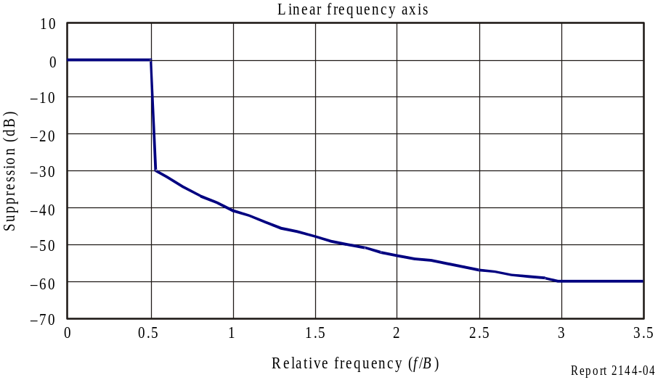
The spectrum mask is symmetrical about the channel centre.

3.6 Antenna constraints
For long and medium wave antennas, the frequency response of the impedance at the feeding point is of particular importance, since the bandwidth of the modulated signal is relatively large compared to the carrier frequency. The influence of the asymmetry of the transmission on the quality of the amplitudes of a modulated oscillation is described with the aid of Fig. 5.

FIGure 5
Influence of the asymmetry of the transmission on the quality
of the amplitudes of a modulated oscillation
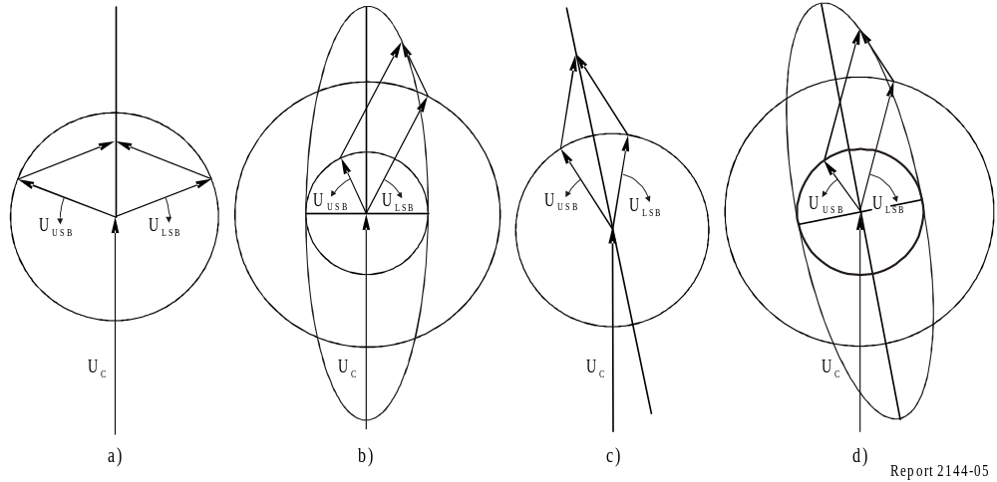
Figure 5a) shows the vector diagram of a pure amplitude modulation. The vector U_{C} represents the carrier, the vectors U_{lsb} and U_{USB} the lower and the upper sideband of the amplitude modulation. In this kind of representation, the vector of the carrier does not move, while the vectors of the sidebands rotate against each other depending on the frequency of the modulating input signal.
The size of these vectors is proportional to the amplitude of the signal. For this example it is assumed, for simplicity, that only one pure tone will be transmitted. The sum of the three vectors represents the instantaneous vector of the amplitude-modulated oscillation. The resulting vector changes its size, but not its phase, because the side band vectors are of the same size and they rotate exactly in opposite directions. In Fig. 5a) the resulting vector remains in the vertical line, which means a pure amplitude modulation.
In Fig. 5b) the sidebands are assumed to be of unequal amplitudes. As result a phase modulation occurs in addition to the pure amplitude modulation shown by the resulting vector that does not remain vertical as it was in Fig. 5a).
Figure 5c) shows the vectors with equal amplitudes but unequal phases of the sidebands. As in the preceding case, a phase modulation also occurs here in addition to the amplitude modulation.
Figure 5d) shows the behaviour of the simultaneous occurrence of amplitude and phase errors. Again simultaneous amplitude and phase modulation occur.
In conclusion, unwanted phase modulation occurs during asymmetrical transmission of the sidebands. It is not significant whether this asymmetry occurs in the amplitude or in the phase of the transfer function.
Load impedance bandwidth:
±5 kHz − symmetry of the load impedance presented to the final RF amplifier within the transmitter such that the standing wave ratio calculated for one sideband impedance, when normalized to the complex conjugate of the corresponding sideband impedance on the other side of carrier frequency, does not exceed 1.035:1.
±10 kHz − the VSWR of the load impedance presented to the final RF amplifier within the transmitter should not exceed 1.20:1 when normalized to the carrier frequency impedance.

4 Coverage and frequency planning

4.1 Introduction
As with all planning of radio services, the planning of DRM is based on two fundamental concepts:
– Minimum usable field strength.
– Protection criteria (protection ratio).

4.1.1 Minimum usable field strength
For proper reception of any radio service, the received field strength must be high enough to allow the demodulator to function in the prevailing noise environment. In general this defines the coverage area of the transmitter. It is to be expected that the strength of the wanted signal will decrease as the receiver moves further away from the transmitter (or the beam centre in the case of a directional antenna), while the noise will stay the same.
The ITU specifies reference receivers with defined characteristics and these are used for service planning. A real receiver might have better or worse characteristics than the reference but it would make no sense to have different planning parameters for each individual receiver or receiver type. The minimum usable field strength is that field strength which is necessary for the receiver to perform to a given (defined) level of performance. In the case of a DRM receiver this level of performance can be defined as a bit error rate (BER). If the BER is low enough, the error correction and other arrangements within the DRM system can reconstruct the audio signal.

4.1.2 Protection criteria
Major sources of “noise” at the receiver input are other radio services operating at or near the desired transmission frequency. Unlike all other sources of noise (intrinsic receiver noise, man made noise, naturally occurring noise, etc.) interference from other radio services can and should be controlled by the planning process. The interfering station is subject to the same planning criteria as the “victim” service and the victim service itself will always be an interferer to someone else. For any one station, the transmitter power along with the antenna gain and directivity are set such that the signal is sufficiently large that a reference receiver will demodulate the signal to the relevant defined quality standard:
– in the required (specified) service area; and
– when compared with the cumulative effect of all the potential interferers.
In the case of DRM, the quality standard is again set by the worst tolerable BER. Similarly, the transmitter power and antenna characteristics must also be set such that the cumulative effect of all interferers (including itself) does not rise above a prescribed limit for other transmissions in their own service area. Clearly, this can be a complicated multi-dimensional calculation.
An analogue, AM radio service (or any other for that matter) carries the information in the sidebands. It is therefore the ratio of wanted signal in the sidebands to noise and interference in the sidebands that defines the signal to noise ratio for the demodulated signal. With an AM radio signal it can reasonably be assumed that the ratio of sideband to carrier energy for one transmission is much the same as for another transmission. When assessing protection to and from other AM transmissions it is reasonable therefore simply to look at the relative levels of the carriers. Similarly, the “sideband” characteristics of any one DRM transmission will be much the same as for another and so the protection requirements can be assessed simply by looking at the overall power.
A DRM transmission, however:
– does not have a carrier component in the same way as does an AM transmission; and
– It has very different power spectral density characteristics.
Assessing the protection criteria in a mixed environment (DRM into AM and vice versa) is therefore much less straightforward. It is necessary to determine the actual energy in the AM sideband and compare this with the total energy in the DRM signal. The energy in the sidebands of an AM transmission is heavily dependent on modulation depth, programme genre and the use (or not) of dynamic carrier control techniques. In part because of this, it is convenient (more consistent) when assessing protection criteria to compare the total energy in a DRM signal with the carrier energy in an AM signal. Since the sideband energy in the AM signal is considerably less than the carrier energy it is to be expected that the energy in a DRM signal will be similarly lower (than the AM carrier) to give the same level of interference. This is reflected in Table 30 in § 4.6.4, which defines the power “back-off” necessary to give an equivalent level of interference when an AM transmission is directly replaced with a DRM transmission. Care must be taken to protect the weakest AM signals.
Simply put, if a DRM transmission is introduced, it should not impose more interference on existing AM services than the analogue transmission it replaces.
In the HF bands, experience of introducing DRM transmissions into the already crowded spectrum suggests that there is an advantage in trying, whenever possible, to group the DRM transmissions together in the same part of a band. Within the informal regional coordination groups (HFCC/ASBU, ABU-HFC) frequency management organizations have been requested to take this into account, as far as possible, when planning and coordinating their seasonal broadcasting schedules.

4.2 LF/MF bands
This section should be read in conjunction with the ITU-R Handbook – LF/MF system design that describes many aspects in more detail.

4.2.1 Frequency bands allocated to LF and MF sound broadcasting
Frequency bands at LF and MF have been allocated to sound broadcasting services in the three ITU-Regions according to the provisions of Radio Regulations (RR). Figure 6 shows the world distribution of the ITU-Regions. The shared part is referred to as the Tropical Zone. Table 10 shows the frequency allocations made according to the Radio Regulations:

FIGure 6
The ITU-Regions
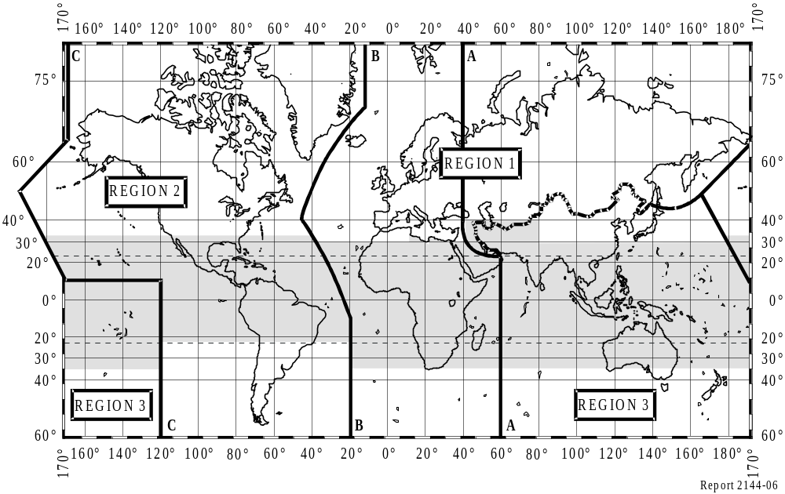
TABLE 10
ITU frequency allocations − LF and MF bands
ITU-Region  (associated Agreements) | LF band | MF band
1  (GE75) | 148.5-255.0 kHz  255.0-283.5 kHz  (Shared with aeronautical services) | 526.5-1 606.5 kHz
2  (RJ81)  (RJ88) | – | 525.0-535 kHz  (Shared with aeronautical services)  535.0-1 605.0 kHz  1 605.0-1 625.0 kHz  1 625.0-1 705.0 kHz  (Shared with fixed and mobile services)
3  (GE75) |  | 526.5-535 kHz  (With mobile services on  a secondary basis)  535.0-1 606.5 kHz

4.2.2 Coverage

4.2.2.1 Coverage area
Daytime coverage in the long and medium wave bands uses ground wave propagation. It is anticipated that DRM coverage will be better or as good as that of AM at transmitted power levels of −7 dB (emrp) (see CCRR/20*) compared to that of an analogue assignment it has replaced. Skywave propagation does not provide any daytime coverage.
Night-time coverage in the long and medium wave bands is more complex. Ground wave generally provides night-time coverage and may be supplemented by skywave in some cases. Self-interference may be an issue. It is anticipated that DRM coverage will be better or as good as that of an AM service where transmitted DRM power levels are −7 dB (see CCRR/20) compared to that of an analogue assignment it has replaced.
However due to high levels of skywave interference particularly at the day to night transition and maybe to a lesser extent during the night, it is generally found that night-time coverage is less than the daytime coverage.
The DRM system includes different digital modulation modes to enable the transmission operator to select a mode with a degree of robustness best suited to the expected propagation and reception conditions. Receivers are capable of automatically detecting which mode is in use (see § 2.1).

4.2.2.2 Coverage concepts for DRM
Coverage concepts applicable to long and medium wave broadcasting using analogue modulation are equally valid for DRM.
A Single transmitter
Where a service is required for a single area or town, a single transmitter may suffice. The placing of a transmitter may be critical to ensure night-time coverage. Propagation effects such as conductivity, “urban suck out” (Causebrook effect) may be equally critical. This equally applies to high or low power assignments utilized for large and small area coverage and apply to both DRM and AM.
B Single frequency networks (SFNs)
Where it is desirable to have large area coverage and ensure spectrum efficiency, several transmitters can be operated on the same frequency. This can be true of an AM (long or medium wave) service (synchronous network) or a DRM service (SFN). The major difference is that the DRM system is able to provide contiguous coverage from a network of transmitters if correctly engineered while the AM service would not provide contiguous coverage due to mutual interference.
C Multi-frequency networks (MFNs)
Where it is desirable to have large area coverage but an SFN may not be achievable due to frequency planning constraints, then an MFN may have to be utilized. This is equally true of both a long or medium wave AM service or an equivalent DRM service. The major advantage that such a DRM service would have over an equivalent AM service is a seamless coverage available through receiver design using AFS (Automatic frequency switching).
This is equally true of high- or low-power networks or combinations of both.

4.2.2.3 Conversion of LF/MF AM assignment
It might be expected that converting an existing or new LF/MF assignment to DRM in line with current ITU-Regulation would increase the coverage area due mainly to a reduction in Emin (see below).
The minimum usable field strength (Emin or MUFS) is a key factor in coverage potential. This is calculated by the addition of the receiver noise floor and the required C/N for a satisfactory service.
Recommendation ITU-R BS.703 – Characteristics of AM sound broadcasting reference receivers for planning purposes, quotes Emin for AM transmission as:
Emin = 66 dB(μV/m) for LF band
Emin = 60 dB(μV/m) for MF band
Recommendation ITU-R BS.1615 – Planning parameters for digital sound broadcasting at frequencies below 30 MHz, should be consulted for the many values of computed Emin for DRM for varying modes of operation:
AM (Emin) 23.5 dB (Rx Noise floor) + 36.5 dB (C/N) = 60 dB(μV/m)
Examples of Emin for DRM (see Tables 11, 12 and 13):
DRM (Emin) 24.5 dB (23.5 + 1) (Rx noise floor) + 8.6 dB (S/N) = 33.1 dB(µV/m)
DRM (Emin) 24.5 dB (23.5 + 1) (Rx noise floor) + 17.1 dB (S/N) = 41.6 dB(µV/m)
NOTE 1 − A more robust DRM mode (lower data rates) can tolerate a lower S/N and hence has a lower Emin.
The additional 1 dB in the Rx noise floor for DRM is due to the larger receiver IF bandwidth of DRM (10 kHz) compared to double sideband AM (8 kHz).
Section 4.5 provides further explanation on the calculation of the minimum usable field strength.
TABLE 11
Minimum usable field strength (dB(µV/m)) to achieve BER of 1 × 10⁻⁴ for DRM robustness
Mode A with different spectrum occupancy types 0 or 2 (4.5 or 9 kHz) dependent
on modulation and protection level scheme for the LF frequency band
(ground-wave propagation)
Modulation  scheme | Protection  level No. | Average  code rate | Robustness mode/spectrum  occupancy type
Modulation  scheme | Protection  level No. | Average  code rate | A/0 (4.5 kHz) | A/2 (9 kHz)
16-QAM | 0 | 0.5 | 39.3 | 39.1
16-QAM | 1 | 0.62 | 41.4 | 41.2
64-QAM | 0 | 0.5 | 44.8 | 44.6
64-QAM | 1 | 0.6 | 46.3 | 45.8
64-QAM | 2 | 0.71 | 48.0 | 47.6
64-QAM | 3 | 0.78 | 49.7 | 49.2

TABLE 12
Minimum usable field strength (dB(µV/m)) to achieve BER of 1 × 10⁻⁴ for DRM robustness Mode A with different spectrum occupancy types dependent on protection level and
modulation scheme for the MF frequency band (ground-wave propagation)
Modulation  scheme | Protection  level No. | Average  code rate | Robustness mode/spectrum  occupancy type
Modulation  scheme | Protection  level No. | Average  code rate | A/0 (4.5 kHz)  A/1 (5 kHz) | A/2 (9 kHz)  A/3 (10 kHz)
16-QAM | 0 | 0.5 | 33.3 | 33.1
16-QAM | 1 | 0.62 | 35.4 | 35.2
64-QAM | 0 | 0.5 | 38.8 | 38.6
64-QAM | 1 | 0.6 | 40.3 | 39.8
64-QAM | 2 | 0.71 | 42.0 | 41.6
64-QAM | 3 | 0.78 | 43.7 | 43.2

TABLE 13
Minimum usable field strength (dB(µV/m)) to achieve BER of 1 × 10⁻⁴ for DRM robustness
Mode A with different spectrum occupancy types dependent on protection level and modulation scheme for the MF frequency band (ground-wave plus skywave propagation)
Modulation  scheme | Protection  level No. | Average  code rate | Robustness mode/spectrum  occupancy type
Modulation  scheme | Protection  level No. | Average  code rate | A/0 (4.5 kHz)  A/1 (5 kHz) | A/2 (9 kHz)  A/3 (10 kHz)
16-QAM | 0 | 0.5 | 34.3 | 33.9
16-QAM | 1 | 0.62 | 37.2 | 37.0
64-QAM | 0 | 0.5 | 39.7 | 39.4
64-QAM | 1 | 0.6 | 41.1 | 40.8
64-QAM | 2 | 0.71 | 44.2 | 43.7
64-QAM | 3 | 0.78 | 47.4 | 46.5

To protect an existing AM service from another co-channel AM interferer an RF protection ratio of 30 dB is required. If that interferer is a co-channel DRM service the RF protection ratio must be increased by 6.6 dB to 36.6 dB for the same interference potential. Hence CCRR/20 requires the DRM emrp to be −7 dB on the AM carrier level to safeguard the existing AM service.
The expected increase in coverage potential when converting an AM assignment to DRM in accordance with CCRR/20 will be relative to the severity of interference that limits the coverage of the AM assignment in the first place.
Figure 7 demonstrates a fictitious example of converting an AM transmitter assignment to an equivalent DRM assignment (−7 dB emrp). The example is for five omnidirectional transmitters. Four are co-channel interferers varying in emrp from 100 to 400 W to demonstrate three distinct levels of interference potential and the wanted is 1 000 W for AM or 200 W (−7 dB) for DRM.
FIGure 7
Example of converting an AM transmitter assignment
to an equivalent DRM assignment
The prediction shown in Fig. 7 is for ground-wave only with no receiving antenna discrimination. It is therefore representative of daytime reception. As the transmitters are relatively close, minimal skywave propagation would occur at night so the coverage will change little. However note that this is not representative of the “real world” where skywave interference at night could severely limit coverage.

4.2.2.4 Channel bandwidth in ITU-Regions 2 and 3
A full bandwidth (18 kHz) DRM medium wave digital radio transmission was carried out on 11 May 2007. This resulted in an excellent quality radio test program received, improved sound emanating from DRM digital radio sets, superior to the service generally resulting from the analogue transmissions. The All India Radio transmitter at Nangli in Delhi operated a full fledged stereo service as a part of the tests. This was for the first time in the world that an 18 kHz DRM test has been carried out in the medium wave band. Significantly, as radio broadcasters in the Asia-Pacific uniquely use 18 kHz wide channels in the medium wave and using DRM in the full channel will enable them to provide very high quality stereo service to listeners. This kind of configuration is suitable for ITU-Regions 2 and 3 because regulations (RJ88 and GE75) allow the transmission of signals with 18 kHz bandwidth in medium wave. This would be the step of DRM technology to be carried out after using Simulcast configuration.

4.2.2.5 Protection ratios
Protection ratios are described in detail in Recommendation ITU-R BS.1615. They are simply the minimum values that the wanted signal levels (assuming it is a service to provide coverage) must exceed unwanted interfering signal(s).
For further details on protection ratios, see § 4.6.

4.2.2.6 Noise
Noise limits the performance of radio systems and relevant further information can be found in Recommendation ITU-R P.372-8 – Radio Noise.

4.2.3 Propagation
Propagation factors are used to define the mode of transmission required. This is described in detail in Recommendation ITU-R BS.1615.
Propagation of the radio waves in the LF and MF bands are described in detail in the ITU-R Handbook – LF/MF system design (Edition of 2001) with particular note that propagation varies with latitude.
Recommendation ITU-R P.368-7 (1992) – Ground-wave propagation curves for frequencies between 10 kHz and 30 MHz. This method is based on a set of predicted field strength versus distance to the transmitter curves, each one referring to a certain electrical conductivity value of the propagation path terrain. Homogeneous Paths method would assume one conductivity value for the whole propagation path and use the corresponding curve to predict the field-strength value. However, usually, a propagation path features sections of different conductivity values. In this case, the Millington or mixed paths method is proposed.
Weighted conductivity
Millington method is very dependent on the accuracy of the conductivity values, especially in the vicinity of the transmitter and the receiver locations. In addition, the homogeneous paths method is much easier to use. In order to take into consideration the non-homogeneity of propagation paths when using the homogeneous paths method, the weighted conductivity is proposed in Document 6A/178*. It is defined as the average of the conductivity values along the path, weighted with the length of every conductivity section:

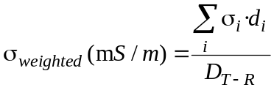
where:
σ_{i}: different conductivity values along the path
d_{i}: lengths of the sections along the path with a constant conductivity value
D_{T-R}: total length of the path.
This method is easier to use than the Millington method and it is not as dependent on the accuracy of the conductivity values of the path*. The proposed method averages the conductivity values along the path and thus reduces this dependence. Nevertheless, it should be noted that for the land-sea-land mixed paths the weighted conductivity should be only used for the land sections, and then the Millington method should be applied.
Terrain obstacles
The recommended prediction methods for the MF band only include the dependency of the received field-strength level with the distance between transmitter and receiver and the electrical characteristics of the terrain. Thus, the influence of the terrain irregularities in the received field-strength level is not considered. This lead to prediction errors related to terrain obstructions in the propagation path**, ***. The estimation of the attenuation due to one obstacle of the terrain within the propagation path can be properly obtained as follows***:

Atten_{Irr} (dB) = (−3.24 · ln(d) + 10.90) · (ln(2.84 · h))

where:
Atten_{Irr}: attenuation due to terrain irregularities (dB)
d: distance between the obstacle and the receiver (km)
h: height of the obstacle above the line of sight between the transmitter and the receiver (number of wavelengths).
The RMSE of the empirical data with respect to above equation is lower than 1.5 dB. The obstructed points of the trials feature distances between the obstacle and the receiver of d < 25 km and obstacle heights of 0.6λ ≤ h < 4λ.
If the path profile contains several representative irregularities it is proposed that the attenuation due to each terrain irregularity is estimated, and only the greatest attenuation value related to the most significant obstruction should be considered.
Furthermore, a detailed comparison study between measured field-strength values in rural and suburban environments and the predicted values given by Recommendation ITU-R P.368-7 is presented in Document 6E/175 and summarized in Annex 3, § A3.1. A comparison between measured field-strength values in urban environments and the predicted values given by Recommendation ITU-R P.368-7 is presented in Document 6A/73**** and summarized in Annex 3, § A3.6.
Urban environment attenuation
Finally, as regards ground-wave propagation, reception in urban environments is affected by several attenuation factors that are not analysed within the recommended prediction methods for the MF band*, **.
Influence of width of the streets
Urban reception environments under test have been classified into three categories:
– Wide streets: more than 4 lanes.
– Medium-width streets: 3-4 lanes.
– Narrow streets: 1-2 lanes.
In each category, the field-strength mean value has been calculated and normalized by the distance to the transmitter. Taking wide streets as a reference, the mean difference between the mean values of such areas and the rest are shown in the following table along with the standard deviations.

TABLE 14
Mean value field-strength differences between wide, medium-width and narrow streets
Streets | Difference | Delhi (666 kHz) | Madrid (1 260 kHz) | Mexico (1 060 kHz)
Wide | Mean | 0 dB | 0 dB | 0 dB
Medium | Mean | 4.2 dB | 9.2 dB | 5.1 dB
Medium | Standard deviation | 0.57 dB | 3.2 dB | 0.3 dB
Narrow | Mean | N/A | 13.8 dB | N/A
Narrow | Standard deviation | N/A | 1.8 dB | N/A

For further details see Document 6A/148**.
Attenuation occurrences due to specific urban elements
The Fig. 8 shows the obtained attenuation mean values for most frequent occurrences. High attenuation mean values are due to tall side obstacles, such as tall buildings, or to above obstacles, such as tunnels and bridges.
The following text is an extract from the ITU-R Handbook – LF/MF system design:
“The general subject of radio propagation is of fundamental importance to LF and MF broadcasting system engineering. It deals with the manner of transmission of radio signals from the transmitter site to each point in the reception area and describes the magnitude of the received signal at each such point in the desired service area and in the areas of potential interference.
It is important to perform valid propagation analysis for the broadcasting system for all points within the broadcasting service area, and in the service areas of other broadcasters using co-channel and adjacent channel frequencies. This is because noise and interference considerations determine
the delivery characteristics of the broadcasting facility that are to be required throughout the broadcasting service area, and in the service areas of other broadcasters on the same and adjacent channels. In general, the quality of this signal is specified in terms of its electrical field strength, usually in V/m. When a broadcasting system is designed, the usual design objective is to guarantee that this received field strength will not fall below some required value, and will not cause interference to other operators.”
FIGURE 8
Mean attenuation caused by urban elements
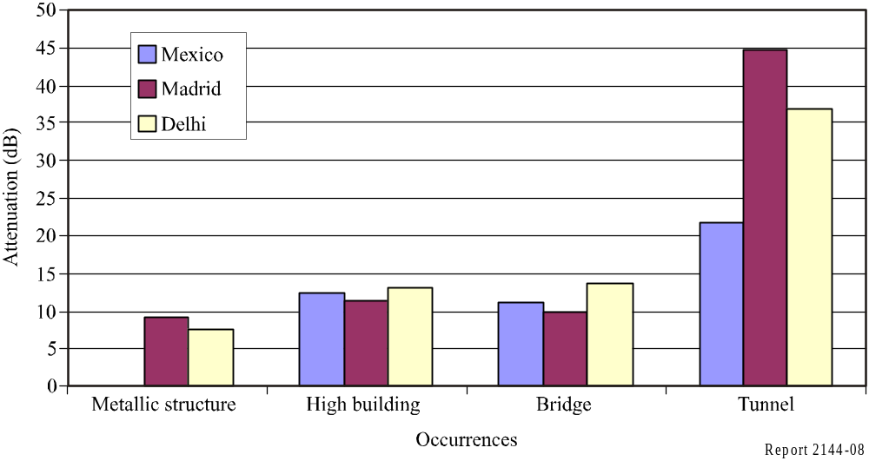
LF and MF signals propagate from the transmitting antenna to the receiver by two distinct propagation mechanisms: ground-wave and skywave propagation. In planning an LF or MF broadcasting system, one should remember that, especially at night, the signal received at any point in and around a broadcasting service area is always the vector sum of the ground wave and the skywave. At some points, the ground wave will clearly dominate and the service provided will be constant and continuous. At other points, the skywave may dominate and the signal will be characterized by some degree of short and long term fading. In some areas, often within the service area, the ground-wave and skywave components of the received signal will be approximately equal. In these areas the signal will exhibit strong and continuous fading. Such a signal will usually not meet the required signal delivery standards. However, this phenomenon may be avoided by judicious design of the vertical pattern of the transmitting antenna, which places this fading zone either outside the broadcasting service area, or in a sparsely populated region within it.
“In the following sections (in the ITU-R Handbook – LF/MF system design), the above mechanisms are described and the methodology for their calculations is presented. In the use of these methods, the broadcasting planning engineer must meet the objective of identifying the parameters required for the design and implementation of the transmitting facility (e.g. transmitter power and antenna pattern). This must be done in such a fashion as to provide the required service quality over the broadcasting service area, while simultaneously meeting the co-channel and adjacent channel protection requirements of the broadcasting ITU-Region in which the facility will be implemented. The broadcasting system designer must keep in mind that the potential of skywaves for interference for both co-channel and adjacent channel is much greater than that of ground waves.
It is important to note that, for interference calculations purposes, propagation calculations performed in connection with the addition of a new assignment or the modification of an existing assignment to one of the regional assignment Plans must be in accordance with the propagation methods of those Plans. This text (in the ITU-R Handbook – LF/MF system design) generally describes the ways in which the propagation methods used in the regional Plans differ from the ITU-R Recommendations.”

4.2.4 Frequency choice and coordination
Frequency choice
– New assignment.
– Converting an existing assignment.
Propagation varies dramatically with frequency in the LF and MF bands. There is no correct way to describe the correct frequency for a particular coverage requirement. Some simple rules may aid a planner’s choice if there is one. If a frequency is available, generally the lower the frequency the larger the coverage with the smallest EMRP is achievable. In urban environments lower frequencies imply larger coverage areas (see Document 6A/73). Conversely it could be said that if the required coverage is smaller and if higher frequencies can be used, better spectral efficiency can be achieved. Software packages are now able easily to identify “quiet” spectrum or usable channels and give an idea of the coverage potential and the likelihood of a successful coordination for a new assignment that may be suitable for the intended purpose.
Another consideration when converting an existing on air assignment is how suitable the antenna system is for DRM. It may be found that, due to the transmission characteristics of a DRM signal, less power than allowed by a simple conversion may be achievable.
Coordination
All AM assignments in ITU-Regions 1 and 3 are registered in the Geneva 75 Plan. This plan can be updated by any administration for a new or modified assignment by following the rules of procedure laid out in the Final Acts of the GE 75 Plan*.
Each assignment is described by its basic transmission parameters that allows at the time of the inclusion of an assignment into the plan for it to have a separate day and night coverage defined by test points. There are eighteen test points used to describe coverage. They are arranged radially around the wanted transmitter site at 20° intervals starting at 0°/360°. Each point is defined in space by its latitude and longitude. This is achieved by working outwards along a radial from the wanted transmitter and calculating where the summation of the nuisance fields (field strength + protection ratio) of all the potential interferers is less than the wanted field strength providing the wanted field strength is adequate (limit of service) for a service. These points are used to facilitate coordination by the use of the “half dB rule” for all except the low power channels as described in the Final Acts of the GE 75 Plan.
At the time of writing, a DRM assignment is effectively registered as an AM assignment but operated under the conditions described in CCRR/20 (Decisions of the RRB − December 2002 regarding the Rules of Procedure GE75, see § 5.1.3.4). It is anticipated as more experience is gained of DRM transmissions the coexistence of AM and DRM in the LF and MF bands may yield modifications to the values used at present for planning DRM.

4.2.5 Reception
A listener can do much to improve the reception of a service if a portable receiver is used. This is explained in a bit more detail below.
The transmitter’s coverage will almost certainly vary according to time of day. Daytime coverage does not mean night-time is ensured. This is explained in more detail in the ITU-R Handbook – LF/MF system design.
Portable reception
Use of the electrical field for reception
– Not normally used for portable reception at MF and LF.
– The electrical field is more susceptible to degradation by man made noise and interference.
– “Telescopic rod” antennas for the reception of the electrical field by virtue of being nominally omnidirectional do not reject unwanted signals.
Use of the magnetic field for reception
– Most portable receivers utilize the magnetic field by using a ferrite rod antenna.
– Ferrite rod antennas can be orientated to reject unwanted signals.
– Ferrite rod antennas by virtue of being directional do not lend themselves to mobile reception.
– Rejection of skywave interference more easily achieved by orientation of receiver.
Mobile reception
Use of the electrical field for reception
– “Telescopic rod” antennas by virtue of being omnidirectional lend themselves to mobile reception however they are generally not omnidirectional due to interaction with the vehicle.
– The electrical field is more susceptible to degradation by man-made noise and interference.
Use of the magnetic field for reception
– This is generally unused in the mobile environment except by professional monitoring and measuring equipment.
Indoor reception
The field strength can vary dramatically as a function of the following factors:
– Environment density given by the surrounding buildings.
– Location of the reception point within the building as regards height and distance from the outer wall.
A detailed study on indoor reception is presented in Document 6A/73 and summarized in Annex 3, § A3.6.
Reception in general:
The incident fields to a LF or MF receiver may vary due to modification by the local surroundings. This is most noticeable in the urban environment by a reduction in field strength (causebrook effect) and increased likelihood of electrical interference. At LF and MF Doppler shift could be experienced due to the velocity difference between the receiver and the transmitter. This should be normally corrected within a DRM receiver unless high velocities are experienced.
Building penetration loss is an unknown factor at these frequencies. It is anticipated that such a loss might be small in general but local modification of the electrical and magnetic fields will be prevalent especially in urban areas or where man has disturbed the surroundings by buildings, roads and service infrastructure.

4.2.6 Planning software
At the time of writing there are a small number of software packages for DRM frequency and coverage planning in the LF and MF frequency bands commercially available. They are principally specialist software packages aimed at broadcasters. They generally implement ITU-Recommendations and use proprietary databases and may further utilize (ITU BR IFIC data). They generally use ITU conductivity data for computation. A broadcaster’s own conductivity data for specific geographical areas can be utilized in some cases. Broadcasters with their own propagation algorithms are generally able to have them incorporated into such packages.
Aspects of planning they facilitate:
– Database management.
– Frequency selection.
– Coverage planning (single Tx, SFN, MFN).
– Coordination.
Any software package has a finite capability and should be used wisely. This is principally controlled by the accuracy of the data and how the algorithms used are at replicating the “real world” propagation. Being very complex packages, the user needs to be competent and able to interpret the results correctly so as to capture anomalies in data or output to ensure worthwhile predictions.

4.3 HF band

4.3.1 Coverage
The HF bands are ideal for providing coverage of large areas at a distance from the transmitting site via skywave propagation. It is also possible to provide coverage of large areas around a transmitting site using the lower HF frequency bands, again by using skywave propagation.
HF frequencies do propagate via ground-wave but the range is only up to a few tens of kilometres. There are some local HF services that use this mechanism to provide coverage of a very small area close to the transmitting site.
The coverage achieved by a single HF transmission using one hop via skywave propagation is primarily a function of the transmitting antenna characteristics. The width of the coverage area as seen from the transmitter is normally taken as the horizontal beamwidth of the antenna (−6 dB reference maximum radiation) while the depth of the coverage area depends on the vertical beamwidth of the antenna. The distance of the centre of the coverage area from the transmitter is a function of the elevation angle of the maximum radiation of the antenna, of the density of the ionospheric layers and of the frequency; high angles provide coverage close to the transmitter and low angles provide coverage at long distances from the transmitter. This is repeated for subsequent hops if the ionosphere supports these. Using appropriate vertical radiation characteristics of the transmitting antenna, it is possible to provide almost seamless coverage between hops. This is often referred to as the antenna “footprint”. Recommendation ITU-R BS.705 – HF transmitting and receiving antennas characteristics and diagrams, gives details of HF antennas as well as an antenna selection chart.
Once the most suitable antenna is selected, the transmitter power is calculated to achieve the wanted quality of service taking into account noise and potential interference from other transmissions on the same or adjacent frequencies within the wanted service area. As the HF bands are congested at peak broadcasting times, the actual coverage achieved is often much less than the antenna footprint. Increasing transmitter power does not lead to significant increase in the antenna footprint but does increase the practical coverage area within the “footprint”.
This is true for both analogue and digital modulation.
When planning a broadcasting service it may be necessary to consider more than one transmitter to provide the wanted level of service over the whole of the wanted service area.
A Synchronous networks and single frequency network (SFN)
There are two variations of network where transmitters are operating on the same frequency.
If the wanted service area is significantly larger than that which can be achieved using a single transmitter and directional antenna, it is possible to use additional transmission facilities on the same frequency to extend the service area. For example, if the wanted service area subtends an arc of 100° from the transmitter site, it is possible to use 2 or 3 antennas on different azimuths such that the edge of the beamwidth of one antenna is just overlapping the edge of another. Usually, the same transmitting site is used for all transmissions but the technique also works if two or more sites are used as long as they are not too far apart. This practice is referred to as synchronization as the frequency of each transmitter must be kept the same to minimize mutual interference in the overlap area.
The second type is where two or more transmissions are used from different sites on the same frequency to the same wanted service area.
These techniques can be used with either analogue transmissions (synchronous network) or digital transmissions (SFN).
Section 4.8 describes an example of an SFN with two DRM transmitters, one located in Germany and the second in Portugal, in the HF band.
B Multiple frequency networks (MFN)
Another technique used to increase the coverage area and improve the reliability of service is to use additional frequencies in different broadcast bands. This is often referred to as a multiple frequency network (MFN). This is particularly true when trying to serve a coverage area that extends across many hundreds of kilometres from the transmitting site.
If it is possible to cover the wanted service area using a single transmission, it is often necessary to use a second transmission in a different frequency band to improve the overall reliability of the service. As propagation conditions vary within the hour, day-to-day and month-to-month within a broadcasting season, reception of a single frequency will vary significantly. Provision of a second frequency in a different band means that one of the two frequencies providing the service is likely to provide adequate reception over the range of propagation conditions likely to occur during the season.

4.3.2 Protection ratios
Protection ratios are described in detail in Recommendation ITU-R BS.1615.
For further details on protection ratios, including the specific values used for HF coordination, see § 4.6.

4.3.3 Propagation
The optimum frequency band for the transmission can be determined by using Recommendation ITU-R P.533 – HF propagation prediction method. This allows the field strength, angle of elevation and other relevant parameters to be predicted for the path from the transmitter to a point within the wanted service area for each HF broadcast band for each hour for the month and sunspot number selected. One parameter is the maximum useable frequency (MUF), which is the highest frequency that will provide a service for 50% of the time. To achieve a more reliable transmission, the frequency band closest to 15% below the MUF is normally selected for the transmission. Choosing a band below this can also provide a service but the delivered field strength is likely to be much less than that provided by the optimum band. In fact, the lower the band below the optimum band, the lower the field strength achieved, to the extent that the transmission may not be able to overcome the noise level in the wanted service area. Again, this is true for analogue and digital transmissions.
Outside urban areas in the Tropical Zone, the noise level can often be higher than experienced elsewhere. During daytime, HF signals also suffer from high levels of . Extra care is therefore required to select the appropriate transmission facilities to provide acceptable coverage of the wanted service area. If a relatively local service is required, special antennas are usually required to maximize the radiation at high elevation angles. These antennas are referred to as tropical band antennas and are fully described in Recommendation ITU-R BS.705.
Although Recommendation ITU-R P.533 is able to predict the likely optimum frequency band for a particular service for both analogue and digital services, additional information is required, such as Doppler shifts, propagation delays etc., to select the best transmission mode for a digital transmission. Radiocommunication Study Group 3 is currently extending Recommendation ITU-R P.533 to provide such information.

4.3.4 Frequency choice and coordination
For the allocation of frequencies the world has been divided into three Regions as shown in Fig. 6. The shaded part represents the Tropical Zones as defined in the RR.
The HF frequency bands available for broadcasting from 1 April 2007 are shown in Table 15.
TABLE 15
HF frequency bands available for broadcasting from 1st April 2007
Metre band | From (kHz) | To (kHz) | Notes
90 | 3 200 | 3 400 | Tropical Zone only
75 | 3 900 | 4 000 | Region 3 only
75 | 3 950 | 4 000 | Region 1 only
60 | 4 750 | 4 995 | Tropical Zone only
60 | 5 005 | 5 060 | Tropical Zone only
49 | 5 900 | 6 200
42 | 7 100 | 7 300 | Regions 1 and 3 only
42 | 7 300 | 7 350
31 | 9 400 | 9 900
25 | 11 600 | 12 100
22 | 13 570 | 13 870
19 | 15 100 | 15 800
16 | 17 480 | 17 900
15 | 18 900 | 19 020
13 | 21 450 | 21 850
11 | 25 670 | 26 100

The bands above 5 900 kHz are planned under the provisions of RR Article 12 while the bands below 5 900 kHz are shared with other services and come under the provisions of RR Article 11. RR Articles 12 and 11 are explained hereafter.
RR Article 12
RR Article 12 – Seasonal planning of the HF bands allocated to the broadcasting service between 5 900 kHz and 26 100 kHz, was adopted by the World Radio Conference held in 1997 (WRC-97). This identifies two broadcasting seasons each year as follows:
– Schedule A: Last Sunday in March to last Sunday in October.
– Schedule B: Last Sunday in October to last Sunday in March;
and encourages the concept of informal coordination to resolve potential mutual interference.
Under RR Article 12, organizations responsible for planning HF broadcasting services choose the frequencies they require to satisfy their broadcasting requirements for each broadcasting season. These organizations are referred to as Frequency Management Organizations (FMO) and are registered under RR Article 12 with the Radiocommunication Bureau.
With the FMOs free to choose frequencies, it is likely that there will be a number of interference problems. RR Article 12 encourages FMOs to resolve these potential interference problems at informal face-to-face meetings between the FMOs. It also encourages the formation of regional coordination groups to manage this informal coordination process. Consequently, there are four coordination groups registered with ITU:
– Arab States Broadcasting Union (ASBU).
– Asia-Pacific Broadcasting Union − High Frequency Conference (ABU-HFC).
– High Frequency Coordination Conference (HFCC).
– African Regional Coordination Group (URTNA).
HFCC and ASBU hold two joint meetings each year. ABU-HFC holds one meeting a year but coordinates the second season via E-mail. These three groups currently hold a joint meeting once every two years but are considering holding joint meetings once a year in the future.
The coordination process developed within the coordination groups can appear to be a complex and daunting process but is, in fact, relatively simple in practice.
For each of the two broadcasting seasons per year, the process has the following Steps:
Step 1: Prior to the closing date agreed for submission of requirements, all member organizations send their frequency requirements via Internet to a central database. An initial automated examination identifies requirements that are incomplete.
Step 2: The field strength for each requirement is calculated at each of the 912 test points using Recommendations ITU-R P.533 and ITU-R BS.705. For each requirement, the CIRAF Zone quadrants where the signal strength achieved is above a predetermined level are identified. Potential incompatibilities are identified where more than one requirement has the same CIRAF Zone quadrants at the same time and on the same or ±5 kHz frequency. A list of these calculated incompatibilities (collisions) is made available for each organization together with the database of requirements.
Step 3: Organizations then try to resolve as many of these collisions as possible prior to the meeting by making changes to the affected requirements if at all possible.
Step 4: At the meeting, organizations discuss each collision with the other organization involved to agree a solution. A solution could involve one organization changing frequency, time or technical parameters to avoid or reduce the potential interference. It is also possible for both parties to agree that there is no problem in practice. Occasionally, a solution to a problem between two organizations can involve other organizations agreeing to change their requirements to help.
Step 5: Organizations are encouraged to submit any changes to the database in case these impact other requirements. New documentation is available via the Internet on a regular basis during the day.
Step 6: After the meeting, organizations continue to amend their schedules in light of new and changed broadcasting requirements and continue to try to resolve the remaining collisions.
RR Article 11
As the bands below 5 900 kHz are shared with other services, use of any frequency in these bands is subject to approval by the administration on whose territory the transmitting site is located. This is to ensure there are no interference problems between the different services. If international recognition and protection of the frequency is required, the details of the transmission can be registered with the ITU using the procedures given in RR Article 11. This is normally done by the administration unless they have authorized the FMO to act on their behalf.

4.3.5 Reception
Reception of an HF transmission is usually via a portable receiver with a built-in short whip antenna. Reception is therefore very dependent on the location of the receiver.
Usually, there are few problems if the receiver is being used in the open air, outside of a city or town that has a number of metal-framed buildings. Man-made noise levels are usually low enough to permit adequate reception of the wanted transmission intended for that reception area.
However, if used inside a building, it is sometimes impossible to receive the wanted transmission. This can be due to two principal reasons:
– The noise level inside the room is high due to electrical appliances including fluorescent lighting.
– The building material attenuates the signal.
It is often the case that reception can be improved within a building by locating the receiver next to a window, preferably one that is facing the direction of the transmitting site, or by attaching an external antenna located outside the building to the receiver whip antenna.
The absorption of radio waves within buildings is referred to as building penetration loss. From experimental results, it has been shown to be an average of 11 dB across the HF bands (see Recommendation ITU-R BS.705 – HF transmitting and receiving antennas characteristics and diagrams).

4.3.6 Planning software
There are a number of software implementations of Recommendation ITU-R P.533 – HF propagation prediction available.
The ITU publishes a CD-ROM containing the results of all requirements submitted each season. This has a graphical interface that shows the coverage achieved by each requirement for each hour.
The software is available on subscription from the ITU website at the following URL: http://www.itu.int/ITU-R/terrestrial/broadcast/hf/cd-rom/index.html.
Several software tools are used by members of the coordination groups:
– HFWIN32 available free from the Institute for Telecommunication Sciences (ITS, United States of America); http://elbert.its.bldrdoc.gov.
– FIELDPLOT available from Microdata (Estonia) for a small fee − www.microdata.ee.
– WPLOTF2000 available free (requires password) from Norbert Schall (Germany)- www.nschall.de.

4.4 Required S/N ratios for DRM reception
To achieve a sufficiently high quality of service for a digital audio programme transmitted via DRM, a BER of about 1 × 10⁻⁴ is needed. In Annex 1 values of S/N ratios required to achieve this BER are given for typical propagation conditions on the relevant frequency bands. The values are taken from Recommendation ITU-R BS.1615. They were derived by tests with receiver equipment developed on the basis of the DRM specification published by the European Telecommunications Standards Institute (ETSI) [ETSI, 2001]. These S/N values can be used to calculate the corresponding minimum usable field strengths.
Information on measurements of S/N values in real world situations can be found in
Documents 6E/175, 6A/73, 6E/403*, 6D/10** and 6E/460*** and EBU [2007] and ETSI [2001].

4.5 Minimum usable field-strength values for planning

4.5.1 Procedure for estimation of the minimum usable field strength
On the basis of these S/N values shown in Annex 1, the minimum usable field strength can be computed applying the procedure proposed in Recommendation ITU-R BS.1615 and given in the following sections.

4.5.1.1 Reference receiver
Receiving by receivers using built-in antenna, as defined in Recommendation ITU-R BS.703.

4.5.1.2 Receiver sensitivity
The method of calculation of the minimum required field strength, also expressed as the receiver sensitivity, is explained in Table 16.

4.5.1.3 Other factors to be considered
The external noise level (increasing man-made noise) and the pulse nature of some of the external noise have to be considered. Recommendation ITU-R P.372 deals with radio noise, including some information on impulsive noise. This provides some indication of the noise levels encountered by a digital system. The integrated effects of distant thunderstorms are also included and the statistical characteristics of the amplitude probability density function are modelled. The method of applying the information is given in Recommendation ITU-R P.372.

4.5.2 Computation of minimum usable field strength
The relevant resulting values can be found in Tables 17 to 20.
For the LF and MF bands (Tables 17 to 19), only results for the DRM robustness mode A are included. If one of the other robustness modes is to be used in these bands, the corresponding field-strength values can be computed with the help of S/N values for these modes given in Annex 1.
TABLE 16
Method of calculation of the minimum required field strength
 |  |  | Double sideband (DSB) (AM) |  | Digital
1 | Required receiving quality |  | Audio frequency S/N = 26 dB with 30% (−10.5 dB) modulation (Rec. ITU-R BS.703*) |  | BER = 1 × 10⁻⁴
2 | C/N for required quality (dB) |  | 26 + 10.5 = 36.5 |  | x
3 | Receiver IF bandwidth (kHz) |  | 8 |  | 10 (1 dB higher receiver intrinsic noise than DSB)
4 | Receiver sensitivity for the above C/N (dB(µV/m)) | LF | 66 | Required in  Rec. ITU-R BS.703 | 30.5 + x | (x dB above the receiver intrinsic noise)
4 | Receiver sensitivity for the above C/N (dB(µV/m)) | MF | 60 | Required in  Rec. ITU-R BS.703 | 24.5 + x | (x dB above the receiver intrinsic noise)
4 | Receiver sensitivity for the above C/N (dB(µV/m)) | HF | 40 | Required in  Rec. ITU-R BS.703 | 4.5 + x | (x dB above the receiver intrinsic noise)
5 | Receiver intrinsic noise related to field strength, for the above sensitivity (dB(µV/m)) | LF | 29.5 | (36.5 dB (C/N) below the sensitivity) | 30.5 | (1 dB higher than DSB)
5 |  | MF | 23.5 | (36.5 dB (C/N) below the sensitivity) | 24.5 | (1 dB higher than DSB)
5 |  | HF | 3.5⁽¹⁾ | (36.5 dB (C/N) below the sensitivity) | 4.5 | (1 dB higher than DSB)
* Characteristics of AM sound broadcasting reference receivers for planning purposes.
⁽¹⁾ This value, 3.5 dB(µV/m), is also indicated in Annex 4 to Recommendation ITU-R BS.560 – Radio-frequency protection ratios in LF, MF and HF.
NOTE 1 − In the case of the digital receiver, the expression S/N should be used instead of C/N, which is used for the analogue DSB receiver.
NOTE 2 − Intrinsic noise of the reference DSB receiver can be calculated as 36.5 dB below the sensitivity.
NOTE 3 − Intrinsic noise of the reference digital receiver is estimated about 1 dB higher than DSB due to IF bandwidth difference. And the sensitivity of the reference digital receiver for × dB S/N is calculated as × dB above that.
NOTE 4 − The increase of antenna loss for any receiver that uses a small-sized built-in antenna directly increases the receiver intrinsic noise related to the field strength. This should be taken into account.

TABLE 17
Minimum usable field strength (dB(µV/m)) to achieve BER of 1 × 10⁻⁴ for DRM robustness
Mode A with spectrum occupancy types 0 or 2 (4.5 or 9 kHz) dependent
on modulation scheme and protection level for the LF frequency band
(ground-wave propagation)
Modulation  scheme | Protection  level No. | Average  code rate | Robustness mode/spectrum  occupancy type
Modulation  scheme | Protection  level No. | Average  code rate | A/0 (4.5 kHz) | A/2 (9 kHz)
16-QAM | 0 | 0.5 | 39.3 | 39.1
16-QAM | 1 | 0.62 | 41.4 | 41.2
64-QAM | 0 | 0.5 | 44.8 | 44.6
64-QAM | 1 | 0.6 | 46.3 | 45.8
64-QAM | 2 | 0.71 | 48.0 | 47.6
64-QAM | 3 | 0.78 | 49.7 | 49.2

TABLE 18
Minimum usable field strength (dB(µV/m)) to achieve BER of 1 × 10⁻⁴ for DRM robustness
Mode A with different spectrum occupancy types dependent on protection level
and modulation scheme for the MF frequency band
(ground-wave propagation)
Modulation  scheme | Protection  level No. | Average  code rate | Robustness mode/spectrum  occupancy type
Modulation  scheme | Protection  level No. | Average  code rate | A/0 (4.5 kHz)  A/1 (5 kHz) | A/2 (9 kHz)  A/3⁽¹⁾ (10 kHz)
16-QAM | 0 | 0.5 | 33.3 | 33.1
16-QAM | 1 | 0.62 | 35.4 | 35.2
64-QAM | 0 | 0.5 | 38.8 | 38.6
64-QAM | 1 | 0.6 | 40.3 | 39.8
64-QAM | 2 | 0.71 | 42.0 | 41.6
64-QAM | 3 | 0.78 | 43.7 | 43.2
⁽¹⁾ A3 (10 kHz) is not applicable to GE75.

TABLE 19
Minimum usable field strength (dB(µV/m)) to achieve BER of 1 × 10⁻⁴ for DRM robustness
Mode A with different spectrum occupancy types dependent on protection level
and modulation scheme for the MF frequency band
(ground-wave plus skywave propagation)
Modulation  scheme | Protection  level No. | Average  code rate | Robustness mode/spectrum  occupancy type
Modulation  scheme | Protection  level No. | Average  code rate | A/0 (4.5 kHz)  A/1 (5 kHz) | A/2 (9 kHz)  A/3⁽¹⁾ (10 kHz)
16-QAM | 0 | 0.5 | 34.3 | 33.9
16-QAM | 1 | 0.62 | 37.2 | 37.0
64-QAM | 0 | 0.5 | 39.7 | 39.4
64-QAM | 1 | 0.6 | 41.1 | 40.8
64-QAM | 2 | 0.71 | 44.2 | 43.7
64-QAM | 3 | 0.78 | 47.4 | 46.5
⁽¹⁾ A3 (10 kHz) is not applicable to GE75.

Table 20 shows the range for minimum usable field strength needed to achieve the BER target on HF channels using robustness mode B. This range arises from varying propagation channel conditions (see § 4.4 and Annex 1 for the values of S/N corresponding to the different channel models). Mode A is not applicable to HF transmission because of the lack of robustness in the OFDM parameters (length of the guard interval and frequency spacing of the subcarriers).
In contrast to the entries in Tables 17 to 19, results for protection level Nos. 2 and 3 in combination with 64-QAM are not included in Table 20 for HF bands, due to the occurrence of bit error floors even at higher S/N, which are caused by the weak error protection. Therefore these protection levels are not recommended for HF transmission on channels with strong time − and/or frequency-selective behaviour.
TABLE 20
Range of minimum usable field strengths (dB(µV/m)) to achieve BER of 1 × 10⁻⁴ for DRM robustness Mode B with spectrum occupancy types 1 or 3 (5 or 10 kHz) dependent
on protection level and modulation scheme for the HF frequency band
Modulation  scheme | Protection  level No. | Average  code rate | Robustness mode/spectrum  occupancy type
Modulation  scheme | Protection  level No. | Average  code rate | B/1 (5 kHz) | B/3 (10 kHz)
16-QAM | 0 | 0.5 | 19.2-22.8 | 19.1-22.5
16-QAM | 1 | 0.62 | 22.5-25.6 | 22.2-25.3
64-QAM | 0 | 0.5 | 25.1-28.3 | 24.6-27.8
64-QAM | 1 | 0.6 | 27.7-30.4 | 27.2-29.9

4.5.3 Feedback from field tests
Several measurement campaigns (see Documents 6E/175; 6A/73; 6E/403 and 6E/460 in § 7) have been carried out in order to evaluate the performance of the DRM system in the MF band and to verify the planning parameters specified in the relevant ITU-Recommendations (see § 4.5 and Annex 1). Summary and main conclusions of these tests are also given in Annex 3.
The measurements indicate that the reception environment (Urban, Suburban or Rural) has a considerable influence on the requirements in terms of field strength.
For rural and suburban environments, results are provided by a DRM measurement campaign in Madrid and surrounding regions of central Spain (see Document 6E/175 in § 7) in the MF band. Several DRM modes were tested and the results suggest minimum field-strength values similar to those proposed by the ITU-R in Recommendation ITU-R BS.1615 for DRM mode A/64/16/0.6/S and to slightly higher values for modes B/64/16/0.5/L and A/16/4/0.5/S.
For actual planning, the network operator may therefore choose to add a small margin to the ITU figures for minimum field strength in the MF band.
For urban environments, the main factor affecting the reception in the MF band is man-made noise. It should be noted that the man-made noise level might vary considerably from one city to another, depending on the density of urbanization and the level of industrial activity. Measurements carried out in Mexico City (see [EBU, 2007] and Document 6E/403 in § 7 and A3.2) showed that the median of the measured values was around 40 dB higher than the ITU-R reference for the MF band. Other measurements made in Madrid have shown man-made noise levels 10 dB higher that ITU-R reference levels.
Reception environmental factors must therefore be taken into account for planning purposes
An example of how to plan for urban environments, taking into account the environmental factors mentioned above, can be found in the results of measurements carried out in the north-west part of Italy (see Document 6E/460 in § 7).
Some specific factors that may affect DRM reception:
– Power lines, including those used for public transports (Tramway) in urban environments.
– Power line transmission systems.
– Fluorescent tubes used in signs.
– Ignition devices in vehicles.
– Power plants.
– Bridges and tunnels.
It should be noted finally that the receiver performance may be a determining factor in defining the minimum field strength required for planning and the resulting reception quality. This performance depends on the following receiver characteristics:
– Sensitivity (including receiving antenna performance).
– Selectivity.
– Behaviour in overloading conditions.

4.6 RF protection ratios

4.6.1 Relative protection ratios

4.6.1.1 Rationale
The figures for protection ratio given in Recommendation ITU-R BS.1615 are relative values and not absolute values. The underlying objective is to find the absolute protection ratio at a particular receiver location. This is the relative (power) level of an unwanted signal that can be tolerated while maintaining a specified quality level (wanted to unwanted ratio) for a wanted signal. In the case of medium frequency AM signals, the target wanted-to-unwanted ratio − absolute protection ratio − at the audio output (AF) of the receiver is > 30 dB (adopted by RRC 75 − Geneva).
It is generally assumed that the average sideband energy in any one analogue AM signal is much the same as in any other. Therefore, because everything scales in the same way, where the interfering signal is itself an AM signal, on the same (carrier) channel as the wanted signal, the RF wanted to unwanted ratio is the same as the AF ratio. The carrier power of the unwanted signal must be 30 dB lower than the wanted signal at the receiver input. The receiver treats the wanted and unwanted signals in the same way.
Where there is a frequency offset between the wanted and unwanted signals, the situation is more complicated. Where the frequency offset is half of the channel bandwidth, (5 kHz in the case of HF for example), only half of the sideband power from the unwanted signal − one sideband only − appears in the passband of the receiver. This suggests that the receiver should be able to tolerate an unwanted signal that is approximately 3 dB stronger and retain the same performance. The reasons that this is “approximate” are:
– That there will inevitably be some “out of band” emissions from the unwanted transmitter − in the symmetrical (co-channel) case, these would be irrelevant, but now they effectively add separate components to the upper and lower sidebands as perceived by the receiver demodulator.
– The receiver IF and AF filtering is less than perfect and components falling outside the receiver passband (including the carrier of the interferer) will appear at the demodulator input.
The precise level depends upon the (unwanted) transmitter performance and the receiver filtering. The (interfering) transmitter spectrum mask should define an upper limit and the ITU specifies the characteristics of a receiver to be used for planning purposes.
If the frequency offset is greater than half the channel bandwidth, the amount of interference appearing at the receiver input depends on the performance of the “unwanted” transmitter, but again, the spectrum mask determines the worst case.
In practice, other values for the AF wanted to unwanted ratio might be appropriate. For HF transmissions 17 dB is used instead of 30 dB. Also it might be known that the wanted audio signal is not as “loud” as the unwanted one and so might need additional protection. In such cases, relative protection ratios are useful. This is a factor in dB that can be added to the required AF ratio to give the RF ratio. In the example cited above − HF AM interfering with HF AM with similar loudness − the relative protection ratio for the co-channel case is 0 dB and for the 5 kHz offset it is −2.5 dB. These figures are given in Table 19.
In the case of AM into AM relative protection ratios are rarely used because it can usually be assumed that any one AM signal has similar characteristics to any other and so there are few variables to consider. This cannot be said of a DRM signal interfering with another DRM signal or for a DRM signal interfering with an analogue signal. The various DRM modes (see § 2.3.1) typically define “robustness”; certain modes defend themselves better against high levels of noise and interference and so perform differently in the presence of the same level of interference. An analogue signal has most of its power in the single frequency carrier while the DRM signal has its power distributed evenly across the channel with no predominant centre frequency carrier component at all and so the effect of analogue on DRM is quite different from the effect of DRM on analogue.

4.6.1.2 Examples
An interesting example of the application of relative protection ratio with different signals is the effect of (unwanted) DRM on (wanted) analogue transmissions. While the transition from analogue to digital takes place, this situation will arise as analogue transmitters are converted to digital. From the point of view of an analogue receiver, the DRM signal will seem like random noise. Clearly, the intrusive effect of the digital signal will depend on the loudness, or modulation depth, of the analogue signal; the louder the analogue, the greater the level of DRM interference that can be tolerated. Annex 2 tabulates values for relative protection ratio in Table 42. These values assume the modulation depth of the analogue signal to be 53% rms − see Annex 4 for the definition of the rms modulation depth. In practice, this is much louder than any real AM transmission [EBU, 2005 and BBC, 2006] and so a correction will typically be needed to account for this.
As an example of the use of Table 42, consider a typical HF DRM signal using mode B3 interfering with a speech based analogue signal on the same channel (co-channel situation). Three factors are involved:
– The wanted AF signal to interference ratio for such an analogue transmission is 17 dB − the figure adopted for HFBC planning by WARC HFBC-87 for AM interfered with by AM.
– The relative protection ratio necessary to defend against a DRM signal with mode B3 is 6 dB. This comes from Table 42 and must be added to the AF protection ratio. It recognizes that a DRM signal distributes its power evenly across the channel while an AM signal concentrates most of its power in the carrier leaving relatively little in the information carrying sidebands.
– The modulation adjustment. The relative protection ratios in Table 43 are tabulated for a wanted AM signal with an rms modulation depth of 53%. A further factor must therefore be added to account for the difference between this nominal value and the actual value of rms modulation depth for the signal it is required to protect. Work carried out by the BBC in 2006 suggests that AM transmissions, using modern transmission processors (compressor / limiters) exhibit modulation depths between 20% rms and 40% rms depending on programme genre. A typical speech based transmission will have a modulation depth of about 22% rms; 6 dB lower than the 53% proposed in Table 42.
Taking all these factors together, the absolute protection ratio necessary for this, speech based, transmission will be:

PR = 17 dB (AF protection ratio) + 6 dB (relative protection
ratio) + 6 dB (modulation adjustment)

i.e., PR = 29 dB.
Where the DRM replaces an existing analogue transmission the power of which is known not to exceed the required protection ratio for AM into AM, the sum of the relative protection ratio (6 dB) and the modulation adjustment (6 dB) gives the power “back-off” (12 dB) necessary to ensure that the DRM transmitter causes no greater interference than the analogue signal that is being replaced. The total rms power of the DRM transmitter must be 12 dB lower than the carrier power of the analogue transmission being replaced. Table 30 gives figures for power back-off. These are identical to the relative protection ratios because no account is taken of modulation depth adjustment in the table.
As another example of the use of Table 43, consider a typical MF DRM signal using mode A2, interfering with a pop music based analogue signal on the adjacent channel. The required AF protection ratio (for MF) is 30 dB. The relative protection ratio (from Table 43) is −29.8 dB and the modulation correction (assuming the pop music to be modulation the transmitter to 40% rms) is 2.4 dB. This gives a value of:

PR = 30 (AF protection ratio) − 29.8 dB (relative protection ratio)
+ 2.4 dB (modulation adjustment)

i.e., PR = 2.6 dB.
Because the only part of the DRM transmission that affects the analogue is the “out of band/ spurious” elements, which are relatively small, the wanted signal can tolerate a high level of interference.

4.6.2 Values of relative protection ratios
The values of protection ratios given in the following sections, extracted from Recommendation ITU-R BS.1615, are provisional according to the Radiocommunication Assembly 2003. They should be reviewed at a future World Radiocommunication Conference (WRC).
The combinations of spectrum occupancy types and robustness modes lead to several transmitter RF spectra, which cause different interference and therefore require different RF protection ratios. The applied calculation method is described in detail in Recommendation ITU-R BS.1615. The differences in protection ratios for the different DRM robustness modes are quite small. Therefore, the RF protection ratios presented in the following tables are restricted to the robustness mode B. More calculation results are presented in Recommendation ITU-R BS.1615.
Table 21 shows calculation results for AM interfered with by digital and Table 22, digital interfered with by AM. These values are calculated for AM signals with high compression. The RF protection ratios for digital interfered with by digital are given in Table 23. Correction values for DRM reception using different modulation schemes and protection levels are given in Table 24.

TABLE 21
Relative RF protection ratios between broadcasting systems below 30 MHz (dB)
AM interfered with by digital
Wanted signal | Unwanted signal | Frequency separation, f_{unwanted} − f_{wanted}  (kHz) |  |  |  |  |  |  |  |  |  |  |  |  | Parameters
Wanted signal | Unwanted signal |  |  |  |  |  |  |  |  |  |  |  |  |  | B_{DRM}  (kHz) | AAF^{(1), (2)}  (dB)
Wanted signal | Unwanted signal | −20 | −18 | −15 | −10 | −9 | −5 | 0 | 5 | 9 | 10 | 15 | 18 | 20 | B_{DRM}  (kHz) | AAF^{(1), (2)}  (dB)
AM | DRM_B0⁽³⁾ | −50.4 | −50.4 | −49 | −35.5 | −28.4 | 6.4 | 6.6 | −30.9 | −46.7 | −48.2 | −50.4 | −50.4 | −50.4 | 4.5 | −
AM | DRM_B1⁽⁴⁾ | −51 | −50.5 | −47.6 | −32 | −23.8 | 6 | 6 | −31.1 | 45.7 | 47.4 | −51 | −51 | −51 | 5 | −
AM | DRM_B2 | −48.8 | −46.9 | −43.5 | −34.4 | −29.7 | 3.4 | 6.5 | 3.4 | −29.7 | −34.4 | −43.5 | −46.9 | −48.8 | 9 | −
AM | DRM_B3 | −47.2 | −45.3 | −41.9 | −32 | −25.9 | 3 | 6 | 3 | −25.9 | −32 | −41.9 | −45.3 | −47.2 | 10 | −
B_{DRM}: nominal bandwidth of DRM signal DRM_B0: DRM signal, robustness mode B, spectrum occupancy type 0.
⁽¹⁾ The RF protection ratio for AM interfered with by digital can be calculated by adding a suitable value for the AF protection ratio according to a given planning scenario to the values in the table.
⁽²⁾ The values presented in this table refer to the specific case of high AM compression. For consistency with Table 22, the same modulation depth, namely that associated with high compression, has been assumed for the AM signal. In order to offer adequate protection to AM signals with normal levels of compression (as defined in Recommendation ITU-R BS.1615), each value in the table should be increased to accommodate the difference between normal and high compression.
⁽³⁾ The centre frequency of DRM_B0 transmission is shifted about 2.2 kHz above the nominal frequency.
⁽⁴⁾ The centre frequency of DRM_B1 transmission is shifted about 2.4 kHz above the nominal frequency.

TABLE 22
Relative RF protection ratios between broadcasting systems below 30 MHz (dB)
digital (64-QAM, protection level No. 1) interfered with by AM
Wanted signal | Unwanted signal | Frequency separation, f_{unwanted} − f_{wanted}  (kHz) |  |  |  |  |  |  |  |  |  |  |  |  | Parameters
Wanted signal | Unwanted signal |  |  |  |  |  |  |  |  |  |  |  |  |  | B_{DRM} (kHz) | S/I  (dB)
Wanted signal | Unwanted signal | −20 | −18 | −15 | −10 | −9 | −5 | 0 | 5 | 9 | 10 | 15 | 18 | 20 | B_{DRM} (kHz) | S/I  (dB)
DRM_B0⁽¹⁾ | AM | −57.7 | −55.5 | −52.2 | −46.1 | −45 | −36.2 | 0 | −3.5 | −30.9 | −41.1 | −46.9 | −50.6 | −53 | 4.5 | 4.6
DRM_B1⁽²⁾ | AM | −57.4 | −55.2 | −51.9 | −45.9 | −44.7 | −36 | 0 | −0.2 | −22 | −37.6 | −46 | −49.6 | −52 | 5 | 4.6
DRM_B2 | AM | −54.6 | −52.4 | −48.8 | −42.8 | −33.7 | −6.4 | 0 | −6.4 | −33.7 | −42.8 | −48.8 | −52.4 | −54.6 | 9 | 7.3
DRM_B3 | AM | −53.9 | −51.5 | −48 | −39.9 | −25 | −3.1 | 0 | −3.1 | −25 | −39.9 | −48 | −51.5 | −53.9 | 10 | 7.3
S/I: Signal to interference ratio for a BER of 1 × 10⁻⁴
⁽¹⁾ The centre frequency of DRM_B0 transmission is shifted about 2.2 kHz above the nominal frequency.
⁽²⁾ The centre frequency of DRM_B1 transmission is shifted about 2.4 kHz above the nominal frequency.

TABLE 23
Relative RF protection ratios between broadcasting systems below 30 MHz (dB)
Digital (64-QAM, protection level No. 1) interfered with by digital
Wanted signal | Unwanted signal | Frequency separation, f_{unwanted} − f_{wanted}  (kHz) |  |  |  |  |  |  |  |  |  |  |  |  | Parameters
Wanted signal | Unwanted signal |  |  |  |  |  |  |  |  |  |  |  |  |  | B_{DRM}  (kHz) | S/I  (dB)
Wanted signal | Unwanted signal | −20 | −18 | −15 | −10 | −9 | −5 | 0 | 5 | 9 | 10 | 15 | 18 | 20 | B_{DRM}  (kHz) | S/I  (dB)
DRM_B0 | DRM_B0 | −60 | −59.9 | −60 | −55.2 | −53.2 | −40.8 | 0 | −40.8 | −53.2 | −55.2 | −60 | −59.9 | −60 | 4.5 | 16.2
DRM_B0 | DRM_B1 | −60.1 | −60 | −59.5 | −52.5 | −50.4 | −37.4 | 0 | −40 | −51.6 | −53.6 | −59.8 | −60 | −60.1 | 5 | 15.7
DRM_B0 | DRM_B2 | −57.4 | −55.7 | −52.9 | −46.7 | −45.1 | −36.6 | 0 | −0.8 | −35.6 | −38.4 | −47.7 | −51.5 | −53.6 | 9 | 13.2
DRM_B0 | DRM_B3 | −55.2 | −53.6 | −50.7 | −44.5 | −42.9 | −33.1 | 0 | −0.1 | −13.6 | −36.2 | −45.5 | −49.3 | −51.4 | 10 | 12.6
DRM_B1 | DRM_B0 | −59.4 | −59.5 | −59.5 | −55 | −53 | −40.8 | 0 | −37.9 | −51.7 | −53.9 | −59.4 | −59.5 | −59.4 | 4.5 | 16.2
DRM_B1 | DRM_B1 | −60 | −60 | −59.5 | −52.8 | −50.8 | −37.8 | 0 | −37.8 | −50.8 | −52.8 | −59.5 | −60 | −60 | 5 | 16.2
DRM_B1 | DRM_B2 | −57.1 | −55.4 | −52.6 | −46.4 | −44.9 | −36.4 | 0 | −0.1 | −13.7 | −36.8 | −46.6 | −50.5 | −52.7 | 9 | 13.2
DRM_B1 | DRM_B3 | −55.5 | −53.8 | −51 | −44.8 | −43.3 | −33.5 | 0 | −0.1 | −8.1 | −35.2 | −45 | −48.9 | −51.1 | 10 | 13.2
DRM_B2 | DRM_B0 | −57 | −56.8 | −54.8 | −43.4 | −39.1 | −0.7 | 0 | −40.6 | −52.2 | −53.9 | −57 | −57 | −57 | 4.5 | 15.9
DRM_B2 | DRM_B1 | −56.9 | −56.1 | −52.7 | −40.2 | −14.1 | −0.1 | 0 | −39.7 | −50.8 | −52.5 | −56.9 | −57 | −57 | 5 | 15.4
DRM_B2 | DRM_B2 | −55.1 | −53.1 | −49.5 | −40.7 | −38.1 | −3.7 | 0 | −3.7 | −38.1 | −40.7 | −49.5 | −53.1 | −55.1 | 9 | 15.9
DRM_B2 | DRM_B3 | −52.9 | −51 | −47.4 | −38.6 | −16.6 | −3.2 | 0 | −3.2 | −16.6 | −38.6 | −47.4 | −51 | −52.9 | 10 | 15.4
DRM_B3 | DRM_B0 | −56.4 | −56.2 | −53.8 | −41.1 | −14.1 | −0.1 | 0 | −37.7 | −50.9 | −52.8 | −56.4 | −56.4 | −56.4 | 4.5 | 15.9
DRM_B3 | DRM_B1 | −56.8 | −55.7 | −52.1 | −38.2 | −8.2 | −0.1 | 0 | −37.6 | −50.1 | −51.9 | −56.7 | −57 | −57 | 5 | 15.9
DRM_B3 | DRM_B2 | −54.3 | −52.3 | −48.6 | −39.3 | −16.7 | −3.1 | 0 | −3.1 | −16.7 | −39.3 | −48.6 | −52.3 | −54.3 | 9 | 15.9
DRM_B3 | DRM_B3 | −52.7 | −50.7 | −47 | −37.7 | −11.1 | −3.1 | 0 | −3.1 | −11.1 | −37.7 | −47 | −50.7 | −52.7 | 10 | 15.9

TABLE 24
S/I correction values in Tables 22 and 23 to be used for other combinations
of modulation scheme and protection level No.
Modulation  scheme | Protection  level No. | Average  code rate | Robustness mode/spectrum  occupancy type
Modulation  scheme | Protection  level No. | Average  code rate | B/0 (4.5 kHz)  B/1 (5 kHz) | B/2 (9 kHz)  B/3 (10 kHz)
16-QAM | 0 | 0.5 | −6.7 | −6.6
16-QAM | 1 | 0.62 | −4.7 | −4.6
64-QAM | 0 | 0.5 | −1.3 | −1.2
64-QAM | 1 | 0.6 | 0.0 | 0.0
64-QAM | 2 | 0.71 | 1.7 | 1.8
64-QAM | 3 | 0.78 | 3.3 | 3.4

The values in Tables 21 to 23 represent relative RF protection ratios, ARF_relative. For the pure AM case, the relative protection ratio is the difference in dB between the protection ratio when the carriers of the wanted and unwanted transmitters have a frequency difference of Df Hz and the protection ratio when the carriers of these transmitters have the same frequency (Recommendation ITU-R BS.560), i.e., the co-channel RF protection ratio, ARF, which corresponds to the audio frequency (AF) protection ratio, AAF. In the case of a digital signal, its nominal frequency instead of the carrier frequency is the relevant value for the determination of the frequency difference. For spectrum occupancy types 2 and 3 the nominal frequency corresponds to the centre frequency of the OFDM block, for the types 0 and 1 the centre frequency is shifted about 2.2 and 2.4 kHz, respectively, above the nominal frequency. Due to the fact that the spectrum of the interference signal is different from the AF spectrum of analogue AM, the values for relative RF protection ratio in the case of co channel interference are not equal to zero.
To adjust Table 21 to a given AM planning scenario, the relevant AF protection ratio has to be added to the values in the table to get the required RF protection ratio (see Recommendation ITU-R BS.1615). Relevant values may be determined taking into account:
– for HF, the AF protection ratio of 17 dB, which was adopted for HFBC planning by WARC HFBC-87 for AM interfered with by AM;
– for LF/MF, the AF protection of 30 dB, which was adopted by the Regional Administrative LF/MF Broadcasting Conference for Regions 1 and 3 (Geneva, 1975) for AM interfered with by AM.
With DRM as the wanted signal, the AF protection ratio as a parameter for the quality of service has to be replaced by the S/I required to achieve a certain BER. A BER threshold of 1 × 10⁻⁴ is supposed for the calculations (see Recommendation ITU-R BS.1615). The protection ratio values in Tables 22 and 23 are based on 64-QAM modulation and protection level No. 1. For other combinations the correction values in Table 24 have to be added to the S/I values given in the tables.

4.6.3 RF protection ratios used for HF coordination
For the purpose of HF coordination, Resolution 543 (WRC-03)* provides provisional RF protection ratio values for analogue and digitally modulated emissions in the HF broadcasting service. Most of the content of the following sections is taken from this Resolution.

4.6.3.1 Standard values
RF protection ratio values to be used for seasonal planning under the provisions of RR Article 12 are contained in Table 25.
The values are consistent with those in Recommendation ITU-R BS.1615.
The characteristics of the digital emission are based on the 64-QAM modulation system, protection level No. 1, robustness mode B, spectrum occupancy type 3 (as contained in Recommendation ITU-R BS.1514 – System for digital sound broadcasting in the broadcasting bands below 30 MHz), which will be used extensively for HF skywave broadcasting in 10 kHz channels.
The characteristics of the analogue emission are based on double-sideband modulation as summarized in Part A of RR Appendix 11 (Edition of 2004), with 53% modulation depth.
TABLE 25
Relative RF protection ratios (dB) associated with digitally modulated emissions
in the HF bands allocated to the broadcasting service
Wanted signal | Unwanted signal | Frequency separation f_{unwanted} − f_{wanted}  (kHz)
Wanted signal | Unwanted signal | −20 | −15 | −10 | −5 | 0 | 5 | 10 | 15 | 20
AM | Digital | −47 | −42 | −32 | 3 | 6 | 3 | −32 | −42 | −47
Digital | AM | −54 | −48 | −40 | −3 | 0 | −3 | −40 | −48 | −54
Digital | Digital | −53 | −47 | −38 | −3 | 0 | −3 | −38 | −47 | −53

In the case of an amplitude modulation (AM) signal interfered with by a digital signal, the protection ratios are determined by adding 17 dB (audio-frequency protection ratio) to the relative RF protection ratios in Table 25.
In the case of a digital signal interfered with by an AM signal, the protection ratios are determined by adding 7 dB (signal-to-interference ratio for a bit error ratio (BER) of 10⁻⁴) to the relative RF protection ratios in Table 25.
In the case of a digital signal interfered with by a digital signal, the protection ratios are determined by adding 16 dB (signal-to-interference ratio for a BER of 10⁻⁴) to the RF relative protection ratios in Table 25.

4.6.3.2 Correction for AM modulation depth
RF protection ratios for a wanted AM signal interfered with by a digital signal depend on the AM modulation depth. A modulation depth of 53% is used as a default value in this text. If a different modulation depth is used, a correction value for RF protection ratio is required. Table 26 provides correction values for typical modulation depths.
TABLE 26
Correction values (dB) to be used for other AM modulation depths
in respect of wanted AM signal
Modulation depth (%) | 20 | 25 | 30 | 38 | 53 | M
Correction value (dB) | 8.5 | 6.5 | 5 | 3 | 0 | 20 log (53/m)

Measurements made by one organization in 2006 indicate that modulation depths for real AM transmitters lie in the range 20% (rms) for speech and 35% (rms) for speech and 35% (rms) for pop music from the 1960s [BBC, 2006]. These measurements were made using modern transmission processors, typical of those used by AM broadcasters.

4.6.3.3 Correction for AM audio quality
RF protection ratios for a wanted AM signal interfered with by a digital signal depend on the required audio quality grade. If another quality grade is used, correction values of RF protection ratios as in Table 27 shall be added.
TABLE 27
Correction values (dB) to be used for other audio quality grades
in respect of wanted AM signal
Audio quality grade | 3 | 3.5 | 4
Correction value (dB) | 0 | 7 | 12

4.6.3.4 Correction for digital modulation scheme, protection level number and robustness mode
RF protection ratios for a wanted digital signal interfered with by an analogue or digital signal depend on the digital modulation scheme and mode. If any combination different from the default value in § 4.6.3.1 is used, correction values of RF protection ratios as in Table 28 shall be added.

TABLE 28
Correction values (dB) to be used for other combinations of digital modulation scheme, protection level number and robustness mode in respect of wanted digital signal
Modulation scheme | Protection level number | Robustness mode
Modulation scheme | Protection level number | B | C | D
16-QAM | 0 | −7 | −6 | −6
16-QAM | 1 | −5 | −4 | −4
64-QAM | 0 | −1 | −1 | 0
64-QAM | 1 | 0 | 0 | 1
NOTE 1 − 10 kHz nominal bandwidth. Protection levels Nos. 2 and 3 and robustness mode A are not recommended for use in HF and are therefore not described here.

4.6.4 RF power reduction for DRM
For the introduction of a digitally modulated signal in an existing environment, it has to be ensured that this new signal will not cause more interference to other AM stations than the AM signal which is replaced by the digitally modulated signal. Values for the required power reduction to fulfill this requirement can easily be found when the RF protection ratios for AM interfered with by AM and AM interfered with by digital are known.
The RF protection ratio is the required power difference between the wanted and the unwanted signal that ensures a stated quality (either analogue audio or digital S/N). When the wanted audio quality for AM interfered with by AM is comparable to AM interfered with by digital, the difference in RF protection ratio is the required power reduction.
Recommendation ITU-R BS.560 contains relative RF protection ratios for AM interfered with by AM (see Table 29).
TABLE 29
Relative RF protection ratios for AM interfered with by AM
Wanted  signal | Unwanted  signal | Frequency separation f_{unwanted} − f_{wanted}  (kHz)
Wanted  signal | Unwanted  signal | −20 | −18 | −15 | −10 | −9 | −5 | 0 | 5 | 9 | 10 | 15 | 18 | 20
AM | AM | −55.4 | −53.3 | −49.5 | −35.5 | −29.0 | −2.5 | 0.0 | −2.5 | −29.0 | −35.5 | −49.5 | −53.3 | −55.4

With that knowledge, the required power reduction for the different DRM modes can be calculated as the difference in the values of Table 21 and of Table 29. The result is given in Table 30.
TABLE 30
Required power reduction
Replaced  signal | New  signal | Frequency separation f_{unwanted} − f_{wanted}  (kHz) |  |  |  |  |  |  |  |  |  |  |  |  | Parameter
Replaced  signal | New  signal | −20 | −18 | −15 | −10 | −9 | −5 | 0 | 5 | 9 | 10 | 15 | 18 | 20 | B_{DRM}  (kHz) | A_{AF}  (dB)
AM | DRM_B0 | 5 | 2.9 | 0.5 | 0 | 0.6 | 8.9 | 6.6 | −28.4 | −17.7 | −12.7 | −0.9 | 2.9 | 5 | 4.5 | –
AM | DRM_B1 | 4.4 | 2.8 | 1.9 | 3.5 | 5.2 | 8.5 | 6 | −28.6 | −16.7 | −11.9 | −1.5 | 2.3 | 4.4 | 5 | –
AM | DRM_B2 | 6.6 | 6.4 | 6 | 1.1 | −0.7 | 5.9 | 6.5 | 5.9 | −0.7 | 1.1 | 6 | 6.4 | 6.6 | 9 | –
AM | DRM_B3 | 8.2 | 8 | 7.6 | 3.5 | 3.1 | 5.5 | 6 | 5.5 | 3.1 | 3.5 | 7.6 | 8 | 8.2 | 10 | –

In Table 30 it can be seen that for some modes the required power reduction necessary to restrict the interference to AM transmissions at certain frequency separations is somewhat higher than the co-channel value.
In these cases it has to be determined if the digitally modulated signal appears somewhere as an interferer with one of these frequency separations and if it is the strongest interferer. If this is proved to be the case, the higher value has to be taken into account.
Recommendation ITU-R BS.1615 gives more details about the method of calculation of RF protection ratios, including the method of measurement and determination of these protection ratios.

4.7 The specific case of the 26 MHz band
The 25 670-26 100 kHz frequency band (herein called the 26 MHz band) is exclusively allocated to the broadcasting service in the ITU-Radio Regulations. This band comes under the provisions of RR Article 12, which includes an informal coordination procedure. This band is not heavily used for transmissions with analogue modulation for the following reasons:
– The sparse availability of suitable receivers capable of receiving this band.
– The periods of propagation that support reliable long distance transmission may be limited (sunspot cycle, seasonal, diurnal).
Recent experimental broadcasting using DRM in the 26 MHz band has provided local coverage similar to that achieved in Band II (VHF FM). In this context the signals require RF bandwidths of 10 kHz for parametric stereo, and 20 kHz for full stereo.
Use of the 26 MHz band for local coverage requires low power transmitters and directional down-tilted antennas (for skywave suppression). Typical coverage areas are within a 15-20 km radius. The transmitting antenna height is expected to be a crucial factor.
Transmit antennas have been designed that support local coverage. Nevertheless, there is concern that unwanted skywave emissions may cause harmful interference to other stations on the same frequency using the 26 MHz band for local coverage.
Four issues should be considered with regard to the use of the 26 MHz band for local coverage:
1 Selection of suitable technical parameters is required among the large number of possible combinations of the DRM system parameters.
2 Antennas: Appropriate antenna radiation characteristics are needed to avoid long-distance harmful interference to other stations.
3 Propagation: Suitable prediction methods are needed to calculate the relevant coverage distances.
4 Regulations: Appropriate rules for coordination are required in order to provide a reliable local service for each station, taking into account the possibility of harmful interference caused by distant stations.
These issues will be subject to further developments in future releases of the present document. It is nonetheless useful to note here the main characteristics and outcome of three trials, conducted in Mexico, Brasilia and India in 2005, 2006 and 2007, respectively [EBU, 2007; Documents 6E/274* and 6D/10].
In Mexico
One transmitter was used to determine audio reliability as a function of S/N and field strength, with the following characteristics:
– Site altitude: 2 560 m (300 m over the average altitude of the City).
– Antenna height: 40 m above ground level.
– Frequency: 25 620 MHz.
– Output power: 200 W rms.
– Antenna: 3 element Yagi-Uda.
– Antenna gain: 7 dBi.
Three system variants where tested, all having 18 kHz bandwidth:
1 DRM Mode A, 64-QAM, code-rate 0.6 offering a data rate of 48.64 kbit/s.
2 DRM mode B, 64-QAM, code-rate 0.6 offering a data rate of 38.18 kbit/s.
3 DRM mode B, 16-QAM, code-rate 0.5 offering a data rate of 21.20 kbit/s.
The trials showed that the third variant (Mode B, 16-QAM, CR 0.5) is the most suitable and is therefore recommended.
It requires a minimum SNR of 18 dB and minimum field strength of 37 dB(µV/m). This value is higher than the ITU-Reference figure of minimum field strength (which should be in the range 21.7 dB(µV/m)-25.1 dB(µV/m), see footnote), this increase was probably required in order to overcome several sources of noise and interference that affect the reception in urban environment (voltage transformation plants, traffic, interference sources from other transmission facilities and in some cases signal dropouts caused by aircraft).
The trials also showed that to provide 100% coverage for the whole Mexico City area an output power in the range of 2-6 kW would be necessary.
In Brasilia
Similar tests were carried out, using another antenna type: a TCI Unbalanced Dipole.
Again, the recommended system variant was (Mode B, 16-QAM, CR 0.5).
The results showed a better performance of this Mode in Brasilia, with a SNR threshold of 12-13 dB instead of 18 dB in Mexico. The estimated power required to cover the whole city of Brasilia is 800 W.
It was noted that the man-made noise values in this band were much lower than in the medium wave band. Moreover, the reference values of man-made noise given in the relevant ITU-Recommendation (ITU-R P.372) are valid in a “quiet” environment such as Brasilia.
In India
Similar tests were carried out in India. Again, the recommended system transmission configuration was (Mode B, 16-QAM, CR 0.5).
Cut-off point was detected at about 7 to 10 km from the transmitter with 500-W RMS power and the reception quality was considered as GOOD by expert listeners.

4.8 Simulcast
DRM simulcast configuration enables simultaneous transmission of analogue and DRM digital MW and HF signals using only one transmitter. The next step in the practical deployment of DRM technology has focused on the techniques to be applied to provide a smooth analogue to digital transition period for broadcasters. The least dramatic scenario is based upon a transitory period of AM and DRM coexistence services, preserving as much as possible the present analogue infrastructure, coverage and reception quality.
There are 9 modes defined in the DRM standard which define different bandwidths for the analog and the digital part of the simulcast signal. The simulcast modes whose total bandwidth is that of a single AM channel, i.e., 9 or 10 kHz depending on the considered ITU Region, have been traditionally called single channel simulcast (SCS) modes. Those modes provide a DRM bandwidth which is limited to 4.5 or 5 kHz. This reduction has a direct reduction also in the available audio bit rate. On the other hand, multichannel simulcast (MCS) modes assign 9 or 10 kHz to the DRM digital part, at the cost that the total MCS bandwidth should be at least 18 kHz. This configuration and its regulatory implications should be analysed by regulators. In Region 2, the channel bandwidth for AM broadcasting is 10 kHz according to the final acts of RJ88 which allows the insertion of a MCS simulcast signal, as the one shown in the block diagram of Fig. 9, in two AM channels.
Figure 9
MCS simulcast configuration transmission spectrum
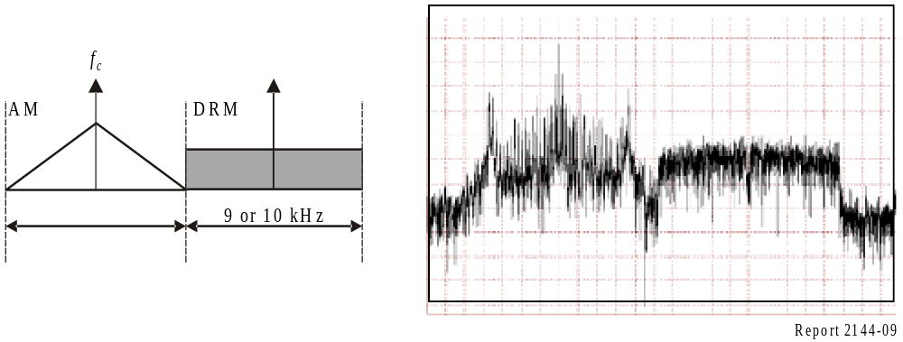
In any case, both options SCS and MCS, and other types should grant the same AM coverage area for the existing services.
This is a challenge considering low selectivity AM receivers and requires anyway a certain protection ratio between both parts of the simulcast. Theoretical calculus according to Recommendation ITU-R 559-1 pointed out the need for a DRM back-off ratio of around 16 dB with respect to the AM carrier of the simulcast. This value was tested with laboratory setups and the results were not concluding at all. Moreover the mentioned value and others have been tested in different measurement campaigns in the three different ITU-Regions (Documents 6A/73; 6E/403 and 6D/10).

4.9 NVIS
Digital near vertical incidence skywave (NVIS) radio transmissions in Tropical (3 and 6 MHz) band have been also tested for DRM system for national coverage areas. Using this technique, the radio signals are directed upward towards the sky which reflects the signals back to the ground in a shower. This provides wide area national coverage for radio, overcoming the impediments of undulating terrain.
Figure 10
Typical NVIS propagation
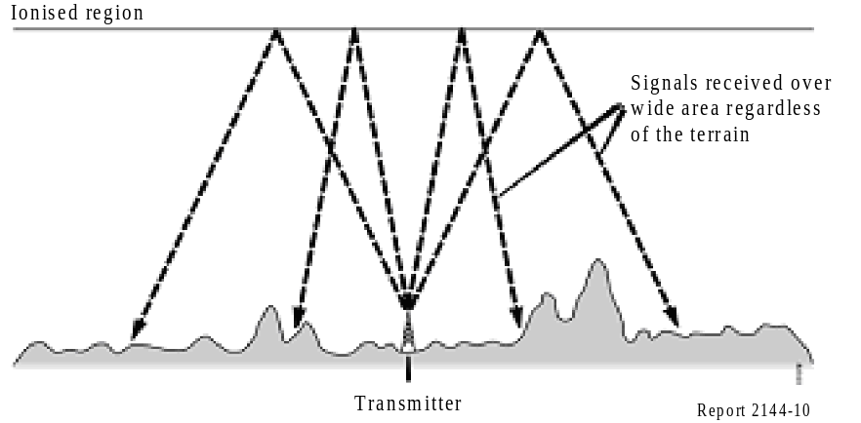
NVIS in this band is regularly used for broadcasting to large areas in tropical regions where the LF and the MF bands are heavily attenuated and for reaching locations with irregular terrain. It is also used to fill what is called skip zone. This is an area of silence or a zone of no reception extending from outer limit of ground wave communication to the inner limit of skywave communication (first hop). For example, India is a large country and so NVIS is a suitable way for reaching remote rural areas.
NVIS utilizes the same principles of ordinary skywave transmissions. The key factor in this operation is the antenna. For effective HF communication using this mode, the antenna must radiate its main beam energy at a very high angle, near vertical. The objective is to launch a wave nearly directly upward from the antenna.
NVIS circuits also suffer the same impairments as long distance skywave circuits, but in this case the delay spread and the Doppler spread are more severe especially at certain times of day, such as dawn and dusk. Due to this fact, DRM modes B and D have been tested in order to evaluate the effect of these problems on the signal and to define which mode is more appropriate for NVIS operation (Document 6D/10).

4.10 Example of SFN use in broadcasting below 30 MHz
Deutsche Welle conducted tests in the summers of 2005 and 2006 with a two-transmitter SFN in the HF band. One transmitter was located in Germany and the second in Portugal. The tests were conducted daily from 0700-0900 UTC at a frequency of 7 265 kHz [Deutsche Welle, 2007].

4.10.1 System setup
Transmitter details and the predicted SFN service area are shown in Fig. 11.
FIGure 11
Transmitter details and predicted SFN coverage area
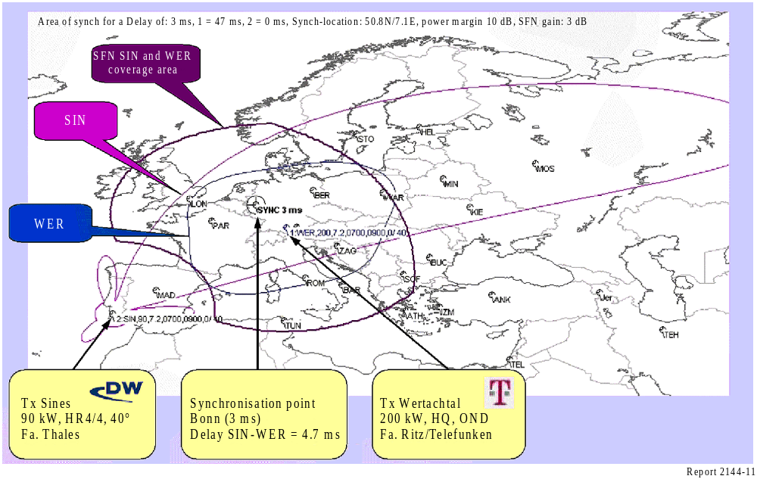
The SFN coverage area is determined by the guard interval of 5.3 ms (Mode B). The spread delay is of the order of 2.3 ms. The synchronization point was set at Bonn. Therefore the value of 3 ms was selected as the maximum delay between the two transmitters in order not to exceed the guard interval of 5.3 ms. The Wertachtal signal had to be delayed by 4.7 ms to compensate the delay due to the different distances of the two stations from Bonn.
A further issue concerned propagation conditions experienced during sunrise:
– Propagation from Sines in Portugal degraded due to an increasing attenuation of the signal.
– Propagation from Wertachtal in Germany improved due to a decreasing skip distance.
In short: Sines degraded but Wertachtal improved during the test period.
The DRM multiplex was generated at Deutsche Welle in Bonn and sent via satellite as an IP data channel. It was important to ensure that the DRM streams transmitted by Sines and Wertachtal were identical and synchronized. GPS was used to synchronies all equipment, as shown in Fig. 12.

FIGure 12
DRM multiplex coding and contribution
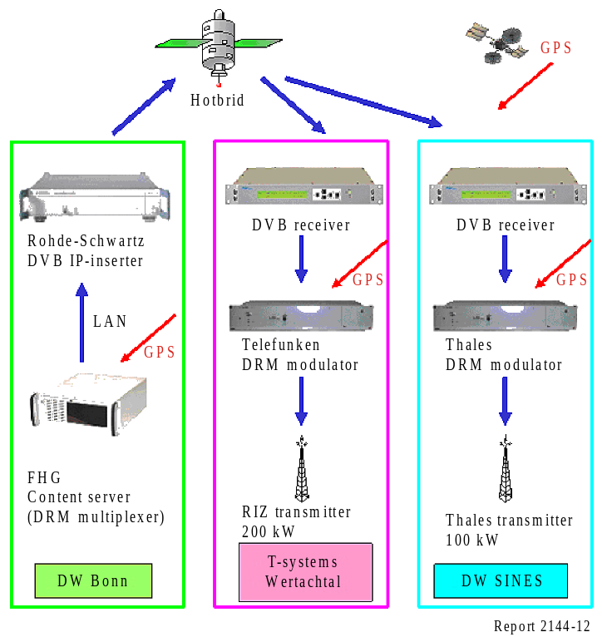

Twenty-five stations within the Deutsche Welle DRM monitoring network (DRMMon, see Fig. 13) were used to receive and evaluate the SFN transmissions. The usual purpose of the DRMMon network is to determine the coverage and availability of Deutsche Welle and other DRM services and each station can monitor a radius of about 150 km. The primary measurement value was that of availability, the ratio of the duration of correct reception to the total duration of the test period.
FIGure 13
Monitoring network
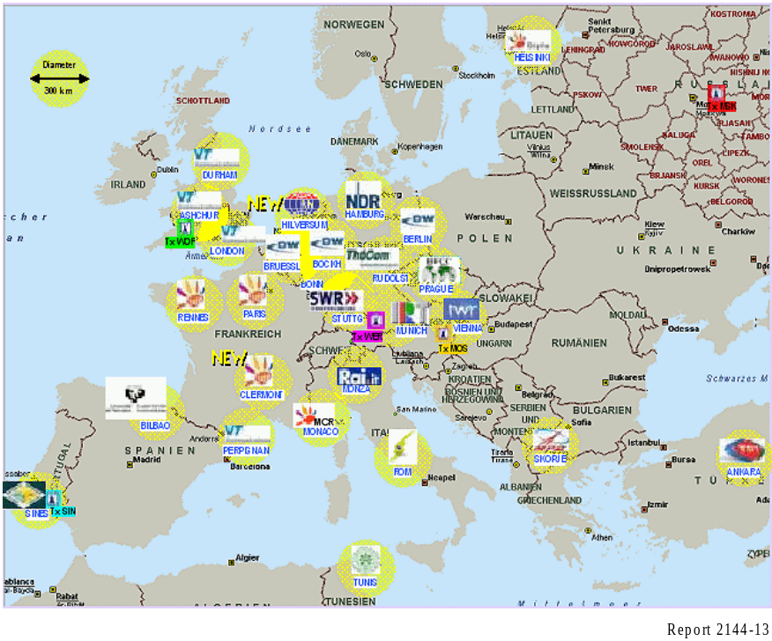

4.10.2 Stand-alone versus SFN transmitter operation
The initial tests were run from July to October 2005. As well as contributing to the SFN, the transmitters were individually measured on different weekdays. Table 31 shows the change in reliability between the individual operation of the transmitters and their operation in SFN.

TABLE 31
Reliability between individual operation and SFN
Transmitting stations | Weekdays of operation | > 99.8% reliability obtained at
SIN only | Tue, Sat | 13 monitoring stations
WER only | Thu, Sun | 7 monitoring stations
SIN and WER in SFN | Mon, Wed, Fri | 16 monitoring stations

The monitored results matched the prediction. The two transmitters effectively filled each other’s gap. The Sines transmitter had the greater impact, especially at 0700-0800 UTC. Differences between time slots are compensated by interplay of both transmitters. Signal availability improved significantly at three sites to a level that would not have been obtained individually.
A disadvantage of a SFN is that it can degrade otherwise good reception if the relative delay between the individual signals exceeds the guard interval. Successful interplay of medium and short distance transmitter operation on one frequency was nevertheless demonstrated.

4.10.3 Long-term test
The goal of the second stage of the SFN test in summer 2006 was to obtain wide area coverage providing constantly high availability over the whole season. An analysis of the results showed very good coverage throughout the year from April to October 2006.
Sites outside the synchronized area get poor reception, as expected; Bilbao is a good example of this. Prague and Vienna were also problem sites, as they are a bit too far from Sines and too close to Wertachtal. However, Rome is a good example of the benefits of an SFN: It is not well covered by a single transmitter but served well by SFN operation.
Constantly high availability on all measurement days was reached. Seamless service (100% availability) is the required goal. For example, in October 2006 up to 20 sites reach more than 99% availability and most exceeded 99.9% availability. Rennes obtained 100% availability, whilst Bonn and Munich nearly achieved 100% availability on all but one day.

4.10.4 Conclusion
SFN operation increases the availability in a well-defined service area and additionally it is spectrum efficient. SFN offers a constantly high availability for nearly all reception sites inside the synchronized area from April to October. The probability of achieving a seamless service is higher through the use of SFN than with stand-alone transmitter operation.
The DRM equipment of different manufactures interoperates, but SFN operation is more complicated and demanding. For example, if synchronization, GPS, MDI routing or delay constant is lost, reception is damaged inside the whole target area.

5 International regulations
As explained in § 4, LF/MF in Regions 1 and 3 are governed by Regional Agreements, while HF has no plan but is planned under provisions of RR Article 12, which relies on seasonal coordination.

5.1 The planning process: assignment planning for LF/MF

5.1.1 Special study regarding the use of digital modulation in the LF and MF bands governed by the Regional Agreements GE75, RJ81 and RJ88
At its meeting in March 2002, Study Group 6 considered various issues related to digital modulation in the broadcasting bands below 30 MHz, including practical arrangements for the introduction of digital modulation in these bands, bearing in mind the current Regional Agreements. In this connection, Study Group 6 addressed a note to the Director, BR by which it requested the Director, BR, “ to initiate the special study referred to in RR No. 13.15 with a view to evaluating the possibilities of introducing digital modulation in the bands governed by the Regional Agreements GE75 and RJ81, using the currently available texts of Study Group 6:
– Document 6/250 − Draft revision of Recommendation ITU-R BS.1514.
– Preliminary draft new Recommendation on planning parameters for digital broadcasting below 30 MHz.
It is important to note that Study Group 6 said that it “believes that appropriate consideration should be given to approach whereby the Agreements are complemented with suitable Rules of Procedure, which would permit digital modulation to be used in the LF and MF broadcast bands if so desired by any broadcaster”.
Study Group 6 also indicated: “If the mechanism of complementing the Regional Agreements with suitable Rules of Procedure proves to be difficult to implement, then other possibilities need to be considered, including the possibility of making the required adjustments to the relevant Agreements by way of regional conferences. One such conference would be required for Regions 1 and 3, and another one for Region 2. Such conferences would be of a short duration and could be associated with another WRC”.
BR has conducted the requested study in response to this request from the Radiocommunication Study Group 6 and the results of these studies, together with the draft Rules of Procedure, where appropriate, are communicated to administrations for comments, in accordance with RR No. 13.14 (Edition of 2004).

5.1.2 Regulatory considerations
The use of the LF/MF bands by the broadcasting service is governed by the following Regional Agreements:
– Regional Agreement concerning the use by the broadcasting service of frequencies in the MF bands in Regions 1 and 3 and in the LF bands in Region 1, Geneva, 1975 (referred to hereafter as GE75).
– Regional Agreement for the MF broadcasting service in Region 2, Rio de Janeiro, 1981 (referred to hereafter as RJ81).
– Regional Agreement for the use of the band 1 605-1 705 kHz in Region 2, Rio de Janeiro, 1988 (referred to hereafter as RJ88).
These Agreements specify the technical criteria that are applicable with respect to each frequency band governed by the respective Agreement, as well as the relevant procedures for modifications to the concerned plans, associated with each of the respective Agreements. In addition, these Agreements specify provisions for the revision of the Agreements themselves.
The sections hereafter summarize the relevant regulatory provisions from each of the respective Agreements, with a particular emphasis on the provisions dealing with modulation techniques.

5.1.3 Regional Agreement GE75
Annex 2 to the GE75 Agreement contains “Technical Data used in the preparation of the Plan and to be used in the application of the Agreement”. Chapter 4 of this Annex specifies the broadcasting standards and § 4.1 contains the following condition: “The Plan is established for a system with double sideband amplitude modulation with full carrier (A3E)”.
Article 14 of the GE75 Agreement contains provision No. 2 which stipulates: “The Agreement shall remain in force until it is revised by a competent conference of the Members of the Union in Regions 1 and 3”.
The GE75 Conference adopted Resolution No. 8 Relating to the use of bandwidth saving modulation systems. With this Resolution, the GE75 Conference resolved as follows:
1 “that broadcasting stations may provisionally use bandwidth saving modulation methods on condition that interference in the same or adjacent channels concerned does not exceed the interference resulting from the application of double sideband modulation with full carrier (A3E);
2 that any administration which envisages using these methods of emission shall seek the agreement of all affected administrations by following the procedure specified in Article 4 of the Agreement.”
The frequency assignment plan annexed to the Regional Agreement GE75 (Annex 1 to the Agreement) contains the particulars of the frequency assignments entered into the Plan. The values related to the necessary bandwidth vary from 9 kHz to 20 kHz. The values related to the necessary bandwidth for DRM system A2 and B2 vary from 8.542 to 8.578 kHz. The values related to the necessary bandwidth for IBOC DSB system range from 20 kHz (all digital mode) to 29.4 kHz (hybrid mode).
In the opinion of the Radiocommunication Bureau, the above elements permit the provisional introduction of digital modulation (DRM A2 or B2) in the bands governed by the GE75 Agreement, without a formal revision of the Agreement as stipulated in Article 14 of the Agreement, provided that the conditions stipulated in Resolution 8 of the GE75 Conference are satisfied and the Plan modification procedure, as specified in Article 4 of the Agreement, is completed in a satisfactory manner. Consequently, the approach of complementing the Regional Agreement GE75 with a suitable Rule of Procedure could be considered. Based on the current ITU-R texts, as detailed in § 3 of this study, the Radiocommunication Bureau concluded that the relevant conditions are achievable and has prepared the following:
1 a draft Rule of Procedure dealing with the notification, under RR Article 11, of the LF/MF assignments to the broadcasting services in the bands governed by the GE75 Agreement, which are related to digital modulation without undergoing the Plan modification procedure (see § 5.1.3.2); and
2 a draft Rule of Procedure dealing with the treatment of the submissions for Plan modification procedure, under Article 4 of the GE75 Agreement, related to frequency assignments using digital modulation (see § 5.1.3.3).
Both rules are independent but may be combined into a single rule. They are given in the following sections.

5.1.3.1 Technical considerations
In Annex 2 of Recommendation ITU-R BS.1615 the Table 32 shows the bandwidth for DRM mode combinations.

TABLE 32
Bandwidths for DRM mode combinations (kHz)
Robustness Mode | Spectrum occupancy type
Robustness Mode | 0 | 1 | 2 | 3
A | 4.208 | 4.708 | 8.542 | 9.542
B | 4.266 | 4.828 | 8.578 | 9.703
C |  |  |  | 9.477
D |  |  |  | 9.536
Nominal bandwidth (kHz) | 4.5 | 5 | 9 | 10

For the GE75 planning area, the systems to be considered are systems A2 and B2 using 9 kHz nominal bandwidth and moderate robustness.
The RF protection ratios applicable to the protection of analogue transmissions from DRM transmissions shall be deduced from Table 33, an extract of which is given below:
TABLE 33
RF protection ratios between broadcasting systems below 30 MHz (dB)
AM interfered with by digital
Wanted signal | Unwanted signal | Frequency separation f_{unwanted} – f_{wanted}  (kHz) |  |  |  |  | Parameters
Wanted signal | Unwanted signal | −18 | −9 | 0 | 9 | 18 | B_{DRM} (kHz) | A_{AF} (dB)
AM | DRM_B2 | −29.9 | −12.7 | 23.5 | −12.7 | −29.9 | 9 | 17
AM | DRM_B2 | −16.9 | +0.3 | +36.5 | +0.3 | −16.9 | 9 | 30
AM | AM | −23 | 0 | 30 | 0 | −23 |  | 30
DRM_B2: DRM signal, robustness Mode B, spectrum occupancy Type 2.
BDRM: Nominal bandwidth of DRM signal.
A_{AF}: Audio frequency protection ratio.
NOTE 1 – The value of 17 dB is used as an example to derive the RF protection ratios and should be substituted by other values as required. The difference to 17 dB has to be added to the respective table values.

The values in the table correspond to the protection ratio of 17 dB adopted for HFBC planning. GE75 is based on a 30 dB co-channel protection ratio. Thus, the required protection ratio for co-channel interference from DRM to AM is 36.5 dB and the adjacent channel protection ratio is 0.3 dB. It can be concluded that the interference from a transmitter using digital modulation (DRM) is less than the interference from an AM transmitter with a power greater than the DRM transmitter by 7 dB. It should also be noted that there is no significant difference between different DRM modulation schemes using the same bandwidth.

5.1.3.2 Rule of Procedure related to Resolution No. 8 of the GE75 Agreement
Resolution No. 8 of the Regional Conference, Geneva, 1975, states:
1 “that broadcasting stations may provisionally use bandwidth saving modulation methods on condition that interference in the same or adjacent channels concerned does not exceed the interference resulting from the application of double sideband modulation with full carrier (A3E);
2 that any administration which envisages using these methods of emission shall seek the agreement of all affected administrations by following the procedure specified in Article 4 of the Agreement.”
After consideration of the relevant ITU-R studies, the Board decided that any frequency assignment for AM broadcasting in the Plan may provisionally be used with digital modulation DRM A2 or B2, provided the radiation is reduced by at least 7 dB in all directions, compared to the radiation of the AM modulated frequency assignment in the Plan.
Therefore, when examining the conformity to the GE75 Plan of a notice received under RR Article 11, the Bureau shall accept such a notice as being in conformity to the Plan. A note should indicate that the favourable finding is provisional.

5.1.3.3 Rule of Procedure related to Annex 2 to the GE 75 Agreement
Chapter 4 of Annex 2 to the GE 75 Agreement gives the broadcasting standards applicable to the Agreement. In particular:
4.1 Class of emission: The Plan is established for a system with double sideband amplitude modulation with full carrier (A3E).
4.2 Power: The power of a transmitter is the carrier power in the absence of modulation.
4.3 Radiated power: The radiated power is assumed to be the product of the nominal power of the transmitter and the gain of the antenna (relative to a short vertical antenna) without taking into account any losses. It is expressed either by the cymomotive force (c.m.f. in V or in dB relative to 300 V) or by the effective monopole radiated power (emrp in kW or in dB relative to 1 kW).
4.4 Protection ratios: In applying the Agreement, the values of the co-channel and adjacent channel protection ratios given below should be used unless otherwise agreed between the administrations concerned. In the case of fluctuating wanted or unwanted signals, the values of the protection ratio apply for at least 50% of the nights of the year at midnight.
However, Resolution No. 8 of the Regional Conference, Geneva, 1975, states:
1 “that broadcasting stations may provisionally use bandwidth saving modulation methods on condition that interference in the same or adjacent channels concerned does not exceed the interference resulting from the application of double sideband modulation with full carrier (A3E);
2 that any administration which envisages using these methods of emission shall seek the agreement of all affected administrations by following the procedure specified in Article 4 of the Agreement.”
After consideration of the relevant ITU-R studies, the Board decided that frequency assignments using digital modulation DRM A2 or B2 may provisionally be introduced into the Plan, in application of Article 4 of the Agreement.
The power of the transmitter to be notified in case of digital modulation shall be the total power within the necessary bandwidth.
In the examination of the probability of interference from notices related to assignments using digital modulation, the Bureau shall use a co-channel protection ratio increased by 7 dB, and an adjacent channel protection ratio increased by 1 dB compared to the one applicable to the interfered transmitter.
When the proposed assignment using digital modulation is recorded into the Plan following the application of Article 4, it shall bear a symbol indicating that the recording is provisional. The reference situation shall be determined as if it were an AM transmission using an audio-frequency modulating signal of 4.5 kHz and a high degree of compression.

5.1.3.4 Decisions of the RRB − December 2002
The RRB (Radio Regulatory Board) approved the Rules of Procedure as proposed with the following amendments:
– Amend the fourth paragraph of the Rule relating to Resolution 8 (Annex 1 to CCRR/20) and the ninth paragraph of the Rule relating to Annex 2 (Annex 2 to CCRR/20) as follows: “After consideration of the relevant ITU-R studies, the Board decided that any frequency assignment for AM broadcasting in the Plan may provisionally be used with digital modulation (transmission types DRM (see Note 1) A2 or B2), provided the radiation is reduced by at least 7 dB in all directions, compared to the radiation of the AM modulated frequency assignment in the Plan”.
NOTE 1 – The DRM system is described in Recommendation ITU-R BS.1514.
– Add a new sentence at the end of each rule as follows: “This Rule of Procedure is of a provisional nature until such time that it is confirmed by a competent conference empowered to deal with the subject matter.”
– The Board noted the comments and support from a number of administrations for the desirability of facilitating the introduction of digital modulation, while preserving the integrity of the Plan. The Board also considered comments from other administrations that suggested that issues dealt with in the Rules should be subject to consideration by a Conference.
– The Board concluded that, given the current schedule of conferences, such a consideration is not envisaged in the foreseeable future.
There is another system (IBOC) defined in Recommendation ITU-R BS.1514, but it is not usable in Regions 1 and 3 because the channel bandwidth is not suitable.

5.1.3.5 CEPT position regarding the introduction of DRM in the LF/MF
The CEPT (European Conference of Postal and Telecommunications Administrations, see www.cept.org) has set up a working group to study the transition to digital sound broadcasting in the LF/MF bands. The group has already produced a draft report on the subject (see draft ECC Report 117 on www.ero.dk). The final report is expected in February 2008. The following text is extracted from the executive summary of the draft report in its version available in November 2007:
“All the necessary regulatory provisions, in particular the Rules of Procedure associated with the GE75 Agreement, are already in place to allow the deployment of DRM within the existing GE75 Plan and to allow a progressive analogue to digital transition for sound broadcasting in the LF and MF bands. Thanks to these Rules of Procedure, a significant number of DRM transmissions are currently “on air” as advertised or experimental services Therefore, no action is currently required in this area.
Further work will be needed, however to review the necessary technical parameters, such as minimum usable field strength and protection ratio, for which the current values are partly based on the results of theoretical studies.
Given the improvement in quality available with DRM, there will be pressure to introduce stereo and other potential enhancements, some of which will require a greater transmission bandwidth. The GE 75 Plan has some assignments with bandwidths wider than the standard 9 kHz channel and the DRM standard encompasses similarly wider bandwidth modes. There will be a need for suitable DRM planning parameters for the wider bandwidth modes.
In the longer term, as more and more transmissions migrate to “digital”, the matter of protecting analogue transmission will become less important and the planning environment may need to be reconsidered, based on the experience gained from practical implementation. It may then be possible to enhance the existing regulatory provisions in order to take advantage of wider bandwidth modes and improved planning parameters as they become available. This may also be the time to consider a new Planning Conference, but such a Conference is not needed in the foreseeable future.
All concerned broadcasters and Administrations within CEPT are encouraged to consider the transition from analogue to DRM digital transmissions in order to benefit from the improved quality of service which is already available.”

5.1.4 Regional Agreement RJ81
Section 4.2 of the RJ81 Agreement specifies the following conditions for the class of emission: “The Plan is based upon double-sideband amplitude modulation with full carrier A3E. Classes of emission other than A3E, for instance to accommodate stereophonic systems, could also be used on condition that the energy level outside the necessary bandwidth does not exceed that normally expected in A3E emission and that the emission is receivable by receivers employing envelope detectors without increasing appreciably the level of distortion.”
Section 4.3 of the RJ81 Agreement specifies the following conditions on the bandwidth of emission: “The Plan assumes a necessary bandwidth of 10 kHz, for which only a 5 kHz audio bandwidth can be obtained. While this might be appropriate value for some administrations, others have successfully employed wider bandwidth systems having occupied bandwidths of the order of 20 kHz without adverse effects.”
Article 12 of the RJ81 Agreement contains provision No. 12.2 which stipulates: “The Agreement shall remain in force until it is revised by a competent administrative radio conference of Region 2.”
The frequency assignment plan annexed to the Regional Agreement RJ81 (Annex 1 to the Agreement) contains the particulars of the frequency assignments entered into the Plan. The values related to the necessary bandwidth notified under Article 11 vary from 8 kHz to 20 kHz.
In the opinion of the Radiocommunication Bureau, the current regulatory provisions of the RJ81 Agreement are rather inflexible and do not permit the introduction of digital modulation in the bands governed by the RJ81 Agreement, without a formal revision of the Agreement as stipulated in Article 12 of the Agreement.

5.1.5 Regional Agreement RJ88
Section 3.2 of the RJ88 Agreement specifies the following conditions for the class of emission: “The Plan is based on double-sideband amplitude modulation with full carrier (A3E). Classes of emission other than A3E may also be used, (…), on condition that the energy level outside the necessary bandwidth does not exceed that normally expected in A3E emission.”
Section 3.3 of the RJ88 Agreement specifies the following conditions on the bandwidth of emission: “The Plan is based on a necessary bandwidth of 10 kHz, for which only 5 kHz audio bandwidth can be obtained. While this may be an appropriate value for some administrations, others may wish to employ wider bandwidth systems with necessary bandwidths of the order of 20 kHz. However, the protection ratios selected allow operation with 20 kHz occupied bandwidth without an appreciable increase in interference (…).”
Article 14 of the RJ88 Agreement stipulates: “The Agreement shall remain in force until revised by a competent administrative radio conference of Region 2.”
The Master International Frequency Register contains particulars of frequency assignments that correspond to the allotments from the RJ88 Plan. The values related to the necessary bandwidth are 10 kHz for all frequency assignments notified up to now.
In the opinion of the Radiocommunication Bureau, the above elements would permit the introduction of digital modulation (DRM A3 or B3) in the bands governed by the RJ88 Agreement, without a formal revision of the Agreement as stipulated in Article 14 of the Agreement, provided that the conditions stipulated in No. 3.2 of Annex 2 to the RJ88 Agreement are satisfied.

5.2 Coordination for HF

5.2.1 The HFBC framework
WARC-79 allocated additional HF spectrum to the broadcasting service on condition that this extra spectrum should be subject to a new planning system. Two HFBC World Administrative Radio Conferences were convened in 1984 and 1987 to agree a new planning system. Although the technical parameters and outline planning method were approved, the resulting test plans were unacceptable to administrations, as they could not accommodate all requirements.
Work then started on developing a new regulatory procedure to take account of the agreed technical criteria and the informal coordination process that had been shown to be successful in reducing mutual interference in the HF broadcasting bands. The result was Article 12, which was adopted by WRC-97 and came into force on 1 January 1999.

5.2.2 The RR Article 12 procedure
Article 12 has three sections:
Section I is the introduction, which notes that the procedure is based on coordination between administrations. It also notes that administrations can authorize broadcasters to do this coordination where the broadcaster is the organization responsible for the choice of frequency.
Section II defines the principles to be taken into account when following the procedure.
Section III describes the procedure in Article 12 (S12.15 to S12.45). A flowchart contained in Resolution 535 (WRC-97) provides the information needed for the application of Article 12 Broadcasters are required to submit their frequency requirements to the Radiocommunication Bureau twice a year for two defined broadcasting seasons each year. The Radiocommunication Bureau is then required to perform a compatibility analysis in accordance with the Rules of Procedure and publish the results.
Broadcasters are encouraged to coordinate their requirements with other organizations with a view to resolve or reduce as much as possible, incompatibilities identified by the compatibility analysis. The procedure encourages the formation of regional coordination groups to facilitate coordination. The coordination process is seen as a continuous process as broadcasters are urged to continue coordinating requirements by any means possible even after the broadcasting season has started. The Radiocommunication Bureau can convene meetings of all the Coordination Groups, if necessary, to improve the process.

6 Conclusions

6.1 DRM is already operational
– DRM is the only worldwide fully specified system for digital sound broadcasting in frequencies from 150 kHz to 30 MHz. Future specifications would cover also VHF Bands I and II.
– DRM offers:
– Improved audio quality compared to AM for the same spectrum occupancy.
– Flexibility (trade-off between capacity and robustness).
– Additional services (automatic or semi automatic tuning, the inclusion of supplementary (or even completely unrelated) data streams and conditional access).
– Spectrum efficiency (single frequency networks).
– Economic benefits (reduced RF power compared to AM for the same coverage).
But, DRM requires:
– New investment in transmission facilities and delivery.
– Attractive services to motivate people to go digital.
– Attractive low price digital receivers.
– Appropriate marketing to raise awareness.
– Transmission equipment is available.
– Receivers are available, and their prices are decreasing while their performance is increasing.
– Regulatory provisions are available and allow for introduction of DRM transmissions in LF/MF and HF bands.
– Technical planning parameters are defined and allow operators who wish so to implement DRM networks and offer digital services immediately for international or national audiences.

6.2 Technical and regulatory information related to DRM services coverage planning that are compiled in this text
This text gathers in one structured text the information contained in separate texts from the following sources:
– Technical and regulatory ITU-R texts.
– Technical documents from DRM consortium.
– Experience from trials carried out by EBU and DRM members.

6.3 Feedback from operational and experimental transmissions is available
– International broadcasting in the HF bands: DRM is already used in many countries.
– National/local broadcasting in the HF 26 MHz band: results of field trials are very promising: A specific mode in 20 kHz channel (DRM mode B with 16-QAM and 0.5 average code, offering 23.835 kbit/s) has given good results in terms of robustness and data capacity. On the other hand, it was verified that man-made noise is close to the reference ITU value. However, some issues are still to be solved, mainly with regard to transmitting antenna optimization to reduce skywave and with regard to the need for appropriate rules for coordination.
– National broadcasting using the MF band: results of field trials show that for rural and suburban environments, a small margin should be added to the ITU-Reference figures for minimum field strength. On the other hand, coverage in urban environments may require a higher margin in order to overcome the high man-made noise levels.
– Single frequency networks: DRM SFN can be used, in LF/MF and HF bands, to:
– Extend the coverage, including for contiguous areas, without using additional frequencies.
– Improve the availability of service within a given coverage area.
Trials made in HF and MF show that DRM SFN networks operate in a satisfactory manner. They need to be engineered with care, however.

6.4 And next …
– For the broadcasters:
– To continue demonstrating through operational transmissions and trials that the DRM system is a viable system for the future.
– For the network operators:
– To further assess noise levels in urban environments.
– To study the impact of topography in LF/MF propagation prediction.
– To pursue studies and tests related to 26 MHz.
– To consider DRM+ in bands I and II.
– To further assess SFN limitations.
– For the manufacturers:
– Improvement of the receivers (antenna, sensitivity, implementation of automatic frequency selection, …).

7 List of terms (abbreviations)
AAC Advanced audio coding
ABU Asia-Pacific Broadcasting Union
ACI Adjacent channel interference
AF Audio frequency
AFS Alternate frequency switching
AM Amplitude modulation
ASBU Arab States Broadcasting Union
BER Bit error ratio
BR Radiocommunication Bureau (ITU)
BR IFIC BR International Frequency Information Circular
C/N Carrier to noise ratio
CEPT Conférence Européenne des Postes et Télécommunications
CCRR ITU Circular Letters concerning Radio Regulations
CELP Code excited linear prediction
CIRAF Conferencia Internacional de Radiodifusión por Altas Frecuencias
COFDM Coded orthogonal frequency division multiplexing
DAB Digital audio broadcasting
DRM Digital Radio Mondiale
DSB Double side band
ECC Electronic Communications Committee
EMRP Effective monopole radiated power
ETSI European Telecommunications Standards Institute
FAC Fast access channel
FEC Forward error correction
FM Frequency modulation
FMO Frequency Management Organization
GE75 Final Acts of the Regional Radiocommunication Conference, Geneva, 1975
GPS Global positioning by satellite
GTO Gate turn off
HF High frequency
HFCC High frequency coordination conference
HVXC Harmonic vector excitation coding
IBOC In band on channel system
IF Intermediate frequency
IGBT Isolated gate bipolar transistor
ITU International Telecommunications Union
LF Low frequency
LW Long wave
MDI Multiplex distribution interface
MER Modulation error ratio
MF Medium frequency
MFN Multiple frequency network
MLC Multi-level coding
MSC Main service channel
MUFS Minimum usable field strength
MW Medium wave
PDM Pulse duration modulation
PSM Pulse-step modulation
QAM Quadrature amplitude modulation
QoS Quality of service
QPSK Quaternary phase shift keying
RDS Radio data system
RF Radio frequency
RJ81 Final Acts of the Regional Radiocommunication Conference, Rio de Janeiro, 1981
RJ88 Final Acts of the Regional Radiocommunication Conference, Rio de Janeiro, 1988
rms Root mean square
RRB Radio Regulations Board (ITU)
RRC Regional Radiocommunication Conference
Rx Receiver
SBR Spectral band replication
SDC Service description channel
SFN Single frequency network
S/N or SNR Signal to noise ratio
SSB Single side band
SW Short wave
Tx Transmitter
URTNA Union of National Radio and Television Organizations of Africa
UTC Coordinated Universal Time
VHF Very high frequency
WRC World Radiocommunication Conference

References

BBC [2006] Assessment of Modulation Depth for AM Transmitters – BBC Contribution to EBU B/LMS.
Deutsche Welle [April 2007] DRM Single Frequency Network (SFN) test results 2005 and 2006. Brief report to EBU Project Group B/LMS (B/LMS 137).
EBU [July 2005] EBU Tech. 3243 – Modulation Processing Techniques; Chapter 1 Amplitude Modulation (B/LMS 052 22 ).
EBU [April 2007] DRM developments: Experimental and Regular Transmissions. Dr. Pablo Angueira, University of the Basque Country (UPV/EHU). Second Technical Specialised Meeting in International Broadcasting, Geneva, Switzerland.
ETSI [2001] ETSI TS 101 980 V1.1.1 (September). Digital Radio Mondiale (DRM) system specification.
SHANNON, C. E. [1949] The Mathematical Theory of Information. University of Illinois Press.

Annex 1
Required S/N values for DRM reception

1 S/N values for LF/MF bands
In Appendix 3 to Annex 1 to Recommendation ITU-R BS.1615, a detailed description of transmission channel models used to evaluate the system performance can be found.
Channel model No. 1 represents the typical behaviour of a transmission channel with ground-wave propagation during daytime in LF and MF bands.
Channel model No. 2 represents a wave propagation model for MF bands at night-time including a delayed skywave in addition to the ground wave.
Channel models No. 3, 4, 5 and 6: channels with strong time- and/or frequency-selective behaviour. They are suited for HF bands.
Channel model No. 5: channel where the fast-fading on the two paths is dominant.
Channel model No. 6 channel with extremely long path delays and Doppler spreads, which is a typical example for tropical-near-vertical incidence skywave propagation.
In Table 34 the required S/N for the different robustness modes and their typical spectrum occupancy types (2 for mode A, i.e., nominal channel bandwidth of 9 kHz, and 3, i.e., 10 kHz, for the others) to achieve a BER of 1 × 10⁻⁴ on channel model No. 1 is given.

TABLE 34
S/N (dB) to achieve BER of 1 × 10⁻⁴ for all DRM robustness modes with spectrum
occupancy Types 2 or 3 (9 or 10 kHz) dependent on modulation scheme
and protection level for channel model No. 1
Modulation  scheme | Protection  level No. | Average  code rate | Robustness mode/spectrum occupancy type
Modulation  scheme | Protection  level No. | Average  code rate | A/2  (9 kHz) | B/3  (10 kHz) | C/3  (10 kHz) | D/3  (10 kHz)
16-QAM | 0 | 0.5 | 8.6 | 9.3 | 9.6 | 10.2
16-QAM | 1 | 0.62 | 10.7 | 11.3 | 11.6 | 12.1
64-QAM | 0 | 0.5 | 14.1 | 14.7 | 15.1 | 15.9
64-QAM | 1 | 0.6 | 15.3 | 15.9 | 16.3 | 17.2
64-QAM | 2 | 0.71 | 17.1 | 17.7 | 18.1 | 19.1
64-QAM | 3 | 0.78 | 18.7 | 19.3 | 19.7 | 21.4

For real transmissions based on ground-wave propagation only, the use of robustness mode A is recommended because of the higher achievable service data rate. The values for the other modes are included in Table 34 only for reference. The degradation of their performance in S/N compared with mode A can be explained by the fact that the ratio between the numbers of data and pilot subcarriers is varying from mode to mode. With the robustness of the mode the number of pilot subcarriers, which are boosted in power in comparison with data subcarriers, also increases and therefore the average usable power of the remaining data subcarriers decreases.
For simulcast applications in a nominal channel bandwidth of 9 or 10 kHz, DRM spectrum occupancy types 0 and 1 are suitable. Only robustness modes A and B are providing this feature. The corresponding S/N values for channel model No. 1 can be found in Table 35.
For the application of robustness Mode A with spectrum occupancy Types 1 or 3 or Mode B with 0 or 2 the S/N values in Tables 34 and 35 are also recommended, because differences in performance are less than 0.1 dB.
In contrast to channel model No. 1 the channel model No. 2 represents a wave propagation model for MF bands at night-time including a delayed skywave in addition to the ground wave. The required S/N for this channel model is shown in Table 36. Only results for the relevant robustness modes A and B are given (also for lower spectrum occupancy types).
Compared with pure ground-wave propagation the system performance degrades due to the increased frequency-selectivity and especially the slowly time-selective channel behaviour caused by the skywave. The values indicate the correlation between the strength of the channel coding and the S/N impairment, i.e., with increasing coding rate, the impairment increases, too. But for correct interpretation of the results, it has to be considered that under the assumption of the same noise power as for pure ground-wave propagation, the additional skywave power would lead to a gain in received signal power of approximately 1 dB, i.e., the resulting impairment in that case is only marginal, at least for a sufficient strength of the applied error protection scheme (protection levels Nos. 0 and 1).
TABLE 35
S/N (dB) to achieve BER of 1 × 10⁻⁴ for DRM robustness Modes A and B with
spectrum occupancy Type 0 or 1 (4.5 or 5 kHz) dependent on modulation
scheme and protection level for channel model No. 1
Modulation  scheme | Protection  level No. | Average  code rate | Robustness mode/spectrum  occupancy type
Modulation  scheme | Protection  level No. | Average  code rate | A/0 (4.5 kHz) | B/1 (5 kHz)
16-QAM | 0 | 0.5 | 8.8 | 9.5
16-QAM | 1 | 0.62 | 10.9 | 11.5
64-QAM | 0 | 0.5 | 14.3 | 14.9
64-QAM | 1 | 0.6 | 15.8 | 16.2
64-QAM | 2 | 0.71 | 17.5 | 17.9
64-QAM | 3 | 0.78 | 19.2 | 19.5

TABLE 36
S/N (dB) to achieve BER of 1 × 10⁻⁴ for DRM robustness Modes A and B with
different spectrum occupancy types dependent on modulation scheme
and protection level for channel model No. 2
Modulation  scheme | Protection  level No. | Average  code rate | Robustness mode/spectrum occupancy type
Modulation  scheme | Protection  level No. | Average  code rate | A/0  (4.5 kHz) | A/2  (9 kHz) | B/1  (5 kHz) | B/3  (10 kHz)
16-QAM | 0 | 0.5 | 9.8 | 9.4 | 10.3 | 10.2
16-QAM | 1 | 0.62 | 12.7 | 12.5 | 13.2 | 13.1
64-QAM | 0 | 0.5 | 15.2 | 14.9 | 15.8 | 15.6
64-QAM | 1 | 0.6 | 16.6 | 16.3 | 17.3 | 16.9
64-QAM | 2 | 0.71 | 19.7 | 19.2 | 20.4 | 19.7
64-QAM | 3 | 0.78 | 22.9 | 22.0 | 22.8 | 22.3

2 S/N values for HF bands
In Tables 37 to 40 the S/N values for the three robustness modes suited for HF transmission are given for channel models Nos. 3 to 6. Mode A cannot be applied for HF due to the lack of robustness in the OFDM parameters (length of the guard interval and frequency spacing of the subcarriers). In the case of Mode B, results both for spectrum occupancy Type 1 and 3 are included. Only robustness mode D is applicable also for channels with extremely long path delays and Doppler spreads as defined with channel model No. 6, which is a typical example for tropical-near-vertical incidence skywave propagation.
For 16-QAM modulation and also for 64-QAM with strong error protection (protection levels Nos. 0 and 1) robustness Mode B achieves the best performance, i.e., the lowest S/N values are required to achieve high quality audio transmission. On channel model No. 5, where the fast fading on the two paths is dominating, the better robustness of mode C and D in view of synchronization and channel estimation plays a more and more important role in the case of reduced coding strength.

TABLE 37
S/N (dB) to achieve BER of 1 × 10⁻⁴ for DRM robustness Mode B with
spectrum occupancy Type 1 dependent on modulation scheme
and protection level for channel model Nos. 3 to 6
Modulation  scheme | Protection  level No. | Average  code rate | Channel model No.
Modulation  scheme | Protection  level No. | Average  code rate | 3 | 4 | 5 | 6
16-QAM | 0 | 0.5 | 18.3 | 16.2 | 14.7 | −
16-QAM | 1 | 0.62 | 21.1 | 19.3 | 18.0 | −
64-QAM | 0 | 0.5 | 23.8 | 21.5 | 20.6 | −
64-QAM | 1 | 0.6 | 25.9 | 23.7 | 23.2 | −
64-QAM | 2 | 0.71 | 29.0⁽¹⁾ | 27.0⁽¹⁾ | 29.4⁽¹⁾ | −
64-QAM | 3 | 0.78 | 31.2⁽¹⁾ | 30.0⁽¹⁾ | − | –
⁽¹⁾ Protection levels not recommended for use in HF propagation conditions with severe time- and frequency-selective fading.

TABLE 38
S/N (dB) to achieve BER of 1 × 10⁻⁴ for DRM robustness Mode B with
spectrum occupancy Type 3 dependent on modulation scheme
and protection level for channel model Nos. 3 to 6
Modulation  scheme | Protection  level No. | Average  code rate | Channel model No.
Modulation  scheme | Protection  level No. | Average  code rate | 3 | 4 | 5 | 6
16-QAM | 0 | 0.5 | 18.0 | 16.0 | 14.6 | −
16-QAM | 1 | 0.62 | 20.8 | 19.0 | 17.7 | −
64-QAM | 0 | 0.5 | 23.3 | 21.3 | 20.1 | −
64-QAM | 1 | 0.6 | 25.4 | 23.5 | 22.7 | −
64-QAM | 2 | 0.71 | 28.3⁽¹⁾ | 26.8⁽¹⁾ | 27.0⁽¹⁾ | −
64-QAM | 3 | 0.78 | 30.9⁽¹⁾ | 29.7⁽¹⁾ | − | −
⁽¹⁾ Protection levels not recommended for use in HF propagation conditions with severe time- and frequency-selective fading.

TABLE 39
S/N (dB) to achieve BER of 1 × 10⁻⁴ for DRM robustness Mode C with
spectrum occupancy Type 3 dependent on modulation scheme
and protection level for channel model Nos. 3 to 6
Modulation  scheme | Protection  level No. | Average  code rate | Channel model No.
Modulation  scheme | Protection  level No. | Average  code rate | 3 | 4 | 5 | 6
16-QAM | 0 | 0.5 | 18.0 | 16.5 | 14.6 | −
16-QAM | 1 | 0.62 | 20.9 | 19.1 | 17.6 | −
64-QAM | 0 | 0.5 | 23.6 | 21.3 | 20.2 | −
64-QAM | 1 | 0.6 | 25.6 | 23.7 | 22.3 | −
64-QAM | 2 | 0.71 | 29.0⁽¹⁾ | 26.8⁽¹⁾ | 26.4⁽¹⁾ | −
64-QAM | 3 | 0.78 | 32.3⁽¹⁾ | 29.6⁽¹⁾ | 33.3⁽¹⁾ | −
⁽¹⁾ Protection levels not recommended for use in HF propagation conditions with severe time- and frequency-selective fading.

TABLE 40
S/N (dB) to achieve BER of 1 × 10⁻⁴ for DRM robustness Mode D with
spectrum occupancy Type 3 dependent on modulation scheme
and protection level on channel model Nos. 3 to 6
Modulation  scheme | Protection  level No. | Average  code rate | Channel model No.
Modulation  scheme | Protection  level No. | Average  code rate | 3 | 4 | 5 | 6
16-QAM | 0 | 0.5 | 18.5 | 16.9 | 15.3 | 16.0
16-QAM | 1 | 0.62 | 21.2 | 19.9 | 18.3 | 19.2
64-QAM | 0 | 0.5 | 24.2 | 22.2 | 20.8 | 22.1
64-QAM | 1 | 0.6 | 26.3 | 24.5 | 22.9 | 25.2
64-QAM | 2 | 0.71 | 29.2⁽¹⁾ | 27.6⁽¹⁾ | 27.2⁽¹⁾ | 29.3⁽¹⁾
64-QAM | 3 | 0.78 | 32.1⁽¹⁾ | 31.7⁽¹⁾ | 35.5⁽¹⁾ | 32.5⁽¹⁾
⁽¹⁾ Protection levels not recommended for use in HF propagation conditions with severe time- and frequency-selective fading.

Nevertheless, the results for protection level Nos. 2 and 3 in combination with 64-QAM show an increasing performance degradation due to the occurrence of a bit-error floor even at higher S/N. Therefore these protection levels are not recommended for HF transmission on channels with strong time- and/or frequency-selective behaviour like channel models Nos. 3 to 6. It also has to be kept in mind that the results given in the different tables may represent typical bad cases for HF transmission, but not necessarily the worst ones. The S/N values for HF and also for MF with skywave propagation have to be seen as a useful index for the achievement of the required quality of service, but cannot guarantee it under all circumstances.
Annex 2
Information related to RF protection ratios

1 Introduction
In this section, more information on calculated RF protection ratios, which are required for AM and DRM reception, is given. Detailed information on the calculation method and parameters can be found in Recommendation ITU-R BS.1615.

2 Calculation parameters

2.1 Analogue signal
AM transmitter
Cut-off frequency or bandwidth: F_{tx} = 4.5 kHz, i.e., B = 9 kHz
Low-pass AF filter slope: −60 dB/octave, starting with 0 dB at F_{tx}
Harmonic distortion: k₂ = 0 k₃ = 0.7% (−43 dB)
Intermodulation: d₃ = −40 dB
Noise floor: −60.3 dBc/kHz
With the above parameters the calculated RF spectrum is compliant with the spectrum mask included in Recommendation ITU-R SM.328 – Spectra and bandwidth of emissions.
AM modulation
Modulating signal for unwanted wave: Coloured noise according to Recommendation ITU-R BS.559
Modulation depth: m_{rms} = 25% (corresponds to a programme signal with normal compression)
High compression: Increases the sideband power by 6.5 dB with normal compression
AM receiver
− Selectivity curve: B_{af} = 2.2 kHz, slope = 35 dB/octave
− Audio signal evaluation: rms used for signal evaluation
− AF protection ratio: Desired value

2.2 DRM signal
The DRM specification allows for several robustness modes (A to D) and spectrum occupancy types (0 to 5) of DRM signals. Only certain combinations of robustness Modes (A to D) and spectrum occupancy Types (0 to 3) are used in this Appendix. The parameters for the used mode combinations, i.e., the respective number of subcarriers and the corresponding subcarrier spacing in OFDM signal lead to the bandwidths in rows A to D of Table 41.
TABLE 41
Bandwidths for DRM mode combinations (kHz)
Robustness mode | Spectrum occupancy type
Robustness mode | 0 | 1 | 2 | 3
A | 4.208 | 4.708 | 8.542 | 9.542
B | 4.266 | 4.828 | 8.578 | 9.703
C |  |  |  | 9.477
D |  |  |  | 9.536
Nominal bandwidth (kHz) | 4.5 | 5 | 9 | 10

The bandwidths in the last row of Table 41 are the nominal bandwidths for the respective spectrum occupancies of the DRM signal, and the values given in lines A to D are the exact signal bandwidths for the different mode combinations.
Transmitter for digital signals
– Bandwidths: see Table 41
– Spectrum masks: calculated according to Recommendation ITU-R SM.328, § 6.3.3 of Annex 1 using the exact bandwidths F of Table 41. This includes a 30 dB attenuation at ±0.53 F, beyond this point there is a slope of −12 dB/octave to −60 dB. Examples of the masks for spectrum occupancy types 1 (5 kHz) and 3 (10 kHz) are given in Figs. 14 and 15 (also including the filter curves for AM and digital receivers).
Receiver/demodulator for digital signals
– Bandwidths: see Table 41
– Shoulder distance: 52 dB
– Additional IF filter: BIF = nominal DRM bandwidth + 6 kHz, slope = 35 dB/octave 4
– Selectivity curve: see Figs 14 and 15
– Required S/I for a BER = 1 × 10−4: valid for 64-QAM, protection level No. 1.

2.3 Values for RF protection ratios
The combinations of spectrum occupancy types and robustness modes lead to several transmitter RF spectra, which cause different interference and therefore require different RF protection ratios. The applied calculation method is described in detail in Recommendation ITU-R BS.1615.
Table 42 shows calculation results for AM interfered with by digital and Table 43, digital interfered with by AM. These values are calculated for AM signals with high compression. The RF protection ratios for digital interfered with by digital are given in Table 44 for all the digital mode combinations, but only for identical mode combination pairings, e.g. digital mode B3 (robustness mode B, spectrum occupancy Type 3) interfered with by digital B3. Table 45 shows RF protection ratios between identical and different spectrum occupancies, but only for the robustness mode B. Correction factors for the different modulation schemes are given in Tables 46 and 47.
FIGure 14
Transmitter spectrum mask and receiver/modulator selectivity curves for DRM robustness
Mode B and spectrum occupancy Type 1 (5 kHz)
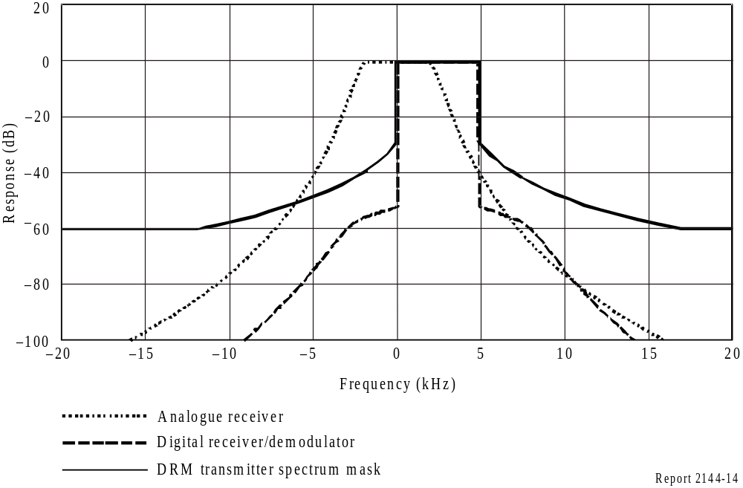

FIGure 15
Transmitter spectrum mask and receiver/modulator selectivity curves for DRM robustness
Mode B and spectrum occupancy Type 3 (10 kHz)
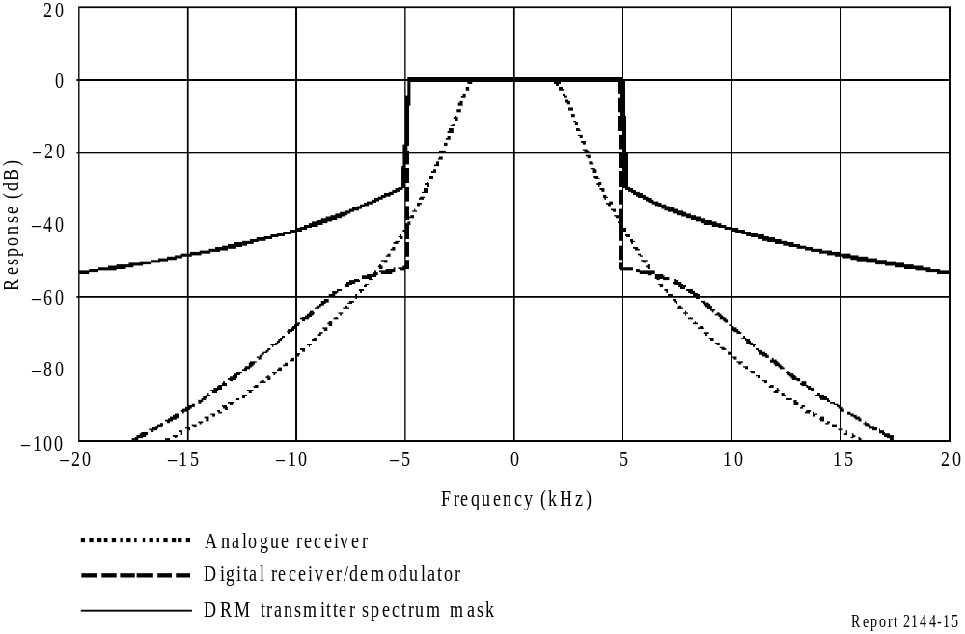

TABLE 42
Relative RF protection ratios between broadcasting systems below 30 MHz (dB) AM interfered with by digital
Wanted signal | Unwanted signal | Frequency separation, f_{unwanted} − f_{wanted}  (kHz) |  |  |  |  |  |  |  |  |  |  |  |  | Parameters
Wanted signal | Unwanted signal |  |  |  |  |  |  |  |  |  |  |  |  |  | B_{DRM} (kHz) | A_{AF}⁽¹⁾ ⁽²⁾ (dB)
Wanted signal | Unwanted signal | −20 | −18 | −15 | −10 | −9 | −5 | 0 | 5 | 9 | 10 | 15 | 18 | 20 | B_{DRM} (kHz) | A_{AF}⁽¹⁾ ⁽²⁾ (dB)
AM | DRM_A0 | −50.4 | −50.4 | −49.1 | −35.6 | −28.5 | 6.5 | 6.6 | −31.1 | −46.9 | −48.3 | −50.4 | −50.4 | −50.4 | 4.5 | −
AM | DRM_A1 | −50.9 | −50.6 | −47.9 | −32.5 | −24.5 | 6.1 | 6.1 | −31.3 | −46 | −47.7 | −50.9 | −50.9 | −50.9 | 5 | −
AM | DRM_A2 | −48.9 | −47 | −43.6 | −34.5 | −29.8 | 3.4 | 6.6 | 3.4 | −29.8 | −34.5 | −43.6 | −47 | −48.9 | 9 | −
AM | DRM_A3 | −47.4 | −45.5 | −42.1 | −32.4 | −26.5 | 3.1 | 6.1 | 3.1 | −26.5 | −32.4 | −42.1 | −45.5 | −47.4 | 10 | −
AM | DRM_B0 | −50.4 | −50.4 | −49 | −35.5 | −28.4 | 6.4 | 6.6 | −30.9 | −46.7 | −48.2 | −50.4 | −50.4 | −50.4 | 4.5 | −
AM | DRM_B1 | −51 | −50.5 | −47.6 | −32 | −23.8 | 6 | 6 | −31.1 | −45.7 | −47.4 | −51 | −51 | −51 | 5 | −
AM | DRM_B2 | −48.8 | −46.9 | −43.5 | −34.4 | −29.7 | 3.4 | 6.5 | 3.4 | −29.7 | −34.4 | −43.5 | −46.9 | −48.8 | 9 | −
AM | DRM_B3 | −47.2 | −45.3 | −41.9 | −32 | −25.9 | 3 | 6 | 3 | −25.9 | −32 | −41.9 | −45.3 | −47.2 | 10 | −
AM | DRM_C30 | −47.5 | −45.6 | −42.2 | −32.6 | −26.7 | 3.1 | 6.1 | 3.1 | −26.7 | −32.6 | −42.2 | −45.6 | −47.5 | 10 | −
AM | DRM_D31 | −47.4 | −45.5 | −42.2 | −32.4 | −26.5 | 3.1 | 6.1 | 3.1 | −26.5 | −32.4 | −42.2 | −45.5 | −47.4 | 10 | −
AAF: audio frequency protection ratio.
DRM_A0: DRM signal, robustness mode A, spectrum occupancy type 0.
⁽¹⁾ The RF protection ratio for AM interfered with by digital can be calculated by adding a suitable value for the AF protection ratio according to a given planning scenario to the values in this table.
⁽²⁾ The values presented in this table refer to the specific case of high AM compression. For consistency with Table 44, the same modulation depth, namely that associated with high compression, has been assumed for the AM signal. In order to offer adequate protection to AM signals with normal levels of compression, each value in the table should be increased to accommodate the difference between normal and high compression.

TABLE 43
Relative RF protection ratios between broadcasting systems below 30 MHz (dB)
Wanted signal | Unwanted signal | Frequency separation, f_{unwanted} − f_{wanted}  (kHz) |  |  |  |  |  |  |  |  |  |  |  |  | Parameters
Wanted signal | Unwanted signal |  |  |  |  |  |  |  |  |  |  |  |  |  | B_{DRM} (kHz) | S/I  (dB)
Wanted signal | Unwanted signal | −20 | −18 | −15 | −10 | −9 | −5 | 0 | 5 | 9 | 10 | 15 | 18 | 20 | B_{DRM} (kHz) | S/I  (dB)
DRM_A0 | AM | −57.7 | −55.5 | −52.2 | −46.2 | −45 | −36.7 | 0 | −3.5 | −31.2 | −41.1 | −47 | −50.7 | −53 | 4.5 | 4.2
DRM_A1 | AM | −57.5 | −55.2 | −52 | −45.9 | −44.8 | −36.6 | 0 | −0.6 | −22.8 | −38.4 | −46.1 | −49.8 | −52.2 | 5 | 4.2
DRM_A2 | AM | −54.7 | −52.4 | −48.8 | −42.9 | −34 | −6.5 | 0 | −6.5 | −34 | −42.9 | −48.8 | −52.4 | −54.7 | 9 | 6.7
DRM_A3 | AM | −54 | −51.7 | −48.1 | −40.6 | −25.8 | −3.6 | 0 | −3.6 | −25.8 | −40.6 | −48.1 | −51.7 | −54 | 10 | 6.7
DRM_B0 | AM | −57.7 | −55.5 | −52.2 | −46.1 | −45 | −36.2 | 0 | −3.5 | −30.9 | −41.1 | −46.9 | −50.6 | −53 | 4.5 | 4.6
DRM_B1 | AM | −57.4 | −55.2 | −51.9 | −45.9 | −44.7 | −36 | 0 | −0.2 | −22 | −37.6 | −46 | −49.6 | −52 | 5 | 4.6
DRM_B2 | AM | −54.6 | −52.4 | −48.8 | −42.8 | −33.7 | −6.4 | 0 | −6.4 | −33.7 | −42.8 | −48.8 | −52.4 | −54.6 | 9 | 7.3
DRM_B3 | AM | −53.9 | −51.5 | −48 | −39.9 | −25 | −3.1 | 0 | −3.1 | −25 | −39.9 | −48 | −51.5 | −53.9 | 10 | 7.3
DRM_C3 | AM | −54 | −51.7 | −48.1 | −40.9 | −26.1 | −3.8 | 0 | −3.8 | −26.1 | −40.9 | −48.1 | −51.7 | −54 | 10 | 7.7
DRM_D3 | AM | −54 | −51.7 | −48.1 | −40.7 | −25.8 | −3.6 | 0 | −3.6 | −25.8 | −40.7 | −48.1 | −51.7 | −54 | 10 | 8.6

TABLE 44
Relative RF protection ratios between broadcasting systems below 30 MHz (dB) digital (64-QAM, protection level No. 1)
interfered with by digital (identical robustness modes and spectrum occupancy types)
Wanted signal | Unwanted signal | Frequency separation, f_{unwanted} − f_{wanted}  (kHz) |  |  |  |  |  |  |  |  |  |  |  |  | Parameters
Wanted signal | Unwanted signal |  |  |  |  |  |  |  |  |  |  |  |  |  | B_{DRM}  (kHz) | S/I  (dB)
Wanted signal | Unwanted signal | −20 | −18 | −15 | −10 | −9 | −5 | 0 | 5 | 9 | 10 | 15 | 18 | 20 | B_{DRM}  (kHz) | S/I  (dB)
DRM_A0 | DRM_A0 | −60.1 | −60 | −60 | −55.4 | −53.4 | −41.2 | 0 | −41.2 | −53.4 | −55.4 | −60 | −60 | −60.1 | 4.5 | 15.8
DRM_A1 | DRM_A1 | −60 | −60 | −59.7 | −53.3 | −51.3 | −38.4 | 0 | −38.4 | −51.3 | −53.3 | −59.7 | −60 | −60 | 5 | 15.8
DRM_A2 | DRM_A2 | −55.1 | −53.1 | −49.6 | −40.8 | −38.3 | −3.8 | 0 | −3.8 | −38.3 | −40.8 | −49.6 | −53.1 | −55.1 | 9 | 15.3
DRM_A3 | DRM_A3 | −53 | −51 | −47.3 | −38.1 | −12.1 | −3.2 | 0 | −3.2 | −12.1 | −38.1 | −47.3 | −51 | −53 | 10 | 15.3
DRM_B0 | DRM_B0 | −60 | −59.9 | −60 | −55.2 | −53.2 | −40.8 | 0 | −40.8 | −53.2 | −55.2 | −60 | −59.9 | −60 | 4.5 | 16.2
DRM_B1 | DRM_B1 | −60 | −60 | −59.5 | −52.8 | −50.8 | −37.8 | 0 | −37.8 | −50.8 | −52.8 | −59.5 | −60 | −60 | 5 | 16.2
DRM_B2 | DRM_B2 | −55.1 | −53.1 | −49.5 | −40.7 | −38.1 | −3.7 | 0 | −3.7 | −38.1 | −40.7 | −49.5 | −53.1 | −55.1 | 9 | 15.9
DRM_B3 | DRM_B3 | −52.7 | −50.7 | −47 | −37.7 | −11.1 | −3.1 | 0 | −3.1 | −11.1 | −37.7 | −47 | −50.7 | −52.7 | 10 | 15.9
DRM_C3 | DRM_C3 | −53.2 | −51.1 | −47.5 | −38.3 | −12.6 | −3.2 | 0 | −3.2 | −12.6 | −38.3 | −47.5 | −51.1 | −53.2 | 10 | 16.3
DRM_D3 | DRM_D3 | −53 | −51 | −47.4 | −38.1 | −12.2 | −3.2 | 0 | −3.2 | −12.2 | −38.1 | −47.4 | −51 | −53 | 10 | 17.2

TABLE 45
RF protection ratios between broadcasting systems below 30 MHz (dB)
Digital (64-QAM, protection level No. 1) interfered with by digital
Wanted signal | Unwanted signal | Frequency separation, f_{unwanted} − f_{wanted}  (kHz) |  |  |  |  |  |  |  |  |  |  |  |  | Parameters
Wanted signal | Unwanted signal |  |  |  |  |  |  |  |  |  |  |  |  |  | B_{DRM} (kHz) | S/I  (dB)
Wanted signal | Unwanted signal | −20 | −18 | −15 | −10 | −9 | −5 | 0 | 5 | 9 | 10 | 15 | 18 | 20 | B_{DRM} (kHz) | S/I  (dB)
DRM_B0 | DRM_B0 | −60 | −59.9 | −60 | −55.2 | −53.2 | −40.8 | 0 | −40.8 | −53.2 | −55.2 | −60 | −59.9 | −60 | 4.5 | 16.2
DRM_B0 | DRM_B1 | −60.1 | −60 | −59.5 | −52.5 | −50.4 | −37.4 | 0 | −40 | −51.6 | −53.6 | −59.8 | −60 | −60.1 | 5 | 15.7
DRM_B0 | DRM_B2 | −57.4 | −55.7 | −52.9 | −46.7 | −45.1 | −36.6 | 0 | −0.8 | −35.6 | −38.4 | −47.7 | −51.5 | −53.6 | 9 | 13.2
DRM_B0 | DRM_B3 | −55.2 | −53.6 | −50.7 | −44.5 | −42.9 | −33.1 | 0 | −0.1 | −13.6 | −36.2 | −45.5 | −49.3 | −51.4 | 10 | 12.6
DRM_B1 | DRM_B0 | −59.4 | −59.5 | −59.5 | −55 | −53 | −40.8 | 0 | −37.9 | −51.7 | −53.9 | −59.4 | −59.5 | −59.4 | 4.5 | 16.2
DRM_B1 | DRM_B1 | −60 | −60 | −59.5 | −52.8 | −50.8 | −37.8 | 0 | −37.8 | −50.8 | −52.8 | −59.5 | −60 | −60 | 5 | 16.2
DRM_B1 | DRM_B2 | −57.1 | −55.4 | −52.6 | −46.4 | −44.9 | −36.4 | 0 | −0.1 | −13.7 | −36.8 | −46.6 | −50.5 | −52.7 | 9 | 13.2
DRM_B1 | DRM_B3 | −55.5 | −53.8 | −51 | −44.8 | −43.3 | −33.5 | 0 | −0.1 | −8.1 | −35.2 | −45 | −48.9 | −51.1 | 10 | 13.2
DRM_B2 | DRM_B0 | −57 | −56.8 | −54.8 | −43.4 | −39.1 | −0.7 | 0 | −40.6 | −52.2 | −53.9 | −57 | −57 | −57 | 4.5 | 15.9
DRM_B2 | DRM_B1 | −56.9 | −56.1 | −52.7 | −40.2 | −14.1 | −0.1 | 0 | −39.7 | −50.8 | −52.5 | −56.9 | −57 | −57 | 5 | 15.4
DRM_B2 | DRM_B2 | −55.1 | −53.1 | −49.5 | −40.7 | −38.1 | −3.7 | 0 | −3.7 | −38.1 | −40.7 | −49.5 | −53.1 | −55.1 | 9 | 15.9
DRM_B2 | DRM_B3 | −52.9 | −51 | −47.4 | −38.6 | −16.6 | −3.2 | 0 | −3.2 | −16.6 | −38.6 | −47.4 | −51 | −52.9 | 10 | 15.4
DRM_B3 | DRM_B0 | −56.4 | −56.2 | −53.8 | −41.1 | −14.1 | −0.1 | 0 | −37.7 | −50.9 | −52.8 | −56.4 | −56.4 | −56.4 | 4.5 | 15.9
DRM_B3 | DRM_B1 | −56.8 | −55.7 | −52.1 | −38.2 | −8.2 | −0.1 | 0 | −37.6 | −50.1 | −51.9 | −56.7 | −57 | −57 | 5 | 15.9
DRM_B3 | DRM_B2 | −54.3 | −52.3 | −48.6 | −39.3 | −16.7 | −3.1 | 0 | −3.1 | −16.7 | −39.3 | −48.6 | −52.3 | −54.3 | 9 | 15.9
DRM_B3 | DRM_B3 | −52.7 | −50.7 | −47 | −37.7 | −11.1 | −3.1 | 0 | −3.1 | −11.1 | −37.7 | −47 | −50.7 | −52.7 | 10 | 15.9

TABLE 46
S/I correction values to be used in Tables 43 and 44 for other combinations
of modulation scheme and protection level No.
Modulation  scheme | Protection  level No. | Average  code rate | Correction values (dB)  for DRM robustness / spectrum occupancy type
Modulation  scheme | Protection  level No. | Average  code rate | A/0 (4.5 kHz)  A/1 (5 kHz) | A/2 (9 kHz)  A/3 (10 kHz)
16-QAM | 0 | 0.5 | −7.0 | −6.7
16-QAM | 1 | 0.62 | −4.9 | −4.6
64-QAM | 0 | 0.5 | −1.5 | −1.2
64-QAM | 1 | 0.6 | 0.0 | 0.0
64-QAM | 2 | 0.71 | 1.7 | 1.8
64-QAM | 3 | 0.78 | 3.4 | 3.4

TABLE 47
S/I correction values to be used in Tables 43, 44 and 45 for other combinations
of modulation scheme and protection level No.
Modulation  scheme | Protection  level No. | Average  code rate | Correction values (dB)  for DRM robustness / spectrum occupancy type
Modulation  scheme | Protection  level No. | Average  code rate | B/0 (4.5 kHz)  B/1 (5 kHz) | B/2 (9 kHz)  B/3 (10 kHz)
f16-QAM | 0 | 0.5 | −6.7 | −6.6
f16-QAM | 1 | 0.62 | −4.7 | −4.6
64-QAM | 0 | 0.5 | −1.3 | −1.2
64-QAM | 1 | 0.6 | 0.0 | 0.0
64-QAM | 2 | 0.71 | 1.7 | 1.8
64-QAM | 3 | 0.78 | 3.3 | 3.4

TABLE 48
S/I correction values to be used in Tables 43 and 44 for other combinations
of modulation scheme and protection level No.
Modulation  scheme | Protection  level No. | Average  code rate | Correction values (dB)  for DRM robustness / spectrum occupancy type
Modulation  scheme | Protection  level No. | Average  code rate | C/3 (10 kHz) | D/3 (10 kHz)
16-QAM | 0 | 0.5 | −6.7 | −7.0
16-QAM | 1 | 0.62 | −4.7 | −5.1
64-QAM | 0 | 0.5 | −1.2 | −1.3
64-QAM | 1 | 0.6 | 0.0 | 0.0
64-QAM | 2 | 0.71 | 1.8 | 1.9
64-QAM | 3 | 0.78 | 3.4 | 4.2

The values in Tables 42 to 45 represent relative RF protection ratios, A_{RF_relative}. For the pure AM case, the relative protection ratio is the difference (dB) between the protection ratio when the carriers of the wanted and unwanted transmitters have a frequency difference of Δf Hz, and the protection ratio when the carriers of these transmitters have the same frequency (Recommendation ITU-R BS.560), i.e., the co-channel RF protection ratio, A_{RF}, which corresponds to the AF protection ratio, A_{AF}. In the case of a digital signal, its nominal frequency instead of the carrier frequency is the relevant value for the determination of the frequency difference.
For spectrum occupancy types 2 and 3, the nominal frequency corresponds to the centre frequency of the OFDM block; for the types 0 and 1, the centre frequency is shifted about 2.2 and 2.4 kHz, respectively, above the nominal frequency. Due to the fact that the spectrum of the interference signal is different from the AF spectrum of analogue AM, the values for relative AF protection ratio in the case of co-channel interference are not equal to zero.
To adjust Table 42 to a given AM planning scenario, the relevant AF protection ratio has to be added to the values in the Table to get the required RF protection ratio. Relevant values may be determined taking into account:
– for HF, the AF protection ratio of 17 dB, which was adopted for HFBC planning by WARC HFBC-87 for AM interfered with by AM;
– for LF/MF, the AF protection ratio of 30 dB, which was adopted by the Regional Administrative LF/MF Broadcasting Conference for Regions 1 and 3 (Geneva, 1975) for AM interfered with by AM.
With DRM as the wanted signal the AF protection ratio as a parameter for the quality of service has to be replaced by the S/I required to achieve a certain BER. A BER threshold of 1 × 10⁻⁴ is supposed for the calculations.
The protection ratio values in Tables 43 and 44 are based on 64-QAM modulation and protection level No. 1. For other combinations, the correction values in Tables 46 to 48 have to be added to the S/I values given in the tables.

Annex 3
Results of some DRM trials

Measurement setup
Despite the successful launch of different DRM services, there is still a need to verify network planning parameter values through field measurements, and to analyse the behaviour of the DRM system under several reception environments and conditions. In order to perform this kind of measurement campaign as efficiently, productively and accurately as possible, both a mobile measurement unit and special measurement methodology need to be designed. In order to have a reference measurement system to evaluate DRM services reliability, audio quality and parameters related to these field trials there is a number of measurement infrastructures used in the tests carried out in different countries such as Spain, Mexico, Brazil, Italy or India, Documents 6E/175; 6A/73; 6E/403; 6D/10; 6E/460 and 6E/274.

1 DRM test in the MF band in Madrid
Source: Document WP 6E/175
An extensive measurement campaign was carried out during 2004 in order to evaluate and study DRM’s daytime performance. This campaign was based on a 4 kW DRM transmitter installed near Madrid. The study analysed several aspects of both fixed and mobile DRM reception in different environments.
Regarding the static reception, several estimated field-strength thresholds for rural and suburban environments have been calculated based on a restrictive audio quality criterion (98% of correctly received audio frames). The results lead to similar values to the ones proposed by the ITU-R in Recommendation ITU-R BS.1615 for DRM mode A/64/16/0.6/S and to slightly higher values for modes B/64/16/0.5/L and A/16/4/0.5/S. These results are not definitive but give a good indication of the performance of the DRM system.
The audio quality was very good all over the measurement area with audio qualities near 100% in all areas. Actually, all the suburban and rural locations within a radius of 100 km from the transmitter received 100% of the transmitted audio frames correctly for all the tested DRM modes, whereas the percentage of locations where the audio quality was higher than 98% ranged from 83% to 100%, depending on the selected DRM mode.
The critical factor for perfect audio decoding in urban environments has been the high level of man-made noise typically found in large cities like Madrid. Measurement of this noise is needed to obtain realistic values. In such noisy environments, broadcasters will have to maintain higher field strengths in order to ensure perfect coverage in large cities.
This document has also presented a detailed comparison study between measured field-strength values in rural and suburban environments and the predicted values given by Recommendation ITU-R P.368-7. The main result of this analysis has led to a very good matching between data predicted using Millington method and the actual measured field-strength values. Simulations in 50% of the locations led to a prediction error ≤ 3 dB and almost all the locations have errors ≤ 9 dB. The overall results indicate that the Millington method underestimates the received field strength when dealing with irregular terrain.
The accuracy of conductivity data has been proven to be critical for good prediction and the maximum error caused by a wrong estimation of the permittivity has been calculated to be 1.5 dB. A simpler method than the Millington mixed paths method has been also proposed, leading to worse but still acceptable prediction results in areas where the terrain conductivity is not known in detail.
Regarding mobile reception, several routes were measured along radials from the transmitter using three DRM modes. For distances up to 35 km from the transmitter, a perfect audio quality could be observed in rural and suburban environments. In the range of 35 to 70 km, very few audio dropouts were present. Audio dropouts were due to power lines, power plants and tunnels.
The possible effect of vehicle speed seemed not to be significant for the reception; thus, the wider carrier separation of mode B did not provide any benefit during these MW tests.
The use of a long interleaver slightly improved the DRM service availability against low-intensity isolated impairments such as small field-strength variations, due mainly to bridges, but it did not show an improved performance against high man-made noise level spots. Besides, as was expected, impairments present when receiving low field-strength signals caused longer dropouts to modes using a long interleaver than those observed for the modes with short interleaving.

2 DRM test in the MF band in Mexico City
Source: Document WP 6E/403
As with digital audio signals in general, the DRM signal was either audible if the signal-to-noise ratio was high enough, or muted if it was so low that the error correction mechanism failed, giving noticeable “audio dropouts”.
For the 10 kHz channel the DRM audio quality was similar to that of a FM broadcast, although with a simulated stereo effect (“parametric stereo”) rather than true stereo. Listeners were pleasantly surprised by the lack of noise in the audio.
This result can be applied to the use of the DRM system in all bands because the audio quality that it can provide depends on the available bit rate and, therefore, the DRM mode but not the frequency band.
It was found that no audio dropouts detectable by non-professional listeners occurred if the signal-to-noise ratio is greater than 17 dB. This value is approximately 19 dB less than the signal to- noise ratio necessary for the reception of an intelligible AM signal. It was found that the system presents a very high reliability of reception with values near to 100% in the different types of environment in Mexico City There were reception problems in only 4 out of 36 locations; these are extremely difficult locations as they are located in places where there is a high electrical noise.
A “perfect reception area” can be defined as the contour where there are few or no perceptible audio dropouts. A little farther away, annoying dropouts were to be expected and even a bit farther away, audio mute was probable.
It was found, however, that due to other factors that influence the coverage, such as the topography, the type of buildings or the type of human activity present, the relationship between the transmission power and the coverage area is not so easy to calculate. The measurements carried out in these tests demonstrated that with a power of 1.25 kW for DRM signals, correct reception was achieved in 32 out of 36 locations at distances from about 4 to 20 km from the transmitter.
Because the received signal-to-noise ratio heavily depends on the local position of the receiver, there are small areas even within the coverage contour where the power level dropped (e.g. when passing under a bridge) or where the noise level was high enough to force the receiver to mute the corrupted signal. In the same or even far better conditions, an AM signal would also be degraded because it requires a higher signal-to-noise ratio than the DRM signal.
It can be emphasized that the overall noise encountered in the Medium Wave band has been very significant. Extensive measurements of electrical noise were taken at 1720 kHz and it was found that levels were quite a lot higher (40 dB) than the published references in the Reports and ITU-Recommendations.
The results of the measurements provide a means of estimating the coverage radius as a function of average DRM power, taking into account increases of 3 and 6 dB above the 1.25 kW used in this test.
To estimate the coverage in environments similar to Mexico City, the calculation is not based on a simple power-distance relation, but in fixed points and mobile measurements.

3 DRM/AM simulcast tests at MW in Mexico
Sources: DRM: MW simulcast tests in Mexico City, Document 6E/403, DRM developments: Experimental and Regular Transmissions*
Simulcast transmissions with DRM and AM in adjacent channels were tested in Mexico with the following configuration (see Fig. 16):
AM transmission: Frequency 1 060 kHz, power (AM carrier): 50 kW
DRM: Mode A/64/16/0.5/L
– bandwidth: 10 kHz
– frequency 1 070 kHz
– power (rms): 1.25 kW.
– bit rate: 22.1 kbit/s, AAC + Parametric Stereo, providing near FM quality
– AM/DRM power ratio: 16 dB (see Fig. 17).

FIGure 16
The multichannel simulcast as tested in Mexico
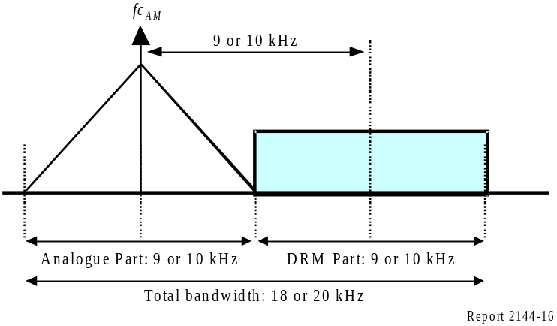
FIGure 17
AM/DRM spectrum plot and power ratio
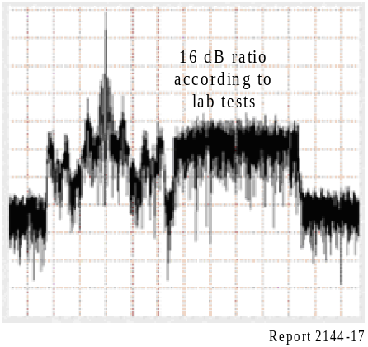

Static (more than 30 locations) and mobile (500 km) measurements were performed to assess:
– AM static/mobile measurements (subjective quality assessment by experts).
– DRM static/mobile measurements.
– Man-made noise levels.
The results may be summarized as follows:
DRM does not degrade the AM subjective quality with the tested configuration.
Of 31 tested locations, twenty-eight showed an AM subjective quality of 5 or 4 and three showed an AM subjective quality of 3 or less. It should be noted that expert subjective evaluation invariably leads to pessimistic results compared to the standard ITU evaluation method.
Moreover, it was noted that the results did not change with the type of analogue receiver tested (four receivers were tested from different manufacturers and with different prices and qualities) and that the AM reception problems were related to external man-made electrical noise.
The DRM reception quality results were excellent:
The total number of tested locations was 36. The audio quality was better than 98% at thirty-two of these locations. Correct reception was obtained at 88.88% of locations and the measured SNR threshold was 17 dB.
It was also noted that the DRM reception quality was independent of the environment (five types were identified: Industrial, Typical Mexican dense, Typical Mexican (not dense), Open residential and Urban).
Further tests were carried out at an AM/DRM power ratio of 13 dB, and the AM subjective quality was still rated at 5 − 4 even with this 13 dB power ratio.
Measurements were also conducted in “special” locations such as in the proximity of high power electrical towers. The results showed that DRM was perfectly received while the AM subjective quality was rated 1.
Finally, man-made noise measurements conducted in Mexico City showed that the measured median values were around 40 dB higher than the ITU-R reference for the MF band. Other measurements made in Madrid have shown man-made noise levels that were 10 dB higher than the ITU-R reference. This leads to the conclusion that reception environmental factors must be taken into account for planning purposes.
In summary of the results of the AM/DRM simulcast tests at MW in Mexico:
– AM-DRM recommended power ratio: 16 dB
– No degradation of the subjective AM quality
– Excellent DRM mode A/64/16/0.5/L quality with 9 or 10 kHz bandwidth
– DRM is very robust in “special” situation with regard to AM
– Noise levels in Mexico City are 40 dB higher than the reference values of ITU-R.

4 DRM test in the MF band in Italy
Source: Document ITU-SG 6/353
A 9 kHz bandwidth DRM signal with transmission configuration A/64/0.5 was broadcasted from a 148 m vertical dipole located in Siziano (20 km from Milan).
Global results
The whole north-west part of Italy is completely covered with a DRM signal whose level is greater then the minimum indicated in the relevant ITU-R Recommendation for the adopted transmission parameters (38.6 dB(μV/m)). Moreover, a minimum SNR of 14.1 dB was exceeded at each measurement point, even in deep valleys.
The extent of the coverage area can be identified with the national border (Sestriere, Ceresole Reale, Domodossola and Bormio). To the east, the DRM signal is available up to Trieste, where at the coast the field strength is 48.5 dB(μV/m) with a SNR of 21.7 dB. Due to particularly mountainous and bad terrain conductivity the Brennero valley is covered up to the town of Trento, only. In a south-eastern direction, DRM is available to just before Ancona. In the south, DRM reaches the entire Liguria coast and a part of the Tuscany coast up to Grosseto town. The cities of Genova, Savona, La Spezia and Livorno are also covered.

FIGure 18
Measured coverage area
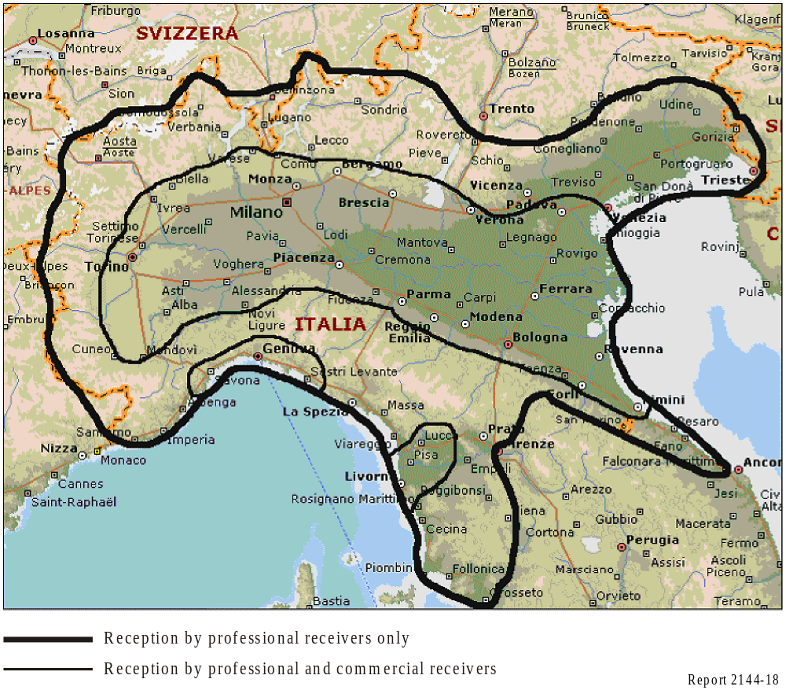

The contours on Fig. 18 show where commercial receivers and professional receivers were able to successfully decode the DRM signal.
The service area shown in Fig. 19 is computed on the basis of 45 dB(μV/m) for towns with a population below 1 000 and of 53 dB(μV/m) for towns with a population of more than 1 000.
At the moment, about 150 static measurement points have been verified.

FIGure 19
Predicted coverage area
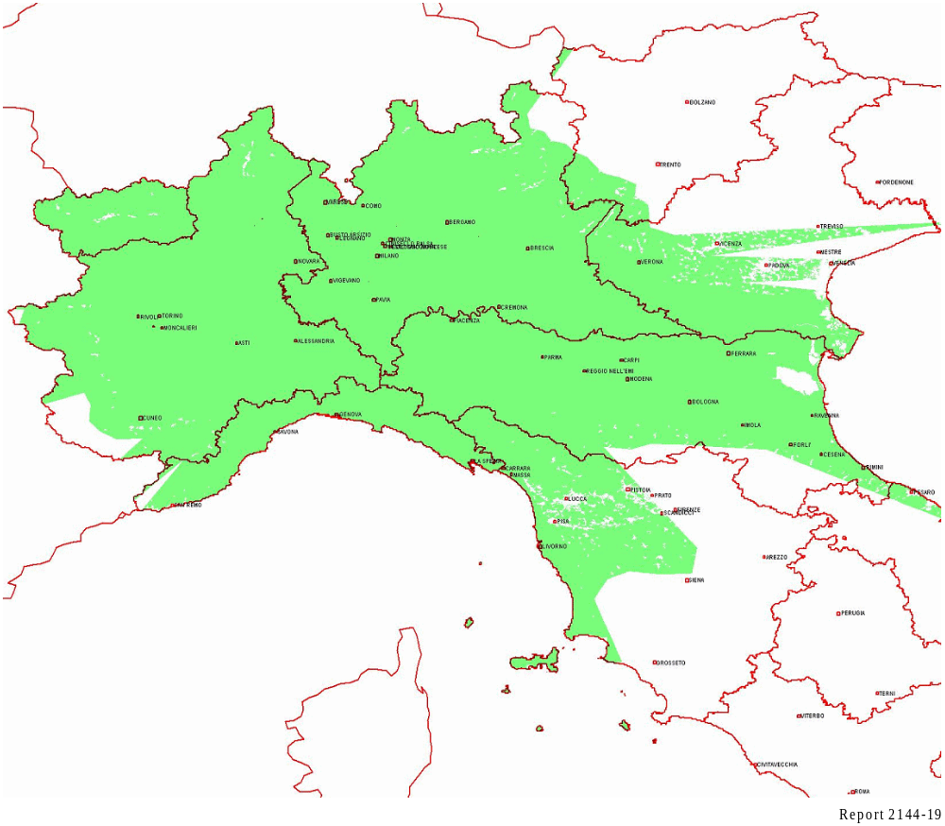

Some data analysis was done in order to identify locations where reception was not available because of local difficulties:
– in the centre of Turin, 125 km from the transmitter, in 1 of 12 measurement points the performance of the DRM signal is degraded by an electric feeder for public transport. At this point a SNR of 13.4 dB was measured with a signal strength of 52.1 dB(μV/m) and no audio was decoded;
– north from Milan, at the beginning of the Valtellina valley (93 km from the transmitter) some mountainous topography and bad terrain conductivity cause low signal strength (35.7 dB(μV/m)) and SNR (8.5 dB). Travelling along the valley route, the signal and SNR increase up towards Bormio, 170 km from the transmitter.
During daytime, no significant broadcast interference was recorded in the whole predicted and measured coverage areas.
It should be noted that the measured and predicted areas are a good match.

5 DRM trials in India: simulcast MW, Tropical Band NVIS and 26 MHz local broadcasting
Source: Document 6D/10
This contribution is based on a series of tests and measurements that were carried out in Delhi and New Delhi (India) from 9 to 12 May 2007. The trials were a part of the DRM-AIR-ABU Showcase Project on Digital Radio Mondiale (DRM) simulcast technologies that took place in Delhi from 7 to 12 May 2007.
The principle objective of the project was to demonstrate and evaluate the relatively new technology of single channel simulcast (SCS) which enables simultaneous transmission of analogue and DRM digital medium wave radio signals using only one transmitter. As an important step, if this technique could be successfully demonstrated in the Asia-Pacific environment, the radio broadcasters in the region could well reap significant benefits.
The project also assessed local digital radio transmissions in the 26 MHz band, digital radio NVIS transmissions in the 3 MHz band for wide area national coverage and the full 18 kHz bandwidth DRM tests in the medium wave band, something which is quite significant for the Asia-Pacific Region. As most Asian countries had so far not taken much initiative in the digital radio technologies in the medium wave band, one of the objectives of this project was to provide them with a scientific basis to consider implementing this technology.
Two transmitter sites in north Delhi were used for all the tests. Measurement techniques and practices were described and the measurement schedules and methods were finalized for the field tests. Broadcast signals and its features are listed below:

Figure 20
Medium wave transmitter at Nangli
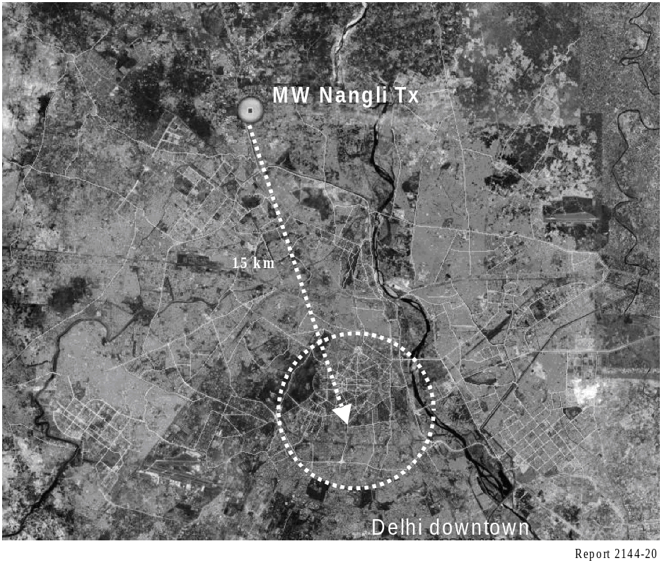
a) Single channel simulcast in an 18 kHz MW channel is practically feasible with the following parameters:
Analogue bandwidth: 9 kHz, DRM bandwidth: 9 kHz
DRM mode: A/16/4/05/S
DRM data rate: 11 kbit/s
Analogue carrier peak power to DRM RMS power ratio: 14 dB
(Analogue carrier peak power: 97.5 kW and DRM RMS power: 2.5 kW were used during the tests)
Antenna: 115 m self radiating mast.
The coverage area for the DRM signal is marginally larger than the analogue coverage. The reception of the DRM signal is consistently better including in urban areas. The reception quality was considered as GOOD by expert listeners.
b) Full 18 kHz MW DRM provides excellent quality stereo audio with the following parameters:
DRM bandwidth: 18 kHz
DRM mode: A/64/16/06/S
DRM data rate: 45 kbit/s
DRM power level: 50 kW.
The coverage area will far exceed that of the analogue coverage (Current AM power on 819 kHz 200 kW). Audio quality was considered as excellent by trained listeners.
c) 26 MHz DRM local coverage provides very good quality local coverage with the following parameters:
DRM bandwidth: 20 kHz
DRM mode: B/16/4/05/L
DRM data rate: 21 kbit/s
DRM RMS power: 500 W
Antenna: 3 element Yagi-Uda
Cut-off point was detected at about 7 to 10 km from the transmitter and the reception quality was considered as GOOD by expert listeners.
d) NVIS 3 MHz DRM wide area coverage provides very good quality with the following parameters:
DRM bandwidth: 10 kHz
DRM mode: B/16/4/05/L
DRM data rate: 11 kbit/s
DRM RMS power: 2 kW
Antenna: Dipole H 1/1/.5λ.
The conclusions based on the measurement results are summarized in the following paragraphs:
The AM and DRM coverage using the simulcast mode was confirmed to be equivalent following a radial route from the transmitter. In some environments within this radial, the DRM outperformed by far the AM reception. It showed an approximately 100 km coverage radius using a transmitted power of 96.17 kW for AM signal and 3.82 kW for DRM signal. In the case of urban environments, e.g. city downtown, they are properly covered by simulcast signal up to 15 km reaching more than 98% of correctly received locations. Another important conclusion is that the simulcast configuration does not interfere significantly the transmitted AM signal using a set of representative receivers of Indian Market.
The results show that using different robustness modes and back-off ratios, the A/16/4/05/S mode was found to be the most appropriate configuration for urban environments. Other DRM modes, A/64/16/0.5 (with 21.2 kbit/s) would have a similar performance, except for some spots behind big buildings and locations near intense man-made noise sources.
The full DRM mode 18 kHz wide in MW band was tested “live” with near FM audio quality and circuit reliability in a harsh radio environment. Urban environments are fully covered using this DRM configuration with 50 kW DRM broadcasted power.
The 26 MHz reception quality was very good at the locations and routes tested reaching more than the 98% of the locations measured in static and mobile modes. It is capable of achieving a near FM audio quality for local coverage using an antenna placed in a 40 m height tower.
The NVIS night-time applications were found very interesting and the results within this short test period encourage further testing by the participants for possible regular use of this band. The results reflected that the variation of the ionospheric conditions determine the performance of this type of propagation, the main problem being the delay spread. This could normally be avoided by using a robust mode but there were some spots where reception was impossible. The participants rated the performance of NVIS reception as acceptable but audio quality for robust modes was considered poor.

6 Multichannel Simulcast, urban and indoor reception in MW Band
Source: Document 6A/73
In 2007 the Spanish broadcaster “Sociedad Española de Radiodifusión” (SER) carried out some DRM experimental tests in close collaboration with other companies experienced in broadcasting, VIMESA, AXION and University of the Basque Country. The study was focused on the performance and related propagation aspects of the DRM system after an extensive measurement campaign in the coverage area of an experimental network installed in the West vicinity of Madrid (Spain). The test period was long enough to evaluate properly the following issues:
Evaluation of the DRM-AM Simulcast system; obtaining the system operating parameters for planning an AM-DRM commercial service. Specifically three objectives are stated in this case:
a) To determine the coverage area, thresholds values and QoS of an AM-DRM MCS signal.
b) To evaluate the influence of the DRM signal over the AM signal when using the Simulcast configuration by means of changing power back-off ratios and evaluating the subjective audio of the AM signal considering a representative set of commercial receivers.
c) This test allows broadcasting the digital signal transmission with the maximum power that does not cause the worsening of the audio quality of the analog signal.
Evaluation of the DRM reception in a city with dense urban areas; transmitting the maximum power that is permitted for the transmitter equipment, without the restrictions of the Simulcast configuration.
Evaluation of the indoor DRM reception; obtaining the reception thresholds according to different reception conditions inside different buildings in order to compare them with the corresponding ones of outdoor reception.
In order to study these aspects a DRM configuration A/64/16/0.6/S was used for the DRM signal. This configuration provided enough bit rate to allow an audio quality much better than AM. The radiating system was a vertical folded monopole.
Next paragraphs sum up the results for above mentioned three different tests or objectives.
Simulcast trials
Those trials were planned in order to evaluate to different aspects: assessment of the system coverage parameters using a 16 dB back-off ratio between transmitted AM and DRM signals and an assessment of the obtained AM reception quality using different Simulcast back-off ratios.
The transmitted modes are shown in Table 49:

TABLE 49
Proposed MCS transmission configurations
Reference code | DRM RMS power  (kW) | AM peak power  (kW) | Power ratio  (dB)
10001 | 0.25 | 10.0 | 16.0
10002 | 0.5 | 7.5 | 11.8
10003 | 0.75 | 4.0 | 7.2
10004 | 0.9 | 1.25 | 1.5

A set of six different representative commercial AM receivers was used and totally, 33 static reception locations and more than 88 km of mobile measurements were analysed.
Using mode 10001 it was found a good AM coverage in West Madrid (the transmitter direction) but the DRM reception was impaired by the lack of field-strength level that resulted insufficient. So, the coverage radius would be considerably greater increasing the broadcasted power by 5 or 10 dB.
As regards to the AM-DRM interference analysis inside Simulcast configuration, it can be concluded that the main cause of the DRM service unavailability was the lack of field-strength level taking into account that the utilization of higher transmitted power configurations for the DRM part led to an increasing of the service quality. So it is important to say that the DRM service part of Simulcast configuration was not interfered by the adjacent AM analog signal.
In the case of the AM part of the Simulcast configuration, the DRM signal placed in the adjacent channel influences over the received AM subjective audio quality and its influence depends highly on the type of AM commercial receiver used for signal demodulation. The high-medium end receiver signal was not impaired or interfered by the DRM signal but some mid-range receivers begun to provide deficient audio quality with MCS 10002 configuration which uses 11.8 dB back-off ratio. The low end range AM commercial receivers never provided a good AM subjective audio quality. The DRM signal spectrum acts as an interferer noise in the adjacent channel for the AM signal and it is a critical factor for the worst receivers. Finally it is important to say that the type of tuning for the analog receivers did not result a critical factor, that is, a digital or analog tuning provided the same audio quality results.
Monocast DRM test (10 kW)
In the case of DRM Monocast test a 9 kHz width DRM signal was broadcasted centred in 1 260 kHz. 52 static locations and around 133 km of mobile routes were measured in order to evaluate the system reliability in dense urban environments.
As a general conclusion for fixed reception, the Monocast DRM service coverage in the center of Madrid, with a power of 10 kW, is very good. It must be highlighted that the only point that presented wrong reception had MER values below the 18 dB threshold. In this point, the failure causes were a combination of a low field-strength level as well as a considerable noise level. The SNR (MER) threshold is 18 dB for the static reception and 20 dB for the mobile reception.
The field-strength thresholds are difficult to establish because they depend on the radio electric noise whose values are very variable spatially. As to the field-strength variability, the obtained result for 90% coverage involves a margin of at least 10 dB above the threshold.
The frequency comparative study concludes that those locations where reception is affected by urban critical factors, such as high buildings and narrow streets, could improve their coverage by means of a change to a lower transmitting frequency as it can be seen in the figure below which represents a normalized graph of the received field strength at same places for 2 different signals (810 and 1 260 kHz) broadcasted from the same transmitter station.

FIGURe 21
Madrid downtown. Received field in 810 kHz and 1260 kHz
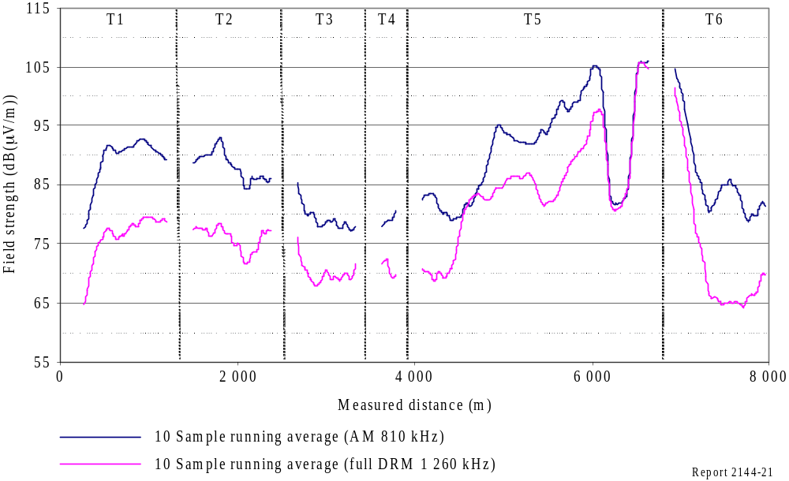
DRM monocast indoor tests
The measurements of this stage of the project were planned for six buildings in the city center of Madrid and one in an industrial zone in Fuenlabrada, a village placed in the south of Madrid. With the aim of determining the performance of the DRM signal, different types of buildings were chosen in different environments. Thus, seven different buildings were divided in two main groups: apartment buildings and commercial buildings, in which 113 locations were measured.
As a conclusion, different aspects of the analysis of the results can be emphasized:
1 In the best reception cases, the buildings had 3 or 4 floors and were placed along wide streets and with similar buildings next to them. The industrial environment where VIMESA is located featured similar conditions. That is, the best reception reliability has been found in non dense urban environments.
2 The rest of the measured apartment buildings, two of them, showed correct reception only near windows. These were very high buildings located in Dense Urban environment. Thus, it can be concluded that, the worst reception reliability has been found in Dense Urban environments.
3 In Non Dense Urban environments, values of MER fluctuate between 12 and 29 dB.
4 According to the measurement location, electric field can vary up to 30 dB inside the same building with a median variation of 16 dB. Moreover, the level of the received electric field increases as the height of the reception point increases, i.e., in the highest floors better levels of electric field and better reception reliability was obtained.
5 The DRM MER threshold for a correct reception is around 17.5 dB.
Finally, it is remarkable that a broadcast power of 10 kW is not enough for granting indoor reception in Madrid. However, with a 20 kW broadcast power, that is, 3 dB more, the coverage is increased considerably, obtaining acceptable levels in more than 80% of the analysed locations. Different field-strength predictions can be observed in Fig. 22 starting from 10 kW transmitted power and adding 3 dB in each prediction.

FigurE 22
Coverage prediction
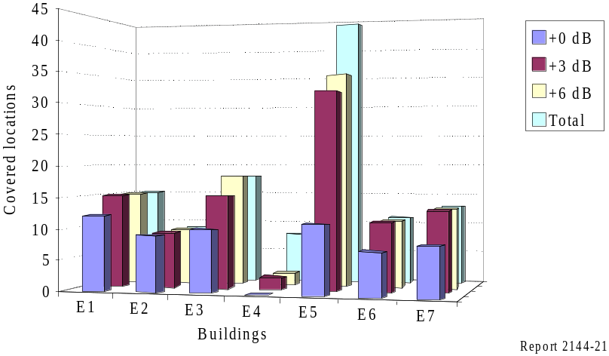
Annex 4
RMS modulation depth

Modulation depth is conventionally expressed in terms of peak sine wave excursion. A sine wave that doubles the carrier (voltage) on positive peaks and reduces it to zero on negative peaks is said to modulate the carrier by 100% (see Fig. 23).

FIGure 23
100% (peak) sine wave modulation
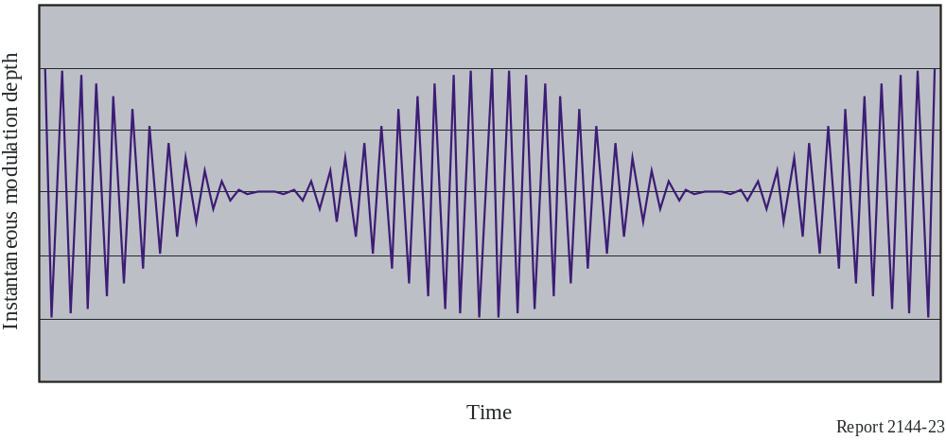

(The maximum instantaneous modulation depth (outer horizontal lines) is +100%. The minimum instantaneous modulation depth (central horizontal line) is −100%).
For the signal in Fig. 23, the instantaneous modulation depth {M_{inst} ( t)} is:

M_{inst}(t) = 100 sin (ω_{m} t)) (5)

where ω_{m} is the modulating (angular) frequency.
For any (arbitrary) function {F(t)} the r.m.s. value of the function over a specific period of time {T} is given by:

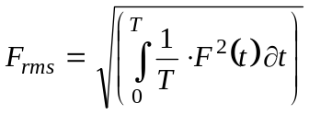 (6)
In the case of the instantaneous modulation depth function shown in equation (5) above the r.m.s. value is:

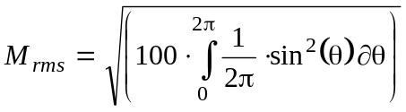 (7)

where θ is equal to ω_{m} t.
Evaluating in equation (7) yields the familiar result for a sine wave M_{rms} = 70.7%. The rms modulation depth for a carrier fully modulated with a sine wave as shown in Fig. 23 above is therefore 70.7%.
The r.m.s. value for any modulated waveform can be calculated by substituting the function describing the instantaneous modulation depth in equation (6).

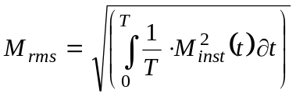 (8)

It can further be shown that the rms modulation depth can be expressed as:

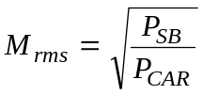 (9)

Where PSB is the power in the sidebands and PCAR the power in the carrier.

Annex 5
DRM facilities and transmissions operated by European Broadcasters

Based on extracts from the DRM Web page www.drm.org, updated as per 19 November 2007.

Programme⁽¹⁾ | Broadcaster/network operator | Site | Power (kW) | Frequency  (kHz) | Band | Target
OldieStar Radio | OldieStar Radio | Burg | 100 | 1 575 | MF | Europe
Radio Luxembourg | BCE (Broadcasting Centre Europe) | Dudelange | 0.15 | 25 795 | 26 MHz | Luxembourg
 | BCE (Broadcasting Centre Europe) | Junglinster | 50 |  | HF | Europe
RTL Radio | BCE (Broadcasting Centre Europe) | Marnach | 120 | 1 440 | MF | Europe
RTL Radio | BCE (Broadcasting Centre Europe) | Marnach | 240 | 1 440 | MF | Europe
RTL Radio | BCE (Broadcasting Centre Europe) | Marnach | 120 | 1 440 | MF | Europe
 | BCE (Broadcasting Centre Europe) | Junglinster | 50 |  | HF | Europe
 | Bayerscher Rundfunk | Ismaning | 10 |  | HF | Europe
 | CVC (Christian Vision) | Julich | 40 |  | HF | Europe and other
 | CVC (Christian Vision) | Julich | 40 |  | HF | Europe and other
 | CVC (Christian Vision) | Julich | 40 |  | HF | Europe and other
 | CVC (Christian Vision) | Julich | 40 |  | HF | Europe and other
 | CVC (Christian Vision) | Julich | 40 |  | HF | Europe and other
 | CVC (Christian Vision) | Julich | 40 |  | HF | Europe and other
DLF | DLF (Deutschlandfunk) | Berlin-Britz | 10 | 855 | MF | Berlin
 | DW (Deutsche Welle) | Sines (Portugal) | 90 |  | HF | Europe
 | DW (Deutsche Welle) | Sines (Portugal) | 90 |  | HF | Europe
 | DW (Deutsche Welle) | Sines (Portugal) | 90 |  | HF | Europe
 | DW (Deutsche Welle) | Trincomalee (SRL) | 90 |  | HF | Asia
 | DW (Deutsche Welle) | Trincomalee (SRL) | 100 |  | MF | South Asia
Glas Hrvatske and HR1 | HRT/OIV (Croatia) | Deanovec | 10 | 594 | MF | NW Croatia
 | KPN Broadcast (Netherlands) | Flevo | 40 |  | HF | Europe
 | MCR (Monte Carlo Radiodiffusion) | Fontbonne | 10 |  | HF | Europe
BBC Radio Devon | NGW (National Grid Wireless) | Crownhill SFN | 0.25 | 855 | MF | Devon
BBC Radio Devon | NGW (National Grid Wireless) | North Hessary Tor | 0.1 | 855 | MF | Devon
 | Norkring (or VT) | Sveio (Norway) | 200 |  | HF | Europe and other
 | ORS (Austria) | Moosbrunn | 50 |  | HF | UK
 | ORS for VT | Moosbrunn | 50 |  | HF | UK
RAI tests | RAIWAY (Italy) | Milano | 30 | 693 | MF | Italy
 | RNW (Radio Netherlands Worldwide) | Bonaire (Dutch Caribbean) | 150 |  | HF | Americas
 | RNW (Radio Netherlands Worldwide) | Bonaire (Dutch Caribbean) | 150 |  | HF | Americas
 | RTBF (Radios et Télévisions Belges Francophones, Belgium) | Wavre | 100 |  | HF | South Europe
EIRE | RTÉ (Ireland’s National Television and Radio Broadcaster) | Summerhill | 100 | 252 | LF | Ireland
SWR cont.ra | SWR (Südwestrundfunk Germany) | Mainz-Wolfsheim | 0.42 | 1 485 | MF | SW Germany
 | TDF (Télédiffusion de France) | Montsinery-Guyane | 150 |  | HF | Americas
 | TDF (Télédiffusion de France) | Issoudun | 150 |  | HF | Any
 | TDF (Télédiffusion de France) | Issoudun | 1 |  | HF (4 MHz) | France
 | TDF (Télédiffusion de France) | Issoudun | 30 |  | HF | Europe and other
TDF Radio | TDF (Télédiffusion de France) | Rennes | 0.1 | 25 775 | 26 MHz | Rennes
 | TSI (T-Systems International, Germany) | Nauen | 40 |  | HF | Europe
 | TSI (T-Systems International, Germany) | Nauen | 200 |  | HF | Europe and other
DLR Kultur | TSI (T-Systems International, Germany) | Oranienburg | 150 | 177 | LF | Germany
VoR (Simulcast) | TSI (T-Systems International, Germany) | Oranienburg | 250 | 693 | MF | Berlin
 | TSI (T-Systems International, Germany) | Putbus | 1 | 729 | MF | NE Germany
 | TSI (T-Systems International, Germany) | Wertachtal | 40 |  | HF | Europe
 | TSI (T-Systems International, Germany) | Wertachtal | 60 |  | HF | Europe
 | TSI (T-Systems International, Germany) | Wertachtal | 60 |  | HF | Europe
 | TSI (T-Systems International, Germany) | Wertachtal | 60 |  | HF | Europe
 | TSI (T-Systems International, Germany) | Wertachtal | 200 |  | HF | Europe
Oldiestar Radio | TSI (T-Systems International, Germany) | Berlin-Schaeferberg | 0.5 | 1 485 | MF | Berlin
Oldiestar Radio | TSI (T-Systems International, Germany) | Frohnou | 0.5 | 1 485 | MF | Berlin
Various | University of Hannover | Hannover | 0.04 | 26 045 | 26 MHz | Hannover
Campus Radio | University of Nurenberg | Dillberg | 0.1 | 26 000 | 26 MHz | Neumarkt
Campus Radio | University of Nurenberg | Nurenberg | 0.1 | 26 012 | 26 MHz | Nurenberg
 | VoR (Voice of Russia) | Komsomolsk Amur | 90 |  | HF | Asia
 | VoR (Voice of Russia) | Taldom | 40 |  | HF | Europe
 | VoR (Voice of Russia) | Taldom | 35 |  | HF | Europe
 | VoR (Voice of Russia) | Taldom | 35 |  | HF | Europe
Vatican Radio | VR (Vatican Radio) | Santa Maria di Galeria | 70 | 1 530 | MF | Europe
Vatican Radio | VR (Vatican Radio) | Santa Maria di Galeria | 28 | 1 611 | MF | Europe
 | VR (Vatican Radio) | Santa Maria di Galeria | 225 |  | HF | America
 | VR (Vatican Radio) | Santa Maria di Galeria | 120 |  | HF | America
 | VR (Vatican Radio) | Santa Maria di Galeria | 70 |  | HF | Europe
 | VR (Vatican Radio) | Santa Maria di Galeria | 125 |  | HF | Europe
 | VR (Vatican Radio) | Vatican + Santa Maria | 0.125 |  | 26 MHz SNF | Vatican
Premier Radio | VT (VT Communications, UK) | Crystal Palace (London) | 0.1 | 25 695 | 26 MHz | Greater London
Deutsche Welle  (2nd audio service on Premier multiplex) | VT (VT Communications, UK) | Crystal Palace (London) | 0.1 | 25 695 | 26 MHz | Greater London
 | VT (VT Communications, UK) | Kvitsoy (Norway) | 50 |  | HF | Europe
BBCWS | VT (VT Communications, UK) | Orfordness, UK | 70 | 1 296 | MF | Europe
 | VT (VT Communications, UK) | Rampisham, UK | 35 |  | HF | Europe
 | VT (VT Communications, UK) | Rampisham, UK | 35 |  | HF | Europe
Deutsche Welle | VT (VT Communications, UK) | Skelton, UK) | 100 |  | HF | Europe
 | VT (VT Communications, UK) | Woofferton, UK | 100 |  | HF | Europe
 | VT (VT Communications, UK) | Woofferton, UK | 100 |  | HF | Europe
 | VT (VT Communications, UK) | Woofferton, UK | 100 |  | HF | Europe
 | VT (VT Communications, UK) | Woofferton, UK | 100 |  | HF | Europe
WDR 2 Klassik | WDR (Westdeutscher Rundfunk) | Langenberg | 10 | 1 593 | MF | W Germany
⁽¹⁾ Blank of HF because, usually, several programmes are transmitted at different hours.

* DRM broadcast user manual. Available for free downloading from www.drm.org.
* * ITU-R Handbook – LF/MF system design, Edition of 2001.
* ITU-R Circular Letter CCRR/20 (Special study, under RR No. 13.15, in relation to the Regional Agreements GE75, RJ81 and RJ88) and associated RRB (Radio Regulations Board) decision in Document RRB02/343, 13 December 2002.
* Document 6A/178 – Estimation of a representative conductivity value in mixed paths for predicting the transmission loss mean value in the MF band.
*
* Document 6A/178 – Estimation of a representative conductivity value in mixed paths for predicting the transmission loss mean value in the MF band.
* * Document 6E/175 – Digital Radio Mondiale (DRM) daytime medium wave tests.
* ** Document 6A/177 – Characterization of the terrain irregularities and method for predicting the transmission loss mean value on the propagation path in the MF band.
* *** Document 6A/73 – Digital Radio Mondiale DRM multichannel simulcast, urban and indoor reception in the medium wave band.
* Document 6A/73 – Digital Radio Mondiale DRM multichannel simulcast, urban and indoor reception in the medium wave band.
* * Document 6A/148 – MF field-strength spatial variability in urban environments.
* Final Acts of the Regional Administrative LF/MF Broadcasting Conference (Regions 1 and 3). Geneva, 1975.
* Document 6E/403 – Digital Radio Mondiale (DRM) medium wave simulcast tests in Mexico D.F.
* * Document 6D/10 – Digital Radio Mondiale (DRM), Asia-Pacific Broadcasting Union (ABU).
* ** Document 6E/460, Italy: DRM daytime medium wave tests for frequencies below 1 MHz.
* Provisional RF protection ratio values for analogue and digitally modulated emissions in the HF broadcasting service.
* DRM local coverage using the 26 MHz band.
These parameters were chosen to approximate the calculated RF protection ratios to the measured values.
* DRM developments: Experimental and Regular Transmissions. Dr. Pablo Angueira, University of the Basque Country (UPV/EHU). Second Technical Specialised Meeting in International Broadcasting – EBU, Geneva April 2007.
A/64/16/0.5/L means: DRM Mode A, modulation used for the MSC channel: 64-QAM, modulation used for the SDC channel: 16-QAM, code rate: 0.5, interleaver: long.
AM Subjective quality is defined in Recommendation ITU-R BS.1284: QualityImpairment5Excellent5Imperceptible4Good4Perceptible, but not annoying3Fair3Slightly annoying2Poor2Annoying1Bad1Very annoying

