REPORT ITU-R BS.1203-1[1]*

DIGITAL SOUND BROADCASTING TO VEHICULAR, PORTABLE AND FIXED RECEIVERS USING TERRESTRIAL TRANSMITTERS IN THE UHF/VHF BANDS

(1990-1994)

This Report contains background and descriptive material for Recommendation ITU‑R BS.774 entitled "Digital sound broadcasting to vehicular, portable and fixed receivers using terrestrial transmitters in the UHF/VHF bands".

# 1. Introduction

Digital techniques have been used in sound programme production and transmission by some broadcasters for many years now, and more recently have become cheap enough to be introduced into the domestic consumer market, leading to wider public appreciation of high-quality sound, albeit via non-broadcast digital media. At the same time, there is rapidly growing congestion in the VHF/FM radio bands in many countries; thus the FM broadcasting services, which can deliver unimpaired sound quality into the home, are under threat of erosion of the quality deliverable. Overcrowding will inevitably increase the levels of interference which must be tolerated, particularly for vehicular and portable receivers, which do not benefit from elevated, directional, receiving antennas, usually assumed in planning service coverage.

Although VHF/FM services can still provide excellent service to properly-installed fixed receivers, the solution for the future development of sound broadcasting is to provide an entirely new digital sound broadcasting service, designed at the outset to meet all the reception requirements of the diverse listening audiences. Also, a complete digital sound programme chain can be established from studio to domestic receiver.

In contrast to existing sound broadcasting systems, the new system has to provide unimpaired sound broadcast reception to fixed, portable and mobile receivers. The requirement for mobile reception necessitates entirely new transmission methods which have been defined and are described below.

This Report describes the requirements for digital sound broadcasting to vehicular, portable and fixed receivers using terrestrial transmitters, the techniques employed in the digital sound broadcasting system, and considers relevant planning parameters and sharing considerations. The Report also makes reference to the terrestrial part and common system characteristics of the mixed satellite/terrestrial digital sound broadcasting service concept as well as the hybrid delivery concept. The mixed satellite/terrestrial service concept is based on the use of the same frequency band by both satellite and terrestrial broadcasting services to the same receiver. The hybrid delivery concept is based on the use of low power terrestrial "gap-filler" to improve the satellite coverage. Both concepts are made possible by the techniques employed in the digital sound broadcasting system and are described in more detail in Report ITU-R BO.955.

Most of the information included in this Report is based on studies and tests undertaken in Canada, Germany, France, the Netherlands, United Kingdom, Sweden and by the EBU in association with the Eureka-147 Project using the system concept described in Annex 1-A.

Recent efforts have been undertaken to explore other possible digital sound broadcasting systems (see Annex 2).

# 2. Service and system requirements

In defining a digital sound broadcasting system, the following requirements shall be taken into account. The system shall be intended for fixed as well as portable and vehicular reception. The list of system requirements applies to terrestrial, cable, satellite as well as mixed/hybrid satellite/terrestrial delivery concepts.

The requirements are:

## 2.1 Sound quality levels

- High quality stereo sound of two or more channels with subjective quality indistinguishable from high quality consumer digital recorded media ("CD quality").

## 2.2 Sound control signals

- Transmission of control information on sound representation (loudness, dynamic range compression, matrixing, etc.).

## 2.3 Service configurations

- High-quality channel stereophonic sound.

- High-quality monophonic sound.

- For special applications, the possibility of adding further sound channels to the basic system (for the universal multi-channel stereophonic sound system as defined in Recommendation ITU-R BS.775).

- Value added services with different data capacities and delivery time (e.g. traffic message channel, business data, paging, still picture/graphics, 1.5 Mbit/s video/sound multiplex, future Integrated Services Digital Broadcasting (ISDB)).

- Flexible allocation/reallocation of services, without affecting continuing services.

## 2.4 Service delivery

Use of common signal processing in receivers for:

a) local, sub-national and national terrestrial VHF/UHF networks;

b) mixed use of terrestrial and national/supernational UHF satellite services;

c) cable.

It would be advantageous, in some countries, to design the system and plan the service in such a way that a common receiver could be used for all the above delivery concepts.

## 2.5 Service information

- Radio programme data related to each programme signal (programme labelling, programme delivery control, copyright control, conditional access, dynamic programme linking, services for the hearing-impaired).

- Multiplex system information (simple programme or service identification, selection and linking).

## 2.6 Interface

- Recording capability of sound signals (in bit-rate reduced form) and related data. This implies recording the complete programme signal including its programme-related data, and the ability to access small blocks of data in the encoded signal.

- Data interface capability to information technology equipment (ITE) and communication networks.

## 2.7 Service availability

- Vehicular, portable and fixed reception.

- High-coverage availability in location and time.

- Subjectively acceptable failure characteristics.

- High immunity to multipath (long and short delay) and Doppler effect (for mobile receivers).

- Trade off between extent of coverage for a given emission power, service quality and number of sound programmes and data services.

## 2.8 Spectrum efficiency

- High spectrum utilization efficiency (better than FM, maximize frequency reuse and single frequency networking, minimize sharing constraints with other services)

- Multiple programme service provision within a contiguous frequency band.

## 2.9 Complexity

- Low-cost basic receiver configuration

- Use simple, non-directional receiving antenna appropriate to vehicular and portable reception.

# 3. System design considerations

## 3.1 Channel characteristics

The design of both a satellite and a terrestrial digital sound broadcasting system is strongly dependent on the factors affecting the propagation characteristics of the path to the vehicular receiver. The propagation path in the VHF/UHF frequencies is subject to attenuation by shadowing due to buildings and other obstacles, and to multipath fading due to diffuse scattering from the ground and nearby obstacles such as trees, etc. The shadowing and multipath effects depend on the operating frequency, the elevation angle to the transmitter and the type of environment in which the receiver is operating: whether it is an open, rural, wooded suburban or dense urban environment. A mathematical description of a vehicular broadcast channel with multipath propagation is given in Annex 1-C together with experimental results.

Conventional digital modulation systems are particularly sensitive to multipath signals since these can create severe inter-symbol interference related to the differences in path delays. The inter-symbol interference cannot be overcome by an increase of the transmit power.

In relation to the digital channel bandwidth necessary, the multipath propagation may be frequency selective and also time varying. For a conventional digital modulation scheme, the achievable error performance is then strongly limited by the frequency selectivity and the fast field‑strength variations with mobile reception. Studies of the statistical distribution of the field‑strength (see Report ITU-R BO.955) have shown that it follows a log-normal distribution over large areas, coupled with a Rayleigh (no line-of-sight path) or Rice distribution (consisting of the direct path and Rayleigh distribution) within small areas (usually of dimensions of the order of a few hundred wavelengths).

Therefore, in most respects the Rayleigh channel within dense urban areas is the least favourable. Any new system must be designed to operate in this propagation environment. A certain amount of wideband propagation data is available [Cox *et al*., 1975]. Typically, at UHF, the 90% correlation bandwidth is of the order of 30 kHz with independence (<10% correlation) at frequency separations of the order of 3 MHz. Also the delay spread in urban areas is found to be of the order of 1-2 s but exceeds 3 s for about 1% of locations in any localized area. In mountainous and hilly terrain, delay spreads can be many tens of microseconds for large area coverage.

For a fixed receiver, the time delay of each path will typically be fixed, but for a moving receiver, the time delay will vary proportionally to the speed of the receiver parallel to the direction of each received path. Thus, different Doppler shifts are associated with multiple paths arriving at the receiver from different angles. The Doppler effect is described in terms of the parameters "Doppler spread" and its Fourier inverse, the correlation (coherence) time. The Doppler spread of the mobile channel depends on the vehicle speed and is typically equal to 2 v/ where v = vehicle speed and  = the carrier wavelength. For a vehicle speed of 100 km/h, a 1 500 MHz signal has a Doppler spread of about 275 Hz and a correlation time of 3.6 ms. A stationary vehicle will nominally have a Doppler spread approaching zero and a very long correlation time. However, the presence of other moving vehicles in the vicinity will also create a non-stationary multipath field. The correlation time defines the amount of time diversity that can be gained by simple symbol interleaving. If the time interval over which symbols are interleaved is large compared to the correlation time, significant time diversity is achieved. Thus, with respect to achieving time diversity, the stationary or slow moving vehicle defines the worst case and at least several hundreds of milliseconds of time interleaving may be desirable.

However, no amount of time interleaving can provide usable time diversity for the stationary receiver. Thus, extensive frequency diversity is also needed.

For portable receivers usually situated in the indoor urban environment, building penetration loss may be a critical factor. In some cases, the attenuation caused by walls and ceilings may be very severe (e.g. exceeding 20 dB), though penetration through apertures will mitigate the overall effects. Nevertheless, it may be uneconomical to provide sufficient link margins from a satellite, and some low power terrestrial retransmitters (gap-fillers) will be needed to provide a service to listeners located in multi-floor office buildings and apartment buildings located within urban service areas.

It should be pointed out that satellite propagation characteristics may substantially differ from those of the terrestrial links. The delay spread of the terrestrial links is generally much longer than that of the satellite link. Similarly, the correlation bandwidth of the terrestrial link is smaller. These differences may cause some divergencies in the parameters of the system design for each application. For example, a VHF terrestrial system may use a longer symbol duration than a UHF satellite or hybrid satellite/terrestrial system (see Annex 1-A).

## 3.2 Basic system characteristics

### 3.2.1 Modulation and channel coding

One way to overcome the selective fading effects of the Rayleigh channel is to employ spread spectrum techniques. Its main weakness is however the low spectrum utilization attainable, usually below 0.25 bit/s/Hz, and this is unacceptable for use in broadcasting where there are severe restrictions on the available spectrum.

#### 3.2.1.1 COFDM (coded orthogonal frequency division multiplex)

A new scheme, known as coded orthogonal frequency division multiplex (COFDM) [Alard and Lassalle, 1987; Le Floch, 1989] has therefore been devised which is well suited to a selective Rayleigh channel and, despite being broadband, provides for efficient frequency utilization. This modulation approach is used in the Digital System A described in Annex 1-A.

COFDM, the RF transmission technique employed by the Digital System A system, was developed to meet the exacting requirements of high bit-rate transmission to vehicular, portable and fixed receivers. Its basic principle consists of distributing the information to be transmitted over many carriers each having low bit rates, so that the corresponding symbol duration can be larger than the delay spread of the channel. Then, provided that a temporal guard interval is inserted between successive symbols, the channel frequency selectivity will not be a cause of intersymbol interference, it does not suppress frequency selective fading; i.e. some of the carriers may be enhanced by constructive interference, while others may suffer from destructive interference (i.e. frequency-selective fading). To correct this problem, COFDM provides for multiple linkage of the elementary signals (information modulating a given carrier during a given symbol time) received at distant locations of the time-frequency domain. The linkage is achieved by convolutional encoding with time and frequency interleaving at the source, in conjunction with a maximum-likelihood Viterbi-decoding algorithm employed in receivers.

The diversity provided by interleaving plays an important role in maximizing Viterbi-decoding efficiency, because successive samples presented at its input are affected only by independent (uncorrelated) fades. Even when a receiver is not moving, the diversity in the frequency domain is sufficient to ensure correct behaviour of the system. Consequently, multipath provides a form of diversity, which, in stark contrast to conventional FM reception, is actually an advantage in COFDM reception. Furthermore, this advantage in ruggedness of the system performance improves with increased transmission-channel bandwidth.

The signal-to-noise ratio will increase as soon as the received signal power is augmented by echoes that cannot combine destructively: this is the case when the echoes are separated by a minimal delay equal to the inverse of the signal bandwidth.

Therefore, the COFDM system combines constructively (power sum) the multipath echoes. These echoes can be artificial ("active echoes") which are obtained by retransmitting on the same frequency block. This is a form of space diversity (at the transmitting end). It allows for a number of different network concepts (see § 4.6):

- the simple network of a single transmitter (see § 4.6.1);

- the synchronized single frequency network of multiple main transmitters used for large area coverage (see § 4.6.2);

- the non-synchronized single frequency network of multiple transmitters used for coverage extension, coverage shaping (see § 4.6.3);

- the hybrid satellite/terrestrial network which is a simple network, the main transmitter of which is on board a satellite augmented by low power terrestrial transmitters (see Report ITU-R BO.955).

In a single frequency network, specially distributed transmitters contribute, by power addition, to the received signal. Since the positions of these transmitters are not concentrated in only one direction from the receiving point, this feature is very useful to avoid a complete shadowing when an obstacle is masking a new direction of the horizontal plane.

So, the COFDM scheme makes extensive use of time, frequency and space diversity.

### 3.2.2 Source coding

Currently, broadcasting systems incorporating digital sound transmission methods (see Reports ITU-R BS.795, ITU-R BO.1073) require between 400 and 900 kbit/s capacity to convey a stereophonic programme. However, in order to make the most efficient use of the scarce radio-frequency spectrum for digital sound broadcasting, a maximum bit-rate reduction of the digital sound source signal is also necessary, whilst conserving the full fidelity of the original studio signal.

The different source coding methods in use are described in Recommendation ITU‑R BS.646 and in Reports ITU-R BS.1068 and ITU-R BS.1199.

Newer low-bit-rate coding methods are recommended in Recommendation ITU-R BS.1196.

The source coding method used for the Digital Sound Broadcasting System described in Annex 1-A corresponds to ISO Draft Standard CD 11172.

Many subjective and objective tests have been performed with the ISO/MPEG-Audio Layer II audio coding system, also known as MUSICAM. The essential part of these tests was to determine the subjective audio quality at different bit rates for most critical monophonic or stereophonic audio signals.

Other important tests have been performed regarding the stereophonic image of the decoded audio signals, and regarding cascades of several codecs, i.e. multiple en- and decoding by using the same coding system. In addition to these subjective tests, an objective evaluation has been performed, including complexity of the encoder and decoder, frequency response, encoding and decoding delay, random access and fast forward/reverse capability. The following list gives an overview of the official tests which have been carried out with the ISO/MPEG-Audio Layer II audio coding system.

*Official subjective and objective tests of ISO/MPEG-Audio Layer II (MUSICAM)*

|  |  |
| --- | --- |
| July 1990 | First subjective and objective tests of ISO/MPEG-Audio, carried out by the Swedish Broadcasting Corporation (SR) in Stockholm. |
| November 1990- April 1991 | MUSICAM listening tests, carried out by the Communications Research Centre (CRC) in Ottawa |
| April-May 1991 | Verification tests of ISO/MPEG-Audio Layer I, II, and III. Conducted by the Swedish Broadcasting Corporation (SR) in Stockholm. |
| November 1991 | Verification test of 'Joint Stereo Coding' and second verification of ISO/MPEG-Audio Layer III, conducted by lnst. für Theor. Nachrichtentechnik und Informations verarbeitung der Universität Hannover in cooperation with Norddeutschen Rundfunk (NDR) and the Swedish Broadcasting Corporation (SR). |
| January-June 1992 | TG 10/2 tests (subjective and objective) for the assessment of low bit‑rate audio coding systems. |

# 4. Terrestrial digital sound broadcasting planning

## 4.1 Frequency planning aspects

A minimum block of bandwidth of about 1.5 MHz is required to provide the necessary independence of multipath fading and typically up to six high‑quality stereophonic programmes may be accommodated in that bandwidth. A single frequency block of only 1.5 MHz would give very limited options for planning where different services are desired in adjacent geographical areas, e.g. in the border regions between neighbouring countries. For example, in order to cover the majority of the population, conventional terrestrial network planning for full area coverage requires some 10‑30 times the amount of the basic spectrum necessary for a single transmitter.

Experiments have shown that the use of a single frequency network of terrestrial transmitters for a new digital service will be possible. Because the receiver is able to cope with multipath signals, it does not, in principle, know from which transmitter the signals have originated. It is only necessary to choose a sufficiently long **guard interval**,  to accommodate the difference in arrival times of the signals from the different synchronized transmitters, consistent with the overall symbol period being short enough to ensure that time coherence is maintained for mobile reception. Furthermore, any deficiencies in the coverage area may be filled in by providing a local, low‑power, low‑cost, "repeater" transmitter on the same frequencies as those already used in the network. This novel feature will also find application in providing re‑broadcast service within buildings and other heavily shielded areas (e.g. tunnels).

In practice, provided that signals from the different transmitters arrive with time differences of the order of the guard interval  or less they will combine constructively in the receiver. With a time difference significantly greater than  (> 1.2 ) signals will combine destructively in terms of a new resulting C/I.

In general, all frequency bands in the VHF and UHF (up to 1 500 MHz) allocated in the Radio Regulations to broadcasting on a primary basis, are in theory suitable for terrestrial digital sound broadcasting but are already used by FM, TV and other services.

One possibility would be that each country makes suitable rearrangements of the existing terrestrial services in these ranges to permit the introduction of the new digital system.

The Digital Sound Broadcasting (DSB) System described in Annex 1-A can offer at least three times higher spectrum efficiency than the existing FM system if it is operated as a single frequency network.

Preferably a common band of sufficient width would be the ultimate aim for this new service. One option would be to have a suitable coordination of rearrangements of existing services in Band II or part of it. This may eventually lead to this objective, provided that programme continuity can be achieved, although this would require another Band II Planning Conference. If a long transition period is needed, an interim solution would have to be found by clearing for digital sound broadcasting using a certain part or parts in the available broadcasting bands (i.e. "starting position(s)"). These starting bands could possibly be used in part or even in total as part of the ultimate solution. In some cases, preference had been indicated for some parts of the VHF/FM band already from the start.

As an alternative or in countries where the "starting position" option in the VHF/UHF bands is not possible or sufficient, the new frequency allocation in the range 1 452 - 1 492 MHz (L-Band) can be considered.

For frequency planning, assuming single frequency networks (SFN), from the international point of view, at least four to five frequency blocks of 1.5 MHz will be necessary to assure national coverage. The total number of large area coverage programmes required will also influence the total spectrum needed.

Future digital sound-broadcasting systems planning should accommodate the needs of different requirements of broadcasters by providing capacity for integrating networked, non-networked, and local radio services, and provide for local origination of programme material for services that are networked for part of the time and need local coverage at other times.

Administrations are encouraged to study and provide further contributions on planning options and methods for delivery of digital sound broadcasting that address this need.

## 4.2 Appropriate frequency bands

### 4.2.1 Possible frequency bands from a technical point of view

The 50 ‑ 1 500 MHz range is being considered for the terrestrial digital sound broadcasting service. Coverage field tests and indoor reception signal level measurements were carried out (some of which are described in Annex 1-C), and the results of which demonstrate the feasibility of establishing such a service in that frequency range.

a) Full area coverage with single frequency networks (SFN)

The upper limit of the possible frequency band is determined by the interrelation of:

- car speed;

- duration of guard interval and useful symbol, which are closely related to the distance between SFN transmitters.

Assuming average transmitter distances of 60‑70 km in a single frequency network and a maximum car speed in the order of 150 km/h, preliminary analysis indicated that if a guard interval of 250 s was required, the most favourable frequency band for a Digital Sound Broadcasting service would be in the range 50 ‑ 250 MHz. Based on these assumptions, it is believed that from a technical and economic point of view Band III would offer the best solution at present. However, it should be stressed that the limitation is not a sharp one. This has been borne out by computer simulations and collaborated by field measurements carried out in the 1.5 GHz range in Canada, where SFN operation with spacing greater than 60-70 km were found to be feasible using considerably shorter guard intervals than assumed above. These findings are reported in Annexes 1-C and 1-D. The use of the UHF bands would require higher ERPs in order to achieve full area coverage, in particular for mobile reception. Also in some situations, additional transmitters may be required to achieve full coverage.

b) Local coverage and area coverage in a simple network

The VHF band and the UHF band up to 1.5 GHz can be envisaged for local DAB coverage and limited area coverages, using simple networks.

### 4.2.2 Frequency bands currently allocated to other services

The frequency bands not allocated to broadcasting are mostly extensively used by other services. Even in those parts not extensively used one may have to take into account long transition periods in order to remove the existing services. The introduction of the Digital System A service in those parts before the year 2000 could be difficult in some countries. Unless this is changed, additional options should be considered for a short‑term introduction of Digital Sound Broadcasting and in particular in some countries, the shared broadcasting bands.

### 4.2.3 Frequency bands allocated to broadcasting

Because it is generally agreed that digital sound broadcasting should be introduced in the near future (i.e. before the year 2000) and that it would be difficult to find new spectrum for broadcasting, the identification of an appropriate frequency band should take into account the bands which can be accessed in the short term. Apart from VHF/FM Band II these are the Bands I, III, IV/V, and the 1.5 GHz Band allocated at WARC-92.

#### 4.2.3.1 Band I

Since the number of TV transmitters in any channel in Band I is generally lower than in the other bands, Band I seems to show good conditions for exclusive usage of a TV channel. In most countries Band I is shared with the Land Mobile Service (LMS). Sharing with the LMS seems to be difficult since in general very low powers are used. Studies on the protection ratios are required.

With respect to adverse propagation effects (sporadic-E propagation) and man‑made noise in Band I the use of the uppermost part of it seems to have advantages over the lowest part.

The replacement of a Band I transmitter will in some cases be possible. However, it should be borne in mind that the coverage contour of a high power Band I transmitter cannot be replaced by that of a single Band IV/V transmitter. The replacement would require many fill‑in TV transmitters.

It should also be recognized that man‑made noise levels in Band I may be in the order of 10 dB higher than in Band III. This may necessitate higher radiated power or the siting of Band I transmitters in urban areas to overcome man‑made noise**.**

#### 4.2.3.2 Band II

In most countries nearly all planned VHF/FM transmitters in the frequency range 87.5 ‑ 103.9 MHz are in operation. Although the frequencies in the range 104.0 ‑ 107.9 MHz still suffer from restrictions by other services (in particular the aeronautical radionavigation service), a few countries are able to use the upper part of the FM band usually for low‑power networks. In order to achieve a better use of the spectrum in future it seems desirable to replace the VHF/FM service or parts of it by a digital system. This, however, requires some kind of reorganization in Band II. Therefore, in many countries Band II does not offer good conditions for immediate introduction of Digital Sound Broadcasting. It should be noted that man‑made noise rather than thermal noise limits the performance of the system in this frequency band.

#### 4.2.3.3 Band III

This band is extensively used by TV transmitters. In some countries it is also shared or used on an exclusive basis by the Land Mobile Service. The removal of one channel from TV will affect a considerable number of transmitters.

In some European countries channel 12 (223 ‑ 230 MHz or 222 - 230 MHz in systems L and K) is also used by the Land Mobile Services leading to power restrictions for the TV transmit­ters. Therefore, quite often, only fill‑in transmitters are operated in it (e.g. in Germany). In other countries (Scandinavia) it is still almost not used for TV. It is expected that some countries might have the opportunity to use channel 12. It should, however, be stressed that replanning and transferring the existing transmitters mainly into Bands IV/V would involve significant costs at the receiving and transmitting sites.

A further possibility under discussion in some European countries is the band 230 to 240 MHz (at present used by the military Mobile Services). It is thought that this band could in some cases be cleared to enable Digital System A transmissions to start in the near future.

#### 4.2.3.4 Bands IV/V

Taking account of the existing broadcasting transmitter distances these bands do not seem suitable for the envisaged Digital System A concept as far as single frequency networks (SFN) using existing broadcasting sites are considered. If, however, a denser network is considered, these bands cannot be excluded from consideration The use of Bands IV/V for a Digital Sound Broadcasting service can also not be excluded, if local coverage possibilities instead of full area coverage are considered. Bands IV/V may also be used to introduce digital TV in future.

#### 4.2.3.5 The 1.5 GHz Band allocated at WARC-92

Arising from the WARC-92 Conference, the following frequency allocations were made to the broadcasting satellite (sound) service (BSS(S)):

- Worldwide (Regions 1, 2 and 3) except the United States, the band 1 452 ‑ 1492 MHz is allocated for BSS(S) and complementary BS(S) on a primary basis, although some countries (mainly in Europe and Africa) have chosen to maintain this allocation on a secondary basis until 1 April 2007.

- For the United States and India, the band 2 310 ‑ 2 360 MHz is allocated for BSS(S) and complementary BS(S) on a primary basis.

- For some countries in Asia and the Russian Federation, the band 2 535 ‑ 2 655 MHz, is by means of a footnote, allocated for BSS(S) and complementary BS(S) on a primary basis.

Associated with the allocations in Article 8 of the RR, there are footnotes restricting the dates of introduction and the level of service in some countries. The worldwide allocation is therefore not available in all countries as the regulations are now phrased. In particular the United States has an alternative allocation and they allocated the band 1 452 ‑ 1 492 MHz to Fixed and Mobile Services on a primary basis.

In addition to the allocation in Article 8, there were several procedures for introduction of new sound services.

Resolution No. 527 recognized that it may be possible to introduce new digital services in the terrestrial VHF broadcasting bands and opened the door to a more detailed consideration.

Resolution No. 528 gives details of the introductory procedures. It discusses the need for a planning conference, restricts the range of fre­quencies that may be used for satellite service before the planning conference to the upper 25 MHz of the appropriate band, and details the method of calculating interference criteria (these are determined by means of Resolution No. 703 procedures, and so there are as yet no formal technical procedures that can be applied).

Figure 1 shows the differences in allocations throughout the world.

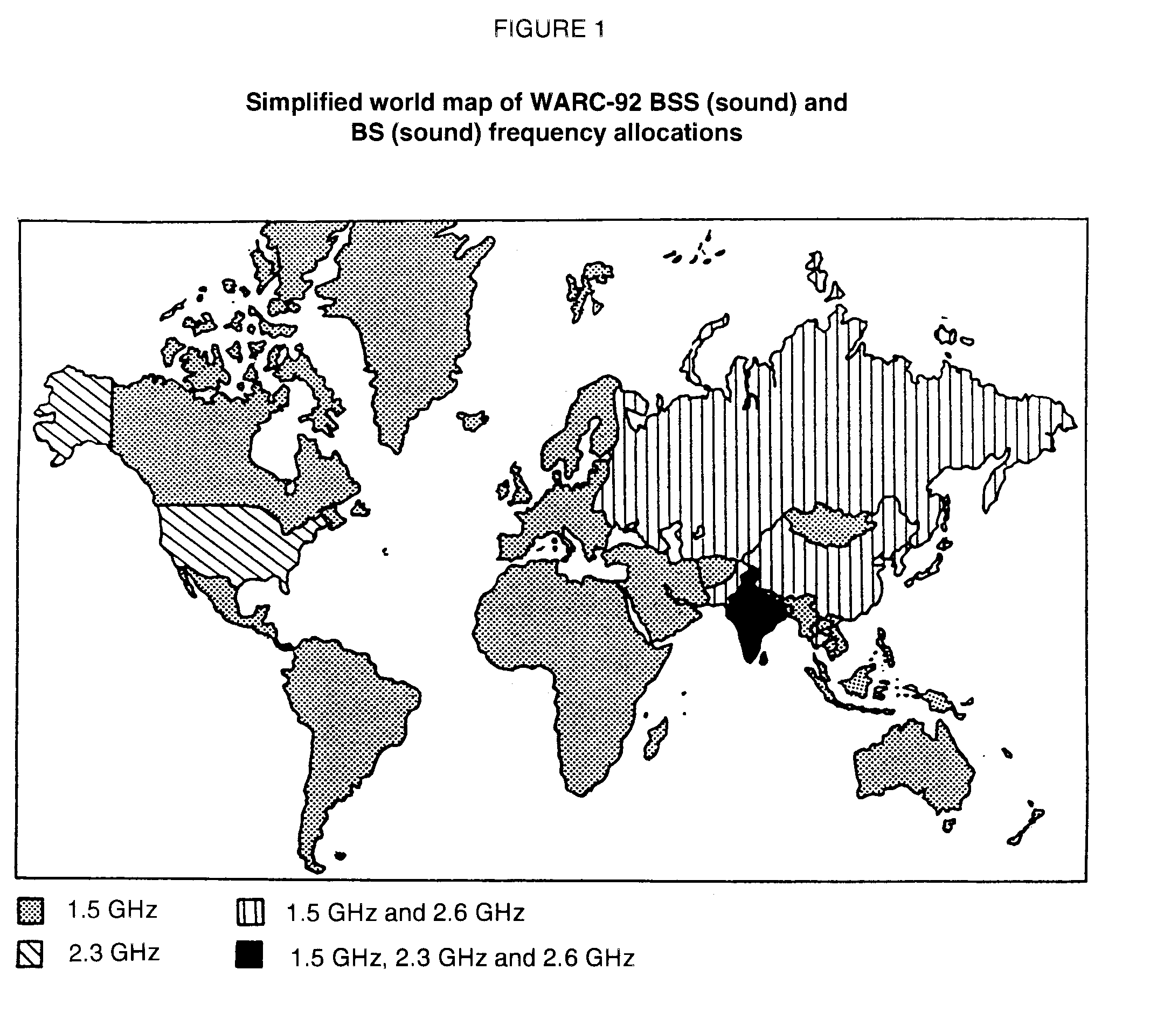

This opens the possibility of using the 1.5 GHz band for terrestrial digital sound broadcasting (as well as satellite), with respect to which the following points should be noted:

i) The 1.5 GHz band may feasibly be used for the following types of coverage:

a) Local: coverage typically only of a city, using one single or a small number of transmitters.

b) "Travel to work zone": with an artificial delay insertion the mode II can be used for larger local coverages with the SFN concept, i.e., to serve a travel to work zone of a metropolitan city.

c) "Grid": where local coverages of the above types a) and b) form nodes which are interconnected along motorway corridors.

d) large area coverage utilizing time synchronized SFN. Although it was originally believed that the 1.5 GHz band could not feasibly be used to provide large area SFN coverage due to the intensive transmitter network believed to be required, more recent investigations of the 1.5 GHz band propagation (see Annex 1-C and  
Annex 1- D) indicate that the 1.5 GHz range may be feasible to provide large area SFN coverage.

ii) The extent to which this frequency band can be utilized for terrestrial DSB will depend significantly upon the following factors:

a) the time scale on which existing users of the band (e.g. fixed links) may be moved to alternative frequencies as a consequence of the provisions of the WARC‑92 Final Acts (for complementary terrestrial service this process must include the coordination with administrations whose services may be affected);

b) the future use of the band also for satellite Digital System A transmissions; this requires a planning conference to accommodate in the most efficient manner both satellite and terrestrial services in this band.

## 4.3 System bandwidth

The terrestrial Digital System A has to solve the problems of the reception in a selective Rayleigh fading channel. The RF‑signals at the input of the receiver (vehicular and home) have differences in power, phase and time delay. The frequency response of the channel is mainly determined by the maximum time delay of the multipath‑signals. The "total energy" that can be taken out of the electro‑magnetic field by the receiver is dependent on the response characteristic of the RF channel and the bandwidth used for the transmission. The lower the bandwidth and the differences in time delay, the higher the probability for deep holes of the "total energy" while moving through the multipath‑field (see Fig. 2). The well‑known effect of the severe degradation in VHF‑FM reception quality which appears when slowly moving with a car‑receiver through the streets in a city is primarily due to the small bandwidth of the VHF‑FM system. The holes can partly be filled by transmitting more power: this is, however, limited because of the increase of interference to the other stations operating on co‑channels or on adjacent channels.

From measurements carried out in Europe and Canada, it has been found that an RF‑channel bandwidth of 1.5 MHz will provide sufficient frequency diversity to cope with flat fading in various environments.

A guard band between adjacent Digital System A frequency blocks is necessary. The necessary amount of it depends on receiver selectivity, network configuration and sharing criteria, however, about 200 kHz is considered to be sufficient**.**

## 

## 4.4 Transmission system considerations

### 4.4.1 Polarization

The use of vertical polarization for the Digital System A will give higher signal levels within a short distance from the ground. Therefore, the most appropriate polarization to be used for terrestrial broadcasting is the vertical polarization. Moreover, this allows maintaining polarization alignment in cases of vehicular and portable applications. This also allows the use of vertical mast antennas at the transmitter and receiver with reasonably omnidirectional radiation patterns, as is widely used today for conventional FM broadcasting. In the case of a mixed satellite/terrestrial broadcasting service, circular polarization may be used for the satel­lite segment and vertical polarization for the terrestrial segment.

In general high powered TV transmitters are horizontally polarized. Making use of vertical polarization for the DSB service would lead to a polarization discrimination of 16 dB (Recommendation ITU-R BT.419) in the case of sharing in order to protect television reception. This value is expected to be exceeded at more than 50% of locations.

### 4.4.2 Receiving antenna

To receive a terrestrial service, the simplest receiving antenna is the /4 monopole above a ground plane. More complex antenna designs can achieve higher gain but the higher directivity may not be appropriate in all cases of reception. A number of different receiving applications exist:

- Fixed domestic: gain dependent on frequency is achievable through the use of directional antennas which also allow for the reduction of interference;

- Vehicular: The antenna needs to be mounted preferably on the roof. The gain radiation pattern needs to be omnidirectional in the horizontal plane;

- Portable: The radiation pattern needs to be omnidirectional;

- Pocket size: The antenna would preferably need to be mounted on the headset to alleviate absorption by the body.

In the case of a mixed satellite/terrestrial service using a common frequency band around 1.5 GHz, the receiving antenna will need to be designed to maximize the gain towards the horizon as well as the satellite. As long as this is considered at the outset, the complexity of the receiving antenna could be marginally affected.

### 4.4.3 Minimum usable field strength

The latest measurement results on the performance of Digital System A in Gaussian and Rayleigh channels are given in § 2.1.2 of Annex 1-B. It is found that in the VHF band, C/N's of 7 dB and 15 dB are required for BER=10-4 in a Gaussian channel and Rayleigh channel respectively. At 1.5 GHz, a C/N of 12 dB is needed in a Rayleigh channel when 1 dB allowance is included for Doppler spread degradation at high vehicle speed. To these values, it is proposed to add 2 dB for interference allowance which will allow for a more efficient spectrum use (i.e., smaller separation distances between interfering co-channel transmitters because a protection ratio of ‑5.2 dB is made possible between the wanted signal for 99% of the time and the interfering signal exceeded for 1% of the time for a standard deviation of 5 dB, see § 4.5.1.1.2).

Assuming specific noise figures for the receiver as explained below, the receiver noise power can be calculated. With regard to the congested frequency band in the VHF range, a DSB receiver would need a highly selective and linear input stage, which can only be realized by an increased noise figure. A conservative noise figure of 10 dB (2 610 K) is assumed for VHF.

The effect of man-made noise may significantly affect the level of the required minimum usable field strength at the receivers in the VHF bands, especially in the urban environment. The results described in § 3.3 of Annex 1-C indicate that an allowance would be required even in suburban areas in Bands I and II and less so for Band III. For example, an additional 20 dB (referenced to 290 K) is required at 100 MHz. In fact, it is found that the increase in man-made noise tends to counterbalance the increase in the effective aperture of the receiving antenna, thus resulting in a minimum usable field strength that is almost constant with frequency.

In the case of the 1.5 GHz band, Report ITU-R BO.955-3 indicates that a receiver noise figure of 1 dB is possible. However a more conservative value of 3 dB is used to take into account the requirement for a wide dynamic range and possible frequency selectivity in the first RF stages for operation in a terrestrial and mixed environment. However, it is very important in the satellite case to minimize the transmit power requirement by minimizing the receiver noise figure. There is only a negligible contribution from man-made noise at 1.5 GHz. SFN field trials carried out in Canada at 1 468.75 MHz and reported in Annex 1-C using second generation Eureka-147 receiver with a receiver figure of merit of -26.1 dB measured a threshold field strength of 39.5 dBuV/m.

The derivation of the minimum usable field strength taking into account the antenna gain and its effective aperture is given in Table 1.

TABLE I

Derivation of minimum usable field strength for Digital System A  
(1.5 MHz bandwidth) at 100 MHz and 1 450 MHz

|  |  |  |  |  |
| --- | --- | --- | --- | --- |
| SYSTEM |  |  |  |  |
| Operating frequency | 100 MHz | | 1 450 MHz | |
| Polarization | linear vertical |  | linear vertical |  |
| Channel error protection | convolutional (R=1/2) |  | convolutional (R=1/2) |  |
| Channel bandwidth | 1.5 MHz |  | 1.5 MHz |  |
| Useful bit rate | 1 152 kbit/s |  | 1 152 kbit/s |  |
| Symbol time | 1 246 sec |  | 312 sec |  |
| Guard interval | 246 sec |  | 62 sec |  |
| Required C/N for BER= 10-4  (includes system and hardware implementation margins) | 7 dB  (Gaussian) | 15 dB  (Rayleigh) | 7 dB  (Gaussian) | 12 dB  (Rayleigh) |
| Interference allowance | 2 dB | 2 dB | 2 dB | 2 dB |
| Required minimum C/N at receiver | 9 dB | 17 dB | 9 dB | 14 dB |
| RECEIVER |  | |  | |
| Receiving antenna gain | 0 dBi | | 0 dBi | |
| Antenna noise temperature including man-made noise | 29 000 K | | 105 K | |
| Coupling and filter losses | 1 dB | | 1 dB | |
| Receiver noise figure | 10 dB  (2 610 K) | | 3 dB  (290 K) | |
| Receiver figure of merit | -45.1 dBK-1 | | -27.4 dBK-1 | |
| MINIMUM FIELD STRENGTH |  |  |  |  |
| Boltzman's constant | 1.38 x 10-23 W/Hz/K | | | |
| Minimum receiver input power | -112.7 dBW | -104.7 dBW | -130.4 dBW | -125.4 dBW |
| Effective antenna aperture | -1.4 dB/m2 | -1.4 dB/m2 | -24.7 dB/m2 | -24.7 dB/m2 |
| Minimum power flux density | -111.3 dBW/m2 | -103.3 dBW/m2 | -105.7 dBW/m2 | -100.7 dBW/m2 |
| Minimum usable field strength for 1.5 MHz block  (dBW/m2 + 145.8 dB -> dB(V/m) | 34.5 dBV/m | 42.5 dBV/m | 40.1 dBV/m | 45.1 dBV/m |

### 4.4.4 Propagation

Information on propagation and channel characteristics is included in Annex 1-C.

For the calculation of the field strengths of a digital sound broadcasting signal, in particular in rural areas, the propagation curves of Recommendation ITU-R PN.370 can be used (for Bands I to V).

Owing to the high rate of failure when the required C/I ratio is not reached, calculations involving a very high percentage of time and locations are required for the wanted field (and a very low percentage for the interfering signals). Therefore, corrections to the E(50, 50) value calculated with the curves of Recommendation ITU-R PN.370 are required.

For the wanted signals, field strength values appropriate for 99% time should be derived from the Recommendation ITU-R PN.370 curves.

For an interfering signal from a transmitter which carries a different programme or which is not synchronized with the wanted transmitter, the 1% time curves of Recommendation ITU‑R PN.370 should be used, even where the interference is continuous because the protection ratio is the same for all percentages of time.

A margin has to be added to the wanted signal to ensure that a service can be achieved at a high percentage of locations. The required location coverage percentage has not yet been defined, but will be in the order of 99%. The margin will depend on the frequency band and the kind of terrain; a typical value of 19 dB is derived from Recommendation ITU-R PN.370. However, recent measure-ments in Europe have shown that, due to a number of factors including the broadband nature of the COFDM signal (1.5 MHz), low receiving antenna height and the use of omnidirectional receiving antenna, the margin can be reduced to 13 dB in the VHF bands: the standard deviation of the field strength probability distribution as measured is significantly less than that predicted by Recom-mendation ITU-R PN.370. Results have been presented (see § 3.2.1 of Annex 1-C) which indicate that a conservative estimation of the reduction in standard deviation when comparing COFDM with CW is in the order of 3 dB. This results in a reduction of 6 dB in the 50% to 99% location correction factor, that is, 13 dB compared to the 19 dB in the CW case (the results apply to mobile reception at a receiving antenna height of 1.5 metres above ground level).

In addition, within (but not at the periphery of) a single frequency network, an "internal network gain" may be applicable in the budget of the wanted signal (see § 4.6.2.2).

Similarly, for the interfering signal, the margin needed to take account of the 99% location requirement is also 13 dB. And the combined margin required for two uncorrelated log normally distributed signals is : 2 x 13 = 18 dB.

The case of signals which are correlated with location needs further study. A number of correlation studies have been undertaken in the United Kingdom. [1990-1994, Doc. 10B/89] presents a number of results. Correlation studies are urgently required between wanted and unwanted signals and administrations are encouraged to submit the results of such studies.

In built‑up areas, the Okumura propagation model (see Report 567) or a model based on more accurate terrain cover information may be more appropriate than Recommendation ITU‑R PN.370.

Measurements were carried out in Canada to evaluate the propagation in the 1 500 MHz range, (which is not covered by Recommendation ITU-R PN.370), the results of which are described in Annex 1-C.

There is a requirement to review and develop a suitable propagation model addressing broadcasting systems employing wide-band digital emission techniques for digital sound broadcasting requiring service availabilities up to 99% of locations. The model needs to address all broadcasting bands including the new bands allocated at WARC-92. This request has been forwarded to the competent Radiocommunication Study Group.

### 4.4.5 Link budget

Assuming that the wanted field strength must be exceeded at 99% of the locations within the coverage area, one can derive the necessary ERP for the Digital System A multiplex by using the median values and standard deviation of Recommendation ITU-R PN.370, with the margin as described in the above § 4.4.4., and also taking account of a receiving antenna height of about 1.5 m (extra margin of approximately 10 dB).

Minimum usable field strengths of 30.5 dBµV/m and 38.5 dBµV/m respectively for Gaussian and Rayleigh channels at 200 MHz are derived from Table 1 (see§ 4.4.3) assuming that there is 10 dB less man-made noise than at 100 MHz (see § 3 of Annex 1‑C) and that the effective aperture is 6 dB less than that at 100 MHz. Calculation of the ERP requirements for some representative single transmitter coverages are given in Table 2; this shows the relationship between typical antenna heights, transmitter powers, and service radii. It should be stressed that the propagation curves of Recommendation ITU-R PN.370 are based on a terrain irregularity of 50 m ( h); whilst a reasonable basis for coordination and initial service design, detailed coverage planning would require margins to be added or subtracted to take account of actual terrain.

As in television planning, the frequency band used for the service determines the number of transmitters needed to cover a certain area. UHF gives more attenuation and necessitates a more dense network and/or higher powers and will also require more fill‑in stations.

In Band I sporadic‑E propagation may cause severe long distance interference, especially in the lower frequencies. Therefore, the highest channel in Band I is preferred.

A further allowance may be required to compensate for building penetration loss. The results of measurements to quantify the magnitude of this allowance are given in § 3.4 of Annex 1‑C.

TABLE 2

ERP for a COFDM transmitter using the propagation model  
of Recommendation ITU-R PN.370 at 200 MHz

Effective antenna height of transmitter 300 m 75 m 75 m

Receiver antenna height 1.5 m

 h 50 m

Transmission frequency 200 MHz

Effective (corrected) minimum usable field strength  
per 1.5 MHz block including margins for 99% location  
and 1.5 m antenna height   
 Gaussian channel (G) 30.5 + 13 + 10 53.5 dBµV/m (G)  
 Rayleigh channel (R) 38.5 + 13 + 10 61.5 dBµV/m (R)

Distance between transmitter and receiver  
(service radius) 30 km 15 km 30 km

ERP per 1.5 MHz block 260 W(G) 260 W(G) 7 kW(G)  
 1 640 W(R) 1 640 W(R) 40 kW(R)

## 4.5 Sharing considerations for planning

### 4.5.1 Intra service

#### 4.5.1.1 Protection ratios

All these values address the Digital System A described in Annex 1-A (DAB system).

##### 4.5.1.1.1 Protection ratios for a wanted Digital System A-signal

Tests were performed by adding simultaneously interference and white noise. In each case, the C/I was measured, which results in a particular loss of C/N performance at a particular failure point, defined as a BER of 10-4, and at a particular frequency difference. Degradations in C/N performance of 1 dB and 3 dB were chosen. The BER at the defined failure point is somewhat less than the BER at which audio impairment occurs.

The differences between the results for different DSB modes were not found to be significant, so the measurements were confined to a MODE II signal only.

##### 4.5.1.1.2 Digital System A interfered with by a different Digital System A transmission

Measurements have been done to determine the radio-frequency protection ratio required by Digital System A against interference from a second Digital System A transmission. Figure 3 presents the results of these measurements as a function of frequency separation between the centres of the channels. The measurements indicate that a co-channel Digital System A interferer has the same effect as white Gaussian noise at the same power. In particular, the co-channel protection ratio is 7 dB which corresponds precisely to the required C/N for BER=10-4 in a white Gaussian channel. The shape of the protection ratio curve presented in Fig. 3 corresponds to the channel filter skirt (i.e., portion of the interfering power still within the channel filter), and beyond 1.6 MHz separation between the centres of the channels, the curve corresponds to the out-of-band rejection of the filter.

As discussed in § 4.4.3, a more effective way to take into consideration co-channel interference from different DSB multiplexes is to include a margin in the definition of the minimum field strength for interference allowance. Then, when the propagation curves of Recommendation ITU-R PN.370 are applied, appropriate account of noise and interference contributions can be taken as described below.

Up to now, the consideration of service availability for analogue broadcasting systems was made independently for noise and interference contributions with a specific definition for the noise limited contour and the interference limited contour. With new digital broadcasting systems, it is found that the interference from a co-channel digital emission is equivalent to an increase in the noise level at the receiver. This brings a new level of flexibility in system design and allows for a range of possible apportionment for noise and interference in the link budget.

A derivation of equations needed to calculate the stochastic addition of noise and interference at the receiver has been made (ITU-R, 1990-1994, Doc. 10B/87, Canada). These equations represent a numerical convolution of two Gaussian distribution curves which can be implemented on a computer to generate curves giving the correspondence between the margin included in the C/N link budget to provide a service availability (C/(N+I) >Th) for a given percentage of location and time (assumed to be a time variation from now on for the case of vehicular reception), to accommodate for interference, and the actual interference restriction requirement (I/N not to be exceeded for a given percentage of the time).

Fig. 4 gives the level of the normalized I/N (relative to the system operation threshold) not to be exceeded for the given percentage of the time as a function of the margin included in the link budget for interference allowance. The required C/N and C/(N+I) are defined for 99% of the time. The standard deviation for both wanted and interfering signals was set at 5 dB, which seems to be representative of the propagation measurement results so far.

The lowest dotted line on Fig. 4 represents the rule for apportioning noise and interference in the case of fully correlated fading processes on both the wanted signal and the interferer. In such case, since they are fully correlated, the I/N level is defined for the same percentage of the time as the C/N (i.e., 99% of the time). The highest dotted line gives the mean of the I/N signal for the fully correlated case.

As an example, if a margin of 2 dB is included in the noise budget, the normalized I/N level not to be exceeded for 1% of the time is 7.2 dB for the fully uncorrelated case. In reality, since there will be a certain amount of correlation between the wanted and interfering signals fades, this allowable level of interference should be somewhat more than 7.2 dB. In fact, the difference between the two means of the correlated and uncorrelated distribution functions is 19.5 dB for 2 dB allowance in the C/N budget. This represents the range of improvement possible from the fully uncorrelated case to the fully correlated case.

Once this I/N value if found from the figure, the usual C/I value can be deduced easily:

C/I= (C/N-Th) - (I/N-Th) = 2 dB - 7.2 dB = - 5.2 dB

It is therefore found that when the standard deviation of the two fading processes on the wanted and interfering carriers, the required service availability and the allowance in the c/n link budget for interference are known, the i/n level to be exceeded for a given percentage of the time can be calculated. The required c/i can then be deduced for the case of fully uncorrelated fading on the wanted and interfering signals.

The results of this exercise are very dependent on the assumed standard deviation of the two fading processes on the wanted and interfering carriers. It is very important that this standard deviation be well documented in the propagation measurements.

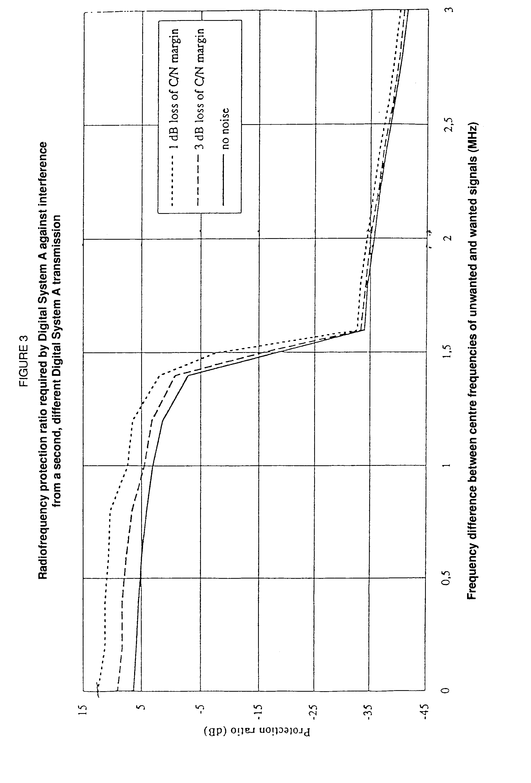

#### 

#### 4.5.1.2 Sharing analysis

##### 4.5.1.2.1 Terrestrial services

*[to be completed]*

##### 4.5.1.2.2 Mixed terrestrial/satellite services

The mixed terrestrial/satellite concept is described in § 2.2 of Report ITU-R BO.955. This concept is based on the use of the same frequency band by both terrestrial and satellite broadcasting services, aimed at the same vehicular, portable and fixed receivers. It has the potential of leading to very efficient spectrum usage. A specific constraint in implementing this concept appears when the coverage of a terrestrial station is located near the edge of a satellite coverage area assigned to the same frequency.

A study has been conducted in Canada (ITU-R 1990-1994, Doc. 10B/70) where the needed geographical separation between a terrestrial station and the edge of the satellite beam has been investigated. It is assumed, in this study, that the geostationary satellite is on the same channel as the terrestrial service and uses the same type of modulation. It is also assumed that the interference from the satellite into the terrestrial service is seen by the receiver as additive uncorrelated white gaussian noise, therefore adding to the thermal noise level in the receiver. It is found that, using the RARC-83 co-polar reference pattern for the satellite transmit antenna, the apparent noise increase in the receiver is less than 1 dB for a receiver located beyond a relative angle seen from the satellite of /= 1.4 where is the half power beamwidth. The apparent noise increase becomes 3 dB at /= 1.2 and 7 dB at /= 1. In physical distances, the example shows that a 3 dB apparent increase in noise corresponds to a distance of about 500 km from the edge of a satellite beam of 1. Obviously this distance can be reduced if beam shaping resulting in sharper roll-off is used on the satellite.

If the terrestrial DSB service is to preserve its coverage under this apparent noise increase at the receivers, there are a number of possible measures that can be applied. The simplest and most straight-forward one would be the increase of the local terrestrial emission power by the same amount as the increase in noise but this could create additional interference into adjacent T‑DSB services. Another measure is the addition of coverage extenders and gap-fillers to re-gain the coverage that would have existed without the satellite interference. Another possibility is to accept the reduction of service in the fringe areas. In the specific case where the S-DSB service is received from an angle close to the local vertical (e.g., from highly inclined elliptical orbit), it would be relatively easy to implement receiving antennas with switchable vertical patterns which would allow for frequency reuse with much smaller separation distances.

Several administrations are considering sound broadcasting services, both for terrestrial and satellite services in the same geographical area. A potential large signal differential at the receiver may occur between satellite services and terrestrial services. This large signal differential could also arise in the implementation of terrestrial services. This potential problem can be minimized provided the receivers offer both large dynamic range and low noise figures.

### 4.5.2 Inter service

#### 4.5.2.1 Protection ratios

All these values address the Digital System A described in Annex 1-A (DAB system).

##### 4.5.2.1.1 Interference into Digital System A

###### 4.5.2.1.1.1 Digital System A interfered with by VHF/FM

The results are shown in Fig. 5.

However, in practical planning cases, an additional margin may be required.

###### 4.5.2.1.1.2 Digital System A interfered with by an AM/VSB television signal

a) I-PAL including a NICAM and a FM sound carrier.  
The video and audio material for the I-PAL signal were the EBU slide "boy with toys" and pink noise. The results are given in Fig. 6.

b) B/G-PAL including dual FM stereo or FM and NICAM 728 sound carriers.  
The same experimental conditions as above were used, and the results are shown in Fig. 7.

c) D/K SECAM including FM sound carriers.  
The same experimental conditions as above were used, and the results are shown in Fig. 8.

d) L-SECAM including one AM sound carrier.  
The same experimental conditions as above were used, and the results are shown in Fig. 9.

###### 4.5.2.1.1.3 Digital System A interfered with by private mobile radio, narrow-band FM transmissions

The results are shown in Fig. 10.

###### 4.5.2.1.1.4 Digital System A interfered with by one CW-interferer

The results are shown in Fig. 11.

##### 4.5.2.1.2 Digital System A interference into other services

###### 4.5.2.1.2.1 Protection ratio for a wanted VHF/FM signal interfered with by Digital System A

The results are shown in Fig. 12. These results are applicable to continuous interference. The quality criteria used was an audio frequency signal-to-interference ratio of 50 dB measured as descri-bed in Recommendation ITU-R BS.641. For tropospheric interference, a protection ratio value of 29 dB is applicable.

###### 4.5.2.1.2.2 Protection ratios for a wanted AM/VSB television signal interfered with by Digital System A

4.5.2.1.2.2.1 Co-channel protection ratios

Tests showed that the interference effects were independent of the Digital System A transmission mode.

a) I-PAL or B/G-PAL interfered with by Digital System A.  
A subjective assessment was made of the C/I required for CCIR grades 3 (tropospheric interference) and 4 (continuous interference) with various frequency differences within the TV channel. The picture material comprised the EBU test slides "Formal Pond" and "Boats". The results are shown in Fig. 13.

b) L-SECAM interfered with by Digital System A  
The same experimental conditions as above were used and the results are shown in Fig. 14.

c) TV-FM (mono) sound interfered with by Digital System A  
The results shown in Fig. 15 correspond to a 40 dB signal-to-noise ratio (weighted according to Recommendation ITU-R BS.468); they are referred to the power of the vision carrier and are applicable to the tropospheric interference case.

d) TV-NICAM sound interfered with by Digital System A  
The results shown in Fig. 16 correspond to a BER of 10-3 in the receiver; they are referred to the power of the vision carrier and are applicable to the tropospheric interference case.

e) TV-AM sound interfered with by Digital System A  
Measurements have shown that a ratio of 50 dB (related to the vision carrier) is needed to achieve an audio signal-to-noise ratio of 48 dB (weighted according to Recommendation ITU-R BS.468) in the situation where the Digital System A signal completely overlaps the AM sound signal.

4.5.2.1.2.2.2 Adjacent-channel protection ratios

A limited number of measurements indicate that the protection ratios for the upper and lower adjacent TV channels cannot be completely disregarded; the value of the protection ratio is dependent on the frequency separation of the Digital System A ensemble from the wanted vision or sound carrier.

Values of +6 dB to -16 dB have been measured for the lower adjacent channel, and between -10 dB and -30 dB for the upper adjacent channel in the case of a wanted PAL signal. Similar values are expected for the lower adjacent channel in the case of the L-SECAM system, but the upper values for the upper adjacent channel will be somewhat greater owing to the protection required for the AM sound carrier of L-SECAM.

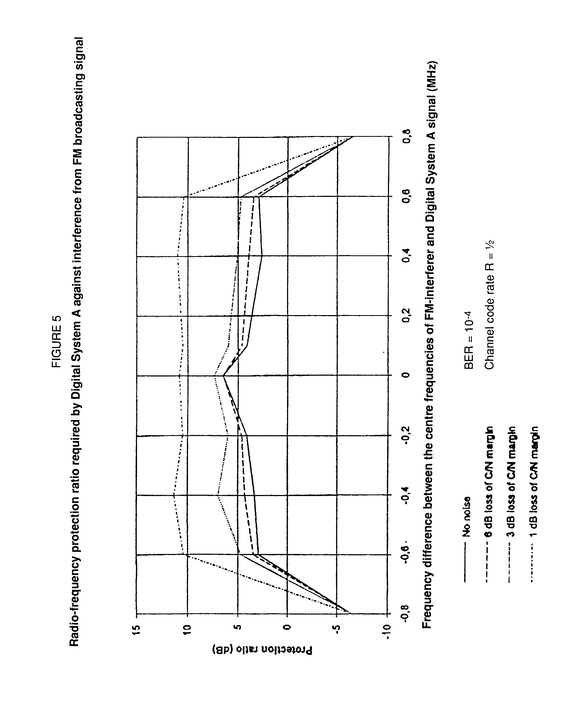

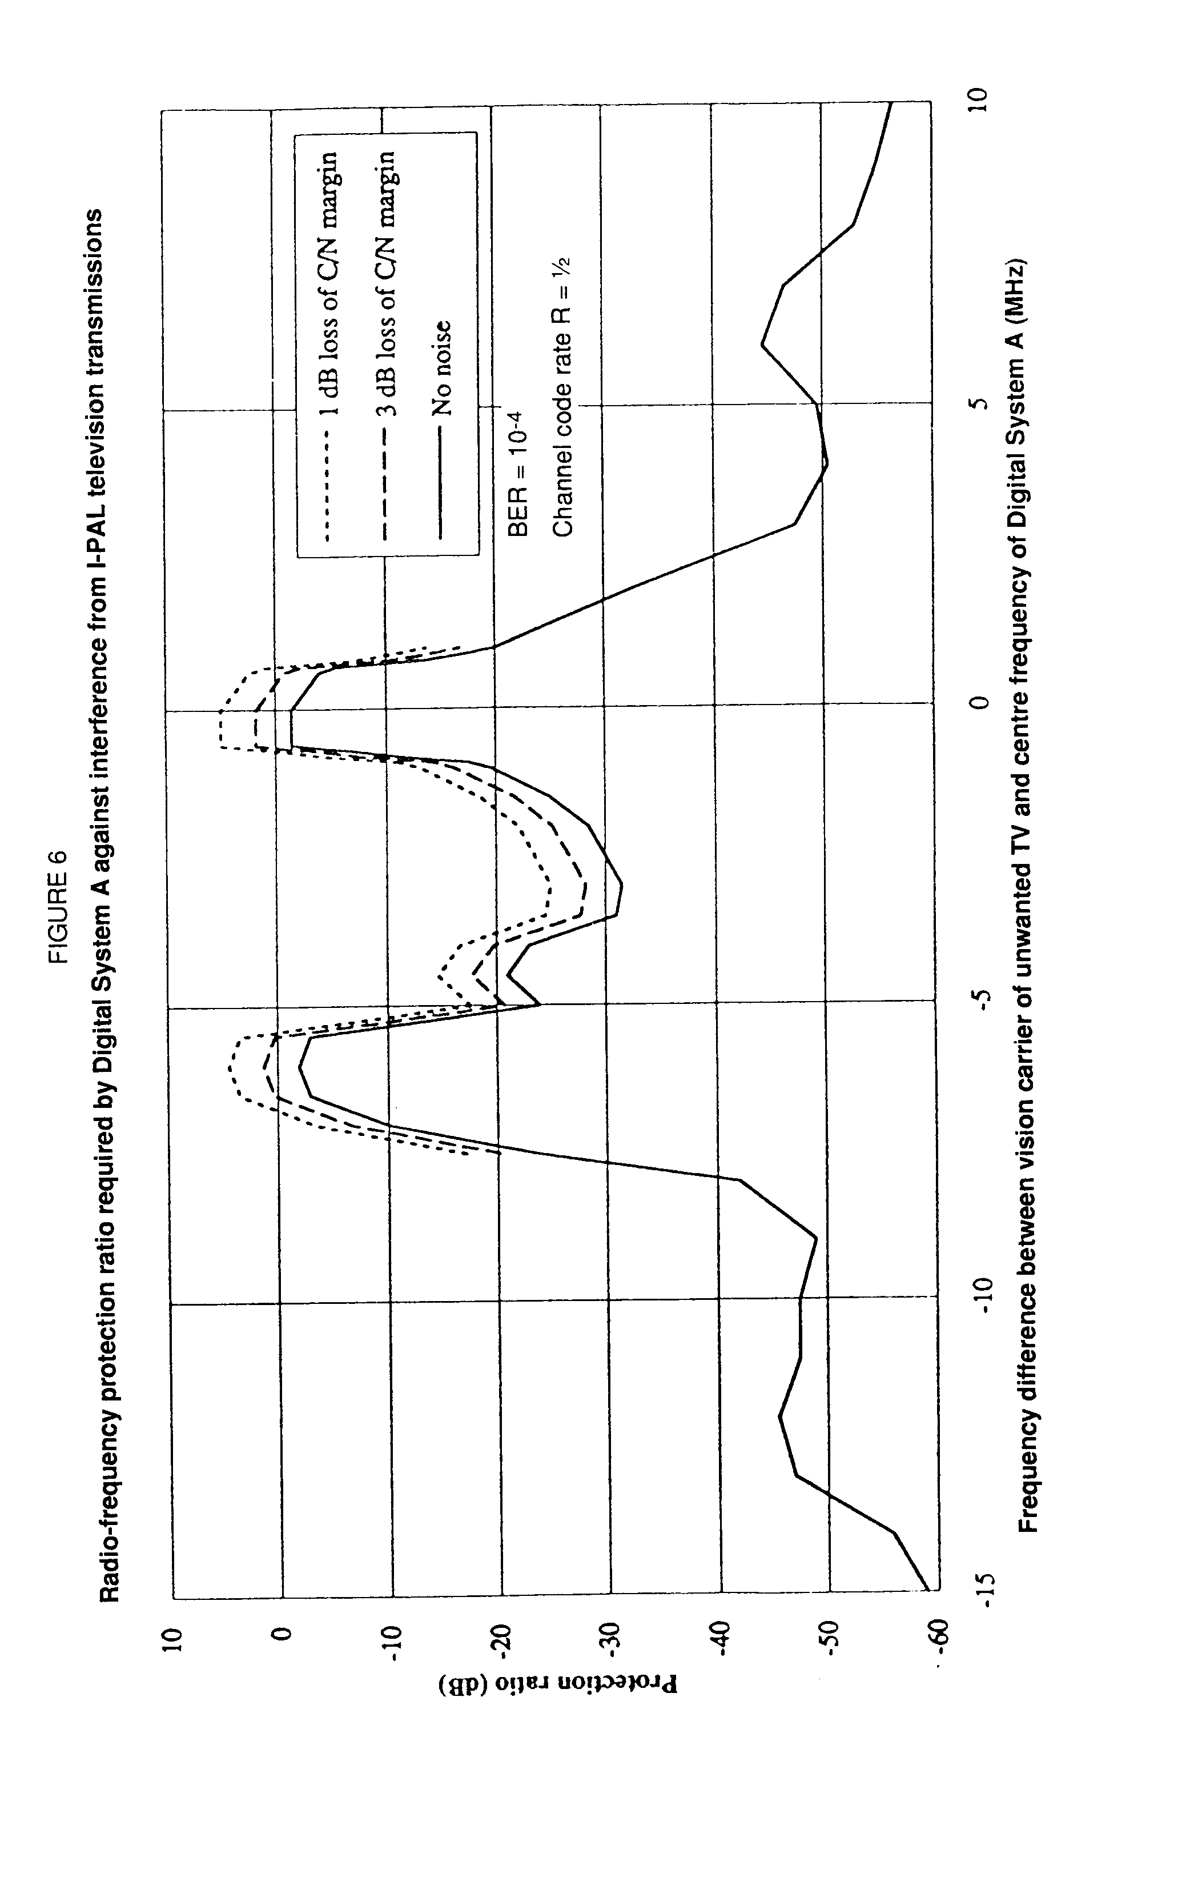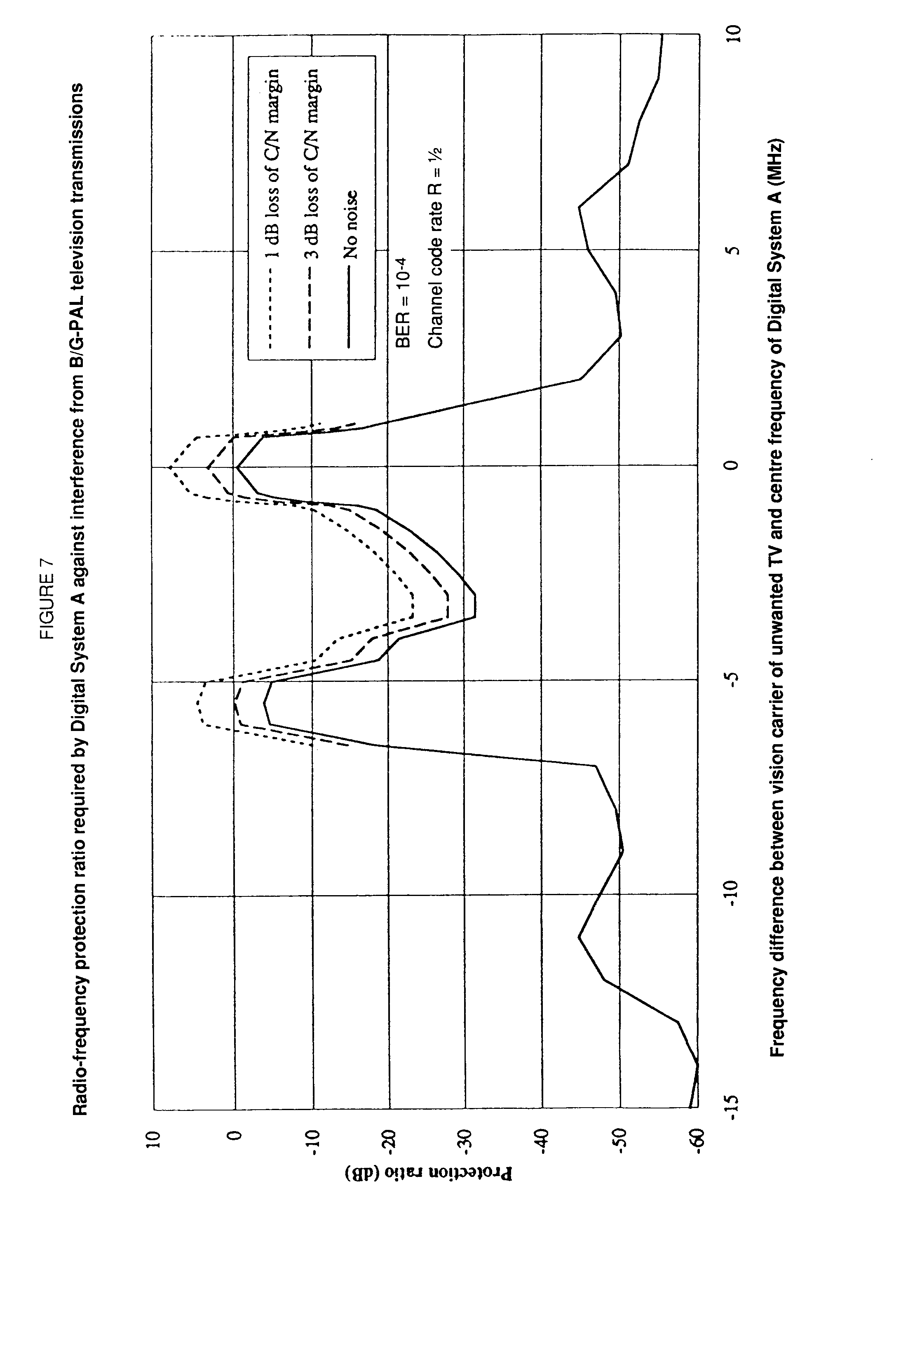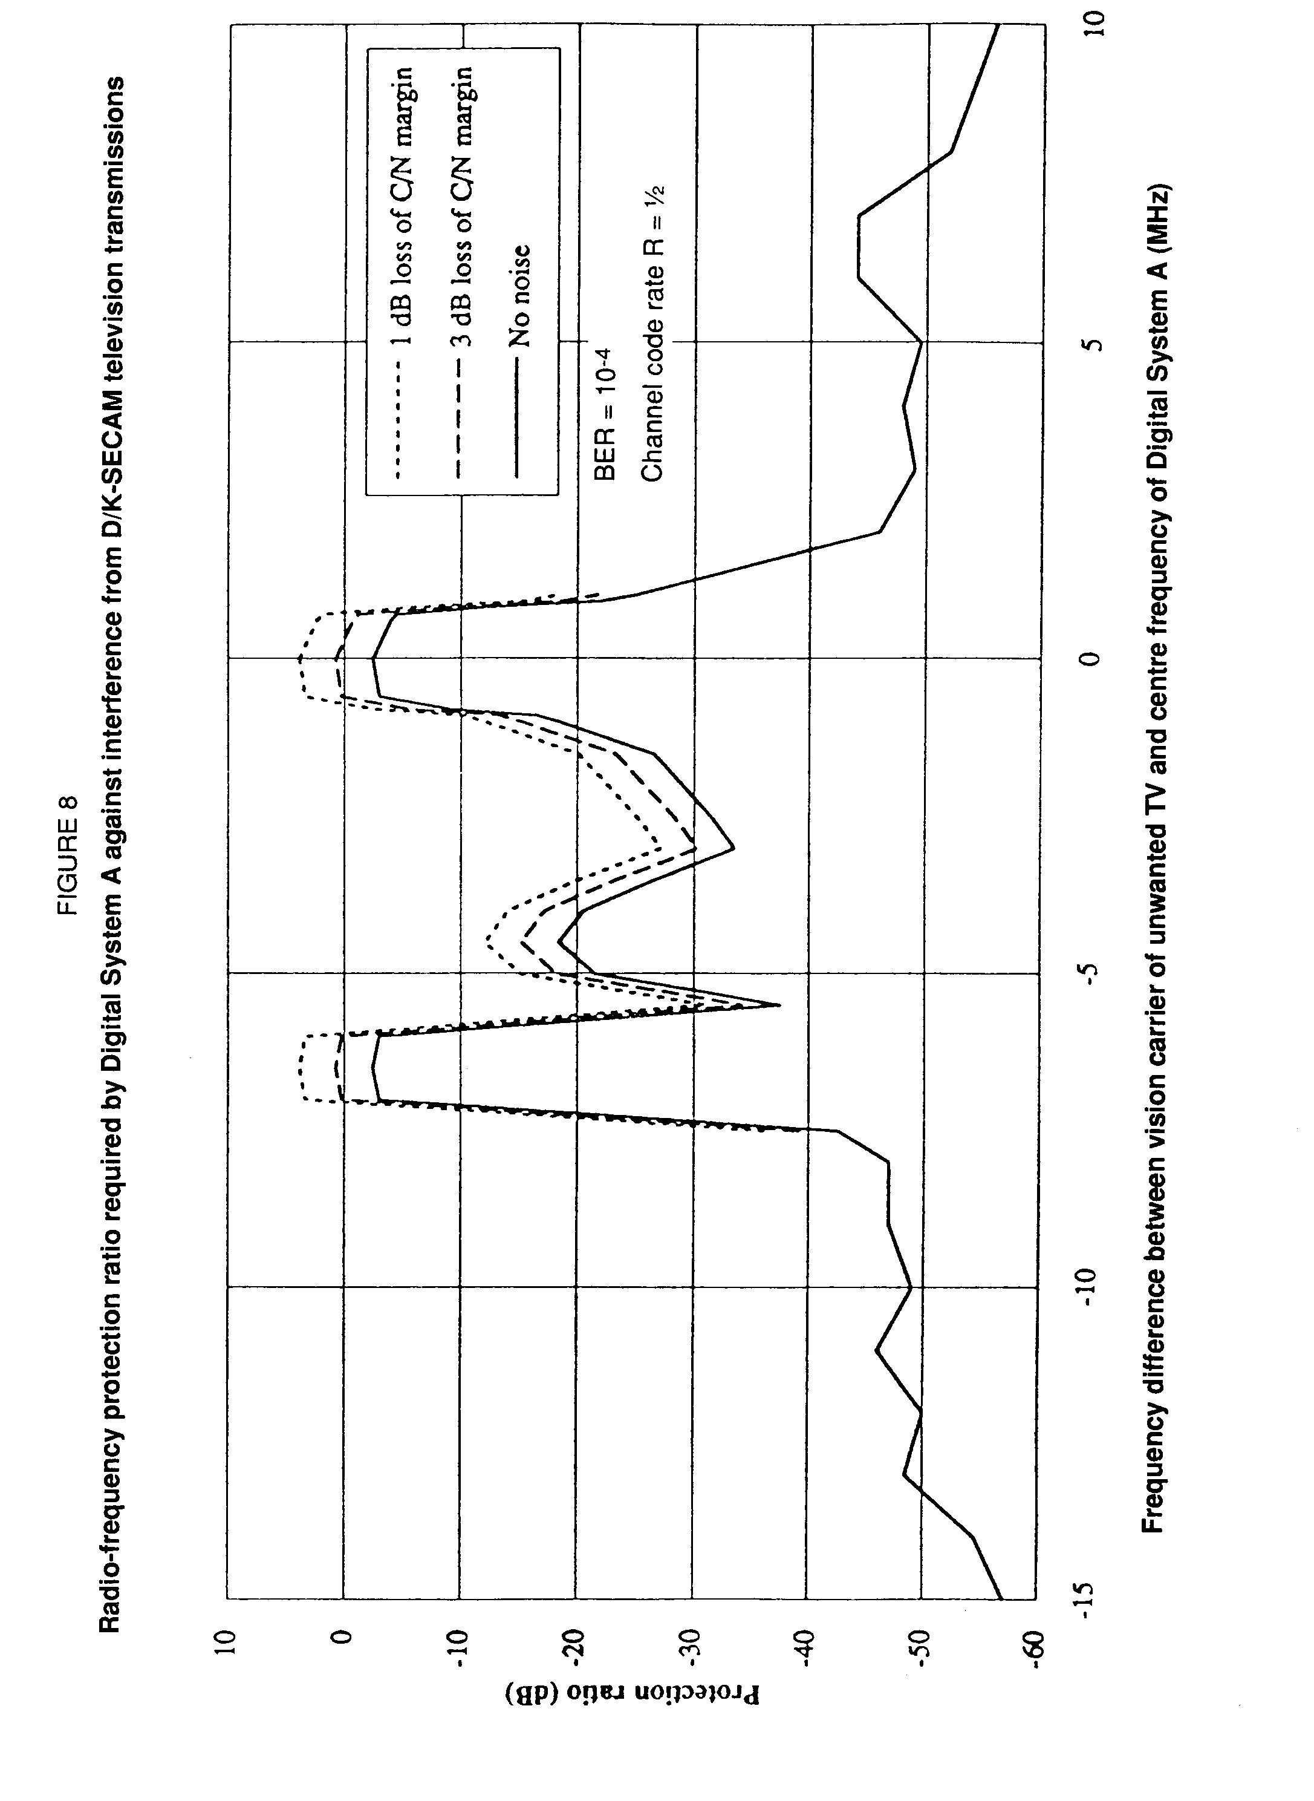  
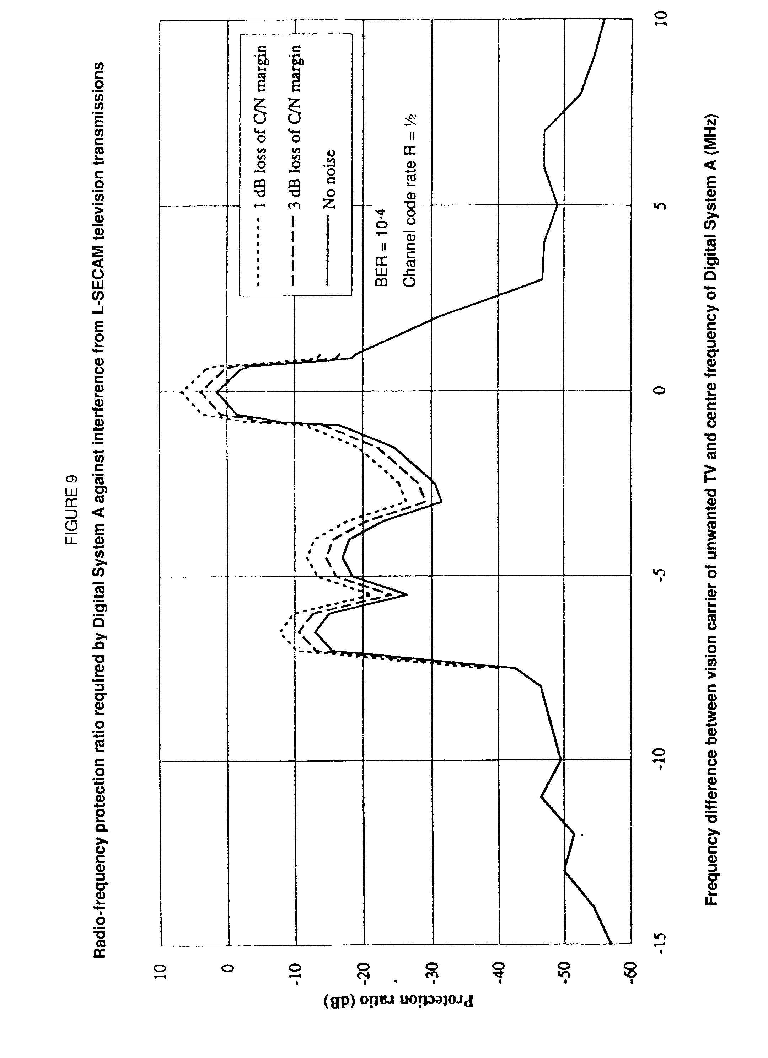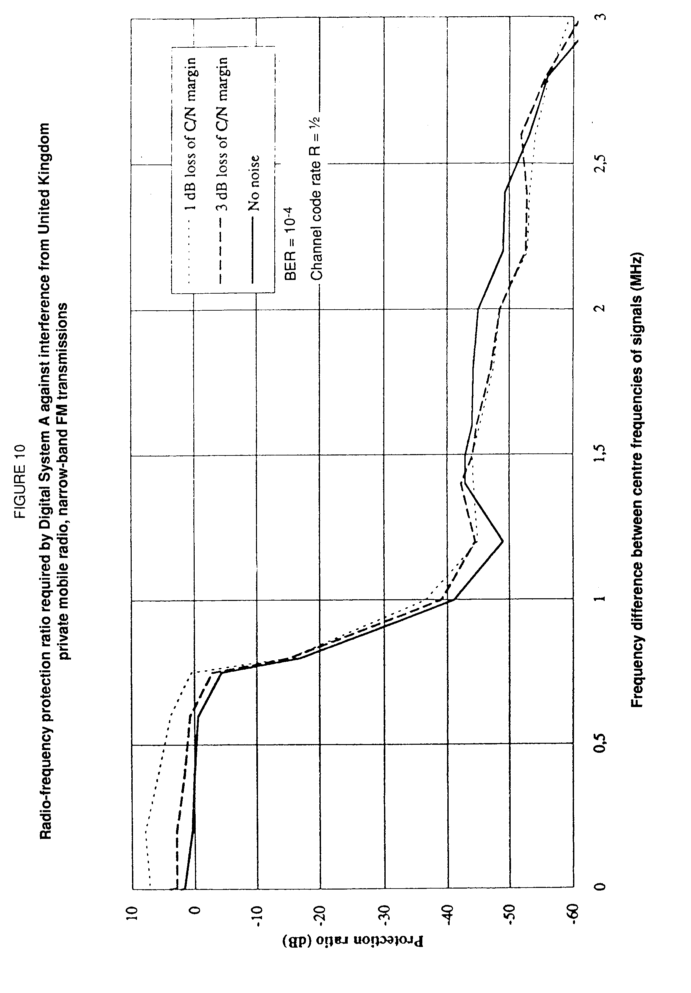

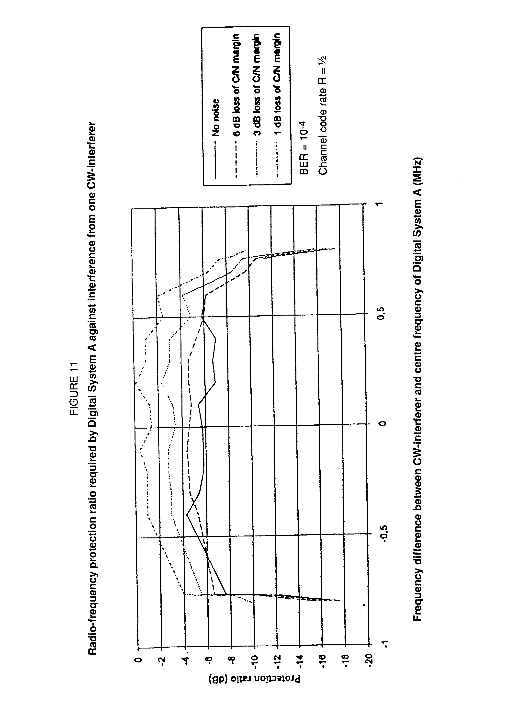

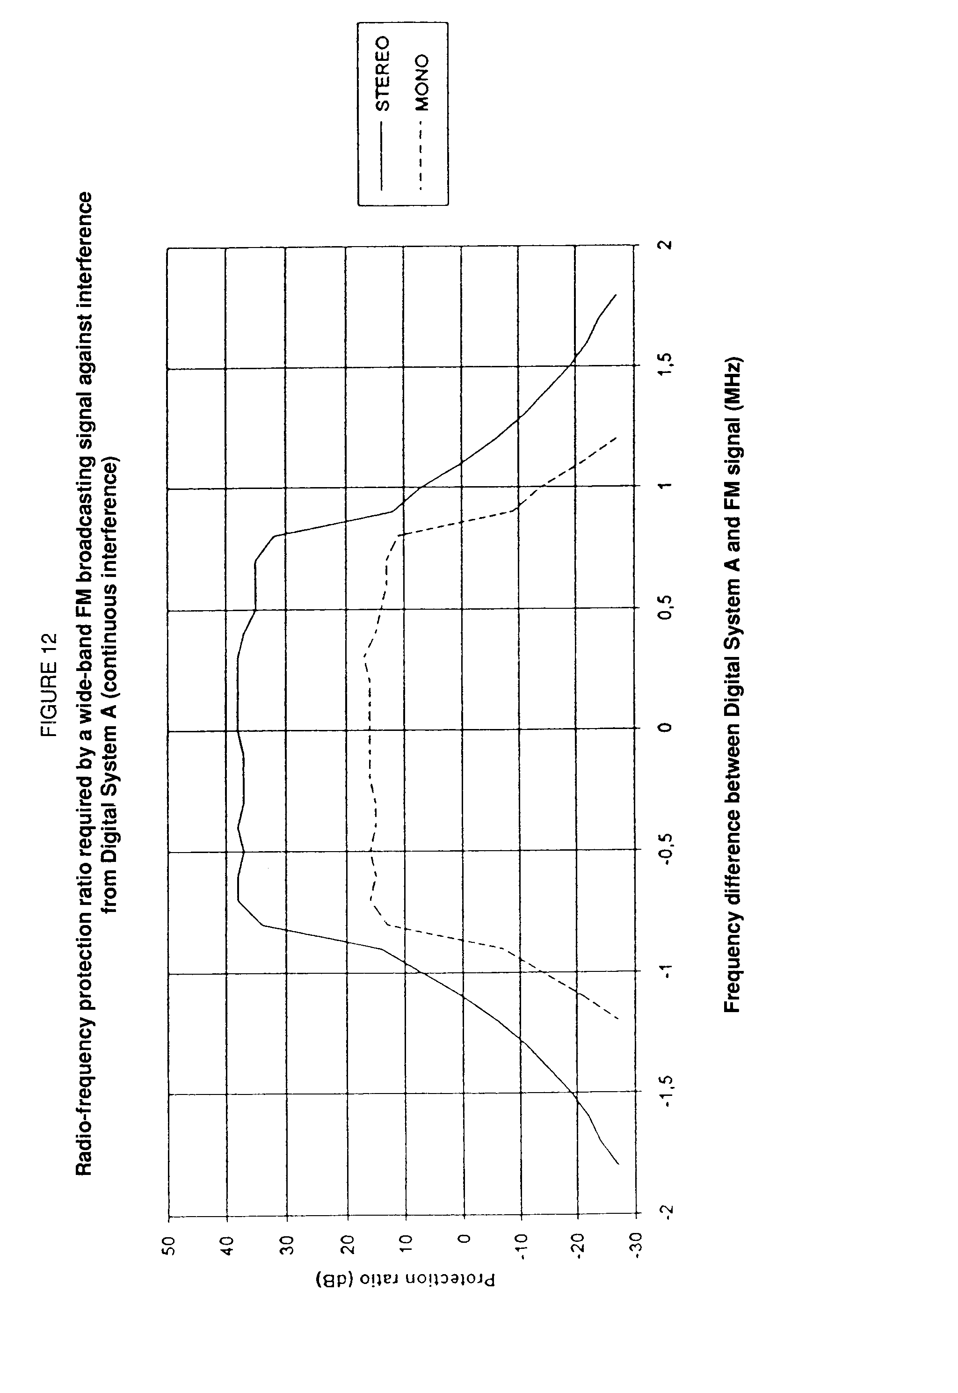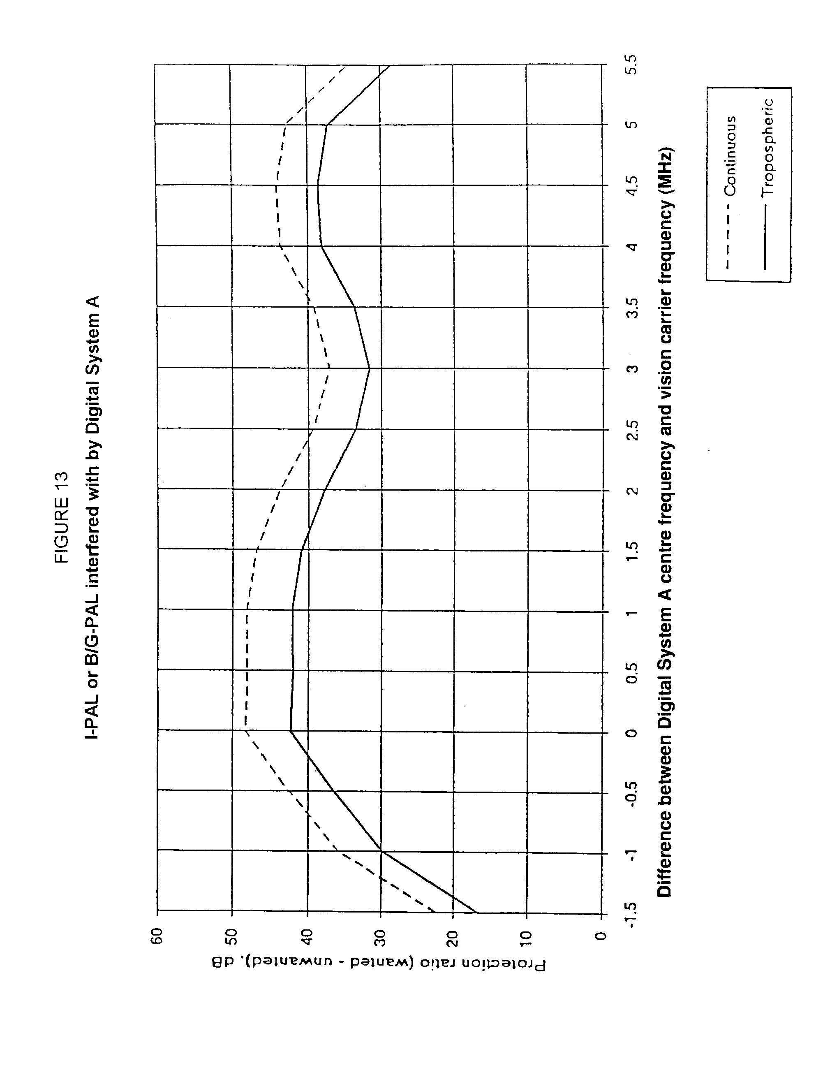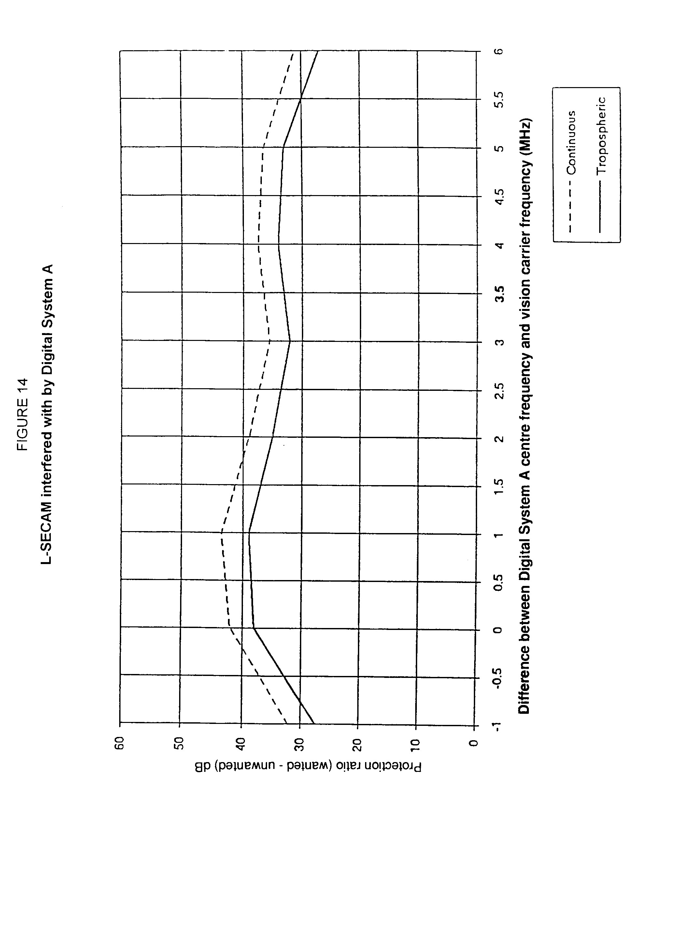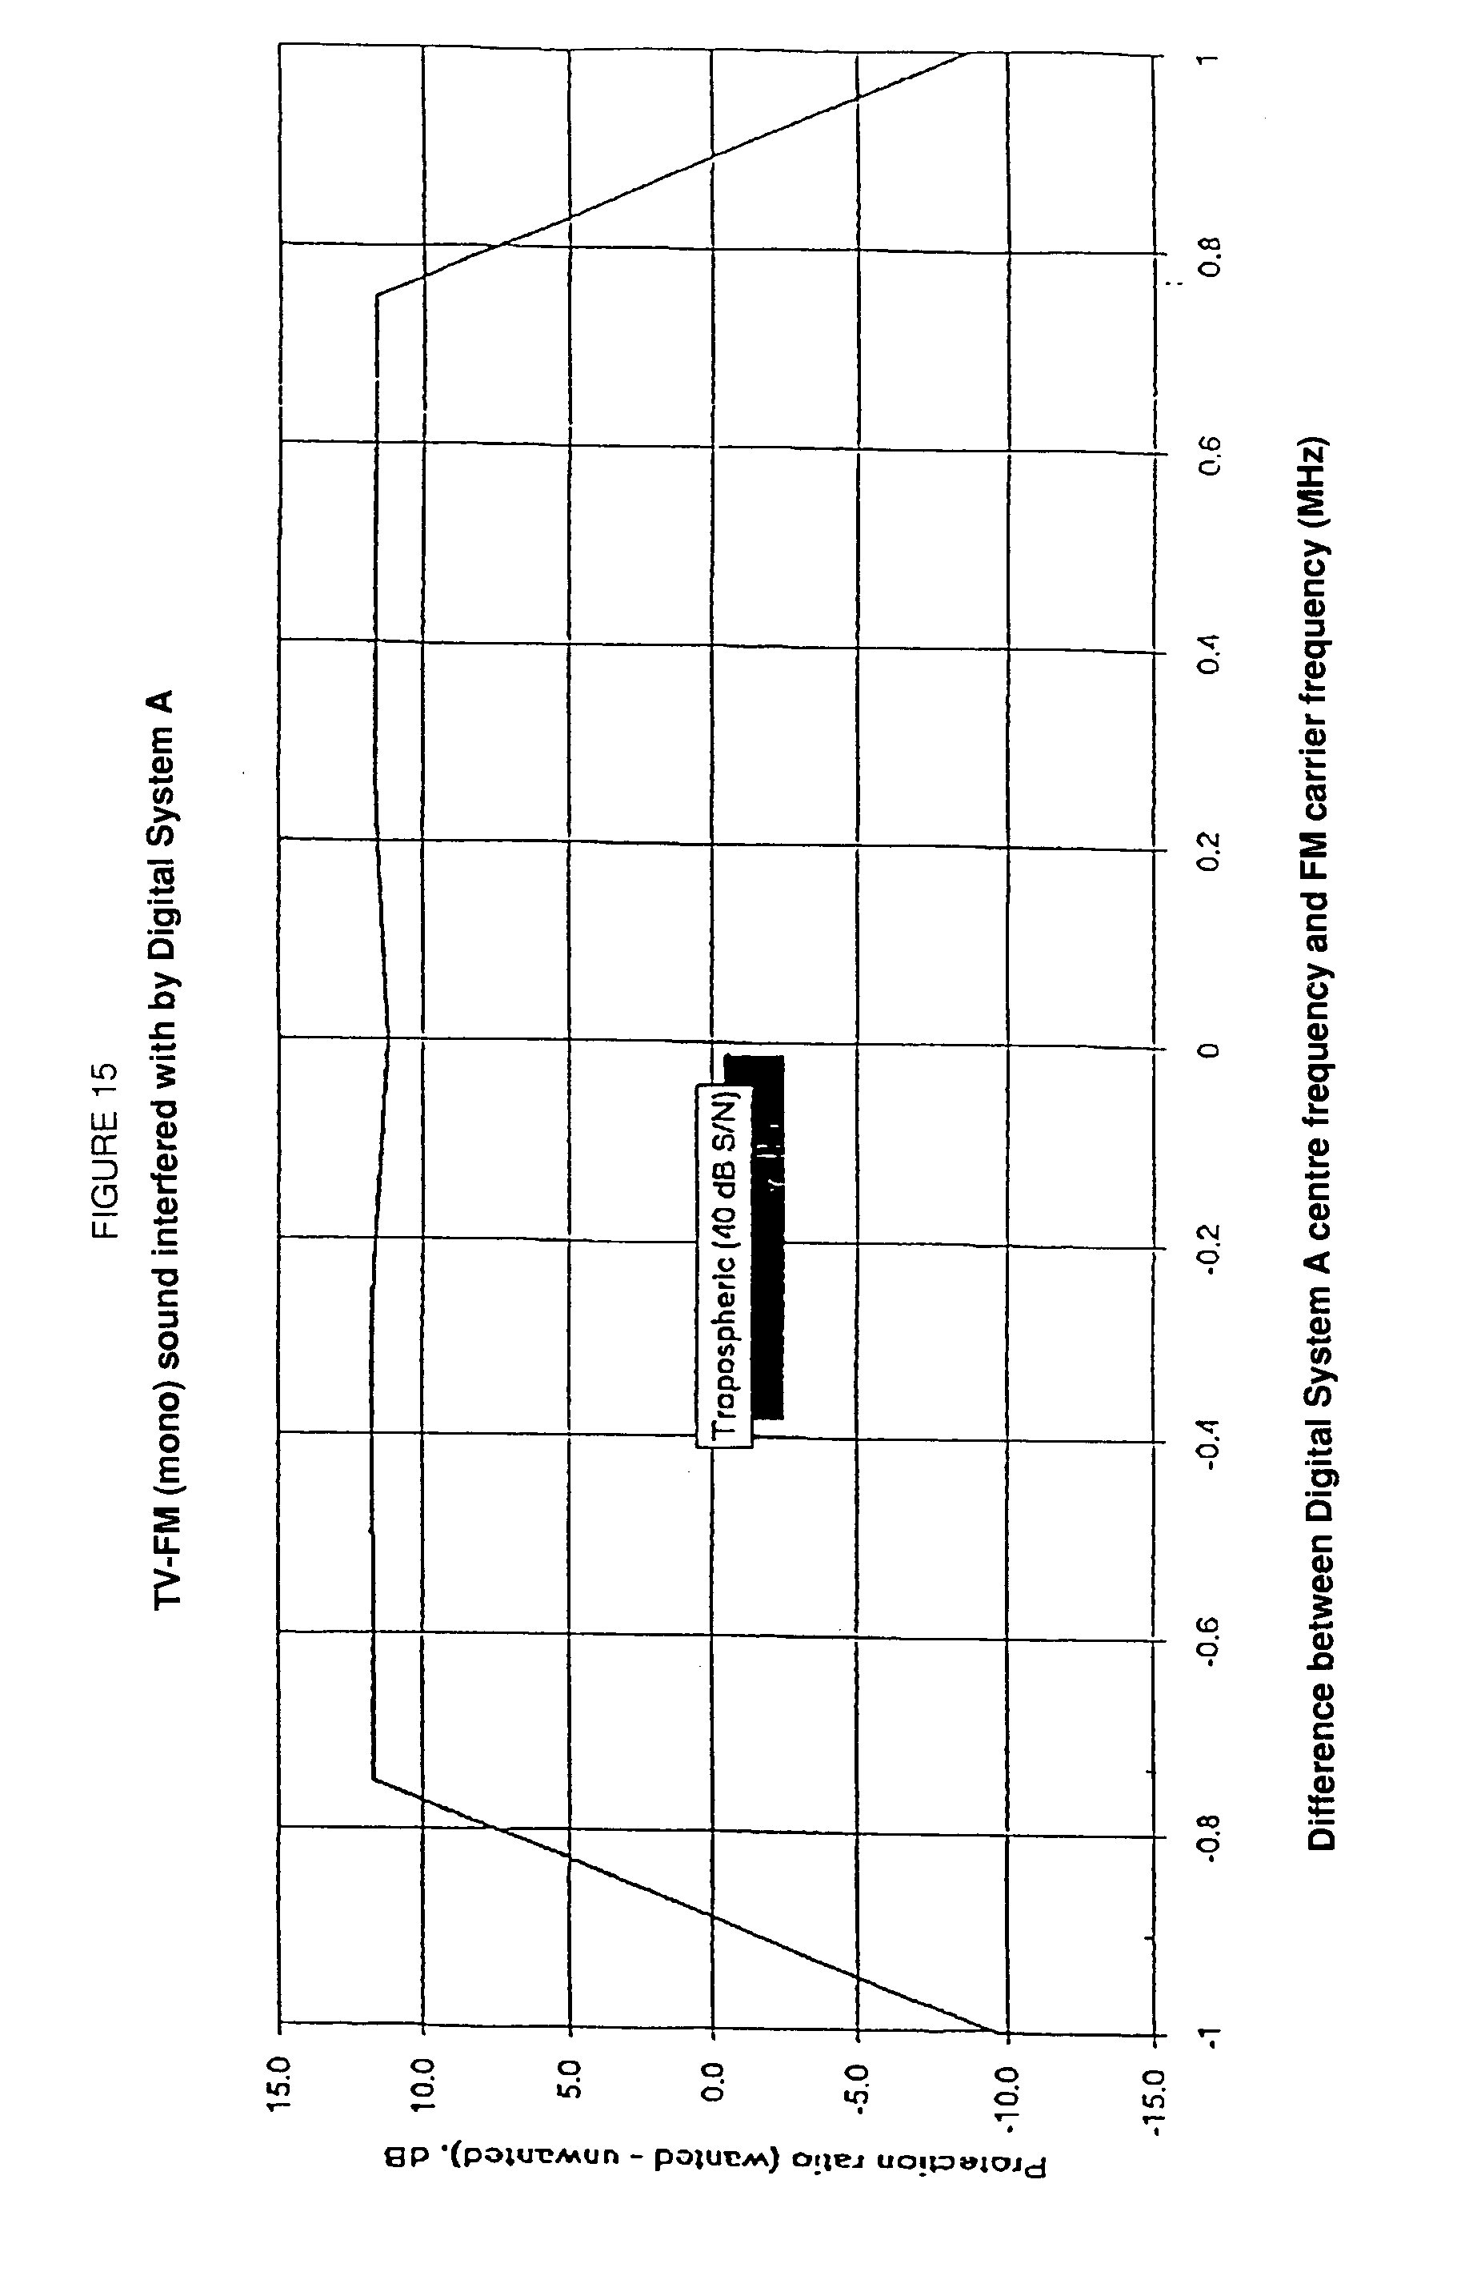

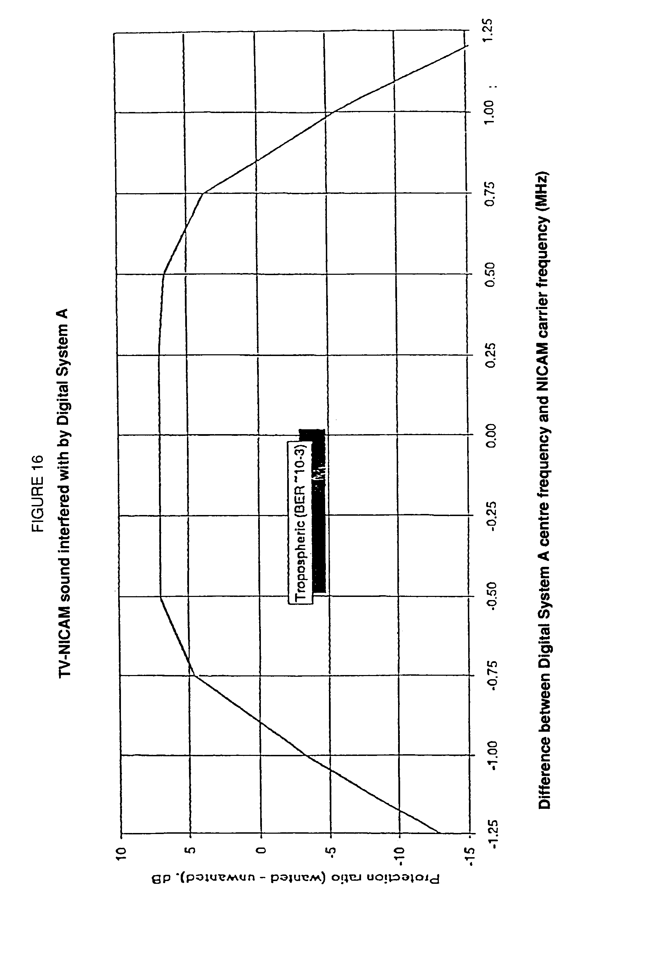  
4.5.2.2 Sharing analysis

##### 4.5.2.2.1 Sharing between Digital System A and television

Report 1087 deals with the protection of the television service against interference from other services. In the absence of more detailed information, the same criteria may also be used for sharing with Digital Sound Broadcasting.

For the case of Digital Sound Broadcasting, the protection ratios are given in § 4.5.2.1.

Based on these values and the use of orthogonal polarization, studies in the EBU showed that:

a) sharing the same channel from the same site is not possible;

b) the use of channel N for Digital Sound Broadcasting at a site where a TV programme is radiated on an adjacent channel N+1 or N‑1 is only possible if:

‑ there is no interference with any TV signals on channel N;

‑ there is no interference with the co‑sited TV transmission on channel N+1 or N‑1 (relevant protection ratios are not yet available, however, for the lower‑adjacent channel, protection of the sound channels should not be overlooked);

c) geographical sharing may lead to separation distances between the Digital Sound Broadcasting transmitter and the TV reception points of about 100 to 250 km depending on ERP (1 to 10 kW), effective antenna height (75 to 300 m) and frequency band (VHF/UHF).

In case c), it should be kept in mind that with careful planning the separation distances may be reduced. With directional antennas at the Digital Sound Broadcasting transmitter station and, as a consequence, additional fill‑in stations, the separation distances can also be reduced.

The terrestrial TV bands are densely used. In many countries there is an increased need for TV channels for local and regional coverages. For further sharing considerations, it will also be necessary to pay special attention to problems at the band edges and to the situation where a TV channel is also used by other services like mobile services inside the video‑band and/or services ancillary to broadcasting in the gaps of UHF channels carrying TV signals of system G. There will be a requirement for more spectrum in relation to digital TV systems.

Unless enough spectrum in the television bands can be completely cleared of television transmitters, single channel operation of a digital sound system, throughout a country, seems to be impossible.

An intermediate solution, involving single channel operation in limited areas, with a different channel being used in another area, may be possible in some countries. However, the time-scales involved in a transfer of an existing television service to a new channel (or even band) could be prohibitively long.

It should be borne in mind that when Digital Sound Broadcasting is used in a TV band, the receiver must be robust enough to remain unaffected by the television signals on nearby frequencies which are likely to be at a significantly higher level than the wanted Digital Sound Broadcasting signals being received.

##### 4.5.2.2.2 Sharing with fixed services at 1 500 MHz

To allow the planning for allocation of DSB services with fixed services, it is necessary to estimate the required geographical separations between terrestrial Digital Sound Broadcasting systems and point-to-multipoint (P-MP) communication systems operating near 1 500 MHz.

## Required geographical separations between DSB and point-to-multipoint

The geographical separations required to deliver the interfering field strengths given in Table 3 are determined for several sets of assumed DSB transmitting parameters. The separations are determined for the NEAR, CENTRAL and FAR sites to find which site is most sensitive.

TABLE 3

Allowable field strength from DSB at P-MP stations

|  |  |  |  |  |
| --- | --- | --- | --- | --- |
| Location to protect | Antenna height (m) | Antenna gain towards DSB (dBi) | Coupling/Line loss (dB) | Allowable field strength (dBµV/m) |
| NEAR CENTRAL FAR | 10  150  10 | -6 10 17 | 1 3 1 | 37 23 14 |

Similarly, the geographical separations required to deliver a P-MP interfering field strength of 24 dB above 1 µV/m are determined for the NEAR, CENTRAL, and FAR sites to see which produces the most interference. The radii of the DSB service areas for each set of DSB transmitting parameters are then added to these separation distances to obtain the required separations between the P-MP CENTRAL station and the DSB transmitter.

Table 4 summarizes the separations required between terrestrial DSB transmitters and P‑MP CENTRAL stations at 1 500 MHz to protect both services under the assumption used in this study. The DSB operating parameters in the table have been arbitrarily selected and are not intended to be interpreted as proposed operating parameters. With different assumptions or operating conditions other minimum separations would apply.

TABLE 4

|  |  |  |
| --- | --- | --- |
| Example parameters of DSB transmitters | | Resulting separation* between DSB Tx and P-MP CENTRAL station |
| ERP (kW) | EHAAT**  (m) | (km) |
| 1000  100  10  1 | 300 300 150 75 | 325 245 160 100 |
| * The separations in this column ensure that interference objectives are met at all CENTRAL and NEAR stations. While interference objectives at some FAR loca-tions are not quite met, this can only occur where FAR stations receive quite strong desired signals and hence would not experience interference. For example, the entry beside the asterisk contains the most vulnerable locations for FAR stations and in this case the interference objectives are not quite met for FAR stations which are within 25 km of the CENTRAL hub.  **Effective Height Above Average Terrain. | | |

Conclusion: this study has provided an example of the required distance separations under specific assumptions when point-to-multipoint systems and terrestrial digital audio broadcasting systems use the same frequency band. The separations required in practice may vary from those given and would depend on the operating parameters of equipment actually employed in each service.

## 4.6 Network and coverage concepts

There is a market for multinational, national, sub‑national and local services of various sizes. Eventually, all these may be served by Digital Sound Broadcasting. The largest services, i.e. those providing coverages for a group of countries, will be most effectively addressed by satellite. Thus it seems probable that the largest coverage areas likely to be served by terrestrial Digital Sound Broadcasting are those of national networks.

The requirements for terrestrial Digital Sound Broadcasting services will therefore range from national services, through sub‑national services, to local services. A common feature in most cases would be the requirement for several services with the same coverage requirements, which can be conveniently satisfied by the concept of the Digital Sound Broadcasting system.

The optimum solution for terrestrial national and sub‑national services would require transmitters at several sites operating as a Single Frequency Network (SFN). For these, a frequency block will be necessary. For local or subregional services it may be envisaged that coverage can be provided either from a single main station, possibly with a few low power relays or with small SFN.

As it is not possible to utilize the same frequency block when carrying different programmes in contiguous areas it follows that throughout most parts of Europe a minimum of four to five such frequency blocks is required to provide national network coverages using SFNs. Subdivision of individual countries into regions would almost certainly require additional frequency blocks.

The smaller the size of the areas served by each SFN, the greater will be the number of frequency blocks required, until in the limit the conditions for conventional network planning are approached.

However, subject to constraints of block reuse distance near borders, it may be possible for one country to use for local, and possibly even regional services the frequency blocks used in neighbouring areas for national services.

It follows from the above that there are in principle three types of terrestrial Digital Audio Broadcasting networks to be considered. These are:

a) Networks planned on conventional principles, allowing different programmes to be carried by individual transmitters using different frequencies.

b) Time-synchronous SFNs where the same programme is transmitted on multiple transmitters operating on the same frequency and the emissions are time synchronized by using a distribution network. This type of SFN would be used for providing large area, common programme coverage. A more difficult planning requirement is that currently occurring, where the transmitters of a country or region carry a common programme for much of the time but on certain occasions, e.g. for local news items, are required to carry different programmes. Any such flexibility may be difficult to achieve and will require further study.

c) Non-time synchronized SFN where the same programme is transmitted on transmitters operating on the same frequency. In this case the transmitters rebroadcast the programme in a relay fashion thus not requiring a distribution network. This type of SFN would be used for coverage extension/shaping and for gap filling.

### 4.6.1 Conventional networks

It is of interest to compare the necessary number of "channels" required for digital modulation using conventional planning for extensive area coverage to that for FM planning, recognizing that digital systems require lower protection ratios.

FM coverage planning is based on a co‑channel protection ratio of at least 37 dB being provided for 99% of the time at 50% of locations at the edge of the coverage area. A higher percentage of locations will achieve this minimum protection ratio as the distance from the transmitter decreases; similarly for a lower percentage of time (e.g. 90%) more than 50% of locations will receive this minimum quality, even at the nominal limit of coverage.

Although the 37 dB co‑channel protection ratio used for FM planning is high, the system is fairly robust with respect to increasing interference. Intelligibility is still possible, e.g. for reception of speech programmes in a car, provided the signal‑to‑interference ratio is above 5 dB. For digital systems the protection ratios for high quality and intelligibility are much closer, due to the failure characteristics of digital systems.

For this reason the reduction in the number of "channels" required for a digital system network relative to that for FM, is likely to be less than implied by the difference in protection ratios required for high quality reception of the two systems. Moreover, the existing VHF/FM Frequency Plan is based on domestic reception assuming a directional receiving antenna at 10 m, whereas any new Digital Sound Broadcasting system should also guarantee high quality for the more critical conditions of mobile reception (i.e. with a non‑directional antenna at lower height).

Practical experience will be necessary to determine the real number of "channels" required for an extended digital system network. It should be recognized that even within such a network using conventional planning, spectrum conservation is possible by having relay stations using the same channels as their parent stations (and any SFN), subject to provision of appropriate programme feed arrangements.

### 4.6.2 Synchronized single frequency network (SFN)

#### 4.6.2.1 Aspects of a SFN (using Digital System A)

A fundamental feature of the Digital System A is the ability to operate satisfactorily in areas having high levels of multipath propagation in particular for mobile reception.

This is achieved largely by the incorporation of a guard interval in the time domain. Provided the longest multipath delay time does not exceed this guard interval then all signal components received add constructively, effectively on a power‑sum basis. As delay times increase above the guard interval the constructive effect of any multipath decreases and the interference effect increases.

The effect of the interfering contribution is similar to that of noise, or of interference from another digital transmission carrying different programmes.

The value of the protection ratio required to avoid interference from such signals will depend upon the signal coding strategy but will be of the order of 10 dB. From the viewpoint of signal processing within the receiver, a multipath signal is indistinguishable from another, suitably synchronized, transmission carrying exactly the same information.

It follows therefore that a Digital System A network employing a single frequency block can be utilized by multiple transmitters over an extensive area without mutual interference, subject to the condition that the delay times of all signals received at significant levels do not exceed the guard interval by very much.

This is the general principle of the "Single Frequency Network".

In this concept, it can be seen that the SFN has a high spectrum efficiency which could, in practice, be at least three times that of a conventional FM network assuming identical programmes through out the network.

When operating in a single frequency network, the Digital System A signals transmitted from individual transmitters should be:

- approximately synchronous in time (with the accuracy of some microseconds for Mode I);

- nominally coherent in frequency;

- identical content of the Digital System A multiplex.

As a prerequisite, different sound programmes emanating from various studios have to be brought into time‑synchronism at the multiplex point (i.e. multiplexer) where different sound programmes are combined into a Digital System A multiplex.

**Time synchronization**

The time synchronization involves the compensation of the differences in nominal transmission delays that occur in the transmission path between the studio and the Digital System A transmitter. This compensation should be maintained at all times and may require timing information to be sent with the signals. The use of dedicated transmission lines is a possible solution.

Another possibility to feed all the Digital System A transmitters by the synchronous multiplex signal is to use a FSS distribution satellite. This method may be economically preferable for the distribution of complete multiplex signals in large SFN. In the case of large satellite footprints, some delay compensation is necessary at each transmitter site to compensate different downlink path lengths.

**Frequency coherence**

The Doppler effect sets limitations to the allowed frequency instability of the carriers of the Digital System A signal. The precision should be within about 1 part in 10-8 if the performance is to be preserved. This can be obtained in very much the same way as precision offset to TV transmitters today, that is to say, by locking the local oscillators to a reference frequency.

**Multiplex consistency**

The easiest way to cope with the requirement for bit identity in the multiplex, is to perform the Digital System A multiplexing in one common nodal point, that is the same as in the centre of a star network. Attention is specially drawn to the fact that no time synchronization is needed before the node, whilst after the node the relative delays between transmitters must be controlled.

#### 4.6.2.2 Internal network gain in a SFN

Due to the multipath tolerance of Digital System A there exists, within some delay time limits, a mutual addition of the signals of all transmitters belonging to the network. This effect is called the network gain of the SFN. It comprises two components, an additive and a statistical one.

Results of measurements indicating the extent of internal network gain in an experimental SFN in the United Kingdom are described in § 3.2.4 of Annex 1-C.

The additive part is simply a result of the fact that there may be more than one useful signal and hence the field strengths can be added. Statistically this is due to the location variation distributions of the different fields. Since the overall standard deviation of the resulting signal is less than that of a single signal the margin to achieve a 90% or 99% coverage probability can be reduced. Theoretical studies indicate that in an SFN, a dense internal network gain of up to 16 dB may be possible. However, this value assumes equal contributions from at least three sources, each having a 50% to 99% location correction factor of 19 dB. As already discussed in § 4.4.4 and in § 3.2 of Annex 1-C, a reduction of this factor to 13 dB seems appropriate, thereby reducing the theoretical network gain to 11 dB.

There are a number of caveats concerning the network gain.

First it has to be taken into account that not all of the transmitters will contribute to the useful signal. Depending on the Digital System A parameters and the distance from the source some signals may contain an interfering component. These components cause a self‑interference which reduces the network gain.

A second and more serious restriction is encountered with the fringe of the coverage area. For particular locations supporting co‑transmitters may be missing and hence the network gain would tend to zero.

Topography may lead to further restrictions. Detailed calculations taking account of the real situation (including topography) may then be more appropriate to determine the network gain.

#### 4.6.2.3 Coverage losses by shadowing

If there are gaps in the coverage of an SFN or if it is required to match coverage contours, for example to the borders of a country, this can be done by low‑power relays using the same frequency block, provided delays relative to the main source are within the guard interval.

If a certain isolation between receiving and transmitting antennas is possible, the fill‑in transmitters can work as normal re‑broadcast transmitters using the same frequency at input and output. However, this may be practical only at higher frequencies. As large shadowing buildings in urban areas provide the necessary isolation as well, this technique of "active reflectors" may be of great interest there. The re‑broadcasting transmitter in principal only consists of an amplifier with the necessary isolation between receiving and transmitting antenna determining the upper limit for the amplification.

An alternative to gap‑filling would be to increase the powers of certain transmitters in the network. Apart from the cost implications this would also increase interference to co‑channel services in other areas. This might preclude implementation of such a high‑power Digital Sound Broadcasting network. On the other hand, use of gap‑filling transmitters contributes to spectrum conservation.

#### 4.6.2.4 Distribution of DAB signals to broadcasting transmitters operating in a SFN

##### 4.6.2.4.1 Terrestrial distribution

###### 4.6.2.4.1.1 Distribution of the COFDM signal as a video baseband signal

In principle, the IF signal produced by the "OFDM" modulator could be directly applied to the IF channel of a microwave link. However, this method would strongly suffer from the frequency instability of the local oscillators used in the microwave links. Amplitude non‑linearities could also affect the transmission of the DSB signal and this phenomenon would be dominant on optical fibres with direct modulation.

A better solution consists of down‑converting the IF into the videofrequency band (e.g. 2 ‑ 5 MHz) and then applying it to conventional TV FM transmission equipment. The IF signal from the Digital System A encoder will then frequency‑modulate the microwave link in the same way as the TV signal. Any error in frequency transposition over the radio‑link path will be removed by the FM demodulation.

This method is currently used to feed gap‑fillers and provides a level of performance that introduces virtually no degradation to the Digital System A signal.

One possible refinement to the method is to multiplex in the same video‑frequency band a pilot frequency used to synchronize the local oscillator of the Digital System A transmitter.

The COFDM signal could also be transmitted in digital form. However, a minimum of about 20 Mbit/s would be required. Considering bit‑rate reduction techniques would lead to one of the two methods presented in the following section.

###### 4.6.2.4.1.2 Digital distribution of digital baseband multiplex signal

4.6.2.4.1.2.1 Distribution of the channel-coded ("C") digital multiplex signal

In this scenario, the baseband multiplex signal is convolutionally coded ("C") according to Digital System A specification and distributed to the various transmitter sites where the OFDM encoding is performed.

The main advantage of this scenario is that transmission capacity is minimized at the expense of some complexity at each transmission site. Also, the OFDM encoding which is performed at the transmitter is completely independent from the multiplex configuration, which guarantees a complete transparency of this solution against service evolutions.

A second advantage is that the distribution path is protected by the same convolutional code as that used for emission and that errors on this path will have reduced effects.

The main drawback is that the bit rate slightly exceeds the threshold of 1 920 kbit/s set by the first hierarchical level of European telecommunication networks. This is expected to be of significant importance in terms of network availability and costs, at least when a single block of programmes is transmitted.

4.6.2.4.1.2.2 Distribution of a transmission multiplex of source encoded digital signals

In this scenario, all signals of the Digital System A baseband multiplex are distributed to the various transmitters in source encoded form, i.e. no full channel coding is involved. Suitable error protection is therefore required.

With this solution the bit rate is held below 1 920 kbit/s, but the actual value may depend on the system configuration.

At the transmitter, a complete COFDM signal has to be constructed, complying with the DAB specification and taking into account the allocation of resources to the various services. This offers transmission remultiplexing possibilities which may be needed under some network organizations (a dedicated error protection may be necessary). A complete channel encoder is required at each transmitter.

Particular attention should be paid to transmission errors if two transmitters receive different data: the convolutional encoding at each transmitter side may result in long bursts of conflicting data. Such undesirable situations should be prevented by using a sufficiently strong error protection system on the distribution path.

Although it might be more difficult to implement, this solution may be the best on a long‑term basis.

##### 4.6.2.4.2 Distribution of Digital System A multiplex signals by satellite links

###### 4.6.2.4.2.1 Distribution of the COFDM signal as a video baseband signal

See § 4.6.2.4.1.1.

###### 4.6.2.4.2.2 Video baseband Digital System A signal combined with TV signal

Another possibility is to combine a TV video signal with a Digital System A pseudo video signal and feeding this sum to the frequency modulator of the satellite link. In this case the DAB centre frequency should be in the order of 7 MHz to 8 MHz. This sharing of a transponder seems to be attractive for economic reasons but the operational implications of combining signals of different services needs further consideration.

###### 4.6.2.4.2.3 Digital modulation of Digital System A multiplex signal

If, instead of frequency modulation, direct digital modulation is used, the bandwidth for a Digital System A multiplex including an appropriate channel coding (error protection) can be minimized, e.g. of the order of 2 to 3 MHz for quaternary modulation. Within the bandwidth of a single TV transponder up to 15 such signals can be accommodated. The transmission of each signal is nominally independent from the others, so no common uplink is necessary (as per SCPC operation). Each network operator can have his own uplink station directly at his premises, thus avoiding terrestrial links to central uplinks stations.

### 4.6.3 Non-synchronized single frequency network

Unlike in the case of conventional analogue sound broadcasting transmission where the service was provided by a single high power transmitter typically located at the centre of the service area and some possible re-broadcast stations using different channels to resolve the problem areas, a new concept called "distributed transmission" is proposed to provide the required field strength over the entire service area by a number of transmitters operating on the same channel. This concept provides the best performance when a COFDM modulation scheme is used since it allows for a constructive power addition of echoes produced by these various on-channel transmitters.

One way to implement this concept is by means of a single frequency network (SFN) which is closely related to the use of a regular lattice of synchronized on-channel transmitters. The conceptdescribed here is slightly different in that the transmitters need not to be synchronized on the same timing, therefore no parallel transmission infrastructure will be needed to bring the signal to the on-channel repeaters. In particular, this concept is proposed to extend the coverage of a main transmitter by the use of on-channel repeaters fed over the air. It can also be used to tailor the coverage by selec-ting sites where these repeaters are to be located. Because of the reduced extent of coverage for each transmitter and the nature of the propagation, the power needed at each transmitter is much reduced, the availability of the signal at the receiver at such smaller distance can also be improved by a margi-nal increase in transmit power and, further, a certain level of redundancy in receiving the signal from the multiple transmitters allows for a further improvement in signal availability (i.e., network gain).

Normally, the repeater would pick-up the signal off-air and re-transmit it without any delay. Some further adjustment of the delay may be useful to improve the coverage. Using negative delays relative to the propagation delay, such as in the case of a synchronized SFN, means that the signal needs to be brought to the re-transmitter sites through a parallel infrastructure (e.g., satellite, optical fibre, micro-wave links, etc.). Positive delays mean using memory lines at the repeater to delay the signal further after pick-up from off-air.

In the case of active echoes produced by on-channel repeaters and the main transmitter, depending on where the receiver is located, some active echoes can be received either before or after the main signal. In fact, at a specific location, two active echoes can be received at exactly the same power and depending whether the receiver is moved towards one repeater or the other (one can be the main transmitter), one echo will be stronger than the other. Each of these active echoes will also be received with passive echoes generated by the receiver surroundings. The presence of active echoes produced by on-channel repeaters will therefore result, in most locations, in apparently more severe multipath conditions over a wider time window at the receivers and unless the receivers can take advantage of these conditions as in the case of a COFDM modulation, the reception would be made more difficult.

In the case of COFDM, the increase in symbol period to cover for both, the active and passive echoes result in an increase in the number of orthogonal carriers in the channel bandwidth. This increase has three effects: a) the reception becomes more susceptible to degradations caused by the Doppler shift in the case of a moving vehicle (there is a linear relationship between the maximum speed at which proper reception in a vehicle is possible and the symbol period, and thus the guard interval for a given spectrum efficiency); b) the tolerance on the phase noise of the receiver local oscillator will need to be tighter for proper signal demodulation; and c) the complexity of the real-time FFT used for the multi-carrier demodulation increases (as a function of Nlog2N where N is the number of carriers).

A proper trade-off needs to be found between the size of the guard interval, and therefore the flexibility in locating the on-channel repeaters up to a given distance from the main transmitter, and the susceptibility of the transmission to the Doppler shift and to the receiver local oscillator phase noise as well as the complexity of the receivers. Such trade-off which involves technical as well as overall system aspects needs to be made before the modulation parameters are set. The computer program described in the following section should be instrumental in such trade-off analysis.

Computer simulations of this concept are included in Annex 1-D, which illustrates the advantages and constraints of using this approach.

The conventional way to cover a service area, that is a single transmitter usually located at the centre of the area, has been used extensively for conventional sound broadcasting. With the advent of digital modulation schemes to be used in digital sound broadcasting, a new approach, called the "distributed transmission concept", has been developed. This concept is quite effective in decreasing the total transmit power required and can provide a better service availability up to the edge of the service area.

The distributed transmission concept can be used to its best advantage when a COFDM type modulation scheme is used. This scheme allows for the constructive power addition of the active echoes generated by the on-channel re-transmitters and therefore improves the signal availability. Best use of this concept is achieved by the use of omnidirectional antennas at all transmitters but this imposes an additional constraint on the width of the guard interval (typically 142 sec is required to locate the re-transmitters at 50 km from the main transmitter for an extent of coverage of 70 km radius).

Another important aspect of the distributed transmission concept is the fact that the coverage area can be carefully shaped to reduce the power requirement and also to produce a sharper signal roll-off at the edge of the coverage area. This allows for a reduction of the separation distance between adjacent coverage areas that use the same frequency and therefore an increase in the overall spectrum efficiency.

Annex 1-A

Digital audio broadcasting (DAB) system description (Digital System A)

# 1. Introduction

Digital System A is designed to provide high‑quality, multi‑service digital radio broadcasting for reception by vehicular, portable and fixed receivers. It is designed to operate at any frequency up to 3 000 MHz for terrestrial, satellite, hybrid (satellite and terrestrial), and cable broadcast delivery. The system is also designed as a flexible, general‑purpose Integrated Services Digital Broadcasting (ISDB) system which can support a wide range of source and channel coding options, sound‑programme associated data and independent data services, in conformity with the flexible and broad‑ranging service and system requirements given in Recommendations ITU‑R BO.789 and ITU‑R BS.774, supported by this Report and Report ITU-R BO.955.

The system is a rugged, yet highly spectrum and power‑efficient sound and data broadcasting system. It uses advanced digital techniques to remove redundancy and perceptually irrelevant information from the audio source signal, then it applies closely‑controlled redundancy to the transmitted signal for error correction. The transmitted information is then spread in both the frequency and time domains so that a high quality signal is obtained in the receiver, even when working in conditions of severe multipath propagation, whether stationary or mobile. Efficient spectrum utilization is achieved by interleaving multiple programme signals and a special feature of frequency reuse permits broadcasting networks to be extended, virtually without limit, using additional transmitters all operating on the same radiated frequency.

A conceptual diagram of the emission part of the system is shown in Fig. 17.

Digital System A has been developed by the Eureka 147 (DAB) Consortium and is known as the Eureka DAB System. It has been actively supported by the EBU in view of introducing digital sound-broadcasting services in Europe in 1995. Since 1988, the system has been successfully demonstrated and extensively tested in Europe, Canada, the United States and in other countries worldwide. In this annex, Digital System A is referred to as "the System". The full system specification will be available as a European Telecommunications Standard.

# 2. Use of a layered model

The System is capable of complying with the ISO Open System Interconnection (OSI) basic reference model described in ISO 7498 (1984). The use of this model is recommended in Recommendation ITU-R BT.807 and Report ITU-R BT.1207, and a suitable interpretation for use with layered broadcasting systems is given in the Recommendation. In accordance with this guidance, the System will be described in relation to the layers of the model, and the interpretation applied here is illustrated in Table 5.

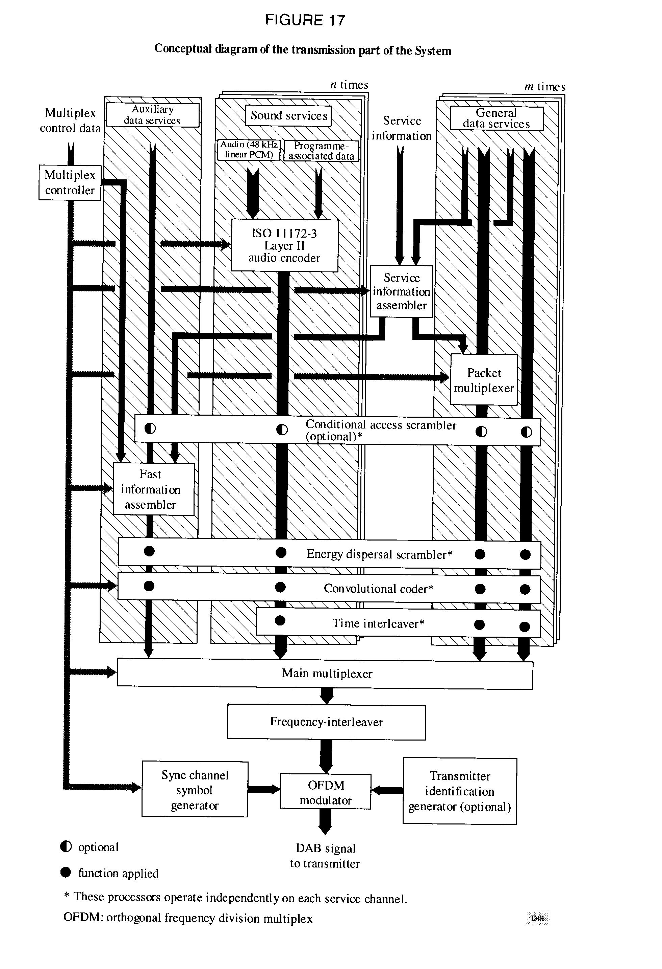

TABLE 5

Interpretation of the OSI layered model

|  |  |  |
| --- | --- | --- |
| Name of layer | Description | Features specific to the System |
| Application layer | Practical use of the System | System facilities Audio quality Transmission modes |
| Presentation layer | Conversion for presentation | Audio encoding and decoding Audio presentation Service information |
| Session layer | Data selection | Programme selection Conditional access |
| Transport layer | Grouping of data | Programme services Main service multiplex Ancillary data Association of data |
| Network layer | Logical channel | ISO audio frames Programme associated data |
| Data link layer | Format of the  transmitted signal | Transmission frames  Synchronization |
| Physical layer | Physical (radio) transmission | Energy dispersal Convolutional encoding Time interleaving Frequency interleaving Modulation by 4-DPSK OFDM Radio transmission |

Descriptions of many of the techniques involved are most easily given in relation to the operation of the equipment at the transmitter, or at the central point of a distribution network in the case of a network of transmitters.

The fundamental purpose of the System is to provide sound programmes to the radio listener, so the order of sections in the following description will start from the application layer (use of the broadcast information), and proceed downwards to the physical layer (the means for radio transmission).

# 3. Application layer

This layer concerns the use of the System at the application level. It considers the facilities and audio quality which the System provides and which broadcasters can offer to their listeners, and the different transmission modes.

## 3.1 Facilities offered by the System

The System provides a signal which carries a multiplex of digital data, and this conveys several programmes at the same time. The multiplex contains audio programme data, and ancillary data comprising Programme Associated Data (PAD), Multiplex Configuration Information (MCI) and Service Information (SI). The multiplex may also carry general data services which may not be related to the transmission of sound programmes.

In particular, the following facilities are made available to users of the System: a) the audio signal (i.e. the programme) being provided by the selected programme service;

b) the optional application of receiver functions, for example dynamic range control, which may use ancillary data carried with the programme;

c) a text display of selected information carried in the SI. This may be information about the selected programme, or about others which are available for optional selection;

d) options which are available for selecting other programmes, other receiver functions, and other SI;

e) one or more general data services, for example a Traffic Message Channel (TMC).

The System includes facilities for conditional access, and a receiver can be equipped with digital outputs for audio and data signals.

## 3.2 Audio quality

Within the capacity of the multiplex, the number of programme services and, for each, the presentation format (e.g. stereo, mono, surround‑sound, etc.), the audio quality and the degree of error protection (and hence ruggedness) can be chosen to meet the needs of the broadcasters.

The following range of options is available for the audio quality:

a) very high quality, with audio processing margin;

b) subjectively transparent quality, sufficient for the highest quality broadcasting;

c) high quality, equivalent to good FM service quality;

d) medium quality, equivalent to good AM service quality;

e) speech‑only quality.

The System provides full quality reception within the limits of transmitter coverage; beyond these limits reception degrades in a subjectively graceful manner.

## 3.3 Transmission modes

The System has three alternative transmission modes which allow the use of a wide range of transmitting frequencies up to 3 GHz. These transmission modes have been designed to cope with Doppler spread and delay spread, for mobile reception in presence of multipath echoes.

The following table gives the constructive echo delay and nominal frequency range for mobile reception. The noise degradation at the highest frequency and in the most critical multipath condition, occurring infrequently in practice, is equal to 1 dB at 100 km/h.

       Parameter Mode I Mode II Mode III

Guard interval duration: 246 µs 62 µs 31 µs

Constructive echo delay up to: 300 µs 75 µs 37.5 µs

Nominal frequency range  
 (for mobile reception) up to: 375 MHz 1.5 GHz 3 GHz

From this table, it can be seen that the use of higher frequencies imposes a greater limitation on the maximum echo delay. Mode I is most suitable for a terrestrial Single‑Frequency Network (SFN), because it allows the greatest transmitter separations. Mode II is most suitable for local radio applications requiring one terrestrial transmitter, and hybrid satellite/terrestrial transmission up to 1.5 GHz. However, Mode II can also be used for a medium‑to‑large scale SFN (e.g. at 1.5 GHz) by inserting, if necessary, artificial delays at the transmitters and/or by using directive transmitting antennas. Mode III is most appropriate for satellite and complementary terrestrial transmission at all frequencies up to 3 GHz.

Mode III is also the preferred mode for cable transmission up to 3 GHz.

# 4. Presentation layer

This layer concerns the conversion and presentation of the broadcast information.

## 4.1 Audio source encoding

The audio source encoding method used by the System is ISO/IEC MPEG‑Audio Layer II, given in the ISO Standard 11172‑3. This sub‑band coding compression system is also known as the MUSICAM system.

The System accepts a number of PCM audio signals at a sampling rate of 48 kHz with programme‑associated data (PAD). The number of possible audio sources depends on the bit rate and the error protection profile. The audio encoder can work at 32, 48, 56, 64, 80, 96, 112, 128, 160 or 192 kbit/s per monophonic channel. In stereophonic or dual channel mode, the encoder produces twice the bit rate of a mono channel.

The different bit-rate options can be exploited by broadcasters depending on the intrinsic quality required and/or the number of sound programmes to be provided. For example, the use of bit rates greater than or equal to 128 kbit/s for mono, or greater than or equal to 256 kbit/s for a stereo programme, provides not only very high quality, but also some processing margin, sufficient for further multiple encoding/decoding processes, including audio post‑processing. For high‑quality broadcasting purposes, a bit rate of 128 kbit/s for mono or 256 kbit/s for stereo is preferred, giving fully transparent audio quality. Even the bit rate of 192 kbit/s per stereo programme generally fulfils the EBU requirement for digital audio bit-rate reduction systems.[2]* A bit-rate of 96 kbit/s for mono gives good sound quality, and 48 kbit/s can provide roughly the same quality as normal AM broadcasts. For some speech‑only programmes, a bit rate of 32 kbit/s may be sufficient where the greatest number of services is required within the system multiplex.

A block diagram of the functional units in the audio encoder is given in Fig. 18. The input PCM audio samples are fed into the audio encoder. One encoder is capable of processing both channels of a stereo signal, although it may, optionally, be presented with a mono signal. A polyphase filter bank divides the digital audio signal into 32 sub‑band signals, and creates a filtered and sub‑sampled representation of the input audio signal. The filtered samples are called sub‑band samples. A perceptual model of the human ear creates a set of data to control the quantizer and coding. These data can be different, depending on the actual implementation of the encoder. One possibility is to use an estimation of the masking threshold to obtain these quantizer control data. Successive samples of each sub‑band signal are grouped into blocks, then in each block, the maximum amplitude attained by each sub‑band signal is determined and indicated by a scale factor. The quantizer and coding unit creates a set of coding words from the sub‑band samples. These processes are carried out during ISO audio frames, which will be described in the Network layer.

## 4.2 Audio decoding

Decoding in the receiver is straightforward and economical using a simple signal processing technique, requiring only de‑multiplexing, expanding and inverse‑filtering operations. A block diagram of the functional units in the decoder is given in Fig. 19.

The ISO audio frame is fed into the ISO/MPEG‑Audio Layer II decoder, which unpacks the data of the frame to recover the various elements of information. The reconstruction unit reconstructs the quantized sub‑band samples, and an inverse filter bank transforms the sub‑band samples back to produce digital uniform PCM audio signals at 48 kHz sampling rate.

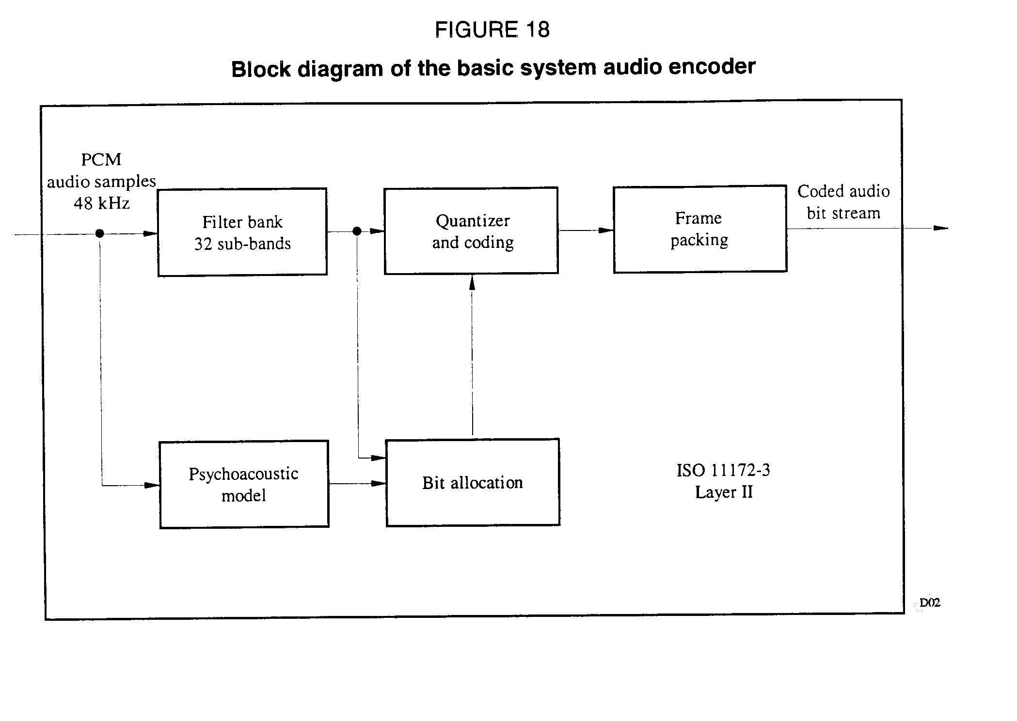

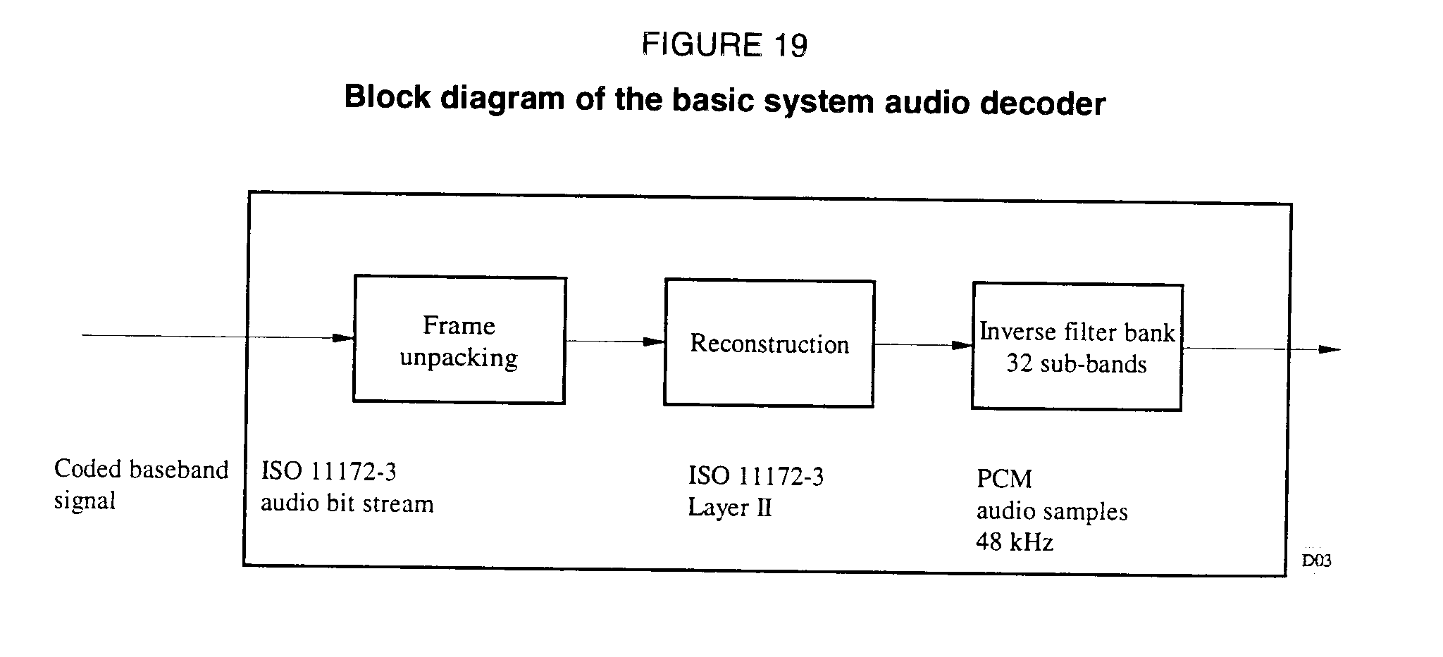

## 4.3 Audio presentation

Audio signals may be presented monophonically or stereophonically, or audio channels may be grouped for surround‑sound. Programmes may be linked to provide the same programme simultaneously in a number of different languages. In order to satisfy listeners in both Hi‑Fi and noisy environments, the broadcaster can optionally transmit a Dynamic Range Control (DRC) signal which can be used in the receiver in a noisy environment to compress the dynamic range of the reproduced audio signal. Note that this technique can also be beneficial to listeners with impaired hearing.

## 4.4 Presentation of Service Information

With each programme transmitted by the System, the following elements of Service Information (SI) can be made available for display on a receiver:

- basic programme label (i.e. the name of the programme);

- time and date;

- cross‑reference to the same, or similar programme (e.g. in another language) being transmitted in another ensemble or being simulcast by an AM or FM service;

- extended service label for programme‑related services;

- programme information (e.g. the names of performers);

- language;

- programme type (e.g. news, sport, music, etc.);

- transmitter identifier;

- Traffic Message Channel (TMC, which may use a speech synthesizer in the receiver).

Transmitter network data can also be included for internal use by broadcasters.

# 5. Session layer

This layer concerns the selection of, and access to, broadcast information.

## 5.1 Programme selection

In order that a receiver can gain access to any or all of the individual services with a minimum overall delay, information about the current and future content of the multiplex is carried by the Fast Information Channel (FIC). This information is the MCI, which is machine‑readable data. Data in the FIC are not time‑interleaved, so the MCI is not subject to the delay inherent in the time‑interleaving process applied to audio and general data services. However, these data are repeated frequently to ensure their ruggedness. When the multiplex configuration is about to change, the new information, together with the timing of the change is sent in advance in the MCI.

The user of a receiver can select programmes on the basis of textual information carried in the SI, using the programme service name, the programme type identity or the language. The selection is then implemented in the receiver using the corresponding elements of the MCI.

If alternative sources of a chosen programme service are available and an original digital service becomes untenable, then linking data carried in the SI (i.e. the "cross reference") may be used to identify an alternative (e.g. on an FM service) and switch to it. However, in such a case, the receiver will switch back to the original service as soon as reception is possible.

## 5.2 Conditional access

Provision is made for both synchronization and control of conditional access.

Conditional access can be applied independently to the service components (carried either in the MSC or FIC), services or the whole multiplex.

# 6. Transport layer

This layer concerns the identification of groups of data as programme services, the multiplexing of data for those services and the association of elements of the multiplexed data.

## 6.1 Programme services

A programme service generally comprises an audio service component and optionally additional audio and/or data service components, provided by one service provider. The whole capacity of the multiplex may be devoted to one service provider (e.g. broadcasting five or six high‑quality sound programme services), or it may be divided amongst several service providers (e.g. collectively broadcasting some twenty medium quality programme services).

## 6.2 Main service multiplex

With reference to Fig. 17, the data representing each of the programmes being broadcast (digital audio data with some ancillary data, and maybe also general data) are subjected to convolutional encoding (see § 9.2) and time‑interleaving, both for error protection. Time‑interleaving improves the ruggedness of data transmission in a changing environment (e.g. reception by a moving vehicular receiver) and imposes a predictable transmission delay. The interleaved and encoded data are then fed to the main service multiplexer where, each 24 ms, the data are gathered in sequence into the multiplex frame. The combined bit stream output from the multiplexer is known as the Main Service Channel (MSC) which has a gross capacity of 2.3 Mbit/s. Depending on the chosen code rate (which can be different from one service component to another), this gives a net bit rate ranging from approximately 0.8 to 1.7 Mbit/s, through a 1.5 MHz bandwidth. The main service multiplexer is the point at which synchronized data from all of the programme services using the multiplex are brought together.

General data may be sent in the MSC as an unstructured stream or organized as a packet multiplex where several sources are combined. The data rate may be any multiple of 8 kbit/s, synchronized to the system multiplex, subject to sufficient total multiplex capacity, taking into account the demand for audio services.

The Fast Information Channel (FIC) is external to the MSC and is not time‑interleaved.

## 6.3 Ancillary data

There are three areas where ancillary data may be carried within the System multiplex:

a) the FIC, which has limited capacity, depending on the amount of essential MCI included;

b) there is special provision for a moderate amount of PAD to be carried within each audio channel;

c) all remaining ancillary data are treated as a separate service within the MSC. The presence of this information is signalled in the MCI.

## 6.4 Association of data

A precise description of the current and future content of the MSC is provided by the MCI, which is carried by the FIC. Essential items of SI which concern the content of the MSC (i.e. for programme selection) must also be carried in the FIC. More extensive text, such as a list of all the day's programmes, must be carried separately as a general data service. Thus, the MCI and SI contain contributions from all of the programmes being broadcast.

The PAD, carried within each audio channel, comprises mainly the information which is intimately linked to the sound programme and therefore cannot be sent in a different data channel which may be subject to a different transmission delay.

# 7. Network layer

This layer concerns the identification of groups of data as programmes.

## 7.1 ISO audio frames

The processes in the audio source encoder are carried out during ISO audio frames of 24 ms duration. The bit allocation, which varies from frame to frame, and the scale factors are coded and multiplexed with the sub‑band samples in each ISO audio frame. The frame packing unit (see Fig. 2) assembles the actual bit stream from the output data of the quantizer and coding unit, and adds other information, such as header information, CRC words for error detection, and PAD, which travel along with the coded audio signal. Each audio channel contains a PAD channel having a variable capacity (generally at least 2 kbit/s), which can be used to convey information which is intimately linked to the sound programme. Typical examples are lyrics, speech/music indication and Dynamic Range Control (DRC) information.

The resulting audio frame carries data representing 24 ms duration of stereo (or mono) audio, plus the PAD, for a single programme and complies with the ISO 11172‑3 Layer II format, so it can be called an ISO frame. This allows the use of an ISO/MPEG‑Audio Layer II decoder in the receiver.

# 8. Data link layer

This layer provides the means for receiver synchronization.

## 8.1 The transmission frame

In order to facilitate receiver synchronization, the transmitted signal is built up with a regular frame structure (see Fig. 20). The transmission frame comprises a fixed sequence of symbols. The first is a null symbol to provide a coarse synchronization (when no RF signal is transmitted), followed by a fixed reference symbol to provide a fine synchronization, AGC, AFC and phase reference functions in the receiver; these symbols make up the synchronization channel. The next symbols are reserved for the FIC, and the remaining symbols provide the MSC. The total frame duration TF is either 96 ms or 24 ms, depending on the transmission mode as given in Table 6 below:

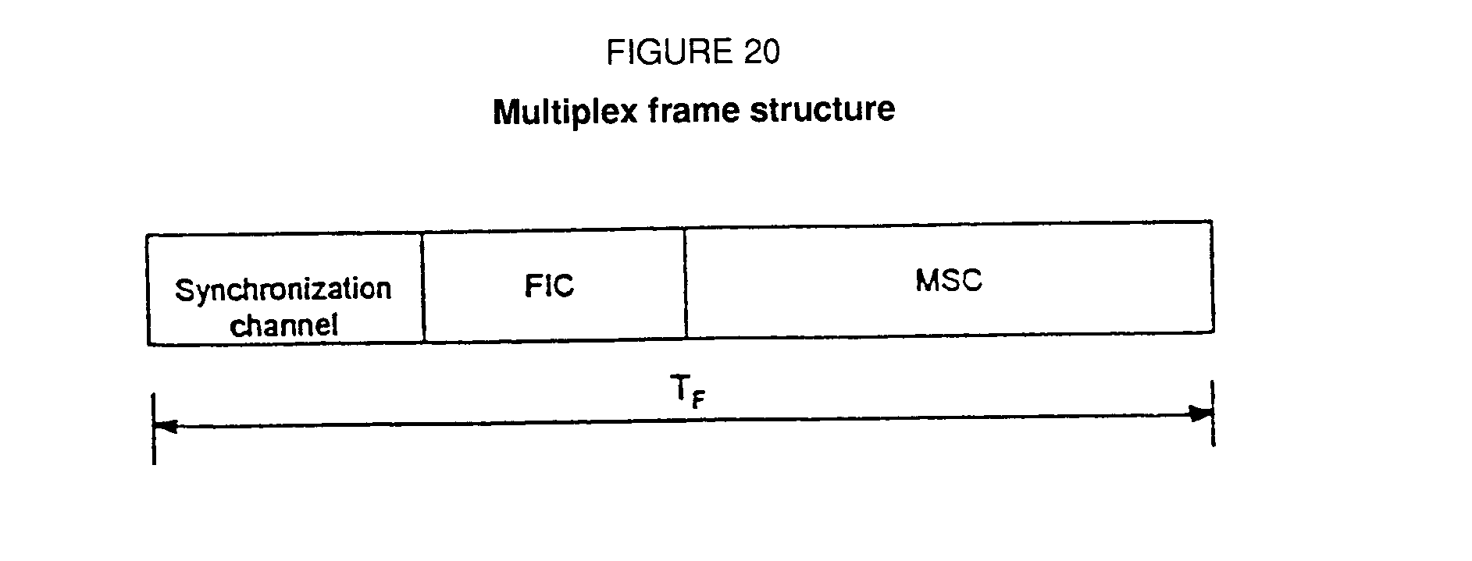

TABLE 6

Transmission parameters of the system

|  |  |  |  |
| --- | --- | --- | --- |
|  | Mode I | Mode II | Mode III |
| TF | 96 ms | 24 ms | 24 ms |
| TNULL | 1.297 ms | 324 µs | 168 µs |
| TS | 1.246 ms | 312 µs | 156 µs |
| ts | 1 ms | 250 µs | 125 µs |
|  | 246 µs | 62 µs | 31 µs |
| N | 1536 | 384 | 192 |

The following notation is used:

TF: total frame duration

TNULL: null symbol duration

TS overall symbol duration

ts useful symbol duration

guard interval duration  
 TS = ts +

N number of radiated carriers

Each audio service within the MSC is allotted a fixed time slot in the frame.

# 9. The physical layer

This layer concerns the means for radio transmission (i.e. the modulation scheme and the associated error protection).

## 9.1 Energy dispersal

In order to ensure appropriate energy dispersal in the transmitted signal, the individual sources feeding the multiplex are scrambled.

## 9.2 Convolutional encoding

Convolutional encoding is applied to each of the data sources feeding the multiplex to ensure reliable reception. The encoding process involves adding deliberate redundancy to the source data bursts (using a constraint length of 7). This gives "gross" data bursts.

In the case of an audio signal, greater protection is given to some source‑encoded bits than others, following a preselected pattern known as the Unequal Error Protection (UEP) profile. The average code rate, defined as the ratio of the number of source‑encoded bits to the number of encoded bits after convolutional encoding, may take a value from 1/3 (the highest protection level) to 3/4 (the lowest protection level). Different average code rates can be applied to different audio sources, subject to the protection level required and the bit rate of the source‑encoded data. For example, the protection level of audio services carried by cable networks may be lower than that of services transmitted in radio‑frequency channels.

General data services are convolutionally encoded using one of a selection of uniform rates. Data in the FIC are encoded at a constant 1/3 rate.

## 9.3 Time interleaving

Time interleaving of interleaving depth of 16 frames is applied to the convolutionally encoded data in order to provide further assistance to a mobile receiver.

## 9.4 Frequency interleaving

In the presence of multipath propagation, some of the carriers are enhanced by constructive signals, while others suffer destructive interference (frequency selective fading). Therefore, the System provides frequency interleaving by a rearrangement of the digital bit stream amongst the carriers, such that successive source samples are not affected by a selective fade. When the receiver is stationary, the diversity in the frequency domain is the prime means to ensure successful reception.

## 9.5 Modulation by 4‑DPSK OFDM

The System uses 4‑DPSK OFDM (Orthogonal Frequency Division Multiplex). This scheme meets the exacting requirements of high bit-rate digital broadcasting to mobile, portable and fixed receivers, especially in multipath environments.

The basic principle consists of dividing the information to be transmitted into a large number of bit streams having low bit rates individually, which are then used to modulate individual carriers. The corresponding symbol duration becomes larger than the delay spread of the transmission channel. In the receiver any echo shorter than the guard interval will not cause inter‑symbol interference but rather contribute positively to the received power (see Fig. 21). The large number N of carriers is known collectively as an ensemble.

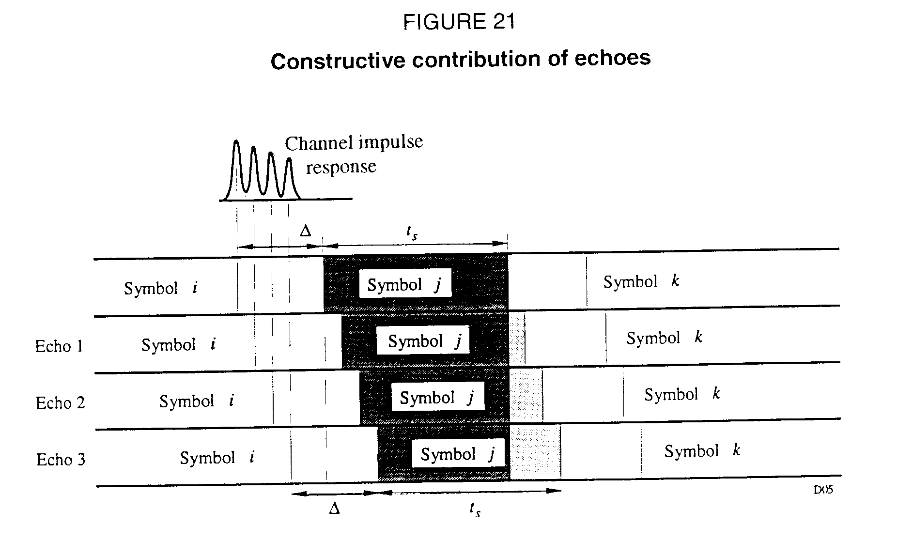

In the presence of multipath propagation, some of the carriers are enhanced by constructive signals, while others suffer destructive interference (frequency selective fading). Therefore, the System includes a redistribution of the elements of the digital bit stream in time and frequency, such that successive source samples are affected by independent fades. When the receiver is stationary, the diversity in the frequency domain is the only means to ensure successful reception; the time diversity provided by time‑interleaving does not assist a static receiver. For the system, multipath propagation is a form of space‑diversity and is considered to be a significant advantage, in stark contrast to conventional FM or narrow‑band digital systems where multipath propagation can completely destroy a service.

In any system able to benefit from multipath, the larger the transmission channel bandwidth, the more rugged the system. In the System, an ensemble bandwidth of 1.5 MHz was chosen to secure the advantages of the wideband technique, as well as to allow planning flexibility. Table 6 also indicates the number of COFDM carriers within this bandwidth for each transmission mode.

A further benefit of using COFDM is that high spectrum and power efficiency can be obtained with single frequency networks for large area coverage and also for city area dense networks. Any number of transmitters providing the same programmes may be operated on the same frequency, which also results in an overall reduction in the required operating powers. As a further consequence distances between different service areas are significantly reduced.

Because echoes contribute to the received signal, all types of receiver (i.e. portable, home and

vehicular) may utilize simple, non-directional antennas.

## 9.6 Spectrum of the RF‑signal

The spectrum of the system ensemble is shown in Fig. 22.

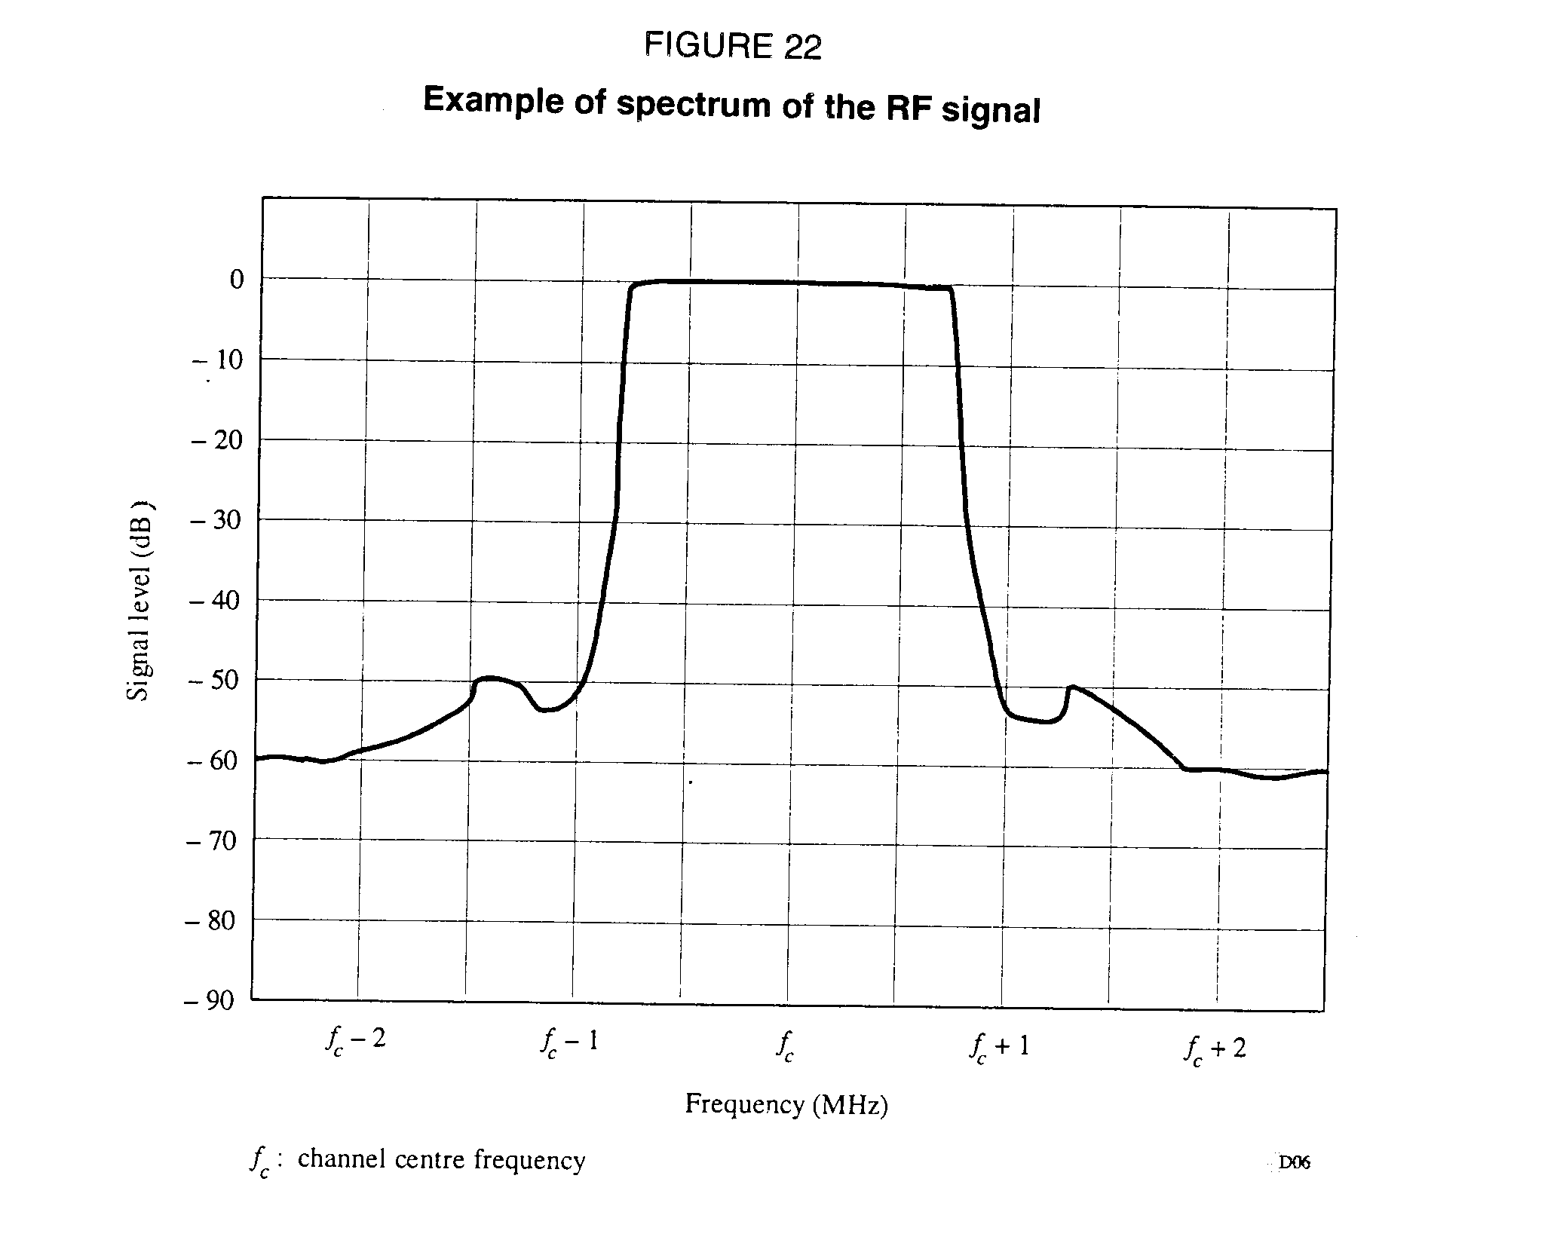

ANNEX 1-B

System experimental evaluations (Digital System A)

# 1. Initial experiments

## 1.1 Rennes and Geneva - 1988

In June 1988, the CCETT installed the first COFDM UHF transmitter at Rennes having the following characteristics:

- transmission frequency 794 MHz

- transmitting antenna height 140 m

- number of stereophonic sound channels[3]* 16

- antenna gain in the direction of the main service area 12 dBi

- power per stereophonic sound channel at the input  
of the transmitting antenna 1 W

- total ERP 256 W

- ERP per stereophonic sound channel 16 W

- total bandwidth 7 MHz

- total number of useful carriers 448

- useful symbol period 64 s

- guard interval 16 s

- maximum path-length difference for which two signals  
are still combined constructively 6 km

The broadcast signal was received in a car equipped for mobile tests. The first successful trial runs under real conditions were conducted in cooperation with the IRT in July 1988 during preparations for the EBU's first public demonstration of the so-called COFDM/MASCAM experimental Digital Audio Broadcasting system in September 1988 at the WARC ORB-88 in Geneva [Dosch et al.1988].

These trial runs showed that despite a quite large service area in which the reception was perfect, some locations in the urban area were impaired by heavy shadowing and there were some gaps in which the signal was attenuated by more than 30 dB.

At that time, the idea of using a gap-filling technique materialized, but two important questions were raised:

- How much separation (in dB) can be achieved between a directive receiving antenna and a transmitting antenna installed in a building environment when the geographical separation is in the range of 50 to 100 m?

- How will the COFDM receiver behave when it moves from the zone served by the main transmitter to that served by the retransmitting station?

To examine these and other points, a small single frequency network with two retransmitting stations has been installed, with the characteristics set out in Table 7. Using this complete UHF single frequency network, numerous test runs and measurements have been made, leading to the following preliminary conclusions:

- at UHF, very simple and cheap equipment can be used for a retransmitting station having an amplifier gain of at least 70 dB;

- despite the relatively short guard interval used in that first experimental system (16 s), the behaviour of the COFDM receiver remains excellent even in some exacting situations where two signals of equal power are received with a delay difference exceeding, by a few microseconds, the guard interval of the COFDM symbols.

Today, apart from a few very small areas, the whole city of Rennes and a wide area of the surrounding countryside are served perfectly, with a total transmitted power per stereophonic sound channel of only 1.1 W.

TABLE 7

Characteristics of two gap-filling transmitters  
installed in Rennes

|  |  |  |
| --- | --- | --- |
|  | Station 1 | Station 2 |
| Receiving antenna gain  Transmitting antenna height  Retransmitting antenna gain  Isolation between the input of the retransmitting antenna and the output of the receiving antenna  Overall gain of the amplifier  Cable losses  Power per stereophonic sound channel at the input of the retransmitting antenna  Total ERP  ERP per stereophonic sound channel | 14 dBi  50 m  9 dBi  86 dB  55 dB  5 dB  2 mW  250 mW  16 mW | 14 dBi  60 m  9 dBi  90 dB  70 dB  5 dB  40 mW  5 W  313 mW |

## 1.2 South of London and Paris - 1991

This first UHF network, which has moved on some way beyond a simple experiment, has demonstrated the viability of the gap-filling technique as a substitute for an increase, by a factor of 100 or more, of the power of the main transmitter.

Tests have also been conducted in the United Kingdom [Shelswell et al., 1991] with the same experimental system working from the Crystal Palace transmitting station in South London at 531 MHz. The urban terrain in the service area is more rugged than in Rennes and it was found necessary to employ gap-filling in areas which were shadowed by terrain (rather than buildings) near ground level; such conditions even occurred at locations where the main station signal was extremely strong at line-of-sight receiving heights. Nevertheless, the gap-filling technique was successful and provided good service with echo delay differences up to about 125% of the guard interval.

In October 1991, a DAB experimental network was introduced in Paris using UHF frequencies, with the objective of a complete coverage of the city and its suburbs. First results indicate that an adjacent channel to a L/SECAM TV channel can be used for DAB local services without reported interference.

As for VHF frequencies, it can be imagined that they would be reserved primarily for regional coverage purposes thanks to the single frequency network (SFN) broadcasting concept.

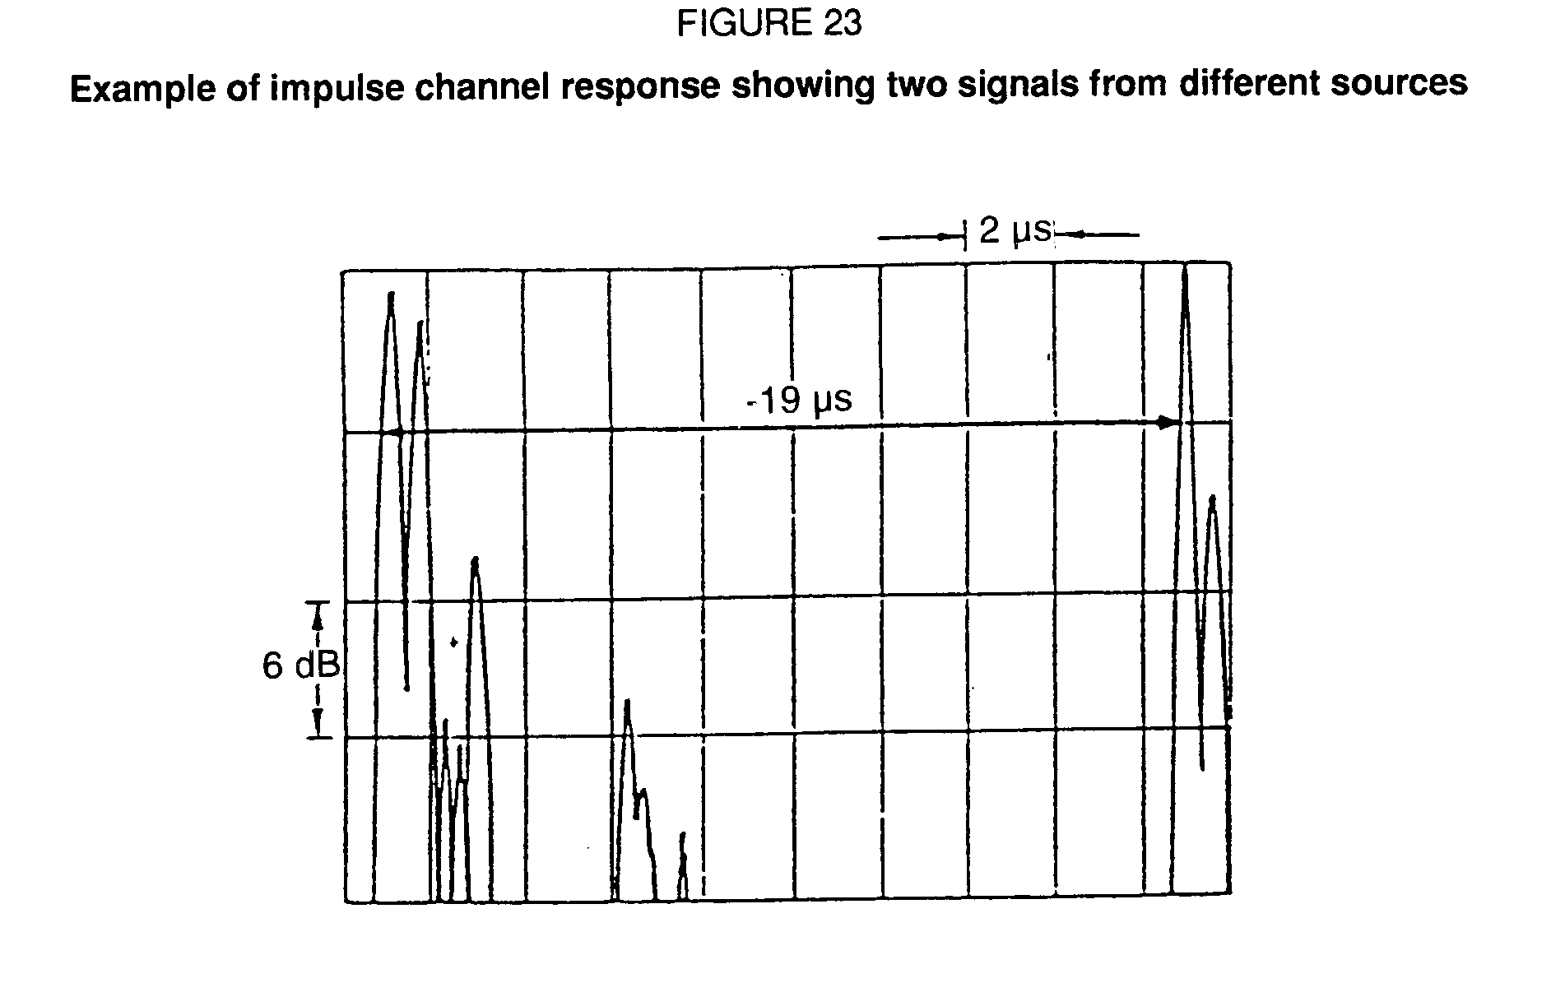

## 1.3 Ottawa, Toronto, Montreal and Vancouver - 1990

The feasibility and potentials of Digital Audio Broadcasting (DAB) were demonstrated using a temporary terrestrial transmitter operating at 798 MHz across Canada, using the Eureka-147 COFDM-MUSICAM system, through an elaborate programme of laboratory and field tests, as well as nation-wide (Ottawa, Toronto, Montreal, Vancouver) static and vehicular demonstrations.

The following are the general project conclusions:

- The trials have demonstrated that a Digital Radio Broadcasting service is practical, that the technology works, and most importantly, that there is a public demand and industry need for this new service.

- The media, industry, and public response was enthusiastic. The reaction to the new radio service concept and the quality of the product delivered by the COFDM/MUSICAM prototype system was very positive.

- All participants in the test programme were highly impressed by the excellent performance of the MUSICAM/COFDM sound broadcasting system in the laboratory and in the field.

- In the laboratory, the MUSICAM/COFDM system performed as per its specification.

- The listening tests showed that the MUSICAM process appears to be transparent with respect to basic audio quality. Audio material processed though MUSICAM (at 128 kbit/s per monophonic channel) was consistently preferred to high-quality FM.

- From an analysis of the data collected during the field tests, it has been concluded that the performance of the system can generally be predicted solely from the received power level.

- In spite of the relatively low transmitting powers used (considering that the equivalent of 16 stereophonic signals were being transmitted in the UHF-TV band), the actual coverage achieved was surprisingly extensive and relatively free of gaps, confirming its power efficiency and ability to cope with multipath fading.

- The effectiveness and practicality of the co-channel gap-filler concept was confirmed.

- In general, it is believed that a close-to-perfect coverage could be obtained with some minor adjustments at the transmitter end and with the addition of a few low-power co‑channel gap-filler transmitters.

- Statistics on the multipath environment of the cities visited indicate that a guard interval in excess of 24 microseconds would be preferred to the 16 microsecond guard interval used in the prototype system tested.

## 1.4 Las Vegas, Birmingham, Berlin and San Francisco - 1991

In 1991, full-scale demonstrations of the Digital Audio Broadcasting System were given at NAB'91 in Las Vegas (Nevada, United States), the Radio Festival in Birmingham (United Kingdom), the IFA in Berlin (Germany) and Radio 91 in San Francisco (California, United States).

Both static and mobile demonstrations in a specially-arranged coach were given. Nine stereo programmes were transmitted simultaneously, along with one FM programme for comparison. For example, in Las Vegas, the main transmitter was located on top of the Las Vegas Hilton Hotel and a gap-filler was located on top of the Golden Nugget Hotel downtown. Some 1500 participants took a tour on a bus. Overall, the demonstration was highly successful and showed clearly the superiority of the Eureka DAB system over FM.

# 2. Later experiments

## 2.1 Joint EBU/Eureka 147 Digital System A evaluation ad hoc Group tests

In November 1992, the Joint EBU/Eureka 147 Digital System A Evaluation ad hoc Group carried out a number of laboratory tests using hardware provided by the Eureka-147 Project.

### 2.1.1 Field tests of the system

A DAB signal was radiated using the CCETT single frequency network (SFN) in Band I in Rennes, and using the BBC SFN in Band Ill in South London. A set of experiments was undertaken to measure the coverage of the individual transmitters and the overall coverage of all the transmitters. This validated the operation of an SFN, showing that a seamless handover is achieved between transmitters, and that the coverage of the whole network is greater that the sum of the parts.

### 2.1.2. RF performance characteristics of Digital System A

RF evaluation tests have been carried out on Digital System A using Mode I at 226 MHz and Mode II at 1 500 MHz for a variety of conditions representing mobile and fixed reception. Measurements of BER vs. C/N were made on a data channel using the following conditions:

D = 64 kbit/s, R = 0.5

D = 24 kbit/s, R = 0.375

where D is the source data rate and R is the average channel code rate.

#### 2.1.2.1 BER vs. C/N (in 1.5 MHz) in a Gaussian channel at 226 MHz

Additive, gaussian white noise was added to set the C/N at the input of the receiver. The results are shown in Fig. 24. As an example, for R = 0.5, the measured results can be compared with those from a software simulation, to show the inherent performance of the system. It can be seen that an implementation margin of less than 0.5 dB is obtained at a bit‑error ratio (BER) of 10‑4.

#### 2.1.2.2 BER vs. C/N (in 1.5 MHz) in a Rayleigh channel at 226 MHz

Measurements of BER vs. C/N were made on a data channel (D = 64 kbit/s, R = 0.5), using a fading channel simulator.

The results are shown in Fig. 25. For the example of a Rayleigh channel with a rural profile and the receiver travelling at 130 km/h, the measured results (curve b) may be compared with those of a software simulation (curve a). The difference is less than 3 dB at a BER of 10‑4. Curve c) illus-trates typical urban performance at relatively low speed, but in a highly frequency dispersive channel. Curve d) illustrates the performance in a representative single frequency network in bad conditions, where signals are received with delays up to 600 s (corresponding to 180 km excess path length).

#### 2.1.2.3 BER vs. C/N (in 1.5 MHz) in a Rayleigh channel at 1 500 MHz

Measurements of BER vs. C/N were made on a data channel using a fading channel simulator. The results are shown in Fig. 26.

#### 2.1.2.4 Audio service availability

Provisional assessments of sound quality indicate that it is not perceptibly impaired if the BER is less than 10‑4.

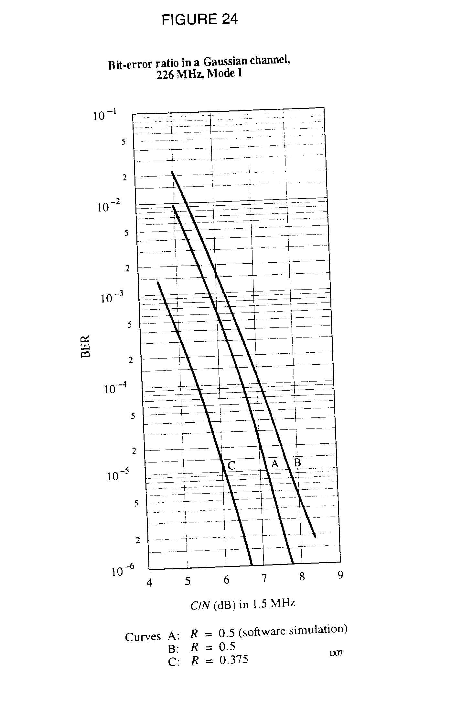

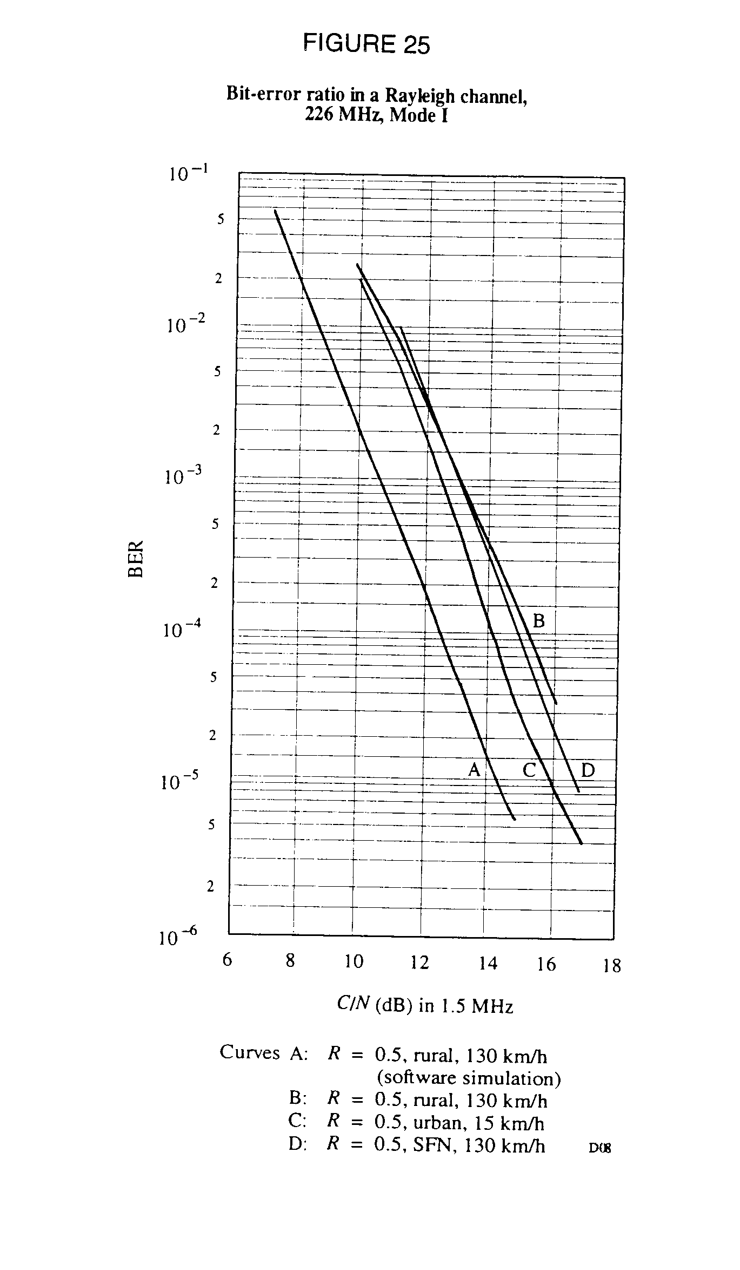

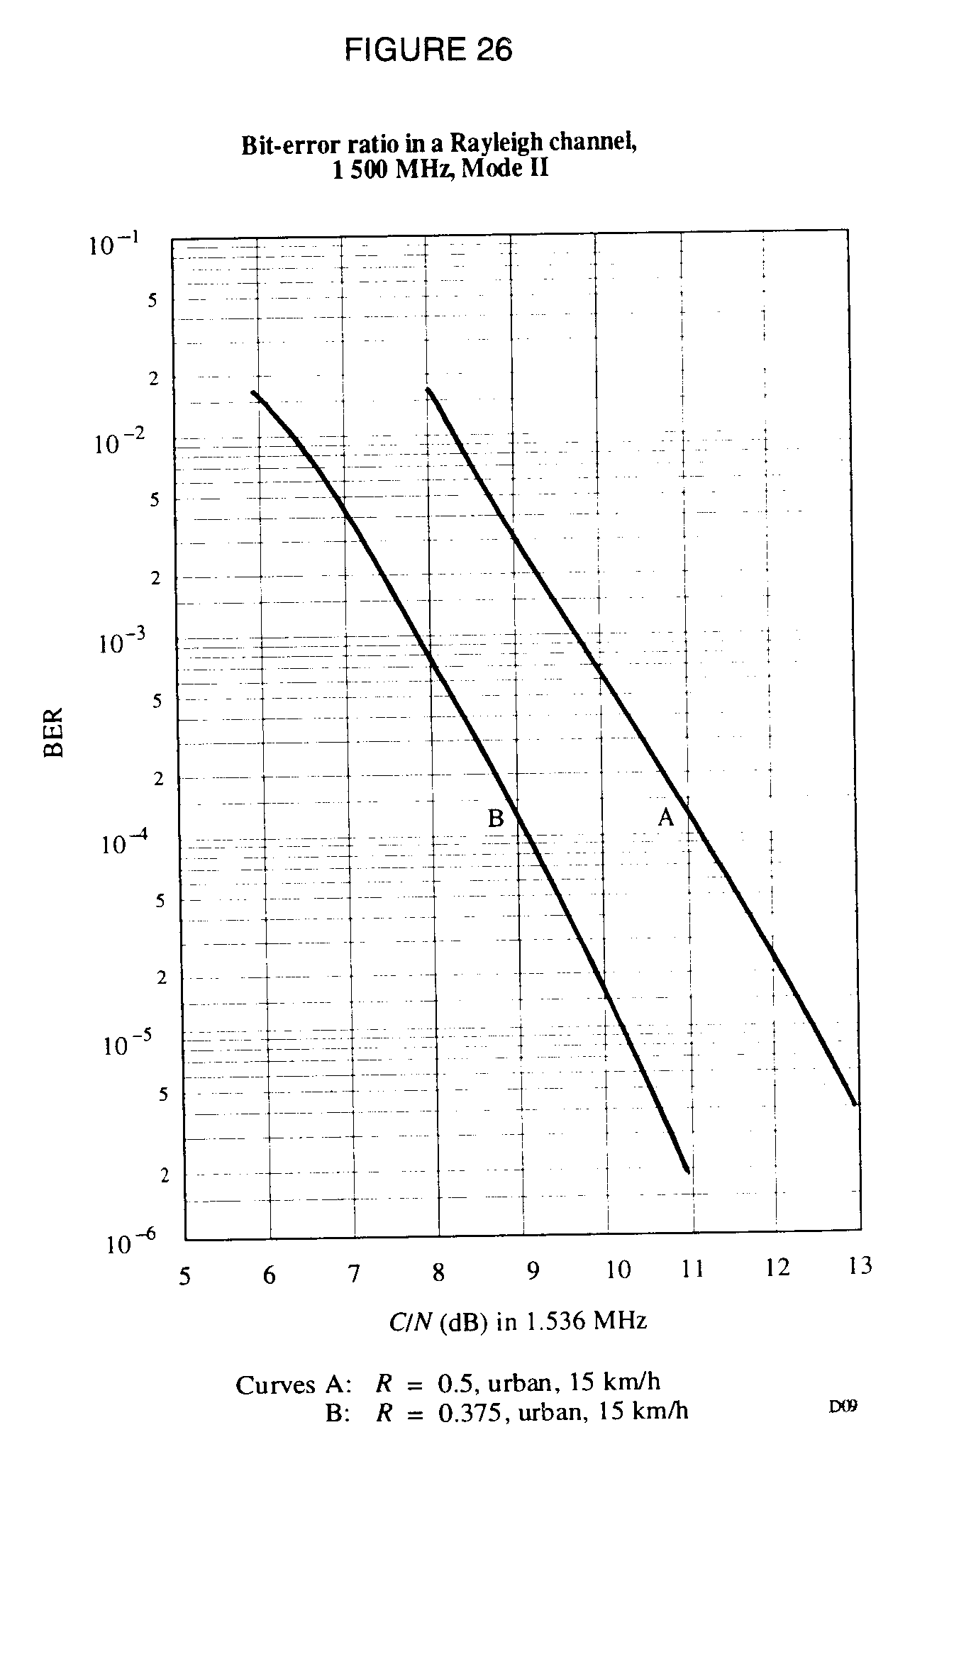

## 2.2 Current experiments

### 2.2.1 Propagation/coverage testing in Trois Rivières - Canada

As a follow on to the Toronto-Barrie coverage and propagation measurements (see Annex 1‑C) a test facility was installed at the CKTM-TV/CBMT-1 transmitter site located north of Trois Rivières, Quebec. The purpose of this field measurement program is to further study the propagation and coverage characteristics at the 1.5 GHz band and to augment the information obtained from the Barrie tests. The objectives of these tests are to determine the coverage statistics within and close to the expected coverage area (i.e. 10 - 100 km from the transmitter) and to characterize field strength variation in the region where possible interference between two co-channel DAB channels could occur (i.e. 100 - 200 km from the transmitter). Also fixed reception over two paths, approximately 62 km and 130 km from the transmitter, are being measured to evaluate the time variability of the field strength for paths above and below the radio horizon respectively. A range of transmit parameters are being used to identify the relationship of these parameters to coverage and propagation at the 1.5 GHz band. Field measurements commenced in late July and are expected to be finished by the end of October 1993.

### 2.2.2 SFN field measurements in Montreal - Canada

Following the Trois Rivières measurement programme an experimental three site SFN network will be established in the Montreal - Rigaud - St. Sauveur triangle. The three site configuration was carefully chosen so that it can be used either in a three site SFN configuration where each of the three sites will be transmitting the signal **synchronously in time**, or as a coverage extension configuration where the Mt. Royal site would be the main transmitter site and either or both of the other two sites could be used as coverage extenders in which case the two "slave" re-transmitters would not be transmitting the Digital System A signal in synchronism with the main transmitter located at Mt. Royal. In the SFN network arrangement the Digital System A signal will be distributed to St. Sauveur and Rigaud transmitters via fixed links (fibre, microwave and satellite links are all being considered) and the signals at Mt. Royal and Rigaud can be appropriately delayed to provide time synchronization. Third generation Eureka-147 Digital System A equipment will be used which will use mode 2 transmission parameters, in particular, a 64 sec guard interval which is double the guard interval used in the Toronto-Barrie SFN tests. The principal objectives of these tests are:

- to evaluate, measure and demonstrate the coverage characteristics, as well as the network configurations feasible for terrestrial Digital System A at L-Band;

- to study coverage extension techniques as a possible approach to duplicating high power FM coverage (a high power FM station located at the Mt. Royal transmitter site will be used for coverage comparison);

- to identify the coverage overlap necessary to achieve high coverage availability e.g. 90% - 99%, and to evaluate the effectiveness of using co-channel transmitting space diversity;

- to verify that the guard interval is sufficient to accommodate these transmitter spacings.

Pertinent transmit parameters for the three sites are given in Table 8.

TABLE 8

Transmit parameters for SFN network

|  |  |  |  |
| --- | --- | --- | --- |
| Site | Mt. Royal | Rigaud | St. Sauveur |
| Ground elevation (m) | 226.6 | 220 | 386 |
| Antenna height AGL (m) | 221 or 311 | 55 | 29 |
| Antenna horizontal beamwidth | Omni | Omni | 120 |
| Antenna isotropic gain (dBi) | 13 | 13 | 18 |
| Transmitter power (watts) | 160 | 160 | 160 |
| e.i.r.p. (kilowatts) | 3.2 | 3.2 | 10.0 |

The start-up date for the three site configuration is anticipated to be late November or early December 1993. Following the three site testing the Mt. Royal transmitter will be made into a "semi-permanent" experimental station to provide Digital System A demonstrations using six channels of live programming. A second demonstration station is planned to commence operation in Toronto early in 1994 in time for the Second International Symposium on Digital System A in March.

### 2.2.3 VHF Paris Digital System A network

A Single Frequency Network has been in operation in Paris since August 1993. This network (two transmitters) operates in Band I (47 - 68 MHz). The authorization to conduct the network has been given by the CSA (French regulatory body for broadcasting) for a period of two years. Some mobile links have been moved in order to use the 64.75 - 68 MHz part (64.75 ‑ 65 MHz is also part of the French TV channel 4). Calculations had been made to predict the protection of TV channels used around Paris in Band I.

The aim is to test propagation in Band I in a dense urban area as well as to propose a digital sound broadcasting service to ten broadcasters in Paris. Each of them will have at least one receiver.

# Signal features; network description

The broadcast signal is consistent with the Eureka 147 (Digital System A) features:

DAB block bandwidth 1.536 MHz

Mode I

Guard interval 246 µs

2 DAB blocks transmitted:

- centre frequencies: 65.5 MHz and 67.25 MHz

- frequency space between the two blocks: 214 kHz

Third generation DAB receivers (prototypes) are used.

The "Musicam" method of coding corresponds to the ISO/IEC 11172-3 Layer II standard.

# Transmitting sites

- Romainville (east of Paris)

ERP per block: 1.5 kW omni.

mean height of the antenna above ground: 220 m

- Meudon (southwest of Paris)

ERP per block: 3 kW (directional in azimuth 60°, antenna aperture: 60°)

mean height of the antenna above ground: 220 m.

Distance between the two transmitters: 18 km

Area: dense urban.

In Meudon and Romainville, the two Digital System A blocks are multiplexed in the same amplifier.

Further results of this experiment are given in Annex 1-C.

### 2.2.4 Digital System A field trials at 1.5 GHz in Rennes and Paris

#### Rennes experiment

During winter of 1992, CCETT evaluated the technical feasibility of terrestrial digital sound broadcasting in the 1 500 MHz frequency range (see Doc. 10B/30, ITU-R, 1990-1994). This first evaluation was performed from a single transmitter/antenna located on the FT tower in Rennes using second generation prototype equipment.

Since then, third generation Digital System A prototype equipment has been set up and numerous wideband field strength measurements were performed in order to improve the propagation and coverage field prediction in urban and rural areas.

# System parameters

The system parameters are the following:

|  |  |
| --- | --- |
| Frequency block | : 1.536 MHz |
| Modulation | : COFDM |
| Symbol length | : 156 µs in mode III : 312 µs in mode II |
| Guard interval | : 31 µs in mode III : 62 µs in mode II |
| Convolutional coding rate | : 0.34 to 0.74 |
| Useful bit rate with code rate 0.5 | : 1 152 kbit/s |
| Spectral efficiency with code rate 0.5 | : 0.75 |

# Transmitting parameters

As in the contribution presented in Los Angeles, it is the same transmitting site, with the following characteristics:

|  |  |
| --- | --- |
| Maximum active power | : 250 W |
| Linear active power | : 80 W (5 dB back off) |
| Transmitting antenna gain | : 17 dBi (45° aperture) |
| Max. ERP | : 2.2 kW |
| Antenna height | : 101 m (AGL) |
| Receiving antenna | : /4 monopole (0 dBi) |

Further results of this experiment are included in § 2,2 of Annex 1-C.

# Paris experiment

An experimental Digital System A transmitter using the 1.5 GHz band commenced transmission in Paris at the beginning of November 1993.

The 1.5 GHz Paris experiment is mainly a coverage field trial in a dense urban area. The coverage of the urban area will be estimated as a function of the Digital System A effective radiated power (ERP).

# Signal features

The broadcast signal is consistent with the Eureka 147 (Digital System A) features:

DAB block bandwidth 1 536 MHz

Mode II

Guard interval 62 µs

One DAB block transmitted:

centre frequency 1 472 MHz

Mode II can be used instead of mode III.

Third generation Digital System A receivers (prototypes) are used.

The "Musicam" method of coding corresponds to the ISO/IEC 11172-3 Layer II standard.

### Transmitting site

Eiffel Tower (centre of Paris)

ERP 1.5 kW

radiation diagram omnidirectional

height of the antenna above ground 300 m

The Digital System A encoder is located at the bottom of the Tower. The RF amplifiers are located at the top of the Tower, near the antennas, in order to avoid high feeder losses.

# Further studies

Field strength measurements will be carried out using a measuring car. They will provide information on the coverage at 1.5 GHz.

### 2.2.5 High powered field trials in London

In London, the United Kingdom established a high powered single frequency network (SFN) in Band III during September 1993. The network comprises four 1 kW ERP stations separated by about 25 km and uses the Eureka 147 third generation DSB equipment. Although the principle of the SFN is well established, the results of this trial will be used to refine the prediction parameters in the United Kingdom terrain data based prediction programmes. In addition, further building loss measurements will be undertaken and correlation coefficients will be examined. Delays will be inserted into one transmission path to study the effect of long distance interference. Opportunity will also be taken to experiment with various methods of distributing the DSB signal to the transmitters.

The central transmitter of the SFN is also capable of radiating up to 10 kW ERP and will be used to study the differences between a single high powered station and a lower powered network.

ANNEX 1-C

Applicable propagation/channel characteristics  
and related experimental results

# 1. Broadcast channel model

For the critical case of a mobile receiver, the broadcast channel can be represented by a two-dimensional function of frequency and time. Considering the frequency domain, at a given time t, the channel response is the Fourier Transform of the channel impulse response h(,t) where denotes the time delay of the channel at instant t.

Now consider the time domain. For a given frequency f, or narrow-band around f, the field strength follows a random function defined by:

- the Rayleigh distribution



where P is the mean power of the received field over a small area;

- the Doppler spectrum of which the Fourier Transform gives the autocorrelation of the field strength variation



where /c denotes the ratio between the speed of the mobile and the speed of light and (/c)f denotes the maximum Doppler frequency.

Figure 27 combines the channel frequency response and the time variation to give a two-dimensional channel representation, above which is a pattern of squares of different size:

- small squares indicate the frequency-time area where the channel may be considered as locally invariant;

- large squares show the minimum separation area for which two small squares are statistically independent.

Thus the size of the small square depends on the channel delay spread for the frequency axis and on the maximum Doppler frequency for the time axis. On the frequency axis, its length is a small fraction of the inverse of channel time spread, since, on the time axis, the length is much less than the inverse of the maximum Doppler frequency.

The large square size is defined from the cross correlation of two frequencies spaced by  F.



where J0(x) is the Bessel function of order zero;

T is the time shift between frequency f and f + F respectively;

T0 is the mean delay spread.

To obtain independence on the frequency axis, whatever the speed of the vehicle, the condition



must be satisfied.

Thus for 0.1 the length of a large square on the frequency axis is about 1/2T0.

Independence with regard for the time axis depends only on the maximum Doppler frequency. The length of large square along the time axis is given by the first zero of J0 (x), i.e.



# 

# 2. Experimental results in the 1 452 - 1 492 MHz band for digital sound broadcasting

This section contains results of tests carried out in the band 1 452 - 1 492 MHz, which was allocated to digital sound broadcasting at the WARC‑92, for the purpose of evaluating propagation characteristics and comparison with propagation models. Also information is included on SFN field trials that have been carried out in the 1 452 - 1 492 MHz band.

## 2.1 Results of field measurements in Canada

The Canadian Broadcasting Corporation (CBC), the Canadian Association of Broadcasters (CAB), the Department of Communications (DOC) and its Communications Research Centre (CRC) have jointly carried out some studies and field tests to evaluate the properties of L-band (frequencies in the 1 500 MHz range) as a suitable frequency band for a terrestrial Digital Sound broadcasting service.

Propagation tests were performed in Ottawa and Montreal in the June - August 1991 time frame. A 1 497 MHz unmodulated carrier was used to perform coverage measurements and a flat spectrum 7 MHz wide RF signal generated by a pseudo-random bit sequence was used to assess the impact of channel bandwidth on selective fading. These signals were transmitted at an effective radiated power (ERP) of 8 kilowatts. The transmitting effective height above average terrain (EHAAT) was 68 metres in Ottawa and 230 metres in Montreal. Coverage assessment, channel bandwidth effects on frequency selective fading as well as indoor reception measurements were done using an experimental omnidirectional 1.5 GHz receive antenna (vertical monopole). Indoor measurements were performed with a field strength metre whereas fixed and mobile outdoor measurements were carried out with a special mini-van equipped with a sophisticated measurements system that automatically sampled and recorded the field strength every eighth of a wavelength (i.e. 2.5 cm). This high sampling rate facilitated the characterization of selective fading.

As an aid to test planning, coverage predictions were made using a CRC VHF/UHF propa-gation software program (PREDICT) which is based on a combination of various prediction models and adjustment factors, and uses terrain topography data. Measurement routes were selected in va-rious environments (i.e. dense urban, urban, suburban and rural areas) including particular possible trouble spots such as predicted coverage gaps, suspected gaps, underpasses, tunnels as well as mea-surements at the anticipated limit of coverage. In total 1 680 eight hundred metre sections consisting of close to 53 million measurement points were recorded. In designing the test and analysis procedure, the expected performance of current digital radio broadcasting systems was considered.

### 2.1.1 Effect of channel bandwidth

The information about the improvement of service availability lies in the distance in decibels between the cumulative distribution curves of the different bandwidths, at specific percentages of service availability. These distances can be reported to a new graph (Fig. 28) showing the increasing multipath fade margin as the channel bandwidth is increased from 100 kHz - 5 MHz, in the different multipath environments. The fade margin can be interpreted as the possible saving in transmit power relative to that needed for a 100 kHz channel bandwidth system, for an equivalent service availability objective.

Fig. 28 shows that for service availability objectives lower than 50%, the improvement in fade margin remains in the order of 1.5 dB for a dense urban area. Significant improvement is observed for service availability objectives of 90% or greater. Each curve can be divided into two sections, the first part being from 100 kHz to a bandwidth value that corresponds to a knee in the curve, the second part being from the knee position to the 5 MHz bandwidth value. The criterion used to consistently locate the knee position is to find the point along the 99% service availability curve that corresponds to a 1 dB reduction of the fade margin value read at 5 MHz.

This method of quantifying the effect of the bandwidth on the multipath fade margin was applied to the eleven zones and the results are summarized in Table 9. This table shows the improvement in multipath fade margins as the channel bandwidth is increased from 100 kHz ‑ 5 MHz for service availability objectives of 90% and 99%.

TABLE 9

Multipath fade margins for service availability of 90% and 99%

|  |  |  |  |  |  |
| --- | --- | --- | --- | --- | --- |
| TYPE OF ENVIRONMENT | KNEE POSITION | TYPICAL IMPROVEMENTS IN FADE MARGIN (dB) | | | |
|  |  | 100 kHz-to-knee | | Knee-to-5 MHz | |
|  | (MHz) | 90% | 99% | 90% | 99% |
| DENSE URBAN | 1.8 | 5.4 | 8.6 | 0.5 | 1.0 |
| URBAN | 1.6 | 4.5 | 7.0 | 0.6 | 1.0 |
| SUBURBAN | 1.9 | 4.1 | 8.1 | 0.6 | 1.0 |
| RURAL, FOREST | 1.7 | 3.7 | 6.0 | 0.7 | 1.0 |
| RURAL, OPEN | 1.1 | 1.2 | 1.8 | 0.7 | 1.0 |

Typically, the 90% service availability objective curves show an improvement in the order of 4 dB, from 100 kHz to the knee (1.1 to 1.9 MHz), and an improvement remaining below 0.7 dB, from the knee to the 5 MHz bandwidth value.

It appears that an appropriate choice for a channel bandwidth is a value around 2 MHz. Below 2 MHz, the multipath fading increases abruptly while above 2 MHz the improvement in fade margin is generally not very significant.

The same results were also analysed from a different direction. In this case, the analysis of the data was made to identify the effect of the signal bandwidth on the variability of the received signal field strength for different environments (rural, suburban and urban), both in small and large areas, in view to give more insight on the amount of additional power required to increase the location coverage percentage from 50% to 99%, as suggested in § 4.4.4 of the main Report in the 1.5 GHz band.

It is noted that the terrain where these measurements were made (i.e. city of Ottawa) is relatively smooth and does not correspond to a degree of terrain irregularity h of 50 metres as assumed in Recommendation ITU-R PN.370, thus resulting in less variability than what is reported in Recommendation ITU-R PN.370.

Large areas are represented by 800 metres long routes, corresponding to 4 000, whereas small areas are represented by 12.5 metre routes, corresponding to 62.5. A large area is characte-rized by the presence of shadowing which is due to terrain features and man-made obstructions. In a small area, the effect of shadowing is relatively constant, and the dominant cause of field strength variation is multipath.

A mobile receiver is exposed to fading from both shadowing and multipath. A narrow-band signal is very much affected by multipath, and the resulting large variations of the field strength are non-negligible when estimating the service availability to the mobile receiver. A wideband signal, however, is less affected by multipath fading. In the context of a DSB service to vehicular receivers, it is useful to study both factors contributing to the signal variations (i.e., shadowing and multipath).

An example of the data used is shown in Fig. 29, which depicts a CW signal seen by a mobile receiver in an urban area. The relative field strength (normalized to the mean) is shown as a function of the receiver location along the measurement route. It can be seen in the large area that multipath causes fast and very deep fades, while a rather slow variation of the envelope of the signal reveals the presence of shadowing due to tall buildings.

A magnified view of the received signal as a function of location, presented as the small area, shows that multipath causes large signal variations resulting from signal cancellation between the various scattered signal components. This variation of the resulting signal field strength usually corresponds to a Rayleigh distribution.

The effect of the signal bandwidth is illustrated in Figs. 29 and 30. These show the variation of a received signal in an urban environment, as seen over a large area, and also as seen in a small segment of this large area. The corresponding cumulative distribution functions (CDF) are also presented, where the dotted line shown as reference is the theoretical cumulative Gaussian distribu-tion function, and the solid line represents the cumulative distribution of the measured signal levels. The results for a CW signal are shown in Fig. 29, while Fig. 30 shows the results for a 1.47 MHz wide signal.

As can be seen from these figures, the 1.47 MHz wide signal exhibits much less multipath fading than the CW signal, and the wideband signal's CDF is closer to the reference Gaussian's CDF than in the case of the CW signal's CDF.

Another measure of the bandwidth's impact is the standard deviation (SD) of the received signal levels. Table 10 presents values of SD for various signal bandwidths and environments, as determined for small area measurements.

TABLE 10

Standard deviation (dB) in small area, for different environments  
and signal bandwidths

|  |  |  |  |  |
| --- | --- | --- | --- | --- |
| Environment | Narrow-band | | Wideband | |
|  | CW | 30 kHz | 1.47 MHz | 3.00 MHz |
| Urban | 5.4 | 4.3 | 1.6 | 1.3 |
| Suburban | N/A | 3.6 | 1.7 | 1.4 |
| Rural | N/A | 3.4 | 1.3 | 1.3 |

The difference in SD between the CW signal and the 1.47 MHz wide signal is around 4 dB for urban environments, and in the order of 3 dB for suburban and rural. Measurements with CW signals were not available to verify this last value but the general trend suggests that it is a reasonable estimate. These results show that a CW signal in a small area is not Gaussian distributed (or log-nor-mal when the field strength is expressed in linear units) and that by widening the signal bandwidth, the Rayleigh component due to multipath is progressively eliminated so that the resulting signal approaches the Gaussian distribution. Statistics of field strength variations in small areas are useful for planning the local service availability for vehicular receivers, but they cannot be used for planning the overall coverage.

Table 11 illustrates the impact of signal bandwidth on the SD in a large area. The narrow-band signals are still very much affected by multipath and their SD values are in the order of 3 dB higher than that of the wideband signals. The wideband signals' SD are more representative of the shadowing component than the multipath component, as was the case for small area. This is supported by the good matching of the theoretical and measured large area CDF curves in Fig. 30.

TABLE 11

Standard deviation (dB) in large area, for different   
environments and signal bandwidths

|  |  |  |  |  |
| --- | --- | --- | --- | --- |
| Environment | Narrow-band | | Wideband | |
|  | CW | 30 kHz | 1.47 MHz | 3.00 MHz |
| Urban | 6.2 | 5.3 | 3.2 | 3.1 |
| Suburban | N/A | 6.2 | 4.6 | 4.3 |
| Rural | N/A | 5.8 | 4.6 | 4.2 |

It can be concluded that, in the case of vehicular and portable reception, in addition to the shadowing component, multipath fading contributes to an increase of the signal variation, making the standard deviation larger than without the presence of multipath. Increasing the signal bandwidth to 1.47 MHz helps to diminish the impact of multipath, therefore bringing the standard deviation of the received signal over a large area closer to what is predicted by Recommendation ITU‑R PN.370 which is based on narrow-band received levels averaged over small areas.

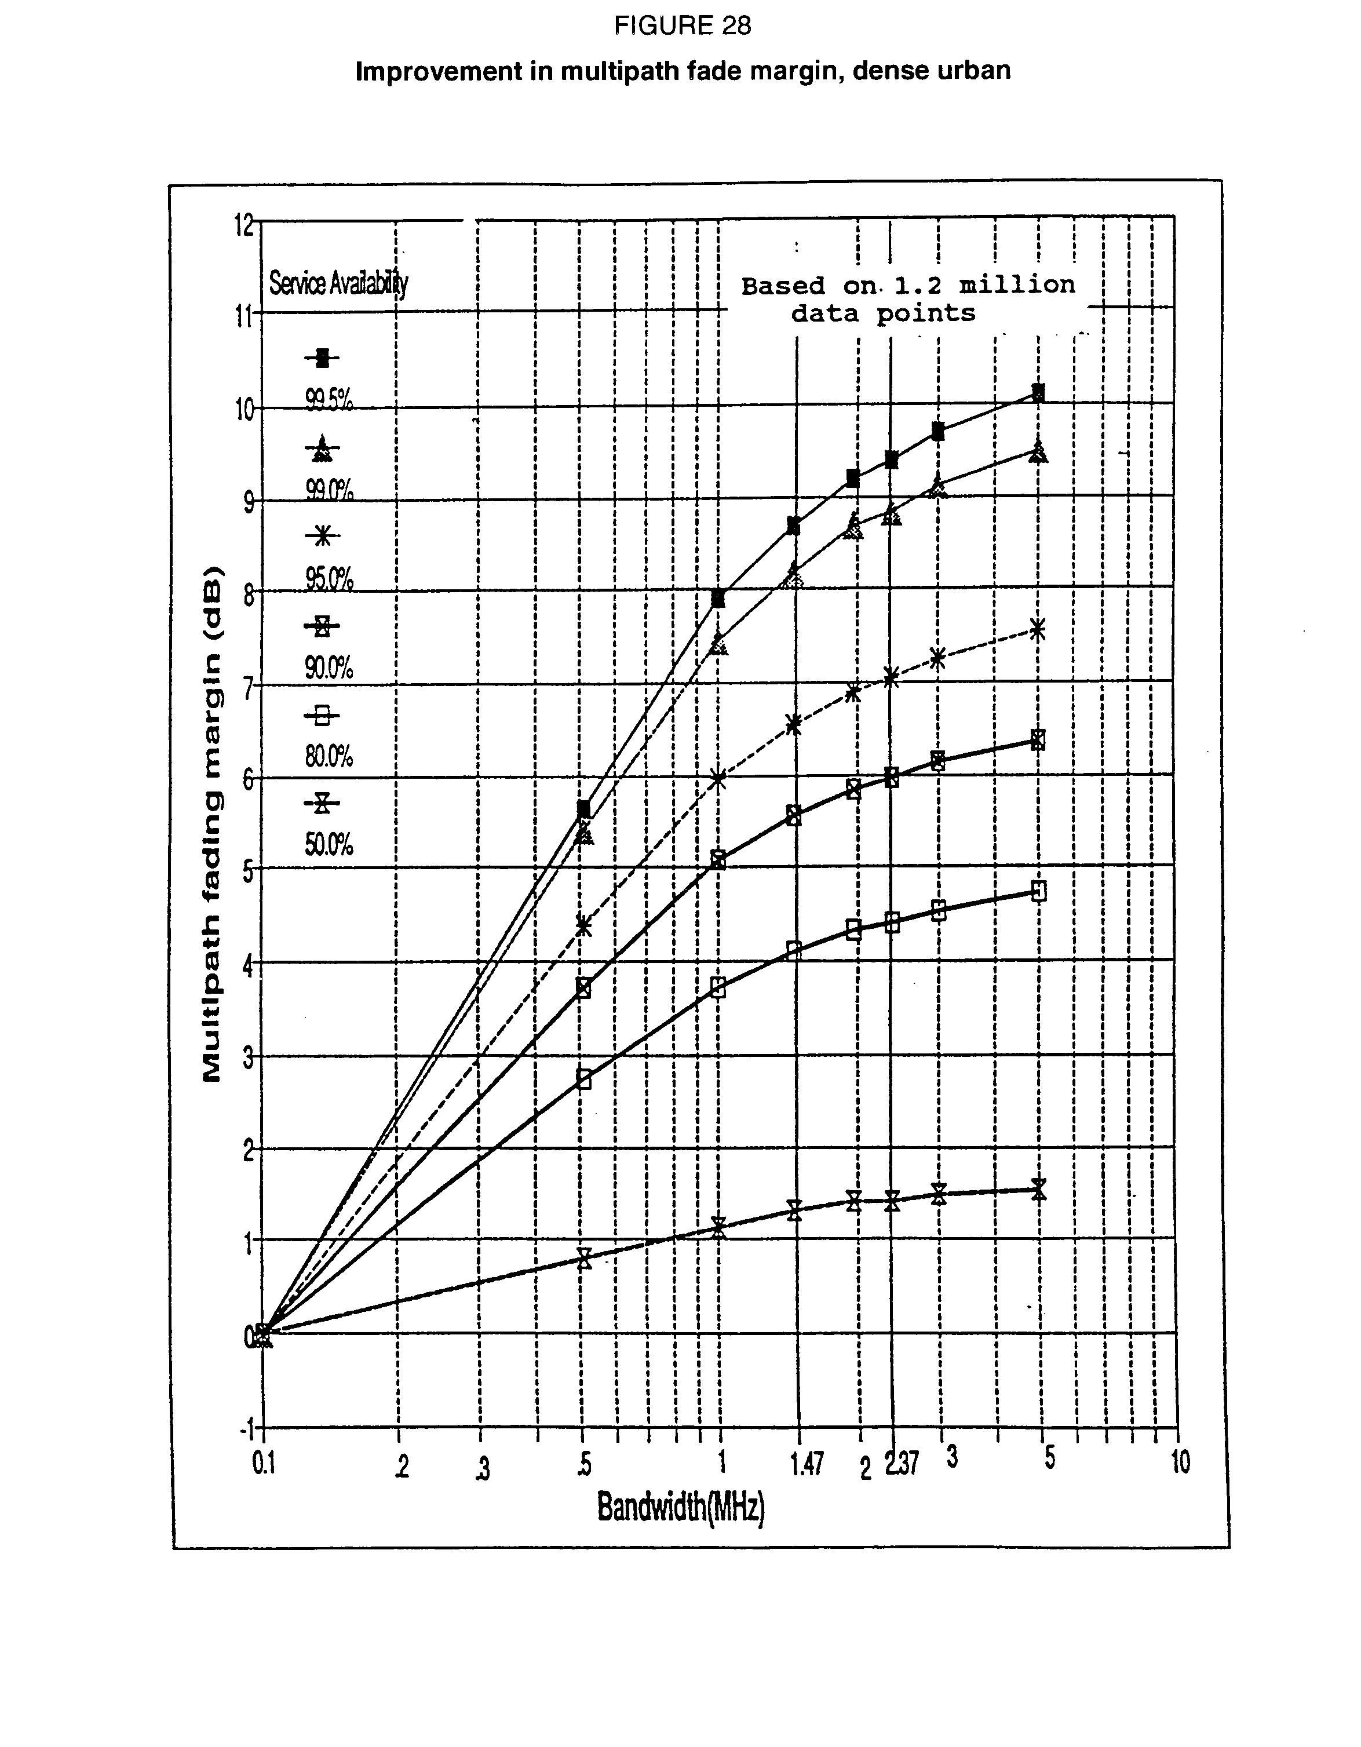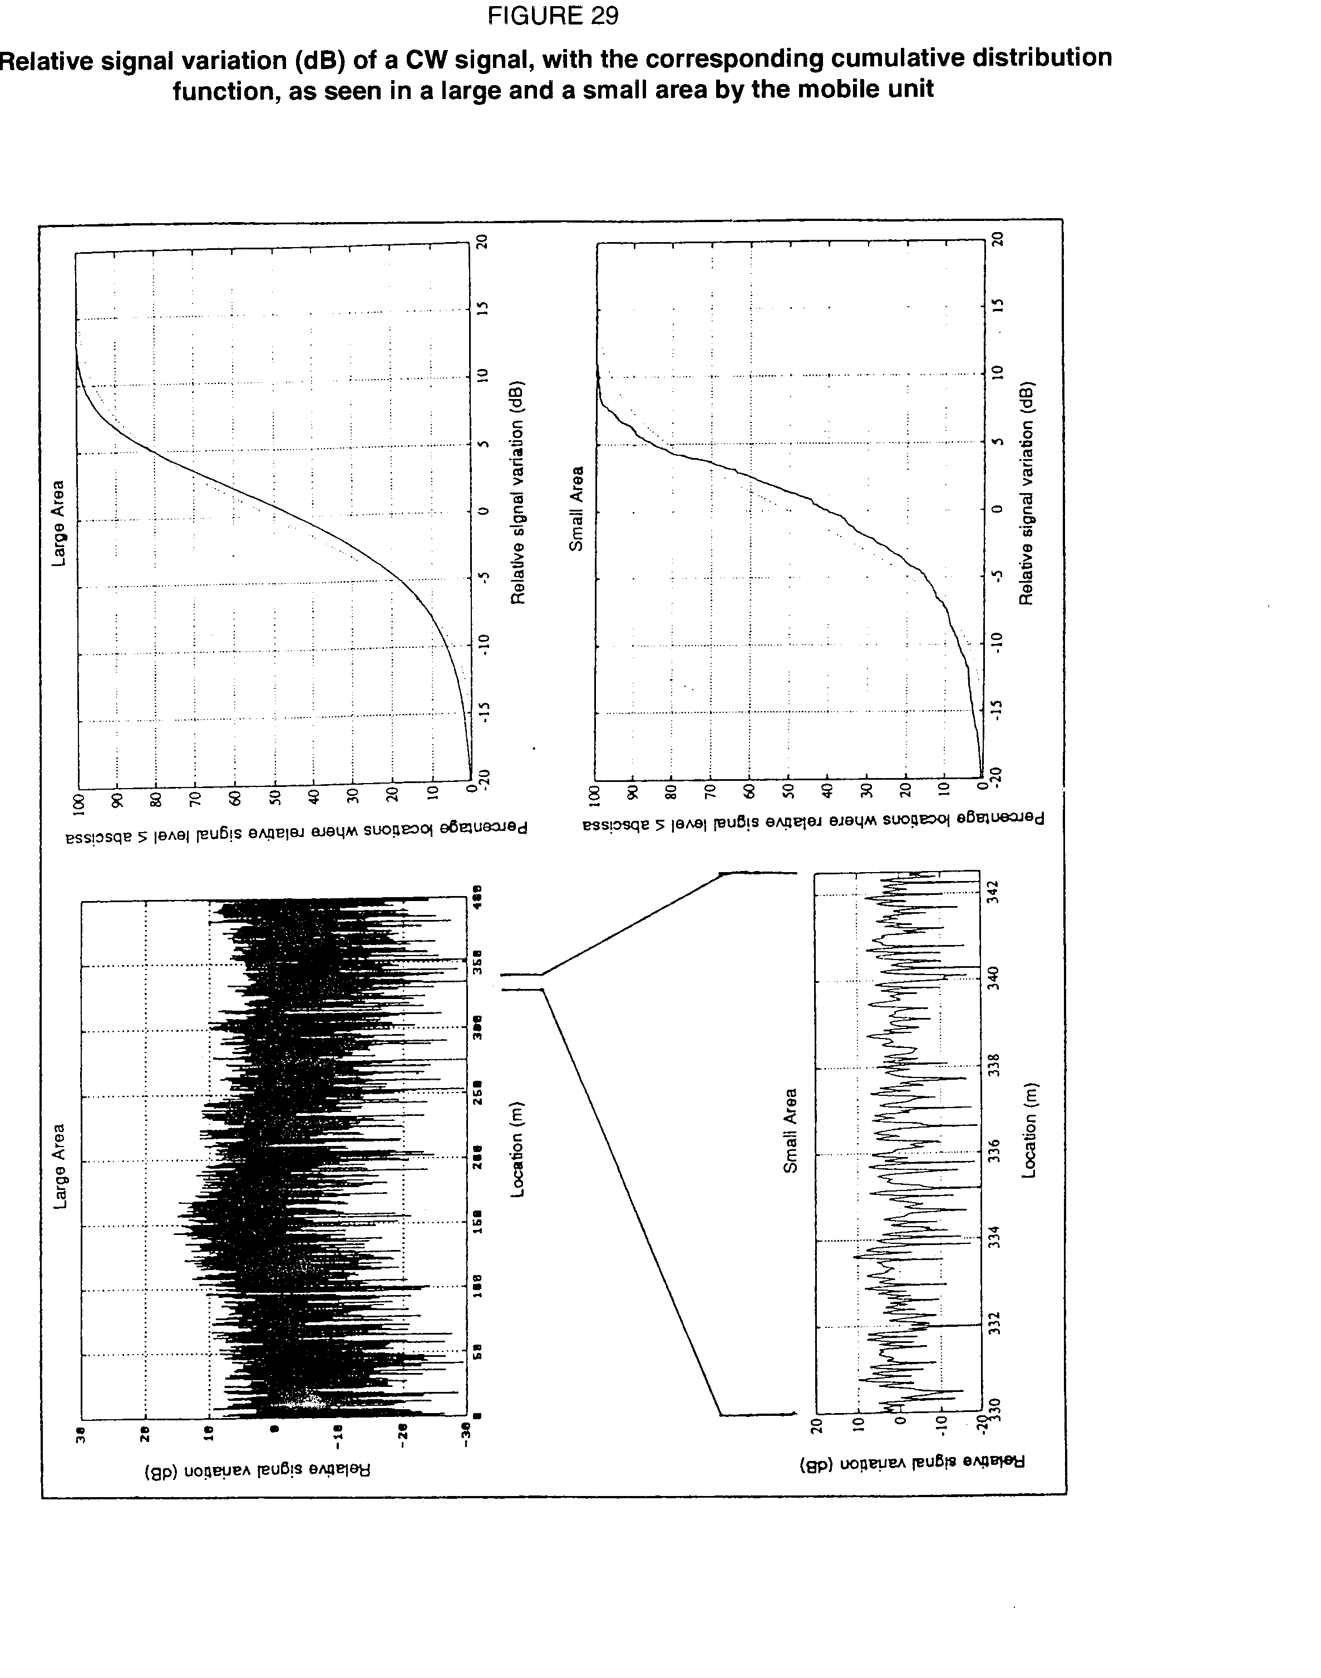

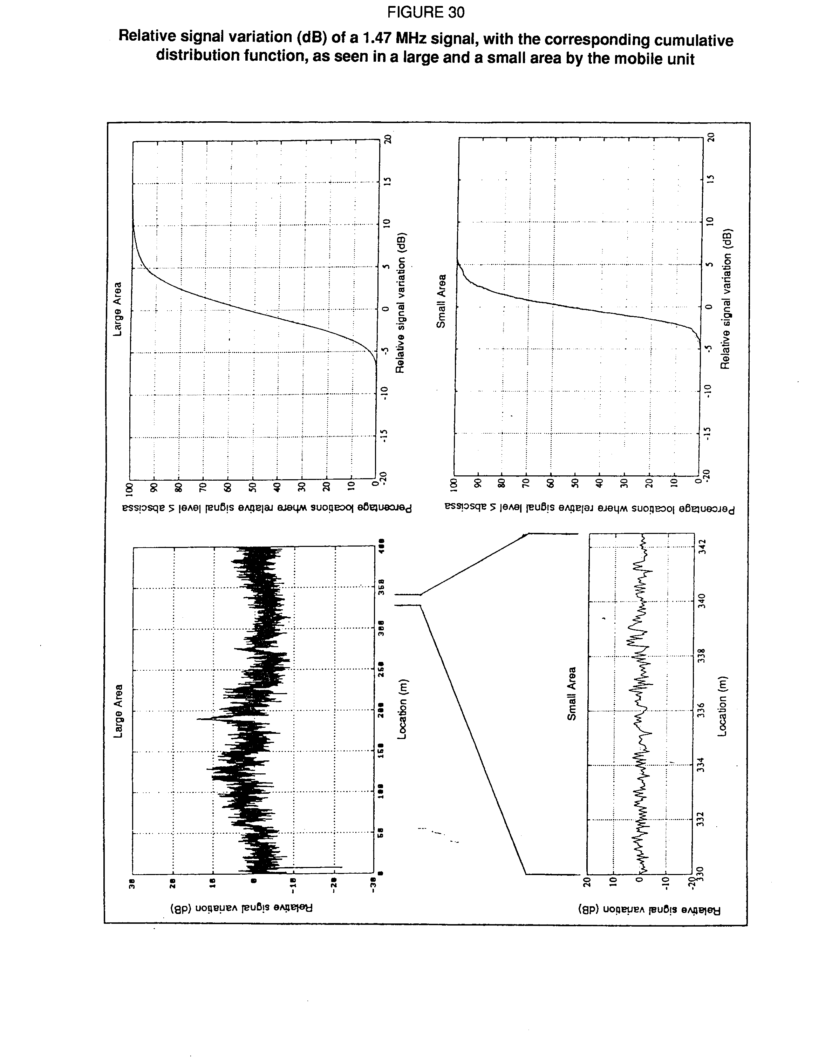

### 

### 

### 2.1.2 Results of coverage measurements

#### 2.1.2.1 Introduction

Propagation measurements were carried out in Ottawa, Canada during the summer of 1991 at 1 497 MHz to, *inter alia*, evaluate the coverage capabilities in this frequency range for digital sound broadcasting.

Measured coverage taking into account the characteristics of digital sound broadcasting systems operating at a frequency of 1 497 MHz is compared to a calculated coverage at 1 497 MHz. Also coverage results are compared to predicted coverage for a FM broadcast facility at 100 MHz utilizing the same transmitter parameters.

#### 2.1.2.2 Calculated contours for 1 497 MHz and for an FM broadcasting service

These other contours, provided for comparison, were generated by the predict programme. This programme, developed at the Communications Research Centre (CRC) of the Department of Communications in Ottawa, is a VHF/UHF propagation prediction programme. It takes into account the terrain profile, climate and seasonal factors (such as tree foliage) to calculate the reflections and the various path losses due to diffraction and tropospheric scattering. The programme outputs field strength values for different azimuths around the transmitter for a chosen percentage of time.

For each of the measured contours, an equivalent predict contour was generated for the same field strength (39 dBV/m) and for the same percentage (50% or 90%).

The predict programme was also used to provide the FM broadcast coverage corresponding to a similar transmitter power and elevation. This way, it is possible to compare the expected coverage for a DSB system at 1.5 GHz (the 39 dBV/m contour) and the corresponding coverage for a traditional FM system.

#### 2.1.2.3 Conclusions

In general, the measured contours at 1 497 MHz are similar to the ones generated by the predict programme. The small discrepancies between the two contours can be explained by the lack of measured values in certain regions and the accuracy of the data base used in the predict program-me. The topographical data base used by the predict programme has a precision of 500 metres and accurate building and tree factors would be necessary to improve the accuracy in the predict analysis. The predict programme, with some refinements to make it more applicable to L‑band frequencies, can be used for planning purposes to predict the coverage for a digital sound broadcasting system.

Comparing the FM coverage (54 dBV/m at 100 MHz) with the DSB coverage (39 dBV/m at 1 497 MHz) shows the similarity between the coverage areas. We can conclude that within a radius of 40 kilometres, DSB at 1.5 GHz band would provide coverage as good as FM at 100 MHz for the same transmitter parameters. However, further tests will be required to verify that the 1.5 GHz band propagation would provide similar coverage to FM at larger distances when using similar transmitting parameters.

### 2.1.3 Results of indoor reception measurements

The measurements were analysed to determine the attenuation between the exterior and the interior received signal. The data were first divided into two groups. The first was the measurements taken in the upper levels of the building which had an unobstructed propagation path from the exterior of the building to the transmitter. The reference exterior received signal for the upper levels was the signal measured on the roof of the building. The second group was the measurements taken at low or ground level of the building which had an obstructed propagation path from the building to the transmitter. The reference exterior received signal for the ground level measurements was the signal measured on the outside of the building at ground level.

An exterior/interior attenuation factor was determined for each group of measurements by subtracting the indoor measurement from the reference exterior received signal. These factors were then arranged by type of location in each building identified as BEST, AVERAGE and WORST. These location types are described as follows:

- BEST: A location next to a window with an unobstructed propagation path to the transmitter.

- AVERAGE: A location around the perimeter of the building at a distance from the windows but not hidden from windows.

- WORST: A location in the interior of the building with no direct view of any windows. This category includes floors with no windows and basement and sub-basement levels.

Examination of these attenuation factors showed similar results based on whether the building was constructed of concrete or wood. The data were thus further arranged based on the type of construction. The mean and range of the attenuation for each type of location was determined and is shown in the table below.

During the course of the measurements, variations of 5 - 8 dB in the received signal level were observed due to traffic near the receiver, (people and objects). A similar variation was noted in exterior measurements due to vehicle and pedestrian traffic.

The exterior received signal was greater than 59 dBV/m in the dense urban and urban areas and greater than 54 dBV/m in the residential area. These levels are 20 and 15 dB (average attenuation of the two building types measured) above the threshold of a digital sound broadcasting receiver.

TABLE 12

Measured building attenuation factors

|  |  |  |  |  |  |
| --- | --- | --- | --- | --- | --- |
|  | |  | Attenuation (dB) | | |
| Type of Building | | Location | Best Location | Average Location | Worst Location |
| Concrete Building | | Upper Level Mean Range  Ground Level Mean Range | 8.1 3 - 13  8.4 3 - 15 | 21.0 11 - 28  17.1 8 - 28 | 31.9 25 - 42*  32.0 - |
| Wood Building | | Ground Level Mean Range | 9.0 - | 16.0 15 - 17 | - - |
| * 42 dB was measured on a floor having no windows and reserved for mechanical equipment. This floor was not occupied and is not a typical receiving location. | | | | | |

# Conclusions

The average attenuation due to buildings at a frequency of 1 500 MHz was found to be 15 - 20 dB depending on the type of building. Suburban residential buildings of wood frame construction with an exterior siding material had an average attenuation of 15 dB. Urban or dense urban office and apartment buildings had an average attenuation of 20 dB. Service contours of 54 dBV/m (residential or rural) and 59 dBV/m (urban or dense urban) will be necessary for satisfactory indoor reception of digital sound broadcasting at 1 500 MHz (based on a receiver with a threshold of 39 dBV/m). These values were achieved in the Montreal test area at distances greater than 20 km from a existing broadcasting location with a transmit ERP of 8 kW.

### 2.1.4 Comparisons with propagation models

#### 2.1.4.1 Measured data curves

Curves of field strength versus distance were generated for the two test sites (Ottawa and Montreal) and for 50% and 90% of locations by grouping the data into distance bands of 1 km increment from the transmitter and averaging the field strength statistics in each band. These curves are then used for comparison with different existing propagation models: the free space model, the Recommendation ITU-R PN.370 model, the Okumura model and the CRC Predict model. It should be noted that the initial part of the curves represents the decrease in level associated with moving from a line-of-sight area to an area with an obstructed or shadowed area. In Ottawa, between 2 and 5 km, the measurement path changed from an open area to a residential area with large trees which obstructed the path to the transmitter. In Montreal, between 19 and 24 km, the measurement path changed from an open line-of-sight area to locations behind a close small mountain which produced a heavily shadowed area. At other distances, the curves generally represent propagation for an average mix of environments (urban, suburban and rural).

#### 2.1.4.2 Free space curves

The free space loss was calculated with the standard formula:

fr.sp.loss = 32.4 + 20 log f + 20 log d = 95.9 + 20 log d

where: f is the frequency (= 1 497 MHz)  
 d is the distance (in km)

The free space field strength curve is determined by subtracting the free space loss from the equivalent field strength for an e.i.r.p. of 41.1 dBW (211.8 dB(µV/m)).

#### 2.1.4.3 ITU-R curves

The curves for 50% of locations were derived from Fig. 9 of Recommendation ITU‑R PN.370-5 (1990). To get the curves for 90% of the locations, a correction of -12 dB from Fig. 12 of the same Recommendation was applied to the 50% curves.

However these curves are designed for frequencies up to 1 000 MHz and for a receiver height of 10 m. On the basis of a contribution from Canada, these curves were corrected for the frequency (1.5 GHz) and for the receiver height (1.5 m).

The correction factors depend on the distance from the transmitter and vary from 9 to 7 dB for the receiver height and 1 to 2 dB for the frequency.

#### 2.1.4.4 Okumura curves

The Okumura curves have been obtained from the Okumura article, entitled "Field Strength and Its Variability in VHF and UHF Land-Mobile Radio Service", published in the Review of the Electrical Communication Laboratory, vol. 16, no. 9-10, Sept-Oct 1968. The urban curves are derived from the Fig. 41(d). The correction factors for suburban, quasi-open and open area are extracted from Figs. 20 and 22. The adjustment for 90% of locations was derived from Figs. 37(a) and 37(b). These Okumura curves have been obtained from multiple measurements done in Japan. They do not rely on any theoretical model.

#### 2.1.4.5 Conclusions

The comparison of the measured curves with the Recommendation ITU-R PN.370 model in Fig. 31shows that the corrected curve for 50% of locations gives a reasonable approximation of the field strength at distances which are less than 2/3 of the radio horizon for each system (30.6 km for Ottawa and 63.2 km for Montreal). Closer to and beyond the radio horizon, the measured field strength is greater than the value predicted by the CCIR curve. When the CCIR model is corrected for 90% of locations, the fit of the measured data is not good.

With the Okumura model shown in Fig. 32, a good correlation between the measured data and the suburban Okumura model is evident at distances within the radio horizon. At distances close to and beyond the radio horizon, the measured data is greater than the suburban model and approaches the curve for the Okumura quasi-open model. As with the CCIR model, the measured data does not compare favourably with the Okumura suburban model for 90% of locations.

These results show that further studies are necessary to develop a reliable propagation model which addresses the full range of transmission parameters that will be used for Digital Radio Broadcasting.

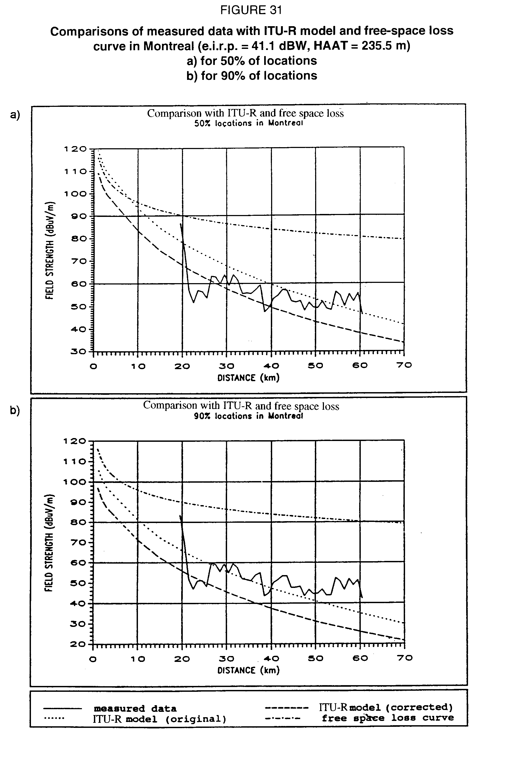

### 

### 2.1.5 SFN field trials at 1 452-1 492 MHz

#### 2.1.5.1 The Canadian Toronto-Barrie experiment

A two-site Digital Sound Broadcasting (DSB) test transmission facility operating in the band 1 452 - 1 492 MHz was established in Canada to evaluate, measure and demonstrate the coverage/propagation and channel characteristics, as well as the transmitter/network configurations feasible for terrestrial DSB in this frequency range.

The test facility consists of two transmitting installations established at existing broadcast sites, located respectively at the CN Tower in Toronto and at the CKVR-TV site in Barrie. The two sites are separated by 82.6 km and broadcast their signal, a single carrier for the coverage measurements and a 3.5 MHz COFDM (Eureka-147 second generation) signal for the SFN trials, on the same frequency at 1 468.75 MHz.

The Barrie site was selected for its surrounding rural environment with varied and difficult terrain conditions as well as the possibility to vary the transmission height.

The Toronto surrounding includes high dense urban, urban, suburban and rural environments.

Table 13 summarizes the transmitter parameters for Barrie:

TABLE 13

|  |  |  |  |
| --- | --- | --- | --- |
| Transmitter location  (Barrie)  Transmitter Frequency  Transmitter Power | Lat. 44°21'05" N  Long. 79°41'55" W  1468.75  160 | | MHz  W |
| Polarization | Linear-Vertical | |  |
| Antenna Beamwidth (-3 dB) | CASE A | CASE B |  |
| E-Plane | 4.0 | 4.0 | Degrees |
| H-Plane | 40 | 120 | Degrees |
| Antenna Gain | 22.5 | 18 | dBi |
| Antenna Height (AGL) | 97 | 230 | Metres |
| ERP | 42.4  17.4 | 37.9  6.2 | dBW  kW |
|  |  |  |  |

The antenna could be located at two positions on the tower, at 97 m and 230 m, respectively. To avoid excessive feeder losses the High-Power Amplifier (HPA) was located on the tower beside the antenna. Although the HPA was capable of transmitting 240 W at saturation it was backed off to approximately 160 W to correspond to the power output used in the COFDM tests. An unmodulated carrier was used for the propagation measurements in order to maximize the capability of measuring low field strengths (i.e., as low as 15 - 20 dBV/m).

Six test routes were selected to measure field strengths. The test routes were chosen to approximate radials with azimuths 120, 160, 170, 180, 184 and 200, respectively. Examples of the topographical profiles for these radials are given in Figs. 33 and 34. The h, calculated as per the definition in Recommendation ITU-R PN.370, are 45.1, 90.4, 90.3, 59.9, 76.9 and 79.9 m, respectively. This gives an average h of 73.7 m which is a larger h value than that used to generate the prediction curves given in Recommendation ITU-R PN.370. For each of the radials, data were collected for distances ranging from approximately 5-80 km from the transmitter.

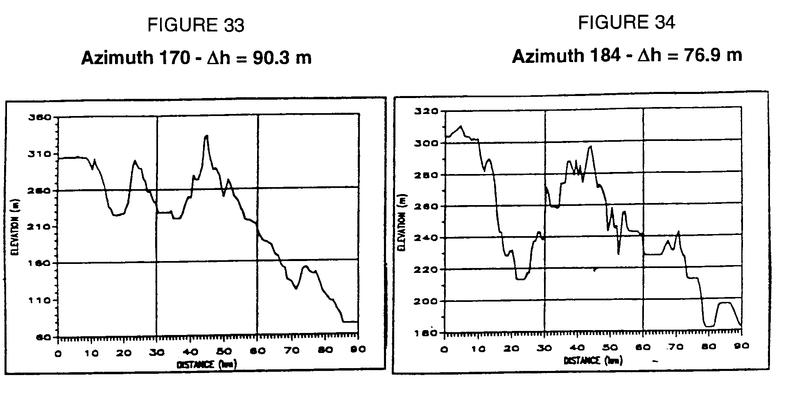

For the SFN trials a second transmitter was set up on the CN Tower in Toronto operating on the same frequency as Barrie (i.e., 1 468.75 MHz). The pertinent characteristics of the CN Tower installation are given in Table 14.

TABLE 14

|  |  |  |
| --- | --- | --- |
|  |  |  |
| Transmitter location (CN Tower) | Lat. 43°38'33" N |  |
|  | Long. 79°23'15" W |  |
| Transmitter frequency | 1 468.75 | MHz |
| Transmitter power | 160 | W |
| Polarization | Linear-Vertical |  |
| Antenna beamwidth (-3 dB) |  |  |
| E-plane | 4 | Degrees |
| H-plane | 60 | Degrees |
| Antenna gain | 21 | dBi |
| Antenna height (AGL) | 364 | m |
| ERP | 12.4 | kW |
|  |  |  |

#### 2.1.5.2 Preliminary results of propagation measurements

As presented in § 2.1.5.1, six routes were tested corresponding approximately to six radials ranging in azimuths from 120 - 200. The results presented here combine the data from all these radials adjusted for the ERP variance due to changes in the antenna gain for the different azimuths. This adjustment was not a substantial correction since all but two radials (120 and 200 for the 40 antenna only) was outside the 3 dB beamwidth. To estimate the DAB coverage distance along these radials the threshold field strength for this particular receiver configuration and generation of Eureka-147 hardware was measured at 39.5 dB(V/m).

Figures 35 and 36 compare the received field strengths for the two transmit antenna heights of 97 m and 230 m for 50% and 90% of locations respectively:

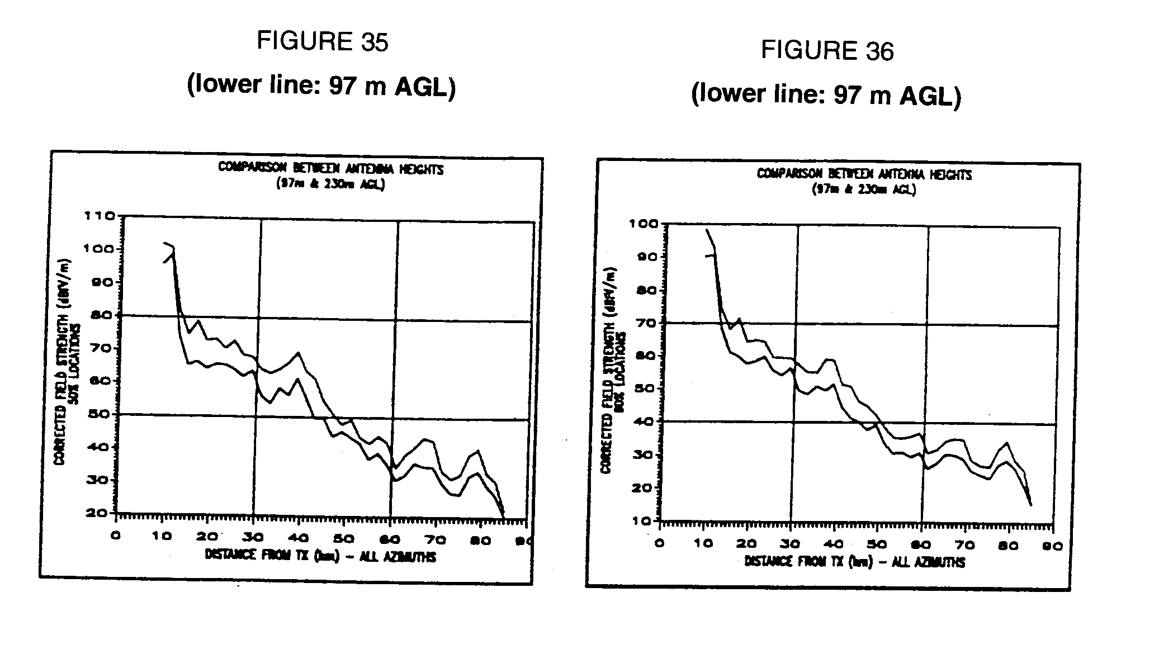

Figure 35, which is for 50% of locations, shows an average of 6.3 dB improvement in field strength, and Fig. 36, for 90% of locations, indicates an improvement of 5.4 dB.

In comparison, the ITU-R model indicates a 9-10 dB difference.

#### 2.1.5.3 SFN trials

##### 2.1.5.3.1 SFN performance measurements along critical routes

In order to better evaluate the performance of the SFN, two critical Study Routes (SR) were selected. One route of them is analysed.

SR 404-8 is representative, in terms of coverage overlap and differential delays, of the general N-S routes covered by the SFN. The detailed surveyed route starts at the intersection of Highways 404 and 7 (23 km from Toronto and 61.2 km away from Barrie), and ends at the intersection of Routes 8 and 32 (62 km from Toronto and 26.5 km away from Barrie). The measured field strength along the route is plotted on Fig. 37 for both the Toronto/Barrie SFN transmission and also for Toronto transmission only (Note - the two curves are misaligned by about a kilometre).

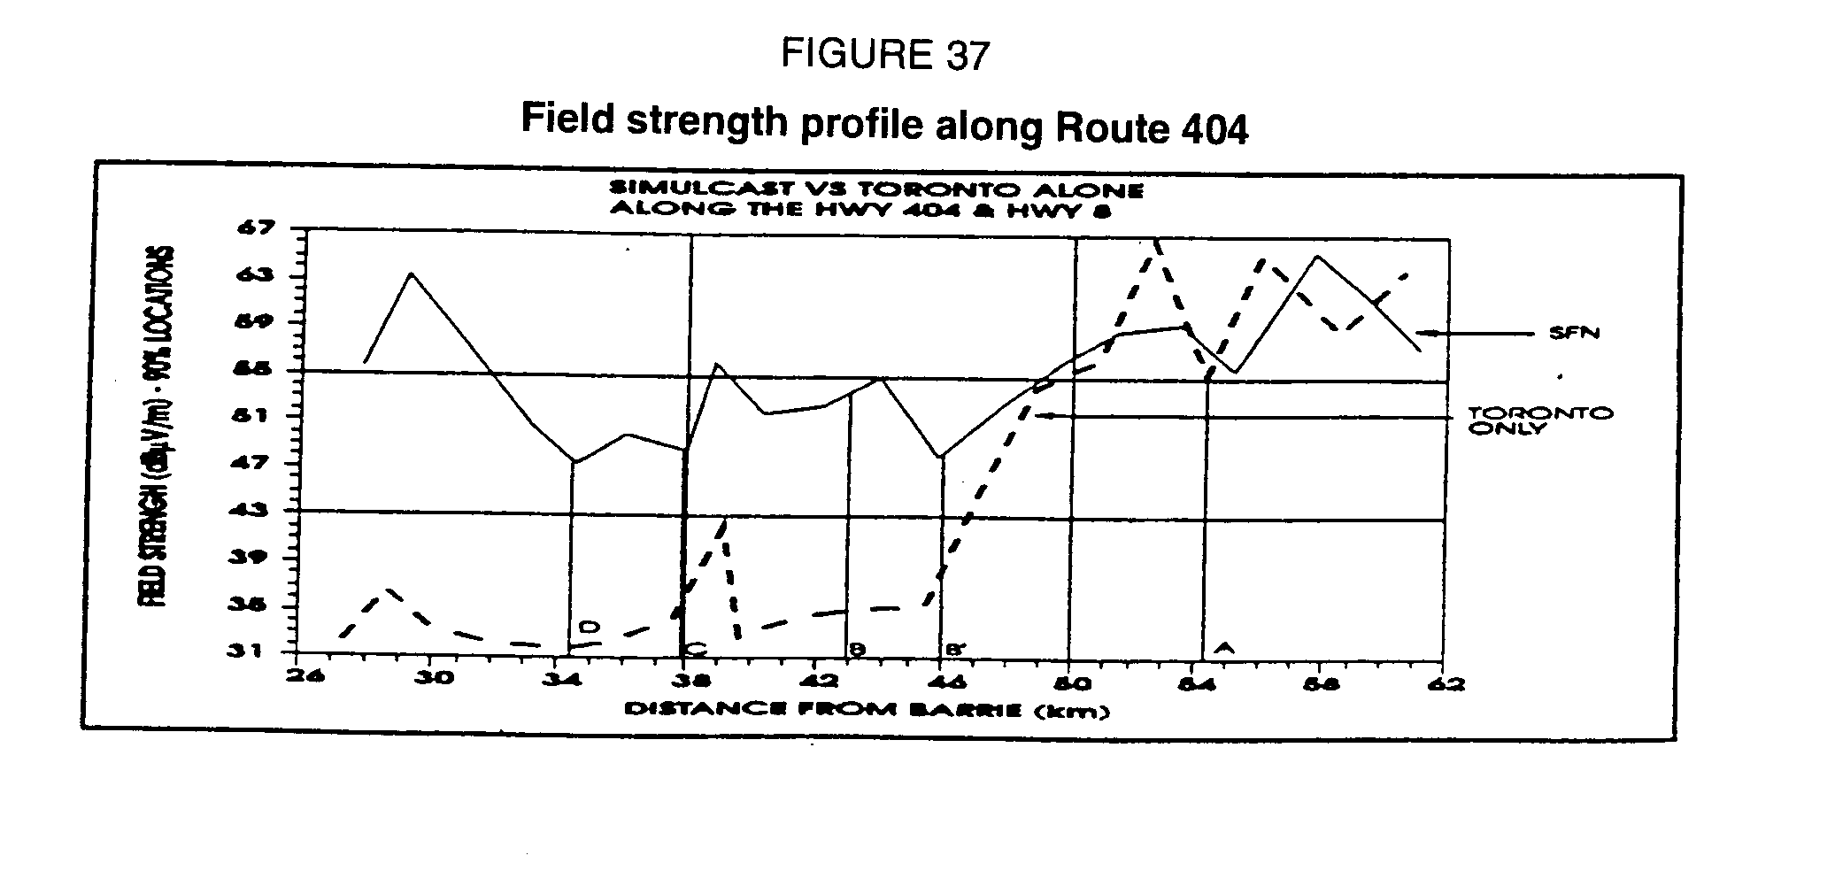

The reception along the entirety of this route was continuous with no signal break-ups (100% locations). The transition from the Toronto transmission to the Barrie transmission and vice versa was seamless.

Observations in the field related to Fig. 37:

- Point A is 37.3 km from Toronto and 54.3 km from Barrie: the combined signal level is 10 to 20 dB above the receiver threshold. Barrie is outside the guard interval but not interfering.

- Point B is 42 km from Toronto and 43 km from Barrie: the combined signal level is 5 to 10 dB above threshold, whereas the Toronto signal alone is 5 dB below threshold. The two signals are almost coincident inside the guard interval.

- Point C is 48 km from Toronto and 38 km from Barrie: the combined signal level is 7 to 15 dB above threshold, whereas the Toronto signal alone is 5 dB below threshold. The Toronto signal is approximately 5 s outside the guard interval.

- Point D is 52 km from Toronto and 34.5 km from Barrie: the combined signal level is 5 to 8 dB above threshold, whereas the Toronto signal alone is 7 dB below threshold. The Toronto signal is approximately 18 s outside the guard interval as illustrated in Fig. 38:

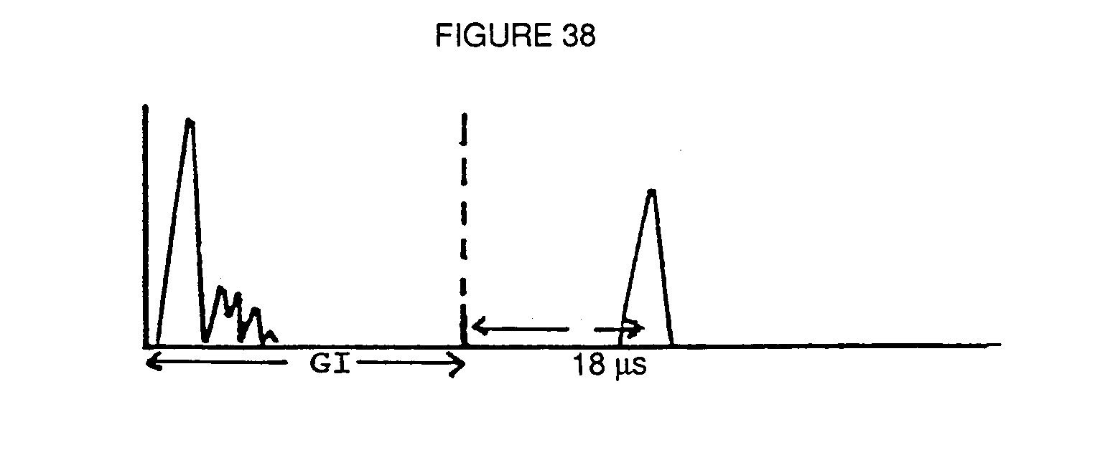

From Fig. 37 it can be seen that at around 46 km from Barrie or 38 km from Toronto (Point B'), the Toronto signal is below threshold but is augmented by the Barrie signal which is received as a constructive echo, illustrating the positive effect of the SFN at the edge of the individual coverage of each transmitter. The SFN effect extend the coverage of Toronto into the one of Barrie.

Another observation from Points C and D is that echoes outside the guard interval will not necessarily cause interference and loss of reception.

The above SR 404-8 illustrates that it is possible to obtain continuous and seamless coverage using a SFN with transmitter spacings in the order of 80 km in the 1.5 GHz frequency range.

##### 2.1.5.3.2 Detailed SFN coverage results

Additional field measurements of the Toronto-Barrie network were carried out for the purpose of identifying the coverage obtained with this configuration and to compare the results with the predicted coverage. The heavy dashed lines in Fig. 39 show the routes used for the detailed coverage measurements. Over 270 km of routes were measured. The area surveyed corresponds approximately to the central part of the coverage area between the Toronto and Barrie transmitter sites which, based on existing FM coverage experience, this area corresponds to the most difficult region to provide good FM coverage from Toronto. This is also supported by the predicted coverage of the SFN network which is also shown in Fig. 39. The light shaded areas in Fig. 39 correspond to the predicted locations where the field strength from either the Barrie or Toronto transmitters would not be sufficient for DAB reception. As can be seen from Fig. 39, the survey routes chosen correspond to the predicted area for worst-case SFN coverage.

The coverage survey was carried out by monitoring the DAB reception while travelling at normal highway speeds. When an outage glitch occurred the locations corresponding to the start of outage and the end of outage were recorded using the GPS receiver. Two types of outages were measured; low-signal outages produced when the received signal was below the receiver threshold level, corresponding to a field strength of approximately 42 dBV/m, and outages produced by interference from the delayed co-channel signal from either the Toronto or Barrie transmitter. This second type of outage occurred when the differential delay of the echo from either the Barrie or Toronto transmitter was greater than the guard interval and of sufficient amplitude to result in outage even though the received signal was above the receiver threshold. The second generation Eureka-147 DAB system used a guard interval of 32 sec.

#### Low-signal outages

The dark shaded areas in Fig. 39 show the areas where the audio signal was lost due to insufficient field strength. A total of 46 areas were measured ranging in size from 100 m up to 2 km.

The total of all these measured outage or intermittent reception areas with unreliable service represents approximately 6.6% of the measured coverage area. The correlation between the predicted outages (light shaded areas in Fig. 39) and the measured outages (dark shaded areas) is reasonably good.

#### Interference outages

Fig. 40 shows the locations where the audio signal was lost due to interference. This occurred when the active echo from either the Barrie or Toronto transmitter (depending on which signal the receiver is synchronized), was sufficiently delayed to fall outside the guard interval and of sufficient amplitude to cause outage. Two sets of lines are drawn on Fig. 40 indicated where the active echoes were constructive for two values of the guard interval. The inner lines correspond to the 32 sec guard interval of the second generation Eureka-147 equipment and the outer lines correspond to the 64 sec guard interval which will be used in the next phase of SFN testing. The locations where outages occurred are indicated as straight lines since this type of outage normally lasted for distances of a 100 m or less. There were a total of 33 outages of this type measured and they were fairly evenly split, 17 and 16 between two areas located at distances of 25 km and 34 km from Toronto and Barrie, respectively. As expected, there were no outages measured within the area encompassed by the 32 sec guard interval and 70% of the outages occurred within the area encompassed by the 64 sec guard interval and hence would be eliminated if this operational mode was used.

Results of the detailed coverage survey indicate that a vehicular coverage availability greater than 90% can be achieved in a simple two-site SFN configuration using directional antennas and with transmitter spacings greater than 80 km. Hence it is expected that SFNs with suitable engineering, augmented with gap fillers and coverage extenders where required, increased guard interval and improved receiver design, coverage availabilities of up to 99% should be achievable.

#### 2.1.5.4 Conclusions

It is concluded from the measurements that it is possible to space the transmitters in a 1.5 GHz COFDM SFN at distances up to and probably further than 85 km which is considerably greater than the distances determined under the assumption that echoes outside the system guard interval are not allowed.

The SFN trials described in this document were performed with a guard interval (GI) of   
32 s, and the results for 83 km transmitter spacing are very positive. While this GI could not cope with all the situations encountered in the field it was found that, in almost all cases investigated, a larger guard interval, closer to the 64 s proposed for Mode II would be sufficient.

More measurements are required to document further the performance of the 1.5 GHz SFN, for high-availability service and with more than two transmitters including the possible use of gap fillers and coverage extenders.

It is also concluded that it is possible to provide coverage, with high availability at 1.5 GHz, of areas with a radius greater than 40 km, even under difficult terrain conditions, using a single transmitter with ERPs comparable to those used in the VHF band. Based on the initial coverage measurement results averaged over six radials from Barrie, it was found that coverage extended further than 50 km for 90% of locations and for a transmit ERP of 17 kW or approximately 2 kW per stereo channel.

Finally, these trials have shown that the SFN concept is very effective in increasing the service availability in a spectrum and power-efficient manner. In theory, it would be possible to cover, with 90% to 99% availability, an area of approximately 80 x 160 km wide with two omnidirectional transmitters of ERPs in the 10 kW range, using the same frequency in the 1.5 GHz range, when using a DSB system, such as the COFDM, which can use active echoes constructively.

### 2.1.6 Recent wideband channel characterization measurements at 1.5 GHz

#### 2.1.6.1 Introduction

In order to lay the groundwork for the use of the WARC-92 allocation at 1 452 ‑ 1 492 MHz for digital sound broadcasting, it is necessary to learn more about the characteristics of the channel. A measurement programme has been undertaken in Canada to gather and compile information on the channel, with the initial emphasis on terrestrial transmission. This section describes some initial results on the multipath characteristics of the 1.5 GHz channel.

#### 2.1.6.2 Measurement apparatus and methodology

The results presented here were derived from data gathered using a mobile impulse response measurement facility. The transmitter consists of a PN sequence generator (511-bit sequence, 5 MHz clock rate) with stable (rubidium) time/frequency reference, RF up‑conversion circuitry, power amplifier, and a vertically-polarized antenna. The receiver system is installed in a standard mini-van and includes a quarter-wave monopole receiving antenna mounted near the centre of the roof, low-noise amplifier, down-conversion circuitry, and a rubidium reference. The in‑phase and quadrature baseband outputs from the receiver are sampled at 10 MHz and digitized at 8 bits. Blocks of 4 096 complex samples were taken at each measurement point, which were later used for the calculation of one impulse response snapshot. The measurement points in a single measurement run are normally spaced at intervals of 5 cm (approximately one-quarter wavelength). Each block encompasses several repetitions of the PN sequence (four repetitions in the case of the 4 096 sample block size), which will allow improvement of the signal-to-noise ratio of the data in the subsequent processing. The samples are then processed off-line by correlation with a stored replica of the PN sequence waveform to produce a series of impulse response snapshots. The stored sequence was obtained using a back-to-back connection between the transmitter and receiver, and thus includes the effect of the system filters and other hardware. One measurement run typically provides 2 048 impulse response snap-shots over a distance of about 100 m. The measurement system provides a Multipath Power Sensiti-vity Ratio (MPSR) of better than 30 dB for input signals of -100 dBm or more. The MPSR is the power ratio between the strongest impulse response peak and the strongest noise peak in the correla-tion. The noise peaks may be either due to receiver noise or side lobes resulting from the cross-corre-lation process. For input signals greater than -100 dBm, the latter dominate, and this sets the lower limit on the level of multipath components which can be distinguished. This level is well below the level which would cause any significant effect on the performance of a communications system.

Once the impulse responses have been calculated (in the form of power-delay profiles), they are visually examined using a software tool designed for this purpose, and any records with obvious problems such as poor signal-to-noise ratio (MPSR less than about 20 dB) are removed before continuing the analysis. The various time-domain multipath parameters are then calculated for each impulse response profile, and data files from similar measurement environments are grouped together for preparation of the summary statistics.

To date, measurements have been carried out using transmitter sites in three areas:

- Barrie, Ontario: e.i.r.p. = 6.2 kW; beamwidth = 120;  
 antenna height = 230 m (AGL)

- Trois Rivières, Québec: e.i.r.p. = 5 kW, beamwidth = 120;  
 antenna height = 200 m (AGL)

- Ottawa, Ontario: e.i.r.p. = 180 W, beamwidth = 360;  
 antenna height = 61m (AGL).

In the Barrie tests, the measurement locations included a range of suburban and rural environments, with particular emphasis on the latter. Much of the terrain in this area is hilly and wooded. In the case of Trois Rivières, there were more urban measurements, taken in a small city of about 50 000. Most of the rural measurements were taken in a broad river valley with many open fields. The river runs roughly east-west, with hills to the north and flatlands to the south. A smaller number of measurements were taken in the hilly areas. In the case of Ottawa, the locations were in suburban to dense urban environments, in a metropolitan area of about 800 000 population.

#### 2.1.6.3 Results

The data presented here are a subset of those suggested in Report ITU-R PN.1144 for characterization of wideband terrestrial land mobile channels. The data point in each case is taken from a representative location on the Cumulative Distribution Function (CDF) for the corresponding parameter (usually the 80% or 90% point). The parameters used in the tables, and their abbreviations, are defined as follows:

**Average excess delay** (TD) is the first moment of the power-density profile of the impulse response, taken with the line-of-sight delay as the reference point. TD90 represents the 90% point on the CDF curve, i.e., only 10% of the measured impulse responses had average delays greater than this value.

**Delay spread** (S) is the square root of the second central moment of the power-density profile of the impulse response (i.e., the standard deviation). S90 is the 90% point on the delay spread CDF.

**Delay window** (Wq) is the length of the middle portion of the impulse response containing a certain percentage q of the total energy, and such that the energy outside the window is split into two equal parts, before and after the window.

**Delay interval** (Ip) is the time interval between the instant that the amplitude of the impulse response first exceeds a given threshold p, and the instant when it falls below that threshold for the last time. The threshold is referenced to the highest peak of the impulse response and is given in decibels; e.g., I12 = the delay interval for a threshold of 12 dB below the peak.

The nomenclature used here follows that of Report ITU-R PN.567-4, which also defines the mathematical relationships between these parameters. In the summary table which follows, the difference TD90 - TD10 is shown instead of the average excess delay itself. This quantity has been termed the average excess delay "jitter" [de Weck, Merki and Lorenz, 1988], which tends to be high in areas where the direct path from the transmitter is intermittently blocked. In the calculation of average delay and delay spread, the integration limits are determined by a cut-off level, which is a certain margin above the noise floor (and where the "noise" consists of both receiver noise and correlation side lobes). For these measurements, we set the cut-off level to 3 dB above the estimated noise floor.

The categories of environment which are used to characterize the measurement locations are based upon those suggested in Report ITU-R PN.567-4, and reproduced below:

*Category Description*

1 Rivers, lakes and seas

2 Open rural areas, e.g., fields and heathlands with few trees

3 Rural areas, similar to the above but with some wooded areas, e.g., parkland

4 Wooded or forested rural areas

5 Suburban areas, low-density dwellings and modern industrial estates

6 Suburban areas, higher-density dwellings

7 Urban areas with buildings up to four storeys, but with some open space between

8 Higher-density urban areas in which some buildings have more than four storeys

9 Dense urban areas in which most of the buildings have more than four storeys, and some can be described as "skyscrapers"

These categories are referred to in the "Area Type" column of the result summary table.

#### 2.1.6.4 Discussion and conclusions

It is apparent from examination of the preliminary data that the 1.5 GHz band is quite similar in multipath characteristics to the lower-frequency UHF bands for which more data exists. The quantitative data are also very similar to those reported by various workers at 900 MHz [COST 207, 1989]. The results to date indicate that the multipath characteristics of the terrestrial broadcast channel at 1.5 GHz will pose no problems for COFDM signals using guard intervals of 32 s or more. This conclusion follows from examination of the delay window and delay interval data.

TABLE 15

Summary of the 1.5 GHz measurement results  
(delays in sec)

|  |  |  |  |  |  |  |  |  |  |  |  |  |  |  |  |  |
| --- | --- | --- | --- | --- | --- | --- | --- | --- | --- | --- | --- | --- | --- | --- | --- | --- |
|  |  | Av. Delay | Delay  Spread | | Delay Window | | | | | | Delay Interval | | | | | |
|  | Area | TD90 - TD10 |  | | 80% CDF | | | 90% CDF | | | 80% CDF | | | 90% CDF | | |
|  | Type |  | S80 | S90 | W90 | W75 | W50 | W90 | W75 | W50 | I9 | I12 | I15 | I9 | I12 | I15 |
| Barrie | 5,6 | 1.70 | 1.43 | 1.98 | 1.8 | 0.6 | 0.3 | 4.1 | 1.2 | 0.4 | 0.7 | 0.8 | 1.2 | 0.8 | 1.4 | 3.8 |
| Ontario | 4 | 1.76 | 2.72 | 4.29 | 3.4 | 1.4 | 0.7 | 5.5 | 2.0 | 1.0 | 1.2 | 1.6 | 2.6 | 1.6 | 2.4 | 3.5 |
|  | 2,3 | 2.10 | 2.35 | 4.76 | 2.1 | 1.5 | 0.8 | 4.9 | 1.7 | 1.3 | 1.6 | 1.9 | 2.1 | 1.9 | 2.1 | 2.9 |
| Ottawa | 9 | 1.52 | 3.18 | 4.09 | 5.7 | 3.1 | 1.6 | 9.8 | 3.7 | 2.0 | 3.3 | 4.4 | 6.3 | 4.2 | 5.6 | 14.2 |
| Ontario | 7,8 | 2.09 | 2.65 | 3.75 | 4.8 | 3.2 | 1.9 | 5.8 | 4.1 | 2.6 | 3.3 | 4.4 | 5.2 | 5.1 | 5.5 | 13.2 |
|  | 6 | 2.57 | 4.07 | 5.62 | 10.8 | 5.0 | 2.5 | 14.4 | 10.0 | 3.3 | 4.3 | 10.0 | 11.1 | 9.7 | 14.4 | 16.0 |
|  | 5 | 3.76 | 5.14 | 5.69 | 9.5 | 3.0 | 2.2 | 12.8 | 9.6 | 5.1 | 2.8 | 3.1 | 9.5 | 3.3 | 10.7 | 13.3 |
| Trois | 7,8 | 4.43 | 4.23 | 5.2 | 10.4 | 6.4 | 3.6 | 17.8 | 8.0 | 5.0 | 6.2 | 8.6 | 18.0 | 8.5 | 18.3 | 21.8 |
| Rivières | 5,6 | 3.06 | 3.81 | 6.29 | 6.6 | 1.8 | 0.7 | 22.9 | 8.9 | 1.9 | 1.1 | 1.9 | 1.9 | 1.9 | 8.0 | 8.0 |
| Québec | 4 | 1.55 | 1.91 | 4.05 | 3.1 | 1.8 | 0.6 | 9.7 | 2.7 | 1.2 | 1.0 | 2.1 | 3.1 | 2.2 | 3.2 | 3.9 |
|  | 2,3 | 0.96 | 1.28 | 2.25 | 2.2 | 0.9 | 0.4 | 3.6 | 1.7 | 0.7 | 0.8 | 1.2 | 2.0 | 1.4 | 2.4 | 3.0 |

## 2.2 Results of field measurements in Europe

### 2.2.1 Introduction

In September 1993, in order to improve the propagation and coverage field prediction in urban and rural areas for terrestrial digital sound broadcasting, numerous wideband field strength measurements were performed, by CCETT, from a single transmitter antenna situated on the France Telecom transmission tower, at Rennes, in France. This experiment was realized in the 1 500 MHz frequency range with a third generation Digital System A prototype equipment.

### 2.2.2 System and transmitting parameters

The system and transmitting parameters were the following:

|  |  |  |  |
| --- | --- | --- | --- |
| - System parameters: | |  | |
| - Frequency block | | : 1.536 MHz | |
| - Modulation | | : COFDM | |
| - Symbol time | | : 156 µs in mode III : 312 µs in mode II | |
| - Guard interval | | : 31 µs in mode III : 62 µs in mode II | |
| - Convolutional coding rate | | : 0.34 to 0.74 | |
| - Useful bit rate with code rate 0.5 | | : 1 152 kbit/s | |
| - Spectral efficiency with code rate 0.5 | | : 0.75 | |

|  |  |  |  |
| --- | --- | --- | --- |
| - Transmitting parameters: | |  | |
| - Maximum active power | | : 250 W | |
| - Linear active power | | : 80 W (5 dB back off) | |
| - Transmitting antenna gain | | : 17 dBi (45° aperture) | |
| - Max. ERP | | : 2.2 kW | |
| - Antenna height | | : 101 m (AGL) | |
| - Receiving antenna | | : /4 monopole (0 dBi) | |

### 2.2.3 Measurements methods

Eight routes were tested. In each case, distance and power level were measured along the route. Distances taken into account were "travelled distances", using a distance transducer. These distances are obviously different from distances between emitter and receiver. One power measurement was performed each metre via a triggered device linked to a distance transducer.

### 2.2.4 Processing methods

From the distance measurements and National Geographic Institute data, terrain elevations were computed. The prediction model used was a Okumura broadcasting model, modified by CCETT. The Okumura broadcasting model was modified in order to take into account the difference between narrow-band and wideband channels. The distribution diagrams and standard deviations were computed using the measured data.

### 2.2.5 Results

First, in order to make the following results clear, a presentation of the theoretical Log Normal and Rayleigh distributions is given in Figs. 41 and 42, respectively.

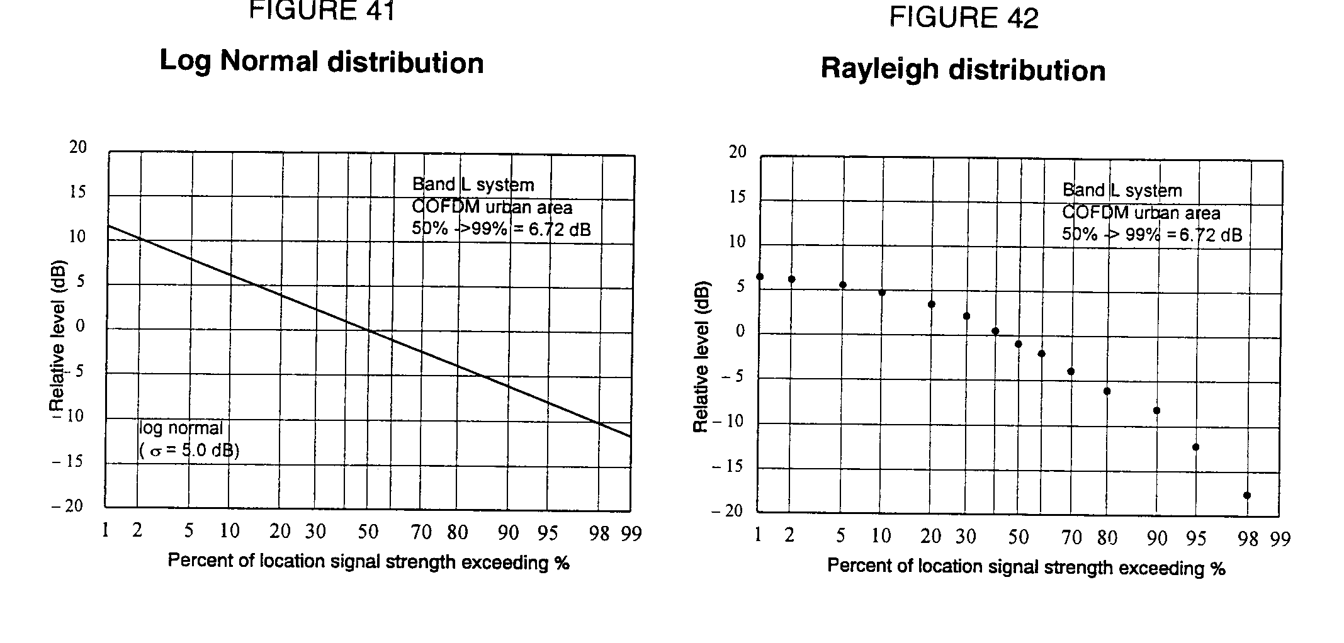

Then, relevant results are shown in Fig. 43 to Fig. 48. They refer to the Plelan axis route. Figs. 43 and 46 concern respectively the urban and rural areas which have been analysed independently, according to the different prediction models. On each of these two figures, four curves are presented:

1) a power level curve. All the measurement values on the curve are those which have been received at antenna input;

2) an elevation profile;

3) a 50% prediction curve;

4) a 99% prediction curve, deduced from 3) by application of 12 dB margin.

It is interesting to note, concerning these Figs. 43 and 48, the strong correlation existing between the power level curve and the elevation profile.**PLELAN AXIS (RURAL)**

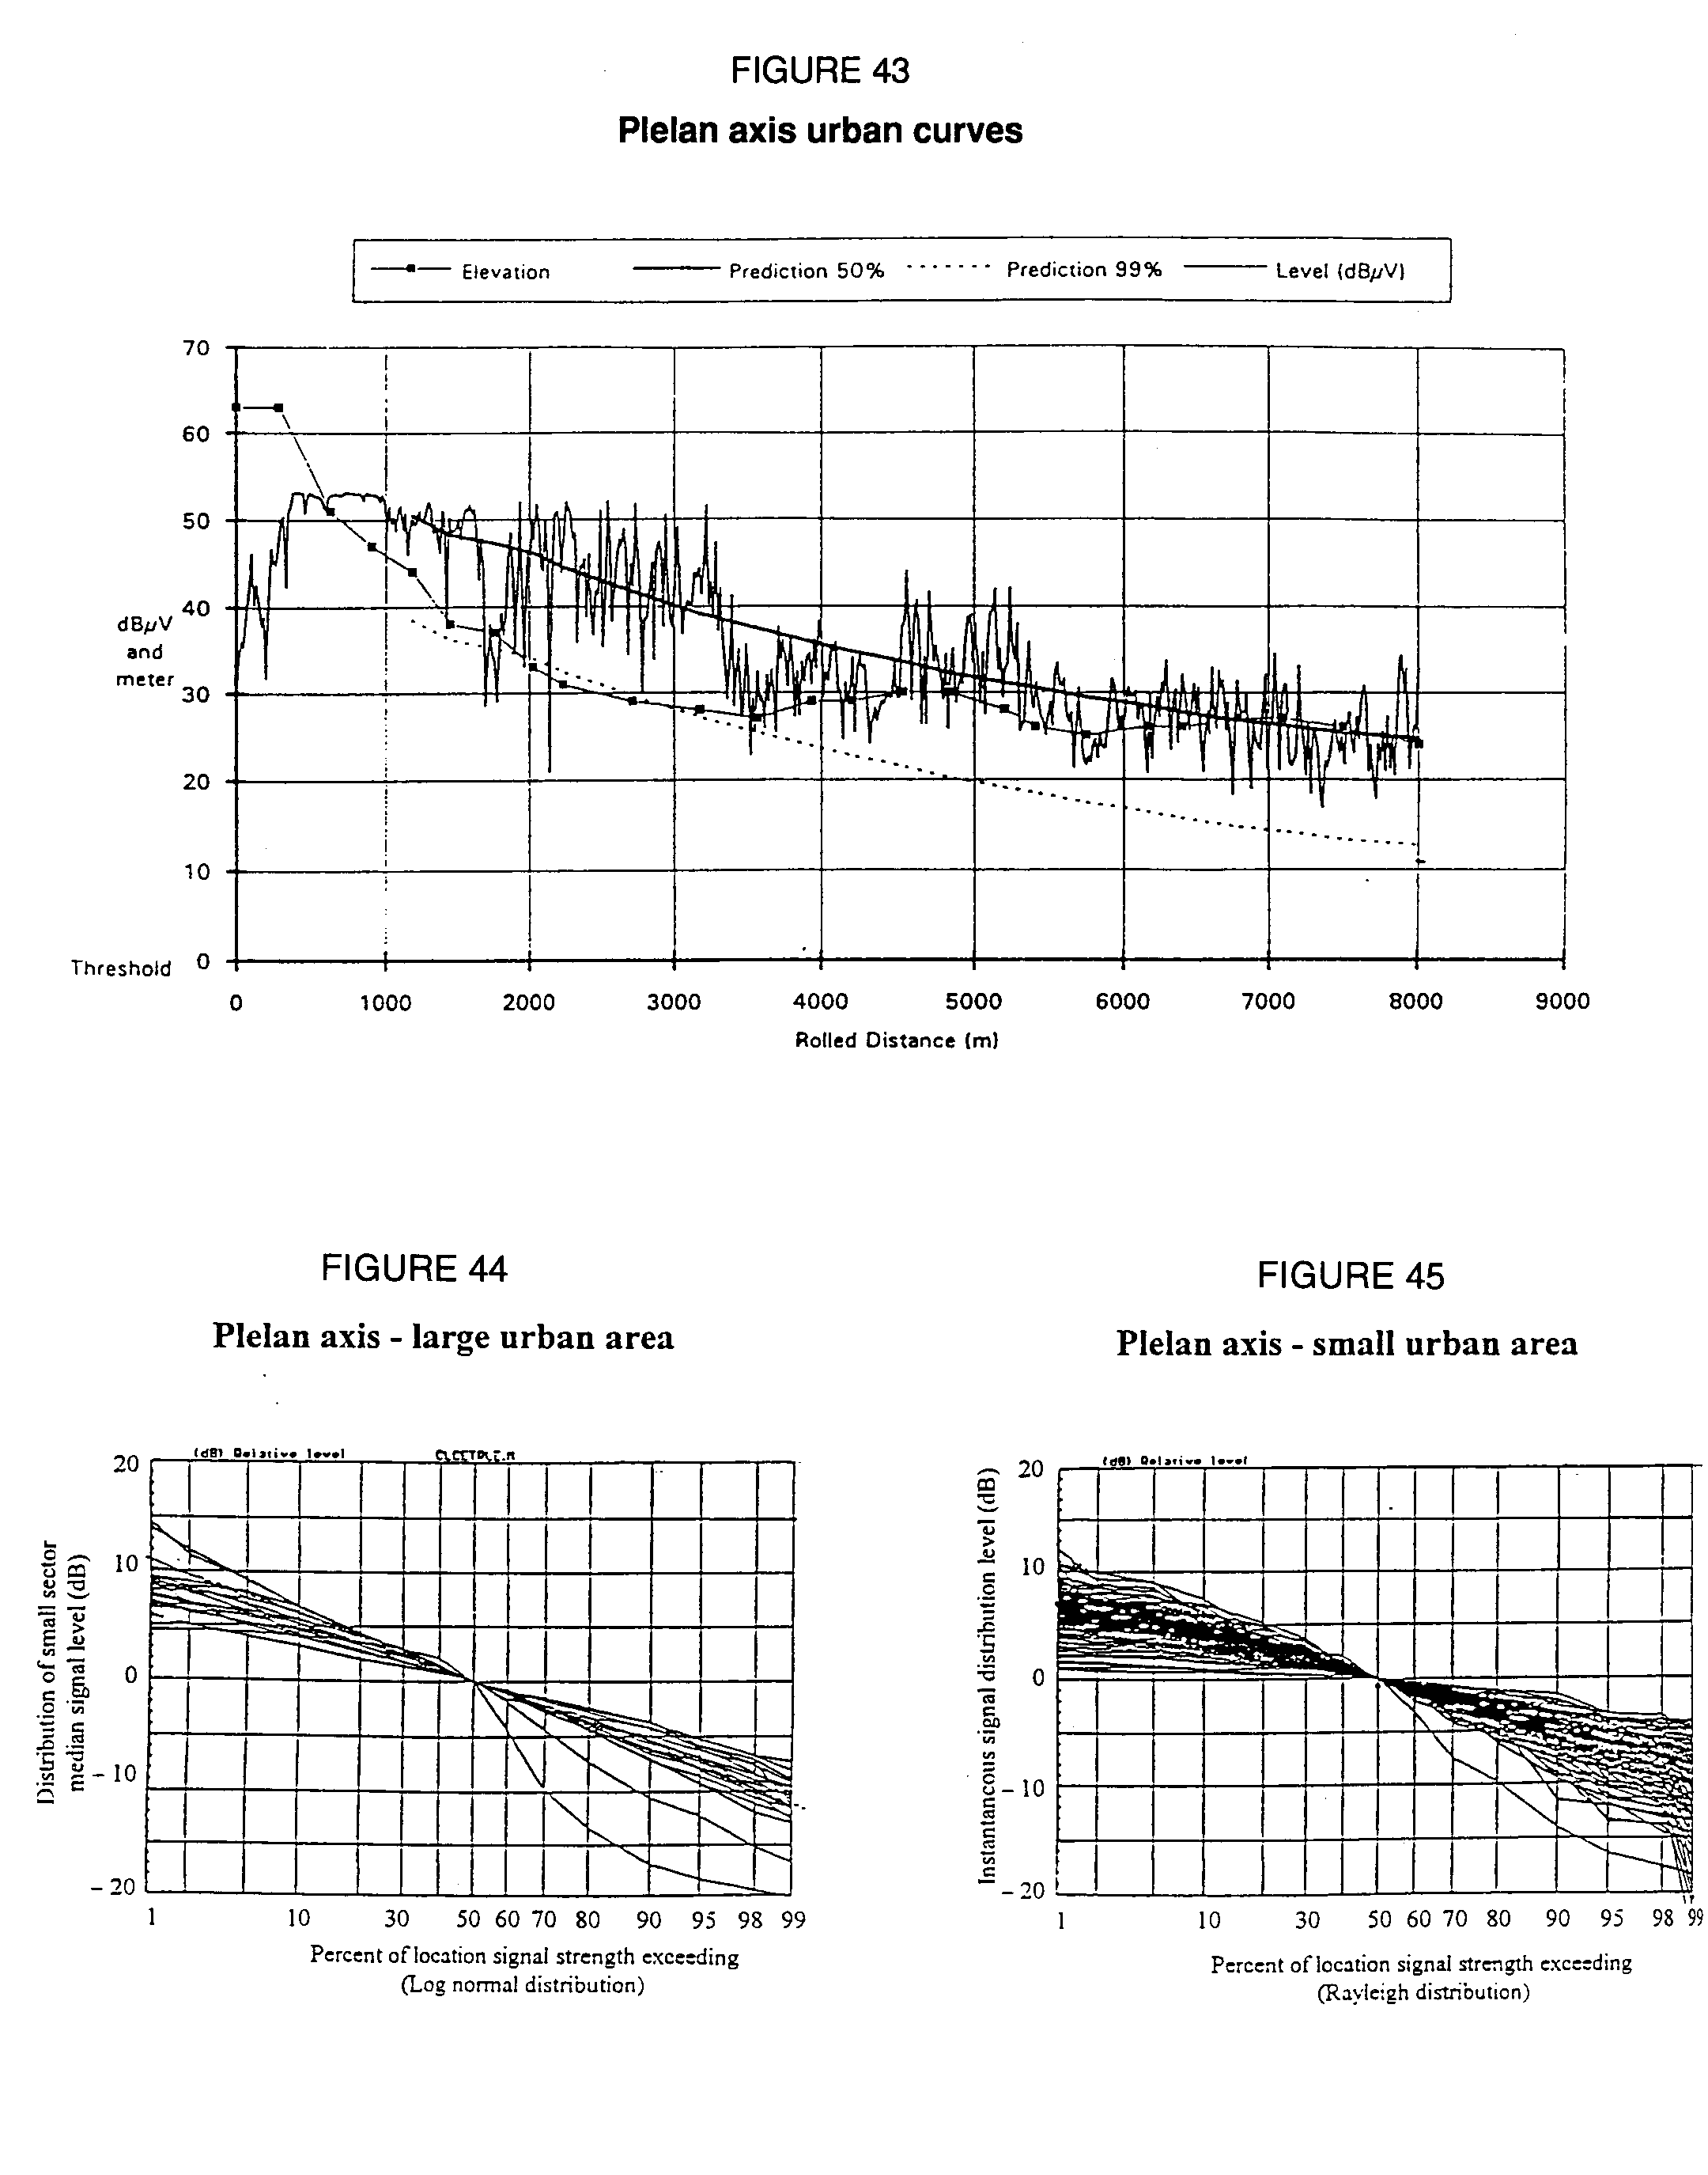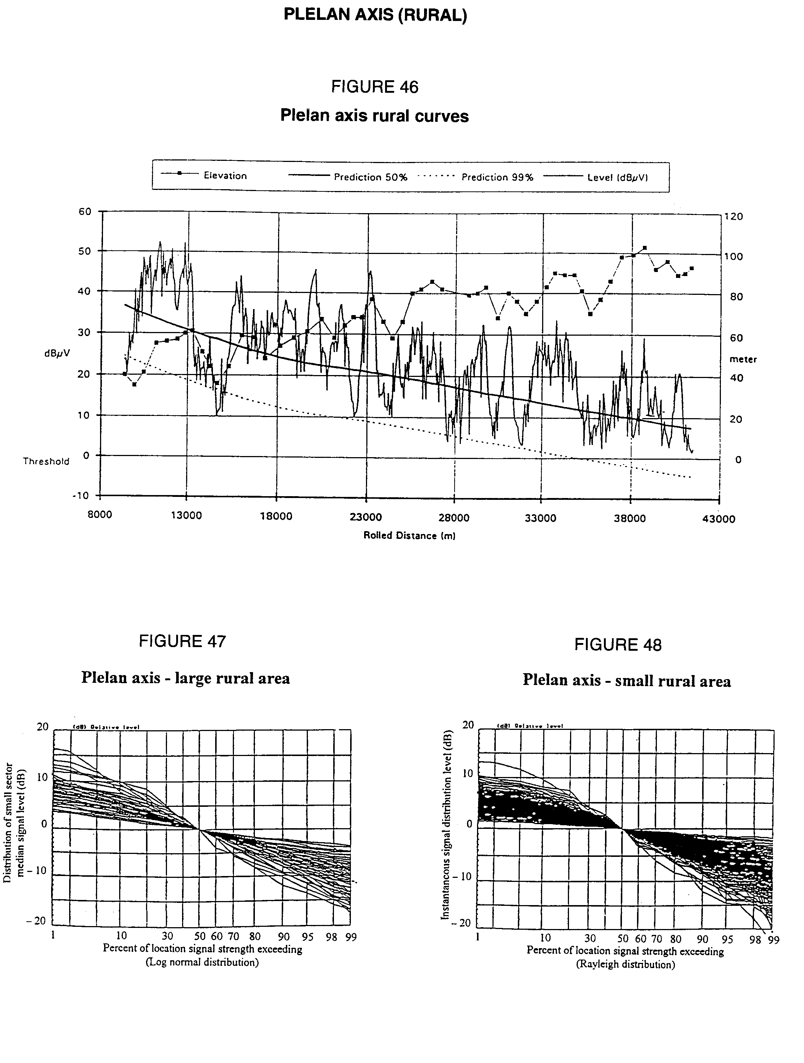

Figures 44 and 47, 45 and 48 represent computed distribution diagrams referring respectively to large areas (300 m) and small areas (50 m) for urban and rural areas of the Plelan axis route. Distribution curves have been drawn considering the power level measurement points. Each curve of the bundles is the result of processing of all the points included in the measurement interval. The purpose of these analysis is to compare these distribution diagrams to log-normal and Rayleigh distributions (cf. Figs. 41 and 42).

### 2.2.6 Conclusions

The conclusions are the following:

1) The CCIR model used over a large area (300 m interval) is verified according to the log-normal law with the following values:

= 5.1 dB

location variation margin 50% to 99% 11.3 dB.

2) As expected due to the wide-band nature of the signal, the Rice-Nagakami model used over small areas (50 m interval) does not fit well with the measured results. The log-normal distribution is a better predictor of the small area measured data. The standard deviation for this log-normal fitting is 4.7 dB and we have a location variation margin 50% to 99% 10.6 dB.

# 3. Experimental results below 1 000 MHz

## 3.1 General

Section 4.2 identifies possible frequency bands for T‑DAB services. Within the United Kingdom, spectrum occupancy has concentrated interest primarily on Broadcast Bands III and I. The results detailed in 3.2 are derived from an experimental Single Frequency Network comprising six low‑power transmitters in an area immediately to the south of London. Tests were mainly carried out at 211 MHz, but two of the stations were also equipped with transmitters operating on 64 MHz.

Signals were recorded in a survey vehicle with a roof mounted antenna (at about 1.5 m above ground) equipped with a computer operated field strength logging system.

## 3.2 Variations of field strength with location

### 3.2.1 Comparisons between standard deviations of field strength for CW signals and T‑DSB signals with a band width of 1.75 MHz

In order to compare the location variability of wideband signals with the narrow‑band transmissions on which Recommendation ITU-R PN.370 is based, sequential measurements were made on two routes of CW signals and of DSB signals (with 1.75 MHz bandwidth). These routes were about 3 km and 8 km in length respectively and, for each, transmissions from three separate sources were measured. For one of these sources comparisons were also carried out for a third route 10.5 km in length. For each set of measurements the distribution with location was effectively log-normal at least within the range from 1% to 99% locations.

Table 16 shows the results expressed in terms of the standard deviations.

TABLE 16

Comparison of standard deviations of location variation of CW signals   
and DSB with 1.75 MHz bandwidth

|  |  |  |  |  |
| --- | --- | --- | --- | --- |
| Tx. | Route | Standard Deviation (dB) | | Ratio of DSB:CW (dB) |
|  |  | CW | DSB |  |
| A | 1 | 9.2 | 5.7 | 0.62 |
|  | 2 | 9.5 | 6.5 | 0.65 |
| B | 1 | 7.0 | 4.5 | 0.64 |
|  | 2 | 8.0 | 4.5 | 0.56 |
|  | 3 | 9.7 | 6.5 | 0.67 |
| C | 1 | 9.7 | 4.5 | 0.47 |
|  | 2 | 9.7 | 5.5 | 0.57 |
|  | Means | 9.0 | 5.4 | 0.60 |

The results indicate the significant reduction in standard deviation, by a factor of 0.6, due to a number of factors including the low antenna height and an omnidirectional antenna pattern.

### 3.2.2 Comparisons between DSB signals of different bandwidths in different types of environment

The results shown in Table 17 indicate the standard deviations, measured in a number of 0.5 sq. km areas at 211 MHz, each between 6 and 12 km from the transmitter. The measurements were carried out with DSB bandwidths of both 1.75 MHz and 3.5 MHz, and the areas were classified into three different environment types. The table shows both the standard deviation and the difference between levels exceeded at 50% and 99% locations.

TABLE 17

Signal level variations for different bandwidths and environments

|  |  |  |  |  |
| --- | --- | --- | --- | --- |
| Environment | Bandwidth 1.75 MHz | | Bandwidth 3.5 MHz | |
|  | std dev (dB) | 50%‑99% variation (dB) | std dev (dB) | 50%‑99% variation (dB) |
| Dense Urban | 5.5 | 12.9 | 5.6 | 13.1 |
| Urban | 5.2 | 12.0 | 5.0 | 11.7 |
| Suburban | 6.0 | 13.9 | 6.2 | 14.5 |
| Mean | 5.6 | 12.9 | 5.6 | 13.0 |

The results indicate that there is negligible difference between the two bandwidths or the environment type. Whilst the standard deviations are slightly greater than for the wideband measurements in Table 16, the overall differences between 50% and 99% location values are entirely consistent with log‑normal distributions having the specified standard deviations.

### 3.2.3 Comparisons between location variations in Bands I and III

Comparative surveys were carried out in an area of field strengths from two transmitters operating at 211 MHz. These were then repeated at a frequency of 64 MHz. The resulting standard deviations are given in Table 18.

TABLE 18

Comparative location variations in Bands I and III

|  |  |  |
| --- | --- | --- |
| Transmitter | Standard Deviation (dB) | |
|  | 64 MHz | 211 MHz |
| A | 4.1 | 4.7 |
| B | 4.6 | 4.8 |
| Mean | 4.4 | 4.8 |

This somewhat limited comparison, together with some other measurements indicates that, as might be expected, the signal level variability is slightly higher at the higher frequency. The difference is, however sufficiently small to support the assumption made in Recommendation ITU‑R PN.370 that, for planning purposes no differentiation is required.

### 3.2.4 The effect of multiple sources on signal levels

Section 4.6.2.2 considers the "internal network gain" available in a Single Frequency Network using Digital System A. This results from the mutual addition of the signals of the transmitters of the network, and comprises two components, additive and statistical.

Due to the low powers used in the first experimental SFN in the United Kingdom the cumulative effect of the multiple transmissions over any significant area was generally limited to two sources. The results in Table 19 are obtained over six areas. In each area mean field strengths and standard deviations are obtained for each of two contributory transmitters individually and then with both operating simultaneously. In five of the areas the mean field strengths of the contributors were within 2 dB of each other.

TABLE 19

Variations of median field strength and standard deviation (SD) in a SFN

|  |  |  |  |  |  |
| --- | --- | --- | --- | --- | --- |
| Area | SD of Tx 1 (dB) | SD of Tx 2 (dB)* | Difference between medians (dB) | SD with both Txs (dB) | Increase of median F/S* (dB) |
| 1 | 6.7 | 6.7 | 1.5 | 4.3 | 3.3 |
| 2 | 4.7 | 6.1 | 1.6 | 5.1 | 1.8 |
| 3 | 4.2 | 5.5 | 1.9 | 4.3 | 1.3 |
| 4 | 5.7 | 3.7 | 0.7 | 4.2 | 1.8 |
| 5 | 5.7 | 4.9 | 0.8 | 5.3 | 4.2 |
| 6 | 5.8 | 4.6 | 9.3 | 4.2 | 1.0 |
| Mean | 5.5 | 5.2 |  | 4.6 |  |
| * In all cases Tx 2 has the higher median field strength and the values for increase are referred to this. | | | | | |

The results show that in all areas, (even area 6 for which there is a large difference in the median value) the presence of two sources increases the mean level by at least 1 dB. Similarly the mean value of standard deviation is reduced by around 0.8 dB, corresponding to an increase of about 2 dB at the 99% location level. It should be noted however that:

i) the standard deviation is not always less than that for Tx 2 alone despite this providing the higher median field strength;

ii) the improvement in coverage is somewhat lower than implied by the theoretical study, using the log‑normal method for combining signals, alluded to in the second paragraph of § 4.6.2.2.

The averaged results of the measurements in Table 19, excluding area 6, indicate an increase in the median field strength of about 2.5 dB, associated with a reduction in the standard deviation corresponding to a further increase of about 2 dB at the 99% level, hence the overall advantage is 4.5 dB. The log‑normal method (described in Report 945) predicts that for a difference between median levels of 1.5 dB and standard deviations of 5.5 dB, the "network gain" at 99% locations is 6.5 dB.

## 3.3 Implications of man‑made noise on minimum usable field strength

Section 4.4.5 of the report considers the minimum usable field strength level which in turn determines the ERP required for a transmitter operating at 100 MHz. The field strength calculation is shown in Table 1 (see § 4.4.3 of the main text).

It is noted that the increased effect of man‑made noise may significantly affect the minimum usable field strength. The basis for Table 2 is a derivation of minimum usable field strength given in § 4.4.3 of the main text and assumes a receiver with a noise figure of 10 dB at 100 MHz (equivalent noise temperature = 2 610 K).

In order to assess man‑made noise levels a series of measurements have been carried out in the United Kingdom at four frequencies between 58 MHz and 215 MHz in six towns/cities. In each case the measurements were divided into the following environment categories; dense urban, urban, suburban, and rural. The number of measurements in the rural areas tended to be lower than for the other categories.

Measurements were made in a vehicle fitted with a roof‑mounted antenna, and a computer controlled logging receiver, and comprised both static and mobile conditions. In the former case approximately 2 000 readings were taken at each location at a rate of 70 samples/sec.

For the mobile measurements the sampling rate was about 50 000 measurements/km. As the measurement frequencies were within spectrum allocated to Private Mobile Radio (PMR) services, preliminary listening tests were carried out in each area and small adjustments to the measurement frequency made if thought necessary to avoid these transmissions. The results of these measurements are given in Table 20. These are expressed in dB relative to thermal noise assuming a temperature of 290 K (expressed in dBW/Hz). For each frequency and environment, results indicate the levels exceeded at 10% and 50% of locations.

TABLE 20

Results of man‑made noise level measurements

|  |  |  |  |  |
| --- | --- | --- | --- | --- |
| Category | Frequency | Level relative to thermal noise (dB) | | |
|  | (MHz) | 10% locations | 50% locations | 10%‑50% (dB) |
| Dense urban | 58 | +28.5 | +23.5 | 5 |
| Urban | 58 | +23.5 | +17.5 | 6 |
| Suburban | 58 | +23 | +17 | 6 |
| Rural | 58 | +7 | +7 | 0 |
| Dense Urban | 67 | +26.5 | +21 | 5.5 |
| Urban | 67 | +20 | +17 | 3 |
| Suburban | 67 | +14 | +10 | 4 |
| Rural | 67 | +9 | +8 | 1 |
| Dense Urban | 106 | +23 | +20 | 3 |
| Urban | 106 | +23 | +19 | 4 |
| Suburban | 106 | +18 | +15 | 3 |
| Rural | 106 | +12 | +11 | 1 |
| Dense Urban | 215 | +14 | +11 | 3 |
| Urban | 215 | +11.5 | +8.5 | 3 |
| Suburban | 215 | +7 | +4 | 3 |
| Rural | 215 | +1 | +1 | 0 |

These results show the expected increase in level with building density: also, (with the exception of the apparently anomalous results at 106 MHz) the expected trend for increased levels with reducing frequency.

Clearly, even in Band III a large allowance would have to be made to overcome man‑made noise in urban and dense urban areas. However it is normal policy in planning broadcast networks to ensure that such areas are provided with field strengths well above the nominal minimum values for the particular service. A more realistic requirement may be to compensate for man‑made noise at 99% of suburban locations.

From the above table we may perhaps neglect the rural values as based on insufficient samples.

For log-normal distributions the 1% variation is about 1.8 times that of the difference between the 10%-50% value, added to the 50% value.

For frequencies in Bands I and III this implies that for 1% suburban man‑made noise level enhancements above thermal noise are:

- 27 dB for 58 MHz;

- 17 dB for 67 MHz;

- 9.5 dB for 215 MHz.

In conjunction with a receiver of assumed noise figure = 10 dB (9 dB above thermal noise) the allowance required to compensate for man‑made noise assuming power‑sum addition is 3 dB for 215 MHz. An interpolated value of 20 dB has been calculated for 100 MHz.

Further studies are desirable to resolve the reason for the apparently anomalous results at 106 MHz and the large differences between those at 58 MHz and 67 MHz. However those at 215 MHz are felt to provide a reliable representation of levels in Band III.

Measurements of man-made noise in Band I have also been undertaken in dense urban areas of Paris. Mobile measurements were made every 10 cm on several routes, the total length of these routes was in the order of 100 km. The noise was measured with a receiver centred on 67 MHz with a 1 MHz bandwidth filter. Each route was divided into sections of 50 m and from each section the noise exceeded for 1% locations was extracted.

The cumulative distribution function (CDF) for these 1% locations was calculated for all routes. If we consider the 99% point of this CDF, the man-made noise level above thermal noise is estimated to be 32 dB.

## 3.4 Measurements of building penetration losses at 211 MHz and 64 MHz

Whilst T‑DSB services may be planned primarily for vehicular reception they are also requi-red to provide satisfactory reception in the home without the need for fixed antennas e.g. for recep-tion on portable receivers. To determine the allowance required in planning for building penetration losses, measurements were carried out in 23 dwellings, all of which were of traditional brick construction.

In each house measurements were made in each room at heights of about 0.5 m and 1.5 to 2 m. The number of measurements were dependent of the size of the room and the amount of furniture, but typically about three measurements per square metre were made at each height. Similar measure-ment were made in rooms on the first floor (above the ground floor). Measurements were then made at a number of locations outside the building at 1.5 to 2 m above ground and a median value for field strengths outside the building obtained. In addition to the above 23 sets of measurements, results were obtained for three first‑floor apartments, of which two were of brick construction and one of concrete. In these cases the outdoor reference was obtained by holding the receiving antenna outside the windows.

These measurements were carried out with a transmission having a bandwidth of 1.75 MHz at a frequency of 211 MHz. Five of the houses were remeasured with a transmission frequency of 64  MHz.

Table 21 gives mean penetration losses obtained by subtracting median values of field strength inside the house from the median value outside. In some cases the house received comparable field strengths from more than one transmitter. In such cases the values below are those with all relevant transmitters in operation.

TABLE 21

Mean penetration losses and standard deviations of signals in domestic dwellings

|  |  |  |  |  |
| --- | --- | --- | --- | --- |
| Ground floor measurements | Mean loss (dB) | | Standard dev. (dB) | |
|  | 211 MHz | 64 MHz | 211 MHz | 64 MHz |
| Room Highest Field Strength | 5.0 | 6.2 | 3.2 | 4.5 |
| Whole Ground Floor | 7.9 | 8.7 | 3.0 | 3.8 |
| Room Lowest Field Strength | 10.0 | 11.1 | 3.7 | 3.5 |
| First Floor Measurements |  |  |  |  |
| Room Highest Field Strength | -0.7 | -0.3 | 4.4 | 5.0 |
| Whole First Floor | 2.8 | 3.7 | 3.4 | 4.0 |
| Room lowest Field Strength | 5.7 | 7.2 | 4.3 | 4.5 |

In the above table the measurements at the lower frequency appear to exhibit slightly higher losses and standard deviations, but these are for a smaller sample. For planning purposes it is probably sufficient to consider the losses as independent of frequency within the VHF broadcast bands.

Comparison with the results obtained at 1.5 GHz, described in § 2.1.3 of this Annex indicate that the mean ground floor losses at VHF are only about half (in dB) those at 1.5 GHz. However, the former results relate to brick buildings and the latter to concrete, and this could influence the comparison.

ANNEX 1-D

Computer simulations of coverage concepts

# 1. Computer program for synthesis and prediction of DSB coverage

The COFDM coverage prediction software, labelled COFDMCOV, developed in Canada is a computer program which enables a user to synthesize and predict the coverage of a DSB station which uses a single transmitter or the distributed transmission concept. The program has been written in C and operates in the DOS environment. The recommended platform is a 486 PC with a clock speed of at least 33 MHz. The user interacts with the software via a user-friendly graphical interface. Selection of features, functions or options is made with the help of a mouse, pull-down menus and pop-up windows.

To perform a case study, a number of input parameters must be specified by the user. These have been grouped in three categories as follows:

a) System parameters

- carrier frequency (typ. = 1 472 MHz)

- symbol period (typ. = 320 µsec)

- guard interval (typ. = 64 µsec)

- useful bit rate (typ. = 1 200 kbit/s)

- spectral efficiency (typ. = 0.8 bit/s/Hz, resulting in a channel bandwidth of 1.5 MHz)

- system and hardware margin (typ. = 6 dB, corresponding to 1 dB allowance for the guard interval, 1 dB for Doppler shift, 2 dB for hardware implementation and 2 dB for interference contribution)

- minimum Eb/No: This is the minimum energy-per-bit/noise spectral density ratio required at the receiver to ensure adequate reception. This ratio corresponds to the system operation threshold. Typical value: 7.5 dB.

- propagation model:

Free Space

Recommendation ITU-R PN.370 F(50,50)

Recommendation ITU-R PN.370 Augmented (F = 1.5 GHz, RX antenna height = 1.5 m)

Okumura-Hata.

b) Receiver parameters

- antenna gain (typ. = 0 dBi)

- antenna noise temperature (typ. = 105 K)

- coupling/filter losses (typ. = 1 dB)

- receiver noise figure (typ. = 1 dB)

- receiving antenna height (typ. = 1.5 m)

- COFDM receiver synchronization algorithm relative to the guard interval:

centre - maximum weighted total power

centre - linearly weighted mean echo

centre - maximum echo

left - maximum echo

left - first echo larger than -20 dB relative to total signal power and 10 dB above noise power.

c) Transmitter parameters

- effective radiated power for each transmitter (ERP in Watts)

- effective antenna height above average terrain for each transmitter (EHAAT in metres)

- antenna radiation pattern for each transmitter (omni, X-dipole broadside, custom)

- position of re-transmitters relative to the main transmitter

- latitude and longitude of the main transmitter.

Once the above parameters have been set, the analysis is performed as follows. The video monitor screen represents a geographical area L km long by W km wide. The main transmitter, normally placed at the centre, is assigned the coordinates X,Y=0,0. Re-transmitters are placed at the specified locations relative to the main transmitter. The area represented on the screen is divided into a virtual matrix of calculation points with a resolution of up to 120 x 120 (max. = 14 400 points). Each calculation point represents a reception site.

At each point, the signal received from each of the transmitters is predicted, using the propagation model selected. Using one of the five receiver synchronization algorithms available, the multipath signals are analysed to determine if the echoes are constructive or destructive. In the current version, only direct path signals from the transmitters are considered without generation of passive echoes. Once these active echoes are predicted and weighted according to their location relative to the guard interval, they are power added. This represents the case where all propagation paths are considered to be correlated. In reality, these paths would only be partly correlated due to the immediate surrounding of the receiver. The fully correlated case is expected to be the worst case in terms of signal availability. From this addition, a carrier-to-noise (C/N) ratio is calculated and compared to the minimum C/N required by the receiver (i.e. the operational threshold). A margin in dB above or below the operation threshold is calculated. Contour lines are then plotted on the screen to indicate areas where 0, 10, 20, 30 and 40 dB of margin are obtained. The area inside the 0 dB contour line is the station coverage area.

The user can freely change any of the input parameters and the location of the re‑transmitters and see the impact on the coverage within seconds. For instance, the number and position of re-transmitters as well as their ERP, EHAAT and radiation pattern can be modified until the desired coverage shape is obtained.

# 2. Non-synchronized SFN DSB coverage simulations at 1.5 GHz

Two sets of coverage exercises are reported here as examples of results obtainable from the computer program and also to make two specific points related to the use of the distributed transmission concept. The results of these exercises are given as coverage maps contained in the attached figures. A number of assumptions were made in trying to limit the number of variables in these coverage simulations.

The first set of exercises is based on the need to cover the typical contour used in Canada for FM sound broadcasting (i.e., 70 km coverage radius). Fig. 49 shows the coverage for a single transmitter at 300 m effective height above the average terrain (EHAAT). The contour lines represent the contours where the signal is 0, 10, 20, 30 and 40 dB above the operation threshold. The power required is 90 kW to reach the specified contour assuming 50% location availability and 90% time availability. This power is required to carry the full 1.2 Mbit/s multiplex up to the edge of the coverage area.

The propagation model used is the CCIR model of Recommendation ITU-R PN.370 which is equivalent to the FCC propagation curves. This model has been augmented to extend its range of applicability to 1.5 GHz and to cover for receiving antennas at 1.5 m height, typical of car reception. In the case of a service availability of 90% location and 90% time, an increase of 12 dB in transmit power would be required. The technical parameters used for this exercise are listed on Fig. 49bis.

Fig. 50 displays a ring of eight re-transmitters around a central transmitter to reach the 70 km radius. Instead of requiring 90 kW as in the case of the single central transmitter, the power require-ment is now of 5.5 kW for each transmitter. These re-transmitters, which use an omnidirectional antenna pattern, are at an EHAAT of 75 m which is seen as typical of tall apartment buildings and are located at 50 km from the main transmitter. The re-transmitters are assumed to pick the signal off the air and re-transmit it without any delay. It is basically a non-synchronized SFN. To generate the coverage, the guard interval had to be increased to 104 µsec (520 µsec symbol period). At this value of guard interval, some holes start to appear in the coverage area. These holes are caused by excessive destructive echo power from active echoes from the re-transmitters falling outside the guard interval.

Another approach to the distributed transmission concept (or non-synchronized SFN) for DSB is the use of directional antenna patterns looking outward from the main transmitter. If the level of emission from the antenna back-lobes can be controlled, minimal destructive echo power would be received at sites located between the main transmitter and the re-transmitters. Therefore the guard interval could be much smaller. In such case, however, the improved availability due to space diversity at the transmit end would be lost.

The second set of coverage exercises, which demonstrates a more practical situation, was done using the populated area in metropolitan Toronto. Fig. 51 shows the coverage resulting from a single transmitter located on the CN Tower, downtown Toronto (EHAAT = 300 m). The antenna is directional as is currently done with analogue FM to reduce the interference towards the nearest American city (Buffalo). The transmit ERP was adjusted to encompass the farthest point of the service area (shaded zone) with the 0 dB margin contour (50 km radius). The required ERP is 6 kW for an extent of coverage of 50 km (F(50,90)).

In Fig. 52, a coverage shaped around the Toronto service area is obtained with the addition of two on-channel coverage extenders, both at 75 m EHAAT. The required ERP at these repeaters is 40 W and 1.1 kW. This allows for a reduction of the ERP of the main transmitter from 6 kW to 230 W to cover a radius of 33 km. The technical parameters used for this example are the same as in the previous exercises with a guard interval of 64 µsec. It is assumed that the signal at the repeaters is picked off the air and that there is no additional delay inserted.

In Fig. 53, the coverage of the metropolitan Toronto is achieved with a better shaping of the coverage area with five re-transmitters, all fed from the main transmitter without any additional delay. All these repeaters are at 30 m EHAAT and need ERPs ranging from 5 W to 80 W. This figure also demonstrates that the shaping of the coverage area also allows for a reduction in the co-channel separation distance. In this case, Kitchener can reuse the same frequency whereas in the case of a single transmitter, the separation distance would have been more than twice that amount.

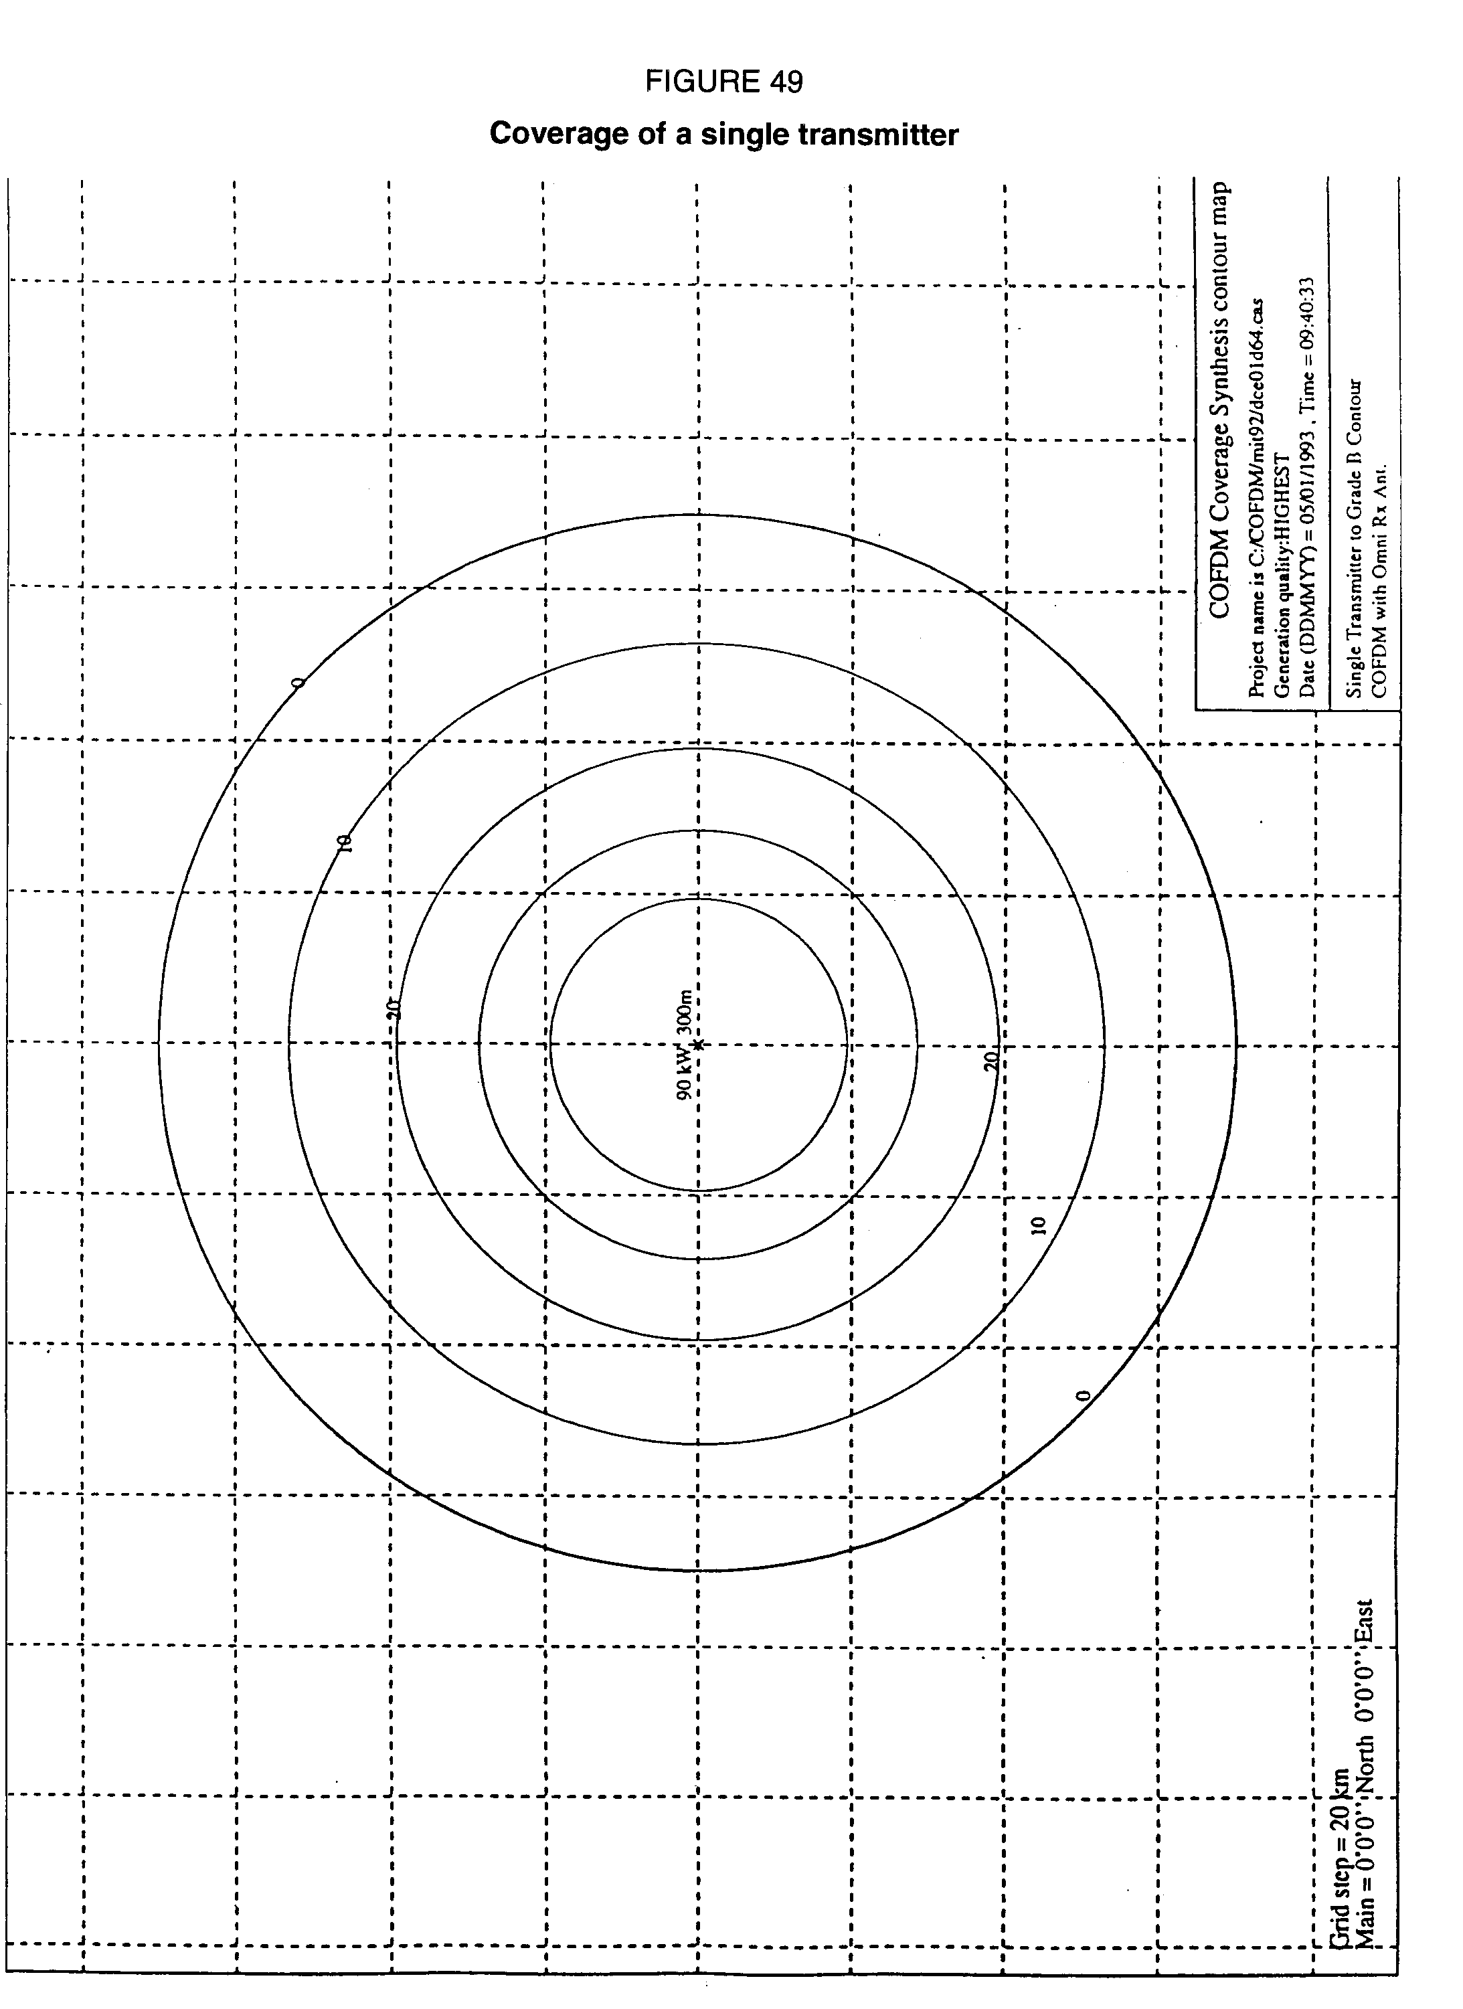

**COFDM coverage synthesis (version 1.53)**

# 1. System parameters

Curves show margin above system operation threshold (dB)

Horizontal span = 260 km

Frequency = 1 472 MHz

Symbol period = 320 s

Guard Interval = 64 s

Useful bit rate = 1 200 kbit/s

Spectrum efficiency = 0.8 bit/s/Hz

Minimum Eb/No = 7.5 dB

System and hardware margin = 6 dB

Propagation model = Rec. ITU-R PN.370 augmented

Receiver antenna height = 1.5 m

Location availability = 50%

Time availability = 90%

# 2. Receiver parameters

Antenna gain = 0 dBi

Antenna noise temperature = 105 K

Coupling and filter losses = 1 dB

Receiver noise figure = 1 dB

Receiver figure of merit = -24.39 dB/K

Antenna pattern: omnidirectional

Synchronization algorithm: Centre = linearly weighted mean echo

# 3. Transmitter parameters

**FIGURE 49 BIS**

|  |  |  |  |  |  |  |  |  |
| --- | --- | --- | --- | --- | --- | --- | --- | --- |
| Technical parameters Transmitter name | Position X Y | ERP (W) | Pattern | Height (m) | Azimuth (degrees) | Delay  (s) | Back lobe (dB) | In use |
| 90 kW 300m | 0 0 | 90 000 | Omnidirectional | 300 | 0 | 0 |  | YES |

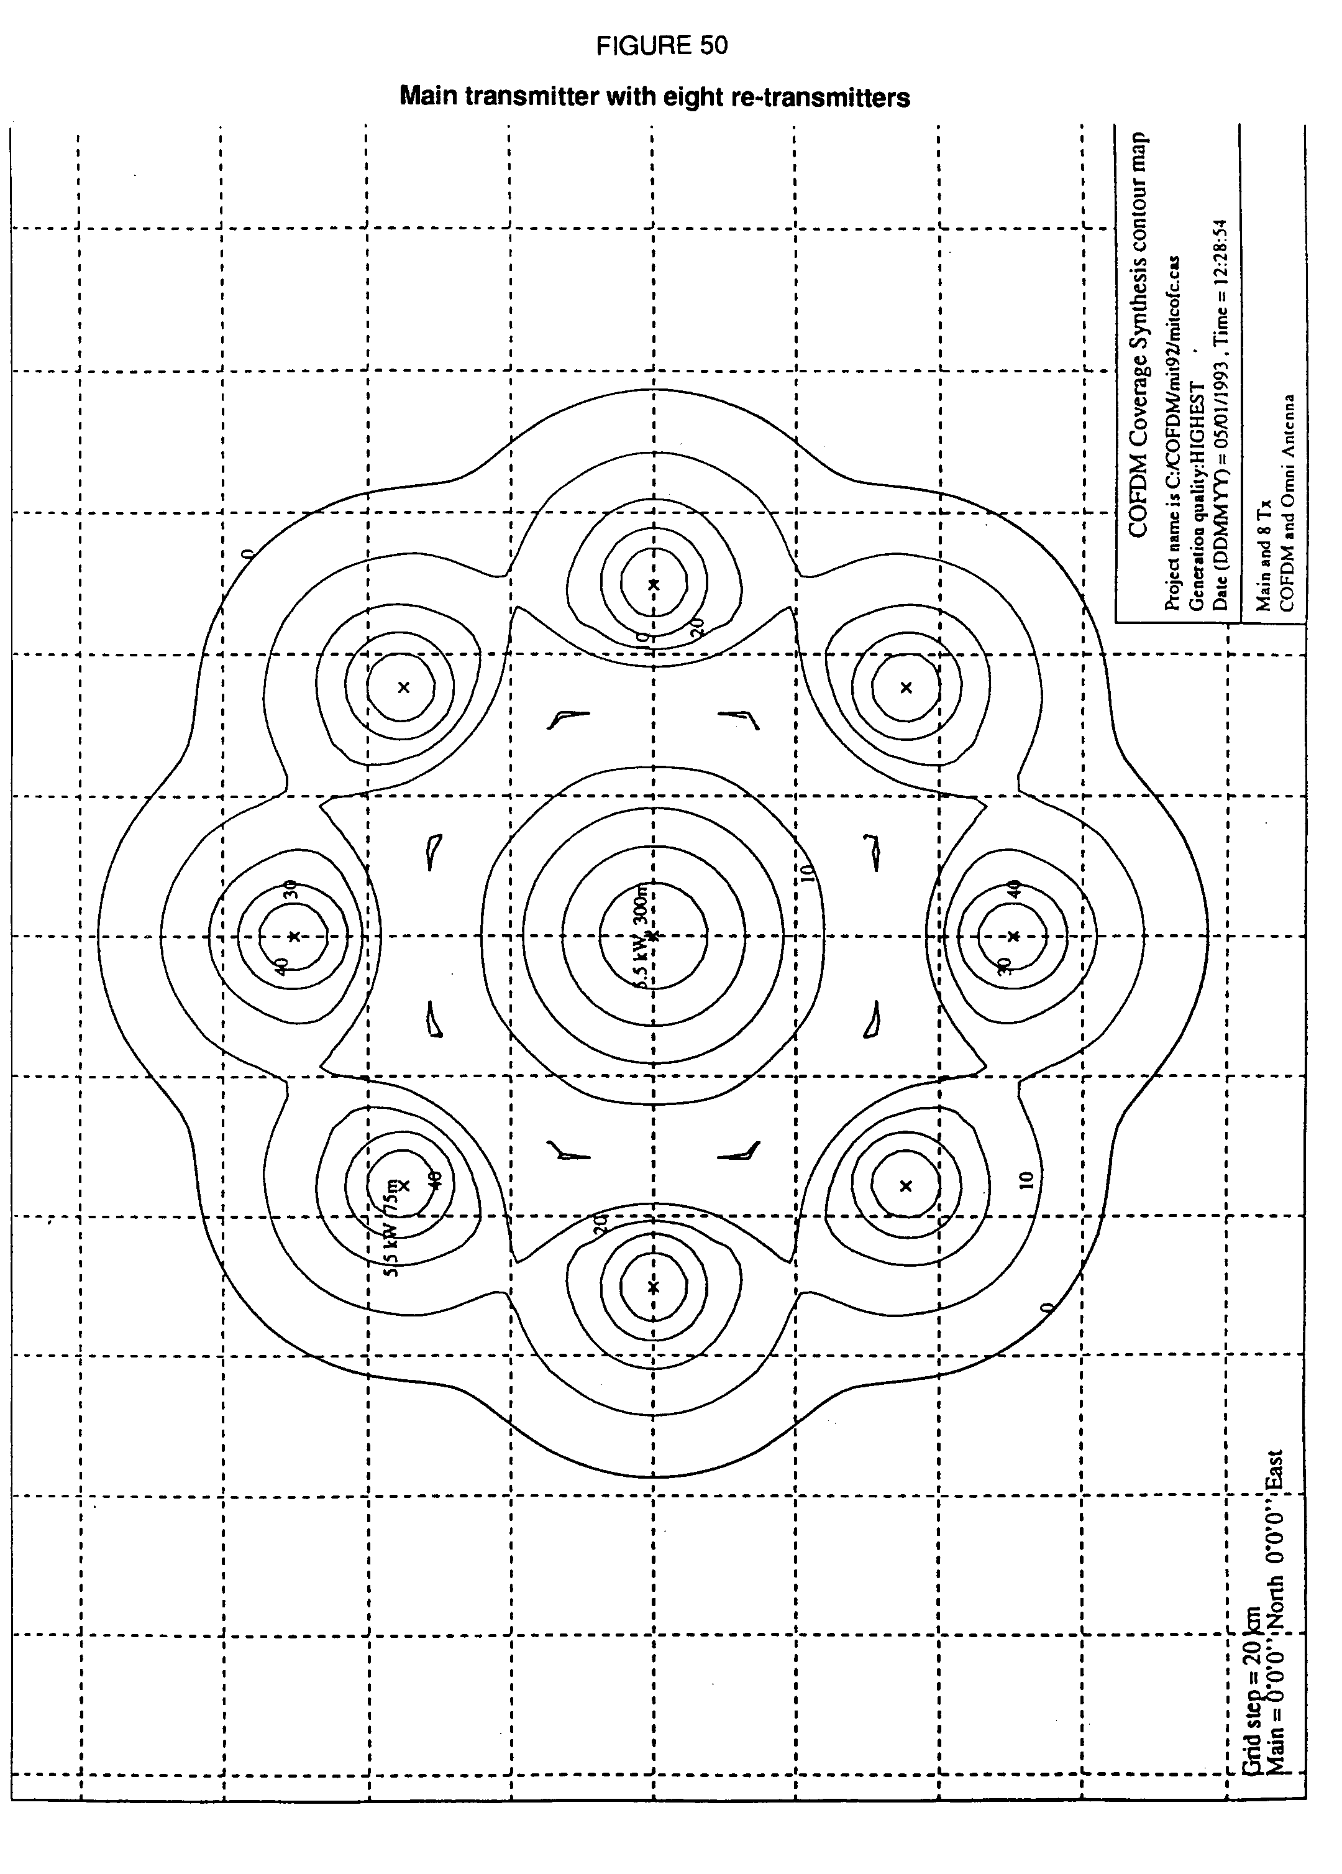

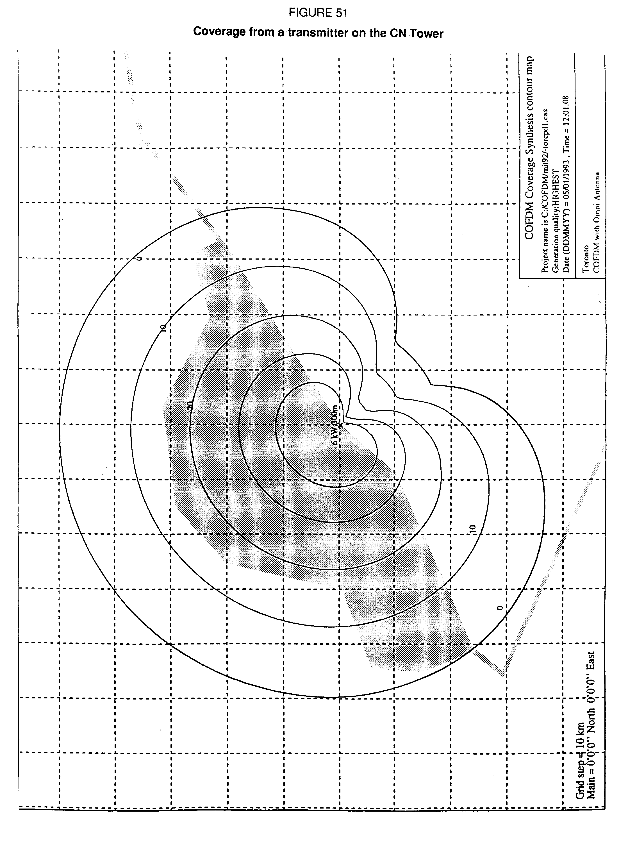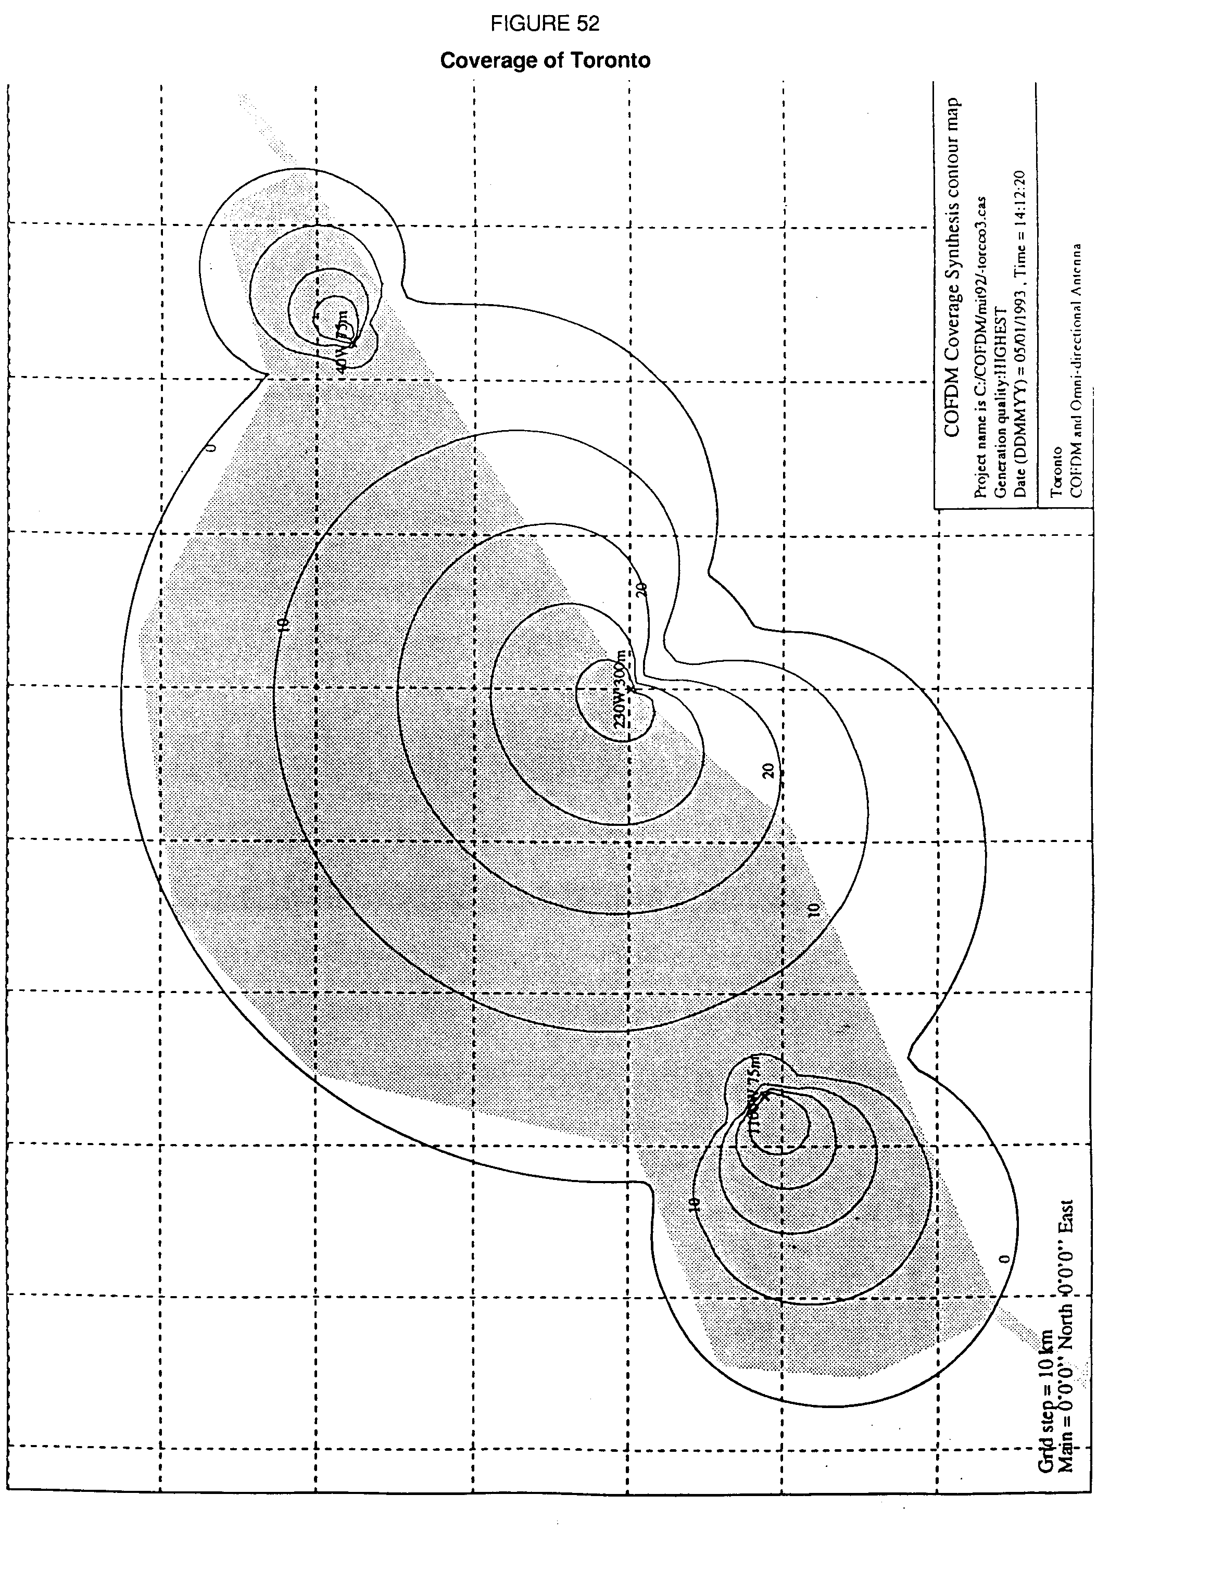

# 3. Synchronized SFN computer simulations at 1.5 GHz

The computer simulations were performed with COFDMCOV, a computer program developed at the Communications Research Centre, Ottawa, Canada. This program predicts the coverage of Digital Sound Broadcasting (DSB) stations using COFDM type modulation with guard interval. The parameter values used in the simulations described herein are summarized in Table 22 (system parameters), Table 23 (receiver parameters) and Table 24 (transmitter parameters) below.

TABLE 22

System parameters used in the simulations

|  |  |  |
| --- | --- | --- |
| **System parameters** | | |
| RF frequency | | 1 472 MHz |
| Total symbol duration (TS) | | 320 s (Mode II)  160 s (Mode III) |
| Guard interval duration () | | 64 s (Mode II)  32 s (Mode III) |
| Useful bit rate | | 1 200 kbit/s(1) |
| Spectrum efficiency | | 0.8 bit/s/Hz(1) |
| Minimum Eb/No | | 7.5 dB(2) |
| System and hardware margin | | 6 dB(3) |
| Propagation model | | Rec. ITU-R PN.370 modified(4)  F(50,90)(5)  F(90,90) |

TABLE 23

Receiver parameters used in the simulations

|  |  |  |
| --- | --- | --- |
| **Receiver Parameters** | | |
| Antenna height | | 1.5 m |
| Antenna gain | | 0 dBi |
| Antenna noise temperature | | 105 oK(2) |
| Coupling and filter losses | | 1 dB(2) |
| Receiver noise figure | | 1 dB(2) |
| Receiver figure of merit | | -24.4 dB/oK |
| Synchronisation algorithm | | First echo 20 dB below total power |

TABLE 24

Transmitter parameters used in the simulations

|  |  |  |  |
| --- | --- | --- | --- |
| **Transmitter Parameters** | | | |
| Antenna pattern | | | Omnidirectional |
| Transmitter spacing | | Variable | |
| **ERP** | | **Variable** | |
| **EHAAT** | | **Variable** | |

*Note 1 -* 1 200 kbit/s 0.8 bit/s/Hz = 1.5 MHz.

*Note 2 -* This value was taken from Report ITU-R BO.955.

*Note 3 -* This value was taken from Report ITU-R BO.955. It includes 1 dB allowance for the 20% guard interval, 1 dB equivalent loss caused by Doppler shift in a vehicle moving at 100 km/h, a 2 dB hardware implementation margin and 2 dB allowance for interference.

*Note 4 -* The Recommendation ITU-R PN.370 model (curves of Fig. 9, land, h = 50 m) was modified for a receiving antenna height of 1.5 m and an RF frequency of 1 472 MHz.

*Note 5 -* F(% locations, % time).

The main purpose of the simulations was to perform a parametric study of the three main transmitter parameters that come into play in an SFN, namely the transmitter spacing, ERP and EHAAT. This parametric study was done for two different guard interval durations (64 and   
32 s) and two sets of time and location availability, namely F(50,90) and F(90,90). The propagation curves used were those of Fig. 9 (land, h = 50 m) of Recommendation ITU‑R PN.370. The five parameters that were varied in the simulations are shown in boldface in the above tables.

# 4. Computer simulation results and discussion: minimum ERP vs. transmitter spacing

In the first series of simulations, the minimum ERP required for each transmitter of the network to ensure proper coverage was determined as a function of transmitter separation. These were arranged in a regular triangular lattice such as the one shown in Fig. 54. Each transmitter was assumed to have an omnidirectional radiation pattern, identical ERP and a fixed EHAAT of 200 m. For a given set of parameters, the minimum ERP was determined by reducing simultaneously the ERP of all transmitters until a first gap would appear anywhere in the coverage area. This was repeated for different transmitter spacings.

The results are shown in Fig. 55 for a guard interval of 32 s and in Fig. 56 for a guard interval of 64 s. In both figures, results are shown for two different sets of location and time availability, namely F(90,90) and F(50,90). ERP and transmitter spacing combinations that fall above the curves shown in these figures will provide satisfactory SFN operation.

For a guard interval of 32 s (Fig. 55), the minimum ERP increases gradually (propagation losses) for transmitter separations from 50 to 75 km and then asymptotically as the transmitter separation approaches 95 km (destructive echoes). SFN operation is impossible with EHAATs of 200 m and transmitter separations greater than 95 km no matter how large the ERP is.

The asymptotic behaviour of the ERP vs. separation distance curve could not be observed for a guard interval of 64 s and transmitter separations up to 120 km as shown in Fig. 56. The asymptote probably exists for transmitter separations somewhere between 150 and 200 km, well beyond the range of feasibility due to propagation losses.

One important result to note is that, for both Mode II and Mode III COFDM parameters and EHAATs of 200 m, transmitter spacings of 50, 60 and 70 km require a minimum ERP of 2.5 kW, 9 kW and 29 kW respectively to provide service at 90% of the locations and 90% of the time. This range of separation and ERP values is quite practical and only based on propagation losses rather than presence of destructive echoes. ERP values about 12 dB smaller would suffice for 50% of the locations and 90% of the time.

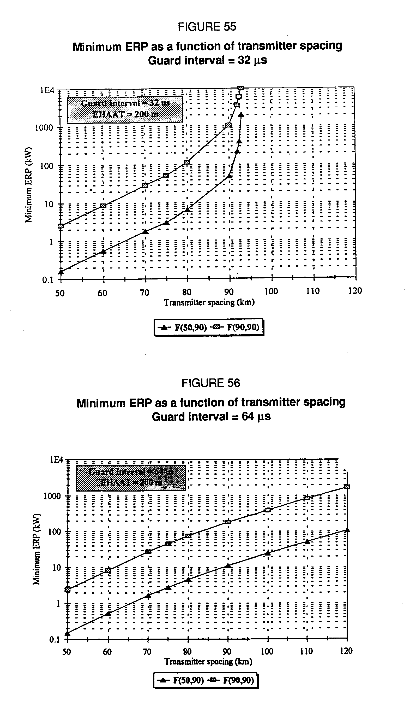

# 5. Conclusion

The detailed computer simulation results reported in this paper have demonstrated the feasibility of synchronized Single Frequency Networks at 1.5 GHz. Using either COFDM Mode II or Mode III parameters, transmitter separations up to 80 km were shown to be possible with realistic values of transmitter ERP and antenna EHAAT.

It was shown that guard intervals as small as 64 sec (Mode II) or 32 sec (Mode III) is not a constraint for transmitter spacings up to 80 km because echoes received outside these guard intervals in a network are well attenuated by propagation losses and are not destructive enough to bring the C/(N+I) ratio below threshold. Propagation loss is an important factor that seems to have been overlooked in previous SFN studies where very long guard interval durations were thought to be required to ensure proper network operation.

In all these computer simulations, a deterministic propagation model was used. This represents the case where all active echo levels are correlated and the presence of passive echoes was not considered. It is likely that in real life, where the fading on each echo received at one point is independent from any other, the situation will somewhat be improved. Further work is required to explore the SFN service availability when stochastic propagation models are used.

annex 1-e

Computer simulations of system performance  
(Digital System A)

# 1. Introduction

Computer simulations have been conducted in Canada to assess the performance of Digital System A in the context of a mixed terrestrial/satellite DSB service at 1.5 GHz. In order to minimize the receiver complexity, a common modulation technique for both satellite and terrestrial transmissions is assumed. The performance of Digital System A in the context of terrestrial emission is reported in this annex, whereas its performance in the context of satellite emission is reported in Annex 3A of Report ITU-R BO.955.

# 2. Computer simulation model

## 2.1 General model

A block diagram of the model used for the analysis and simulation of the COFDM scheme is shown in Fig. 57. The data source generates a pseudo-random binary sequence. The bit generated at any given time is independent of all previous bits and both levels of the binary alphabet are equally likely. The information bits are then error protected by means of a convolutional encoder. After being time and frequency interleaved, the bits are paired into dibits and phase encoded differentially. The OFDM modulation is finally performed by means of an inverse fast Fourier transform (IFFT). After being processed through the mobile channel, the received OFDM signal is first demodulated with an FFT. The information of each subcarrier is then differentially phase decoded and de-interleaved in frequency and in time. The output of the de‑interleaver is quantized before being fed to the Viterbi decoder.

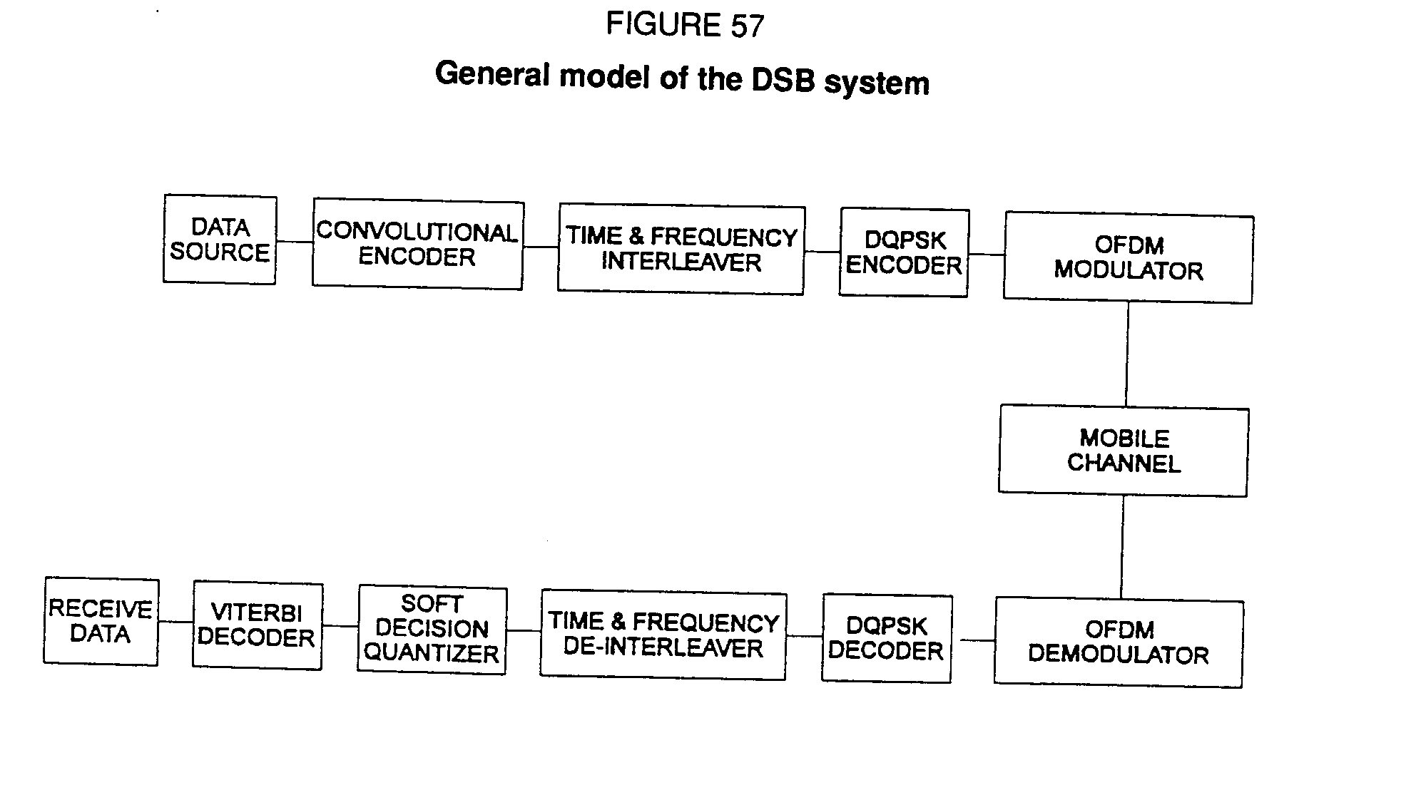

## 2.2 Mobile terrestrial channel model

Both terrestrial and satellite mobile channels have been simulated. The model of the terrestrial mobile channel consists of approximately N = 40 paths each having a fixed delay 1, a fixed Doppler shift fi and equal relative attenuation. The delay values of each path are generated from a probability density function of the form:

 (1)

which corresponds to a given multipath power delay profile. In (1), is a measure of the standard deviation of the delays about the mean value (i.e. the "delay spread") and max is the maximum echo delay. Power delay profiles typical of rural and urban areas were used and are shown in Fig. 58 [COST 207, 1989]. The Doppler shift of each path is generated by:

fi = fmax cos(i) (2)

where fmax is the maximum Doppler shift determined by v/ (vehicle speed/RF carrier wavelength) and i is a random variable uniformly distributed between 0 and 2. Following the fading process, white Gaussian noise is added to the signal.

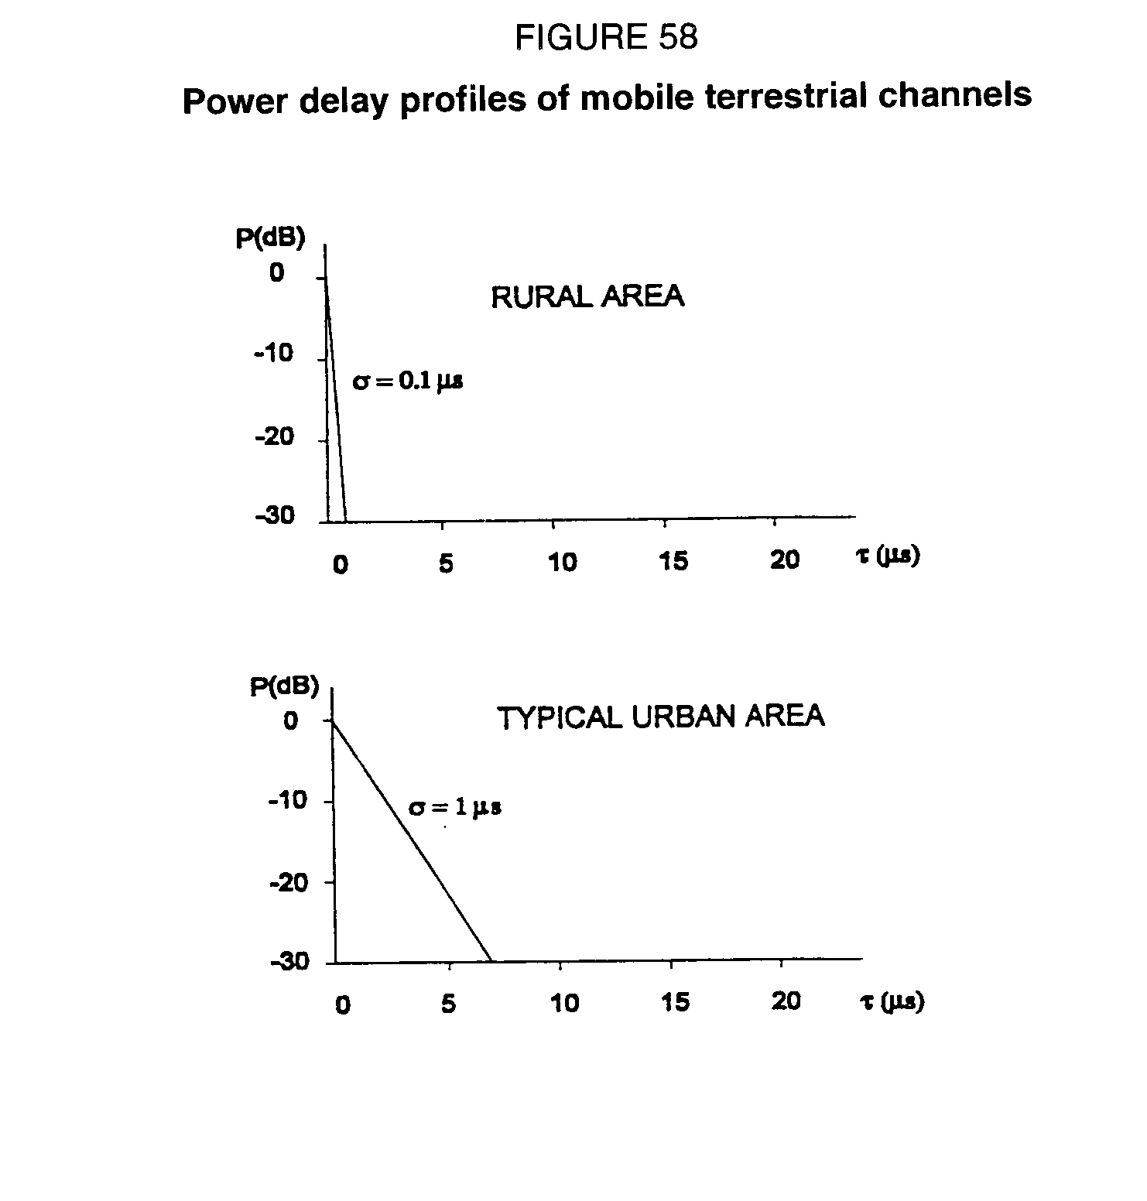

## 2.3 Limitations of the simulations

Perfect synchronization and perfect (brick-wall) filtering were assumed in the simulations reported here. Effects of automatic gain control, phase noise in receiver local oscillators as well as non-linearities in transmit or received equipment have not been considered. The model so far thus represents perfect implementation of the COFDM transmitter and receiver. The results therefore represent the best possible performance for the given channel distortions. Additional simulation software is being developed as part of the same Study Programme to investigate the effect of these hardware implementation factors on the performance of the COFDM scheme.

# 3. Simulation results and discussion

The COFDM parameters investigated were the time interleaving depth, the number of soft decision quantization levels and the constraint length of the convolutional code.

In the results reported below, the energy contained in the guard interval was included in the computation of Eb/No. Corresponding carrier-to-noise (C/N) ratios can be easily obtained by subtracting 1 dB form the Eb/No values.

# 3.1 Time interleaving depth

The purpose of this first series of simulations was to determine the optimal time interleaving depth value. Simulations were performed in both typical urban (TU) and rural area (RA) mobile terrestrial channels at vehicle speeds of 18 km/h (fmax = 25 Hz) and 145 km/h (fmax = 200 Hz). The total symbol duration used was Ts = 156.25 s (Mode III).

The Eb/No values required to achieve a bit error rate (BER) of 10-4 were determined as a function of the time interleaving depth. This latter parameter was varied from 48 to 768 ms.

The results, which are plotted in Fig. 59, show small degradations (at most 1 dB in the RA channel) as the time interleaving depth is reduced from 768 to 384 ms. Below 384 ms, the degradations increase rapidly in both channels. A time interleaving depth value of 384 ms is thus a good compromise between delay and performance.

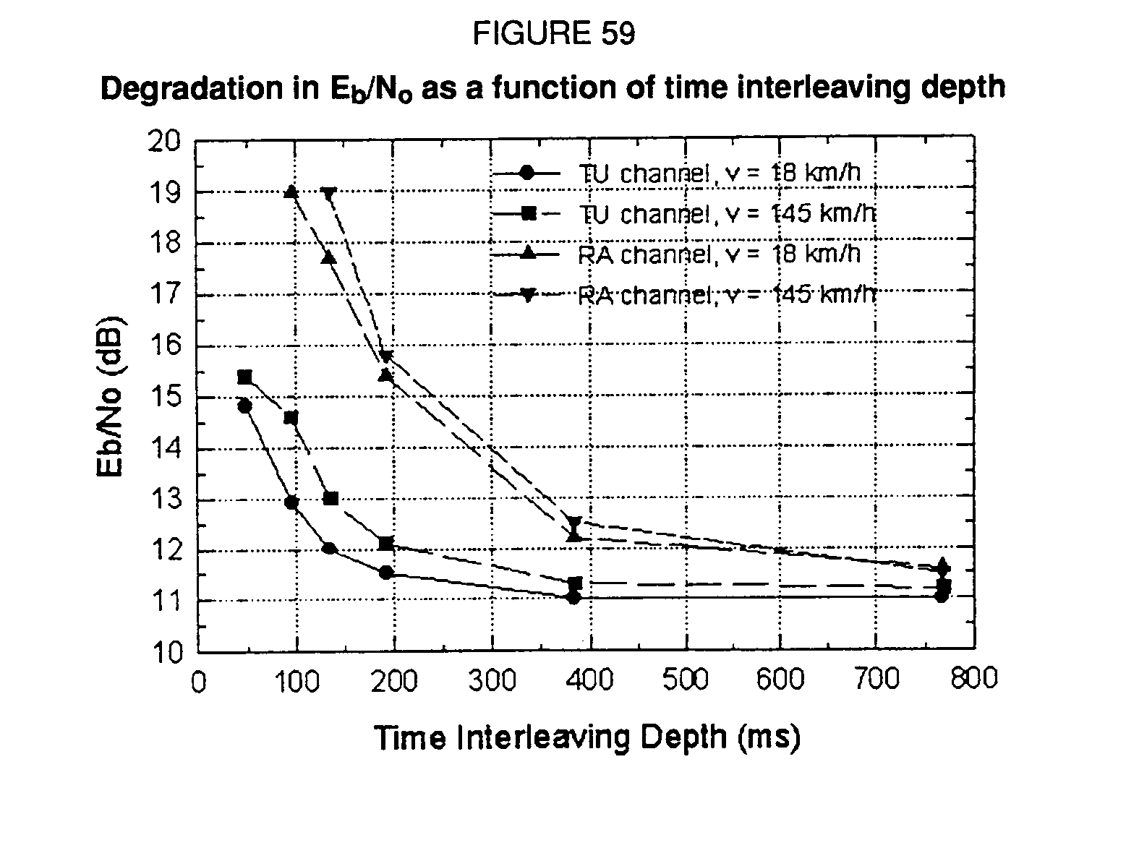

## 3.2 Soft decision quantization levels

The purpose of this second series of simulations was to assess the degradations in performance resulting from a reduction in the number of levels used to quantize the input to the Viterbi decoder. This parameter has an impact on the complexity of the Viterbi decoder. It is demonstrated in [Clark, G.C., 1988] that 8 quantization levels is the optimal choice in the additive white Gaussian noise (AWGN) channel. Is such a number sufficient in mobile channels?

In order to provide some answers to this question, simulations were performed in both the TU and RA mobile channels as well as the AWGN channel. A vehicle speed of 72 km/h (fmax = 100 Hz) was used in the mobile channels. The total symbol duration was 156.25 s (Mode III) and the time interleaving depth had a value of 384 ms.

The Eb/No values required to achieve a bit-error rate (BER) of 10-4 were determined as a function of the number of quantization levels. This latter parameter was varied from 2 (1 bit/sample, hard decision) to 32 (5 bits/sample).

The results, which are plotted in Fig. 60, show no significant increase in the value of Eb/No as the number of quantization levels is reduced down to 8 in the AWGN channel and down to 16 in both TU and RA channels. Below these two values, the degradation increases rapidly. Similar results (not shown) were obtained at higher vehicle speeds. A quantizer with 16 levels (4 bits/sample) is thus optimal in mobile channels. A quantizer with a higher resolution is required in mobile channels (as compared to the AWGN channel) to retain the information contained in the large fluctuations of the received signal envelope.

## 

## 3.3 Convolutional code constraint length

The purpose of this third series of simulations was to determine the effect of reducing the constraint length of the convolutional code from the proposed value of 7. The complexity of the Viterbi decoder grows exponentially with the constraint length value.

The BER vs. Eb/No curves were measured in both the TU and RA mobile channels at vehicle speeds of 18 km/h (fmax = 25 Hz) and 200 km/h (fmax = 275 Hz) and for constraint length values of 5 and 7. The total symbol duration was 156.25 s (Mode III) and the time interleaving depth had a value of 384 ms.

The results are plotted in Fig. 61 for the TU channel. Reducing the constraint length from 7 to 5 results in a degradation of approximately 1.5 dB at a BER of 10-4 and a vehicle speed of 18 km/h. The degradation reaches approximately 2 dB at a speed of 200 km/h for the same BER value. Similar results (not shown) were obtained in the RA channel.

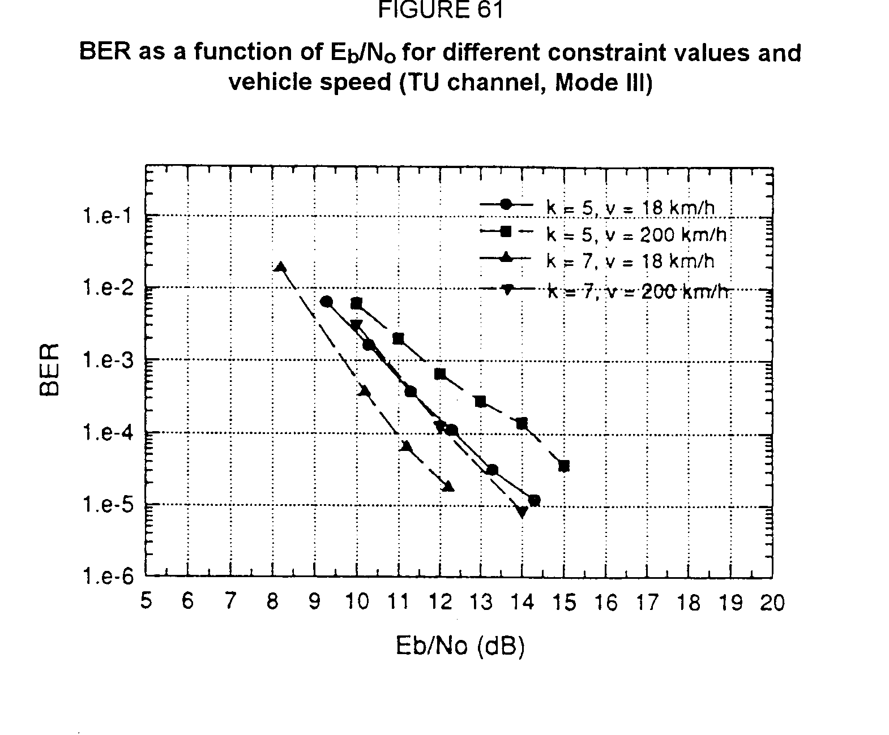

# 4. Conclusions

In this annex, preliminary results of a parametric study of the COFDM emission format operating at 1.5 GHz are presented. The study was performed by computer simulation. Perfect synchronization and perfect (brick-wall) filtering were assumed. Effects of phase noise in receiver local oscillators as well as non-linearities in transmit or received equipment have not been considered. The results therefore represent the best possible performance of the COFDM scheme over the mobile channels investigated. The results showed that:

- a time-interleaving depth of 384 ms is a good trade-off between delay and performance;

- quantizing the input to the Viterbi decoder with 4 bits/sample is optimal in the case of mobile channels;

- reducing the size of the constraint length of the convolutional code from 7 to 5 introduces 1.5 to 2 dB of degradation at a BER of 10-4.

Additional simulation software is being developed to investigate the effects of hardware implementation factors on the performance of the COFDM scheme.

ANNEX 2

In-band on channel (IBOC) digital sound broadcasting systems description

# 1. Introduction

Until recently it was generally believed that new or under-utilized frequencies in the VHF and UHF bands presented the only option available for implementing a new DSB service. Recent research and development work has produced technologies which may make possible another approach to DSB which can utilize the existing broadcasting infrastructure of Band 6 and VHF FM.

"In-band, on-channel", (IBOC) DSB systems are designed to allow a DSB signal to simultaneously occupy the same frequency allocation as the conventional analogue broadcast signal. IBOC DSB is highly spectrum efficient since it utilizes the same frequency twice; once for the analogue broadcast signal and again for the digital broadcast signal. IBOC allows a migration to DSB services in a non-disruptive manner. IBOC DSB technology may make available valuable and scarce VHF and UHF RF spectrum which had previously been identified as DSB replacement service spectrum. Actual on-air tests of the VHF FM and Band 6 IBOC DSB systems have been conducted at various venues within the United States.

# 2. IBOC implementation of DSB

The basic goals for an IBOC implementation of DSB have been formulated to ensure compatibility with the analogue FM systems in the United States.[4]* The goals for these IBOC systems include:

2.1 The encoded and modulated signal should be centred around one of the assigned FM carrier frequencies (Band II on odd integer multiples of 100 kHz), and the composite analogue/digital signal shall conform to the power spectral density masks defined by the FCC.

2.2 The decoded audio signal shall have "near-CD" quality under all conditions of transmission and reception (stationary or mobile) anticipated in urban, suburban and rural environments.

2.3 The overlaying of the DSB signal on the analogue FM shall result in no audible deterioration of the latter under the above-defined conditions when received by a conventional FM receiver of average quality.

2.4Similarly, the presence or absence of the analogue FM signal shall have no audible effect upon the reception of the DSB signal.

Two of the systems under development, which are purported to achieve all of these goals, were described at the January 1993 meeting (Los Angeles); two papers, which question the feasibility of the IBOC concept, were also presented. This report summarizes the systems and questions raised in the latter papers.

# 3. Description of systems

## 3.1 FM system

One of the systems described uses filtering to confine the analogue FM signal to a 200 kHz band centred about the carrier frequency, and places an appropriately filtered COFDM DSB signal in one or both of the 100 kHz side-channels (from fc-200 to fc-100 and/or from fc+100 to fc+200 kHz). The placement of the individual sub-carriers is completely flexible, and the decision about which side-channels to use is made to minimize mutual interference to and from other FM stations (either with or without overaid DSB) in the geographical vicinity. Information defining the side-channel usage is continuously transmitted in a very robust auxiliary channel; the usage may be changed at any time without disruption of either analogue or digital signals.

Multipath effects are mitigated by a combination of frequency diversity across the full span of 400 kHz, interleaving to the full depth permitted by the input/output delay constraint, and powerful forward error correction.

The auxiliary channel may also be used for transmission of non-audio data the paper suggests many possible uses of this data.

In another system, in addition to the traditional multipath mitigation techniques, work proceeds on a "frequency sliding" technique in which the carrier frequencies of the digital subchannels are modulated by the FM programme, and produces a constant frequency offset between the analogue FM carrier and the IBOC digital signals. The frequency slide moves the digital carrier frequencies in synchronization with the instantaneous FM signal frequency. Frequency slide increases the effective IBOC DSB bandwidth and delivers a level of effective frequency diversity against multipath. Additionally, a recently developed high speed equalization technique based on acoustic charge transport (ACT) technology is used to compensate for non‑uniform phase distortion induced by multipath across the band.

In developing the in-band, on-channel FM digital sound broadcast (FM-DSB) system, it was necessary to extract the digital audio signal from a standard analogue FM signal occupying the same spectrum. To extract the DSB signal from the analogue FM, a class of signal-processing components known as adaptive filters is employed. An adaptive filter has the capability of automatically changing its response as the characteristics of the desired or undesired signals change. One form of adaptive filter is the "transversal" filter which uses successive delay, weighting, and summation operations to pass desired signals while rejecting undesired signals. Until recently, implementation of programmable transversal filters capable of handling high-speed signals has been impractical. High-speed transversal filters are now available through a technology that combines the speed and simplicity of analogue components with the programmability and delay capability of digital processing. ACT technology allows the practical implementation of transversal filters which operate over a frequency range from 500 kHz to 180 MHz, providing several hundred parallel delays over a range of several nanoseconds to several microseconds.

Filters meeting specification necessary to extract a DSB signal 30 dB below a standard FM signal have been demonstrated in various public venues in the United States. Filter depth of ‑35 dB have been demonstrated with updating speeds of less than 100 nsec.

An important consideration in the development of an in-band, on-channel FM digital sound broadcasting (FM-DSB) system is the requirement that the digital signals do not interfere with the analogue FM signals occupying the same frequency channel. Interference suppression is achieved by modulating the digital signal in a way that ensures that it is orthogonal to the analogue signal. One method of achieving this orthogonality is to design the digital signal spectrum such that it is never superimposed directly on the analogue signal spectrum. The previously described frequency sliding technique maintains a constant offset between the analogue FM and IBOC DSB signals. Practical system implementations cannot be expected to maintain perfect orthogonality, and any correlation between the analogue and digital signals will result in some amount of mutual interference between the signals. The amount of interference will depend on the ability to prevent any overlap between the analogue signal spectrum and the digital signal spectrum by proper design and implementation of the digital waveform.

Non-interference of an in-band, on-channel FM-DSB signal with conventional analogue FM reception has been demonstrated during over-the-air testing performed with station WWNO in New Orleans, Louisiana and station WILL in Urbana, Illinois. Measurements made prior to injection of the digital signal at station WILL-FM in Urbana, Illinois in September 1992 yielded a S/N of approximately 60 dB; the injection of a frequency-sliding 192-kbit/sec digital signal with a power level of approximately ‑30 dBc decreased the measured S/N by approximately 0.5 dB to 59.5 dB. Additional observations were made on a standard commercial automobile FM receiver in an attempt to detect the presence of the digital signal in the audio output of the receiver. For these tests, the digital transmitter power was cycled on and off while two engineers attempted to discern any change in the quality of the audio. During both mobile and stationary testing, the presence of the digital signal was never detected. In some locations in which severe multipath caused almost total loss of the analogue signal, interference from the digital signal remained undetectable. An in‑band, on-channel DSB was broadcast over WILL-FM for a period of approximately four weeks. During this time, no listener complaints correlated to the IBOC DSB testing were reported.

Questions have been raised as to whether such a system can meet the major technical and operational characteristics listed in Recommendation ITU-R BS.774 for terrestrial digital sound broadcasting. Some of the questions relate to the following selected CCIR service characteristics:

- Audio quality: would a 200 kHz bandwidth also allow for reliable reception of a CD quality stereophonic programme to portable and mobile receivers beyond the fixed receiver as currently considered in FM planning?

- Spectrum and power efficiency: can sufficient power levels be employed to provide the higher service availability required for digital systems over the same coverage area without degrading the current analogue FM coverage, both at the edge and inside the service area? Would non-co-channel systems present significant difficulties to spectrum planning to accommodate the migration of current FM stations to DSB, as well as growth accommodation and the migration of AM stations to FM-DSB if no suitable AM-DSB system can be developed?

- Performance in a multipath and shadowing environment: would a 200 kHz channel be wide enough to provide effective frequency diversity? Would space diversity at the receiver, if necessary, prove to be practical for portable and vehicular reception, and if so, since the FM reception would be improved, would the difference in service quality between FM and DSB be sufficient to secure the viability of this new service?

## 3.2 AM systems

Early development efforts in bringing digital audio broadcasting to Band 6 offers an opportunity to achieve audio reception that rivals the fidelity of the original programme material. Achieving an in-band, on-channel (IBOC) implementation requires no additional spectrum and accomplishes the transition to DSB with minimal disruption.

The primary constraint in realizing an IBOC solution to DSB is to insert the digital waveform within the allocated spectrum. The key element to realizing IBOC DSB is the recent development in source coding algorithms that reduce the data throughput requirement by more than an order of magnitude.

There have been several public demonstrations in the United States where a transmitter operating in Band 6 has been modulated by a digital signal and recovered at a distant fixed site with a bit error rate of less than 1 x 10-9**.** The audio was source coded at 96 kbit/s and met the spectral requirements of the FCCs NRSC mask (+/- 17.5 kHz).

Several questions need to be answered:

- Can in‑band digital sound broadcast systems fit in the current allocation?

- Since a 10 kHz channel having to meet the 26 dB co‑channel protection ratio, used for planning AM in Region 2, can only carry 86 kbit/s (Shannon limit), can this channel carry a CD quality service?

- Can the needs of a digital modulation system be met without interference with the analogue channel?

- What would be the performance and failure characteristics of AM-IBOC systems in the presence of interference from other AM stations, particularly skywave interference?

# 4. Conclusion

Different administrations may have different requirements with respect to their sound broadcast systems. The systems presented above may provide practical alternatives to the DSB systems that have previously been considered. As a result, certain administrations may be better able to introduce DSB service without severe economic disruption of existing services.

REFERENCES

ALARD, M. and LASSALLE, R. [August 1987] - Principles of modulation and channel coding for digital broadcasting for mobile receivers. EBU Review - Technical, No. 224, pp. 168-190.

CLARK, G.C. and CAIN, J.B. - Error-correction coding for digital communications. Plenum Press, New York, Third Edition, 1988.

COST 207 [1989] - Digital land mobile radiocommunications. Final Report of COST Project 207, Commission of the European Communities, Brussels.

COX, D.C. and LECK, R.P. [March 1975] - Distributions of multipath delay spread and average excess delay for 910 MHz urban mobile radio paths. IEEE Trans. on Antenna and Propagation No. 2, Vol. AP-23, pp. 206-213.

de WECK, J.-P., MERKI, P. and LORENZ, R. [1988] - Power delay profiles measured in mountainous terrain. IEEE Vehicular Technology Conference, pp. 105-112.

DOSCH, C., RATCLIFF, P.A. and POMMIER, D. [December 1988] - First public demonstrations of COFDM/MASCAM. A milestone for the future of radio broadcasting, EBU Review - Technical No. 232, pp. 275-283.

LE FLOCH, B., HABERT-LASSALLE, R. and CASTELAIN, D. - Digital sound broadcasting to mobile receivers. IEEE Transactions on Consumer Electronics, Vol. 35, No. 3, August 1989, pp.493-503.

SHELSWELL, P., BELL, C.P., STOTT, J.H., WATELING, S., MADDOCKS, M.C.D., MOORE, J.H., DURRANT, P.R. and RUDD, R.F. - Digital Audio Broadcasting - The first UK field trial, BBC RD 1991/2.

**BIBLIOGRAPHY**

GREEN, J.A. [1992] - Building penetration loss measurements for DAB signals at 211 MHz. BBC Research Department Report, No. BBC RD 1992/1 4.

KRAHE, D. [1986] - Ein Verfahren zur Datenreduktion bei digitalen audio-signalen unter ausnutzung psychoakustischer phäenomene. Rundfunktechnik Mitteilungen 30, pp.117‑123.

THEILE, G., STOLL, G. and LINK, M. [August 1988] - Low bit-rate coding of high-quality audio signals. An introduction to the MASCAM system. EBU Review - Technical No. 230, pp.158-181.

WATERS, G. and KOZAMERNIK, F. - Plans and studies in the EBU for satellite broadcasting of sound radio, 13th AIAA International Communication Satellite Systems Conference, Los Angeles, March 1990, Part I, pp.176-185.

1. * Radiocommunication Study Group 6 made editorial amendments to this Report in October 2010.
2. * See Doc. JIWP 10‑CMTT/1‑7(Rev.1) (EBU):"Digital audio bit-rate reduction systems requirements for broadcast emission and primary distribution".
3. * Only one channel was operated with a sound programme. The 15 remaining channels were loaded by a fixed pattern configuration. Using the most up‑to‑date source coding technique, a total of 24 stereophonic sound channels may be transmitted with the same total useful bit rate of 5.6 Mbit/s.
4. * The question of whether an IBOC system would be viable in countries with differently assigned analogue FM carrier frequencies has not been addressed.