Radiocommunication Study Groups
Source: Report ITU-R M.2514  Subject: Resolution ITU-R 65 | Document IMT-2020-SAT/1-E
 | 4 November 2022
 | English only
Working Party 4B
Background on the satellite component of IMT-2020

1 Key features of the satellite component of IMT-2020
As defined in Resolution ITU-R 56-2, International Mobile Telecommunications-2020 (IMT-2020) systems are mobile systems that include new radio interface(s) which support the new capabilities of systems beyond IMT-2000 and IMT-Advanced.
It is envisioned that the satellite use cases and technical requirements for the satellite radio interface for IMT-2020 will differ from that of the terrestrial interface of IMT-2020 developed in 2017. The use and objective of satellite radio interfaces is expected to be complementary to terrestrial IMT-2020 operations, given satellites’ unique ability to address coverage challenges and use-cases. Certain aspects of IMT-2020 are not expected to be served by the satellite radio interface for IMT-2020, for example very high data throughputs of eMBB, very high connection density of mMTC and low latency for URLLC, given the inherent distance of satellites to associated earth terminals or earth stations and the challenge of resulting greater latency compared to terrestrial operations. Therefore, the requirements and evaluation guidelines developed previously for the terrestrial component of IMT-2020 may be considered for the development of satellite radio interface(s) of IMT-2020 and modified considering specific satellite characteristics, such as modified throughput and user data rates, as necessary.
The new satellite-based service categories are reflected through the definition of eMBB-s, mMTC-s and HRC-s usage scenarios for the satellite component of IMT-2020 as illustrated below:
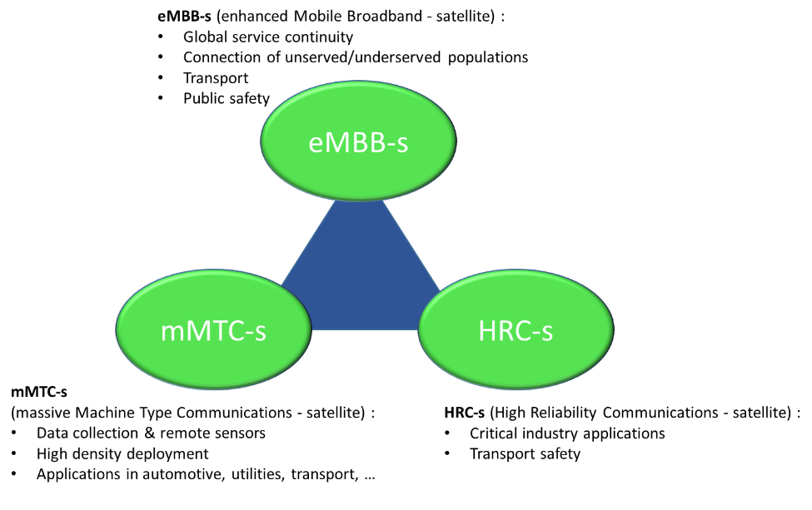

2 Vision of the satellite component of IMT-2020
The ability to ensure global service continuity, high service reliability and availability is an important challenge for the whole ICT sector.
Meeting this challenge requires combining a variety of access technologies. Adding satellite component in the picture will contribute to extend the coverage of the IMT-2020 service in under and unserved areas where complementing the terrestrial component is most relevant. Moreover, the two types of network components will contribute to increase the overall reliability of the IMT-2020 systems.
Different levels of integration, as described in Recommendation ITU-R M.1182-1 may be used, which may benefit from adopting a common architecture framework to improve support of mobility management, multiconnectivity, service continuity and enhance the reliability/quality of the service.
Given that the terrestrial component of IMT-2020 is already defined, the definition of the satellite component of IMT-2020 should take into account the capabilities, the system architecture, the radio interface(s) of the terrestrial component. Moreover, it should be clear that due to inherent physical constraints, the satellite component will feature different technical and performance characteristics (e.g., latency, data rate) compared to the terrestrial component.
Report ITU-R M.2514 defines visions on the satellite component of IMT-2020 for an efficient IMT service delivery with respect to application scenarios, services, system, radio and network interface aspects. In addition, this Report provides evaluation criteria and methodology on the requirements in order to produce Recommendations for the development of the satellite radio interface(s) of IMT-2020.

3 Application scenarios
The satellite component can be used to provide many different applications, for example:
– Global connectivity to end user devices
– Network resilience through high availability combined with high reliability for HRC-s
– Connectivity for transportation purposes
– Content delivery in broadcast or multicast mode to end user devices.
– Machine type communications.
The Enhanced Mobile Broadband (eMBB-s) usage scenario, in the context of the satellite component of IMT-2020, should support high data rate applications in rural and remote areas, air and maritime environments, and, in some cases, suburban areas. Terminal devices on the move, capable of supporting communications at high velocity, should be supported to meet transportation needs and their associated users. Specifically, the following cases are identified:
– Coverage continuity: moving pedestrian (consumer smart phones) should be able to maintain access to a large range of communication services and applications while moving out to remote areas for e.g., remote working, leisure, etc.
– Connecting populations in unserved or underserved areas
– Connectivity to transport: buses, trains, vessels (leisure or cruise) or airplanes
– Public safety: to provide communication services (e.g., messaging, voice, video) to emergency responders (e.g., fire brigade, medical personnel).
The massive machine type communications (mMTC-s) provided through the satellite component of IMT-2020 should be able to address large number of scattered connected fixed or mobile devices over wide areas. Such devices may be low cost and have long battery life. Several use cases typical of the mMTC-s usage scenario in a satellite context are identified below:
– Automotive: this may include traffic flow optimisation, automotive diagnostic, safety status reporting
– Utilities: e.g., surveillance of oil/gas, energy/water supply infrastructures, wind farms
– Transport (road, railway, maritime, aeronautic): Fleet management, asset tracking, digital signage, remote roads alerts.
The high reliability communications (HRC-s) scenario has specific requirements for availability and reliability.

Multiconnectivity in this instance refers to user equipment that may be connected to two or more network nodes.

