|  |  |
| --- | --- |
| **Radiocommunication Advisory Group Geneva, 8-10 June 2011** |  |
|  |  |
|  |  |
|  | **Addendum 1 to Document RAG11-1/1-E** |
| **21 April 2011** |
| **Original: English only** |

|  |  |
| --- | --- |
| |  | | --- | | **Director, Radiocommunication Bureau**  report to the EIGHteenth meeting of the  radiocommunication advisory group | |
|  |

**ITU-R Recommendation download statistics**



Numbers of distinct users downloading ITU-R Recommendation in 2009 and 2010



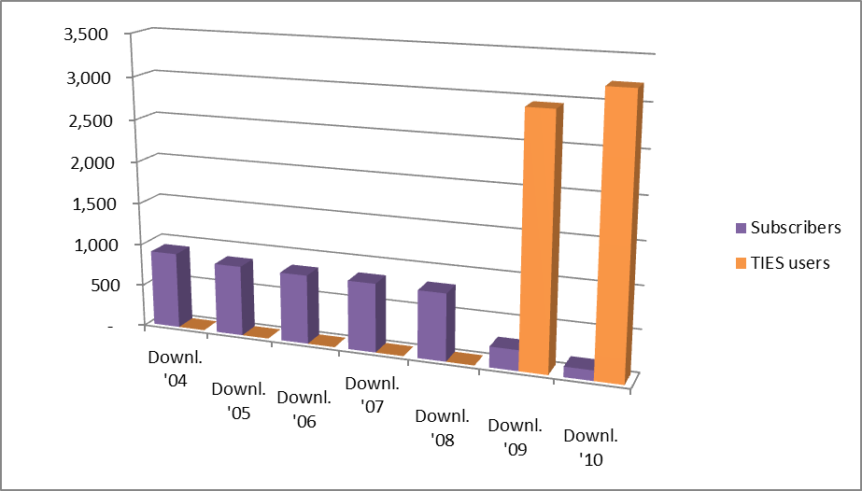

Availability of ITU-R Recommendations in different languages on the ITU Web site

This background information is important in order to balance the download figures below.

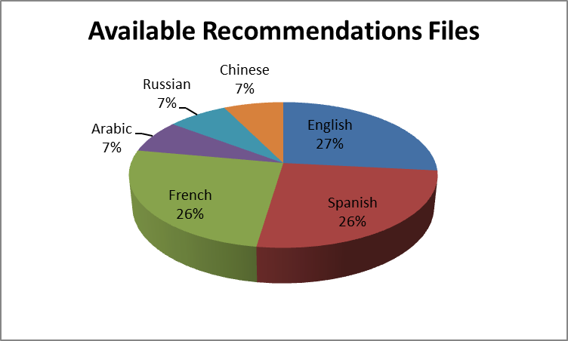

Number of ITU-R Recommendations downloaded by TIES users during 2009 and 2010



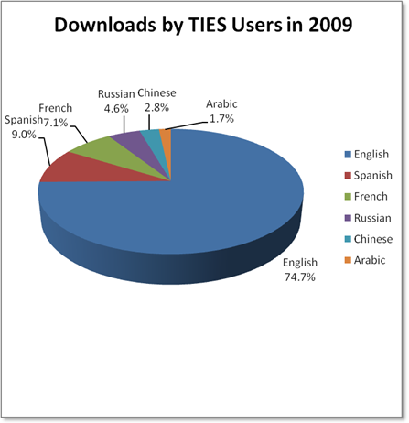

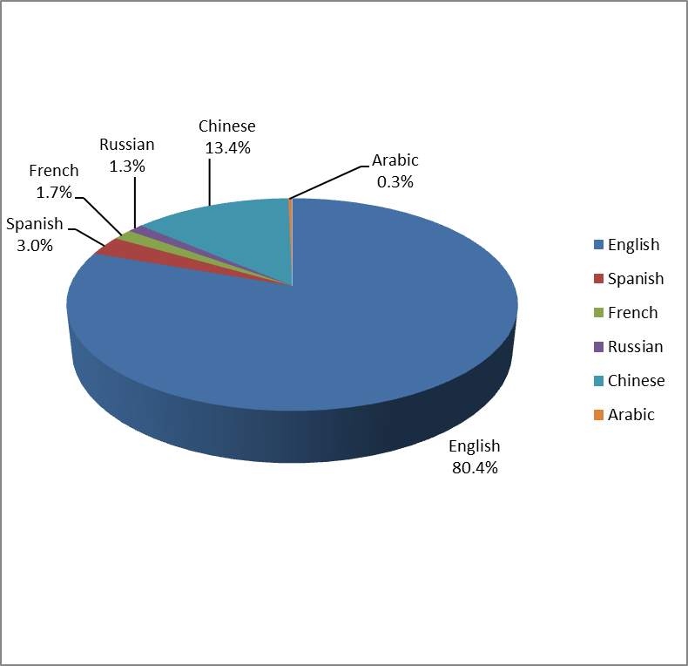

**Downloads by TIES Users in 2010**

_____________