|  |  |
| --- | --- |
| INTERNATIONAL TELECOMMUNICATION UNION | sigleITU |

|  |
| --- |
| *Radiocommunication Bureau*  *(Direct Fax N°. +41 22 730 57 85)* |

|  |  |
| --- | --- |
| **Circular Letter**  **5/LCCE/37** | 3 April 2013 |

**To Administrations of Member States of the ITU, Radiocommunication Sector Members, ITU-R Associates participating in the work of Radiocommunication  
Study Group 5 and ITU-R Academia**

**Subject**: Sixteenth meeting of Working Party 5D on IMT systems

# 1 Introduction

At the kind invitation of the Administration of Japan, this Circular Letter is to announce that the 16thmeeting of ITU-R Working Party 5D will take place in Sapporo, from 10 to 17 July 2013. The opening session will commence on 10 July 2013 at 0930 hours (see table below).

|  |  |  |  |
| --- | --- | --- | --- |
| Group | Meeting date | Deadline for contributions 1600 hours UTC | Opening session |
| Working Party 5D | 10-17 July 2013 | Wednesday, 3 July 2013 | Wednesday, 10 July 2013 at 0930 hours |

2 Programme of the meeting

A draft agenda for the meeting is contained in Annex 1. The Questions assigned may be found at:

<http://www.itu.int/pub/R-QUE-SG05/en>

The Working Party will conduct its work in English.

The meeting will take place at:

Sapporo Park Hotel  
1-1, Minami-10, Nishi-3  
Chuo-ku, Sapporo 064-8589  
Japan

For further information see Annex 2.

3 Contributions

Contributions in response to the work of Working Party 5D are invited. These will be processed according to the provisions laid down in Resolution ITU-R 1-6.

The membership is encouraged to submit contributions (including revisions, addenda and corrigenda to contributions) in order for them to be received 12 calendar days prior to the start of the meeting. The deadline for reception of contributions is seven calendar days (1600 hours UTC) prior to the start of the meeting. **The deadline for reception of contributions for this meeting is specified in the table above.** Submissions received later than this deadline cannot be accepted. Resolution ITU-R 1-6 provides that contributions which are not available to participants at the opening of the meeting shall not be considered.

Participants are requested to submit contributions by electronic mail to: [rsg5@itu.int](mailto:rsg5@itu.int). A copy should also be sent to the Chairman of Working Party 5D and to the Chairman and Vice-Chairmen of Study Group 5. The pertinent addresses can be found on:

<http://itu.int/go/rsg5/ch>

<http://itu.int/go/rwp5d/ch>

# 4 Documents

Contributions will be posted “as received” within one working day on the Working Party 5D webpage established for this purpose: <http://www.itu.int/md/R12-WP5D.AR-C/en>. The official versions will be posted on <http://www.itu.int/md/R12-WP5D-C/en> within 3 working days.

Wireless LAN facilities will be available in all the meeting rooms and an Internet cafe facility will also be provided.

Participants will need to bring their laptops (equipped with a WLAN-card) with them to the meeting because **this will be a completely paperless meeting**.

# 5 Remote participation

Audio webcast of plenary sessions of Working Party 5D and remote participation will not be available for this meeting.

# 6 Participation

Delegate/participant registration for the meetings will be carried out online via the ITU-R website. Member States, Sector Members, Associates and Academia were each requested to designate a focal point to be responsible for the handling of all registration requests for his/her administration/organization. Individuals wishing to attend should contact the focal point designated for all Study Group activities for his/her entity directly. The list of designated focal points (DFPs) is available on the **ITU-R Event Registration and Practical Information** webpage at:

[www.itu.int/en/ITU-R/information/events](http://www.itu.int/en/ITU-R/information/events)

François Rancy

Director, Radiocommunication Bureau

**Annexes**: 2

Distribution:

– Administrations of Member States of the ITU and Radiocommunication Sector Members participating in the work of  
Radiocommunication Study Group 5

– ITU-R Associates participating in the work of Radiocommunication Group 5

– ITU-R Academia

– Chairman and Vice-Chairmen of Radiocommunication Group 5

– Secretary General of the ITU, Director of the Telecommunication Standardization Bureau, Director of the   
Telecommunication Development Bureau

Annex 1

Draft agenda for the 16th meeting of Working Party 5D

(Sapporo, Japan, 10-17 July 2013)

**1** Opening remarks

**2** Adoption of the draft agenda

**3** Report of the 15th meeting of Working Party 5D (Document [5D/300](http://www.itu.int/md/R12-WP5D-C-0300/en))

**4** Reports from Rapporteurs and Correspondence Groups

**5** Working structure and document assignment

**6** Any other business

S. BLUST

Chairman, Working Party 5D

ANNEX 2

Additional information for the 16th meeting of Working Party 5D

# 1 Introduction

The Ministry of Internal Affairs and Communications of Japan is pleased to welcome the participants to the 16th meeting of ITU-R Working Party 5D on IMT Systems (10-17 July 2013). This Annex provides both information on the meeting and guidance to the delegates for their stay in Sapporo, Japan. Sapporo is located in the north of Japan.

# 2 Meeting venue

Sapporo Park Hotel

1-1 Minami-10, Nishi-3, Chuo-ku, Sapporo 064-8589, Japan

Tel: +81 11 511 3131

Fax: +81 11 531 8522

<http://www.park1964.com/n_english/>

The location map of Sapporo Park Hotel is referred to **Figure 1**.

Figure 1

The location map of Sapporo Park Hotel and other hotels

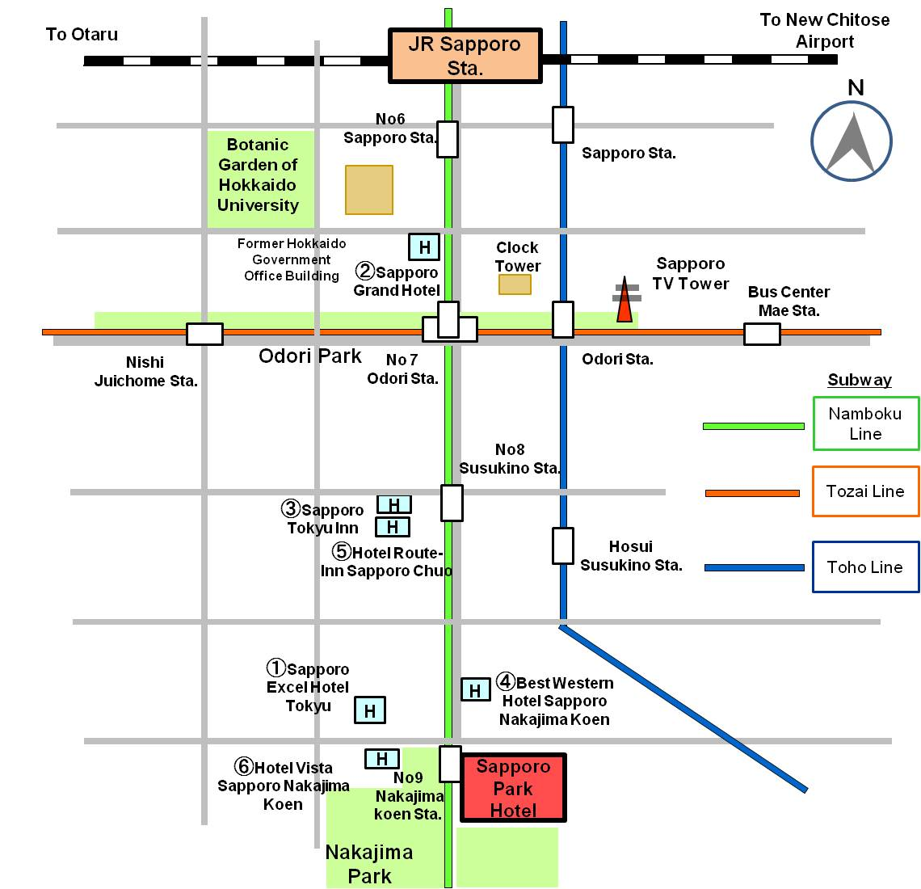

# 3 Registration

Registration will commence at 0830 hours on Wednesday, 10 July 2013 in the foyer of the Park Hall room on the 3rd floor. The plenary meeting will open at 0930 hours at the Park Hall room. For Participants wishing to register before the opening of the meeting, registration services are available on 9 July from 1500-1700 hours in the Secretariat’s room on the 3rd floor. Registration service will resume at the Secretariat’s room from 10 July afternoon.

# 4 Access to the meeting venue

# 4.1 Flights to the New Chitose Airport

The New Chitose Airport is conveniently situated close to the city of Sapporo. It is connected with domestic flights to Japan’s main international airports at Narita (New Tokyo International Airport), Haneda (Tokyo International Airport), Nagoya (Chubu Centrair International Airport) and Kansai (Kansai International Airport). The New Chitose Airport has also regular direct international flights to various cities overseas (see **Figure 2**).

More information is provided at the website below.

<http://www.welcome.city.sapporo.jp/english/transportation/access>

For more detailed information about New Chitose Airport, please see the following website:

<http://www.new-chitose-airport.jp/en/>

FIGURE 2

**Domestic and international service routes to New Chitose Airport**

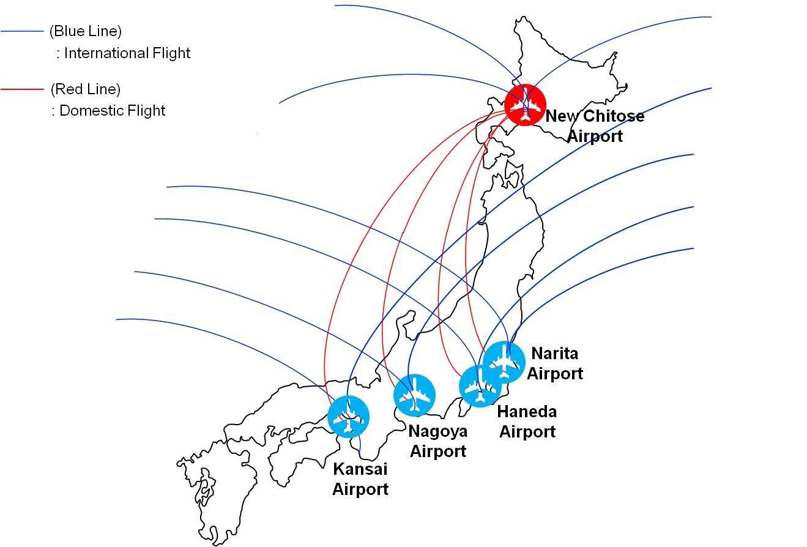

# 4.2 Transportation from New Chitose Airport to the Sapporo city area

* JR Rapid Airport Express

The most convenient transportation is by JR (Japan Railway) Rapid Airport Express. JR New Chitose Airport Station is directly connected with New Chitose Airport. The Rapid Airport Express bound for JR Sapporo Station leaves every 15 min. and takes 36 min. The train fare is 1,040 JPY. After arrival at JR Sapporo Station, newcomers had better go by taxi to their own hotel. It takes about 10 min. from JR Sapporo Station to hotels around the meeting venue. The taxi fare is about 1,000 JPY. For more detailed information about JR Rapid Airport Express, please see the following website:

<http://www.new-chitose-airport.jp/en/access/jr/>

* Airport Limousine Bus

Airport limousine bus is available from New Chitose Airport to Sapporo Downtown. There are two ticket counters, “Chuo bus” and “Hokuto Kotsu”. “Chuo bus” counter is located in JAL (Japan Air Lines) arrival lobby and “Hokuto Kotsu” counter is located in ANA (All Nippon Airways) arrival lobby. The airport limousine bound for Sapporo Downtown leaves every 15 min. It takes about 70 min. from New Chitose Airport to JR Sapporo Station. The bus fare is 1,000 JPY. There are several bus stops before and after JR Sapporo Station and some of them may be close to hotels where you stay. However it will be recommended for newcomers to get off the bus at JR Sapporo Station and go by taxi to their own hotel because the bus route is complicated. For more detailed information about airport limousine, please see the following website:

<http://www.new-chitose-airport.jp/en/access/bus/>

# 4.3 Access to Sapporo Park Hotel

It takes only 30 seconds walk between Sapporo Park Hotel and Exit No.3 of Nakajima Koen Subway Station. Nakajima Koen Station is the 3rdone from Sapporo Station by Subway Namboku Line for Makomanai. Three of the six hotels listed in **Attachment 1** are located within walking distance from Sapporo Park Hotel. The other three hotels are located close to Odori Station or Susukino Station of Subway Namboku Line.

Several alternatives to get from New Chitose Airport to the meeting venue is shown in **Figure 3** and **Table 1**.

FIGURE3

**Transportation from New Chitose Airport to the Meeting Venue**

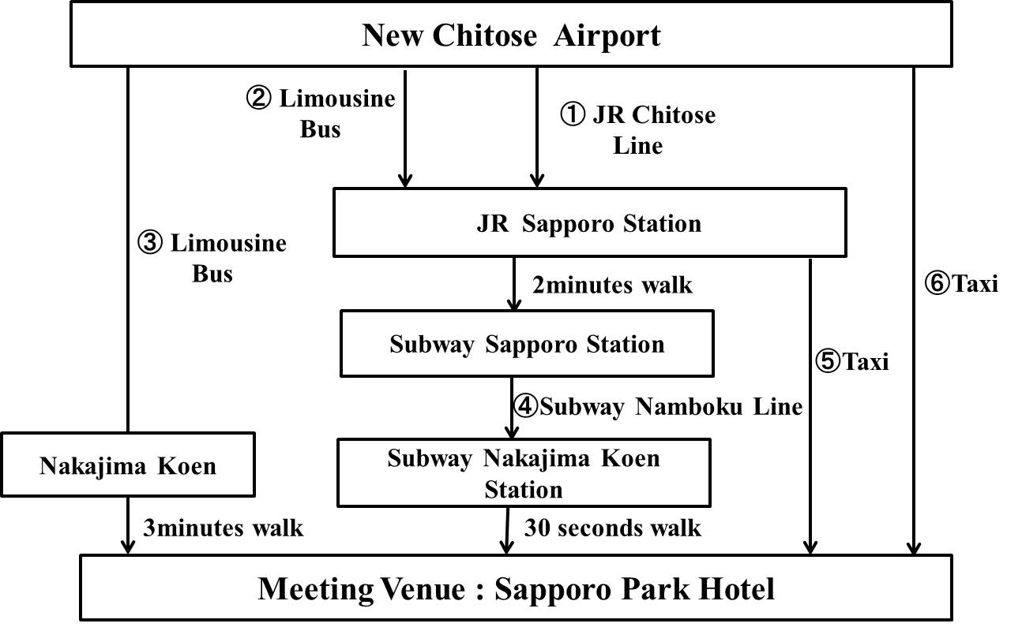

Table 1

List of transportation for use from New Chitose Airport to the Meeting Venue

|  |  |  |  |  |
| --- | --- | --- | --- | --- |
| **No.\*** | **Transportation** | **Approx. time required (minutes)** | **Fees (JPY)** | **Remarks** |
| 1 | JR Chitose Airport | 36 | 1,040 | Every 15min. |
| 2 | Limousine bus | 80 | 1,000 | Every 15min. |
| 3 | Limousine bus | 70 | 1,000 | Every one hour |
| 4 | Subway Namboku Line | 5 | 200 | Every 7 min. |
| 5 | Taxi | 10 | Approx. 1,000 |  |
| 6 | Taxi | 60 | Approx. 14,000 | Including expressway fare |

* The numbers in row correspond to the numbers in Figure 3.

# 5 Hotel accommodation

A total of 250 guest rooms listed in **Attachment 1** have been booked for participants of the ITU-R WP 5D meeting in Sapporo with preferential rates. Please note that no rooms are available at the meeting venue (Sapporo Park Hotel). The location map of those hotels is shown in **Figure 1**. Hotel reservation will be carried out by online system. Participants wishing to reserve a guest room of those hotels are requested to access to the following website managed by JTB Global Marketing & Travel.

<https://mice.jtbgmt.com/WP5D>

It is recommended to print out a confirmation issued by online system and show it at the check-in counter of the hotel. **All reservation requests must be made no later than 7 June 2013**. Availability and room rates are not guaranteed after the date.

**6 Visa and immigration information**

Participants who require a visa should apply for a visa at a Japanese consulate or diplomatic mission in their respective country well in advance of their departure.

Participants are also advised to contact their local travel agents or carriers. The embassy may take at least two weeks for visa processing.

For more information, please visit the website of the Ministry of Foreign Affairs of Japan at:

<http://www.mofa.go.jp/j_info/visit/visa/>

Participants who need visa supporting documents for entering Japan shall **fill out all items in Application Form in Attachment 2,** then email the form to the following contact point together with **a copy of photograph page of the passport no later than 31 May 2013.**

Hideki Suganami (Mr.)/Junkichi Fujisawa (Mr.)  
The ITU Association of Japan  
Tel.: +81 3 5357 7627  
E-mail: [wp5d-visa@ituaj.jp](mailto:wp5d-visa@ituaj.jp) (E-mail is the preferable communication means)

# 7 Network

WLAN service will be provided in the meeting room. Internet is available free of charge in guest rooms of hotels listed in **Attachment 1**.

# 8 Practical information

## 8.1 About Sapporo

Sapporo is the capital of Hokkaido Prefecture and fifth largest city in Japan with a population of 1.9 million. Various information about Sapporo is provided by the following website:

<http://www.welcome.city.sapporo.jp/english/>

A tourism application for smartphones is also available free of charge. Further information is provided at the website below.

<http://www.hbc.co.jp/rocket/sapporoinfo/pc/index_en.html>

## 8.2 Language

Japanese is the official language in Japan. However, English is spoken in major hotels, large restaurants, department stores and other major organizations and tourist locations.

## 8.3 Climate

July is the most comfortable season in Sapporo. The temperature during July ranges from 17 to 25 degrees centigrade. Average rainfall in July is about 80 mm.

## 8.4 Local time

GMT + 9 hours. Daylight saving time is not used.

## 8.5 Banks & currency

The Japanese currency unit is Japanese Yen (JPY). There are four kinds of bills (10,000 yen, 5,000 yen, 2,000 yen and 1,000 yen) and six kinds of coins (500 yen, 100 yen, 50 yen, 10 yen, 5 yen and 1 yen) used. Only Japanese Yen (JPY) is accepted at stores and restaurants. Major foreign currencies may be exchanged to JPY at foreign exchange counters of banks at the International Airports on presentation of your passport. Japanese banks are usually open Monday to Friday from 0900 to 1500. The exchange rate as of 26thMarch 2013 is 94.19 Japanese Yen to 1 US Dollar. Major credit cards can be accepted in most hotels, restaurants, department stores, but only cash is accepted in local smaller shops.

## 8.6 Tipping

Tipping is not customary in Japan.

## 8.7 Electricity

The standard power supply in Japan is 100 volts. The frequency is 50 Hz in eastern Japan including Sapporo. The type of power outlet/connector used in Japan is a two-parallel-pronged type.

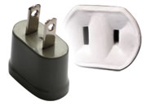

# 9 Emergency phones

The nationwide emergency phone numbers are:

Police: 110

Ambulance/Fire: 119

# 10 Local contact point

If you have any questions about the meeting arrangements, please contact:

Hideki Suganami (Mr.)/Junkichi Fujisawa (Mr.)  
The ITU Association of Japan  
Tel.: +81 3 5357 7627  
Fax: +81 3 3356 8170  
E-mail: [wp5d-sapporo@ituaj.jp](mailto:wp5d-sapporo@ituaj.jp) (E-mail is the preferable communication means)

ATTACHMENT 1

Hotel accommodation for the WP 5D meeting in Sapporo

|  |  |  |  |  |  |
| --- | --- | --- | --- | --- | --- |
| **No.*1** | **Hotel name** | | **Room type** | **Room rate*2 (JPY)** | |
| **Room charge only** | **Including breakfast** |
| 1 | Sapporo Excel Hotel Tokyu |  | Single | 11,550 | 13,125 |
|  | Twin(Single use) | 15,750 | 17,325 |
|  | Twin (Twin use) | 16,800 | 19,950 |
| URL | <http://www.tokyuhotelsjapan.com/en/TE/TE_SAPPO/index.html> | | |
| 2 | Sapporo Grand Hotel |  | Single | 11,000 | 12,000 |
|  | Twin (Single use) | 16,000 | 17,000 |
|  | Twin(Twin use) | 16,000 | 18,000 |
| URL | <http://www.grand1934.com/english/> | | |
| 3 | Sapporo Tokyu Inn |  | Single | 10,500 | 11,550 |
| URL | <http://www.tokyuhotelsjapan.com/en/TI/TI_SAPPO/index.html> | | |
| 4 | Best Western Hotel Sapporo Nakajima Koen |  | Twin (Single use) | 9,450  (10,500)*3 | 10,500  (11,550)*3 |
|  | Twin(Twin use) | 13,650  (15,750)*3 | 15,750  (17,850)*3 |
| URL | <http://sapporo-nakajimakoen.bwhotels.jp/> | | |
| 5 | Hotel Route-Inn Sapporo Chuo |  | Single | - | 7,000 |
|  | Twin (Single use) | - | 8,900 |
|  | Twin(Twin use) | - | 13,000 |
| URL | [http://www.route-inn.co.jp/english/pref/hokkaido.html#sapporo-susukino](http://www.route-inn.co.jp/english/pref/hokkaido.html%23sapporo-susukino) | | |
| 6 | Hotel Vista Sapporo Nakajima Koen |  | Single | 7,600 | 8,400 |
|  | Twin (Twin use) | 10,000 | 11,600 |
| URL | <http://www.hotel-vista.jp/nakajimakohen/index_e.html> | | |

Notes:

*1 Numbers in row correspond to numbers in Figure 1.

*2 Room rates are including 10% service charge and 5% tax.

*3 13th and 14th July.

ATTACHMENT 2

Application form for Visa supporting documents

|  |
| --- |
| **ITU-R SG 5 WP 5D**  **Sapporo, Japan, 10-17 July 2013** |
| **Print all items and save to word or pdf, then send by e-mail** |
| **Name**   |  |  |  |  |  |  | | --- | --- | --- | --- | --- | --- | | (**🖵**Mr. **🖵**Ms.) |  |  |  |  |  |   Family Name Middle Name Given Name   |  |  | | --- | --- | | 漢字姓名(*) |  |   **\*If you are a Chinese participant, please write your name in Chinese characters.**   |  |  | | --- | --- | | **Occupation** |  | | **Job title** |  | | **Company / Organization** |  | | **(**):** |  |   **\*\*If you are a Chinese participant, please write your company/organization in Chinese characters as well.**   |  |  | | --- | --- | | **Country** (where you live) |  | | **Address (*1)**: |  |   **(*1) VISA supporting documents will be sent to the address above by courier service.**   |  |  |  |  |  |  | | --- | --- | --- | --- | --- | --- | | **Phone No:** |  | **Fax No:** |  | **E-mail:** |  |   **PASSPORT INFORMATION:**   |  |  |  |  |  |  | | --- | --- | --- | --- | --- | --- | | **Passport No:** |  | |  |  |  | | **Date of issue:** |  | (DD/MM/YYYY) | **Expiry date:** |  | (DD/MM/YYYY) | | **Place of birth:** |  | | **Date of birth:** |  | (DD/MM/YYYY) | | **Nationality:** |  | |  |  |  |   **THE DATE of ARRIVAL in / DEPATURE from JAPAN and FLIGHT INFORMATION** (*2) **:**   |  |  |  |  |  |  |  |  |  |  |  | | --- | --- | --- | --- | --- | --- | --- | --- | --- | --- | --- | |  |  | Overseas airport |  | JPN airport |  | Date |  | Flight No. |  | Time | | Arrival in Japan | from |  | to |  |  |  |  |  |  |  | |  |  | JPN airport |  | Overseas airport |  | Date |  | Flight No |  | Time | | Departure from Japan | from |  | to |  |  |  |  |  |  |  |   **(*2) For VISA supporting documents, a planned flight schedule is available as well.**  **HOTEL ACCOMMODATION**  This information is **NOT for hotel reservation order sheet, but NEEDED for staying schedule for visa supporting documents.**   |  |  |  |  |  |  | | --- | --- | --- | --- | --- | --- | | **Hotel name:** |  | |  |  |  | | **Address:** |  | | | **Phone No.:** |  | | **Check in date:** |  | (DD/MM/YYYY) | **Check out date:** |  | (DD/MM/YYYY) |   * If making your own accommodation arrangement other than hotels, please indicate your contact address and phone  number:   |  |  |  |  |  | | --- | --- | --- | --- | --- | | **Name of contact person:** |  |  | | | | **Address** |  | | **Phone No.** |  |   **Date: Signature:**  **Deadline of submission: 31 May 2013 for all visa related documents** |
| **Please submit this form to:**  Hideki Suganami(Mr.)/Junkichi Fujisawa(Mr.)  The ITU Association of Japan  Tel: +81 3 5357 7627  E-mail: [wp5d-visa@ituaj.jp](mailto:wp5d-visa@ituaj.jp) (E-mail is the preferable communication means) |

_____________