Annexe
Annex | 1
Anexo

Country symbol: ARM
Beam Identification: ARM06400
Orbital position: 23.0
(plus for E, minus for W)

Test Point | Alt. | Feeder Link |  |  | Polarization |  | Ellipse parameters
No. | (mts.) |  |  |  |  |  |  |  |  |  | Beam Boresight
 |  | Latitude (°)  plus for N  minus for S | Longitude (°)  plus for E  minus for W | Channels  (17 GHz) | Type | Sense | Major  Axis (°) | Minor  Axis (°) | Orientation  (°) | Maximum  Antenna  Gain  (dB) | Latitude(°)  plus for N  minus for S | Longitude (°)  plus for E  minus for W
1 | 0 | 41.10 | 43.50 | 24,28,32,36,40 | Circular | Left | 0.73 | 0.6 | 148.17 | 48.02 | 39.95 | 44.99
2 | 0 | 39.71 | 44.79
3 | 0 | 40.24 | 45.92
4 | 0 | 38.88 | 46.52
5 | 0 | 41.20 | 44.95
6 | 0 | 40.11 | 43.68
7

Test Point | Alt. | Down Link |  |  | Polarization |  | Ellipse parameters)
No. | (mts.) |  |  |  |  |  |  |  |  |  | Beam Boresight
 |  | Latitude (°)  plus for N  minus for S | Longitude (°)  plus for E  minus for W | Channels | Type | Sense | Major  Axis (°) | Minor  Axis (°) | Orientation  (°) | Maximum  Antenna  Gain  (dB) | Latitude (°)  plus for N  minus for S | Longitude (°)  plus for E  minus for W
1 | 0 | 41.10 | 43.50 | 24,28,32,36,40 | Circular | Right | 0.73 | 0.6 | 148.17 | 48.02 | 39.95 | 44.99
2 | 0 | 39.71 | 44.79
3 | 0 | 40.24 | 45.92
4 | 0 | 38.88 | 46.52
5 | 0 | 41.20 | 44.95
6 | 0 | 40.11 | 43.68
7

COUNTRY : ARM Feeder Link and Down Link

Country symbol: AUS
Beam Identification: AUS0040A
Orbital position: 152.0
(plus for E, minus for W)

Test Point | Alt. | Feeder Link |  |  | Polarization |  | Ellipse parameters
No. | (mts.) |  |  |  |  |  |  |  |  |  | Beam Boresight
 |  | Latitude (°)  plus for N  minus for S | Longitude (°)  plus for E  minus for W | Channels  (17 GHz) | Type | Sense | Major  Axis (°) | Minor  Axis (°) | Orientation  (°) | Maximum  Antenna  Gain  (dB) | Latitude(°)  plus for N  minus for S | Longitude (°)  plus for E  minus for W
1 | 0 | -10.60 | 142.20 | 3, 7, 11,15, | Circular | Left | 6.89 | 4.83 | 141.15 | 29.23 | -23.95 | 135.36
2 | 0 | -27.50 | 153.00 | 19,23
3 | 0 | -33.90 | 151.20
4 | 0 | -37.20 | 145.00
5 | 0 | -42.90 | 147.30
6 | 0 | -34.90 | 138.60
7 | 0 | -32.00 | 115.90
8 | 0 | -21.60 | 114.10
9 | 0 | -12.50 | 130.80
10 | 0 | -23.70 | 133.90

Test Point | Alt. | Down Link |  |  | Polarization |  | Ellipse parameters
No. | (mts.) |  |  |  |  |  |  |  |  |  | Beam Boresight
 |  | Latitude (°)  plus for N  minus for S | Longitude (°)  plus for E  minus for W | Channels | Type | Sense | Major  Axis (°) | Minor  Axis (°) | Orientation  (°) | Maximum  Antenna  Gain  (dB) | Latitude (°)  plus for N  minus for S | Longitude (°)  plus for E  minus for W
1 | 0 | -12.19 | 96.83 | 3, 7, 11,15, | Circular | Right | 0.60 | 0.60 | 0 | 48.88 | -12.19 | 96.83
2 |  |  |  | 19,23
3
4
5
6
7

Country symbol: AUS
Beam Identification: AUS0040B
Orbital position: 152.0
(plus for E, minus for W)

Test Point | Alt. | Feeder Link |  |  | Polarization |  | Ellipse parameters
No. | (mts.) |  |  |  |  |  |  |  |  |  | Beam Boresight
 |  | Latitude (°)  plus for N  minus for S | Longitude (°)  plus for E  minus for W | Channels  (17 GHz) | Type | Sense | Major  Axis (°) | Minor  Axis (°) | Orientation  (°) | Maximum  Antenna  Gain  (dB) | Latitude(°)  plus for N  minus for S | Longitude (°)  plus for E  minus for W
1 | 0 | -10.60 | 142.20 | 3, 7, 11,15, | Circular | Left | 6.89 | 4.83 | 141.15 | 29.23 | -23.95 | 135.36
2 | 0 | -27.50 | 153.00 | 19,23
3 | 0 | -33.90 | 151.20
4 | 0 | -37.20 | 145.00
5 | 0 | -42.90 | 147.30
6 | 0 | -34.90 | 138.60
7 | 0 | -32.00 | 115.90
8 | 0 | -21.60 | 114.10
9 | 0 | -12.50 | 130.80
10 | 0 | -23.70 | 133.90

Test Point | Alt. | Down Link |  |  | Polarization |  | Ellipse parameters
No. | (mts.) |  |  |  |  |  |  |  |  |  | Beam Boresight
 |  | Latitude (°)  plus for N  minus for S | Longitude (°)  plus for E  minus for W | Channels | Type | Sense | Major  Axis (°) | Minor  Axis (°) | Orientation  (°) | Maximum  Antenna  Gain  (dB) | Latitude (°)  plus for N  minus for S | Longitude (°)  plus for E  minus for W
1 | 0 | -10.45 | 105.69 | 3, 7, 11,15, | Circular | Right | 0.6 | 0.6 | 0 | 48.88 | -10.45 | 105.69
2 |  |  |  | 19,23
3
4
5
6
7

Country symbol: AUS
Beam Identification: AUS0040C
Orbital position: 152.0
(plus for E, minus for W)

Test Point | Alt. | Feeder Link |  |  | Polarization |  | Ellipse parameters
No. | (mts.) |  |  |  |  |  |  |  |  |  | Beam Boresight
 |  | Latitude (°)  plus for N  minus for S | Longitude (°)  plus for E  minus for W | Channels  (17 GHz) | Type | Sense | Major  Axis (°) | Minor  Axis (°) | Orientation  (°) | Maximum  Antenna  Gain  (dB) | Latitude(°)  plus for N  minus for S | Longitude (°)  plus for E  minus for W
1 | 0 | -10.60 | 142.20 | 3, 7, 11,15, | Circular | Left | 6.89 | 4.83 | 141.15 | 29.23 | -23.95 | 135.36
2 | 0 | -27.50 | 153.00 | 19,23
3 | 0 | -33.90 | 151.20
4 | 0 | -37.20 | 145.00
5 | 0 | -42.90 | 147.30
6 | 0 | -34.90 | 138.60
7 | 0 | -32.00 | 115.90
8 | 0 | -21.60 | 114.10
9 | 0 | -12.50 | 130.80
10 | 0 | -23.70 | 133.90

Test Point | Alt. | Down Link |  |  | Polarization |  | Ellipse parameters
No. | (mts.) |  |  |  |  |  |  |  |  |  | Beam Boresight
 |  | Latitude (°)  plus for N  minus for S | Longitude (°)  plus for E  minus for W | Channels | Type | Sense | Major  Axis (°) | Minor  Axis (°) | Orientation  (°) | Maximum  Antenna  Gain  (dB) | Latitude (°)  plus for N  minus for S | Longitude (°)  plus for E  minus for W
1 | 0 | -66.28 | 110.52 | 3, 7, 11,15, | Circular | Right | 0.6 | 0.6 | 0 | 48.88 | -66.28 | 110.52
2 |  |  |  | 19,23
3
4
5
6
7
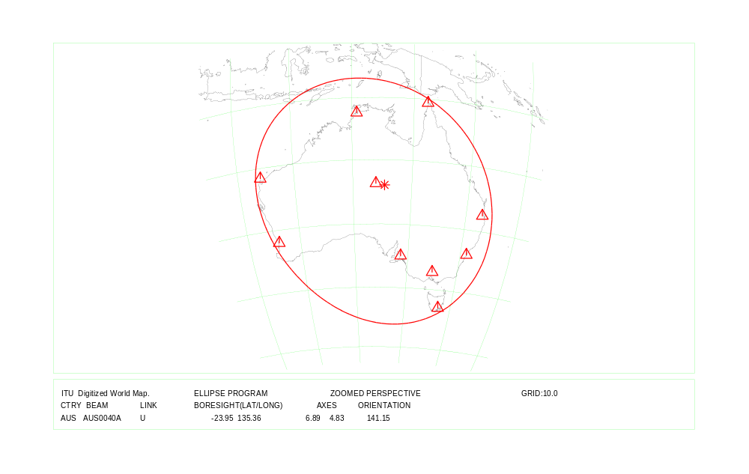
COUNTRY : AUS Feeder Link Beam Identification: AUS0040A / AUS0040B / AUS0040C
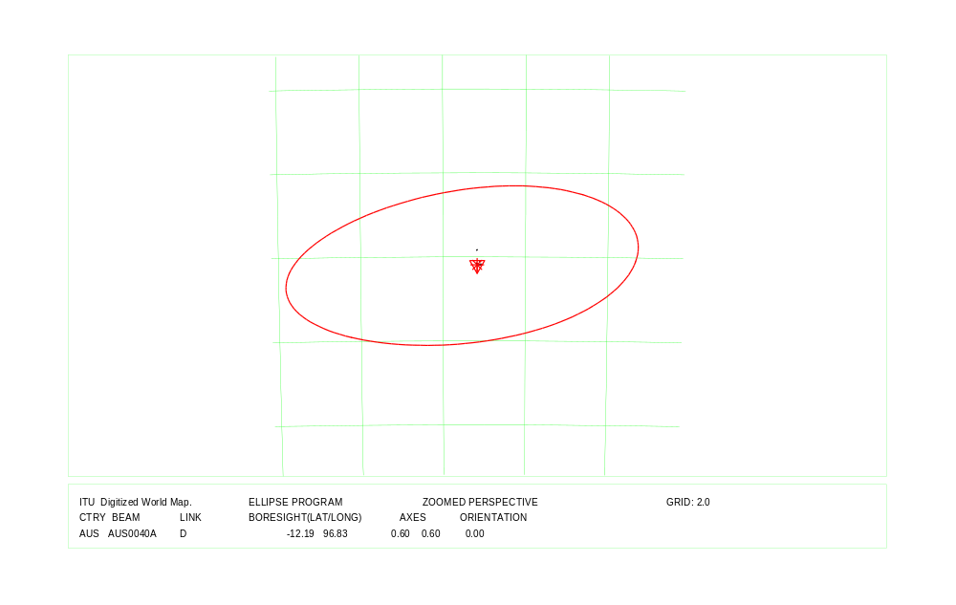
COUNTRY : AUS Down Link Beam Identification: AUS0040A
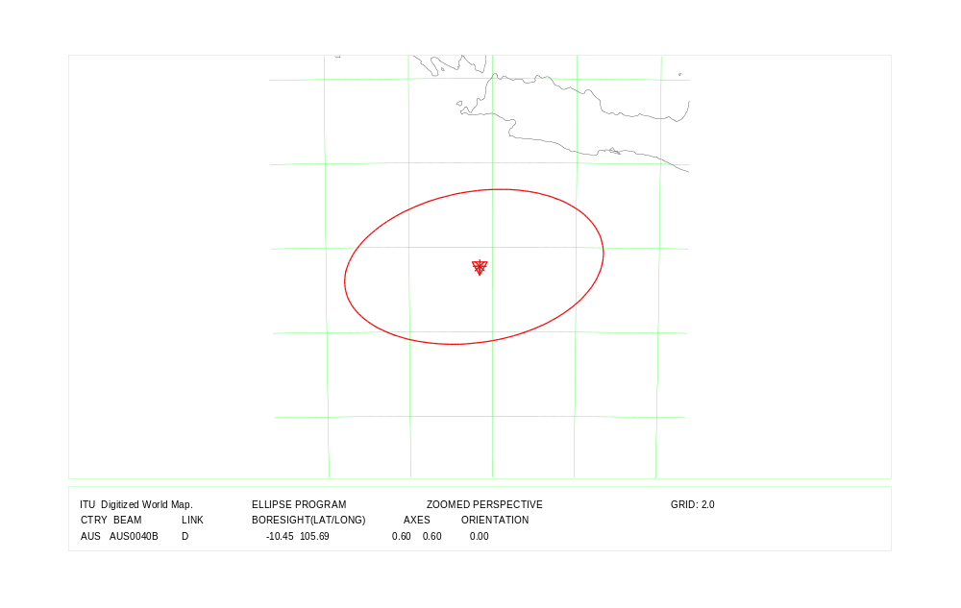
COUNTRY : AUS Down Link Beam Identification: AUS0040B
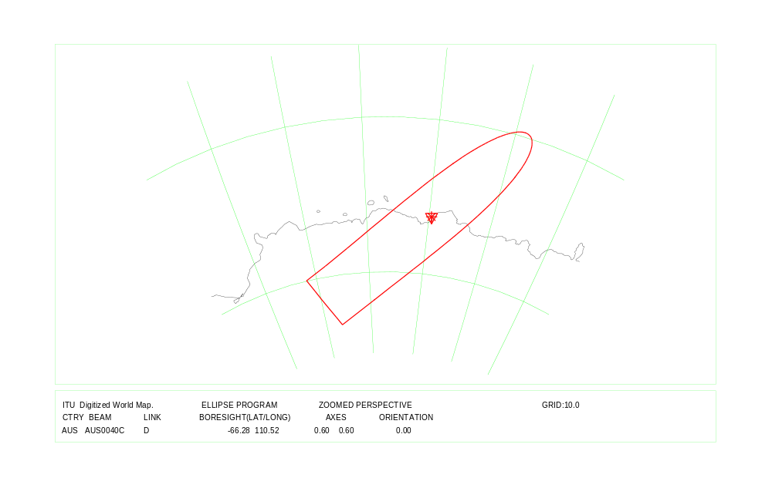
COUNTRY : AUS Down Link Beam Identification: AUS0040C

Country symbol: AUS
Beam Identification: AUS0070A
Orbital position: 164.0
(plus for E, minus for W)

Test Point | Alt. | Feeder Link |  |  | Polarization |  | Ellipse parameters
No. | (mts.) |  |  |  |  |  |  |  |  |  | Beam Boresight
 |  | Latitude (°)  plus for N  minus for S | Longitude (°)  plus for E  minus for W | Channels  (17 GHz) | Type | Sense | Major  Axis (°) | Minor  Axis (°) | Orientation  (°) | Maximum  Antenna  Gain  (dB) | Latitude(°)  plus for N  minus for S | Longitude (°)  plus for E  minus for W
1 | 0 | -10.60 | 142.20 | 3, 7, 11,15, | Circular | Right | 6.82 | 4.20 | 134.19 | 29.87 | -24.16 | 136.62
2 | 0 | -27.50 | 153.00 | 19,23
3 | 0 | -33.90 | 151.20
4 | 0 | -37.20 | 145.00
5 | 0 | -42.90 | 147.30
6 | 0 | -34.90 | 138.60
7 | 0 | -32.00 | 115.90
8 | 0 | -21.60 | 114.10
9 | 0 | -12.50 | 130.80
10 | 0 | -23.70 | 133.90

Test Point | Alt. | Down Link |  |  | Polarization |  | Ellipse parameters
No. | (mts.) |  |  |  |  |  |  |  |  |  | Beam Boresight
 |  | Latitude (°)  plus for N  minus for S | Longitude (°)  plus for E  minus for W | Channels | Type | Sense | Major  Axis (°) | Minor  Axis (°) | Orientation  (°) | Maximum  Antenna  Gain  (dB) | Latitude (°)  plus for N  minus for S | Longitude (°)  plus for E  minus for W
1 | 0 | -54.50 | 158.94 | 3, 7, 11,15, | Circular | Right | 0.6 | 0.6 | 0 | 48.88 | -54.50 | 158.94
2 |  |  |  | 19,23
3
4
5
6
7
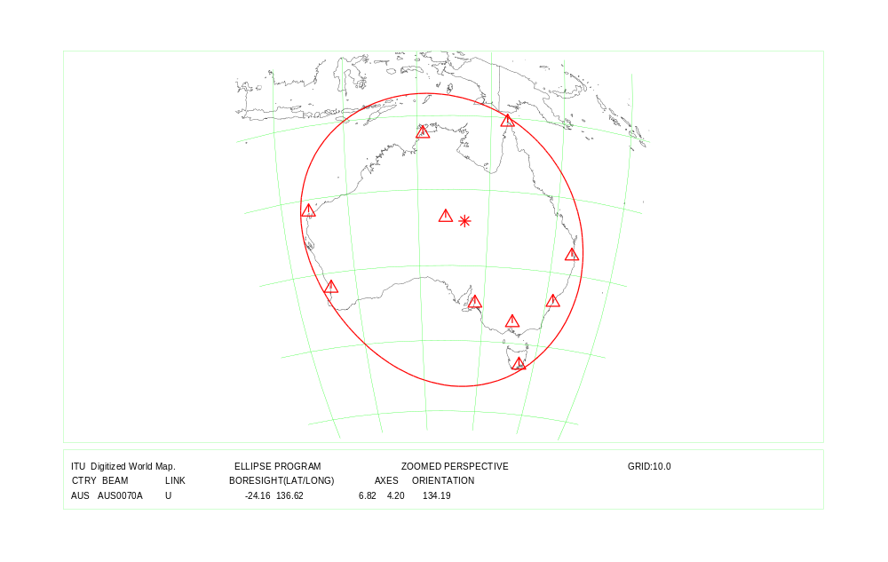
COUNTRY : AUS Feeder Link Beam Identification: AUS0070A
COUNTRY : AUS Down Link Beam Identification: AUS0070A

Country symbol: AUS
Beam Identification: AUS0090A
Orbital position: 164.0
(plus for E, minus for W)

Test Point | Alt. | Feeder Link |  |  | Polarization |  | Ellipse parameters
No. | (mts.) |  |  |  |  |  |  |  |  |  | Beam Boresight
 |  | Latitude (°)  plus for N  minus for S | Longitude (°)  plus for E  minus for W | Channels  (17 GHz) | Type | Sense | Major  Axis (°) | Minor  Axis (°) | Orientation  (°) | Maximum  Antenna  Gain  (dB) | Latitude(°)  plus for N  minus for S | Longitude (°)  plus for E  minus for W
1 | 0 | -10.60 | 142.20 | 27,31,35,39 | Circular | Right | 6.82 | 4.20 | 134.19 | 29.87 | -24.16 | 136.62
2 | 0 | -27.50 | 153.00 | 25,29
3 | 0 | -33.90 | 151.20
4 | 0 | -37.20 | 145.00
5 | 0 | -42.90 | 147.30
6 | 0 | -34.90 | 138.60
7 | 0 | -32.00 | 115.90
8 | 0 | -21.60 | 114.10
9 | 0 | -12.50 | 130.80
10 | 0 | -23.70 | 133.90

Test Point | Alt. | Down Link |  |  | Polarization |  | Ellipse parameters
No. | (mts.) |  |  |  |  |  |  |  |  |  | Beam Boresight
 |  | Latitude (°)  plus for N  minus for S | Longitude (°)  plus for E  minus for W | Channels | Type | Sense | Major  Axis (°) | Minor  Axis (°) | Orientation  (°) | Maximum  Antenna  Gain  (dB) | Latitude (°)  plus for N  minus for S | Longitude (°)  plus for E  minus for W
1 | 0 | -31.52 | 159.06 | 1, 5, 9, 13,17,21 | Circular | Right | 0.6 | 0.6 | 0 | 48.88 | -31.52 | 159.06
2
3
4
5
6
7

Country symbol: AUS
Beam Identification: AUS0090B
Orbital position: 164.0
(plus for E, minus for W)

Test Point | Alt. | Feeder Link |  |  | Polarization |  | Ellipse parameters
No. | (mts.) |  |  |  |  |  |  |  |  |  | Beam Boresight
 |  | Latitude (°)  plus for N  minus for S | Longitude (°)  plus for E  minus for W | Channels  (17 GHz) | Type | Sense | Major  Axis (°) | Minor  Axis (°) | Orientation  (°) | Maximum  Antenna  Gain  (dB) | Latitude(°)  plus for N  minus for S | Longitude (°)  plus for E  minus for W
1 | 0 | -10.60 | 142.20 | 27,31,35,39 | Circular | Right | 6.82 | 4.20 | 134.19 | 29.87 | -24.16 | 136.62
2 | 0 | -27.50 | 153.00 | 25,29
3 | 0 | -33.90 | 151.20
4 | 0 | -37.20 | 145.00
5 | 0 | -42.90 | 147.30
6 | 0 | -34.90 | 138.60
7 | 0 | -32.00 | 115.90
8 | 0 | -21.60 | 114.10
9 | 0 | -12.50 | 130.80
10 | 0 | -23.70 | 133.90

Test Point | Alt. | Down Link |  |  | Polarization |  | Ellipse parameters
No. | (mts.) |  |  |  |  |  |  |  |  |  | Beam Boresight
 |  | Latitude (°)  plus for N  minus for S | Longitude (°)  plus for E  minus for W | Channels | Type | Sense | Major  Axis (°) | Minor  Axis (°) | Orientation  (°) | Maximum  Antenna  Gain  (dB) | Latitude (°)  plus for N  minus for S | Longitude (°)  plus for E  minus for W
1 | 0 | -29.02 | 167.93 | 1, 5, 9, 13,17,21 | Circular | Right | 0.6 | 0.6 | 0 | 48.88 | -29.02 | 167.93
2
3
4
5
6
7
COUNTRY : AUS Feeder Link Beam Identification: AUS0090A / AUS0090B
COUNTRY : AUS Down Link Beam Identification: AUS0090A
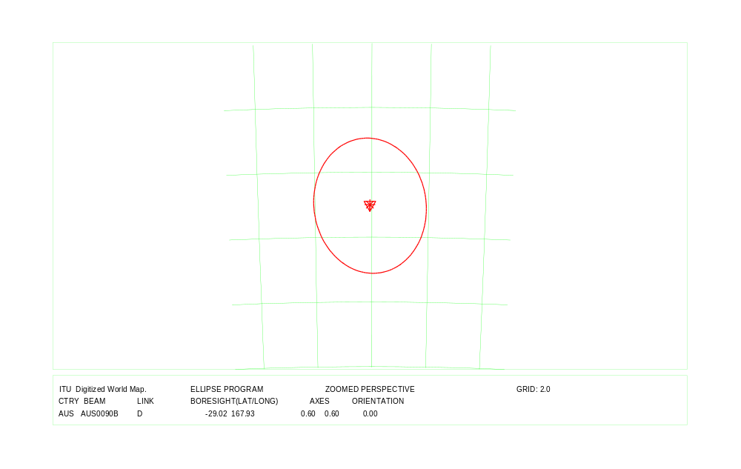
COUNTRY : AUS Down Link Beam Identification: AUS0090B

Country symbol: AZE
Beam Identification: AZE06400
Orbital position: 23.0
(plus for E, minus for W)

Test Point | Alt. | Feeder Link |  |  | Polarization |  | Ellipse parameters
No. | (mts.) |  |  |  |  |  |  |  |  |  | Beam Boresight
 |  | Latitude (°)  plus for N  minus for S | Longitude (°)  plus for E  minus for W | Channels  (17 GHz) | Type | Sense | Major  Axis (°) | Minor  Axis (°) | Orientation  (°) | Maximum  Antenna  Gain  (dB) | Latitude (°)  plus for N  minus for S | Longitude (°)  plus for E  minus for W
1 | 0 | 41.89 | 46.46 | 4, 8,12,16,20 | Circular | Left | 0.93 | 0.60 | 158.14 | 46.98 | 40.14 | 47.47
2 | 0 | 41.74 | 48.60
3 | 0 | 38.45 | 48.88
4 | 0 | 38.86 | 46.12
5 | 0 | 39.65 | 44.82
6 | 0 | 41.28 | 45.03
7 | 0 | 40.30 | 50.35

Test Point | Alt. | Down Link |  |  | Polarization |  | Ellipse parameters
No. | (mts.) |  |  |  |  |  |  |  |  |  | Beam Boresight
 |  | Latitude (°)  plus for N  minus for S | Longitude (°)  plus for E  minus for W | Channels | Type | Sense | Major  Axis (°) | Minor  Axis (°) | Orientation  (°) | Maximum  Antenna  Gain  (dB) | Latitude (°)  plus for N  minus for S | Longitude (°)  plus for E  minus for W
1 | 0 | 41.89 | 46.46 | 4, 8,12,16,20 | Circular | Right | 0.93 | 0.60 | 158.14 | 46.98 | 40.14 | 47.47
2 | 0 | 41.74 | 48.60
3 | 0 | 38.45 | 48.88
4 | 0 | 38.86 | 46.12
5 | 0 | 39.65 | 44.82
6 | 0 | 41.28 | 45.03
7 | 0 | 40.30 | 50.35

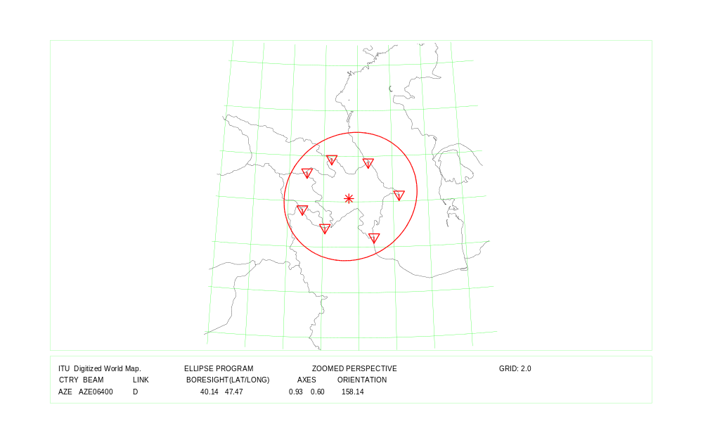
COUNTRY : AZE Feeder Link and Down Link

Country symbol: BIH
Beam Identification: BIH14800
Orbital position: 34.0
(plus for E, minus for W)

Test Point | Alt. | Feeder Link |  |  | Polarization |  | Ellipse parameters
No. | (mts.) |  |  |  |  |  |  |  |  |  | Beam Boresight
 |  | Latitude (°)  plus for N  minus for S | Longitude (°)  plus for E  minus for W | Channels  (17 GHz) | Type | Sense | Major  Axis (°) | Minor  Axis (°) | Orientation  (°) | Maximum  Antenna  Gain  (dB) | Latitude (°)  plus for N  minus for S | Longitude (°)  plus for E  minus for W
1 | 0 | 45.22 | 15.73 | 2, 6, 10,14,18 | Circular | Left | 0.62 | 0.60 | 166.84 | 48.71 | 44.32 | 17.77
2 | 0 | 45.10 | 17.60
3 | 0 | 44.90 | 19.33
4 | 0 | 43.52 | 19.19
5 | 0 | 42.45 | 18.50
6 | 0 | 43.71 | 16.88
7 | 0 | 42.91 | 17.62

Test Point | Alt. | Down Link |  |  | Polarization |  | Ellipse parameters
No. | (mts.) |  |  |  |  |  |  |  |  |  | Beam Boresight
 |  | Latitude (°)  plus for N  minus for S | Longitude (°)  plus for E  minus for W | Channels | Type | Sense | Major  Axis (°) | Minor  Axis (°) | Orientation  (°) | Maximum  Antenna  Gain  (dB) | Latitude (°)  plus for N  minus for S | Longitude (°)  plus for E  minus for W
1 | 0 | 45.22 | 15.73 | 2, 6, 10,14,18 | Circular | Right | 0.62 | 0.60 | 166.84 | 48.71 | 44.32 | 17.77
2 | 0 | 45.10 | 17.60
3 | 0 | 44.90 | 19.33
4 | 0 | 43.52 | 19.19
5 | 0 | 42.45 | 18.50
6 | 0 | 43.71 | 16.88
7 | 0 | 42.91 | 17.62

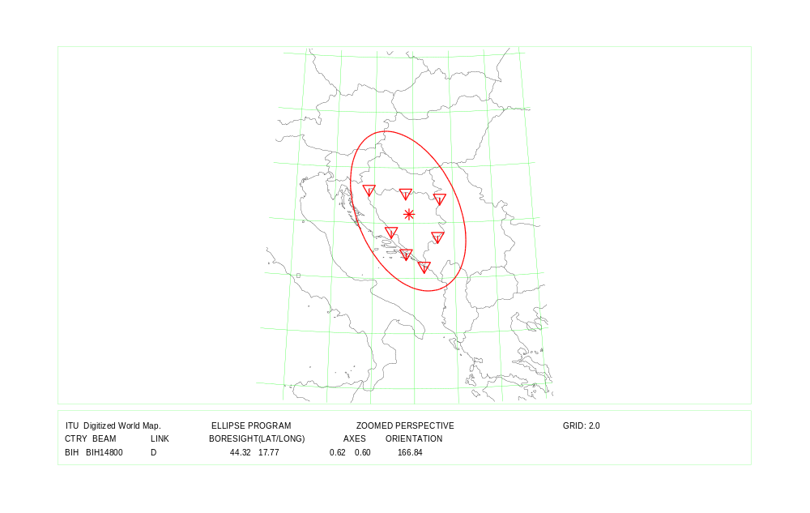

COUNTRY : BIH Feeder Link and Down Link

Country symbol: BLR
Beam Identification: BLR06200
Orbital position: 38.0
(plus for E, minus for W)

Test Point | Alt. | Feeder Link |  |  | Polarization |  | Ellipse parameters
No. | (mts.) |  |  |  |  |  |  |  |  |  | Beam Boresight
 |  | Latitude (°)  plus for N  minus for S | Longitude (°)  plus for E  minus for W | Channels  (17 GHz) | Type | Sense | Major  Axis (°) | Minor  Axis (°) | Orientation  (°) | Maximum  Antenna  Gain  (dB) | Latitude (°)  plus for N  minus for S | Longitude (°)  plus for E  minus for W
1 | 0 | 51.48 | 30.11 | 1, 5, 9, 13,17 | Circular | Right | 1.17 | 0.60 | 9.68 | 45.96 | 53.18 | 28.04
2 | 0 | 53.36 | 32.71
3 | 0 | 52.15 | 23.50
4 | 0 | 55.24 | 30.45
5 | 0 | 55.48 | 27.28
6 | 0 | 53.90 | 23.52
7 | 0 | 55.60 | 30.90
8 | 0 | 51.27 | 30.53

Test Point | Alt. | Down Link |  |  | Polarization |  | Ellipse parameters
No. | (mts.) |  |  |  |  |  |  |  |  |  | Beam Boresight
 |  | Latitude (°)  plus for N  minus for S | Longitude (°)  plus for E  minus for W | Channels | Type | Sense | Major  Axis (°) | Minor  Axis (°) | Orientation  (°) | Maximum  Antenna  Gain  (dB) | Latitude (°)  plus for N  minus for S | Longitude (°)  plus for E  minus for W
1 | 0 | 51.46 | 27.62 | 1, 5, 9, 13,17 | Circular | Left | 1.21 | 0.60 | 11.47 | 45.83 | 53.06 | 27.91
2 | 0 | 51.27 | 30.53
3 | 0 | 51.57 | 23.57
4 | 0 | 53.40 | 32.73
5 | 0 | 52.15 | 23.50
6 | 0 | 55.60 | 30.90
7 | 0 | 53.90 | 23.52

COUNTRY : BLR Feeder Link
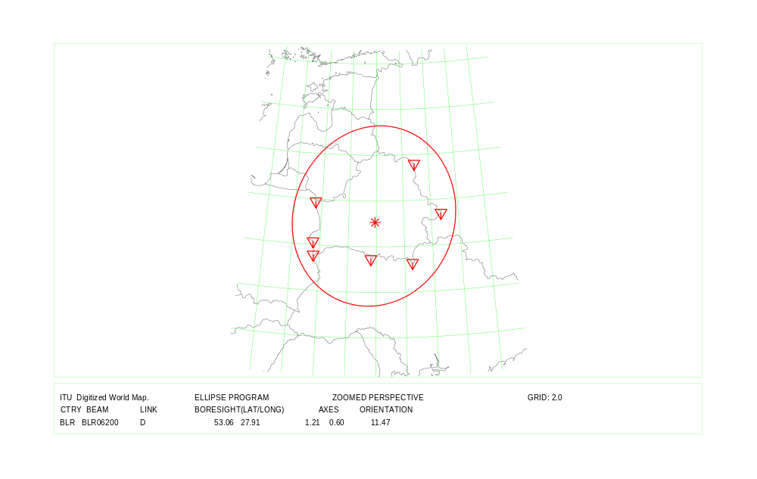

COUNTRY : BLR Down Link

Country symbol: BTN
Beam Identification: BTN03100
Orbital position: 86.0
(plus for E, minus for W)

Test Point | Alt. | Feeder Link |  |  | Polarization |  | Ellipse parameters
No. | (mts.) |  |  |  |  |  |  |  |  |  | Beam Boresight
 |  | Latitude (°)  plus for N  minus for S | Longitude (°)  plus for E  minus for W | Channels  (17 GHz) | Type | Sense | Major  Axis (°) | Minor  Axis (°) | Orientation  (°) | Maximum  Antenna  Gain  (dB) | Latitude (°)  plus for N  minus for S | Longitude (°)  plus for E  minus for W
1 | 0 | 27.21 | 88.78 | 5, 9, 13, 17 | Circular | Left | 0.72 | 0.60 | 175.47 | 48.11 | 27.05 | 90.44
2 | 0 | 26.80 | 90.00
3 | 0 | 26.90 | 92.10
4 | 0 | 28.07 | 91.29
5 | 0 | 27.28 | 92.10
6 | 0 | 28.30 | 90.10
7

Test Point | Alt. | Down Link |  |  | Polarization |  | Ellipse parameters
No. | (mts.) |  |  |  |  |  |  |  |  |  | Beam Boresight
 |  | Latitude (°)  plus for N  minus for S | Longitude (°)  plus for E  minus for W | Channels | Type | Sense | Major  Axis (°) | Minor  Axis (°) | Orientation  (°) | Maximum  Antenna  Gain  (dB) | Latitude (°)  plus for N  minus for S | Longitude (°)  plus for E  minus for W
1 | 0 | 27.21 | 88.78 | 5, 9, 13, 17 | Circular | Right | 0.72 | 0.60 | 175.74 | 48.11 | 27.05 | 90.44
2 | 0 | 26.80 | 90.00
3 | 0 | 26.90 | 92.10
4 | 0 | 28.07 | 91.29
5 | 0 | 27.28 | 92.10
6 | 0 | 28.30 | 90.10
7

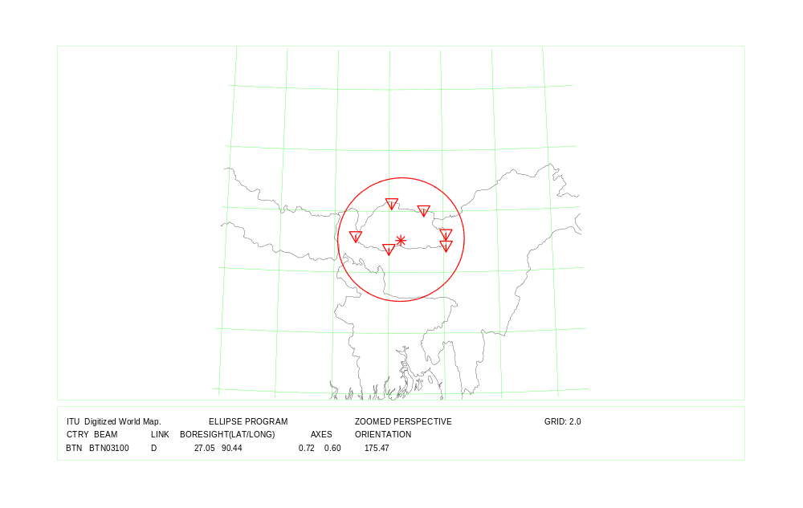
COUNTRY : BTN Feeder Link and Down Link

Country symbol: CZE
Beam Identification: CZE14400
Orbital position: -1.0
(plus for E, minus for W)

Test Point | Alt. | Feeder Link |  |  | Polarization |  | Ellipse parameters
No. | (mts.) |  |  |  |  |  |  |  |  |  | Beam Boresight
 |  | Latitude (°)  plus for N  minus for S | Longitude (°)  plus for E  minus for W | Channels  (17 GHz) | Type | Sense | Major  Axis (°) | Minor  Axis (°) | Orientation  (°) | Maximum  Antenna  Gain  (dB) | Latitude(°)  plus for N  minus for S | Longitude (°)  plus for E  minus for W
1 | 541 | 50.32 | 12.11 | 23,27,31,35,39 | Circular | Right | 0.92 | 0.60 | 172.03 | 47.03 | 49.96 | 15.49
2 | 435 | 51.05 | 14.32
3 | 246 | 50.32 | 17.69
4 | 557 | 49.52 | 18.84
5 | 151 | 48.62 | 16.94
6 | 760 | 48.60 | 14.07
7 | 538 | 49.44 | 12.66

Test Point | Alt. | Down Link |  |  | Polarization |  | Ellipse parameters
No. | (mts.) |  |  |  |  |  |  |  |  |  | Beam Boresight
 |  | Latitude (°)  plus for N  minus for S | Longitude (°)  plus for E  minus for W | Channels | Type | Sense | Major  Axis (°) | Minor  Axis (°) | Orientation  (°) | Maximum  Antenna  Gain  (dB) | Latitude (°)  plus for N  minus for S | Longitude (°)  plus for E  minus for W
1 | 541 | 50.32 | 12.11 | 23,27,31,35,39 | Circular | Left | 0.92 | 0.60 | 172.03 | 47.03 | 49.96 | 15.49
2 | 435 | 51.05 | 14.32
3 | 246 | 50.32 | 17.69
4 | 557 | 49.52 | 18.84
5 | 151 | 48.62 | 16.94
6 | 760 | 48.60 | 14.07
7 | 538 | 49.44 | 12.66

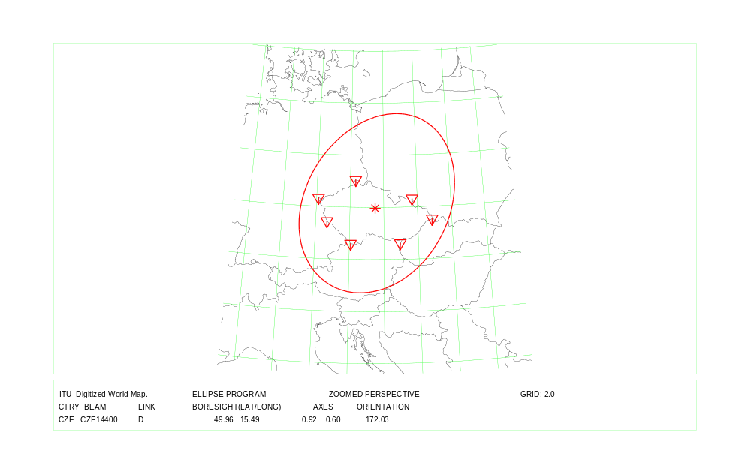
COUNTRY : CZE Feeder Link and Down Link

Country symbol: D
Beam Identification: D 08700
Orbital position: -19.0
(plus for E, minus for W)

Test Point | Alt. | Feeder Link |  |  | Polarization |  | Ellipse parameters
No. | (mts.) |  |  |  |  |  |  |  |  |  | Beam Boresight
 |  | Latitude (°)  plus for N  minus for S | Longitude (°)  plus for E  minus for W | Channels  (17 GHz) | Type | Sense | Major  Axis (°) | Minor  Axis (°) | Orientation  (°) | Maximum  Antenna  Gain  (dB) | Latitude (°)  plus for N  minus for S | Longitude (°)  plus for E  minus for W
1 | 0 | 52.50 | 13.20 | 2, 6,10,14,18 | Circular | Right | 1.30 | 0.64 | 144.40 | 45.25 | 50.46 | 9.86
2 | 0 | 53.70 | 7.00
3 | 0 | 50.74 | 6.02
4 | 0 | 47.60 | 7.80
5 | 0 | 48.92 | 13.63
6 | 0 | 54.75 | 9.97
7

Test Point | Alt. | Down Link |  |  | Polarization |  | Ellipse parameters
No. | (mts.) |  |  |  |  |  |  |  |  |  | Beam Boresight
 |  | Latitude (°)  plus for N  minus for S | Longitude (°)  plus for E  minus for W | Channels | Type | Sense | Major  Axis (°) | Minor  Axis (°) | Orientation  (°) | Maximum  Antenna  Gain  (dB) | Latitude (°)  plus for N  minus for S | Longitude (°)  plus for E  minus for W
1 | 0 | 52.50 | 13.20 | 2, 6,10,14,18 | Circular | Left | 1.30 | 0.64 | 144.40 | 45.25 | 50.46 | 9.86
2 | 0 | 53.70 | 7.00
3 | 0 | 50.74 | 6.02
4 | 0 | 47.60 | 7.80
5 | 0 | 48.92 | 13.63
6 | 0 | 54.75 | 9.97
7

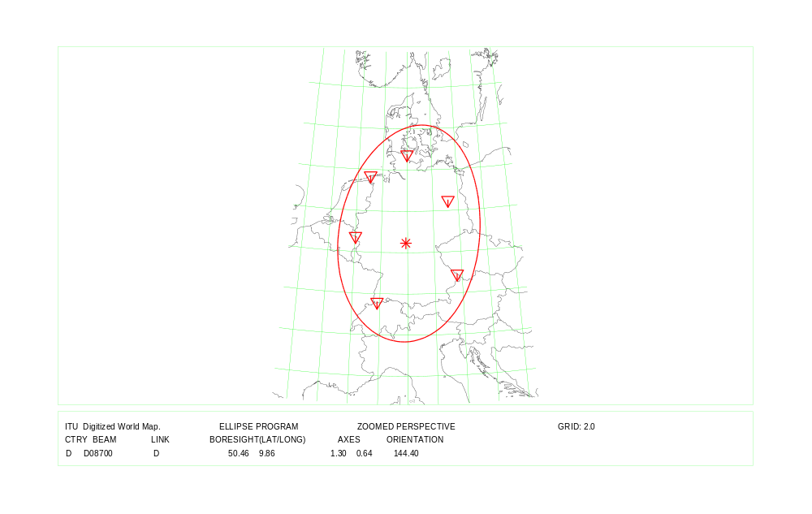
COUNTRY : D Feeder Link and Down Link Beam Identification: D08700

Country symbol: D
Beam Identification: D2-21600
Orbital position: -1.0
(plus for E, minus for W)

Test Point | Alt. | Feeder Link |  |  | Polarization |  | Ellipse parameters
No. | (mts.) |  |  |  |  |  |  |  |  |  | Beam Boresight
 |  | Latitude (°)  plus for N  minus for S | Longitude (°)  plus for E  minus for W | Channels  (17 GHz) | Type | Sense | Major  Axis (°) | Minor  Axis (°) | Orientation  (°) | Maximum  Antenna  Gain  (dB) | Latitude (°)  plus for N  minus for S | Longitude (°)  plus for E  minus for W
1 | 0 | 54.60 | 13.40 | 21,25,29,33,37 | Circular | Right | 0.83 | 0.62 | 127.49 | 47.31 | 51.36 | 12.23
2 | 0 | 54.00 | 10.80
3 | 0 | 50.60 | 9.90
4 | 0 | 48.95 | 13.60
5 | 0 | 53.30 | 14.40
6
7

Test Point | Alt. | Down Link |  |  | Polarization |  | Ellipse parameters
No. | (mts.) |  |  |  |  |  |  |  |  |  | Beam Boresight
 |  | Latitude (°)  plus for N  minus for S | Longitude (°)  plus for E  minus for W | Channels | Type | Sense | Major  Axis (°) | Minor  Axis (°) | Orientation  (°) | Maximum  Antenna  Gain  (dB) | Latitude (°)  plus for N  minus for S | Longitude (°)  plus for E  minus for W
1 | 0 | 54.50 | 12.50 | 21,25,29,33,37 | Circular | Left | 0.77 | 0.60 | 158.85 | 47.77 | 51.98 | 12.60
2 | 0 | 53.38 | 14.39
3 | 0 | 51.00 | 15.00
4 | 0 | 50.50 | 13.00
5 | 0 | 51.40 | 9.90
6 | 0 | 54.00 | 11.00
7

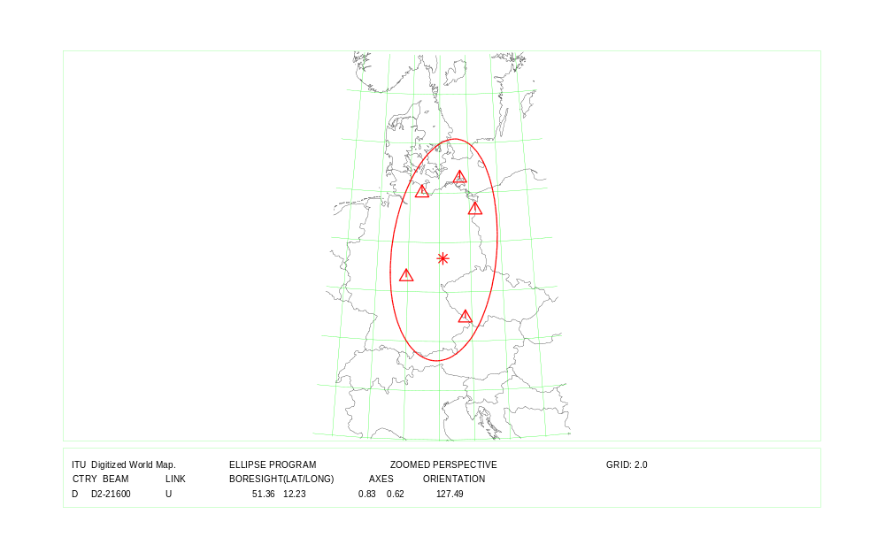
COUNTRY : D Feeder Link Beam Identification: D2-21600
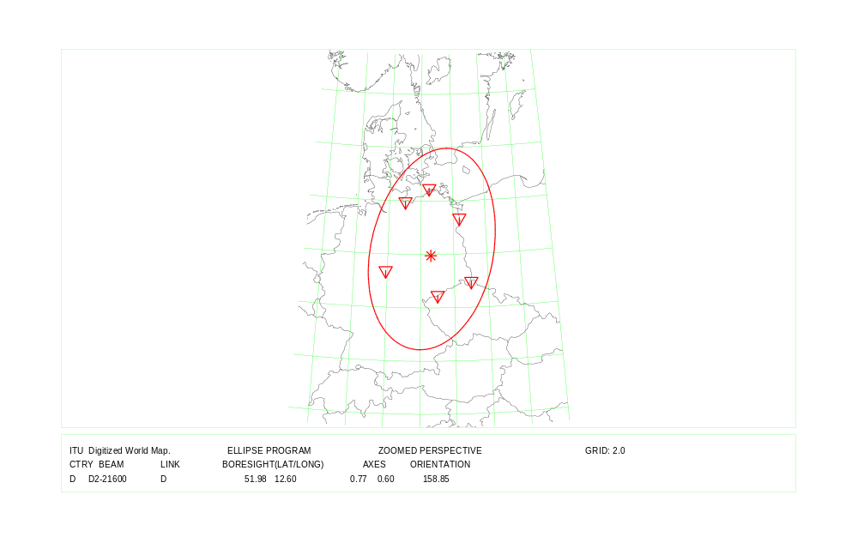
COUNTRY : D Down Link Beam Identification: D2-21600

Country symbol: ERI
Beam Identification: ERI09200
Orbital position: 23.0
(plus for E, minus for W)

Test Point | Alt. | Feeder Link |  |  | Polarization |  | Ellipse parameters
No. | (mts.) |  |  |  |  |  |  |  |  |  | Beam Boresight
 |  | Latitude (°)  plus for N  minus for S | Longitude (°)  plus for E  minus for W | Channels  (17 GHz) | Type | Sense | Major  Axis (°) | Minor  Axis (°) | Orientation  (°) | Maximum  Antenna  Gain  (dB) | Latitude (°)  plus for N  minus for S | Longitude (°)  plus for E  minus for W
1 | 0 | 17.94 | 38.54 | 23, 27,31,35, 39 | Circular | Left | 1.67 | 0.95 | 145.48 | 42.44 | 14.98 | 39.41
2 | 0 | 12.72 | 43.11
3 | 0 | 12.50 | 42.40
4 | 0 | 14.45 | 39.80
5 | 0 | 14.45 | 36.50
6 | 0 | 16.98 | 37.00
7

Test Point | Alt. | Down Link |  |  | Polarization |  | Ellipse parameters
No. | (mts.) |  |  |  |  |  |  |  |  |  | Beam Boresight
 |  | Latitude (°)  plus for N  minus for S | Longitude (°)  plus for E  minus for W | Channels | Type | Sense | Major  Axis (°) | Minor  Axis (°) | Orientation  (°) | Maximum  Antenna  Gain  (dB) | Latitude (°)  plus for N  minus for S | Longitude (°)  plus for E  minus for W
1 | 0 | 17.94 | 38.54 | 23,27,31,35,39 | Circular | Right | 1.67 | 0.95 | 145.48 | 42.44 | 14.98 | 39.41
2 | 0 | 12.72 | 43.11
3 | 0 | 12.50 | 42.40
4 | 0 | 14.45 | 39.80
5 | 0 | 14.45 | 36.50
6 | 0 | 16.98 | 37.00
7

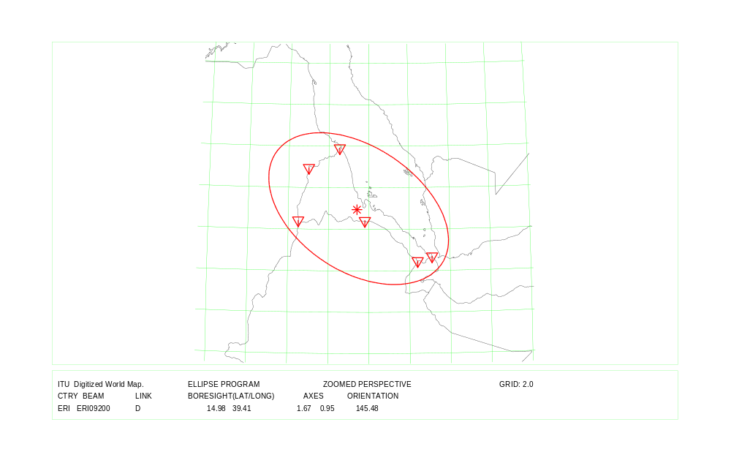
COUNTRY : ERI Feeder Link and Down Link

Country symbol: EST
Beam Identification: EST06100
Orbital position: 23.0
(plus for E, minus for W)

Test Point | Alt. | Feeder Link |  |  | Polarization |  | Ellipse parameters
No. | (mts.) |  |  |  |  |  |  |  |  |  | Beam Boresight
 |  | Latitude (°)  plus for N  minus for S | Longitude (°)  plus for E  minus for W | Channels  (17 GHz) | Type | Sense | Major  Axis (°) | Minor  Axis (°) | Orientation  (°) | Maximum  Antenna  Gain  (dB) | Latitude (°)  plus for N  minus for S | Longitude (°)  plus for E  minus for W
1 | 0 | 59.50 | 24.50 | 1, 5, 9, 13,17 | Circular | Right | 0.68 | 0.60 | 2.17 | 48.37 | 59.31 | 25.36
2 | 35 | 59.40 | 28.25
3 | 70 | 58.25 | 27.00
4 | 0 | 58.60 | 27.30
5 | 0 | 59.00 | 22.50
6
7

Test Point | Alt. | Down Link |  |  | Polarization |  | Ellipse parameters
No. | (mts.) |  |  |  |  |  |  |  |  |  | Beam Boresight
 |  | Latitude (°)  plus for N  minus for S | Longitude (°)  plus for E  minus for W | Channels | Type | Sense | Major  Axis (°) | Minor  Axis (°) | Orientation  (°) | Maximum  Antenna  Gain  (dB) | Latitude (°)  plus for N  minus for S | Longitude (°)  plus for E  minus for W
1 | 0 | 59.60 | 24.50 | 1, 5, 9, 13,17 | Circular | Left | 0.72 | 0.60 | 9.93 | 48.09 | 58.47 | 25.01
2 | 35 | 59.35 | 28.15
3 | 28 | 58.50 | 27.50
4 | 30 | 57.90 | 27.85
5 | 140 | 57.60 | 27.35
6 | 0 | 57.90 | 22.00
7 | 0 | 58.90 | 22.15

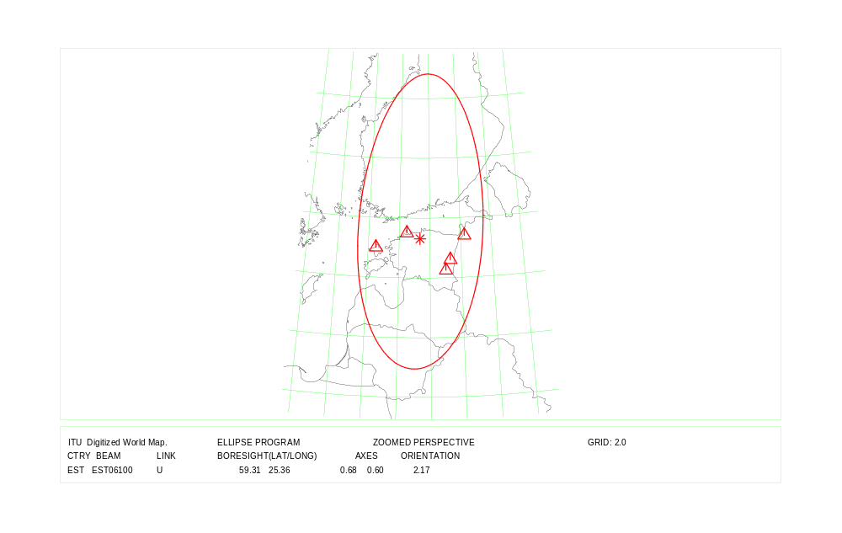
COUNTRY : EST Feeder Link
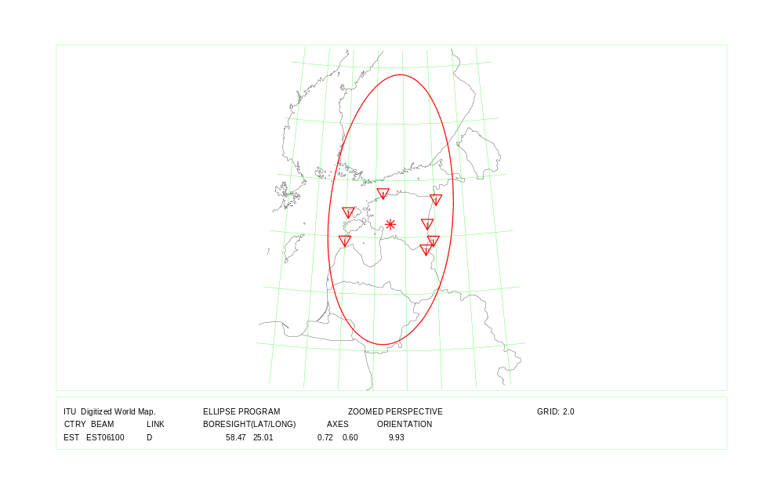
COUNTRY : EST Down Link

Country symbol: ETH
Beam Identification: ETH09200
Orbital position: 23.0
(plus for E, minus for W)

Test Point | Alt. | Feeder Link |  |  | Polarization |  | Ellipse parameters
No. | (mts.) |  |  |  |  |  |  |  |  |  | Beam Boresight
 |  | Latitude (°)  plus for N  minus for S | Longitude (°)  plus for E  minus for W | Channels  (14 GHz) | Type | Sense | Major  Axis (°) | Minor  Axis (°) | Orientation  (°) | Maximum  Antenna  Gain  (dB) | Latitude (°)  plus for N  minus for S | Longitude (°)  plus for E  minus for W
1 | 0 | 4.20 | 42.10 | 2, 6, 8,10,12 | Circular | Right | 2.66 | 2.23 | 166.11 | 36.72 | 9.19 | 40.35
2 | 0 | 4.81 | 35.77
3 | 400 | 5.10 | 45.00
4 | 800 | 7.90 | 34.00
5 | 200 | 8.00 | 47.95
6 | 200 | 10.90 | 34.60
7 | 0 | 12.46 | 42.39
8 | 200 | 14.17 | 40.59
9 | 700 | 14.50 | 37.18
10 | 0 | 14.91 | 37.88

Test Point | Alt. | Down Link |  |  | Polarization |  | Ellipse parameters
No. | (mts.) |  |  |  |  |  |  |  |  |  | Beam Boresight
 |  | Latitude (°)  plus for N  minus for S | Longitude (°)  plus for E  minus for W | Channels | Type | Sense | Major  Axis (°) | Minor  Axis (°) | Orientation  (°) | Maximum  Antenna  Gain  (dB) | Latitude (°)  plus for N  minus for S | Longitude (°)  plus for E  minus for W
1 | 0 | 3.52 | 38.97 | 22,26,30,34,38 | Circular | Left | 2.48 | 1.92 | 128.32 | 37.67 | 8.58 | 39.55
2 | 0 | 5.00 | 45.00
3 | 0 | 6.28 | 34.85
4 | 0 | 7.50 | 35.50
5 | 0 | 12.66 | 42.28
6 | 0 | 14.64 | 39.00
7

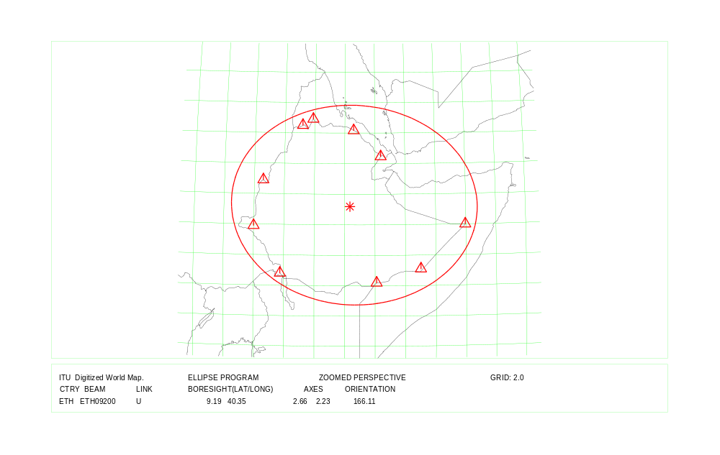
COUNTRY : ETH Feeder Link
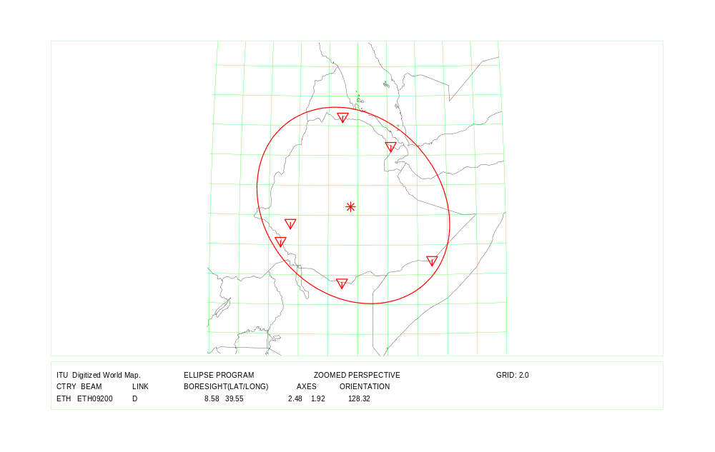
COUNTRY : ETH Down Link

Country symbol: FSM
Beam Identification: FSM00000
Orbital position: 146.0
(plus for E, minus for W)

Test Point | Alt. | Feeder Link |  |  | Polarization |  | Ellipse parameters
No. | (mts.) |  |  |  |  |  |  |  |  |  | Beam Boresight
 |  | Latitude (°)  plus for N  minus for S | Longitude (°)  plus for E  minus for W | Channels  (17 GHz) | Type | Sense | Major  Axis (°) | Minor  Axis (°) | Orientation  (°) | Maximum  Antenna  Gain  (dB) | Latitude (°)  plus for N  minus for S | Longitude (°)  plus for E  minus for W
1 | 0 | 1.02 | 154.78 | 3,7,11,15 | Circular | Right | 5.34 | 1.51 | 166.52 | 35.37 | 5.42 | 151.67
2 | 0 | 5.33 | 163.00
3 | 0 | 6.93 | 158.21
4 | 0 | 8.30 | 137.49
5 | 0 | 8.99 | 150.12
6 | 0 | 10.09 | 139.71
7

Test Point | Alt. | Down Link |  |  | Polarization |  | Ellipse parameters
No. | (mts.) |  |  |  |  |  |  |  |  |  | Beam Boresight
 |  | Latitude (°)  plus for N  minus for S | Longitude (°)  plus for E  minus for W | Channels | Type | Sense | Major  Axis (°) | Minor  Axis (°) | Orientation  (°) | Maximum  Antenna  Gain  (dB) | Latitude (°)  plus for N  minus for S | Longitude (°)  plus for E  minus for W
1 | 0 | 1.02 | 154.78 | 3,7,11,15 | Circular | Left | 5.34 | 1.51 | 166.52 | 35.37 | 5.42 | 151.67
2 | 0 | 5.33 | 163.00
3 | 0 | 6.93 | 158.21
4 | 0 | 8.30 | 137.49
5 | 0 | 8.99 | 150.12
6 | 0 | 10.09 | 139.71
7

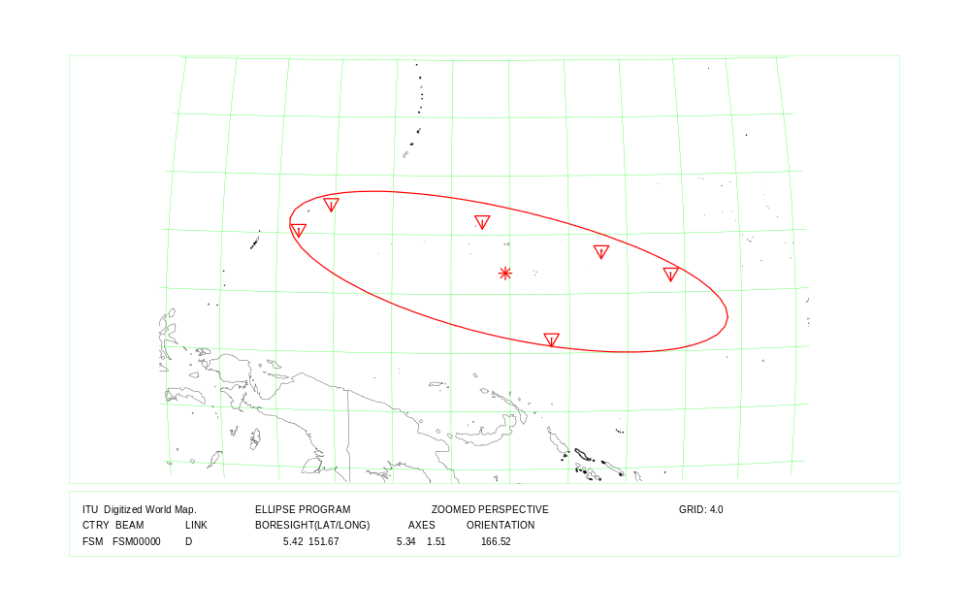
COUNTRY : FSM Feeder Link and Down Link

Country symbol: GEO
Beam Identification: GEO06400
Orbital position: 23.0
(plus for E, minus for W)

Test Point | Alt. | Feeder Link |  |  | Polarization |  | Ellipse parameters
No. | (mts.) |  |  |  |  |  |  |  |  |  | Beam Boresight
 |  | Latitude (°)  plus for N  minus for S | Longitude (°)  plus for E  minus for W | Channels  (17 GHz) | Type | Sense | Major  Axis (°) | Minor  Axis (°) | Orientation  (°) | Maximum  Antenna  Gain  (dB) | Latitude (°)  plus for N  minus for S | Longitude (°)  plus for E  minus for W
1 | 0 | 41.53 | 41.55 | 22,26,30,34,38 | Circular | Left | 1.11 | 0.60 | 161.21 | 46.23 | 42.27 | 43.35
2 | 0 | 43.39 | 40.00
3 | 0 | 42.84 | 43.59
4 | 0 | 41.89 | 46.44
5 | 0 | 41.25 | 44.95
6 | 0 | 41.49 | 42.81
7 | 0 | 41.11 | 46.63

Test Point | Alt. | Down Link |  |  | Polarization |  | Ellipse parameters
No. | (mts.) |  |  |  |  |  |  |  |  |  | Beam Boresight
 |  | Latitude (°)  plus for N  minus for S | Longitude (°)  plus for E  minus for W | Channels | Type | Sense | Major  Axis (°) | Minor  Axis (°) | Orientation  (°) | Maximum  Antenna  Gain  (dB) | Latitude (°)  plus for N  minus for S | Longitude (°)  plus for E  minus for W
1 | 0 | 41.53 | 41.55 | 22,26,30,34,38 | Circular | Right | 1.11 | 0.60 | 161.21 | 46.23 | 42.27 | 43.35
2 | 0 | 43.39 | 40.00
3 | 0 | 42.84 | 43.59
4 | 0 | 41.89 | 46.44
5 | 0 | 41.25 | 44.95
6 | 0 | 41.49 | 42.81
7 | 0 | 41.11 | 46.63

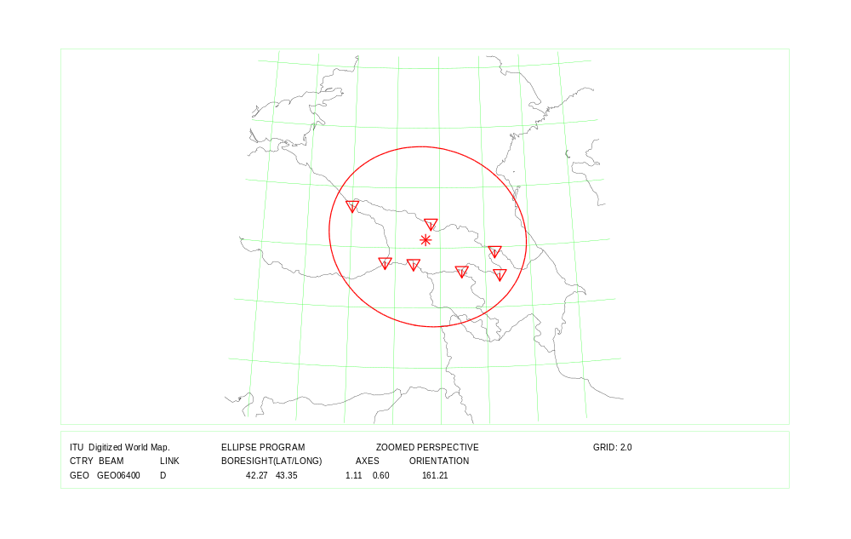
COUNTRY : GEO Feeder Link and Down Link

Country symbol: HRV
Beam Identification: HRV14800
Orbital position: 34.0
(plus for E, minus for W)

Test Point | Alt. | Feeder Link |  |  | Polarization |  | Ellipse parameters
No. | (mts.) |  |  |  |  |  |  |  |  |  | Beam Boresight
 |  | Latitude (°)  plus for N  minus for S | Longitude (°)  plus for E  minus for W | Channels  (17 GHz) | Type | Sense | Major  Axis (°) | Minor  Axis (°) | Orientation  (°) | Maximum  Antenna  Gain  (dB) | Latitude (°)  plus for N  minus for S | Longitude (°)  plus for E  minus for W
1 | 10 | 45.50 | 13.51 | 24,28,32,36,40 | Circular | Left | 0.88 | 0.69 | 5.30 | 46.57 | 44.54 | 16.74
2 | 20 | 42.39 | 16.26
3 | 60 | 42.39 | 18.54
4 | 86 | 45.91 | 18.82
5 | 168 | 46.51 | 16.45
6 | 120 | 45.22 | 19.38
7

Test Point | Alt. | Down Link |  |  | Polarization |  | Ellipse parameters (BR and S. Rapporteur)
No. | (mts.) |  |  |  |  |  |  |  |  |  | Beam Boresight
 |  | Latitude (°)  plus for N  minus for S | Longitude (°)  plus for E  minus for W | Channels | Type | Sense | Major  Axis (°) | Minor  Axis (°) | Orientation  (°) | Maximum  Antenna  Gain  (dB) | Latitude (°)  plus for N  minus for S | Longitude (°)  plus for E  minus for W
1 | 10 | 45.50 | 13.51 | 24,28,32,36,40 | Circular | Right | 0.88 | 0.69 | 5.30 | 46.57 | 44.54 | 16.74
2 | 20 | 42.39 | 16.26
3 | 60 | 42.39 | 18.54
4 | 86 | 45.91 | 18.82
5 | 168 | 46.51 | 16.45
6 | 120 | 45.22 | 19.38
7

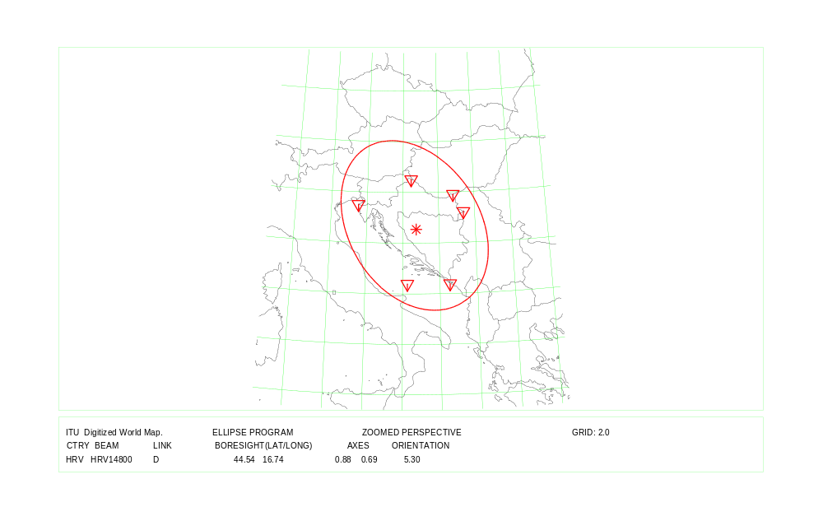
COUNTRY : HRV Feeder Link and Down Link

Country symbol: KAZ
Beam Identification: KAZ06600
Orbital position: 44.0
(plus for E, minus for W)

Test Point | Alt. | Feeder Link |  |  | Polarization |  | Ellipse parameters
No. | (mts.) |  |  |  |  |  |  |  |  |  | Beam Boresight
 |  | Latitude (°)  plus for N  minus for S | Longitude (°)  plus for E  minus for W | Channels  (17 GHz) | Type | Sense | Major  Axis (°) | Minor  Axis (°) | Orientation  (°) | Maximum  Antenna  Gain  (dB) | Latitude (°)  plus for N  minus for S | Longitude (°)  plus for E  minus for W
1 | 0 | 41.24 | 55.48 | 24,28,32,36,40 | Circular | Right | 4.31 | 1.70 | 172.22 | 35.79 | 46.40 | 64.72
2 | 0 | 47.07 | 71.43
3 | 0 | 40.68 | 68.49
4 | 0 | 55.41 | 68.95
5 | 0 | 49.20 | 87.30
6 | 0 | 48.70 | 46.60
7 | 0 | 41.79 | 52.46
8 | 0 | 42.23 | 80.28

Test Point | Alt. | Down Link |  |  | Polarization |  | Ellipse parameters
No. | (mts.) |  |  |  |  |  |  |  |  |  | Beam Boresight
 |  | Latitude (°)  plus for N  minus for S | Longitude (°)  plus for E  minus for W | Channels | Type | Sense | Major  Axis (°) | Minor  Axis (°) | Orientation  (°) | Maximum  Antenna  Gain  (dB) | Latitude (°)  plus for N  minus for S | Longitude (°)  plus for E  minus for W
1 | 0 | 41.24 | 55.48 | 24,28,32,36,40 | Circular | Left | 4.31 | 1.70 | 172.22 | 35.79 | 46.40 | 64.72
2 | 0 | 47.07 | 71.43
3 | 0 | 40.68 | 68.49
4 | 0 | 55.41 | 68.95
5 | 0 | 49.20 | 87.30
6 | 0 | 48.70 | 46.60
7 | 0 | 41.79 | 52.46
8 | 0 | 42.23 | 80.28

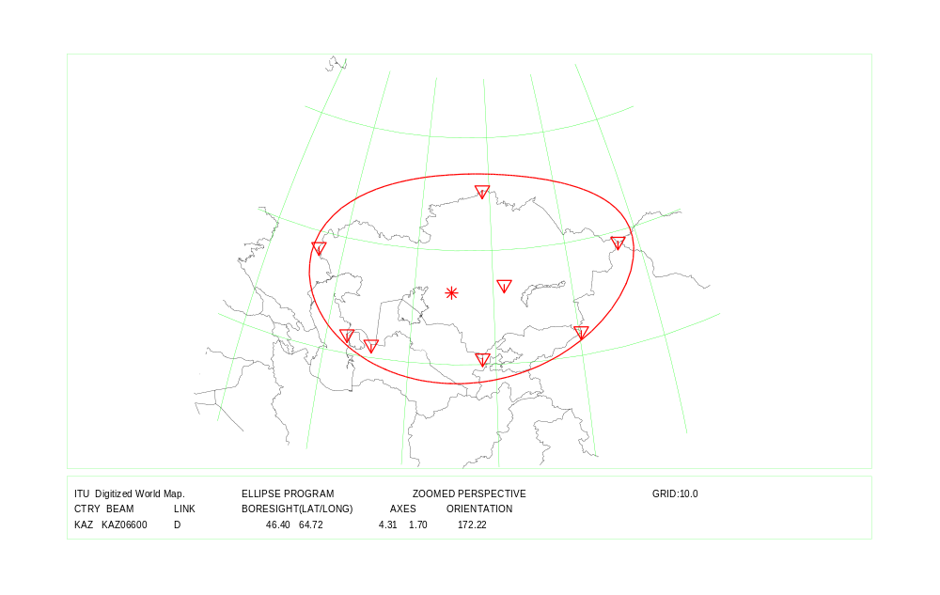
COUNTRY : KAZ Feeder Link and Down Link

Country symbol: KGZ
Beam Identification: KGZ07000
Orbital position: 44.0
(plus for E, minus for W)

Test Point | Alt. | Feeder Link |  |  | Polarization |  | Ellipse parameters
No. | (mts.) |  |  |  |  |  |  |  |  |  | Beam Boresight
 |  | Latitude (°)  plus for N  minus for S | Longitude (°)  plus for E  minus for W | Channels  (17 GHz) | Type | Sense | Major  Axis (°) | Minor  Axis (°) | Orientation  (°) | Maximum  Antenna  Gain  (dB) | Latitude (°)  plus for N  minus for S | Longitude (°)  plus for E  minus for W
1 | 0 | 41.10 | 78.18 | 22,26,30,34,38 | Circular | Right | 1.34 | 0.64 | 3.53 | 45.12 | 41.32 | 73.88
2 | 0 | 43.26 | 74.20
3 | 0 | 42.22 | 80.25
4 | 0 | 39.47 | 73.66
5 | 0 | 39.55 | 69.35
6 | 0 | 41.50 | 70.22
7 | 0 | 42.40 | 70.95

Test Point | Alt. | Down Link |  |  | Polarization |  | Ellipse parameters
No. | (mts.) |  |  |  |  |  |  |  |  |  | Beam Boresight
 |  | Latitude (°)  plus for N  minus for S | Longitude (°)  plus for E  minus for W | Channels | Type | Sense | Major  Axis (°) | Minor  Axis (°) | Orientation  (°) | Maximum  Antenna  Gain  (dB) | Latitude (°)  plus for N  minus for S | Longitude (°)  plus for E  minus for W
1 | 0 | 41.10 | 78.18 | 22,26,30,34,38 | Circular | Left | 1.34 | 0.64 | 3.53 | 45.12 | 41.32 | 73.88
2 | 0 | 43.26 | 74.20
3 | 0 | 42.22 | 80.25
4 | 0 | 39.47 | 73.66
5 | 0 | 39.55 | 69.35
6 | 0 | 41.50 | 70.22
7 | 0 | 42.40 | 70.95

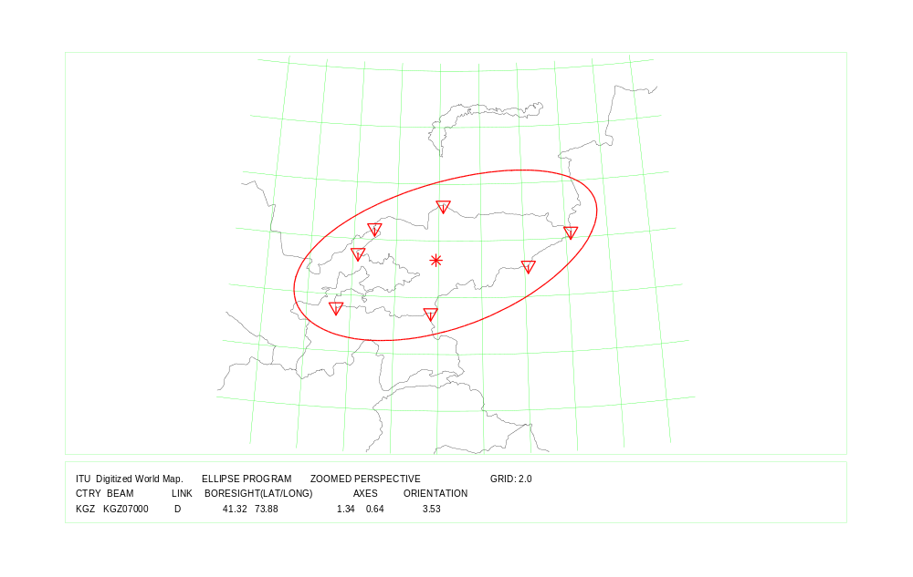
COUNTRY : KGZ Feeder Link and Down Link

Country symbol: KIR
Beam Identification: KIR00001
Orbital position: 176.0
(plus for E, minus for W)

Test Point | Alt. | Feeder Link |  |  | Polarization |  | Ellipse parameters
No. | (mts.) |  |  |  |  |  |  |  |  |  | Beam Boresight
 |  | Latitude (°)  plus for N  minus for S | Longitude (°)  plus for E  minus for W | Channels  (17 GHz) | Type | Sense | Major  Axis (°) | Minor  Axis (°) | Orientation  (°) | Maximum  Antenna  Gain  (dB) | Latitude (°)  plus for N  minus for S | Longitude (°)  plus for E  minus for W
1 | 0 | -0.92 | 169.55 | 3, 7,11 | Circular | Left | 4.47 | 1.27 | 163.00 | 36.91 | -0.79 | 177.16
2 | 0 | 3.29 | 172.97
3 | 0 | -2.51 | 175.96
4 | 0 | 1.49 | 172.99
5 | 0 | -4.51 | -172.23
6 | 0 | -4.49 | -172.21
7 | 0 | 1.43 | 173.00
8 | 0 | -4.45 | -171.22
9 | 0 | -4.43 | -171.23

Test Point | Alt. | Down Link |  |  | Polarization |  | Ellipse parameters
No. | (mts.) |  |  |  |  |  |  |  |  |  | Beam Boresight
 |  | Latitude (°)  plus for N  minus for S | Longitude (°)  plus for E  minus for W | Channels | Type | Sense | Major  Axis (°) | Minor  Axis (°) | Orientation  (°) | Maximum  Antenna  Gain  (dB) | Latitude (°)  plus for N  minus for S | Longitude (°)  plus for E  minus for W
1 | 0 | -0.92 | 169.55 | 3, 7, 11 | Circular | Left | 4.47 | 1.27 | 163.00 | 36.91 | -0.79 | 177.16
2 | 0 | 3.29 | 172.97
3 | 0 | -2.51 | 175.96
4 | 0 | 1.49 | 172.99
5 | 0 | -4.51 | -172.23
6 | 0 | -4.49 | -172.21
7 | 0 | 1.43 | 173.00
8 | 0 | -4.45 | -171.22
9 | 0 | -4.43 | -171.23

COUNTRY : KIR Feeder Link and Down Link Beam Identification: KIR00001

Country symbol: KIR
Beam Identification: KIR00002
Orbital position: 176.0
(plus for E, minus for W)

Test Point | Alt. | Feeder Link |  |  | Polarization |  | Ellipse parameters
No. | (mts.) |  |  |  |  |  |  |  |  |  | Beam Boresight
 |  | Latitude (°)  plus for N  minus for S | Longitude (°)  plus for E  minus for W | Channels  (17 GHz) | Type | Sense | Major  Axis (°) | Minor  Axis (°) | Orientation  (°) | Maximum  Antenna  Gain  (dB) | Latitude (°)  plus for N  minus for S | Longitude (°)  plus for E  minus for W
1 | 0 | 4.72 | -160.41 | 15,19,23 | Circular | Left | 2.40 | 0.64 | 110.62 | 42.60 | -0.33 | -157.78
2 | 0 | 3.82 | -159.24
3 | 0 | 1.77 | -157.20
4 | 0 | -4.00 | -155.00
5 | 0 | -5.63 | -155.91
6 | 0 | -5.61 | -155.87
7 | 0 | -4.03 | -154.97

Test Point | Alt. | Down Link |  |  | Polarization |  | Ellipse parameters
No. | (mts.) |  |  |  |  |  |  |  |  |  | Beam Boresight
 |  | Latitude (°)  plus for N  minus for S | Longitude (°)  plus for E  minus for W | Channels | Type | Sense | Major  Axis (°) | Minor  Axis (°) | Orientation  (°) | Maximum  Antenna  Gain  (dB) | Latitude (°)  plus for N  minus for S | Longitude (°)  plus for E  minus for W
1 | 0 | 4.72 | -160.41 | 15,19,23 | Circular | Left | 2.40 | 0.64 | 110.62 | 42.60 | -0.33 | -157.78
2 | 0 | 3.82 | -159.24
3 | 0 | 1.77 | -157.20
4 | 0 | -4.00 | -155.00
5 | 0 | -5.63 | -155.91
6 | 0 | -5.61 | -155.87
7 | 0 | -4.03 | -154.97

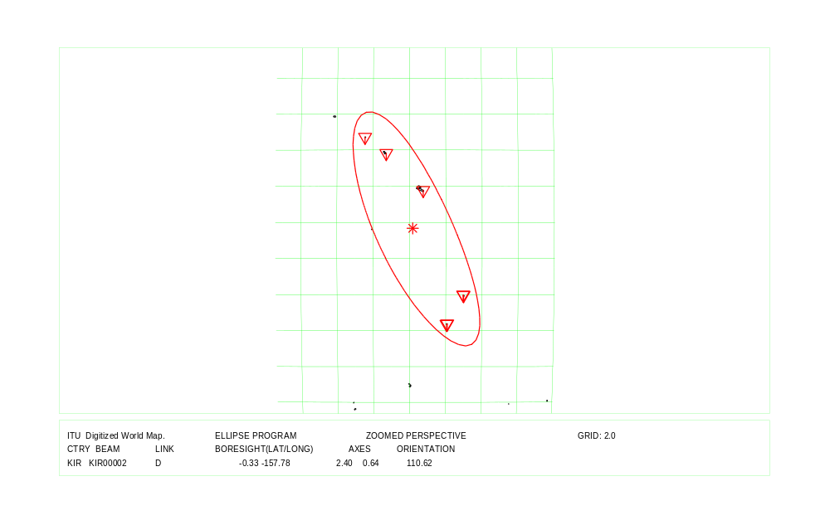
COUNTRY : KIR Feeder Link and Down Link Beam Identification: KIR00002

Country symbol: LTU
Beam Identification: LTU06100
Orbital position: 23.0
(plus for E, minus for W)

Test Point | Alt. | Feeder Link |  |  | Polarization |  | Ellipse parameters
No. | (mts.) |  |  |  |  |  |  |  |  |  | Beam Boresight
 |  | Latitude (°)  plus for N  minus for S | Longitude (°)  plus for E  minus for W | Channels  (17 GHz) | Type | Sense | Major  Axis (°) | Minor  Axis (°) | Orientation  (°) | Maximum  Antenna  Gain  (dB) | Latitude (°)  plus for N  minus for S | Longitude (°)  plus for E  minus for W
1 | 0 | 55.50 | 21.50 | 3, 7,11,15,19 | Circular | Right | 0.72 | 0.60 | 173.90 | 48.11 | 55.46 | 24.02
2 | 0 | 56.00 | 21.25
3 | 0 | 56.20 | 23.50
4 | 0 | 55.28 | 26.78
5 | 0 | 54.15 | 25.68
6 | 0 | 53.99 | 23.49
7

Test Point | Alt. | Down Link |  |  | Polarization |  | Ellipse parameters
No. | (mts.) |  |  |  |  |  |  |  |  |  | Beam Boresight
 |  | Latitude (°)  plus for N  minus for S | Longitude (°)  plus for E  minus for W | Channels | Type | Sense | Major  Axis (°) | Minor  Axis (°) | Orientation  (°) | Maximum  Antenna  Gain  (dB) | Latitude (°)  plus for N  minus for S | Longitude (°)  plus for E  minus for W
1 | 0 | 56.08 | 21.08 | 3, 7,11,15,19 | Circular | Left | 0.70 | 0.60 | 176.00 | 48.21 | 55.66 | 23.79
2 | 0 | 56.25 | 24.75
3 | 0 | 55.58 | 26.50
4 | 0 | 54.50 | 25.50
5 | 0 | 54.38 | 22.80
6 | 0 | 55.25 | 21.27
7

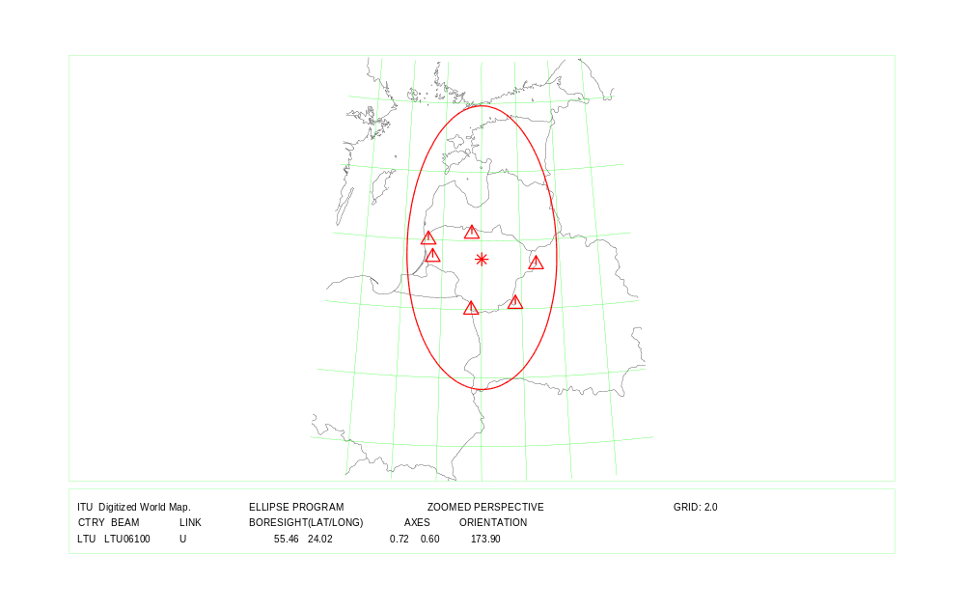
COUNTRY : LTU Feeder Link
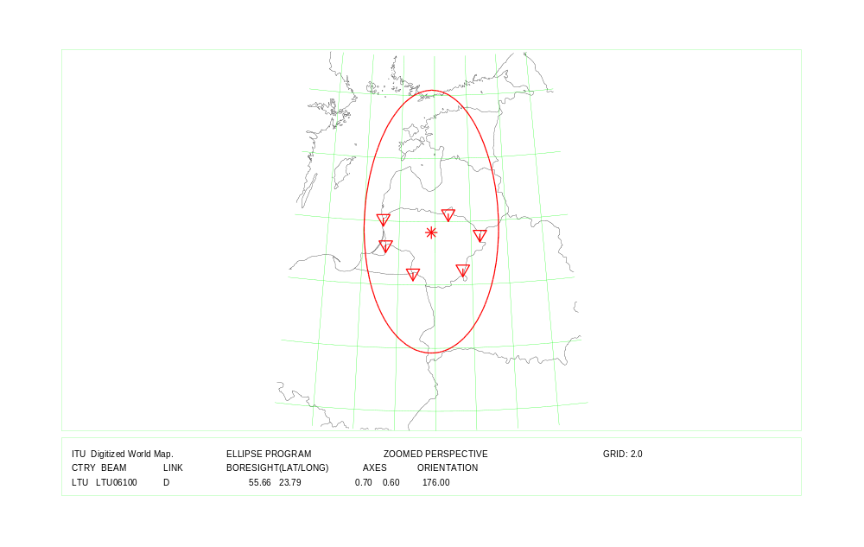
COUNTRY : LTU Down Link

Country symbol: LVA
Beam Identification: LVA06100
Orbital position: 23.0
(plus for E, minus for W)

Test Point | Alt. | Feeder Link |  |  | Polarization |  | Ellipse parameters
No. | (mts.) |  |  |  |  |  |  |  |  |  | Beam Boresight
 |  | Latitude (°)  plus for N  minus for S | Longitude (°)  plus for E  minus for W | Channels  (17 GHz) | Type | Sense | Major  Axis (°) | Minor  Axis (°) | Orientation  (°) | Maximum  Antenna  Gain  (dB) | Latitude (°)  plus for N  minus for S | Longitude (°)  plus for E  minus for W
1 | 0 | 57.90 | 24.40 | 21,25,29,33,37 | Circular | Right | 0.83 | 0.60 | 0.05 | 47.50 | 56.20 | 24.53
2 | 0 | 57.55 | 27.25
3 | 0 | 56.15 | 27.96
4 | 0 | 55.66 | 26.57
5 | 0 | 56.25 | 24.25
6 | 0 | 56.10 | 21.10
7 | 0 | 57.50 | 21.75

Test Point | Alt. | Down Link |  |  | Polarization |  | Ellipse parameters
No. | (mts.) |  |  |  |  |  |  |  |  |  | Beam Boresight
 |  | Latitude (°)  plus for N  minus for S | Longitude (°)  plus for E  minus for W | Channels | Type | Sense | Major  Axis (°) | Minor  Axis (°) | Orientation  (°) | Maximum  Antenna  Gain  (dB) | Latitude (°)  plus for N  minus for S | Longitude (°)  plus for E  minus for W
1 | 0 | 57.90 | 24.40 | 21,25,29,33,37 | Circular | Left | 0.83 | 0.60 | 0.05 | 47.50 | 56.20 | 24.53
2 | 0 | 57.55 | 27.25
3 | 0 | 56.15 | 27.96
4 | 0 | 55.66 | 26.57
5 | 0 | 56.25 | 24.25
6 | 0 | 56.10 | 21.10
7 | 0 | 57.50 | 21.75

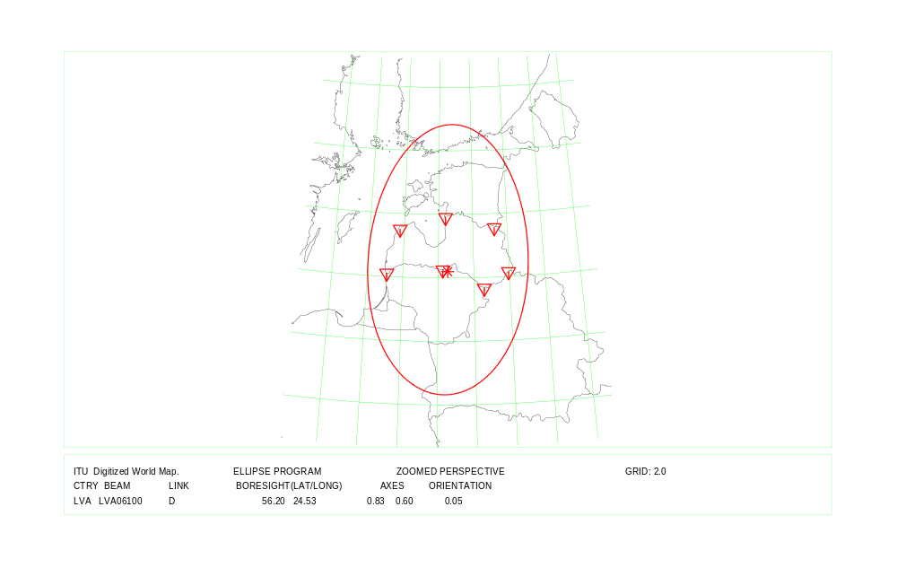
COUNTRY : LVA Feeder Link and Down Link

Country symbol: MDA
Beam Identification: MDA06300
Orbital position: 38.0
(plus for E, minus for W)

Test Point | Alt. | Feeder Link |  |  | Polarization |  | Ellipse parameters
No. | (mts.) |  |  |  |  |  |  |  |  |  | Beam Boresight
 |  | Latitude (°)  plus for N  minus for S | Longitude (°)  plus for E  minus for W | Channels  (17 GHz) | Type | Sense | Major  Axis (°) | Minor  Axis (°) | Orientation  (°) | Maximum  Antenna  Gain  (dB) | Latitude (°)  plus for N  minus for S | Longitude (°)  plus for E  minus for W
1 | 150 | 48.26 | 26.65 | 4, 8,12,16,20 | Circular | Left | 0.60 | 0.60 | 90.00 | 48.88 | 46.99 | 28.41
2 | 200 | 48.11 | 28.77
3 | 10 | 46.37 | 30.07
4 | 100 | 46.50 | 29.00
5 | 30 | 45.50 | 28.17
6 | 50 | 47.20 | 27.80
7

Test Point | Alt. | Down Link |  |  | Polarization |  | Ellipse parameters
No. | (mts.) |  |  |  |  |  |  |  |  |  | Beam Boresight
 |  | Latitude (°)  plus for N  minus for S | Longitude (°)  plus for E  minus for W | Channels | Type | Sense | Major  Axis (°) | Minor  Axis (°) | Orientation  (°) | Maximum  Antenna  Gain  (dB) | Latitude (°)  plus for N  minus for S | Longitude (°)  plus for E  minus for W
1 | 150 | 48.26 | 26.65 | 4, 8,12,16,20 | Circular | Right | 0.60 | 0.60 | 90.00 | 48.88 | 46.99 | 28.41
2 | 200 | 48.11 | 28.77
3 | 10 | 46.37 | 30.07
4 | 100 | 46.50 | 29.00
5 | 30 | 45.50 | 28.17
6 | 50 | 47.20 | 27.80
7

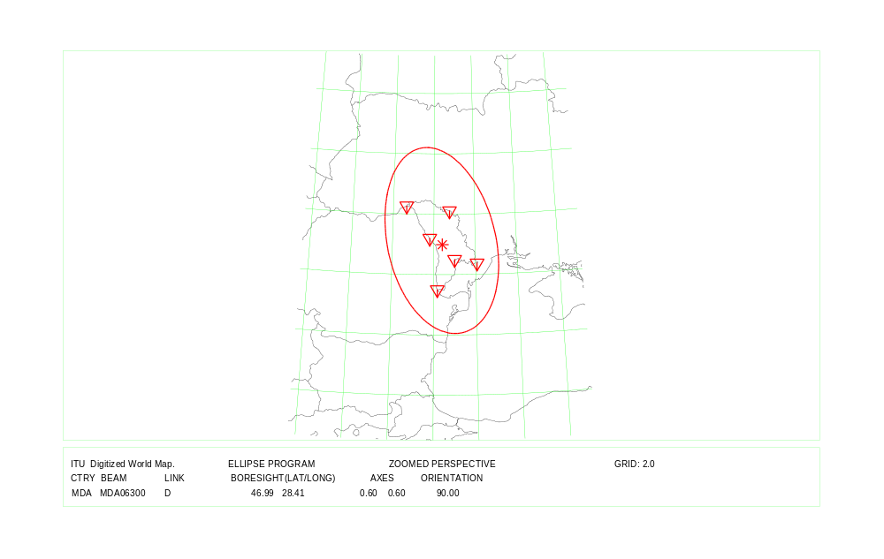

COUNTRY : MDA Feeder Link and Down Link

Country symbol: MHL
Beam Identification: MHL00000
Orbital position: 146.0
(plus for E, minus for W)

Test Point | Alt. | Feeder Link |  |  | Polarization |  | Ellipse parameters
No. | (mts.) |  |  |  |  |  |  |  |  |  | Beam Boresight
 |  | Latitude (°)  plus for N  minus for S | Longitude (°)  plus for E  minus for W | Channels  (17 GHz) | Type | Sense | Major  Axis (°) | Minor  Axis (°) | Orientation  (°) | Maximum  Antenna  Gain  (dB) | Latitude (°)  plus for N  minus for S | Longitude (°)  plus for E  minus for W
1 | 0 | 8.75 | 167.75 | 2, 6, 10, 14, 18 | Circular | Left | 2.07 | 0.90 | 157.42 | 41.75 | 9.83 | 167.64
2 | 0 | 7.12 | 171.37
3 | 0 | 11.36 | 162.33
4 | 0 | 11.24 | 169.85
5
6
7

Test Point | Alt. | Down Link |  |  | Polarization |  | Ellipse parameters
No. | (mts.) |  |  |  |  |  |  |  |  |  | Beam Boresight
 |  | Latitude (°)  plus for N  minus for S | Longitude (°)  plus for E  minus for W | Channels | Type | Sense | Major  Axis (°) | Minor  Axis (°) | Orientation  (°) | Maximum  Antenna  Gain  (dB) | Latitude (°)  plus for N  minus for S | Longitude (°)  plus for E  minus for W
1 | 0 | 8.75 | 167.75 | 2, 6, 10, 14, 18 | Circular | Right | 2.07 | 0.90 | 157.42 | 41.75 | 9.83 | 167.64
2 | 0 | 7.12 | 171.37
3 | 0 | 11.36 | 162.33
4 | 0 | 11.24 | 169.85
5
6
7

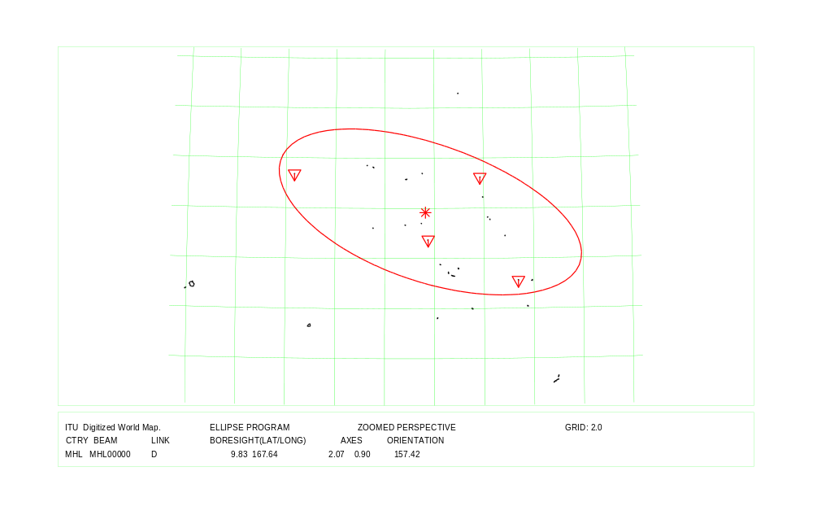
COUNTRY : MHL Feeder Link and Down Link

Country symbol: MKD
Beam Identification: MKD14800
Orbital position: 34.0
(plus for E, minus for W)

Test Point | Alt. | Feeder Link |  |  | Polarization |  | Ellipse parameters
No. | (mts.) |  |  |  |  |  |  |  |  |  | Beam Boresight
 |  | Latitude (°)  plus for N  minus for S | Longitude (°)  plus for E  minus for W | Channels  (17 GHz) | Type | Sense | Major  Axis (°) | Minor  Axis (°) | Orientation  (°) | Maximum  Antenna  Gain  (dB) | Latitude (°)  plus for N  minus for S | Longitude (°)  plus for E  minus for W
1 | 270 | 41.99 | 21.45 | 22,26,30,34,38 | Circular | Left | 0.60 | 0.60 | 90.00 | 48.88 | 41.50 | 21.53
2 | 380 | 41.73 | 22.19
3 | 154 | 41.16 | 22.51
4 | 620 | 41.03 | 21.34
5 | 797 | 41.12 | 20.80
6 | 1741 | 41.99 | 20.90

Test Point | Alt. | Down Link |  |  | Polarization |  | Ellipse parameters
No. | (mts.) |  |  |  |  |  |  |  |  |  | Beam Boresight
 |  | Latitude (°)  plus for N  minus for S | Longitude (°)  plus for E  minus for W | Channels | Type | Sense | Major  Axis (°) | Minor  Axis (°) | Orientation  (°) | Maximum  Antenna  Gain  (dB) | Latitude (°)  plus for N  minus for S | Longitude (°)  plus for E  minus for W
1 | 1900 | 41.75 | 20.58 | 22,26,30,34,38 | Circular | Right | 0.60 | 0.60 | 90.00 | 48.88 | 41.56 | 21.61
2 | 2000 | 42.16 | 21.10
3 | 1100 | 42.24 | 22.35
4 | 1724 | 41.78 | 22.94
5 | 665 | 41.37 | 22.87
6 | 154 | 41.16 | 22.51
7 | 1100 | 40.91 | 20.97
8 | 1060 | 41.12 | 20.62
9 | 660 | 41.53 | 20.53

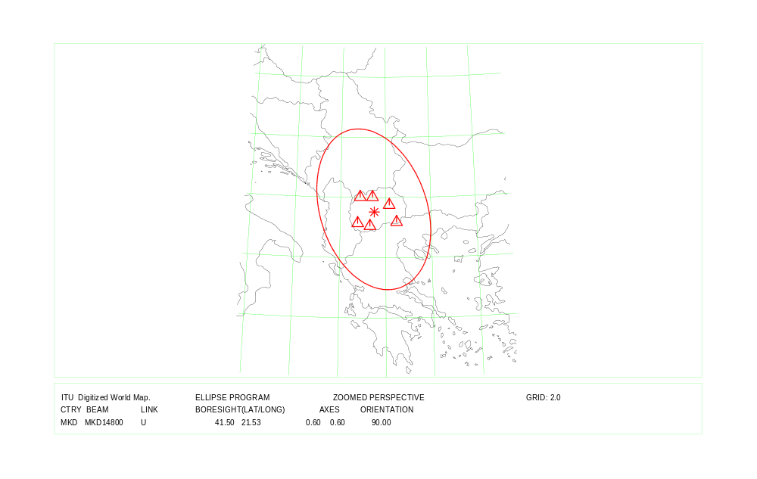
COUNTRY : MKD Feeder Link
COUNTRY : MKD Down Link

Country symbol: PLW
Beam Identification: PLW00000
Orbital position: 146.0
(plus for E, minus for W)

Test Point | Alt. | Feeder Link |  |  | Polarization |  | Ellipse parameters
No. | (mts.) |  |  |  |  |  |  |  |  |  | Beam Boresight
 |  | Latitude (°)  plus for N  minus for S | Longitude (°)  plus for E  minus for W | Channels  (17 GHz) | Type | Sense | Major  Axis (°) | Minor  Axis (°) | Orientation  (°) | Maximum  Antenna  Gain  (dB) | Latitude (°)  plus for N  minus for S | Longitude (°)  plus for E  minus for W
1 | 0 | 2.97 | 131.81 | 4, 8, 12,16 | Circular | Left | 1.29 | 0.60 | 55.84 | 45.55 | 5.52 | 132.99
2 | 0 | 3.01 | 131.17
3 | 0 | 4.32 | 132.31
4 | 0 | 5.35 | 132.22
5 | 0 | 7.50 | 134.60
6 | 0 | 8.09 | 134.71
7

Test Point | Alt. | Down Link |  |  | Polarization |  | Ellipse parameters
No. | (mts.) |  |  |  |  |  |  |  |  |  | Beam Boresight
 |  | Latitude (°)  plus for N  minus for S | Longitude (°)  plus for E  minus for W | Channels | Type | Sense | Major  Axis (°) | Minor  Axis (°) | Orientation  (°) | Maximum  Antenna  Gain  (dB) | Latitude (°)  plus for N  minus for S | Longitude (°)  plus for E  minus for W
1 | 0 | 2.97 | 131.81 | 4, 8,12,16 | Circular | Right | 1.29 | 0.60 | 55.84 | 45.55 | 5.52 | 132.99
2 | 0 | 3.01 | 131.17
3 | 0 | 4.32 | 132.31
4 | 0 | 5.35 | 132.22
5 | 0 | 7.50 | 134.60
6 | 0 | 8.09 | 134.71
7

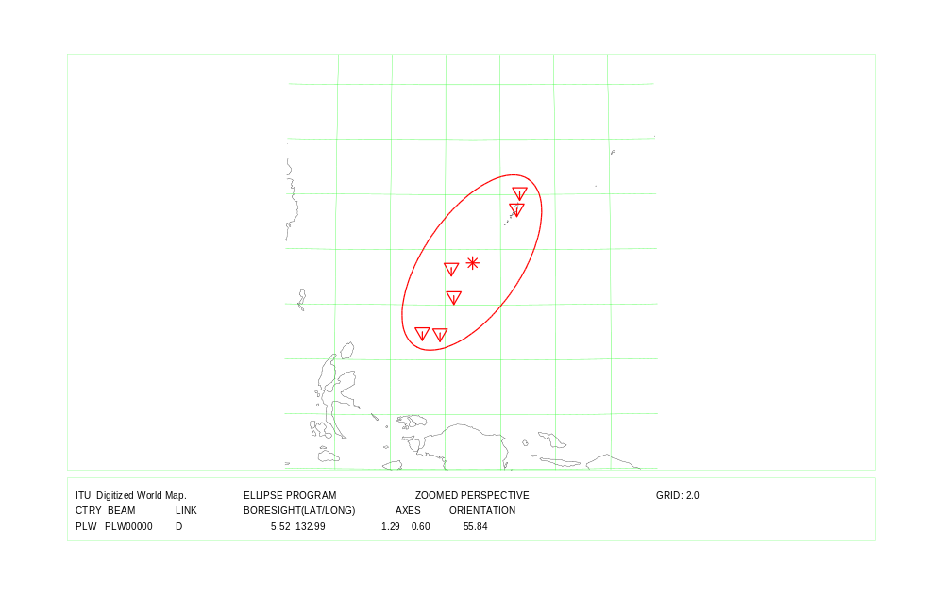
COUNTRY : PLW Feeder Link and Down Link
Country symbol: RUS
Beam Identification: RUSRSA11
Orbital position: 38.0
(plus for E, minus for W)

Test Point | Alt. | Feeder Link |  |  | Polarization |  | Ellipse parameters
No. | (mts.) |  |  |  |  |  |  |  |  |  | Beam Boresight
 |  | Latitude (°)  plus for N  minus for S | Longitude (°)  plus for E  minus for W | Channels  (17 GHz) | Type | Sense | Major  Axis (°) | Minor  Axis (°) | Orientation  (°) | Maximum  Antenna  Gain  (dB) | Latitude (°)  plus for N  minus for S | Longitude (°)  plus for E  minus for W
1 | 0 | 68.92 | 29.00 | 25,27,29,31,33, | Circular | Right | 5.26 | 2.40 | 178.31 | 33.43 | 52.54 | 46.42
2 | 0 | 59.10 | 28.00 | 35,37,39
3 | 0 | 54.44 | 20.00
4 | 0 | 49.00 | 40.05
5 | 2000 | 41.40 | 47.82
6 | 0 | 51.00 | 55.80
7 | 0 | 54.23 | 75.77
8 | 0 | 64.10 | 86.15
9 | 0 | 72.40 | 78.00
10 | 0 | 67.14 | 52.04

Test Point | Alt. | Down Link |  |  | Polarization |  | Ellipse parameters
No. | (mts.) |  |  |  |  |  |  |  |  |  | Beam Boresight
 |  | Latitude (°)  plus for N  minus for S | Longitude (°)  plus for E  minus for W | Channels | Type | Sense | Major  Axis (°) | Minor  Axis (°) | Orientation  (°) | Maximum  Antenna  Gain  (dB) | Latitude (°)  plus for N  minus for S | Longitude (°)  plus for E  minus for W
1 | 0 | 68.92 | 29.00 | 25,27,29,31,33, | Circular | Left | 3.43 | 2.14 | 172.40 | 35.80 | 53.24 | 39.12
2 | 0 | 59.10 | 28.00 | 35,37,39
3 | 0 | 54.70 | 22.00
4 | 0 | 54.40 | 22.70
5 | 0 | 43.50 | 41.59
6 | 2000 | 43.50 | 45.00
7 | 0 | 46.40 | 48.90
8 | 0 | 51.60 | 55.00
9 | 0 | 60.00 | 51.00
10 | 0 | 68.00 | 50.00
Country symbol: RUS
Beam Identification: RUSRSA12
Orbital position: 38.0
(plus for E, minus for W)

Test Point | Alt. | Feeder Link |  |  | Polarization |  | Ellipse parameters
No. | (mts.) |  |  |  |  |  |  |  |  |  | Beam Boresight
 |  | Latitude (°)  plus for N  minus for S | Longitude (°)  plus for E  minus for W | Channels  (17 GHz) | Type | Sense | Major  Axis (°) | Minor  Axis (°) | Orientation  (°) | Maximum  Antenna  Gain  (dB) | Latitude (°)  plus for N  minus for S | Longitude (°)  plus for E  minus for W
1 | 0 | 68.92 | 29.00 | 26,28,30,32,34, | Circular | Left | 5.26 | 2.40 | 178.31 | 33.43 | 52.54 | 46.42
2 | 0 | 59.10 | 28.00 | 36,38,40
3 | 0 | 54.44 | 20.00
4 | 0 | 49.00 | 40.05
5 | 2000 | 41.40 | 47.82
6 | 0 | 51.00 | 55.80
7 | 0 | 54.23 | 75.77
8 | 0 | 64.10 | 86.15
9 | 0 | 72.40 | 78.00
10 | 0 | 67.14 | 52.04

Test Point | Alt. | Down Link |  |  | Polarization |  | Ellipse parameters
No. | (mts.) |  |  |  |  |  |  |  |  |  | Beam Boresight
 |  | Latitude (°)  plus for N  minus for S | Longitude (°)  plus for E  minus for W | Channels | Type | Sense | Major  Axis (°) | Minor  Axis (°) | Orientation  (°) | Maximum  Antenna  Gain  (dB) | Latitude (°)  plus for N  minus for S | Longitude (°)  plus for E  minus for W
1 | 0 | 68.92 | 29.00 | 26,28,30,32,34, | Circular | Right | 3.43 | 2.14 | 172.40 | 35.80 | 53.24 | 39.12
2 | 0 | 59.10 | 28.00 | 36,38,40
3 | 0 | 54.70 | 22.00
4 | 0 | 54.40 | 22.70
5 | 0 | 43.50 | 41.59
6 | 2000 | 43.50 | 45.00
7 | 0 | 46.40 | 48.90
8 | 0 | 51.60 | 55.00
9 | 0 | 60.00 | 51.00
10 | 0 | 68.00 | 50.00
COUNTRY : RUS Feeder Link Beam Identification: RUSRSA11 / RUSRSA12

COUNTRY : RUS Down Link Beam Identification: RUSRSA11 / RUSRSA12
Country symbol: RUS
Beam Identification: RUSRSA21
Orbital position: 56.0
(plus for E, minus for W)

Test Point | Alt. | Feeder Link |  |  | Polarization |  | Ellipse parameters
No. | (mts.) |  |  |  |  |  |  |  |  |  | Beam Boresight
 |  | Latitude (°)  plus for N  minus for S | Longitude (°)  plus for E  minus for W | Channels  (17 GHz) | Type | Sense | Major  Axis (°) | Minor  Axis (°) | Orientation  (°) | Maximum  Antenna  Gain  (dB) | Latitude (°)  plus for N  minus for S | Longitude (°)  plus for E  minus for W
1 | 0 | 68.92 | 29.00 | 25,27,29,31,33, | Circular | Right | 7.93 | 2.52 | 177.28 | 31.43 | 50.95 | 62.76
2 | 0 | 54.44 | 20.00 | 35,37,39
3 | 0 | 49.00 | 40.05
4 | 2000 | 41.40 | 47.82
5 | 0 | 51.00 | 55.80
6 | 0 | 54.23 | 75.77
7 | 3000 | 49.22 | 87.30
8 | 2000 | 50.60 | 107.50
9 | 1000 | 59.00 | 116.00
10 | 0 | 71.20 | 112.00

Test Point | Alt. | Down Link |  |  | Polarization |  | Ellipse parameters
No. | (mts.) |  |  |  |  |  |  |  |  |  | Beam Boresight
 |  | Latitude (°)  plus for N  minus for S | Longitude (°)  plus for E  minus for W | Channels | Type | Sense | Major  Axis (°) | Minor  Axis (°) | Orientation  (°) | Maximum  Antenna  Gain  (dB) | Latitude (°)  plus for N  minus for S | Longitude (°)  plus for E  minus for W
1 | 0 | 68.00 | 50.00 | 25,27,29,31,33, | Circular | Left | 3.41 | 1.49 | 1.81 | 37.38 | 58.01 | 61.95
2 | 0 | 60.00 | 51.00 | 35,37,39
3 | 0 | 51.60 | 50.00
4 | 0 | 51.00 | 55.80
5 | 0 | 54.23 | 75.77
6 | 0 | 64.10 | 86.15
7 | 0 | 72.40 | 78.00
8
9
10
Country symbol: RUS
Beam Identification: RUSRSA22
Orbital position: 56.0
(plus for E, minus for W)

Test Point | Alt. | Feeder Link |  |  | Polarization |  | Ellipse parameters
No. | (mts.) |  |  |  |  |  |  |  |  |  | Beam Boresight
 |  | Latitude (°)  plus for N  minus for S | Longitude (°)  plus for E  minus for W | Channels  (17 GHz) | Type | Sense | Major  Axis (°) | Minor  Axis (°) | Orientation  (°) | Maximum  Antenna  Gain  (dB) | Latitude (°)  plus for N  minus for S | Longitude (°)  plus for E  minus for W
1 | 0 | 68.92 | 29.00 | 26,28,30,32,34, | Circular | Left | 7.93 | 2.52 | 177.28 | 31.43 | 50.95 | 62.76
2 | 0 | 54.44 | 20.00 | 36,38,40
3 | 0 | 49.00 | 40.05
4 | 2000 | 41.40 | 47.82
5 | 0 | 51.00 | 55.80
6 | 0 | 54.23 | 75.77
7 | 3000 | 49.22 | 87.30
8 | 2000 | 50.60 | 107.50
9 | 1000 | 59.00 | 116.00
10 | 0 | 71.20 | 112.00

Test Point | Alt. | Down Link |  |  | Polarization |  | Ellipse parameters
No. | (mts.) |  |  |  |  |  |  |  |  |  | Beam Boresight
 |  | Latitude (°)  plus for N  minus for S | Longitude (°)  plus for E  minus for W | Channels | Type | Sense | Major  Axis (°) | Minor  Axis (°) | Orientation  (°) | Maximum  Antenna  Gain  (dB) | Latitude (°)  plus for N  minus for S | Longitude (°)  plus for E  minus for W
1 | 0 | 68.00 | 50.00 | 26,28,30,32,34, | Circular | Right | 3.41 | 1.49 | 1.81 | 37.38 | 58.01 | 61.95
2 | 0 | 60.00 | 51.00 | 36,38,40
3 | 0 | 51.60 | 50.00
4 | 0 | 51.00 | 55.80
5 | 0 | 54.23 | 75.77
6 | 0 | 64.10 | 86.15
7 | 0 | 72.40 | 78.00
8
9
10
COUNTRY : RUS Feeder Link Beam Identification: RUSRSA21 / RUSRSA22
COUNTRY : RUS Down Link Beam Identification: RUSRSA21 / RUSRSA22
Country symbol: RUS
Beam Identification: RUSRSA31
Orbital position: 86.0
(plus for E, minus for W)

Test Point | Alt. | Feeder Link |  |  | Polarization |  | Ellipse parameters
No. | (mts.) |  |  |  |  |  |  |  |  |  | Beam Boresight
 |  | Latitude (°)  plus for N  minus for S | Longitude (°)  plus for E  minus for W | Channels  (17 GHz) | Type | Sense | Major  Axis (°) | Minor  Axis (°) | Orientation  (°) | Maximum  Antenna  Gain  (dB) | Latitude (°)  plus for N  minus for S | Longitude (°)  plus for E  minus for W
1 | 0 | 68.92 | 29.00 | 25,27,29,31,33, | Circular | Right | 8.06 | 2.49 | 7.80 | 31.42 | 50.63 | 73.14
2 | 0 | 54.44 | 20.00 | 35,37,39
3 | 0 | 49.00 | 40.05
4 | 2000 | 41.40 | 47.82
5 | 0 | 51.00 | 55.80
6 | 0 | 54.23 | 75.77
7 | 3000 | 49.22 | 87.30
8 | 2000 | 50.60 | 107.50
9 | 1000 | 59.00 | 116.00
10 | 0 | 71.20 | 112.00

Test Point | Alt. | Down Link |  |  | Polarization |  | Ellipse parameters
No. | (mts.) |  |  |  |  |  |  |  |  |  | Beam Boresight
 |  | Latitude (°)  plus for N  minus for S | Longitude (°)  plus for E  minus for W | Channels | Type | Sense | Major  Axis (°) | Minor  Axis (°) | Orientation  (°) | Maximum  Antenna  Gain  (dB) | Latitude (°)  plus for N  minus for S | Longitude (°)  plus for E  minus for W
1 | 0 | 72.40 | 78.00 | 25,27,29,31,33, | Circular | Left | 3.41 | 1.75 | 174.31 | 36.70 | 58.00 | 93.94
2 | 0 | 60.88 | 77.00 | 35,37,39
3 | 0 | 54.00 | 79.50
4 | 3000 | 49.22 | 87.30
5 | 2000 | 51.00 | 104.00
6 | 1000 | 59.00 | 114.50
7 | 0 | 73.00 | 110.00
8 | 0 | 73.28 | 96.00
9
10
Country symbol: RUS
Beam Identification: RUSRSA32
Orbital position: 86.0
(plus for E, minus for W)

Test Point | Alt. | Feeder Link |  |  | Polarization |  | Ellipse parameters
No. | (mts.) |  |  |  |  |  |  |  |  |  | Beam Boresight
 |  | Latitude (°)  plus for N  minus for S | Longitude (°)  plus for E  minus for W | Channels  (17 GHz) | Type | Sense | Major  Axis (°) | Minor  Axis (°) | Orientation  (°) | Maximum  Antenna  Gain  (dB) | Latitude (°)  plus for N  minus for S | Longitude (°)  plus for E  minus for W
1 | 0 | 68.92 | 29.00 | 26,28,30,32,34, | Circular | Left | 8.06 | 2.49 | 7.80 | 31.42 | 50.63 | 73.14
2 | 0 | 54.44 | 20.00 | 36,38,40
3 | 0 | 49.00 | 40.05
4 | 2000 | 41.40 | 47.82
5 | 0 | 51.00 | 55.80
6 | 0 | 54.23 | 75.77
7 | 3000 | 49.22 | 87.30
8 | 2000 | 50.60 | 107.50
9 | 1000 | 59.00 | 116.00
10 | 0 | 71.20 | 112.00

Test Point | Alt. | Down Link |  |  | Polarization |  | Ellipse parameters
No. | (mts.) |  |  |  |  |  |  |  |  |  | Beam Boresight
 |  | Latitude (°)  plus for N  minus for S | Longitude (°)  plus for E  minus for W | Channels | Type | Sense | Major  Axis (°) | Minor  Axis (°) | Orientation  (°) | Maximum  Antenna  Gain  (dB) | Latitude (°)  plus for N  minus for S | Longitude (°)  plus for E  minus for W
1 | 0 | 72.40 | 78.00 | 26,28,30,32,34, | Circular | Right | 3.41 | 1.75 | 174.31 | 36.70 | 58.00 | 93.94
2 | 0 | 60.88 | 77.00 | 36,38,40
3 | 0 | 54.00 | 79.50
4 | 3000 | 49.22 | 87.30
5 | 2000 | 51.00 | 104.00
6 | 1000 | 59.00 | 114.50
7 | 0 | 73.00 | 110.00
8 | 0 | 73.28 | 96.00
9
10
COUNTRY : RUS Feeder Link Beam Identification: RUSRSA31 / RUSRSA32
COUNTRY : RUS Down Link Beam Identification: RUSRSA31 / RUSRSA32
Country symbol: RUS
Beam Identification: RUSRSA41
Orbital position: 110.0
(plus for E, minus for W)

Test Point | Alt. | Feeder Link |  |  | Polarization |  | Ellipse parameters
No. | (mts.) |  |  |  |  |  |  |  |  |  | Beam Boresight
 |  | Latitude (°)  plus for N  minus for S | Longitude (°)  plus for E  minus for W | Channels  (17 GHz) | Type | Sense | Major  Axis (°) | Minor  Axis (°) | Orientation  (°) | Maximum  Antenna  Gain  (dB) | Latitude (°)  plus for N  minus for S | Longitude (°)  plus for E  minus for W
1 | 0 | 72.40 | 78.00 | 25,27,29,31,33, | Circular | Right | 7.58 | 2.49 | 174.41 | 31.69 | 51.52 | 118.22
2 | 0 | 60.88 | 77.00 | 35,37,39
3 | 3000 | 49.22 | 87.30
4 | 2000 | 51.00 | 104.00
5 | 0 | 42.42 | 130.62
6 | 0 | 43.93 | 145.56
7 | 0 | 54.50 | 168.08
8 | 0 | 62.68 | 179.50
9 | 0 | 69.62 | 162.46
10 | 0 | 73.29 | 128.00

Test Point | Alt. | Down Link |  |  | Polarization |  | Ellipse parameters
No. | (mts.) |  |  |  |  |  |  |  |  |  | Beam Boresight
 |  | Latitude (°)  plus for N  minus for S | Longitude (°)  plus for E  minus for W | Channels | Type | Sense | Major  Axis (°) | Minor  Axis (°) | Orientation  (°) | Maximum  Antenna  Gain  (dB) | Latitude (°)  plus for N  minus for S | Longitude (°)  plus for E  minus for W
1 | 0 | 71.20 | 112.00 | 25,27,29,31,33, | Circular | Left | 3.59 | 1.65 | 165.75 | 36.73 | 57.81 | 127.76
2 | 500 | 63.50 | 108.00 | 35,37,39
3 | 0 | 48.05 | 130.70
4 | 1000 | 63.85 | 145.64
5 | 0 | 68.00 | 158.20
6 | 0 | 73.29 | 128.00
7
Country symbol: RUS
Beam Identification: RUSRSA42
Orbital position: 110.0
(plus for E, minus for W)

Test Point | Alt. | Feeder Link |  |  | Polarization |  | Ellipse parameters
No. | (mts.) |  |  |  |  |  |  |  |  |  | Beam Boresight
 |  | Latitude (°)  plus for N  minus for S | Longitude (°)  plus for E  minus for W | Channels  (17 GHz) | Type | Sense | Major  Axis (°) | Minor  Axis (°) | Orientation  (°) | Maximum  Antenna  Gain  (dB) | Latitude (°)  plus for N  minus for S | Longitude (°)  plus for E  minus for W
1 | 0 | 72.40 | 78.00 | 26,28,30,32,34, | Circular | Left | 7.58 | 2.49 | 174.41 | 31.69 | 51.52 | 118.22
2 | 0 | 60.88 | 77.00 | 36,38,40
3 | 3000 | 49.22 | 87.30
4 | 2000 | 51.00 | 104.00
5 | 0 | 42.42 | 130.62
6 | 0 | 43.93 | 145.56
7 | 0 | 54.50 | 168.08
8 | 0 | 62.68 | 179.50
9 | 0 | 69.62 | 162.46
10 | 0 | 73.29 | 128.00

Test Point | Alt. | Down Link |  |  | Polarization |  | Ellipse parameters
No. | (mts.) |  |  |  |  |  |  |  |  |  | Beam Boresight
 |  | Latitude (°)  plus for N  minus for S | Longitude (°)  plus for E  minus for W | Channels | Type | Sense | Major  Axis (°) | Minor  Axis (°) | Orientation  (°) | Maximum  Antenna  Gain  (dB) | Latitude (°)  plus for N  minus for S | Longitude (°)  plus for E  minus for W
1 | 0 | 71.20 | 112.00 | 26,28,30,32,34, | Circular | Right | 3.59 | 1.65 | 165.75 | 36.73 | 57.81 | 127.76
2 | 500 | 63.50 | 108.00 | 36,38,40
3 | 0 | 48.05 | 130.70
4 | 1000 | 63.85 | 145.64
5 | 0 | 68.00 | 158.20
6 | 0 | 73.29 | 128.00
7
COUNTRY : RUS Feeder Link Beam Identification: RUSRSA41 / RUSRSA42
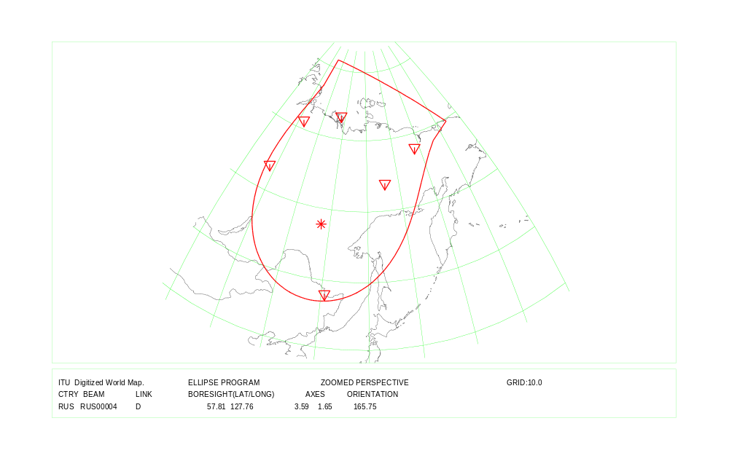
COUNTRY : RUS Down Link Beam Identification: RUSRSA41 / RUSRSA42
Country symbol: RUS
Beam Identification: RUSRSA51
Orbital position: 140.0
(plus for E, minus for W)

Test Point | Alt. | Feeder Link |  |  | Polarization |  | Ellipse parameters
No. | (mts.) |  |  |  |  |  |  |  |  |  | Beam Boresight
 |  | Latitude (°)  plus for N  minus for S | Longitude (°)  plus for E  minus for W | Channels  (17 GHz) | Type | Sense | Major  Axis (°) | Minor  Axis (°) | Orientation  (°) | Maximum  Antenna  Gain  (dB) | Latitude (°)  plus for N  minus for S | Longitude (°)  plus for E  minus for W
1 | 0 | 60.88 | 77.00 | 25,27,29,31,33, | Circular | Right | 7.92 | 2.32 | 7.26 | 31.80 | 52.22 | 130.78
2 | 3000 | 49.22 | 87.30 | 35,37,39
3 | 2000 | 50.60 | 107.50
4 | 0 | 42.42 | 130.62
5 | 0 | 43.93 | 145.56
6 | 0 | 54.50 | 168.08
7 | 0 | 62.68 | 179.50
8 | 0 | 66.10 | -170.00
9 | 0 | 69.62 | 162.46
10 | 0 | 73.29 | 128.00

Test Point | Alt. | Down Link |  |  | Polarization |  | Ellipse parameters
No. | (mts.) |  |  |  |  |  |  |  |  |  | Beam Boresight
 |  | Latitude (°)  plus for N  minus for S | Longitude (°)  plus for E  minus for W | Channels | Type | Sense | Major  Axis (°) | Minor  Axis (°) | Orientation  (°) | Maximum  Antenna  Gain  (dB) | Latitude (°)  plus for N  minus for S | Longitude (°)  plus for E  minus for W
1 | 1000 | 63.85 | 145.64 | 25,27,29,31,33, | Circular | Left | 3.31 | 2.03 | 21.22 | 36.18 | 55.34 | 154.04
2 | 0 | 43.93 | 145.56 | 35,37,39
3 | 0 | 46.85 | 151.86
4 | 0 | 50.77 | 156.02
5 | 0 | 54.50 | 168.08
6 | 0 | 62.68 | 179.50
7 | 0 | 66.10 | -170.00
8 | 0 | 70.01 | 168.31
9 | 0 | 69.62 | 162.46
10 | 0 | 46.02 | 143.42
Country symbol: RUS
Beam Identification: RUSRSA52
Orbital position: 140.0
(plus for E, minus for W)

Test Point | Alt. | Feeder Link |  |  | Polarization |  | Ellipse parameters
No. | (mts.) |  |  |  |  |  |  |  |  |  | Beam Boresight
 |  | Latitude (°)  plus for N  minus for S | Longitude (°)  plus for E  minus for W | Channels  (17 GHz) | Type | Sense | Major  Axis (°) | Minor  Axis (°) | Orientation  (°) | Maximum  Antenna  Gain  (dB) | Latitude (°)  plus for N  minus for S | Longitude (°)  plus for E  minus for W
1 | 0 | 60.88 | 77.00 | 26,28,30,32,34, | Circular | Left | 7.92 | 2.32 | 7.26 | 31.80 | 52.22 | 130.78
2 | 3000 | 49.22 | 87.30 | 36,38,40
3 | 2000 | 50.60 | 107.50
4 | 0 | 42.42 | 130.62
5 | 0 | 43.93 | 145.56
6 | 0 | 54.50 | 168.08
7 | 0 | 62.68 | 179.50
8 | 0 | 66.10 | -170.00
9 | 0 | 69.62 | 162.46
10 | 0 | 73.29 | 128.00

Test Point | Alt. | Down Link |  |  | Polarization |  | Ellipse parameters
No. | (mts.) |  |  |  |  |  |  |  |  |  | Beam Boresight
 |  | Latitude (°)  plus for N  minus for S | Longitude (°)  plus for E  minus for W | Channels | Type | Sense | Major  Axis (°) | Minor  Axis (°) | Orientation  (°) | Maximum  Antenna  Gain  (dB) | Latitude (°)  plus for N  minus for S | Longitude (°)  plus for E  minus for W
1 | 1000 | 63.85 | 145.64 | 26,28,30,32,34, | Circular | Right | 3.31 | 2.03 | 21.22 | 36.18 | 55.34 | 154.04
2 | 0 | 43.93 | 145.56 | 36,38,40
3 | 0 | 46.85 | 151.86
4 | 0 | 50.77 | 156.02
5 | 0 | 54.50 | 168.08
6 | 0 | 62.68 | 179.50
7 | 0 | 66.10 | -170.00
8 | 0 | 70.01 | 168.31
9 | 0 | 69.62 | 162.46
10 | 0 | 46.02 | 143.42
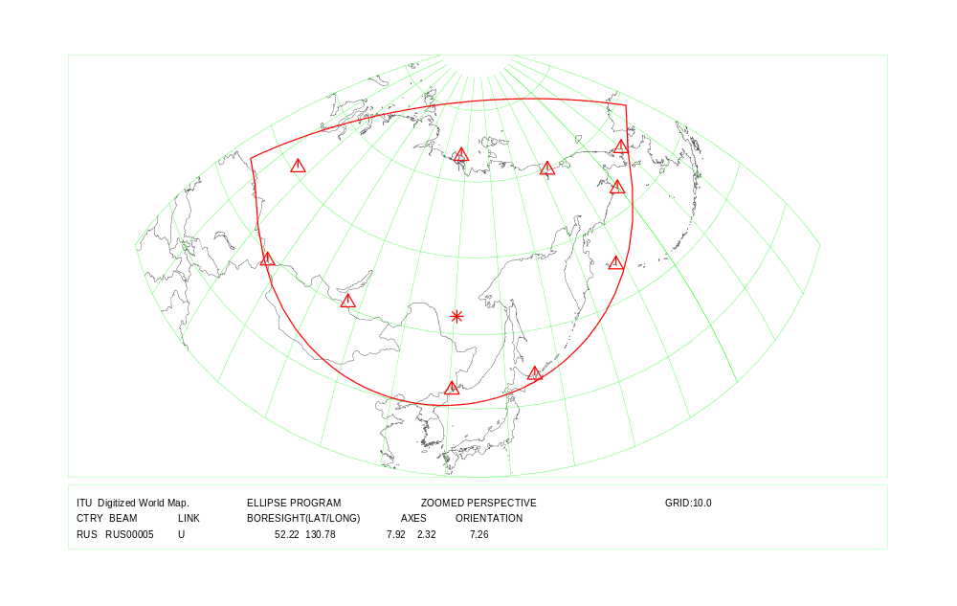
COUNTRY : RUS Feeder Link Beam Identification: RUSRSA51 / RUSRSA52
COUNTRY : RUS Down Link Beam Identification: RUSRSA51 / RUSRSA52

Country symbol: SLM
Beam Identification: SLM00000
Orbital position: 146.0
(plus for E, minus for W)

Test Point | Alt. | Feeder Link |  |  | Polarization |  | Ellipse parameters
No. | (mts.) |  |  |  |  |  |  |  |  |  | Beam Boresight
 |  | Latitude (°)  plus for N  minus for S | Longitude (°)  plus for E  minus for W | Channels  (17 GHz) | Type | Sense | Major  Axis (°) | Minor  Axis (°) | Orientation  (°) | Maximum  Antenna  Gain  (dB) | Latitude(°)  plus for N  minus for S | Longitude (°)  plus for E  minus for W
1 | 0 | -7.04 | 155.85 | 1, 5, 9,13 | Circular | Right | 1.50 | 1.18 | 140.48 | 41.98 | -8.40 | 159.32
2 | 0 | -5.48 | 159.71
3 | 0 | -8.37 | 162.72
4 | 0 | -10.83 | 162.39
5 | 0 | -11.64 | 160.12
6 | 0 | -8.82 | 158.17
7

Test Point | Alt. | Down Link |  |  | Polarization |  | Ellipse parameters
No. | (mts.) |  |  |  |  |  |  |  |  |  | Beam Boresight
 |  | Latitude (°)  plus for N  minus for S | Longitude (°)  plus for E  minus for W | Channels | Type | Sense | Major  Axis (°) | Minor  Axis (°) | Orientation  (°) | Maximum  Antenna  Gain  (dB) | Latitude (°)  plus for N  minus for S | Longitude (°)  plus for E  minus for W
1 | 0 | -7.04 | 155.85 | 1, 5, 9,13 | Circular | Left | 1.50 | 1.18 | 140.48 | 41.98 | -8.40 | 159.32
2 | 0 | -5.48 | 159.71
3 | 0 | -8.37 | 162.72
4 | 0 | -10.83 | 162.39
5 | 0 | -11.64 | 160.12
6 | 0 | -8.82 | 158.17
7

COUNTRY : SLM Feeder Link and Down Link
Country symbol: SVK
Beam Identification: SVK14400
Orbital position: -1.0
(plus for E, minus for W)

Test Point | Alt. | Feeder Link |  |  | Polarization |  | Ellipse parameters)
No. | (mts.) |  |  |  |  |  |  |  |  |  | Beam Boresight
 |  | Latitude (°)  plus for N  minus for S | Longitude (°)  plus for E  minus for W | Channels  (17 GHz) | Type | Sense | Major  Axis (°) | Minor  Axis (°) | Orientation  (°) | Maximum  Antenna  Gain  (dB) | Latitude(°)  plus for N  minus for S | Longitude (°)  plus for E  minus for W
1 | 145 | 48.38 | 16.85 | 3, 7,11,15,19 | Circular | Right | 0.74 | 0.60 | 3.50 | 47.99 | 48.74 | 19.63
2 | 134 | 48.03 | 17.10
3 | 110 | 47.77 | 17.75
4 | 108 | 47.77 | 18.67
5 | 101 | 48.43 | 22.06
6 | 538 | 49.05 | 22.50
7 | 425 | 49.42 | 21.60
8 | 875 | 49.55 | 19.47
9 | 469 | 49.43 | 18.75
10 | 175 | 48.80 | 17.20

Test Point | Alt. | Down Link |  |  | Polarization |  | Ellipse parameters
No. | (mts.) |  |  |  |  |  |  |  |  |  | Beam Boresight
 |  | Latitude (°)  plus for N  minus for S | Longitude (°)  plus for E  minus for W | Channels | Type | Sense | Major  Axis (°) | Minor  Axis (°) | Orientation  (°) | Maximum  Antenna  Gain  (dB) | Latitude (°)  plus for N  minus for S | Longitude (°)  plus for E  minus for W
1 | 145 | 48.38 | 16.85 | 3, 7,11,15,19 | Circular | Left | 0.74 | 0.60 | 3.50 | 47.99 | 48.74 | 19.63
2 | 134 | 48.03 | 17.10
3 | 110 | 47.77 | 17.75
4 | 108 | 47.77 | 18.67
5 | 101 | 48.43 | 22.06
6 | 538 | 49.05 | 22.50
7 | 425 | 49.42 | 21.60
8 | 875 | 49.55 | 19.47
9 | 469 | 49.43 | 18.75
10 | 175 | 48.80 | 17.20
COUNTRY : SVK Feeder Link and Down Link

Country symbol: SVN
Beam Identification: SVN14800
Orbital position: 34.0
(plus for E, minus for W)

Test Point | Alt. | Feeder Link |  |  | Polarization |  | Ellipse parameters
No. | (mts.) |  |  |  |  |  |  |  |  |  | Beam Boresight
 |  | Latitude (°)  plus for N  minus for S | Longitude (°)  plus for E  minus for W | Channels  (17 GHz) | Type | Sense | Major  Axis (°) | Minor  Axis (°) | Orientation  (°) | Maximum  Antenna  Gain  (dB) | Latitude(°)  plus for N  minus for S | Longitude (°)  plus for E  minus for W
1 | 2032 | 46.35 | 13.47 | 4, 8,12,16,20 | Circular | Left | 0.60 | 0.60 | 90.00 | 48.88 | 46.18 | 15.01
2 | 1277 | 46.63 | 15.05
3 | 272 | 46.85 | 16.30
4 | 153 | 46.50 | 16.55
5 | 273 | 45.47 | 15.32
6 | 3 | 45.50 | 13.58

Test Point | Alt. | Down Link |  |  | Polarization |  | Ellipse parameters (BR and S. Rapporteur)
No. | (mts.) |  |  |  |  |  |  |  |  |  | Beam Boresight
 |  | Latitude (°)  plus for N  minus for S | Longitude (°)  plus for E  minus for W | Channels | Type | Sense | Major  Axis (°) | Minor  Axis (°) | Orientation  (°) | Maximum  Antenna  Gain  (dB) | Latitude (°)  plus for N  minus for S | Longitude (°)  plus for E  minus for W
1 | 2032 | 46.35 | 13.47 | 4, 8,12,16,20 | Circular | Right | 0.60 | 0.60 | 90.00 | 48.88 | 46.18 | 15.01
2 | 1277 | 46.63 | 15.05
3 | 272 | 46.85 | 16.30
4 | 153 | 46.50 | 16.55
5 | 273 | 45.47 | 15.32
6 | 3 | 45.50 | 13.58

COUNTRY : SVN Feeder Link and Down Link

Country symbol: TJK
Beam Identification: TJK06900
Orbital position: 44.0
(plus for E, minus for W)

Test Point | Alt. | Feeder Link |  |  | Polarization |  | Ellipse parameters
No. | (mts.) |  |  |  |  |  |  |  |  |  | Beam Boresight
 |  | Latitude (°)  plus for N  minus for S | Longitude (°)  plus for E  minus for W | Channels  (17 GHz) | Type | Sense | Major  Axis (°) | Minor  Axis (°) | Orientation  (°) | Maximum  Antenna  Gain  (dB) | Latitude(°)  plus for N  minus for S | Longitude (°)  plus for E  minus for W
1 | 0 | 37.00 | 67.90 | 1, 5, 9, 13,17 | Circular | Right | 1.25 | 0.76 | 159.15 | 44.65 | 38.37 | 71.14
2 | 0 | 36.69 | 71.84
3 | 0 | 37.30 | 75.10
4 | 0 | 38.47 | 74.84
5 | 0 | 41.03 | 70.43
6 | 0 | 39.47 | 67.41
7 | 0 | 39.46 | 73.68

Test Point | Alt. | Down Link |  |  | Polarization |  | Ellipse parameters
No. | (mts.) |  |  |  |  |  |  |  |  |  | Beam Boresight
 |  | Latitude (°)  plus for N  minus for S | Longitude (°)  plus for E  minus for W | Channels | Type | Sense | Major  Axis (°) | Minor  Axis (°) | Orientation  (°) | Maximum  Antenna  Gain  (dB) | Latitude (°)  plus for N  minus for S | Longitude (°)  plus for E  minus for W
1 | 0 | 37.00 | 67.90 | 1, 5, 9, 13,17 | Circular | Left | 1.25 | 0.76 | 159.15 | 44.65 | 38.37 | 71.14
2 | 0 | 36.69 | 71.84
3 | 0 | 37.30 | 75.10
4 | 0 | 38.47 | 74.84
5 | 0 | 41.03 | 70.43
6 | 0 | 39.47 | 67.41
7 | 0 | 39.46 | 73.68

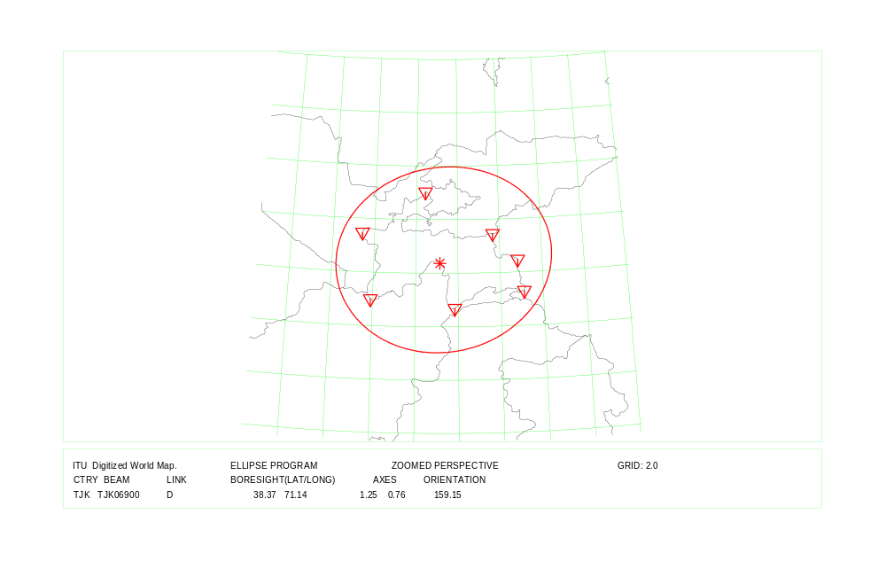
COUNTRY : TJK Feeder Link and Down Link

Country symbol: TKM
Beam Identification: TKM06800
Orbital position: 44.0
(plus for E, minus for W)

Test Point | Alt. | Feeder Link |  |  | Polarization |  | Ellipse parameters
No. | (mts.) |  |  |  |  |  |  |  |  |  | Beam Boresight
 |  | Latitude (°)  plus for N  minus for S | Longitude (°)  plus for E  minus for W | Channels  (17 GHz) | Type | Sense | Major  Axis (°) | Minor  Axis (°) | Orientation  (°) | Maximum  Antenna  Gain  (dB) | Latitude(°)  plus for N  minus for S | Longitude (°)  plus for E  minus for W
1 | 0 | 35.23 | 62.54 | 23,27,31,35,39 | Circular | Left | 2.25 | 0.99 | 164.51 | 40.94 | 38.84 | 59.18
2 | 0 | 37.40 | 66.50
3 | 0 | 38.30 | 57.30
4 | 0 | 42.65 | 58.78
5 | 0 | 37.40 | 53.89
6 | 0 | 41.80 | 52.50
7 | 0 | 38.00 | 66.75

Test Point | Alt. | Down Link |  |  | Polarization |  | Ellipse parameters
No. | (mts.) |  |  |  |  |  |  |  |  |  | Beam Boresight
 |  | Latitude (°)  plus for N  minus for S | Longitude (°)  plus for E  minus for W | Channels | Type | Sense | Major  Axis (°) | Minor  Axis (°) | Orientation  (°) | Maximum  Antenna  Gain  (dB) | Latitude (°)  plus for N  minus for S | Longitude (°)  plus for E  minus for W
1 | 0 | 35.23 | 62.54 | 23,27,31,35,39 | Circular | Right | 2.25 | 0.99 | 164.51 | 40.94 | 38.84 | 59.18
2 | 0 | 37.40 | 66.50
3 | 0 | 38.30 | 57.30
4 | 0 | 42.65 | 58.78
5 | 0 | 37.40 | 53.89
6 | 0 | 41.80 | 52.50
7 | 0 | 38.00 | 66.75

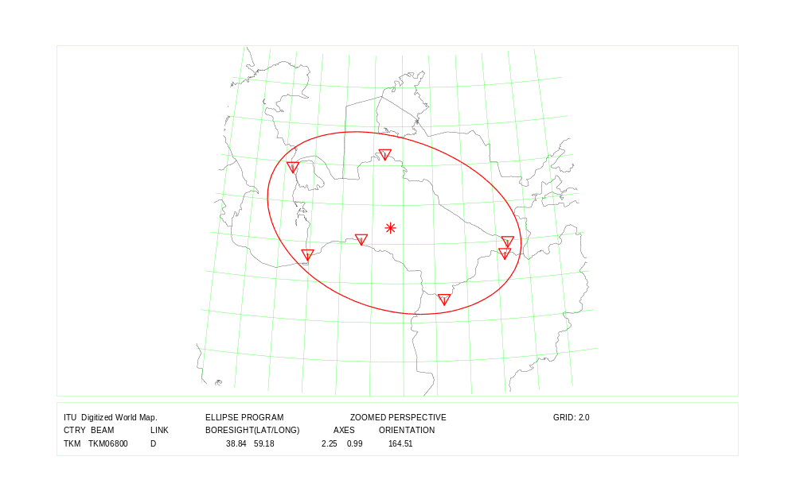
COUNTRY : TKM Feeder Link and Down Link

Country symbol: TUV
Beam Identification: TUV00000
Orbital position: 176.0
(plus for E, minus for W)

Test Point | Alt. | Feeder Link |  |  | Polarization |  | Ellipse parameters
No. | (mts.) |  |  |  |  |  |  |  |  |  | Beam Boresight
 |  | Latitude (°)  plus for N  minus for S | Longitude (°)  plus for E  minus for W | Channels  (17 GHz) | Type | Sense | Major  Axis (°) | Minor  Axis (°) | Orientation  (°) | Maximum  Antenna  Gain  (dB) | Latitude(°)  plus for N  minus for S | Longitude (°)  plus for E  minus for W
1 | 0 | -7.20 | 177.17 | 2, 6,10,14 | Circular | Right | 0.94 | 0.60 | 137.58 | 46.93 | -7.11 | 177.61
2 | 0 | -7.50 | 178.70
3 | 0 | -5.67 | 176.08
4 | 0 | -7.47 | 178.68
5 | 0 | -6.28 | 176.30
6 | 0 | -6.10 | 177.30
7 | 0 | -8.50 | 179.20

Test Point | Alt. | Down Link |  |  | Polarization |  | Ellipse parameters
No. | (mts.) |  |  |  |  |  |  |  |  |  | Beam Boresight
 |  | Latitude (°)  plus for N  minus for S | Longitude (°)  plus for E  minus for W | Channels | Type | Sense | Major  Axis (°) | Minor  Axis (°) | Orientation  (°) | Maximum  Antenna  Gain  (dB) | Latitude (°)  plus for N  minus for S | Longitude (°)  plus for E  minus for W
1 | 0 | -7.20 | 177.17 | 2, 6, 10,14 | Circular | Right | 0.94 | 0.60 | 137.58 | 46.93 | -7.11 | 177.61
2 | 0 | -7.50 | 178.70
3 | 0 | -5.67 | 176.08
4 | 0 | -7.47 | 178.68
5 | 0 | -6.28 | 176.30
6 | 0 | -6.10 | 177.30
7 | 0 | -8.50 | 179.20

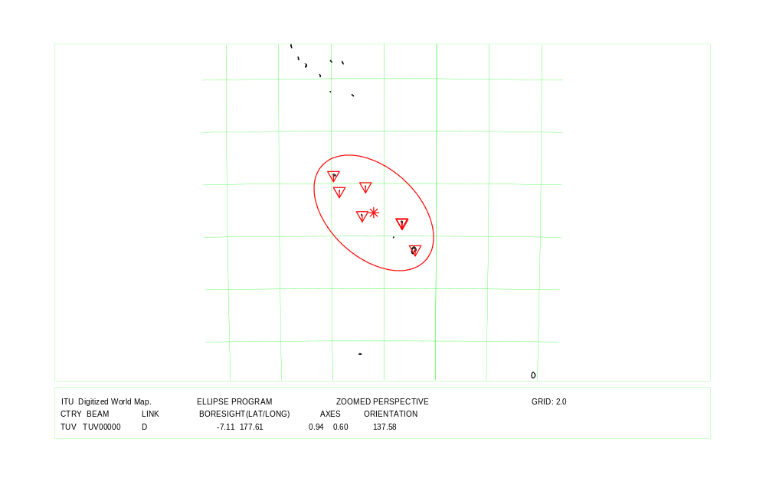
COUNTRY : TUV Feeder Link and Down Link

Country symbol: UKR
Beam Identification: UKR06300
Orbital position: 38.0
(plus for E, minus for W)

Test Point | Alt. | Feeder Link |  |  | Polarization |  | Ellipse parameters
No. | (mts.) |  |  |  |  |  |  |  |  |  | Beam Boresight
 |  | Latitude (°)  plus for N  minus for S | Longitude (°)  plus for E  minus for W | Channels  (17 GHz) | Type | Sense | Major  Axis (°) | Minor  Axis (°) | Orientation  (°) | Maximum  Antenna  Gain  (dB) | Latitude(°)  plus for N  minus for S | Longitude (°)  plus for E  minus for W
1 | 0 | 44.80 | 34.10 | 3, 7,11,15,19 | Circular | Right | 2.32 | 0.95 | 177.32 | 41.01 | 48.19 | 31.82
2 | 0 | 50.46 | 37.45
3 | 0 | 49.11 | 39.34
4 | 0 | 51.24 | 29.48
5 | 0 | 44.40 | 34.00
6 | 0 | 48.40 | 22.10
7 | 0 | 51.53 | 23.64
8 | 0 | 49.60 | 40.20

Test Point | Alt. | Down Link |  |  | Polarization |  | Ellipse parameters
No. | (mts.) |  |  |  |  |  |  |  |  |  | Beam Boresight
 |  | Latitude (°)  plus for N  minus for S | Longitude (°)  plus for E  minus for W | Channels | Type | Sense | Major  Axis (°) | Minor  Axis (°) | Orientation  (°) | Maximum  Antenna  Gain  (dB) | Latitude (°)  plus for N  minus for S | Longitude (°)  plus for E  minus for W
1 | 0 | 45.49 | 28.16 | 3, 7,11,15,19 | Circular | Left | 2.29 | 0.96 | 177.78 | 41.01 | 48.22 | 31.74
2 | 0 | 49.60 | 40.20
3 | 0 | 48.40 | 22.10
4 | 0 | 51.53 | 23.64
5 | 0 | 52.05 | 30.98
6 | 0 | 44.40 | 34.00
7

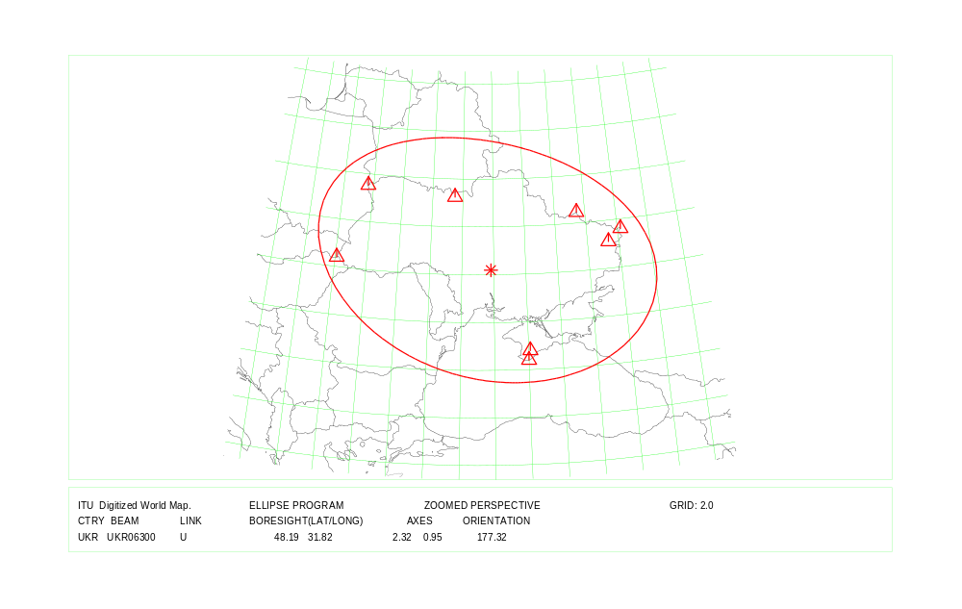
COUNTRY : UKR Feeder Link
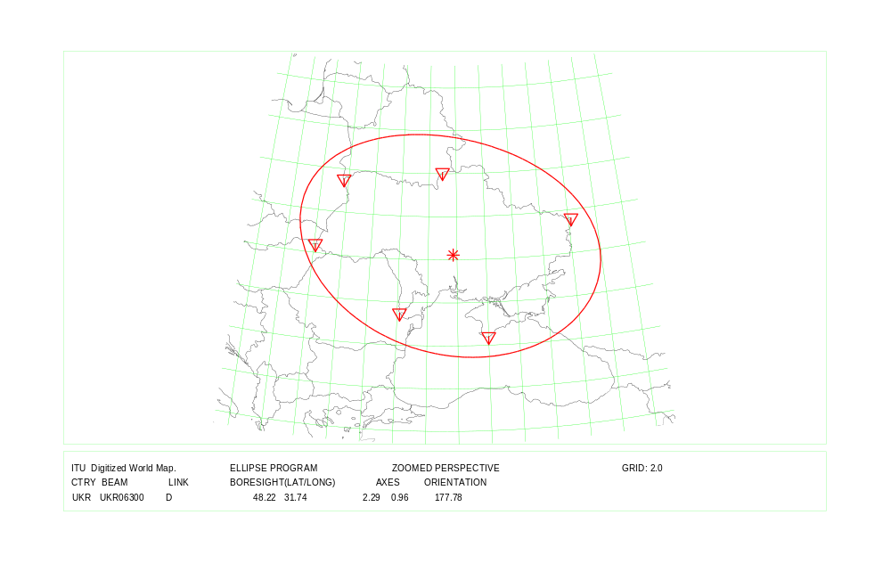
COUNTRY : UKR Down Link

Country symbol: UZB
Beam Identification: UZB07100
Orbital position: 44.0
(plus for E, minus for W)

Test Point | Alt. | Feeder Link |  |  | Polarization |  | Ellipse parameters
No. | (mts.) |  |  |  |  |  |  |  |  |  | Beam Boresight
 |  | Latitude (°)  plus for N  minus for S | Longitude (°)  plus for E  minus for W | Channels  (17 GHz) | Type | Sense | Major  Axis (°) | Minor  Axis (°) | Orientation  (°) | Maximum  Antenna  Gain  (dB) | Latitude(°)  plus for N  minus for S | Longitude (°)  plus for E  minus for W
1 | 0 | 37.24 | 67.72 | 3, 7, 11,15,19 | Circular | Right | 2.67 | 0.96 | 163.32 | 40.37 | 41.21 | 64.01
2 | 0 | 40.80 | 73.10
3 | 0 | 42.22 | 71.23
4 | 0 | 41.14 | 61.87
5 | 0 | 41.30 | 56.00
6 | 0 | 45.00 | 56.00
7 | 0 | 45.54 | 58.54

Test Point | Alt. | Down Link |  |  | Polarization |  | Ellipse parameters
No. | (mts.) |  |  |  |  |  |  |  |  |  | Beam Boresight
 |  | Latitude (°)  plus for N  minus for S | Longitude (°)  plus for E  minus for W | Channels | Type | Sense | Major  Axis (°) | Minor  Axis (°) | Orientation  (°) | Maximum  Antenna  Gain  (dB) | Latitude (°)  plus for N  minus for S | Longitude (°)  plus for E  minus for W
1 | 0 | 37.24 | 67.72 | 3, 7,11,15,19 | Circular | Left | 2.67 | 0.96 | 163.32 | 40.37 | 41.21 | 64.01
2 | 0 | 40.80 | 73.10
3 | 0 | 42.22 | 71.23
4 | 0 | 41.14 | 61.87
5 | 0 | 41.30 | 56.00
6 | 0 | 45.00 | 56.00
7 | 0 | 45.54 | 58.54

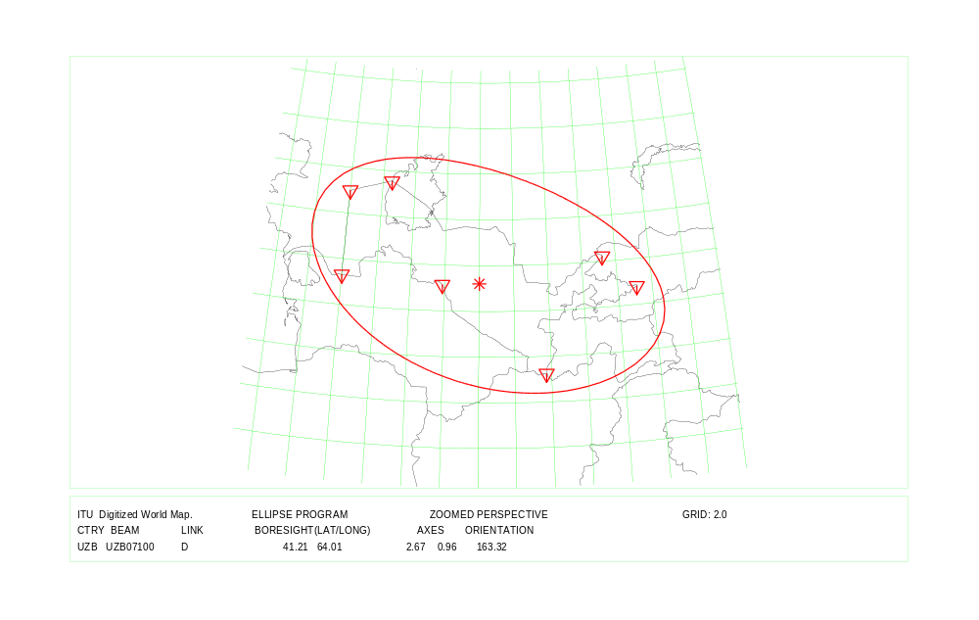
COUNTRY : UZB Feeder Link and Down Link

Country symbol: YEM
Beam Identification: YEM26600
Orbital position: 11.0
(plus for E, minus for W)

Test Point | Alt. | Feeder Link |  |  | Polarization |  | Ellipse parameters
No. | (mts.) |  |  |  |  |  |  |  |  |  | Beam Boresight
 |  | Latitude (°)  plus for N  minus for S | Longitude (°)  plus for E  minus for W | Channels  (17 GHz) | Type | Sense | Major  Axis (°) | Minor  Axis (°) | Orientation  (°) | Maximum  Antenna  Gain  (dB) | Latitude(°)  plus for N  minus for S | Longitude (°)  plus for E  minus for W
1 | 0 | 14.00 | 44.50 | 2, 6,10,14,18 | Circular | Left | 0.77 | 0.60 | 104.23 | 47.78 | 15.70 | 44.36
2 | 0 | 15.00 | 45.50
3 | 0 | 17.40 | 44.16
4
5
6
7

Test Point | Alt. | Down Link |  |  | Polarization |  | Ellipse parameters
No. | (mts.) |  |  |  |  |  |  |  |  |  | Beam Boresight
 |  | Latitude (°)  plus for N  minus for S | Longitude (°)  plus for E  minus for W | Channels | Type | Sense | Major  Axis (°) | Minor  Axis (°) | Orientation  (°) | Maximum  Antenna  Gain  (dB) | Latitude (°)  plus for N  minus for S | Longitude (°)  plus for E  minus for W
1 | 0 | 14.00 | 44.50 | 2, 6,10,14,18 | Circular | Right | 0.80 | 0.60 | 114.88 | 47.66 | 15.67 | 44.00
2 | 0 | 15.00 | 45.50
3 | 0 | 15.38 | 42.56
4 | 0 | 17.21 | 43.18
5 | 0 | 17.40 | 44.16
6
7

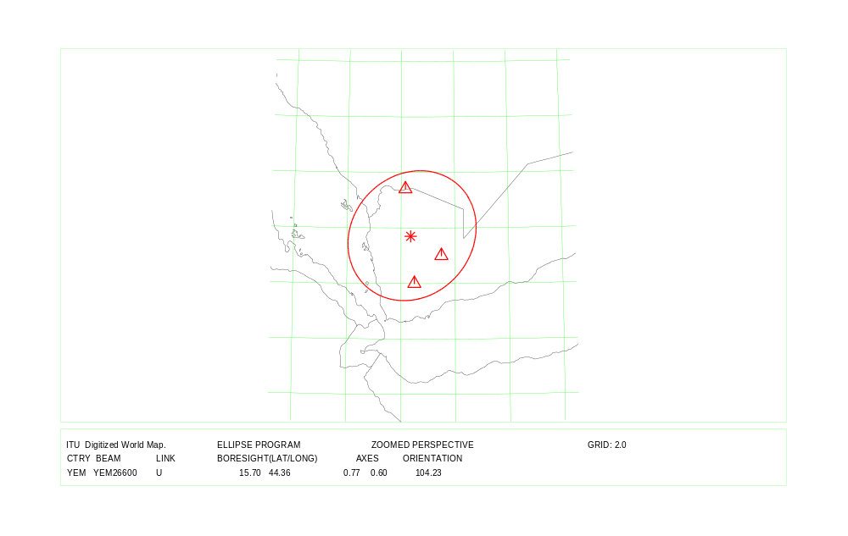
COUNTRY : YEM Feeder Link Beam Identification: YEM26600
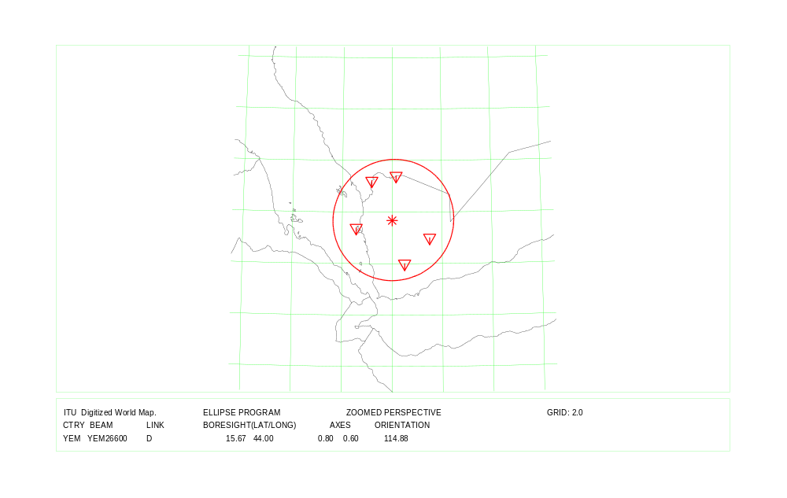
COUNTRY : YEM Down Link Beam Identification: YEM26600

Country symbol: YEM
Beam Identification: YEM26700
Orbital position: 11.0
(plus for E, minus for W)

Test Point | Alt. | Feeder Link |  |  | Polarization |  | Ellipse parameters
No. | (mts.) |  |  |  |  |  |  |  |  |  | Beam Boresight
 |  | Latitude (°)  plus for N  minus for S | Longitude (°)  plus for E  minus for W | Channels  (14 GHz) | Type | Sense | Major  Axis (°) | Minor  Axis (°) | Orientation  (°) | Maximum  Antenna  Gain  (dB) | Latitude(°)  plus for N  minus for S | Longitude (°)  plus for E  minus for W
1 | 0 | 12.31 | 53.72 | 1, 3, 5, 7, 9 | Circular | Right | 1.68 | 1.44 | 157.35 | 40.61 | 14.42 | 48.61
2 | 0 | 12.64 | 43.40
3 | 0 | 13.50 | 46.50
4 | 0 | 15.00 | 45.50
5 | 0 | 16.60 | 52.60
6 | 0 | 18.40 | 49.50
7

Test Point | Alt. | Down Link |  |  | Polarization |  | Ellipse parameters
No. | (mts.) |  |  |  |  |  |  |  |  |  | Beam Boresight
 |  | Latitude (°)  plus for N  minus for S | Longitude (°)  plus for E  minus for W | Channels | Type | Sense | Major  Axis (°) | Minor  Axis (°) | Orientation  (°) | Maximum  Antenna  Gain  (dB) | Latitude (°)  plus for N  minus for S | Longitude (°)  plus for E  minus for W
1 | 0 | 12.64 | 43.40 | 1, 5, 9, 13, 17 | Circular | Left | 1.68 | 1.44 | 157.35 | 40.61 | 14.42 | 48.61
2 | 0 | 15.00 | 45.50
3 | 0 | 18.40 | 49.50
4 | 0 | 16.60 | 52.60
5 | 0 | 12.31 | 53.72
6 | 0 | 13.50 | 46.50
7

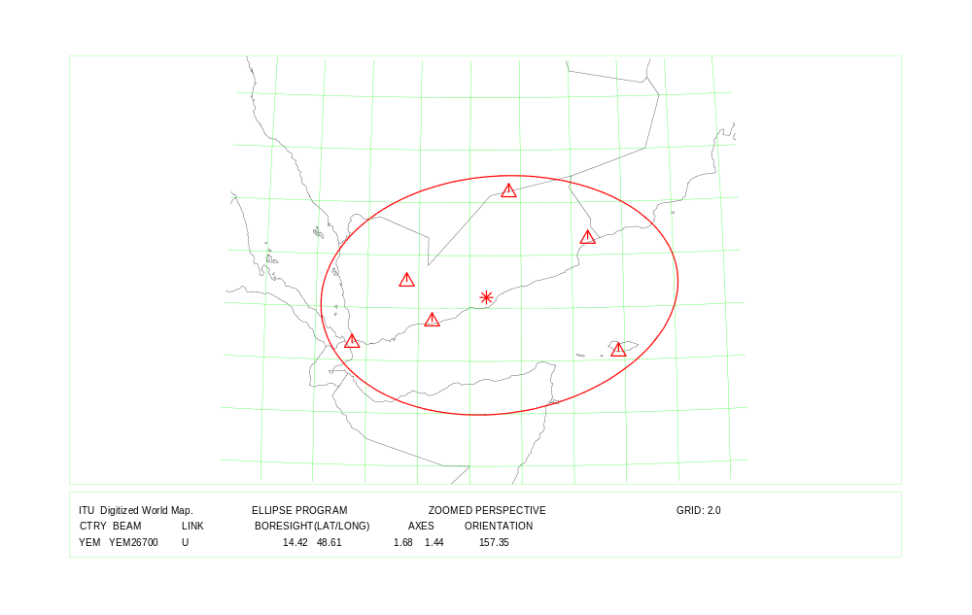
COUNTRY : YEM Feeder Link Beam Identification: YEM26700
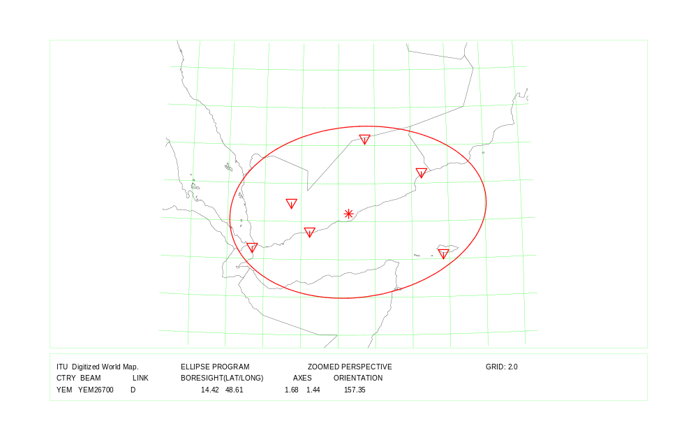
COUNTRY : YEM Down Link Beam Identification: YEM26700

Country symbol: YUG
Beam Identification: YUG14800
Orbital position: -7
(plus for E, minus for W)

Test Point | Alt. | Feeder Link |  |  | Polarization |  | Ellipse parameters
No. | (mts.) |  |  |  |  |  |  |  |  |  | Beam Boresight
 |  | Latitude (°)  plus for N  minus for S | Longitude (°)  plus for E  minus for W | Channels  (17 GHz) | Type | Sense | Major  Axis (°) | Minor  Axis (°) | Orientation  (°) | Maximum  Antenna  Gain  (dB) | Latitude(°)  plus for N  minus for S | Longitude (°)  plus for E  minus for W
1 | 87 | 45.90 | 18.80 | 1, 5, 9, 13,17 | Circular | Left | 0.91 | 0.60 | 145.16 | 47.07 | 43.98 | 20.50
2 | 80 | 46.13 | 20.22
3 | 38 | 44.20 | 22.70
4 | 1000 | 42.33 | 22.43
5 | 1650 | 41.80 | 20.50
6 | 2 | 41.90 | 19.30
7 | 0 | 42.40 | 18.50
8 | 80 | 44.85 | 18.99

Test Point | Alt. | Down Link |  |  | Polarization |  | Ellipse parameters
No. | (mts.) |  |  |  |  |  |  |  |  |  | Beam Boresight
 |  | Latitude (°)  plus for N  minus for S | Longitude (°)  plus for E  minus for W | Channels | Type | Sense | Major  Axis (°) | Minor  Axis (°) | Orientation  (°) | Maximum  Antenna  Gain  (dB) | Latitude (°)  plus for N  minus for S | Longitude (°)  plus for E  minus for W
1 | 87 | 45.90 | 18.80 | 21,25,29,33,37 | Circular | Right | 0.91 | 0.60 | 145.16 | 47.07 | 43.98 | 20.50
2 | 80 | 46.13 | 20.22
3 | 38 | 44.20 | 22.70
4 | 1000 | 42.33 | 22.43
5 | 1650 | 41.80 | 20.50
6 | 2 | 41.90 | 19.30
7 | 0 | 42.40 | 18.50
8 | 80 | 44.85 | 18.99

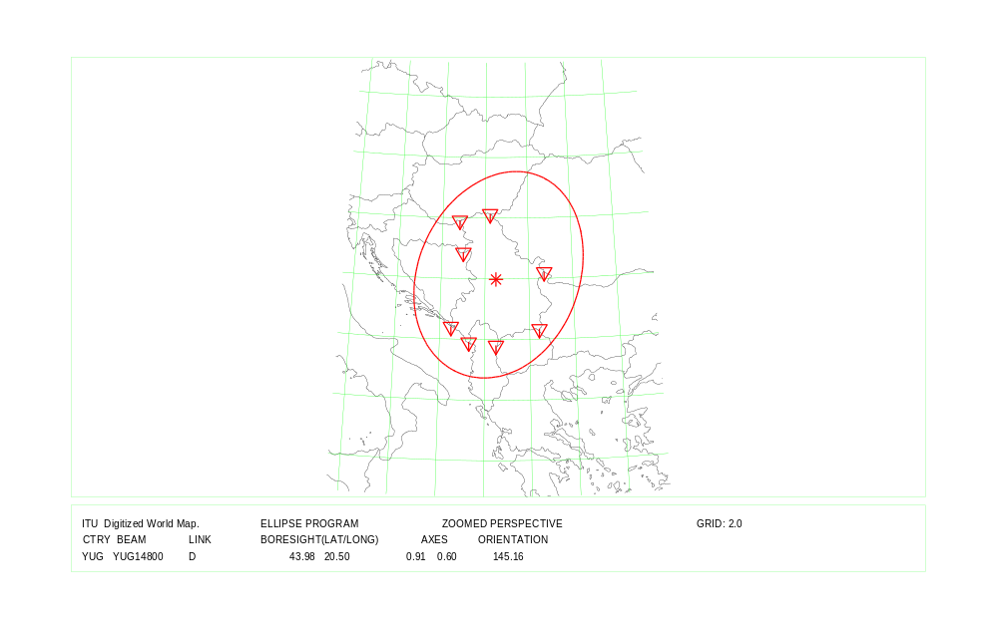
COUNTRY : YUG Feeder Link and Down Link

L’Administration de SVN précise que: “la position orbitale nominale serait aussi proche que possible de la longitude du territoire de la République de Slovénie (14 à 16° E)”. The Administration of SVN has stated “the nominal orbital position would be as close as possible to the longitude of the territory of the Republic of Slovenia (14 to 16° E)”. La Administración de SVN ha declarado que “la posición orbital nominal estaría los más cerca posible de la longitud del territorio de la República de Eslovenia (14 a 16° E)”.

