UNIÓN INTERNACIONAL DE TELECOMUNICACIONES

Oficina de Radiocomunicaciones
(N° de Fax directo +41 22 730 57 85)

Circular Administrativa  CA/110 | 21 de diciembre de 2001
A las administraciones de los países Miembros de la UIT

Asunto: Proyecto de Plan de Actividades del Sector UIT-R para 2002-2003
- Me es grato adjuntar a la presente el proyecto de Plan de actividades del Sector UIT-R para 2002-2003. El Plan se someterá al Grupo Asesor de Radiocomunicaciones (GAR), para que éste lo examine en su 10ª reunión ordinaria que se celebrará en Ginebra del 25 de febrero al 1 de marzo de 2002.
2 Una vez examinado este documento por el GAR, actualizaré oportunamente el proyecto adjunto y volveré a distribuir el Plan de actividades en su versión final.

Robert W. Jones
Director de la Oficina de Radiocomunicaciones

Anexo: Proyecto de Plan de actividades para 2002-2003 (actualmente disponible en inglés solamente – las versiones francesa y española estarán disponibles en la reunión del GAR de febrero de 2002)

Distribución:
– Administraciones de los Estados Miembros de la UIT.
– Miembros del Sector de Radiocomunicaciones
– Presidentes y Vicepresidentes de las Comisiones de Estudio de Radiocomunicaciones y Comisión Especial para asuntos reglamentarios y de procedimiento
– Presidente y Vicepresidentes del Grupo Asesor de Radiocomunicaciones
– Presidente y Vicepresidentes de la Reunión Preparatoria de la Conferencia
– Miembros de la Junta del Reglamento de Radiocomunicaciones.
– Secretario General de la UIT, Director de la Oficina de Normalización de las Telecomunicaciones, Director de la Oficina de Desarrollo de Telecomunicaciones

DRAFT ITU-R OPERATIONAL PLAN
FOR 2002-2003

CONTENTS
Page
Part 1:
Synthesis 6
1 Introduction 6
2 Structure and presentation of the 2002-2003 operational plan 6
3 Summary 8
3.4 Resources allocation for 2000-2001 10
3.5 Application of cost recovery for 2001 and 2002-2003 11
3.6 Proposed efficiency measures 13
4 World Radiocommunication Conference 14
4.1 Description of the activity 14
4.2 Major outputs/outcomes 14
4.3 Resources allocation 15
4.4 Expected accomplishments and performance indicator for 2002-2003 15
4.5 Realized accomplishments and measurement indicator for 2001 16
5 Radiocommunication Assembly 16
5.1 Description of the activity 16
5.2 Major outputs/outcomes 16
5.3 Resources allocation 16
5.4 Expected accomplishments and performance indicator for 2002-2003 16
5.5 Realized accomplishments and measurement indicator for 2001 17
6 Regional Radiocommunication Conference, RRC-04/05 17
6.1 Description of the activity 17
6.2 Major outputs/outcomes 17
6.3 Resources allocation 17
6.4 Expected accomplishments and performance indicator for 2002-2003 18
6.5 Realized accomplishments and measurement indicator for 2001 18
7 Radio Regulations Board 18
7.1 Description of the activity 18
7.2 Major outputs/outcomes 19
7.3 Resources allocation 19
7.4 Expected accomplishments and performance indicator for 2002-2003 19
7.5 Realized accomplishments and measurement indicator for 2001 19
8 Radiocommunication Advisory Group 19
8.1 Description of the activity 19
8.2 Major outputs/outcomes 20
8.3 Resources allocation 20
8.4 Expected accomplishments and performance indicator for 2002-2003 20
8.5 Realized accomplishments and measurement indicator for 2001 21
9 Study Group meetings 21
9.1 Description of the activity 21
9.1.1 Resources allocation 21

Page
9.1.2 Expected accomplishments and performance indicator for 2002-2003 22
9.1.3 Realized accomplishments and measurement indicator for 2001 22
9.2 Regular activities of study groups 23
9.3 Special Committee on Regulatory/Procedural matters 26
9.4 Support to Conference Preparatory Meeting (CPM) 26
9.5 Support for CVC meetings in 2002 and 2003 27
10 Seminars 27
10.1 Description of the activity 27
10.2 Major outputs/outcomes 27
10.3 Resources allocation 28
10.4 Expected accomplishments and performance indicator for 2002-2003 28
10.5 Realized accomplishments and measurement indicator for 2001 28
11 Publications 28
11.1 Policies and orientations for 2002-2003 28
11.2 Description of the activity 29
11.3 Resources allocation 30
11.4 Expected accomplishments and performance indicator for 2002-2003 30
11.5 Realized accomplishments and measurement indicator for 2001 30
12 Activities related to space services 31
12.1 Processing of space notices 31
12.1.1 Description of the activity 31
12.1.2 Resources allocation 31
12.1.3 Major outputs/outcomes 31
12.1.4 Expected accomplishments and performance indicator for 2002-2003 32
12.1.5 Realized accomplishments and measurement indicator for 2001 32
12.1.6 Advance publication of information pertaining to satellite networks (API) 33
12.1.7 Coordination requests pertaining to satellite networks in non-planned
bands 34
12.1.8 Notifications for recording in the Master Register 36
12.1.9 Processing of submissions received by the bureau under
Appendices 30 and 30A 37
12.1.10 Processing of submissions received by the Bureau under Appendix 30B 39
12.1.11 Implementation of Resolution 53 (Rev.WRC-2000): Compatibility between
the new Plans and other services and with the Region 2 Plans 40
12.2 Other Space Activities 41
12.2.1 Due diligence 41
12.2.2 Publications 41
12.2.3 Space network list 41
12.2.4 BR space Web page 41
12.2.5 Support given to Informatics, Administration and Publications Department
from Space Services Department for software development 41
13 Activities related to terrestrial services 41
13.1 Description of the activities 41
Page
13.2 Resources allocation 42
13.3 Details concerning various groups of terrestrial related activities 42
13.3.1 Coordination requests pertaining to terrestrial services 42
13.3.1.1 Description of the activity 42
13.3.1.2 Major output/outcomes 42
13.3.1.3 Expected accomplishments and performance indicator for 2002-2003 42
13.3.1.4 Realized accomplishments and measurement indicator for 2001 43
13.3.2 Plan modification procedures for terrestrial services 43
13.3.2.1 Description of the activity 43
13.3.2.2 Major output/outcomes 43
13.3.2.3 Expected accomplishments and performance indicator for 2002-2003 44
13.3.2.4 Realized accomplishments and measurement indicator for 2001 45
13.3.3 Processing of submissions to HF broadcasting (Article 12 of the RR) 46
13.3.3.1 Description of the activity 46
13.3.3.2 Major output/outcomes 46
13.3.3.3 Expected accomplishments and performance indicator for 2002-2003 46
13.3.3.4 Realized accomplishments and measurement indicator for 2001 46
13.3.4 Notification, examination and recording procedures pertaining to
terrestrial services (Article 11 of the Radio Regulations) 46
13.3.4.1 Description of the activity 46
13.3.4.2 Major output/outcomes 47
13.3.4.3 Expected accomplishments and performance indicator for 2002-2003 47
13.3.4.4 Realized accomplishments and measurement indicator for 2001 48
13.3.5 Other regulatory procedures, including assistance in the application of the regulatory procedures 49
13.3.5.1 Description of the activity 49
13.3.5.2 Major output/outcomes 49
13.3.5.3 Expected accomplishments and performance indicator for 2002-2003 50
13.3.5.4 Realized accomplishments and measurement indicator for 2001 50
13.3.6 Application of administrative and operational procedures 51
13.3.6.1 Description of the activity 51
13.3.6.2 Major output/outcomes 51
13.3.6.3 Expected accomplishments and performance indicator for 2002-2003 51
13.3.6.4 Realized accomplishments and measurement indicator for 2001 52
14 Other ITU-R activities 52
14.1 Resources allocation 52
14.2 Assistance to Members 52
14.3 Cooperation with ITU-D 53
14.4 Cooperation with ITU-T 53
14.5 Cooperation with international and regional organizations 54
14.6 Regional presence and WRC-03 preparation 55
15 Computer support and software development 55
15.1 Resources allocation 56
Page
15.2 Space related software development 56
15.2.1 General description 56
15.2.2 Major outputs/outcomes for 2002-2003 56
15.2.3 Expected accomplishments for 2002-2003 56
15.2.4 Realized accomplishments in 2001 59
15.3 Terrestrial related software development 60
15.3.1 General description 60
15.3.2 Expected achievements for 2002-2003 60
15.3.3 Realized accomplishments in 2001 61
16 Concluding remarks by the Director of the Radiocommunication Bureau 61

ANNEXES
Annex 1-A ITU-R 2002-2003 approved Budget 62
Annex 1-B 63
Annex 2 Planned volumes and costs of the documentation for 2002-2003 64
Annex 3 Glossary and explanations of the relevant terms 65

SYNTHESIS

1 Introduction
1.1 This two-year operational plan paves a new road in the operational planning processes of the Radiocommunication Sector. In order to respond to the member's expectations as expressed in the Minneapolis Plenipotentiary Conference Resolution 72 for an improved linkage between the strategic, financial and operational planning, this operational plan addresses the complete 2002-2003 budgetary period. It also, through a restructured presentation, provides a clear linkage with the budget structure as well as with the activities defined in it.
1.2 As for the previous operational plans, this biennial plan sets out expected achievements to be attained in the period, 2002-2003, but it also describes the accomplished achievements of the past period, i.e. 2001. These achievements will be obtained by implementing a certain number of activities to deliver, products and services in the Radiocommunication Bureau (BR) which fall into two categories: recurrent ongoing work and special projects or studies having a fixed duration.
1.3 The 2002-2003 operational plan reflects a significant overhaul of planning processes and presentation. In order to respond to members' demands concerning the visibility and transparency of the activities as well as of the use of the Union's resources, the operational plan presentation has been refined to be oriented towards activities, products and services.
1.4 This document will also better assist in achieving an effective management of the Bureau's limited resources. The work to be carried out in the various units of BR will be assessed by means of quarterly reports in which the situation at the end of each quarter is compared to the results to be achieved. This assessment is facilitated by key performance indicators that will focus on members' needs taking into consideration, on the one hand, the workload placed on the BR, and on the other hand, the resources available as proposed by the Secretary-General and decided by the ITU Council.

2 Structure and presentation of the 2002-2003 Operational Plan
2.1 This operational plan focuses primarily on the activities, products and services of the Radiocommunication Bureau. As already mentioned in point 1.2 above, the requirement for these products and services is generated by recurrent (regular) activities or by special projects or studies within defined timeframe. The presentation is customer (members) oriented and seeks to improve the BR's efficiency in providing the quality of service required by all members. The ITU-R operational plan is not structured along the lines of the ITU-R organization chart. Rather, ITU-R key activities, products and services are organized according to the activity structure as approved in the 2002-2003 budget.
2.2 The structure of the draft operational plan for 2002-2003 is activity/product/services oriented. It will also include the description of the major objectives and their principal expected accomplishments. In order to provide a better linkage between the financial and operational plans, this plan will be based on the resources level and structure as set in the 2002-2003 budget.
2.3 The key "actions" foreseen in this period, such as efficiency measures, new activities/products/services, discontinued or de-emphasized activities/products/services, foremost programme variations such as new activity as compared to the former period, major management orientations, are also indicated.
2.4 The 2002-2003 operational plan is supplemented by the elements of the performance report for the year 2001. This report, which previously was contained in a separate document, is merged into the present document.
2.5 The financial objective for this operational plan has been set so as, in principle, to remain within the approved appropriations for the 2002-2003 period. Nonetheless, it is to be noted that the appropriations dedicated to the ITU-R Sector for this forthcoming period have been reduced to the greatest extent possible and do not include any provision for eventual cost increase that may occur during the 2002-2003 time-frame.
As an example, the 2002-2003 budget was approved based on the conditions of employment prevailing as at January 2001. Since then, the salary scales have increased for general services as well as for professional and above category of staff. The ITU-R, with its already limited level of resources, will not be able to absorb these cost increases nor any further ones that may arise during the years 2002-2003. Council Resolution 647 might be one of these measures that had proven successful in the past years.
It might be appropriate that some compensative and adaptive measures be implemented so as to guaranty the level of resources allocated in the approved budget as well as the complete implementation of the activities foreseen for this period.
2.6 This report is organized and structured as follows:
For each activity, the following information is provided:
− Description of the activity
− Major outputs or outcomes (products/services)
− Details of resources allocated to this activity
For each of the output/outcomes, the following information is provided:
− Short description
− Expected accomplishment/result for 2002-2003
− Accomplishment/result realized in 2001
− Performance indicator for 2002/2003
− Performance measurement for 2001
− Main changes (if any) compared with former years
For products and services under cost recovery, the realized/projected cost recovery level is provided.
Annex 1 to this report includes two financial tables that summarize the financial budget of the Radiocommunication Sector for 2002-2003.
Annex 2 to this report sets forth details on the planned volume and cost of the documentation for the 2002-2003 period.
Annex 3 to this report provides the definition of some of the principal terms used in this operational plan.

3 Summary
3.1 The objectives of the Radiocommunication Sector for the years 2002-2003 will concentrate on the efficient use of its limited resources in order to:
• Continue to reduce the processing delays for space coordination requests, Article 9 (9.30).
• Pursue the reduction in the processing delays for requests under Article 11.
• Reduction of the processing delay for submissions received under Appendices 30, 30A and 30B.
• Implement further improvements to the processing of satellite network filings (Decisions C99-483, C2001/Res. 1182).
• Complete most of the processing software for the Fixed and Mobile terrestrial services.
• Reduce the backlog in certain terrestrial services to comply with regulatory requirements.
• Simplify the current fee schedule for the processing of space notices.
• Prepare for and manage the Radiocommunication Assembly (RA-03) and the World Radiocommunication Conference (WRC-03).
• Optimize and rationalize the use of resources in streamlining processes and improving working methods to the extent possible.
The-post conference work arising from WRC-2000 will still have a significant impact on the ITU-R resources in 2002-2003. Furthermore, the WRC-03 and RRC-04 preparatory work will generate a notable pressure on the ITU-R Study groups work programme. Therefore, the Bureau will continue to place special emphasis on the support of Radiocommunication Study Groups as well as on the Special Committee on Regulatory/Procedural matters and on the Conference Preparatory Meetings.
3.2 The major realized achievements in 2001 were:
• Completed preparation for a single type of special section for coordination requests (CR/C) (as a result of WRC-95/97 to consolidate all coordination procedures into one article of the Radio Regulations (Article 9) (to apply to networks received as from 1.1.1999); implementation of a higher level of automation of the coordination request regulatory/technical examination and publication; completion of the examination of remaining Article 14 and Res. 533, resolves 5 procedures.
• Examination of notifications submitted under Article 11 has been partially automated.
• Implementation of provisional arrangements for treatment of submissions for some terrestrial services, where no operational tools are implemented yet, with a view to minimizing the impact of the incomplete BR software on administrations' rights.
• Implementation of innovative approaches for dissemination of information to memberships (e.g. introduction of combined publication formats with improved search facilities, dissemination of electronic version of the ship stations database, provision of additional information through Internet, etc.).
• A review of previously published Special Sections under resolves 3 of Res. 533 (Rev.WRC-2000) was completed resulting in 196 Special Sections published together with corrigenda to cover some omissions resulting from errors in applying MSPACE software.
• Processing of 10 requests submitted under Sections I, IA, IB and II of Article 6 of Appendix 30B and 3 requests for new allotments in Part A of the Appendix 30B Plan for new Member States of the Union under Article 7 of Appendix 30B.
• Participation in the work of ITU-R Working Party 6S and its SRG-10 and SRG-12, on issues related to the implementation of Recommendation ITU-R BO.1293-1 (i.e. Appendix 30/30A EPM/OEPM reference situations - MSPACE software application related matters) and to the studies requested in Res. 540 (WRC-2000) (i.e. App30/30A sharing criteria - MSPACE & GIBC software applications related matters).
• Preparation of a substantial number of new or revised Rules of Procedure to take account of the Final Acts of WRC-2000.
3.3 The proposed resources allocation among the planned activities for 2002-2003 is as indicated in the Table and the Chart below:
The figures indicated in the table and chart below have been derived from both the time survey mentioned in 3.4 below as well as from the human resources distribution projected for the 2002-2003 period.

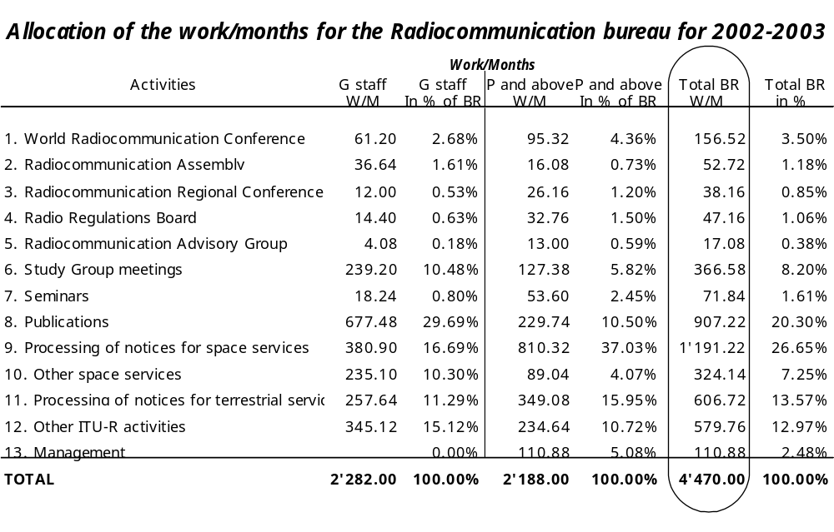
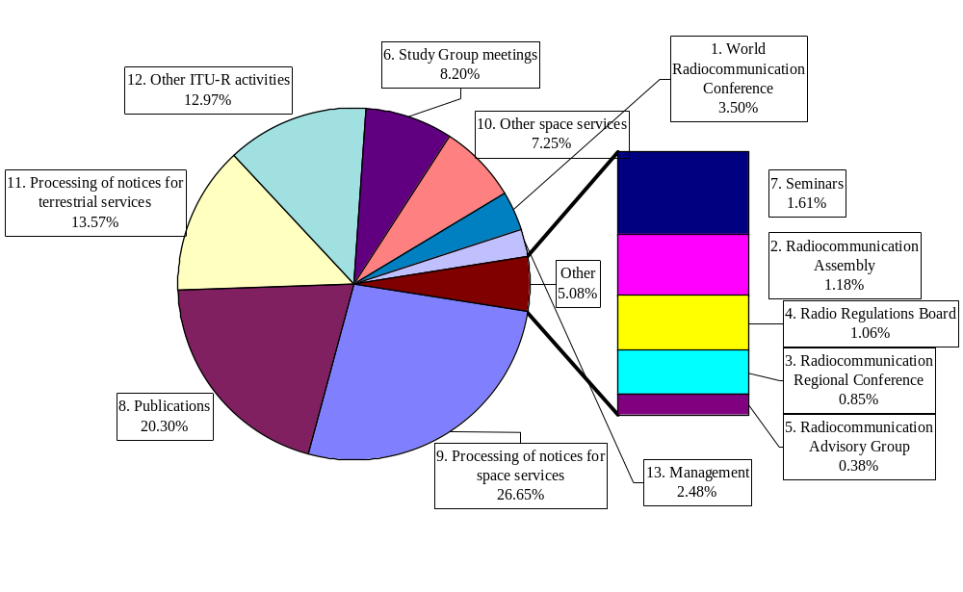

3.4 Resources allocation for 2000-2001
The Radiocommunication Bureau human resources allocation among the ITU-R activities, for the 2000-2001 period, has been estimated on the basis of a time survey conducted in October 2001 concerning the January 2000 to September 2001 period. The distribution among the ITU-R activities is reflected in the Table and Chart Below:
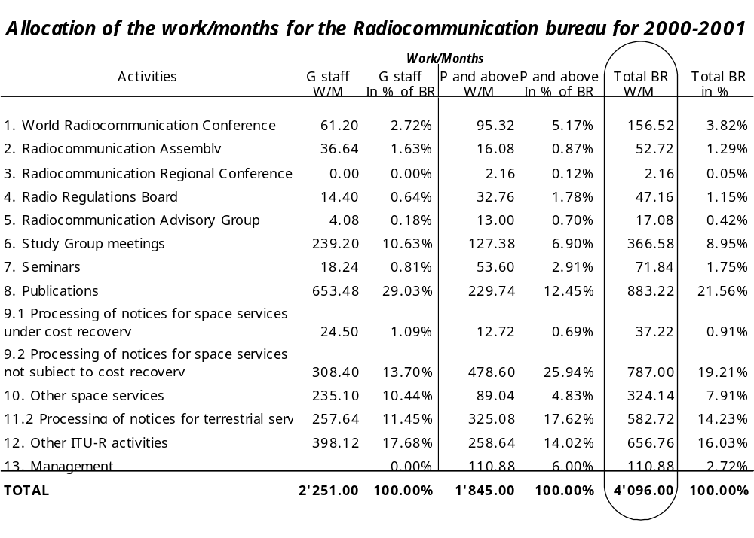

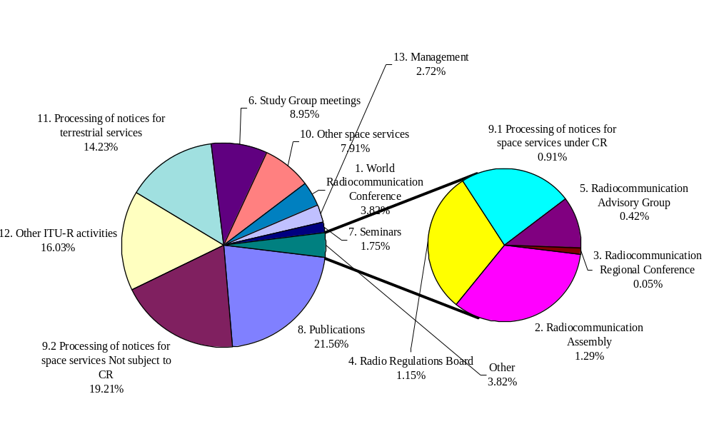

3.5 Application of cost recovery for 2001 and 2002-2003
During 2001, the Bureau started publishing coordination requests received after 7/11/98 but these publications are still not subject to cost recovery because their related advance publication requests were received prior to this date. Only those modifications to coordination requests whose number of pages exceed three times the number of pages covered by the flat fee are chargeable.
The treatment of review of notices under Res. 533 of WRC-97 and WRC-2000 has significantly delayed the treatment of the regular filings for publications for additions or modifications to the Plans and proposed new or modified assignments in the Regions 1 and 3 Lists. As a result there has been no publication of any filing for planned services subject to cost recovery.
The total invoices issued for 2001 (up to 1/11/2001) are as follows:
Advanced publication: 17 invoices for a total of CHF 39 060
Coordination request: 2 invoices for a total of CHF 50 000
Plans: 0 invoices
This "poor" financial result as compared with the income projections made when establishing the 2000-2001 Budget is mainly due to:
• The increase in the number of filings received during the period from mid-1997 to mid-1998 that postponed the treatment of billable filings, as indicated in the Chart below.
• The incidences of the WRC-2000 Decisions and Resolutions that created a significant increased workload for the Bureau.
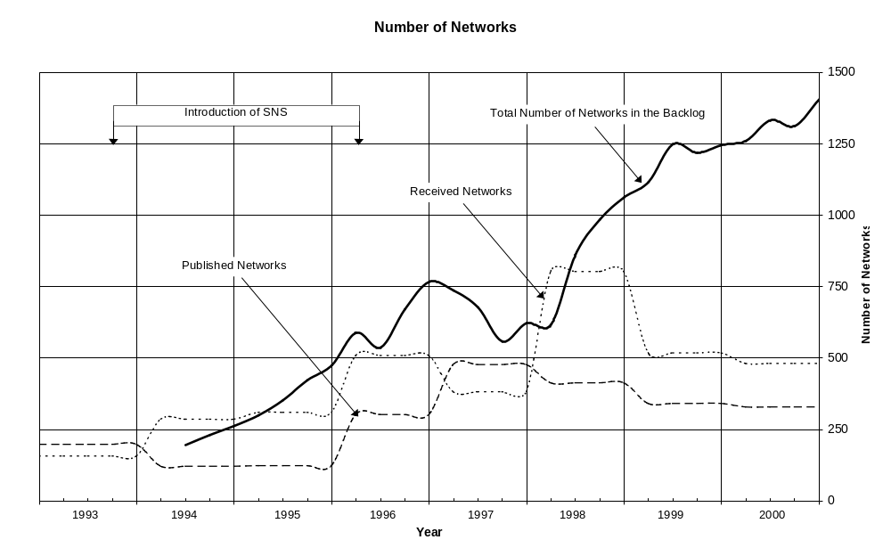
During Council 2001, some changes to the methodology were adopted, which will enter into force in January 2002, including to charge for modifications in the same way as for an original filing, and to invoice for the flat fee at the time of receipt of a filing (upfront payment). With these changes, the estimated income for 2002/2003 will be as follows:
Total estimate for 2002: CHF 8.1 million
Total estimate for 2003: CHF 8.4 million
Assumptions for unplanned space services:
• An average of 50 coordination requests processed each month in 2002 and a target of some 80 per month by end 2003.
• Average of 40 coordination requests received every month.
• 3% deduction due to free entitlement.
• Furthermore, there are additional assumptions about average page numbers, and the distribution of filings among the various categories.
Assumptions for planned space services:
• 440 of the 503 filings currently in the backlog will be published in 2002/2003 (88%).
• 190 new filings are expected to be received during the period of 2002/2003. Among them 80 filings related to Part B Special Sections and Article 5 of Appendices 30 and 30A will be published.
• These targets assume that new software packages are delivered and tested on time and function correctly with the new SNS/SPS database.
TABLE 1
Estimation of cost recovery income for 2002/2003
(based on the current fee schedule)
 |  | CHF
CATEGORY | TYPE | 2002 |  | 2003
 |  | Publication | Upfront | Publication | Upfront
1 | API | 42 150 | 19 500 | 42 150 | 19 500
2 | CR | 790 452 | 1 859 760 | 1 828 800 | 1 859 760
3 | CR (No. 9.11A-GSO) | 866 637 | 1 701 000 | 2 093 908 | 1 701 000
4 | CR (No. 9.11A-non-GSO) | 63 923 | 89 460 | 157 800 | 89 460
5 | CR (small) | 185 | 37 170 | 22 940 | 37 170
6 | CR (No. 9-21-non-GSO) | 0 | 0 | 0 | 0
7 | BSS PLAN (small) | 80 000 | 0 | 16 000 | 0
8 | BSS PLAN | 2 737 112 | 0 | 778 128 | 0
9 | FSS PLAN | 59 400 | 0 | 69 300 | 0
 | Subtotal | 4 639 858 | 3 687 390 | 5 009 026 | 3 687 390
 | Subtotal per year |  | 8 327 248 |  | 8 696 416
 | Deduct for free entitlement |  | 3% |  | 3%
 | Total per year |  | 8 077 431 |  | 8 435 524
 | Total for 2002/2003 |  |  |  | 16 512 954

3.6 Proposed efficiency measures
The Radiocommunication Bureau, while having already made significant and creative efforts so as to maintain its resources level constant over the former and current financial period, will strive to optimize its resources through the implementation of the following measures:
− Greater use of the ITU centralized support services, mainly in the information and communication technology area.
− In depth analysis of current work flows, processes, so as to harmonize them and try to generate synergies.
While not factored into this operational plan, certain suggestions that go beyond the ITU-R Sector could yield greater efficiencies and should be studied. For example, the present process for the production of publications involves many different services, entailing delays and the exchange of a great deal of information, thus holding up the flow of the preparation and production of publications. The involvement of all these services also generates additional costs for the activities in question.
A redeployment of the resources, currently in the General Secretariat centralized services, necessary for the preparation of publications up to the "final clearance for printing" stage in the originating units responsible, could save both money and time. The aim should be to create a synergy by allocating the resources responsible for the composition and proof-reading of publications to the originating services in the respective Sectors. This would improve communication among authors, editors and persons responsible for composition and proof reading. The ITU centralized support services would be solely responsible for production of publications on the different media (paper, CD-ROM, online).
Such a rationalization would also be in line with the need to decentralize the General Secretariat's resources to the Sectors in order to allow them greater flexibility in management, as currently considered in the Council working group on reform.
As far as the various media and production levels are concerned, it would be appropriate to apply a leaner production policy (printing as needed) and to encourage the use of electronic media, mainly using the Web.

THE ACTIVITIES

4 World Radiocommunication Conference

4.1 Description of the activity
A World Radiocommunication Conference will be organized in 2003 for a duration of 4 weeks.

4.2 Major outputs/outcomes
With respect to the WRC-03, the Bureau will undertake the following activities related to the preparations for WRC-2003:
− Organize appropriate monitoring programmes and process the monitoring observations in the HF bands (maritime mobile, aeronautical mobile, broadcasting and other services), in response to Resolution 207 (Rev.WRC-2000) and 350 (WRC-2000), and bearing in mind the requirements stipulated in Resolution 800 (WRC-2000).
− Participate in the studies related to the advancement of new modulation techniques, including digital techniques, capable of providing an optimum balance between sound quality, bandwidth and circuit reliability in the use of the HF bands allocated to the broadcasting service, as well as in those studies that are related to the exhaustion of the MMSI numbering resources and other issues related to GMDSS.
− Participate in the studies, called for in various Resolutions from WRC-2000, that are intended to develop criteria for sharing between the terrestrial and various spaces services (e.g. studies identified in Resolutions 716 (Rev.WRC-2000), 735 (WRC-2000)).
− Pursuant to Resolution 72 (Rev.WRC-2000), participate in meetings organized by various regional telecommunication organizations to assist in detailed preparations and coordination between regions. The Bureau will also assist, wherever possible within its resources, in organizing regional information meetings.
− Participate as required in the work of appropriate study groups and their specific working parties to assist in studies identified in various resolutions relating to the development of satellite-related services such as in Resolution 74 (WRC-2000), Resolution 76 (WRC-2000), Resolution 128 (Rev.WRC-2000), Resolution 136 (Rev.WRC-2000), Resolution 137 (WRC-2000), Resolution 214 (Rev.WRC-2000), Resolution 221 (WRC-2000), Resolution 226 (WRC-2000) and Resolution 733 (WRC-2000).
− Pursuant to Resolution 716 (Rev.WRC-2000), participate in studies to develop and provide the necessary tools to assess the impact of interference in coordinating mobile satellite services in specific bands.
− Participate in relevant study groups in order to facilitate technical studies in respect of sharing criteria specified in Appendices 30 and 30A as required by Resolution 540 (WRC-2000) and Resolution 735 (WRC-2000).
− Coordinate ITU preparations and, in cooperation with the host administration, manage the proceedings of the Conference.
− Assist the informal group, arrange regional preparatory meetings, participate in regional meetings of the regional telecommunication organizations.
Furthermore, the BR will prepare the statutory reports that are required in this regard and will ensure appropriate Bureau support.
The Bureau will also implement in 2003 those decisions of WRC-03 which require immediate application.

4.3 Resources allocation

Human resources | Work/Months | In % of the Bureau
G staff | 61.2 | 2.68%
P and above staff | 95.32 | 4.36%
Total | 156.52 | 3.50%

4.4 Expected accomplishments and performance indicator for 2002-2003

Expected accomplishment | Performance indicator
WRC-03 will examine the 55 agenda items as defined in Council Resolution 1156 and, as appropriate, produce recommendations, resolutions and amendments to the Radio Regulations to be published in the WRC-03 Final Acts. | Timely preparation and distribution of the statutory BR reports to WRC-03; timely processing of the submissions from Member States, Sector Members and other participants, including their posting on the web and on CD-Rom format (in the original language) within 48 hours from the date of receipt; efficient management of the proceedings of the Conference and timely preparation of the definitive Final Acts of the Conference and their distribution to the membership within 6 months following the completion of the work of the Conference

4.5 Realized accomplishments and measurement indicator for 2001

Realized accomplishment | Measurement indicator
WRC-03 preparatory meetings, e.g. APT, CEPT, CITEL | The participation of the Bureau in preparatory meetings organized by the regional organizations was highly appreciated.

5 Radiocommunication Assembly

5.1 Description of the activity
A Radiocommunication Assembly will be organized in 2003, the week preceding WRC-03, for a total duration of five days.

5.2 Major outputs/outcomes
RA-03 will:
• Establish the study group work programme for the next period, between the end of RA-03 and the beginning of the next assembly.
• Revise as appropriate the working methods of ITU-R Study Groups, CPM and the Special Committee on Regulatory/Procedural Matters.
• Select the chairpersons of the study groups, SC, CCV, CPM and RAG.

5.3 Resources allocation

Human resources | Work/Months | In % of the Bureau
G staff | 36.64 | 1.61%
P and above staff | 16.08 | 0.73%
Total | 52.72 | 1.18%

5.4 Expected accomplishments and performance indicator for 2002-2003

Expected accomplishment | Performance indicator
Study group work programme  Working methods of ITU-R study groups  RA will also select the chairpersons of the study groups, SC, CCV, CPM and RAG. | Timely preparation, processing and distribution of documents, including on CD-Rom and posting on the WEB. A provisional paper version of the new and revised ITU-R resolutions will be produced and distributed before the closure of RA-03.

5.5 Realized accomplishments and measurement indicator for 2001

Realized accomplishment | Measurement indicator
Not Applicable | Not Applicable

6 Regional Radiocommunication Conference, RRC-04/05

6.1 Description of the activity
A Regional Radiocommunication Conference concerning the introduction of digital broadcasting in the VHF/UHF bands will be held in 2004 and 2005, and its first session is scheduled for May 2004. As indicated in Council Resolution 1185, this Conference is currently envisaged to revise the European Broadcasting Agreement, Stockholm, 1961, in the frequency bands 174-230 MHz and 470-862 MHz; however, the planning area might be eventually enlarged as a result of the additional consultations in pursuance to Council Resolution 1180. The first session of the RRC is expected to produce a report to the second session on the possible technical basis for the work of the second session of the RRC, as well as on the elements related to the conduct of planning exercises prior to the second session of the RRC.

6.2 Major outputs/outcomes
The major part of the activities will be conducted within the relevant Study Group of the ITU-R. In addition to the standard support to the SG activities, the Bureau will undertake the following activities:
• Participate as required in the work of appropriate study groups and their specific working parties to assist in studies called for in Council Resolution 1185.
• Participate in meetings organized by various regional telecommunication organizations to assist in detailed preparations.
• Participate in studies related to development of necessary planning tools, with the assistance of the Planning project team and the administrations.

6.3 Resources allocation

Human resources | Work/Months | In % of the Bureau
G staff | 12 | 0.53%
P and above staff | 26.16 | 1.20%
Total | 38.16 | 0.85%

6.4 Expected accomplishments and performance indicator for 2002-2003

Expected accomplishment | Performance indicator
Conduct of studies with a view to establishing the technical bases for the introduction of digital broadcasting, including the development of planning criteria, planning methods, network configurations, inter-service and intra-service sharing and compatibility criteria for assessment of the different sharing situations between digital broadcasting, analogue broadcasting and other existing and planned services in the VHF and UHF bands.  Conduct of studies related to development of necessary planning tools, with the assistance of the Planning project team and the administrations. | Efficient preparation for, and participation in, the activities related to RRC that would result in timely and efficient responsiveness to the requirements of the membership.

6.5 Realized accomplishments and measurement indicator for 2001

Realized accomplishment | Measurement indicator
In the year 2001, preparatory reports were submitted to RAG-2001 and to Council-2001, with a view to highlighting some of the issues that were under discussion, and which resulted in the convening of the RRC. Appropriate highlights were presented to the conference preparatory meetings of the concerned regional organizations.  Task Group 6/8 was established to deal with the issues specific to the preparation for the RRC. | The BR responded in a timely manner to requirements of the membership, by contributing appropriately to the agenda-setting process and to commencement of the preparatory studies in a structured manner.

7 Radio Regulations Board

7.1 Description of the activity
Pursuant to the provisions of the ITU Constitution and Convention, seven meetings of the Radio Regulations Board are envisaged during the 2002-2003 biennium, together with the participation of the RRB members at WRC-03. The Radiocommunication Bureau provides support for the RRB including preparation of documents for its consideration, implementation of its decisions and support for the conduct of its meetings. The tasks of the Board involve regular consideration of any difficulties encountered by the Bureau in administering the provisions of the Radio Regulations, any submissions to it by administrations, cases of harmful interference referred to the RRB and regular maintenance of Rules of Procedure. The activities in support of the Radio Regulations Board are linked to § 35 of the ITU Strategic Plan (Resolution 71, (Minneapolis, 1998)) and in particular to the following provision:
"To ensure that the Radio Regulations Board carries out its functions, particularly those concerning the application of the Radio Regulations, in a manner which maintains the confidence of Member States".

7.2 Major outputs/outcomes
In early 2002, a consolidated volume of the Rules of Procedure will be published to incorporate the outcome of a comprehensive review of the rules by the RRB to reflect the WRC-2000 decisions, as well as the new numbering scheme implemented in the 2001 edition of the Radio Regulations. The RRB will continue the ongoing review of the Rules of Procedure pursuant to Article S13.
Resources of the Bureau will continue to be applied to preparation of further revisions of rules of procedure and further improvements in Bureau processing and procedures, e.g. pursuant to Council Resolution 1182. The extent of requirements for new or modified Rules of Procedure also depends, in part, on the proposals and requests for review from administrations as well as on the experience of the Radiocommunication Bureau in applying the Regulations.

7.3 Resources allocation

Human resources | Work/Months | In % of the Bureau
G staff | 14.4 | 0.63%
P and above staff | 32.76 | 1.50%
Total | 47.16 | 1.06%

7.4 Expected accomplishments and performance indicator for 2002-2003

Expected accomplishment | Performance indicator
The RRB is expected to deal expeditiously with any matters referred to it by administrations and to consider and approve, as appropriate, new or revised Rules of Procedure according to relevant texts of the Radio Regulations in force. | RRB will work within the time periods for its various actions as specified in Articles S13 and S14 of the Radio Regulations.

7.5 Realized accomplishments and measurement indicator for 2001

Realized accomplishment | Measurement indicator
During 2001, the Board completed all tasks under its charter including a significant portion of a major revision of Rules of Procedure to recognize the consequences of Decisions from WRC-2000. | Requests for review were resolved at the first available meeting after receiving submissions from Member states and the Board substantially followed the established work programme for considering Rules of Procedure.

8 Radiocommunication Advisory Group

8.1 Description of the activity
The principal duties of the Radiocommunication Advisory Group (RAG) are, inter alia, to review priorities, programmes, operations, financial matters and strategies related to radiocommunication assemblies, study groups and the preparation of radiocommunication conferences, and any specific matters as directed by a conference of the Union, a radiocommunication assembly or the Council. The RAG recommends measures to foster cooperation and coordination with other standards bodies, with the Telecommunication Standardization Sector, the Telecommunication Development Sector and the General Secretariat.
In its advisory capacity, RAG's activities are linked to § 35 of the ITU Strategic Plan (Resolution 71, (Minneapolis, 1998)):
"To continue improving the working methods and cost-effective operation of ITU-R in a flexible organizational structure; to aim at more efficient and more clearly defined roles of the RAG, radiocommunication assemblies and radiocommunication conferences to ensure clear linkages between advisory, decision-making and budgetary responsibilities as new and more efficient working methods evolve; and to further develop the Sector's quality of service and enhance its use of electronic document handling".

8.2 Major outputs/outcomes
RAG will meet twice during the 2002-2003 biennium to review the priorities and strategies for ITU-R activities for the forthcoming year, as well as to advise on the draft Operational Plan for the biennium.
In addition, the RAG is expected to continue with the consideration of the issues related to ITU reform, the WRC/CPM process, the relationship of the RA and WRC, the study groups structure in the light of the current convergence of radiocommunication services, etc.
It is expected that the advice provided by the RAG to the Director will contribute to enhance services to Member States and Sector Members and to foster cooperation and coordination with ITU-T and ITU-D Sectors, as well as with other bodies.

8.3 Resources allocation

Human resources | Work/Months | In % of the Bureau
G staff | 4.08 | 0.18%
P and above staff | 13 | 0.59%
Total | 17.08 | 0.38%

8.4 Expected accomplishments and performance indicator for 2002-2003

Expected accomplishment | Performance indicator
The Bureau will support the work of RAG through the submission of appropriate reference documents, as well as by providing administrative assistance. | Timely preparation and distribution of the BR submissions, sufficiently in advance of the concerned meeting; timely processing of the submissions from Member States and Sector Members, including their posting on the web (in the original language) within 48 hours; dissemination of the final summary of the meeting within 30 days following the completion of the meeting concerned; and timely implementation of the action items as advised by RAG.

8.5 Realized accomplishments and measurement indicator for 2001

Realized accomplishment | Measurement indicator
The Bureau prepared the necessary input to the Ninth RAG meeting (March, 2001). Appropriate follow-up activities were initiated and carried out in response to the conclusions from the RAG-2001 meeting (e.g., submission of documents to WGR, to C-2001, etc). | The objectives set out the Operational Plan for 2001 were achieved (timely preparation and distribution of the BR submissions, timely processing of the submissions from Member States and Sector Members, timely dissemination of the final summary of the meeting, timely implementation of the action items as advised by RAG).

9 Study Group Meetings

9.1 Description of the activity
In addition to the seven radiocommunication study groups and the Coordination Committee for Vocabulary (CCV), this activity includes the work of the Conference Preparatory Meeting (CPM), the Special Committee on Regulatory/Procedural Matters (SC) and the Chairmen and Vice-Chairmen meetings (CVC).
The duties of ITU-R study groups are set out in Article 11 of the Convention, in particular Nos. 149 and 149A. The ITU-R study group work programme for the period between RA-2000 and RA-03 is given in Resolution ITU-R 5-3.
The ITU-R meeting schedule for 2002 and 2003 will be defined and updated by the ITU-R Chairmen and Vice-Chairmen meetings.
During this biennium, about 733 days of meetings will be held, of which 33 with interpretation in six languages. The radiocommunication study group structure is set out in Resolution ITU-R 4-3, as follows:
Study Group 1 (Spectrum management)
Study Group 3 (Radiowave propagation)
Study Group 4 (Fixed-satellite service)
Study Group 6 (Broadcasting services)
Study Group 7 (Science services)
Study Group 8 (Mobile, radiodetermination, amateur and related satellite services)
Study Group 9 (Fixed service)
CCV (Coordination Committee for Vocabulary)

9.1.1 Resources allocation

Human resources | Work/Months | In % of the Bureau
G staff | 239.2 | 10.48%
P and above staff | 127.38 | 5.82%
Total | 366.58 | 8.20%

9.1.2 Expected accomplishments and performance indicator for 2002-2003

Expected accomplishment | Performance indicator
ITU-R study groups will examine 378 Questions and produce, as appropriate, new or revised ITU-R Recommendations. Also, according to WRC-2000 decisions, they will study 55 items for the preparation of WRC-03 and 15 additional items not directly related to the preparation of WRC-03 nor to the preparation of WRC-06. The Special Committee will address the review of regulatory/procedural matters, the results of which will be available to all administrations for their preparations for WRC-03. The Special Committee will produce a report as a contribution to the second meeting of CPM. | BR will provide the adequate support so as to enable study groups to carry out their work in order to produce timely results of their studies according to their urgency as decided by RA. In particular, a timely contribution to CPM will also be prepared:  Satisfaction of participants as to information and documentation availability;  Expected accomplishments achieved with allocated staff and within allocated budget in the specific time frame.

9.1.3 Realized accomplishments and measurement indicator for 2001
Table 1 shows the accomplishments for the year 2001 (up November 2001) in terms of Study Groups and related documents as processed by SGD.
Table 2 indicates additional document pages processed by SGD to make them available on the web to satisfy specific requests (RAG, Chairman's Reports, etc.). For this category of documents no inclusion of KPI was foreseen in the previous Operational Plan.
Measurement indicators
All the key performance indicators established in the previous Operational Plan were achieved in 2001. They were also exceeded in few cases such as:
− 90% (instead of 85%) of all contributions were posted electronically within 24 hours.
− 90% (instead of 80%) of master copies of blue documents were transmitted to EDP within 10 days from approval.
Table 1
Documents processed
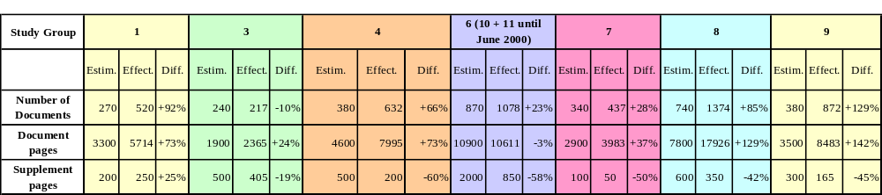
Note: The above figures refer to documentation for SGs, WPs, TG, etc. In the case of SG documents and circulars, currently published in E/F/S, only the figures related to the English version have been included.
Table 2
Documents processed only electronically
Preliminary Annexes to Chairmen's reports |  | Special Committee |  | Attached XLS or  WORD files |  | Misc. Documents,  Handbooks, etc.
# of Doc. | # of pp | # of Doc. | # of Doc. | # of pages | # of pp | # of Doc. | # of pages
13 | 2084 | 5 | 134 | 2 | 246 | 5 | 1291

9.2 Regular activities of study groups
The organization of the work of the study groups, shown in Table 1, takes into account the establishment of joint task groups to carry out studies requested for the WRC-03 as well as other task groups as decided by the relevant parent Study Group in the concerned study period.
Table 1
Organization of the work of the ITU-R study groups
Study Group | 1 | 3 | 4 | 6 | 7 | 8 | 9
Assigned Questions | 23 | 22 | 70 | 109 | 45 | 66 | 43
Working Parties | 3 | 4 | 3 | 7 | 5 | 4 | 4
Task Groups | 1 |  |  | 3
Joint Working Parties
Joint Task Groups | 1 |  | 1 | 1 | 2 | 3 | 2
Joint Rapporteur Groups |  |  |  |  | 1 |  | 2

Expected accomplishment | Performance indicator
Finalization of preliminary draft Recommendations and other texts (such as reports, handbooks, opinions, Questions, etc.) prepared and annexed to the respective Chairmen's reports; | 80% of texts electronically available within 1 month after the meeting.
Preparation of new or revised draft Recommendations and other texts | 95% availability of texts at SG meetings.
Treatment of liaison statements | 90% statements transmitted within 2 days after approval.
Table 2-1
Expected results at meetings other than those of study groups
Study Group | 1 | 3 | 4 | 6 | 7 | 8 | 9
Draft Recommendations | 7 | 18 | 16 | 17 | 14 | 10 | 20
Other texts |  | 2 |  | 11 |  | 5 | 15
Additional draft Recommendations (estimated) | 5 | 8 | 1 | 28 | 4 | 10 | 4
Additional other texts (estimated) | 1 | 1 | 1 | 5 |  | 2 | 4
Liaison statements (estimated) | 30 | 50 | 70 | 100 | 45 | 100 | 50

Expected accomplishment | Performance indicator
Consideration of draft Recommendations and other texts for adoption at the meeting and their subsequent approval | Availability at the meeting: 95% of texts received up to 2 days before the opening.
Consideration of draft Recommendations for adoption by correspondence and subsequent approval
Review of progress on handbooks and examination of other texts
Establishment and organization of future work programme
Table 2-2
Expected results in 2002-2003 at study group meetings
Study Group | 1 | 3 | 4 | 6 | 7 | 8 | 9
Finalized draft Recommendations (adoption at meeting) | 3 | 2 | 8 |  | 13 | 10 | 15
Other texts (estimated) (approval at meeting) | 1 |  |  | 5 |  | 5 | 1
Additional draft Recommendations (estimated) (adoption by correspondence) | 10 | 17 | 16 | 45 | 10 | 10 | 20
Additional other texts considered |  |  |  | 11 | 1 | 2 | 1

Expected accomplishment | Performance indicator
Provide administrative and technical support for preparation, running and follow-up of meetings. | Satisfaction of SG participants as to: meeting organization, information and documentation availability, quality and accessibility of final output material.
• Processing of input, temporary and output documents, circulars, publication master copies, etc.  • Electronic posting of documents.  • Establishment of e-mail reflectors and WWW Pages.  • Preparation of supplement fascicles. | • Achievement of work programme associated with Recommendations within allocated resources.  90% of all contributions posted electronically within 24 hours.
Manage procedures leading to the approval, by correspondence, of Recommendations and Questions, giving advice to the respective Chairmen (see Table 3-1).  Coordinate studies between meetings (e.g. through correspondence groups, etc.) and advise on future planning, in particular with respect to the next CPM.  Assist the SG and SC Chairman to define their work plan and manage their respective budgets.  Assist the SG, WP, TG Chairmen to prepare Chairmen's reports (see Table 3-2). | 80% of pink documents transmitted to edition, document and publication (EDP) division within 3 months from Radiocommunication Assembly.  90% of master copies of blue documents (Recommendations approved by correspondence) transmitted to EDP within 10 days from approval.
Table 3-1
Number of Recommendations expected to be approved by correspondence in 2002-2003
Study Group | 1 | 3 | 4 | 6 | 7 | 8 | 9
No. of Recommendations to be approved by correspondence (estimated) | 10 | 19 | 25 | 60 | 15 | 20 | 35
Table 3-2
Assistance in the preparation of Chairmen's reports
Study Group | 1 | 3 | 4 | 6 | 7 | 8 | 9
No. of pages of Chairmen's reports (estimated) | 500 | 700 | 1600 | 2000 | 700 | 3000 | 1500
• No. of circular letters and other administrative documents: 350 for a total of 6000 pages (estimated).
• Additional workload forecast per study group (see Table 4).
Table 4
Workload forecast per study group
Study Group | 1 | 3 | 4 | 6 | 7 | 8 | 9
Document pages to be processed | 8250 | 5400 | 12000 | 22000 | 6500 | 20000 | 12000
Documents to be electronically posted | 750 | 500 | 800 | 1500 | 750 | 2000 | 1200
Estimated pages of Supplements to Volumes | 420 | 405 | 400 | 850 | 70 | 800 | 400+100 handbook

9.3 Special Committee on Regulatory/Procedural matters
Pursuant to number CV-156 of the Convention, the 2000 Radiocommunication Assembly decided to maintain the Special Committee on Regulatory/Procedural Matters infrastructure (Resolution ITU-R 38-2) to study Radiocommunication regulatory/procedural issues as part of the preparation of WRC-03. WRC-2000 decided to activate it. The SC will work by correspondence and will hold a 5-day meeting in 2002.
The Special Committee will address the review of regulatory/procedural matters, the results of which will be available to all Administration for their preparation for WRC-03. The Special Committee will produce a report as a contribution to the second meeting of the CPM.

Expected accomplishment | Performance indicator
Completion of the report of the SC to CPM-02
Provide administrative and technical support for rapporteur groups and for the SC meeting in July 2002.  Processing of input documents and relevant circulars (1500 document pages to be processed).  Electronic posting of documents (100 documents to be electronically posted).  Assist the SC Chairman to define the SC work plan and to manage the SC budget.  Bureau staff to provide expert advice on the experiences of the BR that would suggest regulatory changes. | Satisfaction of SC participants as to information and documentation availability.  Expected accomplishments achieved with allocated staff and within allocated budget in the specific timeframe.  85% of all contributions posted electronically within 24 hours.  The report of the Special Committee will be ready and available in French, English and Spanish, at least six weeks before the opening of the second meeting of the CPM.  Satisfaction of SC members regarding the accuracy and quality of the Bureau advice on application of the Radio Regulations and related Rules of Procedure.

9.4 Support to Conference Preparatory Meeting (CPM)
The Conference Preparatory Meeting is established by the Radiocommunication Assembly in its Resolution ITU-R 2-3. The CPM determines the structure of its report as well as the distribution of WRC-03 preparatory work among ITU-R Study Groups. It also carries out the updating, rationalization, presentation and discussion of material from ITU-R Study Groups and the Special Committee.
The second meeting of the CPM will be held at the end of year 2002 from 18 to 29 November 2002.
In 2003, the first Conference Preparatory Meeting shall organize preparatory studies for WRC-05/06 and identify studies for the next WRC. The 1st CPM shall appoint a Rapporteur for each Chapter to assist the Chairperson in managing the development and flow of draft report contributions.

Expected accomplishment | Performance indicator
The CPM will produce a report to be considered by WRC-03 | The final report of the CPM will be ready in the three working languages of the Union before the closure of the above-mentioned CPM second meeting
Establishment of the CPM report to WRC-05/06 | Timely availability of the structure for the CPM Report to WRC-05/06.
 | Circulation of the results of the 1st CPM to participants by 1 August 2003

9.5 Support for CVC meetings in 2002 and 2003

Expected accomplishment | Performance indicator
Refinement of the Study Group work plan taking into consideration RA and WRC-03 decisions | Timely availability of draft meeting schedule and other relevant documentation.
Finalization of meeting schedule for the period up to the next meeting of the CVC | Finalization of results within allocated meeting time.

10 Seminars

10.1 Description of the activity
The Radiocommunication Bureau organizes, in Geneva, world seminars on spectrum management every two years, in three languages, as well as regional seminars, in particular for developing countries, some of which may, as appropriate, be provided with interpretation in two languages. The following provisions of the ITU Strategic Plan are linked to the activities of the Radiocommunication Bureau as far as seminars and workshops are concerned:
"In close collaboration with ITU-D and ITU-T, as appropriate, to assist developing countries in spectrum management and disseminate information and know-how through information meetings, seminars, handbooks and the provision of tools for automated spectrum management".
"To expand the assistance offered to Member States in coordinating and registering frequency assignments and in applying the Radio Regulations, with special attention to developing countries and Member States that have recently joined the Union".

10.2 Major outputs/outcomes
A World seminar will be held in Geneva from 11 to 15 November 2002. The BR will also organize 4-5 Regional Radiocommunication Seminars, attempting to cover all three Regions. More emphasis will be given to practical workshops dealing with BR regulatory publications and software. One seminar will be dealing with national spectrum management and will feature senior experts from national spectrum management agencies, etc.

10.3 Resources allocation

Human resources | Work/Months | In % of the Bureau
G staff | 18.24 | 0.80%
P and above staff | 53.6 | 2.45%
Total | 71.84 | 1.61%

10.4 Expected accomplishments and performance indicator for 2002-2003

Expected accomplishment | Performance indicator
Harmonize know-how and knowledge in the field of frequency management, in particular in respect of frequency notification procedures. | Timely preparation, processing and distribution of documents, including on CD-Rom and posting on the web. Around 300 participants would participate in the world seminar and some 500 in the various regional seminars. About 100 fellowships will normally be provided, mainly for least developed countries (LDCs).

10.5 Realized accomplishments and measurement indicator for 2001

Realized accomplishment | Measurement indicator
In 2001, the following events were organized:  − Seminar on BR software in Iran (April 2001).  − Regional Seminar in Mexico City (September 2001).  − Workshop on space services issues in Geneva (June 2001).  − Workshop on terrestrial services issues in Geneva (November 2001). | All preparatory activities were completed in time, the issues were thoroughly prepared, the support for the workshop was adequate, and all these factors contributed to the success of all the three events. some 34 fellowships were granted to participants from the LDCs.

11 Publications

11.1 Policies and orientations for 2002-2003
ITU-R publications are developed and published to provide ITU Members and customers with relevant and timely information and reference documents. This orientation will continue to drive the efforts made by the Bureau to improve the publication process.
In this view, focus will be placed during the 2002-2003 biennium on the further development of IT tools to support - improve and speed up - the publication process. Those tools will be of two sorts: document management automation and terminology management.
Publications – Overall perspectives for 2002-2003
ITU-R publications vary in nature and cycle. Therefore, customer expectations vary as well. However, two criteria are salient at the time of evaluating the quality of the work done by the Bureau: relevance and timeliness. The raison d'être of the Editing of Document and Publications Division (EDP) is precisely to support the efforts of the Bureau to provide ITU-R stakeholders with relevant and timely publications and reference documents.
Relevance factors include accuracy, uniformity and quality in a multilingual environment. EDP will work on the development of tools to improve relevance, in particular the extension of the ITU Document Management System (DMS) and a new ITU-R terminology database. The DMS, already implemented by the BR for the management of Recommendations, will be extended to all ITU-R publications. This will facilitate the versioning, document integrity control, archiving, and web posting of documents (Res. ITU-R 19-1). Studies regarding terminology, started in 2001, will be completed and a report on ITU-R terminology (including an action plan) will be issued in 2002 (Res. ITU-R 33-1, ITU-R 34-1, ITU-R 35-1, and ITU-R 36-1). These two strategic action items should be worked on taking into consideration the specific needs of Arabic, Russian and Chinese.
Time factors are obvious. The broader telecommunication industry is witnessing accelerating production cycles. The ITU has to adapt its methods to this situation and to shorten its production times and reduce publication delays. Res. ITU-R 19-1 should be referred to again, requesting that a specific effort be made to favour electronic dissemination of publications. In that sense, a performance criterion will be monitored starting in January 2002: time to web e.g. the delay between the official approval date of a specific publication and the date it is available for sale on the web.

11.2 Description of the activity
The ITU-R publications include WRC Final Acts, regulatory publications such as the Radio Regulations (RR), Rules of Procedure and the BR International Frequency Information Circular (IFIC) (terrestrial and space services), service documents as specified in the RR, ITU-R Recommendations, handbooks, software applications, databases, and other radiocommunication publications.
This activity follows from Articles 11, 12 and 20 of the Radio Regulations. In response to the requirements stipulated in these Articles, as well as in some of the regional agreements, the Bureau will continue with the publication of the BR International Frequency Information Circular (IFIC), in CD-ROM format, which integrates the IFL, the terrestrial Plans and the bi-weekly Circulars with special sections.
BRIFIC will continue to represent a consolidated regulatory publication resulting from the application of the Radio Regulations and the relevant Regional Agreements. Fifty issues of the BRIFIC are envisaged for the biennium 2002-2003 (twenty five issues per year). Consideration will be given to introducing the DVD format.
The BR will continue with the publication of the HFBC schedules in CD-ROM format in the context of the application of the procedure of Article 12 of the Radio Regulations. Twenty-two issues of this publication are envisaged for the 2002-2003 biennium (eleven issues per year).
The following service documents, as described in Article 20 of the Radio Regulations, will be published during the 2002-2003 biennium:
− List IV (Coast stations): one full edition (18th edition, in 2002) and three supplements (on a bi-annual basis).
− List V (Ship stations): two full editions (42nd edition in 2002, 43rd edition in 2003) and six supplements (on a quarterly basis).
− List VI (Radiodetermination and special service stations): one full edition (15th edition, in 2003) and three supplements (on a bi-annual basis).
− List VIIA (Call signs and numerical identities used by the maritime services): one full edition (21st edition, in 2003) and seven supplements (on a quarterly basis).
− Manual for use by the Maritime Mobile and Maritime Mobile-satellite Services: one edition (in 2002).
− It is also envisaged to publish List VIII ((International monitoring stations) in electronic format (Adobe Acrobat) for direct downloading from the ITU website.

11.3 Resources allocation

Human resources | Work/Months | In % of the Bureau
G staff | 677.48 | 29.69%
P and above staff | 229.74 | 10.50%
Total | 907.22 | 20.30%

11.4 Expected accomplishments and performance indicator for 2002-2003

Expected accomplishment | Performance indicator
During the period 2002-2003, BR will produce the BR-IFIC, in CD-Rom format, which integrates the IFL, the former Weekly Circulars with special sections and terrestrial Plans. This circular is published in two parts: one CD-Rom for space services and one CD-Rom for terrestrial services. Also, during the same period, BR will produce the HFBC schedule on CD-Rom, on a monthly basis, and Lists IV, V, VI, VIIA in accordance with the pre-established schedule. | Timely preparation of the relevant inputs for the publication and compliance with the statutory requirements and the pre-established schedules. Improvement of the publication formats so as to respond more adequately to the requirements of the membership.

11.5 Realized accomplishments and measurement indicator for 2001

Realized accomplishment | Measurement indicator
In 2001, the preparation of the BR publications followed the standard pattern, as foreseen in the Operational Plan, notably:  − The 2001 edition of the RR, incorporating the partial revision of the RR as decided by WRC-2000, was published at the end of 2001, using a revised numbering scheme as decided by WRC-2000.  − BR International Frequency Information Circular (BRIFIC) and the HFBC schedules on CD-ROM were published regularly, with no delay, and the concerned websites were updated on a regular basis.  − The publication of service documents (Lists IV, V, VI, VIIA, VIIB and VIII) followed the standard pattern, and innovative approach was introduced for List V. | The objective specified in the Operational Plan (timely preparation of the publications) has been achieved. The innovative approaches that were implemented (e.g., in the context of List V) received wide support.

12 Activities related to space services
The space related activities are subdivided in two main parts, relating to the processing of space notices and other space activities.

12.1 Processing of space notices

12.1.1 Description of the activity
Under Article 12 of the ITU Convention, in particular No. 170, and the relevant provisions of the Radio Regulations and Rules of Procedure, the BR will process satellite network filings. This activity, subject to partial cost recovery, is the most resource consuming activity of the ITU-R Sector, as some 26.65% of the total human resources of the Bureau are devoted to it.
This particular BR activity is related to § 35 of the Strategic Plan (Resolution 71) (Minneapolis, 1998):
"to facilitate timely coordination between new and existing active and passive systems in both space and terrestrial environments and to develop spectrum regulation initiatives to better harmonize frequency allocations and the use of satellite orbits, while continuing work to improve the frequency coordination and planning process for satellite networks".

12.1.2 Resources allocation

Human resources | Work/Months | In % of the Bureau
G staff | 380.9 | 16.69%
P and above staff | 810.32 | 37.03%
Total | 1.191.22 | 26.65%

12.1.3 Major outputs/outcomes
• API publications.
• Coordination request examination and publication.
• Treatment of notifications and entry in the MIFR.
• Cost recovery. Issuing invoices for satellite network filings that are subject to cost recovery according to Council Decision 482.
• Improvements in electronic processing and validation of new notices.
• Application of Resolution 53 (Rev.WRC-2000).
• Application of Resolution 533 (Rev.WRC-2000).
• Publication of Space Network List
• Application of resolves 5 of Resolution 55 (WRC-2000).
• Production of BR IFIC containing the following:
• Part I-S and Part II-S or Part III-S publications of the frequency assignments notified in accordance with relevant provisions of Article 11 or Article 5 or Article 7 of Appendix 30 or Article 5 of Appendix 30A or Article 8 of Appendix 30B to the Radio Regulations.
• Special Sections containing filed satellite network characteristics and coordination requirements under various provisions of the Radio Regulations and Appendices thereof and the results of regulatory and technical examination relating to the space services.
• Implementation of instructions from WRCs included in various resolutions.
• Preparation of drafts in the development of revised and new rules of procedure.
• Processing of space notices for non-planned services to continue with some improvement in the rate of processing.
• Processing of Advance Publication information is now within prescribed time periods but there remains a significant backlog in processing of coordination requests and notification notices for 2001.

12.1.4 Expected accomplishments and performance indicator for 2002-2003

Expected accomplishment | Performance indicator
During the period 2002-2003:  BR will process the  − Advance publication of information.  − Coordination requests pertaining to satellite networks.  − Notifications for recording in the Master Register (earth and space stations).  − Modify the frequency assignment Plans and lists and the allotment Plan.  − In particular, implement Council Decision 482 on cost recovery for satellite filings, Resolution 1182 on improvements to the processing of satellite filings, and develop appropriate software applications. | During this biennium approximately 900 requests for advance publication of information pertaining to satellite networks and 1 500 coordination requests pertaining to satellite networks is expected to be processed. A reduction in the backlog in processing coordination requests is expected. With respect to Appendix 30B, 8 networks will be processed and for Appendices 30 and 30A, there will be 340 networks processed under Article 4 (Part A). Some 830 cases relating to notifications for recording in the Master Register will be handled, for both earth and space stations. Three to four information workshops on improvement of processing of satellite network filings will be held during the period 2002-2003. The total expected amount to be invoiced for cost recovery for satellite network filings during the biennium is about CHF 16 million.

12.1.5 Realized accomplishments and measurement indicator for 2001
During the years 2000 and 2001, most of the resources allocated to this activity were devoted to the processing of space notices not subject to cost recovery. This was mainly due to the reasons given in paragraph 3.5 above. The breakdown of the resources devoted to the processing of space notice subject/not subject to cost recovery is given in the table below.
Despite the heavy workload arising mostly from the WRC-2000 Decisions/Resolutions as well as the limited resources available, the Bureau was able to realize the following achievements:
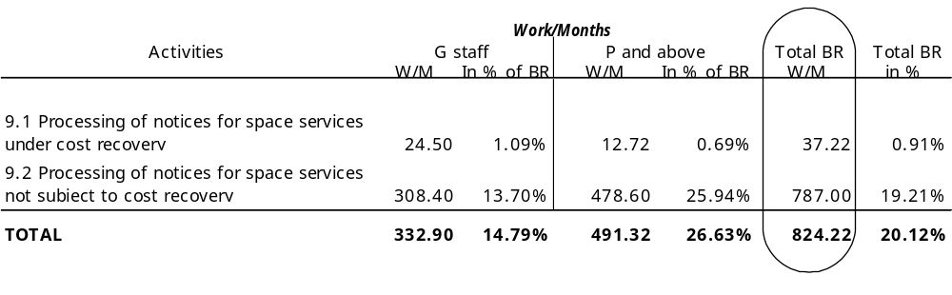

12.1.6 Advance publication of information pertaining to satellite networks (API)

Expected accomplishment | Performance indicator
Examination, validation and publication of the information received on satellite networks submitted under Article 9, subsections 1A and 1B in accordance with No. 9.2B;  − Preparation of special sections and their publication.  − Publication of the request for modification/extension of the date of bringing into use in a MOD API which involves for each request:  1) An examination of the request for extension based on the relevant provisions of the RR and associated Rules of Procedure.  2) Publication of an API MOD.  − Publication of the date of receipt of the API in order to establish the maximum allowed regulatory period.  − Reminders and follow-up steps in the application of No. 9.5D.  − Development and maintenance of databases and the maintenance of archives.  − Taking into account the statistics for 2001, some 650 new or modified cases may be expected to be received in 2002. The total number of APIs to be published in 2002 would therefore be around 650, requiring a publication rate of 25 APIs per BR IFIC. This level of performance has been met in 2001 and should be maintained through 2002 | The objective was to publish within the three-month period prescribed in 9.2B. This objective was met throughout 2001
Realized accomplishments and measurement indicator for 2001

Realized accomplishment | Measurement indicator
− API examination and publication were completed for 768 networks from 1.1.2001 to 30.10.2001. At the end of 2000, 180 networks were carried forward.  − From 01.01.01 to 30.10.01, modifications to the date of bringing into use concerning 210 networks were received and processed.  − A further 293 cases of changes of date of bringing into use are also awaiting processing and inclusion in the SRS database, out of which 120 could not be treated as they are blocked by the examination of modification transactions. | − On the assumption that the number of APIs received in 2002 follows the previous trend, the current rate of processing will be maintained, i.e. 25 APIs (new or mod) per BR IFIC.

12.1.7 Coordination requests pertaining to satellite networks in non-planned bands

Expected accomplishment | Performance indicator
Data capture, data completion and data management;  GIMS antenna diagram capture (paper diagrams) and data validation (electronic diagrams) of incoming antenna diagrams;  Data pre-validation and validation of incoming coordination requests. The objective is to reduce the extent of manual validation checking of incoming coordination requests through the greater use of software driven analysis;  The availability of the new validation software and a proposed new Rule of Procedure related to the receivability of notice forms is expected to enable an increase in the rate of data validation to at least 50 cases per month progressively into 2002/2003.  Regulatory and technical examination of the coordination requests; | An average rate of 50 cases per month for data processing and data validation is envisaged for 2002 and increasing to 80 per month by end 2003.  The availability of the new validation software and more efficient procedures relating to the receivability of notice forms is expected to increase the rate of data validation in the first half of the year 2002 (at least 50 per month).  The processing time for technical and regulatory examination will be reduced and the rate of processing is expected to average 50 systems per month in 2002 increasing to 80 per month during 2003
Development and maintenance of databases and the maintenance of archives.
The following chart indicates the expected evolution of the backlog up to January 2005 to reflect the results of additional resources (approved by Council 2001) and improved methods and software tools.
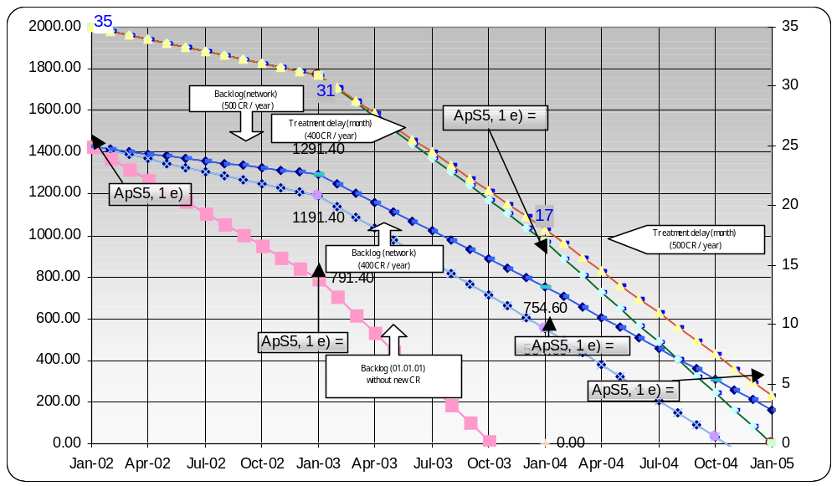
At the end of October 2001, there were:
− 1349 cases awaiting processing to the point of publication of special sections in the BR IFIC. Of these cases, 764 cases were awaiting completion of data management and validation.
− 585 cases awaiting technical and regulatory examination and publication of findings. Based on the rate of receipt of API's over the past 12 months, and based on the number of coordination requests received in 2001, some 960 cases are expected to be received in 2002-2003.
Realized accomplishment and measurement indicator for 2001

Realized accomplishment | Measurement indicator
During the year 2001:  386 networks were validated (i.e. an average rate of 38 networks per month).  The rate of GIMS capture was 193 antenna contours, 180 service area diagrams and 82 diagrams per month for gain in the direction of GSO.  Special Section Publications,  395 R11/C/  141 AR14/C/  465 AP30/C/Article 7 of Appendix 30  312 AR11/C/Article 7 of Appendix 30A  The availability of software to automate the standard BR notes and findings will support a higher rate of publication of special sections in the BR IFIC (Space Services). | On the basis of improved working methods, an assumption of improved examination software being available and the adequate level of professional staff directly involved in the regulatory/technical examination, an average output of at least 40 networks examined per month was expected.

During the period from 1.1.2001 to 1.10.2001 there were 379 coordination requests examined and published (an average of 42 per month) which met the processing objective of around 40 networks per month. During the remainder of 2001, regulatory and technical examination processing was suspended to implement new regulations and procedures applicable to notices received after 1.1.1999.

12.1.8 Notifications for recording in the Master Register

Expected accomplishment | Performance indicator
Submitted data under 11.15 will be captured in the system and be published in Part IS of IFIC after validation.  Regulatory and technical examination will be implemented and findings will be given to notified assignments.  Findings will be published in Part IIS or IIIS of IFIC.  Assignments for which findings are published in Part IIS will be recorded in MIFR and those which are published in Part IIIS will be returned to notifying administrations with explanation. | 315 notifications for space stations and 520 notifications for earth stations will be processed during 2002/2003.
Some 250 space station and 500 earth station cases are currently awaiting process under Article 11. Around 340 space station and 560 earth station cases are expected to be received in 2002 and 2003 based on the rate of receipt of cases in 2001. Taking account of the planned level of resources for 2002/2003 and expected increase of efficiency through automation of the process during this period, at the end of 2003, the processing rate of notification requests, as noted above, is expected to be 315 space stations and 520 earth stations in the two year period of 2002/2003. It implies that the backlog will be increased to some 280 space stations and 540 earth stations at the end of 2003. This estimated backlog may well change; it will depend on the speed at which coordination requests already received and processed "convert" into space and earth station notifications.
Planned level of resource for this activity during 2002/2003 will be increased by 0.9 year at P3 level compared to the level in 2001. This increase will result in 17% increase of production with respect to that of 2001. 9% increase of production is expected through automation of the process.
Realized accomplishment and measurement indicator for 2001

Realized accomplishment | Measurement indicator
Submitted data under S11.15 was captured in the system and be published in Part IS of IFIC after validation.  Regulatory and technical examination was implemented and findings were given to notified assignments.  S21, S22 examination was automated at the end of 2001. | About 128 notifications for space stations and 237 notifications for earth stations will be processed in 2001. This exceeds the objective set in 2001 operational plan (125 space stations and 190 earth stations).

Findings were published in Part IIS or IIIS of IFIC.
Assignments for which findings were published in Part IIS were recorded in MIFR and those of which were published in Part IIIS were returned to notifying administrations with explanation.

12.1.9 Processing of submissions received by the Bureau under Appendices 30 and 30A
The respective activities in these areas, which are also reflected in various resolves of Resolution 533 (Rev.WRC-2000), comprise the publication of modifications to the Appendices 30 and 30A (BSS and feeder link) Region 2 Plan and proposed new or modified assignments in the Regions 1 and 3 Lists, which are submitted under Article 4 of the above-mentioned Appendices by administrations in Part A of a special section and publication of Part B where applicable and processing of notifications submitted under Article 5 of these Appendices.

Expected accomplishment | Performance indicator
For networks submitted under Article 4 of Appendices 30 and 30A  − Publication of as received former Appendices 30/30A Annex 2 data or Appendix 4 data submitted by administrations  − Completeness and correctness check of former Appendices 30/30A Annex 2 data or Appendix 4 data submitted by administrations  − Electronic data capture of former Annex 2 data or Appendix 4 data submitted on paper forms by administrations  − Regulatory and technical examinations under the provisions of Article 4 of Appendices 30 and 30A  − Preparation of draft special sections  − Preparation of correspondence to inform administrations concerned by those special sections  − Technical assistance to administrations  − Software enhancement and testing | See Tables below
For networks submitted under Article 5 of Appendices 30 and 30A:  − Completeness and correctness check of Appendix 4 data submitted by administrations  − Electronic data capture of Appendix 4 data submitted in paper form by administrations | See tables below

− Publication of the assignments in Part I-S of the BR IFIC
− Regulatory and technical examinations under the provisions of Article 5 of Appendices 30 and 30A and formulation of findings
− Preparation of a document with the results of examinations and presentation of the document to the weekly meeting for approval of the BR IFIC
− Publication of the assignments in Part II-S or III-S of BR IFIC in accordance with the results of findings

Part A Special Section publication for networks submitted under Article 4 of Appendices 30 and 30A (implementation of resolves 2 and 4 of Res. 533 (Rev.WRC-2000))
 | AP30 |  | AP30A
 | Total networks yet to be processed | Target for 2002-03 | Total networks to be processed | Target for 2002-03
Pending Article 4 networks to be processed under resolves 4 Res. 533 (Rev.WRC-2000) | 145 | 145  (2002: 74, 2003: 71) | 137 | 137  (2002: 77, 2003: 60)
New Article 4 networks to be processed under resolves 2 of Res. 533 (Rev.WRC-2000) | 45 | 29  (2003: 29) | 42 | 29  (2003: 29)
Expected new submissions for Part A Special Section publication | 50  (2002: 25, 2003: 25) |  | 50  (2002: 25, 2003: 25)
Total | 240 | 174 | 229 | 166
Part B Special Section publication under Article 4
of Appendices 30 and 30A
 | AP30 |  | AP30A
 | Total networks for processing | Target for 2002-03 | Total networks for processing | Target for 2002-03
Networks received by the Bureau and planned to publish in 2002 | 1 | 1 | 6 | 6
Expected new requests for Part B Special Section publication | 20  (2002:10, 2003:10) | 20 | 20  (2002:10, 2003:10) | 20
Total | 21 | 21 | 26 | 26
Networks to be processed under Article 5 of Appendices 30
and 30A
 | AP30 |  | AP30A
 | Total networks for processing | Target for 2002-03 | Total networks for processing | Target for 2002-03
Assignments notified and brought into use before 3 June 2000 which were included in the WRC-2000 Regions 1 and 3 Lists or included in the Plans at WRC-2000, but which were not recorded in the MIFR | 18 | 18 | 17 | 17
Other networks received under Article 5 | 24 | 24 | 26 | 26
New submission expected under Article 5 | 20 | 20 | 20 | 20
Total | 62 | 62 | 63 | 63
Realized accomplishment

Pending Article 4 networks processed under resolves 3 Res. 533 (Rev.WRC-2000) | 2001
 | APS30 | APS30A
 | 91 | 105

12.1.10 Processing of submissions received by the Bureau under Appendix 30B

Expected/realized accomplishment | Performance indicator
• Publication "as received" of the notices submitted under Appendix 30B in the BR IFIC.  • Completeness and correctness checks of data submitted by administrations.  • Receipt, data capture and validation of the notices.  • Regulatory and technical examinations under the procedures of Appendix 30B.  • Analysis of the results of examinations, preparation of the correspondence to the concerned administration(s) and the internal document to be presented to the weekly meeting for approval of the BR IFIC. | The workload for Appendix 30B comprises 52 networks (42 already received plus ten envisaged to be received).  Key Performance Indicator: In 2001 the Bureau processed 13 networks but in 2002-2003, it is expected that only 8 networks will be treated. This is because in 2001 there were no subregional systems included whereas most of the expected 2002-2003 systems will be subregional. In these cases, processing needs to take into account the 30-day "period of adjustment" of technical characteristics stipulated in the Rules of Procedure and the procedure of Section II of Article 6 in which

• Preparation of circular telegrams or special sections depending on the case.  • Updating of the reference situation, if applicable, and posting it on the Web.  • Verification of compliance with Resolution 49 (Rev.WRC-2000).  • Update of the Pre-Determined Arc in accordance with the RR and related RoP.  • Improvements in the MSPACE software and testing.  • Inclusion of the Appendix 30B data into the integrated SNS/SPS database.  • Verification of the current situation of the existing systems in Part B (Section B of Article 10), for the application of § 6.29 of Article 6 of Appendix 30B.  • Requests for technical assistance by the Administrations. | there is a 60-day time limit for comments in relation to sub-regional systems and a requirement to process networks in the date order of their receipt.

12.1.11 Implementation of Resolution 53 (Rev.WRC-2000): compatibility between the new Plans and other services and with the Region 2 Plans
The Resolution requires the Bureau to publish a circular letter which includes the results of compatibility analysis and the entries in the "Remarks" column of Article 9A of Appendix 30A and Article 11 of Appendix 30. This resolution further instructs the Director of the Radiocommunication Bureau to include the results of this analysis in the Director's report to the next World Radiocommunication Conference (WRC-03), which will be considered under agenda item 1.35 by that conference.

Expected accomplishment | Performance indicator
• Data capture, validation and preparation of files.  • Testing of related software.  • Technical and regulatory examination.  • Administrative actions and correspondence.  • Overall management.  • In order to implement Resolution 53 (Rev.WRC-2000), all FSS networks for which the Bureau has received the complete Appendix 4 coordination data before 31 July 2000 need to be captured, validated and thus ready for technical and regulatory examination. | Five professional staff-months will be allocated to this task, together with the necessary general service staff resources allocated as required on a case-by-case basis.  On the basis that the initial capture and validation of the satellite networks will take place in 2001, it is expected that the main implementation activities relating to Resolution 53 (Rev.WRC-2000) will take place in 2002.

12.2 Other Space activities

12.2.1 Due diligence
For networks in the fixed-satellite service, mobile-satellite service and broadcasting-satellite service, the due diligence information needs to be published in the special section within 30 days from the date of receipt. This includes:

Expected accomplishment | Performance indicator
− Capture and validation of the due diligence data.  − Sending RES49 reminders, six months prior to the planned date of bringing into use of satellite networks.  − Examining the due diligence information for completeness, reference to special section numbers, associated frequency range.  − Consulting administrations, should any clarification be required. | The objective is to publish Due Diligence information within one month from the date of receipt as mentioned in Resolution 49, Annex 1, paragraph 8.

12.2.2 Publications
BR IFIC will continue to represent a consolidated regulatory publication resulting from the application of the Radio Regulations and the relevant Regional Agreements. Fifty issues of the BR IFIC are envisaged for the biennium 2002-2003 (twenty five issues per year). Consideration will be given to introducing the DVD format.

12.2.3 Space Network List
The Space Network List is a summary of all the networks registered in the space master register. The quarterly report of the SNL is updated every three months and published in the BR IFIC CDROM and ITU web in pdf format. An online query version is available on the ITU website, updated every 2 weeks.

12.2.4 BR Space Web page
A comprehensive web page is maintained to inform administrations about space related activities including statistics, mandatory electronic filing online support and publication of initial notices "as received".

12.2.5 Support given to Informatics, Administration and Publications Department from Space Services Department for software development
• The specification for each piece of software to be developed requires detailed specifications to be prepared in SSD.
• After the development of the software, it needs to be tested and checked with respect to its output, before release to the administrations.

13 Activities related to terrestrial services

13.1 Description of the activities
The activities related to terrestrial services are subdivided into six major groups of activities:
− Processing of coordination requests pertaining to terrestrial radiocommunication services.
− Application of Plan modification procedures to submissions pertaining to terrestrial radiocommunication services.
− Processing of submissions to broadcasting service in the HF bands.
− Application of notification, examination and recording of frequency assignments pertaining to terrestrial services.
− Application of other regulatory procedures, including assistance in the application of the regulatory procedures.
− Application of administrative and operational procedures.
Each group of activities is described with more details in a separate section hereunder.

13.2 Resources allocation

Human resources | Work/Months | In % of the Bureau
G staff | 257.64 | 11.29%
P and above staff | 349.08 | 15.95%
Total | 606.72 | 13.57%

13.3 Details concerning various groups of terrestrial related activities

13.3.1 Coordination requests pertaining to terrestrial services

13.3.1.1 Description of the activity
This activity comprises the processing of all coordination requests pertaining to terrestrial services (mainly under No. 9.21 of the RR), including the regulatory and technical examinations where appropriate, publication of the relevant special section in the BR IFIC, monitoring of the procedure, and publication of the resulting situation (agreements, disagreements) after the expire of the deadline through special sections in the BR IFIC.

13.3.1.2 Major output/outcomes
The Bureau will apply the relevant steps of the procedures, which comprises timely processing of the submissions from administrations of Member States and their publication in the relevant special sections of the BRIFIC (including their posting on the ITU web site), according to the statutory requirements.

13.3.1.3 Expected accomplishments and performance indicator for 2002-2003

Expected accomplishment | Performance indicator
For the 2002-2003 biennium, it is expected to receive approximately 200 coordination requests pertaining to terrestrial services and the objective is to process each request within the statutory period as prescribed in the RR, in a semi-automated manner. Appropriate actions will be considered with a view to introducing automated processing of the relevant submissions | To process all requests within statutory time-limits

13.3.1.4 Realized accomplishments and measurement indicator for 2001

Realized accomplishment | Measurement indicator
In the year 2001, some 15 requests have been received and all these requests were treated in the statutory period (this activity is being performed outside TerRaSys). No backlog existed at the end of the year 2001. | As forecast in the Operational Plan for the year 2001, all coordination requests were treated in the statutory period.

13.3.2 Plan modification procedures for terrestrial services

13.3.2.1 Description of the activity
This activity comprises the processing of submissions for plan modification under various plan modification procedures (AP25, AP26, ST61, GE75, RJ81, GE84, GE85MM, GE85EMA, GE89). The treatment of the relevant submissions comprises the following principal activities:
• data input (manual, electronic);
• data verification, writing correspondence, data correction;
• archiving (electronic, paper);
• maintenance of validation rules;
• running and monitoring results of computer batch programs;
• examination (regulatory, conformity with the planning principles and with the coordination requirements, technical);
• publication;
• monitoring of the procedure;
• review of the published assignments;
• recording of the assignments;
• review of the recorded assignments.

13.3.2.2 Major output/outcomes
The Bureau will apply the relevant steps of the procedures, which comprises timely processing of the submissions from administrations of Member States and their publication in the relevant special sections of the BRIFIC (including their posting on the ITU website).

13.3.2.3 Expected accomplishments and performance indicator for 2002-2003

Expected accomplishment | Performance indicator
The volumes of the requests for plan modification procedures, in the context of terrestrial services, are relatively stable. The number if the cases that are expected to be received during the biennium 2002 – 2003, are as follows:  − AP25: 40  − AP26: 20  − ST61: 5000  − GE75: 160  − RJ81: 120  − GE84: 4000  − GE85: 80  − GE89: 400. | 1. For the submissions in the VHF/UHF bands, for which the appropriate processing tools are operational and are integrated within TerRaSys (i.e., submissions, which are governed by the regional agreements ST61, GE84 and GE89): the Bureau's objective is to carry out the entire procedure, from the receipt of the notice until its first publication in appropriate Special Section of the BR International Frequency Information Circular – IFIC, within a period of three months following the receipt of a complete notice, and to perform, in a timely manner, the subsequent phases of the procedure in accordance with the requirements stipulated in the relevant regional agreement.  2. For the submissions in the bands governed by AP26 and GE75 plans, for which no processing tools exist yet under TerRaSys, but for which local database systems have been implemented: the Bureau's objective is to carry out the entire procedure within a period of three months following the receipt of complete notices, including the publication of the Special Section for GE75, and to perform, in a timely manner, the subsequent phases of the procedure in accordance with the requirements stipulated in the GE75 agreement.  3. For the submissions in the bands governed by AP25, RJ81 and GE85 plans, for which neither processing tools exist under TerRaSys, nor a local database systems have been implemented so far: the Bureau's objective is to implement alternative approaches (outside TerRaSys), using local database systems, with a view to commencing the examinations in the second half of the year 2002 and, thereafter, to carry out the entire procedure within a period of three months following the receipt of complete notices, including the publication of the concerned Special Sections, until such a time when the TerRaSys processing tools become available (see Section 15.2).

13.3.2.4 Realized accomplishments and measurement indicator for 2001

Realized accomplishment | Measurement indicator
1) For VHF/UHF broadcasting (ST61, GE84, GE89): all pending notices were processed and published, under TerRaSys, in accordance with the statutory requirements (for GE84: after the elimination of the accumulated backlog at the end of October 2001). No backlog existed at the end of year 2001 in any of these three areas (see Table 13.3-1).  2) For AP26 and GE75 Plans: all notices were process and published using local database systems (3 notices under AP26 and 32 notices under GE75). No backlog existed at the end of year 2001.  3) For AP25 and GE85 Plans: no submissions were received. The Bureau applied the relevant procedural steps for the active cases (10 cases under AP25, 3 cases under GE85) outside TerRaSys.  4) For RJ81 Plan: the treatment of the relevant submissions is being suspended pending the delivery of operational tools. | The Bureau's objective (to eliminate the accumulated backlog and to carry out the complete procedure within the statutory limits), either through a standard tool, or through alternate solutions, was achieved in the context of the submissions under AP26, ST61, GE75, GE84 and GE89 Plans.  The Bureau could not achieve the objective concerning the treatment of the RJ81 cases (through a provisional tool) and the slight backlog was accumulated in this regard (60 cases at the end of the year 2001).
table 13.3-1
Submissions under plan modification procedures (BC/BT services)
Procedure | ST61 | GE75 | RJ81 | GE84 | GE89
Expected input | 2000 | 80 | 60 | 2000 | 200
Received notices | 1446 | 32 | 13 | 1237 | 418
Capture and Validation
Captured notices | 1446 | 32 | 0 | 1237 | 418
Performance indicator for data capture | Satisfactory | Satisfactory | Unsatis-factory | Satisfactory | Satisfactory
Backlog (weeks) | 0 | x | x | 0 | 0
Examination and publication
Published notices (Part A) | 499 | 92 | 0 | 3559  (Note 2) | 0
Notices awaiting publication in Part A | 81  (28 weeks) | 25  (20 weeks) | 41 | 1623  (64 weeks) | 183  (100 weeks)
Published notices (Part B) | 1503 | 31 | 0 | 1752 | 167
Notices awaiting publication in Part B | 469  (28 weeks) | 54  (4 weeks) | 14 | 38 | 64  (64 weeks)
Performance indicator for examination and publ. | Satisfactory | Partially satisfactory | Unsatis-factory | Satisfactory | Satisfactory

13.3.3 Processing of submissions to HF broadcasting (Article 12 of the RR)

13.3.3.1 Description of the activity
This activity comprises the processing and technical examination of notices for the broadcasting service in the high frequency (HF) bands which are governed by the procedures of Article 12 of the Radio Regulations and it includes the following steps: the receipt and processing of notices in electronic format, exchange of correspondence with administrations, carrying out of the compatibility analysis and publication of the tentative and final schedules.
This activity also comprises exchange of correspondence with regional coordination groups concerning possible improvements to software, update of reference tables, improvements in the presentation of calculation results, and maintenance of web pages with latest software updates. It also comprises participation in the coordination meetings of the regional coordination groups.

13.3.3.2 Major output/outcomes
The Bureau will apply the relevant steps of the Article 12 procedure, and the major outputs in this regard will consist in timely processing of the submissions from administrations of Member States and authorized broadcasting organizations and their subsequent publication in the HFBC Schedules on CD-ROM, including the maintenance and updating of the reference data on the ITU website.

13.3.3.3 Expected accomplishments and performance indicator for 2002-2003

Expected accomplishment | Performance indicator
To carry out, on a weekly basis, all necessary steps of the procedure, with a view to releasing the appropriate CD-ROM, containing the related HFBC schedule, the associated results of compatibility analysis and the latest version of the HFBC software. | The Bureau's objective is to process, in a timely manner, all the relevant notices within statutory time limits and ensure timely publication of the concerned CD-ROMs, on a monthly basis.

13.3.3.4 Realized accomplishments and measurement indicator for 2001

Realized accomplishment | Measurement indicator
In the year 2001, some 22 000 notices have been received and all these submissions were treated in the statutory period. This resulted in compatibility examinations for over 44 000 submissions. Appropriate enhancements were implemented in the software packages (improved calculations of radiation patterns and antenna gains, pre-validation of requirements, etc). Appropriate support has been provided to the regional coordination groups. | All activities have been completed in accordance with the schedule indicated in Article S12: all submissions were processed according to the schedules and 11 CD-ROMs were published and disseminated within the statutory period.

13.3.4 Notification, examination and recording procedures pertaining to terrestrial services (Article 11 of the Radio Regulations)

13.3.4.1 Description of the activity
This activity encompasses the processing of notices under Article 11 of the Radio Regulations with a view to their recording in the Master International Frequency Register. The treatment of these notices consists in the following principal activities: acknowledgment of the receipt, attribution of ID number, input and validation of the data elements, correspondence concerning data
completeness, data correction and initial publication in the BR IFIC. After the initial publication in the BR IFIC, these notices are subject to various examinations under the relevant provisions of Article 11 of the Radio Regulations (such as conformity with the Table of Frequency Allocations and other provisions of the Radio Regulations, conformity with the coordination procedures or with a frequency allotment or assignment Plan and/or to other provisions of the Agreement, where applicable), which result in appropriate findings and in subsequent recording in the MIFR.

13.3.4.2 Major output/outcomes
The Bureau will apply the relevant steps of the Article 11 procedure, and the major outputs in this regard will consist in timely processing of the submissions from administrations of Member States, their examination in accordance with the applicable procedures and their subsequent publication in the BRIFIC, including posting of the relevant summaries on the ITU website.

13.3.4.3 Expected accomplishments and performance indicator for 2002-2003

Expected accomplishment | Performance indicator
During the 2002-2003 biennium, the Bureau will treat notices for terrestrial services under two different sets of provision: under the provisions of the 1998 edition of the Radio Regulations (Article S11, with respect to notices received between 1 January 1999 and 31 December 2001) and under the provisions of the 2001 edition of the Radio Regulations (Article 11; with respect to notices received after 1 January 2002), in addition to the provisions of the relevant Regional Agreements (where appropriate).  The volumes of the submissions under the notification procedure of Article 11, in the context of terrestrial services, are relatively stable, viz. approximately 50 000 notices per year. The same workload as in past years is expected, i.e., approximately 100 000 notices for the 2002-2003 biennium.  For the 2002-2003 biennium, the Bureau expects to continue with the timely processing and examination in those areas where processing tools are available; to replace the provisional tools in those areas where the delivery of standard processing tools was delayed; to commence with the processing and examination in those areas where the processing or examination was suspended due to unavailability of processing tools and to resume the standard pace of examinations in all areas related to processing of submissions to terrestrial services. | 1. For the submissions related to BC/BT services in the VHF/UHF bands, for which the appropriate processing tools are operational and are integrated within TerRaSys: the Bureau's objective is to carry out the entire examination procedure within the statutory limits.  2. The FXM notices will continue to be examined on a provisional basis, using the currently available provisional tools, until the delivery of operational tools for automated processing, integrated within TerRaSys. It is expected that a part of the tools for automated processing will be delivered in early 2002 which would enable the commencement of the standard examination procedure with respect to the pending notices from the previous period (mainly in the shared bands), as well as with respect to the FXM notices which were examined on a provisional basis during the year 2001 (for the description of the implemented approach see CR/163). After the delivery of operational tools for automated processing, integrated within TerRaSys, the Bureau's objective is to eliminate the accumulated backlog within six months from the date of delivery, and thereafter to perform complete processing of these notices within the statutory time limits. At the end of 2001, there

were some 80 000 notices in this category that were waiting for a standard processing and examination, with the earliest date of receipt of 4 January 1999.
3. The broadcasting notices in the LF/MF bands, whose examination is being suspended since 1 January 2000 due to unavailability of operational tools, will be examined on a provisional basis, using an alternative semi-automated approach (use of local database system similar to that described in CR/163), until the delivery of complete automated and integrated system. After the delivery of the operational tools for automated processing, integrated within TerRaSys, the Bureau's objective is to perform complete processing of these notices within the statutory time limits.
See also Section 15.3 concerning the forecasts for delivery of standard operational tools.

13.3.4.4 Realized accomplishments and measurement indicator for 2001

Realized accomplishment | Measurement indicator
In the year 2001, some 16 000 notices were received in the context of the Article S11 procedure, which is lower than the expected input (50 000 notices). The major part of these notices was processed either with operational tools, or with provisional tools. The examination of these notices followed different patterns:  1) for those areas where standard operational tools exist (i.e., in the VHF and UHF bands allocated to BC/BT services), the Bureau applied the relevant steps of the procedure in a timely manner, some 4 200 notices were examined in this respect within the statutory limits (i.e., in less than three months from the date of receipt of a complete notice) and no backlog exists in this area;  2) for some of the areas where no standard operational tools exist, the Bureau established provisional examination tools (e.g., in the context of Article 11 submissions related to fixed and mobile services in the bands that are not shared with space services) and some 42 000 notices have been examined under this provisional arrangement. Nevertheless, all the relevant submissions (some 80 000 notices) will require additional treatment once the standard processing tools become operational; | The Bureau's objective (to eliminate the accumulated backlog and to carry out the complete procedure within the statutory limits), either through a standard tool, or through alternate solutions, was achieved in the following areas: BC/BT notices in the VHF and UHF bands, and FXM notices in the bands that are not shared with space services.  The Bureau could not achieve the objective concerning the treatment of submissions (through an operational or provisional tool) in the following areas: the BC notices in the LF/MF bands (some 200 pending notices at the end of the year 2001) and the FXM notices in the shared bands (some 30 000 pending notices at the end of the year 2001).

3) for other areas no processing tools were implemented at all (e.g., in the context of Article 11 submissions related to LF/MF broadcasting and to fixed and mobile services in the bands that are shared with space services).

13.3.5 Other regulatory procedures, including assistance in the application of the regulatory procedures

13.3.5.1 Description of the activity
This activity involves the application of regulatory procedures described in the Radio Regulations, in various resolutions and recommendations (e.g., Recommendation 402), other than the standard regulatory procedures specified in Articles 9, 11 and 12 of the Radio Regulations, and it comprises the following:
− Assistance to administrations in the application of coordination, plan modification and notification procedures stipulated in Articles 9, 11 and 12 of the Radio Regulations, in Appendices 25 and 26 of the Radio Regulations, as well as in various regional agreements.
− Treatment of the cases of harmful interference, as a special case of assistance, which is defined in the Radio Regulations.
− Organization of monitoring programmes and processing of monitoring reports in the HF bands (maritime mobile, aeronautical mobile, broadcasting and other services) in pursuance to Resolutions 207 (Rev.WRC-2000) and 350(WRC-2000), as well as to the requirements of Resolution 800(WRC-2000).
− Organization of special monitoring programmes in response to Resolution 205 (Rev.Mob-87), including the associated correspondence with the concerned administrations with a view to eliminating the unauthorized emissions in the band 406-406.1 MHz.

13.3.5.2 Major output/outcomes
The Bureau will apply the relevant steps of the procedures, as defined in the Radio Regulations and in various Resolutions. This includes timely examination of the relevant submissions, formulation of appropriate advice when required, prompt provision of appropriate assistance when requested, and timely dissemination of the relevant reports
In addition, the Bureau will continue to maintain the relevant databases (e.g., monitoring observations submitted by administrations) and will continue to make them available to the registered users, including their on-line availability, through Internet.

13.3.5.3 Expected accomplishments and performance indicator for 2002-2003

Expected accomplishment | Performance indicator
The Bureau expects the same workload as in past years and it anticipates dealing with the following number of requests in the biennium 2002-2003:  − approximately 200 requests for various types of assistance in pursuance to Article 13 of the RR;  − approximately 120 reports of harmful interference;  − approximately 50 000 monitoring reports in response to the regular and special monitoring programmes in the HF bands;  − approximately 100 reports in response to Resolution 205. | The Bureau's objective are as follows:  − to address all of the relevant requests for assistance in a timely manner, with a particular emphasis to the requests from the developing countries.  − Owing to the nature of some services dealing with safety of life, to process each reported case of harmful interference within 48 hours.  − To process, in a timely manner, all monitoring reports and to make them available on the Web within 15 days from the date of receipt.  − To ensure timely dissemination to the administrations concerned of the reports concerning unauthorized emissions in the band around 406 MHz (within two weeks from the date of receipt of the relevant reports).

13.3.5.4 Realized accomplishments and measurement indicator for 2001

Realized accomplishment | Measurement indicator
In the year 2001, assistance and clarifications concerning the application of the regulatory procedures was given to several administrations, notably:  − To one administration (Mali), extensive assistance was given in re-planning the frequency band 87.5-108 MHz, for FM/BC, so as to respond to the new requirements.  − To four administrations (BFA, BHR, MLI, UAE) by providing detailed frequency search and test calculations for GE84.  − To five administrations (BEN, BHR, EGY, KEN, SEN) by providing detailed calculation results and test calculations for GE89.  − To one administration (ISR) by providing assistance in coordination under ST61 Agreement.  − To two administrations (F, RUS) in the frame of the Article S9 procedures of S9.18 and S9.46.  − To one administration (BFA) in the determination of suitable frequencies in the frame of the Article S12 procedures of S12.12 and S12.33. | The Bureau's objectives, as indicated in the Operational Plan for the year 2001, were fully met:  − all requests for assistance were treated in a timely manner and the relevant follow up actions were conducted with no delay;  − each of the reported cases of harmful interference has been processed within 48 hours;  − all monitoring reports were timely processed and made available on the Web;  − the reports concerning unauthorized emissions in the band around 406 MHz were promptly sent to the administrations concerned.

Some 162 cases of harmful interference were treated in 2001 (84 of them being new cases reported in the year 2001).
Some 37 283 observation reports (regular monitoring) and 21 653 monitoring reports (special monitoring program in HF) were processed in 2001.
Some 40 unauthorized emissions were reported and appropriate follow up actions were conducted in response to Resolution 205.

13.3.6 Application of administrative and operational procedures

13.3.6.1 Description of the activity
This activity comprises a considerable number of tasks, such as: allocation of series of call signs, blocks of selective call numbers and Maritime Identification Digits (MID); preparation and publication of service documents; providing of various types of assistance to administrations in the application of administrative and operational procedures that constitute a significant part of the Radio Regulations; etc.
This activity also comprises the maintenance of the relevant databases, such as the electronic version of the ship stations database, including their on-line availability, through Internet.

13.3.6.2 Major output/outcomes
The Bureau will apply the relevant steps of the procedures, as defined in the Radio Regulations and in various Resolutions. This includes timely examination of the relevant submissions and prompt follow-up action, including allocation of appropriate means of identification where justified, timely publication of the relevant information in the Operational Bulletin, formulation of appropriate advice when required, prompt provision of appropriate assistance when requested, and timely dissemination of the relevant reports.
In addition, the Bureau will continue to maintain the relevant databases (e.g., electronic version of the ship stations database) and will continue to make them available to the registered users, including the on-line availability, through Internet.

13.3.6.3 Expected accomplishments and performance indicator for 2002-2003

Expected accomplishment | Performance indicator
For the 2002-2003 biennium, the same workload is expected as in past years, notably:  − About 400 requests dealing with issues related to allocation of series of call signs, blocks of selective call numbers and Maritime Identification Digits (MID) may need to be handled in accordance with Article 19, Resolution 13 (Rev.WRC-97), as well as ITU-R and ITU-T Recommendations.  − Some 60 requests are expected under Articles 47 and 48. | The Bureau's objective is to treat each request in a timely manner (within 15 days from the date of receipt).  The Bureau will continue to monitor the status of the MMSI resource, as requested by Resolution 344 (WRC-97), and will provide an appropriate report to WRC-03.

− Some 20 cases are expected under Resolution 331 (20 cases).
− Some 20 cases are expected under Article 25.
The same pattern in publication of service documents is expected as in previous years (see Section 11).

13.3.6.4 Realized accomplishments and measurement indicator for 2001

Realized accomplishment | Measurement indicator
In 2001, the Bureau handled 17 requests dealing with allocation of series of call signs, blocks of selective call numbers and Maritime Identification Digits. In this connection, one series of call signs has been handled, one block of coast station identification numbers, one block of predetermined group of ship stations and three MIDs. The relevant information was published in the ITU Operational Bulletin, when required.  A total of 204 cases for assistance/clarifications were handled.  The publication of service documents has followed the standard pattern (see Section 11).  The electronic version of the ship-station database was updated on a weekly basis and has been made available on a permanent basis through the Maritime Mobile Access and Retrieval System (MARS). | The Bureau's objectives, as indicated in the Operational Plan for the year 2001, were fully met:  - all requests were treated in time and administrations in almost all cases follow the course of actions and other guidance suggested by BR ;  - all relevant data was promptly made available to all administrations, including the uninterrupted on-line availability of the ship station database through MARS.

14 Other ITU-R activities

14.1 Resources allocation

Human resources | Work/Months | In % of the Bureau
G staff | 345.12 | 15.12%
P and above staff | 234.64 | 10.72%
Total | 579.76 | 12.97%

14.2 Assistance to Members
Assistance and clarification concerning regulatory and administrative provisions of the Radio Regulations are requested, on a daily basis, by many operating agencies, private companies and the general public. The Bureau will try to reply to these requests to the extent that they do not significantly impede the overall priorities of this operational plan.

14.3 Cooperation with ITU-D
Liaison will be maintained between the BR and the BDT in areas of common interest between the two Sectors, with particular emphasis on ITU-D Questions covering:
• ongoing studies in the R-Sector of particular interest to developing countries;
• certain technologies of special interest (identified by ITU-D SG 2);
• handbooks;
• economic aspects of spectrum management;
• liaison will also cover structure and working methods of ITU-D study groups.
The Bureau will cooperate in the study of Questions assigned to the ITU-D study groups and in the work programme of the arising from WTDC-02. It will also collaborate to consider and implement effective means to support the developing countries in the generation of further reports on current and foreseen uses of the radio spectrum (WTDC-98 Resolution 9 ), including the participation in the related workshops organized by the BDT.
Furthermore, follow-up of WRC-2000 Resolutions 72 and 716 will be undertaken in close collaboration with the ITU-D Sector.
Expected accomplishments and performance indicator for 2002-2003

Expected accomplishment in 2002-2003 | Performance indicator
Limit the risk of duplicating studies between ITU-R and ITU-D.  Keeps ITU-R and BR up to date on development issues which, in turn, helps planning of work programmes. | Benefits and satisfaction of developing countries resulting from involvement of ITU-R in relevant studies.
Attend meetings of ITU-D study groups, rapporteur groups, working groups and TDAG;
Ensure appropriate liaison between ITU-D and relevant ITU-R groups;
Where requested, provide advice and assistance to countries on issues such as propagation and spectrum management (including at ICTP, Trieste).

Realized accomplishment in 2001 | Measurement indicator
The BR participated in several activities organized by the BDT, with the emphasis on the activities dealing with spectrum management. The BR provided appropriate assistance and lecturers for several BDT workshops on spectrum management (Dakar – April 2001, Rabat – July 2001, Praia – October 2001, Nairobi – October 2001). | All preparatory activities, including preparation and processing of supporting material, have been completed in time. This resulted in efficient participation, which was appreciated by the participants.

14.4 Cooperation with ITU-T
Liaison will be maintained between the BR and the TSB in areas of common interest between the two Sectors, with particular emphasis on:
• Ongoing studies in the R-Sector on: mobile telephony, digital broadcasting technologies, fixed satellite and terrestrial services, wireless access applications, etc. In particular, an Intersector Coordination Group (ICG) is operational on subjects related to satellite matters. Further specific coordination of work is ensured between ITU-R Study Group 6 and ITU-T Study Groups 9, 12 and 16.
• Common policy on IPR issues.
Expected accomplishments and performance indicator for 2002-2003

Expected accomplishment | Performance indicator
• Limit the risk of duplicating studies between ITU-R and ITU-T.  • Ensure compatibility of ITU-R and ITU-T Recommendations on public network requirements (i.e. SDH and ATM issues, performance and availability objective).  • Keep ITU-R and BR up to date on common issues in order to help planning of work programmes. | Good inter-sectoral cooperation scheme between the activities of the two Sectors.
• Attend meetings of TSAG.
• Where requested, ensure appropriate liaison between ITU-T and relevant ITU-R groups.

14.5 Cooperation with international and regional organizations
Liaison and cooperation will be continued between BR and:
• UN Committee on the Peaceful Uses of Outer Space (UN-COPUOS);
• IMO, ICAO, WMO, IMSO, Cospas-Sarsat, and CICR with regard to the application of ITU treaty texts;
• APT, ATU, CEPT, CITEL, etc. particularly with a view to ensuring effective preparation for WRCs;
• ABU, ASBU, EBU, ETSI, IEC, ISO, RCC, WBU, etc;
• URSI activities, SFCG, RAST and COST Projects of relevance to ITU-R studies.
As appropriate, agreements will be entered into with relevant organizations e.g. ETSI.
An example of cooperation that is planned is the establishment of a Web Board on the ITU site, in cooperation with the Office of Outer Space Affairs and the UN Committee on the Peaceful Uses of Outer Space, to facilitate communications for the action team on global navigation satellite systems.
Another example concerns the joint publication with WMO of a handbook on the Use of radio-frequency spectrum for meteorology.
Expected accomplishments and performance indicator for 2002-2003

Expected accomplishment in 2002-2003 | Performance indicator
Promote dialogue among bodies having common interests.  Help coordination, leading to more effective preparation for events such as WRCs. | Benefits and satisfaction of international and regional organizations.

Keep ITU-R abreast of relevant activities in other organizations to help planning of work programmes
Limit the risk of duplicating studies between ITU-R and other international organizations.
Attend relevant meetings providing reports on ITU activity.
Participate in associated seminars giving lectures where requested.
Conclude agreements as appropriate with other organizations.
Realized accomplishments and measurement indicator for 2001

Realized accomplishment in 2001 | Measurement indicator
The Bureau maintained liaison and cooperation with many International and Regional Organizations, particularly with a view to ensuring effective preparation for WRC-2003 and for RRC/ST61 (IMO, CEPT, ASBU, EBU, etc). Staff of the Bureau attended the relevant meetings of IMO, EBU and Cospas-Sarsat.  Staff of Bureau participated in several meetings concerning the coordination of the HFBC schedules organized by the regional coordination groups (HFCC, ASBU, ABU) and presented the relevant software, as well as the associated procedures for broadcasting services. | The cooperation with the international and regional organizations proved to be beneficial for both ITU/BR and the concerned organizations.

14.6 Regional presence and WRC-03 preparation
The specific appropriations, amounting to CHF 450 000 for 2002-2003, for the regional presence will be mainly dedicated to:
− Organization of regional seminars and regional information sessions to assist countries in their preparation for WRC-03. Special assistance will be given to African, Arab and CIS countries for the organization of these meetings and seminars.
− Organization, in cooperation with the BDT or new technology seminars in the regions bringing in top experts participating in ITU-R Study Groups.
− Participation in BDT efforts to update and support spectrum management courses delivered from the ITU Website.

15 Computer support and software development
In the Radiocommunication Bureau, the Informatics, Administration and Publications Department is in charge of the development of the technical and Administrative software for space and terrestrial activities support and automation.

15.1 Resources allocation

Human resources | Space related software | Terrestrial related software
G staff | 48 | 0
P and above staff | 439 | 192
Total | 487 | 192

15.2 Space related software development

15.2.1 General description
Software required for processing space notices is developed and maintained by the Informatics, Administration and Publications Department (IAP). Two divisions of the IAP Department are involved in this activity – the Space Administrative Software (SAS) Division and the Space Technical Software (STS) Division. In general, the software dealing with the processing of space notices (database development, capture, validation, publication and update of the Master Register and querying functions) is the responsibility of the SAS Division and the software used for regulatory and technical analysis, along with GIMS, SNTRACK, IDWM, is the responsibility of the STS Division. There is substantial interaction in the activities of the two divisions since the goal is to provide an integrated notice processing system to the Space Service Department.

15.2.2 Major outputs/outcomes for 2002-2003
For the period 20002-2003 SAS and STS have set two important objectives:
• To provide the software to Administrations (via the SRS-on-CDROM product and the BR Web site) in order to assist them in carrying out their tasks related to the WRC-2000 requirement of mandatory electronic filing of space notices.
• To provide software to the Space Services Department (SSD) of the BR that will facilitate the processing of space notices and shorten the time to treat them, thus gradually eliminating the backlog.

15.2.3 Expected accomplishments for 2002-2003
In 2002-2003, particular emphasis will be put on the items listed below, many of which require extensive input and assistance from the internal user. The indicated implementation dates are based on the continuing availability of development resources and assistance of users in the validation and testing of packages.

Expected accomplishment | Performance indicator
Complete the development of a new validation software package to replace the existing validation software; this new software will be developed using the latest PC-based tools and will be table-driven and make use of reference databases; it will be integrated with the data capture software and will provide a user-friendly interface; a second version to be available by the middle of 2002. | Delivery of the software to users by the dates indicated.

Following the inclusion of all additional data items introduced into Appendix S4 by WRC-2000 (relating to non-GSO networks and space plans), extend the SpaceCap, SpaceQry, SpacePub and SNS-Online software packages to cover the notification of these additional data items; to be finished by the end of the 1st quarter of 2002.
The SpacePub, SpaceQuery and SNS-Online software packages will be expanded to cover all notice forms (including space plans) relating to the electronic publication of space data – to be completed by the end of the 2nd quarter of 2002.
Produce Part B of the Space Network List (SNL); (done in SPR).
Full integration of the Space Plans' System (Appendix 30B part) with SNS/SPS database.
Modification of Space Plans' System for automation of C/I, C/N and I/N analyses of space networks belonging to non-planned services in accordance with Articles 9 and 11.
Significant improvements to GIMS, i.e. the system that handles graphical data, are foreseen, the most important of which are:
• Application of the new WRC-2000 PFD limits (WRC-2000)
• Include scanned diagrams in GIMSDB
• Add support for viewing the diagrams
• Add support for publishing with SpacePub
• Improvement of the GXT file handling.
• Add a GXT advanced editor
• Review of the validation (new items + re-structuring of the code so that the same validation can be applied to GXT files and captured diagrams)
• Implement a way for forcing the administrations to validate the data before they are sent to BR
• Publish the GIMS data on the Web
• Integrate the composite beams in the GIMS database
• Link GIMS with SNS to retrieve the data required for interactive PFD calculation.

Expected accomplishment | Performance indicator
A significant number of improvements have already been identified in order to provide better system performance and automate existing manual processes. These modifications will be incorporated in the SNS throughout 2002-2003 in accordance with the user's priorities. Specific items are:  • comparison of notices submitted under the Request for Coordination procedure with those submitted under the Advance Publication of Information procedure (API);  • extend the SNS notice processing system to notices submitted under the Resolution 49 (Due Diligence) procedure;  • add the processing of notices submitted in the planned bands to SNS;  • develop and implement software to carry out an examination against Article 5 of the Radio Regulations (Table of Frequency Allocations);  • further optimization of the Appendix 8 software in order to reduce time taken for the analysis;  • enhancement of the Appendix 7 software with the development of a graphical user interface and direct access to the SNS database;  • incorporate cost recovery data in SNS and SNTRACK and develop software to establish the cost recovery categories for networks;  • incorporate standard BR notes and remarks for improved automated publication;  • review IDWM databases (geographical borders, rain-climatic zones and noise zones), capture Maritime zones, and integrate these zones in ApIDWM (GUI of IDWM);  • create a single DLL library containing all geometrical routines used by all space programs;  • complete development of a single library of routines to be used to calculate all standard antenna patterns.  Following the decision of WRC-2000 to make electronic filings mandatory and with the delivery of software relating to the capture, validation and examination of satellite filings to administrations, at least 35% of the resources available for the development of the Space system will be used to provide support for the production system, carry out maintenance activities and provide user training and support (within BR and with Administrations). | See above

15.2.4 Realized accomplishments in 2001

Realized accomplishment | Measurement indicator
Version 1.5 of the existing validation software was distributed; this package was improved substantially, taking into account feedback received from users and the experience gained during the Space Workshop held in June 2001.
The SNS database structure was modified to cover additional data items introduced into Appendix S4 by WRC-2000 (relating to non-GSO and space plans). The resulting Version 4 of the SNS database was distributed on the September 2001 edition of the SRS-on-CDROM.
The SpaceCap software was updated to allow the capture of filings related to the Space Plans.
Many additional queries were added to the SpaceQry and SNS-Online software packages on the request of users.
The SNS processing system was extended to allow the processing of notices submitted under the Advance Publication of Information (API) procedure
Following a decision to modify the examination and publication methods related to the processing of Requests for Coordination received after 1.1.99 (the CR/C approach), substantial effort was put in to modify the SNS notice processing and examination software to cope with the new requirements. This resulted in changes to the order of priorities of tasks that were established earlier.
Many enhancements were made to the Appendix 8, PFD and SpacePub software packages to allow the examination and publication of cases treated under Resolves 5 of Resolution 533 (Rev.WRC-2000).
Conversion to a relational database of the GIMS database (graphical data) for further integration with SNS database (alphanumerical data) was completed by the end of 2001.
The PFD software was modified to take into account the decisions of WRC-2000.
The MSPACE software was modified to interface directly with the SNS database, and software was developed for conversion of Plans into SNS (ApS30B).
A process was established for the automatic capture of findings and coordination requirements produced by the PFD and Appendix 8 software packages into the SNS database.

15.3 Terrestrial related software development

15.3.1 General description
TerRaSys (Terrestrial Radiocommunication System) is partially implemented. When fully implemented, TerRaSys will handle all of the automated processing of all of the terrestrial notices, ranging from data capture to validation to examinations to publication. Without TerRaSys, it would be impossible to process the large volume of terrestrial notices. Because of the Y2K problem, work with the predecessor system (FMS – the Frequency Management System) stopped at the end of 1999. Certain types of terrestrial notices arriving in 2000 and 2001 are not yet fully processed; they await the full implementation of TerRaSys.

15.3.2 Expected achievements for 2002-2003

Expected accomplishment | Performance indicator
Once the results of acceptance testing by the user regarding T11, T12, T13, T14 and T17 (up to and including publication in Part 1) are complete and satisfactory, these portions of TerRaSys will be placed into production. Acceptance testing by the users will be required early in 2002. This will permit to process the major portion of the terrestrial backlog.  The examinations (Technical, Regulatory, etc.) for notice types T11, T12, T13, T14 and T17 required for the publication in Parts 2 and 3, will be implemented, tested, and placed into production. It is estimated that this will require 12-15 work months by the developers, plus the time required by the users for acceptance testing.  Work will begin on the implementation in TerRaSys of the remaining notice types, in this order:  • LF/MF Notices (T03, T04, TB6, TB7, TB8, and TB9)  • Remaining FXM Notices (T15 and T16)  It is estimated that the analysis, design, implementation, and testing of the LF/MF portion will take approximately [50 months by the developers, followed by acceptance testing by the users.  It is estimated that the analysis, design, implementation, and testing of the remaining three FXM notice types, once the requirements are completed by the users will take 35-work months by the developers followed by acceptance testing by the users.  The publication of the BR IFIC, now on CD-ROM, will be expanded to provide an optional version on DVD-ROM. | Tools delivered on time  Respect of the end-users specifications  Satisfaction of the end-users

As time is available, various parts of TerRaSys will be modified to permit their distribution outside of ITU.
An estimated 35 per cent of the resources available for software activities related to TerRaSys will be used to provide support for the production system, carry out maintenance activities, and provide user training and support, both within the Bureau and for administrations.

15.3.3 Realized accomplishments in 2001

Realized accomplishment | Measurement indicator
In 2001, most of the development of the software Notice Types T11, T12, T13, and T14, up to and including publication in Part 1 of the BR IFIC, was completed and acceptance testing is expected to be completed early in 2002.
Because of other unforeseen tasks, further work on these four Notice Types (related to preparation for publication in Parts 2 and 3) has not yet begun.
The FM/TV portion of TerRaSys, which began production in 1999, continues without difficulty, although, from time to time, enhancements are implemented.

16 Concluding remarks by the Director of the Radiocommunication Bureau
The objectives set for 2002-2003 are ambitious but are aimed at meeting the members' expectations vis-à-vis the Radiocommunication Bureau. To this extent, the Union will have to equip itself with adequate tools, procedures and mechanisms so as to be more adaptable and more efficient.
The resources allocated to the Radiocommunication Sector for 2002-2003 will be barely sufficient to face the ongoing increasing demand as well as to implement the ambitious work plan foreseen for this period. For example, as no provisions were included in the 2002-2003 budget for changes in the conditions of employment, neither for any other cost increase, it appears obvious that there has to be some automatic mechanisms to handle currency exchange rate and salary increases since managers can't be expected to hire and fire staff based on fluctuations in these.
So as to improve and enhance the planning processes for the activities of the Radiocommunication Sector, the level of resources should be known and guaranteed for the concerned period. Such a condition is required to enable a good and optimized control of the resources allocated to the Sector. Among several other proposals and improvements that may and will arise, I would recommend that the above-mentioned mechanisms be studied in depth by the Council.
The process of reform that the Union has embarked upon must be vigorously pursued. The overall objective has to be the satisfaction of the real needs for both existing and new products and services of the Radiocommunication Sector.
ANNEX 1
ITU-R 2002-2003 approved Budget

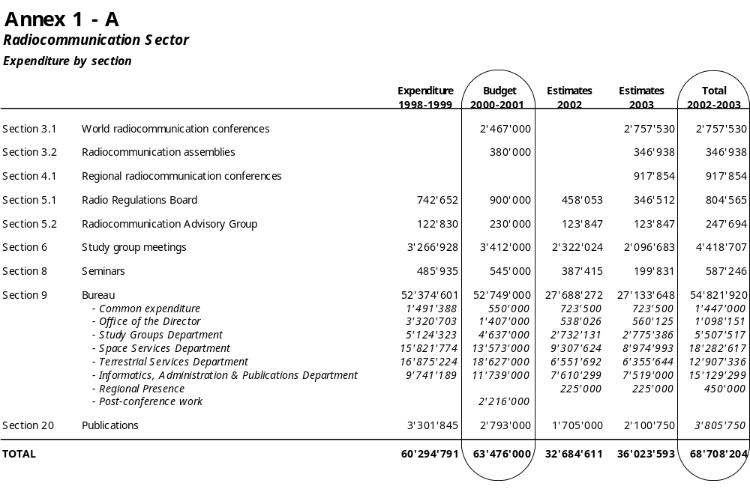

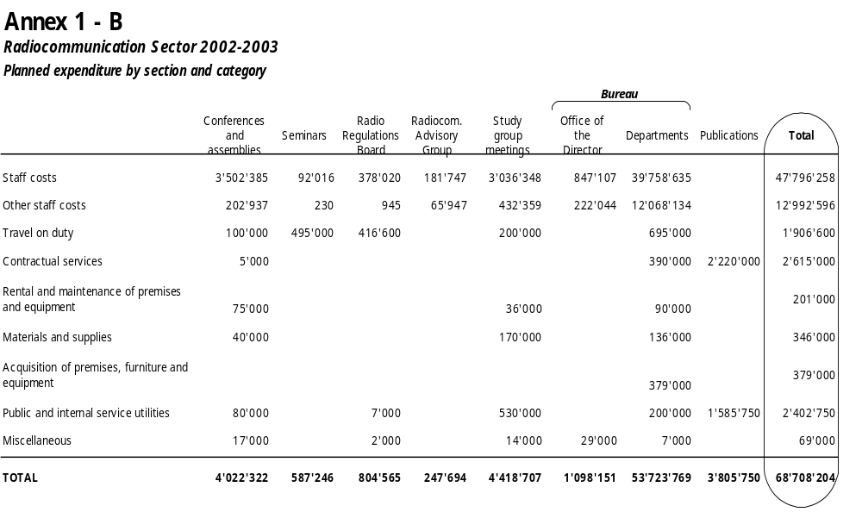

ANNEX 2
Planned volumes and costs of the documentation for 2002-2003

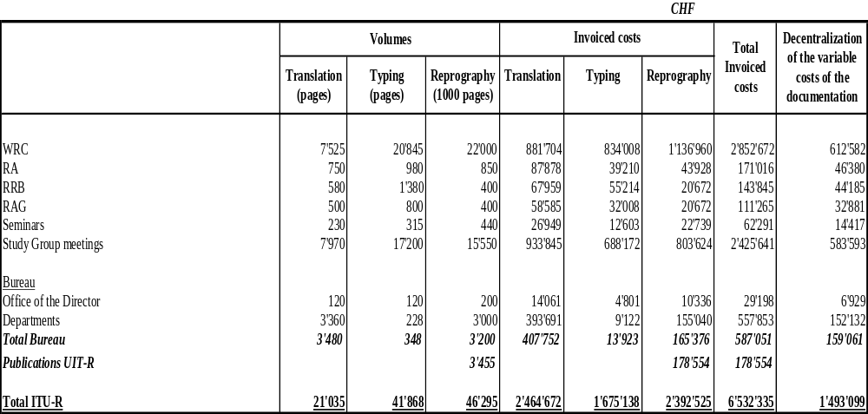

ANNEX 3
Glossary and explanations of the relevant terms

Activity | Action taken to transform resources (inputs) into outputs
Expected accomplishment | A desired outcome involving benefits to end-users (Member States, Sector Members, Associates), expressed as a quantitative or qualitative standard, value or rate. Accomplishments are the direct consequence or effect of the generation of outputs, and lead to the fulfilment of a certain objective.  Expected accomplishments identify the benefits or changes that are expected to accrue to the users or beneficiaries of outputs. Expected accomplishments must be specific and measurable, that is, they should be able to set a quantitative or qualitative value to allow a meaningful comparison with realized accomplishments. Expected accomplishments can also relate to changes in the quality, quantity or timeliness of activities and outputs. For example, a reduction of the backlog for the satellite network filings, an improvement in the quality (or of the satisfaction of the end-users) of advisory services, a reduction in the costs or time required to provide assistance etc.
Output | Final product or service delivered by an activity
Performance indicator | A feature or characteristic used to measure whether and/or the extent to which the expected accomplishment has been achieved. Performance indicators correspond either directly or indirectly to the expected accomplishment for which they are used to measure performance.
Performance measurement | The determination of realized accomplishments in comparison with expected accomplishments, based on data collected for performance indicators for a given period of time or at a certain reference date.

This action will be required until the time when relevant new version(s) of the data capture software (SpaceCap) will be made available to administrations.
For these networks, the routine processing procedures of Article 5 of Appendices 30 and 30A are not applied in accordance with the decision of 26th RRB meeting (5-9 February 2001).
Data relate to the cut-off date of 30 September 2001. Appropriate update (relating to data up to 31 December 2001) will be done in January 2002.
FXM stands for submissions in the fixed, mobile and other services, except the broadcasting service in the LF/MF and VHF/UHF bands.

