Roadmap for the Transition from Analogue to Digital Terrestrial Television in the Kingdom of Tonga

*November 2011*



The roadmap for the transition to digital terrestrial television in the Kingdom of Tonga has been prepared in the framework of the ITU digital broadcasting project in collaboration with the Korea Communications Commission (KCC). The project’s objective is to assist countries in setting out a roadmap and to shift smoothly from analogue to digital terrestrial television broadcasting (DTTB), and to introduce mobile television (MTV).

This report was prepared by ITU expert Mr Doug Stevens with the support from the National Roadmap Team (NRT) of Tonga.

 ITU 2011

All rights reserved. No part of this publication may be reproduced, by any means whatsoever, without the prior written permission of ITU.

Executive Summary

The Kingdom of Tonga (Tonga) is a small nation in the Pacific Ocean that comprises many islands[[1]](#footnote-2) distributed over a distance of about 700 kilometres. The largest island Tongatapu[[2]](#footnote-3) and the adjacent island Eua are home to about 76 per cent[[3]](#footnote-4) of the 101 991 population[[4]](#footnote-5).

The analogue free-to-air (FTA) television broadcasting industry for these two islands comprises two broadcasters and three channels. Tonga Broadcasting Commission (TBC), the public broadcaster, dominates with two channels. Doulos Broadcasting Network (DBN) with its non-commercial Christian broadcast channel, and an affiliate of US Trinity Broadcasting Network (TBN), is the second broadcaster. Both broadcast from individual transmitter sites near Nuku’alofa, the capital of Tonga.

At the Vava’u group of islands to the north of Tongatapu, TBC also broadcasts a localised version of its primary Tongatapu channel to about 15 per cent of Tonga’s population. The combination of the Vava’u population with the populations of Tongatapu and Eua indicates that about 91 per cent of Tonga’s population has access today to some form of FTA analogue terrestrial television[[5]](#footnote-6).

Two pay television networks offer services in Tonga. DigiTV is an MPEG 4, DVB-T digital terrestrial UHF[[6]](#footnote-7) service that operates only on the main island of Tongatapu. It utilises a single frequency, and broadcasts a 20-channel bouquet that does not include any of the three FTA channels. The second pay network Sky Pacific, spans many Pacific Ocean countries via its DVB-S digital satellite coverage. Sky Pacific is a privately owned Fiji company that contracts TBC as its agent in Tonga.

The three existing terrestrial broadcasters[[7]](#footnote-8) reportedly achieve full coverage of Tongatapu and the populated area of Eua from single Tongatapu transmitter sites. This should make the frequency planning and coordination task for prospective DTTB services for these places relatively straightforward[[8]](#footnote-9). This contrasts with the task of identifying a cost-effective digital multi-channel television solution for Tonga that will achieve 100 per cent population coverage. About 9 per cent of the population live on very small islands that would be difficult and expensive to reach with distributed DTTB services. Alternative options will need identification, analysis and objective consideration.

The Communications Act 2000 is a comprehensive piece of supporting legislation that already provides Tonga with much of the necessary scope for successful regulation of its transition to digital television and associated on-going operations administration. It does not however address an ‘analogue switch-off’ process that may require separate legislation.

Radiofrequency spectrum utilisation in Tonga is low and existing television broadcast services all operate within bands forecast to remain as international broadcast bands beyond the World Radiocommunication Conference 2012. There are no television related radiofrequency spectrum conflicts within Tonga or across its national borders, and adequate spectrum does exist for a smooth transition to digital terrestrial television broadcasting.

Mobile television does not exist currently within Tonga and is excluded from roadmap discussions at this time because of the failure of associated business models elsewhere in the world. Tonga will preserve its regulatory ability to adopt MTV capabilities at some future point however, if a successful business model becomes evident.

The Tonga National Roadmap Team (NRT) has proactively taken a number of key decisions[[9]](#footnote-10) that were stimulated by the ITU Guidelines[[10]](#footnote-11) document. Subject to Cabinet[[11]](#footnote-12) ratification, two key roadmap milestones now determined are analogue switch-off (ASO) on 15 June 2015, and commencement of digital terrestrial television broadcasting on 15 June 2013. To meet these dates from a project management perspective, funded approval to proceed with construction of associated DTTB infrastructure will be necessary by about June 2012.

The NRT has also selected its transmission standard, its compression standard and a number of other factors that now enable it to move forward with detailed planning activities, subject to regulatory approval[[12]](#footnote-13).

Chapter 4 identifies and discusses more than ten significant topics that will need NRT analysis and in some cases resolution, prior to further transition towards DTTB. The topics include:

• Tongatapu coverage;

• Vava’u coverage;

• the number of DTTB networks;

• transmitting towers;

• the relationship with DigiTV;

• the relationship with Sky Pacific;

• production equipment upgrades;

• funding;

• national coverage – Is it required? – If so when and how?;

• selection of suitable receivers.

A costed minimum scope-of-work scenario described in chapter 5 may assist with development of funding submissions necessary for the ultimate acquisition and operation in Tonga of a minimum digital terrestrial television capability. The costing conclusions reached in that example are indicative only.

Table of contents

Page

[Executive Summary i](#_Toc309206982)

[Table of Acronyms and Abbreviations v](#_Toc309206984)

[1. Introduction 1](#_Toc309206985)

[2. Current Broadcasting Situation in Tonga 2](#_Toc309206986)

[2.1 Market structure – geography – television 3](#_Toc309206987)

[2.2 Market structure – mobile television 5](#_Toc309206988)

[2.3 Market structure – digital television value chain 5](#_Toc309206989)

[2.4 Market structure – infrastructure 6](#_Toc309206990)

[2.5 Regulatory framework 6](#_Toc309206991)

[2.6 Spectrum utilisation 7](#_Toc309206992)

[2.7 Digital television switch-over objectives 7](#_Toc309206993)

[2.8 Mobile television objectives 9](#_Toc309206994)

[3. National DTTB Roadmap for Tonga 9](#_Toc309206995)

[3.1 Policy and regulation 10](#_Toc309206996)

[3.2 Analogue switch-off 11](#_Toc309206997)

[3.3 Market and business development 11](#_Toc309206998)

[3.4 Networks 11](#_Toc309206999)

[3.5 Roadmap development 11](#_Toc309207000)

[3.6 Tonga NRT decision making workshop 14](#_Toc309207001)

[3.7 Modified Tonga roadmap phases 17](#_Toc309207012)

[3.8 The Tonga roadmap 17](#_Toc309207013)

[3.9 The Tonga roadmap diagram 18](#_Toc309207014)

[4. The Top Ten Key Topics or Issues 21](#_Toc309207019)

[4.1 Tongatapu coverage 21](#_Toc309207020)

[4.2 Vava’u coverage 21](#_Toc309207021)

[4.3 How many DTTB networks? 21](#_Toc309207022)

[4.4 How many transmitting towers? 22](#_Toc309207023)

[4.5 National coverage – Is it required? – If so when and how? 23](#_Toc309207024)

[4.6 The relationship with DigiTV 23](#_Toc309207025)

[4.7 The relationship with Sky Pacific 23](#_Toc309207026)

[4.8 Funding 24](#_Toc309207027)

[4.9 Production equipment upgrades 24](#_Toc309207028)

[4.10 Australian and New Zealand receiver compatibility 24](#_Toc309207029)

[4.11 The National Spectrum Plan 25](#_Toc309207030)

Page

[5. A Minimum Scope DTTB Example for Tonga 26](#_Toc309207031)

[5.1 Infrastructure cost estimates 26](#_Toc309207032)

[5.2 DTTB receiver estimates 28](#_Toc309207033)

[6. Planning 29](#_Toc309207034)

[7. Conclusions 29](#_Toc309207035)

[8. Recommendations 30](#_Toc309207036)

[Annex A: 2011 – Broadcasters’ television infrastructure 32](#_Toc309207037)

[Annex B: ITU Guidelines – Questions for the NRT 37](#_Toc309207044)

Table of Acronyms and Abbreviations

|  |  |
| --- | --- |
| ABU | Asia Pacific Broadcasting Union |
| API | Application programming interface (within receivers) |
| ASO | Analogue Switch-Off |
| CAPEX | Capital Expenditure |
| CEO | Chief Executive Officer |
| Compression | Video compression and multiplexing – the process that effectively ‘compresses’ and combines a number of previously analogue television channels into the same quantity of spectrum previously used for just one of the analogue television channels |
| DBN | Doulos Broadcasting Network |
| DTTB | Digital Terrestrial Television Broadcasting |
| DVB | Digital Video Broadcast – a European standards organisation |
| DVB-S | Digital Video Broadcast-Satellite transmission standard |
| DVB-SI | Digital Video Broadcast – Service Information |
| DVB-T | Digital Video Broadcast – Terrestrial transmission standard |
| FTA | Free-to-air, i.e. unencrypted |
| HDTV | High definition television |
| Head-end | The compression system at the ‘head’ of the distribution system |
| IP | Internet Protocol |
| ITU | International Telecommunication Union |
| ITU Guidelines | ITU Guidelines for the Transition from Analogue to Digital Broadcasting |
| KCC | Korea Communications Commission |
| MTV | Mobile Television – broadcast based not IP based |
| NRT | National Roadmap Team |
| OPEX | Operating Expenditure |
| PSB | Public Service Broadcaster |
| Regulator | Government department responsible for administering the national broadcast environment |
| SDTV | Standard definition television |
| TBC | Tonga Broadcasting Commission |
| TBN | Trinity Broadcasting Network |
| TCC | Tonga Communications Corporation |
| Tonga | The Kingdom of Tonga |
| UHF | Ultra High Frequency – formally between 300-3000 MHz |
| U.S. | United States of America |
| VHF | Very High Frequency – formally between 30-300 MHz |

# 250px-Tonga_on_the_globe_(Polynesia_centered)_svg1. Introduction

The International Telecommunication Union (ITU) selected the Kingdom of Tonga (Tonga) as the sole Pacific Ocean nation to receive its assistance to develop a roadmap for transition to DTTB. The ITU publication, Guidelines for the Transition from Analogue to Digital Broadcasting[[13]](#footnote-14) (ITU Guidelines), provides the reference framework for generic digital television roadmap development. It was used extensively in the development of this report.

The National Roadmap Team (NRT) for Tonga that has researched, debated and created this roadmap includes:

• Mr Paula Pouvalu Ma'u – CEO, Ministry of Information and Communications

• Ms Nanisé Fifita – General Manager, Radio and Television Tonga, TBC

• Mr Barry Taukolo – General Manager, Doulos Broadcasting Network

• Mr Sioeli Maka Tohi – Managing Director, BroadCom Ltd

• Mr Solomone Finau – Chief Engineer, Radio and Television Tonga, TBC

• Mr Marc Santos – Cable Manager, DigiTV – Digicel Tonga

• Ms Ane Mailangi – Company Secretary, Tonga Communications Corporation

• Mr Pepe Vakalahi – Ministry of Information and Communications

• Mr Finau Hufanga – Ministry of Information and Communications

• Mr Alifeleti Tuihalamaka – Ministry of Information and Communications

• Mr Kifitoni Sikulu – Engineer, Radio and Television Tonga, TBC

• Mr Sione Veikoso – Manager Engineering Tonga Communications Corp.

• Mr Justine Kaitapu – Chief Technical Officer – Digicel Tonga

• Mr Kaituú Fotu – Vice President – Tonga Chamber of Commerce

• Mr Doug Stevens – ITU expert[[14]](#footnote-15)

The TV market in Tonga is small by international standards, with 101 991 people in 17 529 households with television.[[15]](#footnote-16) About 93 000 (91 per cent)[[16]](#footnote-17) of these people are within analogue terrestrial television coverage of some kind.

All available television services are accessible on the main island of Tongatapu and an adjacent island Eua. These two islands combined account for 76 per cent of the total resident population[[17]](#footnote-18) of Tonga. The Vava’u group of islands to the north, which is home to about 15 per cent of the population, has one local VHF channel and subscription access to the Sky Pacific digital satellite pay television service. For the remaining 9 per cent of Tonga’s population, the only television option is the Sky Pacific service[[18]](#footnote-19).

The two VHF free-to-air (FTA) analogue terrestrial channels broadcast by the Tonga Broadcasting Commission are the dominant channels viewed on the islands of Tongatapu and Eua. The DBN Christian broadcast channel (FTA UHF) and the DigiTV (PayTV DVB-T UHF) services are also present.

There are three broad streams of activity relating to a transition from analogue to digital television broadcasting, people, businesses and systems as illustrated in Figure 1. All three must be considered together to be able to achieve a successful transition outcome. The membership mix of the NRT for Tonga represents this approach and this commitment.

Figure 1: Activity streams for analogue to digital television transition

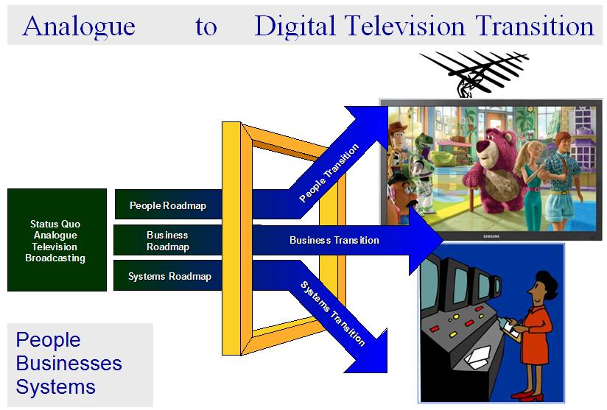

The analogue to digital television roadmap development process included two visits to Tonga by the ITU expert. The first visit extended over two weeks. The second visit of three days focussed on amending this report to represent more appropriately the intentions of the NRT as it leads the transition to digital television within the Kingdom of Tonga.

# 2. Current Broadcasting Situation in Tonga

The geographic challenge that faces those tasked with delivering television to all of the people of Tonga, a widely dispersed islands nation, is evident in Figure 2.

## 2.1 Market structure – geography – television

Figure 2: The Kingdom of Tonga

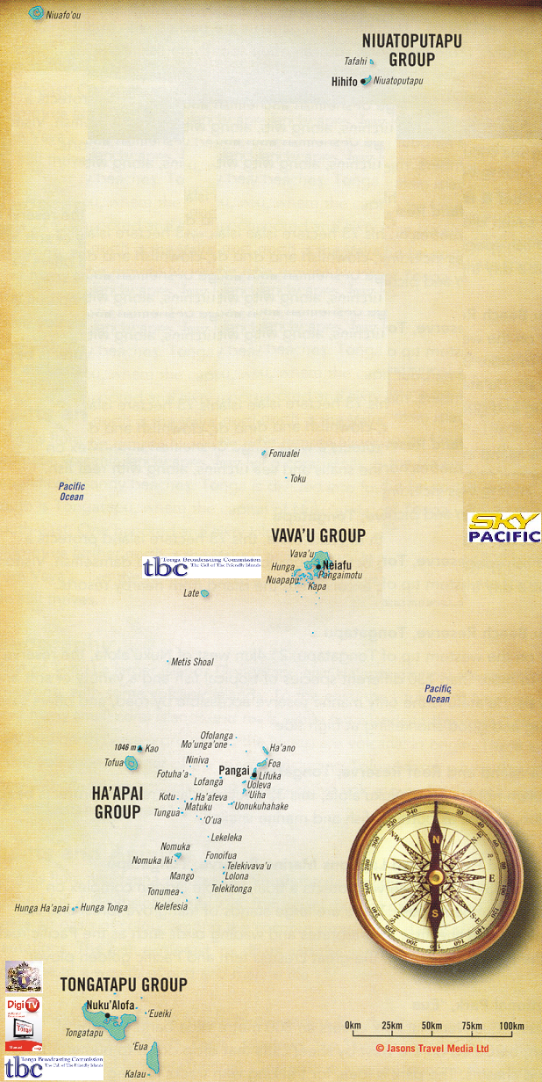

The islands of Tonga extend over about 700 kilometres in a north-north-easterly direction, and the only regional television service that provides 100 per cent population coverage currently is the private Fiji company Sky Pacific, with its digital satellite pay television service. Almost all of the islands are relatively flat however, and potentially provide easy coverage for single tower mounted transmitting antennas. The highest land on Tongatapu for example is about 65 metres above sea level[[19]](#footnote-20).

About 71 per cent of the population lives on the main island of Tongatapu, this is about 30 kilometres long. Together with the 5 per cent of the population who live on the neighbouring island of Eua, these people have access to:

• TBC – the public service broadcaster – two analogue FTA PAL terrestrial VHF channels;

• DBN, in affiliation with TBN – one analogue FTA PAL terrestrial UHF channel – this channel comprises a 70 per cent / 30 per cent mix of international TBN content with local DBN productions respectively;

• DigiTV, a private company co-owned with the local GSM mobile operator Digicel – 20 subscription DVB-T UHF channels – notably with MPEG 4 compression; and

• Sky Pacific – a private Fiji company – 16 subscription DVB-S C-band channels (MPEG 2).

Figure 3: Tonga broadcasters' coverage

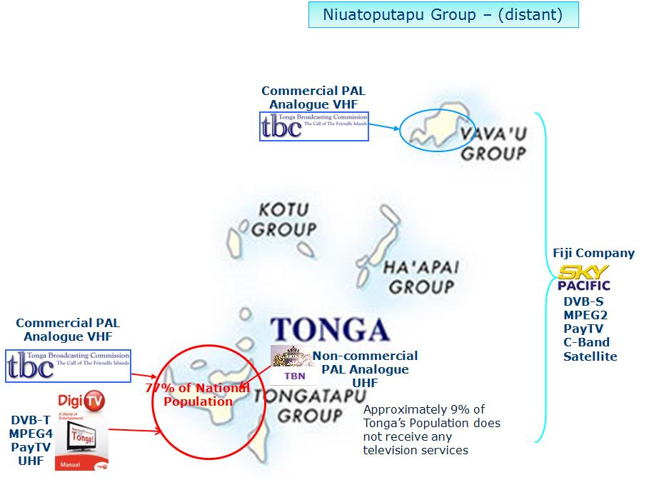

A further 15 per cent of the population live in the Vava’u group of islands. These people have a local TBC analogue FTA PAL terrestrial VHF channel that broadcasts a mix of local productions with content from TBC Tongatapu, including the national news from the day before. The associated news video files reach Vava’u daily via undersea cable[[20]](#footnote-21).

There are no cross border radio frequency interference issues in Tonga.

## 2.2 Market structure – mobile television

There are no mobile video services currently operating within the Kingdom of Tonga; either via mobile television (MTV) or cellular networks 3G services. In the case of 3G networks capabilities, the price of suitable handsets and the availability of adequate bandwidth are two significant inhibitors to the introduction of this type of service.

Two GSM services providers operate – they are Digicel, (which is commonly owned privately with DigiTV), and U-Call, which is owned by the State owned enterprise, Tonga Communications Corporation (TCC). Their market is highly competitive due to the small population base.

## 2.3 Market structure – digital television value chain

Figure 4: Market structure compared with the digital TV value chain

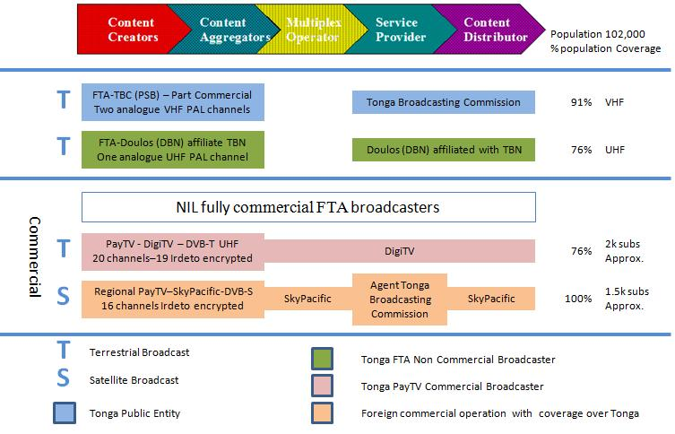

Figure 4 correlates the digital television value chain with:

• terrestrial versus satellite broadcasters;

• government owned versus other broadcasters;

• free-to-air versus encrypted pay television broadcasters;

• Tonga resident versus international broadcasters.

**Content Creators and Content Aggregators** – All Tonga broadcasters are content creators in some way, and all certainly aggregate content from a variety of sources to create and broadcast discrete channels.

**Multiplex Operators** – Only DigiTV and Sky Pacific, as the existing digital television services providers, have a multiplex function within their transmission processes. In both cases, the multiplex functionality wholly integrates into each individual broadcaster’s transmission chain.

**Service Providers** – All of the broadcasters are individually licensed broadcast television service providers **except for** Sky Pacific, which contracts the Tonga Broadcasting Commission to act as its local agent.

**Content Distributors** – All broadcasters separately distribute their own channels.

**Tonga Public Service Broadcaster** – Tonga Broadcasting Commission is the public service broadcaster and additionally is empowered to offer commercial FTA broadcasting services.

## 2.4 Market structure – infrastructure

Each of the broadcasters except Sky Pacific is physically located on the island of Tongatapu, and has a privately owned transmission tower. A fourth tower also present belongs to the former broadcaster Oceania Broadcast Network (OBN). (Refer to Annex A: 2011 – Broadcasters’ Television Infrastructure.)

## 2.5 Regulatory framework

The Ministry of Information and Communications (MIC) is the government department tasked with the regulation of television broadcasting within the Kingdom of Tonga. The relevant legislation is the Communications Act 2000, which as a sub-heading has the following informative text; “An Act for the Establishment of the Department of Communications and the Regulation of Communications Services”.

The scope of this legislation is broad. It enables theoretically the one government department to manage much of the regulation that is necessary for a national transition to digital (terrestrial) television. For example, section headings within the Communications Act 2000 include, but are not limited to:

• Licensing:

– individual licences;

– class licences.

• Consumer protection:

– consumer standards;

– tariffs for services;

– universal service system.

• Technical regulation:

– technical standards;

– spectrum management.

• Social regulation:

– content standards;

– licensee may not provide subscription content;

– licensee may provide advertising content;

– censorship;

– defamation act;

– religion;

– national interest;

– education;

– national emergency;

– political and controversial content;

– offence.

• Economic regulation:

– prohibition on anti-competitive behaviour;

– access to network facilities and services;

– arbitration;

– communications sector performance monitoring;

– inquiries and investigations.

• Miscellaneous:

– installation of network facilities, access to land, etc.;

– Regulations and transitional provisions.

• Schedule:

– standard licence conditions.

All television broadcasters operating within the Kingdom of Tonga have an appropriately worded individual license, except for Sky Pacific, which operates an encrypted regional satellite pay television service that offers services across many Pacific Ocean national boundaries.

## 2.6 Spectrum utilisation

There are four terrestrial radiofrequency licenses for television broadcasting currently in use within Tonga as shown in Figure 5.

Figure 5: Tonga television broadcast and reception frequencies



## 2.7 Digital television switch-over objectives

Tonga has a developing government strategy to use digital and multimedia technologies to bring about substantial local change. An underlying social purpose is to create jobs from the forecast local economic stimulus that will develop. A transition from analogue to digital terrestrial television is a part of that higher-level strategy.

There are many incentives for a transition to digital terrestrial television. Figure 6 illustrates some of these.

Figure 6: Digital television transition incentives

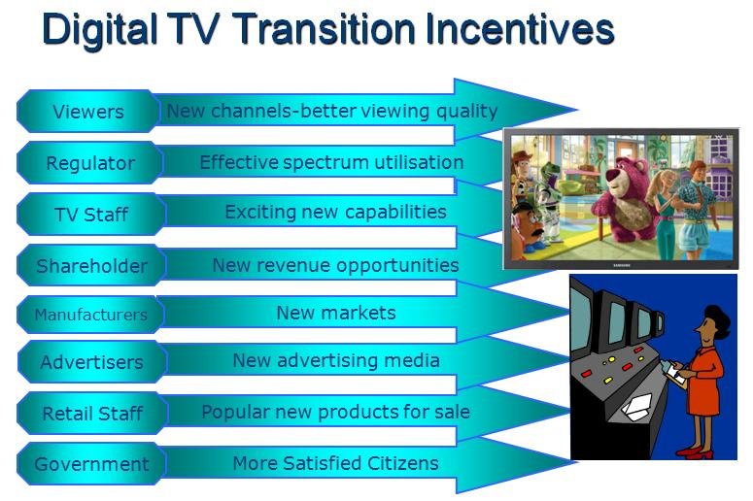

With respect to television services access, Tonga is currently a three-tier society. The first tier comprises the 76 per cent of the population who reside on the islands of Tongatapu and northwestern Eua, and therefore have access to all available television services. The second tier in Vavaú is the 15 per cent of the population who can receive one VHF channel, plus Sky Pacific (if they subscribe). The third tier comprises the remaining and scattered 9 per cent of the population who only have access to Sky Pacific, but very few of these people actually subscribe. An objective of digital switchover is to provide public service television broadcast services to the whole of Tonga’s resident population, although not necessarily by the proclaimed analogue switch-off date.

The compressive capabilities of digital television technologies will readily enable the broadcast of increased volumes of content for only incremental increases in cost[[21]](#footnote-22). Provision of greater viewer choice and additional public-good services are government objectives. In this vein television can be a recognised instrument for public-good by providing ready access to:

|  |  |
| --- | --- |
| • Entertainment | • Education |
| • Health | • Community services |
| • Sunday worship | • Economic issues |
| • Political issues |  |

From a commercial and social perspective, the transition from analogue to digital terrestrial television broadcast has the potential to be disruptive. A smooth transition from one to the other is a clear government objective.

## 2.8 Mobile television objectives

Mobile television services are not sought currently for the Kingdom of Tonga; however, it is a potential market capability that one day may prove viable. The steady decline of DVB-H in Europe[[22]](#footnote-23) and elsewhere[[23]](#footnote-24) in favour primarily of mobile television delivery via 3G (cellular) networks, is a discouraging influence, and the very small potential market in Tonga will additionally make the demonstration of an adequate business plan difficult. Regardless, regulatory provision for potential mobile television services will remain in place; but the associated timelines are separated from digital television transition activities and will not feature further in this report.[[24]](#footnote-25)

# 3. National DTTB Roadmap for Tonga

A roadmap in the context of this report is a diagram that represents a high-level plan for the transition from analogue terrestrial to digital terrestrial television broadcast. The ITU reference process associated with its development[[25]](#footnote-26) provided a discussion framework that enabled the Tonga NRT to reach an associated consensus.

At the outset, the ITU process identifies forty-one individual planning activities that could comprise a fully scoped transition from analogue to DTTB and MTV networks operations, and calls them functional building blocks. Those planning activities are grouped into five functional layers (Figure 7):

• policy and regulation;

• analogue switch-off (ASO);

• market and business development;

• networks;

• roadmap development.

Figure 7: The ITU Guidelines functional framework

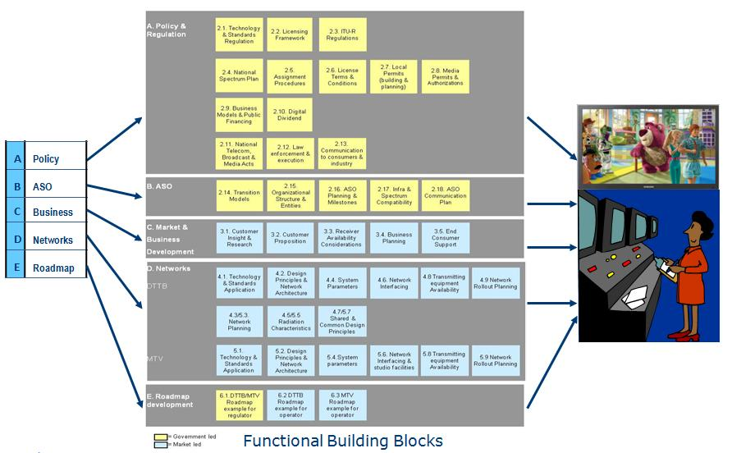

The same planning activities are further split into two categories depending upon whether they are normally government led[[26]](#footnote-27) or market led[[27]](#footnote-28).

## 3.1 Policy and regulation

The *policy and regulation* functional layer of planning activities, normally undertaken by government representatives, considers the key issues and choices that face the regulator, with outcomes that include new policies, new funding, licenses, permits and industry plans.

## 3.2 Analogue switch-off

The *analogue switch-off* functional layer of planning activities, normally also undertaken by government representatives, considers the process of turning off all analogue terrestrial television signals and replacing them effectively and efficiently without interruption, with digital television signals.

## 3.3 Market and business development

The *market and business development* functional layer of planning activities, normally undertaken by companies operating in the local television marketplace, considers the key business issues and choices faced by service providers, network operators, manufacturers and retailers, when planning the commercial launch of DTTB (and MTV) services.

## 3.4 Networks

The *networks* functional layer of planning activities, normally undertaken by companies operating in the local television marketplace, considers the key issues and choices faced by network operators when planning transmitter networks for digital television (and MTV) services.

## 3.5 Roadmap development

The *roadmap development* functional layer of planning activities, desirably undertaken by both government and industry representatives working together, considers all relevant issues relating to the local transition to digital television services and the creation of an appropriate roadmap.

The experience of those who have undertaken this transition internationally, is that a fully successful outcome is achievable only if all industry players have the opportunity to interact and influence the ultimate outcome, which hopefully is an industry-wide consensus.

Having examined the scope of each of the 41 functional modules in some detail over five days of the visit one workshop sessions, the Tonga NRT was presented with all of the modules in the form of randomly sequenced “playing cards”, and tasked with placing them all in a logical and time sequenced order, as in Figure 8.

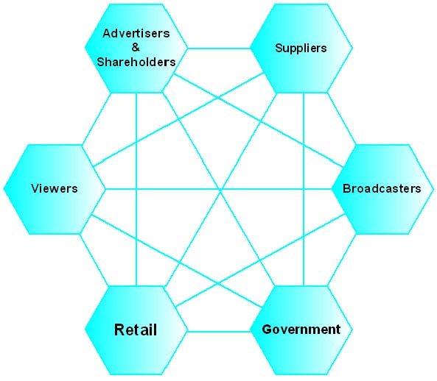

Figure 8: The Tonga NRT workshop task

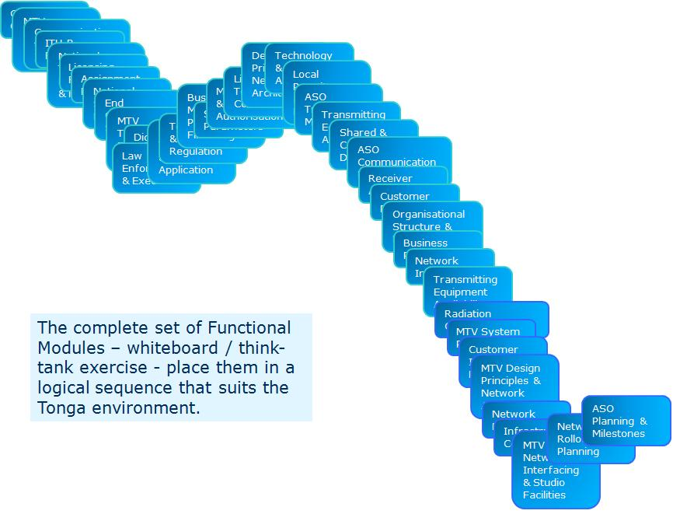

Working as a team, and without considering who ultimately would carry out the work associated with each functional module, the Tonga NRT manipulated the above functional modules as if they were “playing cards”. Consideration of the timeline logic of each one and its relationship with the tasks defined within the other modules generated the diagram at Figure 9.

Notably for Tonga, the roadmap discussion process identified its commencement as being ‘high-level objectives-setting’ by the government.

Subsequent to completion of this NRT workshop, grouping of the functional modules into regulator and network operator phases took place, as illustrated in Figure 10.[[28]](#footnote-29) As defined in the prior workshop the logical and timeline relativities of the functional modules with each other were maintained. The module numbers used in Figure 10 are identical to the module numbers of Figure 7.

Figure 9: Tonga NRT – ITU functional module relationships

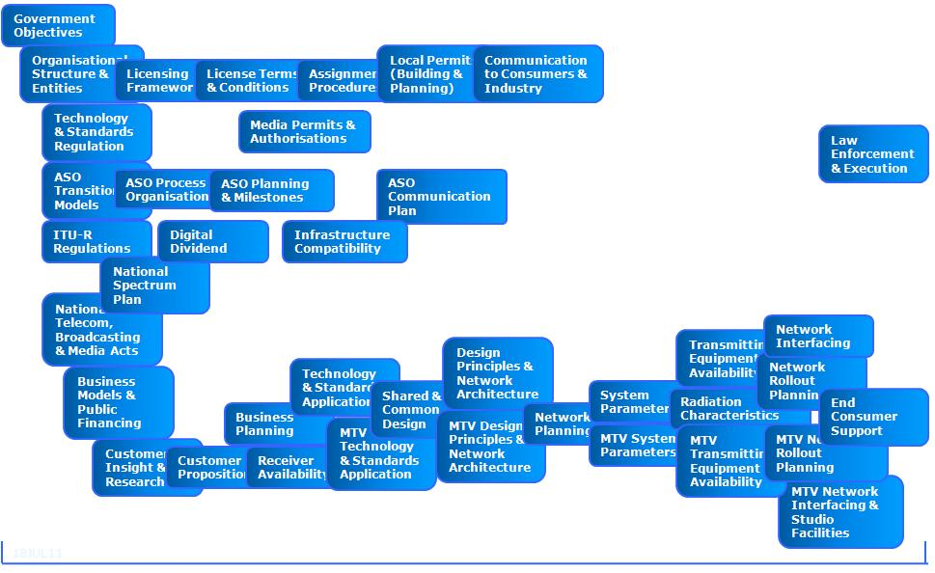

Figure 10: Tonga NRT roadmap phases

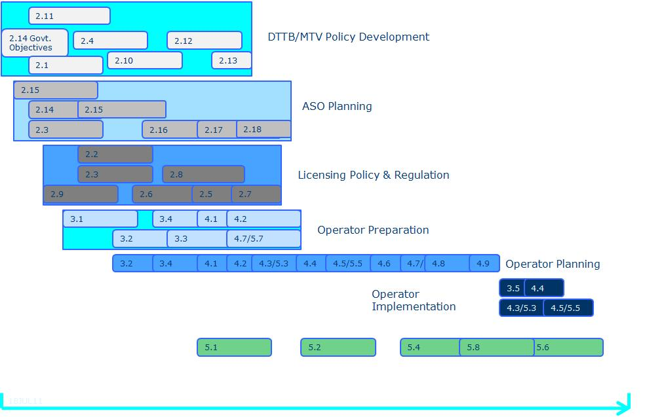

## 3.6 Tonga NRT decision making workshop

The workshop outcome would have been sufficient to enable creation of a roadmap for Tonga; however, the NRT decided to move further forward into the process. An additional one-day workshop was convened during the first visit[[29]](#footnote-30) but without the attendance of the ITU expert. This initiative by the NRT sought to consider a number of essential questions set out in the ITU Guidelines within key functional modules. This workshop effectively commenced the scope of work defined by ITU for DTTB transition.

The decisions taken at that workshop, subject to ratification by Cabinet[[30]](#footnote-31) demonstrate that Tonga has effectively commenced its transition to digital terrestrial television broadcasting. Those decisions follow:

### Technology Standards Regulation – Functional Module 2.1

• SDTV capabilities are required as a minimum by the regulator – HDTV capability development is to be at the discretion of market operators.

• DVB-T is the transmission standard for Tonga DTTB.

• H.264 (MPEG 4 Part 10) is the compression standard for the Kingdom of Tonga DTTB.

• Non PayTV services, free-to-air (FTA) public service and commercial broadcasting), are not to be encrypted.

• The development or not of one or more application programming interfaces (APIs) is to be left to market forces to determine.

### Licensing Framework – Functional Module 2.2

• Each broadcaster / content aggregator operating in Tonga will be licensed.

• Each owner/operator of a multiplex (for either FTA or PayTV services) will be licensed.

• Each owner/operator of a distribution network (satellite, terrestrial, fibre or any technology yet to be developed) will be licensed.

• Any one company could hold all categories of licenses.

### Assignment Procedures – Functional Module 2.5

• Existing analogue FTA broadcasters will have priority for the issuing of relevant DTTB licences.

### License Terms and Conditions – Functional Module 2.6

• The number of potential DTTB multiplexes will be limited by regulation.

• A single licensee could hold licenses for both PayTV and FTA DTTB.

### Local Permits (Building and Planning) – Functional Module 2.7

• Where government regulation requires one or more DTTB participants to share multiplex and/or distribution network assets, relevant government licenses will include rules to ensure fairness for all participants.

### Media Permits and Authorisations – Functional Module 2.8

• FTA DTTB licences will include obligations to observe cultural and other Tongan community values.

### Law Enforcement and Execution – Functional Module 2.12

• A single government agency is intended for the co-ordination, monitoring and enforcement of the National Spectrum Plan and the various DTTB and related licenses and permits that will be created, however these responsibilities are distributed across a number of departments currently.

### Transition Models – Functional Module 2.14

• Government objectives for digital transition include:

1. Digital television is a part of a government strategy for a digital and multimedia future for the Kingdom of Tonga.

2. The implementation of digital television will occur in phases, with the intention that ultimately all resident citizens of Tonga will have FTA digital television signals available for them to access.

3. A smooth transition from analogue to digital.

4. FTA digital television services will provide delivery platforms for the creation of new public services in the fields of:

– entertainment;

– education;

– health;

– community services;

– Sunday worship;

– economic issues;

– political issues.

• DTTB networks construction for Tongatapu and Vava’u will be phased.

• ASO for Tongatapu will occur first followed by ASO for Vava’u.

• Analogue switch-off nationally will be completed by 15 June 2015.

• The analogue switch-off duration will be two years, the implication of which is that DTTB services must commence within Tonga by 15 June 2013.

### Organisational Structure and Entities – Functional Module 2.15

• The NRT will continue to function throughout the ASO process.

• The Ministry of Information and Communications will chair NRT meetings.

### Customer Proposition – Functional Module 3.2

• The DTTB universal (i.e. minimum) service offering will be defined by government.

• The universal service offering will (eventually) be branded (similar to Freeview NZ), although not necessarily implemented by ASO.

• The universal service will at least utilise the embedded EPG[[31]](#footnote-32) of standard set-top-boxes.

• The universal service offering will not include a return path due to cost.

• The universal service offering may create direct connectivity with one or more PayTV platforms through the influence of market forces (e.g. sharing of set-top-boxes).

• The universal service offering will provide more channels and/or services than the status quo analogue television market.

• One or more broadcasters may introduce HDTV services through the influence of market forces.

• Portable and mobile reception capabilities of DTTB technology are to be featured as a part of the planned DTTB public communications strategy.

The above mentioned decisions taken by the NRT, now enable advance planning to commence for the Tonga transition to digital terrestrial television. These decisions, albeit subject to ratification by Cabinet[[32]](#footnote-33), also modify the roadmap phases of Figure 10 to those of the new diagram given in Figure 11.

As can be seen at Figure 11, all policy setting phases and the operator preparation phase of the Tonga NRT roadmap, have effectively commenced. The decisions made also include definition of the ASO date and the ASO duration, thus enabling a real timeline to be now included in the Tonga roadmap.

## 3.7 Modified Tonga roadmap phases

Figure 11: Tonga NRT roadmap progress – 28 July 2011

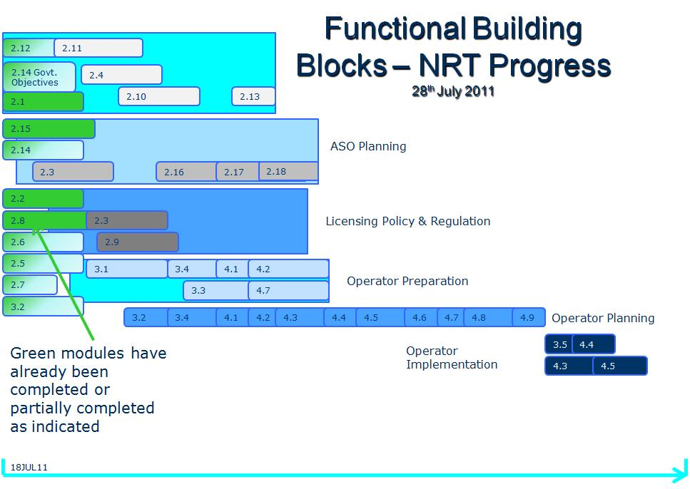

## 3.8 The Tonga roadmap

The process undertaken by the NRT described earlier in this chapter generated the diagram at Figure 11. The associated roadmap diagram for Tonga is a natural extension of that work and is evident in Figure 12.

The roadmap of Figure 12 identifies three key dates for Tonga:

• **June 2012** – the approximate date by when Cabinet debate and approval for the implementation of digital television into Tonga should be concluded if ASO is to be reasonably achieved by June 2015.

• **June 2013** – when the first FTA digital terrestrial television broadcasts should commence on the main Tonga island of Tongatapu.

• **June 2015** – when all analogue television broadcasts in Tonga are switched off.

Within the roadmap, there are a number of phases identified, each of which contains multiple functional activities as mentioned earlier. Description and explanation of some of those activities follows.

## 3.9 The Tonga roadmap diagram

Figure 12: The Kingdom of Tonga DTTB roadmap

**JUL2011 JUN2012 JUN2013 JUN2014 JUN2015**

By

Layer

Phases of The Roadmap

Regulator with NRT

Policy & Regulation

ASO

DTTB Policy Development

Tonga TV Industry

DTTB Market Development

DTTB Network(s)

Timeline

Analogue Switch-Off

Market

Research

DTTB License Administration

Cabinet Approval to Launch DTTB given

First DTTB broadcasts commence

Plan & Build DTTB

Network(s)

Plan DTTB Network(s)

ASO Planning

Licensing Policy & Regulation

Turn off final analogue TV broadcast

## Prior to June 2012

**Regulator with NRT – Policy and Regulation** – Up until Cabinet approval to implement is given in June 2012, the regulator, together with the Tonga NRT will tentatively plan details of:

• DTTB policy;

• digital television industry license structure;

• digital television industry license administration processes;

• the nationwide digital television solution for Tonga.

**Regulator with NRT – ASO** – Up until Cabinet approval to implement is given in June 2012, the regulator, together with the Tonga NRT will tentatively plan details of:

• the ASO management process – including specific consideration of whether new legislation is required to enact analogue switch-off;

• the ASO public communications plan.

**Regulator with NRT and TV Industry** – Up until Cabinet approval to implement is given in June 2012, the regulator, together with the Tonga NRT will tentatively plan details of:

• the DTTB network(s) that will be licensed;

• what digital television will offer to Tonga’s citizens;

• the sourcing of suitable digital television receivers;

• options to enable the 17,529[[33]](#footnote-34) households with television to acquire a suitable digital television receiver by ASO.

**Tonga TV Industry – Market Research** – Up until Cabinet approval to implement is given in June 2012, the Tonga NRT will work with the local television industry, including broadcasters, manufacturers, importers and retailers, to undertake market research and industry focussed planning for the tentative design and rollout of DTTB network(s).

**Regulator and NRT with Networks Operators – Plan DTTB Networks** – Radiated field strength measurements around the island of Tongatapu and on relevant parts of Eua may occur in this period, to determine whether gaps exist in existing television coverage. The results of this survey could directly influence design definition of tower height(s), transmitting antennas’ gain and beam pattern(s), and transmitters’ power levels appropriate to quality DTTB technical service levels.

Transmission rules should be determined also during this period because they will tentatively enable the design of “service information or networks metadata”[[34]](#footnote-35) and the specification of digital television receivers.

**Regulator – Licensing Policy and Regulation** – Once Cabinet approval is given, the regulator may commence the issue of relevant licences that will enable relevant industry players to commit in principle to:

• the formation of new formal business relationships;

• the purchase and installation of DTTB infrastructure;

• the importation of digital television receivers, antennas and related domestic fittings;

• the training of retail sales, installation and technical support staff;

• the acquisition of new television programmes and/or production enhancements.

## Prior to June 2013

**Regulator, NRT, Networks Operators and TV Market – Licensing, ASO and Networks Planning, Networks Implementation** – In the 12 months between Cabinet approval and the commencement of digital television broadcasts on the island of Tongatapu:

• The regulator will ‘fine-tune’ the details of digital television industry licences, and commence their routine on-going administration.

• The regulator together with the NRT, will continue to plan the ASO process, including the development of public and industry communications plans.

• Relevant broadcasters will build their licensed DTTB infrastructure, and prepare their production processes for the creation of digitally distributed channels.

• Commercial broadcasters will ‘sell’ their new capabilities to advertisers and programme sponsors.

• Relevant industry participants will work with the NRT and broadcasters to finalise digital receiver specifications, and to establish business relationships with appropriate manufacturers for the importation and sale in Tonga of relevant products.

• The NRT and industry will work together to develop communications plans relating to the repair and upgrade of household antennas, and the creation of a ‘call-centre’ to answer viewers’ enquiries.

• During the network testing phase prior to formal commencement of digital broadcast services, sample field strength measurements may be taken to verify the designed population coverage, and to warn the industry call-centre of any population coverage short-comings.

## June 2013 to June 2015

**Commencement of DTTB Services** – At the formal commencement of digital television broadcasts in June 2013:

• The industry ‘call-centre’ will temporarily employ additional staff and install additional in-coming telephone lines.

• Each participating broadcaster will include instructional video clips in daily broadcast schedules to inform and assist the public of the transition to digital television.

• Radio stations will have been commissioned to support the public information dissemination process.

• Retailers will have sufficient ready stocks of affordable digital receivers and household antennas to meet the forecast demand.

• Television antenna installers may separately have been licensed to import receivers and antennas to sell ‘turn-key’ solutions directly to individual households.

• Broadcasters will maintain close communications with the industry call-centre to advise, or be made aware of any degradation of their broadcast services.

• The roll out of DTTB networks will complete as planned.

• The regulator will continue to issue DTTB relevant licenses in accordance with associated policy and regulations.

**The ASO Period** – During this two year planned ASO period:

• DTTB network(s) construction will be completed in one or more other island groups as may be determined by the NRT, the regulator and Cabinet.

• The ASO implementation details relevant to the 15 June 2015 switch-off date will be finalised.

• Regulator capabilities for the monitoring and enforcement of digital television industry licence terms and conditions will develop and mature.

• The viewer ‘take-up’ of digital receivers will be monitored monthly by the NRT and regulator, to project how many households with a television will have DTTB reception capability by the ASO date.

**Formal Review of DTTB Take-up Prior to ASO** – By 15 May 2015[[35]](#footnote-36), the NRT and regulator will meet formally to define the take-up statistics for the island of Tongatapu, and any other relevant DTTB installations in Tonga. This will enable preparation of a formal brief to Cabinet on the industry status prior to actual ASO.

## June 2015

**ASO** – On 15 June 2015, subject to Cabinet approval, all remaining analogue television broadcasts will switch-off throughout the Kingdom of Tonga.

# 4. The Top Ten Key Topics or Issues

In no particular order, the following topics identify discussions that the NRT will need to have prior to conclusion of the DTTB policy development phase of the roadmap. Not included here are the many detailed network(s) design issues that will arise once that related phase of Tonga’s DTTB implementation commences. Normal project-management practice will address and resolve any such issues.

## 4.1 Tongatapu coverage

A clear NRT objective is to provide DTTB coverage to all residents of Tongatapu and the occupied areas of neighbouring Eua. All television broadcasters that now operate in the Kingdom of Tonga claim total coverage of the main island of Tongatapu and the population centre(s) of the island of Eua[[36]](#footnote-37). Before proceeding with DTTB network(s) design, probably based upon use of using existing tower(s) and antenna(s) infrastructure, validation of this claim through an objective and structured series of field strength measurements at all relevant frequencies, could be undertaken.

If 100 per cent (or agreed levels of) population coverage cannot be provided from single transmitter sites through adjustment of transmitting antennas and transmitter power combinations, then how many in-fill transmitters will be needed?

## 4.2 Vava’u coverage

The Vava’u service is not equivalent to the Tongatapu service that is available to 76 per cent of the population – should it be? TBC is the only broadcaster providing analogue terrestrial broadcast services over the Vava’u Islands group to the north of Tongatapu[[37]](#footnote-38).

If the NRT determines that the minimum service offering[[38]](#footnote-39) for the citizens of Tonga is to be more than the existing one channel, and/or that the daily national news should be available to all live and in real time, then the direct digital upgrade of the Vava’u service will be inadequate.

If Vava’u is to at least have access to the same FTA channels as Tongatapu[[39]](#footnote-40), then it may be more appropriate to consider the Vava’u solution as a part of a national solution.

## 4.3 How many DTTB networks?

There are two FTA analogue television broadcasters currently operating in the main Tongatapu market, delivering three television channels – should there be two or more DTTB networks created? Even if each broadcaster was to double the number of its channels to a total of six, the potential creation of just one multiplex will accommodate these six SDTV channels and still provide spare capacity for one or more new TV broadcast licensees into the local market.[[40]](#footnote-41)

The development in time of an HDTV capability by one or more broadcasters will at that time sponsor consideration for the creation of one or more additional multiplexes, but until then the most efficient and effective new implementation of a DTTB service for Tonga, could be via the construction of just one multiplex (network). This approach would also acknowledge:

• The shortage of locally skilled technicians at the outset of DTTB in Tonga who can be trained to operate and maintain a digital television network.

• The use of just one tower will enable viewers to align their antennas in just one direction.

• Network metadata (DVB-SI) creation will be simpler.

The alternative approach would be to license each broadcaster with its own frequency[[41]](#footnote-42) (for Tongatapu) and enable it to build its own physical network.

**Regulatory insistence on a common metadata (DVB-SI) scheme** would still be required however, to ensure that all FTA broadcasters in Tonga participate in the one Tonga commercial and public services broadcast system and to optimise digital receivers’ operation.

## 4.4 How many transmitting towers?

The use of one transmitting tower makes it easy for viewers when pointing their antenna(s) for optimum signal reception. Currently however, both TBC[[42]](#footnote-43) and DBN[[43]](#footnote-44) operate from separate towers that are in the same general Nuku’alofa residential area. Potential viewers who live close to these broadcasters must choose to point their antenna at one or the other, or alternatively in a direction that receives a reasonable signal from both.

Consideration of the third terrestrial television tower belonging to DigiTV, further complicates the antenna pointing issue. The DigiTV transmitting tower is significantly distant from the towers of the other two (FTA) broadcasters (see Figure 20). It does have the positive distinction however, of being the most centrally located[[44]](#footnote-45) and the highest transmitting antenna on Tongatapu[[45]](#footnote-46). The dormant OBN tower[[46]](#footnote-47) close to TBC may also be relevant to Tonga DTTB network design(s).

Should the number of transmitting towers on Tongatapu be rationalised given that coverage of the whole island is achievable notionally from just one tower?

The TBC, DBN and OBN towers are all located within Nuku’alofa suburbs, and in the case of the OBN tower, on the edge of the central business district (CBD). DTTB network design solutions at 64 QAM will require an increase in power. Measurement of adjacent radiated power levels during the possible television-coverage field-strength-measurement process, would determine whether power increases would be safe for adjacent communities and consistent with town-planning projections, and thereby assist with network(s) design planning.

## 4.5 National coverage – Is it required? – If so when and how?

About 9 per cent of Tonga’s population has no access to television services delivered by Tonga’s broadcasters – their only option is to subscribe to Sky Pacific[[47]](#footnote-48) which very few do. Given that these people mostly live in low population density communities on widely dispersed islands, planning to include them into Tonga’s digital television and multi-media future represents a challenge.

The simplest concept for national coverage is the creation of a satellite umbrella that will deliver digital television services to anyone who cannot receive digital terrestrial services. Satellite capacity however, can be a significant cost overhead and may well be unaffordable to local commercial broadcasters and to Tonga. It may nonetheless still be the sensible option compared with the costs of terrestrial linking to multiple islands, the construction of a small tower(s) and transmitter(s) on each island or island group, and the recruiting and training of sufficient staff to operate and maintain each installation.

As well as the potential creation of a dedicated Tonga FTA digital satellite national coverage solution, other possible scenarios include:

• using the existing business relationship with Sky Pacific to develop a national coverage solution that utilises the existing Sky Pacific satellite infrastructure and retail set-top box management processes; or

• creating a satellite linking solution that could deliver to distributed DTTB transmitters; or

• extending planned fibre-optic cable links to all island groups to act as linking circuits for distributed DTTB transmitters; or

• creation of a South-Pacific regional digital FTA satellite service that potentially could satisfy the equivalent national broadcast needs of Tonga, Fiji, Samoa, Kiribati, Niue, and the Cook Islands.

## 4.6 The relationship with DigiTV

The DigiTV set-top box (STB) is configurable to receive technically compliant FTA digital terrestrial television broadcast signals, as well as its own Irdeto encrypted services, and may be relevant to the FTA DTTB solution. Potential marketing scenarios exist whereby DigiTV STBs could be the viewer interface to both the FTA and DigiTV PayTV networks, and to mutual advantage.

No formal relationship needs to exist between the FTA broadcasters and DigiTV for shared use of the DigiTV STBs, **providing that** FTA programme schedule content **is not** listed in the DigiTV EPG. A New Zealand industry precedent exists that reinforces copyright ownership by each broadcaster of its own programme schedule information. If FTA channels and/or schedules were to be included within the DigiTV bouquet of channels and services however, then a formal (carriage) agreement between all parties would probably be necessary.

## 4.7 The relationship with Sky Pacific

Tonga Broadcasting Commission is the commercial agent for services delivered by the private Fiji PayTV company Sky Pacific. Given that this commercial relationship already exists and that Sky Pacific already has 100 per cent coverage of the population of Tonga, there may be opportunity to develop this relationship further for mutual commercial and national benefit.

## 4.8 Funding

The capital cost of building DTTB networks is significant and depending upon the scale undertaken, their operating costs are similarly significant and typically no less than the equivalent costs for status quo analogue distribution networks. Aggregation of multiple broadcast channels into single multiplexes can reduce costs incurred for transmitters and head-end infrastructure, but other new costs for linking channels to the common aggregation point will increase. The costs of operating both analogue and digital services together during the proposed two-year ASO period, will also strain operating costs budgets, and place extra demands upon staff that may generate a requirement for more to be recruited.

Whether capital funding to create DTTB network(s) is sourced commercially, or with the aid of the government, related fund raising activities need to commence promptly if the first digital broadcast services are to be launched by 15 June 2013.

## 4.9 Production equipment upgrades

The existing analogue PAL production and transmission chain outputs provide scope for significant upgrade as a part of the transition to DTTB. Production upgrades are not a pre-requisite to being able to commence DTTB operations, but some additional equipment will be required as a minimum to optimise the technical interface between the old analogue source infrastructure and the new digital distribution network(s).

## 4.10 Australian and New Zealand receiver compatibility

An NRT requirement is to optimise the prospect that citizens of Tonga can return from New Zealand or Australia with suitable STBs and/or flat screen displays in their possession that will work locally, or alternatively to have relatives in those places send them to Tonga as gifts. The existing DigiTV[[48]](#footnote-49) service is technically very similar to the Freeview NZ service **except** that it is encrypted (Irdeto).

Of the two countries however, only New Zealandcurrently operates DVB-T with MPEG 4 compression. All DVB-T receivers sold in New Zealand with the “Freeview” logo operate with MPEG 4 compression and these are the only receivers sold by major retailers. An up to date listing of all MPEG 4 and Freeview New Zealand compliant DVB-T receivers available for sale in New Zealand exists on the Freeview NZ web site.[[49]](#footnote-50)

Notwithstanding the fact that MPEG 2 only is broadcast within the Australian DVB-T FTA networks currently it will eventually be introduced, and products are now appearing within Australia that are MPEG 4 capable. As with New Zealand, these are branded by Freeview (Australia) to indicate compliance with its intended operational standards. An up to date listing of all MPEG 4 and Freeview Australia compliant DVB‑T receivers available for sale in Australia exists on the Freeview Australia web site[[50]](#footnote-51).

Based upon the frequency license bandwidth of 8 MHz that is already in use with the DigiTV DVB-T MPEG 4 network in Tonga, and likely to be duplicated in Tonga’s FTA DVB-T network(s)[[51]](#footnote-52), standard New Zealand DVB-T receivers will operate more easily with the Tongan concept for DTTB operations than Australian receivers. Instead of 8 MHz, Australian DVB-T MPEG 4 receivers are set to 7 MHz bandwidth, but providing that a manual scan (or tune) menu function exists, and they can adapt to tuning with an 8 MHz bandwidth, they should be able to operate also within Tonga.



Another option for the supply of affordable receivers into the Tongan market may be via DigiTV. Informal discussions have already indicated that the DigiTV receiver is capable of receiving FTA broadcasts from other networks, and a mutually advantageous business model may develop. They are already available for sale within Tonga’s retail marketplace but without the PayTV subscription SMARTCARD module.

A demonstration by the ITU expert of the interoperability of these DTTB receivers with each other’s network(s) occurred during the second mission to Tonga. Pre-recorded Australian and New Zealand networks’ transport streams were broadcast in a classroom environment to a Freeview certified STB from each country, and attempts were made also to receive the local DigiTV signal directly off-air.

The Australian and New Zealand Freeview STBs each received and correctly displayed the other’s transport stream[[52]](#footnote-53). However, because of the different bandwidths and channelization parameters in use, the tuning process for the STB from the ‘other country’ was initiated manually.

The FTA SDTV version of the DigiTV STB automatically scanned the Australian and New Zealand broadcast streams, albeit very slowly. The local DigiTV STB could not process AAC+ encoded audio channels however; it otherwise operated correctly with both the Australian and New Zealand transport streams.

Using only a small portable antenna inside at the test location to receive the DigiTV UHF signal was not a valid test, and the associated testing of all products was inconclusive as a result. Nevertheless, the Freeview NZ STB did manage to lock onto the weak off-air signal automatically and correctly decoded the local DigiTV service, noting that encryption prevented the actual video images from being displayed.

## 4.11 The National Spectrum Plan

DTTB frequencies for the National Spectrum Plan of Tonga are not yet defined, but the philosophy relating to their eventual definition could assist Tonga’s NRT to achieve one of its objectives indirectly.

Subject to DTTB policy planning outcomes, if the national DTTB frequency assignments are identical to one or more other countries, then that would ensure compatibility with the AUTO SCAN[[53]](#footnote-54) functionality of the other country’s DTTB receivers. This would therefore assist with the local requirement to source affordable receivers for Tonga’s citizens.

# 5. A Minimum Scope DTTB Example for Tonga

As a means of attempting to quantify a minimum scope of work that could be undertaken to enable Tonga to reasonably achieve a successful transition to DTTB, an imaginary scenario has been created and costed using a larger scale example within the ITU Guidelines[[54]](#footnote-55) as a baseline reference.

A minimum level of infrastructure change in Tonga that would create a DTTB network for about 76 per cent of the population by 15 June 2013 would be to:

• create a single DTTB network;

• allocate a single radiofrequency and multiplex digital television license;

• use an existing tower or mast;

• purchase and install a new transmitting antenna for the selected tower so that existing analogue television services would not be interrupted;

• upgrade existing building facilities at the selected existing site;

• upgrade protection power supplies at the selected existing site;

• purchase and install a new redundant DVB-T transmitter system;

• purchase and install a suitably dimensioned DTTB head-end system;

• purchase and install dedicated fibre optic cable[[55]](#footnote-56) in the ground between whichever broadcaster(s) must link channel(s) output to the multiplex and/or transmitter site;

• interface existing analogue production systems to the new DTTB head-end and/or contribution link(s);

• commission and test all systems;

• train local staff to operate and maintain all systems;

• source 13 000 DTTB receivers for the 12 917 households with television of Tongatapu and Eua.

This is probably the minimum scope, minimum time duration and therefore prospectively the minimum total capital equipment cost scenario for Tonga’s existing broadcasters.

Some future proofing could be gained by also purchasing and installing at the outset, a two or three port radiofrequency antenna combiner. This would allow in the future for the addition of a second, or second and third multiplex and transmitter combination, without any consideration necessary for another tower or transmitting antenna.

Project risk could be reduced through a preliminary set of radiated field-strength measurements of existing analogue television broadcasting systems.

## 5.1 Infrastructure cost estimates

The ITU Guidelines provide a capital and operating expenditure budget example, priced in the European currency (Euro), which may serve as a rough guide[[56]](#footnote-57) for the Tonga television environment (see Figure 13).

There are a number of differences in scope however, which are as follows:

• The example is for 19 existing transmitter sites, whereas just one existing site for the island of Tongatapu is considered necessary at this stage.

• The example is for transmitter powers ranging between 5 and 20 kW[[57]](#footnote-58), whereas for the single Tongatapu site 1.2 kW or 2 kW is anticipated.

• The example is for four multiplexes, but only one is anticipated for Tonga, with a built-in expansion capability for three (including HDTV) via the installation of a three port radiofrequency antenna combiner.

Interpolating the Figure 13 estimates, and reducing the scope to approximate the anticipated Tonga environment described above, creates the revised estimates in Figure 14.[[58]](#footnote-59) These budgetary figures are ‘indicative’ only. They reflect the minimum scope of work example described above only. There is no substitute for obtaining firm written quotations via a formal request for proposal (RFP), or request for quotation (RFQ) process, that would more properly represent the price of doing this business in the Asia-Pacific region.

Figure 13: ITU Guidelines CAPEX/OPEX example for a DTTB network[[59]](#footnote-60)



Some detail relating to Figure 14 CAPEX estimates is as follows:

• **Adjustments existing network(s)** – a liberal estimation of interfacing costs between status quo systems and new digital distribution systems.

• **Head-end** – one head-end instead of four.

• **Delivery** – assumed installation of at least one fibre link to the transmitting tower.

• **Monitoring** – assumed installation of IP based monitoring systems with the monitoring stations located in master control of each participating broadcaster.

• **Transmitter and combiner** – assumed the amount of Figure 13 divided by 19 (one existing site instead of 19 existing sites), with an additional amount for a three port radiofrequency antenna combiner.

• **Antenna system** – relocation of existing analogue transmitting antenna and purchase and installation of a new antenna on the selected tower.

• **Tower** – existing serviceable tower.

• **Building and Generator Mods** – assumed that building modifications will be necessary to existing building structures and that emergency power capabilities/capacities will need increasing

Figure 14: Minimum scope Tonga adaptation of Figure – indicative prices only

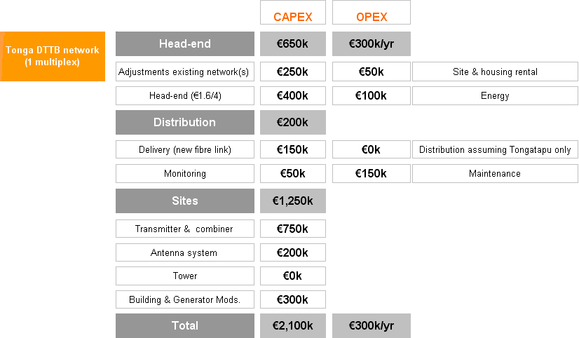

## 5.2 DTTB receiver estimates

In the ITU Guidelines[[60]](#footnote-61), Table 3.3.1 quotes an indicative retail price range for a generic receiver that would satisfy the choices made by the NRT noted in section 3.6, i.e. “Set-top box, no CA, MPEG4, DVB-T” – minimum retail price range USD 70 – USD 80[[61]](#footnote-62).

The ex-factory equivalent prices are difficult to determine but importers typically add about 20 per cent as a gross margin and retailers about 30 per cent as their gross margin. Freight costs are usually additional. An indicative ex-factory unit price might therefore be between USD 45 – USD 50[[62]](#footnote-63).

If by purchasing 13 000 receivers of this generic specification as a single order, bulk discounts could apply, and an indicative price ex-factory for this quantity could be about USD 585 000.

# 6. Planning

The task of planning the whole process of transition to digital television is made easier by the availability of the ITU Guidelines. A part of the challenge to those presented with the task is to be certain that all necessary factors are adequately considered. The extensive experience of those who have implemented digital television transition solutions elsewhere in the world is embedded within the ITU Guidelines, and this will generate confidence.

Annex B to this report is a set of questions compiled by the ITU expert based on the ITU Guidelines that will help the NRT gain confidence that it has considered most policy and market planning issues prior to implementation of its DTTB solution(s).

# 7. Conclusions

A fully functional and proactive National Roadmap Team is operating within Tonga. Government objectives have stimulated the development of its digital television transitional roadmap.

Tonga is a small Pacific Ocean county with a population of approximately 102,000 people mostly resident in groups of islands dispersed across about 700 km of ocean. There are currently about 17,500 households with television in Tonga[[63]](#footnote-64).

Two FTA broadcasters currently broadcast three analogue terrestrial channels on the main island of Tongatapu, the coverage of which also reaches Eua[[64]](#footnote-65), and a localised version of one of those channels is broadcast on the Vava’u island group to the north[[65]](#footnote-66).

The process of transitioning from FTA[[66]](#footnote-67) analogue terrestrial television broadcasting to digital terrestrial television broadcasting, for the 76 per cent of the population who are resident on Tongatapu and neighbouring Eua, will be relatively straightforward from a technology perspective providing that adequate funding is available.

The task of providing a common minimum level of digital television services for the whole nation of Tonga represents a challenge, because of the large distances between the majority of the population on the islands of Tongatapu and Eua, and the smaller community groups on other islands.

The Communications Act 2000 is a comprehensive piece of legislation that already provides the regulator with much of the necessary scope for successful regulation of digital television transition and its on-going operations administration. It does not however address an analogue switch-off process that may require separate legislation.

Digital terrestrial television with DVB-T and MPEG 4[[67]](#footnote-68) is already present in Tonga as the technology of choice for the DigiTV pay television network, and its very existence has influenced the related thinking of the NRT for the FTA DTTB network(s).

There are no television related radiofrequency spectrum conflicts within Tonga or across its national borders, and adequate spectrum does exist for a smooth transition to digital terrestrial television broadcasting.

There are a number of planning issues for the NRT to review prior to any formal ratification of DTTB networks concepts. Chapter 4 identifies and discusses more than ten issues that will need NRT analysis and in some cases resolution. Key topics are:

• Tongatapu coverage – is it actually 100 per cent, or adequate to agreed levels, and if not, how many infill transmitters will be needed?

• Vava’u[[68]](#footnote-69) television availability is less than that available to the people of Tongatapu and Eua – will this be adequate going forward?

• How many DTTB networks? One multiplex should provide sufficient capacity for all anticipated Tonga FTA digital television requirements at the launch of DTTB – will more than one multiplex license be available?

• How many transmitting towers will be used? There are four transmitting towers on the island of Tongatapu – are all needed for DTTB?

• National population coverage – is it required? If so by when and which will be the most appropriate implementation option?

• The relationship with DigiTV – will there be an inter-operational relationship between FTA DTTB and DigiTV?

• The relationship with Sky Pacific – will there be an inter-operational relationship between FTA DTTB and Sky Pacific?

• Funding – will it be available by June 2012?

• Production equipment upgrades – can upgrades to existing analogue production systems be undertaken in the same general time duration?

Mobile television and the delivery of mobile video images to cellular phones via 3G networks services does not exist within Tonga and is not associated with this roadmap towards digital television. The potential remains however, for its possible future introduction.

Subject to ratification by the Cabinet of the Government of Tonga, the date for analogue switch-off is 15 June 2015 and the date for commencement of free-to-air digital terrestrial television broadcasts is 15 June 2013.

The process of defining a roadmap for transition from analogue terrestrial television broadcasting in Tonga has been completed successfully. This document defines that roadmap.

# 8. Recommendations

Analogue switch-off can have a substantial impact upon national communities. In many countries, specific enactments of parliament facilitate in law the right of government to declare an analogue switch-off date, with all associated policy ramifications.

**It is recommended** that Tonga consider whether the passing of an “ASO specific” law may assist the ASO process in Tonga.

The roadmap for transition from FTA analogue terrestrial to FTA digital terrestrial television defined by this report is conditional upon Cabinet[[69]](#footnote-70) ratifying the NRT decisions of section 3.6.

**It is recommended** that Tonga’s NRT seek formal ratification of those decisions, and by direct association, ratification of the roadmap.

Resolution of the issues and discussion topics of chapter ‎0 is fundamental to finalising the strategies associated with transition to digital television for Tonga.

**It is recommended** that Tonga’s NRT examine and discuss all listed issues and use the outcomes to determine:

• the minimum digital television services offering for Tonga’s population;

• whether digital television is to be available to 100 per cent of Tonga’s population;

• whether DTTB could be utilised to deliver digital television to all of Tonga or alternatively whether a mix of satellite with DTTB may be more appropriate;

• the network(s) architectural concept for DTTB in Tonga;

• whether potential relationships with the two pay television service providers could generate national benefits;

• alternative funding sources;

• possible concurrent upgrades to analogue productions systems;

• a strategy for specifying DTTB receivers;

• the DTTB segments of the National Spectrum Plan ensuring that it remains consistent with ITU-R spectrum assignments for ITU Region 3.

Answering the questions listed at Annex B will help the NRT gain confidence that it has addressed the essential policy and market research elements necessary as a pre-requisite for a successful transition to digital television.

**It is recommended** that the NRT answer the questions in Annex B as part of its policy setting processes.

# Annex A: 2011 – Broadcasters’ television infrastructure

Four terrestrial television broadcast facilities exist on the island of Tongatapu; however, of these the Oceania Broadcasting Network facilities are dormant. A collage of photographs for each facility together with its associated operating details follows.

## Tonga Broadcasting Commission

Figure 15: Tonga Broadcasting Commission facilities – Nuku'alofa, Tongatapu

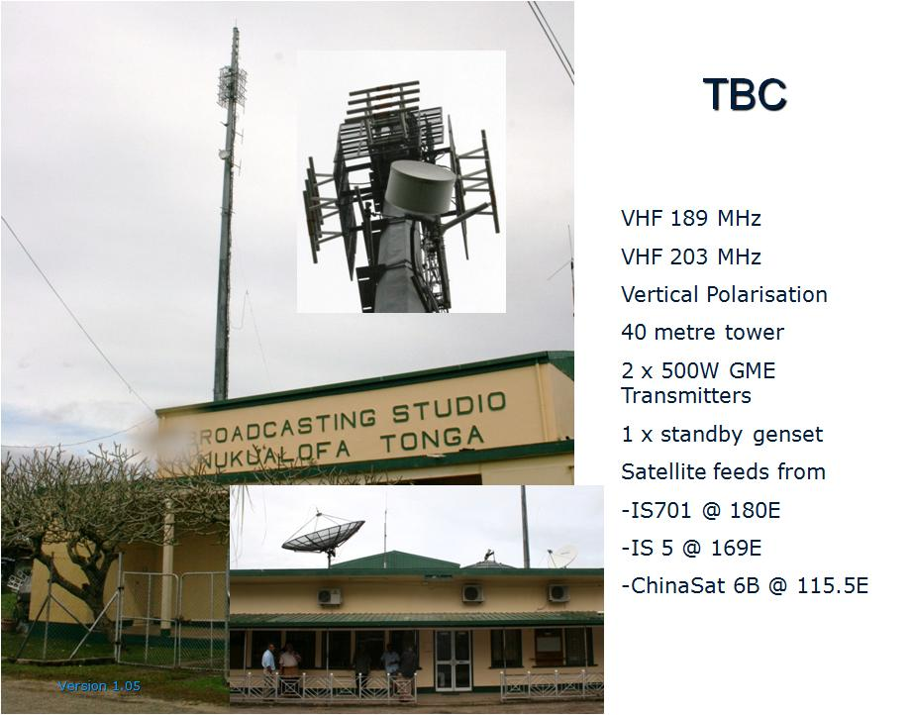

The TBC facility in Nuku’alofa includes company administration, advertising sales, production and maintenance of its radio and television channels. It also includes sales and administration of the local Sky Pacific PayTV service.

Also located at the same facility are the two VHF television transmitters, an antenna combiner, the transmitter tower, and the VHF low gain antenna array as shown in Figure 15.

## Doulos Broadcasting Network

The Doulos (DBN/TBN) facility is at the eastern edge of the Nuku’alofa suburban area (refer Figure 20) and a short distance from the TBC facility. It combines a church with a small television production and administration capability, and an adjacent transmitter hut and antenna mast.

Figure 16: Doulos Broadcast Network facilities – Nuku'alofa, Tongatapu

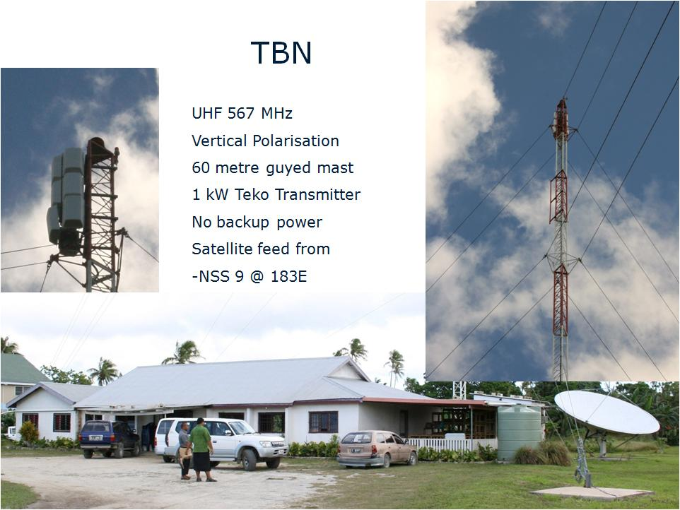

Figure 17: Oceania Broadcasting Network tower – Nuku'alofa, Tongatapu

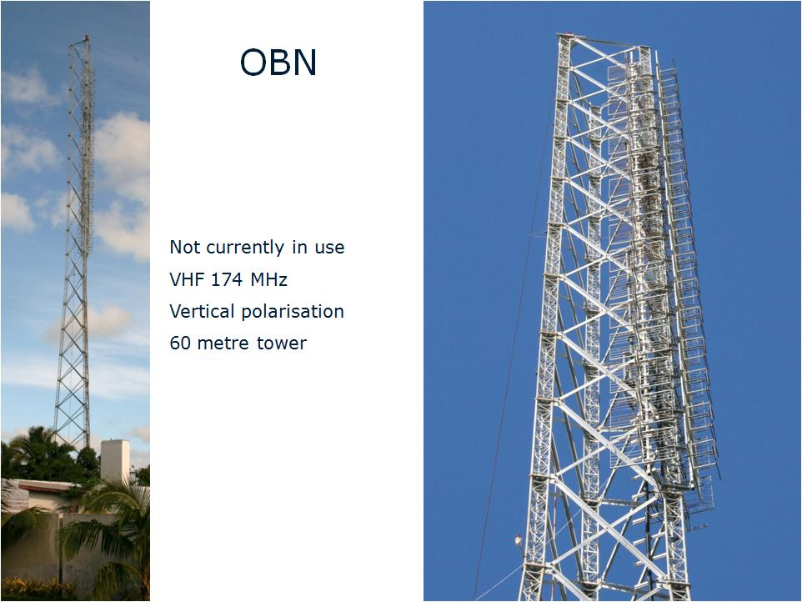

## Former Oceania Broadcasting Network

The dormant OBN tower and VHF transmitting antenna array (higher gain than the TBC antenna) appear well constructed, and may have some potential role in the eventual DTTB solution for Tonga (see Figure 17).

The OBN facility is also in Nuku’alofa very close to the central business district (CBD). It is closer to TBC than DBN/TBN, but in the opposite general direction (see Figure 20).

## DigiTV

Figure 18: DigiTV pay television network facilities – Houma, Tongatapu

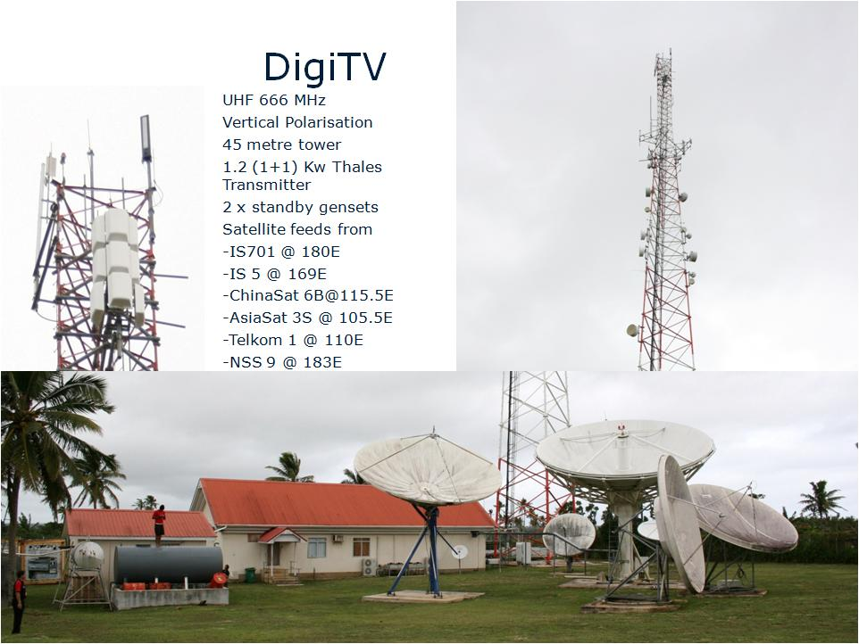

The DigiTV network administration location is located within a Digicel building in the Nuku’alofa CBD. The facilities shown in Figure 18 are remote from Nuku’alofa and comprise a TVRO (television receive only) satellite dish farm, the transmitting tower and UHF antenna, and a building that houses the network infrastructure and operational control equipment for both the cellular and PayTV networks. A robust alternative electrical power system also is present that protects cellular and digital television networks operations. Unlike the other three sites that are only a few metres above sea level, the base of the DigiTV tower has the additional benefit of being about forty metres above sea level.

## Sky Pacific

Sky Pacific utilises the Intelsat 701 satellite that is located at the 180 degrees east longitude geostationary satellite orbital position. Its subscription service uses that satellite’s C-band Pacific spot beam (see Figure 19).

Figure 19: Sky Pacific satellite footprint – Intelsat 701 C-band spot beam

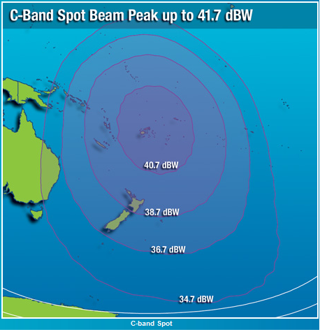

## Transmission Tower Locations

Each of the four facilities described has its own television transmission tower or mast. The position of each is identified in Figure 20. The three FTA towers[[70]](#footnote-71) are sufficiently close to each other that most residential household VHF antennas on the island of Tongatapu (and Eua) pointed towards TBC will also work well with signals transmitted from both the OBN and DBN[[71]](#footnote-72) towers. Residential antennas within Nuku’alofa, and close to these three towers, must rely more upon antenna down lobes and the higher local signal strengths for antenna reception, rather than antenna pointing gain.

The transmission tower of DigiTV is remote from the three FTA towers and places the DigiTV business generally at a disadvantage unless its subscribers already have made provision for the acquisition and installation of a UHF antenna. DigiTV subscribers cannot access any of the FTA channels from within the DigiTV bouquet of channels.

Figure 20: Television broadcast tower locations – Tongatapu

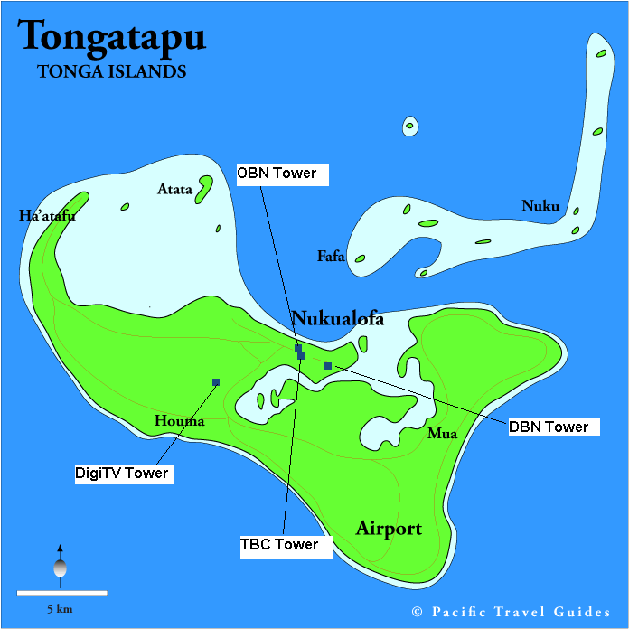

# Annex B: ITU Guidelines – Questions for the NRT







1. That are almost entirely flat [↑](#footnote-ref-2)
2. Tongatapu is about 30 kilometres long [↑](#footnote-ref-3)
3. Tongatapu 71%, Eua 5% [↑](#footnote-ref-4)
4. Tonga 2006 census – total population 101,991 [↑](#footnote-ref-5)
5. Based upon Tonga’s 2006 Census data [↑](#footnote-ref-6)
6. Digital UHF Band V (666 MHz) [↑](#footnote-ref-7)
7. TBN, DBN and DigiTV [↑](#footnote-ref-8)
8. Compared with most other places [↑](#footnote-ref-9)
9. It is important to emphasise that the decisions taken, which included technology specification related decisions, were made in the absence of the ITU expert [↑](#footnote-ref-10)
10. Guidelines for the Transition from Analogue to Digital Broadcasting – ITU 05-2010 [↑](#footnote-ref-11)
11. Of the Government of Tonga [↑](#footnote-ref-12)
12. Via Cabinet approval [↑](#footnote-ref-13)
13. Guidelines for the Transition from Analogue to Digital Broadcasting – ITU 05-2010 – downloadable free from [www.itu.int/publ/D-HDB-GUIDELINES.01-2010/en](http://www.itu.int/publ/D-HDB-GUIDELINES.01-2010/en) [↑](#footnote-ref-14)
14. Contracted by the Asia Pacific Broadcasting Union (ABU) [↑](#footnote-ref-15)
15. Tonga Census 2006 [↑](#footnote-ref-16)
16. About 92% of the population -Tongatapu (71%) + Eua (5%) + Vavaú group (15%) [↑](#footnote-ref-17)
17. From Tonga 2006 Census data [↑](#footnote-ref-18)
18. i.e. – pay television [↑](#footnote-ref-19)
19. Near the airport at the south-eastern end of Tongatapu [↑](#footnote-ref-20)
20. Ethernet based file-transfer-protocol (FTP) [↑](#footnote-ref-21)
21. Once the initial capital expenditure to create a digital terrestrial television infrastructure has been committed [↑](#footnote-ref-22)
22. **DVB-H Mobile TV Downfall Continues**

    April 11, 2011

    [**Ronan de Renesse**](http://www.isuppli.com/Media-Research/Analyst/Pages/Ronan-de-Renesse.aspx)

      
    Dutch telco and broadcast network operator KPN will close its DVB-H based mobile TV broadcast platform on June 1st. The company blames the lack of compatible devices and claims that it lost approximately half its mobile TV subscriber base during 2010. In 2010, Swisscom Broadcast in Switzerland, Mobilkom and Orange in Austria, Mediaset in Italy and Antenna Hungaria in Hungary have either closed their DVB-H services or stopped any plans to launch one.

    **Analysis**  
    Despite strong backing from handset manufacturers, mobile operators and broadcasters at its beginning, DVB-H has failed to take off in Europe for several reasons including little customer appetite for mobile TV, high prices and lack of compatible devices. DVB-H has been on a downward spiral since the end of 2009 when it became clear that neither France, Spain nor Germany would be using the technology in the foreseeable future. Finland and Italy are the only two remaining countries in Europe with a commercial DVB-H based mobile TV service. In Finland, the service is free-to-air and only available on Nokia devices and, in Italy, operator Tre has stopped selling DVB-H devices. Ongoing trials in Russia and Poland could potentially result in the launch of commercial services before the end of the year. Despite the technology also being pushed in some emerging and developing markets where mobile TV is more appealing to consumers, IHS Screen Digest strongly believe that the lack of compatible devices will stop any further progress. The demise of DVB-H doesn't necessarily mean that there is not future for mobile broadcasting in Europe. Key industry players are already talking about DVB-T2 as a potential alternative. The key difference with DVB-H is that DVB-T2 will be primarily used for digital TV broadcasting and won't rely on an unproven mobile TV business case. Mobile operators are looking for ways to offload data traffic from their networks and mobile broadcasting could be an interesting option for them as long as the corresponding costs remain relatively low. Whether DVB-T2 will be able to play this role in Europe remains to be seen. [www.isuppli.com/media-research/marketwatch/pages/dvb-h-mobile-tv-downfall-continues.aspx](http://www.isuppli.com/media-research/marketwatch/pages/dvb-h-mobile-tv-downfall-continues.aspx) [↑](#footnote-ref-23)
23. Mobile Broadcast – Broadcast Engineering July 2011 – World Edition – page 16 – “The graveyard of mobile communication history is littered with failed broadcast standards, even predating cellular telephony itself, culminating with Qualcomm’s abandonment of MediaFLO technology in the United States, along with the failure of DVB-H services elsewhere in the world.” [↑](#footnote-ref-24)
24. The decision to protect Tonga’s ability to potentially license MTV network(s) services in the future was taken on the final day of visit one, (subject to Cabinet approval). [↑](#footnote-ref-25)
25. Section 6 – Guidelines for the Transition from Analogue to Digital Broadcasting – [www.itu.int/publ/D-HDB-GUIDELINES.01-2010/en](http://www.itu.int/publ/D-HDB-GUIDELINES.01-2010/en) [↑](#footnote-ref-26)
26. The “yellow coloured” regulator led functional modules [↑](#footnote-ref-27)
27. The “blue coloured” market led functional modules [↑](#footnote-ref-28)
28. Refer Figure 6.1.2 and Figure 6.2.2 of ITU Guidelines for the Transition from Analogue to Digital Broadcasting [www.itu.int/publ/D-HDB-GUIDELINES.01-2010/en](http://www.itu.int/publ/D-HDB-GUIDELINES.01-2010/en) [↑](#footnote-ref-29)
29. On Tuesday 26 July 2011 at the Tonga Broadcasting Commission Boardroom – Nuku’alofa [↑](#footnote-ref-30)
30. Of the Government of Tonga [↑](#footnote-ref-31)
31. Electronic programme guide – a capability embedded within most DVB based digital television receivers that displays which programmes are on NOW and which are on NEXT as a minimum, and which may also display additional background information relating to some or all programmes [↑](#footnote-ref-32)
32. Of the Government of Tonga [↑](#footnote-ref-33)
33. Tonga 2006 census [↑](#footnote-ref-34)
34. DVB-SI metadata that binds the network together and enables the digital television receivers to function [↑](#footnote-ref-35)
35. Or at a date to be determined by the regulator and the Cabinet [↑](#footnote-ref-36)
36. TBC x 2 analogue channels, DBN/TBN x 1 analogue channel and DigiTV x 20 digital channels (19 of which are encrypted) [↑](#footnote-ref-37)
37. A VHF Band III frequency [↑](#footnote-ref-38)
38. The ITU “Universal Service” [↑](#footnote-ref-39)
39. Potentially the “Universal Service” [↑](#footnote-ref-40)
40. Assuming MPEG 4 compression, DVB-T QAM-64 modulation and good technical quality SDTV broadcasting – noting that TVNZ operated with 2xHDTV and 3xSDTV channels in such a multiplex [↑](#footnote-ref-41)
41. And multiplex [↑](#footnote-ref-42)
42. 40 metre tower [↑](#footnote-ref-43)
43. 60 metre mast [↑](#footnote-ref-44)
44. Refer Figure 20 – Television Broadcast Tower locations – Tongatapu [↑](#footnote-ref-45)
45. 85 metres – due to the combination of height above sea level (about 40 metres) and tower height (45 metres). [↑](#footnote-ref-46)
46. 60 metre tower [↑](#footnote-ref-47)
47. Which does not carry Tongan television content [↑](#footnote-ref-48)
48. Tonga DVB-T MPEG 4 PayTV company [↑](#footnote-ref-49)
49. [www.freeviewnz.tv/products\_and\_retailers/listing/hd](http://www.freeviewnz.tv/products_and_retailers/listing/hd) [↑](#footnote-ref-50)
50. [www.freeview.com.au/products/default.aspx](http://www.freeview.com.au/products/default.aspx) [↑](#footnote-ref-51)
51. Refer paragraph 3.6 [↑](#footnote-ref-52)
52. ‘Other country’ refers to use of the Australian STB with the NZ transport stream, and vice versa [↑](#footnote-ref-53)
53. The software of modern DTTB receivers is configured typically to automatically tune to the local frequencies of the country in which they are designed for sale. [↑](#footnote-ref-54)
54. Figure 3.4.9 – page 169 – Guidelines for the Transition from Analogue to Digital Broadcasting [↑](#footnote-ref-55)
55. Or microwave radio links as may best be appropriate – in Tonga’s environment it is probably better to purchase and install broadcast dedicated systems rather than incur the on-going expensive operating costs of leasing capacity from other service providers [↑](#footnote-ref-56)
56. Figure 3.4.9 – page 169 – Guidelines for the Transition from Analogue to Digital Broadcasting – ITU 05-2010 – NOTE – 2009/2010 European television industry pricing [↑](#footnote-ref-57)
57. ERP – effective radiated power [↑](#footnote-ref-58)
58. Still based upon 2009/2010 European television pricing [↑](#footnote-ref-59)
59. Figure 3.4.9 – page 169 – Guidelines for the Transition from Analogue to Digital Broadcasting – ITU 05-2010 – NOTE – 2009/2010 European television industry pricing [↑](#footnote-ref-60)
60. Page 156 – Table 3.3.1 DTTB receiver price ranges – Guidelines for the Transition from Analogue to Digital Broadcasting [↑](#footnote-ref-61)
61. 2009 – 2010 prices [↑](#footnote-ref-62)
62. This type of purchase is generally only available to PayTV operators who buy directly in bulk [↑](#footnote-ref-63)
63. 2006 Tonga Census [↑](#footnote-ref-64)
64. An island to the East of Tongatapu that contains 5.1% of the population [↑](#footnote-ref-65)
65. Vavaú group of islands contain 15.2% of the population [↑](#footnote-ref-66)
66. Free-to-air, ie not PayTV and not encrypted [↑](#footnote-ref-67)
67. H.264 Advanced Video Codec (AVC), or MPEG 4 Part 10 [↑](#footnote-ref-68)
68. Islands group [↑](#footnote-ref-69)
69. Of the Government of Tonga [↑](#footnote-ref-70)
70. OBN, TBC and DBN towers [↑](#footnote-ref-71)
71. Even though the DBN signal is UHF, it is apparently of sufficient power to be receivable by most VHF antennas. [↑](#footnote-ref-72)