Council 2008  Geneva, 12-21 November 2008 | 
 | Source: Information Services Department
 | 7 October 2008
 | Original: English
Information Technology facilities for delegates at Council 2008

This purpose of this document is to provide delegates documentation on ICT facilities and services offered by the Information Services of the Union.
These services are described through the following paragraphs:
1 Gaining access to the electronic version of the Conference documents
2 Keeping track of recent document additions
3 Downloading multiple documents at once
4 Laptop synchronization with the ITU website
5 Getting short file names for Conference documents
6 Direct booking of the Conference sessions in the user agenda
7 DelWeb - access to ITU’s financial and staffing information

1 Gaining access to the electronic version of the Conference documents
The electronic versions of the Conference documents are available on the ITU website, at the following location:
http://www.itu.int/council/C2008/index.html
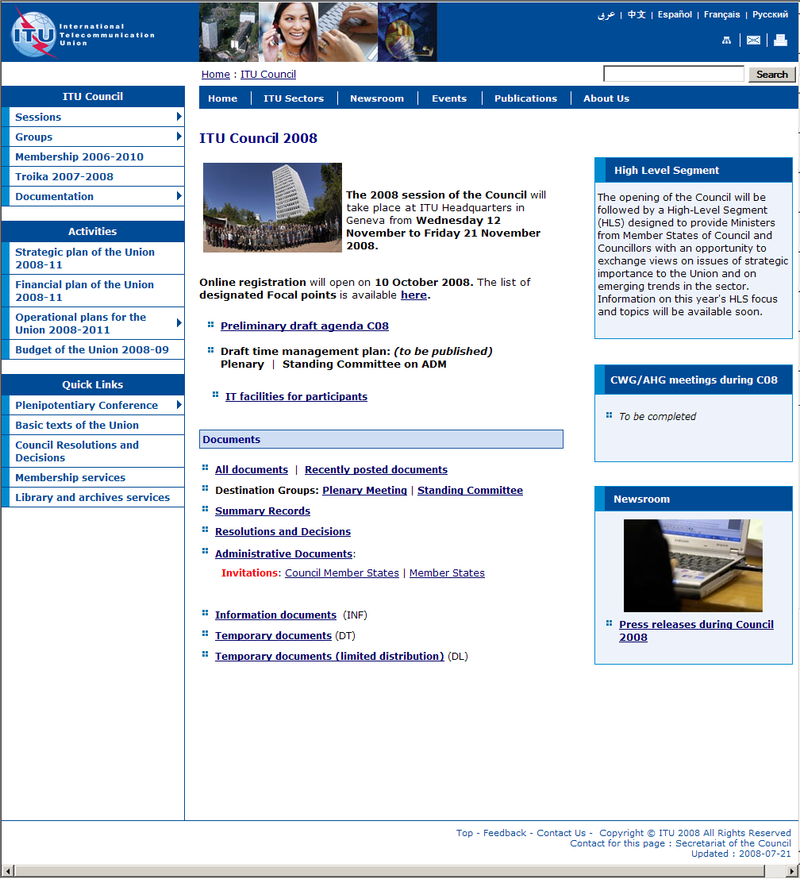
Documents are listed in reverse order along with their: reception date, source, title and destination:
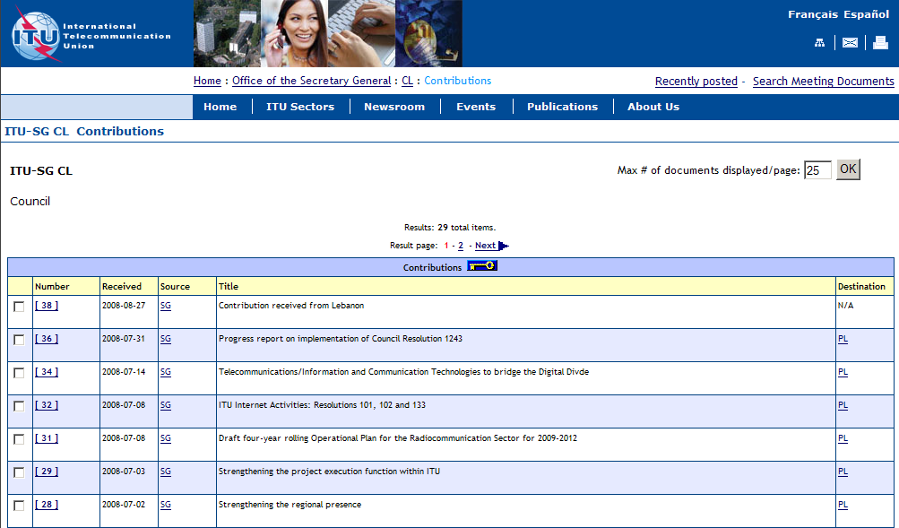
http://www.itu.int/md/S08-CL-C/en
Details about each document are available, comprising eventual revisions, addenda, corrigenda, and the different language versions available. Each version can be downloaded by clicking on the corresponding link: http://www.itu.int/md/S08-CL-C-0036/en
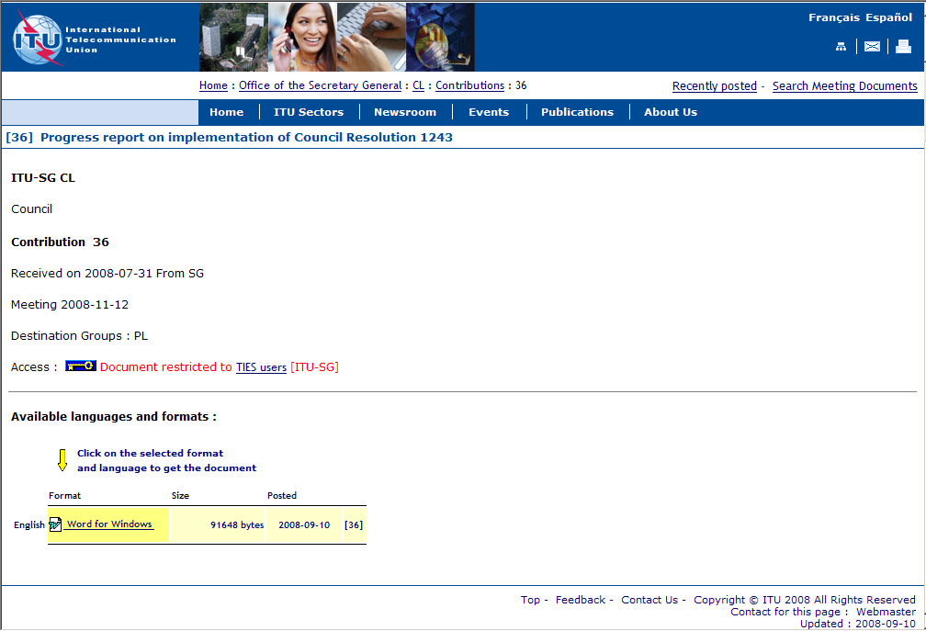

2 Keeping track of recent document additions
A list of recent document additions is available along with the posting date and time, allowing keeping track of new documents availability: http://www.itu.int/md/S08-CL/new/en

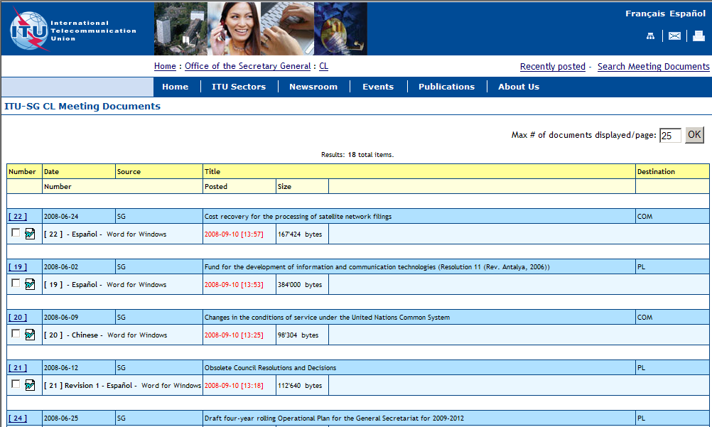

3 Downloading multiple documents at once
In each document list it is possible to select multiple documents using the checkboxes on the left side or the “Check All” button at the bottom. Then the selected documents can be packed into a “zip file” to be downloaded at once, using the “Zip and Download” button.
The zip file is automatically created from:
• the selected documents;
• any existing addenda and corrigenda; and
• associated html pages (similar to the ITU web pages)
in the chosen languages and formats. http://www.itu.int/md/S08-CL-INF/en
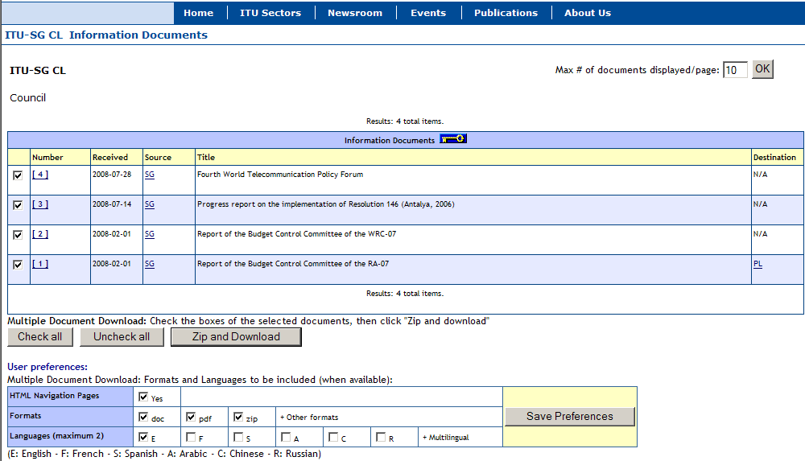
The user has the option to select the formats and languages to be downloaded. It is also possible to get a copy of the html navigation pages (lists of documents). Then the user preferences can be saved (for the whole conference duration).

4 Laptop synchronization with the ITU website
Services are offered to maintain on a laptop a copy of the ITU website related to Conference documents. The strategy for maintaining on a laptop such a website is the following:
• Get the initial set of documents and web pages.
• Update regularly this collection using the multiple document download with the “Recently Posted” option. Select only the documents that have been added since your last synchronization, and make sure the “HTML Navigation Pages” box is checked.

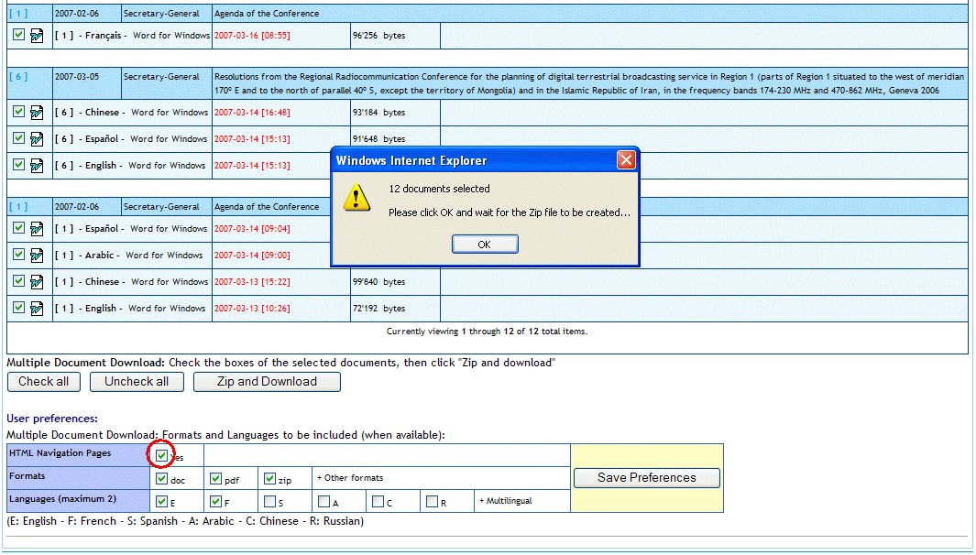
http://www.itu.int/md/S08-CL/new/en

You will get along with the selected documents, up-to-date html web pages (with local links) allowing easy navigation among the documents on the laptop.

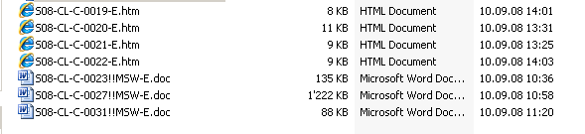

5 Getting short file names for Conference documents
A naming scheme has been developed for ITU Meeting and Conference documents allowing name uniqueness. This naming scheme (long file names) is applied by default to downloaded documents.
For users who prefer to keep a collection of documents with short file names, a utility is available to shorten the names of the downloaded documents in one operation.
This unsupported utility (to be installed on the laptop PC) is available at the following URL:
http://www.itu.int/md/rename_meeting_documents.zip.
Important remark: Short file names are not compatible with the local html pages provided to maintain a local copy of the ITU website.

6 Other services: Direct booking of the Conference sessions in the user agenda
From the agenda of Council session, users can directly book in their agenda the sessions that is of interest by clicking the corresponding icon.
http://www.itu.int/events/ExtWebDailyagenda.asp?sector=ITU-SG

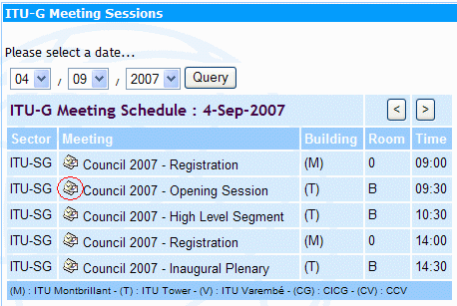

Laptop connectivity

Access to the Internet and Council documents at the ITU Council will be available using the LAN technologies listed below:
- Wired: Ethernet RJ45 10/100 Mbps
  - in Rooms H, K, L, M and cybercafés of ITU
- Wireless IEEE 802.11a/b/g
  - in all conference areas of ITU
To make the most efficient use of network resources, we strongly recommend the following:
- Use wired Ethernet RJ45 connection if available, it provides better consistency and higher throughput.
- Check to see if your laptop has 802.11a capability. If it does not, purchase an 802.11a/b/g card and have it configured before you arrive.
- Ensure that your user account has administrative privileges. Should you require help onsite, the ITU Service Desk staff will only be able to help you if you have administrative rights on your laptop.
- You are kindly requested to test your wireless connection in advance.
- Refrain from using peer-to-peer connections.
Please note that the installation and use of non-ITU wireless access points without prior authorization from the ITU/IS Department is prohibited.

Useful reminders for laptops

Wireless LAN configuration parameters
Please follow the installation instructions delivered with the card. You may need to log in with administrator privileges depending on your PC’s operating system and the card purchased.
The following parameters should be set in order to connect to the ITU wireless network:
• Set the case-sensitive SSID as “ITUdelg”.
• If your wireless card supports 802.11a, add the case-sensitive SSID “ITUdelgA” and move it to the top of the SSID list. This will allow the laptop to choose the 802.11a band whenever possible as it will give you the most bandwidth.
• Most cards are able to search for the radio channel automatically. If your card does not support this function, try channels 36, 40, 44, 48, 52, 56, 60, 64 for 802.11a and channels 1, 6 or 11 for 802.11b/g. You may have to change to another channel if you move to another part of the building.
• Set WEP encryption to “Off”.
• Set Operation mode to “Infrastructure” (not Ad-Hoc or peer-to-peer). The Ad-Hoc mode creates a lot of confusion not only for you but also for other participants.
Notes on using wireless connections:
1) Wireless network connections are good for web browsing but fair for FTP downloads or for telnet applications.
2) Before taking out your wireless card (or any other PC card from its slot), you should first properly stop it, or risk re-installation of the operating system.
3) Wireless cards can drain considerable power from your laptop – so recharge your laptop frequently.

Network Connection settings
Enable DHCP so that your laptop will obtain the IP address and other network parameters automatically
Security
Please be aware that delegate network communication can be intercepted, end-to-end encryption is recommended for confidentiality.
If you are concerned about computer security, please use personal firewall software.
Firewall software configurations may prevent access to local resources (e.g. printers).
All wireless users must have a good anti-virus program that has up-to-date virus database. Viruses can easily spread in the wireless network. You will also need a few spyware detection programs such as Ad-Aware.
Outgoing e-mail
Set up smtp.itu.ch as your outgoing (SMTP) server.
Web-proxy
Ensure that your Internet browser’s proxy setting is removed.
Socks
Disable any SOCKS configurations.

Buying wireless cards

Check Wi-Fi compatibility. ITU recommends the use of 128-bit encryption cards from known vendors to minimize problems and to facilitate troubleshooting.
When buying a new card, be sure to mention that you need “Wi-Fi compatible 802.11a/b/g wireless card with 128-bit encryption” (although encryption is not used at the moment in ITU, it may become mandatory in future and most cards come with it anyway).
Please note that all IEEE 802.11a or 802.11b/g standard compliant cards are not necessarily Wi-Fi compliant, whereas Wi-Fi compliant cards are IEEE 802.11a or 802.11b/g or both compliant. Look for the card with one of the following certificates:
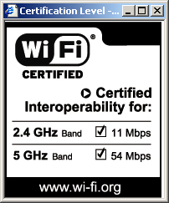
Please check that your card’s model number is mentioned at http://www.wi-fi.com before you buy the card.

Check frequency range
Please note that wireless cards manufactured for some specific countries like France and Spain may not work in ITU because of frequency limitations imposed in these countries.
For 802.11a at the 5 GHz band (5.15 – 5.35 GHz), the following channels are allowed in South Africa:
Channels: 36 40 44 48 52 56 60 64 100 104 108 112 116 120 124 128 132 136 140.
For 802.11b/g at the 2.4 GHz band (2.4-2.4835 GHz), the following channels are allowed in South Africa:
Channels: 1 to 13
To avoid interference and to maximize throughput, we use only three channels 1, 6 and 11 in our 802.11b/g equipment.
Therefore, before buying a card, it is wise to check that it is on the compatibility list at http://www.wi-fi.com and also that your frequency range is valid as described above.

7 DelWeb - access to ITU’s financial and staffing information
e ITU Delegates Website is a nw, secure, online information service designed to assist Membertates in their decision-making.
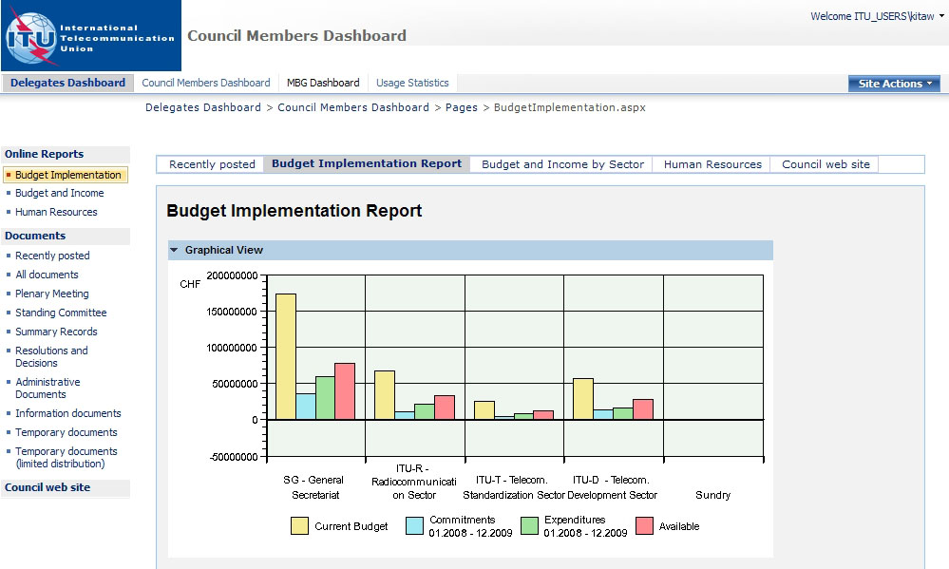

DelWeb, released as a pilot project to the Management and Budget Group (MBG) in June 2008, provides access to the ITU’s financial and staffing information via an easy-to-use, web-based interface.
DelWeb’s first version is now accessible to ITU Councillors from the internet at https://extranet.itu.int/delweb/. Your TIES account credentials are required to access the website.
For detailed information, please refer to the documentation on IT facilities for participants available at the Council 2008 website at: http://www.itu.int/council/C2008/index.html

- DelWeb Functions
The pilot version of DelWeb provides many, pre-defined, online reports on:

- Budget implementation.
- Budget and income by Sector.
- Human resources.

The website is divided into two functional sections:
- Daily Events: This section displays current events related to delegations and is managed by the ITU Conference Service. It provides a quick summary of meetings and conferences as well as details on daily meetings.

- Operational Activities: This section allows Council members to access information on ITU operational activities. Starting from a view of the whole ITU, you can drill-down to find information on a specific department or division.
II. Getting Access
To log on to the DelWeb you will need to use your TIES user name and password.
- Make sure you are connected to the Internet
- Open your browser and enter the address: https://extranet.itu.int/delweb/. Note that the protocol is https, not http.
- You should receive the ISA log-in screen where you will need to authenticate yourself.
- Enter your TIES user name in the format smith@ties.itu.int
- Enter your password.
- Click Log On.

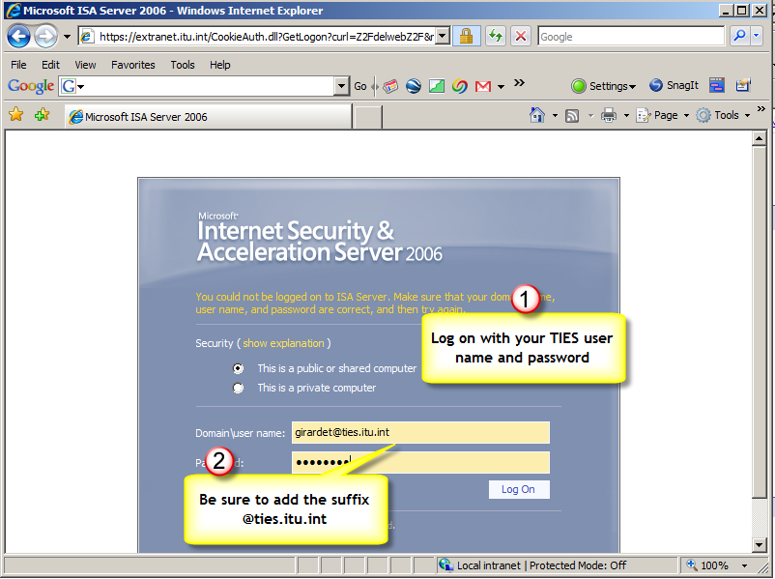

Note: The ITU is in the process of obtaining a certificate for this site. If you receive prompts regarding certificates, please follow the instructions given on the next page.

