WTSA-04
WORLD TELECOMMUNICATION STANDARDIZATION ASSEMBLY
FLORIANÓPOLIS, 5-14 OCTOBER 2004

ITU Document Management System (ITU DMS) Services

This document is aimed at helping users of the ITU Web site to take full advantage of the services offered by the ITU Document Management System (ITU DMS), concerning meeting and Conference documents.
These services are described through the following paragraphs:
- Gaining access to the electronic version of the Conference Documents
- Keeping track of recent document additions
- Downloading multiple documents at once
- Laptop synchronization with the ITU Web Site
- Getting short file names for Conference Documents
- Direct booking of the Conference sessions in the user agenda

Gaining access to the electronic version of the Conference Documents:
The electronic versions of the Conference Documents are available on the ITU Web Site, at the following location:

http://www.itu.int/ITU-T/wtsa-04/index.asp

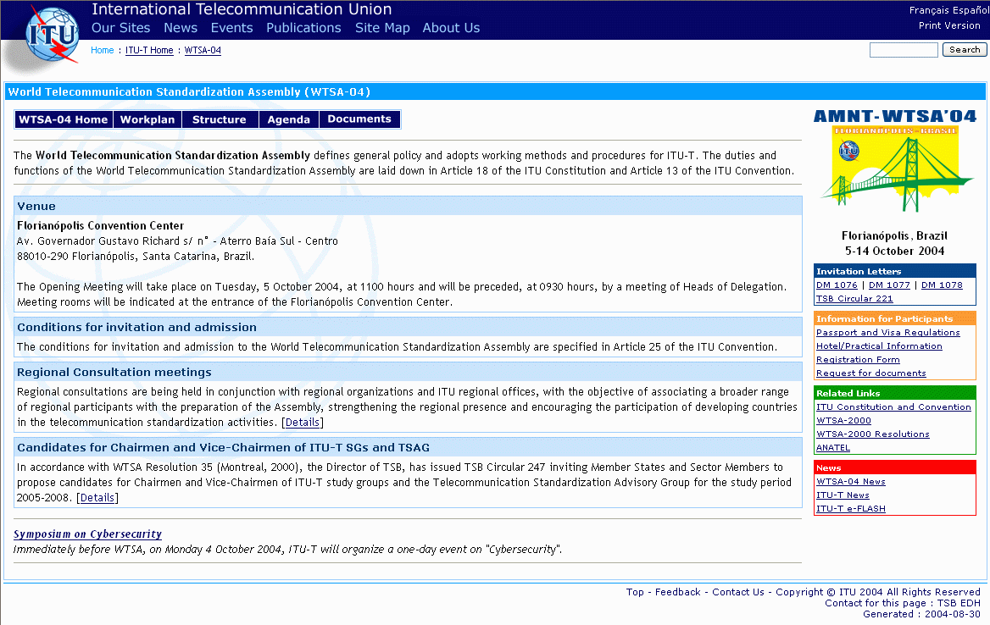
Documents are listed in reverse order along with their source, reception date and title:

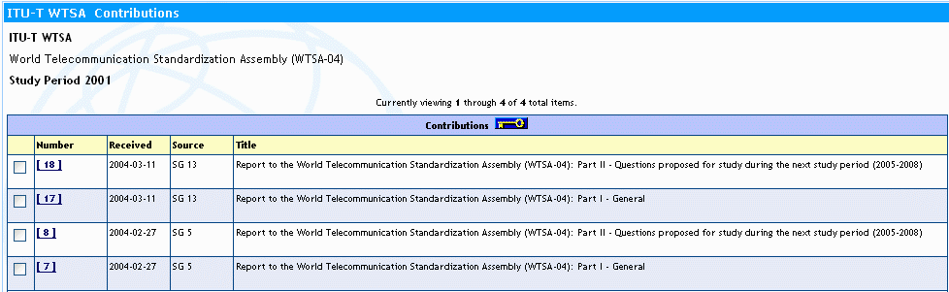

http://www.itu.int/md/meetingdoc.asp?lang=e&type=sfolders&parent=T01-WTSA-C

Details about each document are available, comprising eventual Revisions, Addenda, Corrigenda, and the different language versions available. Each version can be downloaded, by clicking on the corresponding link:
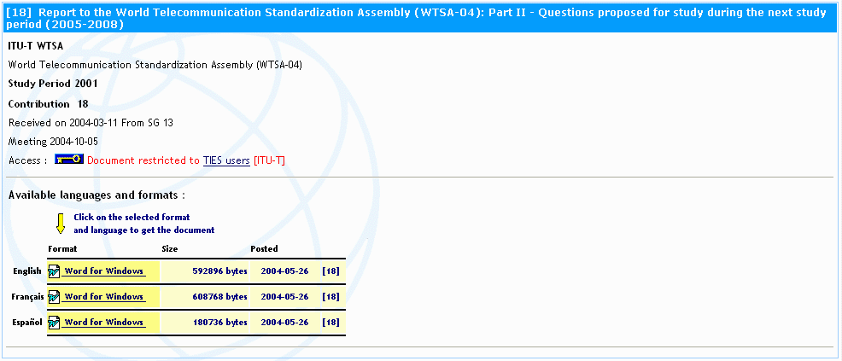

http://www.itu.int/md/meetingdoc.asp?type=sitems&lang=e&parent=T01-WTSA-C-0018

Keeping track of recent document additions
A list of recent document additions is available along with the posting date and time, allowing keeping track of new documents availability:

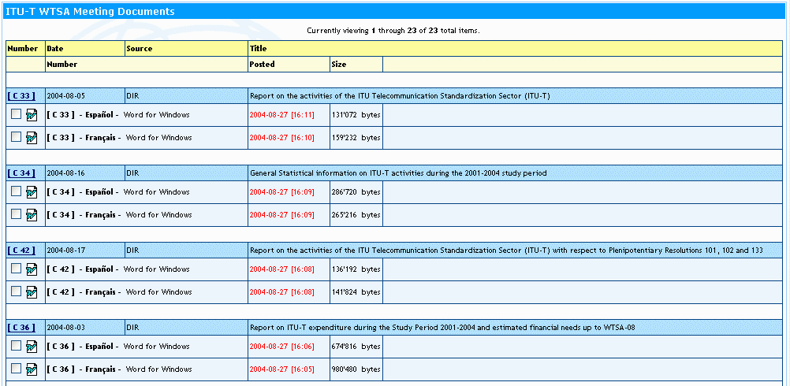

http://www.itu.int/md/meetingdoc.asp?lang=e&type=newitems&parent=T01-WTSA

Downloading multiple documents at once

In each document list, it is possible to select multiple documents using the checkboxes on the left side or the “Check All” button at the bottom. Then, the selected documents can be packed into a “zip file” to be downloaded at once, using the “Zip and Download” button. The zip file is automatically created from
- the selected documents,
- their existing addenda, and corrigenda
- associated html pages (similar to the ITU Web pages)
in the chosen languages and formats.

The user has the option to select the formats and languages to be downloaded.

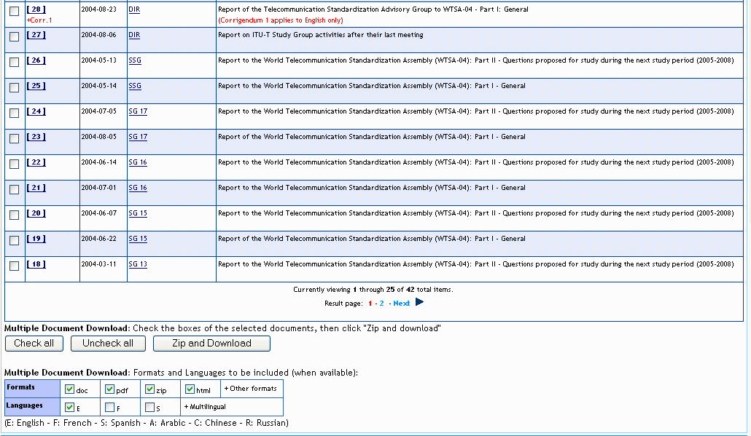

http://www.itu.int/md/meetingdoc.asp?lang=e&type=sfolders&parent=T01-WTSA-C

Laptop synchronization with the ITU Web Site
Services are offered to maintain on a laptop a copy of the ITU Web site related to Conference Documents. The strategy for maintaining on a laptop such a Web site is the following:
- Get the initial set of documents and Web pages.
- Update regularly this collection using the multiple document download with the “Recently Posted” option. Select only the documents that have been added since your last synchronization, and make sure the html box is checked.
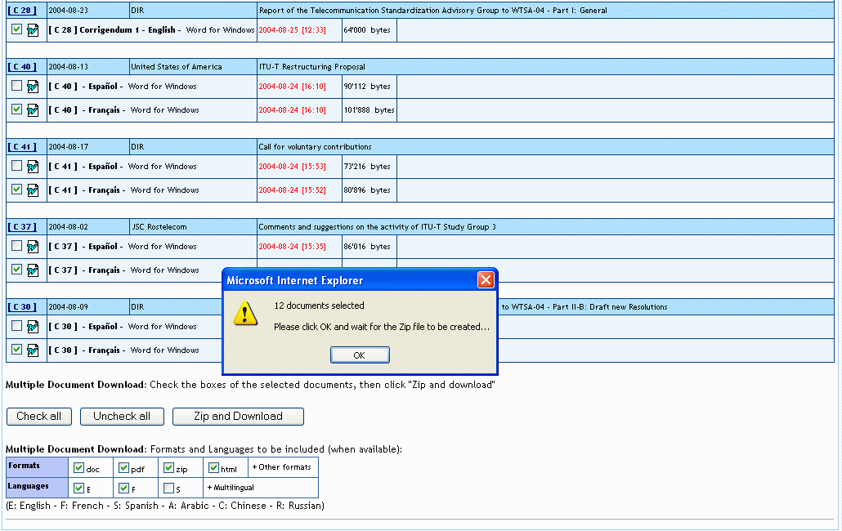
http://www.itu.int/md/meetingdoc.asp?lang=e&type=newitems&parent=T01-WTSA
You will get along with the selected documents, up-to-date html web pages (with local links) allowing easy navigation among the documents on the laptop.
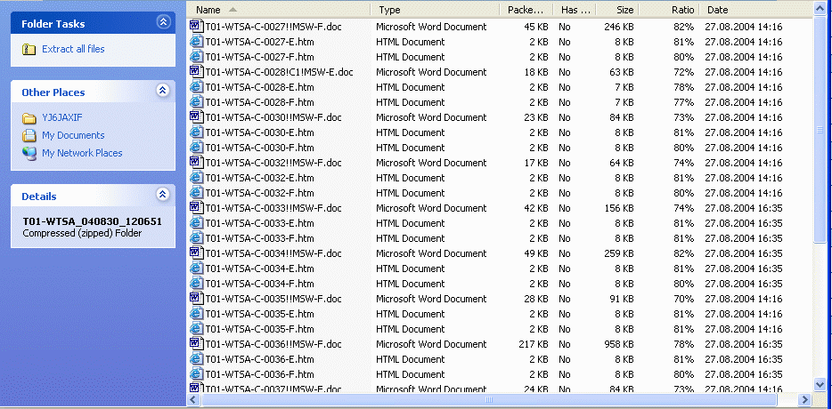

Getting short file names for Conference Documents
A naming scheme has been developed for ITU Meeting and Conference Documents allowing name uniqueness. This naming scheme (long file names) is applied by default to downloaded documents.
For the users who prefer to keep a collection of documents with short file names, a utility is available to shorten the names of the downloaded documents in one operation.
This unsupported utility (to be installed on the laptop PC) is available at the following URL:
http://www.itu.int/md/rename_meeting_documents.zip

Important remark: Short file names are not compatible with the local html pages provided to maintain a local copy of the ITU Web site.

Other services: Direct booking of the Conference sessions in the user agenda
From the ITU-R agenda of Conference Sessions, users can directly book in their agenda the sessions they are interesting by clicking the corresponding icon.
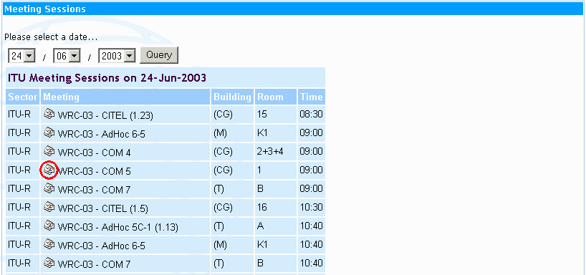
http://www.itu.int/events/ExtWebDailyagenda.asp?sector=ITU-T

