Biography for Dr. Young Kyun Kim

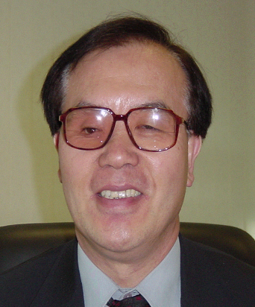
Dr. Young Kyun Kim
Senior Vice President
Global Standards & Research
Telecommunication Network Business
Samsung Electronics, Co. Ltd.

Dr. Young Kyun Kim leads overall global standards and strategy development activities within Samsung Electronics. He manages standards and advanced research on beyond IMT-2000 systems and all IP Networking.

From December 2000, he has served as a Vice Chairman of ITU-T Special Study Group on IMT-2000 and beyond with main interest in mobile core network vision, network mobility management and fixed/mobile network convergence. From September 2003, he has served as a Chairman of APT Wireless Forum (AWF) and also as a Vice Chairman-Asia for the Wireless World Research Forum (WWRF).

Before joining Samsung Electronics, Dr. Kim had 17 years wireless industry standards and research experience in USA including R&D Manager at GTE Corp. and as ITU-R Program Director at INTELSAT.

Dr. Kim has been a Senior Member of IEEE since 1984 and published more than 50 technical papers in IEEE Transactions, presented more than 40 technical papers in IEEE and other conferences and served as an invited speaker for many major Beyond 3G Conferences and Workshops globally. He holds B.S. degree from Seoul National University, Korea in 1972, M.S. from Rutgers University, NJ in 1976 and Ph.D. from Duke University, NC, USA in 1978, all in Electrical Engineering.

