INTERNATIONAL TELECOMMUNICATION UNION |  | Focus Group On Next Generation Networks
TELECOMMUNICATION  STANDARDIZATION SECTOR  STUDY PERIOD 2001-2004 |  | FGNGN-OD-00044
 |  | Original: English
Work Groups | WG2 | Ottawa, 27 September -1 October 2004
OUTPUT DOCUMENT
Source: | (Editor)
Title: | Draft TR-CMIP (Framework for Customer Manageable IP Network)

This is the draft texts of TR-CMIP from FGNGN-ID-00181 (base text) and some inputs of FGNGN-ID-00182, 183, 184, 185 (Korea), FGNGN-ID-00242 (Liaison Statement from SG4), and WG2-WD1-FGNGN (Korea).

(Editor Note) The TR-CMIP is re-produced from Y.NGN-CMIP which is a result of last ITU-T JRG on NGN meeting.

________________

TR-CMIP
Framework for Customer Manageable IP Network

Contents

Introduction
1. Scope
2. References
3. Terms and Definitions
4. Abbreviations
5. Service Definitions and Requirements for Manageable IP Network
5.1 Service Definitions
5.2 Level of Manageability
5.3 Service Requirements
5.3.1 End-User Service Requirements
5.3.2 Network Provider Requirements
5.3.3 VPN Service Requirements
5.3.4 Application Provider Requirements
6. Reference Model of Manageable IP Network
6.1 Introduction
6.2 Reference Architecture
6.3 Capability Sets of Manageability
6.4 Trade-off Analysis of Capability Sets in Scalability, Complexity, and Provisioning Costs
7. Functional Capabilities for Manageable IP Network
7.1 Overview
7.2 Naming and Addressing Capability
7.3 User Grouping and Application Clustering Capability
7.4 End User/Service Registration and Identification Capability
7.5 Information Navigation and Query Capability
7.6 Auto-Discovery and Auto-Configuration Capability
7.7 Information Access Control and Security Capability
7.8 End-to-End Transparency Capability
7.9 Point-to-Point, Point-to-Multipoint, and Multicast Connection Configuration Capability
7.10 Routing and Forwarding Control Capability
7.11 Alternative Path Selection and Multi-homing Capability
7.12 Mobility Control and Management Capability
7.13 Traffic Measurement and Usage Parameter Control Capability
7.14 Bandwidth Assignment and SLA Negotiation Capability
7.15 End-to-End QoS Provisioning and Priority Assignment Capability
7.16 Information Storage and Directory Processing Capability
7.17 Segment OAM and End-to-End OAM Capability
7.18 Virtual Private Network Configuration Capability
7.19 Billing and Charging Capability
7.20 Client/Server Management and Agent Management Capability
8. Service Procedures and Applications Scenarios
8.1 Manageable Naming and Addressing Services
8.2 Manageable Access Control and Security Services
8.3 Manageable QoS Services
8.4 Manageable Mobile IP Services
9. Other Aspects
10. Security Considerations
Appendix
I. Example of Manageable QoS Service Scenarios

TR-CMIP
Framework for Customer Manageable IP network
(Ottawa, 2004)

Introduction

This Draft contains the advanced IP network architecture especially in views of user manageability. The future manageable IP network is not just focused into the data-based network. It equally considers the integrated environments of fixed/wireless network elements to accommodate computer systems, home peripherals and intelligent appliances. The future IP network may compromise of heterogeneous requirements of service quality and physical interface from network and computer and consumer equipments.
A manageable IP network guarantees real-time service quality and multimedia applications. It also provides bandwidth reservation and various service models for present and future business needs. A manageable IP network has the following general features.
- Support business model for differentiated service concept
- Support usage-based billing and charging model
- Stable and secure with reliability performance of 99.999 %

To support these features, the network operator provides network connectivity services to its customers. A service level agreement (SLA) is a formal definition of the contractual relationship between service provider and its customer. It specifies what the customer wants and what the supplier commits to provide. It defines the level for the quality of services provided, setting performance objectives that the supplier must achieve. It also defines the procedure and the reports that must be provided to track and ensure compliance with the SLA.
In this service environment defined by a SLA, the existing IP network should be reliable and manageable. The end-to-end connectivity should meet the negotiated SLAs according to various application types and equipment types. The users may want to include their specific performance requirements in terms of bandwidth, delivery time, and loss performance for each application. But, some users may not want SLA like the existing Best Effort IP service. This will mean no guarantee of delivery time and loss performance.
The SLA for an IP network assure performance and availability of the network to a customer. Until now, the network performance including reliability and availability was the factor that the network operator could control. The network offers a set of SLAs to the customer. The network capabilities which are defined in SLA may be activated by the request-based or subscription-based manners. By negotiating with the customer, the network operator has to control and manage network resources of the IP network. SLAs can be specified in terms of application performance or in terms of the network performance.

(Editor's Note) The relationship of this document to general NGN Requirement [Y.NGN.GRQ], general architecture [Y.NGN.FRA], general management framework [M.NGN.Management /Y.NGN.Management], general quality of service [Y.NGN.QOS] and general end to end quality of service [Y.NGN.e2eQos] is an area that needs further study.

1. Scope

The scope of this Draft covers:

- Definition of and requirements for the service capabilities offered to a customer of a NGN, implemented with IP.
- Reference architecture, from the customer perspective, of a manageable IP network
- Functional capabilities, from the customer perspective, of a manageable IP network
- Applications scenarios and procedures used by the customer of a manageable IP network such as:
- naming and addressing
- access control and security
- selection of QoS type
- Mobile IP services
- etc.

Details of the mechanisms to support these capabilities are out of the scope of this Draft.

2. References

2.1 Normative References
ITU-T
[1] ITU-T Recommendation Y.100 (1998), General overview of the global information infrastructure standards development
[2] ITU-T Recommendation Y.110 (1998), Global information infrastructure principles and framework architecture
[3] ITU-T Recommendation Y.120 (1998), Global information infrastructure scenario methodology
[4] ITU-T Recommendation Y.130 (2000), Information Communication Architecture
[5] ITU-T Recommendation Y.140 (2000), GII - Reference Points for Interconnection Framework
[6] ITU-T Recommendation Y.1001 (2000), A Framework for Convergence of Telecommunications Network and IP Network technologies.
[7] ITU-T Recommendation Y.1241 (2000), IP transfer capability for support of IP-based services
[8] ITU-T Recommendation Y.1221 (2001), Traffic Control and Congestion Control in IP Networks
[9] ITU-T Recommendation I.313 (1997), B-ISDN network requirements
[10] ITU-T Recommendation Y.1311 (2001), IP VPNs – Generic Architecture and Service Requirements
[11] ITU-T Recommendation Y.1311.1 (2001), Network Based IP VPN over MPLS Architecture
[12] ITU-T Recommendation Y.1541 (2000), Network performance objectives for IP-based services
[13] ITU-T Recommendation Y.1720 (2001), Protection Switching for MPLS Networks
[14] ITU-T Recommendation Y.NGN-overview, General overview of NGN functions and characteristics
[15] ITU-T Recommendation Y.GRM-NGN, General reference model for Next Generation Networks
[16] ITU-T Recommendation Y.NGN-FRA, Functional architecture of Next Generation Networks
[17] ITU-T Recommendation Y.NGN-GRQ, NGN General Requirements
[18] ITU-T Recommendation M.3010, TMN Architecture
[19] ITU-T Recommendation M.3400, TMN Management Functions
[20] ITU-T Recommendation M.3050, Enhanced Telecommunications Operations Map
[21] ITU-T Recommendation Y.NGN.Management (M.NGN.Management), Principles for the Management of Next Generation Networks
[22] ITU-T Draft Recommendation Y.17fw, MPLS management framework
[23] ITU-T Recommendation Y.1711, OAM mechanism for MPLS networks

2.2 Informative References

[24] TR-059 DSL Forum, “DSL Evolution – Architecture Requirements for the Support of QoS-Enabled IP Services,” September, 2003
[25] R. Braden, “Requirements for Internet Hosts - Communication Layers,” RFC 1122, October 1989
[26] IETF, Cisco Systems NetFlow Services Export Version 9, draft-claise-netflow-9-08.txt
[27] IETF, LDP Specification, RFC3036, January 2001
[28] IETF, Signalling Unnumbered Links in Resource ReSerVation Protocol - Traffic Engineering, RFC3477, January 2003
[29] IETF, Detecting MPLS Data Plane Failures," Internet Draft draft-ietf-mpls-lsp-ping-05.txt, March 2004
[30] IETF, LSR Self Test, “draft-ietf-mpls-lsr-self-test-02.txt, February 2004
[31] Ian Foster, The Grid: Computing without Bounds, Scientific American, April 2003.

3. Terms and Definitions

- Customer Manageable IP
It defines user manageability of resources and parameters on an IP network. Users can allocate, configure, control, and manage the resources of IP network elements.

- End-to-End Transparency
The seamless connectivity without change of information content between end users, while away from original location with the relevant terminal equipments and applications.
- Information Navigation
- Information Query
- Auto-Discovery
The end users or the network elements find their neighbors automatically by using solicitation and advertisement messages.

- Auto-Configuration
The end user gets its interface address automatically that creates a link-local address and verifies its uniqueness on a link. It should be obtained through the stateful or stateless mechanism.

4. Abbreviations

AAA Authentication/Authorization/Accounting
CDR Connection Detail Record
CoS Class of Service
CPE Customer Premises Equipment
C-Plane Control Plane
DNS Domain Name Service
ftp File Transfer Protocol
M-Plane Management Plane
MPLS Multi-Protocol Label Switching
P2P Point to Point
P2MP Point to Multipoint
PABX Private Automatic Branch Exchange
PDA Personal Digital Assistant
PKI Public Key Infrastructure
QoS Quality of Service
SIP Session Initiation Protocol
SLA Service Level Agreement
SLS Service Level Specification
VPN Virtual Private Network
VTR Video Tape Recorder
UNI User Network Interface
U-Plane User Plane
UPC Usage Parameter Control
URI Uniform Resource Identifier
URL Uniform Resource Locator
XML Extensible Markup Language

5. Service Definitions and Requirements for Customer Manageable IP Network

5.1 Service Definitions

The customer manageable IP service is defined from the users’ point of view. It is clearly different from the existing network service concept. Figure 1/TR-CMIP shows the service concept of the customer manageable network. The network providers construct the network, but they may not be responsible for developing services. The customers can create and develop their own networking services with the help of the network provider. The network capabilities offered to the customers include how to control and manage network elements and their resources. The network capabilities can be classified into a set of menus. A set of menu of network capabilities are specified in terms of a number of SLA parameters. The customer manageable IP service is defined as follows:

- A customer could choose end users which may be human, terminal equipments, or applications.
- The customer could create their own services and network configurations (e.g. virtual private networks (VPN)) with relevant network resources provided by the network providers.
- The customer could choose some control and management functions over their own network. In order to carry out these functions, the customer could choose from the sets of control and management functions, offer and negotiate service level agreements with network providers on QoS and network performance including security capability.

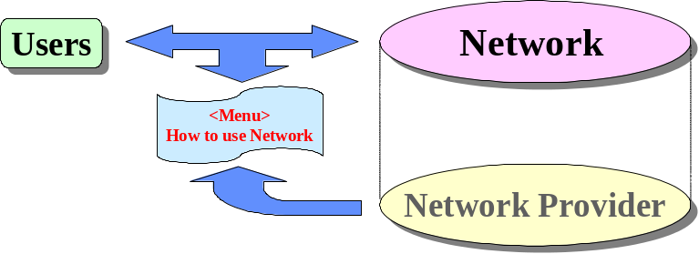
FIGURE 1/TR-CMIP Service concepts of the Customer Manageable IP Network

From the information value chain model of global information infrastructure (GII), the ‘customer’ may be an individual, information agents/brokers, information providers or information service providers [1] – [3].
The menus of network capabilities can be chosen through individual functional blocks or service blocks and their combinations. A functional block can be divided into manageable entities of network resources. The lowest level of manageable resources may be storage, bandwidth, processing time, etc. The highest level of manageable blocks can be distance learning, telecommuting, electronic commerce, telemedicine, on-line entertainment, etc. Some resources dedicated to a group of users are used as a menu of the VPN. Also, some resources are combined with associated technologies and service architectures such as databases, secure networks, WWW, or Java, etc.

5.2 Level of Manageability

The network capability sets are classified into various levels of manageability. They depend upon the points of views of both the customer and the network operator. The detailed means of performance are beyond the scope of this Draft.
The level of manageability can be divided as shown in Table 1/ TR-CMIP.

Table 1/TR-CMIP Levels of Manageability
Levels | Descriptions | Features | Remarks
0 | No Management | No monitoring,  No Resource Control | - No mechanism to detect network fault and congestion.  - No mechanism to control network resources
1 | Overall Network Resource Management | Overall monitoring,  No Resource Control | - Notify overall network fault and resource status by network provider  - No resource control by the customer
2 | Group level  Resource Management | Group level Resource  Monitoring and  Control | - Notify group level network fault and resource status by network provider  - Customer manages the group level resources
3 | Individual  Resource Management | Individual level Resource  Monitoring and  Control | - Notify individual network fault and resource status for end-to-end connectivity  - Customer manages the end-to-end resources

The group level manageability manages the same level of network resources for a set of user groups according to service/application types. It is applicable to the group of virtual private network users. For resource management, the multiple sets of individual resources that are normally dedicated to a single user can be grouped into a single entity of manageability. A single resource entity can also be shared within the same group of users. The same resources can also be shared by different user groups.

(Notes) The accuracy or granularity of manageability of resource parameters is beyond the scope of this Draft since it depends upon the nature of implementation. Some of the manageable functional capabilities are described in section 7.

5.3 Service Requirements

The requirements for customer manageable IP services are divided into end user service requirements, network provider requirements, VPN requirements, and application provider requirements. According to information value chain model, the network providers are responsible for communication and networking of information, for which information processing and storage capability are required. The VPN is to provide the dedicated network resources for a group of users. The application providers include information service brokers and information service providers.

5.3.1 End-User Service Requirements

The end user service requirements can be specified in terms of application level performance or in terms of network level performance. The network operator will not be able to provide the application level requirements to its customers and can provide only network level requirements. But the application level requirements need to build up from the network level requirements. The performance requirements of end-user service include as follows:

- Availability (e.g., 99.999 %)
- Response time (example, less than 5 ms to download a file of 1 Mbytes)
- Service blocking probability including network access blocking
- Service priority and QoS/CoS

5.3.2 Network Provider Requirements

The network provider supports communication and networking services. The network level service requirements specify in terms of network performance parameters between one or more interface points which are in the administrative domain of the network operator. They also include network connectivity, Authentication/Authorization/Accounting (AAA), access filtering, customer service and troubleshooting.
Depending on service and application types (for example, messaging, retrieval and distribution services with/without individual control, etc.), network providers may have the relevant processing and storage capabilities as well as intelligent telecommunication service capabilities. The network can provide the add-on capability such as information query and navigation and name/number/address portability. Then, the network provider requirements may include the performance of information processing and storage. Their requirements are described as follows [refer to I.356 and Y.1541]:

- Network access capabilities:
  - Create/update/delete user profiles including user name, number, subscripted services, etc.
  - Advertisement/solicitation of name, address and number
  - Assignment of network addresses and address filtering
  - Authorization/authentication to identify user (e.g., query for user ID, password, certification, etc.)
  - Customer service and troubleshooting of network access problems
  - Name/number/service portability, navigation, name notification and name database management
  - Accounting of user’s service utilizations for billing

- Network performance parameters:
  - Packet error rate, packet loss rate
  - Round trip delay, one way delay and delay variance
  - Availability (system uptime, mean time to failure, mean time to repair, etc.)
  - Peak bandwidth, available bandwidth, minimum bandwidth
  - Round trip delay of location identification for mobility
  - Access blocking probability and service completion probability
  - Traffic monitoring and statistics (e.g., number of packets to be received or transmitted, number of packets discarded or received in error, etc.)

5.3.3 VPN Service Requirements

VPNs over manageable IP networks show diverse configurations and approaches based upon necessary service features at customer premises. One network provider may operate a different VPN separately, using physically different links and routers. However, the cost savings can be obtained if the network provider can share the physical infrastructure among the different VPNs. Then, the VPN service requirements are basically the same as those of the network provider. Additionally, the following service requirements can be specified:

- Configuration and operation of VPNs
- Security including VPN authentication and authorization

In addition, the following requirements will be necessary to support diverse VPN service features over manageable IP networks:

- VPNs with multiple dimensioned virtual networking
- VPN QoS/Resource negotiation with Policy Server
- IPv6 networking for IPv6 VPN service features
- IPv4/IPv6 VPN services with mobility
- Interworking in routing/forwarding functions of IPv6 VPN over MPLS
- IPv4/IPv6 VPN service level negotiation

Furthermore, if IPv6 VPN is applied to manageable IP network, additional interworking functions are necessary. In particular, it should adapt some interworking functions to provide the destination IPv6 VPNs with IPv6 addressing features.
It is necessary to dynamically configure VPNs with intelligent features. The active configuration features will be very helpful to provide user controllable services among VPN users via manageable IP network.

5.3.4 Application Provider Requirements

The application provider uses a common infrastructure owned by the network provider to provide application or network services to those subscribers whose IP addresses are assigned and managed by the network provider. For example, an application provider may offer gaming, video on demand, filtered Internet access via IPsec or various IP tunneling services. It is envisioned that the service environments of the application provider will be user-level rather than network level. Network elements used by the application provider can include application servers and directory servers as well as switches/routers.
The application provider requirements have similar levels with network provider requirements for network access capabilities. They include authenticating users, assignment of user profiles with preference, customer service and troubleshooting of network access and application-specific problems. They also have the ability to determine traffic usage for accounting purposes and billing.
The application provider requirements depend upon specific applications. They are specified according to the number of application clients as well as the capacity of the application servers and the capacity of the network that connects the clients with the application provider. The performance requirements of application provider are as follows:

- Transfer priority and QoS/CoS
- Security including access control and authentication
- Performance monitoring
- Identification of user, service, and terminal type
- Redundancy of servers (or reliability of servers)
- Clustering of servers
- Round trip delay of naming and identification
- Service completion probability
- Name/number/address/service portability
- Name/service advertisement and solicitation
- Information query and navigation including database management

6. Reference Model of Customer Manageable IP Network

6.1 Introduction

This section provides the reference model of customer manageable IP network. The user network interfaces (UNIs) are the demarcation points between the user domain and the network domain. Also, their functions are identified at the User-Plane (U-Plane), the Control-plane (C-Plane), and Management-Plane (M-Plane). The detailed functional specifications at each interface are beyond the scope of this Draft.

6.2 Reference Architecture

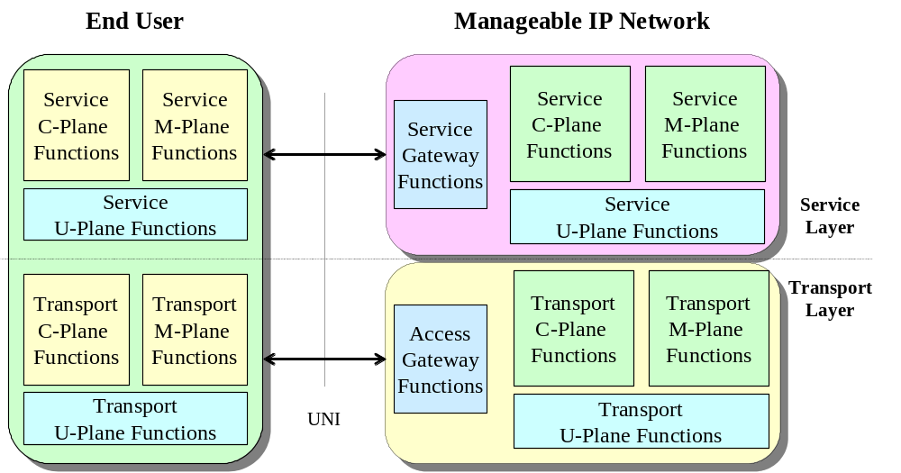
FIGURE 2/TR-CMIP
Reference architecture of customer manageable IP network

Figure 2/TR-CMIP shows the reference architecture of customer manageable IP network. According to the general reference model of Y.NGN-GRM, the customer manageable IP network is divided into service layer and transport layer. The functions of each layer are divided into the User-Plane functions, the Control-Plane functions, and the Management-Plane functions. The transport and service interfaces between end user and network are guided by access gateway functions and service gateway functions respectively. The detail access gateway and service gateway functions are beyond the scope of this Draft.
The business processes in M.3050 and the FCAPS Management Functional Areas in M.3400 should be considered along with the manageability of IP-based networks and services.

6.3 Capability Sets of Manageability

The manageable functional capabilities are provided by the network which is operated by network providers, VPN providers or application providers. The end users choose a set of customer manageable functions according to their desired services and applications. At the transport layer, the functions of the manageable IP network are controlled by end users. The end user also controls the manageable IP network at the service layer.
The manageability level can be classified into implementation stage or control depth of the network. Depending on services and application types, a number of capability sets of manageable functions could be offered to the users. For example, the current router-based IP network does not intend to provide any manageability functions when the end user experiences difficulties to control the IP network elements including routers and servers for their specific applications. The source routing or the destination option in IPv6 can give a kind of manageability function since the routing path can be selected by the user. Also, the existing telephone network like PSTN does not provide any manageability function since users cannot choose any QoS level.
A number of capability sets are defined according to end users’ applications and business needs. The manageability sets can be classified into the following categories:

- Telco-based services and applications (e.g., fixed/wireless telephony, PABX, various access/trunk/home gateways, intelligent call centers and servers, etc.)
- Broadcast-based services and applications (e.g., interactive TV, video conference, satellite TV, etc.)
- Computer-based services and applications including Web services
- Electronic appliance-based applications (e.g., PDA, VTR, consumer electronics, game box, etc.)

The detailed creation of capability sets depends on market opportunities and technical feasibilities. The following categories of technologies are considered from the viewpoint of manageability:

- Fixed and wireless transport technologies
- Switching and routing technologies
- Network control and management technologies
  - Network robustness and resilience, redundancy, intelligent networks, etc.
  - Mobility management including location identification and authentication
- QoS and Traffic Engineering technologies evolution
  - CoS, aggregate QoS, and end-to-end QoS
- Network-based security and PKI technologies
- Navigation/Search/Query technologies including naming and directory services

The capability sets of manageability depend upon network scale, ownership, level of control accuracy, service profile, etc. Table 2/TR-CMIP shows the examples of capability sets of manageability.

Table 2/TR-CMIP Examples of Capability Sets of Manageability'

Classifications | Capability Sets | Features | Descriptions
Public  Networks | P0 | No Management | - subscription by offline
Public  Networks | P1 | Overall Resource Control | - basic OAM including network failure  - monitoring of traffic activity and network status-
Public  Networks | P2 | Group level  Resource Control | - support a group of users and VPN subscribers  - satisfy the group or VPN QoS/SLA including billing options
Public  Networks | P3 | Individual  Resource Control | - handle individual users  - satisfy the negotiated QoS/SLA including billing options
Private  Networks | C0 | No Management | - configured by system operators
Private  Networks | C1 | Overall Resource Control | - basic OAM including system faults  - monitoring of traffic activity and system status
Private  Networks | C2 | Group level  Resource Control | - support a group of users  - maintain the QoS/SLAs for a group of users
Private  Networks | C3 | Individual  Resource Control | - handle individual users  - maintain the predictable QoS/SLA

(Note) It can be noted that the public network and private network can be classified according to ownership, administrative domain, charging option, etc.

The example scenarios for manageability sets of existing IP networks may be as follows:

- 1st stage: priority-controlled IP networks
  - priority and routing control according to source and destination IP address pairs
- 2nd stage: application-based manageable IP networks
  - bandwidth, metering, billing and security options based on application types
- 3rd stage: fully customized IP networks
  - fully customized or personalized end-to-end resource control

From business demands of end user services and applications, the capability sets of manageability could be established on the basis of manageable network elements and technologies. The reference model (as in section 6.2) could be taken as a possible scenario, but it should not discourage any other approaches.

6.4 Trade-off Analysis of Capability Sets in Scalability, Complexity, and Provisioning Costs

The functional sets for manageability can be chosen by end users after trade-off analysis versus their provisioning costs. The functional capabilities which require the trade-off analysis between performance and cost could be identified as follows:

- QoS option: guaranteed, acceptable and best effort
- Security options including authentication
- Billing options including advice of charge

Some capabilities may have a set of granularities depending on implementation. They can be chosen with different weighing factors depending upon end user preferences. Firstly, QoS refers to mechanisms to differentiate performance based on applications or network-operator requirements. It also means providing predictable or guaranteed performance to applications, sessions or traffic aggregates. As regards regional areas, the end user can choose their acceptable QoS by comparing with their provisioning cost. Sometimes, the full sets of QoS capability are used without economic analysis. Economically, users do not want to pay high service costs for their applications. For the issues of authentication, it is also often called 'the identity problem.' Like spam, this is more of a user issue, but it should be solved over the architecture since it may require scalable and hierarchical trust models. From information value chain model, the manageable IP services could be offered with various billing options like flat rate based or service usage-based. The advice of charging may be used before retrieving some video content materials. Also, differentiated billing option can be offered when guaranteeing the delivery time of information materials. A group of users like companies or organizations could be charged for the service usages of their VPNs including fixed and wireless applications.

7. Functional Capabilities for Manageable IP Network

7.1 Overview

The functional capabilities of the manageable IP network are divided according to customer perspectives and provider perspectives. The network providers build the network to be managed by the users in addition to their normal manageable functions. The customer manageable functional sets provided by the network operator are offered to the customers. The customers will use their respective functional sets in order to construct their own manageable network.
Each functional capability for both the customer and the network provider can be categorized following the concepts of the User-Plane, the Control-Plane and the Management-Plane. The relationships of customer manageable functional sets are given in Table 3/TR-CMIP. The manageable objects are divided into the managing entities (active object) and the managed entities (passive object). It assumes that the managing entities are intended to create, initialize, set, and write the corresponding functional capabilities and the managed entities are to receive, read, and release the functional capabilities. The control depth of the manageable objects depends upon the implementation level and the control parameters of those entities.

Table 3/TR-CMIP
Relationships between manageable functional sets in terms of
the U-Plane, the C-Plane and the M-Plane

(Note) The meaning of “x” notation indicates the active management entities which include creation, initialization, write, or remove operations on those management objects. The meaning of “o” notation indicates the passive management entities which include receive, read, process, monitor, and analysis operations.

Functions | Customer Perspectives |  |  | Network Provider Perspectives
Functions | U-plane | C-plane | M-plane | U-plane | C-plane | M-plane
Naming |  |  | x |  |  | o
Addressing | o |  |  | x
User Grouping |  |  | x |  |  | o
Application Clustering |  |  | x |  |  | o
End User/Service Registration |  |  | x |  |  | o
End User/Service Identification |  |  | x |  |  | o
Information Navigation and Query |  |  | x |  |  | o
Auto-Discovery |  |  | o |  |  | x
Auto-Configuration |  |  | o |  |  | x
Information Access Control | x |  |  | o
Information Security | x |  |  | o
End-to-End Transparency | x |  |  | o
Connection Configuration |  | x |  |  | o
Routing and Forwarding Control | x |  |  | o
Alternative Path Selection | x |  |  | o
Multi-homing | x |  |  | o
Mobility Control | x |  |  | o
Mobility Management |  |  | x |  |  | o
Traffic Measurement | x |  |  | o
Usage Parameter Control | x |  |  | o
Bandwidth Assignment | x |  |  | o
SLA Negotiation |  |  | x |  |  | o
End-to-End QoS Provisioning | x |  |  | o
Priority Assignment | x |  |  | o
Information Storage | x |  |  | o
Directory Processing | x |  |  | o
Segment OAM and End-to-End OAM | x |  |  | o
VPN Configuration |  |  | x |  |  | o
Billing and Charging Option |  |  | x |  |  | o
Client/Server Management |  |  | x |  |  | o
Agent Management |  |  | x |  |  | o

7.2 Naming and Addressing Capability

Even if most end-users move continuously, their address and connectivity would be manageable and controllable at any time. In this case, it may frequently bring the binding procedure between permanent address (that is home address) and temporary address (that is care-of-address). The temporary care-of-address may be used to identify the visiting location and it does not play the same role as the fixed home address. The home address looks like a kind of identifier such as an existing telephone number.
To support the manageable IP network, the existing Domain Name Service (DNS) functions based on IP addresses would be extended. Also, the other addressing schemes should be applicable to support the DNS structure. The real-time translation or mapping between the address and domain name server are required to support mobility. The following requirements for naming and addressing are necessary to support the customer manageable IP based services.

- Internet user and terminal identification by number and its naming service
Internet users and terminals can get their address by using name, keyword, number and/or their combinations. Multiple addresses and names for an individual user or a group of users could be possible.
- Granularity of addressing and naming structure
The scalability and granularity on name service could be easily done by the extension of the DNS structure. The DNS mechanism can scale well if the name space is properly assigned for the topology. The naming and addressing for a group of users are also applicable.
- Dynamic update and automatic configuration of name service database
When the IP domain name is changed, it should be able to dynamically check and update its address information in the name service database. The IP clients learn the changed address information dynamically from a name service database. Also, the temporary inconsistency in the information of name service database should be tolerated. The identification information of end user is stored and processed at the relevant location inside the network.
- Selection of naming and addressing types
The users can select one of the various address structure according to network types (e.g., E.164, IPv4, or IPv6, etc.) Depending on their applications, various naming structures can be selected such as DNS, URL, XML, etc.
- Scope of naming and addressing domain including private address
The users can choose the coverage of their names and addresses. Some naming and addressing structure can be used only for intra-domain, regional domain, or specific VPN domains. For example, some organizations can use their own naming and addressing schemes at the geographically distributed location. The specific naming or addressing could be chosen to configure their own network domain such as private intra-network or global VPN. The translations between the private naming/addressing and the global naming/addressing are needed for the end-to-end connectivity.
- Support addressing or naming for unicast, multicast, and broadcast
  - Unicast addressing or naming: It is used to communicate with a single receiver. It requires a mechanism for mapping this address onto the location and the name of receiver.
  - Multicast Addressing: It is used to communicate with a group of receivers. It requires a mechanism for mapping this address onto the location and the name of multiple receivers.
  - Broadcast Addressing: It is used to communicate with all receivers. It requires a mechanism for mapping this address onto the location and the name of all receivers.

In the customer IP network, the name information could be delivered through the IP DNS mechanism. The customers get the name of destinations from the name servers. During the naming and addressing procedure, the name information could be manageable and transferred by user.

7.3 User Grouping and Application Clustering Capability

User grouping capability is mainly used for multicast and VPN service. The customer manageable network requires the proper registration and membership distribution mechanism for user grouping. The flexible grouping mechanism is also used for controlling a number of user groups. Therefore, to give the manageability in the network, a customer can have a right to select, join and leave a group.
Clustering is the common term for distributing a service over a number of servers in order to increase fault tolerance or to support load sharing larger than a single server is able to handle. It is often used for large scale and mission critical applications where there can be no downtime. The application clustering mechanism can be applied to efficiently manage the future very large scale network.
In the customer manageable IP network, application clustering capability is a method of turning multiple computer servers into a cluster. Each of the servers maintain the same information and they perform administrative tasks such as load balancing, determining node failures, and assigning failover duty.

7.4 End User/Service Registration and Identification Capability

The end user can be identified by his name, address, and/or number. The physical attachment point like MAC address is also used to identify him. The relevant binding mechanism among name, address, number and physical attachment point can be needed like DNS.
When the end users move other location, their physical locations have to notify at the corresponding servers or the destination users being active.

7.5 Information Navigation and Query Capability

All the information and applications stored in the network should be addressed and managed by their name and keyword. To handle large volumes of storage information, the database may be searched and sorted with relevant directory concept. The end user and application can be queried by name.
In the future IP network, all information will be available in digital form, which can be used to describe various types of multimedia information. This description (i.e. the combination of descriptors and description schemes) shall be associated with the content itself to allow fast and efficient searching for material of a user’s interest.
For information navigation and query capability, it specifies a standard set of descriptors that describe various types of multimedia information and identify its contents. The “information material” may include textual data, still pictures, graphics, 3D models, audio, speech, video, and information combined in a multimedia presentation. The description of “information material” provides the means to encode audio-visual material as objects having certain relations in time (synchronization) and space (on the screen for video, or in the room for audio). The different granularity of its descriptions could offer the possibility to have different levels of demarcation. Because the descriptive features must be meaningful in the context of the application, they will be different for different user domains and different applications. This implies that the same material can be described using different types of features tuned to the area of application. To get the relevant information descriptions on the customer manageable IP network, it may be required to include the following information as well.

- The form
An example of the form is the coding scheme used or the overall data size.
- Conditions for accessing the material
This could include copyright information, and price.
- Classification
This could include parental rating, and content classification into a number of pre-defined categories.
- Links to other relevant material
The information may help the user speeding up the search.
- The context
In the case of recorded non-fiction content, it is very important to know the occasion of the recording.

In many cases, it may be desirable to use textual information for descriptions. While the users get the relevant information from some graphical interfaces, they may use the searching tools to acquire the identification and access code. (e.g., menu selection, directory service, or search engine, etc.) To help information acquisition, it requires short descriptions for raw information contents. In principle, any type of information materials may be retrieved by means of any type of query material. This means, for example, that video material may be queried using video, music, speech, and text, etc. The indexing information will have to be structured, e.g. in a hierarchical or associative way. The search engine to match the query data and the information description may be needed. A few query examples are as follows.

- Text
Describe the object with the textual information and get a list of keyword pieces containing or matching the content description
- Music
Play a few notes on a keyboard and get in return a list of musical pieces containing (or close to) the required tune or images somehow matching the notes.
- Graphics
Draw a few lines on a screen and get in return a set of images containing similar graphics, logos, etc.
- Image
Define objects, including color patches or textures and get in return examples among which you select the interesting objects to compose your image.
- Movement
On a given set of objects, describe movements and relations between objects and get in return a list of animations fulfilling the described temporal and spatial relations.
- Scenario
On a given content, describe actions and get a list of scenarios where similar actions happened.
- Voice
For example, using an excerpt of the customer’s voice, and getting a list of the customer’s records, video clips where user is singing and the customer is present.

In addition, while users send specific information materials, the server may check whether the other side of the network is ready. To help in information acquisition, an information processing and storage platform may be needed (e.g., servers for messaging, retrieval, and distribution, etc.)

7.6 Auto-Discovery and Auto-Configuration Capability

Auto-discovery and auto-configuration capability are the key technologies that enable the customer manageable IP network to be quickly customized to the environments that they are intended to manage. In order to deploy new services at a rapid pace, it is essential that the discovery methodologies be implemented in an extensible manner, so that new discovery capabilities can be added stage-by-stage to the manageable IP network.
The customer manageable IP network should support an auto-discovery capability that dynamically conveys location information between customer and provider. This capability can be used for other purposes, primarily for service scalability. The advantages of these capabilities are as follows.

- Reduce downtime by eliminating the process of identifying the IP address and manually adding it in the replacement unit.
- Increase safety in the automation system by eliminating the potential for erroneous IP configurations.
- Increase security by monitoring all devices on the network that are making new IP address requests.
- Reduce the added costs in both equipment and support. Eliminating the complexity from modification of switch configuration firmware and/or hardware.

The customer manageable requirements on auto-discovery and auto-configuration are summarized below.

- Automatic host configuration
The automatic host configuration includes the ability to configure the essential parameters of host including address.
- Service discovery
It includes the ability of clients to discover services without the need for prior configuration or any "service discovery" servers being present. Queries are sent via multicast by clients to discover servers on the network.
- Multicast domain name to address resolution
It should be able to resolve domain names using multicast in the absence of a DNS server. In order to support this requirement, an IP host will also have to listen for such requests and respond when the request corresponds to the host's own name.
- Automatic multicast address allocation
It allows an end user to obtain an address allocation for a multicast group for the user own purposes.
- Transition to secure operation
Security configuration constitutes a transition from auto-configuration operation. It is such a vital transition that it must be worked out in details, so that every protocol in the auto-configuration profile will have a "required to implement" security configuration component.

7.7 Information Access Control and Security Capability

The users may at times take network paths with security characteristics. For securing data traffic, it should construct a secure channel to their home networks. It provides the access control technique and cryptographic techniques during registration and activation time. The IP based virtual private network service is mandatory to provide the security with appropriate policy. The set of administrative policies determine both connectivity and quality-of-service for the VPN customers.
The packet filtering capability can provide reasonable protection and access control at the user network interface. It will be applied to various gateway routers or intermediate network equipments between end users and network. The packet filtering and security functions can be combined with specific protocols like SIP, H.323, ftp, or Email, etc.

7.8 End-to-End Transparency Capability

One of the critical requirements for future networks is seamless connectivity when away from original location involving the relevant terminal equipments and applications. Also, the end-to-end transparency and previous QoS are maintained during handover. The future network provider should support the following three transparencies of location, network and protocol. The transparencies are essential for applications to be developed and provide service, independent of the supporting infrastructure.

- Location transparency
With distributed computing technology, third party service providers can access from anywhere regardless of the actual physical location of such server.
- Network transparency
The application server executes the corresponding control process independently of the specific network type of the users’ terminal. The server may neglect the technical features of the target network in that case.
- Protocol transparency
It achieves protocol transparency by providing a standardized protocol interface, realizing independent service control processes, shielding complex network technical details from the service provision platform and developing open communication network interfaces.

The existing IP network cannot support network transparency due to firewall, network address translation (NAT) and so forth. To support the customer manageable IP network, these three transparencies should be manageable by customer. If the customer wants end-to-end transparency, network providers could check whether they could support the end-to-end transparency. The network provider will restrict other functions such as NAT or disguised traffics which can disrupt the transparencies. It should be verified which functions disrupt location, network and protocol transparencies.

7.9 Connection Configuration Capability

The connection configuration specifies who communicates with whom (can be End User, Information Service Brokerage, Information Brokerage, etc.) and does not mention about how the U-plane information is supported. Entities (e.g. sets of users, object entities, sets of processors, etc.) geographically distributed across an open communications environment can communicate with one another through multiple connection setups.
There are three basic connection configurations such as point-to-point, multicast and broadcast. Multicast and broadcast are point-to-multipoint (P2MP or one-to-many) connections. Point-to-point setups may provide unidirectional and bidirectional symmetric and asymmetric connection. This connection setup is one-to-one during a particular session. These are the following connections that may be configured.

- Point-to-point connection can be established, modified, or released by two participating users’ request.
- Point-to-point connection can be established with unicast addressing/naming capability.

In the point-to-multipoint connection, there are two types of connection configuration. One is broadcast that is a connection mechanism to communicate with all entities of a network. The other is multicast that is a connection mechanism to communicate with selected multiple entities of a network. Broadcast connection may provide unidirectional communication between one user and the others. This connection is the one-to-many (all) during a particular initiated session. Sending the broadcast information everywhere is a significant wastage of network resources if only a small group is actually interested in its’ contents.
When sending data to the specific multiple entities, point-to-point connection wastes bandwidth by sending multiple copies of the same data Multicast sends a single copy of the data to those clients who request for it. Multiple copies of data are not sent across the network, nor are data sent to clients who do not want it. Multicast allows the deployment of multimedia applications on the network while minimizing their demand for bandwidth.
Multicast connection may provide unidirectional connection between one user and other users. This connection is the one-to-many relationship continues for duration of a given initiated session. In this connection, one user is root and other users are leaves that are not all users in network. The root can send one copy of each packet and address it to the group of leaves that want to receive it.

- Multicast connection can be established, modified or released in one of the following ways:
    - The root may request the action; or
    - Each leaf may request the action and individually define the full configurations.
    - Each leaf may individually request to be added to (or deleted from) the configuration independent of the other leaves;
    - An external user may request the action

These three simple connection paradigms point-to-point, multicast and broadcast are the basic building blocks through which complex communication topologies (e.g. many-to-many) between multiple entities can be established.

7.10 Routing and Forwarding Control Capability

The proper routing paths between the source and the destination could be decided according to traffic contract and overall network traffic condition. The routing path could be also be chosen by the end user with a definite routing policy. The routing paths between the source and the destination are decided by the forwarding router. For connectionless transfer, the router forwards the IP messages with their respective QoS information along a selected routing link
Otherwise, the switching elements use the routing principle based on IP addresses. They provide reliable connectivity between source and destination both in the connectionless and the connection-oriented transfer mode. In this case, they may not need the address resolution for the destination IP addresses.
In general, the routing algorithm could be classified according to routing decision processes which are generally applied to end-to-end or hop-by-hop connections, a single stream, a block of message streams (designated ‘flow’), or session-initiated message streams. For network scalability and robustness, some combinations of routing decision processes may be used for the specific connections or message flows.
For the connection-oriented transfer mode, the end-to-end virtual connections are established with static or dynamic routing algorithm. The routing paths are decided by the pairs of source and destination addresses. The virtual circuit-based routing mechanism may be used to deliver the large volume of message traffic. As used in the multi-protocol label switching (MPLS) protocol and the IPv6 protocol, the flow labelling technique could be used to speed up routing and forwarding, in which an index number of flow label is associated with a corresponding pair between source and destination addresses. In addition, the flow labelling technique could be utilized to provide the differentiated services with priority class or security level.
For the connectionless transfer mode, the routing algorithm may not perform on end-to-end basis. In this case, the routing path may be decided on each individual packet between source and destination nodes. The flow-based routing algorithm could be applicable to deliver the connectionless IP messages. It may be effective for the session-initiated transaction messages. But, the proper mechanisms are needed to prevent the loops and keep message sequence integrity.
In addition, robust and efficient operation in mobile IP networks is to be supported by incorporating routing functionality into mobile IP hosts. The routing requirements for IP mobility are for further study.
The following routing requirements are necessary to support the IP services in manageable networks:

- Capability to support the QoS enabled path
In case of static routing, the proper routing path able to support QoS should be chosen. In dynamic routing, the QoS specific routing path should be provided according to network load condition and performance parameters. Depending on the routing and scheduling mechanism, user QoS levels may be interpreted into a set of several CoS.
In the customer manageable IP network, new user and devices must be configured according to service templates defined by the service provider and such a service is quite repetitive. The C-plane/M-plane could centralize such a process to guarantee coherence of parameters and accelerate deployment by automating the U-plane configuration. As QoS enabled path configuration highly depends on the user's organization, provisioning templates have to apply to the user's specific requirements (mobility, VPN, security policy, QoS). The U-plane could rely on centralized information and service to get all needed parameters for optimal adaptation of templates to specific needs.

- Capability to provide alternate path
To cope with a failure of routing path, the alternate routing paths should be provided. It is done by a fixed or dynamic routing algorithm for path computation.

- Capability to exchange routing information for internetworking situations
In the internetworking situations, the routing information could be exchanged through the relevant interfaces with QoS parameters and connection modes.
In a multi-domain environment, the end-to-end QoS depends upon the QoS considerations in each domain. In case of a QoS enabled path across two domains, QoS provisioning may reach its limit and such a problem seems difficult to solve. A user should be able to negotiate the QoS parameters with the multiple network providers to support the end-to-end QoS requirements. A network provider may have the network information such as QoS parameters and connection configuration for users and other network providers.

- Capability to provide IP mobility
When the Internet user and terminal are moving, the routing mechanism can help to find the optimal path between the corresponding node and the new location of the mobile node. In IPv6 protocol, the location information of the mobile node can be distributed in a number of IPv6 routers in which the destination option field of the IPv6 header is used at the forwarding process.

- Capability to support VPN:
VPNs may have their own private IP addresses, which are not used for the global routing in the public network. It has to transport the IP messages with private IP address transparently without header processing.

- Capability to support scalable routing
The amount of routing and/or scheduling state in IP network elements must be independent of the total number of paths supported by a service provider and of the number of users. A trade-off introducing a limited amount of routing and/or scheduling state in IP network elements could be considered in order to provide additional capabilities. The routing and scheduling state are dependent on the network provider policy.

- Capability to support flow forwarding
Service Level Specification (SLS) parameters should be specified to enable the user and service provider to support the defined SLS types. The aggregated set of packets is described in the “Flow Descriptor” such as MPLS Label. In order to achieve the guaranteed forwarding properties, the flow should adhere to traffic conformance parameters.
- Capability to support broadcast routing
The network is able to copy packets that allow sources to send packets to all receivers in the network. A primary goal of copying is to ensure that each packet exists only one time on any given network (that is, if there are receivers on a given network, there should only be one copy of the packets on that network). If this connection is used, the network must either stop broadcasts at the given network boundary (a technique that is frequently used to prevent broadcast storms) or send the broadcast everywhere.

- Capability to support multicast routing
The network is able to build packet distribution trees that allow sources to send packets to all receivers that are bound to the multicast spanning tree. A primary goal of these packet distribution trees is to ensure that each packet exists only one time on any given spanning tree (that is, if there are multiple receivers on a given branch, there should only be one copy of the packets on that branch). The multicast tree is built by the network according to network multicast policies that are determined by the network provider.

7.11 Alternative Path Selection and Multi-homing Capability

To deliver reliable service, the user can require a set of procedures to provide protection of the traffic carried on different paths and to support the selection of its’ physical/logical interface. To support this requirement, an alternative path selection and multi-homing capability is needed. [An alternative path selection which chooses a path among different paths between each pair of nodes and multi-homing is to choose the suitable interface to its service and network environment features.]
Alternative path selection has to consider the guarantee of seamless service by avoiding service degradation when network faults occur. There are two types of alternative path selection. The first one is the selection of the backup path for data transfer and the other is the selection of an alternative path among several possible paths available. The former mechanism is a basic and mandatory function to support reliable data transfer. The path discovery and selection algorithms provide the user with an alternative path, where traffic is redirected to the selected alternative path without disruption of services. The manageable IP network maintains its’ route information along the same original path and proceeds to setup the alternative path. The latter mechanism is an optional function to provide better performances. The criteria for considering a path “better” may be based on the length of the path and other QoS parameters. The manageable IP network maintains its route information in the same preplanned alternative path and proceeds to setup the backup path for new protectional capabilities
There are following requirements to support alternative path selection capability:

- Alternative path discovery
Alternative path discovery mechanism deals with finding another route with QoS considerations unchanged from source to destination that is different from the original. The alternative path is provided by the network provider policy to several network entities such as users, network equipments, service providers, etc.
- Alternative path comparison (optional)
[When discovering various alternative paths by network provider, user can determine what the best selected path is].
- Fault detection
When a network fault occurs, the user recognizes it and starts to switch traffic to the alternative path. The network provider must furnish network information to the user in order to inform the network error.
- Change from original path to alternative path
When the network detects fault within a path, the user switches the path to the backup path. This is based on network routing policy, administration considerations and traffic requirements on the working path.

There are some advantages of providing multi-homing capability. The first advantage is redundancy. This is similar to alternative path effect. Network entities such as users, hosts, routers and subnets should be able to insulate it from certain failure modes within one or more network providers. The multi-homing architecture should accommodate continuities in connectivity during the following failures:

      - physical failure such as a physical link damage,
      - router failure,
      - logical link failure such as an unsupported router interface,
      - routing protocol failure such as a BGP peer reset,
      - transit provider failure such as a backbone-wide IGP failure,
      - exchange failure information such as a BGP reset on an inter-provider peering.

The other advantage is to support better performance. By multi-homing, a network entity should be able to protect itself from performance degradations between the entity's transit providers. Multi-homing provides multiple interfaces that are connected to different networks.

These are the requirements related to multi-homing capability in manageable IP networks;:

- Interface selection
A network entity that has multi-homing capability contains multiple physical/logical interfaces. When sending traffic, it must decide upon one interface being a primary interface or unique interface for communicating. Even though the entity does not hope to select every trial, a default interface must be selected by the entity manager. An entity may choose a multi-homed interface for a variety of policy reasons. [A new IPv6 multihoming should provide support for site-multihoming for external policy reasons.]
- Managing multiple interfaces information
A network entity must have the knowledge about its interfaces and all information related with interfaces such as physical addresses, logical addresses, names and connection configurations of each interface. Based on this information, the network entity can provide multi-homing advantages to each connection made.
- Load distribution
In multi-homing conditions, the network entity has several interfaces though it can send or receive traffic on only one interface. If it communicates on more than one interface, there is better performance but this mechanism becomes difficult requiring more complex algorithms such as received traffic ordering, proper traffic distribution to multiple interfaces and management of multiple connection configurations.

7.12 Mobility Control and Management Capability

While most end users are assumed to move continuously, their addresses and connectivity should be manageable and controllable at any time. Furthermore, the hosts for the users need to be reachable in order to allow peer-to-peer communication for future applications. For customer manageable IP networks, the following requirements on mobility control and management capability are concerned:

- Seamless handover: It is important to ensure that connections are not broken when a host changes location-just as phone calls are not immediately dropped when users move around with their mobile phones.
- Reachability: It is equally important as any other mobility aspect. Most users would likely find reachability critical for their needs. Based on the DNS operation, stable addresses are required in order to allow hosts to be reachable.
- Support of roaming between different networks, independent of the different types of access networks and the different network providers.
- Resource availability: Even though a user enters any other region with ongoing service, the service should be continued with the same QoS as the initially negotiated QoS. For this, there should be available resources in the visited region.
- Keeping AAA: After change in locations, the existing authentication, authorization, and accounting capabilities should be kept.

The efficient mobility management procedures should be developed in a combination with security procedures preserving end-to-end transparency. The users and terminals in mobility should be able to dynamically update their location database. It is continuously checked by the mobile users’ database. It establishes the mechanisms that enable a mobile host to maintain and use the same IP address as it changes its point of attachment to the network. It has the relevant registration protocol to authenticate the mobile IP nodes and users. The location resolution procedures are enforced while the IP users or terminals are in motion. For seamless connection, the handover procedure is requested as well. To support mobility control, the following capabilities are necessary:

- Capability to allow a mobile node to be reachable by having a permanent address.
  - Address management function
  - Registration function
- Capability to know where a mobile node is
  - Network information advertising/detecting function
  - Registration function
  - Paging function
- Seamless handover capability
  - Regional mobility management function
  - Multicast function
- Capability to provision proper resources for supporting mobility
- Capability to support inter-domain mobility
- Capability to find optimized route according to the mobility
- Capability to support commonly used AAA, and security schemes according to the mobility

7.13 Traffic Measurement and Usage Parameter Control Capability

UPC is the set of actions the network take to monitor and control traffic. This includes the validity of the connection. The operation of the UPC is to check whether input traffics conform the QoS objectives of a compliant connection or not. However the excessive policing actions on a compliant connection are part of the overall network performance degradation and so safety margins should be engineered to limit the effect of the UPC. Conforming traffic will receive performance guarantees as contracted. Traffic exceeding the traffic conformance test will receive an excess treatment. The forwarding process can further be associated with service priority, and service reliability parameters.
Flow control of UPC guarantees that sources behave as agreed upon during the call setup phase, after a call is accepted and a decision made to penalize or not penalize a cell, traffic or connection when its arrival triggers an overflow. It takes actions if a source does not obey its contract such as tagging or discarding. Violation of its contract takes place when there are malfunctioning equipments, malicious users or delay jitters.
The future IP network has to support directly traffic measurement and usage parameter control functions. To support the manageable IP network, a user can negotiate parameters for UPC with a network provider for QoS which he wants as service. The user can control the QoS based on these UPC parameters. NetFlow describes to provide access to observations of IP packet flows in a flexible and extensible manner [26].

7.14 Bandwidth Assignment and SLA Negotiation Capability

Future IP networks would be manageable, reliable and seamless to satisfy the negotiated SLAs. In addition, end users may choose their service profiles and performance characteristics. In the scalability point of views, the future IP network should be manageable from the home domain to the global area.
The network provider must negotiate and agree with the customer technical details of specific instances of the service product offered. The QoS parameters and limits may be the same as those offered in the standard template or customized to a specific service instance. There are always two SLAs, one for each direction. The contracted values might be different than the analytical computation of the QoS metric in an IP based network. The SLA specification requires extensive testing of the available infrastructure. Usually only upper bounds of QoS parameter ranges can be specified.
The future manageable IP network will provide the customer services as the provisioned SLA. The customer could negotiate SLA with the network provider dynamically online. The customer chooses categories and items of SLA and makes a contract about them with the network provider. The network provider provisions the customer services which are described in the SLA. The customer can change the SLA to the maximum extent the network provider could provide support for.

7.15 End-to-End QoS Provisioning and Priority Assignment Capability

Future network environments promise new capabilities for problem solving and effective distance collaboration. In order for these applications to work to the satisfaction of their users they need performance guarantees for the resources they use. The end-to-end QoS provisioning is required for many applications, such as the upper bound for packet loss and the maximum transmission delay in real-time audio streaming applications..
The customer manageable IP network will allow the customer to select end-to-end QoS for his/her purpose. The network provider should guarantee end-to-end QoS as it finalizes the contract with the customer as part of the SLA.

7.16 Information Storage and Directory Processing Capability

Networks generate a large amount of information for servers, for e-mail addresses and public encryption keys. Compiling and managing this information manually is impossible. Directory processing plays an important role in providing information access across networks around the world. It is involved with many directory operations that require access to information such as customer preferences, patient information, student records and public records.
From a service provider’s perspective, it requires the capability to manage both user profiles (e.g., phone number or address, subscribed service lists) and network/service profiles (e.g., network configuration, topology, and server lists). If a service provider grants an user the capability to manage the user’s profile, the user can manage personal information like password, friends’ address lists, etc.
The service layer at the manageable IP network architecture may provide information storage services for clients. Grid networks are one popular application environment which can provide these services in a secure, flexible, dynamic manner [31].

7.17 Segment OAM and End-to-End OAM Capability

As the network converges onto an IP-based infrastructure, the requirement for both segment and end-to-end OAM capability becomes more pivotal in order to maintain SLA contracts. To construct segment and end to end OAM flows from the perspective of an end system, the MPLS OAM (Y.1711) and MPLS Ping/Trace define OAM mechanisms for the MPLS network [23],[29].

7.18 Virtual Private Network Configuration Capability
(to be included)

The VPN can be overlapped for multiple dimensioned service provider networks. In these multiple dimensioned network environments, VPN service dependent routing and forwarding is required. For the customer manageable IP networks, policy based control functions to provide VPN overlapping functions individually and dynamically is also required. As shown in Figure 3/TR-CMIP, VPN 1 has multiple sub-VPNs for voice, on-demand streaming data, secure information, etc. The sub-VPNs can be interconnected through different Service Provider Networks according to the required QoS and service features. The resource virtualization and virtual networking functions assume an important role with policy-based control functions to support VPN service requirements.

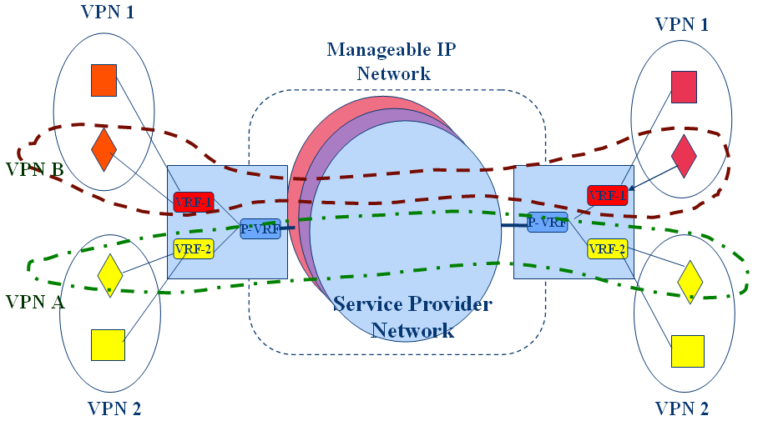
FIGURE 3/TR-CMIP
Example in Provisioning of Multiple Dimensioned Service Provider Networking for sub-VPNs

In order to provide service dependent routing/forwarding features for VPNs, the customer manageable IP network will provide virtual networking and resource virtualization functions. Particularly for IPv6 VPNs, the following functions are provided as illustrated in Figure 4/TR-CMIP.
  - The Provider routers (P) are VPN unaware – scalable
  - Routing for each VPN is the same as regular network routing
  - The choice of the backbone protocols is not constrained by the VPNs and vice versa
  - No protocol modifications in manageable backbone network needed
  - Deployment will not impact normal operation of the provider network
  - Establishment and reconfigure procedures can use directory based tool and auto discovery configurations.

For more demanding QoS satisfactions of VPNs, the resource virtualization function is needed along with virtual networking functions to accommodate VPN service features efficiently in manageable IP networks.
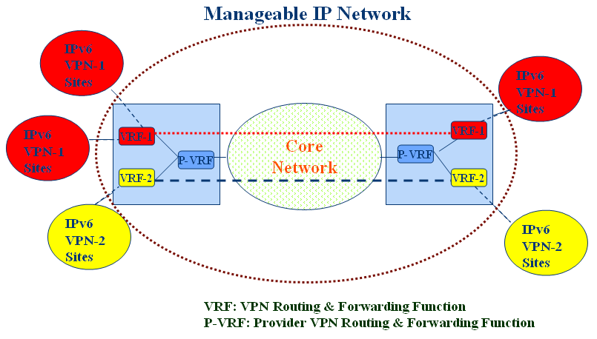
FIGURE 4/TR-CMIP
The Example of Target Route Finding Procedure in IPv6 VPN over MPLS Network

To provide intelligent and dynamic configurations in VPNs, the customer manageable IP network brings up the following issues:
  - For dynamic re-configuration on a VPN node, intelligent features will be necessary to select tunnel(s) for each end system that has to be connected to the VPN. For example, the particular mesh configuration connects all hosts in order to satisfy security and reliability performances.
  - The firewall policies can be chosen to ensure a high degree of security which controls incoming/outgoing unauthorized packets.
  - For QoS-capable VPNs it is important to provide a tailored communications services that could be differentiated in terms of performance, monitoring, accounting, security and privacy. As an example, the ingress node in a manageable IP network performs the aggregate flow scheduling based on multiple individual flows for VPN channels.
  - Hierarchical mobility management (e.g., micro/macro mobility) could be necessary for provisioning mobility among VPN groups.
  - The ingress nodes of a VPN provide dynamic configuration filtering rules with levels of granularity ranging from a single node to an entire VPN. This is perhaps the most appealing feature of VPNs, where it becomes possible to specify which packets may be sent and received at the virtual channels.

7.19 Billing and Charging Capability

[If it applies the relevant traffic control and management functions to some user services and applications, it may need to be charged with relevant service level agreements (SLAs)]. To measure the effects of traffic control, traffic monitoring functions may be needed. In addition, the mechanism for charging of service rates may be needed for audio/video applications.
The billing and charging capabilities are based on collections of the charging parameters. The following charging parameters could be considered:

- Connection mode
- Connection establish and release time
- QoS class and priority
- Traffic parameters including constant bit rate (CBR) and variable bit rate (VBR)
- Connection detail records (CDR) including number of packets to be delivered, tagged and discarded

For end user manageability, some charging parameters could be selected during the SLA negotiation.

7.20 Client/Server Management and Agent Management Capability

The service layer may offer services which aid in managing relations between application clients, servers and agents. Grid networks are popular application environments that can provide these services in a secure, flexible, dynamic manner [31].
The fast growth of network, service and content providers has led to a complex service delivery environment. Therefore, Client/Agent/Server management is required among service providers to support the scalable and efficient deployment of services in this environment and for customers to get various services much more easily. The foundations of the Client/Agent/Server management are inspired by two major models: TINA-C business model and the FIPA model for network management and provisioning. To support the Client/Agent/Server management, the following features could be supported in the future network:

- A service portal that acts as a broker for services and is able to manage the complex service provider relationships that will be prevalent in manageable IP networks. It further mediates between end-users and the other service providers in the service supply chain in order to hide the complexities of configuring and accessing services from the user.
- Separation of service control from service transport, allowing the control of multiple and heterogeneous networks using a common control plane and providing a path to simpler and cheaper network devices. This also enables the future open network marketplace with multiple network providers offering their transport services to the end-user.
- Support of multiple network technologies is also achieved by abstracting the service QoS requirements from the underlying technology. Network providers can offer their transport services and prices to the service portal in such a way that users can select the most appropriate option favorable to them at any point of time.
- A scalable and flexible architecture that enables both service and network plug and play, i.e. dynamic registration of new service and network providers through agent collaboration. In addition, service providers can also introduce new services at run-time and their agents would advertise the real-time availability of each service to the service portal.
- User mobility (user plug and play) enhancement, i.e. users can access the system from multiple Customer Premises Equipments (CPEs) as the CPE agents collaborate with the service portal agent to provide location information of the user.
- Relatively simple distributed software entities (agents) are able to cooperate to implement the complex trading model of the service supply chain

The customer manageable IP network will allow customers to get client/agent/server management on demand of the customer. There could be two kinds of customers, service providers and service clients. If the service provider wants agent management for clients in the customer manageable IP network, the network supports agents of the service provider for provisioning clients. These agents are located at the proper places all over the network and look and act like the service provider to clients. If the service client wants agent management, the network substitutes the client to perform tasks as an agent. This agent will act as a server of a service provider to a client of a service customer and vice versa simultaneously. Clients will release the agent resources of the network once their concerned tasks are executed.

8. Service Procedures and Applications Scenarios

In this section, the protocol procedures for customer manageable IP services and applications are described. The applicable scenarios of manageable IP service can be given as follows, but their lists are not exhausted.

- manageable naming and personal directory services
- manageable access control services
- manageable QoS services
- customer manageable location monitoring services
- manageable home networking services
- client networking Service with QoS and security

(Editor Note) The following examples of customer manageable service scenarios need to compare with the similar IMS services.

8.1 Manageable Personal Directory Services

Manageable personal directory service is a service intended to provide users with access to various personal directory-related information, including the contents of the directory itself. Directory databases are repositories for information about network-based entities, such as applications, files, printers and people. In customer managed IP network environments, the user has his customized directory database in the network and can access the directory any time even if the user moves to a different location. The user can also get the information of other users such as the user’s telephone number and location information using query procedures with directory service.

8.1.1. Objectives of Manageable Personal Directory Services

One of the main objectives for supporting personal directory service in customer manageable IP networks is to have the customized personal directory in the network for the management of user data. For each user a personal set of data has to be stored somewhere in the network and this user profile has to be accessible from every point in the network the user can move around. For supporting this objective, the user profile should be modifiable from all points in the previous network. Another objective is for the network operators to build specialized directory services into their applications to enable the specific functionalities their customers require.

8.1.2. Functional Model of Manageable Personal Directory Services

The basic functions to access and manage the directory service in the core network through gateway are described. Figure 5/TR-CMIP shows the functional model for the manageable personal directory service. This model includes agents, managers and database to support directory service in manageable IP networks as follows.

- Directory User Agent (DUA) and Directory Service Agent (DSA)
The directory service is described as a highly distributed client server system. This may be characterized by a typically small number of hosts (servers, DSA) providing callable services to the other hosts of the system (users, DUA).

- Directory Information Base (DIB)
The DIB is a single, logical, global directory database. The DIB stores information on directory objects such as user profile, location data etc.

- Query Manager and Response Manager
Query Manager and Response Manager of gateway are responsible for processing the query and response message between DUA and DSA.

In this model, the user can directly access his or her own directory service to update and manage directory information for customized directory services.
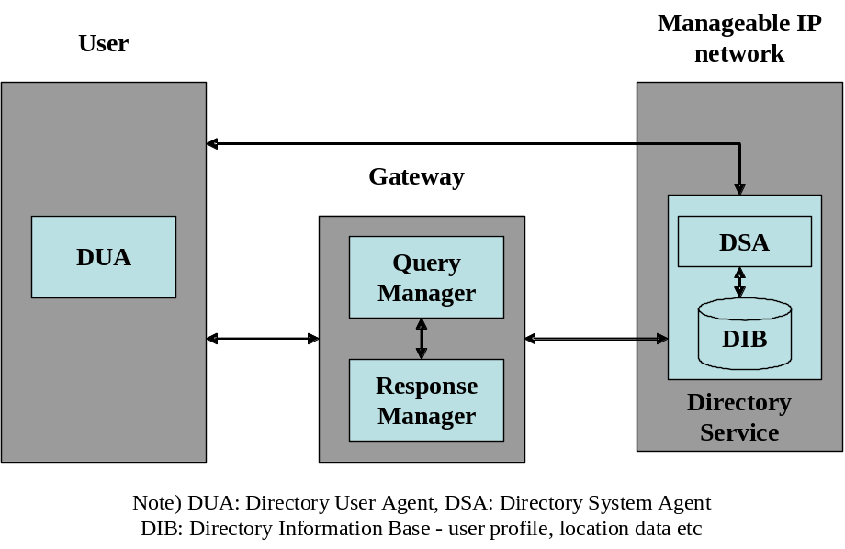
FIGURE 5/TR-CMIP Functional model for manageable personal directory services

The personal directory services offer the following functionalities.

- Creation and deletion of user information in a distributed database maintained in the manageable IP networks
- Download and removal of information copies into network elements
- Modifications to information in user management database and network elements
- Retrieval of information contents from any network site
- Retrieval of object identifiers for users based on properties of their information
- Reconfiguration of information allocation when user changes his or her home site

8.1.3. Service Scenarios and Procedures of Manageable Personal Directory Services

In general, a directory service has to provide four types of services:
- Mapping name → information
For example, an object’s name may be mapped on its network address. Actually, this is exactly the service provided by a phone book or through telephone enquiries.
- Mapping information → set of names
This service establishes a “Yellow pages” function.
- Mapping name → set of names
A set of objects is identified by one single name.
- Secure communication
Authentications as well as mechanisms for electronic signatures are provided.

In manageable personal directory services, the following scenarios are considered.
- Directly accessing user’s own directory between DUA and DSA
- Retrieval of the directory service through gateway

First, the service procedures for accessing user’s own directory are shown in Figure 6/TR-CMIP. The user directly communicates with his or her directory in manageable IP networks. After the authentication procedure is complete, the user can always modify and get his or her user information in his or her directory. User’s location information is updated in the directory in order to always find users in case that the user moves to another location.

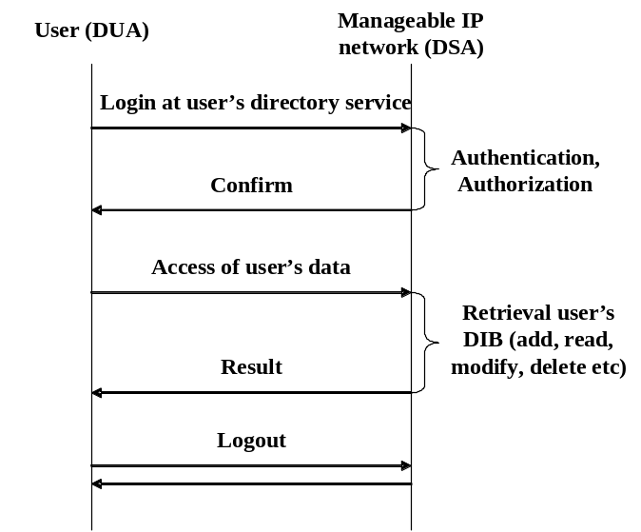
FIGURE 6/TR-CMIP Message flow for accessing user own directory

Secondly, the service procedures for retrieval the directory service through gateway are shown in Figure 7/TR-CMIP. The user sends the query to gateway with the information (name, etc.) that he or she wants to find. The gateway searches the directory service system in the network by Query Manager and sends the information request to the designated directory service system. After retrieval of DIB of the directory service, the gateway is returned the corresponding information (address, number etc) and sends the response to the user through the Response Manager.

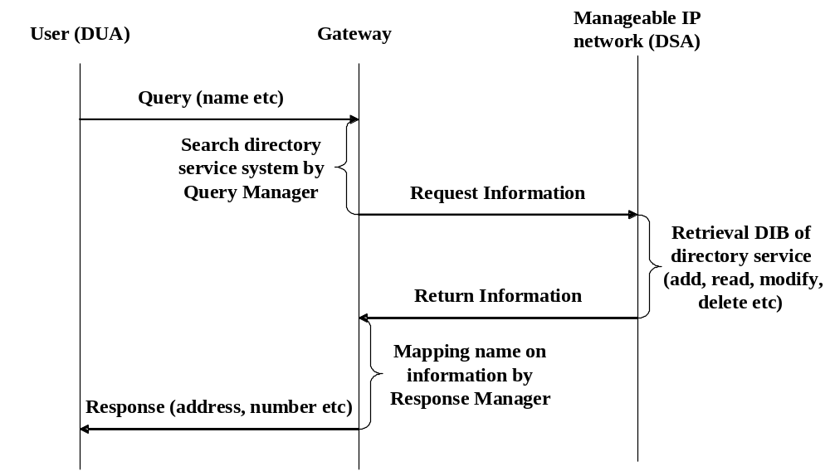
FIGURE 7/TR-CMIP Message flow for retrieval the directory service

8.2 Manageable Access Control Services

Manageable access control is to provide that the customer has some controllability while accessing his own service profiles and the transport capabilities including VPN.

Manageable access control is developed with business model of service provisioning in mind. It gives an insight to provide the customer with superior content retrieval and access while maintaining the economies of scale for the network provider and the customer alike. We describe an access gateway functional block to support the concept of service driven access control in manageable IP networks and show how it can be used to describe procedures to maintain reliable and resilient service provisioning in the context of roaming, integration and internetworking of different domains.

8.2.1. Objectives of Manageable Access Control Services

Reserving a service profile driven access control mechanism for traffic aggregates is one of the key features for manageable IP networks. This is because the user requests may contain application data of different contents and bandwidth requirements. From the perspectives of commercial viability, the customer would want to pay for the networking services only if his or her desired level of content retrieval was satisfied. The existing access control mechanisms for IP networks do not take into consideration the feature of dynamic service profile provisioning to accommodate multiple requests of a customer for multivariable content access. This is the key driving factor behind proposing a service profile driven mechanism for access control.

8.2.2. Functional Blocks of Manageable Access Control Services

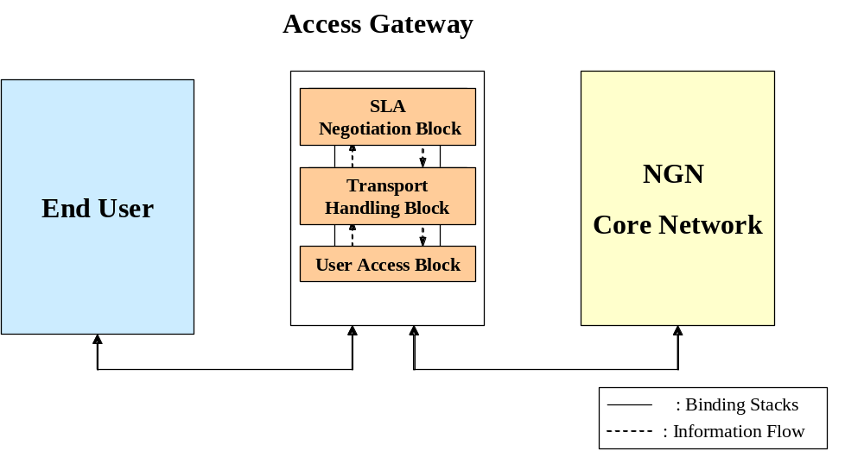
FIGURE 8/TR-CMIP Functional block diagram of manageable access control services

The concept of using functional blocks in intelligent access gateways that are made aware using IP addresses for manageable access control is described. Figure 8/TR-CMIP shows the functional blocks of an access gateway for a manageable IP network that enables service provisioned access control to users. There are three major aspects of the design from the customer manageable access points of view, which are described as follows:

- User Access Block
The User Access Block is where the primary data reduction functions reside and where the user’s request information gets logged first. Information that is deemed critical to manage the network is translated into a standard object format and forwarded to the Transport Handling Block. A User Access Block comprises of software which adheres to open standards. This software is designed to accept traffic flow based on IP addresses and imparts the intelligence to the access gateway for manageable access control.

- Transport Handling Block

The Transport Handling Block provides communications paths with relevant transport management between the User Access Block and the SLA Negotiation Block. All information forwarded from the User Access Block is utilized by the Transport Handling Block to provide information to the network operators. The Transport Handling Block adheres to open standards to provide ubiquitous information access. This allows the Transport Handling Block to share management information stored in distributed database. These databases provide common data storage so that new information contents can be easily inserted into the access handling environment. This is one of the key concepts in manageable access from the customers' point of view where enforcement of service level agreements must be robust and reliable.

- SLA Negotiation Block

The SLA Negotiation Block performs the function of presenting the user's information to the network provider. It has the functionalities for requested SLA negotiation with the network operator based on the user's profile for access control in manageable IP networks. Charging and billing procedures also form an important part of the functionality of the SLA Negotiation Block. It acts as the 'front-end' interface for user-network communications and completes the binding for direct communication with the user once the requested service negotiation and authentication with the network provider is complete. Once this is done, it updates its' reference database about the established session and keeps a tag for billing and accounting processes.

This architecture has two important benefits:
1. It is easy to design and independence of data flow and control information maintenance can be ensured to a very high degree.
2. It involves minimum overhead in communications and is secure in terms of established sessions.

An important feature of the SLA Negotiation Block in manageable access control is dynamism and ability to update easily if the customer's service requests change during an ongoing established session. The SLA Negotiation Block needs only to update its' internal records and communicate the change to the network provider about the change in request. An entirely new session establishment is not necessary. Billing information is passed onto the user once its' session is completed.

8.2.3 Service Procedures for Manageable Access Control Services

- Dynamic negotiation of service profile information:

Dynamic negotiation of service profile information takes place in the SLA Negotiation Block of the access gateway to which the customers are linked with. Network access can thus be partitioned dynamically using the functional blocks of the access gateway for manageable access control.

- Service procedures for manageable access by the user:

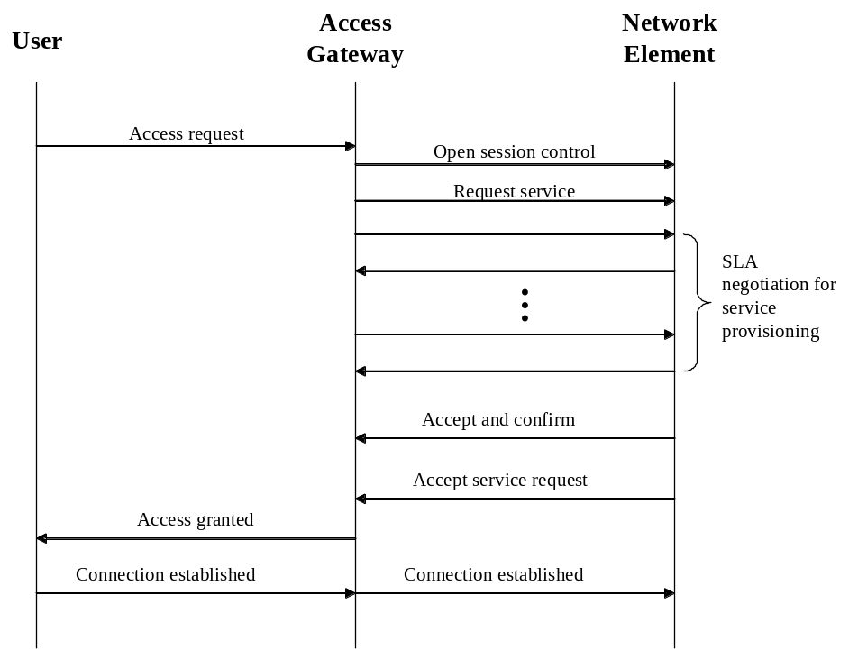
FIGURE 9/TR-CMIP Example of flow diagram for manageable access control services

Figure 9/TR-CMIP shows an example of protocol flow diagram for customer driven access control in manageable IP networks. The user sends in a request to the access gateway with service provisioning requests, whereby the User Access Block looks up the network conditioning database and passes the request on to the Transport Handling Block and thence to the SLA Negotiation Block. The SLA Negotiation Block must provide application multiplexing, which is one of the key concepts in manageable access control. There should be a provision to accommodate changes in customers' service level agreements dynamically in an ongoing established session, and to admit the user profile while roaming. It negotiates the session requirements with the network provider while maintaining a set of default requested objects in its internal database. This is another key feature which enables service provisioning negotiation for manageable access control. Based on the user’s requests, the presentation manager opens a session control session with the network provider and informs the request of services, negotiates about the policy management with the network provider about directory, access control and security issues based on the default stored values and opens the sessions pertaining to bandwidth management and transport.

- Billing and accounting procedures:

The SLA Negotiation Block updates its reference database with the session initiated and starts the system log module once the session is initiated. This is needed for billing and accounting purposes. The logs are important for the collection and distribution of the user's preferences, application requirements, network device capabilities on the network operator side and availing the accounting policy information from the network operator. Once a successful connection with the network provider is done upon authentication and verification of the user profile, it informs the User Access Block and the user starts receiving his service requests.

- Support of mobility and seamless connectivity based on manageable access control:

Since the manageable access control scheme provides gateway access using IP address awareness, it is also important to support cross network policy management for mobile users during roaming. This functional component provides the required policies governing users who access third party networks and cross geographical boundaries. It keeps in constant contact with other cross network location registers of the geographically dispersed but inter-connected networks, exchanging accounting, service feature profile and control data for local and roaming subscribers. If within an established session, there is a change in the user’s service requests, or profile, the SLA Negotiation Block updates its internal database and starts negotiating with the network operator without creating a new session or disrupting the flow in the established one. If the network operator does not entertain this new request, the SLA Negotiation Block informs the user about the unavailability of resources while continuing to service the earlier request. The user has the choice to either go along with or terminate the ongoing session. After the user has terminated the session, the SLA Negotiation Block makes a final write to its internal database about the session statistics and makes a note of the accounting tag. It releases the tokens involved for this session and passes on the information to the User Access Block and thence to the user.

8.3 Manageable QoS Services
(to be included)

(Editor Note) Example scenarios of User-controlled bandwidth management are needed.

8.4 Customer Manageable Location Monitoring Services

Customer manageable location monitoring service is a service to manage other customers’ location information wherever they are at any time. In customer manageable IP networks, the customer’s location information is originally managed by the network provider or service provider. Then, a customer requests other customers’ location information to the network and monitors their location information after retrieving their location information. In this mode of service, a customer could be located at the fixed or wireless/mobile network.

8.4.1 Objectives of Customer Manageable Location Monitoring Service

The main objective feature of customer manageable location monitoring service is that a customer retrieves other customers’ location information from the location information database of manageable IP networks and maintains and manages other customer’s location information to monitor other customers’ location. In many cases, users are interested to communicate with a certain set of their interested peers. Another objective is to provide basic information support to other services such as emergency services and connectivity services.

8.4.2 Functional Model for Customer Manageable Location Monitoring Services

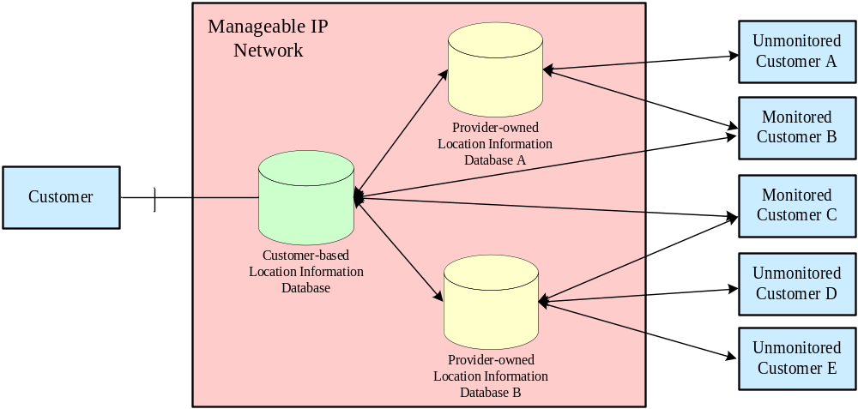
FIGURE 10/TR-CMIP Functional model for customer manageable location monitoring service

The following functions are required to support customer manageable location monitoring service.

- Functions required on the customer side
    - requests about other customers’ locations to the manageable IP network
    - managing monitored customers’ location information

- Functions required on the manageable IP network side
    - managing their respective customers’ location information
    - responding to customer location requests

Manageable IP networks have two types of databases to support customer manageable location monitoring service. One is provider-owned location information database that has raw location information of network customers. This database is an original network location information database such as Home Location Register/Visitor Location Register, Domain Name System, Home Agent/Foreign Agent binding cache. Another is customer-based location information database that contains processed location information of network customers. This database is service dependent location information database, such as GPS location information and location information combined with other customer information such as availability and connectivity.

- Provider-owned Location Information Database
This functional block is to maintain and manage location information of all its’ respective network customers.

- Customer-based Location Information Database
This functional block is to request, update, add, delete other customer location information to Provider-owned Location Information database of other customer and respond to the requested location information.

8.4.3 Service Scenarios and Procedures of Customer Manageable Location Monitoring Services

A customer is interested to know the location information of its peers of interest and manageable IP networks maintain their location information at all places and times. A customer requests their location information to the manageable IP network in the general case. In this scenario, security issues such as authentication and authorization and accounting issues are out of the scope of this draft.

There are two scenarios in this case:

- Customer → Customer-based Location Information Database → Provider-owned Location Information Database
This scenario is a single-mode operation scenario. A customer requests for the other customer’s location information once. The customer-based location information database does not have other the requested customer’s location information. Therefore, the customer-based location information database sends a request to the provider-owned location information database. Customer-based location information database provides the requested information

- Customer → Customer-based Location Information DB → Monitored Customer
This scenario is a continuous-mode operation scenario. A customer requests for the other customer’s location information continuously. After the single-mode operation scenario, the customer-based Location Information Database contains the monitored customer’s location information. Therefore, customer-based location information database issues a request to the monitored customer directly.

In these two scenarios, a customer requests information to the customer-based location information database because the network provider does not want to share its network resources directly with a customer and the provider-owned location information is raw data of network proprietary to the network provider. The provider-owned location information database should manage all their respective customers’ location information.

The first scenario is single-mode operation scenario whose service procedure is shown in Figure 11/TR-CMIP. In this scenario, a customer requests other customer’s location information to the customer-based location information database with a single-mode start message. But, the customer-based location information database does not have the corresponding requested customer’s information and issues a request to the provider-owned location information database to this effect. After receiving the request message, the provider-owned location information database responds with its raw location information to the customer-based location information database. This information is processed by the customer-based location information database and it provides this processed information to the customer who requested for it.

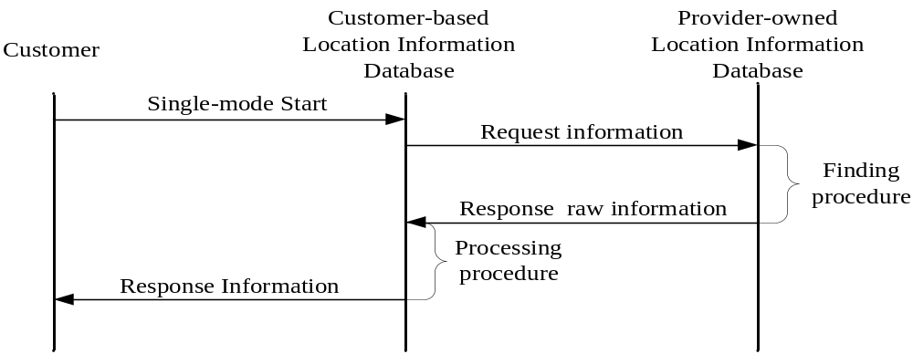

FIGURE 11/TR-CMIP Service Procedure of single-mode operation service scenario

The second scenario is the continuous-mode operation scenario whose service procedure is shown in Figure 12/TR-CMIP In this scenario, a customer requests a monitored customer’s location information to the customer-based location information database with a continuous-mode start message. The first operation is almost the same as the single-mode operation service scenario. However, the customer-based location information database adds other customers to the monitored customer list in the first processing process. Then the customer-based location information database provides its processed information continuously to the customer and requests directly monitored customers’ location information to the respective monitored customers periodically. If the customer-based location information database receives a stop message, this process stops and the customer-based location database deletes this monitored customer’s information from its’ list.

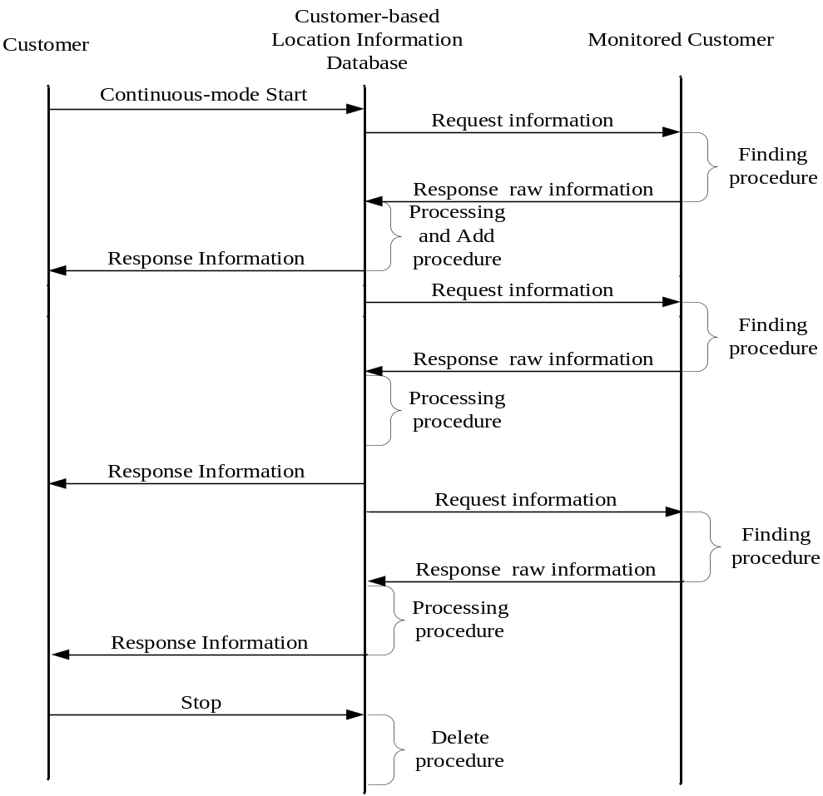

FIGURE 12/TR-CMIP Service Procedure of continuous-mode operation service scenario

8.5. Manageable Home Networking Services

8.5.1 Objectives of Manageable Home Networking Services

Home networking services can be defined as providing home automation services, home entertainment services, security services, and internet service to interwork other networks in outside home. Home automation services are to control lighting, appliances, and climate control in home. Home entertainment services allow user to enjoy audio, video, and theater services in home. In addition, ubiquitous services will be extended to support the interconnection among various things with RFID tags and increase the scale of network connections in comparison with home networking services.

8.5.2 Functional Model of Manageable Home Networking Services

There are the two modes of operation to have access to home networking services. One is the local service access at inside home or within home area network, which is starting service invocation from inside home. The other is the remote service access from the external networks. This draft has only an interest in the manageable home networking service managed from remote access and control.

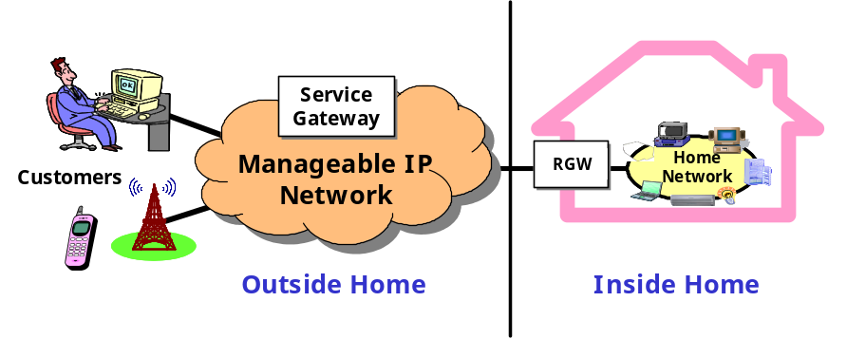
FIGURE 13/TR-CMIP Architecture for home networking service in manageable IP network

In Figure 13/TR-CMIP, it can be seen that the Service Gateway within manageable IP network act as the portal to allow remote access and control from external network to home network. Service Gateway enables the remote customer to manage home networking services and devices via Residential Gateway. The followings are Service Gateway capabilities to support home networking services in manageable IP network;

- User authentication and authorization
- Service management
- Service usage measurement
- Secure connection/session establishment
- Firewall function: to protect against the possible threats
- Home directory service function that collects and presents the instances of home equipment, equipment services, and contents, to the user
- Remote control function
- Remote configuration, management function
- Web service-based interface to have access and control
- Policy decision function to manage QoS

A Residential Gateway is a device that interconnects various home networking devices and as a mediator between the end user of the devices and the Service Gateway. A Residential Gateway allows intelligent end-user services, not just simple network connections, to be created and managed within the home network as well. This document would not touch on the Residential Gateway in detail, because it is out the scope of this document.

8.5.3 Service Scenario and Procedures of Manageable Home Networking Services

Figure 14/TR-CMIP shows the example of information flows of home networking service to enable a customer to “turn on the lights” at remote site as an example. We assume that SIP, HTTP, and SOAP can be used for delivering control messages to communicate between Gateways and home devices. The followings show the information flows to “turn on the lights” home networking service.

- A remote customer is trying to login Service Gateway to have access and control to home networking services
- If a customer is successfully authenticated and authorized, then Service Gateway return OK message to customer
- Customer send a control message, say, “turn on the light in living room” to a device via Service Gateway
- Then, Service Gateway requests the session establishment between Service Gateway and Residential Gateway, and a home device to send a control message
- If a session is successfully established, Service Gateway send “turn on the light in living room” control message to a home device via Residential Gateway
- The response from a home device is ok
- ok control message is delivered to customer
- Customer logoff to quit home networking service
- The session is terminated between Service Gateway and Residential Gateway, and a home device
- The session is ended between customer and Service Gateway, too

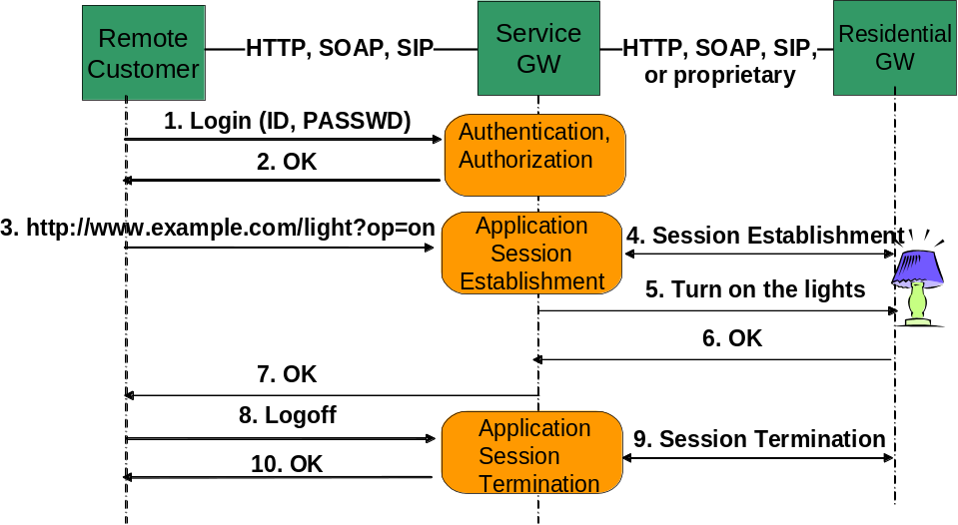
Figure 14/TR-CMIP Example of information flows of home networking service to “turn on the light”

8.6 Client Networking Services with QoS and Security

8.6.1 Objectives of Client Networking Service with QoS and Security

The Customer Manageable IP network provides such functions to control QoS and security capabilities simultaneously or partly as customer requests. It expects that a secured path in many types of services is tightly associated with QoS provisioning. Therefore, it will be necessary to classify networking service features in QoS and security requirements with on-line or off-line manner.

The objective of client networking service with QoS and security is to protect two types of threat. An example is to provide heavy weight authentication mechanism at the level of aggregates of packets such as channels or flows so that these checks need not be done on individual packets. This suggests that an architecture where authentication and other resource management decisions are “front-loaded” to reduce the cost of subsequent decisions. The “multilayered architecture to provide QoS and security procedures may be needed as shown in Figure 15/TR-CMIP.

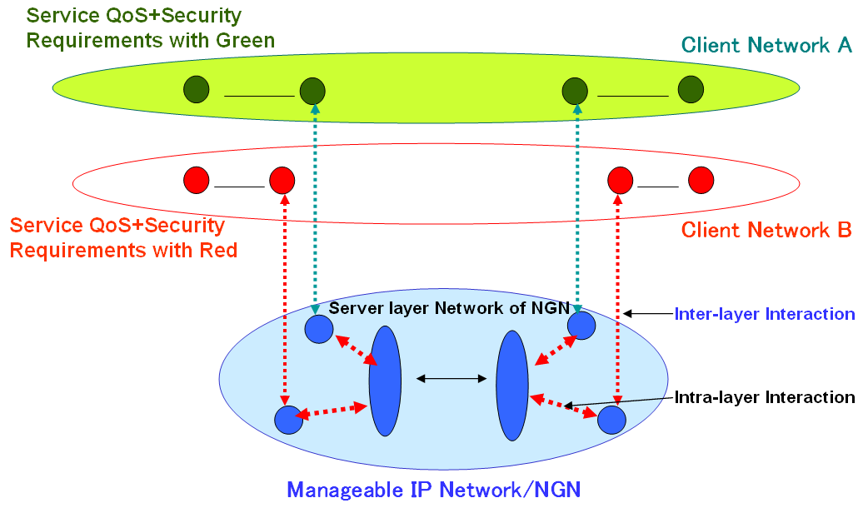

Figure 15/TR-CMIP Example architecture for client networking service with QoS and security

8.5.2 Overlay Model of Client Networking Services with QoS and Security

Figure 16/TR-CMIP shows the overlay model of client networking services with QoS and security. It shows an example on overlay networking and virtual networking function management. The virtual networking is applied to the model based on multilayered architecture independently, which incoming packets are classified at edge level and the packets for secured QoS service are forwarded to policy based overlay networks. Thus it provides secured networking and QoS managed functions through admission control and other control mechanisms. On the basic functional architecture, a networking feature is necessary to adopt QoS and security features efficiently.

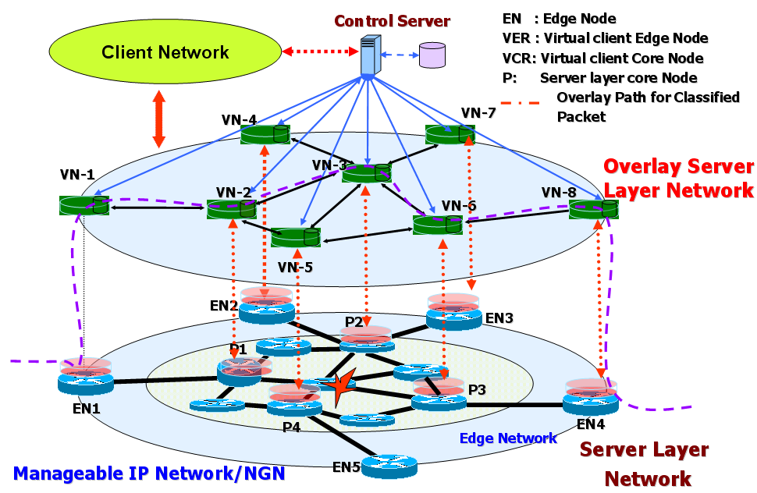

Figure 16/TR-CMIP Overlay model of client networking services with QoS and security

The example of routing management algorithms of overlay model is shown in Figure 17/TR-CMIP. This figure shows the procedure on VNF (Virtual Networking Function) networking table construction. The control information is classified according to incoming customer information, and control server will make its own networking table in procedure (c), (d) and (e). The multiple virtual networking tables constructed according to security level and required QoS are applied to perform routing function over overlay network. The primary goal of VNF provisioning on overlay network is to provide multiple levels of secured QoS paths. The VNF routing function is performed independently with other VNF routing in the network.

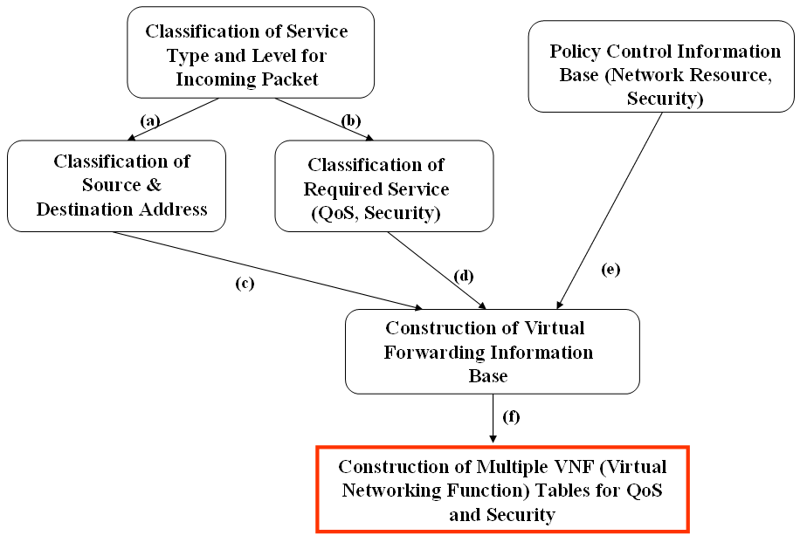
Figure 17/TR-CMIP Examples of table construction of virtual networking function in Overlay model

In order to make a forwarding information base from information of routing and policies, an advanced control mechanisms are needed to supply multilayered virtual client networking associated for customer manageable networking features.

9. Other Aspects
(to be included)

10. Security Considerations

It has become evident that security is a major element that should be considered for most applications. The Internet is becoming more and more popular in using many applications, such as business transactions, banking, government departments, and so on. The proliferation of such applications and many others, has raised the need for more security. This point should be adopted in the manageable IP network. For a secure use of manageable IP, the following items need to be considered.

- Authentication: This is a function to verify claimed identity.
- Authorization: a certain action can be serviced with an identified person after authentication. This ensures that only authorized person or device can be allowed access to network elements, services and applications, and so on.
- Confidentiality: Data should not be dealt with unauthorized entities. That is, the data must be treated by only authorized entities.
- Integrity: Ensuring the data can not be modified in transition route.
- Non-repudiation: Ensuring that the origin of the received data should not be denied by the sender.
- Communication security: This is a function to ensure that information flows only between the authorized end points.
- Availability: This is a function to ensure that there is no denial of authorized access to network elements, services, applications, and so on.
- Privacy security: This function provides data protection. Where, the data can be derived from the observation of network activities

In the area of mobility, it adds inherent security risks. Manageable IP is a new concept that attempts to do something that has not been done before on the Internet. That is, changing route for transmitting data between sender and receiver brings so many different attack points, not present in fixed networks. To be able to use the customer manageable IP concept avoiding some or all of the security attacks associated with it, some types of threats specific to the mobility, need to be identified. So, the weak points, especially in supporting mobility, are introduced and some requirements for reinforcement of the weak points and mobile security as follows:
- Using binding updates: The binding update in IPv6 protocol may be used to redirect route from source to destination. If it is not used carefully, some detrimental results can be caused on the communications with mobility.
  - Stealing data: If a rogue knows a mobile node’s permanent address, he can send a binding update to a correspondent node or a database maintaining the binding update to change route for the original mobile node’s data into his.
  - Reflection and flooding attacks: When a sender and a destination are communicating, it is perfectly acceptable that the sender sends a packet to the destination, which brings the destination to reply back to the sender. However, if the sender sends a packet to the destination that causes the destination to reply to any other person, it is called a reflection attack. In this case, the attacker can make the very another person’s link to be flooded by using the reflection attack.
  - Man in the middle attacks on the binding update: This attack can be used on the communication path between two nodes by an attacker. The obvious method is to change the contents of a packet to cause some results that were not intended by the original sender of the packet. When the attacker is located on the path between a mobile and a correspondent node, he can modify the content of the binding update, possibly bringing a refection attack or hijacking of ongoing connection between the mobile and correspondent nodes.
- Attacks using packet header information: The packet includes destination information. Therefore, if an attacker is communicating with a mobile node, he may put another address in the header information field, bringing the mobile node to forward his packets to another node, which can cause reflection attack or flooding attack.

There can be many requirements on security. Among them, we first consider some points as mentioned above and introduce some securing points as followings.
- Securing communication between mobile node and correspondent node: Messages between a mobile node and a correspondent node are needed for binding cache and binding update list management especially in the mobility management. The binding update is acting as a redirection request. Therefore, it is important that a correspondent node trust the mobile node to be able to accept this request.
  - Message integrity: It should be needed that an attacker can not modify the contents of the binding update message as well as the binding acknowledgment message.
  - Avoiding denial of service attack: In order to avoid this attack, correspondent nodes must ensure that they do not maintain state per mobile node until the binding update is accepted.
- Securing messages in the database for the binding update: the same attacks on the binding update to correspondent nodes are relevant when a mobile node is communicating with its binding update database as well as the database impersonation could be detrimental to the mobile and correspondent nodes. So, it is important that mobile node’s communication is secured using authentication or something like that.

Appendix
I. An Example of functional architecture and service creation scenario for customer manageable VPN services

The VPN will be one of the most promising services in NGN according to rapid increase of VPN service demands. The framework for dynamic creation of VPN service based on intelligent/active networking will promote a variety of VPN application services. In network based on service negotiation, a node with intelligent/active features is able to represent a solution in order to manage the whole amount of different requests coming from consumers.

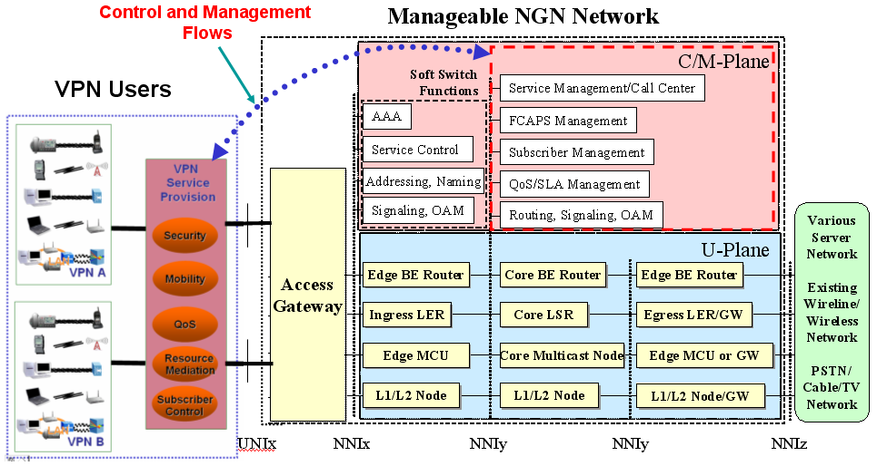
Figure I-1/TR-CMIP an example of functional architecture for customer manageable VPN services

The security is definitely one of the key issues in VPN scenario. An intelligent and active feature in VPN networking will take an important role to provide flexible means to customize services appropriately. The intelligent/active features for security in VPNs are exploited for adaptive secure routing and service capability. The security capability of VPN is negotiated with C/M-Plane of manageable IP network, and its service level will be assigned to VPN users.
As shown in Figure I-2/TR-CMIP, control and management functions of customer manageable IP network, a control flow between a service provision module of VPNs and C/M-Plane Module of customer manageable IP network is established to deliver networking service capabilities from/to VPNs. The C/M-plane of customer manageable IP networkwill have to be characterized to provide the above networking capabilities to VPNs.
In addition to the above features, the following capabilities are characterized to provide intelligent/active VPN services in customer manageable IP network.

- Mobility
- Static/Dynamic QoS provisioning
- Resource Mediation for VPN services
- Subscriber Control on VPNs service capabilities
- Security negotiation/provisioning

From a functional standpoint in intelligent VPN of customer manageable IP network, the VPN is as an active flow that is activated by appropriately customizing additional intelligent/active features of VPN access node. This is achieved via one underlying program and their injected programs, each associated to one of the intelligent/active VPN functions. The activation process is appropriately invoked with respect to the external topology, an internal topology and its routing table of VPNs (with multiple virtual routing tables). By applying these parameters a number of different VPNs are characterized by their own topology and management strategy.
Figure I-2/TR-CMIP indicates an example of functional architecture to implement manageable VPN. If we consider VPNs are interconnected at different operators or ISPs in the customer manageable IP network, implementation architecture for manageable VPN may be shown in this figure. For example, the manageable VPN service needs the following threes functions of Service Mediator, SLA mediator, and Access Mediator.

- Service Mediator Function
  - AAA
  - Presentation
  - Subscription
- SLA Mediator Function
  - Dynamic negotiation and re-negotiation of the SLA
  - Synchronization with other SLA Mediator
  - Communication with resource manager in customer manageable IP network
- Access Mediator Function
  - AAA
  - Directory transactions
  - Preference lists handling
  - Service menu
  - User profile Processing
  - Terminal types and mapping

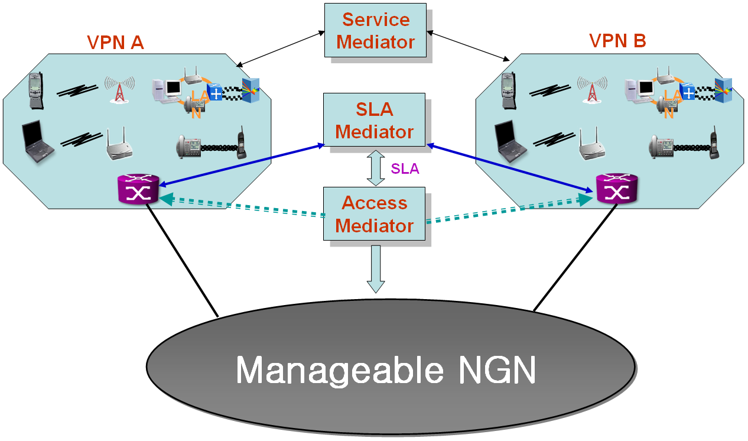

Figure I-2/TR-CMIP An example of implementation scenario for customer manageable VPN

II. Relationship between Customer Manageable Functions and Y.NGN.Management

(Editor Note) In this Appendix, the relationship between the customer manageable functions described in section 7 and Y.NGN.Management as FCAPS models will be given.

________________

