INTERNATIONAL TELECOMMUNICATION UNION |  | Focus Group On Next Generation Networks
TELECOMMUNICATION  STANDARDIZATION SECTOR  STUDY PERIOD 2001-2004 |  | FGNGN-OD-00040R1
 |  | Original: English
WG(s): | 6 | Ottawa, 27 September - 1 October 2004
OUTPUT DOCUMENT
Source: | Editors
Title: | PSTN evolution to NGN

This serves as the initial draft of PSTN evolution to NGN.
Contents
Page
1 Scope 4
2 References 4
3 Definitions 4
4 Abbreviations 5
5 Conventions 6
6 Evolution of PSTN to NGN 6
7 Transport 6
7.1 Evolution scenarios 8
7.1.1 Scenario 1 8
7.1.2 Scenario 2 10
7.1.3 Scenario 3 11
7.1.4 Scenario 4 12
8 Managements aspects 12
8.1 Management scenarios 15
9 Signalling and control aspects 16
9.1 Signalling in the core network 16
10 Service aspects of evolution 17
10.1 Evolution Scenarios 17
10.1.1 Scenario 1 17
11 Security aspects of evolution 18
12 Emergency services 18
Appendix I: Examples of PSTN Transport evolution scenarios 19
II.1 Use of ATM as the packet based network 19
II.2 Use of ATM as a access network to IP in the core 20
II.3 Use of both ATM and IP for overflow of PSTN traffic 21
II.5 Use of PSTN in the access 22
ppendix II: Examples of PSTN service evolution 22

Introduction
NGN (Next Generation Network) is believed to provide new opportunities for and capabilities to the network and service providers. Considering that existing networks have different life span and vast amount of capital has been spent on them, complete replacement of their components is not considered to be either advisable or possible. So, a phased approach should be considered for evolution of existing networks to NGN.
PSTN (public switched telecommunications network) being one of the first networks, is considered to be prime candidate for evolution. For PSTN evolution to NGN a phased approach is considered in this draft.
PSTN EVOLUTION TO NGN

Scope
PSTN (public switched telecommunications network) being one of the first networks in telecommunication is considered to be a prime candidate for evolution to Next Generation Network (NGN). Since vast amount of capital has been invested in PSTN also in any other network, evolution to NGN should be considered as a step-wise approach.
This draft describes possible ways of evolving PSTN to NGN. It provides steps for evolution of transport, management, signalling and control parts of PSTN to NGN. Examples of possible implementation scenarios are provided in the appendices.
Note: PSTN encompasses ISDN for telephony services. The PSTN assumes the emulation of PSTN service (see definition section for definition of PSTN/ISDN emulation).

References
The following ITU-T Recommendations and other references contain provisions, which, through reference in this text, constitute provisions of this draft. At the time of publication, the editions indicated were valid. All Recommendations and other references are subject to revision; all users of this draft are therefore encouraged to investigate the possibility of applying the most recent edition of the Recommendations and other references listed below. A list of the currently valid ITU-T Recommendations is regularly published.
The reference to a document within this draft does not give it, as a stand-alone document, the status of a Recommendation.
[x] ITU-T Recommendation G.100 (2001), Definitions used in Recommendations on general characteristics of international telephone connections and circuits
[x] ITU-T Recommendation G.964 (2001), V-interfaces at the digital local exchange (LE) – V5.1 interface (based on 2048 kbit/s) for the support of access network (AN)
[x] ITU-T Recommendation Y.overview (2004), NGN overview
[x] ITU-T Recommendation Q.310-332 (1988), Specifications of Signalling System R1
[x] ITU-T Recommendation Q.400-490 (1988), Specifications of Signalling System R2
[x] ITU-T Recommendation G.965 (2001), V-interfaces at the digital local exchange (LE) - V5.2 interface (based on 2048 kbit/s) for the support of access network (AN)
[x] ITU-T Recommendation M.3400 (2000), TMN Management Functions
[x] ITU-T Recommendation G.3010 (2000), Principles for a Telecommunications management network

Definitions
This draft uses or defines the following terms:

3.1 Access Network (AN): See Recommendation G.964[x].
3.2 Next Generation Network (NGN): See Recommendation Y.2001 [x].
3.3 Public Switched Network (PSTN): See Recommendation G.100 [x].
3.4 PSTN/ISDN Emulation: The provision of PSTN/ISDN service to PSTN/ISDN terminals by the NGN (e.g. via a gateway).
3.5 PSTN/ISDN Simulation: The provision of PSTN/ISDN-like services to non-PSTN/ISDN terminals. Such terminals may not be able to provide all functionalities that a PSTN/ISDN terminal provides.

3.6 User Access Module (UAM): A unit that physically terminates subscriber lines and converts the analogue signals into a digital format. The UAM is collocated with a Local Exchange (LE), and is connected to the Local Exchange.

3.7 Remote User Access Module (RUAM): A unit that physically terminates subscriber lines and converts the analogue signals into a digital format. The RUAM is physically remote from the Local Exchange.

Abbreviations
This draft uses the following abbreviations.
AS Application Server
ATM Asynchronous Transfer Mode
CAS Channel Associated Signalling
CBR Constant Bit Rate
CCS Common Channel Signalling
CS Call Server
IN Intelligent Network
INAP Intelligent Network Application Part
IP Internet Protocol
ISDN Integrated Service Digital Network
LE Local Exchange
LL Leased Line
OSS Operation Support System
PBX Private Branch Exchange
PCM Pulse Code Modulation
POTS Plain Old Telephone Service
PRI Primary Rate Interface
PSTN Public Switching Telecommunications Network
QoS Quality of Service
SCE Service Creation Environment
SCP Service Control Point
SG Signalling Gateway
SSF Service Switching Function
SSP Service Switching Point
STP Signalling Transfer Point
TDM Time Division Multiplexing
TE Transit Exchange
TG Transit Gateway
TMN Telecommunication Management Network
UAM User Access Module
AG Access Gateway
VoIP Voice over IP

Conventions
[TBD]

Evolution of PSTN to NGN
[editor note: text needed to estate what existing PSTN is and what approach needs to be taken]
In general PSTN networks are comprised of the following entities each with one or multiple functionalities:
- Transport (access plus core): UAM, RUAM, AN (Access Network) via V.5 interface connected to the core switches and core switches themselves
- Control and signalling: exchange hosts
- Management: management of exchanges
- Service: exchange hosts and auxiliary network (e.g. IN)
In PSTN most of the functionalities are located in a single exchange and may use proprietary protocols. However, in NGN it is expected that functionalities will be distributed amongst several elements.

Transport
Figure 7-1 provides a high level view of PSTN. The PSTN transport is comprised of two parts access and core. The access part is comprised of all transmission facilities, UAMs, ANs, and PBXs. The core of PSTN transport is comprised of local and transit exchanges. A brief description of each part is provided below. Possible evolution scenarios are also provided.
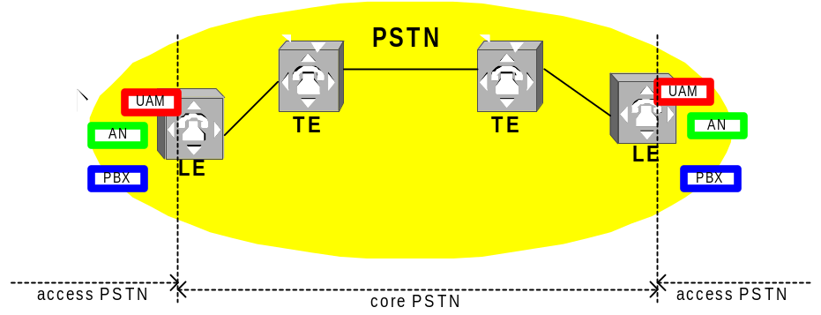
Figure 7-1: General view on PSTN transport
The PSTN access elements which may exist individually or in a combination are:
- UAM (User Access Module) which is connected to exchanges via proprietary interfaces (locally or remotely)
- PBX (Private Branch Exchange) which is connected to the local exchange directly or via remote access modules
- ANs (Access Networks) which is connected to the local exchange via V5.x (G.964/G.965 [x , y]) open interfaces.

Evolution scenarios
Possible scenarios for evolution of PSTN access and core may be as follows:

Scenario 1
This scenario consists of two steps, which are executed consecutively.
Step 1
The aim of step 1 is to prepare the PSTN for future NGN architecture. First all switch functionalities such as control, billing, etc. is removed from some of the local exchanges and access elements such as UAM, PBX, and AN are connected to the remaining exchanges as remote units e.g. UAM becomes RUAM.
Step 2
Step 2 follows step 1 to complete replacement of PSTN with NGN. Call control and billing functions of the LE are performed by the call server (CS) and all functions of UAM, RUAM are done by access gateways (AGs). The transit and signalling gateways are introduced for interconnection with other operators’ PSTN.

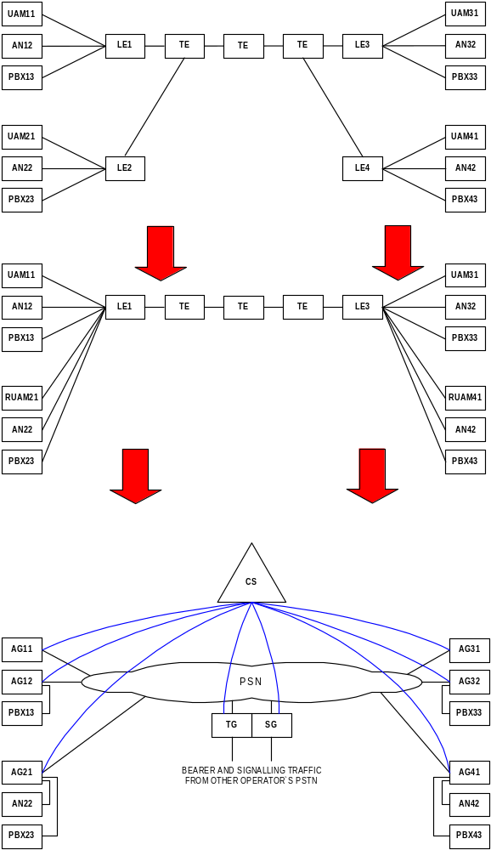
Figure 7-2: Realisation of scenario 1

Scenario 2
The aim of this scenario is to prepare the PSTN for future NGN architecture. Contrary to scenario 1, this scenario directly replaces PSTN with NGN in one step. All call control and billing functions of the LEs are performed by the call server (CS) and all functions of UAM, RUAM are done by access gateways (AGs). The transit and signalling gateways are introduced for interconnection with other operators’ PSTN.
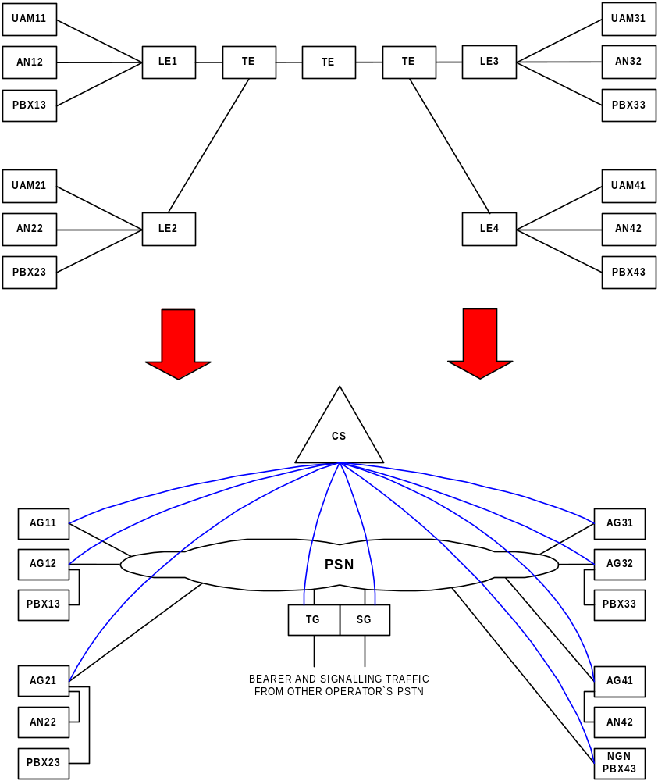

Figure 7-3: Realisation of scenario 2

Scenario 3
The aim of this scenario is to deploy an overlay NGN to PSTN. That is the co-existence of NGN with PSTN. Some of the UAMs are upgraded to AGs to replace LEs and additional new AGs may also be implemented for new subscribers and all these elements are controlled by the call server (CS). The signalling and transit gateways are introduced for interconnection with existing PSTN.

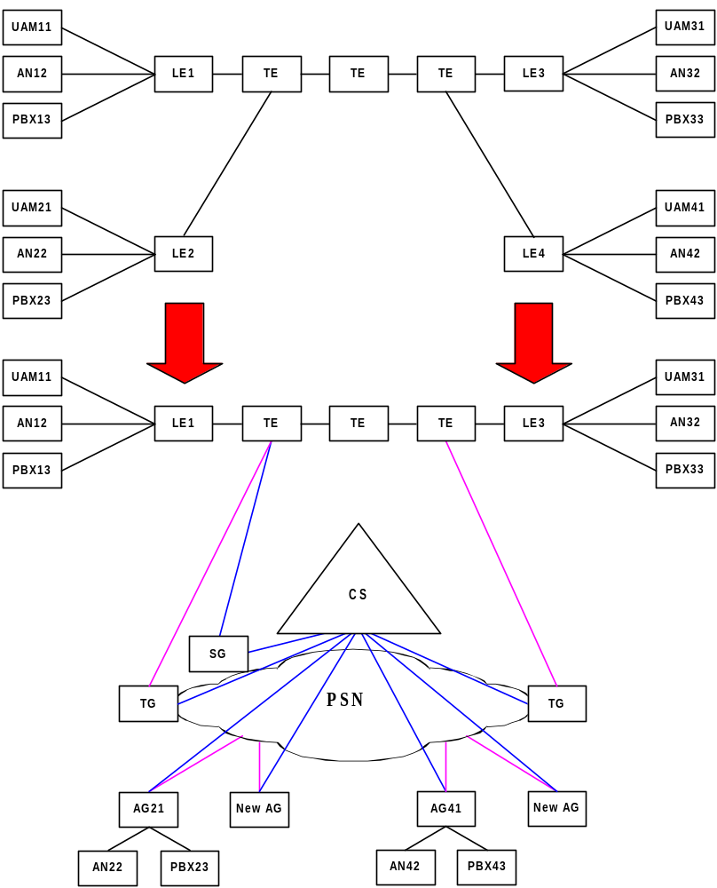
Figure 7-4: Realisation of scenario 3

Scenario 4
In this scenario Class 4 exchanges (also called as trunking exchange, TE) are converted to transit gateway (TG) and new call servers (CSs) are introduced. The TGs are connected either using existing PSTN facilities or of the Packed Based Network.
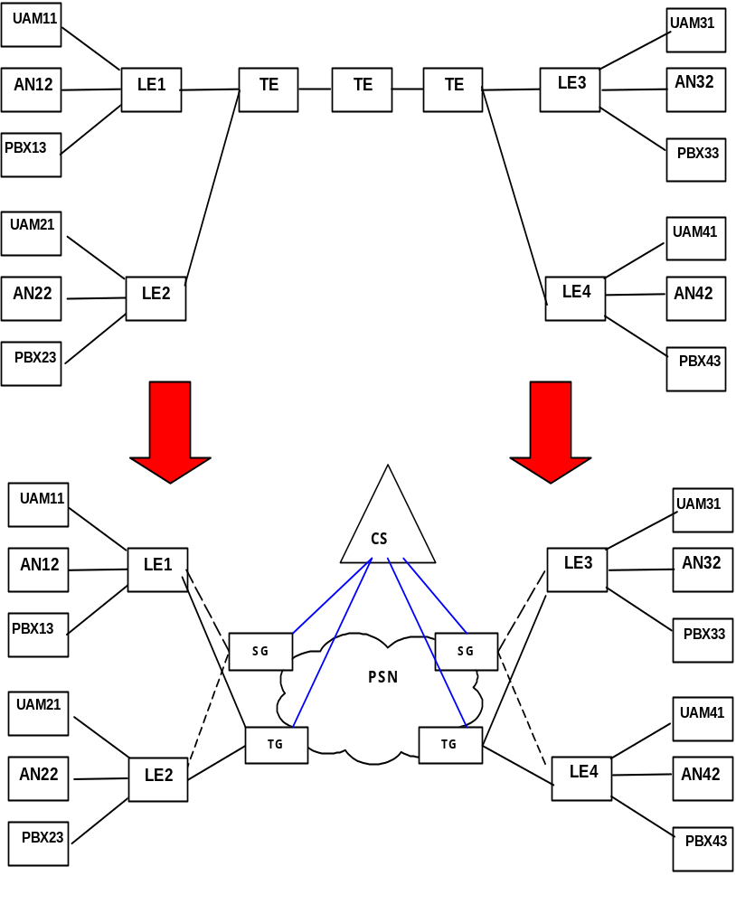
Figure 7-5: Replacement of TEs with TGs
Examples of such variants are shown in Appendix I.

Alternative scenarios
Scenario 1
In this scenario, which is as an ISDN/PSTN simulation configuration, the complete ISDN/PSTN is replaced with NGN. This scenario includes, what are known as end system, an Access network and a Core network. In this scenario, each end system is connected to an originating network via a Type 1 interface (IF1) which behaves as the access point to the Originating network of the IMS architecture as explained in [2]. In this scenario Originating, Originating subscriber’s home, Terminating subscriber’s home and Terminating networks are all NGN. Explanation regarding all interfaces is for further study.
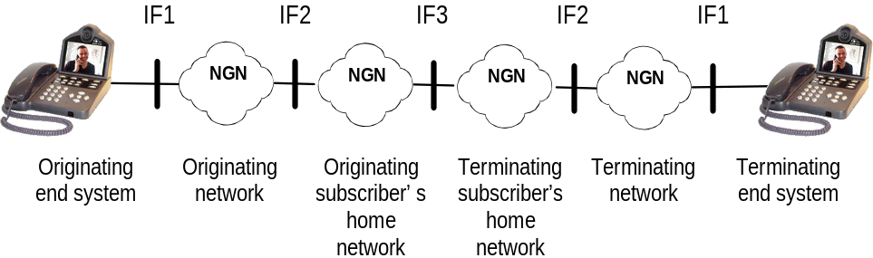

Figure 1: A simulated ISDN/PSTN

Scenario 2
This scenario is similar to scenario 1 except that the originating end system is comprised of a mix of conventional and NGN terminals which are connected to an NGN PBX. The NGN PBX is then connected to the Originating network via a Type 4 interface (IF4). Interfaces IF1, IF2 and IF3 are identical to those of scenario 1. However, a new interface, viz. IF4, is required between the NGN PBX and the Originating network. Explanation of IF4 is for further study.
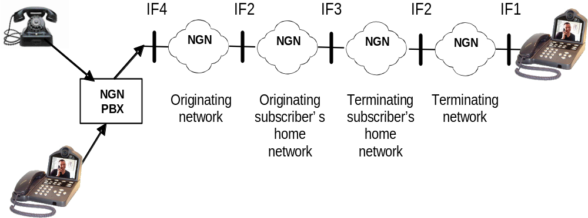

Note: In this scenario the NGN PBX is assumed to convert the TDM signal into another form (example: SIP signalling and an IP bearer) so that it may enter the NGN via the IF4 interface.
Figure 2: An NGN PBX connected to the Originating network

Scenario 3
In this scenario an NGN PBX connects directly to the Originating Subscriber’s home network via a Type 5 interface (IF5). Interfaces IF1, IF2 and IF3 are those of scenario 1 with the new, viz. IF5, between the NGN PBX and the Originating Subscriber’s Home network. Explanation of IF5 is for further study.
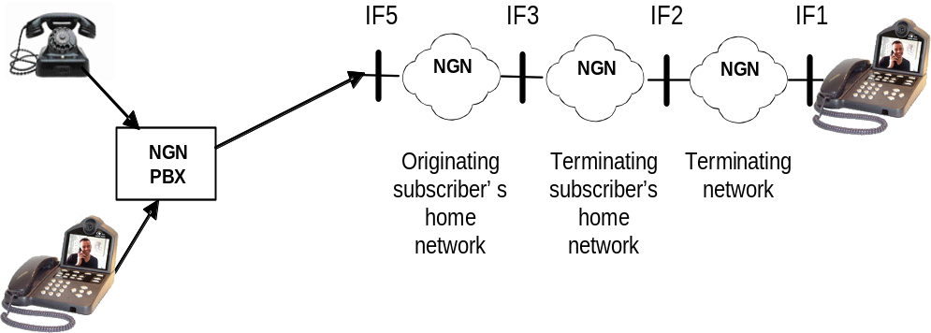

Figure 3: An NGN PBX connected to the Originating subscriber’s home network
Scenario 4
In this scenario an NGN PBX connects directly to the Terminating subscriber’s home network via a Type 6 interface (IF6). Interfaces IF1 and IF2 are those of scenario 1 with new interface, viz. IF6, between the NGN PBX and the Terminating home network. Explanation of IF6 is for further study.
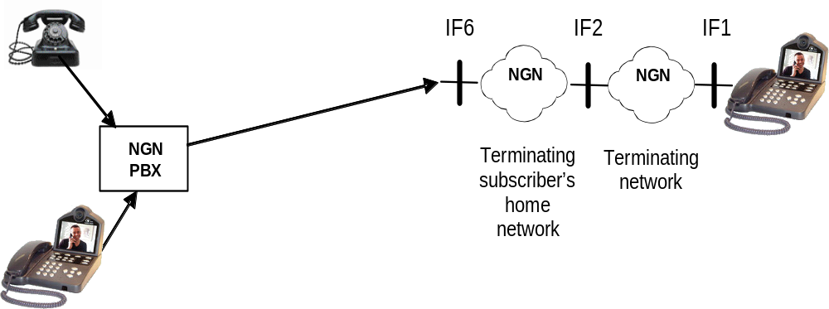

Figure 4: An NGN PBX connected to the Terminating subscriber’s home network

Scenario 5
This scenario is a combination of ISDN/PSTN emulation and simulation. The Originating and Terminating end systems use different technologies. The originating end system is a simulated ISDN/PSDN device but the terminating end system is a conventional ISDN/PSTN device connected to the terminating PSTN. Interfaces IF1, IF2 and IF3 are those of scenario 1 with the new Type 7 interface, viz. IF7, between the Terminating subscriber’s home (NGN) and Terminating ISDN/PSTN. Explanation of IF7 is for further study.
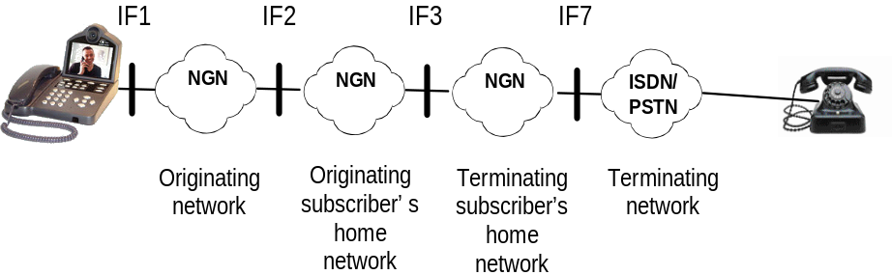

Figure 5: Terminating network is an ISDN/PSTN

Scenario 6
In this scenario the originating end system is an ISDN/PSTN device and the Originating and Originating subscriber’s home networks are ISDN/PSTN. Additionally, the Terminating end system is an NGN terminal Interfaces IF1 and IF2 are the same as in scenario 1 and interface IF7 is the same as in scenario 5.

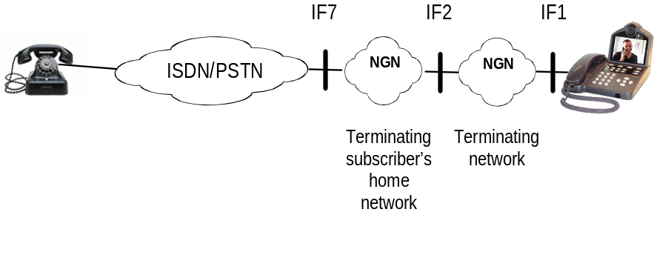
Figure 6: Simulation and emulation of ISDN/PSTN- Originating and Originating subscriber’s home networks are ISDN/PSTN

Managements aspects
The management system of PSTN includes exchange network management, access network management, intelligent network management and OSS (Operation Support System). Recommendations M.3400 [x] and M.3010[x] provide management principles for PSTN.
Referring to the management module defined in TMN, the NGN management system is comprised of three planes, namely the network element management plane, the network control plane and the service management plane. The three planes each implement corresponding management functions to each layer in the NGN layered model. Standard interfaces between these planes will be defined.

Management scenarios
Evolution of PSTN management system could be done in several possible ways. In one scenario PSTN is evolved to NGN but the PSTN management system will be used to mange the newly evolved NGN. In another scenario an NGN management system managing an NGN would also manage a PSTN.

[Editor note: further study is needed in collaboration with other NGN groups including SG4. Until the NGN Management Framework has been defined it would be difficult to discuss strategy for evolution]

Signalling and control aspects

In PSTN, TDM type signalling such as R1 [x], R2 [x], CCS [x], CAS [x] and SS7 are used. Migrating to NGN may require signalling in the packed network. Also signalling and control processing may reside in more than one element in NGN.
The AG needs to support not only POTS analogue subscribers and ISDN digital subscribers, also PBX, V5 subscribers and UAM to extend the coverage. However, different signalling is needed for different access.
The following figure illustrates an evolution scenario.
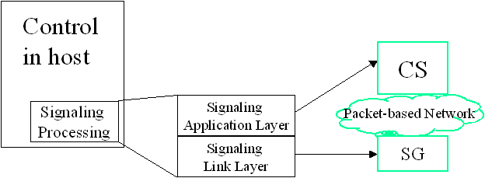
Figure 9-1: Decentralization of Signalling and control functions
The signalling and control functionalities in PSTN may be distributed into different elements in NGN. Also, these elements may use either PSTN or packet based technology for interconnection.

9.1 Signalling in the core network

It is assumed that signalling in PSTN core network is based on SS No. 7 protocol suite with user parts: ISUP (ISDN User Part) or BICC (Bearer independent call control), SCCP (Signalling connection control part), TCAP (Transaction capabilities application part), INAP (Intelligent Network application protocol).
The modes applicable to SS7 architecture (see Figure 1/Q.700 [x]) are:
- associated mode,
- quasi-associated mode.

NGN provides dedicated signalling protocols for PSTN services. Interworking between NGN and the PSTN can be achieved with the introduction of Signalling Gateway (SG) into network architecture.
Possible evolution includes three consecutive steps:
Step 1
Remove STP functionalities from switches and create an STP mesh network.
Step 2
Upgrade STP to SG (Signalling Gateway), which is used for interconnection between existing PSTN and NGN.
Step 3
Remove SG when there is no longer a requirement to interconnect with PSTN.

Service aspects of evolution
PSTN services which are traditionally provided by PSTN exchanges may be transferred to ASs (Application Servers) as applications in NGN.
An example of PSTN service evolution is shown in Appendix II.
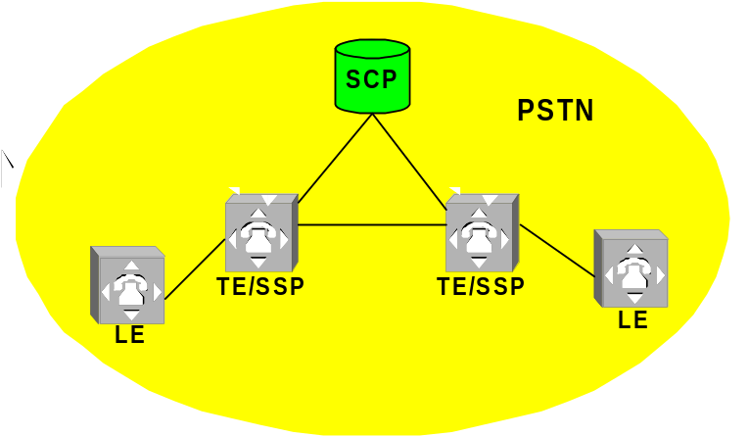Figure 10-1 provides high level view on the realisation of services within Intelligent Network concept.
Figure 10-1: General view on services in PSTN based on IN
SSP that access to IN services is implemented on TE level. Another variant is when SSP is implemented on LE level. In each case open interface INAP between SSP and SCP is used.

Evolution Scenarios
Possible scenarios for evolution of services in PSTN based on IN may be as follows:

Scenario 1
In this scenario it is proposed to reuse existing IN services in NGN by implementation of SSF in CS. Both PSTN and NGN networks exist.
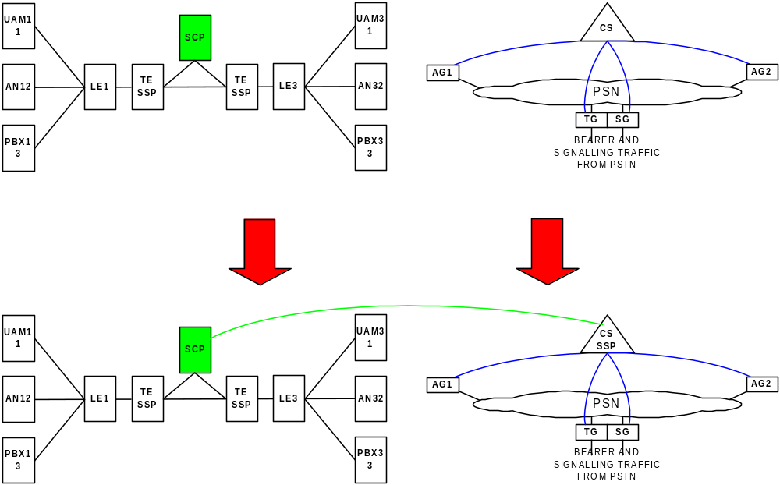Figure 10-2: Realisation of scenario 1.

On the opposite way reversal scenario could be considered.

The SCP (Service Control Point) can be integrated to the Application Server and become part of the Application Server. So, the services created by the SCE (Service Creation Environment) can be directly loaded to the SCP module of the new Application Server.
An example of SCP integrated to the Application Server is shown in Appendix II.

Security aspects of evolution
[TBD]

Emergency services
[TBD]

Appendix I: Examples of PSTN Transport evolution scenarios
(This appendix does not form an integral part of this draft)

II.1 Use of ATM as the packet based network
In this example the ATM networks is used to ensure proper QoS for voice connections. One of the ways of VoIP realization is to use ATM technology (VoIPoATM) as a transport layer having the qualities guaranteeing QoS for voice transmission (e.g. using CBR service).

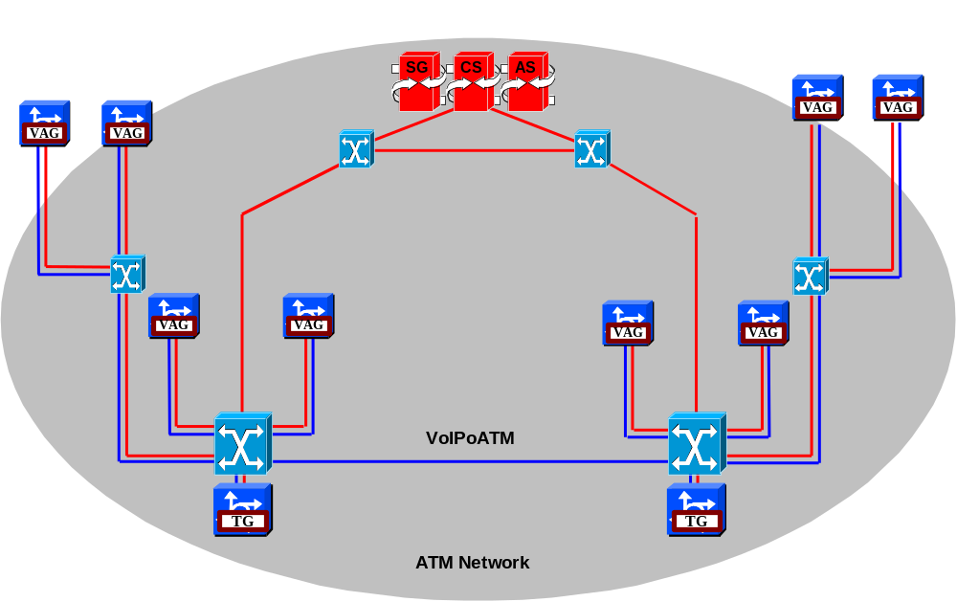
Figure I1-1: Example of ATM as a packet based network

II.2 Use of ATM as a access network to IP in the core
In this example the ATM networks is used as an access to IP in the core for signalling connections. The PSTN is the transport layer for voice connection.
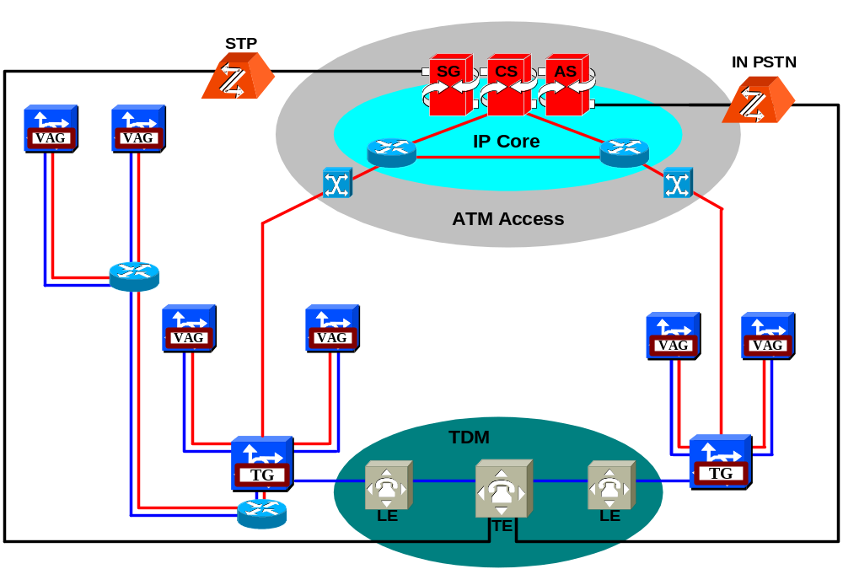
Figure I1-2: Example of ATM as an Access network

II.3 Use of both ATM and IP for overflow of PSTN traffic
In this example both ATM and IP are used for overflow of PSTN traffic.

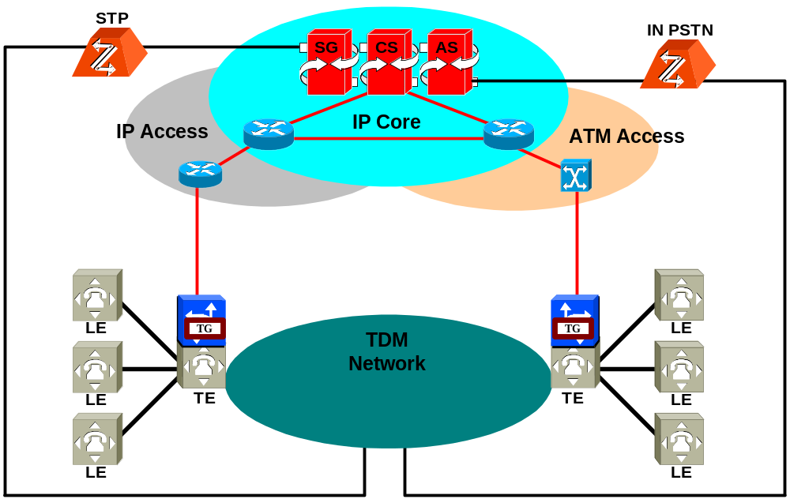
Figure I1-3: Example of ATM and IP being used for overflow of PSTN traffic

II.5 Use of PSTN in the access
In this example the PSTN is used in the access for signalling connection to the IP core. The PSTN is the transport layer for voice connection.

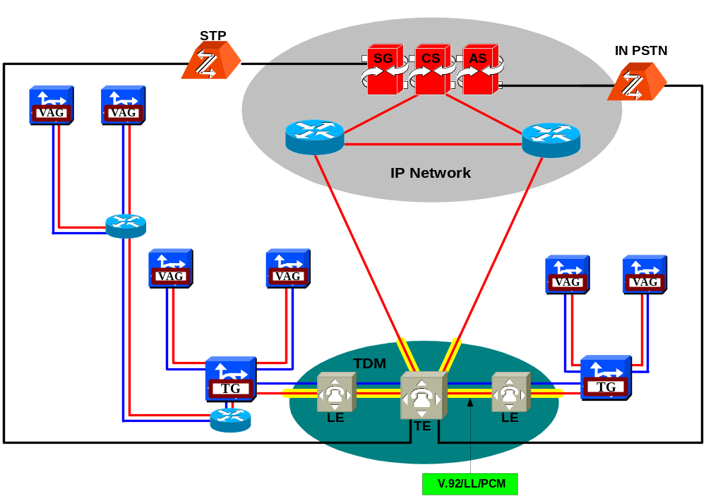
Figure I1-5: Example of PSTN as an Access network

ppendix II: Examples of PSTN service evolution
(This appendix does not form an integral part of this draft)
- Implementation of SSF function of the IN network in the control layer (using open interface INAP allows for treating the IN network elements as the elements of NGN service layer).
- Duplication/implementation of the service logic from PSTN host in NGN service layer (application server - AS). Division of service logic from control.
- Inclusion of SCP of the IN network into NGN service layer - SSP-SCP communication through NGN IP packet network.
- Common SCE for all elements of NGN service layer - optional step.
For the separation of the service function during evolution of PSTN, service process in local exchange can be transferred simply to a tandem exchange through data configuration. Only tandem exchanges are upgraded according to the above described steps. In this way, the collection of information at billing centre becomes simpler too, because all the services are converged at the tandem exchanges, only the information of tandem exchanges needs to be collected rather than that of all the local exchanges.
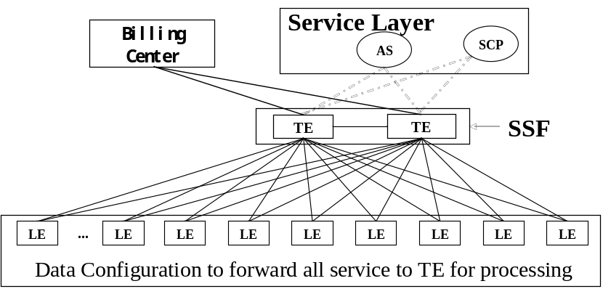
Figure X. Service evolution from PSTN to NGN

Examples of SCP being integrated to the application server
The following Figure shows the SCP is integrated to the Application Server as a whole:
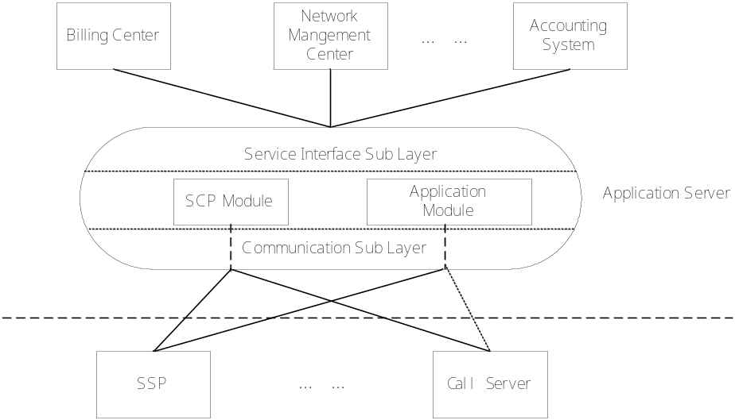
Figure. the SCP is integrated to the Application Server as a Whole
In this networking mode, the SCP is integrated to the Application Server and becomes a part of the Application Server. The bottom layer of the new Application Server is established in a uniform communication layer. The services created by the SCE in the traditional IN can be directly loaded to the SCP module of the new Application Server. The new services developed by using open interfaces (such as Parlay APIs) can run on the Application module. The SCP module and the Application module have a uniform service interface layer with unified data configuration, operation & maintenance and external interfaces.

