 | INTERNATIONAL TELECOMMUNICATION UNION
 | TELECOMMUNICATION  DEVELOPMENT BUREAU  ITU-D STUDY GROUPS | Document 2/261-E  15 August 2001  Original: English only  DELAYED
FOURTH MEETING OF STUDY GROUP 1: CARACAS (VENEZUELA), 3 - 7 SEPTEMBER 2001
FOURTH MEETING OF STUDY GROUP 2: CARACAS (VENEZUELA), 10 - 14 SEPTEMBER 2001
FOR INFORMATION

Question 10/2: Communications for rural and remote areas

STUDY GROUP 2

SOURCE: INDONESIA

TITLE: VINTERNET - HYPERLINK CONCEPT FOR DIVERSIFYING INFORMATION SOURCES FOR RURAL COMMUNITIES

________
Abstract:
The contribution proposes deployment of RVIC (IVR application as a voice based information service for rural communities), in terms of diversifying and disseminating the information sources.
_____

- Introduction
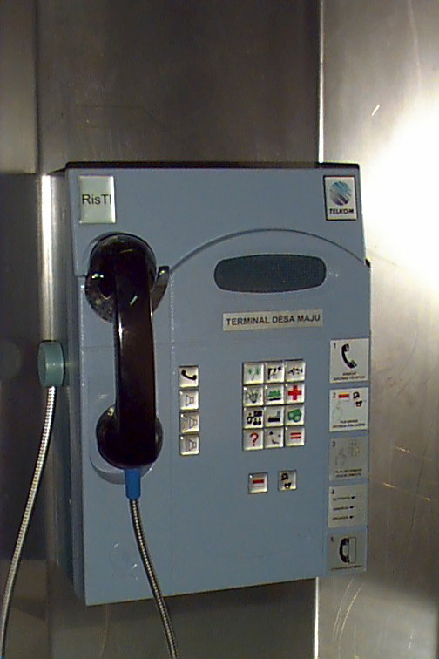
The Indonesian innovation called the Rural Voice-rich Information Community (RVIC, previously known as RIRC) as the embryo of “VInternet” (Voice Internet), could eventually bring the information age to developing country’s often poor and scattered rural population. The innovation has combined existing technologies to create an interactive device that offers Internet features – including information retrieval, Web sites and homepages – through what is essentially a network of IVR Server. The RVIC interfaces with the Internet through a software application developed to transform text into digital speech
RVIC is a system that provide such information based on voice and the content of information are all the things related to activity of economic, education, health etc of rural communities. Next, the system converts text from the Internet into digital speech, this is transmitted to users through RVIC terminal (icon-based telephone terminal) or POTS/Payphone. The RVIC implementation model included a person or group of persons who acted as facilitators by maintaining the information content on the server and responding to recorded inquiries from callers.
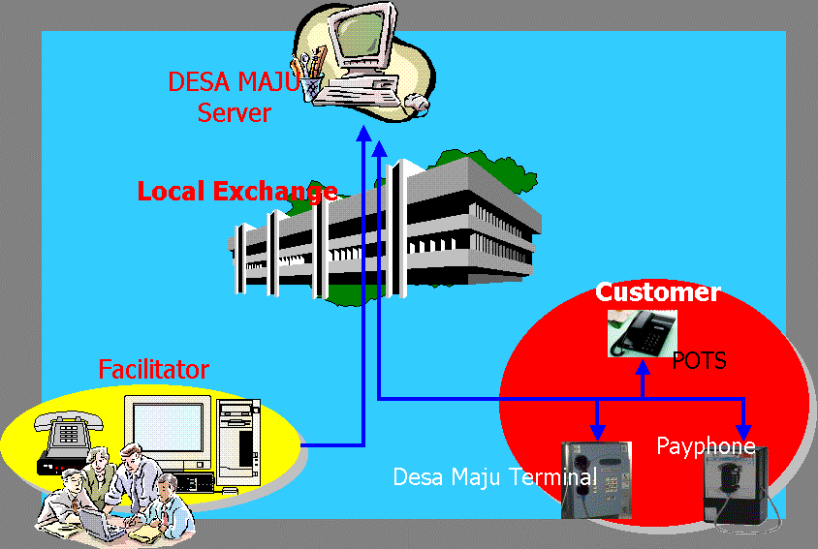
Figure 1 – RVIC Configuration
2. Service Application Aspect
Languages used in RVIC services consist of two different languages: Indonesia language and local language. Customer can select optional button in order to hear information in language desired. The service can be categorized as interactive service since customer has a chance to submit question that stored in Server and later will have notification from Facilitator that customer can retrieve answer from his question.
The information stored in Server is information related to economic activities so the information can stimulate rural community to increase economic growth such as agriculture, home industries, animal husbandry, plantation, health info etc. The information is not limited just guidance, but some of them are transaction, consultation and daily information about good prices.

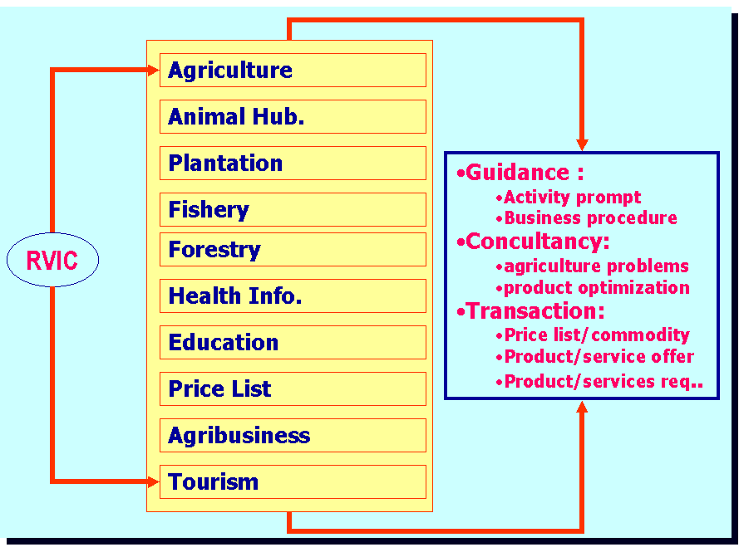
Figure 2 – Information Menu
Information and consultation are expected to stimulate economic activity in rural area efficiently. The readiness of information about product guidance and market is expected will make product higher, besides it will raise a chance to rural community trade their outcome optimally that encompass brokers, finally they can have good in low price.
- Hyperlink Concept for RVIC (VInternet)
The information stored in Server can be expanded whereas each server connected one to another as if hyperlink capability in the Internet Network. Information stored in each server boundary has specific information from its regency/region. Farmers usually need the information about price commodity of their goods in other area, and also what kind of crop they have to plant. In this case, facilitators take their role to arrange the information.
Hyperlink system implemented at RVIC – Vinternet system could make users possible to get information which is not from IVR server connecting. Because of that a method for transferring data process is needed. The hyperlink method we use in this system are Mirroring via Data Network and Call Transfer via PSTN Network..

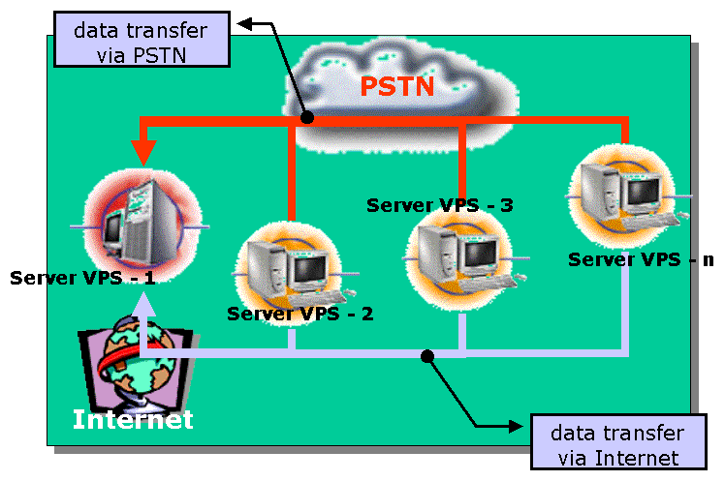
Figure 3 – Voice Internet as Evolution of RVIC

3.1 Hyperlink via PSTN Network (Call Transfer)
Hyperlink concept via PSTN Network will allow users to access information at another IVR server boundary . By pressing certain DTMF number the system will transfer and connect users to another IVR server, so they will get other superior information. Modification program is done in IVR server to give link to destination server.
Figure 3 - Hyperlink RVIC – VInternet

3.2 HYPERLINK via Data Network (MIRRORING)
Basically mirroring is data duplication inside IVR server storage to another IVR server storage through File Transfer Protocol (FTP) facility using data network /Internet.
RVIC – VInternet system using Mirroring is designed as an efforts for giving ease to RVIC system customers in accessing superior information from each IVR server in another area. The information will be transferred periodically by IVR server which has superior information at certain time (for example in the night or at the hours which is considered not as busy hour) by using data network (TELKOM’s Intranet). Then the information is saved at the chosen storage (e.g. : file name and its directory), afterward users can access it by pressing certain buttons to superior information.
In Hyperlink system between IVR server using Mirroring method via Data Network need NIC instrument (Network Interface Card) which connected to the Internet Network in order to exchange data process.
__________

