INTERNATIONAL TELECOMMUNICATION UNION
TELECOMMUNICATION  DEVELOPMENT BUREAU  ITU-D STUDY GROUPS | Document 2/184-E  1 August 2000  Original: English only
THIRD MEETING OF STUDY GROUP 1: GENEVA, 11 - 15 SEPTEMBER 2000
THIRD MEETING OF STUDY GROUP 2: GENEVA, 18 - 22 SEPTEMBER 2000

FOR INFORMATION

Question 10b/2: Development of multi-purpose community telecentres

STUDY GROUP 2

SOURCE: ASSOCIATE RAPPORTEUR FOR QUESTION 10b/2

TITLE: TELECENTRES FOR DEVELOPING COUNTRIES: THE MALI CASE STUDY (TOMBOUCTOU)

________
Abstract:
The idea with a pilot project is to test a new concept of providing services, such as the teleservices, to areas that are deprived of it. This is usually the case of rural or isolated areas in the developing countries. Since providing teleservices to rural areas is known to be much more costly than providing it to the densely populated areas of towns or urban areas in general, it is important to test how new concepts can improve the situation for the people living in rural areas.
The overall aim of the telecentre pilot project is to engage the rural community of Tombouctou and various national stakeholders in the process developing an affordable and accessible model of a multi-purpose community telecentre. This centre will be an experience (model) to be applied for future similar centres throughout Mali.

_____

1. General and pre-project surveys

1.1 Background
The idea with a pilot project is to test a new concept of providing services, such as the teleservices, to areas that are deprived of it. This is usually the case of rural or isolated areas in the developing countries. Since providing teleservices to rural areas is known to be much more costly than providing it to the densely populated areas of towns or urban areas in general, it is important to test how new concepts can improve the situation for the people living in rural areas.
Another factor of importance is that rural areas have a different kind of population, different professional categories, and the income distribution for rural areas is different to urban areas. The purchasing power of households in rural areas is also considerably different to that of urban areas. Thus it is important to find suitable areas in the rural country which can be 'representative' of the country in general, on which a pilot project will provide a valid sample to test the use of community telecenter. Once a representative number of locations have been selected the experiences from the operation of these will help decide what are the requirements best desired by the local community, which are the applications/services, that are demanded and how they generate sufficient income to become sustainable.

An expert coming to a country to assist in developing a pilot project must make himself very well acquainted with the situation in this country. Experiences from other similar projects is no doubt an asset, but when you have to develop a project of the nature the telecenters are, where the objectives are to support development with applications that are provided from many Government Authorities (Ministries of Health, Education and Training, Agriculture and Rural Development, Development of small and medium size industries, Tourism, etc.), you have to seek information from numerous sources to be able to draw up a proposal for a valid pilot project scheme. This work should be done together with the national project partner, usually coming from the national teleorganization.

Since these multi-purpose telecenters are a new approach to the development planning it was found that the telecom partners were rather unfamiliar with such a project form, needing coordinated discussions and collaboration with other organizations with non-telecom backgrounds. The same is usually the case for the counterparts, from a technical field like the telecommunication authority, who for the first time were confronted with meeting other Government ministries.

This matter is mentioned here as it turned out to be one of the greates challenges for the foreign expert to overcome this barrier and get the multi-purpose idea, that the Telecenters are, installed in the spirit of the Project teams. Telecenter pilot projects are poineering projects as furture telecommunication and information technology (IT) projects will involve the provision of many new services, to support health, education, enterprise development, national planners, tourism developers, etc.

1.2 Pre-project survey

A socio-economic development model for services explained in the former ITU/CCITT (now called ITU-T) Handbook GAS 10, Planning data and forecasting methods was used to help identify potential regions for a pilot project. Socio-economic surveys are now becoming available in more and more developing countries where the household situation is explained and which surveys are of great value to investigate requirements of services for people living in rural areas in particular.

The method uses socio-economic data to estimate the requirements of various services. The main relationships used are:

¤ the income (or expenditure) function of households (HH)

¤ the density function of the service related to income/HH (or expenditure/HH)

These relationships can be analysed for various strata of the survey (urban, rural, various regions of the country, ethnic groups of households, etc.). For any of these groupings, the investigations can be further detailed, taking into account professional categories, educational level, age, etc. (of the Head of the household), when the statistical material is sufficiently large.

In the pilot projects of Vietnam and Mali information on households were available at the National Statistical Offices (NSOs). Such data was used to help the selection of pilot regions.

Experience from Mali

2.1 Background
The Mali pilot project is part of a five African country pilot program that had been decided before by the international and African organizations concerned. They had selected 5 countries to represent English, French and Spanish speaking countries of Africa. The preparations for the Mali pilot project was initiated in similar manner as the Vietnam case. After a documentation survey and discussions with the national partners concerned five centers in Mali were selected, Tombouctou, Djenné, Zégoua, Niori and Nara.
The limited financial support available for the African five-country project did not allow selecting more than one pilot center for Mali. This first center was agreed to be established in Tombouctou. Several meetings were held with potential partners that expressed interest in using the telecenter idea for developing services in rural areas.
Apart from the telecom organization, that usually plays a leading role in the creation of such pilot projects, there were participants from the ministries concerned with education, health, agriculture, rural development, tourism, artisan and culture, women's organization (gender), several national NGOs, international organizations, such as UNESCO, ITU, IDRC, FAO and WHO with their national representatives in Mali, TV and broadcasting organizations, aid organizations active in Mali, etc. The outcome of these meetings was the selection of applications and services to be tested in this pilot project, which subject we will discuss in the following sections.
The pilot area, Tombouctou, was visited, where we had meetings with the Government Authorities, the services providing education and training, health, artisan and tourist activities, museums, etc. During the first visit to Tombouctou the decision of the site where the Telecenter will be built, was also agreed upon by the Governor. The site has been chosen at a very central part of the town where a terrain of about 1000 sq. m. has been reserved.
The implementation decision has since been changed and the building is now constructed in the future center of the city according the development plan of the town. It is closer to the restaurant Asco. That new terrain is 700 sq.m. where a 300sq.m building is being built. The building will contain the MCT, the municipality library and the municipality radio.
Map over Tombouctou with location of the Telecenter

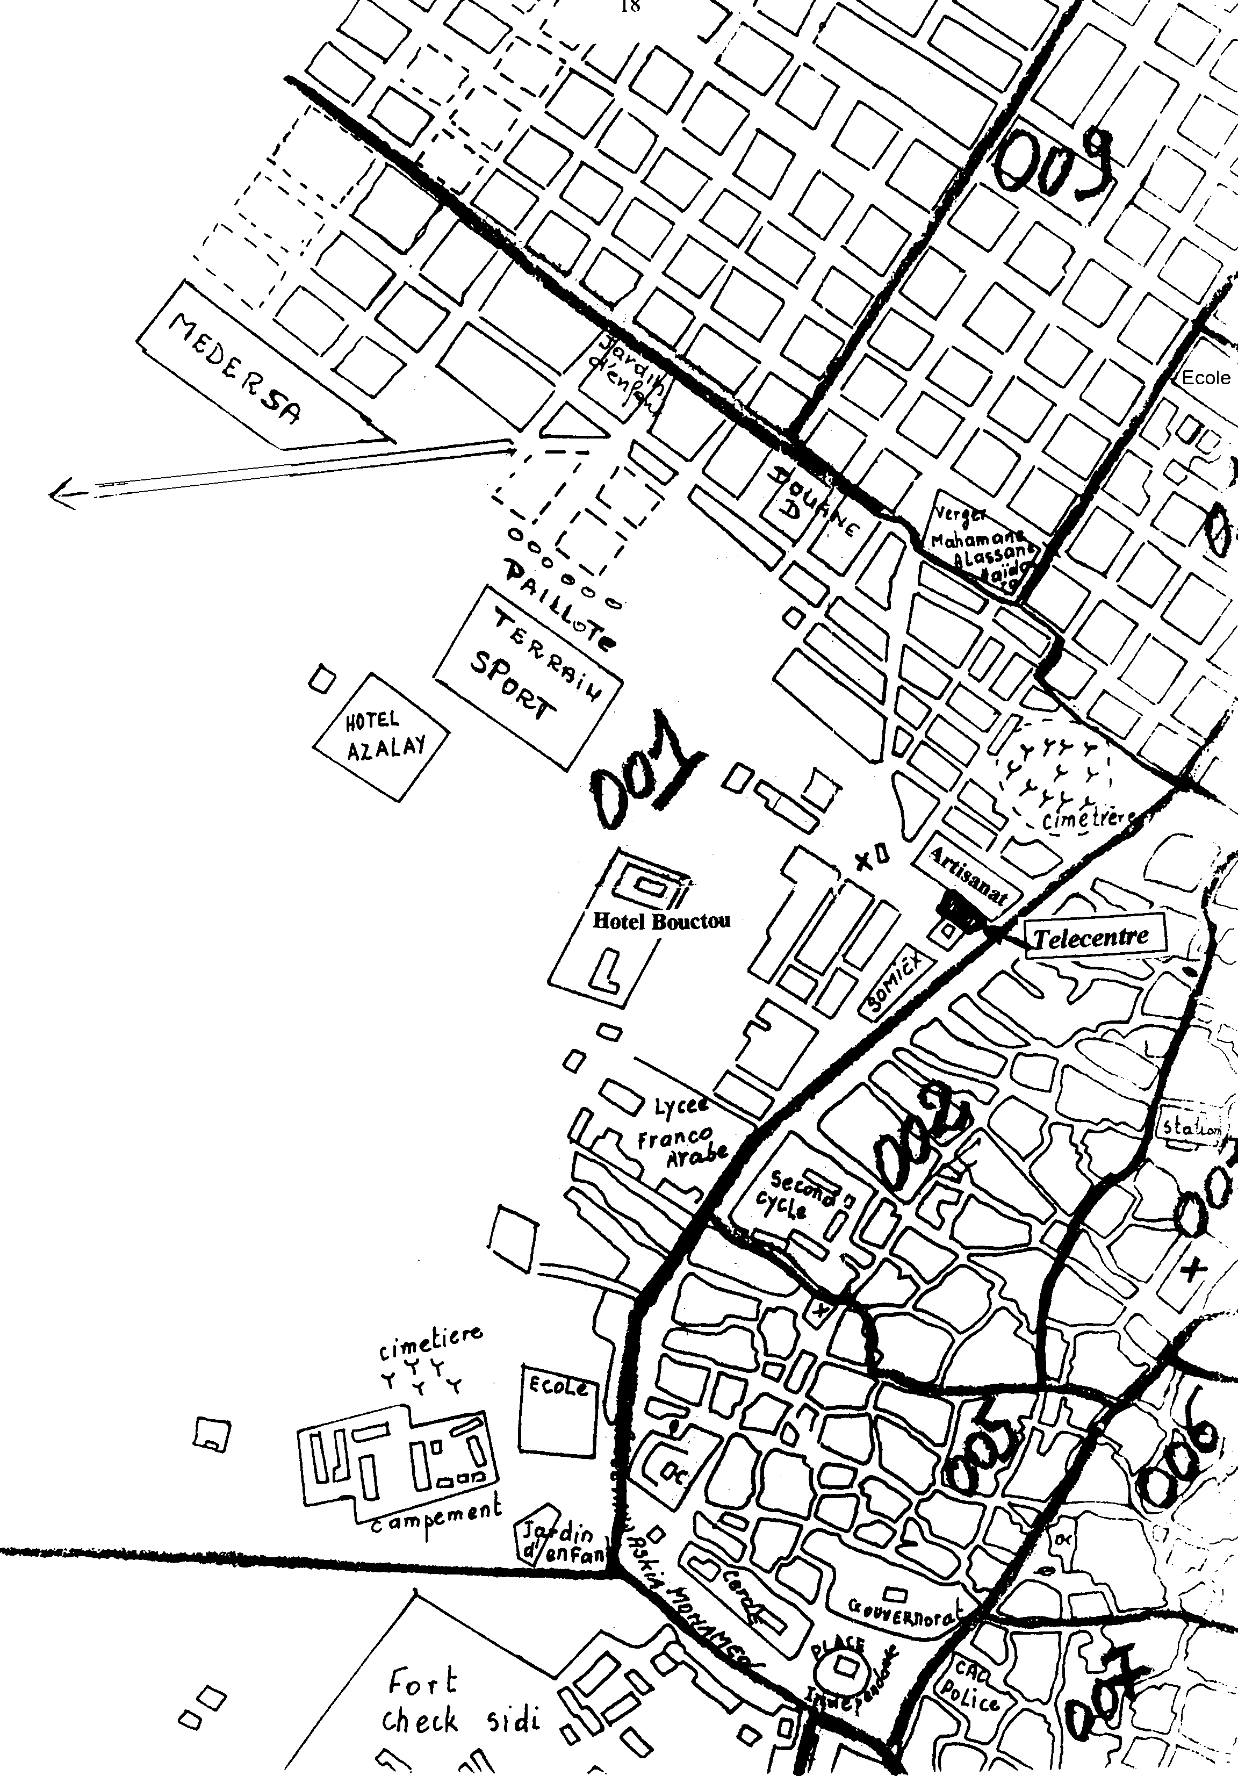
The program in Mali foresees the establishment of similar pilot centers in Djenné, Nará, Nioro and Zégoua, as well as a business center in Bamako. Together with the first center in Tombouctou a support center in Bamako will also be set up (at SOTELMA).

2.2 Population
In 1995 the population of Mali is estimated at 9'013'000, 74% in rural areas. The different regions of Mali show great differences. The regions in the North and Center are partially or totally desert regions. In this part of Mali, representing 60% of the territory, the population density is 0.5-persons/sq. km. The population of the Tombouctou region is 462'000, representing 5.1 % of the country total. In the rest of the country the population density is of the order of 14 persons per sq.km. The most populated regions (Sikasso, Ségou and Mopti) are along the Niger River and the lakes. The Bamako district is a special case, where most of the enterprises and industries of the country are located. Yearly population increase is 2.1 %.

2.3 Economic activities

2.3.1 Primary sector
Agriculture and animal husbandry are the main activities. They make a living for 74 % of the population, and contribute to 42% of the GDP. Fishing is an important activity in the delta region, the Niger River (outside the delta) and Senegal River basin.

2.3.2 Secondary sector
This sector is characterized by a poorly developed industrial activity. It mainly concentrates at transforming the agricultural production. Electric power generation is the monopoly of EDM (Energie du Mali). The privatization of EDM is now under way.
Mining research has revealed existence of bauxite, iron, manganese, lithium, phosphate, copper, tin, lead, uranium, gold and diamonds. This sector is under very rapid development, with great prospective for the future. The gold mining is very rapidly developing.

2.3.3 Tertiary sector
This sector produces 43% of the GDP (1995). The principal activity is in trade, developing very rapidly in the most important towns. Tourism, still little developed, has since the airport Bamako-Sénou came into operation seen a steady increase.

2.4 Transport
The road network is still insufficiently developed. Railway network is operated by RCFM (Régie du Chemin de Fer du Mali). Air transport is provided by several international airlines. River navigation is provided on the Niger and Senegal rivers. From July to December you can travel by boat from Koulikoro to Tombouctou (1000 km).

2.5 Education
The census undertaken in 1987 revealed that the knowledge to read and write is very low in Mali. In 1987 only 18% of the grown up people knew this. The situation is worse in the rural areas than in the urban (8 % respectively 36 %). Since 1981 to 1990 the situation has improved and grown to 22.7 %. That rate has been increase to 31% in 1999 and into the new general policy of the new government it will be up to 36% in 2002 with 25% for women (against 7% in 1996) However, the number of children effectively provided with education has increased by 50% in 1999 and will be up to 62% in 2002 with 53% for girls. In the general policy it is recommended to the ICT project to support the education sector, in order to achieve the government 2 years program.
It is felt this situation is due to the insufficient increase of educational facilities in the country. The rate of school leavers is very high and there is no doubt that this is of great concern for the future. The fact that employment opportunities are also low is supposed to have negative effect on educational interest. The rural areas are much behind with a school attendance 3- 4 times lower than for the urban areas. In the rural areas only 12% to 18% of children go to school. It is possible that the high need of manpower for the agricultural production has an influence.
The geographic disparities have a strong influence on the school attendance. A child in the urban areas has about three times better chance of attending basic education than a child in the rural areas. Secondary school education is more discriminating, socially and geographically seen, than is the basic education mentioned before. Children of the poor households that enter basic education have a chance of 1:26 of continuing with secondary education. In the group non-poor this relationship is ‘only’ 1:15. Superior education is almost entirely provided in Bamako. In total there are about 8’000 - 10’000 students for the whole country. The majority of these students come from the non-poor group of households.
The main causes for low education situation in Mali is primarily thought to be geographically determined. It is also in the rural areas that we find the greatest differences between poor and non-poor households. The rural areas are also the most ‘handicapped’ with facilities for education (schools and teachers).

2.6 Health
The health situation in Mali is among the lowest in the world. At the time of the health survey, CERPOD, in 1987it was revealed that (in 1984) there was only one doctor per 25’000 inhabitants. However, since that year the mortality has decreased importantly, which is a sign of improving health situation in the country. The life expectancy that was on average 48 years in 1976 had reached 57 in 1987, and should today be higher.
The expenditure for health reasons varies for the very poor and the non-poor with 1:8. The highest expenses for health reasons are in Bamako where also medical facilities, hospitals, clinics, pharmacies, are available. The scarcity of such services in the rural areas limits the treatments available and consequently the expenses to pay for medical treatment. The essential part of the expenses for health reasons is used for medicine. Most of it (77%) are spent on modern medicine, whilst 14% are spent on traditional medicine, and for consultations only 9% are used.
It should be remembered that the above cost indications for modern and traditional medicine do not reflect the consummation of such, as the traditional medicine is much cheaper than the modern is.

2.7 Introduction of INTERNET in Mali
The introduction of INTERNET services in Mali has already started. It is under the supervision of SO.TEL.MA, Concessions to operate it has been granted to four local enterprises. At present an INTERNET server exists only in Bamako, making it more expensive for users in other centres of Mali, as they have to pay LD call rates. However SO.TEL.MA. is studying a national service system for INTERNET that would give users anywhere in the country access at same low cost.

3. Project justification

3.1 Present situation
It is also a fact that it is much more difficult to recruit qualified staff for education, health and medical services, etc. to rural areas, who often have to cope with limited staff and often not sufficiently experienced (trained). This has made life in rural areas difficult and brought about the exodus of young and educated students to the larger towns where better work opportunities exist. The Government authorities are concerned about this situation and have participated in the discussions about introducing the Multipurpose Community Telecenters as a constructive element in promoting rural development.
The need to rethink social, economic, cultural, educational and medical services approaches has also special meaning in the rural context. Compounding the immense problems of infrastructure, human and financial resources and organization, rural areas lack access to needed information and learning resources that will allow knowledge building and decision making, as well as mechanisms to communicate with key players in the development process, depriving rural communities of progress made by ‘metropolitan’ institutions. Knowledge and skills available in rural communities are often neglected or disregarded.
Important in the transformation of rural society is the conception and application of information and communication technologies (ICT) that can facilitate communication and provide access to relevant information and knowledge to stimulate processes of learning. Current technological developments present rural communities in Africa not only an opportunity to change existing patterns of imbalance, but also a challenge to leap-frog into the Information Age to participate and compete as equal partners in our global society.

3.2 Expected results of the project
The proposed Multipurpose Community Telecentre is an important step in a process to enhance the rural learning environment by stimulating its people to engage in learning processes aimed at societal and personal change and development through opportunities to stimulate:
- local capacity for informed decision-making to enhance personal, institutional and community development in the areas of health, education, the economy and general development based on facilitated communication, exchange of experience, and access to information and learning resources, research results and newly developed techniques;
- the production of local information and knowledge from resources available within the community to improve local knowledge structures and, at the same time, contribute to a better understanding at local, national and international levels of the specific needs of communities.
By integrating information, communications and library services, the Multipurpose Community Telecentre will provide the following functions:
- basic telecommunications, telematics and computing facilities;
- technical support for the assessment of local learning needs, and for mapping of formal and informal decision making processes and information requirements;
- access to infrastructure, professional expertise and relevant information resources for learning purposes;
- facilities and know-how to produce information, databases and publications reflecting local knowledge and expertise;
- training in how to use modern information and telecommunications technologies, including its use for improving commercial activities.
The project will benefit not only the specific community in Tombouctou and its institutional partners, but also rural communities at large, since it aims at developing a model that is sustainable and replicable in other rural settings.

3.3 Target beneficiaries
The target beneficiaries are for this pilot project the whole community of Tombouctou, primarily the Cercle of Tombouctou, but also the other circles of the region, though they have limited use of the telecentre (MCT) due to distances. In a future extension of services it is possible that other circles of the region can either have their own Telecenter, or a less equipped, and staffed, centre, attached to the main centre at Tombouctou, from where assistance can be given. The long-term plan will see the second phase centres in Djenné, Nioro, Nará and Zégoua be implemented and ultimately the Telecenter model will be available throughout Mali.
¤ The local community of Tombouctou
The multipurpose community telecentre aims at serving the whole community. Within this community specific target groups have been identified, having specific needs for information and communication:

3.3.1 Libraries
There are several libraries in Tombouctou, which will benefit from the new services of a Telecenter:
¤ The famous Centre Ahmed Baba, with its precious collection of books and documentation, regularly visited by national and international researchers, as well as interested tourists
¤ The library of the Mahamane Alassane Haidara Lyceum, visited daily by about 300 students
¤ Biblioteque Lecture Publique, available in all 5 Cercles of the 6th Region
¤ Smaller libraries at other public and private schools
They could profit from the facilities and services at the Telecenter:
¤ get training in using computerized services in general, and in using INTERNET, in particular
¤ be able to connect to the world through INTERNET and telefax services
¤ consult national and international databases, and download documentation (and video clips, etc.) of use for their activities
¤ create records of and organize their documentation as well as loan records
It is expected that several of the libraries will later extend their facilities by having their own computer(s), with direct INTERNET connections.

3.3.2 Educational establishments
The Lyceum ‘Mahamane Alassane Haidara’, the secondary and primary schools, the private school MEDERSA, the forthcoming Lycee Technique Agricole (at Niafunke), as well as the many Kindergartens, that exist in Tombouctou, will all be able to make use of the Telecenter, to the benefit of their educational obligations and goals. The support to be provided through the Telecenter will need to be developed in collaboration with the national ministries and authorities concerned. The supports that can be envisaged are:
¤ basic and more advanced computer literacy training
¤ maintain and update educational curricula in electronic format
¤ training programs for teachers at all educational levels (primary, secondary, lyceum)
¤ INTERNET and WWW-based communications and information access for teachers and students
¤ audio-graphics distance education access with the educational authorities in Bamako (e.g. through the Support Centre -business centre- planned to be set up by SO.TEL.MA)
¤ production of locally adapted learning and teaching materials
¤ professional use of telephone, telefax and INTERNET communication by local teachers

3.3.3 Museum and culture
The protection of cultural and historic values is important for the local and national citizens. It is also very important for the enrichment of visiting tourists and researchers, and can contribute to increase a cultural tourism, which will provide income to the community in many ways (entrance fees, hotel services, handicraft sales, use of Telecenter facilities, etc.). The Museum of Tombouctou has an important collection kept in a large room with historic, archeological, ethnological finds, but is very poorly organized, presented and protected. It needs to have support from a specialist, to organize, document, identify, etc. the museum collection.
It has been discussed during the mission to Mali that the museum in Tombouctou, and in Bamako, could be modernized by using multi-media to present historic, cultural, arts etc. from Mali in particular, and also other areas of Africa with similar historic and cultural origin, that has influenced history of Mali, and for which a large part of documentation and masterpieces exist in museums world-wide

3.3.4 Health and medical facilities, including telemedicine
The regional hospital is located in Tombouctou. There is also a Health Centre (Centre de Santé) in each Cercle of the Region, i.e. in Tombouctou, Goundam, Niafunke, Rharous and Diré.
Some statistics about diseases in the region:
¤ Paludisme 33%
¤ Pneumonia/pathology 20%
¤ IRA 7%
¤ HTA 5%
¤ AIDS (increasing rapidly!) 0.13%
¤ Other diseases 35%

3.3.5 Handicrafts - artisans
The ancient tradition of educating children in handicraft and artistic traditions are very strong in Tombouctou and the potential of extending the very high level of craftsmanship that exist today, should be explored. To make this activity an important income for the population is a possibility the telecentres could contribute to by publicizing e.g. through home pages on Internet the products that are for sale. The local handicraft organizations could organize a commercial enterprise (SME) that could use the telecentres facilities for this.

3.3.6 Tourism
The tourism is limited by sufficient transportation capacity and the two hotels in Tombouctou have a small capacity of beds. There is already work going on to extend the number of hotel beds and to modernize the hotels (including air-conditioning of rooms). The potential of Tombouctou to become an important tourism destination is very high, with the historic fame of the town and the legendary past. It will need to develop the infrastructure in many fields, not only hotel and transport facilities, but also the presentation of Tombouctou, e.g. improve the museum and access to historic houses in the old town (René Caillé, etc.) and the three mosques, and many other interesting sites.
The Telecenter can be used to promote tourism by creating home pages on Internet, producing tourist leaflets, assist in reservation of hotels and transportation means, etc. It requires to be organized with the many existing tourist organizations in Mali (mainly in Bamako today) and to develop this, co-ordinated with visits to many other historic places in the area, such as Djenné, Gao, the Dogon region, etc.

3.3.7 Support to agriculture, fishery and rural development
The UN executing agency FAO is since several years active in Mali in supporting rural development. They are amongst others involved in the ‘relance de la Radio Rural ‘ in Mali and are about to start such an activity in Northern Mali, including the Tombouctou region. The Pilot Project could therefore support the development of agriculture, fisheries and rural development through support activities. More specifically, the agricultural/fishery and rural development applications of the telecentre pilot project should support activities like:
¤ locally developed learning tools and networks
¤ interactive and collaborative information networks among government research and extension agencies, educational institutions, NGOs, input suppliers, product buyers, farmer organizations and rural media outlets
¤ marketing information networks linking locally managed market information systems with provincial, national and global systems
¤ agricultural products and services trading networks
¤ distance learning and tele-training programs
¤ participatory, farmer-led field research and results dissemination
¤ specialized information networks (e.g. weather, environmental protection, disease and pest monitoring, water management)

3.3.8 'Promotion de la femme'
The important role women play in society and for the families is recognized and today there are many local and national activities (organizations) working on promoting the role of women. The need of extended support for education and training of women is important, as they have often not been supported enough in the past. This input to the pilot project will have to be defined during the project period and developed. A special Project Application Team has been assigned to this matter.

4. Objectives of the project
The overall aim of the Telecenter pilot project is to engage the rural community of Tombouctou and various national stakeholders in the process developing an affordable and accessible model of a Multipurpose Community Telecentre. This centre will be an experience (model) to be applied for future similar centres throughout Mali. In this context, the specific objectives of the pilot project are:
i. Development the modalities to support a sustainable community-based telecentre within an African, and specifically Malien context, including developmental testing of:
- processes within the project period (3 years) to transfer full ownership of the centre and its commitments to a community-based Telecenter;
- strategies for local needs assessment and information mapping;
- strategies for learning how to use and benefit from the various services provided by the centre, addressing the needs of the rural population;
- developing training programs on the use of ICTs;
- innovative policies, partnership arrangements and tariff structures for information and communication;
- new technologies and their impact to enhance learning, teaching, supporting the SMEs, health and medical services, etc.
- Assessment of the social, economic and cultural impact of the Telecenter with regard to community, regional and national development processes,
- Contribution towards national and international understanding of the importance of information and telecommunications for development, and the link between modern ICTs and rural development processes.
The objectives of the project will be realized through the following concrete outcomes:
i. Establishment of a Multipurpose Community Telecentre that is:
- owned by the community of Tombouctou
- economically sustainable
- accessible to all people in the Tombouctou community (cercle). and people visiting Tombouctou
- a basis for an enhanced learning and training environment in Tombouctou.
ii. Strategies to identify local information and learning needs and promote a general understanding of the information and learning for development.
iii. A self-instructional kit to train rural communities in using modern information and telecommunications technologies.
- Implementation of policies which promote extension of the existing infrastructure for communication and information.
- A study of the social, economic and cultural impacts on the different users and user groups of the Tombouctou Telecenter, and the community as a whole.
- Contribute to an international comparative study on the five-telecenter pilot projects in Africa, with recommendations on future use of the Telecenter model in rural development.

Implementation phase
Some results obtained so far during the on-going implementation phase of the Project:
¤ The Community has collected US $ 30 770 for the building the MCT. That’s a great success in Mali,
¤ The construction plan, proposed by the project, has now been modified, and will include:
- the MCT,
- the community radio and
- the community library at the same site. That’s a very sustainable act, as this decision has been made by the Community,
¤ A web site www.tombouctou.org.ml has been created,
¤ Application teams are composed and they are participating in the feasibility study of application projects per corporation.
¤ Staff recruited locally are receiving from the project an appropriate training.
¤ The local committee is receiving management training. By now they make good decisions and manage the project with satisfaction.
¤ The Telecenter is becoming a research center. Many students, civil servants, etc. come to search information in the MCT which is very encouraging.
¤ The Project coordinator has been given a consultancy contract from UNESCO to support Benin to start their project in Malanville.
- User training and satisfaction
More than 160 people have received appropriate NTIC training and 4000 persons have visited the MCT. 21 young diploma receivers have got jobs after computer training at the MCT.

6. Long-term objectives
To trained MCT staff recruited locally to use all ICT in the telecenter, so they can give responses to all kind of ICT problems. To trained application teams from all corporations.

7. Service charges and viability of operations
The services have been determined after a study conduct by the steering committee and the staff of MCT with the support of UNESCO. Prices for all services has been fixed by the members of the local Steering Committee on the basis of feasibility studies.
SERVICES OF THE MCT
A dozen of services are offered by the MCT of Tombouctou .
PRICE OF SERVICES
A/- INTERNET CONNEXION
Hour number of connection | Prices of service
10 | 9.600
14 | 13.500
15 | 15.000
30 | 25.800
40 | 32.500
Illimité | 40.000
Using of web and email for one hour | 1.500

B/- INSTALLATION, CONFIGURATION AND TRAINING TO INTERNET
Web and email | 24.000

C/- TRAINING (reduction 20% for women and unemployed young diploma)
Windows (duration 1 month) | 25.000
Word (duration 1 month) | 25.000
Excel (duration 1 month) | 25.000

D/- TYPING
1page | 500
Location machine by hour | 500
Printing per page | 150
Photocopy | 100
Installation of software | 15.000
Scanning | 500

E/- REPARATIONS SOFT / HARD
Printer | 20.000
Keybord and mouse | 2.500
Hard problem in general | 15.000
Monthly maintenance of machine | 15.000

F/- PUBLICATION OF WEB PAGES
Home page | 30.000
Additional page | 10.000
Updating of the Home page | 15.000
Updating of additional page | 5.000
G/- TELEPHONE AND FAX
To conform to SO.TEL.MA's prices. The prices for the services are accepted by the users. The level of revenue is not sufficient to covers all the expenditure of the MCT. But before May 2001 we hope to covers all charges with the takings and get 35% of benefits. See below the evolution of the takings of MCT services.

Month | Income
April99 | 2000
May-99 | 19500
June-99 | 32850
July-99 | 31250
August-99 | 28000
Sept-99 | 71500
Oct-99 | 72100
Nov-99 | 36800
Dec-99 | 80850
Janv-00 | 205330
Fevr-00 | 142845
March-00 | 163290
 | 886315
Selling services started at the end of April. From May 1998 to November 1999 the MCT was located in the hospital. From December 1999 the MCT is located at the « Place de l’Independance at the « Mairie ». That new situation explains the growth of the income.

Annexes
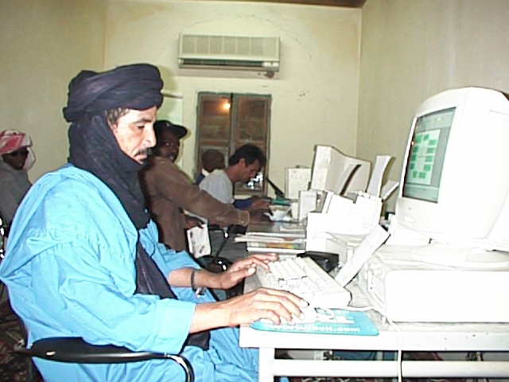Clients into the Internet room

Building of new site of MCT
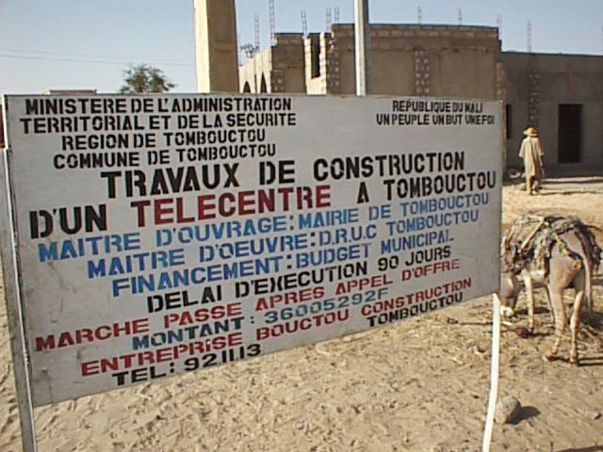

GAS 10 Handbook: Planning Data and Forecasting Methods, Volume 1, page 212 and following (6.4.5.2 )
Benin, Mali, Mozambique, Tanzania, Uganda
80% of the poor households live in the rural areas
Enquête démographique et de santé, 1987, CERPOD
Reference is made to Bunker Roy’s observation that “ ... The poor remain poor because they are not receiving enough information that will allow them to grow, allow them to make choices”. In:Technology and Learning. UNESCO, 1997
The potential value of this for Tombouctou is unique and should be explored how it can best benefit the local community
les maçons, menuisiers-charpentiers, tailleurs et tisserands (e.g. broderie à la main, forgerons, potiers, bijouterie, etc.
in Tombouctou and for other cercles of the region

