CHAPTER 3

3. MOBILE DIGITAL CELLULAR NETWORKS AND SERVICES

3.1 GLOBAL SYSTEM OF MOBILE COMMUNICATIONS (GSM)
    - Introduction

Following the standardisation and launch of the Pan-European digital mobile cellular radio system known as GSM, it is of practical merit to provide a rudimentary introduction to the system’s main features for the communications practitioner. Since GSM operating licences have been allocated to 126 services providers in 75 countries, it is justifiable that the GSM system is often referred to as the Global System of Mobile communications.
The GSM specifications were released as set of thirteen recommendations (ETSI, 1988), which are summarised in section 3.2.8, covering various aspects of the system.

The system elements of a GSM public land mobile network (PLMN) are portrayed in Figure 3.1, where their interconnections via the standardised interfaces A and Um are indicated as well. The mobile station (MS) communicates with the serving and adjacent base stations (BS) via the radio interface Um, whereas the BSs are connected to the mobile switching centre (MSC) through the network interface A. As seen in Figure 3.1, the MS includes a mobile termination (MT) and terminal equipment (TE). The TE may be constituted, for example, by a telephone set and fax machine. The MT performs functions needed to support the physical channel between the MS and the base station, such as radio transmissions, radio channel management, channel coding/decoding, speech encoding/decoding, and so forth.

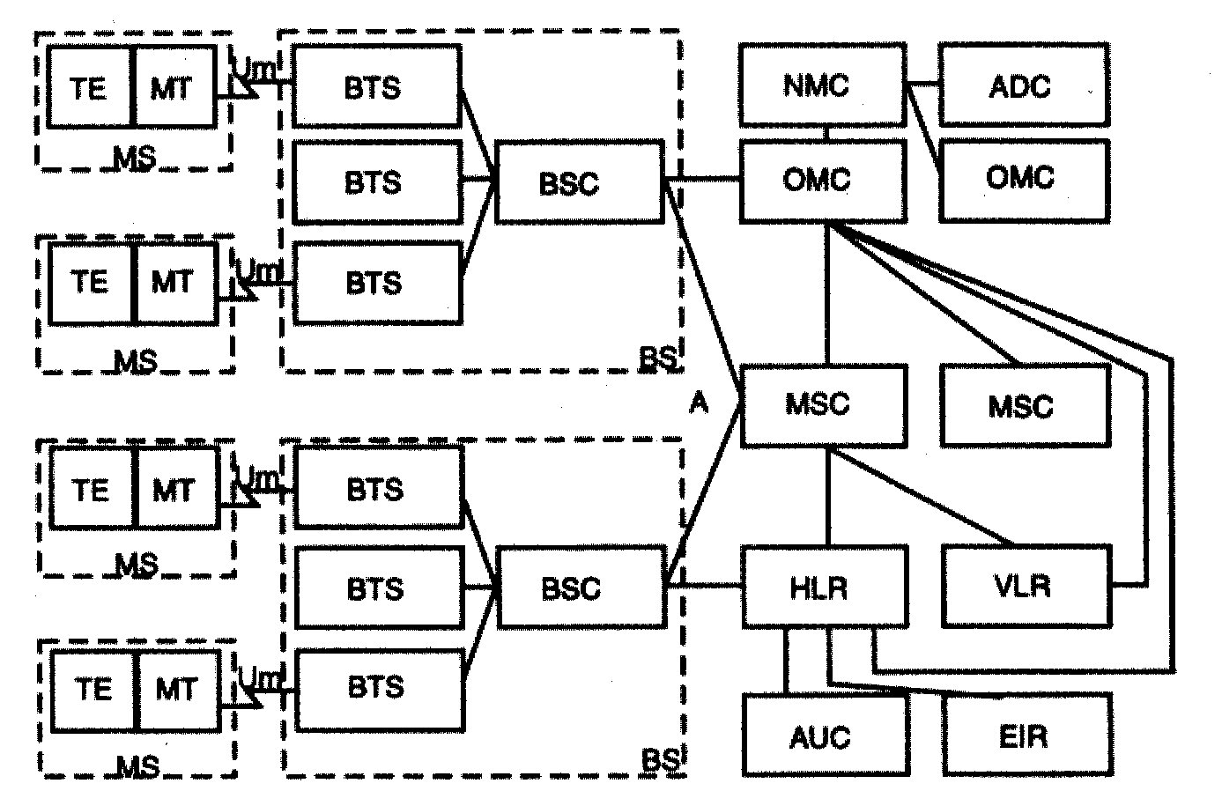
Figure 3.1 Simplified structure of GSM

The BS is divided functionally into a number of base transceiver stations (BTS) and a base station controller (BSC). The BS is responsible for channel allocation (R.05.09), link quality and power budget control (R.05.06 and R.05.08), signalling and broadcast traffic control, frequency hopping (FH) (R.05.02), handover (HO) initiation (R.03.09 and R.05.08), etc. The MSC represents the gateway to other networks, such as the public switched telephone network (PSTN), integrated services digital network (ISDN) and packet data networks using the interworking functions standardised in recommendation R.09. The MSC’s further functions include paging, MS location updating (R.03.12), HQ control (R.03.09), etc. The MS’s mobility management is assisted by the home location register (HLR) (R.03.12), storing part of the MS’s location information and routing incoming call to the visitor location register (VLR) (R.03.12) in charge of the area, where the paged MS roams.
Location update is asked for by the MS, whenever it detects from the received and decoded broadcast control channel (BCCH) messages that it entered a new location area. The HLR contains, among a number of other parameters, the international mobile subscriber identity (IMSI), which is used for the authentication (R.03.20) of the subscriber by his authentication centre (AUC). This enables the system to confirm that the subscriber is allowed to access it. Every subscriber belongs to a home network and the specific services that the subscriber is allowed to use are entered into his HLR. The equipment identity register (EIR) allows for stolen, fraudulent, or faulty mobile stations to be identified by the network operators. The VLR is the functional unit that attends to a MS operating outside the area of its HLR. The visiting MS is automatically registered at the nearest MSC, and the VLR is informed of the MSs arrival. A roaming number is then assigned to the MS, and this enables calls to be routed to it. The operations and maintenance centre (OMC), network management centre (NMC) and administration centre (ADC) are the functional entities through which the system is monitored, controlled, maintained and managed (R.12).
The MS initiates a call by searching for a BS with a sufficiently high received signal level on the BCCH carrier; it will await and recognize a frequency correction burst and synchronize to it (R.05.08). Now the BS allocates a bidirectional signalling channel and also sets up a link with the MSC via the network. How the control frame structure assists in this process will be highlighted later. The MSC uses the IMSI received from the MS to interrogate its HLR and sends the data obtained to the serving VLR.
After authentication (R.03.20) the MS provides the destination number, the BS allocates a traffic channel, and the MSC routes the call to its destination. If the MS moves to another cell, it is reassigned to another BS, and a handover occurs. If both BSs in the handover process are controlled by the same BSC, the handover takes place under the control of the BSC, otherwise it is performed by the MSC. In case of incoming calls the MS must be paged by the BSC. A paging signal is transmitted on a paging channel (PCH) monitored continuously by all MSs, and which covers the location area in which the MS roams. In response to the paging signal, the MS performs an access procedure identical to that employed when the MS initiates a call.

3.1.2 Logical and Physical Channels

The GSM logical traffic and control channels are standardised in recommendation R.05.02, whereas their mapping onto physical channels is the subject of recommendations R.05.03. The GSM system’s prime objective is to transmit the logical traffic channel’s (TCH) speech or data information. Their transmission via the network requires a variety of logical control channels. There are two general forms of speech and data traffic channels: the full-rate traffic channels (TCH/F), which carry information at a gross rate of 22.8 kb/s, and the half-rate traffic channels (TCH/H), which communicate at a gross rate of 11.4 kb/s. A physical channel carries either a full-rate traffic channel, or two half-rate traffic channels. In the former, the traffic channel occupies one timeslot, whereas in the latter the two half-rate traffic channels are mapped onto the same timeslot, but in alternate frames.
A physical channel in a time division multiple access (TDMA) system is defined as a timeslot with a timeslot number (TN) in a sequence of TDMA frames. The GSM system, however, deploys TDMA combined with frequency hopping (FH) and, hence, the physical channel is partitioned in both time and frequency. Frequency hopping (R.05.02) combined with interleaving is known to be very efficient in combating channel fading, and it results in near-Gaussian performance even over hostile Rayleigh-fading channels. The principle of FH is that each TDMA burst is transmitted via a different RF channel (RFCH). If the present TDMA burst happened to be in a deep fade, then the next burst most probably will not be. Consequently, the physical channel is defined as a sequence of radio frequency channels and timeslots. Each carrier frequency supports eight physical channels mapped onto eight timeslots within a TDMA frame. A given physical channel always uses the same TN in every TDMA frame. Therefore, a timeslot sequence is defined by a TN and a TDMA frame number FN sequence.

3.1.3 Speech and Data Transmission

The speech coding standard is recommendation R.06.10, whereas issues of mapping the logical speech traffic channel’s information onto the physical channel constituted by a timeslot of a certain carrier are specified in recommendation R.05.02. Since the error correction represents part of this mapping process, recommendation R.05.03 is also relevant to these discussions. The example of the full-rate speech traffic channel (TCH/FS) is used here to highlight how this logical channel is mapped onto the physical constituted by a so-called burst (NB) of the TDMA frame structure. This mapping is explained by referring to Figs. 3.2 and 3.3.
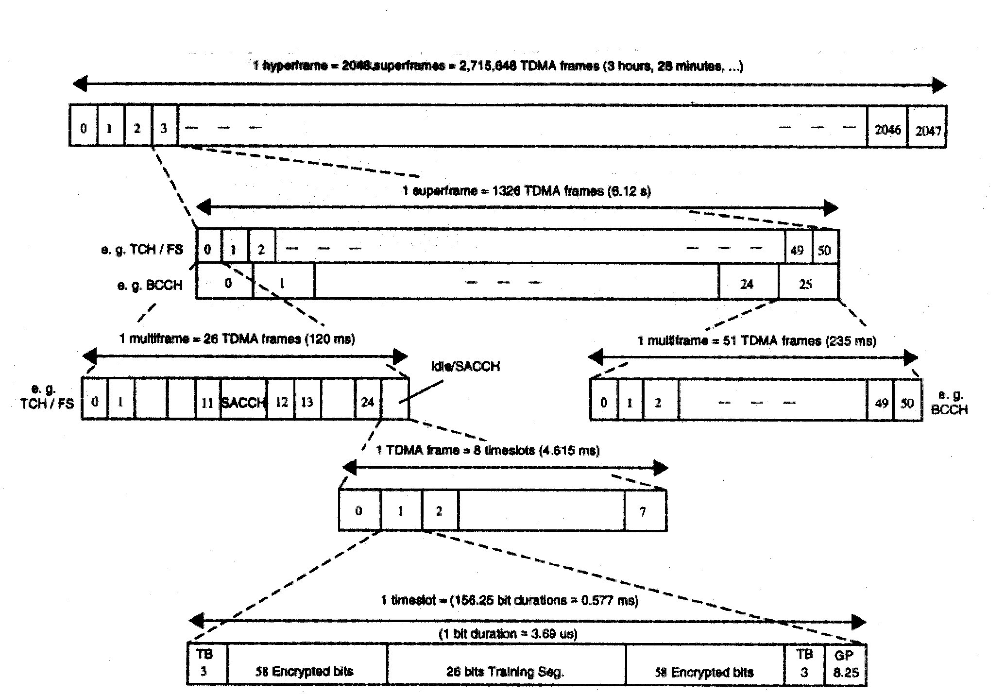

Figure 3.2 The GSM TDMA frame structure

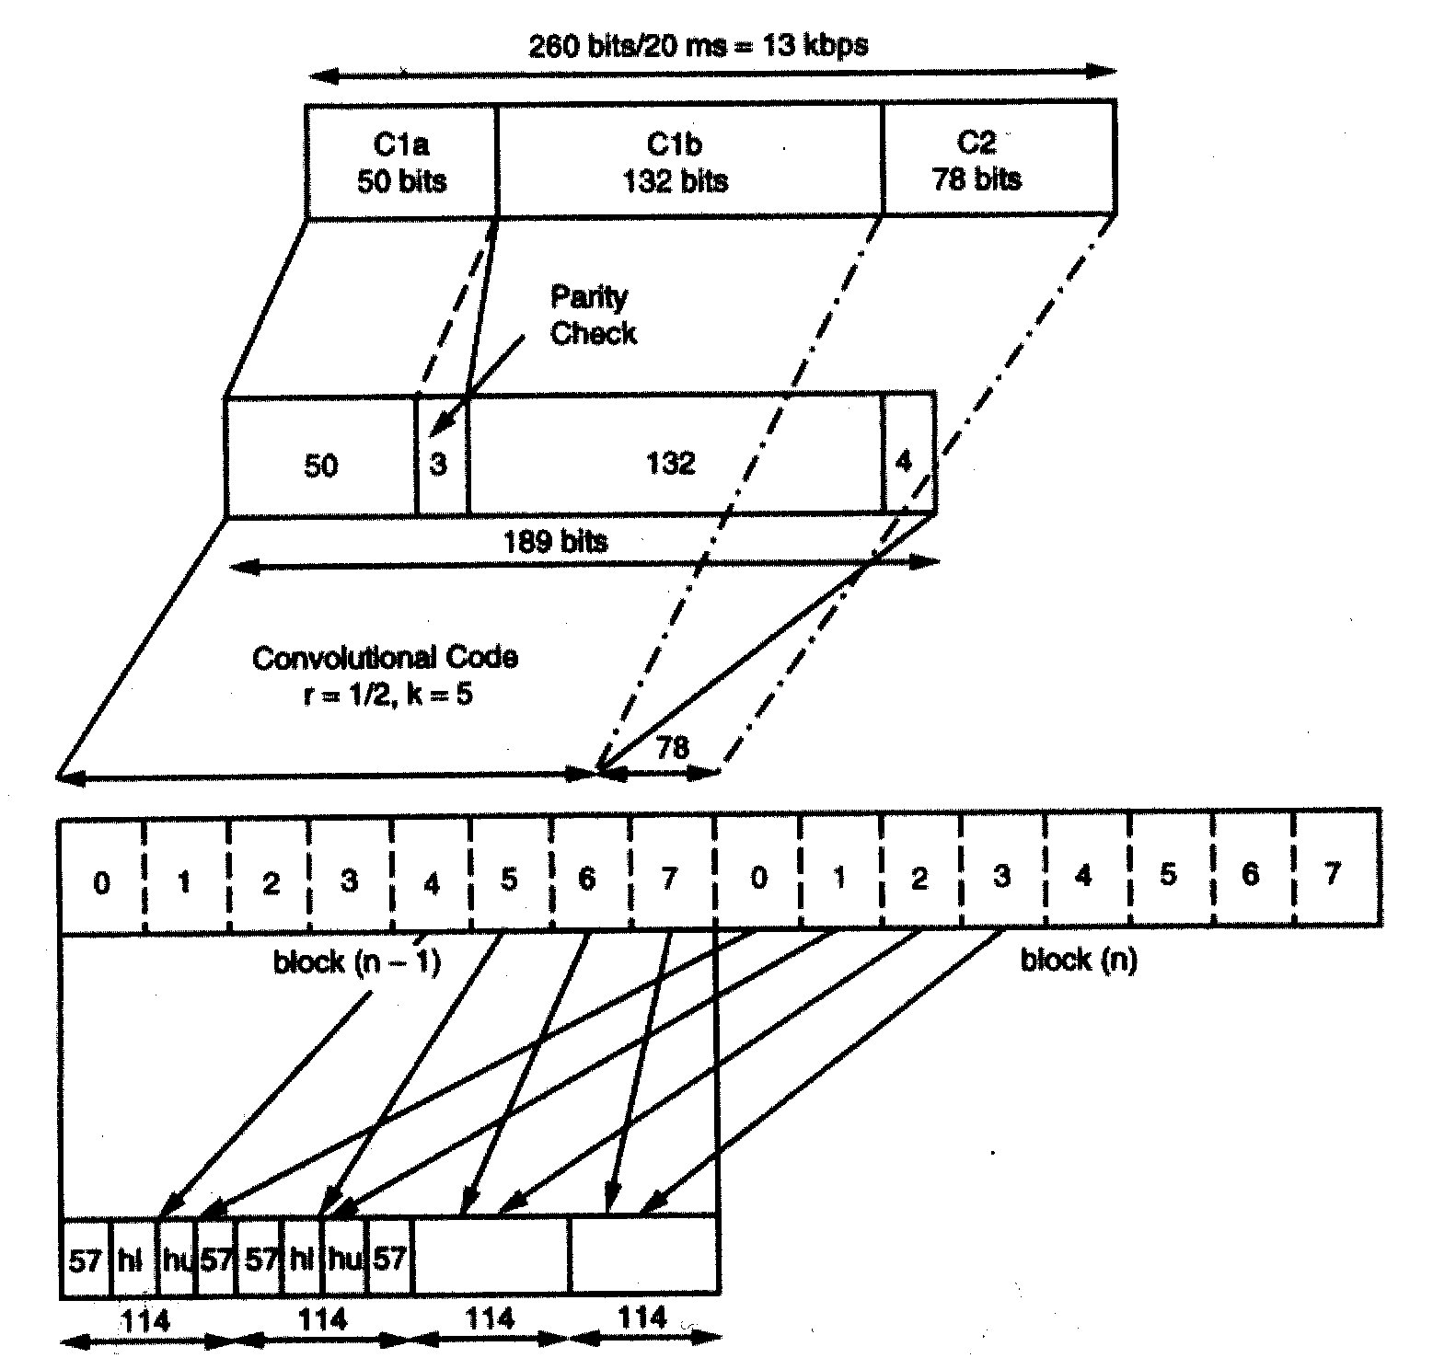

Figure 3.3 Mapping the TCH/FS logical channel onto a physical channel

3.1.4 Transmission of Control Signals

The exact derivation, forward error correcting (FEC) coding and mapping of logical control channel information is beyond the scope of this chapter, and the interested reader is referred to ETSI, 1988 (R.05.02 and R.05.03) and Hanzo and Stefanov, 1992, for a detailed discussion. As an example, the mapping of the 184-b SACCH, FACCH, BCCH, SDCCH, PCH, and access grant control channel (AGCH) messages onto a 456-b block, i.e., onto four 114-b bursts is demonstrated in Fig. 3.4. A double-layer concatenated FIRE-code/convolutional code scheme generates 456 bits, using an overall coding rate of R = 184/456, which gives a stronger protection for control channels than the error protection of traffic channels.

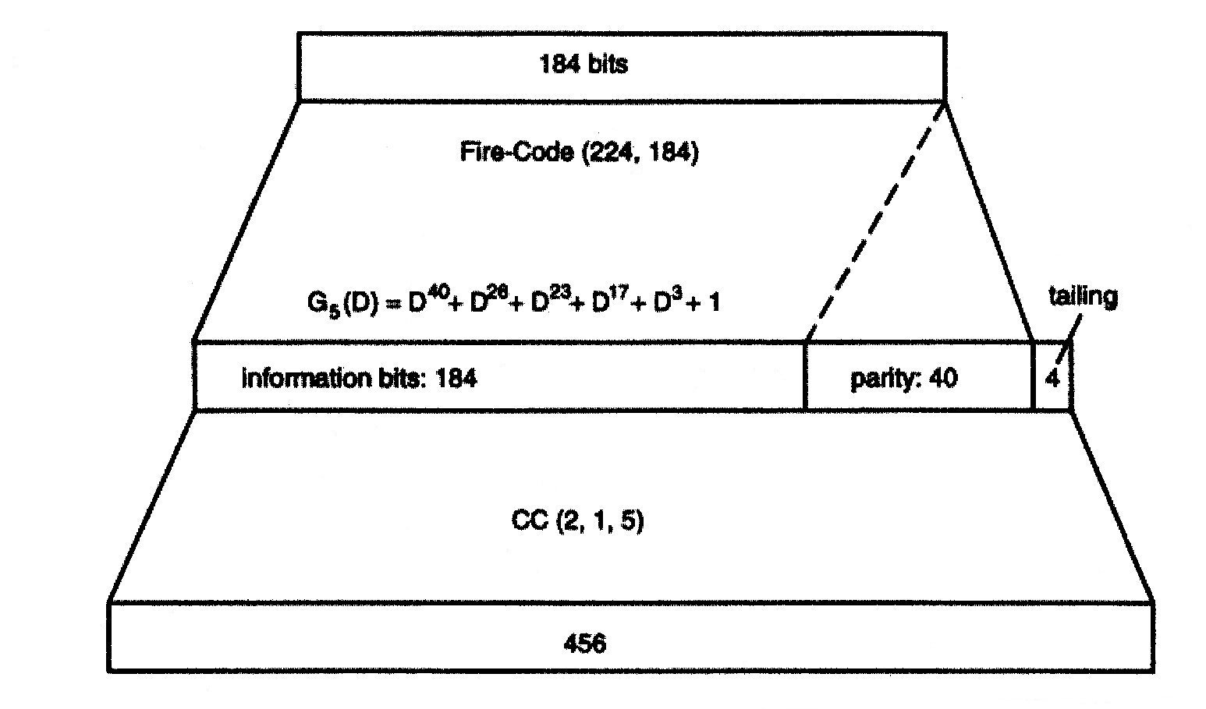

Figure 3.4 FEC in SACCH, FACCH, BCCH, SDCCH, PCH and AGCH

3.1.5 Synchronisation Issues

Although some synchronization issues are standardised in recommendation R.05.02 and R.05.03, the GSM recommendation do not specify the exact BS-MS synchronisation algorithms to be used, these are left to the equipment manufacturers. A unique set of timebase counters, however, is defined in order to ensure perfect BS-MS synchronism. The BS sends FCB and SB on specific timeslots of the BCCH carrier to the MS to ensure that the MS’s frequency standard is perfectly aligned with that of the BS, as well as to inform the MS about the required initial state of its internal counters. The MS transmits its uniquely numbered traffic and control burst staggered by three timeslots with respect to those of the BS to prevent simultaneous MS transmission and reception, and also takes into account the required timing advance (TA) to cater for different BS-MS-BS round-trip delays.

3.1.6 Gaussian Minimum Shift Keying Modulation

The GSM system uses constant envelope partial response GMSK modulation specified in recommendation R.05.04. Constant envelope, continuous-phase modulation schemes are robust against signal fading as well as interference and have good spectral efficiency. The slower and smoother are the phase changes, the better is the spectral efficiency, since the signal is allowed to change less abruptly, requiring lower frequency components. The effect of an input bit, however, is spread over several bit periods, leading to a so-called partial response system, which requires a channel equalizer in order to remove this controlled, intentional inter-symbol interference (ISI) even in the absence of uncontrolled channel dispersion.

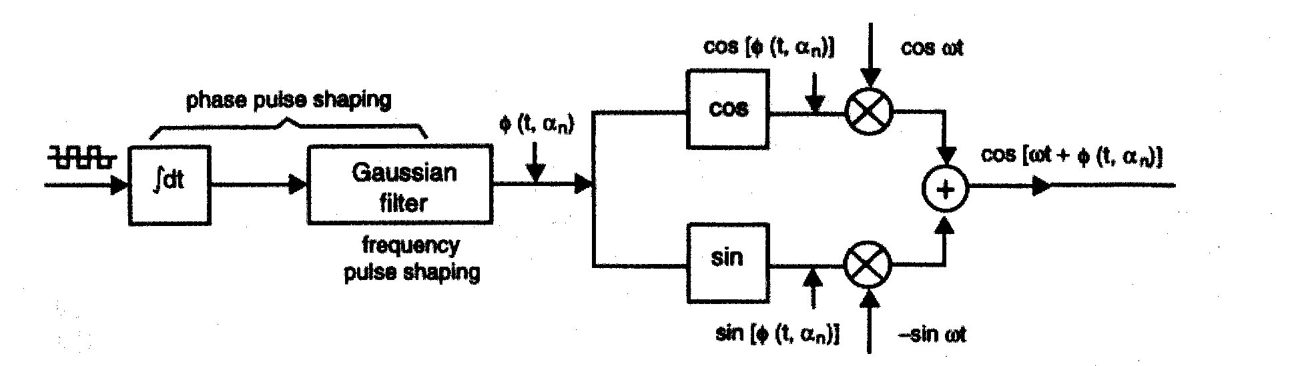

Figure 3.5 GMSK modulator schematic diagram

3.1.7
Wide Channel Models

The set of 6-tap GSM impulse responses specified recommendation R.05.05 where the individual propagation paths are independent Rayleigh fading paths, weighted by the appropriate coefficient h_{i} corresponding to their relative powers portrayed in the Fig. 3.6. In simple terms the wideband channel’s impulse responses is measured by transmitting an impulse and detecting the received echoes at the channel’s output in every D-spaced so-called delay bin. In some bins no delayed and attenuated multipath component is received, whereas in others significant energy is detected, depending on the typical reflecting objects and their distance from the receiver. The path delay can be easily related to the distance of the reflecting objects since radio waves are travelling at the speed of light. For example, at a speed of 300,000 km/s, a reflecting object situated at a distance of 0.15 km yields a multipath component at a round-trip delay of 1μs.

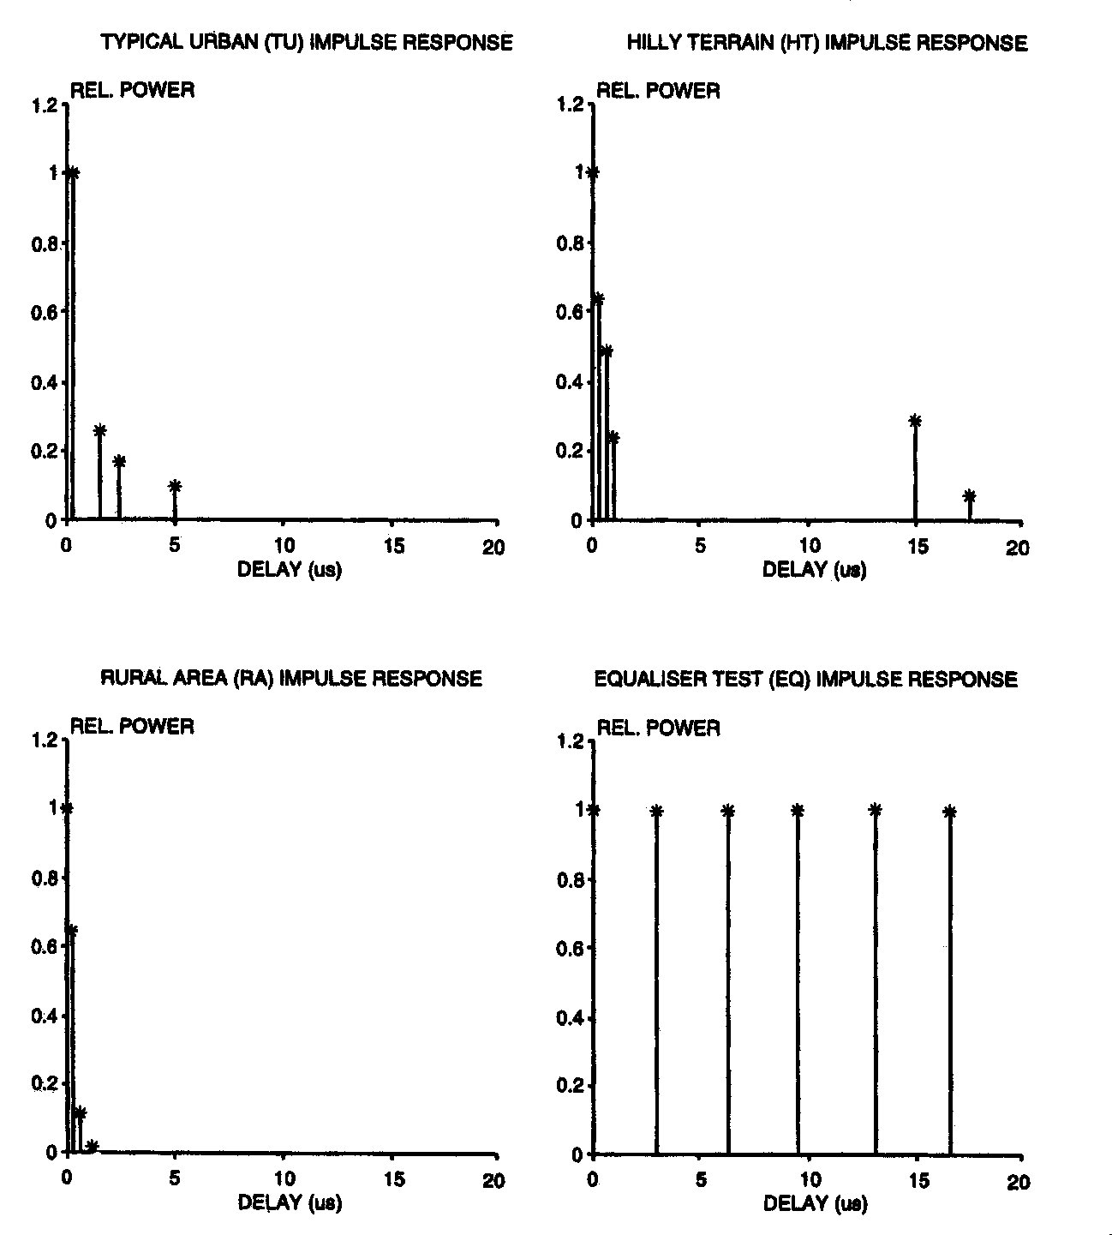

Figure 3.6 Typical GSM channel impulse responses

3.1.8 Discontinuous Transmission

Discontinuous transmission (DTX) issues are standardised in recommendation R.06.31, whereas the associated problems of voice activity detection VAD are specified by R.06.32. Assuming an average speech activity of 50% and a high number of interferers combined with frequency hopping to randomise the interference load, significant spectral efficiency gains can be achieved when deploying discontinuous transmissions due to decreasing interferences, while reducing power dissipation as well. Because of the reduction in power consumption, full DTX operation is mandatory for MSs, but in BSs, only receiver DTX functions are compulsory.
The fundamental problem in voice activity detection is how to differentiate between speech and noise, while keeping false noise triggering and speech spurt clipping as low as possible. In vehicle-mounted MSs the severity of the speech/noise recognition problem is aggravated by the excessive vehicle background noise. This problem is resolved by deploying a combination of threshold comparisons and spectral domain techniques. Another important associated problem is the introduction of noiseless inactive segments, which is mitigated by comfort noise insertion (CNI) in these segments at the receiver.

3.1.9 Summary

The salient features of the GSM system can be summarized as follows.
Time division multiple access (TDMA) with eight users per carrier is used at a multi-user rate of 271 kb/s, demanding a channel equaliser to combat dispersion in large cell environments. The error protected chip rate of the full-rate traffic channels is 22.8 kb/s, whereas in half-rate channels it is 11.4 kb/s. Apart from the full-and half-rate speech traffic channels, there are 5 different rate data traffic channels and 14 various control and signalling channels to support the system’s operation. A moderately complex, 13 kb/s regular pulse excited speech codec with long term predictor (LTP) is used, combined with an embedded three-class error correction codec and multilayer inter leaving to provide sensitivity-matched unequal error protection for the speech bits. An overall speech delay of 57.5 ms is maintained. Slow frequency hopping at 217 hops/s yields substantial performance gains for slowly moving pedestrians.
Constant envelope partial response GMSK with a channel spacing of 200 kHz is deployed to support 125 duplex channels in the 890-915 MHz up-link and 935-960 MHz down-link bands, respectively. At a transmission rate of 271 kb/s a spectral efficiency of 1.35-bit/s/Hz is achieved. The controlled GSMK induced and uncontrolled channel-induced intersymbol interferences are removed by the channel equalizer. A set of standardised wideband GSM channels was introduced in order to provide bench markers for performance comparisons. Efficient power budgeting and minimum co-channel interferences are ensured by the combination of adaptive power and handover control based on weighted averaging of up to eight up-link and down-link system parameters. Discontinuous transmissions assisted by reliable spectral-domain voice activity detection and comfort-noise insertion further reduce interference and power consumption. Because of ciphering, no unprotected information is sent via the radio link. As a result, spectrally efficient, high-quality mobile communication with a variety of services and international roaming is possible in cells of up to 35 km radius for signal to-noise and interference ratios in excess of 10-12 dBs. The key system features are summarized in Table 3.1.
In 1990, by request of the United Kingdom, the specification of a version of GSM adapted to the 1800 MHz frequency band was added to the scope of the standardisation group, with a frequency allocation of twice 75 MHz. This variant, referred to as DCS1800 (Digital Cellular System 1800) is aimed at reaching higher capacities in urban areas for example for the type of mass-market approach known as PCN (Personal Communications Network), Table 3.2.

System feature | Specification
Up-link bandwidth, MHz | 890-915 = 25
Down-link bandwidth, MHz | 935-960 = 25
Total GSM bandwidth, MHz | 50
Carrier spacing, KHz | 200
Number of RF carriers | 125
Multiple access | TDMA
Number of users/carrier | 8
Total number of channels | 1000
TDMA burst rate, kb/s | 271
Modulation | GMSK
Bandwidth efficiency, b/s/Hz | 1.35
Channel equalizer | Yes
Speech coding rate, kb/s | 13
FEC coded speech rate, kb/s | 22.8
FEC coding | Embedded block/convolutional
Frequency hopping, hop/s | 217
DTX and VAD | Yes
Maximum cell radius, km | 35

Table 3.1 Summary of GSM features

System | DCS-1800
Multiple access | TDMA/FDMA
Frequency Band, MHz
Uplink | 1710-1785
Downlink | 1805-1880 (UK)
RF channel Spacing KHz
Uplink | 200
Downlink | 200
Modulation | GMSK
Portable transmit Power
Maximum/average | 1W/125 mW
Speech coding | RPE-LTP
Speech rate, kb/s | 13
Speech/RF channel | 8

Channel Bit rate, kb/s
Uplink | 270.833
Downlink | 270.833
Channel coding | ½ rate conv.
Frame, ms | 3.615

Table 3.2 Summary of GSM and DCS features

3.2 INTERNATIONAL MOBILE TELECOMMUNICATIONS (IMT-2000)
3.2.1 Introduction

By the end of the year 1999 the cellular market reached 468 million users world-wide. This picture of the mobile market development is underlined by the dramatic growth of subscribers of the first digital mobile cellular system known as GSM, which counted for more than 250 million customers. In view of such market growth it is obvious that the situation has to be reconsidered in order to secure a long-term development of the mobile communications market into third generation services.
In the year 1992 it was not known yet what type of services the third generation would carry and even today, although more is known than in 1992, they cannot defined. Multimedia services will be a new market for telecommunications business in addition to the already developed speech and low data mobile communications. Also the Internet will be the main driver for mobile applications and it is important for the world economy to bring Internet onto the air. In the year 2002, when the first IMT-2000 services will start, Internet will have more than 500 million registered users world-wide. This user potential will be large enough to drive the applications forward in this business. Putting Internet (and Intranets) into the air adds mobility to this wire line market base which can be seen as a world wide mass market.

In this context, the international community has recognised that it is of great relevance to analyse the recent market developments and to verify, whether the available spectrum will be sufficient to satisfy customers’ needs or not. It addition to 2nd generation bands the WRC-92 identified a total of 230 MHz of spectrum in the 2 GHz bands on a global basis (see Fig. 3.7). These 230 MHz are split into 170 MHz for global terrestrial use and 60 MHz shared with satellite use with the understanding that IMT 2000 includes a terrestrial and a satellite component. [The name IMT 2000 indicates that the system will begin in the century and that it makes use of spectrum in the 2000 MHz range]. More recently the World Radiocommunication Conference (WRC-2000) allocated further frequency bands for the terrestrial and mobile components of IMT 2000. For more information, please refer to the Final Acts of WRC-2000.

ITU Allocations

Europe

China

Japan
Korea(w/o PHS)

North
America
1850 1900 1950 2000 2050 2100 2150 2200 2250

IMT 2000

IMT 2000

2010Mhz

1885MHz 2025MHz

UMTS

MSS

UMTS

MSS

GSM 1800

1880MHz 1980MHz
1850MHz WLL WLL

IMT 2000

MSS

IMT 2000

MSS

GSM 1800

1885MHz 1980MHz
1885MHz 1918MHz

IMT 2000

MSS

IMT 2000

MSS

1895MHz 2160MHz

Reserved

MDS

MSS
PCS

A

D

F

B

E

C

A

D

F

B

E

C

1850 1900 1950 2000 2050 2100 2150 2200 2250

Figure 3.7 Frequency bands for IMT-2000

As shown in Figure 3.7 a number or regions in the world have converged in the direction of the WARC-92 agreement:
- CEPT in Europe can make available all the ITU spectrum except 15 MHz which are already allocated for DECT. This results in 155 MHz of spectrum for terrestrial services with an additional 60 MHz set aside for UMTS satellite services.
- In China the recent discussion of the UMTS Forum in China reflects the ITU allocations as being quite similar to those in Japan and Korea. It may by assumed that the major part of the ITU bands could be made available. Some segments are designated for wireless access systems. However, no final plan or decision has been made yet.
- Korea has already indicated spectrum allocations for paired and unpaired use: 1895 – 1920 MHz , 1920 – 1980 MHz, 2010 – 2025 MHz, 2110 – 2170 MHz.
- The Japanese Ministry of Post and Telecommunications MPT is planning to designate the WARC-92 spectrum for third generation systems in the same way as the Europeans with the difference, that the frequency band 1895 MHz to 1918.1 MHz is already allocated to PHS services.
- North America has a slightly different scenario. The introduction of PCS services and the auctioning led to a split into licenses of 2 x 15 MHz and 2 x 5 MHz up to 1980 MHz. This spectrum utilisation leads to the question how radio equipment can be harmonized with IMT 2000 services in Europe and in Japan and in the rest of the world. One example is that the Air Interface standard has to fit into 5 MHz frequency blocks.
- The remaining regions in the world such as Africa may continue with the WARC-92 decision. The are no indications in a different direction, which means that the ITU objective, to come to a world wide harmonized IMT 2000 spectrum allocation, is still valid for the most parts in the world.

3.2.2 The IMT 2000 System

System IMT is born as a vision. It is a vision that takes the personal communication user into the information society of the present century. (UMTS is a member of the IMT 2000 systems family). Processing and delivery of information, video and voice, fax and data between users and information providers characterise the information society of tomorrow (Figure 3.8).

tele-working telemedicine
home shopping survelliance
multi-connection telemanagement
teleconsultation teleselling
travel substitution
information seeking & retrieval
tele-maintenance entertainment
telelearning tele-doctor
movement detection
multi-sensual virtual reality
on-line monitoring
movement control & signalling
handicapped support
monitoring waste personal TV
emergencies networking PCs
networking people
remote sensors
interactive training
Customer selected
basic services
Basic Services: speech, paging, ISDN, security, low/high bit-rate data, UPT, comms diary, authentication database updates, ATM ,billing, real-time video, packet data, navigation, control& signalling, continuous data, tracking, networking, handover, location

Wireline quality
UP TO 2Mb/s

on-demand & in-call variable

Figure 3.8 Customised Multi-Media
IMT comprises the 3rd generation of mobile radio system technologies dealing with broadband multimedia applications. The information age, however, is expected to generate demand for personalised multimedia telecommunications in which the customer bundles the available basic services before and during the communication. Flexible allocation of radio resources with unpredictable bit rate and asymmetric transmission throughput is required as well as high processing power in end user equipment. This is the challenge for the telecomms industry, as well as for the IT industry and probably the media market.

The world wide liberalisation in telecommunications will enable mobile operators to offer fixed network services and vice-versa. In this situation a broadband-capable multi-environment IMT technology becomes essential to ensure mobile operators can compete in the resulting highly competitive telecommunications market.

In this context, some operators are already preparing for the convergence of fixed and mobile networks. They will benefit from developments such as network intelligence, service creation and personal numbering. Support of fixed and cellular network convergence is therefore a key IMT qualification for both operator and customer.

One of the main objectives of IMT is to integrate the heterogeneous world of different radio systems with different standards, different applications and features, cell sizes from pico cells up to hyper cells.

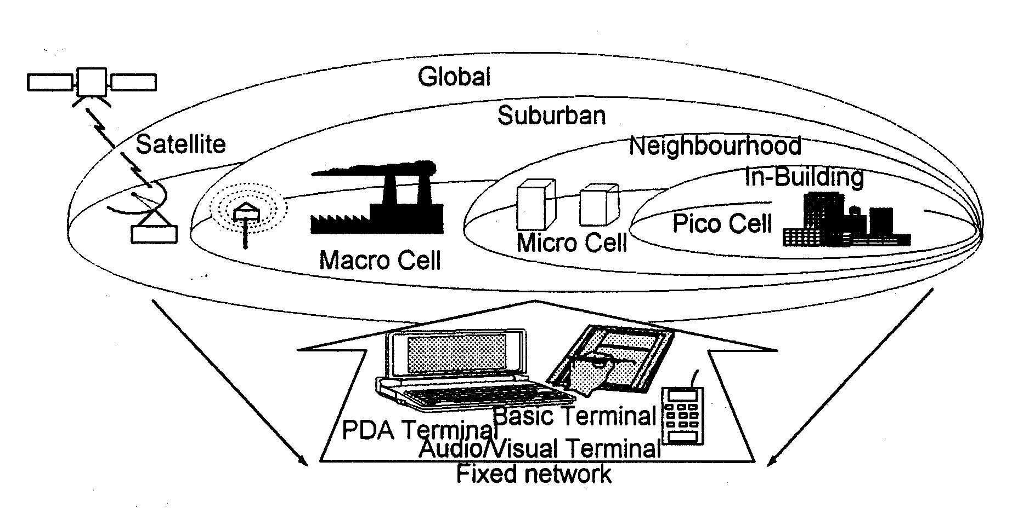
Figure 3.9 Integrated Wired & Wireless Networks with Broadband Capabilities
Positioning parameters for future service providers:
- Private … public
- Local coverage … global coverage
- Low mobility … high mobility
- Low data … high data
- Basic services … multi-media services

IMT will offer access methods that are
currently served by dedicated systems:
- Cellular public networks
- Cordless for domestic use
- Cordless terminal mobility
- Wireless PABX
- Wireless LAN
- Wireless local loop
- Private mobile radio
- Mobile data networks
- Paging networks
- Satellite systems
- Access anytime, anywhere

3.2.3 The Mobile Market

The IMT market is characterised by the need of many types of service. There are the current “voice-band” compatible services like fax and medium speed data. There will be audio-video services with higher bandwidth demands. And there will be multimedia services with asymmetrical traffic profiles. Such a scenario describes the market base for IMT. Mobility is another but dominant success factor for IMT as can be seen by the fast developments of mobile networks today. The main questions considering a IMT market are:

- Who are the users, what market segments will they come from?
- How is mobility affecting services?
- What kind of terminals will be used?
A market model needs to be developed looking at segments such as business and private, tariff schemes and price structures that need to be taken into account.
What about market and competition? Competition of suppliers, network operators or service providers? This is an important driver to develop the IMT market as already realized by the world wide liberalisation in the telecommunications business. Regulatory items play an important role to boost the market for IMT services.

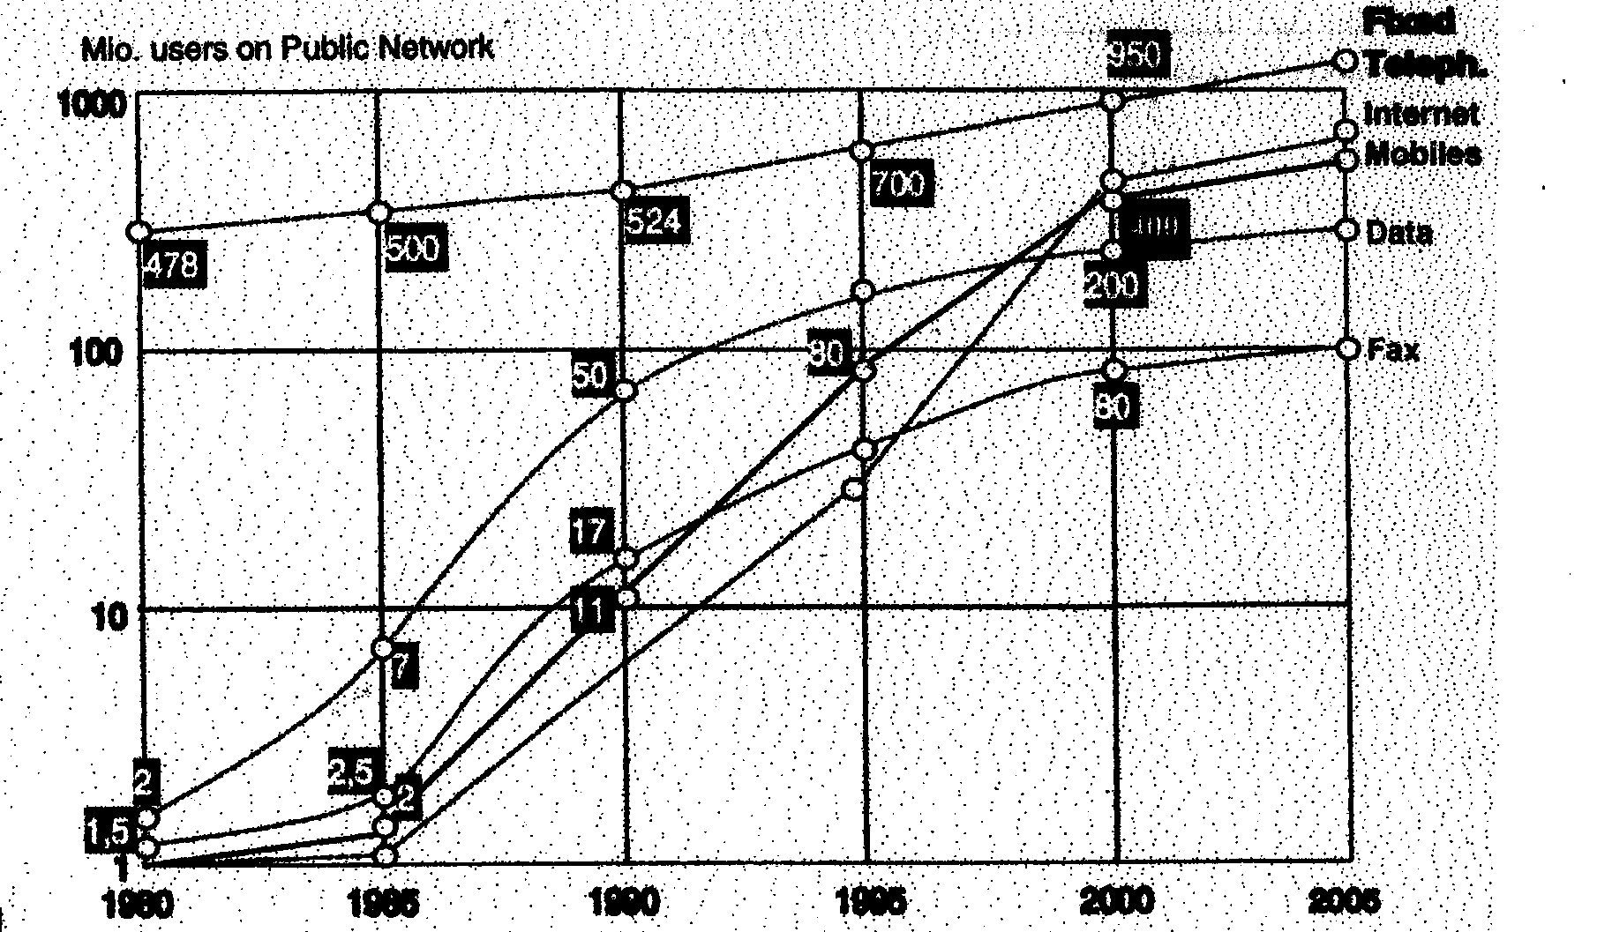

Figure 3.10 Telecommunications Market Worldwide

If we look into the telecommunications market up to 2005 (Fig.3.10), we recognize a shift in the market potential from wire line services to mobile personal services and Internet-type services. The IMT market is planned to begin in 2005. There is no clear picture foreseeable today regarding combined audio-video services and multimedia services. But there are indications from the mobile market and Internet market developments. The work on UMTS must therefore concentrate on these issues in order to find the best way to penetrate the right market for a mass consumer business as the final goal.
(GSM is a good example how to develop the personal mobile market successfully as it has already reached a global footprint).

3.2.4 The IMT Technology

It is recognised today that personal communications are mainly linked with a “voice-band” structured transmission capability. Personal voice communications are dominant, the world wide popular handhelds are mainly personal communications for one application and this is telephony.

System Aspects | Existing 2 G  Mobile Systems | New 3 G  IMT-2000 Systems
Use of digital technology | Already used for modulation, speech and channel coding as well as implementation and control of data channels | Increased use of digital technologies
Commonality between different operating environments | Each systems is primarily optimised for its specific operating environment | Optimisation of radio interfaces for multiple operating environments such as vehicular, pedestrian, intro-office, fixed wireless access and satellite, via a single flexible or scalable radio interface.
Frequency bands | Operate in frequency bands ranging from 800 MHz to 1.9 GHz, depending on the country | Use a common global frequency band
Data services | Limited to data rates below 115 kb/s (WAP-GRPS-SMS) | Transmission speeds up to 2 Mb/s
Roaming | Generally limited to specific regions, Handsets not compatible between different systems | Global frequency coordination and ITU standards will provide true global roaming and equipment compatibility
Technology | Spectrum efficiency, cost and flexibility limited by technology in use at time of system design | Spectrum efficiency, flexibility and overall costs all significantly improved.

Table 3.4 The evolution of mobile technology

In the year 2005 we may expect to see far more Internet-type users than voice users and technology development progressing towards adaptive codecs for video and voice.
IMT in the year 2005 has to provide the means to transport, switch and process applications for combined video, voice and data. Multimedia communication should be available at this point of time comparable to “Voice Handhelds” today for an acceptable price, volume and weight. The channel bandwidth for the user may vary from 16 kbps up to 2 Mbps.

The positioning of IMT on the network infrastructure side can be considered in two parts:

The IMT Radio Part
IMT is likely to cover a large variety of radio environments from indoor to outdoor – satellite coverage included. Adaptation of the mobile terminal to a specific radio environment takes place through negotiation mechanism. The radio part must concurrently support multiple public and private networks, dynamic and asymmetrical user bit rate demands. The transmission bit rate objectives for IMT are determined by service requirements. It is proposed to reach bit rates up to 2 Mbit/s to the terminal in the micro/pico cell areas, up to 144 kbit/s or probably up to 384 kbit/s in macro cells. They should offer dynamic allocation of radio bearer services.

The IMT Switching Part
The IMT switching part comprises the core network and the value-added service functions including intelligent network capabilities. IMT will serve the user with many different interfaces for
- Public mobile networks
- Cordless systems including wireless PABX, wireless LANs, cordless Terminal Mobility (CTM)
- Wireless Local Loop
- Satellite PCNs
- Private mobile radio networks
- Mobile data networks
- Paging networks

Parts of the IMT infrastructure will be operated by competing public carriers, other parts will be in private ownership on a non-regulated basis. A core set of standardised services will support the various applications. Open interfaces must also exist on the switching platforms to allow easy interworking. With IN, rapid creation and deployment of services can be offered spanning the core networks involved in IMT. Transmission and switching must be state-of-the-art technology. As IMT goes far into the century, in addition to circuit switching, TCP/IP and ATM will be the dominant switching principles.

3.2.5 Conclusions

The motivation for IMT results from recognizing the future developments towards multimedia combined with personal mobility. In addition to the technical innovations in the existing networks, only new broadband radio technologies can completely reflect such requirements. This needs to be combined with the achieved level of world-wide mobility in cellular networks (e.g. GSM) using network intelligence.
Convergence between fixed and mobile networks will arise which together with the upcoming demand for mobility independent from user location, needs to be developed in an evolutionary way. The 21st century customer will demand services independent from the access method.

3.2.6 Current ITU Recommendations for IMT-2000

ITU-R M.687 MT-2000 Concepts and Objectives
M.816 Framework for Services Supported by IMT-2000
M.817 IMT-2000 Network Architecture
M.818 Satellite Operation within IMT-2000
M.819 IMT-2000 for Developing Countries
M.1034 Requirements for the Radio Interface(s) for IMT-2000
M.1035 Framework for Radio Interface(s) and Radio Sub-system Functionality for IMT-2000
M.1036 Spectrum Considerations for Implementation of IMT-2000 in the bands 1,885 – 2.025 MHz and 2.110 – 2.200 MHz
M.1078 Security Principles for IMT-2000
M.1079 Speech and Voiceband Data Performance for IMT-2000
M.1167 Framework for the Satellite Component of IMT-2000
M.1168 Framework of IMT-2000 Management
M.1223 Evaluation of Security Mechanisms for IMT-2000
M.1224 Vocabulary of Terms for IMT-2000
M.1225 Guideline for Evaluation of Radio Transmission Technologies (RTTs) for IMT-2000
M.1308 Evolution of Land Mobile Systems Towards IMT-2000
M.1311 Framework for Modularity and Commonality within IMT-2000
SM.328 Spectrum and bandwidth emission
SM.329 Spurious emissions

ITU-T F.115 Service Objectives and Principles for IMT-2000
F.116 Service Features in IMT-2000
H.324 (Annex C) Mobile extension of H.324 (videotelephony)
I.5xw Network Interworking Between IMT-2000 and other Types
of Network
1.5xz UPT/Mobile Interaction
I.140 Attribute Technique for Characterization of ISDN services for
IMT-2000
I.340 ISDN Connection Types for IMT-2000
Q.1541 UPT Stage 2 for Services Set I on CSI-1995
Q.1701 Framework for IMT-2000 Networks
Q.1711 IMT-2000 Network Architecture.

3.2.7 ITU Publications

Following ITU publications could be of assistance in studying, planning and engineering mobile communications:
- Manual for Use by Maritime Mobile and Maritime Mobile-Satellite Services, 1999
- Land Mobile (including Wireless Access), Volume 2: Handbook on principles and Approaches on Evolution to IMT-2000/FPLMTS, 1997,
- Manual on Mobile Communications Development, 1997
- World Telecommunication Development Report –Mobile Cellular –World Telecommunication Indicators, 5th edition, 1999,
- GMPCS Reference Book, 2000
- WRC-2000 Resolutions

3.2.8 ETSI GSM Recommendations

R.00 | Preamble to the GSM recommendations
R.01 | General structure of the recommendations, description of a GSM network, associated recommendations, vocabulary, etc.
R.02 | Service aspects: bearer-, tele- and supplementary services, use of services, types and features of mobile stations (MS), licensing and subscription, as well as transferred and international accounting, etc.
R.03 | Network aspects, including network functions and architecture, call routing to the MS, technical performance, availability and reliability objectives, handover and location registration procedures, as well as discontinuous reception and cryptological algorithms, etc.
R.04 | Mobile/base station (BS) interface and protocols, including specifications for layer 1 and 3 aspects of the open systems interconnection (OSI) seven-layer structure.
R.05 | Physical layer on the radio path, incorporating issues of multiplexing and multiple access, channel coding and modulation, transmission and reception, power control, frequency allocation and synchronization aspects, etc.
R.06 | Speech coding specifications, such as functional, computational and verification procedures for the speech codec and its associated voice activity detector (VAD) and other optional features.
R.07 | Terminal adaptors for MSs, including circuit and packet mode as well as voiceband data services.
R.08 | Base station and mobile switching centre (MSC) interface, and transcoder functions.
R.09 | Network interworking with the public switched telephone network (PSTN), integrated services digital network (ISDN) and, packet data networks.
R.10 | Service interworking, short message service.
R.11 | Equipment specification and type approval specification as regards to MSs, BSs, MSCs, home (HRL) and visited location register (VLR), as well as system simulator.
R.12 | Operation and maintenance, including subscriber, routing tariff and traffic administration, as well as BS, MSC, HLR and VLR maintenance issues.

3.3 FIXED-MOBILE CONVERGENCE

3.3.1 Introduction

Increasing competition in the telecommunications world is forcing operators, incumbents and newcomers alike, to seek for new and attractive forms of services and to cut costs. Today, fixed and mobile operators are usually separate companies managing two different businesses. Even regulation is oriented to regulate fixed and mobile as different businesses. However, customers are the main driving force for telecom services development. They have requirements that can be described as:
- Always –on connectivity
- Number portability/single user address
- Service bundling
- Common billing/single bill for communication services
- Universal service profile (transparently upheld across different networks)
- Common point of customer service and management.

To deliver this will require that networks are mobility-enabled from the inside out – mobility must be built into all segments of the future communications networks.

In measuring up to the challenge, operators must ensure they have:
- A new flexible and scalable communications architecture that can meet today’s and tomorrow’s requirements for multiple services and multiple ways of accessing those services for the users
- Key partners that can manage all the systems integration work and telecommunications management systems and services required
- Superior technology to develop and deploy any new service swiftly and cost-effectively
- Mobility built into the core of their communications architectures to let users take full advantage of mobility-enabled networking independent of place or time.

One of the attractive approaches is the convergence of fixed and mobile systems and services, termed Fixed Mobile Convergence (FMC), allowing the provision of communications services based on a combination of fixed and mobile technologies and streamlining of network facilities and operations.
FMC is an appealing evolution of today's heterogeneous communications world consisting of a variety of fixed, cellular, cordless and data networks. It is of major interest for telecommunications operators and a challenge for the telecommunications industry.
FMC is driven by the increasing demand for personal communication services and for higher bandwidth data applications on one hand and by the demand of services integration and transparency on the other.
FMC may be described as the integration of network and service capabilities, allowing the user to access a set of services in a consistent way irrespective of the terminal and the access point, i.e. by using public, private, fixed or mobile networks and enjoying a personal number and a unique bill.
Particularly important is the capability to satisfy the desire of users wanting to roam between different networks whilst always being able to access the same set of services.

3.3.2 Approach for Fixed Mobile Convergence

The mid and long-term scenario for FMC is strongly tied to a service and network integration. This allows the provision of advanced 'personal services' such as one personal number, one bill, one voice mail, Internet and multimedia services.
Within this context the following technical issues are addressed:
- Network level: transmission and switching resources are shared to attach wired and wireless subscribers;
- Service level: offered services are equally available at all types of access;
- Service Management level: fixed-mobile services will be supported by an integrated open management platform with integrated billing and customer care systems.
The implementation follows a phased approach allowing for a smooth evolution in terms of network and service convergence as illustrated in the following Figure 3.12 starting from existing fixed and mobile networks:
2Phones1Service
Enhancement
1Phone1Service
One Bill
One Personal Number
One voicemail
Common Access Technologies and Network Protocols
CTS HBS to PSTN/ISDN/PLMN
Dual Mode DECT/GSM
wireless
pure cellular
pure fixed
Network Convergence
Migration
Common Transmission and Switching Resources
Multifunctional Exchange supporting
various access techniques (mobile,fixed,broadband,etc.)
various protocols (analog,ISDN,GSM,DECT,CTS,etc.)
common CCBS
common Network management

Figure 3.12 Fixed Mobile Convergence

The first phase offering for Fixed Mobile Convergence could be a package called '2Phones1 Service'. This package enables end-users to have access from different networks and terminals to a set of features including persona1 number, one bill and one voicemail.
2Phones1Service is an Intelligent Network based solution (see more in sections 2.3 and 2.9 in Chapter 2) that allows the quick introduction of the service network-wide and to minimise the impact on existing networks.
The 1Phone1 Service package adds indoor "cordless" access to the above outlined service package, using multi-mode or multi-standard mobile stations together with the matching "home base stations".
In parallel to the first phase, which is more related to the service convergence, providers work on the network convergence. The strategy is to start with the integration of the transmission and switching resources and to continue to work on a common CCBS and Network management platform.
The migration step from package 1 features an optimisation of the network in terms of resources such as access and network management facilities and network protocols.
In addition to the capabilities of phase 1, this package will support a wider range of applications.
Many switching platforms are upgradeable to broadband data and IP capability while its IN and Value-Added service platforms and applications will evolve in support of a harmonised and powerful service architecture enabling fast introduction of differentiating services across cooperating networks
The strategy fully supports evolution to UMTS that means the introduction of three related major innovations:
- A wideband cellular radio access
- The convergence of fixed and mobile, telecom voice and data and IT, public and private and
- A powerful service architecture.

3.3.3 Conclusions

Evolution of the telecommunication systems towards and standardisation of UMTS should consider also the current convergence of networks. Adopting the requirements for FMC allows UMTS to be the future global communication system supporting not only a wide range of access technologies and network protocols but also a wide variety of services.
For competitive reasons future networks will evolve to hybrid systems supporting multi-functionality including a variety of features such as fixed and mobile telephony, mobility services, Internet access, VPN, Centrex, IN and narrowband/broadband services.

  - List of Abbreviations

ADC | Administration center
AGCH | Access Grant Control Channel
ATM | Asynchronous Transfer Mode
BCCH | Broadcast Control Channel Handling
BCCH | Broadcast Control Channel
BS | Base Station
BSC | Base Station Controller
BTS | Base Transceiver Station
CCBS | Compilation of Call to Busy Subscriber
CNI | Confort Noise Insertion
CTM | Cordless Terminal Mobility
DECT | Digital Enhanced Cordless Telecommunication System
DTX | Discontinuous Transmission
ETSI | European Telecommunication Standardization Institute
FACCH | Fast Associated Control Channel
FCB | Frequency Correction Burst
FEC | Forward Error Correcting
FH | Frequency Hopping
FPLMTS | Future Public Land Mobile Telecommunications System
GSM | Global System of Mobile Communications
GMPCS | Global Mobile Personal Communications by Satellite
GMSK | Gaussian Minimum Shift Keying
HLR | Home Location Register
HO | Handover
IMSI | International Mobile Subscriber Identity
IMT 2000 | International Mobile Telecommunications 2000 standard
ISDN | Integrated Service Digital Network
ISI | Inter-Symbol Interface
MS | Mobile Station
MSC | Mobile Switching Center
MT | Mobile Termination
NMC | Network Management Center
OMC | Operation & Maintenance Center
PABX | Public Branch Exchange
PCH | Paging Channel
PCN | Personal Communications network
PLMN | Public Land Mobile Network
PSTN | Public Switched Telephone Network
RFCH | Radio Frequency Channel
SACCH | Slow Associated Control Channel
SB | Synchronization Burst
SDCCH | Stand-alone Dedicated Control Channel
TCH | Traffic Channel
TCH/F | Traffic Channel Full-rate
TCH/H | Traffic Channel Half-rate
TCP/IP | Transmission Control Protocol/Internet Protocol
TDMA | Time Division Multiple Access
TE | Terminal Equipment
TN | Timeslot Number
UMTS | Universal Mobile Telecommunications System
UPT | Universal Personal Telecommunications
VLR | Visitor Location Register
WRC | World Radio Conference

