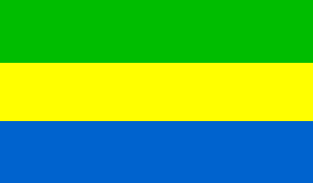 | Capacity Building Workshop on Guidelines and Toolkit on Universal Service and Access  21-22 June 2012  Libreville, Gabon  Practical Information | 

PLACE OF WORKSHOP
The workshop will be held at the City of Democracy in Libreville, Gabon.
FOCAL POINTS
- Mr Thierry MADOUNGOU
Mobile : +241 07190000
Fax: + 241 446805
E-mail: ce_madoungou@hotmail.com

- Mme Marthe Yolande Edwige
Mobile : +241 07736918
Fax: +241 446805
E-mail: marthe-yolande-edwige@hotmail.fr
ENTRY VISA
The entry to Gabon is subject to presentation of a valid passport, a letter of invitation (if a visa is required) and an international certificate of vaccination with the vaccine against yellow fever which is mandatory. Delegates are advised to contact the Embassy of Gabon in their country of residence to see if they need an entry visa and if so, get it before they travel.
However, for nationals of countries which have no diplomatic representation of Gabon, to obtain a visa on arrival is possible subject to pass at the latest June 4, 2012 a copy of the first three pages of their passport valid for focal points designated above.
DETAILS FOR DELEGATES TRANSPORTATION
For proper organization of transport to the hotels selected by the organization and place of the meeting, delegates are requested to send detailed information on their flight to focal points (see Fact Sheet delegates).
ARCEP will organize transport for delegates from the airport to the respective hotels, and their return to the airport after work.
ARCEP will also take care of the transportation from hotel to the conference venue.
HOTEL RESERVATION
It is recommended that delegates make themselves reservations by phone, fax or internet and send all the information of booking focal points. The model for the information of delegates and a list of selected hotels are attached. The fact sheet to send delegates to the focal points should indicate the date and time of arrival and departure and be sent no later than June 4, 2012.
NB : For further information on hotels, contact the focal points.Détails des dates d’arrivée et transport
CURRENCY EXCHANGE
Gabon is a member of the CFA franc zone (1 Euro = 656 XAF BEAC). Banks are open every weekday from 9 am to 15 pm, Monday through Friday. International credit cards are accepted.
ELECTRICITY
The voltage is 220 volts on the power distribution network in Gabon.
CLIMAT
Time in Libreville in June is pleasant. The temperature can vary from 25 to 30 degrees centigrade.
EAU
Tap water is good and safe.

