Annex 3
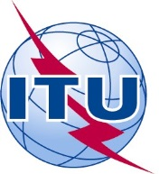 | 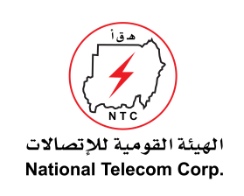 | 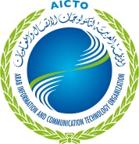 | 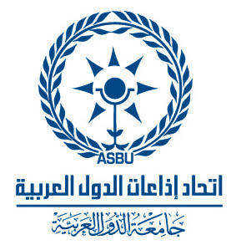
Regional Workshop
“Transition to Digital Broadcasting and Digital Dividend: Current Deployment & Regulatory Issues”
Khartoum, Sudan, 17-18 December 2013
HOTEL RESERVATION FORM
(to be submitted before 10 December 2013)
(CAPITAL LETTERS)
1. Mr. / Mrs.
(Family name) (First name)
2. Country :

3.Address :

4. Tel.:__________________ Fax: __________________ E-mail :

PLEASE SEND DIRECTLY TO THE HOTEL CHOOSEN

5. Specify name of hotel
Hotel Fax No.
Booking of a single room
Booking of a double room
from to
for nights

6. Arrival Date :
Day: _____________ Time : _________________ Flight No. : ________________
7.Departure date :
Day : ____________ Time : _________________ Flight No. : _______________

Date : Signature :

To be returned before 10/12/2013, to: to:  cc: | the hotel choosen  Ms. Aryg Mohammed Ahmed  NTC, Sudan  Tel: +249 187 171326 / Mobile: +249 912 973291  Fax: +249 183 4562360  E-mail: aryg@ntc.gov.sd

