Annex 2

  Ministry of Communications and  Information Technology | Regional Workshop  on “ICT Indicators from Strategy to Impact”  Sharm El Sheikh-Egypt, 8-9 June 2012 | 

Information Note

- Venue of the forum
The Workshop will be held from 8 to 9 June in Sharm El Sheikh-Egypt, at the following address:

Grand Rotana Resort and Spa - Sharm Elsheikh

- Coordinators
Workshop Coordinator | ITU ARO Coordinator
Dr. Nagwa EL-SHENAWI  Information Center Director  Ministry of Communication and Information Technology  Tel: +202 35341615  Fax: +202 35371222  E-mail: Nagwash@MCIT.gov.eg | Dr. Ahmed EL HEFNAWY  Senior Advisor,  ITU Arab Regional Office  Tel: +202 35 37 17 77  Fax: +202 35 37 18 88  E-mail: ITU-RO-ArabStates@itu.int

- REGISTRATION AND Working Hours
The registration of the participants will be online. The opening session will start at 09:30 am. Proposed working hours are from 09:00 to 17:00.

- proposed ACCOMODATION
Kindly be advised that it is recommended for participants to reserve their hotel accommodations via fax or e-mail, by sending the Hotel Reservation Form (Annex 3) directly to the hotel chosen, with copy to Ms. Nahla El Baih, MCIT (Fax: +202 35371222 , E-mail: nelbeh@mcit.gov.eg) and Ms. Alaa Ahmed Abdelwahab, (FAX: 202 35370033, E-mail: aaabdelwahab@mcit.gov.eg). Please fill in the Hotel Reservation Form indicating your arrival schedules and return it by 1 June 2012.

LIST OF PROPOSED HOTELS
Grand Rotana Resort and Spa - Sharm Elsheikh

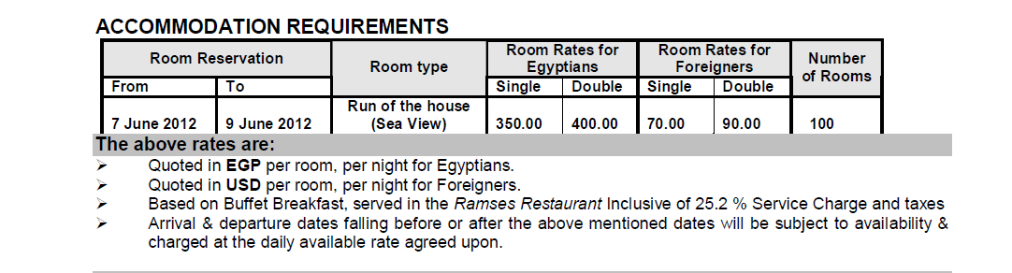

For Reservation, please contact the following person:
Mr. Ahmed SHARAF EL DIN
Sales Manager
Tel: 00 202 2644 0992 / 3
Fax: 00 202 2644 0997
Mobile: 00 20 100 444 0525
Email: ahmed.sharaf@rotana.com

As June will be a busy period, most hotels are booked and it might be difficult to secure a hotel accommodation. Hence, please ensure that your hotel accommodation is booked and confirmed at the earliest.

- Visa Formalities
A valid passport is required to enter Egypt. Visas can be issued from any Consulate or Embassy of Egypt in your country of origin.
The participant who doesn’t have any Embassy or Consulate in their original country, they can send copies of their passport to Ms. Nahla El Baih, MCIT (Fax: +202 35371222, E-mail: nelbeh@mcit.gov.eg and Mr. Ahmed Shbana, MCIT (Fax: +202 35370033, E-mail: ashabana@MCIT.gov.eg and Mr. Ahmed Said, Email: ahmedsaid@MCIT.gov.eg) in order to obtain the visa upon arrival to the airport.

- DETAILS OF ARRIVAL AND TRANSPORT
The transportation from Airport to the hotels and vice versa will be valid to the participants according to the travel details received from the delegates sent to Ms. Nashwa Ahmed, MCIT (Fax: +202 35371222, E-mail: NShennawy@MCIT.gov.eg) and Ms. Alaa Ahmed Abdelwahab, MCIT (Fax: +202 35370033, E-mail: aaabdelwahab@mcit.gov.eg).
- OTHERS
- Local time: GMT+ 2.
- Climate: Hot and approx. temperatures will vary between 30ْ - 35ْ.
- The official currency is the Egyptian Pound (LE).
1 US$ = 6.03 Egyptian Pounds (LE) (approx.)

Banks are opened from Sunday till Thursday, from 9.00 to 14.00.
Visa, American Express, Access/MasterCard, Diners Club cards and travelers checks are widely accepted.

