Annex 4

 | ITU Regional Workshop on Efficiency of the  Frequency Spectrum Use in the Arab Region  Amman-Jordan, 5-7 Dec. 2011 | 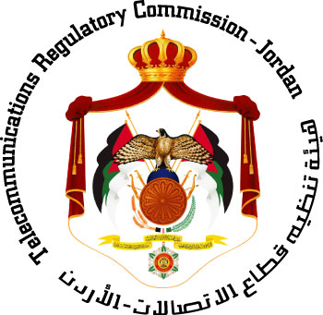

HOTEL RESERVATION FORM
(to be submitted before 25 November 2011)
(CAPITAL LETTERS)
1. Mr. / Mrs.
(Family name) (First name)
2. Country :

3. Address :

4. Tel.:__________________ Fax: __________________ E-mail :

PLEASE SEND DIRECTLY TO THE HOTEL CHOOSEN

5. Specify name of hotel
Hotel Fax No.
Booking of a single room
Booking of a double room
from to
for nights

6. Arrival Date :
Day: _____________ Time : _________________ Flight No. : ________________
7. Departure date :
Day : ____________ Time : _________________ Flight No. : _______________

Date : Signature :

To be returned before 25/11/2011, to: to:  cc: | the hotel choosen  Mr. Omar AJARMEH  Head of Public Relations Section  Telecommunications Regulatory Commission - Jordan  Tel: +962 6 550 11 20 (Ext. 2130)  Fax: +962 6 586 36 41  E-mail: Omar.ajarmah@trc.gov.jo

